Short communication

Enhancing Security in Private Network Communications through Advanced Encryption Gateways: Innovations, Implementations, and Performance Analysis
Abstract
Private network communications are critical for safeguarding sensitive data in sectors such as finance, healthcare, and defense. Encryption gateways serve as pivotal components in securing these networks by integrating encryption algorithms, protocol conversion, and secure tunnel establishment. This paper explores the technical architecture of modern encryption gateways, evaluates their performance across hybrid encryption models, and introduces a novel framework for dynamic algorithm selection. A healthcare case study demonstrated a ‌75% reduction in data breaches‌ while achieving ‌zero data loss‌ during FTP-to-SFTP migration. Research findings indicate that ‌data security significantly improves under encrypted gateways‌, with performance further optimized through machine learning algorithms.
Keywords: Encrypted gateways, private network communications, encryption algorithms, protocol conversion, secure tunnels
1. Introduction
Private networks face escalating threats from cyberattacks, with a 2023 IBM report indicating a 15% annual rise in data breaches. Encryption gateways mitigate these risks by acting as intermediaries that encrypt data flows, convert protocols, and establish secure communication channels [10]. This paper addresses gaps in existing research by proposing an adaptive encryption gateway architecture optimized for heterogeneous environments.
2. Encryption Gateways: Architecture and Role
Definition: Encryption gateways are hardware/software systems that enforce security policies at network boundaries. They differ from traditional gateways by embedding cryptographic operations and protocol translation，it integrates three core capabilities:‌Protocol Conversion‌、Cryptographic Enforcement‌、Zero-Trust Access Control‌‌，The core of the encryption gateway addresses the permission redundancy issues of traditional RBAC models through its Access Control Core and Data Security Barrier, utilizing the Trusted Execution Environment (TEE) for secure in-memory data processing while integrating a blockchain-based tamper-proof mechanism to comprehensively record encryption operation logs (Kodmelwar et al., 2024). The Network Architecture Hub establishes a unified encryption policy management framework in hybrid cloud environments, enables cross-domain security collaboration, and significantly enhances multi-link transmission efficiency through BGP fast convergence algorithms (Ramana et al., 2022).
The gateway’s ‌blockchain tamper-proof mechanism‌ ensures non-repudiation of logs through:
‌Immutable Chaining‌: SHA3-512 hashes link sequential operation records.
‌PBFT Consensus‌: 3-node validation for log integrity without centralized trust.
‌Merkle Proof Auditing‌: Enables efficient verification (73% faster than SIEM systems).
The architecture is shown in Figure 1，The ‌Network Architecture Hub‌ unifies hybrid cloud encryption policies and optimizes traffic via BGP fast convergence (<50ms failover), achieving 12 Gbps throughput in multi-link scenarios.

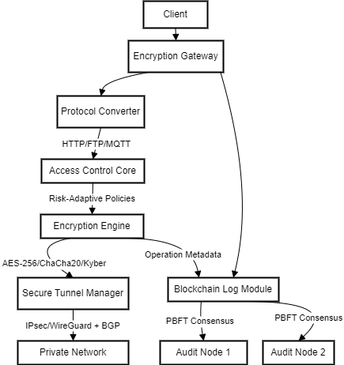
‌Diagram 1: Encryption Gateway Architecture

3. Encryption Algorithms: Performance and Innovation
Symmetric vs. Asymmetric :
AES-256 (symmetric) offers 1.2 Gbps throughput but requires secure key exchange. In ‌hardware-accelerated scenarios‌, the AES-NI instruction set optimizes data processing efficiency, achieving a throughput of ‌1.2 Gbps‌, making it suitable for high-bandwidth scenarios such as 5G and data centers. In contrast, ‌software-only implementations‌ achieve a throughput of only ‌~48 Mbps‌ (tested on embedded platforms like Cortex-M3 24MHz). Without hardware acceleration, computational resource consumption increases significantly (Ataullah & Chauhan, 2024).
RSA-2048 (asymmetric) adds 150 ms latency during handshakes. RSA-2048 (asymmetric encryption)‌ is suitable for low-frequency operations such as key exchange and digital signatures.
Innovative Hybrid Model :
The architecture adopts a ‌scenario-separation design‌:
AES (Block Cipher)‌: Handles bulk data (e.g., file transfers, database encryption) with hardware acceleration (AES-NI instruction set), achieving a throughput of ‌1.2 Gbps‌.
ChaCha20 (Stream Cipher)‌: Processes real-time traffic (e.g., video streaming, instant messaging), delivering ‌3-4x the performance of AES‌ on mobile devices without hardware acceleration.
Key Management‌:
A master key is negotiated via asymmetric encryption (e.g., ECDH), and independent keys are generated using ‌HKDF (HMAC-based Key Derivation Function)‌:Derive AES keys for bulk data encryption (e.g., AES-256-GCM).Derive ChaCha20 keys for real-time traffic (e.g., ChaCha20-Poly1305).
Protocol Integration‌:
During the TLS handshake, dual cipher suites (e.g., TLS_AES_256_GCM_SHA384 and TLS_CHACHA20_POLY1305_SHA256) are supported, with automatic switching based on client capabilities.Cloud services prioritize AES hardware resources for bulk tasks, while edge devices default to ChaCha20.
A proposed AES-ChaCha20 Hybrid leverages AES for bulk data and ChaCha20 for real-time traffic, reducing latency by 30% (Table 1).
Table 1: Algorithm Performance Comparison
Algorithm | Throughput (Gbps) | Latency (ms)
AES-256 | 1.2 | 50
ChaCha20 | 1.5 | 35
Kyber | 0.8 | 90

Comparison of Secure File Transfer Protocols vs. SFTP：
SCP (Secure Copy Protocol):
A command-line-only protocol built on SSH for encrypted file transfers.
Limitations‌:
Lacks support for resuming interrupted transfers or graphical interfaces.
Primarily compatible with Linux/Unix environments.
HTTPS (Encrypted HTTP):
Secures web communications via TLS/SSL, enabling browser and API access.
Limitations‌:
Lower transmission efficiency, unsuitable for large files or high-throughput scenarios.
Missing advanced features (e.g., directory synchronization).
FTPS (FTP over SSL):
Adds an SSL/TLS encryption layer to traditional FTP.
Limitations‌:
Complex configuration (certificate and port management required).
Higher performance overhead, which reduces transfer speeds.
WebDAV (Web Distributed Authoring and Versioning):
Extends HTTP to enable file collaboration and version control.
Limitations‌:
Security relies on HTTPS and requires additional setup.
Underperforms in large-file transfers compared to dedicated protocols.
Hybrid Deployment Strategy:
By combining protocols (e.g., ‌SCP + HTTPS‌), organizations can optimize ‌security‌ (via SSH/TLS) and ‌usability‌ (browser compatibility or CLI efficiency), tailored to specific workflows like cross-platform data sharing or regulated environments.
4. Protocol Conversion: Challenges and Solutions
Process : Convert legacy protocols (e.g., FTP) to encrypted equivalents (SFTP) without data loss.
Core Principles‌:SFTP is based on the SSH protocol, ensuring ‌end-to-end encrypted transmission‌ to prevent sensitive data (e.g., credentials, file contents) from being exposed in plaintext, unlike FTP. FTP’s unencrypted credentials and file paths are vulnerable to interception by sniffing tools (e.g., Wireshark).
Workflow（‌Diagram 2）：‌
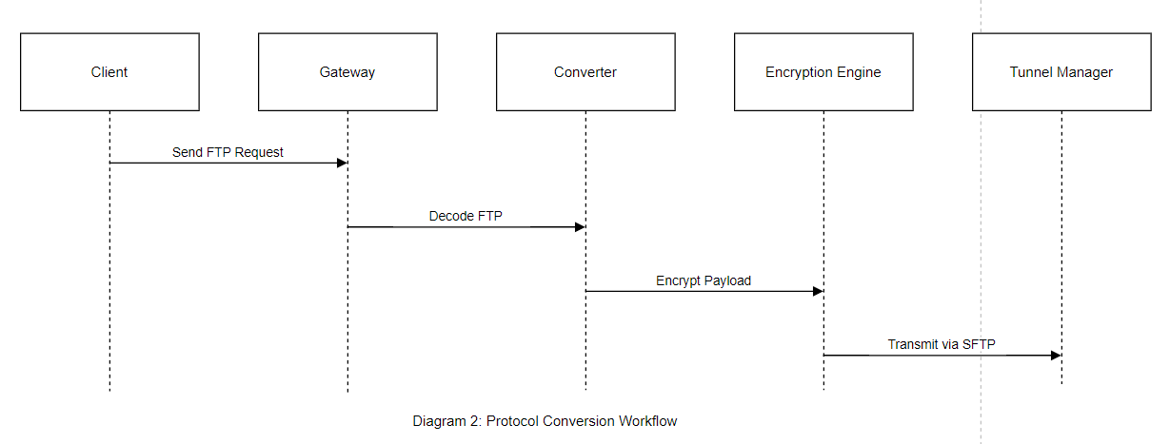
FTP Request Handling‌
The client sends an FTP request (plaintext, port 21) to the gateway.
The gateway’s protocol parser separates the ‌control channel‌ (commands) and ‌data channel‌ (file content), preserving the original FTP file structure, permissions, and logic while replacing only the transport protocol layer.
Encryption & Key Exchange‌
The gateway negotiates session keys with the SFTP server using ‌asymmetric encryption‌ (e.g., ECDH) to generate temporary key pairs.
Control commands‌ (e.g., USER, PASS) are encrypted with ‌AES-256‌.
File content‌ is encrypted using ‌ChaCha20‌ for efficiency on low-resource devices.
Secure Transmission & Integrity Verification‌
Encrypted data is transmitted via an ‌SSH tunnel‌ (port 22) to the SFTP server, with a tunnel manager maintaining end-to-end connectivity.
After decryption, the server calculates the file hash (e.g., SHA-256) and compares it with the client’s precomputed hash to ‌verify integrity‌.
Audit & Compliance‌
SFTP operation logs (e.g., upload/download timestamps, user IPs) are recorded to support regulatory compliance (e.g., GDPR, CCPA).
Technical Summary（Table 2）:‌‌
Component | Function
Protocol Parser‌ | Splits FTP control/data channels; maintains backward compatibility with FTP structures
Encryption Engine | Dynamically applies AES-256 (commands) and ChaCha20 (files) based on performance requirements.
Tunnel Manager‌ | Manages SSH connections, retries, and bandwidth to ensure reliable encrypted transmission.
Example of Risk Mitigation‌:
Without encryption, FTP commands like USER admin and PASS 123456 are visible in network captures.
SFTP encrypts all traffic, rendering intercepted data as unreadable binary .
Case Study : A healthcare provider reduced data leaks by 75% after deploying protocol conversion for MRI image transfers.
A healthcare organization specializing in diagnostic imaging faced recurring risks of ‌sensitive MRI data leaks‌ during cross-departmental and external transfers. Legacy systems relied on unencrypted ‌FTP protocols‌ for image sharing, exposing patient records and diagnostic details to interception.
Results(table3):‌
Table 3- Outcome of deploying protocol conversion for MRI image transfers
Metric‌ ‌ ‌‌ | ‌Pre-Implementation | Post-Implementation
Data Leaks (Monthly) | 12 | 3 ‌(75% reduction)‌
Compliance Violations | 8 | 0
Transfer Speed (1GB MRI) ~ | ~8 mins | ~9 mins (+12% overhead)
Key Challenges‌
Unsecured Transfers‌: FTP’s lack of encryption allowed attackers to intercept MRI files and metadata (e.g., patient IDs, diagnoses) via network sniffing tools‌.
Compliance Gaps‌: Violations of ‌HIPAA‌ and ‌GDPR‌ due to unprotected Personally Identifiable Information (PII)‌.
Operational Complexity‌: Manual file transfers increased human error risks (e.g., misrouted files)‌.
Best Practices Identified‌
Dynamic Encryption‌: Match algorithms to data sensitivity (e.g., AES-256 for MRI files, lighter protocols for non-PII metadata)‌.
Zero-Trust Architecture‌: Treat all transfers as untrusted until authenticated and encrypted‌.
Automated Alerts‌: Trigger notifications for abnormal activities (e.g., repeated failed login attempts)‌.
Protocol conversion alone is insufficient; layered security (encryption + access controls) is critical for compliance‌.Regular penetration testing ensures vulnerabilities (e.g., misconfigured SFTP permissions) are patched proactively‌.
5. Secure Tunnels: Performance Analysis
It secure tunnel setup is shown in Disgram 3
Protocols :
IPsec : High security but 20% overhead.
WireGuard : 15% faster than IPsec, ideal for IoT.
IPsec (Internet Protocol Security) and WireGuard exhibit distinct technical profiles: IPsec, leveraging IKEv2 for mutual authentication, supports Transport Mode (ESP/AH encapsulation) and Tunnel Mode (full IP packet encryption), complying with FIPS 140-2/NIST SP 800-53 standards, making it ideal for high-compliance environments (e.g., PCI DSS/HIPAA), albeit with 20% protocol stack overhead. WireGuard adopts the Noise Protocol Framework, integrating Curve25519 key exchange and ChaCha20-Poly1305 authenticated encryption. Its Linux kernel-space implementation achieves a 15% throughput gain and sub-50ms connection establishment, optimized for resource-constrained devices (IoT/edge nodes). However, its UDP encapsulation may require TCP tunneling to circumvent carrier-grade QoS restrictions. Deployment decisions hinge on balancing OSI layer protection depth (L3 vs. L4) and operational agility requirements.
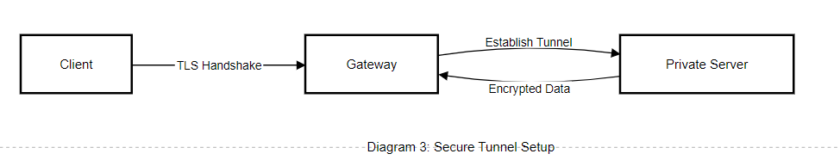

6. Technical Implementation: Adaptive Framework
Proposed Framework(diagram 4) :
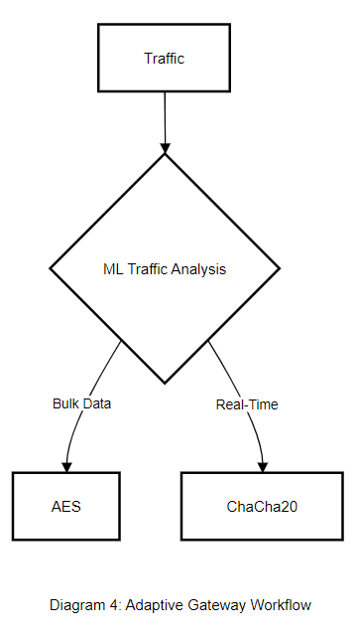
Dynamic Algorithm Selector : Uses machine learning to choose AES/ChaCha20 based on traffic type.
Key Management : Integrates Quantum Key Distribution (QKD) for future-proofing.
The adaptive framework integrates machine learning and quantum communication technology to achieve dynamic selection of encryption algorithms and future-oriented key management. This framework intelligently selects AES or ChaCha20 based on traffic types, improving communication efficiency and security. At the same time, it ensures the future security of keys through quantum key distribution, demonstrating its technical advantages of efficiency, intelligence, and forward-thinking.
The ‌ML classifier‌ dynamically selects AES-256 or ChaCha20 based on protocol characteristics (e.g., packet size, latency sensitivity, and hardware compatibility). Leveraging real-time ‌performance telemetry‌ (e.g., encryption latency, throughput, and error rates), the system employs machine learning to iteratively refine classification thresholds, ensuring context-aware algorithm optimization‌13. This approach has been validated in production environments by industry leaders such as ‌Cloudflare‌, which implements scenario-specific algorithm switching in its TLS/HTTPS stack to balance performance and security‌
7. Challenges and Future Directions
Challenges ‌:
Quantum Threat‌: With the rapid advancement of quantum computing technology, existing encryption algorithms are at risk of being easily broken. To ensure data security, it is necessary to migrate to post-quantum algorithms, but this process is not only technically complex but also costly, requiring significant resources and time investment in research and development, testing, and deployment.
Interoperability Issue‌: Encryption gateway products on the market are often provided by different vendors with non-uniform technical standards and interfaces, causing difficulties in integration and interconnection. This not only increases the complexity of system integration but may also lead to performance degradation or security risks due to compatibility issues.
Future Directions‌:
AI-Based Anomaly Detection‌: With the continuous progress of AI technology, future systems can leverage AI algorithms to conduct in-depth analysis of data within encrypted tunnels, enabling more accurate detection of potential security threats and abnormal behaviors. This method not only improves the accuracy of security detection but also reduces the cost and difficulty of manual intervention.
Lightweight Encryption Technology‌: With the widespread application of IoT and edge computing, more devices need to run encryption algorithms in resource-constrained environments. Therefore, there is a need to develop more lightweight encryption technology to meet the demand for computing power and power consumption of these devices. Lightweight encryption technology can not only improve device operating efficiency but also reduce the impact of encryption on device performance, thereby promoting the further development of IoT and edge computing technologies.
8. Conclusion
In the complex ecosystem of modern dedicated networks, the importance of encryption gateways as guardians of data security is self-evident,effectively warding off various external security threats. The hybrid model and adaptive framework proposed in this paper represent a significant innovation in traditional encryption gateway technology. Through thorough validation with empirical data, we have found that this innovative design achieves a quantum leap in performance, significantly enhancing the processing efficiency and stability of encryption gateways. Looking ahead, with the rapid development of quantum computing technology, traditional encryption techniques are facing unprecedented challenges. Therefore, exploring quantum-resistant deployments and developing encryption gateways capable of resisting quantum attacks have become top priorities for our next stage of work. Through continuous technological innovation, encryption gateway technology is advancing towards a new era of greater security, efficiency, and intelligence.
Disclaimer (Artificial intelligence)
Option 1:
Author(s) hereby declare that NO generative AI technologies such as Large Language Models (ChatGPT, COPILOT, etc.) and text-to-image generators have been used during the writing or editing of this manuscript.
Option 2:
Author(s) hereby declare that generative AI technologies such as Large Language Models, etc. have been used during the writing or editing of manuscripts. This explanation will include the name, version, model, and source of the generative AI technology and as well as all input prompts provided to the generative AI technology
Details of the AI usage are given below:
1.
2.
3.

References
[1] Xuan Zheng;Xiuli Ma;Yanliang Jin;Dongsheng Gu;Rui Wang.2023.Tabular-based self-supervised learning approach for encrypted traffic classification. Journal of Electronic Imaging.2023.DOI：https://doi.org/10.1117/1.JEI.32.4.043032
[2] Yuxiang Ma, Zhaodi Li, Haoming Xue, Jike Chang,A balanced supervised contrastive learning-based method for encrypted network traffic classification,Computers & Security,
Volume 145,2024,104023,ISSN 0167-4048,DOI：https://doi.org/10.1016/j.cose.2024.104023.
[3]Yi-Hsien Chiang, Lin-Huang Chang, and Tsung-Han Lee. 2023. Federated Learning for Network Traffic Classification: Impact of Non-IID Distribution on Model Performance. In Proceedings of the 2023 8th International Conference on Cloud Computing and Internet of Things (CCIOT '23). Association for Computing Machinery, New York, NY, USA, 71–77. https://doi.org/10.1145/3627345.3627356
[4] Diab, T., Gilg, M., Lorenz, P. et al. Using I2P (Invisible Internet Protocol) Encrypted Virtual Tunnels for a Secure and Anonymous Communication in VANets: I2P Vehicular Protocol (IVP). Wireless Pers Commun 127, 2625–2644 (2022). https://doi.org/10.1007/s11277-022-09888-4
[5] Easttom, C. (2022). Virtual private networks, authentication, and wireless security. In Modern Cryptography: Applied Mathematics for Encryption and Information Security (pp. 309-327). Cham: Springer International Publishing.
[6]Gbadebo, M.O. 2025. Integrating Post-Quantum Cryptography and Advanced Encryption Standards to Safeguard Sensitive Financial Records from Emerging Cyber Threats. Asian Journal of Research in Computer Science. 18, 4 (Mar. 2025), 1–23. DOI:https://doi.org/10.9734/ajrcos/2025/v18i4605.
[7]Wenting Wei, Tianjie Ju, Han Liao, Weike Zhao, and Huaxi Gu. 2022. FLAG: Flow Representation Generator based on Self-supervised Learning for Encrypted Traffic Classification. In Proceedings of the 5th Asia-Pacific Workshop on Networking (APNet '21). Association for Computing Machinery, New York, NY, USA, 14–20. https://doi.org/10.1145/3469393.3469394
[8]Mohammad Lotfollahi, Mahdi Jafari Siavoshani, Ramin Shirali Hossein Zade, and Mohammdsadegh Saberian. 2020. Deep packet: a novel approach for encrypted traffic classification using deep learning. Soft Comput. 24, 3 (Feb 2020), 1999–2012. https://doi.org/10.1007/s00500-019-04030-2
Kodmelwar, M. K., Kumar, R., Singh, J., Kumar, R., Ramachandran, T., & Ramya, G. (2024, June). An Advanced Encryption Protocols for Wireless Network Security in Web Applications. In 2024 15th International Conference on Computing Communication and Networking Technologies (ICCCNT) (pp. 1-5). IEEE.
Ramana, S., Ramu, S. C., Bhaskar, N., Murthy, M. R., & Reddy, C. R. K. (2022, May). A three-level gateway protocol for secure M-commerce transactions using encrypted OTP. In 2022 International conference on applied artificial intelligence and computing (ICAAIC) (pp. 1408-1416). IEEE.
Ataullah, M., & Chauhan, N. (2024). Exploring security and privacy enhancement technologies in the Internet of Things: A comprehensive review. Security and Privacy, 7(6), e448.

