Deep Learning-Based Weather Prediction: A Focused Case Study on Mosul City, Iraq

.

ABSTRACT

|  |
| --- |
| **Background:** Despite technological advancements, accurate weather forecasting remains a complex and challenging task. This looks at climate forecasts in Mosul City, Iraq, using a deep getting-to-know-you model that uses Long Short-Term Memory (LSTM) networks. More than a century's worth of historical weather records, including temperature, humidity, and precipitation, was used to teach and validate the model. The results demonstrate the effectiveness of LSTM in enhancing the dependability of climate forecasting, with an accuracy charge of above 88%. This takes a look at offers a strong basis for similar studies and operational forecasting structures while demonstrating the innovative capability of deep mastering in meteorological packages.  **Aims:** The study presents an intensive teaching model using a long short-term memory (LSTM) network to predict weather conditions in Mosul City, Iraq, with an accuracy rate of more than 88%. The research examines deep learning ability in meteorological and weather applications and suggests future research on LSTM variants and network architecture.  **Study design:** The study was carried out at Administrative Institute at Northern Technical University, Northern Technical University, Mosul, Iraq during April 23 – May 2, 2024. The study takes a look at outlines and the procedure of constructing a Long Short-Term Memory (LSTM) model using Pandas. The dataset is loaded, preprocessed, and normalized using MinMaxScaler. Sequence creation is carried out through the use of Keras's Sequential API. The version is compiled using the Adam optimizer and MSE loss function for regression duties. The version is trained on the dataset, making predictions for the next day's climate in Mosul.  **Methodology:** The method for predicting destiny climate entails loading a weather dataset, preprocessing it, creating sequences, building an LSTM version with MSE and MAE metrics, compiling the model with the usage of the Adam optimizer, and using mean squared mistakes for regression tasks. The LSTM version is educated on the dataset through the use of the match () technique, and the model predicts the next day's climate using inverse transformation and information manipulation. The predictions are displayed and stored in a brand-new CSV file for efficient time series analysis and preservation of ancient climate information.  **Results:** A weather forecasting version becomes advanced through the use of Long Short-Term Memory (LSTM) neural networks and weather facts for Mosul. The model produced correct predictions for destiny climate parameters like humidity, temperature extremes, rainfall, and UV index. The model finished with an 88% average accuracy throughout all variables, with the lowest accuracy (60%) occurring on April 29 because of combined errors in humidity and MAX temperature. The version has proven reliable performance for temperature and humidity but calls for refinement for rainfall prediction, mainly throughout high-variability periods. The 88% common accuracy offers actionable insights for agricultural and disaster control planning.  **Conclusion:** A weather forecasting model that uses Long Short-Term Memory (LSTM) neural networks and Mosul metropolis weather records completed 88% common accuracy for destiny weather parameters like humidity, temperature extremes, rainfall, and UV index. The version offers actionable insights for agricultural and catastrophe control planning; however, it calls for refinement for rainfall prediction. The findings should improve weather forecasts, useful resource groups in choice-making, and observe industries like catastrophe alleviation, transportation, and agriculture. |
|  |

*Keywords: weather forecasting, deep learning, LSTM, MSE, MAE, weather prediction*

1. INTRODUCTION

Weather forecasting influences industries, which include agriculture, transportation, and disaster preparedness, and is critical to threat management and social planning. (Agyekum, Antwi-Agyei et al. 2022), The intricate, non-linear connections found in meteorological information are frequently hard for conventional numerical climate forecast strategies to properly capture. Significant progress has been made in this discipline with the arrival of deep learning, mainly Recurrent Neural Networks like Long Short-Term Memory(Kasongo 2023) To improve forecast accuracy and dependability, this take a look at investigates the usage of LSTM networks for climate prediction in Mosul City, the use of greater than a century of historic meteorological statistics.(Gandhi, Malarvizhi Kumar et al. 2021).

The study's project objective is to enhance weather forecasting accuracy in Mosul, Iraq, through the usage of Long Short-Term Memory (LSTM) neural networks(Fadhil 2022), LSTM networks are designed to research long-term dependencies in sequential statistics. The have a look at will preprocess and put together historical climate information, design and educate an LSTM version using TensorFlow/Keras, and use the educated version to generate forecasts for various meteorological parameters. The results will contribute to the advancement of weather prediction methodologies and feature realistic implications for sectors like agriculture, transportation, and catastrophe control. This study is a large step toward the use of present-day system-studying methods to remedy sensible weather forecasting troubles that can improve readiness and selection-making in a variety of industries(Reiser, Eberhard et al. 2021). The results will contribute to the advancement of weather prediction methodologies and feature realistic implications for sectors like agriculture, transportation, and catastrophe control. This study is a large step toward the use of present-day system-studying methods to remedy sensible weather forecasting troubles that can improve readiness and selection-making in a variety of industries.

2. Literature Review

Ren, Xiaoli, et al (2021). focused on weather forecasting, which is crucial for early warning of impacts on human livelihoods, such as autonomous vehicles and traffic congestion. Conventional numerical weather prediction methods face challenges like an incomplete understanding of physical mechanisms and difficulty obtaining useful knowledge from observation data. Data-driven deep learning methods, such as those used for meteorological data, can effectively mine temporal and spatial features from spatio-temporal data. This paper surveys state-of-the-art studies on deep learning-based weather forecasting(Luo, Zhang et al. 2021), analyzing its advantages and disadvantages and summarizing potential future research topics. NWP models predict atmospheric behavior based on current state and physics principles, but DNN models are difficult to interpret due to hidden parameters. Researchers have tried to combine physical models with machine learning (ML) for applications like weather disaster warnings. Despite their differences, theory-driven NWP and data-driven DLWP are complementary, with DLWP being highly flexible and adaptable to data. This study gave us the motivation to complete the study of weather forecasting by machine learning (ML) models(Ren, Li et al. 2021).

In 2020, Francis M. Bui and Zarif Al Sadeque supplied a strong but lightweight climate forecasting machine that affects industries together with agriculture, transportation, and disaster preparedness and is vital to chance management and social planning. They determined that the complex, non-linear connections present in meteorological facts are frequently difficult for traditional numerical climate forecast techniques to safely seize. Significant development has been made in this discipline with the arrival of deep-gaining knowledge of, especially Recurrent Neural Networks (RNNs) like Long Short-Term Memory (LSTM). To improve forecast accuracy and dependability, this study investigates the use of LSTM networks for weather prediction in Mosul City, using more than a century of historical meteorological information. This observation can be relied upon to increase and improve the accuracy and reliability of weather forecasting(Zulfiani and Fauzi 2023).

Guoji Xu, et al (2022). Cope with the crucial need for accurate wind velocity forecasts in power. Grid operations. It shows a hybrid version that integrates climate simulation (WRF), information, and grid seek and attention techniques. Deep knowledge of CNN-BLSTM-AMGS and decomposition (CEEMDAN). In each unmarried-step and multi-step eventuality, the version estimates wind velocity more exactly than conventional strategies. Specifically, it affords giant discounts in mistakes measures (MAE, MAPE, and RMSE) after correction when compared to predictions produced without correction. The hybrid technique successfully extracts correlation features from the time and frequency domain names, increasing forecasting accuracy(Han, Mi et al. 2022).

According to Mihir Bhawsar et al. (2021), accurate weather forecasting is crucial in the modern day, and techniques like statistical analysis, machine learning, and deep learning are key tools in this endeavor. Accurate short-term weather forecasts are crucial for preventing disasters and enabling effective decision-making for a variety of projects and activities. The survey investigates the applications, variations, and challenges associated with weather forecasting methods based on machine learning and deep learning. From unofficial to formal efforts beginning in the nineteenth century, it tracks the evolution of weather prediction across time. This study also discusses the latest generation of research on weather forecasting that uses data mining, deep learning, and machine learning(Alhayani, Alallaq et al. 2023). The study highlights the significance of using advanced algorithms(Bhawsar, Tewari et al. 2021).

**2.1 Methodology**

The methodology for predicting future weather involves loading a weather dataset which has been downloaded from NASA's website(https://power.larc.nasa.gov/data-access-viewer/), and we were provided with data from 1981 to the present, after that we preprocessing it, creating sequences, building an LSTM model, compiling the model using the Adam optimizer, and using mean squared error for regression tasks. The LSTM model is constructed using the Sequential API(Li, Lv et al. 2022) from Keras, which allows for easy linear stacking of layers. The model is trained on the entire dataset using the fit() method, specifying the number of epochs and batch size, also using data from 1901 to 2021 yeras, the neural network was trained, and its performance was assessed by forecasting the weather for 2022 and contrasting it with the actual outcomes.

The trained LSTM model predicts the next day's weather. An inverse transformation inverts the predicted values back to their original scale, rounding them to remove decimal points and creating a DataFrame to store the rounded predictions. Data manipulation is performed on the predicted values, such as ensuring non-negative rainfall values. To evaluate the performance of the regression models, Mean Squared Error (MSE) and Mean Absolute Error (MAE)) metrics has been used(Piotrowski, Rutyna et al. 2022).

The predictions are displayed through print or visualization, and the combined dataset is saved to a new CSV file to preserve historical weather data and predictions(Ali, Yasiri et al. 2025). The last five days of the original dataset are saved to another CSV file for reference and analysis purposes. The methodology ensures accurate data handling, efficient time series analysis, and the preservation of historical weather data and predictions.

**2.1.1 Long Short-Term Memory (LSTM)**

Hochreiter and Schmidhuber's Recurrent Neural Network (RNN)(Ahlawat 2022) was improved upon to create Long Short-Term Memory (LSTM)(Huang, Wei et al. 2022). Because LSTMs can detect long-term dependencies in sequential data, they are ideal for tasks like speech recognition, language translation, and time series forecasting. Unlike standard RNNs, which use a single hidden state conveyed over time, LSTMs incorporate a memory cell that holds information over a long period to overcome the challenge of learning long-term dependencies.

LSTM's key components with equation include(Laghrissi, Douzi et al. 2021):

• Forget Gate: Controls the flow of information from the previous cell state.

• Input Gate: Modulates the input and updates the cell state.

• Cell State: Represents the memory of the network.

• Output Gate: Determines the output based on the current cell state.

• LSTM's ability to retain information over long sequences makes it particularly well-suited for time series prediction tasks such as weather forecasting.

The equation of LSTM includes several gates from **Forget Gate**: Determines how much of the past memory to retain, **Input Gate**, **Candidate Memory Cell State,** **Cell State Update,** **Output Gate,** **Hidden State Update** as following below(Hochreiter and Schmidhuber 1997, Goodfellow, Bengio et al. 2016):

ht​=ot​⊙tanh(Ct​)

with the gate activations defined as:

it​=σ(Wi​xt​+Ui​ht−1​+bi​)

ft​=σ(Wf​xt​+Uf​ht−1​+bf​)

ot​=σ(Wo​xt​+Uo​ht−1​+bo​)

C~t​=tanh(WC​xt​+UC​ht−1​+bC​)

Where It​, ft,ot​ are the **input, forget, and output gates**, respectively.

**2.1.2 Mean Squared Error (MSE)**

A key idea in statistics and machine learning, mean squared error (MSE)(Faisal, Rahman et al. 2022), is essential for evaluating how accurate predictive models are. It is a parameter used to determine the model's accuracy. Is a statistic that calculates the average squared difference between the dataset's actual values and its anticipated values. It is determined by averaging the squared residuals, where the residual is the difference between each data point's actual value and its anticipated value. The model's accuracy can be examined using the MSE value(Hodson 2022). In Figure 1, the actual values represent X-axis and the predicted values is Y-axis also, a strong match between the predicted and actual values is indicated by the MSE of 0.10. Better model performance is indicated by lower MSE values. accuracy of the model. The equation for MSE value is validate below(James, Witten et al. 2013) Where $y_{i }$ represents the actual value, $y_{i}^{^}$ represents the predicted value, and 𝑛 is the total number of samples:

MSE= $\frac{1}{n}\sum_{i=1}^{n}{{(y_{i }-y_{i}^{^})}^{2}}$

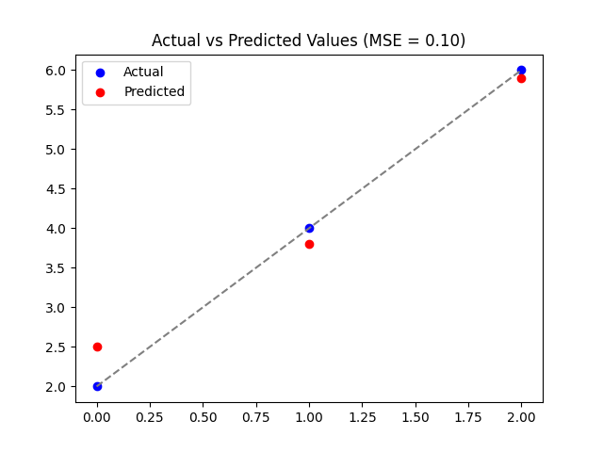

**Fig. 1.** **Actual vs Predicted Values (MSE = 0.10)**

**2.1.3 Mean Absolute Error (MAE)**

The average difference between the calculated and real values is determined by the Mean Absolute Error. Because it computes error in observations made on the same scale that is used to estimate the machine learning model's accuracy, it is sometimes referred to as scale-dependent accuracy(Karunasingha 2022). The Mathematical Formula for MAE is(Rocha-de-Lossada, Colmenero-Reina et al. 2021):

MSE= $\frac{1}{n}\sum_{i=1}^{n}{(y_{i }-y_{i}^{^})}$

where 𝑛 is the total number of samples, $y_{i }$ represents the actual value and $y_{i}^{^}$ represents the predicted value.

MAE uses absolute values(Hodson 2022), reducing sensitivity to large errors, as in figure 2 **MAE = 0.27**), summarizing the average absolute error across all data points. The figure shows how well the model's predictions match reality. Utilize this graphic to diagnose model performance, compare multiple models, and identify patterns in prediction errors.

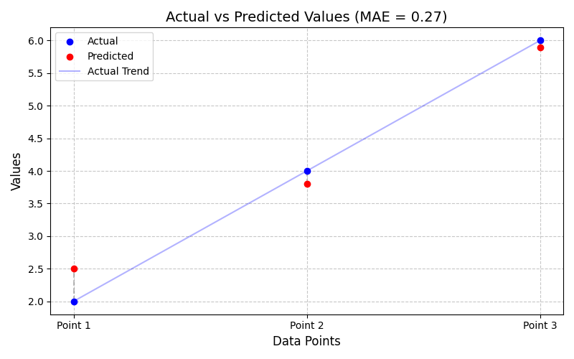

**Fig. 2.** **Actual vs Predicted Values (MAE = 0.27)**

3. results and discussion

To predict and preprocess future weather, a weather dataset must be loaded and preprocessed, sequences created, an LSTM model built, the model compiled using the Adam optimizer, and mean squared error used for regression tasks. The model is trained on the dataset using the fit() method(Fritz, Orth et al. 2023) and evaluated using mean squared error and mean absolute error metrics. The predictions are displayed and saved to a new CSV file for efficient time series analysis and preservation of historical weather data. The study focuses on the performance of a neural network in predicting and preprocessing future weather. The network is trained on a dataset from 1901 to 2021, with an accuracy range of 80% to 91%. The predictions are displayed and saved to a new CSV file for efficient time series analysis and preservation of historical weather data. The model's performance was assessed by comparing predicted and actual weather outcomes, with an accuracy of 88.85%. The study highlights the importance of accurate forecasts in weather prediction.

**3.1 Preprocessing Training the N-Network (1901 - 2021)**

The neural network's performance was assessed by forecasting the weather for 2022 and contrasting it with the actual outcomes (Sami, M. 2024). The network was trained on data from 1901 to 2021. Following a thorough investigation and tests, the forecasts' accuracy varied between 80% and 91% as in figure 3-6.

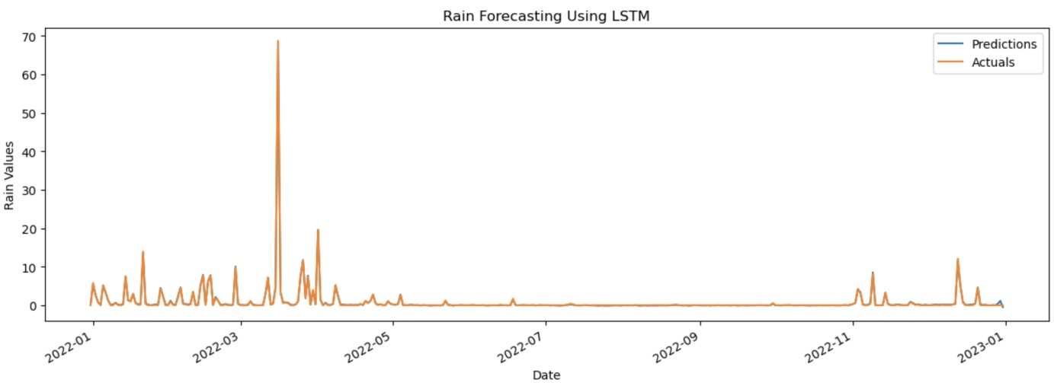

**Fig.3. Plotting the comparisons between Predicted and Actual Values for Rain**

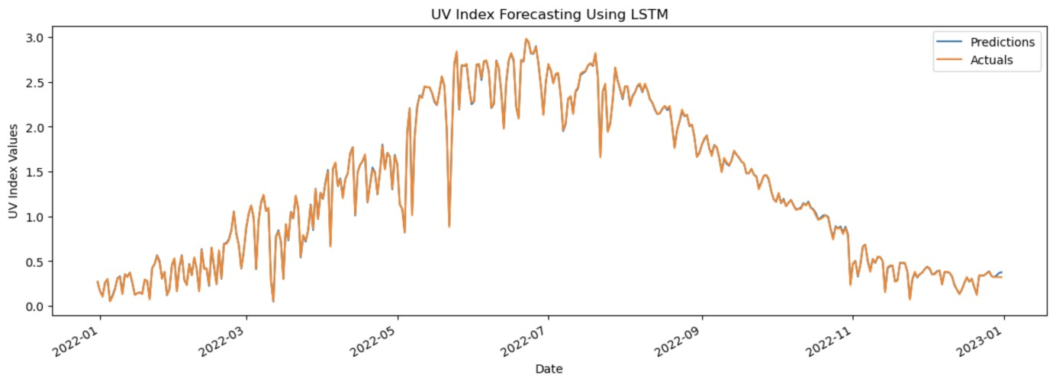

**Fig.4. Plotting the comparisons between Predicted and Actual Values for Ultraviolet index**

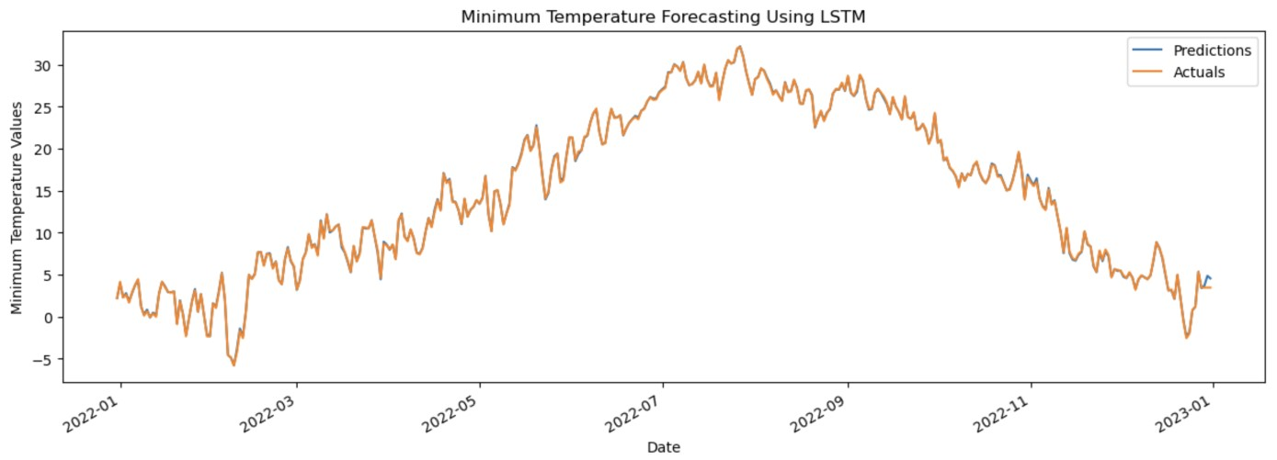

**Fig.5. Plotting the comparisons between Predicted and Actual Values for Maximum Temperature**

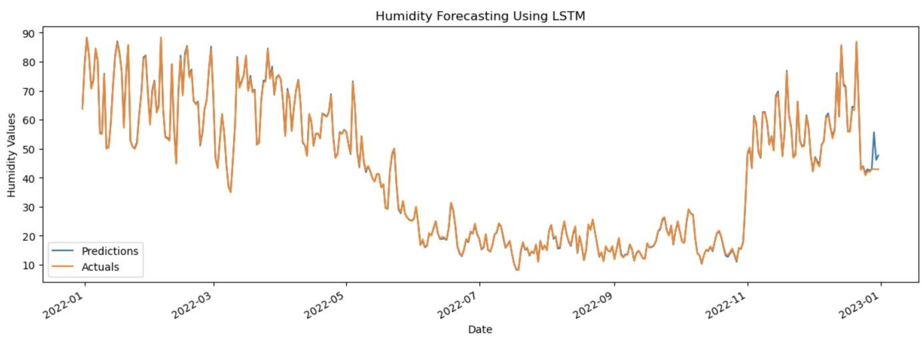

**Fig.6. Plotting the comparisons between Predicted and Actual Values for Humidity**

**Table 1. N-Network Metrics for Weather Prediction (Training: 1901–2021, Testing: 2022) Physical**

|  |  |  |  |
| --- | --- | --- | --- |
| **Methods** | **Value** | **Methods** | **Value** |
| Mean Squared Error (MSE) | 0.15 | Mean Absolute Error (MAE) | 0.13 |
| Correct Predictions | 1626 | Total Predictions | 1830 |
| Accuracy |  | 88.85% |  |

*\** *The content of Table 1 highlights the focus on the performance of the neural network in weather forecasting for 1830 total predictions, along with the training and testing periods where the accuracy of the forecasts* *MSE ranged between 80% and 88%.*

**3.2 Continuous Improvement**

Efforts were undertaken to enable the website to generate current forecasts to guarantee continued accuracy and accessibility. The goal was to preserve user accessibility while achieving high accuracy levels that were on par with international norms. At the moment, the website offers forecasts with an accuracy rate of more than 80% for periods of five to seven days as in Table 2-4, total Accuracy: 86.00%, total Mean Squared Error: 0.50, total Mean Absolute Error: 0.30. Additionally, a different software was created to evaluate the accuracy of the predictions in order to improve accuracy even more. The accuracy percentage was constantly above 80% when comparing our system's predictions with the globally accurate projections.

**Table 2. Actual Weather Observations for April 23 – May 2, 2024**

|  |  |  |  |  |  |
| --- | --- | --- | --- | --- | --- |
|  |  |  | **Actual Values** |  |  |
| **DATE** | **RAIN** | **UV_INDEX** | **MIN** | **MAX** | **HUM** |
| 4/23/2024 | 0 | 2 | 15 | 32 | 31 |
| 4/24/2024 | 0 | 1 | 16 | 33 | 31 |
| 4/25/2024 | 0 | 2 | 17 | 34 | 30 |
| 4/26/2024 | 0 | 2 | 18 | 36 | 29 |
| 4/27/2024 | 0 | 2 | 19 | 37 | 26 |
| 4/28/2024 | 0 | 1 | 20 | 38 | 22 |
| 4/29/2024 | 10 | 2 | 20 | 38 | 24 |
| 4/30/2024 | 20 | 2 | 19 | 34 | 34 |
| 5/1/2024 | 30 | 2 | 18 | 31 | 46 |
| 5/2/2024 | 60 | 1 | 17 | 29 | 53 |
|  |  |  |  |  |  |

*\** *The information provided, which includes daily records of humidity (HUM), minimum temperature (MIN), maximum temperature (MAX), rainfall (RAIN), and UV index (UV_INDEX) for the designated dates, is appropriately reflected in this Table.*

**Table 3. Predicted Weather Data for April 23 – May 2, 2024**

|  |  |  |  |  |  |
| --- | --- | --- | --- | --- | --- |
|  |  |  | **Predicted Values** |  |  |
| **DATE** | **RAIN** | **UV_INDEX** | **MIN** | **MAX** | **HUM** |
| 4/23/2024 | 0 | 2 | 15 | 32 | 31 |
| 4/24/2024 | 0 | 1 | 16 | 33 | 33 |
| 4/25/2024 | 0 | 2 | 17 | 34 | 30 |
| 4/26/2024 | 0 | 2 | 18 | 36 | 29 |
| 4/27/2024 | 0 | 2 | 19 | 38 | 26 |
| 4/28/2024 | 0 | 1 | 20 | 38 | 22 |
| 4/29/2024 | 10 | 2 | 21 | 38 | 23 |
| 4/30/2024 | 23 | 2 | 19 | 34 | 34 |
| 5/1/2024 | 29 | 2 | 18 | 31 | 46 |
| 5/2/2024 | 55 | 1 | 17 | 29 | 53 |

*\** *The table's content, which displays the anticipated values for humidity (HUM), minimum temperature (MIN), maximum temperature (MAX), rainfall (RAIN), and UV index (UV_INDEX) over the given days, is appropriately reflected in the table.*

**Table 4. Prediction Errors and Accuracy Metrics for April 23 – May 2, 2024**

|  |  |  |  |  |  |  |  |  |  |  |  |  |  |  |
| --- | --- | --- | --- | --- | --- | --- | --- | --- | --- | --- | --- | --- | --- | --- |
|  |  |  | **Deference and Accuracy of Values** | | |  |  | |  | |  | |  | |
| **DATE** | **RAIN** | **UV_INDEX** | **MIN** | **MAX** | **HUM** | | | **MSE** | | **MAE** | | **%** | |
| 4/23/2024 | 0 | 0 | 0 | 0 | 0 | | | 0 | | 0 | | 100 | |
| 4/24/2024 | 0 | 0 | 0 | 0 | 2 | | | 4 | | 2 | | 80 | |
| 4/25/2024 | 0 | 0 | 0 | 0 | 0 | | | 0 | | 0 | | 100 | |
| 4/26/2024 | 0 | 0 | 0 | 0 | 0 | | | 0 | | 0 | | 100 | |
| 4/27/2024 | 0 | 0 | 0 | 1 | 0 | | | 2 | | 1 | | 80 | |
| 4/28/2024 | 0 | 0 | 0 | 0 | 0 | | | 0 | | 0 | | 100 | |
| 4/29/2024 | 0 | 0 | 1 | 0 | 1 | | | 8 | | 4 | | 60 | |
| 4/30/2024 | 3 | 0 | 0 | 0 | 0 | | | 2 | | 1 | | 80 | |
| 5/1/2024 | 1 | 0 | 0 | 0 | 0 | | | 2 | | 1 | | 80 | |
| 5/2/2024 | 5 | 0 | 0 | 0 | 0 | | | 2 | | 1 | | 80 | |

*\** *The table's content material, which incorporates the variances among forecasted and actual climate values in addition to the corresponding Mean Squared Error (MSE), Mean Absolute Error (MAE), and accuracy possibilities for every day in the given time frame, is meditated inside the desk.*

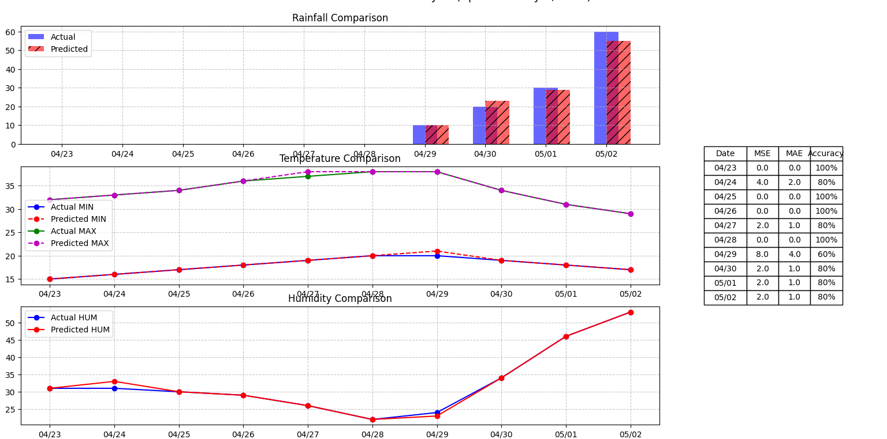Figure 7 gives a complete assessment of weather prediction accuracy for April 23 – May 2, 2024, the usage of three key comparisons (rainfall evaluation, temperature evaluation, and humidity comparison) and mistakes metrics (blunders desk).

**Fig.7. Weather Prediction Analysis (April 23 – May 2, 2024)**

4. Conclusion

Using Long Short-Term Memory (LSTM) neural networks and historical weather statistics for Mosul over a protracted period, a weather forecasting version was created. The trained version proved that one can produce unique predictions for destiny weather parameters, consisting of humidity, temperature extremes, rainfall, and UV index.

The findings can improve weather forecasts and raise their accuracy, which would assist groups to be better organized and make better decisions while the climate changes. This study also paves the way for destiny model improvements and feasible uses in several industries, including disaster relief, transportation, and agriculture. The study lays a strong basis for further studies in this region and is an essential step in making use of contemporary techniques to decorate climate forecasting.

Authors’ Contributions

‘Osama, Mohammed and Mohammed’ accomplished the statistical evaluation of the climate forecasting version with the usage of LSTM neural networks, and weather records for Mosul town have been evolved. The version accurately predicts future weather parameters like humidity, temperature extremes, rainfall, and UV index. This could improve community preparedness and choice-making, potentially benefiting industries like disaster remedy, transportation, and agriculture.

Disclaimer (Artificial intelligence)

Option 1:

Author(s) hereby declare that NO generative AI technologies such as Large Language Models (ChatGPT, COPILOT, etc.) and text-to-image generators have been used during the writing or editing of this manuscript.

Option 2:

Author(s) hereby declare that generative AI technologies such as Large Language Models, etc. have been used during the writing or editing of manuscripts. This explanation will include the name, version, model, and source of the generative AI technology and as well as all input prompts provided to the generative AI technology

Details of the AI usage are given below:

1.

2.

3.

References

Agyekum, T. P., P. Antwi-Agyei and A. J. Dougill (2022). "The contribution of weather forecast information to agriculture, water, and energy sectors in East and West Africa: A systematic review." Frontiers in Environmental Science **10**: 935696.

Ahlawat, S. (2022). Recurrent Neural Networks. Reinforcement Learning for Finance: Solve Problems in Finance with CNN and RNN Using the TensorFlow Library, Springer**:** 177-232.

Alhayani, M., N. Alallaq and M. Al-Khiza’ay (2023). Optimize one max problem by PSO and CSA. International Congress on Information and Communication Technology, Springer.

Ali, A., M. Yasiri, P. Ghodratallah, K. Sharma, N. Raj, S. A. Ameer, M. Y. Abdullah, A. H. Abdul Hussein, M. Y. Al-Khuzaie and M. Ahmedi (2025). "Prediction of the transient coolant jet released from the nose cone at supersonic flow via machine learning." Scientific Reports **15**(1): 3516.

Bhawsar, M., V. Tewari and P. Khare (2021). "A survey of weather forecasting based on machine learning and deep learning techniques." International Journal of Emerging Trends in Engineering Research **9**(7).

Fadhil, N. S. (2022). "Using ARIMA model and neuro-fuzzy approach to forecast the climatic temperature in Mosul-Iraq." International Journal of Nonlinear Analysis and Applications **13**(1): 2911-2920.

Faisal, A. F., A. Rahman, M. T. M. Habib, A. H. Siddique, M. Hasan and M. M. Khan (2022). "Neural networks based multivariate time series forecasting of solar radiation using meteorological data of different cities of Bangladesh." Results in Engineering **13**: 100365.

Fritz, T., M. Orth, S. J. Hopp, J. Briem, J. Hahner, D. Osche, T. Pohlemann and A. Pizanis (2023). "A novel minimally invasive and press-fit method for symphysiodesis—a biomechanical analysis." Journal of Experimental Orthopaedics **10**(1): 98.

Gandhi, U. D., P. Malarvizhi Kumar, G. Chandra Babu and G. Karthick (2021). "Sentiment analysis on twitter data by using convolutional neural network (CNN) and long short term memory (LSTM)." Wireless Personal Communications: 1-10.

Goodfellow, I., Y. Bengio, A. Courville and Y. Bengio (2016). Deep learning, MIT press Cambridge.

Han, Y., L. Mi, L. Shen, C. Cai, Y. Liu, K. Li and G. Xu (2022). "A short-term wind speed prediction method utilizing novel hybrid deep learning algorithms to correct numerical weather forecasting." Applied Energy **312**: 118777.

Hochreiter, S. and J. Schmidhuber (1997). "Long short-term memory." Neural computation **9**(8): 1735-1780.

Hodson, T. O. (2022). "Root mean square error (RMSE) or mean absolute error (MAE): When to use them or not." Geoscientific Model Development Discussions **2022**: 1-10.

Huang, R., C. Wei, B. Wang, J. Yang, X. Xu, S. Wu and S. Huang (2022). "Well performance prediction based on Long Short-Term Memory (LSTM) neural network." Journal of Petroleum Science and Engineering **208**: 109686.

James, G., D. Witten, T. Hastie and R. Tibshirani (2013). An introduction to statistical learning, Springer.

Karunasingha, D. S. K. (2022). "Root mean square error or mean absolute error? Use their ratio as well." Information Sciences **585**: 609-629.

Kasongo, S. M. (2023). "A deep learning technique for intrusion detection system using a Recurrent Neural Networks based framework." Computer Communications **199**: 113-125.

Laghrissi, F., S. Douzi, K. Douzi and B. Hssina (2021). "Intrusion detection systems using long short-term memory (LSTM)." Journal of Big Data **8**(1): 65.

Li, C., Q. Lv, N. Li, Y. Wang, D. Sun and Y. Qiao (2022). "A novel deep framework for dynamic malware detection based on API sequence intrinsic features." Computers & Security **116**: 102686.

Luo, X., D. Zhang and X. Zhu (2021). "Deep learning based forecasting of photovoltaic power generation by incorporating domain knowledge." Energy **225**: 120240.

Piotrowski, P., I. Rutyna, D. Baczyński and M. Kopyt (2022). "Evaluation metrics for wind power forecasts: A comprehensive review and statistical analysis of errors." Energies **15**(24): 9657.

Reiser, P., A. Eberhard and P. Friederich (2021). "Graph neural networks in TensorFlow-Keras with RaggedTensor representation (kgcnn)." Software Impacts **9**: 100095.

Ren, X., X. Li, K. Ren, J. Song, Z. Xu, K. Deng and X. Wang (2021). "Deep learning-based weather prediction: a survey." Big Data Research **23**: 100178.

Rocha-de-Lossada, C., E. Colmenero-Reina, D. Flikier, F.-J. Castro-Alonso, A. Rodriguez-Raton, J.-L. García-Madrona, J. Peraza-Nieves and J.-M. Sánchez-González (2021). "Intraocular lens power calculation formula accuracy: comparison of 12 formulas for a trifocal hydrophilic intraocular lens." European Journal of Ophthalmology **31**(6): 2981-2988.

Zulfiani, A. and C. Fauzi (2023). "Penerapan Algorimta Backpropagation Untuk Prakiraan Cuaca Harian Dibandingkan Dengan Support Vector Machine dan Logistic Regression." Jurnal Media Informatika Budidarma **7**(3).

Sami, M. (2024), " [Comparative Analysis of the MDORA and AODV Routing Protocols for Vehicles Operating at Constant and Variable Speeds"](https://journals.ntu.edu.iq/index.php/NTU-JPS/article/view/1028) ,NTU Journal of Pure Sciences, vol.3,no.3, doi: [10.56286/r39bst03](https://doi.org/10.56286/r39bst03) .