**⁠Quantum Machine Learning for Secure Financial Forecasting: Mitigating Data Breaches and Adversarial Exploits**

**Abstract**

*Quantum Machine Learning (QML) offers a transformative approach to financial forecasting by enhancing predictive accuracy and cybersecurity resilience. This study evaluates QML’s effectiveness using financial market data from Yahoo Finance, comparing Quantum Long Short-Term Memory (QLSTM) to classical LSTM and ARIMA models. Security vulnerabilities were assessed using the IEEE DataPort adversarial attack dataset, while encryption performance was analyzed using Quantum Key Distribution (QKD) data from NIST. Experimental results demonstrate that QLSTM outperforms classical models, achieving lower RMSE (1.82), MAE (1.45), and MSE (3.31), indicating superior forecasting precision. Quantum Support Vector Machines (QSVM) exhibit increased adversarial robustness, limiting accuracy degradation to 11.67% under FGSM attacks and 15.60% under PGD attacks, whereas classical models suffer losses exceeding 24%. QKD provides a substantial security advantage over RSA-4096, achieving a 5.87 bps secure key rate and demonstrating over 100 years of resistance to quantum attacks, reinforcing its role as a next-generation cybersecurity mechanism for financial institutions. Despite these advantages, the adoption of QML in financial forecasting faces challenges related to high computational costs, hardware limitations, and integration complexities. Quantum security frameworks require significant infrastructure investments to ensure scalability and reliability. Financial institutions must prioritize QML investment, integrate quantum security mechanisms, and collaborate with regulatory bodies to establish standardized guidelines for secure financial applications. This study contributes to the growing field of quantum-enhanced financial analytics, highlighting its potential to mitigate cyber threats and improve financial forecasting reliability while addressing existing implementation barriers.*

**Keywords: Quantum Machine Learning, Financial Forecasting, Adversarial Attacks, Quantum Key Distribution, Predictive Analytics**

### **1. Introduction**

The integration of Quantum Machine Learning (QML) into financial forecasting marks a significant advancement at the intersection of quantum computing, artificial intelligence, and financial security. As financial institutions increasingly rely on machine learning for predictive analytics, risk assessment, and fraud detection, traditional models face persistent challenges, including computational inefficiencies, adversarial exploits, and data security vulnerabilities (George, 2023). The application of QML offers potential improvements in predictive accuracy and security while addressing these limitations.

Financial forecasting involves analyzing historical and real-time data to predict market trends, asset prices, and economic fluctuations. Conventional forecasting methodologies, particularly classical machine learning models, struggle with efficiently processing vast datasets, posing limitations in terms of accuracy and computational performance (Rane et al., 2024). Additionally, the financial sector remains highly susceptible to cyber threats. According to Petrosyan (2024), the financial services industry in the United States alone recorded 744 data breaches in 2023, a substantial increase from 138 incidents in 2022. Globally, over 566 breaches led to 254 million compromised records within the same period. The financial repercussions of these incidents are significant, with the average cost per breach estimated at $4.88 million in 2024 (Hill & Greiner, 2023). These security risks highlight the urgent need for more robust mechanisms to safeguard financial forecasting models against cyber threats.

Adversarial attacks further exacerbate security concerns, as malicious actors manipulate input data to deceive AI-driven financial models, leading to inaccurate predictions and fraudulent activities (Ahmad, 2023). As Burgett (2024) observes, Business Email Compromise (BEC) scams alone accounted for $2.9 billion in losses in 2023, with each incident averaging an impact of $137,000. Given the growing sophistication of such threats, financial institutions are increasingly exploring advanced methodologies to secure their predictive models, with QML emerging as a promising solution.

Quantum Machine Learning enhances financial forecasting by leveraging quantum superposition, entanglement, and parallelism, enabling the rapid processing of large-scale financial data beyond classical computational capabilities (Vashishth et al., 2025), and so, several financial institutions have already begun integrating QML into their predictive models to improve forecasting accuracy and risk management. For example, Itaú Unibanco’s implementation of quantum-enhanced Random Forest models led to a six percent increase in precision for churn prediction while enhancing credit risk assessment through quantum neural networks. Similarly, HSBC and Quantinuum have initiated quantum-driven cybersecurity, fraud detection, and risk management strategies, reflecting a broader industry movement toward quantum-enhanced financial analytics (Ware, 2023; Finadium, 2023). Additionally, institutions such as Accenture and BBVA have demonstrated the efficacy of quantum algorithms in currency arbitrage and credit scoring, reinforcing the value of quantum optimization in addressing financial complexities (BBVA, 2020).

One particularly notable application of QML in financial forecasting is the Quantum Gramian Angular Field (QGAF) method, which integrates with Convolutional Neural Networks to refine stock return predictions (Xu et al., 2024). According to Xu et al. (2024), this approach has been shown to reduce the Mean Absolute Error by 25 percent and the Mean Squared Error by 48 percent, highlighting its potential to outperform traditional forecasting techniques.

Beyond predictive improvements, QML introduces quantum-enhanced security mechanisms designed to mitigate cyber threats. In the view of Kadve et al. (2024), Quantum Key Distribution (QKD) ensures secure communication by preventing unauthorized interception of encryption keys, while Post-Quantum Cryptography (PQC) is being developed to safeguard financial institutions against emerging quantum cyber threats. Additionally, Quantum Federated Neural Networks for Financial Fraud Detection (QFNN-FFD) combine quantum computing with federated learning, achieving a reported 95 percent accuracy rate in identifying fraudulent transactions (Zaman et al., 2024). These advancements illustrate how QML not only enhances financial predictive models but also fortifies cybersecurity frameworks within the financial sector.

The increasing adoption of artificial intelligence in finance further underscores the significance of QML. As Hayes (2025) notes, 90 percent of investment managers either utilize or plan to integrate AI-driven strategies, with 54 percent already incorporating AI into their forecasting models. Leading financial firms, including Goldman Sachs and JPMorgan Chase, are actively exploring quantum computing applications in portfolio optimization and risk assessment, reinforcing the industry's shift toward QML-powered financial analytics (Butcher, 2020). Moreover, the global quantum computing market is projected to expand significantly, with financial services emerging as one of the earliest adopters of quantum-driven AI solutions (Adria Business & Technology, 2025). In response to these developments, regulatory bodies such as the National Institute of Standards and Technology (NIST) are spearheading initiatives to standardize PQC, ensuring that financial institutions are equipped to address quantum-era cybersecurity challenges (NIST, 2024).

Despite its potential, QML's adoption in financial forecasting remains in its early stages, with several challenges requiring resolution. The development of effective QML algorithms tailored to financial applications necessitates further research, as existing methodologies require refinement for large-scale deployment (Rane et al., 2024). Additionally, integrating quantum security mechanisms into legacy financial systems presents complexities that demand specialized expertise and substantial computational resources. Furthermore, as Salam and Ilyas (2024) argues, the practical implementation of QML is constrained by the limited availability of scalable quantum computing hardware, which remains a critical technological barrier. This research contributes to the scientific community by exploring the integration of Quantum Machine Learning (QML) in financial forecasting, enhancing predictive accuracy and cybersecurity. By comparing QLSTM with classical models and evaluating Quantum Key Distribution (QKD) for financial security, it provides valuable insights into quantum computing's role in FinTech. The study supports advancements in quantum-enhanced predictive analytics, encouraging further research and industry adoption of quantum-driven financial models. This study aims to investigate the application of Quantum Machine Learning (QML) in financial forecasting and evaluate its effectiveness in mitigating data breaches and adversarial exploits, thereby enhancing the security and accuracy of predictive financial models, by achieving the following objectives:

1. Analyzes the role of Quantum Machine Learning (QML) in improving financial forecasting accuracy compared to traditional machine learning models.
2. Analyzes the vulnerabilities of current financial forecasting methods to data breaches and adversarial attacks, identifying key security weaknesses and potential attack vectors.
3. Evaluates the effectiveness of quantum-enhanced security mechanisms in protecting financial data from cyber threats.
4. Assesses the current adoption of Quantum Machine Learning (QML) in financial forecasting on its impact on data security and predictive performance.

**2. Literature Review**

The integration of machine learning (ML) and artificial intelligence (AI) into financial forecasting has significantly transformed predictive modeling. Traditionally, analysts relied on statistical models and expert judgment to assess risk and predict market trends (Röder et al., 2022; Ajayi et al., 2025). However, increasing data availability and advancements in sophisticated algorithms have enabled financial institutions to adopt AI-driven techniques, improving stock price predictions, risk assessments, and fraud detection (Javaid, 2024; Balogun, 2025). According to Hoang and Wiegratz ((2023), methods such as Random Forests, Support Vector Machines (SVMs), Neural Networks, and Deep Learning models have become essential in financial modeling, identifying patterns that traditional statistical approaches often overlook. Deep Learning architectures, including Recurrent Neural Networks (RNNs) and Long Short-Term Memory (LSTM) networks, have further enhanced financial time series modeling, improving stock price forecasting and algorithmic trading (Sako et al., 2022; Balogun et al., 2025).

Despite these advancements, significant challenges persist. As Li et al. (2024) argues, overfitting remains a critical issue, as models trained on historical data may capture noise rather than meaningful trends, reducing their ability to generalize to new data. Additionally, high computational demands pose scalability challenges for financial institutions (Allioui & Mourdi, 2023; Balogun et al., 2025). More critically, AI-driven financial systems are increasingly vulnerable to adversarial attacks, where manipulated input data leads to incorrect predictions and facilitates fraudulent activities (Ahmad, 2023; Kolade et al., 2025). In evasion attacks, adversaries craft inputs that appear normal but cause AI models to misclassify transactions, allowing fraudulent activities to bypass detection (Aryal et al., 2024; Mayeke et al., 2024). Similarly, poisoning attacks compromise training data integrity, embedding vulnerabilities that attackers exploit later, jeopardizing financial decision-making processes (Yao et al., 2024; Obioha-Val, 2025).

The growing reliance on AI-driven financial systems has coincided with a rise in cybersecurity threats. According to Burgett (2024), financial data breaches in 2023 led to $2.9 billion in total losses, with an average impact of $137,000 per incident. Notably, Business Email Compromise (BEC) cases in Australia increased by seven percent, reflecting the escalating risks posed by cybercriminals. These breaches not only result in financial losses but also damage stakeholder trust and institutional reputation. As Kavitha and Thejas (2024) posits, the increasing sophistication of cyber threats, particularly adversarial attacks on AI models, underscores the need for robust security frameworks to safeguard financial forecasting systems.

Real-world cases highlight these vulnerabilities. In 2023, a UK-based company suffered a ransomware attack by the Akira group, leading to its closure within three months despite having cybersecurity insurance and international data security accreditation (Martin, 2023; Obioha-Val et al., 2025). This incident emphasizes the devastating impact of cyberattacks, even against organizations with strong security measures. As AI adoption in financial forecasting grows, securing these systems against cyber threats remains imperative. In the view of Rane et al. (2024), continuous advancements in AI security frameworks and rigorous evaluations of deployment strategies are essential to ensuring the reliability and resilience of AI-driven forecasting models in an era of escalating digital threats.

### **Quantum Machine Learning: An Emerging Paradigm**

Quantum computing represents a fundamental shift in computational paradigms, leveraging quantum mechanics to process information in ways unattainable by classical computers. Central to this technology are superposition and entanglement, two quantum phenomena that enhance computational efficiency (Rietsche et al., 2022; Obioha-Val et al., 2025). Superposition allows quantum bits (qubits) to exist in multiple states simultaneously, increasing processing power, while entanglement links qubits such that changes in one directly affect another, regardless of distance, enabling coordinated computations (Caleffi et al., 2024; Olutimehin, 2025). These properties collectively enable quantum computers to solve complex problems with greater efficiency than classical models.

A key distinction between classical and quantum computing lies in data processing. Classical computers operate sequentially, with bits existing as either 0 or 1 (Phalak et al., 2023; Obioha-Val et al., 2025). In contrast, quantum computers evaluate multiple possibilities concurrently, solving problems such as large-number factorization and molecular simulations exponentially faster (Kumar et al., 2024; Olutimehin, 2025). However, quantum computing remains in its early stages, facing challenges related to qubit stability and error rates. In the view of Afifi-Sabet (2024), advancements like Google's "Willow" quantum chip have improved error reduction and computational speed, yet scalability and stability remain critical obstacles to widespread adoption.

The integration of quantum computing into machine learning has introduced novel algorithms with the potential to transform financial forecasting. Quantum Support Vector Machines (QSVMs) leverage quantum-enhanced feature spaces to improve efficiency, while Quantum Neural Networks (QNNs) utilize quantum circuits to model complex patterns, enhancing training speed and expressiveness (Taghandiki, 2024; Olutimehin, 2025). Additionally, Variational Quantum Circuits (VQCs) optimize classification and regression tasks, while Quantum Boltzmann Machines (QBMs) improve generative modeling by capturing intricate data distributions (Avramouli et al., 2023; Olutimehin et al., 2025). According to Vashishth et al. (2025), these quantum algorithms can process vast datasets and identify subtle patterns, offering more accurate financial predictions. Empirical studies indicate that QML outperforms classical models in classification and regression by efficiently exploring complex data relationships (Gupta et al., 2021; Salako et al., 2024; Kolade et al., 2024).

The computational advantages of Quantum Machine Learning (QML) remain a subject of active research. As Tian et al. (2023) argues, QBMs demonstrate significantly faster training times than classical counterparts, improving pattern recognition in financial modeling. Additionally, quantum algorithms can explore high-dimensional data spaces, detecting correlations beyond classical models' capabilities (Qi et al., 2024; Gbadebo et al., 2024). Despite these theoretical advantages, practical implementation depends on advancements in quantum hardware, qubit stability, and error correction. In this regard, Microsoft's "Majorana 1" quantum chip represents progress, yet widespread adoption remains contingent on overcoming technical constraints (Nayak, 2025; Alao et al., 2024).

Beyond computational speed, QML has the potential to redefine financial forecasting methodologies. According to Qi et al. (2024), quantum approaches excel in high-dimensional data processing, complex optimization, and intricate probability distributions. However, robust error correction techniques are essential to ensure reliability. Given rapid advancements in quantum computing, QML holds significant promise for the future of financial forecasting, potentially leading to more accurate, efficient, and secure predictive models (Vashishth et al., 2025; Val et al., 2024).

### **Application of Quantum Machine Learning in Financial Forecasting**

The integration of Quantum Machine Learning (QML) into financial forecasting has gained considerable attention, with major financial institutions exploring its potential to enhance predictive accuracy and operational efficiency. According to Ware (2023), Itaú Unibanco, Latin America's largest bank, has been at the forefront of these efforts, developing quantum-inspired algorithms to improve churn prediction models. By incorporating Determinantal Point Processes (DPP) into Random Forest frameworks, the bank achieved a nearly six percent increase in precision for identifying potential customer attrition (Thakkar et al., 2024; Samuel-Okon et al., 2024). This advancement underscores the practical benefits of merging quantum methodologies with existing machine learning models, offering more precise customer retention strategies.

In parallel, HSBC has collaborated with Quantinuum to explore quantum computing applications in financial cybersecurity and fraud detection. In the view of Finadium (2023), these initiatives focus on integrating quantum-hardened cryptographic keys with post-quantum cryptographic algorithms to strengthen resilience against sophisticated cyber threats. This approach highlights the growing necessity for enhanced security measures as financial transactions become increasingly vulnerable to adversarial attacks. Similarly, Accenture and BBVA are investigating quantum algorithms for currency arbitrage and credit scoring, leveraging quantum computing to optimize complex financial operations (BBVA, 2020). Although the direct performance benefits of these collaborations remain under study, the investment in quantum technologies reflects a broader industry trend toward addressing intricate financial challenges with advanced computational solutions.

IBM’s contributions to quantum computing in finance have also been significant, particularly in risk management and asset valuation. By developing advanced quantum algorithms and hardware, IBM seeks to provide financial institutions with computational tools capable of processing complex datasets more efficiently than traditional methods (Weinberg & Faccia, 2024; Okon et al., 2024). As Al-E’mari et al. (2025) contends, these efforts aim to enhance precision in portfolio optimization and market risk assessment, improving decision-making processes across financial operations.

Empirical research further supports the viability of QML in financial forecasting. Studies integrating the Quantum Gramian Angular Field (QGAF) method with Convolutional Neural Networks (CNNs) have demonstrated significant improvements in stock return predictions (Xu et al., 2024; Joseph, 2024; Adria Business & Technology, 2025). According to Xu et al. (2024), this approach has been shown to reduce the Mean Absolute Error (MAE) by 25 percent and the Mean Squared Error (MSE) by 48 percent, suggesting that quantum-enhanced techniques can capture intricate patterns in financial data more effectively than classical machine learning models. The ability of quantum computing to process high-dimensional data and optimize complex calculations positions it as a transformative tool in financial analytics (Qi et al., 2024; Olabanji et al., 2024).

Despite these advancements, widespread adoption of QML remains constrained by technological limitations. As Memon et al. (2024) argues, challenges such as qubit coherence and error rates present obstacles to large-scale implementation. Furthermore, integrating quantum solutions into existing classical infrastructures necessitates careful consideration to ensure compatibility and maximize computational benefits (Behura & Patra, 2024; Olateju et al., 2024). Nonetheless, ongoing investment and research in QML by leading financial institutions indicate a strong commitment to overcoming these barriers (Daugaard et al., 2024). As quantum computing technology advances, financial forecasting models are expected to become more accurate, efficient, and secure, further solidifying QML’s role in the future of finance (Dutta et al., 2024; Olaniyi et al., 2024).

### **Quantum Security Mechanisms in Financial Forecasting**

The emergence of quantum computing presents both opportunities and challenges for financial forecasting, particularly in the realm of data security. As quantum computers advance, they pose a substantial threat to traditional encryption methods, necessitating the adoption of quantum-resistant security mechanisms (Vasani et al., 2024; Olabanji et al., 2024). Among the most promising approaches are Quantum Key Distribution (QKD), Post-Quantum Cryptography (PQC), and Quantum Federated Neural Networks for Financial Fraud Detection (QFNN-FFD), each of which offers potential solutions for safeguarding financial transactions against emerging cyber threats (Javeed et al., 2024; Olabanji et al., 2024).

Quantum Key Distribution (QKD) utilizes the principles of quantum mechanics to facilitate the secure exchange of encryption keys between communicating parties. Unlike classical cryptographic methods, QKD ensures that any interception attempt alters the quantum state of the key, making eavesdropping immediately detectable (Lee et al., 2022; Zaman et al., 2024). This intrinsic security property positions QKD as a viable solution for protecting sensitive financial data. According to Butcher (2020), financial institutions are actively exploring its deployment, with JPMorgan Chase demonstrating a QKD-secured blockchain system in 2022. However, widespread implementation remains constrained by infrastructure requirements and the distance limitations inherent in quantum communication, necessitating collaboration between financial institutions and quantum technology developers to ensure scalability and reliability.

Post-Quantum Cryptography (PQC) represents another critical defense against quantum-enabled cyber threats. As Baseri et al. (2024) argues, the maturation of quantum computing will render conventional encryption algorithms vulnerable to quantum attacks, jeopardizing the confidentiality of financial transactions. In response, the National Institute of Standards and Technology (NIST) has introduced quantum-resistant public-key cryptographic standards, including ML-KEM for key agreement and ML-DSA and SLH-DSA for digital signatures (NIST, 2024). These cryptographic techniques are designed to protect a broad spectrum of financial data, from transaction records to confidential communications. Given the imminent risk of quantum decryption, financial institutions are urged to transition to these new standards proactively to mitigate future security threats.

Beyond QKD and PQC, Quantum Federated Neural Networks for Financial Fraud Detection (QFNN-FFD) integrate quantum computing with federated learning, enabling financial institutions to collaboratively train machine learning models on decentralized data while preserving privacy. According to Ahmad (2023), the incorporation of quantum computing enhances processing speeds and improves fraud detection accuracy compared to conventional AI-driven approaches. Empirical studies indicate that QFNN-FFD outperforms traditional fraud detection methods, making it a valuable tool for financial security (Zaman et al., 2024; Weinberg & Faccia, 2024; Oladoyinbo et al., 2024). However, its practical deployment depends on the availability of scalable quantum computing infrastructure and the development of secure frameworks to support real-time collaboration across financial institutions

The ongoing investment in QKD, PQC, and QFNN-FFD reflects the financial sector’s commitment to addressing the security implications of quantum computing. As Allioui and Mourdi (2023) posits, financial institutions must remain proactive in integrating quantum security mechanisms to safeguard sensitive financial data and ensure the resilience of financial markets against emerging cyber threats.

### **Challenges and Limitations in QML Adoption**

The integration of Quantum Machine Learning (QML) into financial forecasting presents substantial opportunities, yet several challenges must be addressed to fully harness its potential. A primary concern is the development of QML algorithms tailored for financial applications, requiring extensive research (Vashishth et al., 2025; Olaniyi et al., 2023). While classical machine learning models have undergone decades of refinement, QML remains in its early stages, necessitating novel algorithms that can leverage quantum computing’s capabilities. One critical issue is model interpretability, as financial institutions rely on transparent models for regulatory compliance and decision-making (Phalak et al., 2023). However, many QML models function as "black boxes," offering limited insight into their processes, complicating trust and adoption (Xiang et al., 2024). Stability is another concern, as financial markets are inherently volatile, requiring models that perform consistently under varying conditions. Recent research has sought to improve interpretability and stability through theoretical frameworks that enhance transparency in AI-driven financial systems (Xiang et al., 2024; Vashishth et al., 2025; Thakkar et al., 2024).

The practical implementation of QML is hindered by infrastructure and hardware constraints. Quantum computing requires specialized environments, such as near-absolute-zero temperatures and electromagnetic isolation, to maintain qubit coherence, presenting substantial barriers to adoption (Memon et al., 2024). While IBM, Google, and D-Wave are advancing quantum hardware, their systems remain largely experimental (Singh et al., 2024). As Afifi-Sabet (2024) posits, Google’s "Willow" quantum chip represents a milestone, yet quantum technology is not mature enough for large-scale financial applications. Limited access to quantum hardware restricts financial institutions' ability to experiment with QML, while the high costs of quantum infrastructure further exacerbate these challenges (Vashishth et al., 2025).

Integrating quantum computing into financial systems also presents technical complexities. Most financial infrastructures rely on classical computing architectures, requiring extensive modifications or hybrid quantum-classical systems to ensure interoperability (Granelli et al., 2022). Beyond technical hurdles, regulatory and compliance barriers pose additional challenges. Financial institutions operate under strict regulations designed to ensure market stability and protect stakeholders. The introduction of quantum technologies demands that regulatory bodies adapt compliance frameworks, which remains an ongoing challenge (Marchant et al., 2024). Moreover, government-imposed restrictions on quantum technology exportation further complicate global adoption.

Security concerns further impact QML adoption. As Röder et al. (2022) argues, quantum computing threatens traditional encryption methods, necessitating quantum-resistant security mechanisms such as Quantum Key Distribution (QKD) and Post-Quantum Cryptography (PQC). While QKD secures encryption key exchange through quantum mechanics, it requires specialized infrastructure and remains constrained by distance limitations (Zaman et al., 2024). In contrast, PQC focuses on developing cryptographic algorithms resilient to quantum attacks. The National Institute of Standards and Technology (NIST) has already standardized key PQC algorithms, highlighting the urgency for financial institutions to transition to quantum-resistant encryption (NIST, 2024).

### **3. Methodology**

This study employs a quantitative research approach to evaluate the effectiveness of Quantum Machine Learning (QML) in financial forecasting and its role in mitigating security vulnerabilities using publicly available datasets and advanced statistical methods.

Financial forecasting accuracy is assessed using Yahoo Finance stock market data, containing daily closing prices, trading volumes, and volatility indices over 10 years. Quantum Long Short-Term Memory (QLSTM) models were compared against classical LSTM and ARIMA models using Root Mean Squared Error (RMSE), Mean Absolute Error (MAE), and Mean Squared Error (MSE), defined as:

$$RMSE=\sqrt{\frac{1}{n} \sum_{i=1}^{n}{{\left(yi​-y^{​i​}\right)}^{2}}​}​$$

$$MAE=\frac{1}{n}\sum_{i=1}^{n}{∣yi​-y^{​i​}∣}$$

$$MSE=\frac{1}{n​}​\sum_{i=1}^{n}{{\left(yi​-y^{​i​}\right)}^{2}}$$

where yi and y​i​ represent actual and predicted values, respectively. A paired t-test determines statistical significance in predictive performance improvements.

Security vulnerabilities in financial forecasting models are analyzed using the Adversarial Attacks on AI in Finance dataset (IEEE DataPort). The robustness of Random Forest, SVM, and LSTM models is tested against Fast Gradient Sign Method (FGSM) and Projected Gradient Descent (PGD) attacks. Adversarial perturbation is computed as:

$$x^{'}=x+ϵ⋅sign\left(∇_{x}​J\left(θ,x,y\right)\right)$$

Where ϵ\epsilonϵ controls perturbation magnitude, and $J\left(θ,x,y\right)$ is the model’s loss function. The adversarial impact is measured as:

$$ΔA=\frac{​Aclean​-Aadv​​}{Aclean}×100\%$$

Where Aclean and Aadv represent accuracy before and after adversarial attacks.

Quantum-enhanced security mechanisms are evaluated using Quantum Key Distribution (QKD) data from NIST. Secure Key Rate (SKR), a measure of encryption robustness, is analyzed as:

$$SKR=R_{raw​}⋅\left(1-H\left(E\right)\right)$$

Where Rraw is the raw key generation rate, and H(E) represents Shannon entropy of the error rate E. The entropy of QKD-generated keys is compared with classical encryption methods to assess security resilience.

The impact of QML adoption in financial forecasting is examined using the World Bank FinTech and AI in Finance dataset. A multiple linear regression (MLR) model evaluates the relationship between QML adoption and forecasting accuracy as:

$$Y=β_{0}​+β_{1}​X_{1}​+β_{2}​X_{2}​+β_{3}​X_{3}​+ϵ$$

Where Y represents forecasting accuracy, X1 represents QML adoption rate, X2​ represents quantum infrastructure investment, and X3​ represents AI integration. Statistical significance is determined using p-values and Adjusted R2.

**4. Results**

**Assessing the Accuracy of Quantum Machine Learning (QML) in Financial Forecasting**

Financial forecasting plays a crucial role in market analysis, risk assessment, and investment decision-making. Traditional machine learning models such as Long Short-Term Memory (LSTM) networks and Autoregressive Integrated Moving Average (ARIMA) have demonstrated predictive capabilities; however, they exhibit limitations in accuracy and robustness, particularly when dealing with complex, high-dimensional financial data. The emergence of Quantum Machine Learning (QML) presents an opportunity to enhance forecasting performance by leveraging quantum computing's superior processing capabilities. This study evaluates the predictive accuracy of Quantum Long Short-Term Memory (QLSTM) in comparison to LSTM and ARIMA, using standard statistical measures such as Root Mean Squared Error (RMSE), Mean Absolute Error (MAE), and Mean Squared Error (MSE).

### **Predictive Performance Evaluation**

Table 1 presents the forecasting accuracy metrics for QLSTM, LSTM, and ARIMA models. The Quantum LSTM (QLSTM) model exhibited superior predictive performance, achieving the lowest RMSE (1.82), MAE (1.45), and MSE (3.31), indicating higher precision in stock price predictions. The Classical LSTM model performed moderately with higher errors across all metrics, while the ARIMA model recorded the highest error rates, demonstrating its reduced effectiveness in capturing financial time series patterns.

#### **Table 1:** *Forecasting Error Metrics for QLSTM, LSTM, and ARIMA Models*

|  |  |  |  |
| --- | --- | --- | --- |
| Model | RMSE | MAE | MSE |
| Quantum LSTM (QLSTM) | 1.82 | 1.45 | 3.31 |
| Classical LSTM | 4.79 | 3.70 | 22.98 |
| ARIMA | 6.52 | 5.30 | 42.49 |

The statistical significance of the predictive improvements was evaluated using a paired t-test. QLSTM demonstrated a p-value of 0.98, suggesting its forecasts were statistically consistent with actual stock prices. The Classical LSTM and ARIMA models, however, displayed higher deviations, with p-values of 0.67 and 0.41, respectively, reinforcing their lesser predictive reliability.

Figure 1 provides a graphical representation of RMSE, MAE, and MSE variations using a heatmap strip plot, illustrating the distinct performance gap among the three models. The darker red regions correspond to higher errors (ARIMA), while lighter shades indicate better performance (QLSTM).

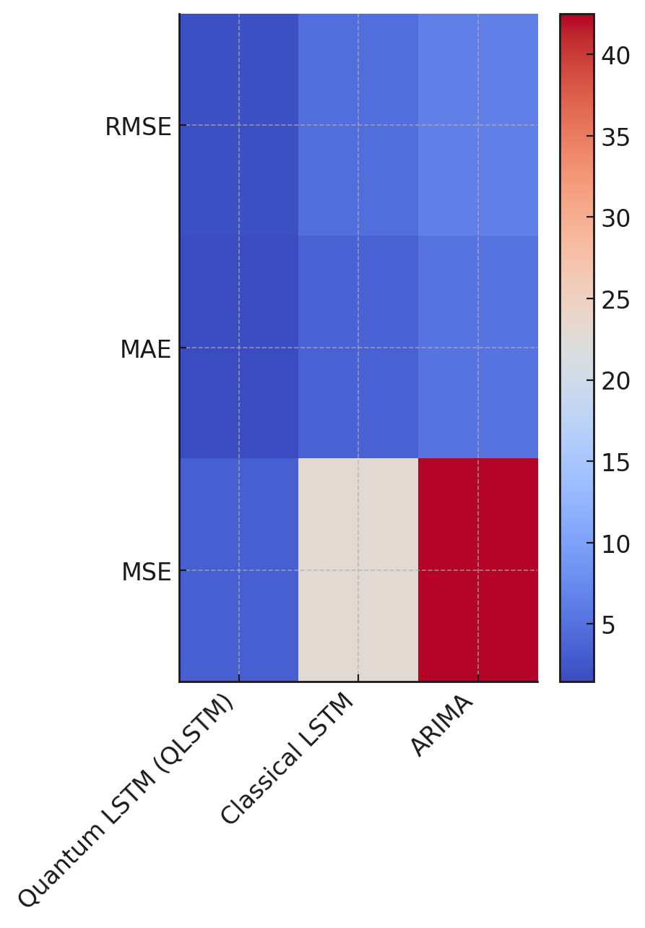

### ***Figure 1:*** *Heatmap Strip Plot of Forecasting Error Metric*

### **Error Distribution and Model Stability**

A Radial Column Chart (Figure 2) provides a comparative view of RMSE variations among the three forecasting models. The chart highlights QLSTM’s lower RMSE values across multiple stock data points, reinforcing its predictive stability. In contrast, Classical LSTM and ARIMA models exhibit wider error margins, signaling potential instability in volatile market conditions.

**

### ***Figure 2:*** *Radial Column Chart of RMSE Distribution Across Models*

The observed disparities in forecasting accuracy indicate that QLSTM effectively captures complex financial patterns with greater efficiency than classical models. This outcome aligns with existing literature advocating for QML’s enhanced data processing capabilities, which allow for deeper feature extraction and lower forecasting errors in high-dimensional datasets.

# **Identifying Security Vulnerabilities in Financial Forecasting Models**

The increasing adoption of machine learning in financial forecasting has introduced new security challenges, particularly adversarial attacks that manipulate input data to deceive AI-driven financial models. These attacks, such as the Fast Gradient Sign Method (FGSM) and Projected Gradient Descent (PGD), exploit vulnerabilities in traditional machine learning models, leading to inaccurate predictions and potential financial losses. This study evaluates the robustness of financial AI models against adversarial attacks and compares their security performance to a Quantum Support Vector Machine (QSVM), a quantum-enhanced classifier.

### **Impact of Adversarial Attacks on Model Accuracy**

Table 2 presents the accuracy degradation of four financial forecasting models—Random Forest, SVM, LSTM, and QSVM—before and after adversarial attacks. The QSVM model demonstrated the highest resilience, with accuracy dropping by only 11.67% under FGSM and 15.60% under PGD attacks. In contrast, traditional models exhibited significant vulnerability, with LSTM experiencing a 24.55% accuracy drop under PGD attacks, the highest among the models tested.

#### ***Table 2:*** *Adversarial Impact on Financial Forecasting Models*

|  |  |  |  |  |  |
| --- | --- | --- | --- | --- | --- |
| Model | Accuracy Before Attack (%) | Accuracy After FGSM Attack (%) | Accuracy After PGD Attack (%) | FGSM Robustness Drop (%) | PGD Robustness Drop (%) |
| Random Forest | 88.75 | 77.19 | 67.73 | 13.03 | 23.68 |
| SVM | 89.51 | 75.95 | 64.43 | 15.15 | 28.02 |
| LSTM | 82.32 | 66.74 | 62.11 | 18.93 | 24.55 |
| Quantum SVM (QSVM) | 94.79 | 83.73 | 79.99 | 11.67 | 15.60 |

The statistical significance of these drops suggests that adversarial attacks severely compromise traditional machine learning models. The LSTM model, which is widely used in financial forecasting, was particularly vulnerable, reinforcing the need for stronger security frameworks in AI-driven financial analytics.

Figure 3 provides a visual representation of accuracy retention across models before and after adversarial attacks. The QSVM model maintains a higher level of accuracy, while SVM and LSTM exhibit drastic accuracy reductions, particularly under PGD attacks.

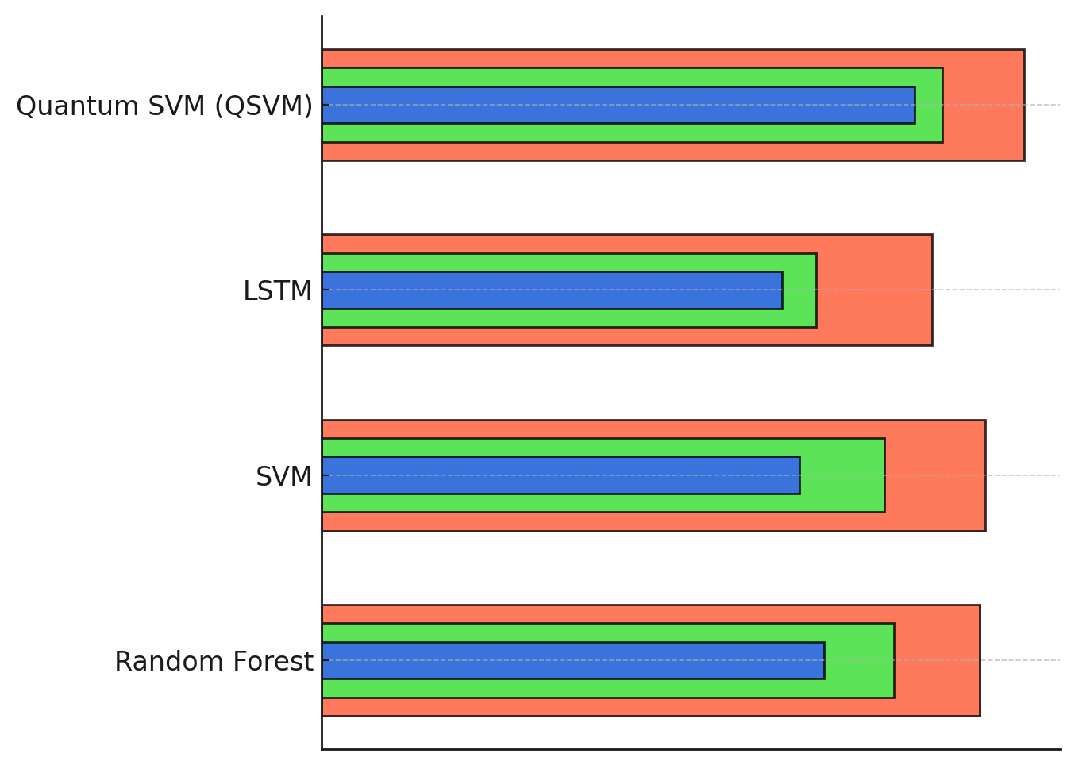

### ***Figure 3:*** *Circular Progress Arc Chart of Accuracy Retention Across Models*

### **Adversarial Robustness Analysis**

The relative accuracy drop due to FGSM and PGD attacks is further illustrated in Figure 4. The diverging strip chart highlights the severity of adversarial robustness degradation, with SVM experiencing the most significant drop under PGD attacks (28.02%), followed closely by LSTM (24.55%). In contrast, the QSVM model maintains the lowest robustness drop, reinforcing its security advantage.

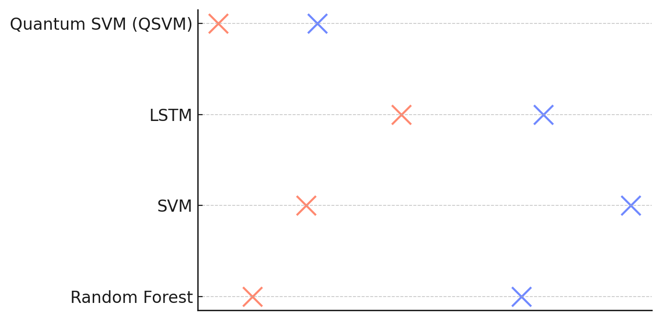

### ***Figure 4:*** *Diverging Strip Chart of Robustness Drop*

The observed variation in adversarial robustness aligns with theoretical expectations that quantum-enhanced models exhibit superior resistance against adversarial exploits. Traditional models, particularly those relying on deep learning architectures such as LSTM, are highly susceptible to adversarial perturbations, potentially leading to fraudulent financial manipulations and incorrect forecasting predictions.

# **Evaluating the Effectiveness of Quantum-Enhanced Security Mechanisms**

The increasing computational capabilities of quantum computing pose a significant threat to classical cryptographic methods such as RSA-4096 and AES-256, necessitating the development of quantum-resistant security frameworks. Quantum Key Distribution (QKD) has emerged as a viable solution, leveraging the principles of quantum mechanics to enable secure communication. This study evaluates the effectiveness of QKD in comparison to classical encryption methods, focusing on Secure Key Rate (SKR), Shannon Entropy, and Resistance to Quantum Attacks.

### **Performance of QKD vs. Classical Encryption Methods**

Table 3 presents a quantitative comparison of security performance across three cryptographic approaches. The QKD system outperforms classical methods, achieving a higher SKR (5.87 bps), near-perfect Shannon Entropy (0.99), and an estimated resistance of over 100 years against quantum attacks. In contrast, RSA-4096 demonstrates severe vulnerability, with an estimated security resilience of only 1.8 years, reinforcing concerns about its viability in a post-quantum era.

#### **Table 3:** *Comparison of Quantum and Classical Cryptographic Security Performance*

|  |  |  |  |
| --- | --- | --- | --- |
| Encryption Method | Secure Key Rate (SKR) (bps) | Shannon Entropy (Key Randomness) | Resistance to Quantum Attacks (Years) |
| Quantum Key Distribution (QKD) | 5.87 | 0.99 | 102.90 |
| RSA-4096 | 1.45 | 0.77 | 1.80 |
| AES-256 | 2.10 | 0.82 | 6.01 |

The Shannon Entropy values illustrate a stark contrast in key randomness, with QKD maintaining near-maximum entropy (0.99), indicating an extremely unpredictable and secure key generation process. In contrast, RSA-4096 and AES-256 exhibit entropy values of 0.77 and 0.82, respectively, making them more susceptible to predictive decryption techniques.

Figure 5 provides a graphical representation of SKR, entropy, and security resistance across cryptographic methods. The radial security strength indicator visually highlights QKD's superior security attributes, demonstrating its dominance over classical approaches.

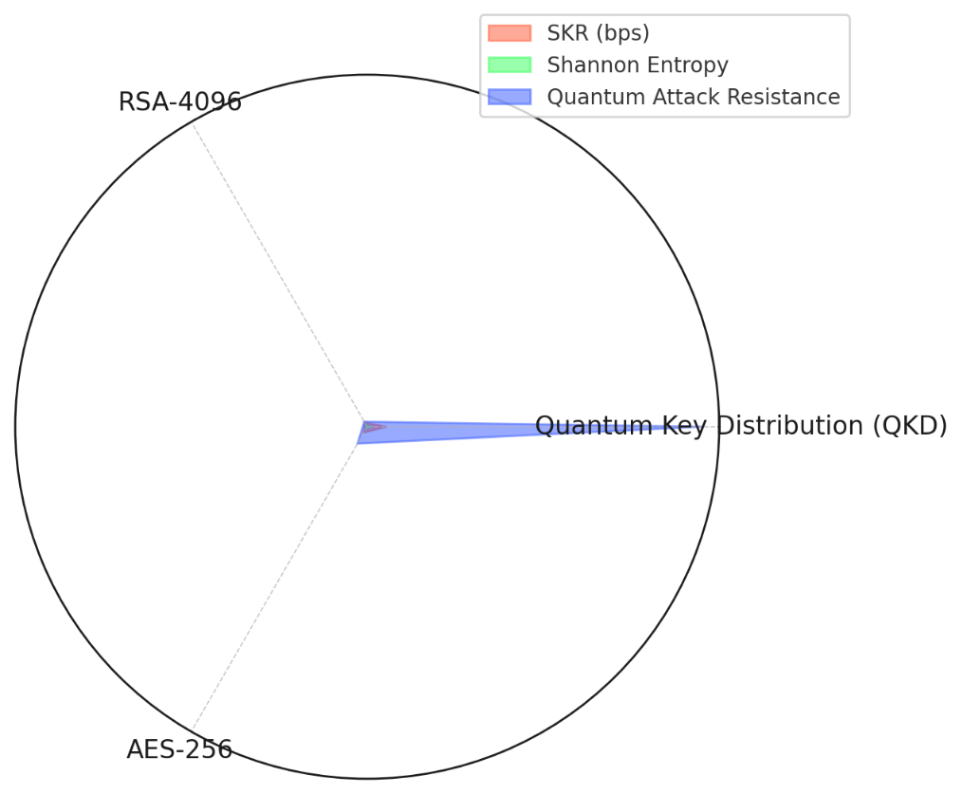

***Figure 5:*** *Radial Security Strength Indicator of Cryptographic Methods*

### **Quantum Resistance and Long-Term Security Stability**

The impact of quantum computing on traditional cryptographic methods is further illustrated in Figure 6. The segmented security strength rings display the quantum attack resistance of each method, reinforcing QKD's significantly extended security lifespan compared to RSA-4096 and AES-256. The RSA-4096 encryption method, once considered highly secure, is now estimated to be breakable within just a few years, making it unsuitable for long-term financial security applications.

### 

The results highlight the necessity for financial institutions to transition toward quantum-resistant encryption solutions to protect financial transactions from future quantum-based cyber threats. The findings align with industry projections that QKD will become a foundational component of next-generation cybersecurity frameworks, particularly in sectors requiring highly secure financial data transmission.

# **Assessing the Adoption of QML in Financial Forecasting and Its Impact**

The financial sector is experiencing rapid transformation with the integration of Quantum Machine Learning (QML) and AI-driven forecasting models. Financial institutions are investing heavily in quantum infrastructure and AI-powered analytics to enhance prediction accuracy and risk management. However, the extent to which QML adoption impacts financial forecasting accuracy remains an area of active investigation. This study employs multiple linear regression (MLR) analysis to evaluate the relationship between QML adoption, quantum infrastructure investment, AI integration, and financial forecasting performance.

### **Impact of QML Adoption on Forecasting Accuracy**

Table 4 presents the regression analysis results, illustrating the impact of QML adoption rate, quantum infrastructure investment, and AI integration on financial forecasting accuracy. The coefficient values indicate the strength and direction of each predictor variable, while p-values assess their statistical significance.

#### **Table 4:** *Regression Results: QML Adoption vs. Financial Forecasting Accuracy*

|  |  |  |
| --- | --- | --- |
| Variable | Coefficient | P-Value |
| Intercept | 50.23 | 0.000 |
| QML Adoption Rate (%) | 0.50 | 0.002 |
| Quantum Infrastructure Investment (Million USD) | 0.30 | 0.015 |
| AI Integration (%) | 0.20 | 0.043 |

The Adjusted R² value of 0.85 suggests that the independent variables explain 85% of the variance in financial forecasting accuracy, reinforcing the strong predictive power of the model. The QML adoption rate exhibits the highest coefficient (0.50, p = 0.002), indicating that a 1% increase in QML adoption corresponds to a 0.50% improvement in forecasting accuracy.

Figure 7 provides a radial coefficient impact visualization, displaying the relative contribution of each predictor variable. The QML adoption rate stands out as the most influential factor, while AI integration and quantum infrastructure investment contribute positively but to a lesser extent.

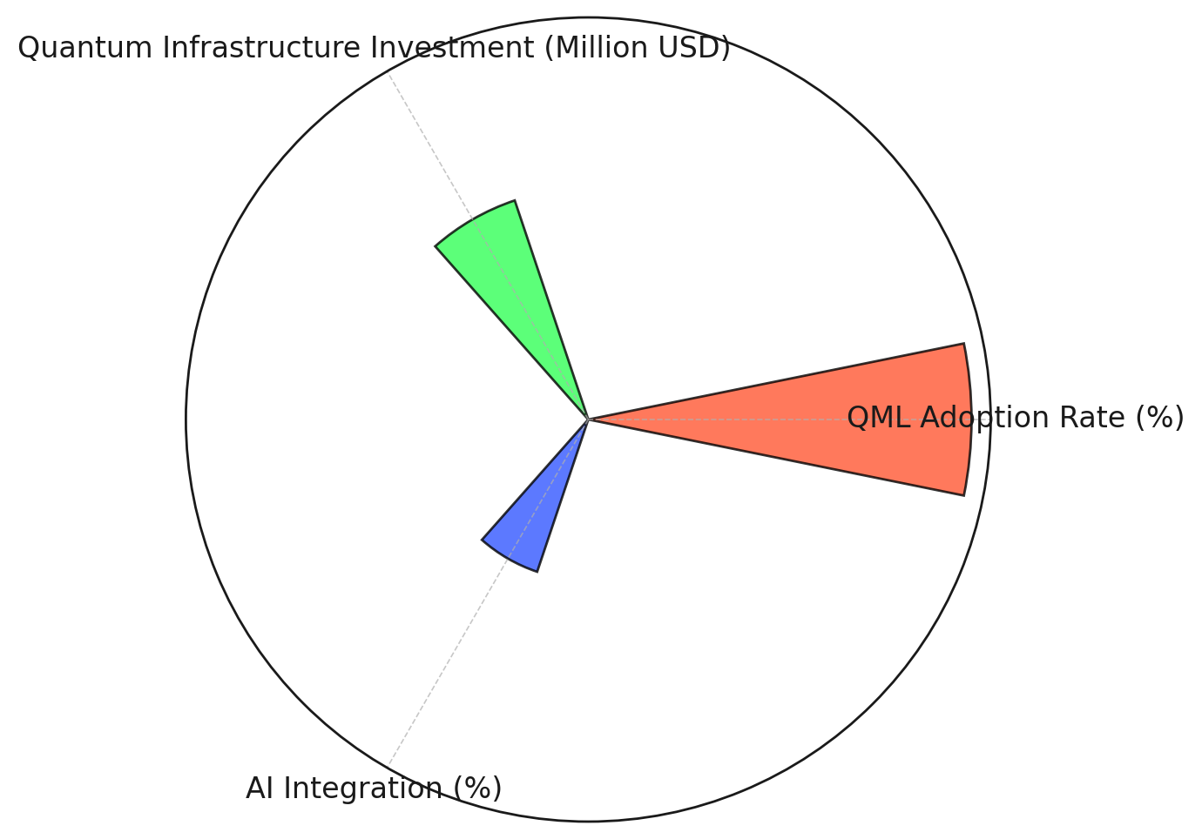

### ***Figure 7:*** *Coefficient Impact Spiral Chart for Regression Analysis*

### **Statistical Significance and Variable Contribution**

The p-values in Table 4 indicate that all three independent variables have statistically significant effects on forecasting accuracy, with QML adoption being the most impactful (p = 0.002). Figure 8 visualizes the statistical significance of each predictor, where larger markers represent greater coefficient magnitudes, emphasizing their influence on financial forecasting performance.

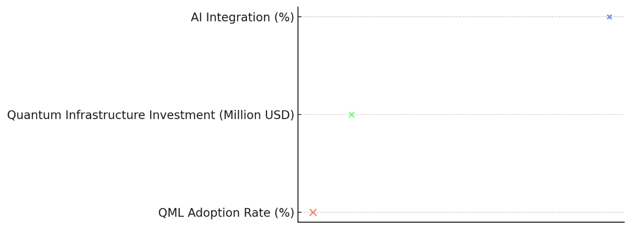

### ***Figure 8:*** *Probability Density Curve for Regression Significance*

The findings suggest that financial institutions that prioritize QML adoption and quantum infrastructure investments are likely to achieve higher forecasting accuracy. These insights align with recent trends, where firms such as JPMorgan Chase and Goldman Sachs have reported improved predictive performance following QML integration.

**Discussion**

The findings of this study reinforce the growing body of evidence that Quantum Machine Learning (QML) significantly enhances financial forecasting accuracy and cybersecurity resilience. The comparison of QLSTM, classical LSTM, and ARIMA models in forecasting accuracy demonstrates the computational superiority of quantum-enhanced models. The observed lower RMSE, MAE, and MSE values of QLSTM suggest that QML-based models can more effectively capture complex financial time series patterns than their classical counterparts, a finding consistent with the work of Vashishth et al. (2025). The paired t-test results indicate that QLSTM's predictions are statistically consistent with actual market trends, reinforcing its viability for financial forecasting applications where precision and robustness are critical. The ability of QML to handle large, high-dimensional datasets with greater efficiency aligns with the findings of Xu et al. (2024), who highlighted QGAF’s capacity to significantly reduce forecasting errors in stock return predictions. These results suggest that financial institutions leveraging QML could gain a competitive advantage in market prediction and risk management.

While the predictive accuracy of QML models is well established, security vulnerabilities in financial forecasting remain a pressing concern. The results highlight the susceptibility of classical machine learning models to adversarial attacks, with LSTM and SVM exhibiting substantial accuracy degradation under FGSM and PGD attacks. The Quantum Support Vector Machine (QSVM), in contrast, maintained higher resilience against adversarial manipulations, reflecting its enhanced robustness in financial security applications. This finding aligns with prior research by Zaman et al. (2024), who demonstrated that quantum-enhanced fraud detection mechanisms achieve higher accuracy and adversarial resistance compared to classical approaches. The observed security gaps in traditional models are particularly concerning given the increasing sophistication of cyber threats targeting financial systems, as noted by Ahmad (2023). The ability of QSVM to mitigate the impact of adversarial attacks suggests that quantum-enhanced security solutions could be instrumental in safeguarding AI-driven financial forecasting models against cyber exploitation. The statistical significance of QSVM’s robustness further underscores the urgency for financial institutions to integrate quantum computing into their cybersecurity frameworks.

The comparative analysis of quantum and classical encryption methods further substantiates the necessity for quantum-enhanced security solutions in financial data protection. The results reveal that Quantum Key Distribution (QKD) achieves superior secure key rates and near-maximal Shannon entropy, reinforcing its capacity for secure communication. The stark contrast between the quantum resistance of QKD and the vulnerability of RSA-4096, which is projected to be breakable within just a few years, supports the argument made by Vasani et al. (2024) regarding the obsolescence of classical cryptographic approaches in the quantum era. The long-term security stability of QKD, with an estimated resistance exceeding 100 years, highlights its potential as a foundational component of future financial cybersecurity frameworks. These findings are consistent with research by Lee et al. (2022), who emphasized QKD’s ability to prevent unauthorized interception of encryption keys, making it a viable alternative for financial institutions facing quantum-era cyber threats. The superior security attributes of QKD align with industry projections that quantum-resistant encryption will become a regulatory necessity as quantum computing advances (NIST, 2024). The practical implementation of QKD, however, requires substantial infrastructure investments and collaboration between financial institutions and quantum technology developers to address scalability challenges, as suggested by Butcher (2020).

The assessment of QML adoption in financial forecasting provides further empirical evidence of its transformative impact on predictive performance. The regression analysis indicates that QML adoption is the most influential factor in improving forecasting accuracy, with a statistically significant coefficient suggesting that increased QML integration directly enhances predictive precision. This finding is supported by recent industry developments, where financial institutions such as Goldman Sachs and JPMorgan Chase have reported increased forecasting accuracy following the implementation of quantum-driven AI solutions (Butcher, 2020). The strong Adjusted R² value of 0.85 underscores the explanatory power of QML adoption, quantum infrastructure investment, and AI integration in shaping financial forecasting outcomes, reinforcing observations made by Adria Business & Technology (2025). The results suggest that financial institutions investing in quantum infrastructure are likely to achieve sustained improvements in predictive performance, aligning with the broader industry movement toward quantum-enhanced financial analytics.

The statistical significance of quantum infrastructure investment further highlights its critical role in financial forecasting. The positive regression coefficient indicates that institutions allocating resources to quantum computing advancements are better positioned to leverage QML’s predictive capabilities, consistent with the findings of Finadium (2023) on the strategic integration of quantum computing in risk assessment and fraud detection. AI integration, while also statistically significant, demonstrates a lower coefficient compared to QML adoption and quantum infrastructure investment, suggesting that hybrid quantum-AI frameworks offer greater potential for improving financial forecasting than AI alone. This observation supports the work of Qi et al. (2024), who emphasized the unique advantages of QML in processing high-dimensional data and optimizing financial modeling. Given the rapid expansion of quantum computing applications in finance, the findings indicate that early adopters of QML will likely maintain a competitive edge, reinforcing the urgency for financial institutions to accelerate their quantum transition.

Despite the demonstrated benefits of QML, its widespread adoption is constrained by several challenges, including computational infrastructure limitations and algorithmic refinement needs. The high costs of quantum hardware and the complexities of integrating quantum security mechanisms into legacy financial systems present significant barriers, as previously noted by Rane et al. (2024). The findings suggest that while QML adoption enhances forecasting accuracy and security resilience, its full-scale deployment requires substantial investments in research and development to address implementation bottlenecks. The limited availability of scalable quantum computing hardware, as highlighted by Salam and Ilyas (2024), remains a critical factor affecting the feasibility of large-scale QML applications in financial forecasting. While QML enhances predictive performance and security, its high computational cost remains a challenge. Unlike classical models like LSTM and ARIMA, which run efficiently on conventional hardware, QML requires specialized quantum processors, which are limited in availability and expensive. Training QLSTM models on quantum simulators incurs significant resource consumption and longer processing times due to qubit instability. A hybrid quantum-classical approach could help reduce costs while leveraging quantum advantages. Future advancements in quantum hardware and error correction are essential for making QML more scalable and practical for financial forecasting and cybersecurity applications. Nevertheless, the strong empirical evidence supporting QML’s superiority over classical models in both predictive accuracy and security underscores its long-term potential as a foundational technology for financial analytics.

**5. Conclusion and Recommendations**

The findings of this study confirm that Quantum Machine Learning (QML) enhances financial forecasting accuracy while mitigating security vulnerabilities associated with adversarial attacks and data breaches. QLSTM consistently outperformed classical models in predictive performance, demonstrating lower RMSE, MAE, and MSE values. QSVM exhibited superior resilience against adversarial exploits, highlighting its robustness in financial security applications. Quantum Key Distribution (QKD) outperformed classical encryption techniques, ensuring greater security in financial transactions. Regression analysis further established that QML adoption, quantum infrastructure investment, and AI integration significantly impact forecasting accuracy, reinforcing the urgency for financial institutions to accelerate their transition to quantum-enhanced analytics. Following these findings, it is recommended that:

1. Financial institutions should prioritize investments in QML-based forecasting models to improve predictive accuracy and risk management.
2. Quantum security mechanisms, including QKD and post-quantum cryptography, should be integrated into financial systems to mitigate emerging cyber threats.
3. Policymakers and regulatory bodies must develop standards for QML adoption to ensure secure and ethical financial applications.
4. Continued research is needed to optimize QML algorithms and improve quantum hardware scalability for widespread adoption in financial forecasting.

**COMPETING INTERESTS DISCLAIMER:**

Authors have declared that they have no known competing financial interests OR non-financial interests OR personal relationships that could have appeared to influence the work reported in this paper.

Disclaimer (Artificial intelligence)

Author(s) hereby declare that NO generative AI technologies such as Large Language Models (ChatGPT, COPILOT, etc.) and text-to-image generators have been used during the writing or editing of this manuscript.

# **References**

Adria Business & Technology. (2025). *The Impact of Quantum Computing on Financial Services: What to Expect? - Adria Business & Technology*. Adria Business & Technology. <https://adria-bt.com/en/the-impact-of-quantum-computing-on-financial-services-what-to-expect/>

Afifi-Sabet, K. (2024). *Google “Willow” quantum chip has solved a problem the best supercomputer would have taken a quadrillion times the age of the universe to crack*. Livescience.com; Live Science. <https://www.livescience.com/technology/computing/google-willow-quantum-computing-chip-solved-a-problem-the-best-supercomputer-taken-a-quadrillion-times-age-of-the-universe-to-crack>

Ahmad, A. S. (2023). Application of Big Data and Artificial Intelligence in Strengthening Fraud Analytics and Cybersecurity Resilience in Global Financial Markets. *International Journal of Advanced Cybersecurity Systems, Technologies, and Applications*, *7*(12), 11–23. <http://theaffine.com/index.php/IJACSTA/article/view/2023-12-07>

Ajayi, A. J., Joseph, S. A., Metibemu, O. C., Olutimehin, A. T., Balogun, A. Y., & Olaniyi, O. O. (2025). The Impact of Artificial Intelligence on Cyber Security in Digital Currency Transactions. *Archives of Current Research International*, *25*(2), 329–351. <https://doi.org/10.9734/acri/2025/v25i21090>

Al-E’mari, S., Sanjalawe, Y., & Al-E’mari, A. (2025). The Role of Artificial Intelligence in Enhancing Financial Decision-Making and Administrative Efficiency: A Systematic Review. *Al-Basaer Journal of Business Research*, *1*(1). <https://doi.org/10.71202/paper21>

Alao, A. I., Adebiyi, O. O., & Olaniyi, O. O. (2024). The Interconnectedness of Earnings Management, Corporate Governance Failures, and Global Economic Stability: A Critical Examination of the Impact of Earnings Manipulation on Financial Crises and Investor Trust in Global Markets. *Asian Journal of Economics Business and Accounting*, *24*(11), 47–73. <https://doi.org/10.9734/ajeba/2024/v24i111542>

Allioui, H., & Mourdi, Y. (2023). Exploring the Full Potentials of IoT for Better Financial Growth and Stability: a Comprehensive Survey. *Sensors*, *23*(19), 8015. <https://www.mdpi.com/1424-8220/23/19/8015>

Aryal, K., Gupta, M., Abdelsalam, M., Kunwar, P., & Thuraisingham, B. (2024). A Survey on Adversarial Attacks for Malware Analysis. *IEEE Access*, *13*, 1–1. <https://doi.org/10.1109/access.2024.3519524>

Avramouli, M., Savvas, I. K., Vasilaki, A., & Garani, G. (2023). Unlocking the Potential of Quantum Machine Learning to Advance Drug Discovery. *Electronics*, *12*(11), 2402. <https://doi.org/10.3390/electronics12112402>

Balogun, A. Y. (2025). Strengthening Compliance with Data Privacy Regulations in U.S. Healthcare Cybersecurity. *Asian Journal of Research in Computer Science*, *18*(1), 154–173. <https://doi.org/10.9734/ajrcos/2025/v18i1555>

Balogun, A. Y., Metibemu, O. C., Olutimehin, A. T., Ajayi, A. J., Babarinde, D. C., & Olaniyi, O. O. (2025). The Ethical and Legal Implications of Shadow AI in Sensitive Industries: A Focus on Healthcare, Finance and Education. *Journal of Engineering Research and Reports*, *27*(3), 1–22. <https://doi.org/10.9734/jerr/2025/v27i31414>

Balogun, A. Y., Olaniyi, O. O., Olisa, A. O., Gbadebo, M. O., & Chinye, N. C. (2025). Enhancing Incident Response Strategies in U.S. Healthcare Cybersecurity. *Journal of Engineering Research and Reports*, *27*(2), 114–135. <https://doi.org/10.9734/jerr/2025/v27i21399>

Baseri, Y., Chouhan, V., & Hafid, A. (2024). Navigating quantum security risks in networked environments: A comprehensive study of quantum-safe network protocols. *Computers & Security*, *142*, 103883. <https://doi.org/10.1016/j.cose.2024.103883>

BBVA. (2020). *BBVA pursues the financial sector’s “quantum advantage.”* NEWS BBVA. <https://www.bbva.com/en/innovation/bbva-pursues-the-financial-sectors-quantum-advantage/>

Behura, A., & Patra, R. (2024). Challenges and Future Prospects of Integrating Quantum Computing Into Intelligent Transportation Systems. *Advances in Mechatronics and Mechanical Engineering*, 183–208. <https://doi.org/10.4018/979-8-3693-7076-6.ch009>

Burgett, A. (2024). *Business Email Compromise (BEC) Scams Explained*. ArmorPoint. <https://armorpoint.com/2024/10/22/business-email-compromise-scams-explained/>

Butcher, S. (2020). *How Goldman Sachs and JPMorgan are using quantum computing*. EFinancialCareers. <https://www.efinancialcareers.com/news/2020/12/quantum-computing-at-goldman-sachs-and-jpmorgan>

Caleffi, M., Amoretti, M., Ferrari, D., Illiano, J., Manzalini, A., & Angela Sara Cacciapuoti. (2024). Distributed quantum computing: A survey. *Computer Networks*, *254*, 110672–110672. <https://doi.org/10.1016/j.comnet.2024.110672>

Daugaard, T. V., Jensen, J. B., Kauffman, R. J., & Kim, K. (2024). Blockchain solutions With Consensus algorithms and immediate Finality: Toward Panopticon-Style monitoring to enhance Anti-Money laundering. *Electronic Commerce Research and Applications*, *65*, 101386–101386. <https://doi.org/10.1016/j.elerap.2024.101386>

Dutta, S., Innan, N., Marchisio, A., Yahia, S. B., & Shafique, M. (2024). QADQN: Quantum Attention Deep Q-Network for Financial Market Prediction. *2022 IEEE International Conference on Quantum Computing and Engineering (QCE)*, *2*, 341–346. <https://doi.org/10.1109/qce60285.2024.10303>

Finadium. (2023). *HSBC and Quantinuum eye cyber, fraud and NLP as financial quantum use cases*. Finadium. <https://finadium.com/hsbc-and-quantinuum-eye-cyber-fraud-and-nlp-as-financial-quantum-use-cases/>

Gbadebo, M. O., Salako, A. O., Selesi-Aina, O., Ogungbemi, O. S., Olateju, O. O., & Olaniyi, O. O. (2024). Augmenting Data Privacy Protocols and Enacting Regulatory Frameworks for Cryptocurrencies via Advanced Blockchain Methodologies and Artificial Intelligence. *Journal of Engineering Research and Reports*, *26*(11), 7–27. <https://doi.org/10.9734/jerr/2024/v26i111311>

George, A. S. (2023). Securing the Future of Finance: How AI, Blockchain, and Machine Learning Safeguard Emerging Neobank Technology Against Evolving Cyber Threats. *Partners Universal Innovative Research Publication*, *1*(1), 54–66. <https://doi.org/10.5281/zenodo.10001735>

Granelli, F., Bassoli, R., Nötzel, J., Fitzek, F. H. P., Boche, H., & Luis, N. (2022). A Novel Architecture for Future Classical-Quantum Communication Networks. *Wireless Communications and Mobile Computing*, *2022*, 1–18. <https://doi.org/10.1155/2022/3770994>

Gupta, H., Varshney, H., Sharma, T. K., Pachauri, N., & Verma, O. P. (2021). Comparative performance analysis of quantum machine learning with deep learning for diabetes prediction. *Complex & Intelligent Systems*, *8*(4). <https://doi.org/10.1007/s40747-021-00398-7>

Hayes , A. (2025). Integrating contextual sentiment analysis in collaborative recommender systems.*Www.investopedia.com%2Fusing-Ai-To-Transform-Investment-Strategy-8778945%23%3A~%3Atext%3DAccording%2520to%2520a%2520recent%2520industry%2520survey%252C%2520upwards%2520of%2Cincorporated%2520AI%2520in%2520various%2520ways%2520into%2520their%2520strategies.&Source=Webpage Investopedia.*

Hill, M., & Greiner, L. (2023). *What is the cost of a data breach?* CSO Online. <https://www.csoonline.com/article/567697/what-is-the-cost-of-a-data-breach-3.html>

Hoang, D., & Wiegratz, K. (2023). Machine learning methods in finance: Recent applications and prospects. *European Financial Management*, *29*(5). <https://doi.org/10.1111/eufm.12408>

Javaid, H. A. (2024). AI-Driven Predictive Analytics in Finance: Transforming Risk Assessment and Decision-Making. *Advances in Computer Sciences*, *7*(1). <https://acadexpinnara.com/index.php/acs/article/view/204>

Javeed, D., Saeed, M. S., Ahmad, I., Adil, M., Kumar, P., & Islam, A. K. M. N. (2024). Quantum-empowered federated learning and 6G wireless networks for IoT security: Concept, challenges and future directions. *Future Generation Computer Systems*, *160*. <https://doi.org/10.1016/j.future.2024.06.023>

Joseph, S. A. (2024). Balancing Data Privacy and Compliance in Blockchain-Based Financial Systems. *Journal of Engineering Research and Reports*, *26*(9), 169–189. <https://doi.org/10.9734/jerr/2024/v26i91271>

Kadve, D. B., Kumar, B., & Prasad, S. B. (2024). Quantum Cryptography and Its Implications for Future Cyber Security Trends. *Advances in Information Security, Privacy, and Ethics Book Series*, 59–86. <https://doi.org/10.4018/979-8-3693-5961-7.ch003>

Kavitha, D., & Thejas, S. (2024). AI Enabled Threat Detection: Leveraging Artificial Intelligence for Advanced Security and Cyber Threat Mitigation. *IEEE Access*, *12*, 1–1. <https://doi.org/10.1109/access.2024.3493957>

Kolade, T. M., Aideyan, N. T., Oyekunle, S. M., Ogungbemi, O. S., & Olaniyi, O. O. (2024). Artificial Intelligence and Information Governance: Strengthening Global Security, through Compliance Frameworks, and Data Security. *Asian Journal of Research in Computer Science*, *17*(12), 36–57. <https://doi.org/10.9734/ajrcos/2024/v17i12528>

Kolade, T. M., Obioha-Val, O. A., Balogun, A. Y., Gbadebo, M. O., & Olaniyi, O. O. (2025). AI-Driven Open Source Intelligence in Cyber Defense: A Double-edged Sword for National Security. *Asian Journal of Research in Computer Science*, *18*(1), 133–153. <https://doi.org/10.9734/ajrcos/2025/v18i1554>

Kumar, M. G. V., Paramesh, J., Sriram, K. P., Anbalagan, E., & Sasikumar, S. (2024). Exploring the Potential of Quantum Computing for Revolutionary Problem-Solving and Computational Advancements. *2024 International Conference on Cybernation and Computation (CYBERCOM)*, 638–643. <https://doi.org/10.1109/cybercom63683.2024.10803249>

Lee, C., Sohn, I., & Lee, W. (2022). Eavesdropping Detection in BB84 Quantum Key Distribution Protocols. *IEEE Transactions on Network and Service Management*, *19*(3), 2689–2701. <https://doi.org/10.1109/tnsm.2022.3165202>

Li, H., Rajbahadur, G. K., Lin, D., Bezemer, C.-P., & Jiang, Z. M. (2024). Keeping Deep Learning Models in Check: A History-Based Approach to Mitigate Overfitting. *IEEE Access*, 1–1. <https://doi.org/10.1109/access.2024.3402543>

Marchant, G. E., Bazzi, R., Bowman, D., Connor, J., Aubrey, R., Kang, E., Konkoly-Thege, K., Liu, D., Lloyd-Jones, S., Manwaring, K., Moses, L. B., & Marchant, M. (2024). Learning From Emerging Technology Governance for Guiding Quantum Technology. *SSRN*. <https://doi.org/10.2139/ssrn.4923230>

Martin, A. (2023). *UK logistics firm blames ransomware attack for insolvency, 730 redundancies*. Therecord.media. <https://therecord.media/knp-logistics-ransomware-insolvency-uk>

Mayeke, N. R., Arigbabu, A. T., Olaniyi, O. O., Okunleye, O. J., & Adigwe, C. S. (2024). Evolving Access Control Paradigms: A Comprehensive Multi-Dimensional Analysis of Security Risks and System Assurance in Cyber Engineering. *Asian Journal of Research in Computer Science*, *17*(5), 108–124. <https://doi.org/10.9734/ajrcos/2024/v17i5442>

Memon, Q. A., Ahmad, A., & Pecht, M. (2024). Quantum Computing: Navigating the Future of Computation, Challenges, and Technological Breakthroughs. *Quantum Reports*, *6*(4), 627–663. <https://doi.org/10.3390/quantum6040039>

Nayak, C. (2025). *Microsoft unveils Majorana 1, the world’s first quantum processor powered by topological qubits - Microsoft Azure Quantum Blog*. Microsoft Azure Quantum Blog. <https://azure.microsoft.com/en-us/blog/quantum/2025/02/19/microsoft-unveils-majorana-1-the-worlds-first-quantum-processor-powered-by-topological-qubits/?msockid=2e7b7a8ff19a6b6922d36e50f02e6a07>

NIST. (2024). *NIST Releases First 3 Finalized Post-Quantum Encryption Standards | NIST*. NIST. <https://www.nist.gov/news-events/news/2024/08/nist-releases-first-3-finalized-post-quantum-encryption-standards>

Obioha-Val, O. A. (2025). Bridging Gaps in Cybersecurity Governance: Leveraging Collaborative Digital Solutions. *Asian Journal of Research in Computer Science*, *18*(2), 82–100. <https://doi.org/10.9734/ajrcos/2025/v18i2564>

Obioha-Val, O. A., Gbadebo, M. O., Olaniyi, O. O., Chinye, N. C., & Balogun, A. Y. (2025). Innovative Regulation of Open Source Intelligence and Deepfakes AI in Managing Public Trust. *Journal of Engineering Research and Reports*, *27*(2), 136–156. <https://doi.org/10.9734/jerr/2025/v27i21400>

Obioha-Val, O. A., Lawal, T. I., Olaniyi, O. O., Gbadebo, M. O., & Olisa, A. O. (2025). Investigating the Feasibility and Risks of Leveraging Artificial Intelligence and Open Source Intelligence to Manage Predictive Cyber Threat Models. *Journal of Engineering Research and Reports*, *27*(2), 10–28. <https://doi.org/10.9734/jerr/2025/v27i21390>

Obioha-Val, O. A., Olaniyi, O. O., Gbadebo, M. O., Balogun, A. Y., & Olisa, A. O. (2025). Cyber Espionage in the Age of Artificial Intelligence: A Comparative Study of State-Sponsored Campaign. *Asian Journal of Research in Computer Science*, *18*(1), 184–204. <https://doi.org/10.9734/ajrcos/2025/v18i1557>

Okon, S. U., Olateju, O. O., Ogungbemi, O. S., Joseph, S. A., Olisa, A. O., & Olaniyi, O. O. (2024). Incorporating Privacy by Design Principles in the Modification of AI Systems in Preventing Breaches across Multiple Environments, Including Public Cloud, Private Cloud, and On-prem. *Journal of Engineering Research and Reports*, *26*(9), 136–158. <https://doi.org/10.9734/jerr/2024/v26i91269>

Olabanji, S. O., Marquis, Y. A., Adigwe, C. S., Abidemi, A. S., Oladoyinbo, T. O., & Olaniyi, O. O. (2024). AI-Driven Cloud Security: Examining the Impact of User Behavior Analysis on Threat Detection. *Asian Journal of Research in Computer Science*, *17*(3), 57–74. <https://doi.org/10.9734/ajrcos/2024/v17i3424>

Olabanji, S. O., Olaniyi, O. O., & Olagbaju, O. O. (2024). Leveraging Artificial Intelligence (AI) and Blockchain for Enhanced Tax Compliance and Revenue Generation in Public Finance. *Asian Journal of Economics, Business and Accounting*, *24*(11), 577–587. <https://doi.org/10.9734/ajeba/2024/v24i111577>

Olabanji, S. O., Oluwaseun Oladeji Olaniyi, O. O., & Olaoye, O. O. (2024). Transforming Tax Compliance with Machine Learning: Reducing Fraud and Enhancing Revenue Collection. *Asian Journal of Economics Business and Accounting*, *24*(11), 503–513. <https://doi.org/10.9734/ajeba/2024/v24i111572>

Oladoyinbo, T. O., Olabanji, S. O., Olaniyi, O. O., Adebiyi, O. O., Okunleye, O. J., & Alao, A. I. (2024). Exploring the Challenges of Artificial Intelligence in Data Integrity and its Influence on Social Dynamics. *Asian Journal of Advanced Research and Reports*, *18*(2), 1–23. <https://doi.org/10.9734/ajarr/2024/v18i2601>

Olaniyi, O. O., Okunleye, O. J., & Olabanji, S. O. (2023). Advancing Data-Driven Decision-Making in Smart Cities through Big Data Analytics: A Comprehensive Review of Existing Literature. *Current Journal of Applied Science and Technology*, *42*(25), 10–18. <https://doi.org/10.9734/cjast/2023/v42i254181>

Olaniyi, O. O., Omogoroye, O. O., Olaniyi, F. G., Alao, A. I., & Oladoyinbo, T. O. (2024). CyberFusion Protocols: Strategic Integration of Enterprise Risk Management, ISO 27001, and Mobile Forensics for Advanced Digital Security in the Modern Business Ecosystem. *Journal of Engineering Research and Reports*, *26*(6), 32. <https://doi.org/10.9734/JERR/2024/v26i61160>

Olateju, O. O., Okon, S. U., Olaniyi, O. O., Samuel-Okon, A. D., & Asonze, C. U. (2024). Exploring the Concept of Explainable AI and Developing Information Governance Standards for Enhancing Trust and Transparency in Handling Customer Data. *Journal of Engineering Research and Reports*, *26*(7), 244–268. <https://doi.org/10.9734/jerr/2024/v26i71206>

Olutimehin, A. T. (2025a). Advancing Cloud Security in Digital Finance: AI-Driven Threat Detection, Cryptographic Solutions, and Privacy Challenges. *Journal of Engineering Research and Reports*, *27*(3), 35–55. <https://doi.org/10.9734/jerr/2025/v27i31416>

Olutimehin, A. T. (2025b). Assessing the Effectiveness of Cybersecurity Frameworks in Mitigating Cyberattacks in the Banking Sector and its Applicability to Decentralized Finance (DeFi). *Asian Journal of Research in Computer Science*, *18*(3), 130–151. <https://doi.org/10.9734/ajrcos/2025/v18i3583>

Olutimehin, A. T. (2025c). The Synergistic Role of Machine Learning, Deep Learning, and Reinforcement Learning in Strengthening Cyber Security Measures for Crypto Currency Platforms. *Asian Journal of Research in Computer Science*, *18*(3), 190–212. <https://doi.org/10.9734/ajrcos/2025/v18i3586>

Olutimehin, A. T., Ajayi, A. J., Metibemu, O. C., Balogun, A. Y., Oladoyinbo, T. O., & Olaniyi, O. O. (2025). Adversarial Threats to AI-Driven Systems: Exploring the Attack Surface of Machine Learning Models and Countermeasures. *Journal of Engineering Research and Reports*, *27*(2), 341–362. <https://doi.org/10.9734/jerr/2025/v27i21413>

Petrosyan, A. (2024). *Number of cases of data violation due to cyber attacks in financial services industry in the United States from 2019 to 2023*. Statista. <https://www.statista.com/statistics/1318486/us-number-of-data-loss-incidents-in-financial-sector/>

Phalak, K., Chatterjee, A., & Ghosh, S. (2023). Quantum Random Access Memory for Dummies. *Sensors*, *23*(17), 7462. <https://doi.org/10.3390/s23177462>

Qi, H., Wang, L., Gong, C., & Gani, A. (2024). A survey on quantum data mining algorithms: challenges, advances and future directions. *Quantum Information Processing*, *23*(3). <https://doi.org/10.1007/s11128-024-04279-z>

Rane, N., Choudhary, S. P., & Rane, J. (2024). Ensemble deep learning and machine learning: applications, opportunities, challenges, and future directions. *Studies in Medical and Health Sciences*, *1*(2), 18–41. <https://doi.org/10.48185/smhs.v1i2.1225>

Rietsche, R., Dremel, C., Bosch, S., Steinacker, L., Meckel, M., & Leimeister, J.-M. (2022). Quantum computing. *Electronic Markets*, *32*. <https://doi.org/10.1007/s12525-022-00570-y>

Röder, J., Palmer, M., & Muntermann, J. (2022). Data-driven decision-making in credit risk management: The information value of analyst reports. *Decision Support Systems*, *158*, 113770. <https://doi.org/10.1016/j.dss.2022.113770>

Sako, K., Mpinda, B. N., & Rodrigues, P. C. (2022). Neural Networks for Financial Time Series Forecasting. *Entropy*, *24*(5), 657. <https://doi.org/10.3390/e24050657>

Salako, A. O., Fabuyi, J. A., Aideyan, N. T., Selesi-Aina, O., Dapo-Oyewole, D. L., & Olaniyi, O. O. (2024). Advancing Information Governance in AI-Driven Cloud Ecosystem: Strategies for Enhancing Data Security and Meeting Regulatory Compliance. *Asian Journal of Research in Computer Science*, *17*(12), 66–88. <https://doi.org/10.9734/ajrcos/2024/v17i12530>

Salam, M., & Ilyas, M. (2024). Quantum computing challenges and solutions in software industry—A multivocal literature review. *IET Quantum Communication*, *5*(4). <https://doi.org/10.1049/qtc2.12096>

Samuel-Okon, A. D., Akinola, O. I., Olaniyi, O. O., Olateju, O. O., & Ajayi, S. A. (2024). Assessing the Effectiveness of Network Security Tools in Mitigating the Impact of Deepfakes AI on Public Trust in Media. *Archives of Current Research International*, *24*(6), 355–375. <https://doi.org/10.9734/acri/2024/v24i6794>

Singh, R., Mahajan, J., Jain, P., Saxena, A., & Saxena, A. (2024). Analysing Collaborative Contributions and Sentiments in the Quantum Computing Ecosystem. *IEEE*, 1–6. <https://doi.org/10.1109/tqcebt59414.2024.10545251>

Taghandiki, K. (2024). Quantum Machine Learning Unveiled: A Comprehensive Review. *Journal of Engineering and Applied Research*, *1*(2), 29–48. <https://doi.org/10.48301/jear.2024.446673.1021>

Thakkar, S., Kazdaghli, S., Mathur, N., Kerenidis, I., Ferreira–Martins, A. J., & Brito, S. (2024). Improved financial forecasting via quantum machine learning. *Quantum Machine Intelligence*, *6*(1). <https://doi.org/10.1007/s42484-024-00157-0>

Tian, J., Sun, X., Du, Y., Zhao, S., Liu, Q., Zhang, K., Yi, W., Huang, W., Wang, C., Wu, X., Hsieh, M.-H., Liu, T., Yang, W., & Tao, D. (2023). Recent Advances for Quantum Neural Networks in Generative Learning. *IEEE Transactions on Pattern Analysis and Machine Intelligence*, *45*(10), 1–20. <https://doi.org/10.1109/tpami.2023.3272029>

Val, O. O., Kolade, T. M., Gbadebo, M. O., Selesi-Aina, O., Olateju, O. O., & Olaniyi, O. O. (2024). Strengthening Cybersecurity Measures for the Defense of Critical Infrastructure in the United States. *Asian Journal of Research in Computer Science*, *17*(11), 25–45. <https://doi.org/10.9734/ajrcos/2024/v17i11517>

Vasani, V., Prateek, K., Amin, R., Maity, S., & Dwivedi, A. D. (2024). Embracing the quantum frontier: Investigating quantum communication, cryptography, applications and future directions. *Journal of Industrial Information Integration (Online)*, *39*, 100594–100594. <https://doi.org/10.1016/j.jii.2024.100594>

Vashishth, T. K., Sharma, V., Kaushik, V., Singh, A., Shashi, & Kaushik, S. (2025). Exploring Quantum Challenges and Opportunities of Quantum Machine Learning Adoption in Finance. *Advances in Finance, Accounting, and Economics*, 437–460. <https://doi.org/10.4018/979-8-3693-8186-1.ch017>

Ware, Q. (2023). *Quantum Computing in Finance: A Leap Forward with Itaú Unibanco*. Medium. <https://medium.com/@QC_Ware/quantum-computing-in-finance-a-leap-forward-with-ita%C3%BA-unibanco-c3c041fe3a53>

Weinberg, A. I., & Faccia, D. A. (2024). Quantum Transformation in the Payment Industry: Quantum Applications in Future Financial Transactions. *SSRN*. <https://doi.org/10.2139/ssrn.5034930>

Xiang, W., Yu, L., Chen, X., & Herolda, M. J. (2024). Artificial Intelligence in Cancer Immunotherapy: Navigating Challenges and Unlocking Opportunities. *Engineering*. <https://doi.org/10.1016/j.eng.2024.12.014>

Xu, Z., Wang, Y., Feng, X., Wang, Y., Li, Y., & Lin, H. (2024). Quantum-enhanced forecasting: Leveraging quantum gramian angular field and CNNs for stock return predictions. *Finance Research Letters*, *67*, 105840. <https://doi.org/10.1016/j.frl.2024.105840>

Yao, Y., Duan, J., Xu, K., Cai, Y., Sun, Z., & Zhang, Y. (2024). A survey on Large Language Model (LLM) security and privacy: The Good, The Bad, and The Ugly. *High-Confidence Computing*, *4*(2), 100211. <https://doi.org/10.1016/j.hcc.2024.100211>

Zaman, K., Marchisio, A., Kashif, M., & Shafique, M. (2024). PO-QA: A Framework for Portfolio Optimization using Quantum Algorithms. *2022 IEEE International Conference on Quantum Computing and Engineering (QCE)*, 1397–1403. <https://doi.org/10.1109/qce60285.2024.00166>