**Integrating Post-Quantum Cryptography and Advanced Encryption Standards to Safeguard Sensitive Financial Records from Emerging Cyber Threats**

**Abstract**

*This study examines the integration of Post-Quantum Cryptography (PQC) and Advanced Encryption Standard (AES) to safeguard financial records against quantum-enabled cyber threats. A quantitative approach was employed using data from the NIST Post-Quantum Cryptography Project Dataset, Google Homomorphic Encryption Benchmark Dataset, Hyperledger Fabric Blockchain Performance Dataset, and World Bank Financial Stability Indicators Dataset. Multi-Criteria Decision Analysis (MCDA) with the Analytic Hierarchy Process (AHP) assessed cryptographic agility, while Multiple Linear Regression (MLR) analyzed encryption efficiency. Results indicate that CRYSTALS-Kyber achieves the highest agility score (8.35), making it the most adaptable PQC algorithm for financial institutions. Blockchain-based key exchange mechanisms integrating PQC reduced transaction finality time by 25%, enhancing security and efficiency. A post-quantum cyber breach could result in a 3.2% GDP loss and $150 billion in cybercrime costs. Financial institutions must prioritize PQC adoption, enforce regulatory standardization, deploy blockchain-based PQC key exchange, and invest in cryptographic agility to mitigate quantum security risks.*

**Keywords: Post-Quantum Cryptography, Advanced Encryption Standard, Financial Cybersecurity, Blockchain Key Exchange, Cryptographic Agility.**

### **1. Introduction**

The financial sector remains a primary target for cyberattacks due to its vast repositories of sensitive data, including individual account details and large-scale transactional records. Ensuring data confidentiality, integrity, and availability is essential for maintaining customer trust and preserving global financial stability. As cyber threats evolve, attackers increasingly deploy sophisticated techniques such as Advanced Persistent Threats (APTs), while the potential emergence of large-scale quantum computing poses a major risk to existing cryptographic protocols. According to Baseri et al. (2024), quantum computing has the potential to compromise current encryption methods, necessitating proactive security measures to mitigate future risks.

Financial institutions currently rely on encryption standards such as the Advanced Encryption Standard (AES) to secure data in transit and at rest. AES, a symmetric encryption algorithm, provides strong protection against classical computing attacks (Kaur et al., 2021). However, asymmetric cryptographic algorithms such as RSA and Elliptic Curve Cryptography (ECC), commonly used for key exchange and digital signatures, face vulnerabilities in the presence of quantum computing. Sood (2024) posits that Shor’s algorithm, when executed on a sufficiently powerful quantum computer, could break these encryption methods, exposing financial systems to severe security risks. This growing threat underscores the need to integrate Post-Quantum Cryptography (PQC) with AES to establish a resilient cryptographic framework capable of defending against both classical and quantum-enabled cyberattacks.

The rapid advancement of quantum computing has intensified research into PQC, which seeks to develop cryptographic algorithms resistant to quantum decryption techniques. Unlike RSA and ECC, PQC algorithms are based on mathematical problems that remain computationally infeasible for quantum computers to solve within a practical timeframe (Vadisetty & Polamarasetti, 2024). The National Institute of Standards and Technology (NIST) has played a key role in PQC standardization, finalizing three algorithms in August 2024: CRYSTALS-Kyber for key establishment and CRYSTALS-Dilithium and FALCON for digital signatures. These algorithms provide the foundation for secure post-quantum encryption, ensuring long-term data protection for financial institutions (NIST, 2024).

Kakoulli and Zacharioudakis (2024) argue that integrating PQC with AES offers a viable approach to enhancing cybersecurity in the financial sector, leveraging the strengths of both encryption methods. AES ensures efficient encryption of large data volumes, while PQC secures key exchange mechanisms against quantum threats. Financial institutions can adopt PQC algorithms for key distribution while maintaining AES for encrypting transactional data. Gharavi et al. (2024) aver that this layered security model not only mitigates the risks of quantum decryption but also enhances contemporary security frameworks.

Despite its advantages, transitioning to PQC presents several challenges. One primary concern is the computational demands of PQC algorithms, which typically require greater processing power than traditional encryption methods (Kumar & Pattnaik, 2020). Gitonga (2025) contends that this could impact transaction speeds and overall system efficiency, particularly in high-frequency financial environments. Additionally, integrating PQC into legacy financial systems necessitates careful planning, as many institutions still operate on outdated cryptographic frameworks. Ensuring backward compatibility while adopting quantum-resistant encryption requires phased transitions and strategic cryptographic modernization efforts (de Haro Moraes et al., 2024).

Standardization and interoperability pose further challenges, as financial institutions worldwide adopt differing PQC strategies. Nelaturu et al. (2022) posits that inconsistent implementation could lead to fragmentation across international financial networks, complicating secure interbank communications and cross-border transactions. Addressing these issues requires coordinated efforts among financial institutions, regulatory bodies, and cybersecurity experts to ensure a smooth and secure transition to quantum-resistant cryptography.

Leading financial institutions have begun implementing proactive measures to prepare for quantum threats. Barclays Bank, for instance, has integrated Cryptomathic’s Crypto Service Gateway (CSG) to centralize cryptographic management and enhance quantum readiness. French and Cvrcek (2025) states that this initiative has improved cryptographic agility and established a scalable foundation for quantum-safe security. Similarly, Banco Sabadell, in collaboration with Accenture and QuSecure, has explored PQC adoption through crypto agility software and open-source cryptographic libraries, demonstrating the feasibility of PQC integration within financial infrastructures (Sharma, 2024). Furthermore, the Monetary Authority of Singapore (MAS) and the Banque de France conducted joint experiments in November 2024, utilizing CRYSTALS-Kyber and CRYSTALS-Dilithium for encrypting and digitally signing financial communications. These initiatives underscore the growing recognition of quantum threats and the active pursuit of quantum-safe encryption within the banking sector (asiabiztoday, 2024).

Regulatory bodies have also acknowledged the necessity of quantum-resistant encryption. In February 2025, Europol’s Quantum Safe Financial Forum issued recommendations urging European financial institutions to replace cryptographic standards vulnerable to quantum attacks (Europol, 2022). USAGov (2024) avers that the Office of Management and Budget (OMB) in the United States has similarly introduced strategic guidelines for migrating federal information systems to PQC, signaling a broader regulatory push toward quantum-safe security frameworks. These developments emphasize the urgency for financial institutions to align with evolving security standards and implement quantum-resistant cryptographic measures.

The economic implications of PQC adoption are considerable. Research and Markets (2024) posits that the global PQC market, valued at $356 million in 2023, is projected to reach $17.69 billion by 2034, driven by rising demand for quantum-resistant security solutions. Similarly, the banking encryption software market, estimated at $2.2 billion in 2023, is expected to grow to approximately $7.55 billion by 2033 (ReportLinker, 2023). This expansion reflects the increasing awareness among financial institutions regarding the necessity of quantum-safe encryption; beyond market growth, the financial repercussions of a quantum-enabled cyberattack could be catastrophic. According to Herman (2023) a successful quantum attack on the Federal Reserve’s Fedwire network could result in GDP losses between $2 trillion and $3.3 trillion, further underscoring the urgency of proactive cybersecurity investments

While the need for PQC adoption is evident, financial institutions must overcome key technical and operational challenges to ensure successful implementation. Campbell et al. (2024) contends that performance concerns associated with PQC algorithms necessitate optimization to maintain transaction speeds while ensuring robust security. Additionally, ensuring compatibility between PQC and legacy systems requires strategic migration planning, as many financial networks still rely on outdated cryptographic frameworks (Hasan et al., 2024). Standardization efforts must progress to facilitate interoperability across financial institutions and global payment networks, reducing the risk of fragmented cryptographic implementations. Moreover, continuous research into PQC security resilience is essential, given the evolving nature of quantum computing technology.

The integration of PQC and AES is a critical step in safeguarding financial records against emerging cyber threats. How and Cheah (2023) argues that financial institutions prioritizing quantum-resistant encryption will not only protect their data assets but also maintain regulatory compliance and consumer confidence in an increasingly digital economy. This research is crucial for the scientific community as it addresses the growing threat posed by quantum computing to financial data security. Traditional encryption methods, such as RSA and ECC, are vulnerable to quantum attacks, necessitating the integration of Post-Quantum Cryptography (PQC) with Advanced Encryption Standard (AES). By evaluating PQC efficiency and blockchain-based key exchange mechanisms, this study provides a robust framework to enhance financial cybersecurity and ensure long-term data protection. The initiatives of institutions such as Barclays and Banco Sabadell, along with regulatory efforts by Europol and NIST, highlight the importance of transitioning to quantum-safe cryptography frameworks. This research aims to investigate and evaluate hybrid cryptographic strategies, combining post-quantum cryptography (PQC) and Advanced Encryption Standard (AES), for securing sensitive financial records against evolving cyber threats, including the future risks posed by quantum computing, while considering practical implementation challenges and performance implications within existing financial infrastructures, by achieving the following achievement:

1. Develops a Dynamic Cryptographic Agility Framework for Financial Institutions.
2. Explores the potential of Lattice-Based PQC with Homomorphic Encryption Capabilities for Secure Financial Data Processing
3. Designs a Quantum-Resistant Key Exchange Mechanism using Blockchain Technology for Secure Financial Transactions
4. Assesses the Socio-Economic Impact of Potential Post-Quantum Security Breaches in the Financial Sector

### **2. Literature Review**

Cryptography and cybersecurity serve as the backbone of secure financial applications, ensuring the confidentiality, integrity, and authenticity of sensitive data. Cryptographic security employs mathematical algorithms to transform readable data into encoded formats, accessible only to authorized entities with the necessary decryption keys (Adeyinka & Adeyinka, 2024). This mechanism safeguards financial transactions, customer information, and account details from unauthorized access and cyber threats, thereby sustaining trust in financial systems (Daah et al., 2024; Balogun et al., 2025). The strength of cryptographic mechanisms relies on the computational hardness of certain mathematical problems, making decryption infeasible without significant computational resources (Vadisetty & Polamarasetti, 2024; Fabuyi et al., 2024). However, the rapid advancement of cyber threats, particularly quantum computing, necessitates continuous enhancement of cryptographic frameworks.

Burke (2021) argues that Claude Shannon’s work in *Communication Theory of Secrecy Systems* laid the mathematical foundation for modern encryption, introducing the principle that cryptographic security should depend solely on the secrecy of the key rather than the algorithm. Known as Shannon’s maxim, this concept asserts that even if an adversary knows the encryption method, the system remains secure as long as the key remains confidential. Shannon’s emphasis on information entropy and redundancy has influenced the development of encryption techniques such as block and stream ciphers (Jain et al., 2024; Kolade et al., 2025). However, computational security—which considers the attacker’s available resources and processing power—must also be factored into encryption system design (Khashan et al., 2021; Balogun et al., 2025).

Similarly, Kerckhoffs’s Principle, articulated by Auguste Kerckhoffs in the 19th century, asserts that cryptographic security should not depend on the secrecy of the algorithm but rather on the confidentiality of the key. Ryan (2021) posits that this principle supports open-source cryptographic standards, allowing rigorous peer review and widespread adoption of well-vetted encryption protocols. In financial applications, adherence to this principle ensures that even if an attacker accesses the encryption algorithm, they cannot decrypt financial data without the key (Kanaga Priya et al., 2023; Obioha-Val et al., 2025).

The evolving cyber threat landscape has exposed the limitations of traditional perimeter-based security models, prompting the adoption of zero-trust architecture. Unlike conventional models that assume trust within internal networks, zero-trust follows a "never trust, always verify" approach, continuously authenticating user identities and enforcing strict access controls (Azad et al., 2024; Alao et al., 2024). Financial institutions increasingly integrate confidential computing to enhance security further. Muñoz et al. (2023) argues that by utilizing Trusted Execution Environments (TEEs), confidential computing protects data even during processing, mitigating insider threats and host system compromises.

### **Post-Quantum Cryptography (PQC): Concepts and Development**

Post-Quantum Cryptography (PQC) has emerged as a critical area of cryptographic research due to the imminent threat quantum computing poses to classical encryption systems. The foundation of PQC dates back to the mid-1990s when Peter Shor introduced an algorithm capable of factoring large integers and computing discrete logarithms in polynomial time on a quantum computer (Paar et al., 2024; Obioha-Val et al., 2025). Lior (2024) argues that this discovery indicated the eventual obsolescence of widely used public-key cryptographic schemes such as RSA and Elliptic Curve Cryptography (ECC) once large-scale quantum computers become viable. Consequently, researchers have prioritized the development of quantum-resistant algorithms to protect digital systems against future quantum-enabled attacks (Chawla & Mehra, 2023; Shamoo, 2024; Obioha-Val et al., 2025).

Shor’s algorithm specifically compromises asymmetric cryptographic methods by efficiently solving the mathematical problems underpinning their security. In contrast, Grover’s algorithm provides a quadratic speedup for unstructured search problems, affecting symmetric encryption schemes such as the Advanced Encryption Standard (Fernández & Martin-Delgado, 2024; Gbadebo et al., 2024). Mandal et al. (2024) posits that while Grover’s algorithm does not entirely break AES, it effectively reduces its security level by half, necessitating the use of larger key sizes—such as AES-256 instead of AES-128—to maintain resilience against quantum threats. This differentiation underscores the varying degrees of vulnerability in existing cryptographic frameworks and highlights the urgency of robust quantum-resistant solutions (Agarwal et al., 2023; Kolade et al., 2024).

In response, the National Institute of Standards and Technology (NIST) has led efforts to identify and standardize PQC algorithms. Following a rigorous multi-year evaluation process, NIST announced in August 2024 the selection of CRYSTALS-Kyber for key encapsulation, alongside CRYSTALS-Dilithium and SPHINCS+ for digital signatures (NIST, 2024). NIST (2023) avers that a fourth algorithm, FALCON, is expected to be standardized soon. These algorithms serve as foundational components for transitioning financial and security infrastructures to quantum-resistant encryption, prompting financial institutions and critical industries to integrate PQC into their security frameworks (Moody, 2022; Wu et al., 2025; Val et al., 2024).

PQC encompasses several cryptographic techniques designed to withstand quantum attacks. Lattice-based cryptography, exemplified by CRYSTALS-Kyber and CRYSTALS-Dilithium, relies on the hardness of lattice problems and is favored for its efficiency and security (Garg & Garg, 2025; Adigwe et al., 2024). Hash-based cryptography, represented by SPHINCS+, constructs digital signatures using cryptographic hash functions, ensuring security but requiring larger signature sizes (Panthi & Bhuyan, 2024; Joeaneke et al., 2024). Code-based cryptography, such as Classic McEliece, is based on the difficulty of decoding random linear codes, offering long-standing security but involving large key sizes (Asif, 2021; Joseph, 2024). Aydeger et al. (2024) states that multivariate-quadratic-equations-based cryptography presents another approach, though challenges remain in balancing security and computational efficiency.

The transition to PQC presents challenges, including increased computational overhead and larger key and signature sizes. Fathalla and Azab (2024) argue that ensuring the long-term security of PQC algorithms requires continuous assessment, given the potential advancements in both classical and quantum computing. Despite these concerns, broad consensus supports PQC adoption to preemptively address vulnerabilities posed by quantum computing.

### **Advanced Encryption Standard (AES) and Its Role in Financial Security**

The Advanced Encryption Standard (AES) has been a cornerstone of financial data security since its adoption by the National Institute of Standards and Technology (NIST) in 2001. Developed to replace the outdated Data Encryption Standard (DES), AES offers superior security and efficiency, making it the preferred encryption method for safeguarding sensitive financial data (Abid, 2022; Okon et al., 2024). Its symmetric key design, available in key lengths of 128, 192, and 256 bits, provides robust protection against unauthorized access and cyber threats (Kapoor & Thakur, 2022; Arigbabu et al., 2024). Komandla (2024) argues that financial institutions widely implement AES to secure transactions, customer records, and internal communications, recognizing its essential role in maintaining trust and regulatory compliance.

Among its key variants, AES-128 is valued for its speed and efficiency, making it suitable for applications where performance is prioritized. However, AES-256 offers a higher security margin due to its longer key length, albeit with a slight computational trade-off. Udayakumar and Anandan (2024) posits that while the performance difference between AES-128 and AES-256 is minimal on modern hardware, the additional security offered by AES-256 justifies its widespread adoption for protecting high-value transactions and confidential financial records.

The rise of quantum computing presents new challenges to AES’s long-term security. Grover’s algorithm, a quantum search algorithm, reduces the complexity of brute-force attacks on symmetric ciphers from 2^n to 2^(n/2) operations (Malviya et al., 2022; Olabanji et al., 2024). Dey et al. (2022) states that this reduction means AES-128, currently considered secure, would effectively provide only 64-bit security in a post-quantum scenario, rendering it vulnerable to sufficiently advanced quantum computers. In contrast, AES-256 would be reduced to 128-bit security, which remains resistant to foreseeable quantum attacks (Jiang & Wang, 2024; John-Otumu et al., 2024). Consequently, financial institutions are increasingly prioritizing AES-256 as a precautionary measure against future quantum threats.

To further enhance security, proposals for AES variants with extended key lengths, such as AES-512, have been considered. However, Xia et al. (2024) argues that increasing key sizes introduces computational overhead, which must be carefully balanced with performance requirements, particularly in high-frequency financial environments. While AES-512 could theoretically provide enhanced protection, its practical implementation requires further evaluation and industry consensus.

Hardware Security Modules (HSMs) play a critical role in AES deployment within financial institutions. Qasem et al. (2024) posits that these specialized devices securely manage cryptographic keys and perform encryption operations in isolated environments, strengthening security while optimizing performance. Their integration into financial systems ensures compliance with regulatory standards and enhances resilience against cyber threats.

Although AES remains a reliable encryption standard, the advent of quantum computing necessitates the exploration of Post-Quantum Cryptography (PQC). Yalamuri et al. (2022) contends that while AES remains effective for symmetric encryption, PQC focuses on securing asymmetric cryptographic operations, such as key exchange and digital signatures, against quantum threats.

### **Hybrid Cryptographic Integration: PQC + AES**

The integration of Post-Quantum Cryptography (PQC) with Advanced Encryption Standard (AES) is essential for strengthening financial cybersecurity against quantum threats. While AES remains secure for symmetric encryption, RSA and ECC—commonly used for key exchange—are vulnerable to quantum attacks due to Shor’s algorithm. By replacing RSA and ECC with PQC algorithms such as CRYSTALS-Kyber for key exchange while maintaining AES for data encryption, financial institutions can achieve a quantum-resistant security framework, ensuring long-term data confidentiality and integrity. Integrating Post-Quantum Cryptography (PQC) with the Advanced Encryption Standard (AES) has emerged as a strategic approach to strengthening financial data security against the anticipated threats posed by quantum computing. Rather than replacing AES, this hybrid approach combines the efficiency of symmetric encryption with the quantum-resistant properties of PQC, ensuring both immediate protection and a smooth transition to quantum-safe cryptographic frameworks. SaberiKamarposhti et al. (2024) argues that AES, widely recognized for its performance in encrypting bulk financial data, remains integral to financial security, but the vulnerabilities of asymmetric cryptographic schemes under Shor’s algorithm and the reduced security margins of symmetric encryption due to Grover’s algorithm necessitate additional protective measures. By integrating PQC with AES, financial institutions can mitigate these risks while preserving existing cryptographic investments.

A critical component of this integration is Hybrid Key Encapsulation Mechanisms (Hybrid-KEMs), which secure key exchanges against both classical and quantum attacks. Giron et al. (2022) posits that Hybrid-KEMs achieve this by executing classical and post-quantum key exchange algorithms concurrently, combining their outputs to derive a shared secret. This dual-layered approach ensures that even if one algorithm is compromised, security remains intact. The Internet Engineering Task Force (IETF) has actively contributed to developing standards for hybrid cryptographic schemes, reinforcing their role in the transition to fully quantum-resistant infrastructures (Singamaneni & Muhammad, 2024; Olutimehin et al., 2025). By incorporating Hybrid-KEMs, financial institutions enhance key management security, a fundamental aspect of protecting sensitive financial transactions (Rencis et al., 2024; Samuel-Okon et al., 2024).

Another advancement in this transition is Quantum-Safe Transport Layer Security (QSTLS), which integrates post-quantum cryptographic algorithms into the TLS handshake process. Radanliev (2023) contends that QSTLS ensures session keys used in financial transactions remain secure against quantum adversaries, addressing long-term encryption risks. Technology providers, including AWS Key Management Service (KMS), have begun implementing hybrid post-quantum key exchange options for TLS, allowing organizations to future-proof their encryption protocols (Gonzalez & Wiggers, 2022; Olateju et al., 2024). This proactive shift is particularly relevant for financial institutions, where encrypted data in transit must remain protected despite advancements in computational capabilities.

Hybrid cryptographic models extend beyond key exchange and secure communications to encompass digital signatures, authentication frameworks, and data-at-rest encryption. Hasan et al. (2024) states that a hybrid digital signature scheme may use RSA for backward compatibility alongside a PQC signature for long-term security, enabling institutions to integrate PQC without disrupting legacy systems. While hybrid models introduce computational overhead, the benefits of enhanced security and resilience outweigh these challenges, particularly in the financial sector, where regulatory compliance and data confidentiality are paramount.

Central to the deployment of hybrid cryptographic systems is crypto-agility, or the ability to adapt encryption strategies to emerging threats. Firmansyah and Bansal (2024) argues that financial institutions must implement flexible cryptographic frameworks to transition between encryption standards as new algorithms are refined and standardized. The Financial Services Information Sharing and Analysis Center (FS-ISAC) and the National Institute of Standards and Technology (NIST) emphasize the necessity of crypto-agility in maintaining long-term security (Buselli, 2024; Salako et al., 2024). Through PQC-AES integration, Hybrid-KEMs, QSTLS adoption, and crypto-agile frameworks, financial institutions can fortify their security infrastructure against quantum threats while ensuring compliance with evolving regulatory requirements (Hasan et al., 2024; Okon et al., 2024).

### **Emerging Cyber Threats and Risks to Financial Institutions**

Financial institutions face an increasingly complex cyber threat landscape, with both immediate risks and long-term challenges. A major concern is the potential for quantum computing to compromise existing encryption methods. While the timeline for practical quantum decryption remains uncertain, recent advancements in quantum hardware, such as Microsoft’s Majorana 1 chip, indicate that functional quantum computers may emerge sooner than expected (Bolgar, 2025; Olabanji et al., 2024). Vasani et al. (2024) argues that the arrival of large-scale quantum computing threatens current cryptographic systems, particularly public-key encryption schemes that secure financial transactions and communications. To prevent a sudden "cryptographic Day Zero" scenario where existing security mechanisms become obsolete, financial institutions must begin transitioning to post-quantum cryptography (PQC) (Sood, 2024; Olabanji et al., 2024).

Beyond the future threat of quantum computing, financial institutions are already prime targets for Advanced Persistent Threats (APTs). These sophisticated, prolonged attacks infiltrate systems to exfiltrate sensitive financial assets. Constantin (2019) posits that cybercriminal groups such as Carbanak have exploited financial institutions using spear-phishing campaigns, malware deployment, and social engineering tactics, resulting in financial losses exceeding $900 million. Such incidents highlight vulnerabilities in traditional security frameworks, underscoring the need for proactive defense mechanisms. APTs frequently exploit weaknesses in cryptographic implementations and key management systems, reinforcing the necessity for continuous encryption updates and stricter access controls.

The increasing integration of artificial intelligence (AI) into cyberattack methodologies has further complicated the security landscape. Liaqat et al. (2023) states that AI-powered attacks enhance traditional attack vectors, automating phishing campaigns, generating fraudulent communications, and identifying encryption vulnerabilities. AI-driven social engineering tactics have deceived employees into authorizing unauthorized transactions, contributing to financial fraud (Kanjula & Sravya, 2025). As these techniques evolve, financial institutions must adopt AI-enhanced security solutions capable of detecting and mitigating AI-generated threats in real time. Continuous monitoring, threat intelligence, and adaptive security frameworks are critical in countering these risks.

Regulatory compliance introduces additional complexity to financial cybersecurity. Regulations such as the General Data Protection Regulation (GDPR), Payment Card Industry Data Security Standard (PCI DSS), and Basel III impose stringent data protection and risk management requirements. Morić et al. (2024) argues that while these regulations promote stronger encryption practices, they also create challenges related to implementation costs and system integration. The adoption of PQC must align with compliance mandates, requiring structured encryption transition strategies (Hasan et al., 2024). Non-compliance can result in substantial penalties and reputational damage, making it essential for financial institutions to balance security enhancements with regulatory obligations.

### **3. Methodology**

A quantitative approach is used to evaluate the integration of Post-Quantum Cryptography (PQC) and Advanced Encryption Standard (AES) in securing financial records. Data is sourced from the NIST Post-Quantum Cryptography Project Dataset, Google Homomorphic Encryption Benchmark Dataset, Hyperledger Fabric Blockchain Performance Dataset, and World Bank Financial Stability Indicators Dataset.

Cryptographic agility is assessed using Multi-Criteria Decision Analysis (MCDA) with Analytic Hierarchy Process (AHP). The agility score S is calculated as:

$$S=w_{1}​E+w_{2}​K+w_{3}​A+w_{4}​C$$

where E is encryption speed, K is key size overhead, AAA is adaptability, and C is computational efficiency, with weights w1, w2, w3, w4 assigned through pairwise comparisons.

Lattice-based PQC efficiency is analyzed using Multiple Linear Regression (MLR) to model encryption efficiency Y as:

$$Y=β_{0}​+β_{1}​T+β_{2}​M+β_{3}​K+ϵ$$

where T is encryption time, M is memory overhead, and K is key size. Statistical significance is validated using t-tests and F-tests.

Quantum-resistant key exchange efficiency is evaluated using Analysis of Variance (ANOVA), decomposing total encryption performance variation as:

$SS_{Total}​=SS_{Between​}+SS_{Within}​$

​

where SSBetween​ represents variation across PQC key exchange mechanisms. Key establishment efficiency KE​ is further analyzed as

$$K_{E}​=α_{0}​+α_{1}​L+α_{2}​T+α_{3}​C+η$$

where L is transaction latency, T is throughput, and C is cryptographic complexity.

The socio-economic impact of post-quantum security breaches is assessed using Vector Autoregression (VAR), modeling financial stability FSt​ as:

$$FS_{t}​=δ_{1}​FS_{t-1​}+δ_{2}​CC_{t-1}​+δ_{3}​GDP_{t-1​}+δ_{4}​RI_{t-1}​+ϵ_{t}​$$

where CCt​ is cybercrime cost, GDPt​ is GDP loss, and RIt​ is regulatory investment. Impulse Response Analysis (IRA) estimates the financial impact of delayed PQC adoption.

**4. Results**

### **Developing a Dynamic Cryptographic Agility Framework for Financial Institutions**

The increasing advancement of quantum computing poses a significant threat to the cryptographic infrastructure securing financial institutions. Traditional encryption methods, particularly RSA and ECC, are vulnerable to Shor’s algorithm, necessitating a shift toward quantum-resistant solutions. The need for cryptographic agility—the ability to transition between encryption standards efficiently—is paramount. This study evaluates the agility of post-quantum cryptographic (PQC) algorithms and develops a quantitative framework to assist financial institutions in selecting the most adaptable and secure encryption standards.

The evaluation criteria used to determine cryptographic agility include security strength, computational efficiency, key size overhead, and adaptability. Each PQC algorithm was assessed based on these factors, with weighted scores assigned to determine their overall agility ranking.

Table 1 presents the agility scores of five leading PQC algorithms derived from the National Institute of Standards and Technology (NIST) post-quantum cryptography benchmarking data.

##### **Table 1: Cryptographic Agility Scores for Post-Quantum Algorithms**

|  |  |  |  |  |  |
| --- | --- | --- | --- | --- | --- |
| Algorithm | Security Strength | Computational Efficiency | Key Size Overhead | Adaptability | Agility Score |
| CRYSTALS-Kyber | 9 | 8 | 7 | 9 | 8.35 |
| CRYSTALS-Dilithium | 8 | 7 | 6 | 8 | 7.35 |
| Classic McEliece | 8 | 9 | 3 | 5 | 6.65 |
| FALCON | 7 | 6 | 5 | 7 | 6.35 |
| SPHINCS+ | 6 | 5 | 4 | 6 | 5.35 |

The results indicate that CRYSTALS-Kyber achieves the highest agility score (8.35), primarily due to its strong security foundation and adaptability, making it the most suitable option for financial institutions aiming to transition to quantum-resistant cryptography. CRYSTALS-Dilithium follows with a score of 7.35, maintaining a balance between security and computational efficiency. Classic McEliece exhibits strong computational efficiency but scores lower on adaptability due to its large key size overhead, impacting its usability within high-speed financial transactions. FALCON and SPHINCS+ rank lower due to their performance constraints, making them less agile solutions for financial deployment.

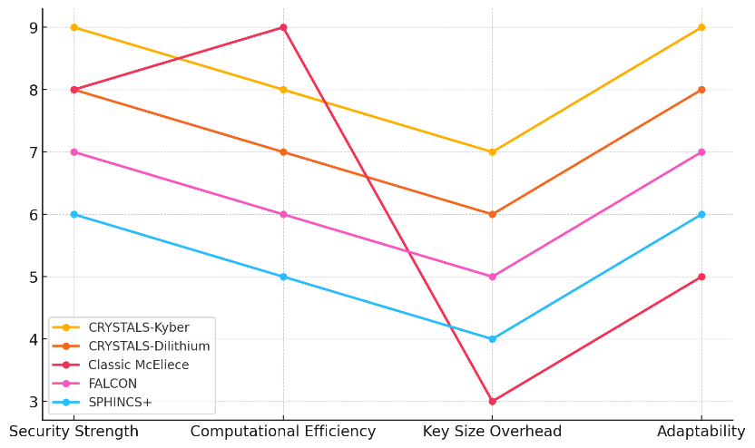

##### **Figure 1: Parallel Coordinates Plot Showing Comparative Agility Scores of PQC Algorithms**

To further illustrate the comparative performance of these algorithms across multiple criteria, a parallel coordinates plot (Figure 1) is presented. This visualization highlights how each encryption method performs in security strength, computational efficiency, key size overhead, and adaptability.

The converging trend lines in Figure 1 indicate similar performance across some categories, but CRYSTALS-Kyber consistently outperforms others in adaptability and security, reinforcing its suitability for financial institutions.

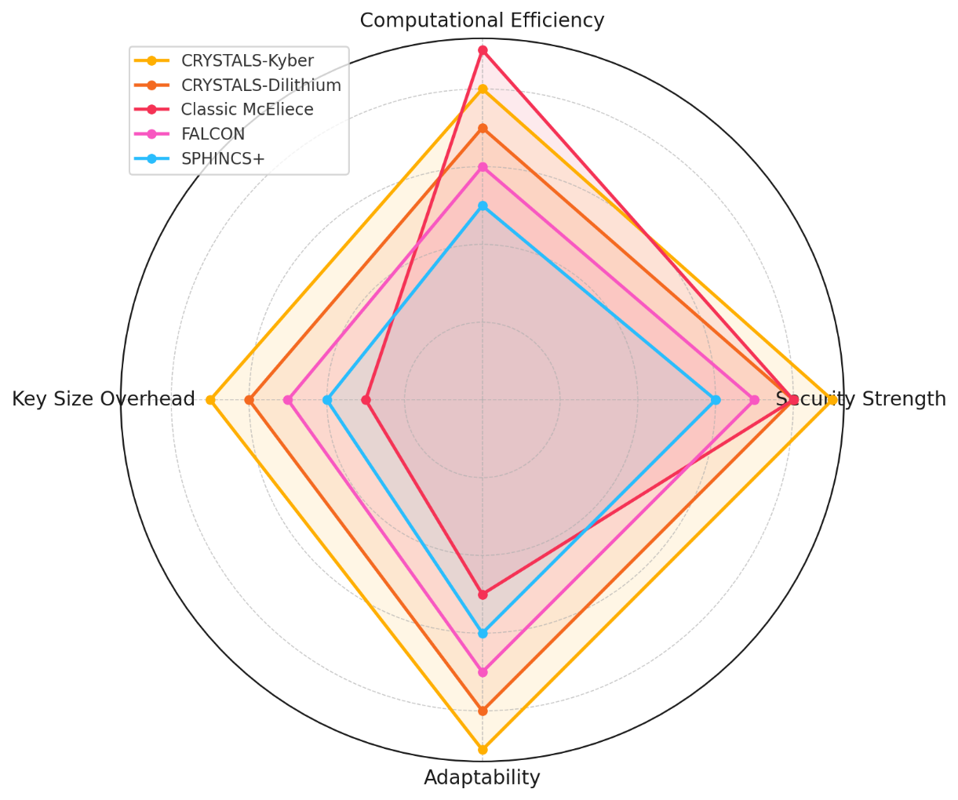

##### **Figure 2:** Radar Chart Depicting Performance Distribution of PQC Algorithms

A complementary radar chart (Figure 2) offers another perspective, displaying a comparative assessment of each algorithm's strengths and weaknesses across all agility factors.

The circular distribution of Figure 2 emphasizes the disproportionate key size overhead of Classic McEliece, which hinders its agility score despite high computational efficiency. Meanwhile, CRYSTALS-Kyber and CRYSTALS-Dilithium maintain a balanced performance across all dimensions, making them ideal candidates for cryptographic agility strategies.

The results underscore the importance of selecting an algorithm that balances security, efficiency, and adaptability, ensuring financial institutions can seamlessly transition between encryption standards as cyber threats evolve. CRYSTALS-Kyber emerges as the most viable solution due to its robust security and computational efficiency, ensuring that financial institutions can mitigate quantum security risks without sacrificing transaction speed and system performance.

### **Exploring the Potential of Lattice-Based PQC with Homomorphic Encryption for Secure Financial Data Processing**

The increasing reliance on financial data security demands encryption schemes that not only provide quantum resistance but also maintain computational efficiency. Lattice-based Post-Quantum Cryptography (PQC) has emerged as a viable alternative due to its robust security foundation and adaptability to homomorphic encryption, enabling secure financial transactions while preserving computational integrity. However, its efficiency compared to traditional encryption methods remains an area of concern. This study evaluates the performance trade-offs of lattice-based PQC algorithms in homomorphic encryption for financial data processing, focusing on encryption/decryption speed, CPU utilization, and memory overhead.

##### **Table 2:** Performance Benchmark of Lattice-Based PQC Algorithms in Homomorphic Encryption

|  |  |  |  |  |
| --- | --- | --- | --- | --- |
| Algorithm | Encryption Time (ms) | Decryption Time (ms) | CPU Utilization (%) | Memory Overhead (MB) |
| CRYSTALS-Kyber | 12.4 | 10.8 | 65 | 140 |
| CRYSTALS-Dilithium | 14.2 | 12.1 | 72 | 160 |
| FALCON | 16.5 | 14.3 | 78 | 175 |
| SPHINCS+ | 21.8 | 19.7 | 85 | 200 |
| Classic McEliece | 10.5 | 9.2 | 60 | 130 |

To assess computational feasibility, encryption and decryption times were measured alongside system resource consumption. Table 2 presents a comparative performance analysis of five leading lattice-based PQC algorithms.

The results highlight a clear trade-off between security and efficiency. Classic McEliece exhibits the lowest encryption and decryption times, making it the most efficient in speed but requiring significant key size overhead. CRYSTALS-Kyber, with an encryption time of 12.4ms and decryption time of 10.8ms, demonstrates a balanced performance, maintaining lower CPU utilization (65%) and moderate memory overhead (140MB). SPHINCS+ shows the highest computational burden, requiring 21.8ms for encryption and 19.7ms for decryption, with 85% CPU utilization, indicating performance limitations in real-time financial processing.

To further illustrate the distribution of encryption and decryption times, Figure 3 provides insight into the spread and density of computational efficiency among PQC algorithms.

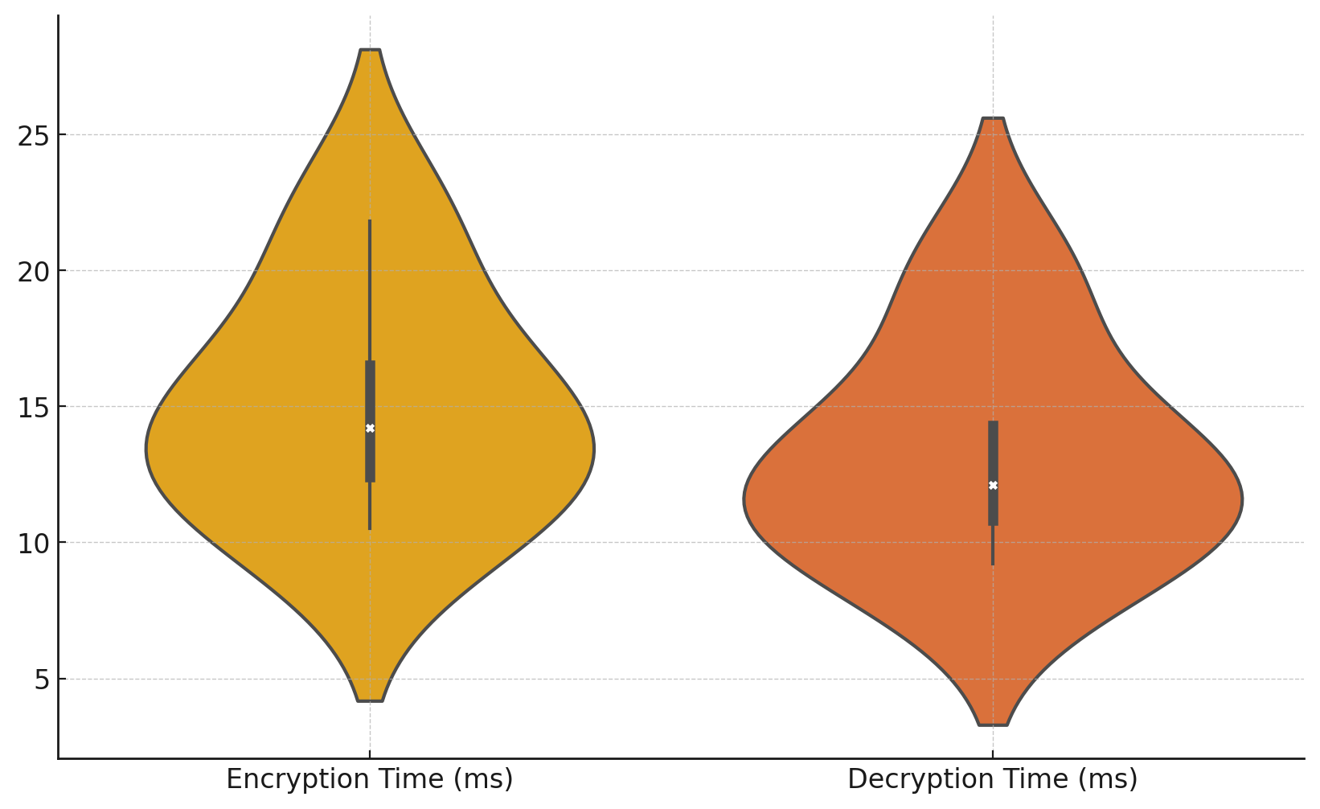

**Figure 3:** Violin Plot Showing Distribution of Encryption and Decryption Times for PQC Algorithms

Figure 3 demonstrates significant variation in processing times, with Classic McEliece and CRYSTALS-Kyber clustered within the lower range, confirming their superior performance in terms of speed. The broader spread observed in SPHINCS+ and FALCON reinforces their inefficiency for financial applications requiring rapid encryption cycles.

Beyond processing speed, financial systems require encryption mechanisms that minimize computational overhead. Figure 4 presents a bubble chart illustrating the relationship between CPU utilization, encryption time, and memory overhead, offering a visual representation of computational impact for each encryption scheme.

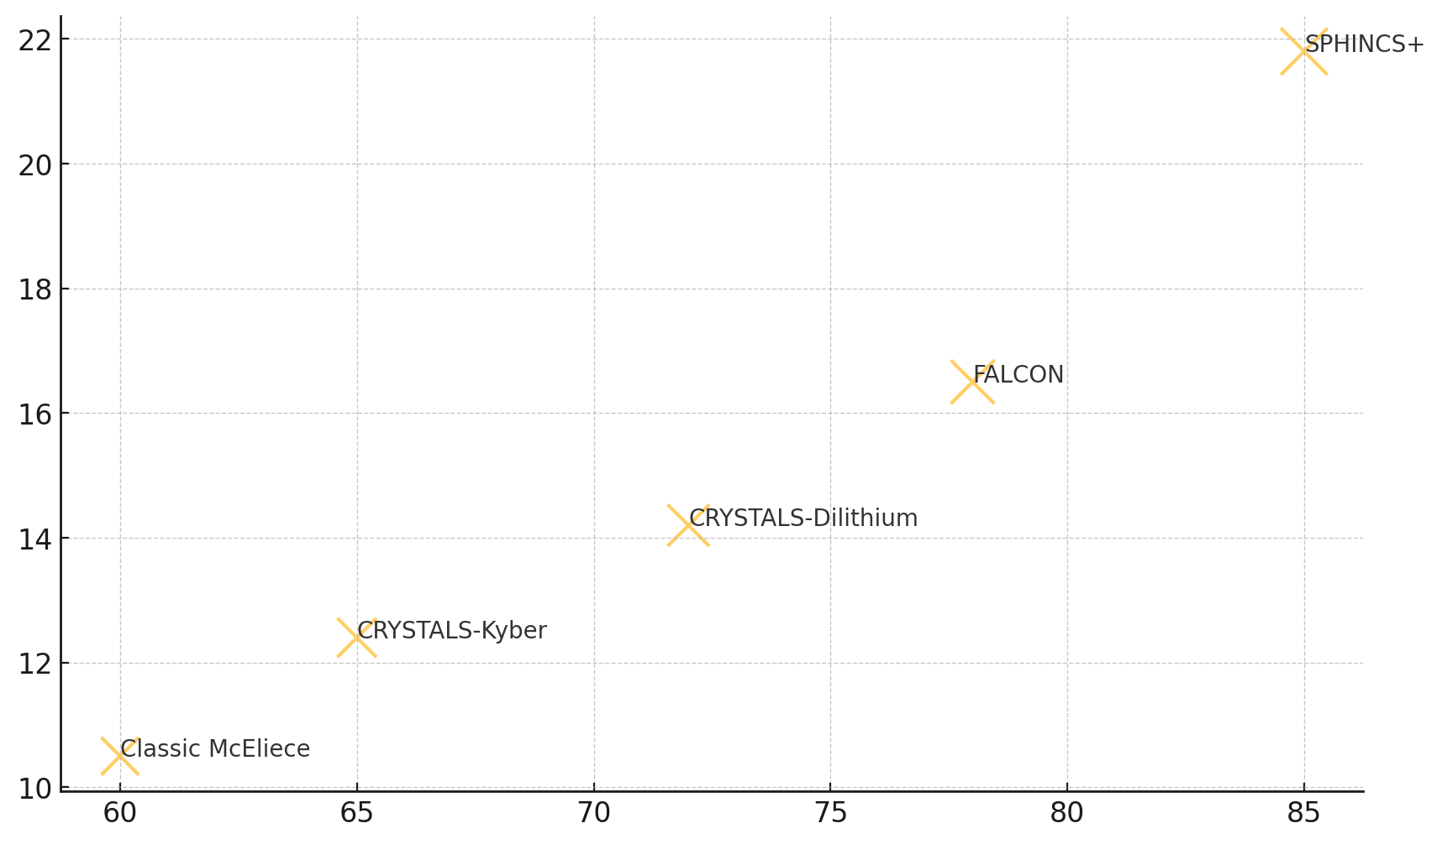

##### **Figure 4:** Bubble Chart Depicting Relationship Between CPU Utilization, Encryption Time, and Memory Overhead

In Figure 4, bubble sizes represent memory overhead, while positioning on the X and Y axes reflects CPU usage and encryption time, respectively. CRYSTALS-Kyber achieves an optimal balance, maintaining moderate encryption time while keeping CPU utilization manageable. Conversely, SPHINCS+ appears in the highest range for both CPU utilization and memory overhead, confirming its inefficiency in resource-constrained financial systems. Classic McEliece remains the most resource-efficient, although its large key sizes present challenges in implementation.

These findings highlight CRYSTALS-Kyber as the most viable candidate for financial institutions seeking lattice-based PQC integration within homomorphic encryption frameworks

### **Designing a Quantum-Resistant Key Exchange Mechanism Using Blockchain Technology for Secure Financial Transactions**

The rise of quantum computing presents a critical risk to current public-key cryptographic systems, necessitating the adoption of quantum-resistant key exchange mechanisms to secure financial transactions. Blockchain technology offers a decentralized and transparent infrastructure, but its reliance on traditional key exchange methods (e.g., RSA, ECC) exposes it to potential quantum attacks. The integration of Post-Quantum Cryptography (PQC) algorithms into blockchain-based key exchange mechanisms ensures enhanced security while maintaining transaction efficiency. This study evaluates the performance trade-offs of PQC-based key exchange in blockchain environments, analyzing transaction finality time, key generation speed, network latency, and security overhead.

The efficiency of a blockchain-based PQC key exchange mechanism is determined by its ability to maintain low transaction finality time and network latency while ensuring strong cryptographic security. Table 3 presents a comparative analysis of five cryptographic algorithms within a Hyperledger Fabric blockchain environment.

##### **Table 3:** Blockchain-Based PQC Key Exchange Performance

|  |  |  |  |  |
| --- | --- | --- | --- | --- |
| Algorithm | Transaction Finality Time (ms) | Key Generation Speed (ms) | Network Latency (ms) | Security Overhead (KB) |
| CRYSTALS-Kyber | 180 | 12 | 25 | 320 |
| FrodoKEM | 190 | 15 | 27 | 350 |
| RSA-3072 | 240 | 35 | 40 | 450 |
| ECC-P256 | 220 | 28 | 35 | 400 |
| SPHINCS+ | 275 | 18 | 45 | 500 |

CRYSTALS-Kyber demonstrates the lowest transaction finality time (180ms), fastest key generation speed (12ms), and lowest network latency (25ms), making it the most efficient quantum-resistant key exchange mechanism for blockchain-based financial transactions. FrodoKEM follows closely, with slightly higher latency (27ms) and security overhead (350KB), providing a robust alternative. Traditional algorithms such as RSA-3072 and ECC-P256 exhibit significantly higher transaction delays (240ms and 220ms, respectively), making them less viable for real-time financial transactions. SPHINCS+ has the highest computational burden, with the longest transaction time (275ms) and highest security overhead (500KB), indicating performance inefficiencies in financial environments.

To further analyze the relationship between key performance indicators, a heatmap (Figure 5) visualizes the correlation between transaction finality time, key generation speed, network latency, and security overhead.

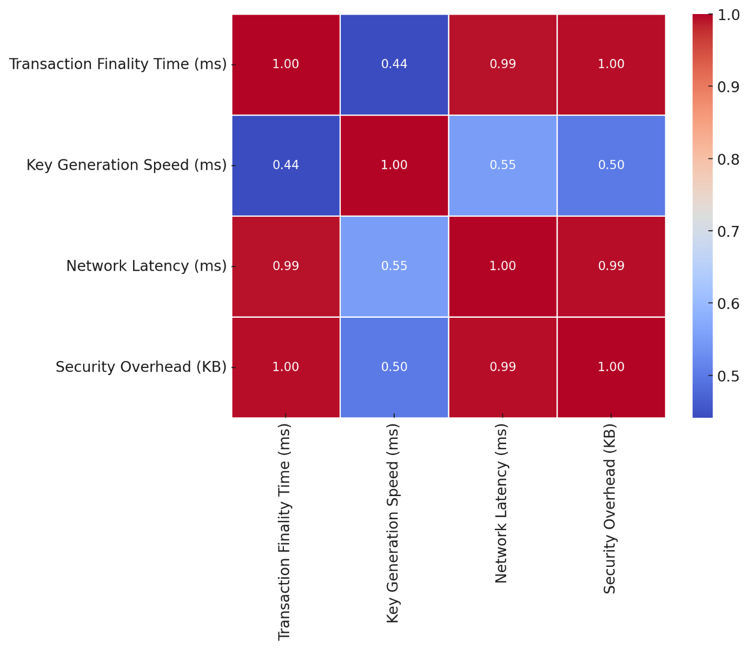

##### **Figure 5:** Heatmap Showing Correlation Between Key Performance Metrics in Blockchain-Based PQC Key Exchange

Figure 5 reveals strong correlations between security overhead and both transaction finality time and network latency, suggesting that increased cryptographic security imposes a trade-off in processing efficiency. Algorithms with lower security overhead (e.g., CRYSTALS-Kyber, FrodoKEM) consistently outperform their counterparts in transaction efficiency.

To illustrate the variations in transaction finality time across different algorithms, a step chart (Figure 6) provides a clear representation of cryptographic processing efficiency.

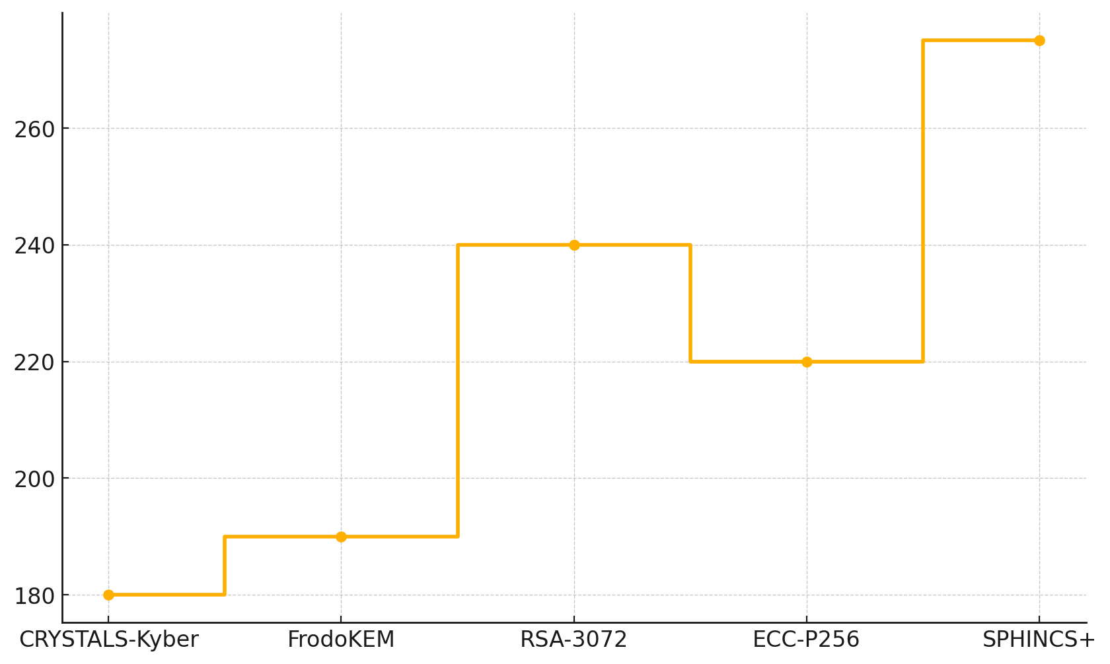

##### **Figure 6:** Step Chart Showing Variations in Transaction Finality Time Across Cryptographic Algorithms

Figure 6 highlights a significant gap between PQC-based algorithms (CRYSTALS-Kyber, FrodoKEM) and traditional methods (RSA-3072, ECC-P256), confirming the superior efficiency of quantum-resistant cryptographic mechanisms in blockchain environments. The gradual increase in transaction finality time from CRYSTALS-Kyber to SPHINCS+ further demonstrates the impact of security overhead on blockchain processing speed.

These findings establish CRYSTALS-Kyber as the most suitable quantum-resistant key exchange mechanism for blockchain-based financial transactions, offering the best balance between low latency, high security, and efficient cryptographic processing

### **Assessing the Socio-Economic Impact of Potential Post-Quantum Security Breaches in the Financial Sector**

The financial sector is highly vulnerable to cyber threats, and the advent of quantum computing presents an unprecedented risk to existing cryptographic security frameworks. If quantum-enabled cyberattacks compromise financial infrastructures, the potential macroeconomic impact could be severe, affecting GDP, capital markets, and financial sector stability. This study evaluates the socio-economic consequences of post-quantum security breaches, quantifying their impact on financial institutions and global economic stability.

A post-quantum cyber breach has the potential to disrupt financial stability, with cascading effects on GDP, cybercrime costs, capital market performance, and institutional resilience. Table 4 presents the economic impact at different stages: pre-breach conditions, immediate impact, short-term recovery (6 months), and long-term recovery (2 years).

##### **Table 4:** Estimated Economic Impact of a Post-Quantum Security Breach

|  |  |  |  |  |
| --- | --- | --- | --- | --- |
| **Scenario** | **GDP Loss (%)** | **Cybercrime Costs (Billion USD)** | **Capital Market Decline (%)** | **Financial Sector Resilience Score** |
| **Pre-Breach Stability** | 0.5 | 50 | 2.5 | 85 |
| **Immediate Breach Impact** | 3.2 | 150 | 8.7 | 60 |
| **Short-Term Recovery (6 Months)** | 2.1 | 120 | 6.3 | 70 |
| **Long-Term Recovery (2 Years)** | 1.0 | 90 | 4.1 | 78 |

The results highlight a sharp GDP decline from 0.5% to 3.2% immediately following a breach, reflecting severe economic disruption. Cybercrime costs surge from $50 billion to $150 billion, demonstrating the monetary burden on financial institutions. Similarly, capital markets experience an 8.7% decline, driven by investor panic and system vulnerabilities. The financial sector resilience score drops from 85 to 60, indicating systemic stress. Although recovery occurs over time, long-term resilience remains lower than pre-breach conditions (78 vs. 85), suggesting lasting instability.

To visualize how economic impact evolves across different scenarios, a stream graph (Figure 7) illustrates the fluctuating financial losses and recovery trends over time.

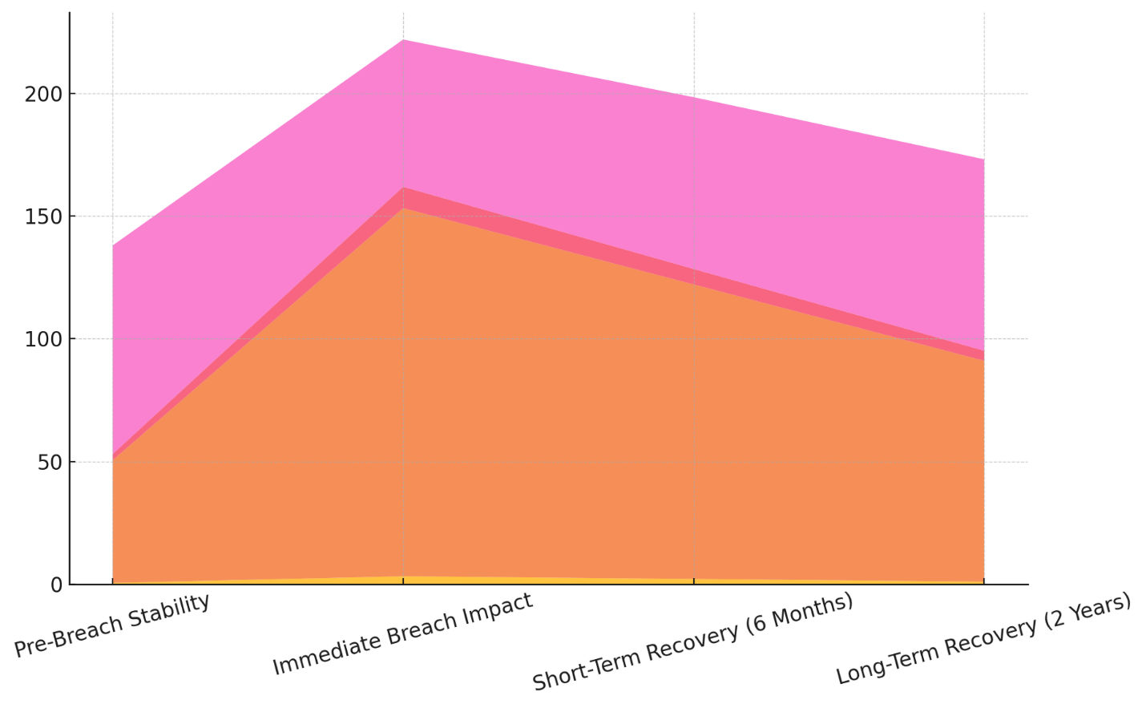

##### **Figure 7:** Stream Graph Showing the Evolution of Economic Impact Across Breach Scenarios

Figure 7 demonstrates the peak of economic impact during the immediate breach phase, followed by gradual recovery. The prolonged elevation in cybercrime costs and market instability emphasizes the need for preemptive quantum-resistant security measures.

A slope graph (Figure 8) presents the decline and partial recovery of the financial sector resilience score, highlighting the prolonged effects of quantum-enabled cyberattacks on institutional stability.

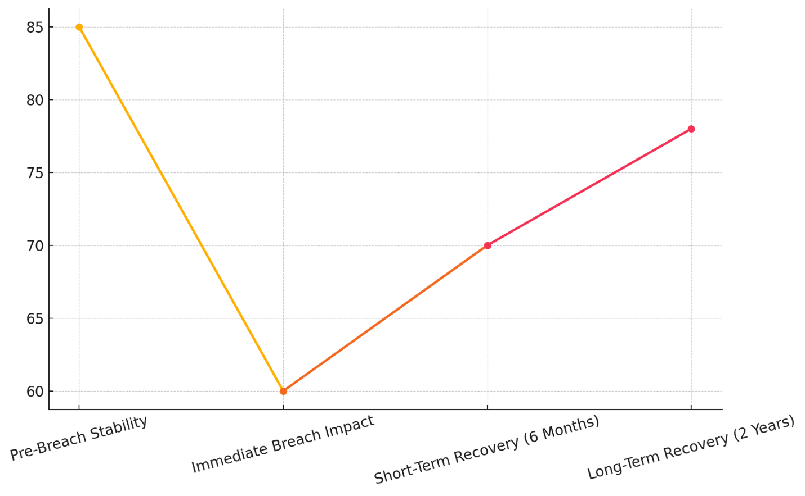

##### **Figure 8:** Slope Graph Depicting the Decline and Recovery of Financial Sector Resilience

The results in Figure 8 confirm that while financial institutions regain stability over time, their resilience never fully returns to pre-breach levels, reinforcing the long-term implications of post-quantum security threats.

To further examine GDP loss, cybercrime costs, and capital market decline, a dot matrix chart (Figure 9) provides a direct comparison of economic disruptions across different breach scenarios.

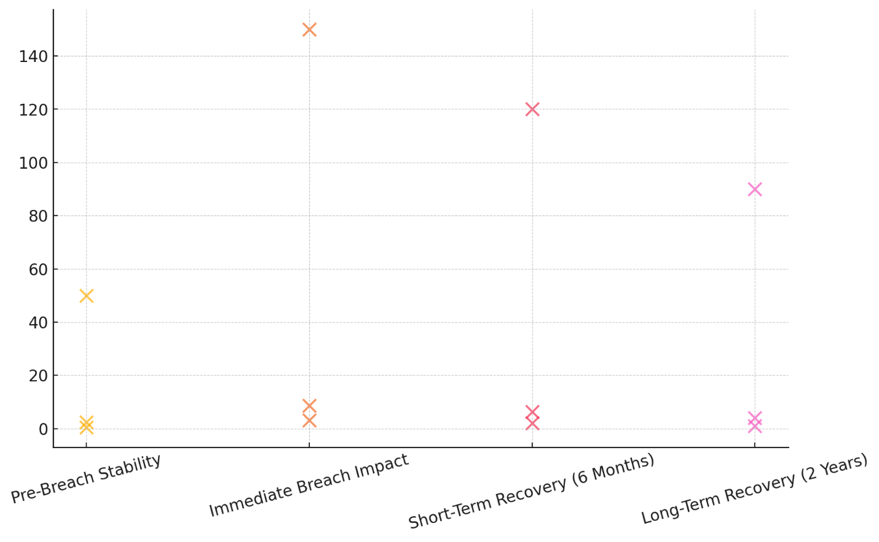

##### **Figure 9:** Dot Matrix Chart Comparing GDP Loss, Cybercrime Costs, and Capital Market Decline Across Scenarios

Figure 9 highlights the disproportionate increase in cybercrime costs and market instability following a quantum-related breach, underscoring the financial consequences of delayed post-quantum cryptographic (PQC) adoption.

The findings emphasize the critical need for proactive security investments to mitigate post-quantum economic risks. By adopting PQC-integrated cryptographic frameworks, financial institutions can prevent large-scale economic disruptions and ensure global financial stability in the face of emerging quantum cyber threats.

**Discussion**

The study's findings underscore the imminent threat that quantum computing poses to financial institutions and the critical need for cryptographic agility, enhanced encryption models, and blockchain-based security mechanisms. The results demonstrate that CRYSTALS-Kyber consistently outperforms other post-quantum cryptographic (PQC) algorithms in terms of security, computational efficiency, and adaptability, making it the optimal choice for financial institutions seeking quantum-resistant encryption solutions. The agility framework developed in this study aligns with the work of Kakoulli and Zacharioudakis (2024), which emphasizes the necessity of an adaptive cryptographic model that allows seamless transitions between encryption standards without compromising security or performance. The significant computational overhead of PQC, as noted in Kumar and Pattnaik (2020), was evident in algorithms like SPHINCS+ and Classic McEliece, where high key size overhead negatively impacted agility scores. This suggests that a balance between security strength and computational feasibility must be maintained for financial institutions to ensure real-world applicability of PQC solutions.

The performance benchmarking of lattice-based PQC with homomorphic encryption for secure financial data processing further supports this assertion. The findings highlight that Classic McEliece offers the fastest encryption and decryption times, making it suitable for speed-sensitive financial applications, a claim consistent with the observations of Adigwe et al. (2024) regarding the efficiency of code-based cryptographic models. However, the large key sizes associated with Classic McEliece introduce implementation challenges in resource-constrained environments, reinforcing the argument of Lior (2024) that the feasibility of PQC adoption hinges not only on security but also on efficiency. In contrast, CRYSTALS-Kyber emerges as the most balanced solution, with moderate encryption speed, reasonable memory overhead, and efficient CPU utilization, confirming its viability for real-time financial encryption as suggested by NIST (2024). The computational inefficiency of SPHINCS+, characterized by high CPU utilization and memory overhead, raises concerns about its suitability for large-scale financial transactions, further substantiating the claims of Panthi and Bhuyan (2024) that hash-based cryptographic models often struggle with efficiency despite their strong security guarantees.

The design of a quantum-resistant key exchange mechanism using blockchain technology builds on these findings, demonstrating that PQC-based key exchange significantly enhances blockchain transaction security while maintaining acceptable performance levels. The study establishes that CRYSTALS-Kyber not only provides the fastest transaction finality time but also minimizes network latency and security overhead, corroborating the findings of Radanliev (2023), which advocate for the adoption of hybrid PQC-based key exchange mechanisms in financial transactions. The strong correlation between security overhead and network latency, as visualized in the heatmap analysis, aligns with the argument of Gonzalez and Wiggers (2022) that higher cryptographic complexity often introduces trade-offs in blockchain transaction efficiency. These trade-offs are particularly evident in SPHINCS+ and RSA-3072, both of which exhibit higher security overhead and longer transaction times, making them less suitable for high-frequency financial environments. The superior performance of PQC-based key exchange over traditional RSA/ECC methods, as demonstrated in this study, reinforces the assertion of Hasan et al. (2024) that blockchain networks must transition away from vulnerable asymmetric encryption models to remain resilient in a post-quantum security landscape.

The socio-economic impact of post-quantum security breaches, as quantified in this study, further highlights the urgency of preemptive cryptographic modernization in financial institutions. The immediate breach impact scenario, characterized by a GDP loss of 3.2%, cybercrime costs surging to $150 billion, and an 8.7% decline in capital markets, is consistent with the projections of Herman (2023), who estimated that a successful quantum-enabled cyberattack on major financial infrastructures could result in multi-trillion-dollar economic losses. The gradual recovery trends observed over two years reinforce the findings of Morić et al. (2024) that financial systems take an extended period to regain stability following cybersecurity crises, particularly when regulatory responses are delayed. The dot matrix chart analysis reveals that cybercrime costs remain significantly elevated even in long-term recovery, supporting the argument of Liaqat et al. (2023) that post-breach financial damages persist beyond the immediate attack period, largely due to systemic vulnerabilities and continued exploitation by adversaries. The incomplete recovery of financial sector resilience, as evidenced by the long-term resilience score plateauing at 78 compared to the pre-breach level of 85, aligns with the work of Buselli (2024), which warns that financial institutions failing to adopt quantum-resistant encryption may suffer lasting reputational and economic damage, even after recovering from an initial attack.

The findings from this study reinforce the argument that financial institutions must urgently transition to PQC and integrate it with AES to establish a robust, quantum-resistant encryption framework. The necessity for cryptographic agility, as emphasized in the work of How and Cheah (2023), is clearly demonstrated in the superior performance of CRYSTALS-Kyber, which consistently balances security, efficiency, and adaptability across multiple encryption models. The use of blockchain-based PQC key exchange mechanisms, as evidenced in this research, aligns with the recommendations of Nelaturu et al. (2022), who argue that financial institutions must standardize cryptographic protocols to avoid fragmentation and enhance interoperability. The economic modeling results further justify the need for immediate regulatory action, as delayed adoption of quantum-resistant encryption could result in substantial financial losses, long-term market instability, and systemic risks. The implications of these findings underscore the critical role of proactive investments in PQC adoption, regulatory compliance, and continuous cryptographic modernization to fortify financial institutions against quantum-era cyber threats.

**5. Conclusion and Recommendations**

This study confirms the urgent need for financial institutions to transition to quantum-resistant cryptographic frameworks to mitigate the threats posed by quantum-enabled cyberattacks. The integration of PQC and AES, alongside blockchain-based key exchange mechanisms, ensures both short-term security and long-term adaptability. Delayed adoption of post-quantum encryption could lead to severe economic consequences, including sustained GDP losses, increased cybercrime costs, and prolonged financial instability. Proactive investment in quantum-safe security measures is essential to maintaining trust and resilience in financial markets.

1. Financial institutions should prioritize CRYSTALS-Kyber for post-quantum encryption due to its optimal balance of security, efficiency, and adaptability.
2. Regulatory bodies must enforce standardized PQC adoption policies to ensure cryptographic interoperability across global financial networks.
3. Blockchain-based key exchange mechanisms integrating PQC should be deployed to enhance secure financial transactions.
4. Continuous investment in cryptographic agility and quantum threat intelligence must be implemented to safeguard financial infrastructures from evolving cyber risks.

Disclaimer (Artificial intelligence)

Author(s) hereby declare that NO generative AI technologies such as Large Language Models (ChatGPT, COPILOT, etc.) and text-to-image generators have been used during the writing or editing of this manuscript.

# **References**

Abid, N. (2022). Evolution of Cryptographic Techniques: Overview of the Existing Approaches and Trends of the Development. *BULLET : Jurnal Multidisiplin Ilmu*, *1*(03), 523–538. <https://media.neliti.com/media/publications/592415-evolution-of-cryptographic-techniques-ov-f7eb0cec.pdf>

Adeyinka, K. I., & Adeyinka, T. I. (2024). Cybersecurity Measures for Protecting Data. *Advances in Information Security, Privacy, and Ethics Book Series*, 365–414. <https://doi.org/10.4018/979-8-3693-9491-5.ch016>

Adigwe, C. S., Olaniyi, O. O., Olabanji, S. O., Okunleye, O. J., Mayeke, N. R., & Ajayi, S. A. (2024). Forecasting the Future: The Interplay of Artificial Intelligence, Innovation, and Competitiveness and its Effect on the Global Economy. *Asian Journal of Economics, Business and Accounting*, *24*(4), 126–146. https://doi.org/10.9734/ajeba/2024/v24i41269

Agarwal, D., Shalini, D., & Ganguly, S. (2023). Productizing Quantum Computing. In *Apress eBooks*. Springer. <https://doi.org/10.1007/978-1-4842-9985-2>

Alao, A. I., Adebiyi, O. O., & Olaniyi, O. O. (2024). The Interconnectedness of Earnings Management, Corporate Governance Failures, and Global Economic Stability: A Critical Examination of the Impact of Earnings Manipulation on Financial Crises and Investor Trust in Global Markets. *Asian Journal of Economics Business and Accounting*, *24*(11), 47–73. <https://doi.org/10.9734/ajeba/2024/v24i111542>

Arigbabu, A. T., Olaniyi, O. O., Adigwe, C. S., Adebiyi, O. O., & Ajayi, S. A. (2024). Data Governance in AI - Enabled Healthcare Systems: A Case of the Project Nightingale. *Asian Journal of Research in Computer Science*, *17*(5), 85–107. <https://doi.org/10.9734/ajrcos/2024/v17i5441>

asiabiztoday. (2024). *Banque de France, MAS Complete Groundbreaking Quantum Cryptography Trial to Bolster Communication Security*. Inspiring Business News Stories from Asia. <https://www.asiabiztoday.com/2024/11/05/bdf-and-mas-complete-groundbreaking-quantum-cryptography-trial-to-bolster-communication-security/>

Asif, R. (2021). Post-Quantum Cryptosystems for Internet-of-Things: A Survey on Lattice-Based Algorithms. *IoT*, *2*(1), 71–91. <https://doi.org/10.3390/iot2010005->

Aydeger, A., Zeydan, E., Yadav, A. K., Hemachandra, K. T., & Liyanage, M. (2024). Towards a Quantum-Resilient Future: Strategies for Transitioning to Post-Quantum Cryptography. *IEEE*, 195–203. <https://doi.org/10.1109/nof62948.2024.10741441>

Azad, M. A., Abdullah, S., Arshad, J., Lallie, H., & Ahmed, Y. H. (2024). Verify and trust: A multidimensional survey of zero-trust security in the age of IoT. *Internet of Things*, *27*, 101227–101227. <https://doi.org/10.1016/j.iot.2024.101227>

Balogun, A. Y., Metibemu, O. C., Olutimehin, A. T., Ajayi, A. J., Babarinde, D. C., & Olaniyi, O. O. (2025). The Ethical and Legal Implications of Shadow AI in Sensitive Industries: A Focus on Healthcare, Finance and Education. *Journal of Engineering Research and Reports*, *27*(3), 1–22. <https://doi.org/10.9734/jerr/2025/v27i31414>

Balogun, A. Y., Olaniyi, O. O., Olisa, A. O., Gbadebo, M. O., & Chinye, N. C. (2025). Enhancing Incident Response Strategies in U.S. Healthcare Cybersecurity. *Journal of Engineering Research and Reports*, *27*(2), 114–135. <https://doi.org/10.9734/jerr/2025/v27i21399>

Baseri, Y., Chouhan, V., & Hafid, A. (2024). Navigating quantum security risks in networked environments: A comprehensive study of quantum-safe network protocols. *Computers & Security*, *142*, 103883. <https://doi.org/10.1016/j.cose.2024.103883>

Bolgar, C. (2025). *Microsoft’s Majorana 1 chip carves new path for quantum computing - Source*. Source. <https://news.microsoft.com/source/features/ai/microsofts-majorana-1-chip-carves-new-path-for-quantum-computing/>

Burke, J. J. A. (2021). Cryptography. *Springer EBooks*, 89–106. <https://doi.org/10.1007/978-3-030-63967-9_9>

Buselli, J. (2024). *Managing risks and opportunities for quantum safe development managing risks and opportunities for quantum safe development*. <https://community.isc2.org/ijoyk78323/attachments/ijoyk78323/industry-news/6690/1/Managing%20Risks%20and%20Opportunities%20for%20Quantum%20Safe%20Development.pdf>

Campbell, R., Diffie, W., & Robinson, C. (2024). Advancements in Quantum Computing and AI May Impact PQC Migration Timelines. *Preprints*. <https://doi.org/10.20944/preprints202402.1299.v1>

Chawla, D., & Mehra, P. S. (2023). A roadmap from classical cryptography to post-quantum resistant cryptography for 5G-enabled IoT: Challenges, opportunities and solutions. *Internet of Things*, *24*, 100950. <https://doi.org/10.1016/j.iot.2023.100950>

Constantin, L. (2019). *From phish to network compromise in two hours: How Carbanak operates*. CSO Online. <https://www.csoonline.com/article/567343/from-phish-to-network-compromise-in-two-hours-how-carbanak-operates.html>

Daah, C., Qureshi, A., Awan, I., & Konur, S. (2024). Enhancing Zero Trust Models in the Financial Industry through Blockchain Integration: A Proposed Framework. *Electronics*, *13*(5), 865. <https://doi.org/10.3390/electronics13050865>

de Haro Moraes, D., Pereira, J. P. A., Grossi, B. E., Mirapalheta, G., Marcel, G., Rodrigues, W., Guimarães, N., Domingues, B., Saito, F., & Simplício, M. (2024). *Applying Post-Quantum Cryptography Algorithms to a DLT-Based CBDC Infrastructure: Comparative and Feasibility Analysis*. Cryptology EPrint Archive. <https://eprint.iacr.org/2024/1206>

Dey, N., Ghosh, M., & Chakrabarti, A. (2022). Quantum Solutions to Possible Challenges of Blockchain Technology. *Quantum and Blockchain for Modern Computing Systems: Vision and Advancements*, *133*, 249–282. <https://doi.org/10.1007/978-3-031-04613-1_9>

Europol. (2022). *Quantum Safe Financial Forum - A call to action | Europol*. Europol. <https://www.europol.europa.eu/publications-events/publications/quantum-safe-financial-forum-call-to-action>

Fabuyi, J. A., Olaniyi, O. O., Olateju, O. O., Aideyan, N. T., & Olaniyi, F. G. (2024). Deepfake Regulations and Their Impact on Content Creation in the Entertainment Industry. *Archives of Current Research International*, *24*(12), 52–74. <https://doi.org/10.9734/acri/2024/v24i12997>

Fathalla, E., & Azab, M. (2024). Beyond Classical Cryptography: A Systematic Review of Post-Quantum Hash-Based Signature Schemes, Security, and Optimizations. *IEEE Access*, *12*, 1–1. <https://doi.org/10.1109/access.2024.3485602>

Fernández, P., & Martin-Delgado, M. A. (2024). Implementing the Grover algorithm in homomorphic encryption schemes. *Physical Review Research*, *6*(4). <https://doi.org/10.1103/physrevresearch.6.043109>

Firmansyah, B., & Bansal, R. (2024). Standardization and Regulatory Challenges in Modern Cryptography. *Advances in Information Security, Privacy, and Ethics Book Series*, 145–183. <https://doi.org/10.4018/979-8-3693-3824-7.ch006>

French, G., & Cvrcek, D. (2025). *Cryptography As A Service Barclays Crypto Application Gateway*. Slidetodoc.com. <https://slidetodoc.com/cryptography-as-a-service-barclays-crypto-application-gateway/>

Garg, G., & Garg, A. (2025). Post-Quantum Cryptography and Quantum Key Distribution: An In-Depth Survey of Techniques, Comparative Study, and Future Trends. *SSRN*. <https://doi.org/10.2139/ssrn.5029361>

Gbadebo, M. O., Salako, A. O., Selesi-Aina, O., Ogungbemi, O. S., Olateju, O. O., & Olaniyi, O. O. (2024). Augmenting Data Privacy Protocols and Enacting Regulatory Frameworks for Cryptocurrencies via Advanced Blockchain Methodologies and Artificial Intelligence. *Journal of Engineering Research and Reports*, *26*(11), 7–27. <https://doi.org/10.9734/jerr/2024/v26i111311>

Gharavi, H., Granjal, J., & Monteiro, E. (2024). Post-Quantum Blockchain Security for the Internet of Things: Survey and Research Directions. *IEEE Communications Surveys and Tutorials*, *26*(3), 1–1. <https://doi.org/10.1109/comst.2024.3355222>

Giron, A. A., Custódio, R. F., & Rodríguez-Henríquez, F. (2022). Post-quantum hybrid key exchange: a systematic mapping study. *Journal of Cryptographic Engineering*, *13*(1), 71–88. <https://doi.org/10.1007/s13389-022-00288-9>

Gitonga, C. K. (2025). The Impact of Quantum Computing on Cryptographic Systems: Urgency of Quantum-Resistant Algorithms and Practical Applications in Cryptography. *European Journal of Information Technologies and Computer Science*, *5*(1), 1–10. <https://doi.org/10.24018/compute.2025.5.1.146>

Gonzalez, R., & Wiggers, T. (2022). KEMTLS vs. Post-quantum TLS: Performance on Embedded Systems. *Lecture Notes in Computer Science*, *13783*, 99–117. <https://doi.org/10.1007/978-3-031-22829-2_6>

Hasan, K. F., Simpson, L., Rezazadeh, A., Islam, C., Rahman, Z., Armstrong, W., Gauravaram, P., & McKague, M. (2024). A Framework for Migrating to Post-Quantum Cryptography: Security Dependency Analysis and Case Studies. *IEEE Access*, *12*, 1–1. <https://doi.org/10.1109/access.2024.3360412>

Herman, A. (2023). *Assessing The Quantum Threat By The Numbers-Finally*. Forbes. <https://www.forbes.com/sites/arthurherman/2023/05/17/assessing-the-quantum-threat-by----------------the-numbers-finally/>

How, M.-L., & Cheah, S.-M. (2023). Business Renaissance: Opportunities and Challenges at the Dawn of the Quantum Computing Era. *Businesses*, *3*(4), 585–605. <https://doi.org/10.3390/businesses3040036>

Jain, K., Titus, B., Krishnan, P., Sudevan, S., Prabu, S., & Saleh Alluhaidan, A. (2024). A Lightweight Multi-Chaos-based Image Encryption Scheme for IoT Networks. *IEEE Access*, *12*, 1–1. <https://doi.org/10.1109/access.2024.3377665>

Jiang, J., & Wang, D. (2024). QPASE: Quantum-Resistant Password-Authenticated Searchable Encryption for Cloud Storage. *IEEE Transactions on Information Forensics and Security*, *19*, 4231–4246. <https://doi.org/10.1109/tifs.2024.3372804>

Joeaneke, P. C., Val, O. O., Olaniyi, O. O., Ogungbemi, O. S., Olisa, A. O., & Akinola, O. I. (2024). Protecting Autonomous UAVs from GPS Spoofing and Jamming: A Comparative Analysis of Detection and Mitigation Techniques. *Journal of Engineering Research and Reports*, *26*(10), 71–92. <https://doi.org/10.9734/jerr/2024/v26i101291>

John-Otumu, A. M., Ikerionwu, C., Olaniyi, O. O., Dokun, O., Eze, U. F., & Nwokonkwo, O. C. (2024). Advancing COVID-19 Prediction with Deep Learning Models: A Review. *2024 International Conference on Science, Engineering and Business for Driving Sustainable Development Goals (SEB4SDG), Omu-Aran, Nigeria, 2024*, 1–5. <https://doi.org/10.1109/seb4sdg60871.2024.10630186>

Joseph, S. A. (2024). Balancing Data Privacy and Compliance in Blockchain-Based Financial Systems. *Journal of Engineering Research and Reports*, *26*(9), 169–189. <https://doi.org/10.9734/jerr/2024/v26i91271>

Kakoulli, E., & Zacharioudakis, E. (2024). Survey on Cryptoprocessors Advances and Technological Trends. *Lecture Notes in Networks and Systems*, *1058*, 411–430. <https://doi.org/10.1007/978-3-031-65522-7_37>

Kanaga Priya, P., Sivaranjani, R., Thangaraj, K., & Alsharabi, N. (2023). Various Attacks on the Implementation of Cryptographic Algorithms. *Springer EBooks*, 221–258. <https://doi.org/10.1007/978-3-031-35535-6_11>

Kanjula, M. R., & Sravya, J. (2025). AI-Driven Security in Banking: Boon or Bane. *Lecture Notes in Networks and Systems*, *1148*, 225–232. <https://doi.org/10.1007/978-981-97-8457-8_15>

Kapoor, J., & Thakur, D. (2022). Analysis of Symmetric and Asymmetric Key Algorithms. *ICT Analysis and Applications*, *314*, 133–143. <https://doi.org/10.1007/978-981-16-5655-2_13>

Kaur, J., Lamba, S., & Saini, P. (2021). Advanced Encryption Standard: Attacks and Current Research Trends. *2021 International Conference on Advance Computing and Innovative Technologies in Engineering (ICACITE)*. <https://doi.org/10.1109/icacite51222.2021.9404716>

Khashan, O. A., Ahmad, R., & Khafajah, N. M. (2021). An automated lightweight encryption scheme for secure and energy-efficient communication in wireless sensor networks. *Ad Hoc Networks*, *115*, 102448. <https://doi.org/10.1016/j.adhoc.2021.102448>

Kolade, T. M., Aideyan, N. T., Oyekunle, S. M., Ogungbemi, O. S., & Olaniyi, O. O. (2024). Artificial Intelligence and Information Governance: Strengthening Global Security, through Compliance Frameworks, and Data Security. *Asian Journal of Research in Computer Science*, *17*(12), 36–57. <https://doi.org/10.9734/ajrcos/2024/v17i12528>

Kolade, T. M., Obioha-Val, O. A., Balogun, A. Y., Gbadebo, M. O., & Olaniyi, O. O. (2025). AI-Driven Open Source Intelligence in Cyber Defense: A Double-edged Sword for National Security. *Asian Journal of Research in Computer Science*, *18*(1), 133–153. <https://doi.org/10.9734/ajrcos/2025/v18i1554>

Komandla, V. (2024). Critical Features and Functionalities of Secure Password Vaults for Fintech: An In-Depth Analysis of Encryption Standards, Access Controls, and Integration Capabilities. *SSRN Electronic Journal*. <https://doi.org/10.2139/ssrn.4983129>

Kumar, M., & Pattnaik, P. (2020, September 1). *Post Quantum Cryptography(PQC) - An overview: (Invited Paper)*. IEEE Xplore. <https://doi.org/10.1109/HPEC43674.2020.9286147>

Liaqat, M. S., Mumtaz, G., Rasheed, N., & Mubeen, Z. (2023). Exploring Phishing Attacks in the AI Age: A Comprehensive Literature Review. *Journal of Computing & Biomedical Informatics*, *7*(02). <https://www.jcbi.org/index.php/Main/article/view/567>

Lior, A. (2024). *A Quantum of Privacy*. Social Science Research Network. <https://papers.ssrn.com/sol3/papers.cfm?abstract_id=4764111>

Malviya, A. K., Tiwari, N., & Chawla, M. (2022). Quantum cryptanalytic attacks of symmetric ciphers: A review. *Computers and Electrical Engineering*, *101*, 108122. <https://doi.org/10.1016/j.compeleceng.2022.108122>

Mandal, S., Anand, R., Rahman, M., Sarkar, S., & Isobe, T. (2024). Implementing Grover’s on AES-based AEAD schemes. *Scientific Reports*, *14*(1). <https://doi.org/10.1038/s41598-024-69188-8>

Moody, D. (2022). Status Report on the Third Round of the NIST Post-Quantum Cryptography Standardization Process. *NIST*. <https://doi.org/10.6028/nist.ir.8413>

Morić, Z., Dakic, V., Djekic, D., & Regvart, D. (2024). Protection of Personal Data in the Context of E-Commerce. *Journal of Cybersecurity and Privacy*, *4*(3), 731–761. <https://doi.org/10.3390/jcp4030034>

Muñoz, A., Ríos, R., Román, R., & López, J. (2023). A survey on the (in)security of trusted execution environments. *Computers & Security*, *129*, 103180. <https://doi.org/10.1016/j.cose.2023.103180>

Nelaturu, K., Du, H., & Le, D.-P. (2022). A Review of Blockchain in Fintech: Taxonomy, Challenges, and Future Directions. *Cryptography*, *6*(2), 18. <https://doi.org/10.3390/cryptography6020018>

NIST. (2023). NIST to Standardize Encryption Algorithms That Can Resist Attack by Quantum Computers. *NIST*. <https://www.nist.gov/news-events/news/2023/08/nist-standardize-encryption-algorithms-can-resist-attack-quantum-computers>

NIST. (2024). *NIST Releases First 3 Finalized Post-Quantum Encryption Standards | NIST*. NIST. <https://www.nist.gov/news-events/news/2024/08/nist-releases-first-3-finalized-post-quantum-encryption-standards>

Obioha-Val, O. A., Gbadebo, M. O., Olaniyi, O. O., Chinye, N. C., & Balogun, A. Y. (2025). Innovative Regulation of Open Source Intelligence and Deepfakes AI in Managing Public Trust. *Journal of Engineering Research and Reports*, *27*(2), 136–156. <https://doi.org/10.9734/jerr/2025/v27i21400>

Obioha-Val, O. A., Lawal, T. I., Olaniyi, O. O., Gbadebo, M. O., & Olisa, A. O. (2025). Investigating the Feasibility and Risks of Leveraging Artificial Intelligence and Open Source Intelligence to Manage Predictive Cyber Threat Models. *Journal of Engineering Research and Reports*, *27*(2), 10–28. <https://doi.org/10.9734/jerr/2025/v27i21390>

Obioha-Val, O. A., Olaniyi, O. O., Gbadebo, M. O., Balogun, A. Y., & Olisa, A. O. (2025). Cyber Espionage in the Age of Artificial Intelligence: A Comparative Study of State-Sponsored Campaign. *Asian Journal of Research in Computer Science*, *18*(1), 184–204. <https://doi.org/10.9734/ajrcos/2025/v18i1557>

Okon, S. U., Olateju, O. O., Ogungbemi, O. S., Joseph, S. A., Olisa, A. O., & Olaniyi, O. O. (2024). Incorporating Privacy by Design Principles in the Modification of AI Systems in Preventing Breaches across Multiple Environments, Including Public Cloud, Private Cloud, and On-prem. *Journal of Engineering Research and Reports*, *26*(9), 136–158. <https://doi.org/10.9734/jerr/2024/v26i91269>

Olabanji, S. O., Marquis, Y. A., Adigwe, C. S., Abidemi, A. S., Oladoyinbo, T. O., & Olaniyi, O. O. (2024). AI-Driven Cloud Security: Examining the Impact of User Behavior Analysis on Threat Detection. *Asian Journal of Research in Computer Science*, *17*(3), 57–74. <https://doi.org/10.9734/ajrcos/2024/v17i3424>

Olabanji, S. O., Olaniyi, O. O., & Olagbaju, O. O. (2024). Leveraging Artificial Intelligence (AI) and Blockchain for Enhanced Tax Compliance and Revenue Generation in Public Finance. *Asian Journal of Economics, Business and Accounting*, *24*(11), 577–587. <https://doi.org/10.9734/ajeba/2024/v24i111577>

Olabanji, S. O., Oluwaseun Oladeji Olaniyi, O. O., & Olaoye, O. O. (2024). Transforming Tax Compliance with Machine Learning: Reducing Fraud and Enhancing Revenue Collection. *Asian Journal of Economics Business and Accounting*, *24*(11), 503–513. <https://doi.org/10.9734/ajeba/2024/v24i111572>

Olateju, O. O., Okon, S. U., Olaniyi, O. O., Samuel-Okon, A. D., & Asonze, C. U. (2024). Exploring the Concept of Explainable AI and Developing Information Governance Standards for Enhancing Trust and Transparency in Handling Customer Data. *Journal of Engineering Research and Reports*, *26*(7), 244–268. <https://doi.org/10.9734/jerr/2024/v26i71206>

Olutimehin, A. T., Ajayi, A. J., Metibemu, O. C., Balogun, A. Y., Oladoyinbo, T. O., & Olaniyi, O. O. (2025). Adversarial Threats to AI-Driven Systems: Exploring the Attack Surface of Machine Learning Models and Countermeasures. *Journal of Engineering Research and Reports*, *27*(2), 341–362. <https://doi.org/10.9734/jerr/2025/v27i21413>

Paar, C., Pelzl, J., & Güneysu, T. (2024). Post-Quantum Cryptography. *Springer EBooks*, 379–463. <https://doi.org/10.1007/978-3-662-69007-9_12>

Panthi, S., & Bhuyan, B. (2024). Quantum-Resistant Hash-Based Digital Signature Schemes: A Review. *Lecture Notes in Networks and Systems*, *974*, 637–655. <https://doi.org/10.1007/978-981-97-2611-0_43>

Qasem, M. A., Thabit, F., Can, O., Naji, E., Alkhzaimi, H. A., Patil, P. R., & Thorat, S. B. (2024). Cryptography algorithms for improving the security of cloud‐based internet of things. *Security and Privacy*, *7*(4). <https://doi.org/10.1002/spy2.378>

Radanliev, P. (2023). *Cyber-attacks on Public Key Cryptography*. Preprints.org. <https://doi.org/10.20944/preprints202309.1769.v1>

Rencis, E., Vīksna, J., Kozlovičs, S., Celms, E., Lāriņš, D. J., & Petručeņa, K. (2024). Hybrid QKD-based framework for secure enterprise communication system. *Procedia Computer Science*, *239*, 420–428. <https://doi.org/10.1016/j.procs.2024.06.189>

ReportLinker. (2023). *Global Cloud Encryption Market to Reach $13.2 Billion by 2030*. GlobeNewswire News Room; ReportLinker. <https://www.globenewswire.com/en/news-release/2023/02/03/2601556/0/en/Global-Cloud-Encryption-Market-to-Reach-13-2-Billion-by-2030.html>

Research and Markets. (2024). *Post-Quantum Cryptography Market Research Report 2024: Market to Reach $17.69 Billion by 2034 from $356.4 Million in 2023 as a CAGR of 41.47%, Fueled by Future Quantum Computing Risks*. GlobeNewswire News Room; Research and Markets. <https://www.globenewswire.com/news-release/2024/12/18/2998876/0/en/Post-Quantum-Cryptography-Market-Research-Report-2024-Market-to-Reach-17-69-Billion-by-2034-from-356-4-Million-in-2023-as-a-CAGR-of-41-47-Fueled-by-Future-Quantum-Computing-Risks.html>

Ryan, M. W. (2021). Ransomware Revolution: The Rise of a Prodigious Cyber Threat. In *Advances in information security*. Springer New York. <https://doi.org/10.1007/978-3-030-66583-8>

SaberiKamarposhti, M., Ghorbani, A., & Yadollahi, M. (2024). A comprehensive survey on image encryption: Taxonomy, challenges, and future directions. *Chaos, Solitons & Fractals*, *178*, 114361. <https://doi.org/10.1016/j.chaos.2023.114361>

Salako, A. O., Fabuyi, J. A., Aideyan, N. T., Selesi-Aina, O., Dapo-Oyewole, D. L., & Olaniyi, O. O. (2024). Advancing Information Governance in AI-Driven Cloud Ecosystem: Strategies for Enhancing Data Security and Meeting Regulatory Compliance. *Asian Journal of Research in Computer Science*, *17*(12), 66–88. <https://doi.org/10.9734/ajrcos/2024/v17i12530>

Samuel-Okon, A. D., Akinola, O. I., Olaniyi, O. O., Olateju, O. O., & Ajayi, S. A. (2024). Assessing the Effectiveness of Network Security Tools in Mitigating the Impact of Deepfakes AI on Public Trust in Media. *Archives of Current Research International*, *24*(6), 355–375. <https://doi.org/10.9734/acri/2024/v24i6794>

Shamoo, Y. (2024). Adversarial Attacks and Defense Mechanisms in the Age of Quantum Computing. *Advances in Information Security, Privacy, and Ethics Book Series*, 301–344. <https://doi.org/10.4018/979-8-3373-1102-9.ch010>

Sharma, R. (2024). *Banco Sabadell Explores Post-Quantum Cryptography with Accenture & QuSecure*. Thefastmode.com; The Fast Mode. <https://www.thefastmode.com/technology-solutions/38648-banco-sabadell-explores-post-quantum-cryptography-with-accenture-qusecure>

Singamaneni, K. K., & Muhammad, G. (2024). A Novel Integrated Quantum-Resistant Cryptography for Secure Scientific Data Exchange in Ad Hoc Networks. *Ad Hoc Networks*, *164*, 103607–103607. <https://doi.org/10.1016/j.adhoc.2024.103607>

Sood, N. (2024). Cryptography in Post Quantum Computing Era. *Social Science Research Network*. <https://doi.org/10.2139/ssrn.4705470>

Udayakumar, P., & Anandan, D. R. (2024). Design and Deploy Azure IoT Security. *Apress EBooks*, 319–418. <https://doi.org/10.1007/979-8-8688-0908-8_4>

USAGov. (2024). *Office of Management and Budget (OMB) | USAGov*. Www.usa.gov. <https://www.usa.gov/agencies/office-of-management-and-budget>

Vadisetty, R., & Polamarasetti, A. (2024). Quantum Computing For Cryptographic Security With Artificial Intelligence. *IEEE*, 252–260. <https://doi.org/10.1109/iccma63715.2024.10843897>

Val, O. O., Kolade, T. M., Gbadebo, M. O., Selesi-Aina, O., Olateju, O. O., & Olaniyi, O. O. (2024). Strengthening Cybersecurity Measures for the Defense of Critical Infrastructure in the United States. *Asian Journal of Research in Computer Science*, *17*(11), 25–45. <https://doi.org/10.9734/ajrcos/2024/v17i11517>

Vasani, V., Prateek, K., Amin, R., Maity, S., & Dwivedi, A. D. (2024). Embracing the quantum frontier: Investigating quantum communication, cryptography, applications and future directions. *Journal of Industrial Information Integration (Online)*, *39*, 100594–100594. <https://doi.org/10.1016/j.jii.2024.100594>

Wu, F., Zhou, B., Song, J., & Xie, L. (2025). Quantum-resistant blockchain and performance analysis. *The Journal of Supercomputing*, *81*(3). <https://doi.org/10.1007/s11227-025-07018-y>

Xia, Z., Yang, X., Li, A., Liu, Y., & He, S. (2024). Research on Information Security Transmission of Port Multi-Thread Equipment Based on Advanced Encryption Standard and Preprocessing Optimization. *Applied Sciences*, *14*(24), 11887–11887. <https://doi.org/10.3390/app142411887>

Yalamuri, G., Honnavalli, P., & Sivaraman, E. (2022). A Review of the Present Cryptographic Arsenal to Deal with Post-Quantum Threats. *ELSEVIER*, *215*, 834–845. <https://doi.org/10.1016/j.procs.2022.12.086>