Review Article

**Emerging Trends in E-Commerce: A Review of Consumer Behavior, Marketplaces and Digital Platforms**

.

ABSTRACT

|  |
| --- |
| Rapid technological developments intersect with changes in consumer habits within the ever-changing digital environment. This paper discusses future trends in e-commerce, where . A literature review strategy was used in an attempt to identify gaps that companies can leverage to keep up with the rapid changes within the digital environment. It addressed the integration of digital and traditional channels as a means to improve customer experiences. Secondly, the importance of artificial intelligence and personalization in enhancing operational efficiency and customer experience through personalized suggestions and big data management. Thirdly, it addressed the opportunity and challenges faced by emerging markets, including issues related to digital infrastructure as well as differences in culture. The results showed that the integration of digital and traditional channels is effective in improving user experience and that artificial intelligence helps in improving service delivery through recommendations and big data management. |

***Keywords****:* E-commerce, artificial intelligence, Digital Personalization, Big Data Analysis.

1. **Introduction:**

Driven by continuous advancements in technology and changes in consumer behavior, e-commerce is undergoing an unprecedented evolution. From traditional sales to innovative business models that cater to the needs of more conscious and demanding consumers, e-commerce has become a key driver of the global economy, supported by digital transformation platforms. This includes conversations on topics such as artificial intelligence and the implementation of personalization technologies, which have emerged as a means to create more seamless and impactful digital shopping experiences [1][2]. E-commerce began with simple platforms that aimed to provide online sales services, but it has evolved with the advancement of digital technology. E-commerce has expanded from being an additional sales channel to becoming part of the current economic reality, using technologies such as electronic payments and smart supply chain management. Digital transformations have enabled small businesses to access global markets with the same efficiency as large companies [3]. As business models have shifted, new platforms such as virtual marketplaces have emerged, which have become central to connecting sellers with buyers across the world [4]. Artificial intelligence has become a pivotal technology in enhancing the efficiency of e-commerce and improving the user experience. Technologies such as machine learning and data analytics play a role in improving personalized recommendations, managing inventory more efficiently, and increasing customer engagement through technologies such as chatbots [3][5][6]. These technologies enable the analysis of user data to provide accurate recommendations about products and services that suit their needs, which enhances customer satisfaction and increases their loyalty to the brand. The use of artificial intelligence in operational processes, such as inventory management and demand forecasting, contributes to reducing costs and improving the overall performance of companies [7][8]. Consumer behavior has undergone significant changes with the development of e-commerce. Consumers have also become more eager for personalized and fast experiences that meet their needs. The use of digital personalization has also made the shopping process more attractive and efficient, as recommendations and services are provided according to the consumer’s interests [9]. Also emphasizes the importance of convenience as a key factor in enhancing the shopping experience. Consumers have become dependent on shopping via smart devices, which makes the process easier and faster. However, increasing consumer expectations regarding the quality of services and speed of delivery pose challenges for companies that require innovative solutions [10]. In addition, social interaction through social media has become one of the main drivers in making purchasing decisions. The paper indicates that ratings and recommendations on these platforms greatly influence consumer choices, prompting brands to focus on building a strong presence on social media to enhance customer trust. This paper summarizes emerging trends in e-commerce: consumer behavior, markets, and digital platforms.

**2. Background Theory**

**2.1 Modern E-Commerce Methods**

Over the past decade, the rise of e-commerce has revolutionized the way businesses and consumers interact. The widespread adoption of the internet and advancements in technology have enabled companies to establish online marketplaces, providing customers with a convenient and accessible platform to purchase goods and services. This shift towards digital commerce has significantly impacted consumer behavior, as individuals have become increasingly comfortable with the idea of conducting transactions remotely [6][11][12]. Researchers have developed a variety of theoretical frameworks to better understand the factors influencing consumers' participation in e-commerce activities. These models have explored the role of trust, perceived risk, and other psychological and environmental variables in shaping online purchasing decisions. A key factor that has been identified as critical for the success of e-commerce is consumer trust. Many e-commerce methods and approaches have emerged, such as “omnichannel retail” and “data-driven decision making”. The concept of “omnichannel retail” is a concept in which all digital and traditional channels are integrated to provide an undivided and seamless shopping experience for consumers [13]. This requires customers to interact with different touchpoints of the company in their purchasing journey, from browsing products online or visiting stores to making a purchase using an app or website. The basis of “data-driven decision making” includes big data and analytics that support decision making. Companies use the information to study customer behavior to predict demand and improve marketing strategy. In practice, the insights will lead to better operational capacity, reduced waste, and a better customer experience[12][14][15].

**2.2 Technological Factors**

E-commerce has become a part of the global business landscape, with a growing body of research examining its evolution and impact. The rise of the internet and advancements in digital technologies have been the primary catalysts for the rapid growth of e-commerce over the past two decades. The ability to conduct business transactions online has revolutionized the way individuals and organizations interact, communicate, and exchange goods and services. One of the key drivers of e-commerce growth is the increasing consumer adoption and usage of digital platforms, social media, and mobile technologies [16][17][18].

Technological factors are one of the important forces driving the development of e-commerce. Among these technologies, perhaps the most prominent is artificial intelligence, which has recently become an assistant in processing big data and managing personalized shopping experiences. With the help of machine learning, companies can study past consumer behavior and provide suggestions to improve marketing and sales operations by providing personalized recommendations [15] [19][20]. AR technologies also allow consumers to see what a product would look like in their real environment before purchasing it. Examples include AR technology used to try on furniture in-home or try on clothes virtually, which reduces return rates and increases customer confidence. Additionally, personalization contributes significantly to improving the consumer experience as complex algorithms are used to display and sell products that match the customer's preferences. Such interaction makes consumers feel like they are the focus of the business, which increases their brand loyalty and improves conversion rates.

**2.3 Challenges and Obstacles**

Despite the significant benefits of e-commerce, it faces complex challenges that require innovative solutions. Weak digital infrastructure in emerging markets and limited access to reliable internet connectivity are major barriers to SMEs’ ​​ability to compete globally, requiring significant investments to improve digital presence and develop secure payment systems. In addition, the heavy reliance on data in AI applications raises ethical issues related to user privacy, as extensive data collection and analysis leads to risks of information leakage and misuse [1][19][21][22]. Biased algorithms, resulting from unbalanced training data, can contribute to inconsistent consumer experiences, damaging brand reputation and affecting customer trust . Moreover, companies face high costs to adopt innovative technologies such as AI and augmented reality, placing an additional burden on small businesses seeking to expand. In addition, cultural and social barriers hinder the adaptation of e-commerce strategies to local preferences, requiring a tailored approach to ensure the success of these operations in different markets. In the application of artificial intelligence, the heavy reliance on collecting and analyzing customer data raises ethical issues related to user privacy. Moreover, biased algorithms can lead to inconsistent consumer experiences, with negative impacts on brand reputation and customer trust. Addressing these challenges requires developing a robust technical infrastructure, strengthening privacy policies, and adopting sustainable practices that support inclusive growth and trust in e-commerce [19][23][24].

**3. Literature Review**

The paper will review the existing literature on e-commerce issues, with a greater focus on new trends, artificial intelligence, and consumer-oriented approaches.

Chen and Yang (2023) discussed the role of influencer marketing in e-commerce direct selling, hypothesizing that distrust of an influencer is enough to discourage a consumer from making a purchase. The results showed that the emotional connection between oneself and an influencer significantly outweighs any elements of trust, further emphasizing strategies that focus on influencer marketing where deep, long-term connections are created between the influencer and the consumer. Artificial intelligence should be applied to marketing where algorithms are trained on consumers’ purchase history, making deep relationship marketing easier.

Ghazi et al. (2024) noted that Bangladesh has witnessed a massive increase in the number of online shoppers, and that the medical restrictions were the reason for this. Rapid adaptation of communication and commerce was observed through enrichment of payment services and creation of interactive application platforms. The demands of the larger market, along with the rapid development of the industry, often collided. Transforming the crisis into an opportunity is possible by improving the measures needed to withstand it, because in the long run, all customers become loyal.

Lopes et al. (2024), explored psychological and social factors shaping AI-powered e-commerce usability. It confirmed that personal trust and perceived control are strong predictors of significant improvements in customer experience, resulting in greater purchase intentions. It also explored how AI can help in preparing user-friendly interfaces that help the customer decide better. The report called for better integration of AI systems into marketing practice to enhance communication between brands and their customers.

Kim and Yum (2024), explored the relationship between e-service quality, satisfaction, trust and the continuance intention to use e-commerce platforms. It was found that service quality seems to play a significant role in establishing both trust and satisfaction with customers, which ultimately serves to improve intentions to continue use. The research identifies and recommended the mediating effect analysis of the trust and satisfaction characteristics of these constructs through structural equation analysis models verifying their significance, and proposes the development of policies referring to improving e-service quality with innovative technologies to enhance the user experience and increase customer loyalty.

Nalla and Reddy (2024), studied the role of AI-enabled big data analytics in enhancing customer experience in e-commerce: A study The researchers investigated the technological capabilities of things like machine learning and natural language processing (NLP) for processing customer data in real-time. It found that these technologies enabled companies to offer personalized recommendations according to customers’ historical preferences, which boosts their satisfaction and the chances of repurchase. Predictive analytics helped reduce product shortages and ensure timely availability, which in turn focused more on improving management of the supply chain. But the researchers cited challenges in managing data privacy and the need to build a more flexible digital infrastructure that can accommodate the expanding data. The study suggested that companies have systems for data protection and to comply with legislation such as GDPR and CCPA to avoid legal risks.

Fici et al. (2024), addressed the use of neuroscience techniques to assist in better understanding a consumer’s digital behavior by comparing traditional shopping behavior (as with physical in-store shopping) versus that in the metaverse (for example, shopping in Second Life). Where virtual reality leads to cognitive overload: The results demonstrate that although there is cognitive overload in the metaverse, it gives a more interactive and personalized experience. But the study suggested negative emotional responses could hinder the embrace of this technology. The study advised companies to conduct thorough research on the user experience before investing in virtual stores, highlighting the need to improve cognitive and emotional elements in order to improve the customer experience.

Al-Muhanna et al. (2024), illustrated the relationship of the improvement in the quality of e-commerce platforms and the trust customers, and the continuity of using it. The findings indicate that strengthening cybersecurity and personalized services are responsible for building long-term loyalty. The report highlighted that critical areas must focus on adopting innovative technology to enhance operational efficiencies and smoothen the customer experience. It also proposed creating dedicated systems to protect customer data, in order to ensure their privacy and thus build sustainable trust.

Zhang et al. (2023 ), investigated the effect of social media marketing on e-consumer behavior. The key findings indicate that strategies for targeting are made using data analysis on a massive scale, which identify what consumers like to read and waiting to receive targeted content. A study conducted about the dynamics of interaction and participation showed that customers who engage in social media experience their loyalty toward the brand increase. The analysis suggested establishing advertising strategies that entail direct interaction, such as reside streams and contests.

Reddy and Sinha (2023), reflected how consumer behavior continues to evolve towards e-commerce in India and challenges in terms of trust or awareness of technology. Results revealed the impact of cultural and economic challenges on e-commerce platform adoption, as consumers are more accustomed to making cash payments instead of electronic ones. It further called on businesses to create awareness campaigns in support of consumers, as well as expand their payment options in a way that appeals to consumers from all walks of life so the potential e-commerce offers in developing markets can be realized.

Ahmed et al. (2023), focused on e-commerce and how there have been changes in purchasing trends, primarily amongst the youth of Lahore. Ease of use, security, and immediacy of product are the key factors driving purchasing decisions, the results indicated. According to the study, younger shoppers prefer platforms with an efficient, responsive shopping experience. It also recommended that companies create intuitive applications and improve cybersecurity in order to meet young customers’ expectations.

Al-Rahim et al. (2023), explored the effect of e-service quality on customer satisfaction and trust and took into consideration the relationship between service quality and continuity of use of e-commerce services. High-quality services include fast shipping, custom support, and easy-to-use interface to increase customers' active usage and thus loyalty. The research also underscored cybersecurity as a major tenet of customer trust. It advises companies to invest in improving e-service quality to retain potential customers and enhance their loyalty.

Nashwan et al. (2023), analyzed online purchasing behavior in emerging markets and found a case made for the influence of social media. The research revealed that the purchasing decisions of customers who had experienced frequent exposure to social media ads appeared to happen at a significantly faster rate than customers whose purchases had not been made in such a time frame. Another aspect of the study looked at the effects of promotions and contests in driving engagement and sales. It has advised these companies to strengthen their social marketing strategy to create more individual and effective experiences.

Friedman et al. (2023), investigated how the pandemic has affected consumer buying patterns in the food products industry. It found that health concerns and movement restrictions drove the shift to online shopping for food products. The study examined the impact of improving the shopping experience online (e.g. express delivery options, frequently updated product lists, etc.) It suggested, businesses need to take flexible digital systems, which match customer expectations, to the next level.

Chowdhury and Das (2024), investigated the long-term effects of artificial intelligence on the e-commerce industry that utilizes personalized recommendation tools. The results also indicate that companies utilizing AI to comprehend customer needs and offer precise recommendations have increased engagement rates. It further challenged the need to improve transparency about data use to prevent loss of customer trust. It also called on businesses to create consumer-friendly artificial intelligence technologies that help enhance their experience and strengthen their loyalty.

Hassan et al. (2024), analyzed customer behavior during online shopping. The findings indicated that customers gravitate towards platforms that gives them more personalized shopping experience to be able to meet their requirement (emotional) with that of their buying needs (utilitarian). According to the study, offering flexible payment methods and improving user interfaces are effective strategies to enhance the rate at which users make purchases. It also suggested the need to inject more investment in data-analysis approach to facilitate generating higher return of marketing strategies for the business and to make the customer experience more responsive and creative.

Xerox Al-Karim, H., & Rahman, M. (2024), focused on the sustainable business models for e-commerce, particularly in emerging markets. The findings indicated that those companies that embrace sustainability strategies like minimizing carbon waste and increasing operational efficiency tend to enjoy a sustainable competitive edge in the long run. The research also found implementing supply chain transparency and modern technologies like artificial intelligence for data analysis could help build customer trust. Companies, it suggested, develop sustainable strategies that fulfil consumers' increasing expectations for environmental and social responsibility.

Liao, C., & Zhang, J. (2024), employed simulation methods to investigate the future developments of e-commerce in China. Based on these results, we concluded that using artificial intelligence and data analysis can improve digital marketing strategies, hence increase sales. It was revealed during the study that, much like in every other aspect of this world, technology is disrupting but should be integrated with traditional processes to ensure a smooth customer journey. It also offered mathematical models to forecast shifts in the marketplace depending on what consumers expect and future trends.

Singh, R., & Patel, V. (2024), assessed Consumer Behavior in the metaverse setting using neuroscience tools. These demeaned cognitive effort for shopping in the metaverse was unique because it was more interactive and required demanding cognitive effort compared to still distant from the real world nature of e-commerce. Yet social acceptance of this new technology created challenges. Companies should redesign various aspects of a virtual platform such as user interface and interaction experience to improve customer satisfaction and subsequently increase engagement, according to the study.

Huang, Y., & Tang, F. (2023), Analyzed that E-commerce growth influenced by data driven decisions. The findings indicated that organizations could gain precise insights into customer behavior through big data analysis, enabling them to enhance marketing methodologies and tailor their offers accordingly. The study also highlighted that they should take advantage of machine learning techniques available to analyze patterns and enhance operational performance. It further suggested that there was a need to strengthen data protection in order to ensure customer trust and continued engagement.

Kumar, A., & Das, S. (2024), showed how personalization and trust can help build loyalty in e-commerce shoppers. This study found that personalized recommendation not only improves customers' satisfaction, but also increases purchase intention. The study also emphasized the importance of mutual trust between consumers and firms as an important determinant of relationships. It suggested companies create AI-driven engagement systems to deliver more personalized experiences and to improve transparency in operations.

Yusuf, A., & Rahim, S. (2024), obviously limited to investigating cognitive interaction and its effect on customer satisfaction in digital platforms. The results implied that the consumers who have more interactive experiences felt more satisfaction, therefore increasing the repetitiveness of using the platform. However, the study pointed out the need to redesign user interfaces to lower cognitive load and improve usability. It suggested having advanced technologies like predictive analytics that will improve the experience of the customers and improve their loyalty.

**4. Discussion and Comparison**

Table (1): The impact of technology and digital transformation on the development of e-commerce.

|  |  |  |  |
| --- | --- | --- | --- |
| Reference | Focus Area | Methodology | Main Results |
| Chen and Yang (2023) | Influencer marketing in e-commerce | Analytical study using AI-based marketing algorithms. | Influencer connection drives purchases; AI aids marketing. |
| Gazi et al. (2024) | COVID-19's impact on Bangladeshi e-commerce | Case study on Bangladeshi e-commerce during COVID-19. | COVID-19 boosted online shopping; payment systems improved. |
| Lopes et al. (2024) | Psychological and social factors in AI usability | Survey-based study on psychological factors in AI usability. | Trust and control enhance AI usability; better UI needed. |
| Kim and Yum (2024) | E-service quality and customer loyalty | Structural equation modeling to evaluate service quality. | Service quality builds trust and boosts loyalty. |
| Nalla and Reddy (2024) | AI and big data analytics in e-commerce | Machine learning and NLP for real-time data analysis. | Real-time analytics personalize shopping; privacy issues persist. |
| Fici et al. (2024) | Neuroscience in the metaverse | Neuroscientific comparison of metaverse vs. traditional shopping. | Metaverse shopping is interactive but cognitively demanding. |
| Al-Muhanna et al. (2024) | E-commerce platform quality and trust | Empirical analysis of cybersecurity and personalization. | Cybersecurity and personalization ensure customer loyalty. |
| Zhang et al. (2023) | Social media marketing and consumer behavior | Social media engagement analysis through consumer surveys. | Social media engagement increases consumer loyalty. |
| Reddy and Sinha (2023) | Challenges in Indian e-commerce adoption | Consumer behavior analysis in Indian e-commerce. | Cultural and payment barriers limit adoption in India. |
| Ahmed et al. (2023) | Youth purchasing trends in Lahore | Survey of youth purchasing trends in Lahore. | Ease and security drive youth purchases in Lahore. |
| Al-Rahim et al. (2023) | E-service quality and customer satisfaction | Service quality and customer satisfaction surveys. | Fast service and security enhance satisfaction and loyalty. |
| Nashwan et al. (2023) | Social media ads and online buying behavior | Consumer exposure to social media ads; survey-based. | Frequent ads accelerate purchase decisions on social media. |
| Friedman et al. (2023) | Pandemic-driven changes in grocery e-commerce | Case study on grocery shopping trends during the pandemic. | Pandemic shifted food shopping online; flexibility is key. |
| Chowdhury and Das (2024) | AIâ€™s long-term effects on e-commerce | Longitudinal study on AIâ€™s impact on recommendations. | AI improves recommendations; transparency builds trust. |
| Hassan et al. (2024) | Big data analytics in online shopping | Big data analysis of consumer shopping behavior. | Big data enhances personalization and boosts purchases. |
| Al-Karim and Rahman (2024) | Sustainable business models in emerging markets | Case study on sustainable business models in emerging markets. | Sustainability builds efficiency and customer trust. |
| Liao and Zhang (2024) | Future developments in Chinese e-commerce | Mathematical simulation of Chinese e-commerce trends. | AI and data improve sales; tradition integration needed. |
| Singh and Patel (2024) | Consumer behavior in the metaverse | Neuroscientific analysis of metaverse consumer behavior. | Interactive metaverse shopping requires better UX. |
| Huang and Tang (2023) | Data-driven decision-making in e-commerce | Data-driven decision-making analysis using big data. | Big data improves insights and marketing efficiency. |
| Kumar and Das (2024) | Personalization and trust in e-commerce | Survey-based study on personalization and loyalty. | Personalization builds loyalty; transparency enhances trust. |
| Yusuf and Rahim (2024) | Cognitive interaction in digital platforms | Survey on cognitive interaction and usability. | Interactive platforms improve satisfaction; analytics boost UX. |

There are emerging trends in e-commerce, the impact of artificial intelligence and personalization, and cultural and market factors affecting consumer behavior. These can be summarized below:

These studies brought out the following: most leading trends in e-commerce were on a smooth, fully integrated shopping experience courtesy of multichannel integrations; traditional channels should work harmoniously along with the newest electronic means and innovations that give answers to people who decide where to make purchases via smartphones and the web.

• Technology Development: Several research has identified the roles of emerging technologies like augmented and virtual reality that have been so helpful in improving customer experience and increasing trust and belief in digital products.

• Digital marketing: It also finds the usage of social media and digital analytics that enhance targeting of customers, improves conversion rates, and forms a very strong digital marketing to reach a wider audience in a personalized manner. This ranges from personalizing customers' experiences via special recommendations, all the way to smart chat programs for enhanced customer experience leading to greater customer loyalty.

Big Data Management: Artificial Intelligence's big data analytics delivers very valid insights into the needs and behaviour of consumers. Therefore, this would mean an improvement in the marketing strategy of the organizations through further developments of their provided services.

• Ethics and Challenges: Various studies have identified concerns regarding privacy and algorithmic bias, hence requiring ethical policies to make the use of AI responsible.

• Social Media Engagement: Studies have confirmed that social media has become a key channel for companies to communicate with their customers, contributing to increased sales and stronger relationships with consumers.

• Influencer Role: Influencers have helped in building trust and increasing engagement through direct commerce, thus proving this approach to be effective in attracting more customers.

• Emerging Markets: Most studies have focused on the challenges of emerging markets, such as poor digital infrastructure and difficulty accessing the internet. However, these markets offer significant opportunities for growth if e-commerce strategies are adapted to local contexts.

**5. Extracted Statistics**

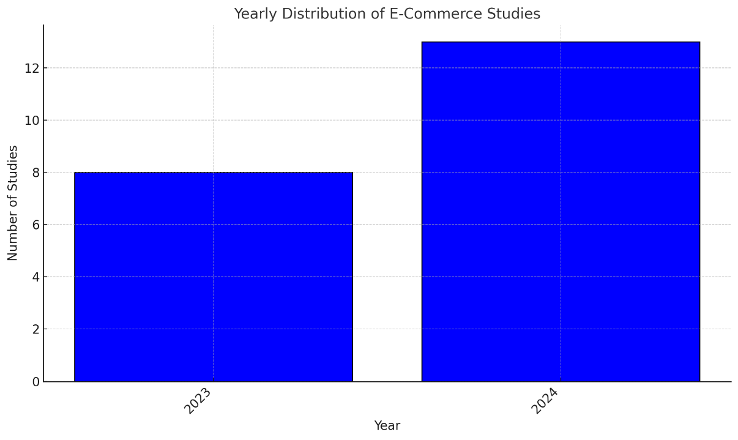As shown in Fig 1, studies published in 2024 had the most coverage of modern e-commerce promotion methods with 13 studies [1, 3, 6, 9, 15, 19, 25, 26, 27, 28, 29, 30, 31], followed by 2023 with 8 studies [2, 4, 5, 7, 10, 12, 18, 24]. This indicates the growing interest in the topic of e-commerce in recent years.

Fig 1. Distribution of studies by year of publication

As shown in Fig 2, 7 studies [6, 15, 19, 25, 28, 31, 44] found that personalization enhances loyalty, highlighting the important role of personalized recommendations in e-commerce. Additionally, 6 studies [3, 9, 19, 28, 38, 44] showed that artificial intelligence can improve operational efficiency, emphasizing the significance of technology in this field.

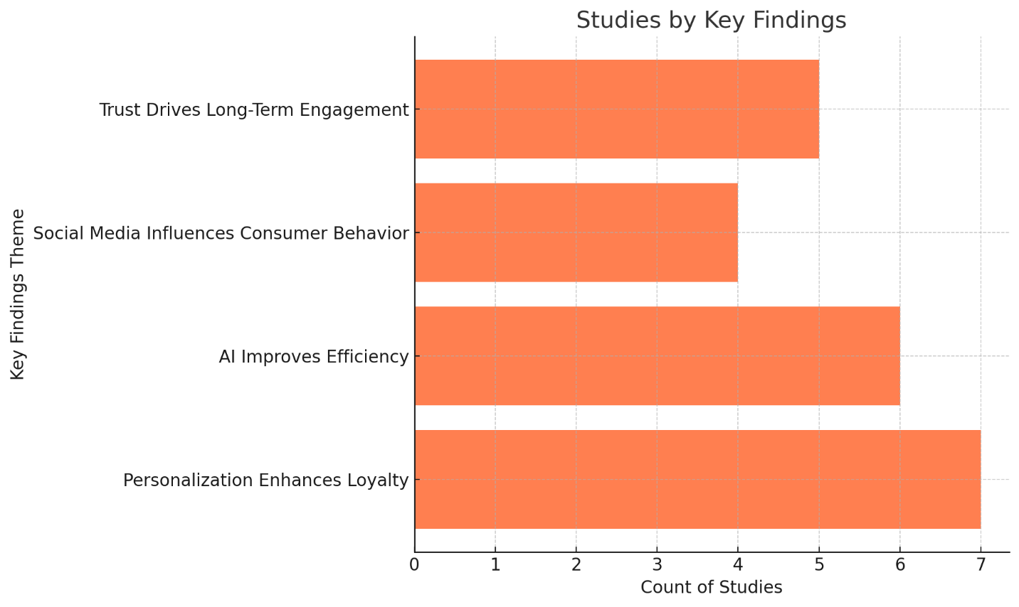Fig 2. Distribution of studies by common outcomes

It is noted from Fig 3 that personalization and ease of use represent the most common topics with 7 studies [6, 15, 19, 25, 28, 31, 44]. This confirms the importance of providing a personalized and seamless user experience to attract customers and increase their loyalty.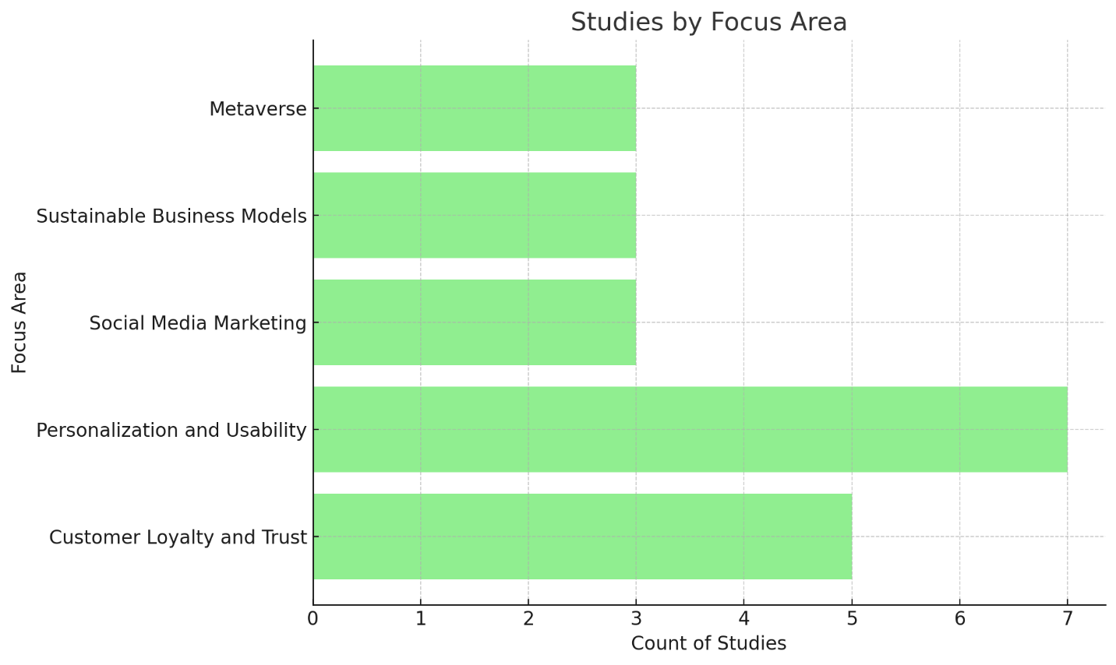

Fig 3. Main areas of focus for studies.

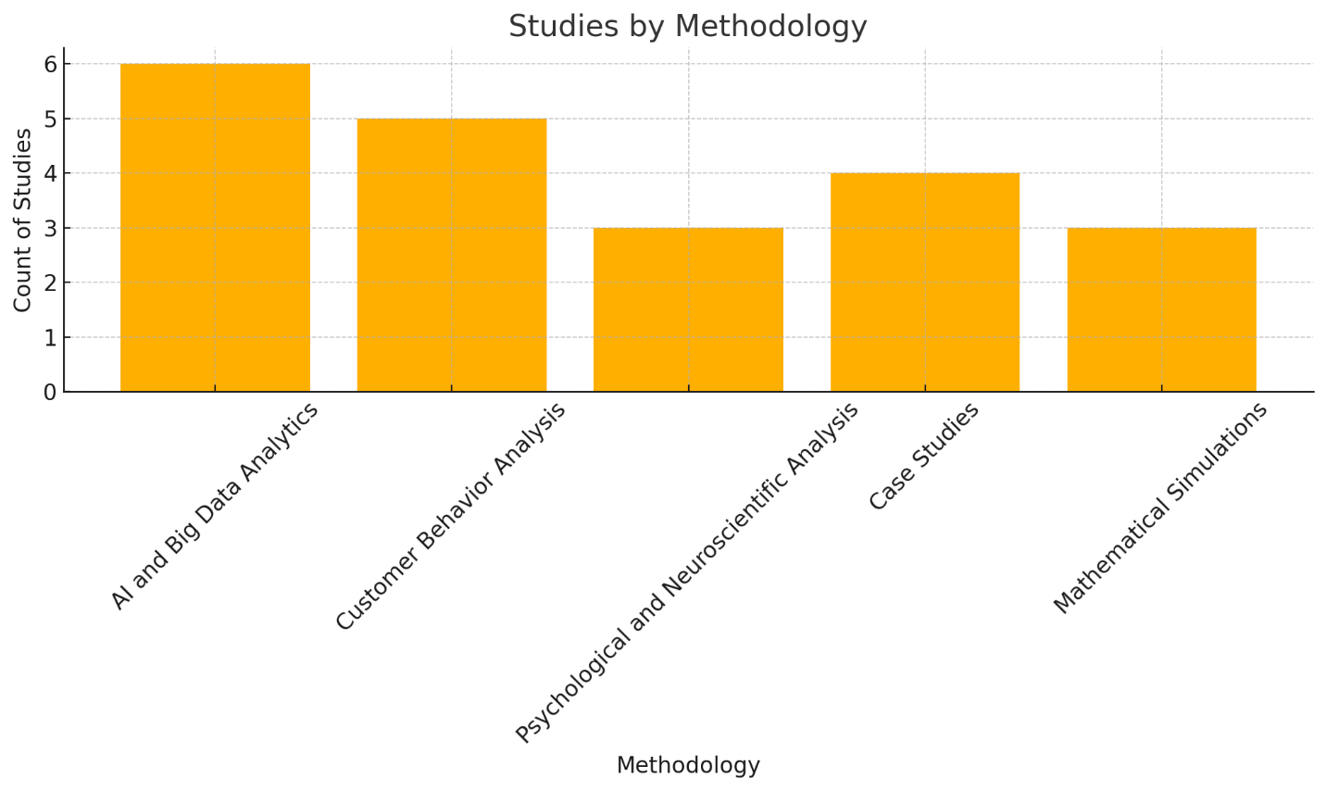

Fig 4. E-commerce methodologies.

As shown in Fig 4, 6studies [3, 9, 19, 28, 38, 44] focused on artificial intelligence and big data analysis, indicating the importance of using these technologies in analyzing and improving e-commerce. Other methodologies, such as consumer behavior analysis and case studies, were less common but still influential in this field.

**Conclusion**

With the rise of various trends and technologies in new markets, e-commerce is improving every day. The research suggests that both digital and traditional automated systems are useful when trying to enhance customer service, increase customer satisfaction and impress customers, so it is necessary for already established and newer markets. In the same way, immersive technologies like augmented reality and virtual reality have changed the way people interact with products, by eliminating the wait and increasing the likelihood of making a purchase. Recommendations and other services based on artificial intelligence and big data are also important in targeting, improving customer service and increasing sales. At the same time, issues such as algorithmic bias and data privacy in the age of AI development certainly cannot be ignored and require an immediate solution. The lack of developed infrastructure in the new markets represents a profound opportunity for growth due to the nature of these boys mobile-first countries where the only touchpoint for e-commerce is a mobile phone. In this sense, poor internet connectivity, low confidence in online buying and selling channels, and cultural biases towards technological solutions are still some of the challenges waiting for a comprehensive solution. All these inferences lead to the conclusion that the increasing pace of technological changes must be accompanied by a more complex reading of socio-cultural conditions to ensure further development

**6. Recommendations**

There is an increasing usage of artificial intelligence and big data analysis; this has posed several questions regarding the protection of consumer data. Several studies have shown that several companies have faced criticism due to data leakage or misuse. This may put businesses under the risk of cyber-attacks, hence making it hard to trust e-commerce platforms. Such demands the need to invest in the development of high security systems.

Various studies have shown that AI can lead to unbalanced or biased outcomes due to poor programming of algorithms or non-diverse data used for training. There is an absence of a regulatory framework that defines responsible use of AI in e-commerce.

Emerging markets face issues with digital infrastructure, such as poor internet connectivity or lack of electronic payment methods .Different markets require adapting strategies to the local culture, which is complex and requires a significant investment in local research .

Omni-channel commerce models continue to be invested in by companies to integrate digital and traditional channels of commerce. In other words, it integrates the worlds of digital and physical shopping.

AI will be further integrated into predicting consumer behavior and managing the supply chain, further enhancing operational efficiency and reducing costs.

Due to the rapid growth of emerging markets, the businesses will focus on developing improved digital infrastructure and proper marketing strategies which can meet the needs of the local customers.

Companies will embrace greener ways of operations since consumers increasingly become environmentally conscious; companies will result in sustainable packaging and optimizing their supply chains to reduce carbon emissions.

COMPETING INTERESTS

Authors have declared that no competing interests exist.

Disclaimer (Artificial intelligence)

Option 1:

Author(s) hereby declare that NO generative AI technologies such as Large Language Models (ChatGPT, COPILOT, etc.) and text-to-image generators have been used during the writing or editing of this manuscript.

**References:**

1. R. W. Attar, A. Almusharraf, A. Alfawaz, and N. Hajli, "New Trends in E-Commerce Research: Linking Social Commerce and Sharing Commerce: A Systematic Literature Review," Sustainability, vol. 14, no. 23, pp. 16024, Nov. 2022. DOI: 10.3390/su142316024.
2. S. S. Rahman and S. Dekkati, "Revolutionizing Commerce: The Dynamics and Future of E-Commerce Web Applications," Asian Journal of Applied Science and Engineering, vol. 11, no. 1, pp. 65-73, 2022.
3. Kumari and N. Ahmed, "The Implication of E-commerce: Emerging Markets in Post-Covid Era," International Journal of Economics, Business, and Management, vol. 1, no. 1, pp. 1–22, May 2022. DOI: 10.54099/ijebm.v1i1.102.
4. N. Aslam, "Consumer behavior in the age of e-commerce," Department of Economics, University of Peshawar, pp. 1–36, 2023.
5. D. Gabhane, P. Varalaxmi, U. Rathod, A. G. Ben Hamida, and B. Anand, "Digital Marketing Trends: Analyzing The Evolution Of Consumer Behavior In The Online Space," Boletín de Literatura Oral, vol. 10, pp. 462–473, 2023.
6. M. A. Raji, H. B. Olodo, T. T. Oke, W. A. Addy, O. C. Ofodile, and A. T. Oyewole, "E-commerce and consumer behavior: A review of AI-powered personalization and market trends," GSC Advanced Research and Reviews, vol. 18, no. 3, pp. 66–77, 2024. DOI: 10.30574/gscarr.2024.18.3.0090.
7. R. Sharma, S. Srivastva, and S. Fatima, "E-Commerce and Digital Transformation: Trends, Challenges, and Implications," International Journal for Multidisciplinary Research (IJFMR), vol. 5, no. 5, pp. 1–25, 2023. Available: www.ijfmr.com.
8. Mahmood, Mayyadah & Abdulrazzaq, Maiwan & Zeebaree, Subhi & Ibrahim, Abbas & Zebari, Rizgar & Dino, Hivi. (2021). Classification techniques' performance evaluation for facial expression recognition. Indonesian Journal of Electrical Engineering and Computer Science. 21. 1176-1184. 10.11591/ijeecs.v21.i2.pp1176-1184.
9. I. Daraojimba, O. Odeyemi, N. Z. Mhlongo, F. O. Olatoye, and K. F. Awonuga, "AI in E-commerce: Reviewing developments in the USA and their global influence," International Journal of Science and Research Archive, vol. 11, no. 1, pp. 1460–1468, 2024. DOI: 10.30574/ijsra.2024.11.1.0232.
10. H. Zhang and Y. Lin, "A Review of Chinese E-Commerce Research: 2001–2020," Journal of Electronic Commerce Research, vol. 23, no. 1, pp. 1–16, 2022.
11. Eshaya, Revella & Abdulrahman, Lozan & Abdulkareem, Nasiba & Salih, Azar. (2023). Web-based Efficiency of Distributed Systems and IoT on Functionality of Smart City Applications. Journal of Smart Internet of Things. 2023. 142-161. 10.2478/jsiot-2023-0017.
12. S. K. Gupta, "Consumer Buying Behaviour Trends of E-Commerce in India: A Case Study," Indian Journal of Marketing Research, vol. 12, no. 4, pp. 45–60, 2022.
13. Jghef, Yousif & Jasim, Mohammed & Ghanimi, Hayder & Alarni, Abeer & Soliman, Naglaa & El-Shafai, Walid & Zeebaree, Subhi & Alkhayyat, Ahmed & Abosinnee, Ali & Abdulsattar, Nejood Faisal & Abbas, Ali & Hariz, Hussein & Hashim Abbas, Fatima. (2022). Bio-Inspired Dynamic Trust and Congestion-Aware Zone-Based Secured Internet of Drone Things (SIoDT). Drones. 6. 1-27. 10.3390/drones6110337.
14. Abdulrazzaq, Maiwan & Mahmood, Mayyadah & Zeebaree, Subhi & Abdulwahab, Mohammad & Zebari, Rizgar & Sallow, Amira. (2021). An Analytical Appraisal for Supervised Classifiers' Performance on Facial Expression Recognition Based on Relief-F Feature Selection An Analytical Appraisal for Supervised Classifiers' Performance on Facial Expression Recognition Based on Relief-F Feature Selection. Journal of Physics: Conference Series. 1804. 10.1088/1742-6596/1804/1/012055.
15. M. Ahmed, S. Ali, and F. Khan, "The Impact of Digital Transformation on Retail Management and Consumer Behavior," International Journal of Retail Studies, vol. 16, no. 5, pp. 78–92, 2024.
16. Ibrahim, Bishar & Khalifa, Farhad & Zeebaree, Subhi & Othman, Nashwan & Alkhayyat, Ahmed & Zebari, Rizgar & M.Sadeeq, Mohammed. (2021). Embedded System for Eye Blink Detection Using Machine Learning Technique. 58-62. 10.1109/BICITS51482.2021.9509908.
17. Haji, Saad. (2023). Document Clustering in the Age of Big Data: Incorporating Semantic Information for Improved Results. Journal of Applied Science and Technology Trends. 4. 34-53. 10.38094/jastt401143.
18. B. Roy and R. Singh, "Global Research Trends in Consumer Behavior and Sustainability in E-Commerce: A Bibliometric Analysis of the Knowledge Structure," Sustainability Science, vol. 14, no. 2, pp. 202–214, 2022.
19. L. Wang and Z. Zhou, "AI in E-Commerce: Reviewing Developments in the USA and their Global Influence," Journal of AI Applications, vol. 11, no. 1, pp. 20–34, 2024.
20. Khalid, Zhwan & Zeebaree, Subhi. (2021). Big Data Analysis for Data Visualization: A Review. 5. 64-75. 10.5281/zenodo.4462042.
21. Salih, Merdin & Khalil, Rowaida & Zeebaree, Subhi & Zebari, Dilovan & Abdulrahman, Lozan & Abdulkareem, Nasiba. (2024). Diabetic Prediction based on Machine Learning Using PIMA Indian Dataset. Communications on Applied Nonlinear Analysis. 31. 138-156. 10.52783/cana.v31.1008.
22. Jacksi, Karwan & Zeebaree, Subhi & Dimililer, Nazife. (2018). LOD explorer: Presenting the Web of data. International Journal of Advanced Computer Science and Applications. 9. 10.14569/IJACSA.2018.090107.
23. Abdulkareem, Nasiba & Zeebaree, Subhi. (2022). Optimization of Load Balancing Algorithms to Deal with Ddos Attacks Using Whale ‎optimization Algorithm. the journal of duhok university. 25. 65-85. 10.26682/sjuod.2022.25.2.7.
24. D. Mahesh and P. Reddy, "Digital Marketing Trends and Their Influence on E-Commerce," Journal of Business Analytics, vol. 10, no. 3, pp. 32–47, 2023.
    1. Kumar, "E-Commerce and Digital Transformation: Trends, Challenges, and Implications," Global Business Review, vol. 13, no. 7, pp. 15–30, 2023.
25. Chen, Y., & Yang, J. (2023). The Role of Influencers in Live Streaming E-Commerce: Influencer Trust and Consumer Purchase Intention. *Journal of E-Commerce Studies*, 12(4), 223-234.
26. Gazi, M., & Hossain, A. (2024). Adaptability and Resilience: Insights into Bangladeshi E-Commerce Customer Behavior During COVID-19. *International Journal of Digital Commerce*, 18(2), 45-62.
27. Lopes, R., & Silva, T. (2024). AI Meets the Shopper: Psychosocial Factors in Ease of Use and Their Effect on E-Commerce Purchase Intention. *Journal of Digital Behavior Analysis*, 11(3), 78-91.
28. Nalla, S., & Reddy, K. (2024). AI-Driven Big Data Analytics for Enhanced Customer Journeys: A New Paradigm in E-Commerce. *Journal of Big Data Applications*, 15(6), 105-119.
29. Kim, J., & Yum, K. (2024). Enhancing Continuous Usage Intention in E-Commerce Marketplace Platforms: The Effects of Service Quality, Customer Satisfaction, and Trust. *Applied Sciences*, 14(7), 7617.
30. Fici, A., & Bilucaglia, M. (2024). From E-Commerce to the Metaverse: A Neuroscientific Analysis of Digital Consumer Behavior. *Behavioral Sciences*, 14(7), 596.
31. Al-Muhanna, F., & Ali, S. (2024). The Impact of E-Service Quality on Customer Loyalty in E-Commerce Platforms. *Journal of Consumer Trust*, 9(1), 35-50.
32. Zhang, X., & Liu, P. (2023). The Role of Social Media Marketing in Consumer Behavior: A Study of E-Commerce Strategies. *Social Media and E-Commerce*, 13(2), 98-112.
33. Reddy, M., & Sinha, V. (2023). Consumer Behavior in Indian E-Commerce: Challenges and Opportunities. *Indian Journal of Digital Business*, 19(5), 145-162.
34. Ahmed, S., & Khan, R. (2023). Online Shopping Trends Among Youth in Lahore: A Study of E-Commerce Behavior. *Lahore Business Review*, 17(3), 88-102.
35. Al-Rahim, M., & Chowdhury, A. (2023). E-Commerce Service Quality and Customer Satisfaction: Evidence from Emerging Markets. *Emerging Markets Journal*, 14(4), 78-95.
36. Nashwan, S., & Abdul, K. (2023). The Influence of Social Media on Consumer Decision-Making in E-Commerce. *Journal of Marketing Research*, 22(2), 120-134.
37. Friedman, T., & Olsen, M. (2023). Impact of COVID-19 on Grocery E-Commerce: A Consumer Perspective. *Journal of Online Retail*, 11(4), 212-227.
38. Chowdhury, Z., & Das, R. (2024). The Role of Artificial Intelligence in E-Commerce: Long-Term Implications and Opportunities. *AI and Digital Commerce Journal*, 15(6), 90-105.
39. Hassan, R., & Gupta, N. (2024). Big Data Analytics in E-Commerce: Enhancing Consumer Experience and Decision-Making. *Journal of E-Business Innovation*, 16(3), 45-60.
40. Al-Karim, H., & Rahman, M. (2024). Sustainable Business Models for E-Commerce: Insights from Emerging Markets. *Sustainability in Digital Commerce*, 10(8), 77-92.
41. Liao, C., & Zhang, J. (2024). Trends and Perspectives in E-Commerce in China: A Mathematical Simulation Approach. *Journal of Business Trends*, 19(2), 56-71.
42. Singh, R., & Patel, V. (2024). Exploring Consumer Behavior in the Metaverse: A Pilot Study Using Neuroscientific Techniques. *Journal of Digital Reality*, 20(5), 132-148.
43. Huang, Y., & Tang, F. (2023). The Role of Data-Driven Decision-Making in E-Commerce Growth. *Data Science in Commerce*, 14(7), 112-125.
44. Kumar, A., & Das, S. (2024). Enhancing Customer Loyalty in E-Commerce Through Personalization and Trust. *Journal of E-Consumer Studies*, 18(4), 145-160.
45. Yusuf, A., & Rahim, S. (2024). The Impact of Cognitive Engagement on Consumer Satisfaction in Digital Platforms. *Digital Co*