**Antioxidant Properties of *Rydingia persica* (Burm.f.) Scheen & V.A. Albert (Lamiaceae)**

**Abstract**

*Rydingia persica* (Burm.f.) Scheen & V.A. Albert (Lamiaceae) also known as *Otostegia persica* belongs to the *Lamiaceae* family. *Lamiaceae* family is one of the largest and most distinct families of flowering plants with about 220 genera and approximately 4000 species worldwide. The *Otostegia* genus consists of about 33 species that mainly grow in the Mediterranean region and Asia Minor. The purpose of this research was to investigate the antioxidant properties of the golder plant and its phytochemical studies. This research was based on the phytochemical analysis of *Otostegia persica* samples. First, the extraction was done by soaking with different solvents (water, ethanol) and then the antioxidant properties of the plant were done by DPPH and Reducing Power methods on each of the extracts separately, and then the total phenol content, Anthocyanin, a plant flavonoid, was measured. The leaves of these plants were used for phytochemical studies. These findings suggest that *Otostegia persica* could serve as a valuable natural source of antioxidants, supporting its traditional medicinal applications and potential use in the pharmaceutical and nutraceutical industries. The results revealed that the ethanolic extract demonstrated a stronger inhibitory effect than the aqueous extract. Ethanol, being a high-polarity solvent, extracts highly polar bioactive compounds such as phenolic acids and flavonoids, which are known for their potent antioxidant activity. The bioactive compounds present in *Otostegia persica* may have broader therapeutic applications beyond antioxidant activity. Additionally, isolating and characterizing the specific phytochemicals responsible for its high antioxidant potential could facilitate the development of nutraceutical and pharmaceutical products and supporting its traditional medicinal uses and expanding its role in various health-related industries.

**Keywords**: antioxidant, gold, ethanol, extract, anthocyanin.

**Introduction**

*Rydingia persica* (Burm.f.) Scheen & V.A. Albert (Lamiaceae)also known as *Otostegia persica* or in other words *Otostegi a* is a famous medicinal plant that is located in arid and semi-arid areas [9,15]. This plant belongs to the *Lamiaceae* family and is native to Southwest Asia, especially Iran.

*Otostegia persica* is a herbaceous perennial plant whose height is about 1-2 meters. It has dry and wooden stems and its leaves are balanced and have an oval or oval-lobe shape. The flowers of *Otostegia persica* are purple to bluish-purple in color and are borne in umbellate clusters at the head of the stem. In addition to its beauty, this plant is also known for its medicinal and soothing properties [10,11].

In traditional medicine, *Otostegia persica* is used in the treatment of many diseases. Its leaves and flowers have active compounds such as essential oils, tannins and flavonoids, which have antimicrobial, anti-inflammatory and anti-cancer properties [19]. In some sources, *Otostegia persica* has been introduced to treat respiratory infections, cough, asthma and respiratory allergies, stomach and intestinal inflammations, arthritis, skin diseases and even heart disorders. However, for the optimal use of *Otostegia persica* and if you need to treat a specific disease, it is recommended to consult a doctor or herbalist [12,13,14].

In conclusion, *Otostegia persica* is a medicinal plant with many properties used in traditional medicine. However, for optimal use and to ascertain the effects and side effects associated with it, medical consultation is appropriate.

**Methodology**

Sampling was done in the spring and winter seasons of 2018 and 2019. Samples were taken from different areas and taken to the laboratory. In the laboratory, the samples were cleaned and a herbarium sample was prepared from them. To carry out antioxidant work, the leaves and green branches of the plant species were also sampled. *Otostegia persica* samples were analyzed phytochemically. First, the extraction was done by soaking with different solvents (water, ethanol) and then the antioxidant properties of the plant were done by DPPH and Reducing Power methods on each of the extracts separately, and then the total phenol content, Anthocyanin, a plant flavonoid, was measured.

**Antioxidants**

Antioxidants are substances that can destroy free radicals and protect against cell damage caused by free radicals. Your body can also be exposed to free radicals from various environmental sources such as cigarette smoke, air pollution, and sunlight. Free radicals can cause oxidative stress, a process that can cause cell damage [16]. Oxidative stress is thought to play a role in a variety of diseases, including cancer, cardiovascular diseases, diabetes, Alzheimer's disease, Parkinson's disease, and eye diseases such as cataracts and age-related macular degeneration [18].

Antioxidants are man-made or natural substances that may prevent or delay some cellular damage. Diets containing vegetables and fruits, which are good sources of antioxidants, are known to be healthy. Examples of antioxidants include vitamins C and E, selenium and carotenoids such as beta-carotene, lycopene, lutein and zeaxanthin. High dose antioxidant supplements may be harmful in some cases. For example, the results of some studies have shown that the use of high-dose beta-carotene supplements increases the risk of lung cancer in smokers, and the use of high-dose vitamin E supplements increases the risk of prostate cancer.

**Methods of measuring the power of antioxidants**

There are many methods to measure the antioxidant power, which we mention, although the measurement process is not a simple and clear process due to the variety of compounds and their different reactivity [1].

**Di phenyl picryl hydrazyl (DPPH) method**

2,2-diphenylpicrylhydrazyl (DPPH) method is widely used in plant biochemistry to evaluate the properties of plant constituents and inhibit free radicals. This method is based on the spectrophotometric measurement of the change in DPPH concentration caused by the reaction with an antioxidant [2].

This method is one of the most popular and common among antioxidant methods. This method is simple, efficient, relatively cheap and fast. However, like most antioxidant assays, it requires a UV-Vis spectrophotometer. The basis of this method is based on the reduction of DPPH free radical by antioxidants in the absence of other free radicals in the environment. The result obtained for a compound is generally compared with a known antioxidant compound. Antioxidant capacity evaluation analysis by 2,2-diphenylpicrylhydrazyl method is a test that has received a lot of attention in the fields of food, medicine and biotechnology.

**ABST method**

Evaluation of antioxidant activity by azino bis thiazoline sulfic radical (ABST+) was introduced by Miller & Evans in 1994 and modified by Re et al. in 1999. In this improved method, a blue-green ABSTo+ chromophore is produced through the reaction of ABST and potassium persulfate. This ABTSo+ radical cation takes hydrogen in the presence of hydrogen-donating antioxidant and its solution absorption decreases.

**Oxygen Radical Absorbance Capacity (ORAC) method**

Oxygen radical absorption capacity method provides a new method to evaluate antioxidant activity. This method uses a technique under the curve and thus combines both the inhibition time and the degree of inhibition of free radicals by an antioxidant into a single value. Oxygen radical absorption capacity is a method to measure antioxidant capacity in biological samples in laboratory conditions.

**PCL method**

The (Photochemiluminescent) PCL method was developed by Popov and Levin (1999) and in this method, the substance luminol (5-amino-2,3-dihydrophthalazine-1,4-dione) is used, which after being oxidized, it emits light. This device produces free radicals using a photosynthesizer that stimulates the reaction molecules. A sensor measures the intensity of light produced when free radicals react with luminol. If there is an antioxidant in the reaction, the intensity of the light is lower and it takes longer to be emitted, so the intensity and time are both related to the antioxidant activity of the sample.

**Beta-carotene-linoleic acid method**

β-Carotene is a carotenoid compound that is abundant in the human diet and is found in all human tissues, including blood. Due to its high biological activity, it is also widely used in medicine. Among the numerous functions of β-carotene in the human body, one of the most important ones is related to the supply of vitamin A, which mostly affects the growth and development of the fetus, proper growth and vision. It is considered as an inhibitor of some genes. In addition, it shows anti-cancer and antioxidant properties.

Linoleic acid is the most desirable fatty acid used in cosmetics and personal care products because it cannot be synthesized by the body and is always used as a softener or moisturizer for skin, nails and hair. In addition to the structural role of unsaturated fatty acids in the cell membrane, linoleic acid causes the creation of arachidonic acid, which is the main precursor of a set of active metabolites called eicosanoids, which regulate a large number of physiological processes.

**The method of measuring antioxidant power by ferric reduction (FRAP)**

The FRP method was initially developed by Benzi and Strain (1996) to measure the reducing power in plasma, but later this method was adapted and used to measure antioxidants in plants. In this method, the ability of extracts to regenerate ferric ions (Fe3+) in the presence of antioxidants is measured. By reducing ferric ions (Fe3+) and converting it to ferrous ions (Fe2+) in acidic pH and in the presence of tripyridyl triazine (TPTZ), the Fe-TPTZ complex is formed, and its color is blue. After that, optical measurement is done at 593 nm. Of course, it should be noted that the ability of an antioxidant to overcome free radicals does not necessarily correspond to its ability to reduce Fe3+ to Fe2+ [3].

**Reducing Power method**

The power measurement method is based on the principle that materials that have reduction potential react with potassium ferricyanide (Fe3+) and become potassium ferrocyanide (Fe2+), then react with ferric chloride and a set of Iron forms the maximum absorption in this method at a wavelength of 700 nm.

**Extraction steps from the plant by different solvents for phytochemical investigations**

Extraction was done by maceration (soaking) method [4]. For this purpose, 5 grams of dry powder of tested medicinal plants were added to 50 ml of different solvents (ethanol and double-distilled water) and were mixed on a shaker for 24 hours. The samples obtained by Whatman filter paper 42, smooth and in order to completely remove suspended particles, each of the extracts were centrifuged by a centrifuge at a speed of 10000 rpm for 20 minutes. After the solvent was removed, due to the high sensitivity of the prepared extracts to light, oxygen, and heat, they were placed in a dark container and kept in a refrigerator until the experiment was performed.

**Measurement of antioxidant power**

Measurement of antioxidant power by DPPH method: This method was first presented by Bouleis in 1958, which was later slightly modified by other researchers. This is one of the most important methods for evaluating the antioxidant power of plant samples. In this method, DPPH, which is a stable radical, reacts with the antioxidant and takes a hydrogen atom from it, which leads to a change in color from purple to yellow. In this method, the antioxidant power of the extracts obtained from different solvents is determined by changing the purple color of the methanolic diphenylpicrylhydrazyl solution to yellow. Di phenyl picryl hydrazyl radicals are used as reagents [5].

The measurement method was as follows: at first, a concentration of 1000 µg/ml was made from all the extracts, and specific volumes of the extracts were added to 1 ml of DPPH methanolic solution with a concentration of 0.1 mM. And with methanol, the volume reached 2 ml, and the container without extract was considered as a control. Then, the absorbance of the samples was read after 30 minutes in the dark environment at a wavelength of 517 nm against the control.

IC 50 is a concentration of antioxidants in which the inhibitory power of extracts is 50%. That is, half of the free radicals in this concentration of the extract have been neutralized by the antioxidant molecules in the extract. The lower this concentration is, it indicates that half of the free radicals are neutralized at lower concentrations of the antioxidant, so it is a stronger antioxidant.

Calculation of IC50: The percentage of inhibition of free radicals was calculated by the following formula, and then the inhibition graph of each extract was drawn according to concentration.

%IP = (A control- A sample / A control) × 100

Then, a concentration of the extract that provides 50% inhibition against radicals (IC50) was calculated from the drawn graph of the inhibition of the extract according to the concentration of the extract. In this way, in the equation of the line obtained from the graph, instead of y, we put the number 50 and the obtained X is equal to IC50.

The antioxidant activity of the available extracts is determined by changing the purple color of the methanolic solution of diphenyl picryl hydrazyl to yellow. Di phenyl picryl hydrazyl radicals were used as reagents in the spectrophotometric method. This method is known as Brand-Williams method, whose reaction is shown in Figure 1-2.

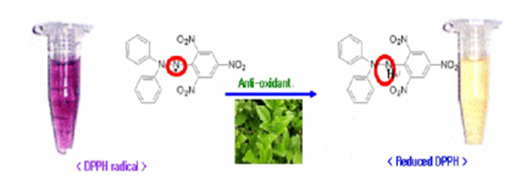

Figure 1: Color changes of DPPH method

Figure 2 shows the UV-Vis spectra of DPPH before and after adding antioxidants.

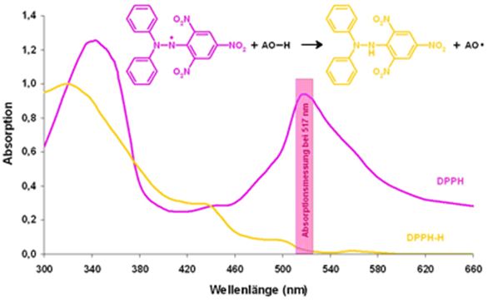

Figure 2: UV-Vis spectra related to DPPH, before and after adding antioxidants

**Power reduction measurement method**

To measure the power reduction, the method used by Chong et al. was used [6].

We mixed 0.1 ml of the organic extract with 0.1 ml of phosphate buffer with a concentration of 0.2 mM (pH=6.6) and 0.1 ml of 1% potassium ferricyanide. Then we put it in the oven at 50 degrees Celsius for 20 minutes. Then, 0.2 ml of 1% trichloroacetic acid was added to it, and it was centrifuged at 2000 rpm for 10 minutes.

To 0.25 ml of the above mixture, we added 0.25 ml of double distilled water and 0.5 ml of 0.1% FeCl3, and we read its absorbance at 700 nm wavelength. In this test, BHT was used as a positive control.

**Measurement of total phenol content**

Total phenol content was measured using Folin-Ciocaltio reagent and gallic acid was used as a standard [17].

2.5 ml of 10% Folin reagent was added to 0.5 ml of the obtained extracts, and after 5 minutes, 2 ml of 5% sodium carbonate (Na2CO3) solution was mixed and the tubes were kept for 30 minutes in a dark place. Then the absorbance of the samples was read at a wavelength of 765 nm.

**Drawing a standard curve to measure the amount of total phenol**

Gallic acid solution with a concentration of 100 mg/liter was used to draw the standard curve of total phenol. After preparing gallic acid solution, 0, 50, 100, 150, ..., 450 and 500 microliters of gallic acid solution were added to the test tubes. Then 2 ml of 5% sodium carbonate solution (Na2CO3) and 2.5 ml of Folin reagent 10% were added separately to each. And finally, the total volume of the tubes was brought to 5 ml by distilled water. The test tube without gallic acid was considered as a control (blank). After 30 minutes, the absorbance of the samples was read at a wavelength of 765 nm.

Table 1: standard concentrations of gallic acid for drawing the standard curve

|  |  |  |  |  |  |
| --- | --- | --- | --- | --- | --- |
|  | Gallic acid (ml) | Distilled water (ml) | Folin (ml) | sodium carbonate (ml) | absorption |
| blank | 0 | 50/0 | 5/2 | 2 | 0 |
| 1 | 05/0 | 45/0 | 5/2 | 2 | 051/0 |
| 2 | 10/0 | 40/0 | 5/2 | 2 | 118/0 |
| 3 | 15/0 | 35/0 | 5/2 | 2 | 241/0 |
| 4 | 20/0 | 30/0 | 5/2 | 2 | 382/0 |
| 5 | 25/0 | 25/0 | 5/2 | 2 | 419/0 |
| 6 | 30/0 | 20/0 | 5/2 | 2 | 554/0 |
| 7 | 35/0 | 15/0 | 5/2 | 2 | 637/0 |
| 8 | 40/0 | 10/0 | 5/2 | 2 | 760/0 |
| 9 | 45/0 | 05/0 | 5/2 | 2 | 843/0 |
| 10 | 50/0 | 0 | 5/2 | 2 | 922/0 |

**Determination of total flavonoids**

Aluminum chloride colorimetric method was used to measure the amount of total flavonoids. and quercetin was used as a standard [7].

The measurement method was that 100 microliters of each of the available extracts was mixed separately with 1.5 ml of ethanol, 100 microliters of aluminum chloride (10%), 100 microliters of sodium acetate (1 M) and 8 2 ml of distilled water were mixed. After 30 minutes at room temperature, the absorbance of the samples was read at a wavelength of 415 nm [8].

**Drawing a standard curve to measure the amount of total flavonoids**

Quercetin solution with a concentration of 500ppm was used to draw the total flavonoid standard curve. After preparing the quercetin solution, 0, 100, 200, 300, ..., 450 and 500 ppm values were prepared in Falcon tubes. Then, 1.5 ml of ethanol, 100 microliters of aluminum chloride (10%), 100 microliters of sodium acetate (1 M) and 2.8 ml of distilled water were added to each separately. Then after 30 minutes. The absorbance of the samples was read at a wavelength of 415 nm.

Table 2: quercetin standard concentrations for drawing the calibration curve

|  |  |  |  |  |  |  |
| --- | --- | --- | --- | --- | --- | --- |
| Number of samples | Quercetin (ml) | Distilled water (ml) | 95% ethanol (ml) | %10 AlCl3  (ml) | sodium carbonate (ml) | absorption (nm) |
| blank | 0 | 4/3 | 5/1 | 0 | 1/0 | 0 |
| 1 | 1/0 | 2/3 | 5/1 | 1/0 | 1/0 | 151/0 |
| 2 | 2/0 | 1/3 | 5/1 | 1/0 | 1/0 | 334/0 |
| 3 | 3/0 | 3 | 5/1 | 1/0 | 1/0 | 401/0 |
| 4 | 4/0 | 9/2 | 5/1 | 1/0 | 1/0 | 519/0 |
| 5 | 5/0 | 8/2 | 5/1 | 1/0 | 1/0 | 640/0 |

**Measurement of total anthocyanins**

Extraction method: We put 0.1 g of the dry powder of the plant in 4 ml of 99% acidic methanol (99 ml of ethanol - 1 ml of HCl) in a dark environment and room temperature, and then absorb it after 24 hours. We read at two wavelengths of 530 and 653 nm. Due to the high absorption, a certain amount of the extract (200 microliters) is poured into the cell and made up to one milliliter with methanol.

**Measurement method**

1. We get AOD absorption from the following equation.

AOD= A530- (0.24 * A653)

2. Then put bc = A in the relationship and calculate the amount of anthocyanin in mill molar.

(9/26 =)



3. Multiply the milli mol of anthocyanin by the volume (1 ml) and divide by 1000 to get the milli mol of anthocyanin in the corresponding volume.

4. Multiply the obtained milli moles by 4 to get milli moles of anthocyanin in 0.1 gram of dry powder of the golden plant.

5. Multiply the obtained value by the molecular mass of anthocyanin (449.2 g/mol) to obtain milligrams of anthocyanin in 0.1 g. Finally, this value is divided by 0.1 to calculate the milligrams of anthocyanin in one gram of dry powder.

**Measuring antioxidant power by DPPH method**

The inhibitory power in terms of concentration, related to the synthetic antioxidant properties of ascorbic acid by the di phenyl picryl hydrazyl method, is shown in Figure 3.

Figure 3: calibration curve of the inhibitory power of ascorbic acid

According to Figure 3, the inhibition concentration of 50% for ascorbic acid is IC50=6.06 ppm.

IC50: the inhibitory power of extracts in this concentration of antioxidant is 50%.

The inhibitory power in terms of concentration, related to the antioxidant properties of the ethanolic extract by the di phenyl picryl hydrazyl method, is shown in Figure 4:

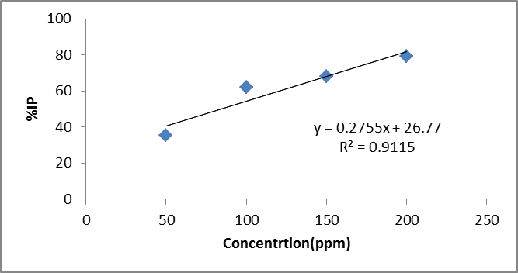

Figure 4: calibration curve of inhibition power of organic extract of Golden plant

According to Figure 4, 50% inhibitory concentration has been obtained for the ethanolic extract, IC50 = 47.84 ppm.

The inhibitory power in terms of concentration, for the antioxidant property of aqueous extract by DPPH method, is shown in Figure 5:

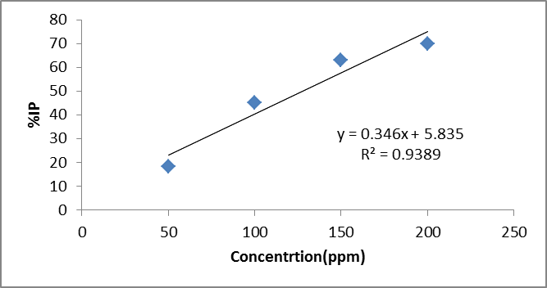

Figure 5: calibration curve of inhibition power of water extract of golden plant

According to Figure 5, the inhibition concentration of 50% was obtained for aqueous extract IC50 = 127.64 ppm.

Figure 6 shows the 50% inhibitory power of the ethanolic and aqueous extracts compared to the synthetic antioxidant ascorbic acid.

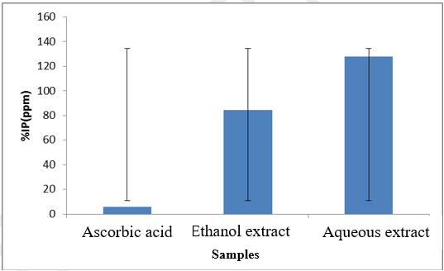

Figure 6: Comparison of IC50 of ethanolic and aqueous extract in DPPH method

According to the results obtained in the graph of Figure 6 for the water and ethanol extracts of the golden plant, the ethanol extract had the highest and the water extract the lowest antioxidant power compared to the ascorbic acid standard.

**Result and Discussion:**

**Results from reduced power**

According to the calculations, the reduction power of ethanolic and aqueous extracts against BHT is 42.36, 18.12 and 56.45 mg of iron (II) per gram of sample, respectively. Figure 7 shows the comparison of the reducing power of ethanolic and aqueous extracts compared to BHT.

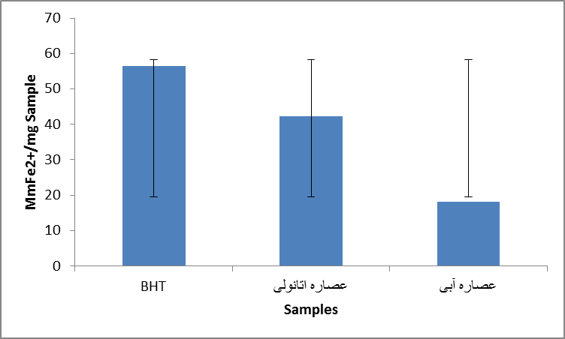

Ethanol extract

Aqueous extract

Figure (7) Comparison of the reducing power of ethanolic and aqueous extracts in BHT

The power measurement method is based on the principle that materials that have reduction potential react with potassium ferricyanide (Fe3+) and become potassium ferrocyanide (Fe2+), then react with ferric chloride and a set of Iron forms the maximum absorption in this method at a wavelength of 700 nm. According to the calculations, the reduction power of ethanolic and aqueous extracts against BHT is 42.36, 18.12 and 56.45 mg of iron (II) per gram of sample, respectively.

**Total phenol content**

In order to measure the amount of total phenol in the extracts, first a calibration curve and its standard graph were drawn. Figure 8 shows the standard diagram of gallic acid.

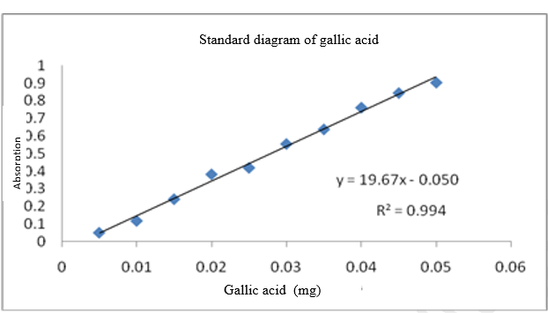

Figure (8) standard diagram of gallic acid for total phenolic measurement of golder plant

After reading the absorbance of the samples at a wavelength of 765 nm and using the prepared equation from the standard graph, the amount of total phenol for ethanolic and aqueous extracts was obtained as 49.21 and 29.68 mg of gallic acid per gram of extract, respectively. Is. Figure 9 shows the comparison of total phenol content of ethanolic and aqueous extracts.

Since the reagent phenol compound, gallic acid, was used to draw the standard curve, then this amount can be attributed to the presence of gallic acid. There is a significant difference between the amounts of total phenol in the aqueous and organic extracts of plant leaves, so the best antioxidant activity is related to the ethanol extract of the leaves. The high amount of gallic acid in the leaves of this plant shows that its antioxidant power is probably related to the presence of phenolic compounds.

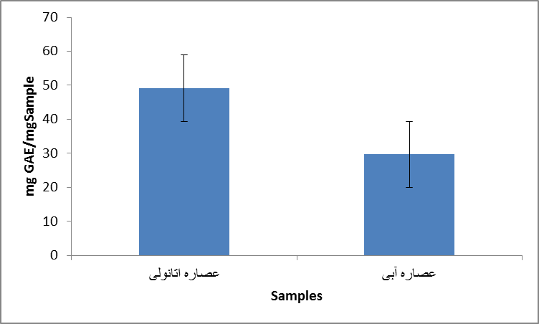

Aqueous extract

Ethanol extract

Figure (9) Comparison of total phenol content of ethanolic and aqueous extracts

**Measurement of flavonoid content**

In order to measure the total flavonoid content of the extracts, the calibration curve and its standard graph must be drawn first. Figure 10 shows the standard quercetin diagram.

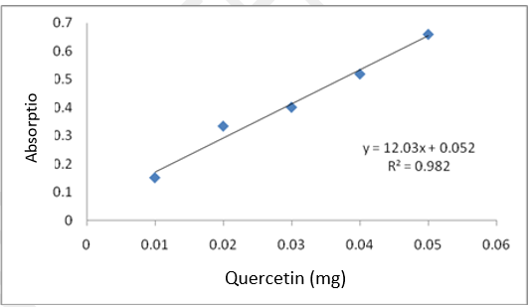

Figure (10) Quercetin standard diagram for measuring the flavonoid content of the golden plant

After reading the absorbance of the samples at a wavelength of 765 nm and using the prepared equation from the standard graph, the amount of total flavonoid for the ethanolic and aqueous extracts was obtained as 30.5 and 4.44 mg of quercetin per gram of the extract, respectively. Figure 11 shows the comparison of total phenol content of ethanolic and aqueous extracts.

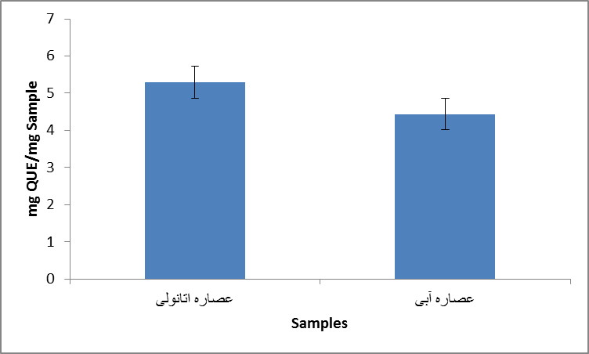

Ethanol extract

Aqueous extract

Figure (11) Comparison of total flavonoid content of ethanolic and aqueous extracts

Flavonoids help regulate cell activity and fight against free radicals that cause oxidative stress on the body. In simpler terms, they help the body to perform better against toxins and everyday stressors. Flavonoids are also powerful antioxidant agents. Aluminum chloride calorimetric method was used to measure the amount of total flavonoids and quercetin was used as a standard. Using the prepared equation, the highest amount of flavonoids is related to the ethanolic extract of plant leaves.

**Anthocyanin test results**

According to the calculations made, as well as the amount of dilution of the sample, the amount of anthocyanin in one gram of golden plant powder is 23.65 mg per gram of dry plant powder.

Antioxidants are substances that can prevent or slow down cells caused by free radicals, unstable molecules that the body creates as a reaction to environmental and other pressures. Antioxidant sources can be natural or synthetic. It is believed that some plant foods are rich in antioxidants. Plant antioxidants are a type of plant nutrients or plant elements. Flavonoids, flavones, catechins, polyphenols and phytoestrogens are types of antioxidants and plant nutrients and all of them are found in plant foods.

In this regard, the antioxidant properties of *Otostegia persica* were investigated. Extraction was done by ethanol and water solvent on the plant leaves. First, the antioxidant power of the extracts was investigated by the DPPH method and compared with the synthetic antioxidant ascorbic acid as a positive control. The obtained results showed that the inhibitory effect of the ethanolic extract is greater than that of the aqueous extract. 50% inhibitory concentration for ethanolic extract, IC50 = 84.47 ppm has been obtained. Ethanol solvent is a relatively high polarity solvent and the compounds extracted with this solvent naturally have high polarity compounds. Antioxidant compounds are mostly phenolic acid and flavonoids and have more inhibitory power.

**Conclusion**

This study analyzed the phytochemical composition and antioxidant properties of *Otostegia persica* collected from different regions. The antioxidant potential was evaluated using the widely recognized 2,2-diphenylpicrylhydrazyl (DPPH) assay, a reliable and commonly used method in plant biochemistry. The extraction process was performed using ethanol and water as solvents, followed by maceration and filtration to obtain purified extracts. The results demonstrated that the ethanolic extract exhibited a significantly stronger inhibitory effect compared to the aqueous extract, with an IC₅₀ value of 47.84 ppm. This suggests that ethanol, a high-polarity solvent, efficiently extracts bioactive compounds such as phenolic acids and flavonoids, which are known for their potent antioxidant activity.

These findings highlight *Otostegia persica* as a valuable natural source of antioxidants, reinforcing its traditional medicinal applications and potential use in pharmaceutical and nutraceutical industries. Additionally, the bioactive compounds present in *Otostegia persica* may possess therapeutic benefits beyond antioxidant activity. Further research to isolate and characterize these phytochemicals is essential for developing novel nutraceutical and pharmaceutical products, ultimately expanding the plant’s role in health-related applications.

**Disclaimer (Artificial intelligence)**

Option 1:

Author(s) hereby declare that NO generative AI technologies such as Large Language Models (ChatGPT, COPILOT, etc.) and text-to-image generators have been used during the writing or editing of this manuscript.

**References**

1. Romesburg H, C., (2016) Cluster analysis for researchers. Robert E. Krieger Pub. *Co. Florida, USA*,
2. Sneath P. H. A., & Sokal R. R., (2017) Numerical taxonomy: the principles and practice of numerical classification. *San Francisco: Freeman*, [Vol.8 No.3](https://www.scirp.org/journal/home?issueid=9097),
3. Nei. M., & Li W, H., Mathematical model for studying genetic variation in terms of restriction endonucleases. *Proc. Natl. Acad. Sci*, vol. 76,
4. Azizian Sharme A, Valizadeh M, Ghasemi A, Mehraban A, Kamali Deljo A., (2016). Phytochemical investigation, assessment of antioxidant and antibacterial activity of extracts of five medicinal species of Pulicaria gnaphalodes (Vent.) Boiss, Rhazya stricta L., Salvadora persica, Teucrium polium L., Hibiscus sabdariffa L. *Journal of University Sistan and Baluchistan province,*
5. Azizian S. A., Taherizadeh M, Valizadeh M, Ghasemi A, (2018). investigation of antimicrobial, antioxidant activities and determination of phenolic and flavonoid content of total extracts of five species from different genera of medicinal plants grown in Sistan and Baluchistan province, *Journal of University of Sciences Fasa Medicine,* 7 (4),
6. Einali, A., Azizian-S., A., & Ghasemi, A., (2018). Phytochemical screening and antimicrobial activities of Periploca aphylla Decne, Persian walnut (Juglans regia L.) and oleander (Nerium indicum Mill.) Leaf extracts. *Journal of Food Measurement and Characterization,*12, p. 1350-1359*,*
7. Azizian-S., A., Valizadeh, M., Taherizadeh, M*.* (2020)*.* Phytochemical investigation and phytosynthesis of eco-friendly stable bioactive gold and silver nanoparticles using petal extract of saffron (*Crocus sativus* L.) and study of their antimicrobial activities. *Mashhad University of Medical Sciences, Mashhad, Iran.*
8. Yassa, N., Sharififar, F., & Shafiee, A. (2005). *Otostegia persica*. as a Source of Natural Antioxidants. *Pharmaceutical biology*, *43*(1), 33-38.
9. Tofighi, Z., Alipour, F., Hadavinia, H., Abdollahi, M., Hadjiakhoondi, A., & Yassa, N. (2014). Effective antidiabetic and antioxidant fractions of *Otostegia persica* extract and their constituents. *Pharmaceutical Biology*, *52*(8), 961-966.
10. Sadeghi, Z., Akaberi, M., & Valizadeh, J. (2014). *Otostegia persica* (Lamiaceae): A review on its ethnopharmacology, phytochemistry, and pharmacology. *Avicenna journal of phytomedicine*, *4*(2), 79.
11. Sharifi-Rad, M., Pohl, P., & Epifano, F. (2021). Phytofabrication of silver nanoparticles (Agnps) with pharmaceutical capabilities using *Otostegia persica* (burm.) boiss. leaf extract. *Nanomaterials*, *11*(4), 1045.
12. Nematinejad, M., Raissi, A. S., Asgharipour, M. R., & Nosrati, F. (2022). Study of Edaphic, Morphological and Phytochemical Components of Wild Population of *Otostegia persica* B. in Habitats of Baluchistan, Iran. *Journal of Horticultural Science*, *36*(2), 429-442.
13. Sadeghi, H., Soltani, M., Kokhdan, E. P., Abbasi, R., Sadeghi, H., Mostafazade, M., & Mehraban, F. (2021). Renoprotective effect of *Otostegia persica* on vancomycin-induced nephrotoxicity in rats. *Comparative Clinical Pathology*, *30*, 431-439.
14. Parvin, A., Yaghmaei, P., Noureddini, M., Haeri Roohani, S. A., & Aminzadeh, S. (2019). Comparative effects of quercetin and hydroalcoholic extract of *Otostegia persica* boiss with atorvastatin on atherosclerosis complication in male wistar rats. *Food Science & Nutrition*, *7*(9), 2875-2887.
15. [Yassa](https://scholar.google.com/citations?user=RKR0G5kAAAAJ&hl=en&oi=sra) N,  [Sharififar](https://scholar.google.com/citations?user=4mI2LCIAAAAJ&hl=en&oi=sra) F,*Shafiee A. Otostegia persica*. as a Source of Natural Antioxidants. *Pharmaceutical biology*. 2005 Jan 1;43(1):33-8.
16. Sharififar, F., Yassa, N., & Shafiee, A. (2003). Antioxidant activity of Otostegia persica and its constituents. Iranian Journal of Pharmaceutical Research, 235-239
17. Sharififar, F., et al. (2007). Antioxidant activity of essential oils of Otostegia persica. Journal of Medicinal Plants Research
18. Tofighi, Z., et al. (2009). Antioxidant potency comparison of O. persica essential oils with synthetic antioxidants like BHA and vitamin E
19. Asghari, B., et al. (2006). Antioxidant effects of ethyl acetate extracts of O. persica. Journal of Natural Remedies