**Comparative Analysis of Bioactive Compounds in Guava (*Psidium guajava* L.) Fruit and Leaves**

**ABSTRACT**

**Introduction:** *Psidium guajava* L. of Myrtaceae family commonly known as guava is highly consumed by people all over the world and India holds first position in cultivating best variety of fruit. Each part of guava tree contains properties that can be used in treating various diseases. Guava leaves are generally considered as non-conventional food product as it is not consumed by the people. Both guava fruit and its leaves contain good amount of nutritional, medicinal properties and they are considered to be a good source of bioactive compounds. Nearly all of these bioactive components exhibit beneficial properties, including antimicrobial, anti-inflammatory, anticarcinogenic, and cardioprotective effects. These substances are valuable as food additives due to their antioxidant capabilities. **Aim:** This study focused on analyzing and comparing the bioactive compounds present in guava fruit and its leaves. **Methodology:** This study used fresh guava fruit and leaves that were dried and ground separately into a powder. Then, the powders were used for analysis of the bioactive compounds. **Results:** The results revealed that guava leaves showing higher phenolic content (125±0.5 mg GAE/g), alkaloid content (11.98±0.3 mg/g), tannin content (265±0.4 mg/l), flavonoid content (8.72±0.7 mg/g) while guava fruit had elevated terpenoid content (3.79±0.2 mg/g) and saponin content (0.5%±0.3). **Conclusion:** The findings show that the guava leaves aqueous contain a high content of bioactive compounds as compared to the guava fruit. Future studies can explore the therapeutic applications of guava bioactive compounds in pharmaceuticals and functional foods.

**KEYWORDS:** Guava, Leaves, Bioactive Compounds, Nutritional Value, Medicinal Properties

1. **INTRODUCTION**

Bioactive compounds are the secondary metabolites that are found in plants which have numerous of health benefits to the human body and the mechanism of action helps in reducing the risk of many diseases [1,2]. The plants are considered as the main natural source of these bioactive compounds and *Psidium guajava* L. which is commonly known as guava that belongs to Myrtaceae family is considered as a very good source of bioactive compounds [3]. The various parts of guava tree are utilized for several purposes like root, bark, stem, leaves and fruits are used for treating diabetes, stomachache, diarrhea etc. the guava fruit and leaves are high are considered to be rich in phytochemicals like tannins, flavonoids, alkaloids, saponins, carotenoids, lectins, phenols, terpenoids, essential oils etc. [4.5]. The guava fruit and leaves are also considered to be highly nutritious and to have medicinal properties in it. Guava fruit is rich in phenolic compounds, essential oils, vitamins, minerals, ascorbic acid and it contain properties like antimicrobial, antidiarrheal, antiallergic, anticancer, antihyperglycemic. It is also helpful in treating ulcer, diabetes, cholesterol, skin disease, digestive problem, jaundice, malaria, laryngitis, vaginal disorder and nephritis [6,7,8]. The guava leaves are highly rich in gallic acid, rutin, catechin, kaempferol, isoflavonoids, naringenin, quercetin, essential oils and numerous of phenolic compounds which are responsible for antihypertension, antiobesity, antidiabetic, anti-inflammatory, antispasmodic, anticancer and antimicrobial effect. The guava leaves are also used in treating various dental and cardiovascular diseases [9,10].

The aim of this study is to compare the bioactive compounds of the guava fruit and leaves and analyze the presence of high content of bioactive compounds

1. **METHODS AND MATERIALS**
   1. **Collection of plant material**

There are numerous of existing guava variety and the variety chosen for in this study is “Allahabad Safeda” which is considered to be nutritious. The guava fruit and its leaves belong to the same variety and were collected from the Krishi Vigyan Kendra of Banasthali Vidyapith, Newai, Rajasthan, India in the month of November.

* 1. **Preparation of samples**

The guava fruit and leaves both were separately washed under running water for the removal of environmental impurities and then separately air-dried. The time taken for completely drying for leaves and fruit was 15 and 20 hours respectively. After the drying, they both were grinded separately into a powder and stored for the further use and are shown in figure 1 and 2.

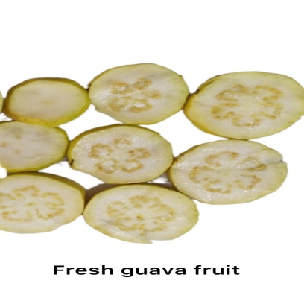  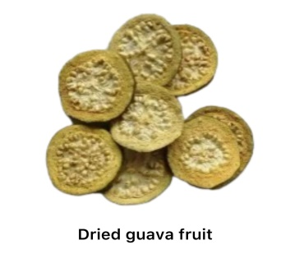  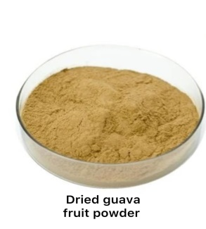

**Figure 1: Preparation of dried guava fruit powder**

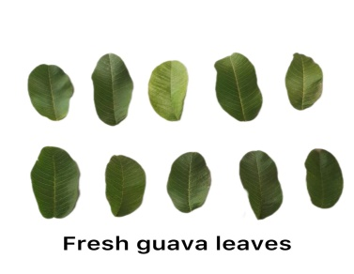  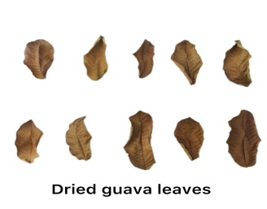  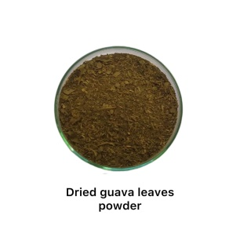

**Figure 2: Preparation of dried guava leaves powder**

* 1. **Estimation of Bioactive Compounds**

In this study, bioactive compounds like Total phenolic content, flavonoids, alkaloids, saponins, tannins and terpenoids were determined. The total phenolic content was assessed using the Folin-Ciocalteu method, while the flavonoid content was measured using the aluminum chloride method. Alkaloids, saponins, and tannins were quantified according to the standard procedures described in [11].

For determining terpenoid, 100 mg dried sample was taken and dissolved in 9 ml ethanol and left for 24 hours at room temperature. After this, Whatman filter paper was used to filter the solution. Then 10 ml of petroleum ether was used to extract the remaining filtrate. The ether extract was isolated and dried in pre-weighed glass vials and then ether was evaporated to determine the total terpenoid yield (%).

Formula used for calculation: (wi-wf/wi x 100)

Where, wi = initial weight of the sample and wf = final weight of the sample

1. **RESULTS AND DISCUSSION**

The bioactive compounds that were analyzed were saponins, tannins, terpenoids, alkaloids, flavonoids and total phenolic content.

**Figure 3: Comparative bioactive analysis of guava fruit and leaves**

* 1. **Flavonoids:** The flavonoid content of both guava fruit and leaves is depicted in figure 3 which shows the presence of high flavonoids content in guava leaves with 8.72±0.7 mg/g followed by the guava fruit with 7.65 mg/g. The study was conducted by Ademiluyi A O *et al*., 2016 [12] to compare the antihypertensive and antioxidant properties of phenolic extracts of guava fruit and leaves of different varieties in which the leaf and fruit extracts were used for analyses and the results showed that the leaf extract contain high flavonoids content with the values of 43.4 mg QAE/100g content of small white guava and 56.3 mg QAE/100g content in pink guava as compared to the fruit extract with the values of 36.7 mg QAE/100g of small white guava and 49.0 mg QAE/100g of pink guava.
  2. **Alkaloids:** The alkaloids content of guava fruit and leaves were evaluated and shown in figure 3 which states that the guava leaves contain high alkaloids content with 11.98±0.3 mg/g as compared to the guava fruit with 10.18 mg/g.
  3. **Saponins:** The saponin content present is guava fruit and leaves is shown in figure 3 and its value are represented in (%). The values show the presence of saponins content to be high in guava fruit with 0.5%±0.3 as compared to the guava leaves with 0.47%.
  4. **Tannins:** The presence of tannins content in guava fruit and leaves is shown in figure 3 and the values shows the high content in guava leaves with 265±0.4 mg/l as compared to the guava fruit with 251 mg/l.
  5. **Terpenoids:** The terpenoids content present in guava fruit and leaves are showed in figure 3, which shows the presence of high terpenoids content in guava fruit with 3.79±0.2 mg/g followed by the guava fruit with 3.04 mg/g.
  6. **Total Phenolic Content:** The total phenolic content present in guava fruit and leaves is shown in figure 3 and the value is determined in the terms of gallic acid as it was taken as the standard. The values the high presence of total phenolic content in guava leaves with 125±0.5 mg GAE/g as compared to the guava fruit with 97 mg GAE/g. Ademiluyi A O *et al*., 2016 [12] conducted the study to compare the antihypertensive and antioxidant properties of phenolic extracts of guava fruit and leaves of different varieties in which the lead and fruit extracts were used for analyses and the results showed that the leaf extract contain high total phenolic content with the values of 53.4 mg GAE/100g content of small white guava and 78.9 mg GAE/100g content in pink guava as compared to the fruit extract with the values of 44.8 mg GAE/100g of small white guava and 66.16 mg GAE/100g of pink guava.

1. **CONCLUSION**

The guava leaves are an abundant source of bioactive compounds with significant nutritional and medicinal value. This study highlights that guava leaves, often underutilized, contain higher levels of bioactive compounds such as flavonoids, alkaloids, tannins, and phenolics as compared to the fruit. These compounds exhibit various health-promoting properties, including antioxidant, antimicrobial, anti-inflammatory, and cardioprotective effects, supporting their potential use in functional foods, pharmaceuticals, and natural remedies. The findings emphasize the importance of integrating guava leaves into dietary practices to enhance overall health and manage various diseases. Further exploration and utilization of these bioactive compounds could pave the way for developing innovative health products.

**DISCLAIMER (ARTIFICIAL INTELLIGENCE)**

Authors declare that NO generative AI technologies such as Large Language Models (ChatGPT, COPILOT, etc.) and text-to-image generators have been used during the writing or editing of this manuscript.

**REFERENCES**

1. Khanna, S., Singh, P. and Chauhan, E.S. (2022). Nutritional analysis of Guava (Psidium guajava L.) and its incorporation in Bhakarwadi. Int. J. Food Ferment. Technol., 12(07): 117-120.
2. Kumar M, Tomar M, Amarowicz R, Saurabh V, Nair MS, Maheshwari C, Sasi M, Prajapati U, Hasan M, Singh S, Changan S. Guava (Psidium guajava L.) leaves: Nutritional composition, phytochemical profile, and health-promoting bioactivities. Foods. 2021 Apr 1;10(4):752. Borah A, Pandey SK, Haldar S, Lal M. Chemical composition of leaf essential oil of Psidium guajava L. from North East India. Journal of Essential Oil Bearing Plants, 2019; 22(1):248-253.
3. Khanna, S., Singh, P., & Chauhan, E. S. (2024). Yield of Bioactive Compounds from Guava Fruit and Leaves Using Green Extraction (Ultrasound-Assisted Extraction): A Comparative Study. *International Journal of Biochemistry Research & Review*, *33*(6), 637–642.
4. Ruksiriwanich W, Khantham C, Muangsanguan A, Phimolsiripol Y, Barba FJ, Sringarm K, Rachtanapun P, Jantanasakulwong K, Jantrawut P, Chittasupho C, Chutoprapat R. Guava (Psidium guajava L.) leaf extract as bioactive substances for anti-androgen and antioxidant activities. Plants. 2022 Dec 14;11(24):3514.
5. Sahal A, Chaudhary S, Hussain A, Arora S, Dobhal A, Ahmad W, Kumar V, Kumar S. A comprehensive review on the nutritional composition, bioactive potential, encapsulation techniques, and food system applications of guava (Psidium guajava L.) leaves. Grain & Oil Science and Technology. 2024 Dec 26.
6. Barbalho SM, Farinazzi-Machado FM, de Alvares Goulart R, Brunnati AC, Otoboni AM, Ottoboni BJ. Psidium guajava (Guava): A plant of multipurpose medicinal applications. Med Aromat Plants. 2012 May;1(4):1-6.
7. Díaz-de-Cerio E, Verardo V, Gómez-Caravaca AM, Fernández-Gutiérrez A, Segura-Carretero A. Exploratory characterization of phenolic compounds with demonstrated anti-diabetic activity in guava leaves at different oxidation states. International Journal of Molecular Sciences. 2016 May 11;17(5):699.
8. Jiang, L.; Lu, J.; Qin, Y.; Jiang, W.; Wang, Y. Antitumor effect of guava leaves on lung cancer: A network pharmacology study. Arab. J. Chem. 2020, 13, 7773–7797.
9. Khanna, S., Singh, P., Chauhan, P., & Chauhan, E. S. (2025). Medicinal and Nutritional Potential of Guava Leaves: A Natural Remedy for Health and Wellness. *Journal of Advances in Food Science & Technology*, *12*(1), 13–20.
10. Sampath Kumar NS, Sarbon NM, Rana SS, Chintagunta AD, Prathibha S, Ingilala SK, Jeevan Kumar SP, Sai Anvesh B, Dirisala VR. Extraction of bioactive compounds from Psidium guajava leaves and its utilization in preparation of jellies. AMB Express. 2021 Dec;11:1-9.
11. Singh P, Khanna S and Chauhan ES: Comparative analysis of bioactive compound extraction from beet greens: a study on the influence of solvents used in ultrasonic assisted extraction. Int J Pharm Sci & Res 2024; 15(8): 1000-07.
12. Ademiluyi AO, Oboh G, Ogunsuyi OB, Oloruntoba FM. A comparative study on antihypertensive and antioxidant properties of phenolic extracts from fruit and leaf of some guava (Psidium guajava L.) varieties. Comparative Clinical Pathology. 2016 Mar;25:363-74.