*Original Research Article*

**IMPACT OF HOLE TRANSPORTING LAYER (HTL) ON THE PERFORMANCE OF TIN-BASED PEROVSKITE SOLAR CELLS**

**Abstract**: Perovskites solar cells (PSC) constitutes of different thin layers deposited on top of a substrate. Hole Transporting Layer (HTL) plays a significant role on the efficiency of the device owing to its numerous advantages such as good conductivity, solution processable, and suitable energy level that matches with perovskite absorber layer. However, Spiro-OMeTAD is extremely expensive and suffers from low hole mobility. However, it is imperative to search for an alternative to the expensive Spiro-OMeTAD commonly used as HTL in PSC. In this work, the influence of various hole transporting layers (such as CuI, CuSCN, Cu2O, and PEDOT:PSS) on the electrical performance of methyl-ammonium tin-iodide based perovskite solar cells was numerically examined using Solar Capacitance (SCAPS) simulator. To optimize the device performance, the HTL and absorber layer thickness were varied and investigated. The simulation results show that the device performance strongly depends on the absorber layer thickness. Among the four selected HTLs, the best performance was achieved using Cu2O with Voc, Jsc, FF, and PCE of 0.9676 V, 32.8344 mA/cm2, 80.97 %, and 25.72 % respectively. The results obtained from this numerical investigation show the potential of fabricating efficient, inexpensive and stable tin-based perovskite solar cells with inorganic HTL.

**Keywords**: efficiency, Cu2O, thickness, tin-iodide, perovskite, solar cells.

**INTRODUCTION**: Perovskites solar cells (PSCs) are the fastest growing technology in photovoltaic research community due to its rapid increase in power conversion efficiency (PCE) from less than 4 % to about 25.2 % [1] in few years. This promising performance resulted from their distinctive properties including high absorption co-efficient, high charge carrier mobility, long diffusion length, and simple methods of fabrication [2, 3]. Perovskites solar cells (PSC) constitutes of different thin layers deposited on top of a substrate. Hole Transporting Layer (HTL) is one of the essential components in PSC. It plays a significant role on a device performance due to its numerous advantages such as good conductivity, solution processable, and suitable energy level that matches with perovskite absorber layer. However, Spiro-OMeTAD is extremely expensive and suffers from low hole mobility [4]. For HTL to perform this function of transporting holes to back contact, it must possess a valence band edge lying above the valence band edge of the perovskite active layer. Recently, studies have indicated that inorganic HTL are reported with long stability and high hole mobility than organic HTL [5 - 7]. Hence, the search for less expensive and more stable HTL for perovskite-based solar cells is imperative. The main aim of this work is to further explore a best alternative HTL to Spiro-OMeTAD in methyl-ammonium tin-iodide perovskite solar cells, a numerical simulation to investigate the influence of various HTL (such as CuI, CuSCN, Cu2O, and PEDOT:PSS) on the performance of the device in planar structure; FTO/TiO2/CH3NH3SnI3/HTL/Au was conducted using SCAPS. Furthermore, effect of HTL and absorber layer thickness and were varied, studied and discussed. The schematic arrangement of the device is shown in Figure 1.

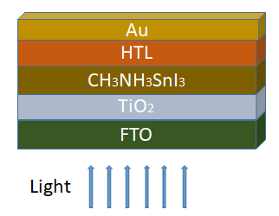

Figure 1. The schematic arrangement of the device

**2.0 MATERIALS AND METHOD**

**2.1 Materials**: In this numerical simulation, ~~a planar architecture; in planar structure; FTO/TiO~~~~2~~~~/CH~~~~3~~~~NH~~~~3~~~~SnI~~~~3~~~~/HTL/Au is adopted~~. FTO and Au were used as front contact and back contact respectively. TiO2 was acted as Electron Transporting Layer while, CH3NH3SnI3 used as a light absorbing material. The proposed HTLs in the PSCs were CuI, CuSCN, Cu2O, and PEDOT:PSS. A planar structure; FTO/TiO2/CH3NH3SnI3/HTL/Au is adopted in this work. The simulation input parameters of the above mentioned layers were carefully obtained from previous experimental and theoretical literature [7 - 13] and were tabulated in Table 1 and Table 2.

Table 1. Input parameters for simulation of CH3NH3SnI3 PSC

|  |  |  |  |
| --- | --- | --- | --- |
| **Parameters** | **FTO** | **TiO2** | **CH3NH3SnI3** |
| Thickness (nm) | 500 | 100 | 700 varied |
| Band gap (eV) | 3.5 | 3.2 | 1.3 |
| Electron affinity (eV) | 4.0 | 3.9 | 4.17 |
| Dielectric permittivity | 9.0 | 9.0 | 8.2 |
| CB effective density of state (cm-3) | 1 x 1019 | 1 x 1021 | 1 x 1018 |
| VB effective density of state (cm-3) | 1 x 1019 | 2 x 1020 | 1 x 1018 |
| Electron thermal velocity (cms-1) | 1 x 107 | 1 x 107 | 1 x 107 |
| Hole thermal velocity (cms-1) | 1 x 107 | 1 x 107 | 1 x 107 |
| Electron mobility (cm2s-1) | 100 | 20 | 1.6 |
| Hole mobility (cm2s-1) | 25 | 10 | 1.6 |
| Donor density (cm-3) | 2 x 1019 | 1 x 1019 | 0 |
| Acceptor density (cm-3) | 0 | 0 | 1 x 1016 |
| Defect density (cm-3) | 1 x 1014 | 1 x 1015 | 1 x 1015 |

Table 2 Input parameters for various HTL

|  |  |  |  |  |
| --- | --- | --- | --- | --- |
| **Parameters** | **CuI** | **CuSCN** | **Cu2O** | **PEDOT:PSS** |
| Thickness (nm) | 100 varied | 100 varied | 100 varied | 100 varied |
| Band gap (eV) | 2.98 | 3.4 | 2.17 | 2.2 |
| Electron affinity (eV) | 2.1 | 1.9 | 3.2 | 2.9 |
| Dielectric permittivity | 6.5 | 10 | 6.6 | 3.0 |
| CB effective density of state (cm-3) | 2.8 X 1019 | 1.7 X 1019 | 2.5 X 1020 | 2.2 X 1015 |
| VB effective density of state (cm-3) | 1.0 X 1019 | 2.5 X 1021 | 2.5 X 1020 | 1.8 X 1018 |
| Electron thermal velocity (cms-1) | 1.0 X 107 | 1.0 X 107 | 1.0 X 107 | 1.0 X 107 |
| Hole thermal velocity (cms-1) | 1.0 X 107 | 1.0 X 107 | 1.0 X 107 | 1.0 X 107 |
| Electron mobility (cm2s-1) | 0.00017 | 0.0001 | 80 | 0.02 |
| Hole mobility (cm2s-1) | 0.0002 | 0.1 | 80 | 0.0002 |
| Donor density (cm-3) | 0 | 0 | 0 | 0 |
| Acceptor density(cm-3) | 1.0 X 1018 | 1.0 X 1018 | 1.0 X 1018 | 3.17 X 1014 |
| Defect density (cm-3) | 1.0 X 1015 | 1.0 X 1014 | 1.0 X 1015 | 1.0 X 1015 |

**2.2 Numerical method**: This numerical simulation was performed via SCAPS (SCAPS 3.3.10 version) software. The parameters adopted from the software are AM1.5G with an incident power density of 1000 W/cm2, working temperature of 300 K, and frequency of $1.0 X {10}^{6} Hz$. SCAPS-1D was designed and developed at the department of Electronics and Information Systems (ELIS) of the University of Gent, Belgium [14]. The software can be freely obtained from the manufacturer based on request. It works by solving the fundamental semiconductor equations [15]. The simulation procedure is shown in Figure 2.

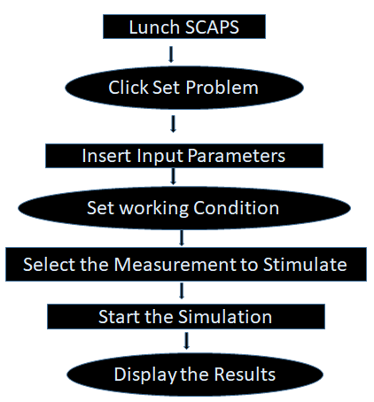

Figure 2. The simulation procedure

**3.0** **RESULTS AND DISCUSSION**

* 1. **Electrical Performance obtained with different HTLs**

Hole Transporting Layer is one of the essential components in perovskite solar cells. It plays a significant role on the efficiency of the device. The main function of HTL is to extract and transport the generated holes by the perovskite absorber layer to back contact (usually Au or Ag). Figure 3.1 shows the J-V curves of the PSCs with the four different HTLs. Furthermore, Table 2.1 tabulated the electrical outputs obtained. It could be seen from Table 2.1 that the device with the Cu2O achieves the highest power conversion efficiency with the electrical parameters; the best performance was achieved using Cu2O with Voc, Jsc, FF, and PCE of 0.9676 V, 32.8344 mA/cm2, 80.97 %, and 25.72 % respectively. Moreover, the PCE achieved by Cu2O is higher than the PCE attained by Spiro-OMeTAD as reported by [13]. This achievement resulted from the good properties of Cu2O such as high hole mobility, narrow band-gap, non-toxic and low cost [18, 19].

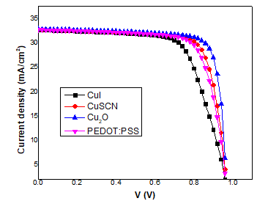

Figure 3.1. The J-V Curves of the devices with the various HTLs

Table 2.1.The device performance parameters obtained with various HTLs.

|  |  |  |  |  |
| --- | --- | --- | --- | --- |
| HTL | Voc (V) | Jsc (mA/cm2) | FF (%) | PCE (%) |
| CuI | 0.9701 | 32.6103 | 68.71 | 21.74 |
| CuSCN | 0.9681 | 32.6968 | 76.84 | 24.32 |
| Cu2O | 0.9676 | 32.8344 | 80.97 | 25.72 |
| PEDOT:PSS | 0.9682 | 32.6748 | 74.75 | 23.65 |

**3.2 Effect of HTL thickness on the device performance**

For the optimization of the device, the individual HTL thickness was varied from 100 nm to 500 nm and analyzed. Figure 3.2 shows the plotted J-V characteristic curves of the devices with the selected HTLs. Similarly, Tables, 3.1, 3.2, 3.3, and 3.4 represent the electrical outputs achieved using the chosen HTLs. From Tables 3.1 and 3.4, it was observed that the PCE gradually drop with increasing thickness of CuI and PEDOT:PSS. The decrease in FF is due to mainly the internal recombination occurred within the perovskite material originating from a short carrier lifetime from the holes as explained by [16]. Moreover, the results show that the CuSCN and Cu2O thickness has no significant effect on the electrical performance of the devices as the PCE relatively remain steady as the thickness increases.

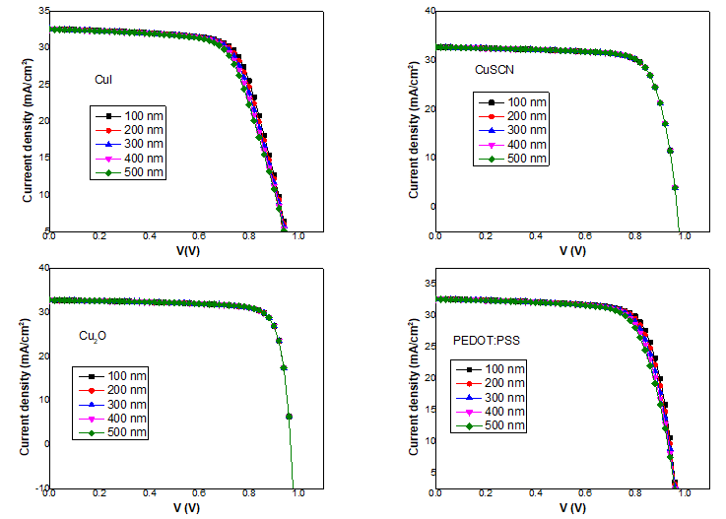

Figure 3.2. The plotted J-V characteristic curves of the devices with the selected HTLs.

Table 3.1. Effect of CuI thickness on the device performance

|  |  |  |  |  |
| --- | --- | --- | --- | --- |
| Thickness (nm) | Voc (V) | Jsc (mA/cm2) | FF (%) | η (%) |
| 100 | 0.9702 | 32.6205 | 69.52 | 22.00 |
| 200 | 0.9701 | 32.6103 | 68.71 | 21.74 |
| 300 | 0.9766 | 32.5998 | 67.40 | 21.46 |
| 400 | 0.9767 | 32.5893 | 66.64 | 21.19 |
| 500 | 0.9751 | 32.5786 | 65.83 | 20.91 |

Table 3.2. Effect of CuSCN thickness on the device performance

|  |  |  |  |  |
| --- | --- | --- | --- | --- |
| Thickness (nm) | Voc (V) | Jsc (mA/cm2) | FF (%) | η (%) |
| 100 | 0.9681 | 32.6968 | 76.84 | 24.32 |
| 200 | 0.9681 | 32.6968 | 76.84 | 24.32 |
| 300 | 0.9681 | 32.6968 | 76.83 | 24.32 |
| 400 | 0.9681 | 32.6967 | 76.83 | 24.32 |
| 500 | 0.9681 | 32.6967 | 76.83 | 24.32 |

Table 3.3. Effect of Cu2O thickness on the device performance

|  |  |  |  |  |
| --- | --- | --- | --- | --- |
| Thickness (nm) | Voc (V) | Jsc (mA/cm2) | FF (%) | η (%) |
| 100 | 0.9676 | 32.8339 | 80.97 | 25.72 |
| 200 | 0.9676 | 32.8344 | 80.97 | 25.72 |
| 300 | 0.9676 | 32.8349 | 80.97 | 25.72 |
| 400 | 0.9676 | 32.8353 | 80.97 | 25.72 |
| 500 | 0.9676 | 32.8357 | 80.97 | 25.73 |

Table 3.4. Effect of PEDOT:PSS thickness on the device performance

|  |  |  |  |  |
| --- | --- | --- | --- | --- |
| Thickness (nm) | Voc (V) | Jsc (mA/cm2) | FF (%) | η (%) |
| 100 | 0.9681 | 32.6839 | 75.58 | 23.92 |
| 200 | 0.9682 | 32.6749 | 74.75 | 23.65 |
| 300 | 0.9682 | 32.6653 | 73.87 | 23.36 |
| 400 | 0.9693 | 32.6556 | 72.96 | 23.10 |
| 500 | 0.9691 | 32.6457 | 72.10 | 22.81 |

* 1. **Effect of absorber layer thickness with different HTLs**

Effect of absorber layer thickness on the photovoltaic performance of the devices in different architectures with the various HTL was numerically investigated. The thickness of the CH3NH3SnI3 was varied from 300 nm to 1000 nm while the other input parameters kept constant. The plotted I-V curves are shown in Figure 3.3. The PV parameters achieved are tabularized in Tables 4 – 7. The results show that the VOC decrease with the increase in the absorber layer thickness. This is caused by increase in charge carrier recombination as the absorber layer thickness increases as described by [17]. Furthermore, the results indicate rapid increase in JSC with the increasing absorber layer. This significant increase in JSC is resulted from increase in the production of electron-hole pairs by the light absorber and consequently led to increment in the PCE.

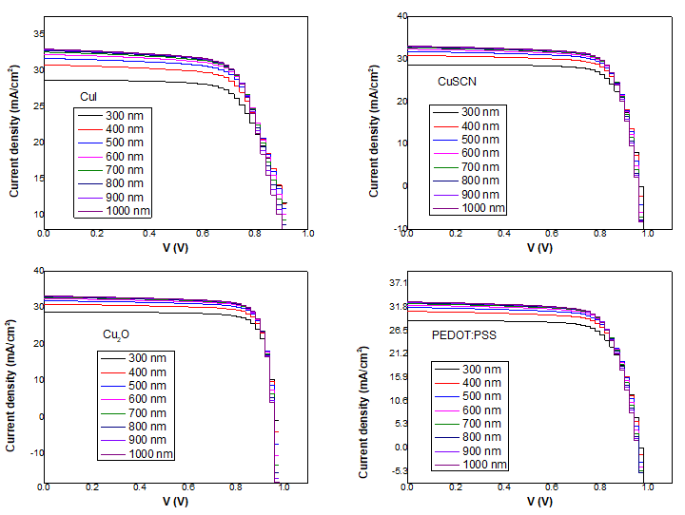

Figure 3.3. J-V curves of the devices with varied absorber layer thickness using different HTL

Table 4. Influence of absorber layer thickness with CuI as HTL

|  |  |  |  |  |
| --- | --- | --- | --- | --- |
| Thickness (nm) | Voc (V) | Jsc (mA/cm2) | FF (%) | η (%) |
| 300 | 0.9803 | 28.7125 | 68.83 | 19.37 |
| 400 | 0.9763 | 30.8450 | 68.71 | 20.69 |
| 500 | 0.9729 | 31.7561 | 68.93 | 21.30 |
| 600 | 0.9728 | 32.2873 | 68.76 | 21.60 |
| 700 | 0.9701 | 32.6103 | 68.71 | 21.74 |
| 800 | 0.9744 | 32.8121 | 68.18 | 21.80 |
| 900 | 0.9783 | 32.9413 | 67.71 | 21.82 |
| 1000 | 0.9757 | 33.0259 | 67.68 | 21.81 |

Table 5. Influence of absorber layer thickness with CuSCN as HTL

|  |  |  |  |  |
| --- | --- | --- | --- | --- |
| Thickness (nm) | Voc (V) | Jsc (mA/cm2) | FF (%) | η (%) |
| 300 | 0.9801 | 28.7195 | 76.92 | 21.65 |
| 400 | 0.9760 | 30.9054 | 76.62 | 23.11 |
| 500 | 0.9726 | 31.8366 | 76.86 | 23.80 |
| 600 | 0.9700 | 32.3696 | 76.91 | 24.15 |
| 700 | 0.9681 | 32.6968 | 76.84 | 24.32 |
| 800 | 0.9666 | 32.9029 | 76.73 | 24.40 |
| 900 | 0.9655 | 33.0355 | 76.63 | 24.44 |
| 1000 | 0.9648 | 33.1231 | 76.54 | 24.46 |

Table 6. Influence of absorber layer thickness with Cu2O as HTL

|  |  |  |  |  |
| --- | --- | --- | --- | --- |
| Thickness (nm) | Voc (V) | Jsc (mA/cm2) | FF (%) | η (%) |
| 300 | 0.9887 | 28.8212 | 81.52 | 22.20 |
| 400 | 0.9750 | 30.9596 | 80.96 | 24.44 |
| 500 | 0.9719 | 31.9502 | 81.04 | 25.16 |
| 600 | 0.9694 | 32.5054 | 81.03 | 25.53 |
| 700 | 0.9676 | 32.8344 | 80.97 | 25.72 |
| 800 | 0.9663 | 32.0357 | 80.89 | 25.82 |
| 900 | 0.9653 | 32.1620 | 80.83 | 25.87 |
| 1000 | 0.9646 | 33.2400 | 80.77 | 25.90 |

Table 7. Influence of absorber layer thickness with PEDOT:PSS as HTL

|  |  |  |  |  |
| --- | --- | --- | --- | --- |
| Thickness (nm) | Voc (V) | Jsc (mA/cm2) | FF (%) | η (%) |
| 300 | 0.9802 | 28.8209 | 74.90 | 21.16 |
| 400 | 0.9762 | 30.9264 | 74.60 | 22.52 |
| 500 | 0.9728 | 31.8267 | 74.82 | 23.17 |
| 600 | 0.9702 | 32.3515 | 74.84 | 23.49 |
| 700 | 0.9682 | 32.6748 | 74.75 | 23.65 |
| 800 | 0.9667 | 32.8789 | 74.64 | 23.72 |
| 900 | 0.9666 | 33.0102 | 74.45 | 23.75 |
| 1000 | 0.9657 | 33.0969 | 74.35 | 23.76 |

**CONCLUSION**

In this paper, a lead-free based perovskite solar cell in planar structure; glass/FTO/TiO2/CH3NH3SnI3/HTL/Au was successively designed and simulated using SCAPS-1D simulating software. HTL and CH3NH3SnI3 thicknesses were varied to investigate their effect on the photovoltaic parameters. The simulation results shown that the device performance strongly depends on the absorber layer thickness. Among the four selected HTLs, the best performance was achieved using Cu2O with Voc, Jsc, FF, and PCE of 0.9676 V, 32.8344 mA/cm2, 80.97 %, and 25.72 % respectively. Hence, the high performance displayed by Cu2O could be due to its properties such as band-gap (2.17 eV), electron affinity (3.2 eV), hole mobility (80 cm2s-1), and thickness ≥ 500 nm. The price of Cu2O is relatively low compared to that of Spiro-OMeTAD. 1 Kg of Cu2O cost $ 10 - $ 100. Conclusively, this numerical investigation shows the potential of fabricating efficient, inexpensive and stable tin-based perovskite solar cells with inorganic HTL. Based on the results obtained from this work, future research should be carried out on the impact of hole mobility and band-gap alignment of the selected HTLs on the electrical properties of lead-free perovskite solar cells.

**References**

[1] Pv magazine. [https://www.pv-magazine.com/2021/04/06/unist-epfl-claim-25-6-efficiency- world-record-for-perovskite-solar-cell/](https://www.pv-magazine.com/2021/04/06/unist-epfl-claim-25-6-efficiency-%09world-record-for-perovskite-solar-cell/) (Retrieved February 15, 2022).

[2] Chen, Q., Marco, N.D., Yang, Y., Song, T.B., Chen, C.C., Zhou, H., Yang, Y. (2015).Under the Spotlight: The Organic-Inorganic Hybrid Halide Perovskite for Optoelctronic Applications. *Nano Today*.10:355-396.

[3] Green, M.A, Ho-Baillie A, Snaith, H.J. (2014). The emergence of perovskite solar cells. *Nature Photonics.* 8(7):506–514.

[4] Vivo, P., Salunke, J.K. and Priimagi, A. (2017). Hole-Transporting Materials for Printable Perovskite Solar Cells,Materials, 10, 1087; doi:10.3390/ma10091087.

[5]. Liang, J.; Liu, J.; Jin, Z. (2017). All-Inorganic Halide Perovskites for Optoelectronics: Progress and Prospects. *Sol. RRL*, 1, 1700086.

[6] Yang, T.C.-J.; Fiala, P.; Jeangros, Q.; Ballif, C. (2018). High-Bandgap Perovskite Materials for Multijunction Solar Cells. *Joule*, 2, 1421–1436.

[7] Chen, H.; Xiang, S.; Li,W.; Liu, H.; Zhu, L.; Yang, S. (2018). Inorganic Perovskite Solar Cells: A Rapidly Growing Field. *Sol. RRL*, 2, 1700188

[7] Patel. P.K. (2012). Device simulation of highly efficient eco-friendly CH3NH3SnI3 perovskite solar cell. *Scientific reports*, 11,3082, doi:10.1038/s41598-021-828-w

[8] Baig, F.; Khattak, Y.H.; Marí, B.; Beg, S.; Ahmed, A.; Khan, K. (2018). Efficiency Enhancement of CH3NH3SnI3 Solar Cells by Device Modeling*. J. Electron. Mater*., 47, 5275 5282.

[9] Azri, F.; Meftah, A.; Sengouga, N.; Meftah, A. (2019). Electron and hole transport layers optimization by numerical simulation of a perovskite solar cell. *Sol. Energy*, 181, 372– 378.

[10] Minemoto, T.; Murata, M. (2014). Impact of work function of back contact of perovskite solar cells without hole transport material analyzed by device simulation. *Curr. Appl. Phys*., 14, 1428–1433.

[11] Teimouri, R.; Mohammadpour, R. (2018). Potential application of CuSbS2 as the hole transport material in perovskite solar cell: A simulation study. *Superlattices Microstructure*, 118, 116–122.

[12] Slami. A.; Bouchaour. M.: and Merad. L. (2020). Comparative Study of Modelling of Perovskite Solar Cell with Different HTM Layers*. International Journal of Materials*, vol. 7.

[13] Yongjin, G., Xueguang, Bi., Yucheng, L., Binyi, Q., Qingliu, L., Qubo,J. and Pei, M. (2020). Numerical Investigation Energy Conversion Performance of Tin-Based Perovskite Solar Cells Using Cell Capacitance Simulator. *Energies*, 13, 5907.

[14] Burgelman. M.; Decock. K.; Niemegeers. A.; Verschraegen. J.; Degrave. S. (2012). SCAPS Manual, Department of Electronics and Information System (ELIS), University of Gent, Belgium

[15] Movla, H. (2014). Optimization of the CIGS based thin film solar cells: numerical simulation and analysis. *Optik,* vol. 125, no. 1, pp. 67–70.

[16]Chen, Q.; Ni, Y.; Dou, X.; Yoshinori, Y. (2022). The Effect of Energy Level of Transport Layer on the Performance of Ambient Air Prepared Perovskite Solar Cell: A SCAPS-1D Simulation Study. *Crystals*, 12, 68. <https://doi.org/10.3390/cryst12010068>.

[17] Bag. A.; Radhakrishnan. R.; Nekovei. R. and Jeyakumar, R. (2020). Effect of absorber layer, hole transport layer thicknesses, and its doping density on the performance of perovskite solar cells by device simulation. *Solar Energy,* vol. 196, pp. 177–182.

[18] Nejand, B.A.; Ahmadi, V.; Gharibzadeh, S.; Shahverdi, H.R. (2016). Cuprous Oxide as a Potential Low-Cost Hole-Transport Material for Stable Perovskite Solar Cells. *ChemSusChem*, 9, 302–313.

[19] Wang, Y.; Xia, Z.; Liang, J.; Wang, X.; Liu, Y.; Liu, C.; Zhang, S.; Zhou, H. (2015).Towards printed perovskite solar cells with cuprous oxide hole transporting layers: A theoretical design. *Semicond. Sci. Technol*., 30, 054004.