***Original Research Article***

Development of IoT Smart Voltmeter for Real time Voltage Monitoring

**ABSTRACT**

A voltmeter capable of accurately measuring and providing remote monitoring for both AC and DC voltage is crucial in modern application, especially with the growing demand for IoT based devices. Real-time voltage measurement poses challenges, particularly in ensuring reliability and efficiency. This paper addressed these challenges by designing and constructing a wireless voltmeter incorporating an ESP32 microcontroller for wireless communication, a 7805-voltage regulator for stable power supply and PCB17 opto-coupler for electrical isolation and safety. The circuit design was simulated using Proteus software to verify its functionality and performance prior to physical implementation. The completed system successfully measured AC voltages in the range 2-250V and DC voltages between 3 -25V, achieving a minimal error margin after calibration. Voltage readings were wirelessly transmitted to the Blynk IoT platform, enabling seamless real-time monitoring via a mobile application. The system’s accuracy and reliability were validated through extensive testing, demonstrating its effectiveness as practical solution for modern voltage measurement.

***Keywords:*** *Design,Microcontroller,Remote,Development, Wireless, AC (alternating current) and DC (Direct Current) Voltage, measurement, IoT(internet of things)*

**INTRODUCTION**

Measurement provides a standard for everyday things and processes. Without the ability to measure, it would be difficult for scientists to conduct experiments or form theories. It is essential in farming, engineering, construction, manufacturing, commerce, and numerous other occupations and activities, hence plays a very important role in our lives (Bird, 2010) Measurement plays a crucial role in numerous scientific and engineering disciplines, enabling us to quantify and understand the physical properties of various phenomena. When conducting experiment(s) on electrical or electronics system it is essential to measure the fundamental electronic properties like resistance, voltage, and current, capacitance and inductance using appropriate measuring equipment, (Pawar and Ahire, 2023).

Electronic systems are made of circuits that contain a sequence of electronic components that are connected by wires to a power source, such as battery or main electricity. Electronic systems also involve the generation, transmission, processing, and storage of electronic signals or data. These signals can represent information, such as audio, video, or digital data, and are typically in the form of electrical voltages or currents, (Alamgir and Dev, 2015).The measurement of electronic signals is a critical aspect of working with electronic circuits and systems. It involves the quantitative analysis and characterization of various electrical parameters to understand the behavior and performance of electronic components, circuits, and systems. Some common electronic signals that are measured include voltage, current, resistance, frequency, and time, (Hui-feng and Xiao-Hua, 2013).

Electronic systems have two categories, which are analog and digital electronics systems. The analog system is a continuous-valued system which changes its output value linearly as the input value varies. An analog voltmeter is an example of a scale and pointer. A digital electronic system is one in which both the input and output values are discrete or quantized. This means that the values can only take on specific distinct values. In digital electronics signals are represented by binary digits (0 and 1), which are the only two output levels it may produce based on the input’s range of values. Bits, a term derived from “Binary Digit,” are the names given to these discrete values, (Malaric, 2011).

However, most electrical quantities are measured with a device called a meter. Among the most fundamental measurements is the determination of voltage, a key parameter in electrical and electronic systems. Voltage is measured with a voltmeter. Voltmeters are sometimes connected into a circuit to provide continuous monitoring of an electrical quantity. Voltmeters are devices specifically designed for voltage measurement, and have evolved significantly over the years, transitioning from analog to digital formats to provide greater precision, accuracy, and ease of use, (Saghaei, 2012)

A voltmeter is an electrical instrument used to measure the voltage, or electric potential difference, between two points in an electrical circuit. In every aspect of electrical engineering, from power systems to the voltage inside VLSI (Very large-scale integration) chips, voltage is a fundamental quantity. Voltmeter is connected in parallel to the part of the circuit where the voltage needs to be measured. By connecting the voltmeter in parallel, it creates a parallel branch with a very high resistance, which ensures that the current flowing through the voltmeter is minimal and doesn't significantly affect the circuit being measured. This allows the voltmeter to measure the voltage accurately without disturbing the circuit's operation. , (Muckelroy,2016).

When the voltmeter is properly connected, it displays the voltage difference between the two points in the circuit, usually in volts (V). The operating range and precision of a voltmeter can vary depending on the specific application and the requirements of the electrical circuit being measured. For example, in power systems, where high voltages are involved, voltmeters capable of measuring kilovolts (kV) may be required. On the other hand, in more sensitive applications such as measuring voltages inside VLSI (Very Large-Scale Integration) chips or nerve cells, the voltage levels are much lower and may be in the millivolt (mV) or microvolt (μV) range. (Malhotra *et al*, 2015)

A voltmeter can measure both AC and DC voltages. The measurement capability of a voltmeter depends on its design and specifications. Some voltmeters can specifically measure AC voltages, while some can measure DC voltages. However, some voltmeters are designed as dual-range voltmeters, capable of measuring both AC and DC voltages. They provide separate scales for AC and DC measurements, allowing the user to select the appropriate range for the type of voltage being measured. (Arora, 2014).

In this particular design, the voltmeter is optimized for measuring voltages within the range 0 - 25V for DC (Direct current) voltage and 2- 250V for AC (alternating current) voltage, which is a common range for many electronic devices and circuits. It has a precision of 10mV, meaning that the smallest distinguishable change in voltage it can detect is 10mV. This level of precision allows for accurate measurement and monitoring of voltage levels within the specified range. It's important to note that when using a voltmeter, it should be set to an appropriate voltage range that matches the expected voltage in the circuit being measured. Otherwise, using an incorrect range can damage the voltmeter or yield inaccurate readings, Voltmeters can be analog or digital, with digital voltmeters providing numerical readings, while analog voltmeters use a pointer or needle to indicate the voltage on a scale.

In recent times, the advent of wireless communication technologies has revolutionized the field of instrumentation by introducing wireless sensing and monitoring capabilities. This has led to the development of wireless sensors and transmitters that can transmit measurement data to a central monitoring system without the need for physical connections. Integrating wireless communication into voltmeters offers the potential for increased convenience, mobility, and flexibility in voltage measurement applications, (Gay, 2021)

This paper aims to develop IoT digital voltmeter to provide accurate voltage measurements wirelessly. By leveraging advancements in wireless communication technologies and digital signal processing techniques, this paper seeks to contribute to the development of innovative solutions in the field of measurement instrumentation.The successful implementation of a wireless voltmeter will enable improved efficiency, flexibility, and convenience in voltage measurement applications, paving the way for advancements in various sectors that rely on precise voltage measurements. The objectives of the design includes; To Develop an IoT voltmeter, write a firmware for microcontroller to establish remote monitoring and data transmission, implement wireless communication protocol (Wifi/GPRS), create a user friendly mobile Application for data visualization, and ensure high precision and accuracy in voltage measurement with an error margin of less than 1%.The scope of this paper is limited to the design, simulation and construction of a digital voltmeter with an IoT cloud interface. It is specifically built to measure AC and DC voltage without the capability to measure current or resistance. This restricts its application to scenarios where voltage measurement is required. The circuit design includes a voltage interface, battery management and temperature monitoring interface which can be viewed from both the LCD display and through the Blynk IoT cloud platform.

**RELATED WORK**

According to Hui-feng & Xiao-hua,. (2013), who Designed a simple DC digital voltmeter, which comprises of ATMEL 8-bit MCU (Main Computational Unit), AT89S52 and national semiconductor's ADC (Analog-to-Digital Converter) 0804, including a certain number of components. The system uses the AT89S52 MCU as the main controller, which processes the acquired analog voltage and realize LED (light-emitting diode) digital display by dynamic scanning. The voltmeter can measure the DC (direct current) voltage in the rage of 0 ∼ 5V and display the measurement results by the four LED digital tube. The IoT voltmeter shares similar components like Microcontroller, ADC, though a different kind of microcontroller with 10 bit ADC. The IoT voltmeter as well varies in measurement design and specification, as it has higher output range of measurement and dual range capability to measure both AC and DC voltages, unlike the simple DC digital voltmeter. They also varies at the medium at which the measured voltage is displayed.

However, due to higher 10 bit ADC in IoT Voltmeter, as compared to the lower 8 bit ADC in simple DC voltmeter, the IoT voltmeter gives higher precision and accuracy. The advantage of the the simple DC digital Voltmeter is that it has low cost due to fewer components

The IoT Voltmeter and Gao et al (2014) transmits data wirelessly and both has high precision and accuracy results. However, unlike the IoT voltmeter which can transmit data wirelessly over a long distance, the Labview-based voltmeter by Gao et al can only transmit data over 10-meter range.

The IoT voltmeter and Yang Jian-cheng (2012) are similar as a lot of Proteus simulation experiments are made, and the measurement results which the ordinary just hardware digital voltmeter cannot achieve are obtained. The experimental results from both show that the digital voltmeter using the combination method of software and hardware has the advantages of simple structure, high accuracy and low failure rate.

**material and methods**

The following materials were used in the development of IoT smart Digital Voltmeter; ESP32Dev Microcontroller, Voltage regulator sensor (7805), Opto-coupler, BC547 Transistors, Thermistor, LCD (Liquid crystal display), Piezo-Buzzer, 18650 Lithium-ion battery, TP4056 Battery charging module, DPDT Push button, Resistors, LED (Light emitting diode), Capacitors, Connecting wires, soldering iron, Metal alloy (63/37 Sn-Pb), Blynk IoT app, Proteus app.

**Hardware Design**

The Design of hardware circuit is composed of six parts: AC/DC input voltage, AC/DC reset circuit, and General reset circuit, and Power supply unit, Control unit (ESP32 Microcontroller), LCD display. The block diagram of the circuit design is as shown in Figure 1.

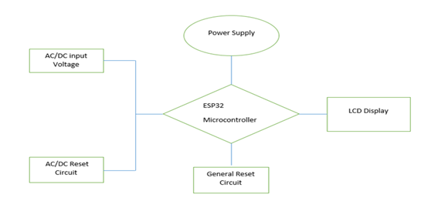

**Figure 1** Block Diagram of the Circuit Design

**Power supply section**: The power supply section is responsible for managing power for the entire device. This is the charging section of the device, it accepts a minimum to Maximum voltage of 5-5.1V to charge the battery of the device. In this section, the charging and distribution of voltage was configured. When the device is switched on, power moves in through the four diodes (IN4007) for rectification. The device's battery is rechargeable, so the four diodes provide the rectification for charging the battery. The 5V then moves to voltage regulator U2 (7805), which is used to regulate a 9V built-in battery. However, since 9V cannot pass U2 (7805), it has to be regulated from 9V to 5V to give an acceptable voltage.

**AC/DC Reset Circuit**: A push button/switch is used to toggle between AC/DC modes, preparing the device for the correct type of voltage reading. When the switch is pushed down, the connections move to the DC terminal and when pushed up it switches from DC to AC. The push switch is connected to the microcontroller through pin 11 and pin 5.

**General Reset Circuit:** This unit consists of Double pole, double throw push button. This is where you toggle between interface for voltage measurement, Temperature interface and Battery percentage interface.

**2.2.4 Control Unit:** This section consists of the microcontroller, ESP32Dev module which serves as the central control unit managing all operations based on an embedded algorithm. It’s powered through pin 3v3 (pin 1), which receives 5V supply. The output from the power supply section is fed into the control unit

When voltage signals from the measurement probe enters the Opto-coupler PCB17, it conditions it to allow only safe voltage levels to pass through. If the voltage is within acceptable range, it is sent from output 4 of the Optocoupler to pin 3v3 of the microcontroller. If it’s out of range, the voltage is diverted to the ground through output 3. Resistor R7 steps down voltage levels to ensure compatibility with the microcontroller. The inbuilt ADC converts analog voltage signals from the probe to digital data. It’s then passed to the LCD through pin 36 for data communication. The ESP32Dev’s Wi-Fi and GPRS capabilities allow real-time data transmission to a cloud-based configuration accessible through the Blynk IoT app for end users.

**LCD Display:** The voltage values processed by the microcontroller are sent to the LCD for display through pins 36 and 33 on the microcontroller. The two pins are connected to the data pins SCL of the LCD, handling the transmission of voltage values to be displayed. The LCD requires 5V power supply, which is regulated by the U2 7805 voltage regulator. The 7805 regulator ensures a consistent 5V output to power the LCD, preventing fluctuations that could affect display stability. Pin 38 to the VSS of the LCD is connected to the ground, while VDD is connected to the 5V output from the 7805 regulator. Pin 27 from the microcontroller is connected to the base of a BC547 transistor to a $1kΩ$ resistor. The BC547 acts as a switch in the setup. When the microcontroller sends a signal to pin 27, it triggers the BC547 transistor creating a closed circuit. The closed circuit activates the Buzzer (Buzz), which emits a beep to indicate that the device is powered on. Simultaneously, the LCD lights up, confirming that the device is active and ready for measurement display. The measured voltage can also be viewed through Blynk IoT app.

**Program Design:**

The program design employs the principle of modular program. The modular program includes initializing module, A/D conversion, and display module. The circuit was designed to replicate the voltmeter functionality in a simulated environment. The embedded code for the voltmeter was written in C++ within Arduino sketch. Since the ESP32 microcontroller’s online interface functionality could not be directly simulated in Proteus, the code was structured with careful consideration of the voltmeter’s operational requirements.

The code relies on Binary Coded Decimal (BCD) format to handle analog-to-digital conversions essential for the voltmeter’s accuracy and precision. BCD simplifies handling voltage values by converting binary representations into decimal format, aiding in accurate digital representation and display. This process is described through a flowchart given below.

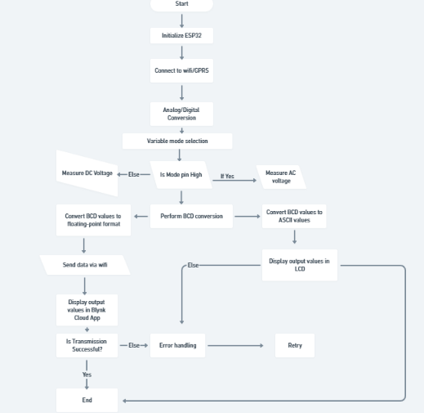

**Figure 2** Flow Chart of the Program Design

The BCD values are convert to either ASCII values or to floating point or numeric format. The ASCII values are sent to LCD for display, while the values in numeric format are sent to the Blynk cloud App. The ADC of the microcontroller uses 10bit. The analog voltage value (1.65) is multiplied by the analog-to-digital conversion result to get the floating point number, which is transmitted to the Blynk App. The display module is used to display the digital value processed by the Microcontroller.

**Real time voltage monitoring using Blynk IoT Mobile application interface**

The ESP32 reads and processes the digital voltage values, then transmits them to the Blynk cloud server via Wi-Fi. This is achieved by assigning the Blynk IoT virtual pins to the voltage data output from the microcontroller’s ADC. By aligning virtual pins with the ADC output, The ESP32effectively communicates voltage data to the Blynk platform.

To facilitate communication between the ESP32 and Blynk, the Blynk library is installed in the Arduino IDE. This library includes functions to establish the Wi-Fi connection, format the voltage data, and transmit it to the Blynk cloud where it’s stored and visualized on the Blynk app.

Custom code in the Microcontroller is written in Arduino IDE to collect voltage readings, process them and send them to the Blynk cloud. This code integrates the Blynk library to handle data transmission between the ESP32 and the Blynk app, ensuring continuous updates in real time.

The voltage readings from the ESP32 were compared with the values displayed on the Blynk app to ensure synchronization. Both the local voltmeter readings and the Blynk displayed values were confirmed to be accurate and in sync, verifying the reliability of the data transmission. A password and user name are usually assigned to the hotspot of the mobile phone where the Blynk app is installed and used for the remote data reading.

This integration allows real-time voltage monitoring on the Blynk app, providing an efficient and convenient IoT solutions for remote access to the voltage data.

**results and discussion**

Simulation and Error analysis

The designed voltmeter was simulated and debugged of error before transferring it into a hardware. The simulation results are somewhat consistent with the hardware results, with small variations due to rounding up and potential calibration issues. The absolute error values between the simulated and measured results of the IoT voltmeter range from 0.0004 to 0.0046. This indicates that the hardware measurements result of the designed voltmeter are very close to simulation results with minor deviations. The biggest error 0.0046 occurs at the highest voltage 10.20 suggesting a slight precision loss at higher voltages. It was also compared with the standard voltmeter in the market. However, the designed hardware voltmeter demonstrates a high level of accuracy, making it reliable for most applications. The table below shows the simulated IoT voltmeter, Measured (hardware) voltmeter and standard voltmeter in the market.

|  |  |  |  |
| --- | --- | --- | --- |
| Measured Iot Voltmeter Reading (V) | Simulated Iot Voltmeter Reading (V) | Standard Voltmeter Reading (V) | Actual Voltage Value (V) |
| 3.27 | 3.2704 | 3.26 | 3.00 |
| 4.40 | 4.4017 | 4.84 | 4.50 |
| 6.20 | 6.2037 | 6.48 | 6.00 |
| 7.41 | 7.4113 | 7.80 | 7.50 |
| 9.20 | 9.2024 | 9.81 | 9.00 |
| 10.20 | 10.2046 | 10.89 | 10.50 |

Table 1: DC Voltage Readings

|  |  |  |  |
| --- | --- | --- | --- |
| Measured Iot Voltmeter Reading (V) | Simulated IoT Voltage Reading (V) | Standard Voltmeter Reading (V) | Actual Voltage Value  (V) |
| 2.30 | 2.3147 | 2.00 | 2.00 |
| 4.30 | 4.3087 | 4.05 | 4.00 |
| 6.23 | 6.2336 | 6.10 | 6.00 |
| 8.23 | 8.2371 | 8.15 | 8.00 |
| 10.20 | 10.2061 | 10.20 | 10.00 |
| 12.21 | 12.2122 | 12.23 | 12.00 |

Table 2: AC Voltage Readings

**Quantization error represents the variation between the digitalized output voltage and the real analog input voltage**.

Accuracy can be determined using, Mean absolute error (MAE) calculation function;

$MAE= \frac{1}{n}\sum{\frac{V_{actual}-V_{measured}}{V_{actual}}}$,

Where, n is the number of voltage readings taken.

The lower the value of MAE, the higher the accuracy.

The Accuracy of the ADC’s digital output is within $±stepsize$ of the actual analog input voltage. This means that the digital representation might not exactly match the true analog voltage but will be within 1 step of it. For this prticular Voltmeter Design, the quantization error for the first reading of the DC voltage measurement is 12.207mV or 0.012027V, while the quantization error for the first AC voltage reading is $0.12207V⇒122.07mV$.

For linearity error, this function is used,

L $inearity Error= \frac{Maximum Deviation}{Full-scale range}x100$

The linearity error for DC Voltage reading is 1.05%, which suggest that the voltmeter measurement deviates from a perfect linear response by a maximum of 1.05% of the full-scale range of the actual value. This can be seen from the figure below.

**Figure 3:** Graph of average voltage value of measured IoT Voltmeter against actual Voltage value for DC

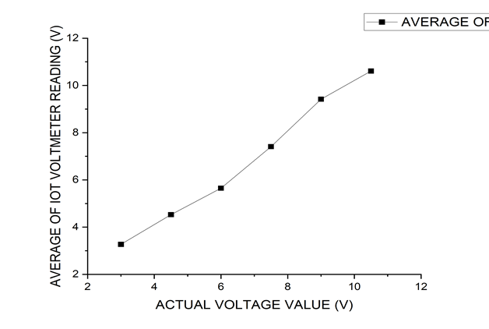

While the linearity error for AC voltage is 0.0378%. This can be seen in the figure below.

**Figure 4:** Graph of average voltage value of measured IoT Voltmeter against actual Voltage value for AC

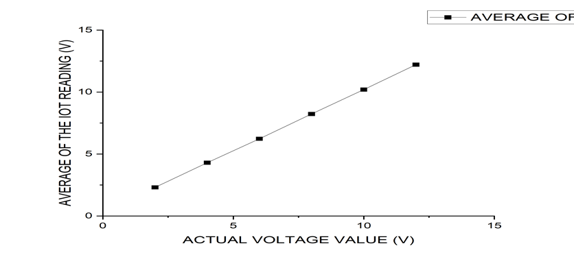

Full scale error can be calculated using, $\frac{Maximum Error}{Full-scale range}x100\%$

The full-scale error for DC voltage reading is 1.2%, which shows that the measurement error across the entire range is up to 1.2% of the full-scale, while the full-scale error for AC voltage is 0.125%.

To calculate efficiency, the function can be used;

$Efficiency\%=1-\frac{Linearity error}{Full scale range}x 100$

The efficiency of the device is 95.23%, and 99.98% for DC Voltage and AC voltage measurement respectively.

**Conclusion**

This paper has successfully presented a functional IoT based digital voltmeter capable of accurately measuring and transmitting AC and DC voltage wirelessly within a specified range. The stand out features includes a variable output voltage range of 3–25V for DC voltage and 2–250V for AC voltage, wireless capability for remote monitoring. Opto-coupler and voltage regulator for safety measures.The test carried out proved that the voltmeter is stable, accurate and precise. It can also successfully transmit data wirelessly to a cloud-based platform.

Disclaimer (Artificial intelligence)

Option 1:

Author(s) hereby declare that NO generative AI technologies such as Large Language Models (ChatGPT, COPILOT, etc.) and text-to-image generators have been used during the writing or editing of this manuscript.

Option 2:

Author(s) hereby declare that generative AI technologies such as Large Language Models, etc. have been used during the writing or editing of manuscripts. This explanation will include the name, version, model, and source of the generative AI technology and as well as all input prompts provided to the generative AI technology

Details of the AI usage are given below:

1.

2.

3.

**References**

Alamgir, M. S., & Dev, S. (2015). Design and implementation of an automatic voltage regulator with a great precision and proper hysteresis. International Journal of Advanced Science and Technology, 75(1), 21-32.

Arora, Jatin & Gagandeep, & Rawat, Sarvesh & Srinivasan, Karthik & Puri, Vikram. (2014). Design and development of digital voltmeter using different techniques. (pp. 1-5) 10.1109/ICGCCEE.2014.6922298.

Bauer, W., & Westfall, G. D. (2011). University physics (Vol. 5458). New York, NY: McGraw-Hill.

Baumann, P. (2022). Piezoelectric Buzzer. In Selected Sensor Circuits: From Data Sheet to Simulation (pp. 183-220). Wiesbaden: Springer Fachmedien Wiesbaden.

Bird, John (2010). [Electrical and Electronic Principles and Technology](https://books.google.com/books?id=A1tAHm_5sl0C). Routledge. pp. 63–76. [ISBN](https://en.wikipedia.org/wiki/ISBN_(identifier)) [978-0-08089056-2](https://en.wikipedia.org/wiki/Special:BookSources/978-0-08089056-2). Retrieved 2013-03-17.

Chowdhury, T., & Bulbul, H. (2010). Design of a temperature sensitive voltage regulator for AC load using RTD. International Journal of Engineering Science and Technology, 2(12), 7896-7903.

Dange, E., Hamsa, R., Madhuri, M., & Jain, A. (2021). PVDF-based piezoelectric alarm system. ISSS Journal of Micro and Smart Systems, 10(1), 83-86.

Duh, Y. S., Sun, Y., Lin, X., Zheng, J., Wang, M., Wang, Y, & Yu, G. (2021). Characterization on thermal runaway of commercial 18650 lithium-ion batteries used in electric vehicles: A review. Journal of Energy Storage, 41, 102888.

Ethman, Y., Elbastawesy, M., Emad, M., Younes, I., Al-Hosseny, B. I., Matar, O, & Badr, B. M. (2023, February). Design Low-Cost Battery Management System for Low Power Applications of Photovoltaic Systems. In 2023 IEEE Conference on Power Electronics and Renewable Energy (CPERE) (pp. 1-6). IEEE.

Floyd, T (2005) Electronic Devices (7th ed.). Upper Saddle River, New Jersey, USA: [Pearson Education](https://en.wikipedia.org/wiki/Pearson_Education). p. 10. [ISBN](https://en.wikipedia.org/wiki/ISBN_(identifier)) [0-13-127827-4](https://en.wikipedia.org/wiki/Special:BookSources/0-13-127827-4).

Gao, Feng & Liu, Liang & Zhao, Hong. (2014). LabVIEW-Based Intelligent Digital Voltmeter Design. Advanced Materials Research. 945-949. 2237-2240. 10.4028/www.scientific.net/AMR.945-949.2237.

Henao-Bravo E. E, Aponte-Roa D. A, and Benitez-Montalvan. Lu A (2018) Low-cost digital voltmeter with temperature-measuring and data logging," 2018 IEEE International Instrumentation and Measurement Technology Conference (I2MTC), Houston, TX, USA, 2018, pp. 1-5, doi: 10.1109/I2MTC.2018.8409798.

Hui-feng, Wang & Xiao-hua, Liu. (2013). Design of a simple DC digital voltmeter. 234-236. 10.1109/CECNet.2013.6703314.

Ihlenfeld, W. G. K., & Landim, R. P. (2016). The quantum vector digital voltmeter of INMETRO. In Journal of Physics: Conference Series (Vol. 733, No. 1, p. 012079). IOP Publishing.

Irom, F., Edmonds, L. D., Allen, G. R., & Rax, B. G. (2018). A method to separate proton damage in LED and phototransistor of optocouplers. IEEE Transactions on Nuclear Science, 65(8), 1553-1560.

Kuerten Ihlenfeld, Waldemar & Landim, Regis. (2016). The quantum vector digital voltmeter of INMETRO. Journal of Physics: Conference Series. 733. 012079. 10.1088/1742-6596/733/1/012079.

Lenicek, Ivan &Ilic, Damir & Malaric, Roman. (2008). Determination of High-Resolution Digital Voltmeter Input Parameters. Instrumentation and Measurement, IEEE Transactions on. 57. 1685 - 1688. 10.1109/TIM.2008.923786.

Malhotra, S., Verma, A., &Shrimali, T (2015) Design of Digital Voltmeter for AC Voltage Measurement Using PIC Microcontroller. International Journal of Science and Research (IJSR) ISSN (Online), 2319-7064.

Muckelroy, C. E. (2016). Multichannel digital voltmeter using the LM3S8962 evaluation board (Doctoral dissertation).

Nursusanto, U. (2022). Development of Monitoring Device for Battery Charge/Discharge Control as Electrical Energy Storage in Mini-Generating Systems. In Journal of Physics: Conference Series (Vol. 2406, No. 1, p. 012017). IOP Publishing.

Pawar, Jayshree & Ahire, Harshawardhan. (2023). Electrical and Electronics Measurements Systems. ISBN: 978-81-955629-8-5

Pingali, A., Paruchuri, S., Vailipalli, C., Devineni, V. K. D. B., & Shaik, H. (2023). Implementation of Artificial Neural Network-Based Signal Conditioning Circuit for a Temperature Transducer. In 2023 2nd International Conference on Futuristic Technologies (INCOFT*)* (pp. 1-7). IEEE.

Pratap Singh, G., Lehri, Y., Bhatia, L., & Sehgal, Y. (2022). Monitoring of lithium-ion cells using a microcontroller. Clean Energy, 6(1), 89-96.

Ramesh, P., Rajasekaran, P., Sengeni, D., & Rao, K. R. (2021). Digital meter. The opportunities of uncertainties: flexibility and adaptation needed in current climate, 224.

Saghaei, Hamed. (2012). Design and implementation of digital voltmeter using AVR microcontroller. 10.13140/RG.2.2.13271.27049.

Srivastava, V. M., Yadav, K. S., & Singh, G. (2012). Analysis of drain current and switching speed for SPDT switch and DPDT switch with the proposed DP4T RF CMOS switch. Journal of Circuits, Systems, and Computers, 21(04), 1250026.

Subramaniam, A., Ibrahim, N. A., Jabar, S. N., & Rahman, S. A. (2022). Driving cycle tracking device big data storing and management. International Journal of Electrical and Computer Engineering, 12(2), 1402.

Venugeetha, Y., Ashwini, C., & Sudheer Rao, Y. (2020). Implementation of LCD interfacing with ARM controller LPC2148. International Journal of Scientific & Technology Research, 9(03), 4638-4642.

White, Alexander D., Geun Ho Ahn, Kasper Van Gasse, Ki Youl Yang, Lin Chang, John E. Bowers, and Jelena Vučković. (2023), Integrated passive nonlinear optical isolators." Nature Photonics 17, no. 2143-149.

https://www.globalspec.com/learnmore/labware_test_measurement/multimeters_electrical_test_meters/analog_voltmeters)

<https://www.shivajicollege.ac.in/sPanel/uploads/econtent/ea0b74cfefa0180a78db6630fd5db2a4.pdf>

https://electricalworkbook.com/digital-voltmeter/