***Case report***

Adrenocortical Carcinoma in a Child: A Diagnostic Challenge and Clinical Outcome

|  |
| --- |
| AIMS - - The aim of this case is to highlight the clinical presentation, diagnostic challenges and treatment outcomes of adrenocortical carcinoma (ACC) in a paediatric patient. It aims to emphasize the importance of early recognition of ACC in children, particularly with signs such as virilization and precocious puberty and to illustrate the role of multimodal treatment, including surgical resection and chemotherapy in improving survival outcomes. The case further underscores the need for ongoing follow-up to monitor for recurrence, as well as the challenges in managing this aggressive malignancy.  PRESENTATION OF CASE - We present a rare case of A 16-month-old female who presented with precocious puberty, signs of Cushing’s syndrome, and a palpable mass in the left lumbar region. Diagnostic workup confirmed stage 3 ACC with a thrombus in the renal vein extending to the suprarenal inferior vena cava (IVC). The child underwent surgical resection of the tumour, followed by chemotherapy. Initially, the child showed significant improvement with virilization regressing after just one cycle of treatment. Despite discontinuing further treatment, the child remained asymptomatic for two years. However, relapse occurred, and the child ultimately succumbed to respiratory failure.    CONCLUSION- In children, the rapid onset of symptoms often leads to early detection; however, without prompt diagnosis and intervention, the condition can worsen rapidly. Diagnosis requires clinical evaluation, hormonal tests, imaging, and histopathological analysis. Complete surgical resection remains the gold standard, and while research into oncological treatments is ongoing, individualized care is essential, particularly for advanced or inoperable cases. Genetic testing can help assess prognosis for patients and their families. |

ABSTRACT

***Keywords****:* *Childhood adrenocortical carcinoma, Cushing's syndrome,* precocious puberty,virilizing tumors

INTRODUCTION - Adrenocortical carcinoma (ACC) is a rare and highly aggressive malignancy that arises from the adrenal cortex, affecting both adults and children, though with a notably higher incidence in Southern Brazil due to the prevalence of a specific TP53 mutation (p.R337H)[1]. ACC in children occurs at a rate of 0.2–0.3 cases per million annually, primarily affecting those under 5 years old, and represents about 0.2% of all paediatric cancers [2]. While the majority of adult cases are sporadic, a significant proportion of paediatric cases are linked to genetic syndromes such as Li-Fraumeni syndrome, Beckwith-Wiedemann syndrome, multiple endocrine neoplasia type 1 (MEN1) and familial adenomatous polyposis [3]. Around 50-80% of paediatric ACC cases involve genetic anomalies including mutations in the TP53 gene overexpression of insulin-like growth factors (IGF2) and other chromosomal anomalies like 11p15.5. ACC can lead to virilization due to excessive androgen production, causing symptoms like hirsutism, voice deepening, and menstrual irregularities in females. In pediatric cases, hormonal overproduction is a key feature, often presenting as precocious puberty, voice deepening, and rapid growth. [4]. Cushing syndrome, hyperaldosteronism, and feminization are less common though they can occur. Nonfunctional tumours, which do not secrete hormones are rarer in children and are often identified incidentally. The diagnosis involves a detailed endocrine workup, PET CT and biopsy. While CT and MRI are important for identifying the tumour, a comprehensive clinical approach including biochemical tests and histopathological evaluation is necessary for accurate diagnosis. The differentiation between benign adrenocortical adenomas and ACC remains challenging with metastasis being the only clear sign of malignancy. ACC typically metastasizes to the lungs, liver, and retroperitoneal space and the presence of metastasis significantly worsens prognosis.

Surgical resection often in the form of adrenalectomy, is the first-line treatment and offers the best chance for a cure. With timely and proper diagnosis, along with appropriate treatment, including surgery and adjuvant therapies such as chemotherapy and radiation many children with ACC can experience a full recovery. However, recurrence rates remain high and the 5-year survival rate for paediatric ACC is relatively low ranging from 46-55%. Newer research is investigating potential therapeutic strategies, including the use of tyrosine kinase inhibitors for cases involving epidermal growth factor receptor (EGFR) mutations. Additionally, genetic testing is recommended before surgery for personalized treatment strategies, and lifelong follow-up is necessary due to the risk of recurrence and metastasis. Although ACC is a challenging and aggressive cancer, early diagnosis and prompt intervention can greatly improve recovery chances. A multidisciplinary approach, involving various specialists, is crucial for effective treatment. Ongoing research into genetic markers, prognostic factors, and new therapies is key to improving outcomes and survival rates for ACC patients. In this communication, we present the clinical manifestations of an intriguing case of adrenocortical carcinoma (ACC) in a child who initially presented with precocious puberty. A detailed workup ultimately led to the diagnosis of ACC.

**CASE PRESENTATION –** A 16-month-old female child presented with a three-month history of generalized swelling and increased appetite.Along with that mother observed rapid weight gain, acne on the face and excessive hair growth on the face, back and pubic area (Figure 1). The child had no prior history of similar symptoms. She was the fourth offspring of non-consanguineous parents. The first and second children were healthy males while the third, a female, died at one month of age due to heart disease. There was no family history of obesity or cancer. The child’s birth was uncomplicated, with a vaginal delivery at term, weighing 3 kg and no NICU care required.

On physical examination, the child appeared alert, playful and comfortable. Vital signs within normal range: temperature 98.4°F, pulse 138 bpm, respiratory rate 32 breaths per minute and oxygen saturation 98% on room air. Blood pressure was 130/80 mmHg in the right upper limb and 138/80 mmHg in the lower limb. The child exhibited moon-like facies (Figure 2), acne, hirsutism, buffalo hump (Figure 3) and skin folds on both limbs. Abdominal examination revealed distension with a palpable mass in the left hypochondrium and left lumbar region, measuring 7x8 cm. The mass was firm, ill-defined and non-movable with respiration. There was no hepatomegaly, splenomegaly or fluid thrill.

Laboratory investigations showed normal haematological and biochemical parameters. However, hormonal testing revealed elevated levels of cortisol (45.4 mcg/dl), testosterone (10.8 nmol/l), ACTH (1055 mcg/dl) and DHEA (1000 mcg/dl) indicating hormonal overproduction. An abdominal ultrasound revealed a cystic lesion in the left suprarenal region, which was suggestive of a haemorrhagic cyst of the left adrenal gland. Contrast-enhanced CT imaging revealed a well-defined, lobulated, heterogeneously enhancing mass in the left suprarenal region with areas of internal necrosis and cystic change, along with peripheral calcifications. A filling defect was noted in the proximal left renal vein, extending to the suprarenal inferior vena cava (IVC), raising concern for malignancy most likely adrenocortical carcinoma (ACC) or neuroblastoma. PET-CT imaging further supported the diagnosis, demonstrating a hypermetabolic mass in the left suprarenal region, with central necrosis and extension into the renal vein and IVC (Figure 4). No regional or distant metastases were detected thus suggestive of primary adrenocortical carcinoma (ACC). Thus, suggesting stage 3 disease.Following a comprehensive workup, the child underwent left adrenalectomy (Figure 5), IVC thrombectomy, and left renal vein repair. Histopathological examination confirmed the diagnosis of left adrenocortical carcinoma, with a modified Weiss score of 7/7, indicating a high-grade malignant tumour. The final staging was determined to be stage 3 left adrenocortical carcinoma. Postoperatively, the child was treated with chemotherapy, which included cisplatin, doxorubicin, and etoposide. Remarkably, the virilization regressed after just one cycle of chemotherapy. The parents were counselled regarding the need for further cycles of chemotherapy. However, they decided to discontinue treatment and opted for discharge against medical advice, refusing to return for follow-up visits. Despite this, we maintained telephone follow-up to monitor the child's condition. The child remained asymptomatic and was doing well for two years and two months. Subsequently, the child developed gradually increasing abdominal distension, which was suggestive of disease relapse. The child was taken to a local hospital, where relapse of the disease was confirmed. Unfortunately, the child eventually succumbed to respiratory failure.

 Figure 1- Pubic hair

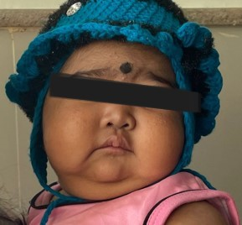 Figure 2- Moon-like facies

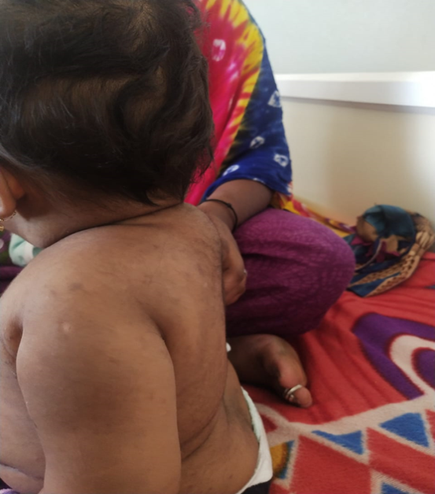 Figure 3- buffalo hump

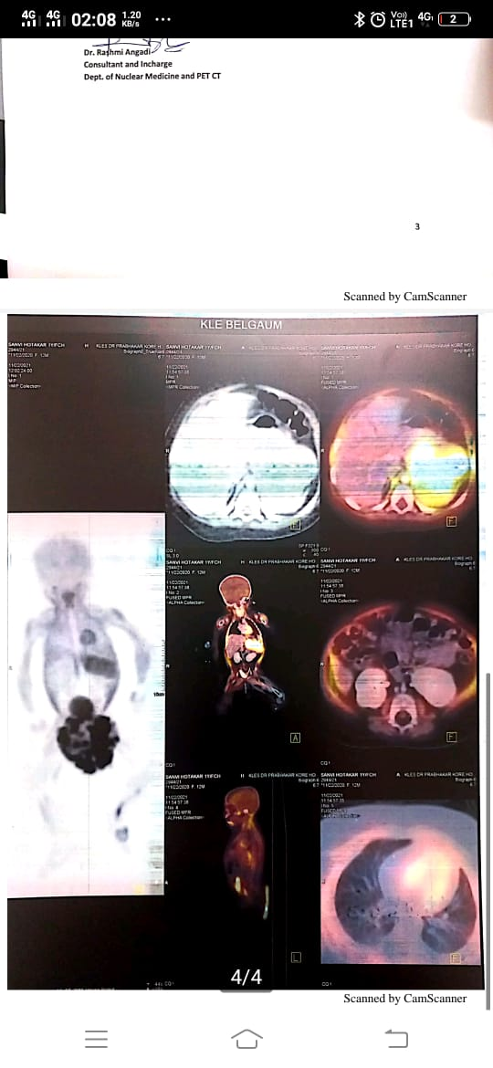 Figure 4 – PET CT report

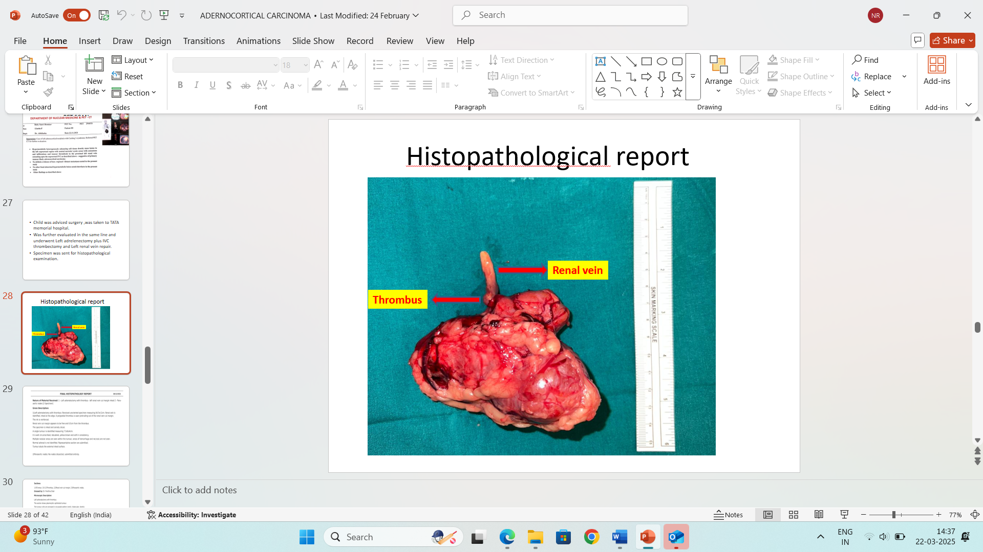  
FIGURE 5 – Gross specimen of Adrenalectomy

DISCUSSION – Adrenocortical carcinoma (ACC) is a rare and aggressive paediatric cancer, comprising only 0.2% of all childhood malignancies [6]. The adrenal gland in children can give rise to three main types of tumours: neuroplastic tumours, pheochromocytomas and adrenocortical tumours (ACT), with ACC being the malignant form originating from the adrenal cortex [5]. The incidence of paediatric ACC is low, at 0.2-0.3 cases per million annually, but there is a notably higher incidence in southern and southeastern Brazil, likely due to the TP53 p.R337H mutation [7]. This regional genetic predisposition underscores the importance of genetic and environmental factors in ACC development, highlighting the need for focused research to improve early detection, prevention and treatment strategies for this rare malignancy.Regarding the pathophysiology of ACC, tumorigenesis is mediated by β-catenin, insulin-like growth factors, p53/Rb signalling and chromatin remodelling processes.Common benign causes of precocious puberty in young children include familial sexual precocity,premature activation of the hypothalamic-pituitary-gonadal axis, and benign ovarian or adrenal tumours. In contrast, malignant causes like adrenal cortical carcinoma (ACC) typically present with rapid progression, virilization, abdominal mass, and accelerated bone age. In our patient, the swift onset of symptoms, including a rapidly growing mass and significant hormonal excess, raised suspicion for a malignant cause, distinguishing ACC from benign conditions. The early onset and hormone-mediated virilization suggest the tumour’s origin in the fetal zone of the adrenal gland. ACC in children is often hormonally active, leading to excessive production of glucocorticoids and androgens, which is reflected in our patient’s signs of both glucocorticoid excess (e.g., moon facies, buffalo hump) and androgen excess (e.g., acne, hirsutism), complicating diagnosis and management [8].

Diagnosis of adrenal tumours can be established through pathological features, immunohistochemical markers, reticulin histochemical staining and imaging findings. Elevated levels of cortisol, testosterone, DHEA and ACTH, combined with physical symptoms, raised suspicion for a hormonally active adrenal tumour, which was confirmed by imaging studies [9]. Imaging plays a crucial role in distinguishing between benign and malignant lesions, as well as metastatic and non-metastatic conditions, helping to minimize the need for invasive procedures. The Wieneke criteria (WC) is a strong predictor of clinical outcomes, and the presence of vena cava invasion and peri-adrenal extension is 100% specific for diagnosing adrenal cortical neoplasms [10]. In cases of adrenal masses showing necrosis and calcifications, abdominal ultrasound and CT scans are essential for confirming diagnoses like Adrenal Cortical Carcinoma (ACC) [11]. CT images of ACC typically show heterogeneous enhancement, often peripheral or rim-shaped, due to areas of haemorrhage or necrosis within the tumour. In some cases, particularly in children, the tumour may be smaller than 5 cm and appear more regular in shape, which can occasionally lead to confusion with adenomas.

In our case, imaging studies revealed a mass in the left suprarenal region with peripheral calcifications, necrosis and extension into the renal vein and inferior vena cava (IVC), which is a common finding in paediatric ACC. Similar imaging features, including heterogeneous enhancement and extension into vascular structures have been reported in other paediatric cases of ACC, reinforcing the diagnostic utility of imaging modalities like CT and PET-CT in detecting this malignancy. These imaging findings are consistent with the aggressive nature of ACC, as it often presents with local invasion into adjacent structures, as observed in our patient and in the literature.The prognosis for paediatric ACC largely depends on the stage at diagnosis, with early-stage tumours typically offering a better outcome. In our case, the child was diagnosed with stage 3 ACC according to WC, which usually carries a less favourable prognosis compared to earlier-stage tumours.

However, the child successfully underwent surgical resection, including left adrenalectomy, IVC thrombectomy and renal vein repair, followed by chemotherapy with cisplatin, doxorubicin, and etoposide. This multimodal approach aligns with standard treatment protocols for high-risk paediatric adrenal cortical carcinoma (ACC), as seen in other studies. Notably, the child showed a remarkable response to chemotherapy with complete resolution of virilization after just one cycle. This rapid response contrasts with reports, such as those by Guruge et al. (2020), where children with advanced-stage ACC typically exhibit slower or less dramatic responses. Guruge observed that these children often require more intensive chemotherapy and experience longer recovery periods.

Despite the initial success, the family later decided to discontinue further treatment, opting against additional chemotherapy cycles. However, for two years following treatment, the child remained asymptomatic and was doing well, with no signs of recurrence. This period of remission highlights the potential benefits of early diagnosis and aggressive multimodal therapy. Eventually, the child succumbed to the disease, but the two years of remission without recurrence stand in contrast to other cases, such as Coral-Rivera et al. (2017), where long-term follow-up was less definitive.

**Conclusion-** Early diagnosis of paediatric adrenal cortical carcinoma (ACC) is crucial for improving outcomes. Timely recognition of clinical signs, such as premature pubarche and Cushing’s syndrome, combined with appropriate hormonal testing and imaging, facilitates prompt intervention. Surgical resection remains the gold standard, with oncological treatments tailored to the individual patient. Genetic testing plays a key role in assessing prognosis and identifying familial risks. Early detection and intervention are essential for enhancing survival and long-term prognosis in paediatric ACC.

Ethical Approval:

As per international standards or university standards written ethical approval has been collected and preserved by the author(s).

Consent

All authors declare that ‘written informed consent was obtained from the patient and parents for publication of this case report and accompanying images. A copy of the written consent is available for review by the Editorial office/Chief Editor/Editorial Board members of this journal.

Disclaimer (Artificial intelligence)

Option 1:

Author(s) hereby declare that NO generative AI technologies such as Large Language Models (ChatGPT, COPILOT, etc.) and text-to-image generators have been used during the writing or editing of this manuscript.

Option 2:

Author(s) hereby declare that generative AI technologies such as Large Language Models, etc. have been used during the writing or editing of manuscripts. This explanation will include the name, version, model, and source of the generative AI technology and as well as all input prompts provided to the generative AI technology

Details of the AI usage are given below:option1

1.chat gpt

2.

3.

References -

1. Management of adrenal tumours in paediatric patients [Internet]. ClinicalKey. [cited 2024 Aug 12]. Available from: https://www.clinicalkey.es/#!/content/playContent/1-s2.0S1055320720301071?returnurl=https:%2F%2Flinkinghub.elsevier.com%2Fretrieve%2Fpii%2FS1055320720301071%3Fshowall%3Dtrue&referrer=https:%2F%2Fpubmed.ncbi.nlm.nih.gov%2F.

2. Brondani VB, Fragoso MCBV. Pediatric adrenocortical tumor - review and management update. Curr Opin Endocrinol Diabetes Obes. 2020;27(3):177–86.

3. Pediatric adrenocortical tumors [Internet]. ClinicalKey. [cited 2024 Aug 12]. Available from: https://www.clinicalkey.es/#!/content/playContent/1-s2.0S1521690X20300750?returnurl=https:%2F%2Flinkinghub.elsevier.com%2Fretrieve%2Fpii%2FS1521690X20300750%3Fshowall%3Dtrue&referrer=https:%2F%2Fpubmed.ncbi.nlm.nih.gov%2F.

4. Pamporaki C, Redlich A, Taïeb D, Pacak K. Editorial: Pediatric adrenal neoplasms. Front Endocrinol (Lausanne). 2023;14:1227835.

5. Riedmeier M, Decarolis B, Haubitz I, Müller S, Uttinger K, Börner K, et al. Adrenocortical carcinoma in childhood: a systematic review. Cancers (Basel). 2021;13(21):5266.

6. Jain V, Sehgal M, Dhua A, Bakhshi S, Kandasamy D, Mani K, et al. Adrenocortical neoplasms in children: treatment and outcomes. J Indian Assoc Pediatr Surg. 2022;27(2):157–62.

7. Naotunna NPGCR, Siriwardana HVDN, Lakmini BC, Gamage DS, Gunarathna S, Samarasinghe M, et al. Adrenocortical tumors in children: Sri Lankan experience from a single center, and a mini review. J Med Case Rep. 2023;17:137.

8. Ilanchezhian M, Varghese DG, Glod JW, Reilly KM, Widemann BC, Pommier Y, et al. Pediatric adrenocortical carcinoma. Front Endocrinol (Lausanne). 2022;13:961650.

9. d'Amuri FV, Maestroni U, Pagnini F, Russo U, Melani E, Ziglioli F, et al. Magnetic resonance imaging of adrenal gland: state of the art. Gland Surg. 2019;8(Suppl 3):S223–32.

10. Gan W, Han X, Gong Y, Yang Y, Wang C, Zhang Z. Diagnostic and prognostic assessments of adrenocortical carcinomas by pathological features, immunohistochemical markers and reticular histochemistry staining. Diagn Pathol. 2024;19(1):71.

11. Lopez-Nunez O, Virgone C, Kletskaya IS, Santoro L, Giuliani S, Okoye B, et al. Diagnostic utility of a modified reticulin algorithm in pediatric adrenocortical neoplasms. Am J Surg Pathol. 2024;48(3):309–16.