Case report

Multisystem involvement in a rare case of Histiocytosis lymphadenopathy plus syndrome

**ABSTRACT**

**Aim**- The aim of this case report was to understand the pleomorphic nature of this rare syndrome and to create awareness regarding the need for multidisciplinary approach towards this disease.

**Presentation of Case**- We report a case of a 5 year 9 month old child, who presented with megaloblastic anemia, bilateral sensorineural hearing loss, antibody negative diabetes mellitus, hepatosplenomegaly and short stature with mitral regurgitation. Thorough laboratory and genetic evaluation confirmed the diagnosis of histiocytosis lymphadenopathy plus syndrome. Child was started on immunomodulators along with other supportive treatment.

**Discussion**- Histiocytosis lymphadenopathy plus syndrome is a rare genetic disorder, caused by mutation in the SLC29A3 gene which encodes for the hENT3 transporter. This transporter is found mainly in lysosomal and mitochondrial membrane.It is characterized by symptoms such as hyperpigmentation, hypertrichosis, hepatosplenomegaly, hearing loss, hypogonadism, hyperglycemia, and heart-related issues. Due to overlapping clinical features with various other disorders, this syndrome can be easily missed.

**Conclusion**- Early diagnosis and treatment is the key to prevent and manage the multisystem complications associated with this rare syndrome.

*Keywords: H syndrome, SLC29A3, diabetes mellitus, megaloblastic anemia, hepatosplenomegaly*

1. **INTRODUCTION**

Histiocytosis-lymphadenopathy plus is a category of disorders, characterized by histiocytosis, which includes conditions like H-syndrome, Faisalabad histiocytosis, Pigmented hypertrichosis with insulin-dependent diabetes mellitus syndrome (PHID syndrome), and sinus histiocytosis with extensive lymphadenopathy (1). H-syndrome is a rare genetic disorder first recognized in 2008 in Arab families (2). There have been about 100 reported cases, including individuals of Arab descent, with an estimated incidence of 1 in 1,000,000 (3). It is caused by mutations in the SLC29A3 gene, which affects the Human Equilibrative Transporter 3 (hENT3), leading to issues in nucleoside transport and nucleotide synthesis (9, 10). It is characterized by symptoms such as hyperpigmentation, hypertrichosis, hepatosplenomegaly, hearing loss, hypogonadism, hyperglycemia, and heart-related issues (1). Due to the pleomorphic nature of this disease with overlapping clinical features with various other disorders like Torg-Winchester syndrome, POEMS syndrome, and Rosai-Dorfman disease, it is often misdiagnosed (4). There is paucity of literature regarding this rare but potentially treatable syndrome. We report a case of a 5 year 9 month old child who presented with Type 1 diabetes mellitus and megaloblastic anemia and was eventually diagnosed as a case of Histiocytosis lymphadenopathy plus syndrome after thorough laboratory and genetic workup. This case report is an attempt to create awareness amongst the practising paediatricians regarding the requirement of multidisciplinary approach to address the heterogenous symptoms and complications of the syndrome to ensure early diagnosis which can reduce morbidity associated with this rare syndrome.

1. **PRESENTATION OF CASE**

A 5 year 9 month old female child, born out of 3rd degree consanguineous marriage, was referred to pediatric hematology OPD for the evaluation of transfusion dependent anemia. The child had received multiple blood transfusions, almost 6-7 times in the last 1 year. The child was diagnosed with antibody negative diabetes mellitus, at 1 year of age and was on Insulin treatment since then. Mother gave history of child being hard of hearing and having speech delay. Gross and fine motor milestones were appropriate for age.

On anthropometric examination, child’s height was 96 cms (less than 3rd centile), weight was 13 kgs (less than 3rd centile) and BMI was 14.11 kg/m2 with head circumference of 45cms. Hence the child was underweight, had short stature with microcephaly. On general physical examination, child had pallor and knuckle pigmentation. Per abdomen examination revealed presence of hepatosplenomegaly (liver span being 11cms with grade 2 splenomegaly), with normal external genitalia. On auscultation, pansystolic murmur was heard at the apex of the heart. Other systems were normal. Blood investigations showed severe anemia, with increased MCV levels and macrocytic picture on peripheral smear. Bone marrow aspiration and biopsy report revealed megaloblastic hypercellular marrow with normal megakaryocyte series with myeloid series showing giant metamyelocytes.

As the child had persistent high blood sugar values, pediatric endocrinologist opinion was taken and insulin dose was titrated accordingly. 2D ECHO revealed Mitral regurgitation. In view of hearing impairment, ENT evaluation was done and child was found to have bilateral sensorineural hearing loss.

These features of megaloblastic anemia, sensorineural hearing loss and Type 1 diabetes mellitus, were fitting into the classical triad of Thiamine responsive megaloblastic anemia. Hence, child was started on thiamine and vitamin B12 supplementation. Whole exome sequence (WES) was sent to confirm the diagnosis. It was reported as homozygous mutation in the gene SLC29A3 at exon 6 with variant nomenclature being c.1220_1221del (p.Val407GlyfsTer32), thus leading to a diagnosis of Histiocytosis lymphadenopathy plus syndrome. Parents were counselled regarding the morbidities associated with this rare syndrome and the need for multidisciplinary care and regular follow up to reduce morbidity and ensure a good quality of life.

1. **DISCUSSION**

In this study we present a case of Histiocytosis lymphadenopathy plus syndrome, who had presented to us with insulin dependent diabetes mellitus, hepatosplenomegaly, bilateral sensorineural hearing loss, cardiac abnormalities- mitral regurgitation, severe anemia and short stature.

H syndrome is a rare condition, first described by Molho- Pessach et al in 2008, and only few hundred cases have been reported since then (2). It is an autosomal recessive disorder, mainly seen in people from the Middle East, Asia, Europe, and Africa. On thorough review of literature, very few cases have been reported from India so far. There is no clear age and gender preference for the condition. It is caused by a mutation in the SLC29A3 gene, which encodes for the hENT3 transporter (1). This transporter is found mainly in lysosomal and mitochondrial membrane. The widespread presence of these organelles throughout the body, helps to explain the variety of symptoms observed in H syndrome (4). The hallmark skin manifestations like indurated hyperpigmentation on the inner thighs and genitalia, along with hypertrichosis are key to diagnosis, but the syndrome can also present with a range of other symptoms, such as insulin-dependent diabetes, hepatosplenomegaly, short stature, hypogonadism, camptodactyly, hearing loss, microcytic hypochromic anemia, hypothyroidism, and hypertriglyceridemia. (1-4)

Our patient did not have the classical skin manifestations of hypertrichosis and hyperpigmentation. Thus, conditions that were not present in our patient, can present over time and hence, should be monitored periodically. Our patient also presented with macrocytic anemia instead of characteristic microcytic anemia. The definitive diagnosis can be made using whole exome sequencing, where mutations in the SLC29A3 gene can be detected.

Bolze et al observed that sensorineural hearing loss and hepatosplenomegaly occur in approximately half of the patients with H syndrome (5). Several studies have highlighted that the hallmark features of hyperpigmentation and hypertrichosis, are the most common clinical manifestations in individuals with H syndrome and should be regarded as pathognomonic signs of the condition (2). El-Bassyouni HT et al, reported a case that presented with fever, recurrent joint pain, hyperpigmentation and hypertrichosis of the inner thigh skin along with sensorineural hearing loss and amyloidosis which was thought to be a case of Muckle–Wells syndrome initially. However, presence of a positive consanguinity, with classical skin manifestations and presence of hepatosplenomegaly and microcytic hypochromic anemia led to a diagnosis of H syndrome (6). In another case reported by Elif Arik et all, child had presented with pericardial effusion with sensorineural hearing loss, arthralgia, short stature and lymphadenopathy. No skin changes were present. Genetic testing revealed mutation in SLC29A3 gene and hence diagnosis of Histiocytosis lymphadenopathy plus syndrome was made (7).

Study by **Hiller et al** offers an in-depth review of th**e radiological spectrum of this syndrome,** emphasizing the **skeletal abnormalities** that are often observed in affected individuals. This study concluded that skin thickening along with subcutaneous fat infiltration and deformities of the hands and feet are typical for H syndrome (8).

Treatment of this rare syndrome mainly includes symptomatic treatment and the use of immunomodulating agents (4). Immunomodulators like steroids, mycophenolate mofetil, tocilizumab (recombinant monoclonal antibody IL-6 receptor inhibitor), methotrexate, cyclosporine and cyclophosphamide can be used to treat H syndrome. Corticosteroids are frequently used, either by themselves or in conjunction with other drugs (4). Steroid sparing agents like Mycophenolate mofetil helps to decrease the joint stiffness and hyperpigmentation. Some patients have had short-term alleviation with the use of methotrexate and cyclophosphamide (4). Supportive management like hearing aids, monitoring child’s growth and nutrition, correcting the cardiac complications etc. is another aspect of treatment. We could not start steroids for our patient because of the high blood sugar levels. Our patient was put on mycophenolate mofetil and regular follow up is needed to note the response to the treatment.

1. **CONCLUSION**

In conclusion, a multidisciplinary approach is needed to address the heterogenous symptoms and complications of this syndrome. Early diagnosis and treatment is the key to prevent and manage the complications associated with this rare syndrome and regular follow-up is necessary for improving long-term health.

Consent

As per international standards, parental written consent has been collected and preserved by the author(s).

**ETHICAL APPROVAL**

As per international standards or university standards written ethical approval has been collected and preserved by the author(s).

**DISCLAIMER (ARTIFICIAL INTELLIGENCE)**

Author(s) hereby declare that NO generative AI technologies such as Large Language Models (ChatGPT, COPILOT, etc.) and text-to-image generators have been used during the writing or editing of this manuscript.

**COMPETING INTERESTS**

Authors have declared that no competing interests exist.

References

Mori K. S., Balachandran K., Asirvatham A. R., & Mahadevan S. (2021). ‘H syndrome’: a multisystem genetic disorder with cutaneous clues. BMJ Case Reports, 14(5), e238973.

Molho-Pessach V., Agha Z., Aamar S., et al. (2008). The H syndrome: a geno-dermatosis characterized by indurated, hyperpigmented, and hypertrichotic skin with systemic manifestations. Journal of the American Academy of Dermatology, 59(1), 79–85

Molho-Pessach V., Lerer I., Abeliovich D., Agha Z., Abu Libdeh A., Broshtilova V., et al. (2008). The H syndrome is caused by mutations in the nucleoside transporter hENT3. American Journal of Human Genetics, 83(4), 529-534.

Hamad A., Elwaheidi H., Salameh F., Alyahya M., El Fakih R., & Aljurf M. (2024). H syndrome: A histiocytosis-lymphadenopathy plus syndrome. A comprehensive review of the literature. Hematology/Oncology and Stem Cell Therapy, 17(3), 159-167.

Bolze A., Abhyankar A., Grant A. V., et al. (2012). A mild form of SLC29A3 disorder: a frameshift deletion leads to the paradoxical translation of an otherwise noncoding mRNA splice variant. PLoS One, 7(1), e29708

El-Bassyouni H. T., Thomas M. M., & Tosson A. M. S. (2020). Mutation in the SLC29A3 gene in an Egyptian patient with H syndrome: A case report and review of literature. Journal of Pediatric Genetics, 9(2), 109-113.

Arik E., Keskin O., Kucukosmanoglu E., & Cesur M. (2023). A rare autoimmune disease detected in the differential diagnosis of immunodeficiency: Histiocytosis-lymphadenopathy plus syndrome. Iranian Journal of Allergy, Asthma, and Immunology, 22(4), 405-408.

Hiller N., Zlotogorski A., Simanovsky N., Ingber A., Ramot Y., Molho-Pessach V. (2013). The spectrum of radiological findings in H syndrome. Clin Imaging, 37(2), 313-319.

Molho-Pessach V., Suarez J., Perrin C., et al. (2010). The H syndrome: Two novel mutations affecting the same amino acid residue of hENT3. J Dermatol Sci, 57(1), 59-61

Kang N., Jun AH., Bhutia YD., Kannan N., Unadkat JD., Govindarajan R. (2010). Human equilibrative nucleoside transporter-3 (hENT3) spectrum disorder mutations impair nucleoside transport, protein localization, and stability. J Biol Chem, 285(36), 28343-52

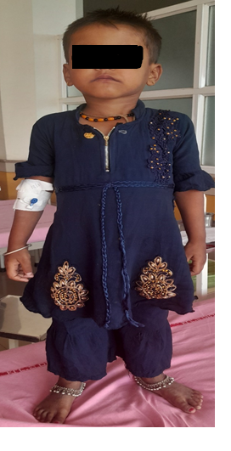

**Figure 1- Short stature with microcephaly**

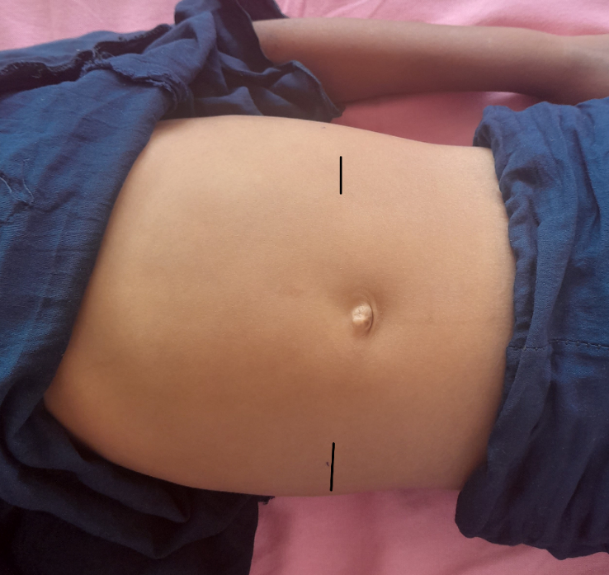

**Figure 2- Hepatosplenomegaly**

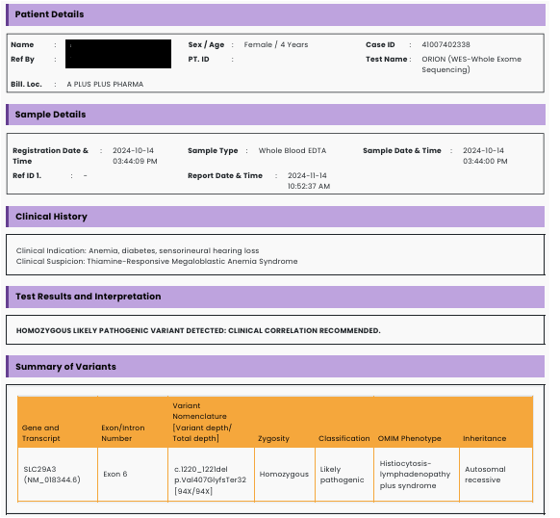

**Figure 3- Whole exome sequencing report**