Case report

PURPURA FULMINANS AND NECROTIZING FASCIITIS: A LETHAL COMBINATION FOLLOWING VARICELLA INFECTION

ABSTRACT
Aims:
Varicella is typically a self-limiting infection; however, secondary bacterial infections can lead to severe complications such as necrotizing fasciitis (NF) and purpura fulminans (PF). This case highlights an unusual presentation of NF and PF secondary to varicella, caused by Burkholderia cepacia, in an immunocompetent child.
Presentation of Case:
A 2-year-10-month-old unvaccinated male presented with fever, vesicular rash, and progressive skin necrosis over the neck, shoulders, and abdomen. He developed septic shock and disseminated intravascular coagulation (DIC), requiring intensive care. Blood cultures identified Burkholderia cepacia, an uncommon pathogen in pediatric NF. The child was treated with intravenous antibiotics, inotropic support, blood product transfusions, and emergency surgical debridement. Over 20 days of hospitalization, he showed significant recovery and was discharged on oral antibiotics.
Discussion:
Varicella predisposes children to bacterial superinfections due to skin barrier disruption, immune dysregulation, and a prothrombotic state. NF is typically caused by Group A Streptococcus or Staphylococcus aureus; however, Burkholderia cepacia, primarily an opportunistic pathogen, caused extensive soft tissue necrosis in this case. Early surgical debridement and targeted antibiotic therapy were crucial for survival.
Conclusion:
This case highlights the importance of early recognition of secondary bacterial infections in varicella and emphasizes the rare occurrence of Burkholderia cepacia as a causative agent of NF. Vaccination remains the most effective strategy in preventing severe varicella-related complications.
Key words- Varicella, Necrotizing fasciitis, Purpura Fulminans, Sepsis

- Introduction
Varicella, commonly known as chickenpox, is a highly contagious viral infection caused by the varicella zoster virus, a member of the Herpesviridae family. It is primarily a childhood disease characterized by fever and generalized vesicular rashes. While varicella is typically self-limiting in immunocompetent children, complications can arise due to viral or bacterial superinfections, particularly in the absence of vaccination. Secondary bacterial infections can lead to life-threatening conditions such as necrotizing fasciitis and purpura fulminans.^{1,2}
Necrotizing fasciitis is a severe, rapidly progressing soft tissue infection characterized by widespread necrosis of the fascia and subcutaneous tissues. The condition is often polymicrobial, with Group A Streptococcus and Staphylococcus aureus being the most commonly implicated pathogens. However, rare pathogens such as Burkholderia cepacia, primarily an opportunistic nosocomial pathogen, have been documented in isolated cases of necrotizing fasciitis. The risk of bacterial superinfection in varicella is attributed to the disruption of the skin barrier, impaired immune response, and an increased prothrombotic state. Invasive bacterial infections, including necrotizing fasciitis, are associated with high morbidity and mortality.²
Purpura fulminans is a life-threatening thrombotic disorder characterized by cutaneous hemorrhagic necrosis and widespread intravascular thrombosis. It can manifest in three forms: idiopathic, congenital, and infectious, with infectious purpura fulminans being the most common variant. Infections with organisms such as Neisseria meningitidis, Streptococcus pneumoniae, and, less commonly, Burkholderia cepacia, have been implicated in infectious purpura fulminans. The pathophysiology involves endothelial damage, activation of the coagulation cascade, and impaired fibrinolysis, leading to extensive microvascular thrombosis and tissue necrosis. When associated with varicella, the development of purpura fulminans signifies a critical deterioration requiring urgent medical intervention³
This case report describes the presentation, diagnosis, and management of a child who developed secondary bacterial complications to varicella infection. It emphasizes the importance of early recognition of these bacterial infections and provide insights into the optimal management strategies for such rare but life-threatening complications.
2.PRESENTATION OF CASE
A 2 year 10-month-old male was brought to emergency with history of fever and vesicular rashes for 5 days. Child was diagnosed clinically with varicella infection and was treated symptomatically from local hospital. However, mother noticed that the rashes progressively increased in size over the next 3 days and was associated with blackish discoloration, swelling and peeling of skin particularly over the neck, shoulder and abdomen. The child experienced abdominal pain and generalized body aches which made him irritable. There was no history of recent trauma or insect bites. The child had not received varicella vaccination.
On examination, his vitals were: Temperature-39.3 C, Pulse rate-143 bpm, Blood pressure- 85/40 mmHg with extensive purpuric lesions with necrotic centers on neck shoulders and abdomen. Central nervous system examination revealed no neurological deficits, with normal muscle tone. Respiratory examination was unremarkable, with no signs of distress. The cardiovascular examination showed tachycardia with feeble peripheral pulses, while the gastrointestinal system appeared normal, with a soft abdomen and no hepatosplenomegaly.
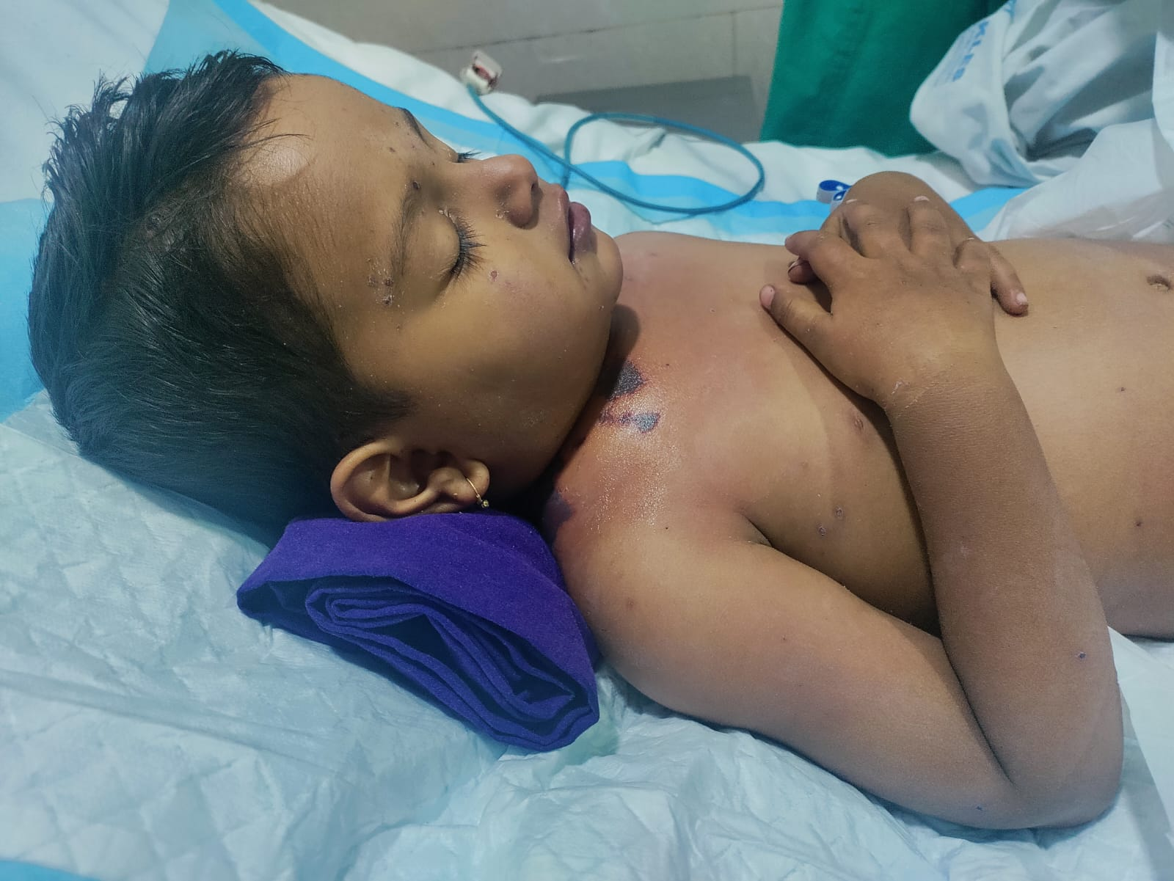
FIGURE1: Morphology of the the child
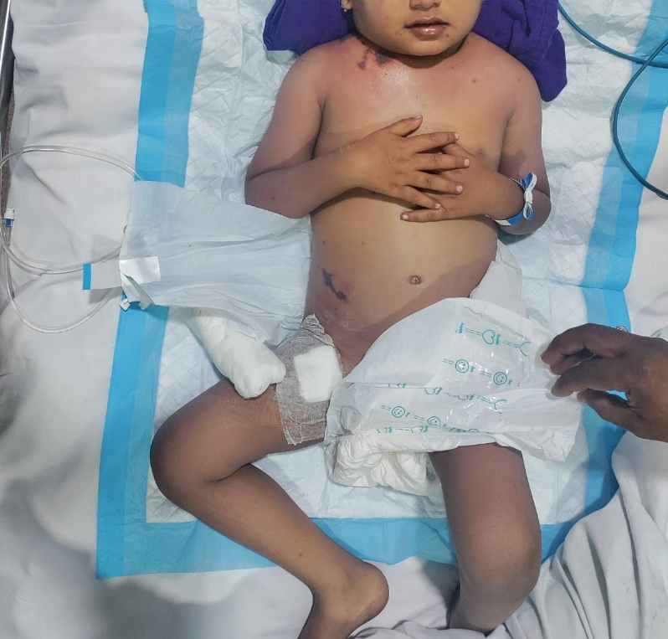
FIGURE2 : cardiovascular examination showed tachycardia with feeble peripheral pulses
Child had leukocytosis (WBC 21,100), thrombocytopenia (platelets 23,000), and elevated CRP levels (273 mg/L). Coagulation studies revealed prolonged PT and aPTT, elevated D-dimer (>5000 ng/mL), and low fibrinogen, consistent with disseminated intravascular coagulation (DIC). Blood culture confirmed Burkholderia cepacia sensitive to meropenem, levofloxacin, trimethoprim/sulfamethoxazole.
Child was initially given fluid boluses and started on iv inotropes, broad spectrum antibiotics like piperacillin tazobactum and antivirals like iv acyclovir. Child received blood products to stabilize coagulation disorder. Prompt medical intervention led to localization of lesions within 72 hours. Inotropic support was tapered off and emergency surgical debridement was performed. There was no gas formation or abscess pockets, and all necrotic tissue was excised. Postoperatively, the child required regular wound dressing, nutritional support with enteral feeds.
Over the course of 10 days in pediatric intensive care, the child showed gradual improvement. Skin lesions began to stabilize, with early granulation tissue formation. After 20 days of hospitalization, the child was discharged on oral antibiotics and other supportive care. At two-weeks follow-up, the child showed significant improvement in skin healing, with no new lesions or signs of infection.
3.DISCUSSION
Varicella-zoster virus (VZV), which belongs to the Herpesviridae family is responsible for two distinct clinical syndromes: varicella (chickenpox) and herpes zoster (shingles). Primary infection with VZV leads to varicella, a common childhood disease characterized by fever and rash that progresses through maculopapular, vesicular, and crusted stages. The virus establishes latency in sensory dorsal root ganglia, with potential reactivation later in life, manifesting as herpes zoster with painful, dermatomal rash.¹
Varicella-zoster virus enters the body through respiratory tract or direct contact with infected lesions. After initial replication in the nasopharynx and regional lymph nodes, the virus spreads via the bloodstream (primary viremia) to the liver, spleen, and other reticuloendothelial organs, where further replication occurs. Secondary viremia follows, disseminating the virus to the skin, leading to the characteristic vesicular rash. Following primary infection, VZV establishes lifelong latency in sensory dorsal root ganglia. Reactivation later in life results in herpes zoster (shingles), often triggered by immunosuppression or aging. The immune response plays a crucial role in limiting disease severity, with cell-mediated immunity being particularly important in controlling viral replication.²
This child presented with a vesicular rash, rapidly progressing skin necrosis, purpura, hypotension, all of which strongly suggested a varicella-associated invasive soft tissue infection, most consistent with Necrotizing fasciitis requiring urgent intervention. Necrotizing fasciitis is a rapidly progressive, life-threatening soft tissue infection characterized by necrosis of the fascia and subcutaneous tissue. Group A Streptococcus (GAS) is the most common causative pathogen. Infection by Burkholderia cepacia is extremely rare, especially in immunocompetent children. However, varicella infection predisposes children to severe bacterial superinfections due to three key factors: disruption of the skin barrier by varicella lesions, immune dysfunction (including impaired neutrophil function and cytokine response), and a prothrombotic state that increases susceptibility to purpura fulminans and DIC. The combination of these factors created an environment where Burkholderia cepacia could thrive, leading to extensive tissue destruction and systemic involvement^{.4}
Purpura fulminans is a rapidly evolving thrombotic disorder characterized by cutaneous hemorrhagic necrosis and disseminated Intravascular Coagulation (DIC). It is classified into infectious PF (most common), idiopathic PF (immune-mediated), and congenital PF (associated with protein C and S deficiencies). In this case, varicella infection triggered systemic inflammation, endothelial damage, and activation of the coagulation cascade. The presence of Burkholderia cepacia bacteremia further aggravated the inflammatory response, increasing the severity of tissue necrosis and coagulopathy.⁵
Empirical broad-spectrum antibiotics were initiated immediately to cover Gram-positive, Gram-negative, and anaerobic pathogens. Once Burkholderia cepacia was identified in blood cultures, therapy was adjusted to Meropenem according to sensitivity pattern. Studies have shown that delayed or inadequate antibiotic therapy significantly increases NF mortality, highlighting the importance of early, targeted antibiotic adjustments. Intravenous acyclovir was initiated to reduce viral load, and minimize the risk of additional bacterial superinfections. Studies have shown that early antiviral therapy in severe varicella infections reduces complications and accelerates healing, supporting its use in critically ill patients.⁶
Child presented in septic shock, requiring intravenous fluid resuscitation and inotropes to maintain perfusion. Blood products were administered to correct coagulopathy. Managing DIC was particularly challenging, as aggressive clotting factor replacement increases the risk of thrombotic complications, whereas insufficient correction can lead to fatal hemorrhage. A careful balance was maintained through close monitoring and judicious transfusions.⁷
Early surgical debridement is considered critical for survival, as it removes necrotic tissue that serves as a reservoir for ongoing bacterial proliferation and toxin production. In this case, debridement was performed, preventing further systemic spread. Previous studies indicate that mortality rates can exceed 30-50% in necrotizing fasciitis without timely surgical intervention, emphasizing the importance of rapid decision-making and aggressive surgical management. ⁸
This case aligns with prior reports showing that varicella-associated secondary bacterial infections often present with fulminant sepsis. However, unlike most cases of necrotizing fasciitis caused by GAS or Staphylococcus aureus, this case was atypical due to the involvement of Burkholderia cepacia in an immunocompetent child. Burkholderia cepacia is primarily a nosocomial pathogen that typically affects immunocompromised patients (e.g., those with cystic fibrosis or chronic granulomatous disease). The absence of underlying immunodeficiency makes this a rare presentation. This child had a relatively favorable prognosis. This is in contrast with mortality rates of 30-50% in Necrotizing fasciitis, especially in cases with delayed intervention or coexisting DIC. ⁴
The introduction of the varicella vaccine has significantly reduced the incidence and severity of these complications, emphasizing the importance of vaccination and early medical intervention in high-risk cases. Prompt recognition and management of complications are crucial to reducing morbidity and mortality associated with varicella in children ⁹
4.CONCLUSION
This case highlights the potential severity of varicella-related complications, requiring prompt recognition and aggressive management. The presence of Burkholderia cepacia as the causative pathogen in an immunocompetent child highlights the unpredictable nature of secondary bacterial infections in varicella. Timely initiation of broad-spectrum antibiotics, hemodynamic stabilization, and early surgical debridement played a pivotal role in the patient's recovery. This case emphasizes the importance of vaccination in preventing severe varicella infections and their associated complications. Strengthening vaccination programs and ensuring widespread immunization coverage can significantly reduce the incidence of such severe complications, ultimately improving public health outcomes.

ETHICAL APPROVAL: As per international standards or university standards written ethical approval has been collected and preserved by the author(s).

CONSENT - As per international standards, parental written consent has been collected and preserved by the authors

Disclaimer (Artificial intelligence): OPTION 1
Option 1:
Author(s) hereby declare that NO generative AI technologies such as Large Language Models (ChatGPT, COPILOT, etc.) and text-to-image generators have been used during the writing or editing of this manuscript.
Option 2:
Author(s) hereby declare that generative AI technologies such as Large Language Models, etc. have been used during the writing or editing of manuscripts. This explanation will include the name, version, model, and source of the generative AI technology and as well as all input prompts provided to the generative AI technology
Details of the AI usage are given below:
1.NONE
2.
3.

REFERENCES
- Sorel, O., Messaoudi, I. Insights into the Pathogenesis of Varicella Viruses. Curr Clin Micro Rpt 6, 156–165 (2019). https://doi.org/10.1007/s40588-019-00119-2

- Gershon AA, Gershon MD. 2013. Pathogenesis and Current Approaches to Control of Varicella-Zoster Virus Infections. Clin Microbiol Rev 26:.https://doi.org/10.1128/cmr.00052-13

- Januário, Gustavo MD; Ramroop, Shiva MRCPCH; Shingadia, Delane V. FRCPCH, MPH; Novelli, Vas FRCP. POSTINFECTIOUS PURPURA FULMINANS SECONDARY TO VARICELLA-INDUCED PROTEIN S DEFICIENCY. The Pediatric Infectious Disease Journal 29(10):p 981-983, October 2010.
https://journals.lww.com/pidj/Fulltext/2010/10000/Postinfectious_Purpura_Fulminans_Secondary_to.25.aspx

- Jonathan Lovis, Thomas Krebs, Jörg Grünert, Frank-Martin Häcker,Necrotizing fasciitis after varicella infection in children: A case series,Journal of Pediatric Surgery Case Reports,Volume 98,2023,102725,ISSN 2213-5766, https://doi.org/10.1016/j.epsc.2023.102725 https://www.sciencedirect.com/science/article/pii/S2213576623001513

- Darmasseelane K, Banks T, Rjabova T Necrotising fasciitis as a complication of primary varicella infection in an immunocompetent childCase Reports 2018;2018:bcr-2018-225018. https://casereports.bmj.com/content/2018/bcr-2018-225018

- Kwak BO, Lee MJ, Park HW, Song MK, Chung S, Kim KS. Necrotizing fasciitis and streptococcal toxic shock syndrome secondary to varicella in a healthy child. Korean J Pediatr. 2014 Dec;57(12):538-41. https://e-cep.org/journal/view.php?doi=10.3345/kjp.2014.57.12.538

- Christopher L. Slack, Gregory C. Allen, John E. Morrison, Kurt C. Garren, Mark G. Roback; Post-Varicella Epiglottitis and Necrotizing Fasciitis. Pediatrics January 2000; 105 (1): e13. 10.1542/peds.105.1.e13 https://publications.aap.org/pediatrics/article/105/1/e13/65706/Post-Varicella-Epiglottitis-and-Necrotizing

- Danielle M. Zerr, E. Russell Alexander, Jeffrey S. Duchin, Laura A. Koutsky, Craig E. Rubens; A Case-Control Study of Necrotizing Fasciitis During Primary Varicella. Pediatrics April 1999; 103 (4): 783–790. 10.1542/peds.103.4.783 https://publications.aap.org/pediatrics/article/103/4/783/65926/A-Case-Control-Study-of-Necrotizing-Fasciitis

- Zhou F, Harpaz R, Jumaan AO, Winston CA, Shefer A. Impact of Varicella Vaccination on Health Care Utilization. JAMA. 2005;294(7):797–802. doi:10.1001/jama.294.7.797 https://jamanetwork.com/journals/jama/fullarticle/201405

