**TRAUMATIC DIAPHRAGMATIC HERNIA WITH PANCREATITIS AND SPLENIC INJURY: A RARE AND CHALLENGING ENTITY**

.

ABSTRACT

|  |
| --- |
| AIMS  Diaphragmatic hernias are defined by herniation of the abdominal viscera into the thoracic cavity. Typically, Diaphragmatic Hernias are Congenital or Acquired in adulthood due to blunt or penetrating injury. Many complications are known to occur in association with a Diaphragmatic Hernia, Acute Pancreatitis occurring in this situation is very rare entity.  PRESENTATION OF CASE  A 17 year old male child presented with acute onset abdominal pain, vomiting and breathlessness. Initial investigations and Chest Xray revealed diaphragmatic hernia and further evaluation was done. CT reported Acute Pancreatitis and Diaphragmatic Hernia with Splenic injury. Child was revealed to have had blunt trauma to the thorax and abdomen which was the cause for the traumatic diaphragmatic hernia. Surgical correction of Diaphragmatic hernia and conservative management of Acute Pancreatitis and Splenic injury were done. Child recovered well.  DISCUSSION  Small diaphragmatic hernias may remain undetected for months or even years until patients develop symptoms. Clinicians should consider diaphragmatic hernia in individuals with a history of trauma presenting with atypical abdominal or respiratory manifestations. 1  Pancreas are mainly found in cases of Hiatal Hernias or Congenital Hernias. Traumatic Diaphragmatic hernia accompanied by Acute Pancreatitis is an extremely rare phenomenon with very few cases reported in literature. 1   A potential mechanism of pancreatitis is pancreatic ischemia due to traction effect, or pancreatic duct obstruction.  CONCLUSION  Traumatic Diaphragmatic Hernia can have a late presentation, so any child with acute onset of respiratory distress, abdominal complaints with even a remote history of trauma should undergo prompt evaluation to ensure detection and correction of Herniation. |

***Keywords****: Diaphragmatic hernia, Blunt trauma, Acute Pancreatitis, Splenic injury*

INTRODUCTION

A diaphragmatic hernia (DH) is characterized by the displacement of abdominal organs into the thoracic cavity or mediastinum due to a structural defect in the diaphragm. These hernias may arise from congenital anomalies, hiatal dysfunction, or traumatic injury and are classified based on the transient or persistent migration of abdominal viscera through the diaphragmatic defect.2

Although diaphragmatic injuries resulting from blunt or penetrating trauma are relatively uncommon, they represent one of the most frequently overlooked diagnoses in trauma patients, with an incidence of approximately 3–7% in cases of abdominal or thoracic trauma.1

Post-traumatic Diaphragmatic Hernia is described as the permanent or intermittent prolapse of any abdominal structures into the Mediastinum or thoracic cavity via the Diaphragm apertures.2. Most often, acquired DH follows blunt or penetrating trauma that results in injury and defects in the diaphragm.3 The stomach is the most commonly herniated organ. Small intestine, spleen, and transverse colon herniations are among the least common. Pancreas's herniation is relatively uncommon.2

Recent studies have highlighted an association between Pancreatitis and Diaphragmatic herniation. While common etiologies of Acute Pancreatitis include Gallstones, Hyperlipidemia, and Alcohol consumption, Traumatic Diaphragmatic herniation remains an exceptionally rare causative factor. 3 Acute pancreatitis (AP) is a prevalent gastrointestinal disorder resulting in localized damage, systemic inflammatory response syndrome, and organ failure. The revised Atlanta classification system is popularly used for the diagnosis and classification of Acute Pancreatitis, and severity of AP may be classified as mild, moderately severe (MSAP), or severe (SAP), and there are also two distinct stages (early and late). This classification also explains how AP is diagnosed, stresses the importance of pain as a benchmark, and singles out local complications, interstitial pancreatitis, and necrotizing pancreatitis based on which decision regarding management can be taken. 4

The Revised Atlanta Classification is summarized in Table 1. 5

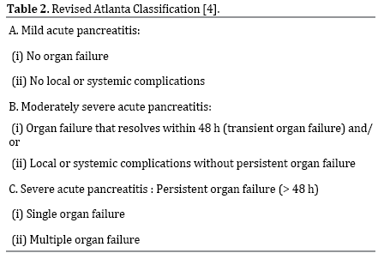

These guidelines help in making a choosing between medical and surgical management for AP.

Splenic trauma management now favors non-operative approaches like observation and angiography to preserve spleen function, especially in children. However, it can be fatal due to delayed complications like hematoma or pseudoaneurysm rupture, and splenectomy increases the risk of severe infections (OPSI). 6

Herein we report a case of Acute Pancreatitis occurring as a late presentation of Traumatic Diaphragmatic Hernia.

AIM-

This case report describes the clinical presentation, diagnostic approach, and management of a child that presented with Traumatic Diaphragmatic Hernia and Acute Pancreatitis, Splenic injury following blunt trauma.

**PRESENTATION OF CASE –**

A 17 year-old male patient presented with acute onset abdominal pain, breathlessness and vomiting, fever since 4 to 5 days. Patient was managed symptomatically and was referred to our Hospital for care. Chest X-ray (Figure 1) showed Gastric and Colonic shadow in chest. Plain CT done outside (Figure 2) revealed a Left-sided Diaphragmatic Hernia with herniation of the Stomach, Large Intestine, into the thoracic cavity, accompanied by Acute edematous Pancreas with intra abdomen collection. On stressing on the trauma history, patient revealed history of fall from bike 10 days back. Blood investigations were done, Serum Lipase was elevated (560 IU), Hemoglobin was low ( 7.2g/dl).

Diagnostic Laparoscopy was done, blood was noted in Pelvis, right and left Para Colic regions , Hematoma near Spleen and multiple small lacerations (s/o Grade 2splenic injury) (Figure 3). Continuous ooze was noticed after hematoma dislodgement.

Laparoscopy was converted to left Subcostal Laparotomy, hemostasis was achieved. Diaphragmatic Hernia noticed in Postero-Lateral region with contents of abdomen(Figure 4), grossly dilated Stomach with volvulus and Large bowel in thoracic cavity . Contents were reduced, surgical repair of the diaphragmatic defect was done with Mersilk 2-0 (Figure 5). Mesh was not placed in view of active infection, and resolving Pancreatitis.

Thorough warm saline wash was given, hemostasis achieved, abdomen drain and InterCostal Drain were placed.

Postoperatively, child was shifted to Pediatric ICU, given blood transfusion, antibiotics. Pancreatitis and Splenic injury were treated conservatively. Serum Lipase was repeated and was found to be decreasing.

Child had a stable and uneventful post operative recovery within a week and is doing well on follow Up.

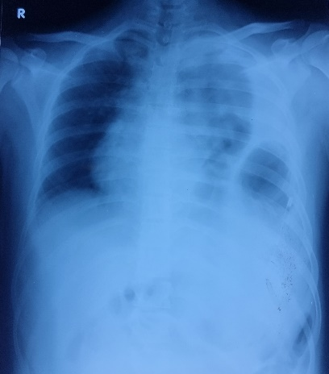Figure1- CXR showing stomach Ryles tube in thorax

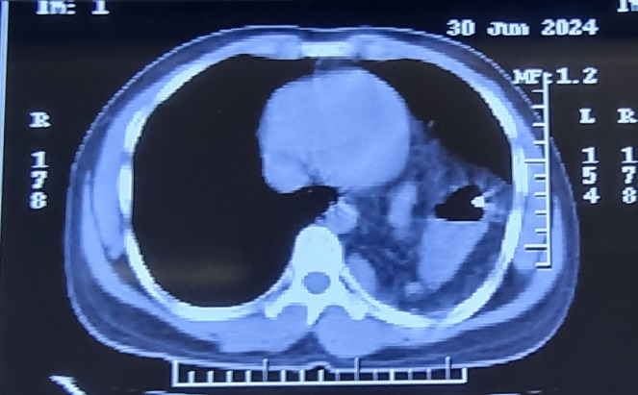 figure 2 –CT shows Abdominal contents in thorax with collection

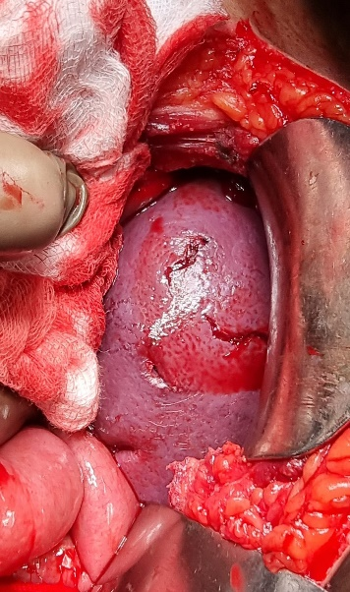Figure 3 – Splenic lacerations with bleeding

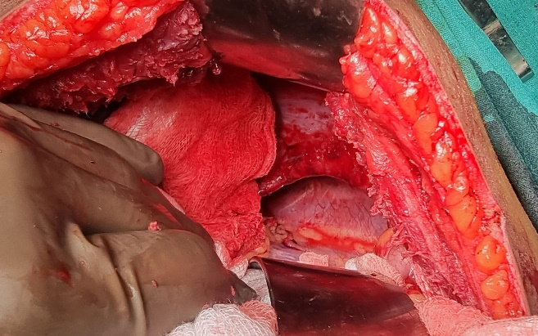Figure 4 – Postero-lateral Diaphragmatic Hernia

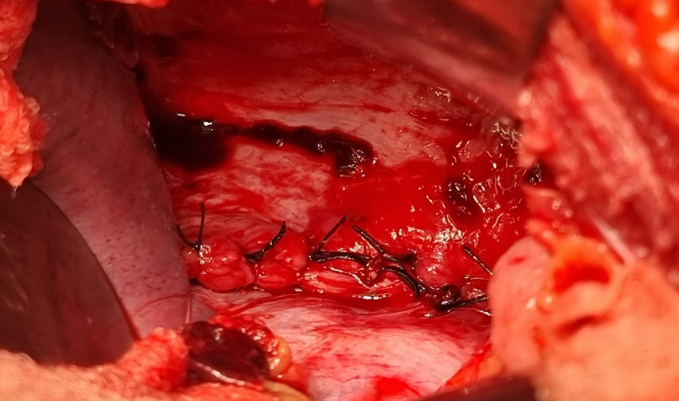Figure 5- Diaphragmatic repair

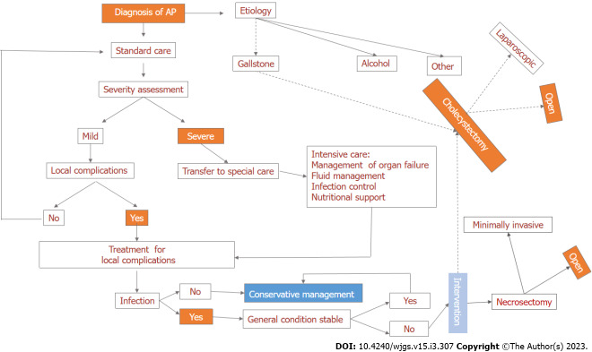 figure 6 – approach to management of acute pancreatitis

DISCUSSION –

Diaphragmatic tears can result from both blunt and penetrating trauma. Small diaphragmatic hernias may remain undetected for months or even years until patients develop symptoms. Clinicians should consider diaphragmatic hernia in individuals with a history of trauma presenting with atypical abdominal or respiratory manifestations. 1

Blunt trauma may cause injury in any part of the diaphragm, but the most injuries occur in the posterolateral aspect of the left side of the diaphragm. . 1

The cases in medical literature about Acute Pancreatitis after diaphragmatic herniation of the Pancreas are mainly found in cases of Hiatal Hernias or Congenital Hernias. Nevertheless, even this is an extremely rare presentation with very few cases described in literature . 1

Nevertheless, it is always important to assess serum Amylase, Lipase in such cases, and in any patient presenting with blunt trauma to thorax or abdomen.

Traumatic Diaphragmatic hernia accompanied by Acute Pancreatitis is an extremely rare phenomenon with very few cases reported in literature. 1

Pancreatic herniation is an exceptionally rare phenomenon due to the retroperitoneal positioning of the pancreatic head and duodenum, which are stabilized by Treitz’s ligament. However, elevated intra-abdominal pressure can induce stretching of the transverse mesocolon, resulting in posterior fascia loosening. This process may increase pancreatic mobility, potentially leading to herniation, though such occurrences remain exceedingly uncommon. 2

A potential mechanism of pancreatitis is pancreatic ischemia resulting from the traction effects of the hernia or acute gastric distention, leading to pancreatic duct obstruction. In the present case, the latter mechanism likely accounts for the development of acute pancreatitis. 3

We cannot however, rule out the possibility that Pancreatitis might be due to blunt trauma itself, which made surgical intervention complex.

Among the cases previously reported regarding Acute Pancreatitis in the setting of diaphragmatic hernia, all of them required emergent surgical intervention due to incarceration or volvulus.

The decision regarding management of AP as surgical or medical depends on the severity, complications associated. A summary is given in figure 6. 4

Traumatic diaphragmatic hernia (TDH) necessitates urgent surgical intervention following diagnosis, especially in patients exhibiting signs of obstruction, due to the risk of severe complications. 3

Traditionally, traumatic diaphragmatic hernia (TDH) has been managed using either a Transabdominal or Transthoracic approach. However, advancements in surgical techniques have introduced Laparoscopic and Thoracoscopic approaches. The choice between a Thoracic or abdominal approach largely depends on the surgeon’s expertise and preference. Filosso et al. advocate for a Thoracotomy approach in chronic TDH cases, as it offers superior access and visualization of the diaphragmatic rupture, facilitating the release of herniated abdominal organs from adhesions within the thoracic cavity. Additionally, this approach allows for rapid identification of potential bowel complications, such as necrosis or perforation. 3

 In our case, laparoscopic approach was taken which was then converted to Subcostal Laparotomy for better visualization and accessible operative field.

The Eastern Association for the Surgery of Trauma (EAST) recommends non-operative management (NOM) for all hemodynamically stable children with blunt splenic trauma, regardless of injury severity. NOM is more effective in children than adults and is therefore preferred in pediatric cases. It also reduces hospital costs, length of stay, need for transfusions, vaccinations, and antibiotics while preserving immunity and lowering infection risk. 6 Unlike any other grade 2/3 splenic injury along with traumatic diaphragmatic injury where splenectomy was carried out in other case series we tried to preserve spleen in this child, since splenectomy alone carries a risk of overwhelming post-splenectomy infection. Our case is unique as our patient was treated conservatively with considerable improvement in his lipase level and symptomatology along with preservation of splenic function.

Conclusion-

Today, thanks to easy access to simple diagnostic and radiological modalities like Xray, the prompt detection of conditions like diaphragmatic Hernia is easy. Further evaluation and surgical intervention can be taken up as appropriate.

This case highlights the importance of prompt recognition a management of traumatic Diaphragmatic Hernia, especially when complicated by pancreatitis and splenic injury, to prevent significant morbidity and mortality

AcknowledgEments

I sincerely thank my Consultants, seniors and colleagues, and most importantly my family, and God for providing the adequate resources that enabled me to write this case report.

Competing interests

No competing interests exist.

Authors’ Contributions

Author 1 collected the necessary data and wrote the first draft of the manuscript.

Author 2,3 managed the editing of the report.

All authors read and approved the final manuscript.

Consent

All authors declare that ‘written informed consent was obtained from the patient and parents for publication of this case report and accompanying images. A copy of the written consent is available for review by the Editorial office/Chief Editor/Editorial Board members of this journal.

References

*1) Tolga Dinc, Selami Ilgaz Kayilioglu, and Faruk Coskun Department of General Surgery, Ankara Numune Training and Research Hospital , Turkey. 16 August 2015 Copyright © 2015 Tolga Dinc et al.*

*2) Siham Nasri, Guerrouj, MD, Widad Abbou, Department of Radiology, Mohammed VI University Hospital, Faculty of Medicine, University Mohammed First,Oujda, Morocco. https:/doi.org?10.10.1016?j.radcr.2021.11.042*

*3) Sy, C.A., Macalino, J.U., Go, B.S.D. et al. Traumatic diaphragmatic hernia associated with acute pancreatitis. Discov Med****2****, 9 (2025). https://doi.org/10.1007/s44337-025-00208-w*

4*) Alzerwi N. Surgical management of acute pancreatitis: Historical perspectives, challenges, and current management approaches. World J Gastrointest Surg. 2023 Mar 27;15(3):307-322. doi: 10.4240/wjgs.v15.i3.307. PMID: 37032793; PMCID: PMC10080605.*

*5)* ***Manrai M, Kochhar R, Thandassery RB, Alfadda AA, Sinha SK.*** *The Revised Atlanta Classification of Acute Pancreatitis: A Work Still in Progress? JOP. J Pancreas (Online). 2015 Jul 8;16(4):356-364.*

6*) Coccolini, F., Montori, G., Catena, F. et al. Splenic trauma: WSES classification and guidelines for adult and pediatric patients. World J Emerg Surg****12****, 40 (2017). https://doi.org/10.1186/s13017-017-0151-4*

**DISCLOSURES**

**Human subjects**: Consent was obtained by the patient and attenders for this study.

**Payment/services info**: All authors have declared that no financial support was received from any organization for the submitted work.

**Financial relationships**: All authors have declared that they have no financial relationships at present.