**Case report**

**CHYLOTHORAX IN STEROID RESISTANT NEPHROTIC SYNDROME: DIFFICULT TO TREAT AND CHALLENGING SCENARIO**

ABSTRACT

AIM

The aim of the case study was to showcase treatment modalities in a child with nephrotic syndrome who presented with chylothorax.

PRESENTATION OF CASE

An 8-year-old male child, known case of nephrotic syndrome presented with recurrent breathlessness episodes. Initially, he had mild respiratory distress and X-ray showed mild pleural effusion which was managed with antibiotics and other supportive care. In a short time, he again presented with rapidly progressive breathlessness. On examination there was tachypnea, severe retractions, saturation of 80% and bilateral reduced air entry. Chest X-ray showed presence of massive bilateral pleural effusion and immediate pleural tapping was done and about 400-450ml of milky white fluid was drained on each side. Biochemical evaluation of the pleural fluid showed it was sterile with high levels of triglyceride and lymphocytes, which suggested the presence of chyle. The child was initially managed aggressively with intercostal drainage placement and high end antibiotics but later a multidisciplinary approach was required due to the recurrent presentation.

DISCUSSION

Steroid-resistant nephrotic syndrome with chylothorax is complex scenario. This case necessitated a multidisciplinary approach. A vital aspect of the management in this case was dietary modification. The child was started on a high calorie high protein low-fat, medium-chain triglyceride (MCT) based diet. MCTs are absorbed directly into the portal system, bypassing the intestinal lymphatics, and thus reducing thoracic duct flow and also takes care of nutritional requirement. Additionally, child was put on anti-tubercular therapy due to significant past history of tuberculosis.

CONCLUSION

chylothorax can also be a cause of sudden distress in nephrotic syndrome. A thorough, multidisciplinary approach was vital in devising an effective management strategy to treat chylothorax, infection, malnutrition and also steroid resistant nephrotic syndrome. Diet modification played a major role in management.

KEYWORDS: chylothorax, nephrotic syndrome, pleural tapping, antibiotics

INTRODUCTION

Nephrotic syndrome is characterized by proteinuria, hypoalbuminemia, edema and hyperlipidemia. It also results in various complications including infection like pleural effusion, peritonitis, cellulitis, bone & joint infections, flare up of tuberculosis, higher chance of thromboembolism and acute kidney injury (AKI). They are also prone for steroid toxicity and side effects of immunosuppressive drugs in steroid dependent and resistant cases [5,6].

Chylothorax occurs when chyle leaks from thoracic duct into the pleural cavity. In nephrotic syndrome, it is usually secondary to chylous ascites [1] or Superior vena cava (SVC) obstruction due to thrombosis [2]. It can also be secondary to infection like tuberculosis. Other rarer causes include thrombosis of thoracic duct or subclavian vein, lymphangiomatosis, familial lymphedema and congenital malformation of lymphatics [7,8].

AIM

This case report showcases a difficult to treat nephrotic syndrome who presents with chylothorax. The case report highlights how a multidisciplinary approach helped in management of nephrotic syndrome, chylothorax, malnutrition and infection.

PRESENTATION OF CASE

This case report describes an 8-year-old male child with a known history of nephrotic syndrome, initially diagnosed at the age of 4 and started on steroid therapy. Frequent relapses associated with severe infections like pneumonia and spontaneous bacterial peritonitis (SBP), requiring Pediatric Intensive Care Unit (PICU) admissions were also seen and had also developed steroid toxicity features including hypertension and cataract. Over time, he became steroid resistant, hence necessitating renal biopsy which showed features of Focal segmental glomerulosclerosis and prompted cyclosporine usage.

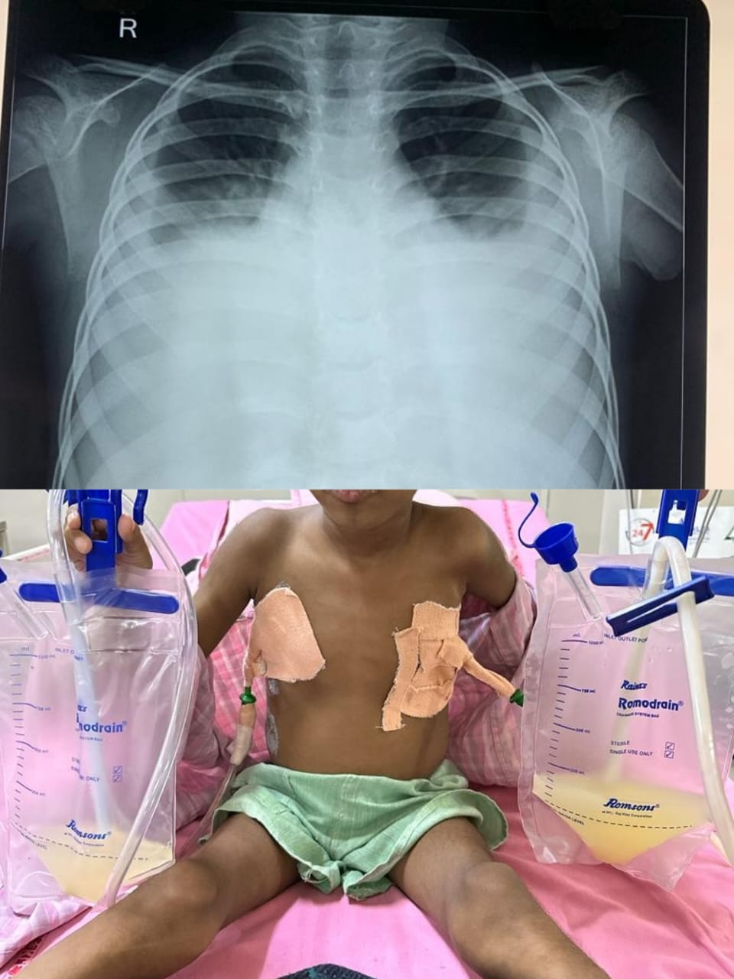

Figure 1: Chest-X ray of the patient; and management with ICD

His condition took a massive turn when he presented with recurrent breathlessness episodes. Initial episodes, he had mild respiratory distress and X-ray showed mild pleural effusion and was managed with antibiotics and other supportive care. Later again he presented with rapidly progressive breathlessness. On examination there was tachypnea, severe retractions, saturation of 80% and bilateral reduced air entry. Chest X-ray showed presence of massive bilateral pleural effusion and immediate pleural tapping was done and about 400-450ml of milky white fluid was drained on each side. Biochemical evaluation of the pleural fluid showed it was sterile with high levels of triglyceride and lymphocytes, which suggested the presence of chyle. Other lab parameters showed that he was in relapse of nephrotic syndrome. There was no evidence of thrombosis.

Pediatric surgeon was involved and bilateral Intercostal drainage (ICD) was inserted. High-resolution computer tomography (HRCT) showed bilateral pleural effusion with atelectasis of underlying lung segments. Few subcentric, pre-paratracheal and prevascular group of lymph nodes were seen. Line hyperdense area involving the superior vena cava suggestive of calcification was also seen.

In view of persistent ICD drainage of 1.5-2 liters/day, Cardio-thoracic surgeon was sought for further surgical management. To confirm the exact site of leakage from thoracic duct, nuclear medicine opinion was sought and lymphangiography was attempted but the procedure was unsuccessful as dye could not be injected. Then lymphoscintigraphy was performed which showed diffuse low grade tracer accumulation in right hemithorax which confirmed the leak, but the exact site and extent of leak could not be demonstrated. Hence, decision to conservatively manage with ICD and medium-chain triglyceride (MCT) based diet was taken by the cardiothoracic surgeon. In the next 2 weeks, the ICD drainage was clear and was less than 50ml/day. Repeat X-ray after 2 days of ICD removal was normal.

In parallel, the cause of recurrent pneumonia and pleural effusion was evaluated. The clinical history was reanalyzed and history of tuberculosis at 3 years of age came into light. Confirmation of tuberculosis could not be established. But in view of high clinical suspicion, anti-tubercular therapy was started.

Now the child has completed 6 months of anti-tubercular therapy and is continuing treatment with cyclosporine for Steroid-Resistant Nephrotic Syndrome (SRNS). There were no further episodes of chylothorax or any infection requiring hospital admission. He is taking normal diet now and has shown improvements in growth parameters.

DISCUSSION

Steroid-resistant nephrotic syndrome with chylothorax is a complex scenario. This case necessitated a multidisciplinary approach involving pediatrician, pediatric nephrologist, pediatric surgeon, cardiothoracic surgeon and nuclear medicine specialist to formulate the best course of treatment modality. Since there was no clear cut cause, site and extent of chyle leak, a conservative approach was preferred as child was clinically stable following intercostal drainage of chyle and keeping in mind the high chances of tuberculosis and malnutrition in the Indian scenario [9]. There were also previous reports suggesting the use of diet based approach instead of direct surgical intervention , regardless of how complex the chylothorax was [11]. Venous thrombosis was also one of the causes that was considered pertaining to the earlier case studies showing a similar clinical picture.[12]

A vital aspect of the management in this case was dietary modification [3, 4]. The child was started on a high calorie (150kcal/kg/day), high protein (2.5-3g/kg), low-fat, medium-chain triglyceride (MCT) based diet. MCTs are absorbed directly into the portal system, bypassing the intestinal lymphatics, and thus reducing thoracic duct flow and also takes care of nutritional requirement.

Additionally, the child was put on anti-tubercular therapy, considering the past history and high prevalence of infection in India and due to the fact that chylothorax was reported to be a rare presentation associated with tuberculosis [13,14]. The immunological evidence may be absent because of the immunocompromised state and the laboratory evidence could not be demonstrated, maybe because the load of the bacilli in pleural fluid is usually low. Even though complex surgical strategies like thoracic duct ligation [10], involving a cardiothoracic surgeon as seen in many prior studies was available , a more simpler approach was preferred considering the common etiologies in the paediatric population.

CONCLUSION

In conclusion, chylothorax can also be a cause of sudden distress in nephrotic syndrome. A thorough, multidisciplinary approach was vital in devising an effective management strategy to treat chylothorax, infection, malnutrition and also steroid resistant nephrotic syndrome. Diet modification played a major role in the management.

Ethical Approval:

As per international standards or university standards written ethical approval has been collected and preserved by the author(s).

Consent

As per international standards, parental written consent has been collected and preserved by the author(s).

**Disclaimer (Artificial intelligence)**

Option 1:

1. I, Dr.Sumanth Pothineni , hereby declare that NO generative AI technologies such as Large Language Models (ChatGPT, COPILOT, etc.) and text-to-image generators have been used during the writing or editing of this manuscript.

**REFERENCES**

1. Voudiclari S, Sonikian M, Kallivretakis N, Pani I, Kakavas I, Papageorgiou K. Chylothorax and nephrotic syndrome. Nephron. 1994;68(3):388. doi: 10.1159/000188407. PMID: 7838267.

2. Poswal L, Dhyani A, Malik P, Ameta P. Bilateral Chylothorax due to Brachiocephalic Vein Thrombosis in Relapsing Nephrotic Syndrome. Indian J Pediatr. 2015 Dec;82(12):1181-2. doi: 10.1007/s12098-015-1769-4. Epub 2015 May 9. PMID: 25952663.

3. Steven BR, Carey S. Nutritional management in patients with chyle leakage: a systematic review. Eur J Clin Nutr. 2015 Jul;69(7):776-80. doi: 10.1038/ejcn.2015.48. Epub 2015 Apr 29. PMID: 25920423.

4. Ruangnapa K, Anuntaseree W, Saelim K, Prasertsan P, Puwanant M, Dissanevate S. Treatment and outcomes of chylothorax in children: 20-year experience of a single institute. J Thorac Dis. 2022 Oct;14(10):3719-3726. doi: 10.21037/jtd-22-474. PMID: 36389337; PMCID: PMC9641314.

5. Lee IH, Kim SG, Park KS, Ahn DJ, Kim MK. Chylothorax associated with primary membranous nephropathy: a case report. Annals of Palliative Medicine. 2023 Jul 31;12(4):83442-842.

6. Hanna J, Truemper E, Burton E. Superior vena cava thrombosis and chylothorax: relationship in pediatric nephrotic syndrome. Pediatric Nephrology. 1997 Jan;11:20-2.

7. Bhatnagar M, Fisher A, Ramsaroop S, Carter A, Pippard B. Chylothorax: pathophysiology, diagnosis, and management—a comprehensive review. Journal of Thoracic Disease. 2024 Feb 22;16(2):1645.

8. McGrath EE, Blades Z, Anderson PB. Chylothorax: aetiology, diagnosis and therapeutic options. Respiratory medicine. 2010 Jan 1;104(1):1-8.

9. Khoo MS, Masra F, Ali A. Tuberculous chylothorax in paediatric population-a case report and systematic review of the literature. Transl Pediatr. 2023 Jul 31;12(7):1439-1449. doi: 10.21037/tp-22-636. Epub 2023 Jun 21. PMID: 37575907; PMCID: PMC10416126.

10.Pulle MV, Puri HV, Asaf BB, Bishnoi S, Yadav A, Kumar A. Chylothorax - Modalities of management and outcomes: A case series. Lung India. 2021 Mar-Apr;38(2):154-160. doi: 10.4103/lungindia.lungindia_526_20. PMID: 33687010; PMCID: PMC8098887.

11.Winder MM, Vijayarajah S, Reeder RW, et al. Successfully Reducing Fat-modified Diet Duration for Treating Postoperative Chylothorax in Children. Ann Thorac Surg 2022;114:2363-71. 10.1016/j.athoracsur.2021.10.028

12.Rathore V, Bhattacharya D, Pandey J, Bhatia A, Dawman L, Tiewsoh K. Chylothorax in a Child with Nephrotic Syndrome. Indian J Nephrol. 2020 Jan-Feb;30(1):32-34. doi: 10.4103/ijn.IJN_24_19. Epub 2019 Sep 17. PMID: 32015598; PMCID: PMC6977379.

13.Onyenekwu C.P., Zemlin A.E., Erasmus R.T. High pleural fluid adenosine deaminase levels: a valuable tool for rapid diagnosis of pleural TB in a middle-income country with a high TB/HIV burden. S. Afr. Med. J. 2014;104:200–203. doi: 10.7196/samj.7428.

14.Santos Arêas C.G.S., Normando Júnior G.R., Farias Júnior O.S., Carneiro I.C.S. Parapneumonic pleural effusion: reality and strategies in an Amazon university hospital. Rev. Col. Bras. Cir. 2016;43(6):424–429. doi: 10.1590/0100-69912016006003.