# A STUDY ON EXPONENTIAL POISSON LINDLEY DISTRIBUTION; ITS PROPERTIES, SIMULATIONS AND ITS APPLICATION IN ENGINEERING

# Abstract

This study extends the continuous Poisson Lindley distribution with the aid of an existing link function, the Exp-G family. It studied the probability density function (pdf) and the cumulative distribution function (cdf) of the new Extended Poisson Lindley distribution (ExPLinD) and presents appropriate plots. Statistical Properties of the ExPLinD were studied and presented. Some of these properties include its moments, moment generating function (mgf), characteristics function and quantile function. Reliability studies was carried out and relevant charts showing the plot of the survival function and hazard functions were presented. The ExPLinD has an increasing hazard shape among others displayed in the hazard shape plots, this makes the distribution useful in reliability studies. Maximum Likelihood method was employed to estimate the parameters of ExPLinD. Simulation studies of the ExPLinD was done using different parameter values and different sample sizes. Simulation studies of ExPLinD shows that the average estimates of the parameters of ExPLinD tends to the true parameters as sample size increases, this is in order with first order asymptotic theory. The ExPLinD was fitted to an Engineering data and compared to some closely related distributions. It provided a better fit compared to the related distribution which makes it an important distribution in Statistical modeling.

*Keywords: Exp-G link function, Continuous Poisson-Lindley distribution moments, Monte Carlo simulation, maximum likelihood estimation, reliability studies, Engineering data.*

# Introduction

Some of the popular distributions handy in reliability studies are well documented in literature. These distributions include exponential, Weibull, Lindley, lognormal and gamma distributions. The Lindley distribution is a one parameter probability distribution that was investigated in context of fiducial statistic as a counter example of Bayesian theory by Lindley (1). It is a combination of exponential and gamma distributions. The superiority of Lindley distribution over the exponential distribution was shown by Ghitany *et al*. (2) while studying the mathematical and statistical properties, estimating parameter and data application. Afterwards, many researchers have studied this distribution, for instance, Mazucheli and Achcar (3) applied the distribution to competing risks lifetime data, they proposed Lindley as possible alternative to exponential and Weibull distributions. Krishna and Kumar (4) estimated the parameter of the distribution with progressive Type-II censoring scheme and showed that it may be better lifetime model than exponential, lognormal and gamma distributions in some real life situations. Singh and Gupta (5) used the distribution under load sharing system models. Al-Mutairi *et al*. (6) developed an inferential procedure of the stress-strength parameter when both stress and strength variables follow Lindley distribution and discovered that the distribution is useful when the data has an increasing failure rate. All these make the use of Lindley distribution in lifetime data analysis more frequent than the exponential distribution. It also has simple and tractable mathematical properties. Over the years several two parameter extensions and three parameter extension of the distributions have been studied, such as the transmuted Lindley distribution by Merovci *et al*., (7) the exponentiated Power Lindley distribution by Ashour *et al*., (8) Generalized Lindley distribution by Nadarajah et al., (9) Transmuted Generalized Lindley distribution by Elgarhy *et al*., (10) Extended Power Lindley distribution by Alkarni et al.,(11) a two-parameter Lindley distribution by Shanker et al., (12) the Lomax-Lindley distribution by Yahaya et al.(13) Transmuted Two-Parameter Lindley distribution by Al-khazaleh et al., (14), three-parameter Lindley distribution by Shanker et al.,(15) and the continuous Poisson Lindley Distribution by Onwuka *et. al*.(16). The various three parameter Lindley generalization which have been defined over the past decade assembled flexibility and strength in modeling different shapes of lifetime data, this has resulted in loss of interest in studying Lindley generalisation with more than three parameters (Hamed and Alzaghal, (17). There are several ways of adding one or more shape parameter to a distribution to increase its flexibility in modeling data which have been studied in existing literature. A brief summary is given by Ieren et. al. (18), Ur and Ahmad (19), (20) and (21). This current studies uses one of these two parameter extensions of the Lindley distribution, the continuous Poisson-Lindley distribution and an existing Exp-G, a member of the Weibull-G family by Tahir et. al. (22) as a link function to formulate a new three parameter continuous distribution called the Exponential Poisson Lindley Distribution (ExPLinD). It is an important distribution as it has the continuous Poisson Lindley (PLinD), exponential Lindley distribution and the Lindley distribution as sub-distributions. The rest of the paper proceeds as follows: section 2.1 defines the distribution, statistical properties and their plots are studied in section 2.2, sections 2.3 and 2.4 respectively shows reliability analysis and estimation of parameters of ExPLinD, sections 3.1 and 3.2 carry out simulation studies and application of ExPLinD to real-life data. Results and discussions as well as Summary and conclusions are presented in section 4.1 and 4.2 respectively.

# **2.0 Material and Methods**

This sections presents the statistical methods that aids in the current study.

## **2.1 Definition of Exponential Poisson Lindley Distribution**

This section presents the pdf and cdf of ExPLinD and some statistical properties with their appropriate plots.

### 2.1.1 Pdf and cdf of ExPLinD.

We present the pdf and cdf of ExPLinD using the pdf and cdf of Exp-G by Tahir et. al.(22) in equations 2.1 and 2.2 as link function, pdf and cdf of continuous PLinD by Onwuka et al (16)in equations 2.3 and 2.4 respectively.

 (2.1)

 (2.2)

Where, α > 0 is the additional shape parameter of Exp-G link function, G(x) and g(x) are the cdf and the pdf of the continuous PLinD respectively.

 (2.3)

 (2.4)

Where θ > 0, 𝛌 > 0 x > 0, 𝛌 is the shape parameter and θ is the scale parameter of the PLinD.

Using equation (2.3) and (2.4) in (2.1) and (2.2) and simplifying, we obtain the cdf and pdf of the Exponential-Poisson Lindley distribution (ExPLinD) as equations 2.5 and 2.6





 (2.5)



 (2.6)

Where x > 0, α, θ, 𝛌 > 0 where α and 𝛌 are shape parameters and θ is a scale parameters of ExPLinD.

### 2.1.2 Graphical representation of the PDF and CDF

Given some values for the parameters θ, 𝛌, and α, some possible shapes for the pdf and the cdf of ExPLinD are provided in Figures 1 and 2.

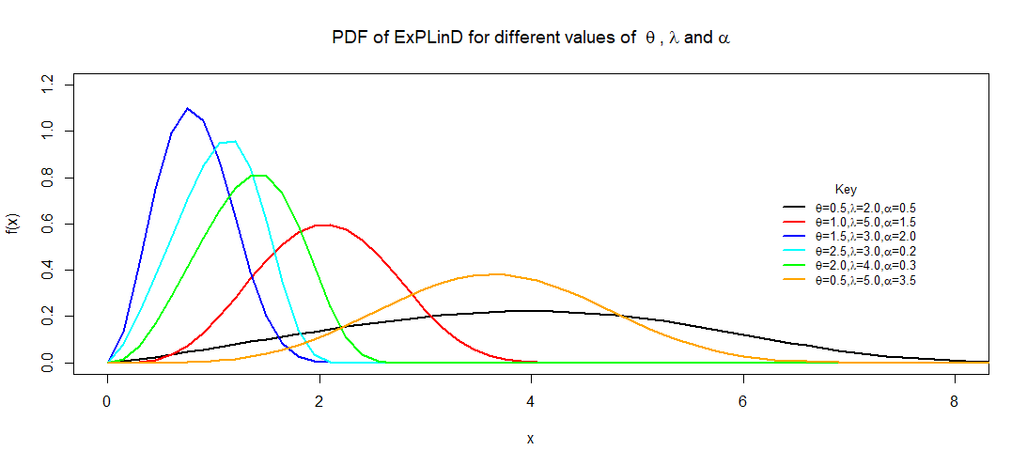 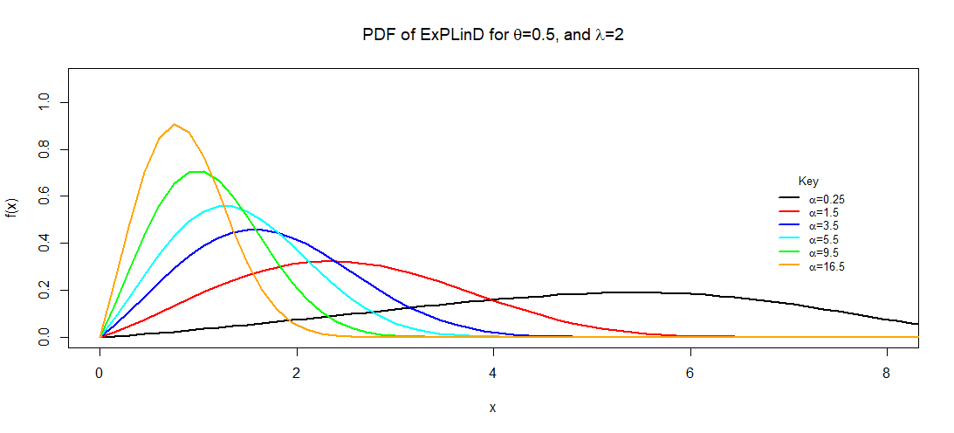

**Figure** **1: PDF of the ExPLinD for Different Parameter Values**.

Figure **1** indicates ExPLinD has different shapes which are as a result of the changes in the value of the additional parameter. This shows the ability of the model to capture datasets with different shapes.

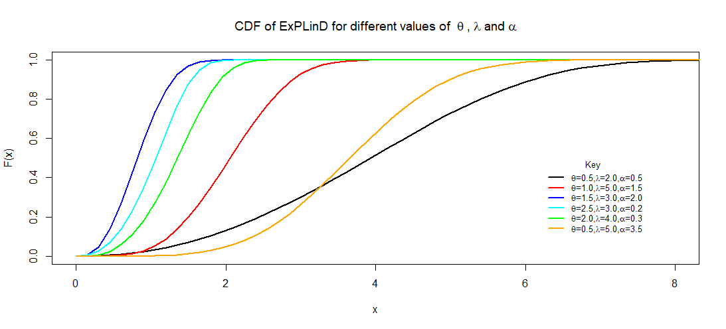 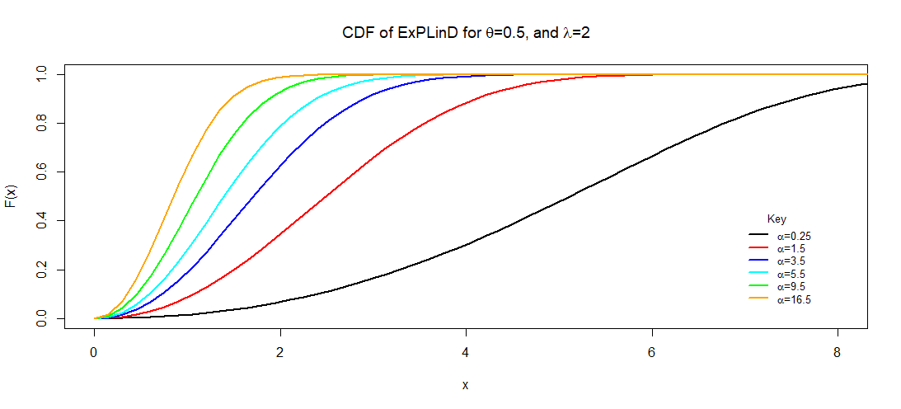

**Figure 2: CDF of the ExPLinD for Different Parameter Values.**

Figure 2 shows that the ExPLinD is a valid probability distribution as the cdf increases as x increases and approaches 1 asymptotically.

## **2.2 Statistical properties of ExPLinD**

Some statistical properties of ExPLinD are presented in this section. Recall the pdf of ExPLinD in Equation 6

Simplification of the above pdf as follows:

 (3)

The pdf becomes:



Using binomial expansion, we have:



By substituting the result above, we obtain:



Again using binomial expansion gives:



Hence;



Again we have







Again by binomial expansion we obtain:











Let 

Such that

 (7)

### 2.2.1 Moment of ExPLinD.

 (8)

Substituting equation (7) into equation (8) yeilds

 (9)

Using integration by substitution, we have:

let 



Substituting for and in the integral above gives:







 (10)

### 2.2.2 Moment Generating Function of ExPLinD.



 (11)

### 2.2.3 Characteristics Function of ExPLinD.



 (12)

2.2.4 Quantile Function of ExPLinD

Let *Q(u)* = $F^{-1}$*(u)* be the quantile function (qf) of F(x) for 0 *< u <*1.

Recall thecdf of the ExPLinD in Equation (5), inverting it give the quantile function. 

Inverting F(x) = u

 (13)

Simplifying equation (13) above, we obtain:









 (14)

From the expression above, it can be seen that  is the Lambert function of the real argument, because the Lambert function is defined as: 

Recall that the Lambert function has two branches with a branching point located at. The lower branch,  is defined in the interval  and has a negative singularity for. The upper branch, , is defined for . Hence, equation (14) can be written as:

 (15)

Now for any  and , it follows that  and . Therefore, considering the lower branch of the Lambert function, equation (3.58) can be presented as:

 (16)

Collecting like terms in Equation (16) and simplifying the result, the quantile function of the ExPLinD is obtained as:

 (17)

where *u* is a uniform variate on the unit interval *(0,1)* and represents the negative branch of the Lambert function.

**2.3 Reliability Analysis of ExPLinD**

2.3.1 Survival Function

Survival function is the likelihood that a system or an individual will not fail after a given time. Mathematically, the survival function is given by:

S(*x*) = 1-F(x) (18)

Where F(x) is the *cdf* of the ExPLinD in Equation (5)





 (19)

Figure 3 is a Plot of the Survival Function of ExPLinD at Chosen Parameter Values.

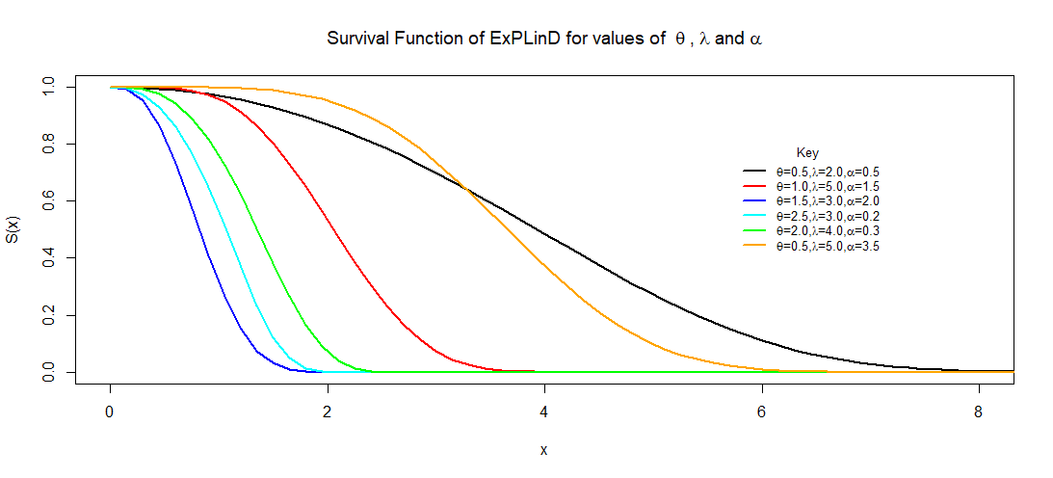 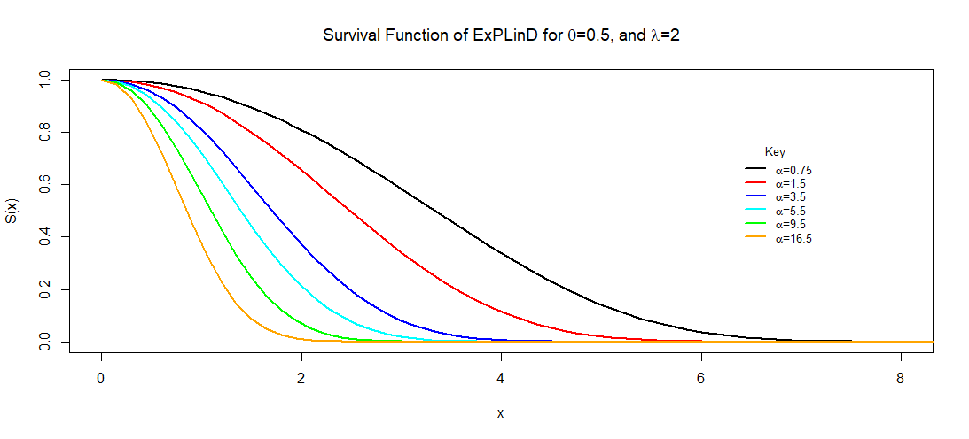

**Figure** **3**: **Survival Function of the ExPLinD for Different Parameter Values**.

Figure 3 shows ExPLinD has a decreasing survival function. This implies that the ExPLinD can be used to model random variables whose survival rate decreases as their age increase.

### 2.3.2 Hazard Function of ExPLinD.

Hazard function is the probability that a component will fail or die for an interval of time. The hazard function is defined as;

 (20)

Where *f(x)* and S(x)are the *pdf* and survival function of the ExPLinD given in Equations (6) and (19). Substituting and simplifying yields  (21)

The plot of the hazard function at chosen parameter values is shown in Figure **4**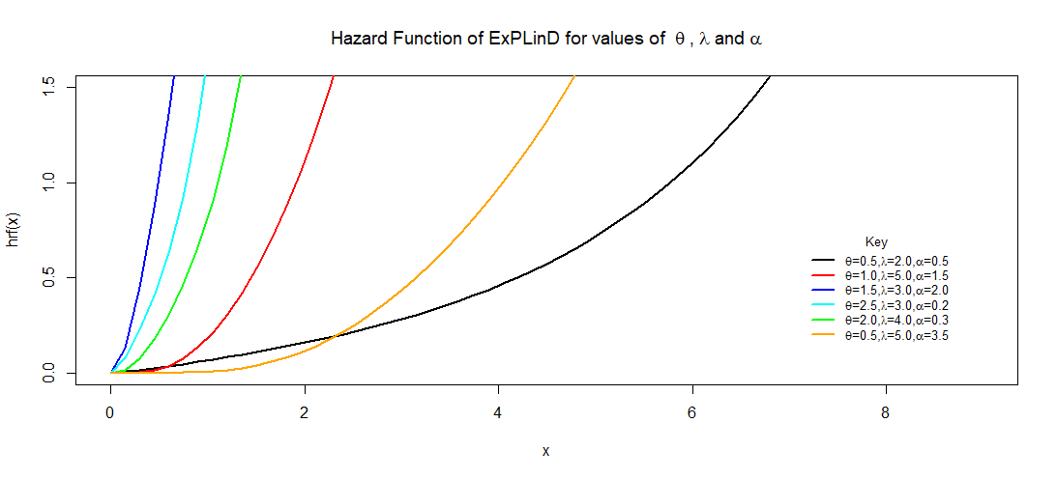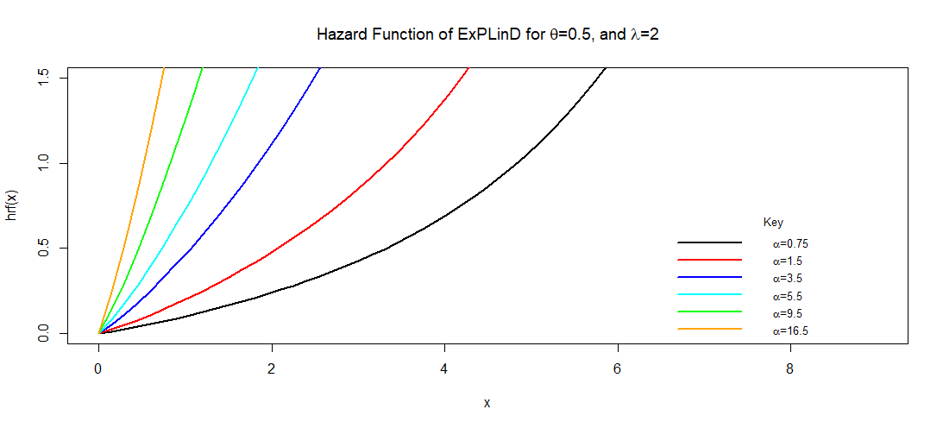

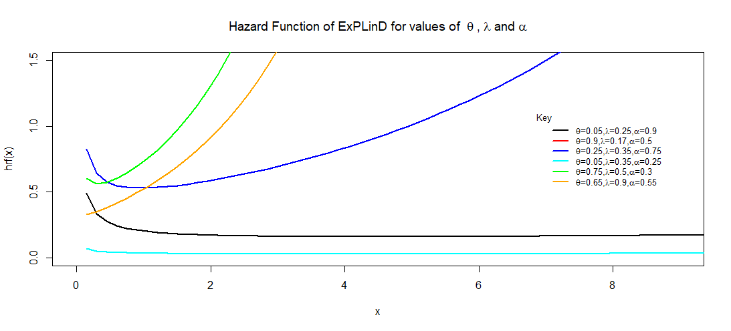

**Figure 4**: **The hazard function of the ExPLinD**.

Figure 4 reveals that the probability of failure for any random variable following ExPLinD increases as the values of the random variable increases, that is, as time goes on, probability of death increases. This implies that the distribution can be used to model random variables with increasing failure rate. Some other failure rate shapes such as bathtub shape and slightly decreasing then constant shape were observed for parameter values less than one.

## **2.4 Maximum Likelihood Estimation of Parameter of ExPLinD.**

Let  be a sample of size ‘n’ independently and identically distributed random variables from the ExPLinD with unknown parameters, α, 𝛌 and θ, defined previously. Recall the pdf of the ExPLinD in Equation (6). The likelihood function is given by: (22)

Let the log-likelihood function,, therefore

 (23)

Differentiating $l$ partially with respect to α, 𝛌 and θ respectively gives;

 (24)

 (25)

 (26)

The solution of the non-linear system of equations; ,  will give us the maximum likelihood estimates of parameters α 𝛌 and θ. However, the solution cannot be obtained analytically except numerically with the aid of suitable statistical software like R, SAS, Mapple, e.t.c when data sets are available. This current study utilised the R package and the Library(AdequacyModel) in obtaining the Maximum Likelihood Estimates (MLEs) of ExPLinD.

## **3.1 Simulation Studies of ExPLinD**

In this section, we perform a Monte Carlo (MC) simulation study with the objective to assess the behaviours of the MLEs of ExPLinD via the optim() R-function with the argument method = "L-BFGS-B". It is used for maximizing the log-likelihood function of a probabilistic model. We consider about 500 MC replicates under different sample sizes *n* = 27, 54. . . 500. These samples are obtained using the quantile function of ExPLinD. The simulation study is conducted for three different combination of θ, 𝛌 and α. These combination values are given by (i) θ = 0.5, 𝛌 = 0.5 and α = 0.5 (ii) θ = 2.5, 𝛌 = 0.5 and α = 0.5 and (iii) θ = 0.5, 𝛌 = 0.5 and α = 2.5. The performances of the MLEs of the parameters of ExPLinD,  and  are evaluated based on two criteria. These are the Mean square error (MSE) and Bias. For every sample size, the average MLEs, mean square errors (MSE), Biases and Absolute biases were computed. The results obtained after performing the MC simulation are provided in Tables 1, 2 and 3 and displayed graphically in Figure 5, 6 and 7. The parameters for simulations where chosen based on the properties of the parameters of the ExPLinD, they are non-negative continuous random variables and can take on values up to infinity. The sample sizes started out small and gradually increased up to about 500, all in a bid to achieve the law of Asymptotic theory where parameter estimates approaches true values and both bias and MSEs approach zero as sample size increases.

Table 1: Simulation Results for the ExPLinD for θ = 0.5, 𝛌 = 0.5 and α = 0.5.

|  |  |  |  |  |  |  |  |  |  |
| --- | --- | --- | --- | --- | --- | --- | --- | --- | --- |
|  | Measures/Criteria | Parameters | | | N | Measures/Criteria | Parameters | | |
|  |  |  |  |  |  |
| n=27 | MLEs | 0.1791 | 0.7859 | 4.6490 | n=189 | MLEs | 0.3117 | 0.6443 | 2.8580 |
| Biases | 0.3209 | 0.2859 | 4.1490 | Biases | 0.1883 | 0.1443 | 2.3580 |
| MSEs | 0.1136 | 0.1119 | 18.6705 | MSEs | 0.0678 | 0.0415 | 10.6110 |
| n=54 | MLEs | 0.2094 | 0.7486 | 4.2170 | n=297 | MLEs | 0.3500 | 0.6134 | 2.3720 |
| Biases | 0.2906 | 0.2486 | 3.7170 | Biases | 0.1500 | 0.1134 | 1.8729 |
| MSEs | 0.1032 | 0.0860 | 16.7265 | MSEs | 0.0542 | 0.0318 | 8.4240 |
| n=81 | MLEs | 0.2125 | 0.7224 | 4.1090 | n=378 | MLEs | 0.3850 | 0.5854 | 1.9310 |
| Biases | 0.2875 | 0.2224 | 3.6090 | Biases | 0.1150 | 0.0854 | 1.4310 |
| MSEs | 0.1036 | 0.0676 | 16.2405 | MSEs | 0.0416 | 0.0233 | 6.4395 |
| n=108 | MLEs | 0.2422 | 0.7109 | 3.7670 | n=486 | MLEs | 0.4146 | 0.5631 | 1.5620 |
| Biases | 0.2578 | 0.2109 | 3.2670 | Biases | 0.0854 | 0.0631 | 1.0620 |
| MSEs | 0.0919 | 0.0654 | 14.7015 | MSEs | 0.0309 | 0.0172 | 4.7790 |

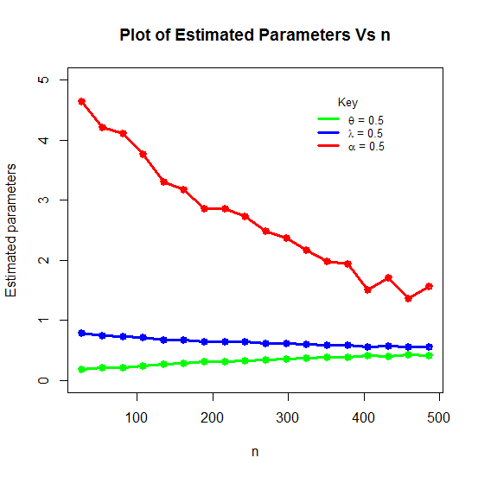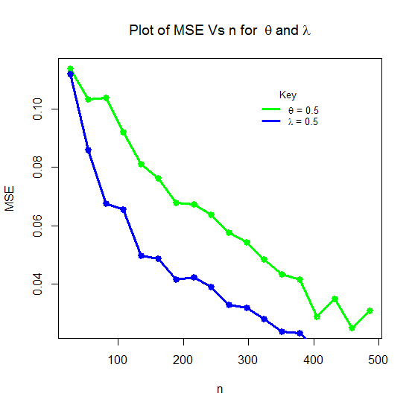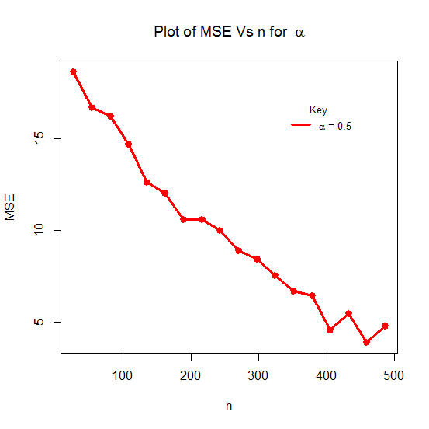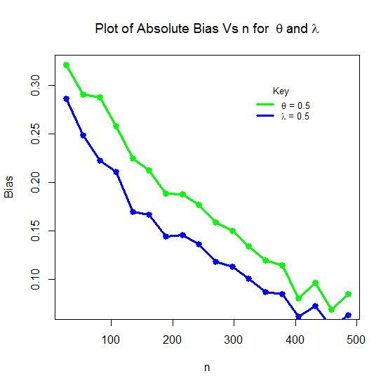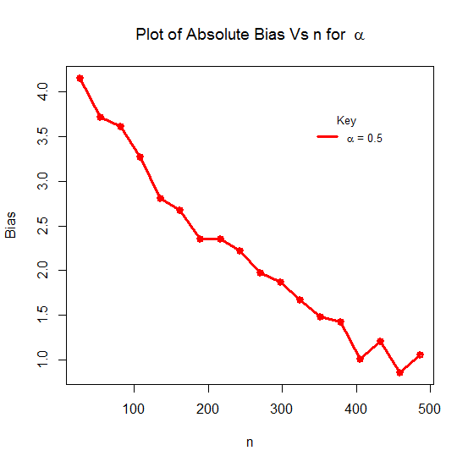

**Figure 5: Plots of MLEs, Absolute Biases and MSEs of the ExPLinD for**

**θ = 0.5, 𝛌 = 0.5 and α = 0.5**

Table 2: Simulation Results for the ExPLinD for θ = 2.5, 𝛌 = 0.5 and α = 0.5

|  |  |  |  |  |  |  |  |  |  |
| --- | --- | --- | --- | --- | --- | --- | --- | --- | --- |
| N | Measures/Criteria | Parameters | | | n | Measures/Criteria | Parameters | | |
|  |  |  |  |  |  |
| n=27 | MLEs | 1.3879 | 0.7660 | 3.407 | n=189 | MLEs | 2.3087 | 0.5379 | 0.977 |
| Biases | 1.1121 | 0.2660 | 2.907 | Biases | 0.1913 | 0.0379 | 0.477 |
| MSEs | 1.9511 | 0.1283 | 13.0815 | MSEs | 0.3456 | 0.0139 | 2.1465 |
| n=54 | MLEs | 1.6002 | 0.6929 | 2.777 | n=297 | MLEs | 2.4746 | 0.5050 | 0.563 |
| Biases | 0.8998 | 0.1929 | 2.277 | Biases | 0.0254 | 0.0050 | 0.063 |
| MSEs | 1.6093 | 0.0796 | 10.2465 | MSEs | 0.0463 | 0.0018 | 0.2835 |
| n=81 | MLEs | 1.8891 | 0.6247 | 2.030 | n=378 | MLEs | 2.4965 | 0.5007 | 0.509 |
| Biases | 0.6109 | 0.1247 | 1.530 | Biases | 0.0035 | 0.0007 | 0.009 |
| MSEs | 1.1023 | 0.0486 | 6.885 | MSEs | 0.0063 | 0.0003 | 0.0405 |
| n=108 | MLEs | 2.1086 | 0.5827 | 1.490 | n=486 | MLEs | 2.4927 | 0.5013 | 0.518 |
| Biases | 0.3914 | 0.0827 | 0.990 | Biases | 0.0073 | 0.0013 | 0.018 |
| MSEs | 0.6998 | 0.0331 | 4.455 | MSEs | 0.0132 | 0.0004 | 0.081 |

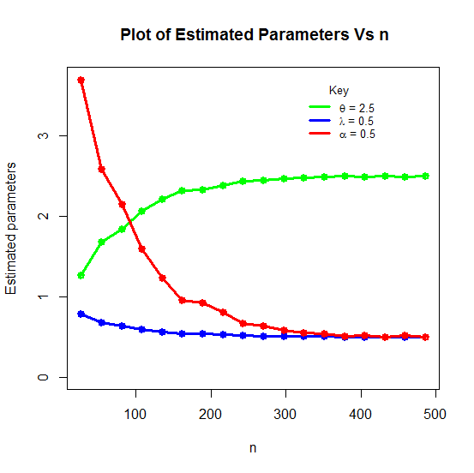

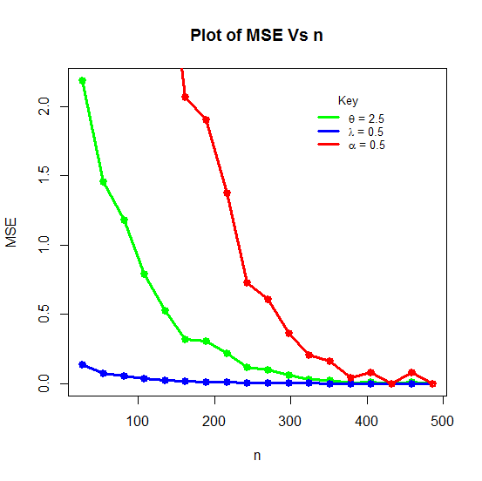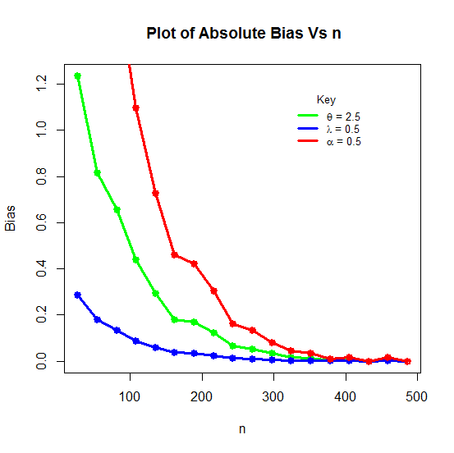

**Figure 6: Plots of MLEs, Absolute Biases & MSEs of the ExPLinD for θ = 2.5, 𝛌=0.5 and α = 0.5**

Table 3: Simulation Results for the ExPLinD for θ = 0.5, 𝛌 = 0.5 and α = 2.5.

|  |  |  |  |  |  |  |  |  |  |
| --- | --- | --- | --- | --- | --- | --- | --- | --- | --- |
| N | Measures/Criteria | Parameters | | | n | Measures/Criteria | Parameters | | |
|  |  |  |  |  |  |
| n=27 | MLEs | 0.3863 | 0.5962 | 4.180 | n=189 | MLEs | 0.4902 | 0.5057 | 2.620 |
| Biases | 0.1137 | 0.0962 | 1.680 | Biases | 0.0098 | 0.0057 | 0.120 |
| MSEs | 0.0309 | 0.0218 | 4.2000 | MSEs | 0.0021 | 0.0007 | 0.300 |
| n=54 | MLEs | 0.4198 | 0.5483 | 3.495 | n=297 | MLEs | 0.4987 | 0.5006 | 2.515 |
| Biases | 0.0802 | 0.0483 | 0.995 | Biases | 0.0013 | 0.0006 | 0.015 |
| MSEs | 0.0181 | 0.0078 | 2.4875 | MSEs | 0.0003 | 0.0001 | 0.0375 |
| n=81 | MLEs | 0.4358 | 0.5350 | 3.265 | n=378 | MLEs | 0.4986 | 0.5006 | 2.515 |
| Biases | 0.0642 | 0.0350 | 0.765 | Biases | 0.0014 | 0.0006 | 0.015 |
| MSEs | 0.0143 | 0.0048 | 1.9125 | MSEs | 0.0003 | 0.0001 | 0.0375 |
| n=108 | MLEs | 0.4574 | 0.5224 | 3.005 | n=486 | MLEs | 0.5000 | 0.5000 | 2.500 |
| Biases | 0.0426 | 0.0224 | 0.505 | Biases | 0.0000 | 0.0000 | 0.000 |
| MSEs | 0.0094 | 0.0028 | 1.2625 | MSEs | 0.0000 | 0.0000 | 0.0000 |

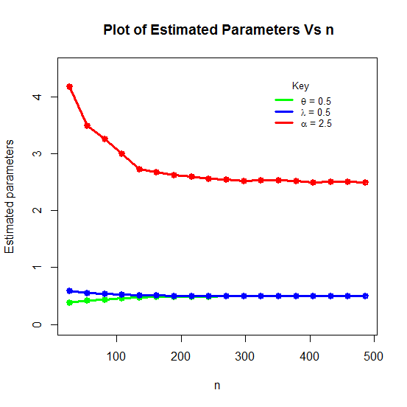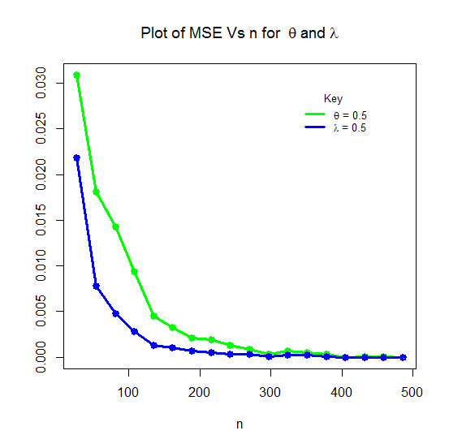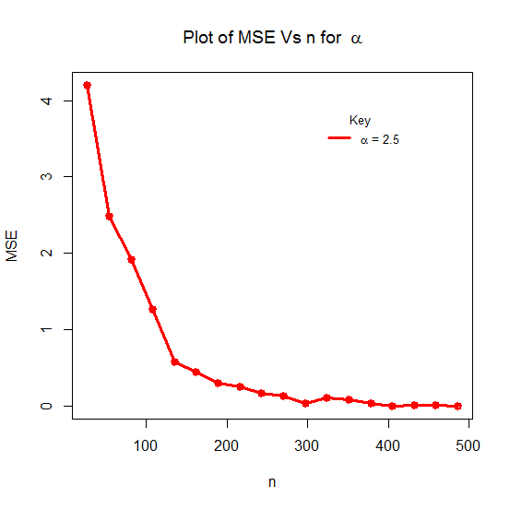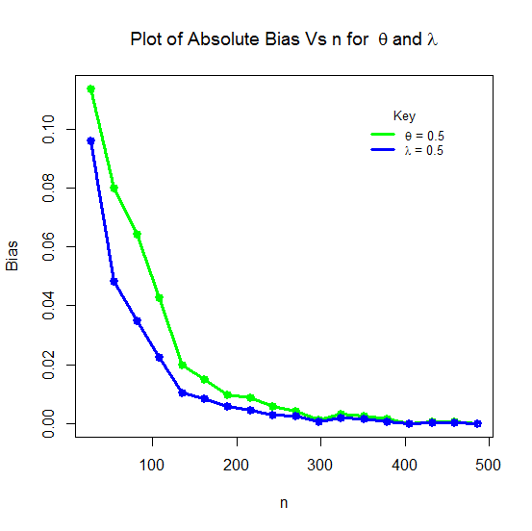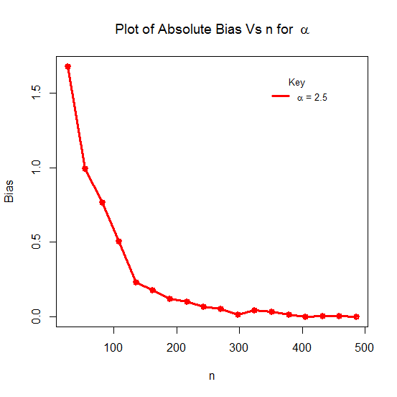

**Figure 7: Plots of MLEs, Absolute Biases and MSEs of the ExPLinD**

**for θ = 0.5, 𝛌 = 0.5 and α = 2.5**

The results in Tables 1-3 and Figures 5-7 show the averages of the MLEs (Mean), their biases (Absolute Bias) and mean square errors (MSEs) for the parameters of the ExPLinD. Based on the values from the Tables and the visual illustration in the Figures, the average estimates tends to the true parameters values when sample size increases and the biases and mean square errors all tend to zero as sample size increases which is expected for every normal parameter.

**3.2 Applications of the ExPLinD to Engineering Data.**

This section presents a dataset, its descriptive statistics and application to some selected generalized probability distributions. It has compared the adequacy of the ExPLinD to that of six other models. The models are: Poisson-Lindley distribution (PLinD), Exponential-Lindley distribution (ExLinD), inverse exponential distribution (INExD), inverse Lindley distribution (INLinD), exponential distribution (ExD) and Lindley distribution (LinD).Some criteria which will enable us carry out the comparisons are: AIC (Akaike Information Criterion), CAIC (Consistent Akaike Information Criterion), BIC (Bayesian Information Criterion) and HQIC (Hannan Quin information criterion). The formulas for these statistics are given as follows:





 and



Where ƖƖ denotes the log-likelihood function evaluated at the *MLEs*, k is the number of model parameters and n is the sample size.

Decision bench mark: The model with the lowest values of these statistics would be chosen as the best model to fit the data.

**Dataset**: This data set represents the strength of carbon fibers tested under tension at gauge lengths of 10mm. It has been used previously by Kundu and Raqab (23), Bi and Qui (24). The observations are as follows: 1.901, 2.132, 2.203, 2.228, 2.257, 2.350, 2.361, 2.396, 2.397, 2.445, 2.454, 2.474, 2.518, 2.522, 2.525, 2.532, 2.575, 2.614, 2.616, 2.618, 2.624, 2.659, 2.675, 2.738, 2.740, 2.856, 2.917, 2.928, 2.937, 2.937, 2.977, 2.996, 3.030, 3.125, 3.139, 3.145, 3.220, 3.223, 3.235, 3.243, 3.264, 3.272, 3.294, 3.332, 3.346, 3.377, 3.408, 3.435, 3.493, 3.501, 3.537, 3.554, 3.562, 3.628, 3.852, 3.871, 3.886, 3.971, 4.024, 4.027, 4.225, 4.395, 5.020.

Table 4: Summary Statistics for Data Set

|  |  |  |  |  |  |  |  |  |  |  |
| --- | --- | --- | --- | --- | --- | --- | --- | --- | --- | --- |
| Parameters | N | Mini |  | Median |  | Mean | Maximum | Variance | Skewness | Kurtosis |
| Values | 63 | 1.901 | 2.554 | 2.996 | 3.421 | 3.059 | 5.020 | 0.386 | 0.633 | 0.286 |

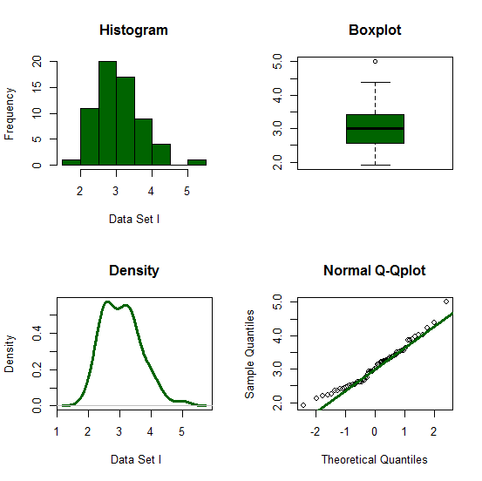

**Figure 8: A graphical summary of dataset**

Descriptive statistics in Table 4 and the graphical summary in Figure 8 shows that the dataset on the strength of carbon fibers tested under tension at gauge lengths of 10mm is slightly skewed to the right or positively skewed which is proper for skewed models.

Table 5: Maximum Likelihood Parameter Estimates for the Dataset

|  |  |
| --- | --- |
| Distribution | Parameter Estimates |
| ExPLinD | =0.4083674, =0.3516601, =0.4083674. |
| PLinD | =0.4598007, =0.4555799. |
| ExLinD | =0.7488845, =0.6868056. |
| INLinD | =3.584214 |
| INExD | =2.942385 |
| LinD | =0.5389887 |
| ExD | =0.3269008 |

Table 6: The Statistics *ℓ*, AIC, CAIC, BIC and HQIC for Dataset I

|  |  |  |  |  |  |  |  |  |  |  |  |  |
| --- | --- | --- | --- | --- | --- | --- | --- | --- | --- | --- | --- | --- |
| Distribution |  | | *AIC* | | *CAIC* | | *BIC* | | *HQIC* | | Ranks | |
| ExPLinD | -1.554066 | 2.891869 | | 3.298648 | | 9.3221273 | | 5.420585 | | 1st | |
| PLinD | 0.2701584 | 4.540317 | | 4.740317 | | 8.826586 | | 6.226127 | | 2nd | |
| ExLinD | 2.876741 | 9.753482 | | 9.953482 | | 14.03975 | | 11.43929 | | 3rd | |
| LinD | 121.3576 | 244.7153 | | 244.7809 | | 246.8584 | | 245.5582 | | 4th | |
| INLinD | 131.8826 | 265.7652 | | 265.8308 | | 267.9083 | | 266.6081 | | 5th | |
| INExD | 133.4229 | 268.8458 | | 268.9114 | | 270.9889 | | 269.6887 | | 6th | |
| ExD | 133.4458 | 268.8915 | | 268.9571 | | 271.0347 | | 269.7344 | | 7th | |

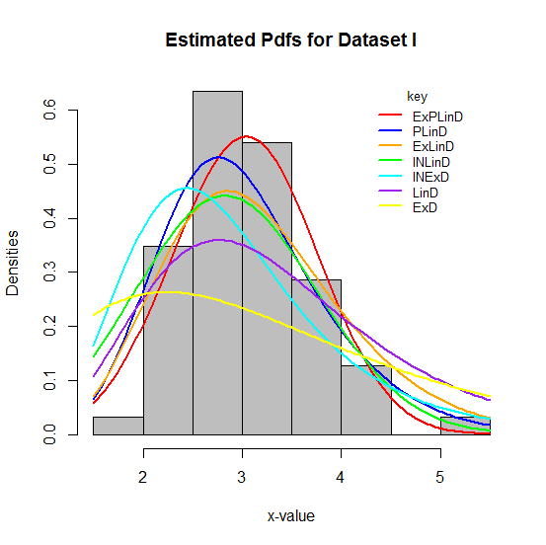 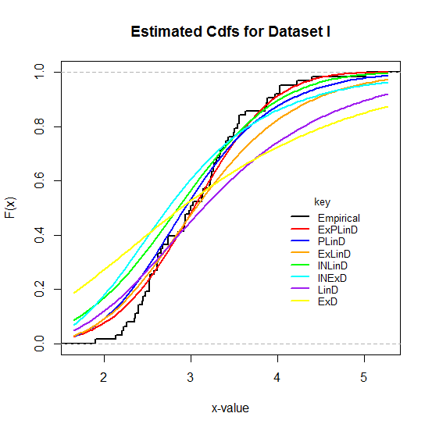

**Figure 9: Histogram and Plots of the Estimated Densities and cdfs of the Fitted Distributions to Dataset.**

## **4.1 Results and Discussions**

Descriptive statistics in Table 4 and the graphical summary in Figure 8 shows that the dataset on the strength of carbon fibers tested under tension at gauge lengths of 10mm is slightly skewed to the right or positively skewed which is proper for skewed models. Tables 5 presents the parameter estimates and Tables 6 presents the values of AIC, CAIC, BIC and HQIC for the fitted distributions based on the Dataset. The values of AIC, CAIC, BIC and HQIC in Tables 6 are smaller for the ExPLinD compared to those of the other fitted distributions. The result of BIC the Baseline distribution is smaller than that of the ExPLinD but bigger for the rest of the Criteria. This results indicates that the Exponential-Poisson Lindley distribution (ExPLinD) performed better in fitting the dataset compared to the Poisson Lindley distribution (PLinD), exponential-Lindley distribution (ExLinD), inverse Lindley distribution (INLinD), inverse exponential distribution (INExD), Lindley distribution (LinD) and the exponential distribution (ExD).This result reaffirms that that the exponential-G family from the Weibull-G family of distributions has the capacity to produce distributions with greater flexibility in distribution theory and applications. Figure 9 shows graphically how well each of the distribution fits the dataset. The ExPLinD is shown to have a better fit compared to the other fitted distributions.

## **4.2 Summary and Conclusions.**

A new three parameter continuous probability distribution called the Exponential Poisson Lindley Distribution (ExPLinD) was introduced. Its statistical properties and reliability analysis were carried out and appropriate plots presented. Simulation Studies of ExPLinD was carried out and it was applied to real life data in comparison to some stated distributions. Findings indicate that the ExPLinD can be used to model age or time related random variable. Also, the average estimates of the parameters of ExPLinD approaches the true parameters values when sample size increases and the biases and mean square errors all tend to zero as sample size increases which is expected for every normal parameter. The ExPLinD provided a better fit to the dataset compared to the other stated distributions, hence it is an important distribution for Statistical modeling. The baseline distribution (PLinD) performed better than the ExPLinD under the BIC criterion, this needs further studies to ascertain why.

Disclaimer (Artificial intelligence)

Author(s) hereby declare that NO generative AI technologies such as Large Language Models (ChatGPT, COPILOT, etc.) and text-to-image generators have been used during the writing or editing of this manuscript.

References

Lindley, D.V. Fiducial distributions and Bayes Theorem. *Journal of Royal Statistical Society*. Series B (Methodological), (1958). 20(1): 102–107.

Ghitany, M.E., Atieh, B. and Nadarajah, S. (2008) Lindley distribution and its applications. *Mathematics and Computers in Simulation*. 78(4): 493-506.

Mazucheli, J., Achcar, J.A. (2011). The Lindley distribution applied to competing risks lifetime data. *Computer Methods and Programs Biomedicine*. 104(2): 188–192.

Krishna, H. and Kumar, K. (2011). Reliability estimation in Lindley distribution with progressively type-ii right censored sample. *Mathematical and Computer in Simulation*, 82(2): 281–294.

Singh, B., Gupta, P.K. (2012). Load-sharing system model and its application to the real data set. *Mathematical Computation and Simulation*, 82: 1615–1629.

Al-Mutairi, D.K., Almutairi, M.E., Kundu, D. (2013). Inferences on stress-strength reliability from Lindley distributions. *Communications in Statistics–Theory and Methods,* 42: 1443–1463.

Merovci, F. (2013). Transmuted Lindley distribution. International. *Journal of Open Problems in Computer Science and Mathematics*, 6(2): 63-74.

Ashour, S. K. and Eltehiwy, M. A. (2015). Exponentiated power Lindley distribution. *Journal of Advanced Research*, 6: 895–905

Nadarajah, S., Bakouch, H. S. and Tahmasbi, R. (2011). A generalized Lindley distribution. *Sankhya B*, 73: 331–359. DOI 10.1007/s13571-011-0025-9.

Alkarni, S. H. (2015). Extended Power Lindley Distribution: A New Statistical Model For Non-Monotone Survival Data. *European Journal of Statistics and Probability*, 3(3): 19-34.

Elgarhy, M., M.Rashed, M. and Shawki, A.W. (2016). Transmuted Generalized Lindley Distribution. *International Journal of Mathematics Trends and Technology,* 29(2): 145-154.

Shanker, R., Kamlesh, K. K. and Fesshaye, H. (2017). A Two Parameter Lindley Distribution: Its Properties and Applications. *Biostatistics and Biometrics Open Access Journal*, 1(4): 555570.

Yahaya A, Lawal A. (2018). A study on Lomax–Lindley distribution with applications to simulated and real life data. Nigeria: University of Calabar, Calabar.

Al-khazaleh, M., Al-Omari, A. I. and Al-khazaleh, A. M. H. (2016). Transmuted Two-Parameter Lindley Distribution. *Journal of Statistics Applications & Probability*, 5(3): 421-432.

Shanker, R., Shukla, K. K., Shanker, R. and Leonida, T. A. (2017). A Three-Parameter Lindley Distribution. *American Journal of Mathematics and Statistics*. 7(1): 15-26.

Onwuka G. I., Asongo A. I., Bako I. A., Ortese C. A. and Allahde H. (2021). Modeling Neonatal Mortality Rate in Nigeria using a Continuous Poisson-Lindley Distribution. *International Journal of TROPICAL DISEASES And Health,* 42(19): 6-16

Hamad D. and Alzaghal A. (2021). New class of Lindley distributions: properties and applications. *Journal of Statistical Distributions and Applications*, 8, 11 (2021). https://doi.org/10.1186/s40488-021-00127-y.

Tahir, M.H., Zubair, M., Mansoor, M., Cordeiro, G.M., Alizadeh, M. (2016). A new Weibull-G family of distributions. *Hacettepe Journal of Mathematics and Statistics,* 45(2): 629-647.

Ieren, T. G., Oyamakin, S. O. & Chukwu, A. U. (2018a). Modeling Lifetime Data With Weibull-Lindley Distribution. *Biometrics and Biostatistics International Journal*, 7(6): 532‒544.

Ur, R. S., and S. P. Ahmad (2022). "Power Length biased weighted lomax distribution Reliability: Theory & Applications 17.4 (71): 543-558.

Ur, R. S., and S. P. Ahmad and S. P. Ahmad (2023). "Ratio transformation Lomax distribution with applications." Reliability: Theory & Applications 18.1 (72): 282-300.

Ur, R. S., and S. P. Ahmad and S. P. Ahmad. (2024). "Exponentiated Power Inverse Lomax Distribution with Applications." Punjab University Journal of Mathematics 56.

Kundu, D and Raqab, M.Z. (2009) Estimation of R = P(Y < X) for three-parameter Weibull distribution. Statistics and Probability Letters, 79(17); 1839-1846.

Bi, Qixuan and Gui, Wenhao. (2017). Bayesian and Classical Estimation of Stress-Strength Reliability for Inverse Weibull Lifetime Models. Algorithms. 10.71.10.71.10.3390/a10020071.