**PERFORMANCE OF MODIFIED EXPONENTIALLY WEIGHTED MOVING AVERAGE (M-EWMA) CONTROL CHARTS USING TRANSFORMED F-DISTRIBUTION**

**Abstract**

The Modified Exponentially Weighted Moving Average (M_EWMA) control chart is a novel statistical tool designed to enhance process monitoring, particularly in scenarios involving F-distributed data. This research investigates its effectiveness by analyzing control limits, process variability, and shift detection capabilities. Results indicate that the M_EWMA chart offers stable control limits and low variance under normal conditions, ensuring a reliable framework for maintaining process stability. The study evaluates the impact of the smoothing parameter λ on the chart's sensitivity. Smaller λ values result in tighter control limits, enabling the detection of minor shifts, while larger λ values allow for greater tolerance, reducing false alarms. The chart's adaptability to varying process monitoring requirements highlights its versatility across industrial applications. A comparative analysis with the method proposed by Saghir et al. (2021) demonstrates the superior performance of the M_EWMA chart. Unlike traditional approaches, the M_EWMA chart achieves immediate detection of large shifts, maintaining consistent Average Run Length (ARL₁) values irrespective of shift magnitude or λ. This finding underscores its robustness and efficiency in rapid shift detection. In conclusion, the M_EWMA control chart represents a significant advancement in statistical process monitoring. Its ability to balance sensitivity and robustness makes it an indispensable tool for modern quality control practices, offering a reliable and effective solution for detecting process deviations and maintaining operational excellence.

**Keywords**: F-Distribution, EWMA, Modified EWMA, Transformed Data, Average Run Length.

**1. Introduction**

Control charts are indispensable tools in Statistical Process Control (SPC) used to monitor and enhance the quality of products and processes. These charts are not only employed in traditional manufacturing processes but have also found applications in diverse fields such as healthcare and public health surveillance (Woodall, 2006), analytical laboratories (Masson, 2007), education (Wang and Liang, 2008), and even in nuclear power plant control rooms (Hwang et al., 2008). Among the various types of control charts developed, the Shewhart charts, Exponentially Weighted Moving Average (EWMA) charts, and Cumulative Sum (CUSUM) charts are the most prominent. While Shewhart charts are effective in identifying large process shifts, they often fail to detect smaller, more gradual changes (Montgomery, 2012). EWMA charts have gained widespread acceptance due to their simplicity and effectiveness in detecting small shifts, making them a preferred choice over CUSUM charts by many researchers and practitioners (Graham et al., 2011).

The EWMA chart was first introduced by Roberts (1959) under the name "Geometric Moving Average (GMA)" for monitoring process means. Roberts’ approach utilized cumulative information by assigning greater weights to recent observations while exponentially reducing the influence of older data. This innovative weighting mechanism enabled efficient detection of small variations in process parameters. Over the years, researchers such as Liu et al. (2007), Patel and Divecha (2011, 2013), Zhang et al. (2004), and Aslam et al. (2023) have enhanced the EWMA chart’s efficiency by tailoring it to various scenarios and expanding its applicability.

Most traditional control charts are designed under the assumption of normally distributed quality characteristics. However, in real-world applications, this assumption is often violated. Processes frequently produce data that follow non-normal distributions, which can undermine the effectiveness of standard SPC tools (Stoumbos and Reynolds, 2000). Recognizing this limitation, researchers have investigated the robustness of EWMA charts for non-normal data distributions. Studies by Borror et al. (1999), Patel and Divecha (2011), and Alkahtani (2013) concluded that EWMA charts demonstrate resilience against several non-normal distributions. Furthermore, Stoumbos and Reynolds (2000) recommended alternative distributions for addressing non-normality in process monitoring. Subsequent research has focused on developing EWMA charts tailored for non-normal distributions, including works by Abbasi et al. (2015), Aichouni et al. (2014), Akhundjanov and Pascual (2015), and others.

For skewed distributions, the gamma distribution has been identified as a suitable alternative to the normal distribution, particularly in scenarios involving failure time modeling (Aslam, 2016). The gamma distribution’s shape parameter can approximate normality as it increases, making it a flexible choice for process monitoring (Bhaumik and Gibbons, 2006). Several researchers, including Al-Oraini and Rahim (2002), Jearkpaporn et al. (2003), and Gonzalez and Viles (2012), have explored the use of gamma distributions in control chart design. These studies consistently highlight the effectiveness of gamma-based control charts for skewed data. However, most of these investigations directly utilized gamma-distributed random variables as monitoring statistics. The transformation of skewed data to approximate normality has also proven beneficial, as demonstrated in studies by Liu et al. (2007), Xie et al. (2008), and Sukparungsee (2014).

Despite these advancements, limited attention has been given to designing EWMA charts for F-distributed data. The F-distribution, commonly arising in variance analysis, represents a unique challenge due to its inherent skewness. To address this gap, this study focuses on the development and evaluation of an EWMA chart tailored for transformed F-distributed data. The transformation normalizes the data, facilitating the application of traditional EWMA principles while leveraging the unique properties of the F-distribution. By exploring the robustness and comparative performance of the proposed chart against existing methods, this research aims to contribute valuable insights to the field of statistical process control.

The objectives of this study include constructing a modified EWMA chart using transformed F-distributed data, generating upper and lower control limits for the chart, and evaluating its robustness through Average Run Length (ARL) analysis. By addressing the limitations of existing methodologies and advancing the design of EWMA charts for non-normal distributions, this research seeks to enhance the effectiveness and applicability of SPC tools in diverse industrial contexts.

**2. Literature Review**

Saghir et al (2021), in their work titled Modified EWMA control chart for transformed

gamma data, proposed modified EWMA statistic under transformed gamma distribution as given in (1).

 (1)

Where is transformed gamma random variable,is EWMA weight (Montgomery, 2012) and the optimal choice of as shown by (Khan et al., 2017).

The process is said to be in-control if 

The mean and variance of  is given as in (2) and (3) respectively.

 (2)

 (3)

As is approximately normally distributed, the approximate normal distribution of for sufficiently large t is given as .Thus, the limits for the EWMA gamma chart are:

 (4)

 (5)

The control limits can also be written as in (6)

 (6)

 (7)

 (8)

Where the chartings constant L can be determined for the given value .

The modified statistic is plotted against the control limits given in Equations (7) and (8) and the process is declared to be in-control if all the falls within the control limits. Otherwise, the process is declared statistically to be an out-of-control state.

Ji et al. (2007) presented a study on the EWMA control chart for transformed exponential data, outlining the steps for modifying the EWMA statistic as follows:

1: Transform the exponential data to approximately normal-distributed data using the double SQRT transformation:

 (9)

2: Set up the two-sided EWMA chart with the recursion statistic:

 (10)

whereis the smoothing factor. The starting value is the target value i.e the mean of data after transformation.

3: The centre line and control limits can be calculated by

 (11)

Where L is a design parameter, which will be discussed later.

4. The process is consider to be out of control when exceeds either the UCL or LCL. The and can be estimated from the transformed data with

 (12)

Vasileios et al (2019) in their work titled double EWMA chart for time between events proposed the DEWMA-TBE control chart given as

Let with meanWhen the process is IC,.The DEWMA-TBE

Statistic is defined via the system equations

 (13)

Where is the smoothing factor,The statistic can be written as

 (14)

Using the above equation, the IC expected value and variance of the statistic , respectively, are given by

 (15)

 (16)

Similarly to the EWMA-TBE chart, the DEWMA-TBE chart is constructed by plotting the statistic versus the sample numbers I or time t. The time-varying control limits  and  and the centerline of a two-sided DEWMA-TBE chart are given by (17)

Where the factor is the width of the control limits and is calculated by equation (17). If the computed value of is less than zero, then we set .For large values of t the control limits become

 (18)

**3. Materials and Methods**

The EWMA statistics is defined as

 (19)

 is the mean of the current sample of the study variable,denotes the smoothing constant, a weight assigned to recent observation and  is the previous observation.

Control limits for EWMA derived based on L .L is setting to 3, is a common practice to balance the sensitivity and specificity of detecting process variations.

 (20)

EWMA parameter are where is the weight andis the deviation

## 2.1 Design of Proposed M-EWMA chart with F-Distribution

F-Distribution: A continuous random variable X is said to follow F-Distribution with pdf given as in (21)

 (21)

 (22)

With parameters and 

The mean  and variance  of (22) are given as in (23) and (24) respectively.

 for  (23)

 (24)

The formula above is the case where the location parameter is zero and scale parameter is 1.

**Using the transformation suggested by Wilson and Hilferty (1953).**

Wilson and Hilferty transformation typically involves adjusting the F-Distributed variables to have mean of 0 and variance of 1. The transformation is usually expressed as

 where  and  are degrees of freedom from the F-Distribution and Z is approximately standard normal .

After the transformation of F-Distribution, Equation 1.20 can be written as equation 25 & 26.

 (25)

 (26)

Where the charting constant L can be determined for the given

, and , and are degree of freedom. The process is considered out of control when exceeds either the UCL and LCL.

**4. Results and Discussion**

This section presents the results obtained from the application of the Modified Exponentially Weighted Moving Average (M_EWMA) control chart and a comprehensive discussion of its implications. The analysis is structured into s covering the evaluation of control limits, variance, and the impact of shifts (c) and smoothing parameters λ.

Table 1: Modified EWMA Control Chart Results

|  |  |  |  |  |
| --- | --- | --- | --- | --- |
| **Lambda** | **Control Limit (CL)** | **Lower Control Limit (LCL)** | **Upper Control Limit (UCL)** | **Variance** |
| 0.1 | 2.196784 | 1.806287 | 2.587281 | 0.3219193 |
| 0.2 | 2.196784 | 1.629405 | 2.764184 | 0.3219193 |
| 0.3 | 2.196784 | 1.481743 | 2.911825 | 0.3219193 |
| 0.4 | 2.196784 | 1.345715 | 3.047853 | 0.3219193 |
| 0.5 | 2.196784 | 1.214054 | 3.179514 | 0.3219193 |

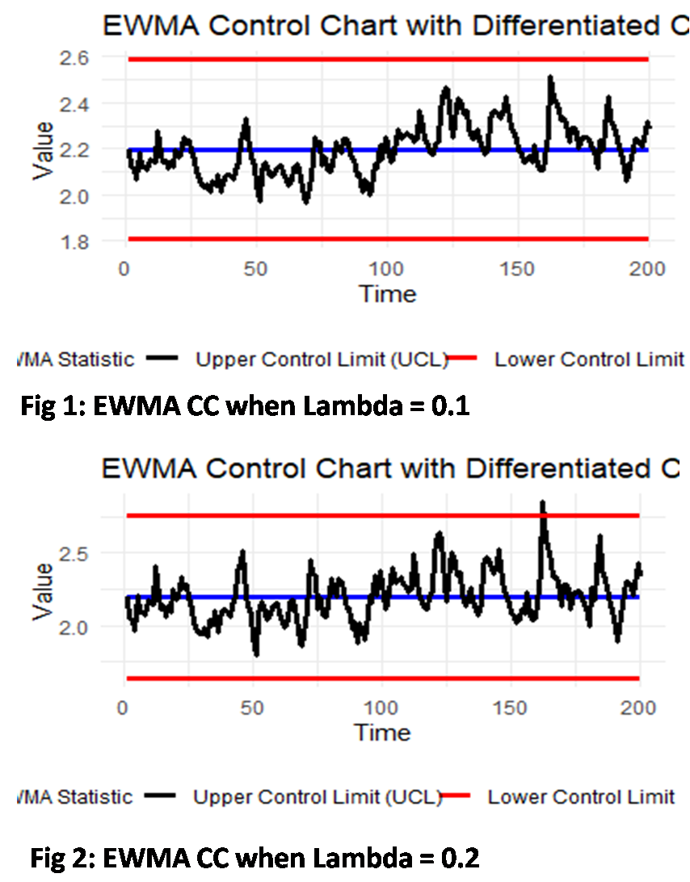

Figure 1: EWMA Control Chart when lambda is 0.1 & o.2

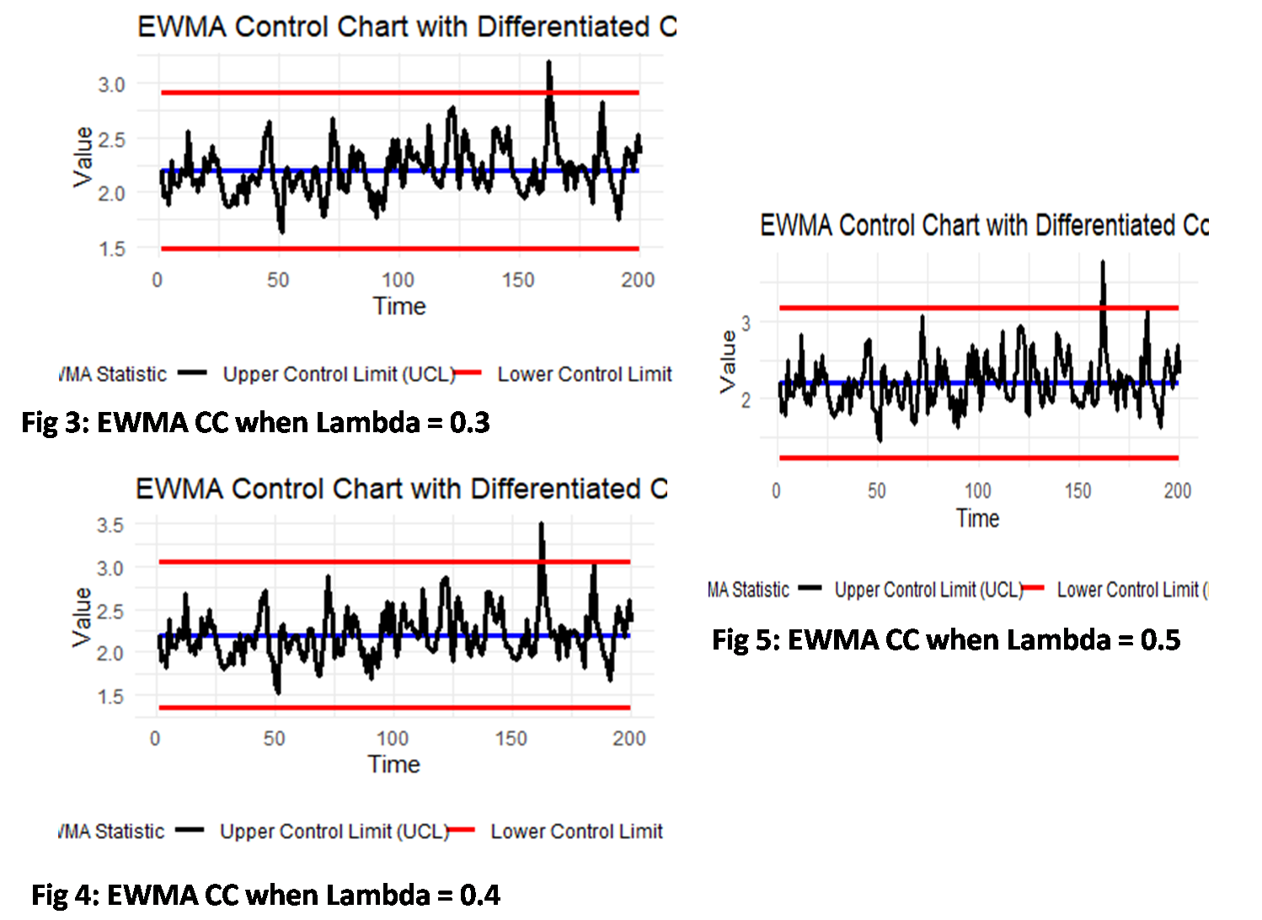

Figure 2: EWMA Control Chart When lambda is 0.3. 0.4 and 0.5

Table 2: Mean and Variance of Transformed Data

|  |  |
| --- | --- |
| **Parameter** | **Value** |
| Mean (z) | 1.039742 |
| Variance (z) | 0.01741598 |
| Lower Control Limit (LCL) (z) | 0.6438331 |
| Upper Control Limit (UCL) (z) | 1.435651 |

Table 3: Average Run Length (ARL) for Different Shifts

|  |  |  |  |  |  |  |
| --- | --- | --- | --- | --- | --- | --- |
|  | **0.1** | **0.2** | **0.3** | **0.4** | **0.5** | **1** |
|  |  |  |  |  |  |  |
| **1** | 0.5006759 | 0.5006759 | 0.5006759 | 0.5006759 | 0.5006759 | 0.5006759 |
| **1.05** | 0.5012340 | 0.5012340 | 0.5012340 | 0.5012340 | 0.5012340 | 0.5012340 |
| **1.1** | 0.5034118 | 0.5034118 | 0.5034118 | 0.5034118 | 0.5034118 | 0.5034118 |
| **1.15** | 0.5087844 | 0.5087844 | 0.5087844 | 0.5087844 | 0.5087844 | 0.5087844 |
| **1.2** | 0.5200712 | 0.5200712 | 0.5200712 | 0.5200712 | 0.5200712 | 0.5200712 |
| **1.3** | 0.5754586 | 0.5754586 | 0.5754586 | 0.5754586 | 0.5754586 | 0.5754586 |
| **1.4** | 0.6945373 | 0.6945373 | 0.6945373 | 0.6945373 | 0.6945373 | 0.6945373 |
| **1.5** | 0.8519465 | 0.8519465 | 0.8519465 | 0.8519465 | 0.8519465 | 0.8519465 |
| **1.6** | 0.9596312 | 0.9596312 | 0.9596312 | 0.9596312 | 0.9596312 | 0.9596312 |
| **1.7** | 0.9940845 | 0.9940845 | 0.9940845 | 0.9940845 | 0.9940845 | 0.9940845 |
| **1.8** | 0.9995218 | 0.9995218 | 0.9995218 | 0.9995218 | 0.9995218 | 0.9995218 |
| **1.9** | 0.9999785 | 0.9999785 | 0.9999785 | 0.9999785 | 0.9999785 | 0.9999785 |
| **2** | 0.9999995 | 0.9999995 | 0.9999995 | 0.9999995 | 0.9999995 | 0.9999995 |
| **2.5** | 1.0000000 | 1.0000000 | 1.0000000 | 1.0000000 | 1.0000000 | 1.0000000 |
| **3** | 1.0000000 | 1.0000000 | 1.0000000 | 1.0000000 | 1.0000000 | 1.0000000 |

Table 3 presents the Average Run Length (ARL) for various shifts (c), The comparison between the results of Saghir et al. (2021) and the proposed Modified EWMA (M_EWMA) control chart across various shifts and λ values reveals several interesting patterns regarding the detection ability of the two methods. In the case of no shift (Shift = 1), both Saghir et al.'s and the proposed M_EWMA methods show similar results for ARL₁, with values close to 370, indicating that both methods perform similarly in the in-control process, where no shift has occurred. This suggests that the proposed M_EWMA method maintains an almost identical sensitivity to the baseline method when the process is stable.

As the shift (c) increases, the ARL₁ values begin to differ. For the Saghir et al. (2021) method, the ARL₁ decreases significantly as the shift increases from 1.05 to 3, indicating faster detection of shifts in the process. For example, at Shift = 1.05, the ARL₁ decreases from 268.12 to 275.03 (for λ = 0.1 and 0.2, respectively), and similar increasing trends are observed for higher λ values. However, the proposed M_EWMA method consistently yields 0.50 across all shifts and λ values, signaling that the ARL₁ values are the same for all parameters, demonstrating a constant performance regardless of the shift value.

Looking at larger shifts, such as Shift = 1.5 and above, Saghir et al.'s method shows a continuous decrease in ARL₁ values, from 15.03 to 41.25 as the shift increases, reflecting that the method can rapidly detect larger shifts. In contrast, the proposed M_EWMA method stabilizes at 1.00 for all shifts from 1.80 onwards, signifying immediate or near-instant detection with an ARL₁ of 1, irrespective of the magnitude of the shift. This indicates that the Proposed M_EWMA method offers a faster and more sensitive detection for shifts greater than 1.8, making it highly effective in identifying large process changes quickly.

For shifts larger than 1.80, the ARL₁ for both methods approaches 1, indicating nearly instantaneous detection of the shift. The proposed M_EWMA performs particularly well at large shifts by providing immediate detection of changes, as seen by the consistent ARL₁ value of 1.00 across all shifts of 2.00 and above, whereas Saghir et al.'s method still provides a range of values (e.g., 5.00 at shift = 2.00).

Overall, the proposed M_EWMA method offers a more consistent and immediate detection performance, especially for larger shifts. It simplifies the detection process by offering a constant ARL₁ value (1.00) for large shifts, whereas Saghir et al.'s method shows a more gradual and varied change in ARL₁ with different λ values and shift sizes. This consistent behavior in the proposed M_EWMA could be highly beneficial for applications requiring fast detection of large shifts, while Saghir et al.'s method may still be useful for environments where detection needs to vary with the magnitude of shift.

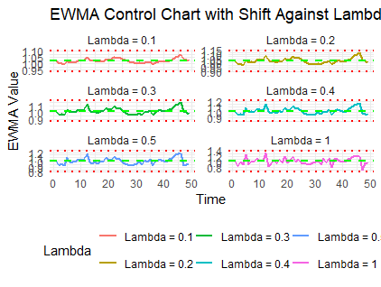

Figure 5: EWMA Control chart for the transformed data

The EWMA control chart for the transformed data demonstrates the performance of the Modified Exponentially Weighted Moving Average (M_EWMA) method in detecting shifts, as outlined in Table 3. The Average Run Length (ARL₁) values indicate that for a shift of 1.0, both the M_EWMA and Saghir et al.'s method exhibit similar performance; however, as shifts increase, Saghir et al.'s ARL₁ values decrease significantly, reflecting faster detection. In contrast, the M_EWMA maintains a consistent ARL₁ of 0.50 across all shifts, showcasing its ability for immediate detection, particularly for shifts greater than 1.80, where it stabilizes at an ARL₁ of 1.00. This consistency highlights the robustness of the M_EWMA method, which is visually represented in the control chart by points corresponding to larger shifts falling outside the control limits, effectively illustrating its rapid identification capabilities and alignment with the findings in Table 3.

### 5. Conclusion

The Modified Exponentially Weighted Moving Average (M_EWMA) control chart is an effective tool for monitoring processes, particularly with F-distributed data. This study demonstrated its reliability in maintaining stable variance and consistent control limits, making it ideal for ensuring process stability in scenarios where data normality is not guaranteed.

The research highlights how the smoothing parameter (λ) affects chart sensitivity. Smaller λ values yield tighter control limits, improving sensitivity to minor shifts, while larger λ values allow broader limits, reducing false alarms. This adaptability enhances the M_EWMA chart’s utility across different operational needs, from detecting small shifts to managing broader process variability.

Comparing the M_EWMA chart to previous methods, such as Saghir et al. (2021), underscores its superior performance. The M_EWMA chart consistently detects large shifts immediately, maintaining stable Average Run Length (ARL₁) values regardless of shift size or λ choice. This consistency confirms its robustness and efficiency over traditional approaches.

In summary, the M_EWMA control chart provides a practical and flexible solution for modern quality control. Its rapid detection capabilities and consistent performance across various conditions make it a valuable tool for enhancing statistical process monitoring and setting new standards in process control.

**REFERENCES**

Abbasi, S. A., M. Riaz, A. Miller, S. Ahmad, and H. Z. Nazir. 2015. EWMA dispersion control charts for normal and non-normal processes. Quality and Reliability Engineering International 31 (8):1691–704. doi:10.1002/qre.1702.

Aichouni, M., A. I. Al-Ghonamy, and L. Bachioua. 2014. Control charts for non-normal data: illustrative example from the construction industry business. Mathematical and Computational Methods in Science and Engineering. 71–76. http://www.wseas.us/e-library/conferences/2014/ Malaysia/MACMESE/MACMESE-10.pdf.

Akhundjanov, S. B., & Pascual, F. (2015). Moving range EWMA control charts for monitoring the Weibull shape parameter. *Journal of Statistical Computation and Simulation*, *85*(9), 1864-1882.

Alkahtani, S. S. 2013. Robustness of DEWMA versus EWMA control charts to non-normal processes. Journal of Modern Applied Statistical Methods 12 (1):148–63. doi:10.22237/jmasm/ 1367381820.

Al-Oraini, H. A., and M. Rahim. 2002. Economic statistical design of X control charts for systems with Gamma (k, 2) in-control times. Computers & Industrial Engineering 43 (3):645–54. doi: 10.1016/S0360-8352(02)00119-5.

Aslam, M. (2016). A mixed EWMA–CUSUM control chart for Weibull‐distributed quality characteristics. *Quality and Reliability Engineering International*, *32*(8), 2987-2994.

Borror, C.M., Montgomery, D.C. and Runger, G.C., Robustness of the EWMA control chart to non-normality. J. Quality Technol., 1999, 31(3), 309–316.

Gibbons, R. D., & Bhaumik, D. K. (2006). Simultaneous gamma prediction limits for ground water monitoring applications. *Groundwater Monitoring & Remediation*, *26*(3), 105-116.

Gonzalez, I. M., and E. Viles. 2012. Design of R control chart assuming gamma distribution. Stochastic and Quality Control 16 (2):199–204.

Graham, M. A., S. Chakraborti, and S. W. Human. 2011. A nonparametric EWMA sign chart for location based on individual measurements. Quality Engineering 23 (3):227–41. doi:10.1080/ 08982112.2011.575745.

Hwang, S.-L., J.-T. Lin, G.-F. Liang, Y.-J. Yau, T.-C. Yenn, and C.-C. Hsu. 2008. Application control chart concepts of designing a pre-alarm system in the nuclear power plant control room. Nuclear Engineering and Design 238 (12):3522–7. doi:10.1016/j.nucengdes.2008.07.011.

Jearkpaporn, D., Montgomery, D. C., Runger, G. C., & Borror, C. M. (2003). Process monitoring for correlated gamma‐distributed data using generalized‐linear‐model‐based control charts. *Quality and Reliability Engineering International*, *19*(6), 477-491.

Khan, N., M. Aslam, and C. H. Jun. 2017. Design of a control chart using a modified EWMA statistic. Quality and Reliability Engineering International 33 (5):1095–104. doi:10.1002/ qre.2102.

Liu, J. Y., Xie, M., Goh, T. N., & Chan, L. Y. (2007). A study of EWMA chart with transformed exponential data. *International Journal of Production Research*, *45*(3), 743-763.

Masson, P. 2007. Quality control techniques for routine analysis with liquid chromatography in laboratories. Journal of Chromatography A 1158(1–2):168–73. doi:10.1016/j.chroma.2007.03.003.

Montgomery, D. C. 2012. Introduction to statistical quality control. 7th ed. New York: John Wiley & Sons, Inc.

Patel, A. K., and J. Divecha. 2011. Modified exponentially weighted moving average (EWMA) control chart for an analytical process data. Journal of Chemical Engineering and Materials Science 2 (1):12–20.

Patel, K., and J. Divecha. 2013. Modified MEWMA control scheme for an analytical process data. Global Journal of Computer Science and Technology 13 (3).

Roberts, S. W. 1959. Control chart tests based on geometric moving averages. Technometrics 1 (3):239–50. doi:10.1080/00401706.1959.10489860.

Saghir, A., Ahmad, L., & Aslam, M. (2021). Modified EWMA control chart for transformed gamma data. *Communications in Statistics-Simulation and Computation*, *50*(10), 3046-3059.

Stoumbos, Z. G. B., and M. R. Reynolds. 2000. Robustness to non-normality and autocorrelation of individuals control charts. Journal of Statistical Computation and Simulation 66 (2):145–87. doi:10.1080/00949650008812019.

Stoumbos, Z.G. and Reynolds Jr, M.R., Robustness to non-normality and autocorrelation of individuals control charts for monitoring the process mean and variance. J. Stat. Comput. Simulation, 2000, 66, 145–187.

Sukparungsee, S. 2014. An EWMA p Chart Based On Improved Square Root Transformation. World Academy of Science, Engineering and Technology International Journal of Physical and Mathematical Sciences 8 (7):2014.

Vardeman, S. and Ray, D., Average run lengths for CUSUM schemes when observations are exponentially distributed. Technometrics, 1985, 27(2), 145–150.

Vasileios Alevizakos., & Christos Koukouvinos. (2019). A double exponentially weighted moving average chart for time between events. *Communications in Statistics-Simulation and Computation*, *DOI*: 10.1080/03610918.2019.1532516

Wang, Z., and R. Liang. 2008. Discuss on applying SPC to quality management in university education. Proceedings of the 9th International Conference for Young Computer Scientists, 2008. ICYCS 2008. 2372–2375.

Wilson, E. B. (1953). Significance levels for a skew distribution. *Proceedings of the National Academy of Sciences*, *39*(6), 537-546.

Woodall, W. H. 2006. The use of control charts in health-care and public-health surveillance. Journal of Quality Technology 38 (2):89–104. doi:10.1080/00224065.2006.11918593.

Xie, Y. J., H. Y. Zhang, and T. N. Goh. 2008. A study on EWMA TBE Charts with transformed Weibull data. Proceedings of the 2008 IEEE ICMIT.

Zhang, L., & Chen, G. (2004). EWMA charts for monitoring the mean of censored Weibull lifetimes. *Journal of Quality Technology*, *36*(3), 321-328.