**Cervical Spondylotic Myelopathy: A Descriptive Study**

**ABSTACT**

Cervical spondylotic myelopathy (CSM), also known as degenerative cervical myelopathy, is a progressive spinal disorder caused by vertebral canal narrowing and spinal cord compression. It is commonly associated with degenerative disc disease, cervical osteoarthritis, spondylolisthesis, and ligament hypertrophy or ossification. Epidemiological studies report high prevalence rates, particularly in older populations, with variations across different regions. Pathophysiology involves static and dynamic compression mechanisms, vascular compromise, and chronic inflammation leading to neurological deficits. Clinical manifestations include motor dysfunction, sensory impairment, and myelopathic reflexes. Diagnosis relies on imaging modalities such as MRI, CT, and X-ray. Surgical intervention is the primary treatment for moderate to severe Cervical Spondylotic Myelopathy (CSM) when conservative management fails. The optimal surgical approach for decompression surgery remains debated between anterior or posterior approach. A thorough understanding of the indications for each procedure significantly influences patient outcomes The main goals are to slow progression and restore function, with surgical approaches chosen based on pathology location for optimal decompression. Surgical outcomes show significant symptom relief, with prognosis influenced by disease severity and intervention timing.

**Key words:** Cervical Spondylotic Myelopathy, Degenerative, Surgical Intervention, cervical osteoarthritis, spondylolisthesis

**1. INTRODUCTION**

Cervical spondylotic myelopathy (CSM), also referred to as degenerative cervical myelopathy (DCM)1,2. is a progressive degenerative disorder characterized by direct spinal cord compression due to vertebral canal narrowing. This condition is commonly associated with degenerative disc disease, cervical osteoarthritis (spondylosis), spondylolisthesis or subluxation, ligament hypertrophy, and calcification or ossification of spinal ligaments, including the ligamentum flavum and posterior longitudinal ligament. Clinically, CSM is most often manifested by gait instability, loss of fine motor control in the upper extremities, limb weakness, neck pain, and reduced cervical range of motion (ROM)3.

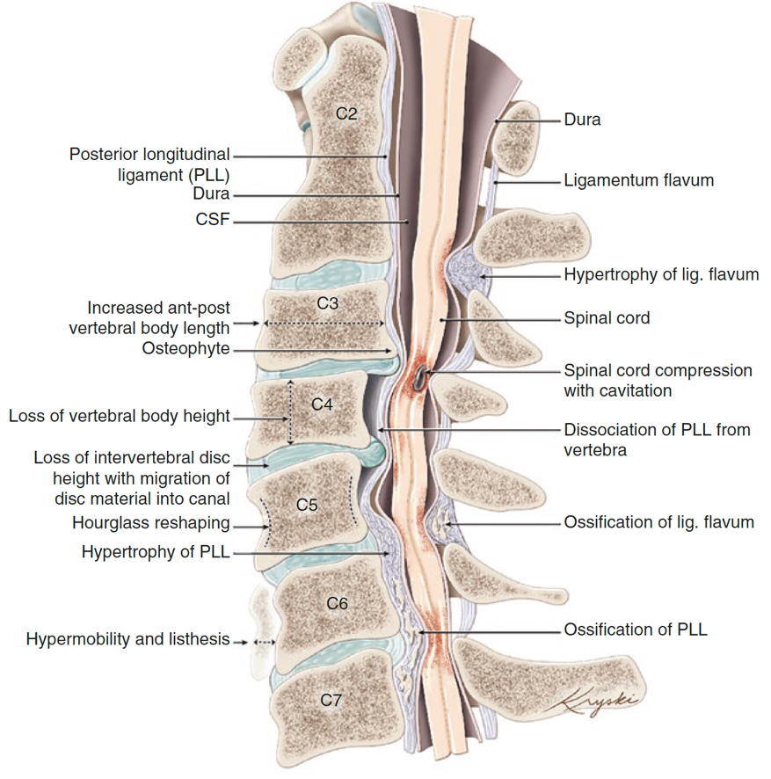

Figure 1. The Degenerative Process That Occurs In CSM1.

1. **EPIDEMIOLOGY**

Cervical spondylotic myelopathy (CSM) is the most common non-traumatic spinal disorder, with epidemiological variations observed across different populations. Ramos et al. reported an incidence of 60 cases per 100,000 individuals in North America3, while McCormick et al. noted that 10% of individuals aged 55 years and 85% of those over 60 years in the United States experience CSM4. Similarly, a 2017 study in Canada estimated an incidence of 1,120 cases per 1 million individuals5. In the Netherlands, Bajamal et al. documented a higher prevalence in males, with an incidence rate of 4 per 100,0006.

Pathological findings indicate that spondylosis is present in 90% of CSM cases and is often associated with ligamentum flavum hypertrophy in more than 50% of cases. In contrast, disc degeneration, spondylolisthesis, and ossification of the posterior longitudinal ligament (OPLL) account for only 10% of cases in Western populations. Notably, OPLL is significantly more prevalent in Asian populations (29%) compared to non-Asian populations (4.8%) (p = 0.3 × 10⁻¹¹), while spondylolisthesis is less frequent in Asians (1.9%) than in non-Asians (14.8%) (p = 0.002)7.

1. **PATHOPHYSIOLOGY**

Cervical spondylotic myelopathy (CSM) occurs due to mechanical compression of the spinal cord, which leads to progressive neurological deficits. Several anatomical structures in the cervical spine contribute to this compression, including intervertebral disc bulging or herniation, posterior osteophyte protrusion, hypertrophy or ossification of the posterior longitudinal ligament (PLL), infolding or ossification of the ligamentum flavum (LF), and osteoarthritis of uncovertebral and apophyseal joints. In many cases, static compression occurs due to a combination of these factors. Additionally, dynamic instability, caused by abnormal motion or segmental instability, can exacerbate spinal cord compression and contribute to the progression of myelopathy. Other contributing factors include spinal cord stretching, vascular compromise, and chronic repetitive microtrauma14.

**Pathogenesis of CSM**

The pathogenesis of CSM can be divided into three categories:

1. Cervical Osteoarthritis

Cervical osteoarthritis is a degenerative process characterized by repeated stress and structural damage to the vertebral bodies and intervertebral discs. Degeneration of the intervertebral disc is the primary event in cervical spondylosis, leading to flattening and loss of disc height, which disrupts weight-bearing capacity and load transmission in the cervical spine. As a result, facet joints become hypermobile, leading to spinal instability and spondylolisthesis. Over time, osteophyte formation occurs due to remodeling in response to stress on the cartilaginous endplates, further contributing to canal narrowing.

Loss of disc height and anterior-posterior enlargement of the vertebral bodies lead to restructuring of the vertebral segment, causing progressive spinal canal stenosis in CSM patients. Studies indicate that an AP diameter of ≤13 mm in the cervical spinal canal is significantly associated with disc degeneration and cervical stenosis7,14.

1. Cervical Non-Osteoarthritis

In addition to disc degeneration and facet joint changes, age-related spinal ligament changes contribute to CSM, particularly in the PLL and ligamentum flavum. Two key pathological processes occur:

* Hypertrophy and ossification of the PLL (OPLL): This condition is more common in Asian populations and is influenced by age, local tissue characteristics, patient comorbidities, and genetic factors. Hypertrophy precedes ossification and may be triggered by nucleus pulposus protrusion.
* Ligamentum flavum hypertrophy and dynamic infolding: These processes contribute to spondylosis and disc height loss, further exacerbating canal stenosis.

Radiologically, OPLL can be classified into four types: (1) localized, (2) segmental, (3) continuous, and (4) mixed (a combination of the previous types). OPLL is progressive, leading to worsening stenosis and myelopathy. A cohort study of 207 patients over 10 years found that 34% (70 patients) developed myelopathy. Another study suggested that dynamic instability plays a key role in OPLL progression. Ossification of the ligamentum flavum (OLF) is another ligamentous disorder, predominantly affecting Asian populations, with >7% prevalence in individuals over 45 years. It is commonly found in the thoracic region, where it often remains asymptomatic. However, in rare cases, OLF and OPLL co-exist, a phenomenon known as "tandem ossification", leading to simultaneous anterior and posterior spinal cord compression7-12.

1. Mechanism and Pathobiology of Spinal Cord Compression

In addition to static anterior and posterior spinal cord compression, excessive cervical spine motion can accelerate CSM progression. Dynamic compression occurs due to daily activities involving cervical motion, leading to changes in spinal canal dimensions4,7,14.

* During cervical flexion, the spinal cord undergoes tensile stress, particularly at the anterior disc bulging or osteochondral bars.
* During cervical extension, ligamentum flavum infolding and hypertrophy increase spinal cord compression.
* These dynamic injuries worsen CSM symptoms, especially in patients with pre-existing static compression.

On a cellular level, CSM pathobiology involves hypoxic-ischemic injury, chronic inflammation, demyelination, spinal cord atrophy, and neuronal apoptosis. The initial insult occurs due to vascular compromise, which reduces blood flow to the intramedullary parenchyma of the spinal cord. Over time, tension forces and kyphotic deformity contribute to vascular flattening and progressive ischemia, ultimately leading to neural tissue degeneration and loss of function7,14.

Figure 2. CSM Pathogenesis (BSCB: blood-spinal cord barrier)14.

1. **CLINICAL SYMPTOMS AND PHYSICAL EXAMINATION**

Cervical spondylotic myelopathy (CSM) is a progressive neurological disorder characterized by spinal cord compression, leading to motor, sensory, and autonomic dysfunction. The clinical manifestations vary in severity, ranging from mild motor impairment to profound neurological deficits13.

1. Motor Dysfunction

One of the earliest and most prominent signs of CSM is fine motor impairment in the hands, making it difficult for patients to perform tasks such as writing, typing, or buttoning clothes. As the disease progresses, gross motor dysfunction appears, leading to abnormal gait patterns and frequent falls. Patients often develop spasticity, particularly in the lower extremities, which contributes to an unsteady gait. Weakness in the lower limbs further exacerbates mobility issues, increasing the risk of falls and injuries.

2. Sensory and Proprioceptive Impairment

Chronic myelopathy can result in proprioceptive loss, leading to difficulty in balance and coordination. In severe cases, tetraplegia (paralysis of all four limbs) may occur due to progressive spinal cord damage. Patients may also experience numbness, tingling, or burning sensations in the extremities.

3. Neck Pain and Radicular Symptoms

Neck pain is often the first symptom of CSM, sometimes radiating to the shoulders and upper limbs. This pain can be constant or intermittent and may worsen with neck movement. In some cases, trigeminal nerve involvement leads to facial pain or neuralgia, particularly when the upper cervical spine is affected.

4. Myelopathic Reflexes and Neurological Signs

CSM is associated with several abnormal reflexes and neurological signs, which aid in diagnosis:

* Lhermitte’s sign – An electric shock-like sensation that runs down the spine and into the limbs when the neck is flexed.
* Hoffman’s sign – An abnormal finger reflex indicating upper motor neuron dysfunction.
* Reverse radial reflex – Absence of the brachioradialis reflex, with simultaneous flexion of the fingers.
* Babinski’s sign – Upgoing toes when the plantar surface of the foot is stimulated, indicating corticospinal tract involvement.
* Oppenheim’s sign – Extension of the big toe upon stroking the shin, similar to Babinski’s sign.
* Gordon’s sign – Toe extension upon squeezing the calf muscle.
* Schaefer’s sign – Toe extension upon pinching the Achilles tendon.
* Bing’s sign – Reflexive dorsiflexion of the big toe upon pricking the dorsum of the foot.
* Chaddock’s sign – Babinski-like response when stimulating the lateral aspect of the foot.

1. **CLASSIFICATION**

The severity of Cervical Spondylotic Myelopathy (CSM) can be assessed using the European Myelopathy Score (EMS), derived from the Japanese Orthopaedic Association (JOA) score. EMS evaluates functional criteria without formal testing, relying on patient history or questionnaires. The maximum normal score is 18 points, with paresthesia and dysesthesia commonly reported.

Table 1. The European Myelopathy Score13.

|  |  |  |
| --- | --- | --- |
| Criterion | Clinical situation | Points |
| Motor function upper  extremity | Paralysis | 1 |
| Fine motor function massively  decreased | 2 |
| Fine motor function decelerated | 3 |
| Discreet weakness in hands  or proximal arm | 4 |
| Normal function | 5 |
| Motor function lower  extremity | Unable to walk | 1 |
| Need walking aid on flat floor | 2 |
| Need handrail on stairs | 3 |
| Able to walk without walking  aid, but inadequate | 4 |
| Normal function | 5 |
| Sensory | Upper extremity/lower extremity/trunk |  |
| Apparent sensory loss | 1 |
| Minimal sensory loss | 2 |
| Normal function | 3 |
| Bladder function | Urinary retention | 1 |
|  | Severe dysfunction | 2 |
| Mild dysfunction | 3 |
| Normal function | 4 |
| Total score |  | 0-17 |

Table 2. Japanese Orthopaedic Association (JOA) scale for Spondyloarthritis myelopathy13,14.

|  |  |  |  |
| --- | --- | --- | --- |
|  |  |  | Point |
| Motoric | Upper Extremity | Eating with a spoon or chopsticks impossible | 0 |
| Possible to eat with a spoon or chopsticks | 1 |
| Possible to eat with chopsticks, but inadequate | 2 |
| Possible to eat with chopsticks, but clumsy | 3 |
| Normal | 4 |
| Lower Extremity | Unable to walk | 0 |
|  | Walking on flat ground only with cane or aid | 1 |
|  | Climbing stairs only with aid | 2 |
|  | Gait clumsy, but no aid necessary | 3 |
|  | Normal walking and climbing stairs | 4 |
| Sensoric | Upper Extremity | Apparent sensory loss | 0 |
| Minimal sensory loss | 1 |
| Normal | 2 |
| Lower Extremity | Apparent sensory loss | 0 |
| Minimal sensory loss | 1 |
| Normal | 2 |
| Trunk |  | Apparent sensory loss | 0 |
| Minimal sensory loss | 1 |
| Normal | 2 |
| Bladder function |  | Complete retention | 0 |
| Sense of retention or dribbling or straining | 1 |
| Urinary frequency or hesitancy | 2 |
| Normal | 3 |
| Total |  |  | 17 |

Table 3. Nurick score15.

|  |  |
| --- | --- |
| *Grade* | Sign and Symptoms |
| 0 | *Root symptoms only or normal* |
| 1 | Signs of cord compression; normal gait |
| 2 | Gait difficulties but fully employed |
| 3 | Gait difficulties prevent employment, walks unassisted |

1. **DIAGNOSTIC EXAMINATION**

Diagnostic examinations are usually performed using imaging techniques. The imaging modalities used to assess cervical spondylosis include cervical X-ray, Computed Tomography (CT) scan, and Magnetic Resonance Imaging (MRI) 9-15.

1. A cervical X-ray includes AP, lateral, and open-mouth odontoid views, with flexion-extension or oblique views if needed. Though MRI provides superior information, X-rays help assess dynamic instability and sagittal alignment, aiding prognosis. CT scans are superior for evaluating disc calcification, osteophytes, OPLL, fractures, and lytic bone lesions. X-rays can estimate spinal canal narrowing, but MRI or CT/myelography better assess spinal cord compression and signal abnormalities.

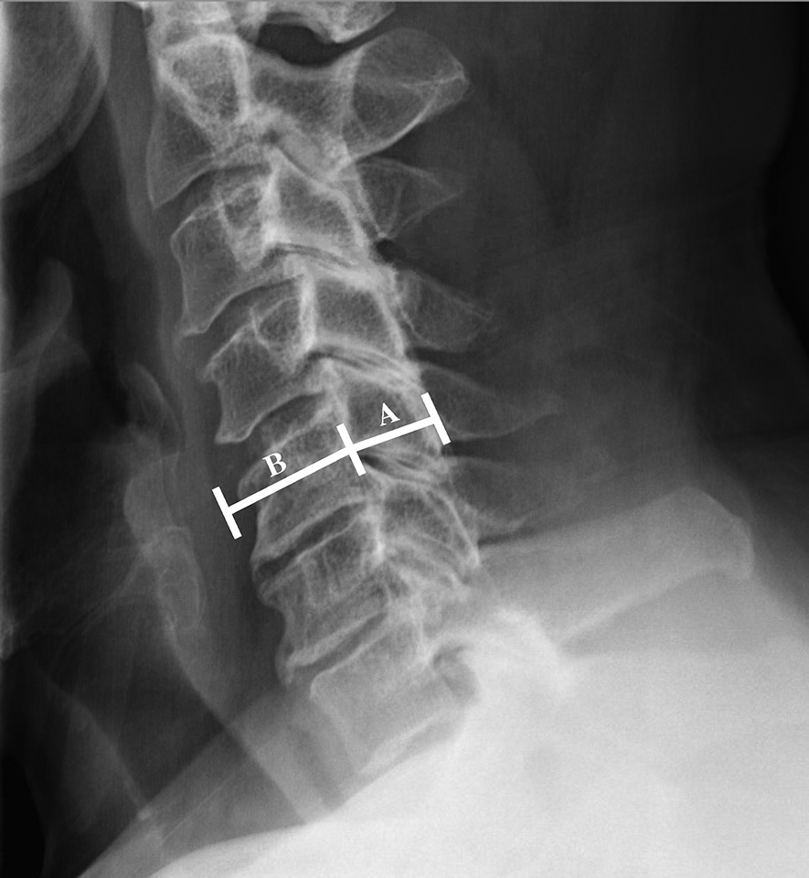

*Figure 3*. Lateral cervical X-ray shows the Torg-Pavlov ratio at the C5 level.  
The calculation includes the canal diameter (A) and vertebral body diameter.  
A ratio of <0.8 is significant for canal stenosis.  
A canal diameter of <12 mm is associated with spinal cord compression16.

1. Computed Tomography (CT) scan CT effectively visualize bony structures and canal narrowing but lack adequate soft tissue detail (discs, ligaments, spinal cord, and nerves). CT myelography provides high-resolution sagittal and axial views, superior to MRI for bony detail but is invasive, requiring lumbar puncture and ionizing radiation, without assessing spinal cord parenchymal changes.
2. MRI provides detailed imaging of the spinal canal and intrinsic spinal cord abnormalities, including demyelination, syringomyelia, atrophy, and edema. It also helps identify alternative diagnoses such as Chiari malformation or spinal cord tumors. However, bone structures and ligament calcifications are poorly visualized, and differentiating osteophytes from disc herniation may require cervical X-rays or thin-slice CT scans focused on bone structures for better assessment.

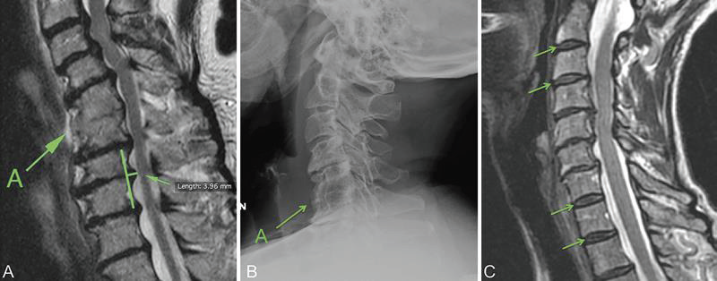

Figure 4. CSM C5-C615

1. **DIFFERENTIAL DIAGNOSIS**

Table 4. Differential Diagnosis14

|  |  |
| --- | --- |
| Differential Diagnosis | Sign and Symptoms |
| Amyotrophic lateral sclerosis | Loss of sensory symptoms  Cranial nerve dysfunction (e.g., impaired speech and swallowing |
| Multiple Sklerosis | Visual dysfunction  Cranial nerve impairment (e.g., visual and bulbar symptoms)  Fatigue |
| Peripheral nerve entrapments (ulnar neuropathy, carpal tunnel syndrome) | Minimal central symptoms |
| Patologi intrakranial | Cranial nerve symptoms  Headache, vomiting  Altered consciousness |
| Defisiensi Vitamin D | Fatigue  Cognitive dysfunction  Glossitis  Visual disturbances |

1. **MANAGEMENT**

The management of Cervical Spondylotic Myelopathy (CSM) can be divided into two types: non-surgical management and surgical management.

1. Non-Surgical Management7,9.

The primary goal of non-surgical management in Cervical Spondylotic Myelopathy (CSM) is to quickly relieve pain, minimize the decline in quality of life and work performance, and restore functional mobility. The initial approach should focus on pain management and improving motor function for the patient. The examples of non-surgical management that can be used are medication, physiotherapy and injections.

1. Surgical Management

Theoretically, surgical intervention is the primary treatment option for Cervical Spondylotic Myelopathy (CSM) that does not improve with conservative management, especially in moderate and severe stages. A study by Zhang et al. reported that decompression surgery can significantly reduce symptoms in severe CSM cases. The main goals of surgery are to slow symptom progression and restore normal function. The surgical management options for Cervical Spondylotic Myelopathy (CSM) can be categorized based on different surgical approaches, depending on the location of the pathology to maximize decompression effectiveness.

Figure 5. CSM Surgical Approach16.

* 1. Anterior

Surgical management with an anterior approach in the form of Anterior Cervical Discectomy and Fusion (ACDF) is the most common procedure performed for the treatment of CSM. Complications that can arise from the anterior approach are neurological and vascular injuries, esophageal injuries, respiratory disorders, graft dislocation, cerebrospinal fluid (CSF) leaks, and infections17.

Anterior Cervical Corpectomy fusion (ACCF) can be indicated in cases of confluent stenosis of several segments due to stenosis that continues from the disc space to the back of the vertebral corpus. In addition to decompression of the nerve structure, this surgical therapy can be performed to achieve sagittal stabilization and cervical lordosis14.

* 1. Posterior

Surgical management with a posterior approach can be performed on patients with dominant compression of the dorsal spinal cord. There are two different procedures that can be performed, including laminectomy and lateral mass fusion or open-door laminoplasty. Neurologically, the results achieved are almost the same for both procedures, but laminectomy and fusion usually result in less neck pain than open-door laminoplasty7,14.

* 1. Anterior vs Posterior Approach

The optimal surgical approach for managing CSM remains debated. A thorough understanding of the indications for each procedure significantly influences patient outcomes.The advantage of the anterior approach is direct cervical decompression, allowing better visualization of pathological discs without disturbing the spinal cord. The incision can be made at the front of the neck, and structures such as neck muscles, the trachea, and the esophagus can be retracted for better visualization of the cervical spine. Additionally, stabilization with arthrodesis can significantly reduce pain.If the compression is located anteriorly and involves only 1–2 cervical levels, the anterior surgical approach is preferred. However, if more than two cervical levels are affected, the risk of complications from the anterior approach increases, making the posterior approach a better recommendation24. Several complications are associated with the anterior approach, including graft dislocation, pseudoarthrosis, prolonged post-operative brace use, and loss of range of motion (ROM). Conversely, the posterior approach offers the advantage of achieving broader decompression in pathological lesions25. A study by Shamji et al., involving 124 CSM patients evaluated using JOA, Nurick, and the Neck Disability Index, concluded that there was no significant difference in outcomes between CSM patients with lordosis undergoing anterior surgery and those receiving a posterior approach. Additionally, CSM patients with kyphosis who underwent anterior or combined surgery had more favorable outcomes. Meanwhile, a study by Tang et al., involving 113 CSM patients with multi-level kyphosis who underwent posterior surgery, found a higher risk of disability, which was associated with a Sagittal Vertical Axis (SVA) of 40 mm26.

* 1. Combination

The combination of anterior and posterior approaches is a surgical technique indicated for severe cases of Cervical Spondylotic Myelopathy (CSM), characterized by sagittal kyphosis and multi-level stenosis. Theoretically, posterior arthrodesis and instrumentation can be utilized to strengthen the anterior anatomy in patients with unstable conditions, such as two- or three-level corpectomy, often associated with laminectomy or poor bone quality7,18.

table 5. Several Considerations of Factors That Can Be Evaluated to Determine the Anterior or Posterior Surgical Approach19.

|  |  |
| --- | --- |
| Consideration of evaluation results | Surgical Approach |
| Alignment sagittal   * Kyphosis * Neutral / lordosis | * Fixed: Anterior * Flexible: anterior / posterior with fusion |
| Grade (level)   * ≥ 3 * ≤ 2 | * posterior (laminoplasty) * Anterior |
| Usia   * *Elderly* * *Young* | * Posterior * Anterior |
| Pre-operative pain scale   * *Moderate – High* * None to Low | * Anterior or Posterior with fusion * Posterior (laminoplasty) atau anterior |
| Instability   * Yes * No | * Anterior or Posterior with fusion * Posterior (laminoplasty) or anterior |

Figure 6. CSM Surgical Algorhythm19.

* 1. Arthroplasty Cervical

The latest management approach involves cervical facet joint arthroplasty, a surgical technique used to replace osteoarthritic facet joints with implants. In 2017, a case study reported the management of a single-level cervical disc using arthroplasty and compared it to the ACDF technique, showing better post-operative outcomes for arthroplasty patients. Another study also found that two-level cervical arthroplasty resulted in better post-operative range of motion after 39 months compared to ACDF27. Arthroplasty surgery is recommended using the anterolateral approach, with the neck positioned in mild hyperextension without excessive traction. A combination of hyperextension and excessive head traction may cause tissue compression, and the laryngeal nerve may be at risk of injury due to this positioning. Rigid neck support is crucial to prevent complications when manipulating the vertebral body. Additionally, excessive traction can lead to brachial plexus injury. The anterolateral approach is strongly recommended; however, other complications, such as nerve, vascular, and organ injuries in the neck region, have been reported but can be effectively prevented28.

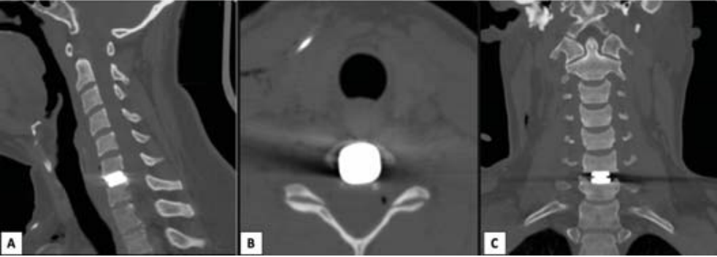

Figure 7. Post-Operative Evaluation of Cervical Arthroplasty Using Sagittal, Axial, and Coronal CT-Scan Sections28.

1. **PROGNOSIS**

Clinical improvement following surgery with an anterior approach has been reported in 70%–80% of CSM patients, with a 60%–70% improvement in JOA scores20-23. No significant difference in success rates has been found between Anterior Cervical Discectomy and Fusion (ACDF) and Anterior Cervical Corpectomy with Fusion (ACCF)7. ACDF is associated with lower intraoperative blood loss and fewer postoperative complications compared to ACCF7,14.

# 10. PREVIOUS STUDY

Study by (Mattei et al., 2011)29 explained that Cervical spondylotic myelopathy is a prevalent degenerative spinal disease which may lead to significant clinical morbid ity. The clinical findings are variable, and both dynamic and static X-rays, as well as MRI, are important for preoperative evaluation as well as individualizing surgical planning. The choice of the most appropriate technique is affected by patient’s clinical condition and radiologic findings as well as surgeon’s experience. Another study by (Bakhsheshian et al., 2017)30 shown CSM is a major cause of disability, especially in the elderly, requiring early diagnosis and management. While mild cases may be managed conservatively, surgery is superior for moderate to severe cases. The optimal surgical approach remains debated, and high-quality studies are needed to refine treatment strategies and long-term outcomes.

* 1. **CONCLUSION and IMPORTANCE**

# Cervical spondylotic myelopathy (CSM) results from spinal cord compression due to vertebral canal narrowing, linked to degenerative disc disease, osteoarthritis, spondylolisthesis, and ligament hypertrophy or ossification. Diagnosis involves history, physical examination, and imaging (X-ray, MRI, CT scan). Treatment includes non-surgical management (analgesics, rehabilitation) or surgical intervention (anterior, posterior, or combined approaches), considering alignment, pathological level, age, pain severity, and stability. This manuscript provides valuable insights into the clinical characteristics and management outcomes of Cervical Spondylotic Myelopathy (CSM), a leading cause of spinal cord dysfunction. By offering a comprehensive descriptive analysis, it enhances the understanding of disease progression, patient demographics, and treatment effectiveness. The findings can contribute to optimizing surgical decision-making and improving patient outcomes. Additionally, this study serves as a reference for future research on CSM, helping to refine treatment strategies and improve long-term care.

**Disclaimer (Artificial intelligence)**

Option 1:

Author(s) hereby declare that NO generative AI technologies such as Large Language Models (ChatGPT, COPILOT, etc.) and text-to-image generators have been used during the writing or editing of this manuscript.

Option 2:

Author(s) hereby declare that generative AI technologies such as Large Language Models, etc. have been used during the writing or editing of manuscripts. This explanation will include the name, version, model, and source of the generative AI technology and as well as all input prompts provided to the generative AI technology

Details of the AI usage are given below:

1.

2.

3.

# References

1. Nouri A, Murray JC, Fehlings MG. Degenerative cervical myelopathy: a spectrum of degenerative spondylopathies. Springer Nature Switzerland AG. 2019:37-51.
2. Davies BM, Mowforth OD, Smith EK, et al. Degenerative cervical myelopathy. BMJ 2018;360:k186
3. De la Garza Ramos R. Predictors of Return to Normal Neurological Function After Surgery for Moderate and Severe Degenerative Cervical Myelopathy: An Analysis of A Global AOSpine Cohort of Patients. Neurosurgery. 2019:1-7
4. McCormick JR. Sama AJ, Schiller NC, et al. Cervical spondylotic myelopathy: a guide to diagnosis and management. J Am Board Fam Med. 2020;33:303–313.
5. Milligan J, Ryan K, Fehlings M, et al. Degenerative cervical myelopathy Diagnosis and management in primary care. Canadian Family Physician. 2019;619-24.
6. Bajamal AH, Kim SH, Arifianto MR, et al. Posterior surgical techniques for cervical spondylotic myelopathy: wfns spine committee recommendations. Neurospine 2019;16(3):421-434.
7. Kaiser MG, Haid RW, Shaffrey CI, et al. Degenerative Cervical Myelopathy and Radiculopathy. Spinger. 2019:37-50.
8. Benzel, Edward C. The Cervical Spine.Lippincott Williams and Wilkins. 2012; 34-70. Goel A, Cacciola F. The Craniovertebral Junction: Diagnosis, Pathology, Surgical Technique. New York: Thieme. 2010; 14-160
9. Swartz U, Floyd T. Cervikal Spine Functional Anatomy and Biomechanics of Injury Due to Compressive Loading. Journal of Athletic Training. Hampshire: National Sthletic Trainers Association. 2005; 155-161.
10. Goel A, Cacciola F. The Craniovertebral Junction: Diagnosis, Pathology, Surgical Technique. New York: Thieme. 2010; 14-160.
11. Korres, Demetrios S. The Axis Vertebra. Milan: Springer. 2013; 21-26.
12. Suchomel P, Choutka O. Reconstruction of Upper Cervical Spine and Craniovertebral Junction. Heidelberg: Springer. 2011; 17-21.
13. Suyasa K. Spine surgery. Baswara Press. 2022
14. Milligan J, Ryan K, Fehlings M, Baumann C. Degenerative cervical myelopathy diagnosis and management in primary care. Canadian Family Physician 2019; 65:619-24.
15. Suyasa K. Penyakit degenerative cervical. Udayana university press: 2019
16. Zhang AS, Myers C, Mc Donald CL, et al. Cervical myelopathy: diagnosis, contemporary treatment, and outcomes. *The American Journal of Medicine*. 2022;135(4):435-43
17. Deora H, Kim SH, Behari S, et al. Anterior Surgical Techniques for Cervical Spondylotic Myelopathy: WFNS Spine Committee Recommendations. Posteri Neurospine. 2019;16(3):408-420.
18. Han YC, Liu ZQ, Wang SJ, et al. Is anterior cervical discectomy and fusion superior to corpectomy and fusion for treatment of multilevel cervical spondylotic myelopathy? A systemic review and meta-analysis. PLoS One 2014;9:e87191.
19. Bajamal AH, Kim SH, Arifianto MR, et al. Posterior surgical techniques for cervical spondylotic myelopathy: wfns spine committee recommendations. Neurospine 2019;16(3):421-434.
20. Bram R, Fiore S, Labiak JJ, et al. Combined anterior-posterior decompression and fusion for cervical spondylotic myelopathy. Am J Orthop (Belle Mead NJ) 2017;46:E97-104
21. Muthukumar N. Surgical management of cervical spondylotic myelopathy. Neurol India 2012;60:201-9.
22. Bakhsheshian J, Mehta VA, Liu JC. Current diagnosis and management of cervical spondylotic myelopathy. Global Spine J 2017;7:572-86.
23. Song KJ, Johnson JS, Choi BR, et al. Anterior fusion alone compared with combined anterior and posterior fusion for the treatment of degenerative cervical kyphosis. J Bone Joint Surg Br 2010;92:1548-52
24. Klineberg E. Cervical spondylotic myelopathy: a review of the evidence. Orthop Clin North Am 2010;41:193-202.
25. Zeng J, Duan Y, Yang Y, et al. Anterior corpectomy and reconstruction using dynamic cervical plate and titanium mesh cage for cervical spondylotic myelopathy: a minimum 5-year follow-up study. Medicine (Baltimore) 2018;97:e9724.
26. Shamji MF, Mohanty C, Massicotte EM, et al. The association of cervical spine alignment with neurologic recovery in a prospective cohort of patients with surgical myelopathy: analysis of a series of 124 cases. World Neurosurg 2016;86: 112-9.
27. Bram R, Fiore S, Labiak JJ, et al. Combined anterior-posterior decompression and fusion for cervical spondylotic myelopathy. Am J Orthop (Belle Mead NJ) 2017;46:E97-104
28. Rodríguez-García M, Silva Pena L, Garcia, et al. Cervical disc arthroplasty, challenges and indications: case report. Arch Clin Exp Orthop. 2022; 6: 001-004.
29. Bakhsheshian, J., Mehta, V. A., & Liu, J. C. (2017). Current Diagnosis and Management of Cervical Spondylotic Myelopathy. *Global Spine Journal*, *7*(6), 572–586. https://doi.org/10.1177/2192568217699208
30. Mattei, T. A., Goulart, C. R., Milano, J. B., Dutra, L. P. F., & Fasset, D. R. (2011). Cervical Spondylotic Myelopathy: Pathophysiology, Diagnosis, and Surgical Techniques. *ISRN Neurology*, *2011*, 1–5. https://doi.org/10.5402/2011/463729