Osteochondroma of Dorsal Scapula: A Rare Case Report

Abstract
Osteochondroma is the most common benign bone tumour, but its occurrence in the dorsal scapula is rare. we report a case of17 year old girl who presented with painless, progressively enlarging bony swelling over dorsal scapula. Imaging confirmed an exophytic lesion arising from scapula. Due to mechanical discomfort and cosmetic concern, lesion was surgically excised. Histopathological examination confirmed the diagnosis without malignant transformation.

Keyword: osteochondroma, dorsal scapula, benign bone tumour, malignant transformation.

Introduction:
Osteochondromas are bone lesions with continuous medullary cavity and has a cartilaginous cap of hyaline cartilage. The medullary cavity and cortical bone with the continuity of the tumours is a tell tale feature for osteochondroma and it is a diagnostic feature[2-4]. Initially it was considered as neoplasm but now it is placed under a group of developmental disorder. Osteochondromas emerge due to a separation of a part of the cartilage of the epiphyseal growth plate which, herniates through the periosteal bone surrounding the growth plate[2, 5-8] . The most common primary bone tumour of all benign tumour is osteochondroma which is around 40%[1].Proximal humerus, proximal tibia, and distal femur are some of the most common sites of osteochondroma[14,15] but may also occur in scapula and ilium. It is most common radiation induced benign tumour in children[16-21]. Osteochondroma rarely occurs in the scapula; but most common tumour in scapula is osteochondroma, accounting for 4.6% of all bone tumours[25]. Majorly dorsal osteochondroma is accidental finding due asymptomatic nature. However, symptoms may present with cosmetic concern, mechanical compression of adjacent structures, fractures, bursities or osseous deformities, or it can also show malignant transformation[3,4,27,28]. If malignant transformation is present it is usually present with exostosis[27].Common symptoms of ventral osteochondroma includes pain and discomfort on shoulder movement or at rest, restricted range of motion, compression ver brachial artery or anterior chest wall Most common cases of scapula osteochondroma are anterior[27-29] and posterior are rare, as we have reported in this paper, which further explains why our presented case is unique. Very little information is available regarding dorsal scapular osteochondromas. All reported cases of dorsal osteochondroma were managed with surgical excision, which effectively relieved symptoms. Surgery is typically indicated in cases of pain, cosmetic concerns, complications, high malignant transformation risk, or uncertain diagnosis.We present a case of 17 years female with dorsal scapular osteochondroma.

Case presentation:
We report a case of a 17-year-old girl who came to OPD with chief complain a palpable growing swelling on her left scapula since 24 months accompanied by little difficulty to sleep supine. On examination, a hard, oval solid mass was palpable with no free movements in dermal or muscular plane with size of around 3*3 cm on infero medial surface of scapula. Swelling moved along with scapular movement.
No limitation in the shoulder and scapulo-thoracic joint's range of motion was appreciated.
No similar swellings were found over part of body.
No similar history in family members was seen.
Xray of left shoulder revealed a bony mass arising from dorsal of scapula and same findings were confirmed on CT.(fig 1,2,3) CT scan confirmed the diagnosis of osteochondroma.
After confirmation of diagnosis, patient was planned for surgical excision.

.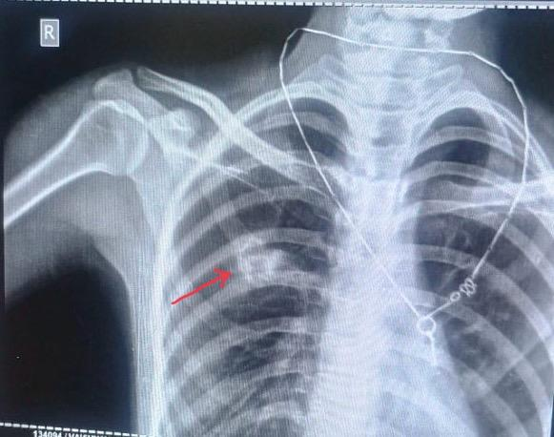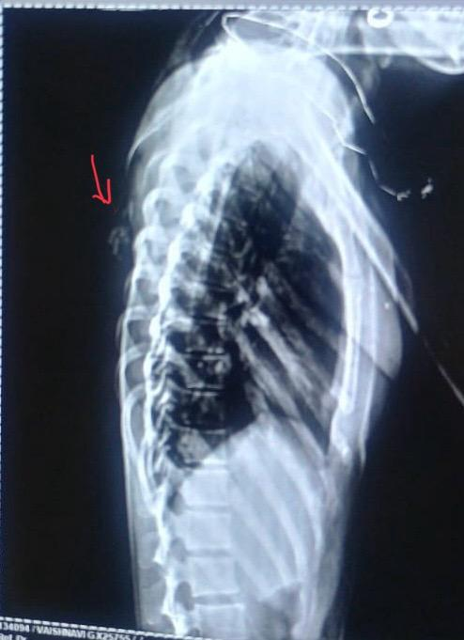
Fig: 1: Antero-posterior radiographs of scapula Fig 2: lateral radiographs of scapula
.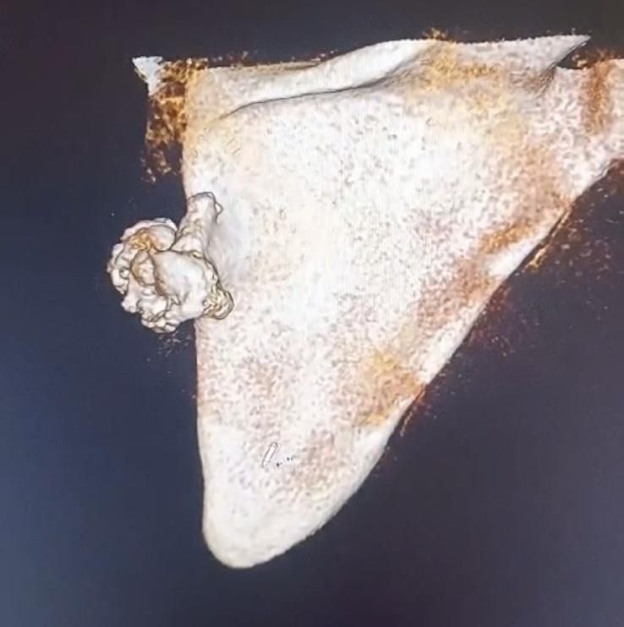
Fig 3: 3D CT reconstruction of scapula

Under general anesthesia, the patient was positioned prone on the operating
table to allow optimal access to the lesion (Fig. 4). The incision site was thoroughly cleansed with iodine solution to maintain aseptic conditions, and standard sterile draping was applied. A vertical skin incision was made directly over the palpable mass, ensuring adequate exposure. Careful dissection was performed layer by layer, with meticulous handling of the soft tissues to minimise trauma. The borders of the mass were identified and carefully separated from the surrounding musculature to preserve adjacent structures (Fig. 5). Once fully exposed, the lesion was excised en bloc using an osteotome, ensuring complete removal. The excised mass measured 3×2×2 cm (Fig. 5).
The specimen was sent for histopathological examination, which confirmed the diagnosis of osteochondroma without malignant transformation. Postoperatively, antibiotics and non-steroidal anti-inflammatory drugs were prescribed for pain relief. The patient was discharged on the third postoperative day without complications. An arm sling was advised for two weeks, and shoulder exercises were initiated after suture removal.
Patient is regularly followed at interval of 6 weeks for 1 year. There was no signs of recurrence and patient can perform her routine activity.
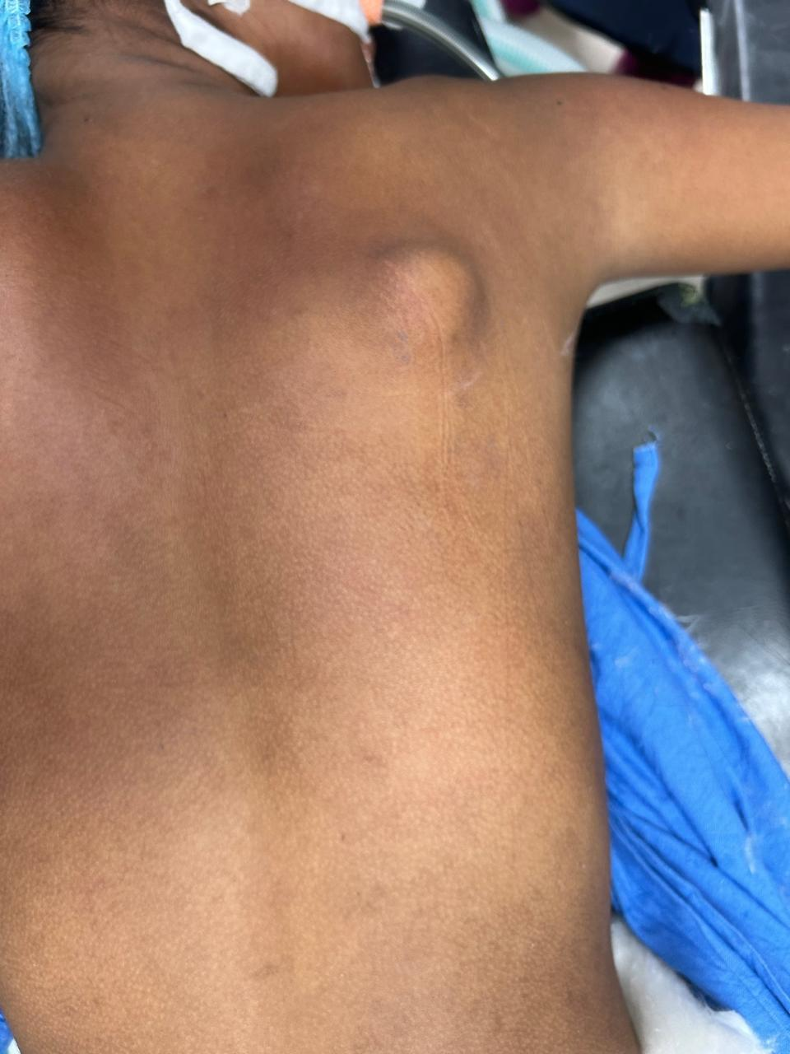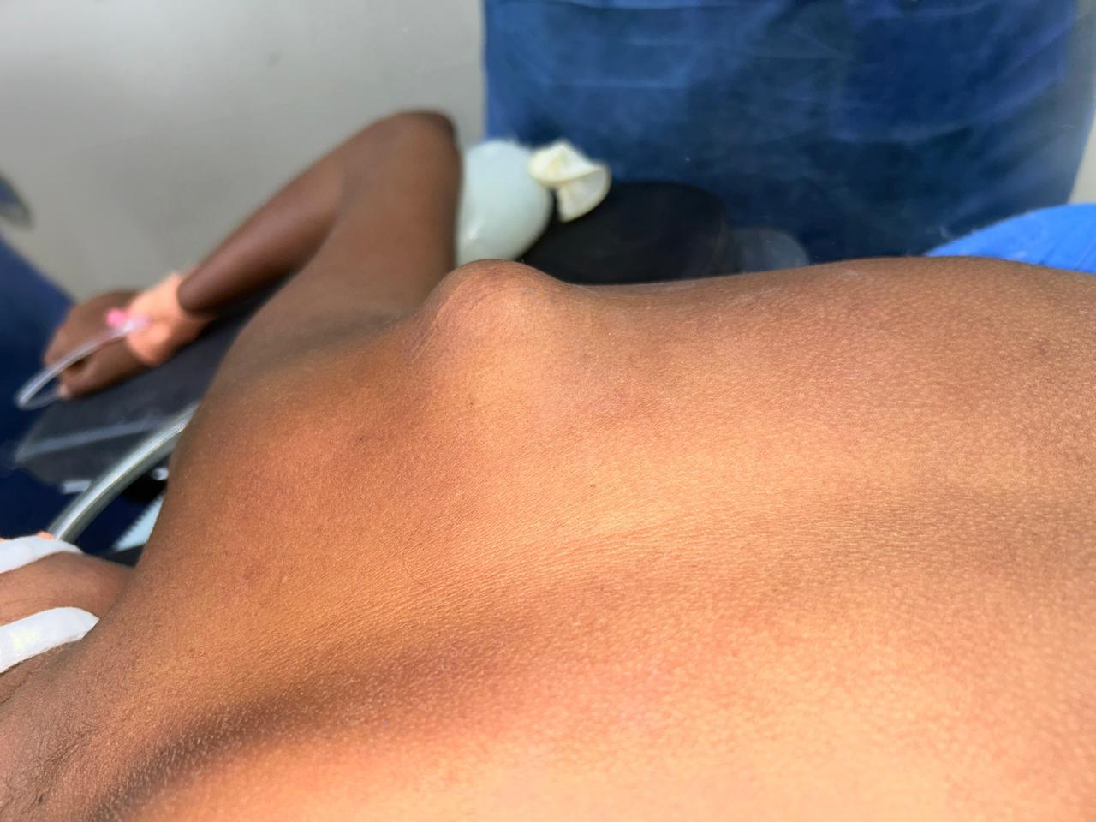
Fig 4: clinical pre operative photograph

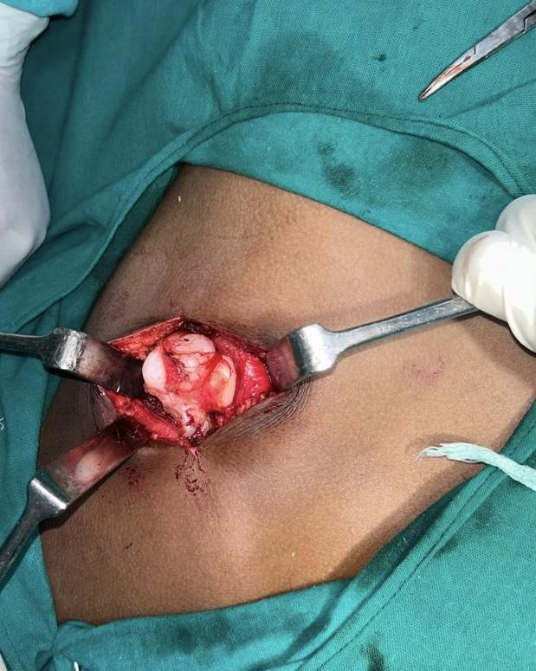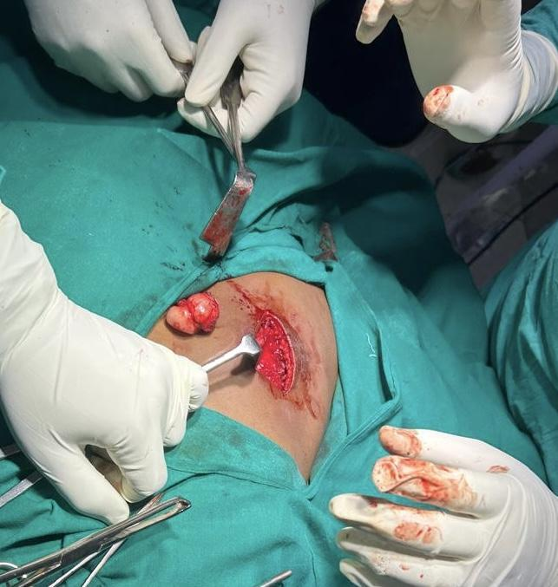
Fig 5: Intraoperative images
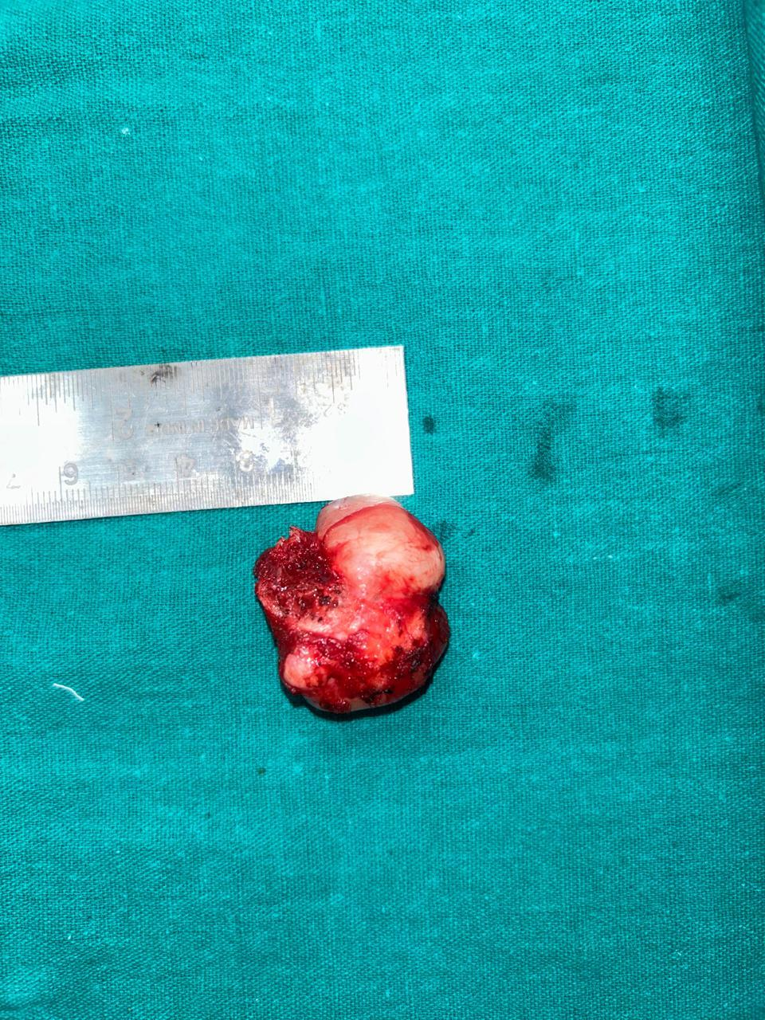
Fig 6: Specimen sent for histopathology

Discussion:
Osteochondromas are benign bone tumours that most commonly affect the proximal humerus, pelvis, and knee. However, they are rarely observed in flat bones. These tumours are typically asymptomatic and often discovered incidentally.[29] Scapular osteochondromas are classified into two types based on their location: dorsal and ventral. Patients with dorsal scapular osteochondromas typically seek medical attention for cosmetic concerns or discomfort while sleeping in a supine position [24]. In contrast, ventral scapular osteochondromas are primarily associated with mechanical symptoms such as snapping or pseudo-winging, which often lead to hospital admission. In this case, the patient had no pain but cosmetic problem and mild difficulty with sleeping in a supine position. X-rays are usually sufficient for diagnosis. CT scans are helpful to diagnose scapular osteochondromas as medullary cavity continuation can be seen.[26] However if malignant transformation is suspected MRI is diagnostic as to see cartilaginous cap thickness.

Malignant transformation is a potential complication of osteochondromas, leading to the development of secondary chondrosarcoma. The current literature identifies specific risk factors that can raise suspicion for this transformation, categorized into clinical, radiological, and genetic factors.
Clinically, key indicators include persistent pain accompanied by an increasing lesion size, a male predominance (2:1), and a typical occurrence in the pelvis or hip, with a peak incidence in the mid-30s. Radiologically, a cartilage cap thickness greater than 2 cm is considered suggestive of malignant transformation, though this threshold is not definitive. Despite these risk factors, malignant transformation remains rare and generally has a good prognosis when it occurs in adults.
Table 1: Statement of Review literature
Author | Sex | Age | Presentation | Location | Treatment | Histology | Tumour  Size | Follow  up
Altwaijri et al (2022)[34] | F | 2 | Increasisng swelling | Dorsal | Excision of osteochondroma | Yes | 3.0* 2.5 cm | Upto 6 months
Yadkikar et al (2013)[35] | F | 14 | Progressive pain and inability to sleep supine | Dorsal | Excisional biopsy | Yes | 3.0*2.0 cm | Upto 12 mpnths
Kumar et al (2014)[36] | M | 12 | Inability to sleep supine | Dorsal | Excision of osteochondroma | Yes | 3.0*1.7 cm | Upto 6months
Jadhav et al (2016)[37] | M | 19 | Increasing swelling and pain | Dorsal | Excised en mass | Yes | 4.0*3.0 cm | Upto 1 months
Nekkanti et al (2018)[38] | M | 5 | Increasing swelling | Dorsal | Excision of osteochondroma | Yes | 3.0*3.0 cm | NAA
Matthewson et al [39]  (2019) | M | 2 | Mass in right shoulder | Dorsal | Excision of osteochondroma | Yes | 1.51.0 cm | NA
Bekta et al (2019)[40] | F | 15 | Painful shoulder movement | Dorsal | Excision of osteochondroma | Yes | NA | NA

Conclusion:
Osteochondromas, benign bone tumours originating from the growth plate, typically occur in long bones like the femur or humerus but can occasionally manifest in the scapula, though infrequently. When found in the ventral region of the scapula, they often result in snapping scapula syndrome characterised by audible or palpable crepitus and pain due to friction against the rib cage. Conversely, osteochondromas located dorsally on the scapula are less common but can still provoke symptoms depending on their size. Large dorsal osteochondromas may cause pain, restricted movement, or compression of nearby structures. Diagnosis usually involves imaging such as X-rays, CT scans, or MRI to visualize the characteristic bony growth. Managing scapular osteochondromas involves monitoring for symptoms and potential complications, with surgical removal considered for symptomatic or problematic cases, ensuring optimal patient care and outcome.

Consent:
As per international standards, parental written consent has been collected and preserved by the author(s).

Disclaimer (Artificial intelligence)
Option 1:
Author(s) hereby declare that NO generative AI technologies such as Large Language Models (ChatGPT, COPILOT, etc.) and text-to-image generators have been used during the writing or editing of this manuscript.
Option 2:
Author(s) hereby declare that generative AI technologies such as Large Language Models, etc. have been used during the writing or editing of manuscripts. This explanation will include the name, version, model, and source of the generative AI technology and as well as all input prompts provided to the generative AI technology
Details of the AI usage are given below:
1.
2.
3.

References:
1.MS Mohsen ,NK Moosa,P Kumar,osteochndroma os the scapula associated with winging and large ursa formation.Med. principles an practice, 2006
2. Imaging of osteochondroma: variants and complications with radiologic-pathologic correlation. Murphey MD, Choi JJ, Kransdorf MJ, Flemming DJ, Gannon FH.
3. Benign bone tumors—recent developments. Garcia RA, Inwards CY, Unni KK.
4. Benign bone tumors. Motamedi K, Seeger LL.
5. Mirra JM. Bone Tumors: Clinical, Radiologic, and Pathologic Correlations. Vol. 2. Philadelphia, PA: Lea & Febiger; 1989. Benign cartilaginous exostoses: osteochondroma and osteochondromatosis; pp. 1626–1659.
6. Resnick D, Kyriakos M, Greenway GD. Diagnosis of Bone and Joint Disorders.Philadelphia, PA: Saunders; 1995. Osteochondroma; pp. 3725–3746.
7. The origins of osteochondromas and enchondromas. A histopathologic study. Milgram JW. https://europepmc.org/article/med/6600991Clin Orthop Relat Res. 1983;174:264–284.
8. Studies on the anatomical changes which accompany certain growth-disorders of the human body: I. The nature of the structural alterations in the disorder known as multiple exostoses. Keith A.
9. Benign tumours of the bone: a review. Hakim DN, Pelly T, Kulendran M, Caris JA.
10. The many faces of osteosarcoma. Murphey MD, Robbin MR, McRae GA, Flemming DJ, Temple HT, Kransdorf MJ. Radiographics. 1997;17:1205–1231.
11. Ossifying chronic subperiosteal haematoma of the iliac bone. Hughes P, Dow D, Boyer L, Morganti V.
12. The imaging of cartilaginous bone tumours. I. Benign lesions. Douis H, Saifuddin A.
13. Skeletal osteochondromas revisited. Mavrogenis AF, Papagelopoulos PJ, Soucacos PN.
14. Large osteochondroma of the scapula in a 2-year-old. Matthewson G, Singh M, Thompson S.
15. Osteochondroma: ignore or investigate? de Souza AM, Bispo Júnior RZ. Rev Bras Ortop. 2014;49:555–564.
16. Osteochondroma in long-term survivors of high-risk neuroblastoma. Kushner BH, Roberts SS, Friedman DN, et al. Cancer. 2015;121:2090–2096.
17. Irradiation effects of roentgen therapy on the growing spine. Neuhauser EB, Wittenborg MH, Berman CZ, Cohen J.
18. Osteochondromata following irradiation in children. Cole AR, Darte JM.. 1963;32:285–288.
19. Skeletal changes following irradiation of childhood tumors. Katzman H, Waugh T, Berdon W. J Bone Joint Surg Am. 1969;51:825–842.
20. Radiation-induced osteochondromas. Libshitz HI, Cohen MA. https://doi.org/10.1148/radiology.142.3.6278535.Radiology. 1982;142:643–647.
21. Radiation induced osteochondroma in long-term survivors of childhood cancer. Jaffe N, Ried HL, Cohen M, McNeese MD, Sullivan MP.
gov/pmc/articles/PMC5404176/ J Orthop Case Rep. 2016;6:96–99.
22. Chest wall deformity associated with osteochondroma of the scapula: a case report and review of the literature. Tomo H, Ito Y, Aono M, Takaoka K. J Shoulder Elbow Surg. 2005;14:103–106.
23. Osteochondroma of the ventral scapula causing scapular static winging and secondary rib erosion. Sivananda P, Rao BK, Kumar PV, Ram GS.
24. An unusual location of osteochondroma: dorsal scapula. Bektas YE, Ozmanevra R. Cureus. 2019;11:0.
25. Solitary sessile osteochondroma of scapula, a rare case report. Kumar C Y, Shervegar S, Gadi D, Rahul P. J Clin Diagn Res. 2014;8:174–175.
26. Osteochondromas: review of the clinical, radiological and pathological features. Kitsoulis P, Galani V, Stefanaki K, Paraskevas G, Karatzias G, Agnantis NJ, Bai M.
27. Osteochondromas: an updated review of epidemiology, pathogenesis, clinical presentation, radiological features and treatment options. Tepelenis K, Papathanakos G, Kitsouli A, et al.
28. An analysis of indications for surgical excision and complications in 116 consecutive cases of osteochondroma. Khare GN.
29. A solitary osteochondroma of the scapula. Vaishya R, Dhakal S, Vaish A. BMJ Case Rep. 2014;2014
30. Surgical treatment of rare case of scapula osteochondroma in a resource limited setting: A case report. Ngongang FO, Fodjeu G, Fon AC, Fonkoue L, Guifo ML, Bitang A Mafok LJ, Ibrahima F. Int J Surg Case Rep. 2019;61:130–134.
31. Large bursa formation associated with osteochondroma of the scapula: a case report and review of the literature. Okada K, Terada K, Sashi R, Hoshi N. Jpn J Clin Oncol. 1999;29:356–360.
32. A solitary osteochondroma of the scapula: uncommon location for a common tumor. Segura Sánchez D, Pino Almero L, Mínguez Rey MF. https://pubmed.ncbi.nlm.nih.gov/34569764/ Arch Argent Pediatr. 2021;119:0–6.
33.Ceberut K, Korkmaz M, Ergin I, Müslehiddinoglu A. Bursa formation with scapular osteochondroma in hereditary multiple exostoses. J Coll Physicians Surg Pak. 2013;23:512–4.
34. Altwaijri NA, Fakeeha J, Alshugair I. Osteochondroma of the scapula: a case report and literature review. Cureus. 2022 Oct 21;14(10).
35. Yadkikar SV, Yadkikar VS. Osteochondroma on dorsal surface of the scapula in 11 years old child-a case report. International Journal of Medical Research & health sciences. 2013;2(2):305-
36. Kumar Y, Shervegar S, Gadi D, Rahul P. Solitary sessile osteochondroma of scapula, a rare case report. Journal of Clinical and Diagnostic Research: JCDR. 2014 Mar 15;8(3):174.
37.Jadhav PU, Banshelkikar SN, Seth BA, Goregaonkar AB. Osteochondromas at unusual sites-case series with review of literature. Journal of Orthopaedic Case Reports. 2016 Jan;6(1):52.
38.Nekkanti S, Moogali A, Mahtani A. A comparative analysis of morphological parameters in south indian hip joints with review of literature. Journal of the Anatomical Society of India. 2020 Apr 1;69(2):71-80.
39. Matthewson G, Singh M, Thompson S. Large osteochondroma of the scapula in a 2-year-old. Journal of pediatric surgery case reports. 2019 Mar 1;42:12-6.
40. Bektas YE, Ozmanevra R. An unusual location of osteochondroma: dorsal scapula. Cureus. 2019 Dec 25;11(12).

