Original Research Article
Effect Of Co-administration Of Methamphetamine And Vitamin E On The Hippocampus Of An Adult Male Wistar Rat.

ABSTRACT
Much attention has been given to the toxic effects of methamphetamine on humans. However, it is not clear whether this toxicity is related to vital organs such as the hippocampus,; hence, the present study aimed not only to elucidate the toxic effect of methamphetamine (METH) on the hippocampus but also, more importantly, to investigate the protective effect of vitamin E against methamphetamine-induced toxicity in this organ. Thirty-five adult Wistar rats (185-220g) were divided into seven groups of five animals each. Group A was given normal rat feed and water as the control; groups B, C, D, E, F, and G, were administered 5 mg/kg body weight of METH, 10 mg/kg body weight of METH, 500 mg/kg body weight of vitamin E, 1000 mg/kg body weight of vitamin E, 5 mg/kg body weight of METH and 500 mg/kg body weight of vitamin E, and 10 mg/kg body weight of METH and 1000mg/kg body weight of vitamin E, respectively. All the treatments were administered orally daily for twenty-one, Neurobehavioral test was conducted three days before the last administration. days; 24 hours after the last exposure, the animals were anesthetized using chloroform vapour. The brain tissues were harvested, and weighed, and some of the tissues were fixed in phosphate buffered formalin for biochemical analysis, while the rest were fixed in 10% neutral buffer formalin for histological studies. Compared with those in the control group, the body weights of the animals in groups B, C, F and G, which were administered methamphetamine, were significantly lower. The serum levels of malondialdehyde (MAD) in groups B, C, F & G were significantly greater (P<0.05) than those in the control group, whereas the serum levels of gluthathione (GSH); and superoxide dismutase (SOD) in groups B & C (P>0.05) were significantly lower than those in the control group. Histological observations revealed that following the administration of vitamin E, there were no degenerated cells; instead, there was an increase in the number of active granular cells in groups A, D & E, and mild regeneration, moderate /-mild vacuolation and a moderate increase in the number of active granular cells were observed in groups F & G, whereas severe degeneration and vacuolation and severe pyknotic granular cells were observed in groups B & C. The results of this study revealed that no adverse biochemical alterations were associated with the use of vitamin E and no histopathological lesions were found in the hippocampus of adult male Wistar rats when they were treated with vitamin E. The drug vitamin E may have antioxidant and chemoprotective properties against methamphetamine-induced neurotoxicity.
Introduction
Background of the Study
Methamphetamine is a potent and highly addictive psychostimulant that affects the central nervous system (National Institute on Drug Abuse, 2023). It is typically found as a white, odorless, bitter-tasting crystalline powder, that dissolves easily in alcohol or water. METH induces euphoria and stimulant effects similar to those of cocaine (National Library of Medicine, 2023). It works by increasing the levels of naturally occurring neurotransmitters such as dopamine and norepinephrine in the brain. Compared to cocaine, the effects of methamphetamine last longer, and it is both less expensive and easier to produce using readily available ingredients. Street names for the drug include chalk, crank, crystal meth, and speed (Medical News Today, 2023), as well as "mkpuru mmiri" in southeastern Nigeria.
Developed in the early 20th century from its parent compound, amphetamine, methamphetamine was initially used in nasal decongestants and bronchial inhalers. Compared with amphetamine, it has a higher affinity and toxicity toward serotonergic neurons. Methamphetamine can be consumed by swallowing, inhalation, smoking, or injection. Smoking methamphetamine allows it to enter the bloodstream rapidly, with users feeling its effects almost immediately (National Institute on Drug Abuse, 2023).
Vitamin E, a vital lipid-soluble antioxidant, is obtained exclusively through the diet (Volker Bohm, 2018). This nutrient plays a crucial role in maintaining vision, reproduction, and the health of the blood, brain, and skin. As an antioxidant, vitamin E helps protect cells from damage caused by free radicals, which are molecules produced during food metabolism or when the body is exposed to tobacco smoke and radiation. Free radicals can contribute to various diseases, including heart disease and cancer. While vitamin E supplements may not provide the same benefits as naturally occurring antioxidants in food (Mayo Clinic, 2022), they are still considered essential for preventing oxidative damage in biological systems (Pizzino et al 2017; Traber et al., 2007; Niki et al., 2014). In addition to its antioxidant properties, vitamin E has been shown to influence cellular signalling, gene regulation, membrane functions, and nerve activity (Azzi et al., 2007; Brighelius-Flore et al., 2010; Galli et al., 2017). It is also effective in the prevention and treatment of various diseases, such as cardiovascular disease, cancer, cataracts, Alzheimer's disease, and HIV/AIDS. A deficiency in vitamin E can result in neuropathy (Mayo Clinic, 2022).
Foods rich in vitamin E include canola oil, olive oil, margarine, almond, and peanuts, as well as meats, dairy products, leafy greens, and fortified cereals. Vitamin E supplements are also available in capsules or drops. The recommended daily intake for adolescents is 15 milligrams (Mayo Clinic, 2022).
The hippocampus, a key structure in the brain, is essential for memory consolidation and spatial navigation (Britannica, 2023). Part of the limbic system, the hippocampus is vulnerable to the toxic effects of environmental factors such as heavy metals, plant toxins, drug abuse, and cerebrovascular insufficiency. It is also affected by neurodegenerative diseases.
While the individual effect of pharmalogical effects of METH and vitamin E have been studied, their specific impacts on the hippocampus remain largely unexplored. Previous research has focused on the effects of methamphetamine on the central nervous system and the antioxidant properties of vitamin E. However, the potential effects of these substances on the hippocampus—particularly in an animal model closely resembling human physiology—warrant further investigation.
The Wistar rat is a widely used model in histological and anatomical research because of its physiological similarities to humans. Studies involving Wistar rats have provided valuable insights into the toxicological and pharmacological effects of various substances, helping to enhance our understanding of their potential impacts on human health.
Given the limited scientific evidence on the combined effects of methamphetamine and vitamin E on the hippocampus, this study aims to contribute valuable knowledge regarding the potential impact of these substances on the hippocampus of adult male Wistar rats.

Methods
Ethical Approval
All the animals were treated following the approval of the ethical committee with the number FBMS/EA/1220, College of Health Sciences, Nnamdi Azikiwe University, Nnewi Campus, in line with the “Guide for the Care and Use of Laboratory Animals” (NRC 2011).
Experimental Animals
Thirty-five (35) adult Wistar rats were procured from Ela’s Animal Farm, Oko Anambra State. Perspex cages were used to house a group of seven (7) animals for the routine experiment. Each cage had a wire gauze top for cross ventilation. The animals were allowed to acclimatize for a period of two weeks at the animal house of the Anatomy Department, Nnamdi Azikiwe University, Nnewi Campus, before their weight was-measured, under a controlled room temperature of approximately 25-28°C, a relative humidity of approximately 60-80% and photo-periodicity of 12h day / 12h night. All the animals were treated in accordance with the approval of the ethical committee; of the College of Health Sciences, Nnamdi Azikiwe University, Nnewi Campus, in compliance with the “Guide for the Care and Use of Laboratory Animals” prepared by the National Academy of Sciences and published by the National Institute of Health Guide for the Care and Use of Laboratory Animals (2011).
Methodology
METH was obtained from the National Drug Law Enforcement Agency of Nigeria (NDLEA). All chemicals used in this study will be purchased at the highest available purity and quality.

Experimental Protocols
Thirty-five (35) adolescent male Wistar rats were obtained from Research Enterprise Farms, University of Ibadan, Oyo State. These rats were weighed and allocated into seven groups of five animals each. The groups were designated groups A, B, C, D, E, F and G. Group A served as the control group and was administered distilled water and feed only. The experimental groups B, C, D, E, F and G were administered different doses of drugs as follows:
Group B ------------ 5 mg/kg of methamphetamine (low)
Group C ------------ 10 mg/kg of methamphetamine (high)
Group D ------------ 500 mg/kg of Vitamin E (low)
Group E ------------ 1000 mg/kg of Vitamin E (high)
Group F ------------ 5 mg/kg of methamphetamine + 500 mg/kg of vitamin E (low)
Group G ------------ 10 mg/kg of methamphetamine + 1000 mg/kg of vitamin E (high)
Mode of Exposure
The drugs were administered once a day between 12 and 3.30pm for a period of twenty-eight days. The drugs were administered orally using intubations method. After the twenty-eightth day, the animals were weighed, and their weights were recorded.

Behavioural Function Test
Morris (assessment of spatial learning and memory)
The Morris water maze (MWM) test was used to assess the spatial learning and memory of the rats in the form of place navigation and probe test (Ishola et al, 2017) The MWM apparatus consisted of a circular water tank (10 cm diameter × 60 cm height) filled with water (26 ± 2°C) to a depth of 30 cm. The pool was divided into four hypothetical quadrants; N (north), E (east), W (west), S (south). A black round platform with a diameter of 10 cm was placed 2 cm below the surface of the water in a constant position in the middle of the southwest quadrant in all trials. The MWM tasks were given for five consecutive days with 3 trials per day, and the rats were given a maximum of 60 s (cut-off time) to locate the hidden platform and were allowed to stay on it for 30 s. The time taken for the rat to locate the escape platform was recorded using a stop watch. In the event that the animal was unable to locate the hidden platform within 60 s, it was gently guided to it and allowed to stay on it for 30 s. Each rat was subjected to a daily session of 3 trials per day for 5 consecutive days. The escape latency time (ELT) (time to locate the hidden platform in the water maze) was used as an index of learning (Ishola et al, 2017,), On day 26, the platform was removed from the tank, and the rat underwent a spatial probe trial in which they were given 45 s to search for the platform. The time spent in a 2× (40 cm diameter) concentric area surrounding the platform (time spent in platform annulus) was recorded. The experimenter was blinded to the treatment groups.
Biomedical analysis
The brain tissues were analysed for oxidative stress markers, namely;, malondialdehyde (MDA) for lipid peroxidation and superoxide dismutase (SOD) and reduced glutathione for antioxidants (GSH) at the Department of Biochemistry, Nnamdi Azikiwe University, Nnewi Campus. One gram of each animal brain tissue sample was added to 10 mL of 0.9% normal saline and homogenized at room temperature. After this, each of the samples was subsequently centrifuged at 3,000 rpm for 20 min at room temperature. The supernatants were separated and stored for further analyses.
Tissue Processing
For easy study of the sections under a microscope, the tissues were subjected to several processes of fixation, dehydration, clearing, infiltration, embedding, sectioning and staining. Fixation was carried out in 10% neutral buffered formalin (sodium phosphate monobasic, 4.0 gm; sodium phosphate dibasic, 6.5 gm; formaldehyde 37% 100.0 ml; distilled water 900.0 ml). The tissues remained in the medium for 48 hours. After fixation, the tissues were washed overnight under a stream of tap water to remove any surplus fixatives. Dehydration of the fixed tissues was performed to remove water and other substances. This was carried out with different percentages of alcohol 50%, 70% and 95% absolute. For each grade of alcohol, the tissues were changed twice for two (2) hours, and one (1) hour for each change. After dehydration, the tissues were cleared in xylene for two (2) hours after which infiltration was performed in molten paraffin wax at a temperature of 60⁰C for two (2) hours, each with two changes. When the paraffin wax cools, it forms a hard block which allows easy sectioning of the tissues.
Histological processing
Tissue Processing: After the organs were weighed, a small part of the Amygdala tissue was removed and immediately fixed in 10% formal saline to preserve the various constituents of the cells in their normal micro anatomical position and to prevent autolysis and putrefaction. After fixation the tissues were dehydrated to remove water and other substances. This was carried out with different percentages of alcohol (50%, 70% and 95% absolute). For each grade of alcohol, the tissues were changed twice for two (2) hours, with one (1) hour for each change. After dehydration, the tissues were cleared in xylene for two (2) hours after which infiltration was performed in molten paraffin wax at a temperature of 60⁰C for two (2) hours, each with two changes. When the paraffin wax cools, it forms a hard block which allows easy sectioning of the tissues. The tissue sections were produced by normal histochemical methods of dehydration, clearing, impregnation, embedding, sectioning and staining (with H&E). The micrographs of the relevant stained sections were subsequently taken with the aid of a light microscope.
Termination of Treatment:
Twenty-four hours after the last exposure, following the behavioral test, the animals were weighed, and then anaesthetized under chloroform vapour, and the skulls were dissected by occipitofrontal incision. Brain tissues were harvested from the animals and weighed. The brain tissues of some of the animals were prepared for biochemical analysis through the process of homogenization while the remaining tissues of some of the animals were fixed in 10% neutral buffered formalin for 48 hrs and gross to isolate the brain tissue of interest for histological investigations. They were trimmed down to a size of 3 mm x 3 mm thick. The tissue slides were prepared in the histology laboratory of the Anatomy Department, Nnamdi Azikiwe University, Nnewi, Anambra State. The degree of oxidative stress was determined via the Randox method.

3.13 Data analysis
Data were analyzed using SPSS version 27.0.1 software package. The means and standard deviations were obtained and one-way analysis of variance (ANOVA) was used to compare values between groups. The data are expressed as the mean + standard deviation (SD) and were considered statistically significant when P <0.05.
RESULTS
Analysis of Body Weight

Table 1: Comparison of the mean initial and final body weights and weight changes across all the groups (A, B, C, D, E, F & G).

GROUPS | MEAN±SEM  (Initial weight)  (g) | MEAN±SEM  (Final weight)  (g) | WEIGHT CHANGE (g) | p-value
GROUP A | 210.05±0.8 | 235.33±1.76 | 25.28±0.96 | 0.044
GROUP B | 202.33±0.88 | 196.67±1.20 | -5.66±.0.32 | 0.001
GROUP C | 201.33±0.88 | 192.00±2.00 | -9.33±1.12 | 0.001
GROUP D | 202.33±0.88 | 218.00±2.00 | 15.67±1.12 | 0.001
GROUP E | 199.62±3.02 | 210.05±4.00 | 10.43±0.98 | 0.0001
GROUP F | 197.58±0.67 | 189.67±0.88 | -7.91±0.21 | 0.001
GROUP G | 200.34±0.88 | 192.76±1.20 | -7.58±0.32 | 0.001
The data were analysed via Student's t test, and values were considered significant at P<0.05.

Figure 1: Comparison of the mean initial and final body weights and weight changes across all the groups (A, B, C, D, E, F & G).

The results obtained from the analysis of the initial, final and weight changes of the various groups are presented in Table 2. The final body weights of groups D and E were significantly greater (p<0.05) than those of control group A. The final body weights of groups B and C, which were treated with only methamphetamine, were significantly lower (P>0.05) than those of the control animals and were significantly lower than those of the control animals (P>0.05). The final body weights of the F & G group treated with methamphetamine and vitamin E were significantly lower (P>0.05) than those of the control group.

Morris Water Maze Test- Escape Latency (Seconds).
Table 2: Results of the Morris water maze test: escape latency
 | Groups | Mean ± SEM | p-value | F-value
Morris Water Maze Test- Escape latency  (Seconds) | Group A | 16.16 ±2.93 |  | 6.369
Morris Water Maze Test- Escape latency  (Seconds) | Group B | 40.25 ±3.84 | 0.044
Morris Water Maze Test- Escape latency  (Seconds) | Group C | 43.50±11.23 | 0.002
Morris Water Maze Test- Escape latency  (Seconds) | Group D | 28.80±11.23 | 0.002*
 | Group E | 29.50 ±5.62 | 0.003
 | Group F | 25.20 ±4.54 | 0.341
 | Group G | 33.25 ±3.84 | 0.044*

Figure 2: Chart showing the escape latency of the Morris water maze.

Activities of Serum Levels of Malondialdehyde (MDA), Gluthathione (GSH), and Superoxide Dismutase (SOD).
Table 3 Activities of serum levels of MDA, GSH, and SOD).
 | Groups | Mean± SEM | p-value | F-value
MDA (mm⁻¹) | Group A | 3.42 ± 0.01 |  | 44.160
MDA (mm⁻¹) | Group B | 3.64 ±0.02 | 0.000
MDA (mm⁻¹) | Group C | 3.72 ±0.06 | 0.000
MDA (mm⁻¹) | Group D | 3.42± 0.06 | 0.000
 | Group E | 3.40±0.06 | 0.000
 | Group F | 3.50 ± 0.01 | 0.003
 | Group G | 3.57 ± 0.02 | 0.000
GSH (mm⁻¹) | Group A | 1.44 ± 0.02 |  | 14.246
GSH (mm⁻¹) | Group B | 1.30 ± 0.03 | 0.031
GSH (mm⁻¹) | Group C | 1.25 ± 0.02 | 0.002
GSH (mm⁻¹) | Group D | 1.42 ± 0.02 | 0.002
 | Group E | 1.44 ± 0.02 | 0.002
 | Group F | 1.42 ± 0.01 | 0.890
 | Group G | 1.39 ± 0.03 | 0.031
SOD (mm⁻¹) | Group A | 8.56 ± 0.02 |  | 1336.758
SOD (mm⁻¹) | Group B | 7.54 ± 0.01 | 0.000
SOD (mm⁻¹) | Group C | 7.33 ± 0.03 | 0.000
SOD (mm⁻¹) | Group D | 8.53 ± 0.03 | 0.000
 | Group E | 8.54 ± 0.03 | 0.000
 | Group F | 8.29 ± 0.02 | 0.000
 | Group G | 7.90 ± 0.01 | 0.000
The data were analysed via one-way ANOVA, followed by post hoc Fisher’s LSD multiple comparison test, and the data were considered significant at P<0.05.

Figure 3: Chart showing the activities of MDA, GSH,and SOD
MDA= malondialdehyde, GSH= glutathione, SOD= superoxide dismutase.
The results MDA, GSH and SOD, analyses revealed no significant differences among groups A, D & E in terms of the MDA levels at all the doses of the drugs, except for groups B & C, which were treated with methamphetamine and vitamin E. In groups B & C, the MDA activity levels were significantly greater (P<0.05) than those in the control group (A) and groups D & E. The GSH activity levels significantly increased (P<0.05) in groups B, D & E compared with those in the control group, with the exception of group C, which was treated with high-dose methamphetamine and vitamin E. The SOD activity significantly increased (P<0.05) in groups B, D & E relative to the control (A), except in group C.
5 Acute Toxicity Test (Ld₅₀) Result of Methamphetamine and Vitamin E:
Methamphetamine and vitamin E did not cause any mortality up to doses of 10 mg/kg and 1000 mg/kg body weight, respectively, in adult Wistar rats. There were also no changes in posture, nature or frequency of stool, but there were changes in behavior as the animals given only methamphetamine and vitamin E were more agile and aggressive.
6 Histopathological findings of the hippocampus.
Micrograph 1 of the microscopic examination of the hippocampal cells of the animals in group A (control) revealed normal hippocampal architecture, as indicated by the presence of active granular cells.
Micrograph 2 shows the histology/ microscopic examination of the hippocampal cells in group B (treated with methamphetamine and vitamin E at a low dose). This shows the presence of mild vacuolation with active granular cells, as this mild vacuolation may indicate a possible adaptive physiological response presumably for damage limitation.
Micrograph 3 shows the histology/ microscopic examination of the hippocampal cells in group C (treated with high dose methamphetamine and vitamin E). The micrograph shows a normal and active hippocampal architecture, as the granular cells are active and well outlined.
Micrograph 4 shows the histology/ microscopic examination of the hippocampal cells in group D (treated with vitamin E alone at a low dose). The results revealed moderate regeneration of cells with mild vacuolation and a moderate increase in the number of active granular cells. The image shows a slightly normal hippocampal architecture.
Micrograph 5 shows the histology/ microscopic examination of the hippocampal cells in group E (treated with vitamin E at a high dose). It shows a mild regeneration with moderate vacuolation and moderate pyknotic (cell nuclei condensation) active granular cells.
HISTOLOGICAL FINDINGS
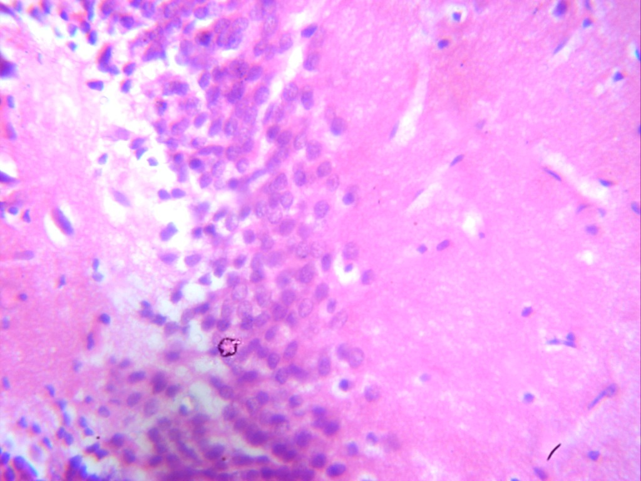
Plate 1: Photomicrograph of group A (control), a section of the hippocampus (x100(x400) (H/E) (CV) shows hippocampus with active granular cells (GC).
GC
GP A

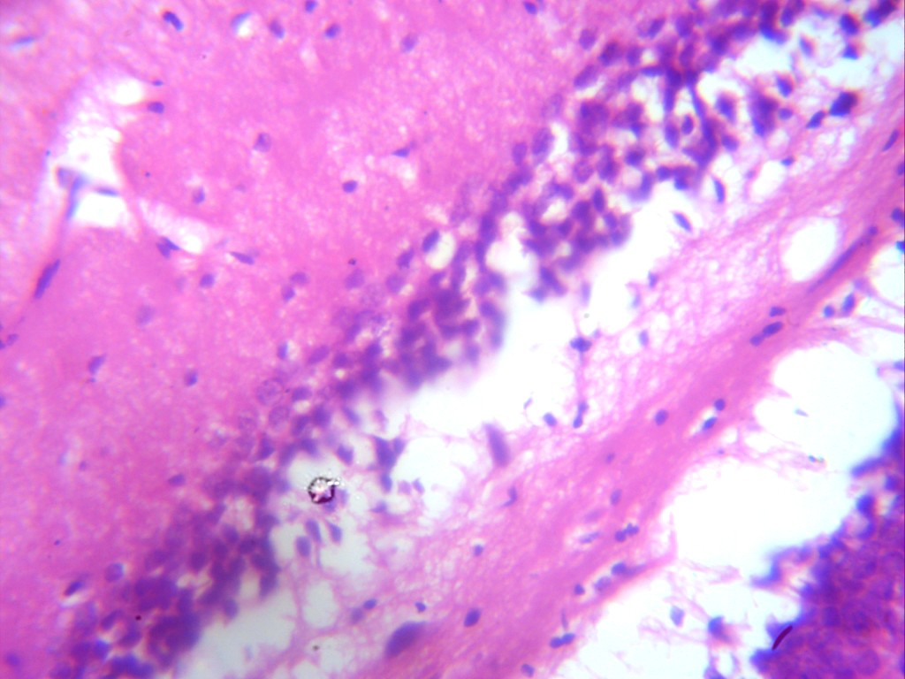

Plate 2: Photomicrograph of group B section of the hippocampus induced with 5 mg/kg of methamphetamine(x100x400) (H/E) shows severe degeneration with severe vacuolation(v) and severe pyknotic(P) granular cells.
(P)
(v)
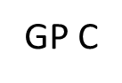
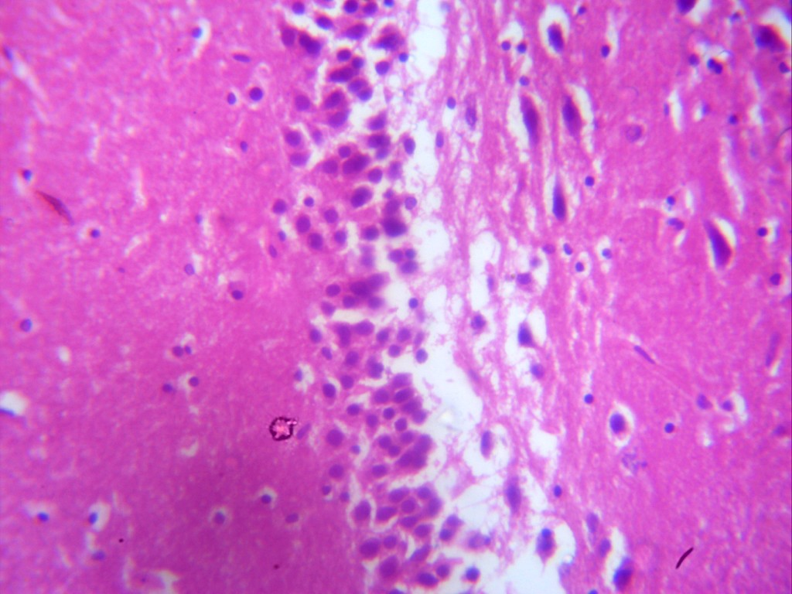

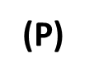

Plate 3: Photomicrograph of group C section of the hippocampus induced with 10 mg/kg of methamphetamine(x100x400)(H/E) shows severe degeneration with severe vacuolation(v) and severe pyknotic(P) granular cells.
Plate 4: Photomicrograph of group D section of hippocampus administered with 500 mg/kg of vitamin E only (x100x400) (H/E) shows mild vacoulation(v) with active granular cell (GC).

GC
GP D
V
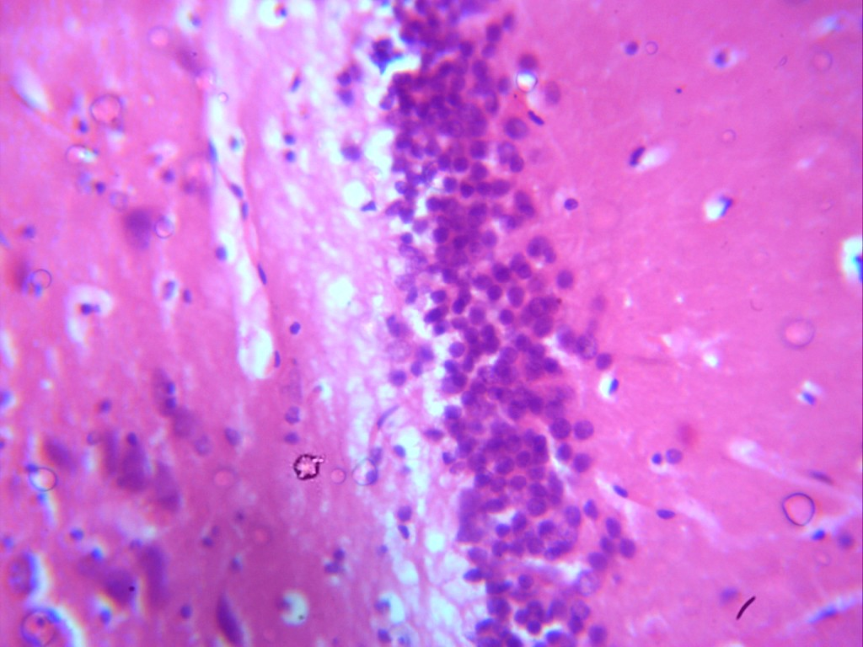
Plate 5: Photomicrograph of group E section of hippocampus administered with 1000 mg/kg of vitamin E only (x100x400) (H/E) shows well outlined active granular cell (GC)
V
P
GC
GP E
GC
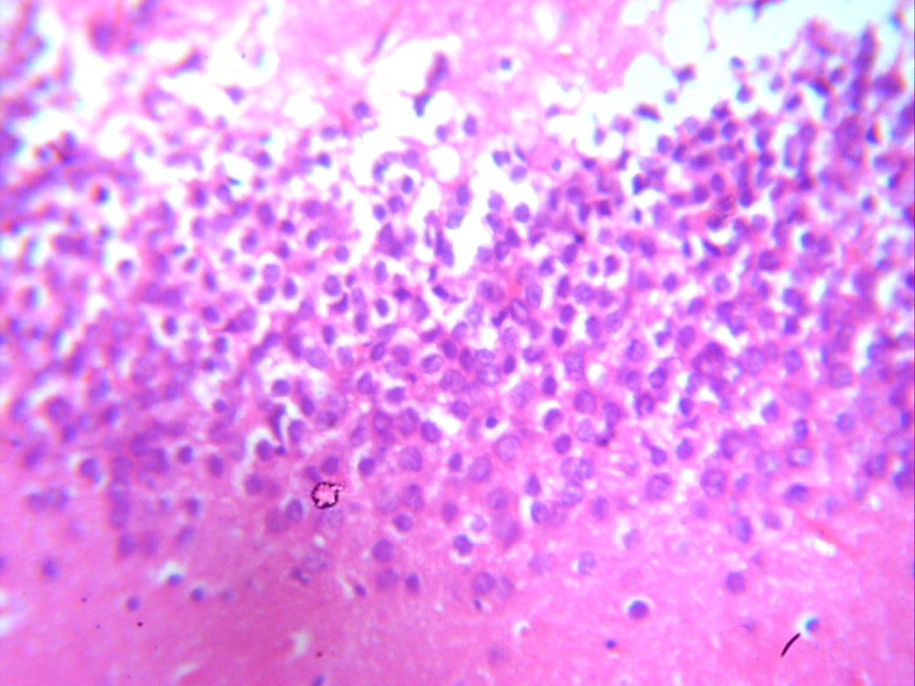
Plate 6: Photomicrograph of group F section of hippocampus induced with 5 mg/kg of methamphetamine and 500 mg/kg vitamin of E (x100x400) (H/E) shows moderate regeneration with mild vacoulation(v) and moderate increase in the number of active granular cell.
V
GC
GP F
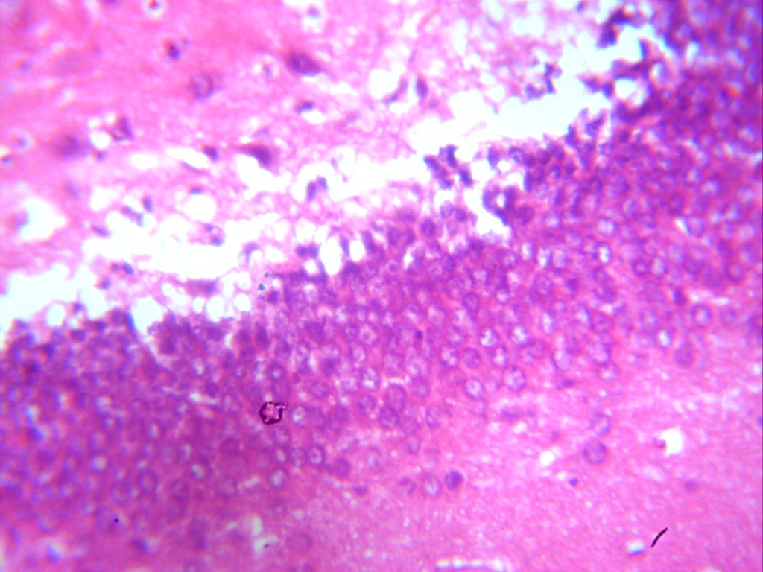
V
P
GP G
Plate 7: Photomicrograph of group G section of hippocampus induced with 10 mg/kg of methamphetamine and 1000 mg/kg of vitamin E (x100x400) (H/E) shows mild regeneration with moderate vacoulation(v) and moderate pyknotic(P) active granular cell.
P

Discussion
Methamphetamine is a powerful, highly addictive psychostimulant that affects the central nervous system (National Institute on Drug Abuse, 2023). It takes the form of a white, odorless, bitter tasting crystalline powder that easily dissolves in alcohol or water. It produces euphoria and stimulant effects similar to those of other stimulants, such as cocaine (National Library of Medicine, 2023). METH increases the levels of naturally occurring dopamine and norepinephrine in the brain. These effects last longer than those of cocaine, and it is less expensive and easier to make with commonly available ingredients. Vitamin E is a major lipid-soluble antioxidant in the cell antioxidant system, and it is exclusively obtained from the diet (Volker Bohm, 2018). Vitamin E is a nutrient that is important to vision, reproduction, and the health of one's blood, brain, and skin. Vitamin E also has antioxidant properties. Antioxidants are substances that might protect cells against the effects of free radicals — molecules produced when the body breaks down food or is exposed to tobacco smoke and radiation. Free radicals might play a role in heart disease, cancer, and other diseases. If vitamin E is used for its antioxidant properties, the supplement might not offer the same benefits as naturally occurring antioxidants in food (Mayo Clinic, 2022).
The results of this study revealed that the intake of methamphetamine caused some characteristic physical changes in adult male Wistar rats as evident in the reduction in physical activity, whereas the intake of only vitamin E also caused some characteristic physical changes in adult male Wistar rats as evident in the increase in body weight.
The observation of the difference in body weight among the groups revealed an increase in the body weight of the animals in group A. This could be physiological, as the only substances they were exposed to were water and feed. A significant increase in body weight was also observed in the experimental groups D & E, which were treated with only vitamin E, similar to the control group. This could have been caused by the increase in appetite caused by vitamin e. The increase in weight was mainly due to the increase in fat mass. A decrease in the production of reactive oxygen species has been suggested to prevent increases in the metabolic weight of animals (Afzal et al., (2023). These findings further suggest that vitamin E (an antioxidant) could slow body metabolism and favour fat accumulation. This result agrees with the results of Ima-Nirwana (2000), who reported that increases in weight were observed in Wistar rats fed vitamin E diets.
Compared with those in the control group, the body weights of the animals in groups B, C, F and G, which were administered methamphetamine, were significantly lower (P>0.05) than those of the control group. This is probably a result of the histological inflammation, degeneration and necrosis in fat tissue caused by METH. This result is in accordance with the work of Jaafari-Sheybani, Hosseini et al., (2021), who reported that METH use in Wistar rats resulted in significant inflammation and necrosis in adipose tissue, indicating the dangers of METH use, when recreationally targeted for weight loss purposes.
Measurement of the activities of marker enzymes in tissues and body fluids can be used to assess the degree of assault and the toxicity of a chemical compound to organs/tissues (Malamo, 2000; Yakubu et al., 2003). The measurement of enzyme activities can also be used to indicate tissue damage caused by a chemical compound long before histological changes occur (Yangguang Ou, 2018). Enzyme activity levels in serum and tissues are often used as markers to ascertain the toxic effects of administered foreign compounds on experimental animals (Yoko et al, 2019). MDA is a marker of oxidative, whereas GSH and SOD are enzymatic antioxidants. These enzymes are highly concentrated in some brain tissues, such as the hippocampus and prefrontal cortex; e.g. they are found in significant quantities only in the serum when the cell membrane becomes leaky and even completely ruptured. A rise or fall in the serum level or a decrease in the tissue level of these intracellular enzymes is an index of damage to the hippocampal cells.
In the present study, there was a significant increase(P<0.05) in the serum levels of MDA in groups B and C relative to those in control group A, as an increase in the serum levels of MDA indicates an increase in free radicals. This result indicated that the drug methamphetamine caused damage to the hippocampus during the experimental period. These results agree with those of Kita et al. (2003) and Escubedo et al. (2003), who reported that METH induced neurotoxicity by generating reactive oxygen species.
The antioxidative action and neuroprotective behavior of vitamin E were observed following significant histopathological analysis and a reduction in the serum level of MDA and an increase in the serum levels of GSH, and SOD in the groups that were treated with vitamin E (groups D, E, F & G). In the present study, there was a slight increase (P<0.05) in the serum levels of GSH in groups D & E, which were treated with only vitamin E, relative to the control (group A). There was also a slight increase (P<0.05) in group F which was treated with methamphetamine and vitamin E at a low dose. This could also be as a result of the neuroprotective behavior and antioxidant properties of vitamin E. This result agrees with the findings Pal et al. (2023), who reported that the decrease in the serum levels of GSH in a rat’s brain was reduced under acute stress conditions; however, the administration of vitamin E or vitamin C demonstrated promising effects in mitigating the oxidative stress induced by acute restraint stress. There was a significant decrease in the serum levels of GSH in group C compared with the control group in the present study. This is as a result of or can be attributed to the neurotoxic properties of methamphetamine, which induce oxidative stress in the hippocampus of the animal. The low levels of GSH could be linked to the xenobiotic detoxification, or adaptive mechanisms as reported by Dasari et al. (2018) and Laborde (2010). This result agrees with the work of Nwogueze et al. (2021), who reported that the serum levels of glutathione-related antioxidants in the brain tissue of stressed Wistar rats were reduced when exposed to stressors such as RCT, MCT etc. In this case, the stressor agent was methamphetamine. This observation was supported by (Richards and Laurin 2025), who reported that glutathione deficiency or reduction could increase the vulnerability of the brain to oxidative stress. GSH which is an enzymatic antioxidant whose level is reduced in the hippocampal tissues or cells, can lead to neurodegenerative diseases such as Alzheimer’s disease and Parkinson’s disease. Compared with those in the control group, the serum levels of SOD slightly decreased (P>0.05). The serum level of SOD in group G significantly lower (P>0.05) than that in the control group. This decrease is a result of the neurotoxic/neurodegenerative properties of methamphetamine which can cause oxidative stress in the brain. This result agrees with the work of Otitoju et al. (2008), who reported that an increase in the level of SOD activity in the brain can reduce possible neurobehavioural effects such as body tremor or aggression, which can be caused by an increase in oxidative stress levels.
The histopathological findings of the present study revealed normal hippocampal tissues in control group A. This could be physiological, as the only substance they were exposed to was water and feed. The results of groups D & E as shown in photomicrographs 4 and 5, revealed normal hippocampal tissue with active granular cells. This is a result of the vitamin E that was administered to the animals in these groups.
The animals in groups B & C, which were administered only methamphetamine, presented severe damage to the hippocampal tissue architecture as shown in photomicrographs 2 and 3. Here, severe degeneration with severe vacuolation and severe pyknotic granular cells was observed. This could be a result of decrease in the levels of antioxidant enzymes and biomarkers caused by methamphetamine. This result agrees with the work of Nwogueze et al. (2021). The groups F & G which included the animals that were administered methamphetamine and vitamin E caused mild damage to the hippocampal tissue architecture as shown in photomicrographs 6 and 7. Here, moderate regeneration with mild vacuolation and a moderate increase in the number of active granular cells were recorded in the group F animals whereas mild regeneration with moderate vacuolation and a moderate pyknotic active granular cells were recorded in the group G animals. This could also be the result of a decrease in the antioxidant enzymes and biomarkers induced by methamphetamine. This result also agrees with the work of Nwogueze et al. (2021). The animals in groups F and G provide a particularly interesting observation of the dynamics of reactions to the presence of various substances in our systems. After the administration of vitamin E to the groups, no changes in toxicity were associated with physical or behavioral observations. Body weight increases, which were statistically similar to those in the control group, and few to no histological lesions were observed in the hippocampal tissues. On the basis of these observations, one may deduce that the administration of vitamin E may increase the tolerance to methamphetamine-induced toxicity. Thus, the neuroprotective effect of vitamin E on the methamphetamine-induced hippocampus observed in the present study is attributed to is antioxidant and chemoprotective properties.
CONCLUSION
Vitamin E did not induce adverse alterations in the serum levels of MAD, GSH, or SOD, and very few histopathological lesions were observed in the hippocampal tissues of the rats given vitamin E. This study demonstrated the potential ability of vitamin E to protect against methamphetamine-induced neurotoxicity in the hippocampus of adult male Wistar rats. Rat tissues are very similar in many aspects to those of humans. The findings of this study suggest that vitamin E administered to individuals exposed to methamphetamine poisoning could provide some slight protection against methamphetamine toxicity and perhaps ameliorate the effects of methamphetamine neurotoxicity on the hippocampus.
RECOMMENDATION
This study provides a possible means of preventing damage to human tissues caused by methamphetamine. I recommend that vitamin E either from vitamin E-rich foods or from dietary supplements, should be administered to determine whether it is possible to demonstrate a possible countereffect on the hippocampus. However, further work is needed particularly on the effects of these drugs on other organs, such as the spleen and heart.

Disclaimer (Artificial intelligence)
Option 1:
Author(s) hereby declare that NO generative AI technologies such as Large Language Models (ChatGPT, COPILOT, etc.) and text-to-image generators have been used during the writing or editing of this manuscript.
Option 2:
Author(s) hereby declare that generative AI technologies such as Large Language Models, etc. have been used during the writing or editing of manuscripts. This explanation will include the name, version, model, and source of the generative AI technology and as well as all input prompts provided to the generative AI technology
Details of the AI usage are given below:
1.
2.
3.
REFERENCES
Akanji, M. A., Nafiu, M. O. and *Yakubu, M. T., (2008). Enzyme Activities and Histopathology of Selected Tissues in Rats Treated with Potassium bromate. African Journal of Biomedical Research, Vol. 11, pp.87 – 95.
Alessio, A., Damasceno, B.P., Camargo, C.H.P., Kobayashi, E., Guerreiro, C.A.M. and Cendes, F., (2004). Differences in memory performance and other clinical characteristics in patients with mesial temporal lobe epilepsy with and without hippocampal atrophy. Epilepsy & Behavior, 5(1), pp.22-27.
Anglin, M.D., Burke, C., Perrochet, B., Stamper, E. and Dawud-Noursi, S., (2000). History of the methamphetamine problem. Journal of psychoactive drugs, 32(2), pp.137-141.
Bartke, A., Brown-Borg, H.M., Bode, A.M., Carlson, J., Hunter, W.S. and Bronson, R.T., (1998). Does growth hormone prevent or accelerate aging? Experimental gerontology, 33(7-8), pp.675-687.
Bast, T., (2011). The hippocampal learning-behavior translation and the functional significance of hippocampal dysfunction in schizophrenia. Current opinion in neurobiology, 21(3), pp.492-501.
Birenbaum, B., The Hippocampus: Definition, Function, & Anatomy.
Bonilha, L., Martz, G.U., Glazier, S.S. and Edwards, J.C., (2012). Subtypes of medial temporal lobe epilepsy: influence on temporal lobectomy outcomes?. Epilepsia, 53(1), pp.1-6.
Borel, P., Preveraud, D. and Desmarchelier, C., (2013). Bioavailability of vitamin E in humans: an update. Nutrition reviews, 71(6), pp.319-331.
Brecht, M.L., O'Brien, A., Von Mayrhauser, C. and Anglin, M.D., (2004). Methamphetamine use behaviors and gender differences. Addictive behaviors, 29(1), pp.89-106.
Brown KM, Morrice PC, Duthie GG., (1997). Erythrocyte vitamin E and plasma ascorbate concentrations in relation to erythrocyte peroxidation in smokers and non-smokers: Dose response to vitamin E supplementation. Am J Clin Nutr, 65, pp.496–502.
Burton GW, Joyce A, Ingold KU., (1983). Is vitamin E the only lipid-soluble, chain- breaking antioxidant in human blood plasma and erythrocyte membranes? Arch Biochem Biophys, 221, pp.281–90.
Canton, H., (2021). United Nations Office on drugs and crime—UNODC. In The Europa Directory of International Organizations 2021 (pp. 240-244). Routledge.
Cearley, C., Churchill, L. and Krueger, J.M., (2003). Time of day differences in IL1β and TNFα mRNA levels in specific regions of the rat brain. Neuroscience letters, 352(1), pp.61-63.
Cho, A.K., (1990). Ice: a new dosage form of an old drug. Science, 249(4969), pp.631-634.
Ciccarone, D., (2011). Stimulant abuse: pharmacology, cocaine, methamphetamine, treatment, attempts at pharmacotherapy. Primary Care: Clinics in Office Practice, 38(1), pp.41-58.
Coodley, E.L. (1970) Diagnosic Enzymology. (3rd ed.) W.B. Saunders Co. Philadelphia, USA.
Copes, H., Tchoula, W. and Ragland, J., (2019). Ethically representing drug use: Photographs and ethnographic research with people who use methamphetamine. Journal of Qualitative Criminal Justice and Criminology, 8(1), pp.21-36.
Cruickshank, C.C. and Dyer, K.R., (2009). A review of the clinical pharmacology of methamphetamine. Addiction, 104(7), pp.1085-1099.
Cumming, C., Troeung, L., Young, J.T., Kelty, E. and Preen, D.B., (2016). Barriers to accessing methamphetamine treatment: a systematic review and meta- analysis. Drug and alcohol dependence, 168, pp.263-273.
Degenhardt, L., Mathers, B., Guarinieri, M., Panda, S., Phillips, B., Strathdee, S.A., Tyndall, M., Wiessing, L., Wodak, A. and Howard, J., (2010). Meth/amphetamine use and associated HIV: Implications for global policy and public health. International Journal of Drug Policy, 21(5), pp.347-358.
Dhikav, V. and Anand, K., (2011). Potential predictors of hippocampal atrophy in Alzheimer’s disease. Drugs & aging, 28, pp.1-11.
Dhikav, V. and Anand, K.S., (2007). Is hippocampal atrophy a future drug target?. Medical hypotheses, 68(6), pp.1300-1306.
Dumbili, E. and Ebuenyi, I., (2022). Factors influencing methamphetamine (mkpulummiri) use in Eastern Nigeria. Available at SSRN 4020039.
Ellis, M.S., Kasper, Z.A. and Cicero, T.J., (2018). Twin epidemics: the surging rise of methamphetamine use in chronic opioid users. Drug and alcohol dependence, 193, pp.14-20.
Feoli, A.M., Siqueira, I.R., Almeida, L., Tramontina, A.C., Vanzella, C., Sbaraini, S., Schweigert, I.D., Netto, C.A., Perry, M.L. and Gonçalves, C.A., (2006). Effects of protein malnutrition on oxidative status in rat brain. Nutrition, 22(2), pp.160-165.
Fisher, D.G., Reynolds, G.L., Ware, M.R. and Napper, L.E., (2011). Methamphetamine and Viagra use: relationship to sexual risk behaviors. Archives of sexual behavior, 40, pp.273-279.
Grzywacz, A., Chmielowiec, J., Chmielowiec, K., Mroczek, B., Masiak, J., Suchanecka, A., Sipak-Szmigiel, O., Szumilas, K. and Trybek, G., (2019). The Ankyrin Repeat and Kinase Domain Containing 1 Gene Polymorphism (ANKK1 Taq1A) and Personality Traits in Addicted Subjects. International Journal of Environmental Research and Public Health, 16(15), p.2687.
Han, B., Compton, W.M., Jones, C.M., Einstein, E.B. and Volkow, N.D., (2021). Methamphetamine use, methamphetamine use disorder, and associated overdose deaths among US adults. JAMA psychiatry, 78(12), pp.1329-1342.
Hansen, E.R., Carvalho, S., McDonald, M. and Havens, J.R., (2021). A qualitative examination of recent increases in methamphetamine use in a cohort of rural people who use drugs. Drug and alcohol dependence, 229, p.109145.
Hanson, C., Lyden, E., Furtado, J., Van Ormer, M., Schumacher, M., Kamil, A., McGinn, E., Rilett, K., Elliott, E., Cave, C. and Johnson, R., (2019). Vitamin E status and associations in maternal-infant Dyads in the Midwestern United States. Clinical nutrition, 38(2), pp.934-939.
Ijomone MO, Nwoha PU, Olaibi OK, Obi AU, Alese MO., (2011). Effects of methamphetamine on the hippocampus of rats: Behavioural and morphological approach. J Neurosci Behav Health 3, pp.107-12.
Ima-Nirwana S, Khalid BAK, Azman A., (2001). The effects of vitamin E on bodyweight and fat mass intact and ovariectomized female rats. Med J Islam Academy sci, 14(4), pp.125-138.
Jaafari-sheybani F, Hoseini SE, Mehrabani D, Derakhshanfar A, Karimi-Busheri F., (2021). Histological changes in adipose tissue: An alarm when methamphetamine is targeted for weight loss purposes. Wrld J plas surg, 10(1), p.53.
Kamal‐Eldin, A. and Appelqvist, L.Å., (1996). The chemistry and antioxidant properties of tocopherols and tocotrienols. Lipids, 31(7), pp.671-701.
Kerr, K.M., Agster, K.L., Furtak, S.C. and Burwell, R.D., (2007). Functional neuroanatomy of the parahippocampal region: the lateral and medial entorhinal areas. Hippocampus, 17(9), pp.697-708.
Kita T, Wagner GC, Nakashima T., (2003). Current research on methamphetamine- induced neurotoxicity: animal models of monoamine disruption. Journal of pharmacological sciences, 92(3), pp.178-195.
Koehl, M. and Abrous, D.N., (2011). A new chapter in the field of memory: adult hippocampal neurogenesis. European Journal of Neuroscience, 33(6), pp.1101-1114.
Kuczenski, R., Segal, D.S., Cho, A.K. and Melega, W., (1995). Hippocampus norepinephrine, caudate dopamine and serotonin, and behavioral responses to the stereoisomers of amphetamine and methamphetamine. Journal of Neuroscience, 15(2), pp.1308-1317.
Lim, S.H., Akbar, M., Wickersham, J.A., Kamarulzaman, A. and Altice, F.L., (2018). The management of methamphetamine use in sexual settings among men who have sex with men in Malaysia. International Journal of Drug Policy, 55, pp.256-262.
Limanaqi F, Gambardella S, Biagioni F, Busceti CL, Fornai F., (2018). Epigenetic Effects Induced by Methamphetamine and Methamphetamine-Dependent Oxidative Stress. Oxid Med Cell Longev, 2018:4982453.
Maranella E, Mareri A, Nardi V, Di Natale C, Di Luca L, Conte E, Pannone V, Catalucci A, Di Fabio S., (2019). Severe neurologic and hepatic toxicity in a newborn prenatally exposed to methamphetamine. A case reports. Brain Dev, Feb;41(2):191-194.
McKetin, R., Kelly, E. and McLaren, J., (2006). The relationship between crystalline methamphetamine use and methamphetamine dependence. Drug and alcohol dependence, 85(3), pp.198-204.
Mielke, M.M., Okonkwo, O.C., Oishi, K., Mori, S., Tighe, S., Miller, M.I., Ceritoglu, C., Brown, T., Albert, M. and Lyketsos, C.G., (2012). Fornix integrity and hippocampal volume predict memory decline and progression to Alzheimer’s disease. Alzheimer's & Dementia, 8(2), pp.105-113.
Molnár, K. and Kéri, S., (2014). Bigger is better and worse: on the intricate relationship between hippocampal size and memory. Neuropsychologia, 56, pp.73-78.
Morgado-Bernal, I., (2011). Learning and memory consolidation: linking molecular and behavioral data. Neuroscience, 176, pp.12-19.
Mueller, S.G., Schuff, N., Yaffe, K., Madison, C., Miller, B. and Weiner, M.W., (2010). Hippocampal atrophy patterns in mild cognitive impairment and Alzheimer's disease. Human brain mapping, 31(9), pp.1339- 1347.
Niki E, Traber MG., (2012). A history of vitamin E. Ann Nutr Metab, 61, pp.207– 12.
Nwogueze BC, Ojieh AE, Aloamaka CP, Igweh JC, Onyesom I., (2021). Levels of gluthatione-related antioxidants in ssome tissues of stressed Wistar rats. Indian J Physiol Pharmacol, 65, pp.167-76.
Ohm, T.G., (2007). The dentate gyrus in Alzheimer's disease. Progress in brain research, 163, pp.723-740.
Onwurah IN, Otitoju O, Otitoju GT, Ugwu CE., (2008). Oxidative stress and superoxide dismutase activity in the brain of rats fed with diet containing permethrin. Biokemistri, 20(2), pp.93-98.
Palamar, J.J., Han, B.H. and Keyes, K.M., (2020). Trends in characteristics of individuals who use methamphetamine in the United States, 2015-2018. Drug and alcohol dependence, 213, p.108089.
Pizzino G, Irrera N, Cucinotta M, Pallio G, Mannino F, Arcoraci V, Squadrito F, Altavilla D, Bitto A. Oxidative Stress: Harms and Benefits for Human Health. Oxid Med Cell Longev. 2017;2017:8416763. doi: 10.1155/2017/8416763. Epub 2017 Jul 27. PMID: 28819546; PMCID: PMC5551541.
Parsons, N.L., (2014). Meth Mania: A History of METH.
Pini, L., Pievani, M., Bocchetta, M., Altomare, D., Bosco, P., Cavedo, E., Galluzzi, S., Marizzoni, M. and Frisoni, G.B., (2016). Brain atrophy in Alzheimer’s disease and aging. Ageing research reviews, 30, pp.25-48.
Pubill, D., Canudas, A.M., Pallàs, M. et al., (2003). Different glial response to methamphetamine- and methylenedioxymethamphetamine-induced neurotoxicity. Naunyn-Schmiedeberg's Arch Pharmacol, 367, pp.490–499.
Raederstorff, D., Wyss, A., Calder, P.C., Weber, P. and Eggersdorfer, M., (2015). Vitamin E function and requirements in relation to PUFA. British Journal of Nutrition, 114(8), pp.1113-1122.
Rawson, R.A., Huber, A., Brethen, P., Obert, J., Gulati, V., Shoptaw, S. and Ling, W., (2001). Status of methamphetamine users 2–5 years after outpatient treatment. Journal of Addictive Diseases, 21(1), pp.107-119.
Sato, A., (2008). Methamphetamine use in Japan after the Second World War: Transformation of narratives. Contemporary Drug Problems, 35(4), pp.717- 746.
Schönheit, B., Glöckner, F. and Ohm, T.G., (2007). Apolipoprotein E polymorphism and dendritic shape in hippocampal interneurons. Neurobiology of Aging, 28(5), pp.677-686.
Scott, J.C., Woods, S.P., Matt, G.E., Meyer, R.A., Heaton, R.K., Atkinson, J.H. and Grant, I., 2007. Neurocognitive effects of methamphetamine: a critical review and meta-analysis. Neuropsychology review., 17, pp.275-297.
Sexton, R.L., Carlson, R.G., Leukefeld, C.G. and Booth, B.M., (2006). Methamphetamine use and adverse consequences in the rural southern United States: An ethnographic overview. Journal of psychoactive drugs, 38(3), pp.393-404.
Shoptaw, S. and Reback, C.J., (2007). Methamphetamine use and infectious disease‐ related behaviors in men who have sex with men: implications for interventions. Addiction, 102, pp.130-135.
Spallazzi, M., Dobisch, L., Becke, A., Berron, D., Stucht, D., Oeltze-Jafra, S., Caffarra, P., Speck, O. and Düzel, E., (2019). Hippocampal vascularization patterns: a high-resolution 7 Tesla time-of-flight magnetic resonance angiography study. NeuroImage: Clinical, 21, p.101609.
Suvvari TK, Pal G, Mishra HP, Tanwar A, Ghosh T, Verma P, Pal A, Mahapatra C, Amanullah NA, Shukoor SA, Kamal S, Rohil V., (2023). Oxidative stress in Wistar rats under acute stress and its modification by antioxidants and nitric oxide modulators. Cureus, 15(8): e43333.
Thiele, J.J., Hsieh, S.N. and Ekanayake‐Mudiyanselage, S., (2005). Vitamin E: critical review of its current use in cosmetic and clinical dermatology. Dermatologic surgery, 31, pp.805-813.
Thom, M., Eriksson, S., Martinian, L., Caboclo, L.O., McEvoy, A.W., Duncan, J.S. and Sisodiya, S.M., (2009). Temporal lobe sclerosis associated with hippocampal sclerosis in temporal lobe epilepsy: neuropathological features. Journal of Neuropathology & Experimental Neurology, 68(8), pp.928-938.
Traber, M.G., (2006). How much vitamin E?... Just enough!. American journal of clinical nutrition, 84(5), pp.959-960.
Traber, M.G., (2024). Human Vitamin E deficiency, and what is and is not Vitamin E?. Free Radical Biology and Medicine.
Violet, P.C., Ebenuwa, I.C., Wang, Y., Niyyati, M., Padayatty, S.J., Head, B., Wilkins, K., Chung, S., Thakur, V., Ulatowski, L. and Atkinson, J., (2020). Vitamin E sequestration by liver fat in humans. JCI insight, 5(1).
Wu, D. and Meydani, S.N., (2019). Vitamin E, immune function, and protection against infection. Vitamin E in human health, pp.371-384.
Yang X, Wang Y, Li Q, Zhong Y, Chen L, Du Y, He J, Liao L, Xiong K, Yi CX, Yan J., (2018). The Main Molecular Mechanisms Underlying Methamphetamine- Induced Neurotoxicity and Implications for Pharmacological Treatment. Front Mol Neurosci, 11, pp.186.
Zingg, J.M. and Azzi, A., (2004). Non-antioxidant activities of vitamin E. Current medicinal chemistry, 11(9), pp.1113-1133.
National Research Council (US) Committee for the Update of the Guide for the Care and Use of Laboratory Animals. Guide for the Care and Use of Laboratory Animals. 8th edition. Washington (DC): National Academies Press (US); 2011. Available from: https://www.ncbi.nlm.nih.gov/books/NBK54050/ doi: 10.17226/12910

Afzal S, Abdul Manap AS, Attiq A, Albokhadaim I, Kandeel M, Alhojaily SM. From imbalance to impairment: the central role of reactive oxygen species in oxidative stress-induced disorders and therapeutic exploration. Front Pharmacol. 2023 Oct 18;14:1269581. doi: 10.3389/fphar.2023.1269581. PMID: 37927596; PMCID: PMC10622810.

Ou Yangguang, Wilson RE, Weber SG. Methods of Measuring Enzyme Activity Ex Vivo and In Vivo. Annu Rev Anal Chem (Palo Alto Calif). 2018 Jun 12;11(1):509-533. doi: 10.1146/annurev-anchem-061417-125619. Epub 2018 Mar 5. PMID: 29505726; PMCID: PMC6147230.

Richards JR, Laurin EG. Methamphetamine Toxicity. [Updated 2023 Jun 8]. In: StatPearls [Internet]. Treasure Island (FL): StatPearls Publishing; 2025 Jan-. Available from: https://www.ncbi.nlm.nih.gov/books/NBK430895/

Yoko Yokoyama, Atsushi Ono, Midori Yoshida, Kiyoshi Matsumoto, Mikako Saito, Toxicological significance of increased serum alkaline phosphatase activity in dog studies of pesticides: Analysis of toxicological data evaluated in Japan, Regulatory Toxicology and Pharmacology, Volume 109,2019, 104482, ISSN 0273-2300,

