**Case Report**

**The Correlation Between Anti GAD65 Antibody and Autoimmune Encephalitis with Seizures responding to IVIG and Rituximab: A Case Report**

**Abstract**

This case report discusses the clinical presentation, diagnostic challenges and management of a 24-year-old male with anti-GAD65 encephalitis. The report highlights the importance of early diagnosis and treatment to ensure a favourable outcome. The glutamic acid decarboxylase 65-kilodalton isoform (GAD65) antibody is a biomarker of autoimmune central nervous system (CNS) disorders and, more commonly, non-neurological autoimmune diseases. Type 1 diabetes, autoimmune thyroid disease, and pernicious anaemia are the most frequent GAD65 autoimmune associations. One or more of these disorders coexists in approximately 70% of patients with GAD65 neurological autoimmunity. Neurological phenotypes have central nervous system (CNS) localization and include limbic encephalitis, epilepsy, cerebellar ataxia, and stiff-person syndrome (SPS), among others. Timely initiation of appropriate therapy can avoid serious complications in the patient. Therefore, high clinical suspicion should be there if the initial workup doesn’t lead to a diagnosis.

**Key Words:** Anti GAD65 antibody, anaemia, Autoimmune encephalitis, Seizure

**Introduction**

“Anti-glutamic acid decarboxylase 65 (GAD65) antibodies target the intracellular enzyme necessary to synthesize gamma aminobutyric acid (GABA). Glutamic acid decarboxylase 65 (GAD65) catalyzes the production of gamma-aminobutyric acid (GABA), the most important inhibitory neurotransmitter in CNS” (1). “Anti-GAD65 is one of the antibodies to the antigen in intracellular cytoplasmic of neuron. Patients may present with stiff man syndrome or cerebellar ataxia” (2). “Additional clinical presentations include temporal lobe epilepsy with cognitive behavioural features and type I diabetes. Magnetic Resonance imaging (MRI) demonstrates signal abnormality and swelling in the amygdala and hippocampus typical of limbic encephalitis” (3). “Multifocal central nervous system (CNS) abnormalities are seen in a minority of cases” (4). “Anti-glutamic acid decarboxylase 65 (GAD65) antibodies are also used in confirming the diagnosis of stiff-man syndrome, autoimmune encephalitis, autoimmune ataxia, brain stem encephalitis, autoimmune epilepsy, autoimmune myelopathy” (5)

**Case Presentation**

This is a case of 24 Years old male patient who presented with complaints of high-grade fever(102-104oF) for two days and one episode of Generalised tonic clonic seizure (GTCS) with post ictal drowsiness. Considering as infective etiology all the relevant investigations were done and patient was intubated as general condition of the patient was poor and the patient was not responding to verbal commands and making inappropriate sounds. Blood investigations and imaging of the brain did not reveal any abnormality apart from mild thrombocytopenia. Neurologist opinion was taken and cerebrospinal fluid (CSF) was drained through lumbar puncture. To our surprise apart from mildly increased protein 79mg/dl (Normal range 10-40mg/dl ) and glucose level of 84mg/dl(Normal range 50-80mg/dl) all other parameters of cerebrospinal fluid (CSF) were within normal range with no oligoclonal bands seen and normal blood glucose level of 112mg/dl. Other antibodies like Anti Ma2, Anti-Hu, Anti-AMPA were also negative in the serum. Patient was on ventilatory support for some time. Developed fever with new infiltrates on chest Xray – Ventilatory associated Pneumoniae (VAP). The blood culture grew Klebsiella pneumoniae, Carbapenem Resistant strain (CRE) which responded to Ceftazidime-Avibactam & Aztreonam. The patient gradually regained consciousness and was extubated after two days. The images of the CT scan of chest are attached below.

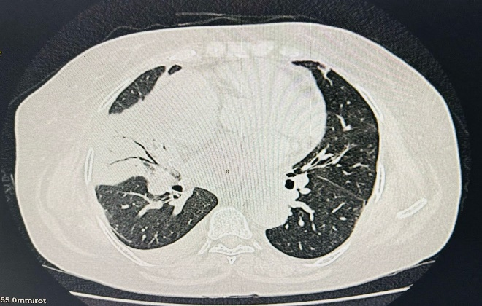 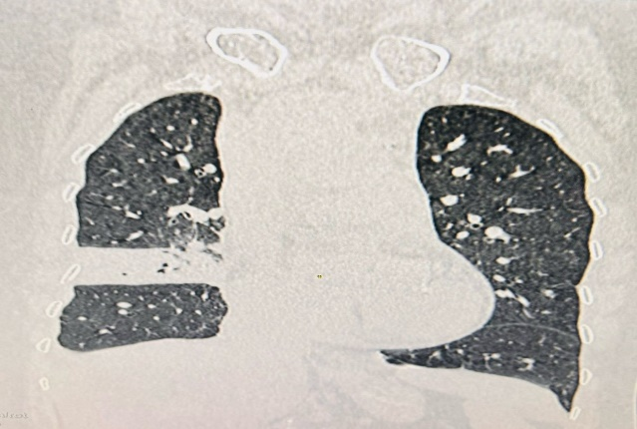

Image1: Transverse section showing consolidation Image2: Coronal section showing Consolidation of Right middle lobe. and pleural effusion on right side.

“The patient again had an episode of Generalised tonic clonic seizure (GTCS) while he was on multiple antiepileptic medication as the patient had multiple episodes of seizures which lead to deterioration of general condition of the patient, it was then that the suspicion of autoimmune disorder was considered and the relevant investigations were done. Anti- glutamic acid decarboxylase 65 (GAD65) antibody came positive in the serum (133mg/dl) confirming the underlying autoimmune pathology” (5). “Meanwhile patient blood culture grew Klebsiella pneumoniae which was treated accordingly. Apart from positive Anti glutamic acid decarboxylase 65(GAD65) antibody, no other investigation pertaining to diagnosis of fever with seizure was positive. The patient was treated with Methylprednisolone (6), IVIG (Intravenous Immunoglobulin)” (7) and Rituximab (Anti CD20 antibody) (8), to which the patient responded dramatically. Gradually the seizure episodes subsided and the antiepileptic medications were also cut down.

**Discussion**

Glutamic acid decarboxylase 65(GAD65) is a crucial enzyme involved in the production of a neurotransmitter named Gamma-Aminobutyric Acid (GABA). Gamma-Aminobutyric Acid (GABA) is the major inhibitory neurotransmitter in the central nervous system (CNS). There still is a lot unknown as to the role Glutamic acid decarboxylase 65 (GAD65) antibodies play in neuroinflammation and their pathogenic role remains controversial; in addition, T-cell mediated immune response seem to be important in the pathogenesis of Glutamic acid decarboxylase 65 (GAD65) encephalitis (9). Anti Glutamic acid decarboxylase 65 (GAD65) Antibody is one of the most frequently detected antibodies in patients presenting with idiopathic drug-resistant epilepsy. Anti Glutamic acid decarboxylase 65 (GAD65) Antibody titre in neurological condition often 100 times higher than type 1 diabetes (10).

While steroids, IV immunoglobulins, and plasmapheresis have been used to treat autoimmune encephalitis, comprehensive data regarding the efficacy of various treatment modalities are lacking, making treatment dependent not only on the clinician's expertise, but also on the patient's comorbidities (11).

**Conclusion**

Glutamic acid decarboxylase 65(GAD65) is a crucial enzyme involved in the production of a neurotransmitter named Gamma-Aminobutyric Acid (GABA). T-cell mediated immune response seem to be important in the pathogenesis of Glutamic acid decarboxylase 65 (GAD65) encephalitis. Anti Glutamic acid decarboxylase 65 (GAD65) Antibody titre in neurological condition often 100 times higher than type 1 diabetes. Early diagnosis and timely initiation of immunotherapy are crucial for improving clinical symptoms and reducing the likelihood of relapses.

**Consent**

As per international standards or university standards, patient(s) written consent has been collected and preserved by the author(s).

Ethical Approval:

As per international standards or university standards written ethical approval has been collected and preserved by the author(s).

**Disclaimer (Artificial intelligence)**

**Option 1:**

**Author(s) hereby declare that NO generative AI technologies such as Large Language Models (ChatGPT, COPILOT, etc.) and text-to-image generators have been used during the writing or editing of this manuscript.**

**Option 2:**

**Author(s) hereby declare that generative AI technologies such as Large Language Models, etc. have been used during the writing or editing of manuscripts. This explanation will include the name, version, model, and source of the generative AI technology and as well as all input prompts provided to the generative AI technology**

**Details of the AI usage are given below:**

**1.**

**2.**

**3.**

**References**

1. Tsiortou P, Alexopoulos H, Dalakas MC. GAD antibody-spectrum disorders: progress in clinical phenotypes, immunopathogenesis and therapeutic interventions. Therapeutic Advances in Neurological Disorders. 2021;14. doi:10.1177/17562864211003486
2. Dalakas, M.C., Rakocevic, G., Dambrosia, J.M., Alexopoulos, H. and McElroy, B. (2017), A double-blind, placebo-controlled study of rituximab in patients with stiff person syndrome. Ann Neurol., 82: 271-277. <https://doi.org/10.1002/ana.25002>
3. Zhang, Lin-ming et al. Efficacy of rituximab as second-line therapy for autoimmune encephalitis: A systematic review and meta-analysis. Heliyon, Volume 11, Issue 2, e41747, January 2025
4. Christopher Ball, Ryan Fisicaro, Lee Morris, Andrew White, Thomas Pacicco, Karuna Raj, Amit Agarwal, Wan-Ching Lee, Fang Frank Yu,

Brain on fire: an imaging-based review of autoimmune encephalitis,

ISSN 0899-7071,

<https://doi.org/10.1016/j.clinimag.2021.12.011>.

1. <https://www.mayocliniclabs.com/test-catalog/overview/81596>
2. Azizi S, Vadlamuri DL, Cannizzaro LA. Treatment of Anti-GAD65 Autoimmune Encephalitis with Methylprednisolone. Ochsner J. 2021 Fall;21(3):312-315. doi: 10.31486/toj.20.0096. PMID: 34566516; PMCID: PMC8442218.
3. Lee ST, Lee HS, Lee WJ, Cha HA, Kim SH, Shin SY, Chu K, Lee SK. The safety and efficacy of intravenous immunoglobulin in autoimmune encephalitis. Ann Clin Transl Neurol. 2022 May;9(5):610-621. doi: 10.1002/acn3.51540. Epub 2022 Mar 22. PMID: 35315247; PMCID: PMC9082384.
4. <https://aealliance.org/ae-types/anti-gad65-limbic-encephalitis/>
5. Daif, Ahmad et al. Antiglutamic acid decarboxylase 65 (GAD65) antibody-associated epilepsy. Epilepsy & Behaviour, Volume 80, 331 – 336, March 2018
6. Azizi S, Vadlamuri DL, Cannizzaro LA. Treatment of Anti-GAD65 Autoimmune Encephalitis With Methylprednisolone. Ochsner J. 2021 Fall;21(3):312-315. doi: 10.31486/toj.20.0096. PMID: 34566516; PMCID: PMC8442218.
7. Fredriksen JR, Carr CM, Koeller KK, Verdoorn JT, Gadoth A, Pittock SJ, Kotsenas AL. MRI findings in glutamic acid decarboxylase associated autoimmune epilepsy. Neuroradiology. 2018 Mar;60(3):239-245. doi: 10.1007/s00234-018-1976-6. Epub 2018 Jan 20. PMID: 29353399.