**Original Research Article**

**Assessing Mucin in Cervical Intraepithelial and Cancerous Lesions Using PAS and Alcian Blue Stain**

***Abstract:***

***Background****:* *Cervical carcinoma is the fourth most common cancer in women worldwide and the second leading cause of cancer-related deaths. However, it is potentially treatable if precursor lesions and invasive carcinomas are identified early. Given the poor prognosis associated with adenocarcinoma and adenosquamous carcinoma, precise identification of these cancers during routine histopathological examinations can significantly benefit patients. Therefore, in developing countries like Bangladesh, using cost-effective mucin stains, such as Periodic Acid-Schiff and Alcian Blue, may be helpful in the early detection of carcinomatous processes, particularly aggressive mucin-secreting carcinomas.*

***Objective****: This study explores mucin characteristics in cervical precancerous lesions and invasive cancers to enhance histological diagnosis and predict prognosis.*

***Materials and methods:*** *This cross-sectional descriptive study includes 100 paraffin blocks (70 from patients histopathologically diagnosed with cervical carcinoma and 30 from patients diagnosed with cervical intraepithelial lesions) at the Department of Pathology, Rajshahi Medical College.*

***Results*** *- In a study involving 70 cases of invasive cervical carcinoma, mucin positivity was detected in 28 cases. Acidic mucin was the most prevalent type, found in 15 cases, followed by mixed mucin in 11 cases and neutral mucin in only 2 cases. Notably, mucin positivity was present in 15 cases of grade one cancers, which is significantly higher compared to grades two and three. Among 17 cases of poorly differentiated squamous cell carcinoma, 4 cases tested positive for mucin, leading to the reclassification of 3 cases as adenosquamous carcinoma and 1 case as adenocarcinoma. This result was statistically significant, with a P-value of less than 0.05. Furthermore, among 30 cases of cervical intraepithelial neoplasia, intraepithelial mucin was observed in 5 cases—of which 3 were identified as neutral mucin types and 2 as mixed. However, this finding was not statistically significant, indicated by a P-value greater than 0.05.*

***Conclusion****- This study demonstrates that the prevalence of acid mucin rises in conjunction with an increase in tumor grade. Furthermore, some commonly diagnosed squamous cell carcinomas are actually mucin-secreting adenocarcinomas or adenosquamous carcinomas. Thus, mucin could serve as a valuable marker for accurate histological diagnosis, early detection of malignant transformation, and prediction of prognosis.*

***Keywords:*** *Adenocarcinoma, Tumor grade, mucin, PAS, Alcian Blue.*

**Introduction**:

Cervical cancer is the fourth most common cancer among women worldwide, with an estimated 604,127 new cases and 341831 deaths reported in 2020. In Bangladesh, it ranks as the second most common cancer in women, with 8,268 new cases and 4,971 deaths in the same year.1

The incidence and mortality rates of cervical cancer are significantly higher in developing countries compared to developed countries. This disparity is mainly due to limited access to screening facilities, which often results in cases being detected only at more advanced stages. Cervical cancer has multiple contributing factors which are Human Papillomavirus (HPV) Infection, smoking, immunosuppression and chlamydia infection, but it also has a strong potential for prevention. Given its serious implications, it is a crucial topic for in-depth study.2

The precancerous lesions of the cervix are categorized into cervical intraepithelial neoplasia grades 1, 2, and 3. Invasive cervical cancers are broadly categorized into squamous cell carcinoma, adenocarcinoma, and adenosquamous carcinoma, while other types like small cell neuroendocrine carcinoma, large cell neuroendocrine carcinoma, clear cell carcinoma and glass cell carcinoma are rare.3

Well-differentiated lesions typically do not present diagnostic challenges. However, in 20-30% of cases, poorly differentiated squamous cell carcinomas that are diagnosed using H&E staining may actually be adenocarcinomas or adenosquamous carcinomas when examined with mucin stains. This highlights the importance of routine inclusion of mucin stains in the diagnostic process.4 The importance of identifying mucin-secreting cancers is that these tumors tend to have an unusually aggressive progression and are linked to a significantly worse prognosis compared to their pure squamous counterparts.3 Identifying mucin-secreting cancers is crucial because these tumors often exhibit more aggressive behavior and are associated with a poorer prognosis than pure squamous cell carcinomas. Prognosis is typically assessed by comparing survival rates, recurrence rates, and response to treatment between mucin-secreting and non-mucin-secreting tumors. Methods such as statistical analysis of clinical outcomes, histopathological examination, and molecular profiling are commonly used to evaluate and compare the progression and prognosis of these cancer types.

Mucins are divided into two main types: neutral and acidic mucins, with neutral mucins being slightly alkaline. In malignancy, cancerous cells change behavior and secrete different mucins than normal cells, reverting to an embryonic state during carcinogenesis. Secretory changes in mucins can occur before visible nuclear alterations, making the study of these changes valuable for early cancer detection.5

Normal endocervical glands contain a mix of neutral and acidic mucins, primarily neutral. In malignant glands, the balance shifts to a predominance of acidic mucin, indicating a change in the mucin pattern.6

This study was conducted to evaluate mucin characteristics in precancerous lesions and invasive cervical cancers and to compare our findings with those in the existing literature.

In this study, we evaluated mucin characteristics in precancerous lesions and invasive cervical cancers by conducting histopathological examinations and comparing the mucin profiles of these lesions. Our focus will be on identifying shifts in mucin patterns, particularly the transition from neutral to acidic mucins, and assessing their correlation with cancer progression and prognosis. We will limit our findings to key insights from existing literature that highlight the diagnostic and prognostic significance of mucin alterations in cervical cancer.

**Materials and methods:**

This study was conducted in the Department of Pathology at Rajshahi Medical College, Rajshahi from March 2020 to February 2022. It included 100 paraffin blocks from patients who were histopathological diagnosed with cervical intraepithelial neoplasia and cervical carcinomas in this department. Patient’s informed consent was taken in a prtescribed data sheet and ethical clearance was taken from the Institutional Review Board (IRB) of Rajshahi Medical College, Bangladesh. Cases confirmed by histopathological study were included in the study, while poorly fixed samples were excluded.

Calculation of sample size: Sample size was calculated by Cochran’s formula 14

Here,

n=estimated sample size

Z=1.96 at 95% confidence interval.

P=21.46% (prevalence of cervical cancer in women is 21.46%=0.214 (Ref: Globocan Bangladesh, 2018).

q=(1-p) =(1-0.214)=0.786

d=0.5 (marginal error considered as 5%).



=258

Due to the limitations of resource, a total of 70 carcinoma cases and 30 CIN cases are taken as study population. Thus, the total sample size is100.

H&E and combined PAS/AB staining were conducted following the protocol from the Department of Pathology at Rajshahi Medical College. Slides were examined to classify CIN cases as CIN I, II, or III. Invasive carcinomas were graded as grade 1 (well-differentiated), grade 2 (moderately differentiated), or grade 3 (poorly differentiated). Tumors were categorized by mucin content as negative (less than 5%), mild (5-30%), moderate (31-70%), or strong (greater than 70%).

**Results:**

This study includes 100 cases of cervical precancerous lesions and cancers from the Department of Pathology at Rajshahi Medical College, Rajshahi having taken ethical clearance from the Institutional Review Board (IRB) of the same medical college. Among the cases, 75 (75%) were aged 40 to 60 years, 7 (7%) were under 40, and 18 (18%) were over 60. The mean age was 51.42 ± 8.75 years. Table 1 shows the age distribution of cervical adenocarcinomas in the study.

**Table I: Distribution of the study subjects by their age (n = 100).**

|  |  |  |
| --- | --- | --- |
| Age (years) | Frequency | (%) |
| <40 | 7 | 7% |
| 41-60 | 75 | 75% |
| >60 | 18 | 18% |
| Mean $±$ SD | 51.42 $±$ 8.75 | |
| Range (Min-Max) | (29-74) | |

Of the total 100 cases, 45 (45%) were invasive cervical squamous cell carcinoma, 15 (15%) were invasive adenocarcinoma, 10 (10%) were invasive adenosquamous carcinoma, and 30 (30%) were cervical intraepithelial neoplasia (Figure 1).

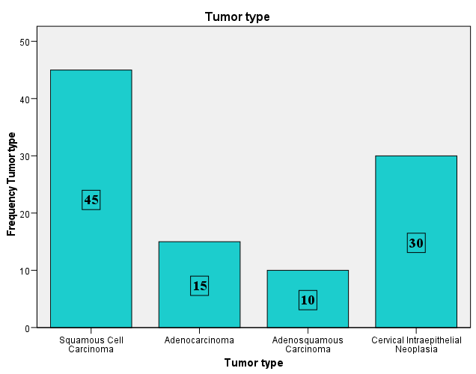

**Figure 1: Bar diagram showing the distribution of cases according to the type of tumor (n = 100).**

Most cases were CIN-II (36.67%), followed by CIN-III (33.33%) and CIN-I (30%) as shown in Figure 2.

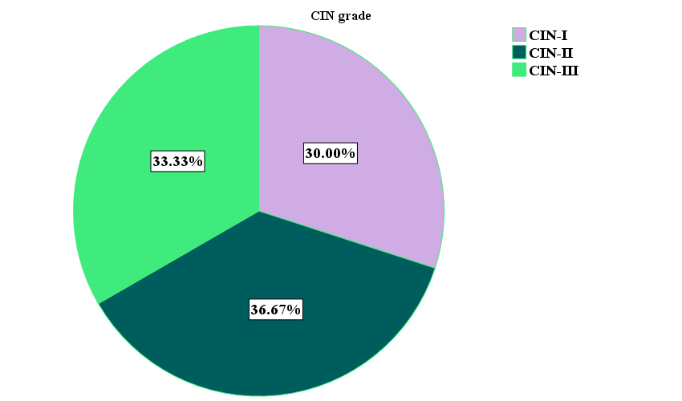

**Figure 2: Pie chart showing the distribution of study subjects according to CIN grade (n=30).**

In grade 1 cancers, 41.9% were classified as squamous cell carcinoma, while adenocarcinoma accounted for 34.9% and adenosquamous carcinoma made up 23.3%. Additionally, all cases of grade 2 (10 cases) and grade 3 (17 cases) invasive cervical cancers were identified as squamous cell carcinoma (see Table II).

**Table II: Distribution of invasive cervical carcinoma by their histological types (n = 100).**

|  |  |  |  |  |  |  |  |  |  |
| --- | --- | --- | --- | --- | --- | --- | --- | --- | --- |
| Tumor type | Tumor grade of invasive cancers | | | | | | Total | |  |
| **Grade 1** | | **Grade 2** | | **Grade 3** | | **P value** |
| **N** | **%** | **N** | **%** | **N** | **%** | **N** | **%** |  |
| Squamous Cell Carcinoma | 18 | 41.9 | 10 | 100 | 17 | 100.0 | 5 | 64.3 |  |
| Adenocarcinoma | 15 | 34.9 | 0 | 0.0 | 0 | 0.0 | 15 | 21.4 | <0.001 |
| Adenosquamous Carcinoma | 10 | 23.3 | 0 | 0.0 | 0 | 0.0 | 10 | 14.3 |  |
| Total | 43 | 100 | 10 | 100 | 17 | 100.0 | 70 | 100.0 |  |

Out of 70 cases of invasive cervical cancer, 42 (60%) were mucin-positive, while 28 (40%) were mucin-negative (Figure 3).

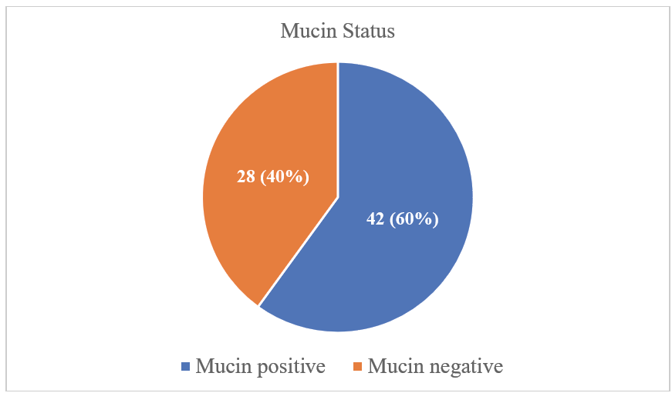

**Figure 3: Pie chart showing the distribution of mucin in invasive carcinoma (n = 70).**

Out of 30 cases of CIN, 5 (16.67%) were mucin positive and 25 (83.33%) were mucin negative (Figure 4).

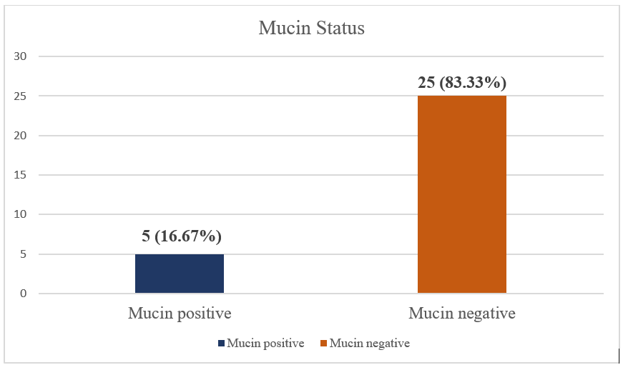

**Figure 4: Bar diagram showing the distribution of mucin in CIN (n = 30).**

Among the 28 mucin-positive cases, 15 (53.57%) exhibited predominantly acidic mucin, 11 (39.29%) displayed predominantly mixed-type mucin, and 2 (7.14%) showed neutral mucin (Figure 5).

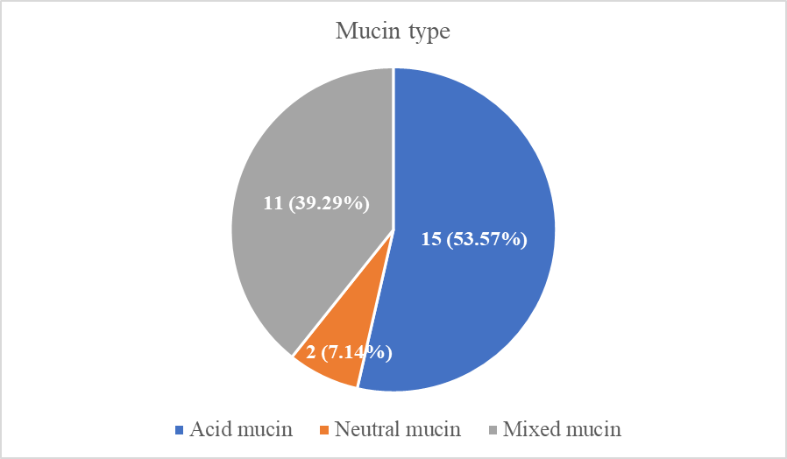

**Figure 5: Pie chart showing mucin types in invasive carcinoma (n=70).**

Out of the five mucin-positive cases, three (60%) exhibited predominantly neutral mucin, two (40%) displayed predominantly mixed-type mucin, and none showed acidic mucin (Figure 6).

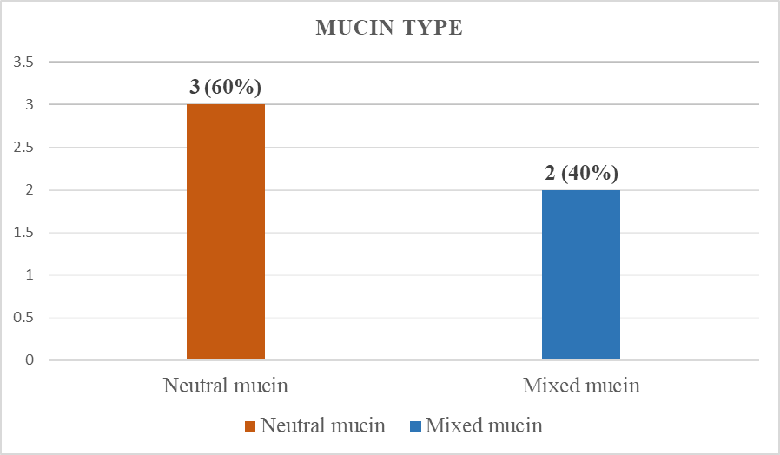

**Figure 6: Pie chart showing mucin types in CIN (n=30).**

Mucin was positive in 4 cases (8.9%) of squamous cell carcinoma, 15 cases (100%) of adenocarcinoma, 9 cases (90%) of adenosquamous carcinoma, and 5 cases (16.7%) of cervical intraepithelial neoplasia. The differences among the study groups were statistically significant (p < 0.05, Table III).

**Table III: Association of mucin with tumor type (n =100).**

|  |  |  |  |  |  |  |  |  |  |  |  |  |
| --- | --- | --- | --- | --- | --- | --- | --- | --- | --- | --- | --- | --- |
|  | | **Tumor type** | | | | | | | | **Total** | | **P value** |
| **Squamous Cell Carcinoma** | | **Adenocarcinoma** | | **Adenosquamous Carcinoma** | | **CIN** | |
| N | % | N | % | N | % | N | % | N | % |  |
|  | Mucin positive | 4 | 8.9 | 15 | 100.0 | 9 | 90 | 5 | 16.7 | 33 | 33.0% | <0.001 |
| Mucin negative | 41 | 91.1 | 0 | 0.0 | 1 | 10.0 | 25 | 83.3 | 67 | 67.0 |  |
| Total | | 45 | 100.0 | 15 | 100.0 | 10 | 100. | 30 | 100.0 | 100 | 100 | |

In the study, 24 out of 43 (55.8%) grade 1 invasive cancers exhibited mucin positivity, while 4 out of 17 (23.5%) grade 3 invasive cancers showed mucin positivity. Notably, none of the grade 2 tumors demonstrated any signs of mucin positivity. The mean difference among the study groups was not statistically significant (p > 0.05) as shown in Table IV.

**Table IV: Association of mucin status with tumor grade (n=43)**

|  |  |  |  |  |  |  |  |  |  |  |
| --- | --- | --- | --- | --- | --- | --- | --- | --- | --- | --- |
| **Mucin status** | | **Tumor grade of invasive cancers** | | | | | | **Total** | |  |
| **Grade 1** | | **Grade 2** | | **Grade 3** | | **P value** |
| **N** | **%** | **N** | **%** | **N** | **%** | **N** | **%** |  |
|  | Mucin positive | 24 | 55.8 | 0 | 00 | 4 | 23.5 | 28 | 40 |  |
| Mucin negative | 19 | 44.2 | 10 | 100 | 13 | 76.5 | 42 | 60 | 0.072ns |
| Total | | 43 | 100 | 10 | 100 | 17 | 100 | 70 | 100 |  |

Out of 30 CIN cases, 3 (33.3%) CIN-I cases showed mucin positivity, along with 1 (9.1%) CIN-II case and 1 (16.7%) CIN-III case. The mean difference among groups was not statistically significant (p > 0.05) (Table V).

**Table V: Distribution of mucin by CIN grades (n=30)**

|  |  |  |  |  |  |  |  |  |  |
| --- | --- | --- | --- | --- | --- | --- | --- | --- | --- |
| **Mucin status** | **CIN grade** | | | | | | **Total** | | **P value** |
| **CIN-I** | | **CIN-II** | | **CIN-III** | |
| **N** | **%** | **N** | **%** | **N** | **%** | **N** | **%** | >0.05 |
| Mucin positive | 3 | 33.3% | 1 | 9.1% | 1 | 10.0% | 5 | 16.7% |
| Mucin negative | 6 | 66.7% | 10 | 90.9% | 9 | 90.0% | 25 | 83.3% |
| Total | 9 | 100.0% | 11 | 100.0% | 10 | 100.0% | 30 | 100.0% |  |

Table VI summarizes mucin types in carcinoma cases. Among mucin-positive squamous cell carcinoma, 4 out of 45 cases (8.9%) showed mixed mucin, with no other types detected. All 15 cases (100%) of adenocarcinoma were mucin-positive: 9 (60%) had acidic mucin, 4 (26.7%) had mixed mucin, and 2 (13.3%) had neutral mucin. In adenosquamous carcinoma, 6 out of 9 cases (66.7%) showed acidic mucin, while 3 (33.3%) had mixed mucin. Additionally, of the 5 mucin-positive CIN cases, 3 (60%) showed neutral mucin and 2 (40%) showed mixed mucin (see Table VI).

**Table VI: Distribution of mucin-type by the type of tumors (n=100)**

|  |  |  |  |  |  |  |  |  |  |  |  |  |  |  |  |
| --- | --- | --- | --- | --- | --- | --- | --- | --- | --- | --- | --- | --- | --- | --- | --- |
|  | | | **Tumor type** | | | | | | | | | **Total** | | |  |
| **Squamous Cell Carcinoma** | | **Adenocarcinoma** | | **Adenosquamous Carcinoma** | | | **CIN** | | **P value** |
| **N** | **%** | **N** | **%** | **N** | | **%** | **N** | **%** | **N** | | **%** |  |
|  | Acidic | 0 | | 0.0 | 9 | 60 | | 6 | 60 | 0 | 0.0 | | 15 | 15.0 |  |
| Neutral | 0 | | 0.0 | 2 | 13 | | 0 | 0.0 | 3 | 10.0 | | 5 | 5.0 |  |
| Mixed | 4 | | 8.9 | 4 | 26.7 | | 3 | 30.0 | 2 | 6.7 | | 13 | 13.0 | <0.001 |
| Negative | 41 | | 91.1 | 0 | 0.0 | | 1 | 10.0 | 25 | 83.3 | | 64 | 64.0 |  |
| Total | | | 45 | 100 | 15 | 100 | 10 | | 100 | 30 | 100.0 | 100 | | 100.0 |  |

Among invasive cervical cancer cases, 15 (21.4%) showed predominantly acidic mucin, 11 (15.7%) had mixed mucin, and 2 (2.9%) exhibited neutral mucin. In grade 1 tumors, 15 (34.9%) were predominantly acidic, 7 (16.3%) mixed, and 2 (4.7%) neutral, while 19 (44.2%) showed no mucin positivity. Grade 2 tumors had no mucin positivity, and in grade 3 tumors, 4 (23.5%) showed mixed mucin, with 13 (76.5%) showing none. The mean differences among groups were statistically significant (p < 0.05) as indicated in Table VII.

**Table VII: Distribution of mucin-type by the grade of invasive tumors (n=70)**

|  |  |  |  |  |  |  |  |  |
| --- | --- | --- | --- | --- | --- | --- | --- | --- |
| **Mucin status** | | **Tumor grade of invasive cancers** | | | | | | **P value** |
| **Grade 1** | | **Grade 2** | | **Grade 3** | |
| **N** | **%** | **N** | **%** | **N** | **%** |
|  | Predominantly acidic | 15 | 34.9 | 0 | 10 | 0 | 0.0 |  |
| Predominantly neutral | 2 | 4.7 | 0 | 20 | 0 | 0.0 |  |
| Mixed | 7 | 16.3 | 0 | 0.0 | 4 | 23.5 | 0.039 |
| No mucin present | 19 | 44.2 | 10 | 100 | 13 | 76.5 |  |
| Total | | 43 | 100 | 10 | 100 | 17 | 100 |  |

Out of 17 cases of poorly differentiated squamous cell carcinoma, only 1 (5.9%) showed strong mucin expression, 3 (17.6%) cases exhibited mild mucin expression, while the remaining 13 (76.5%) showed no mucin expression (<5%) (Table VIII).

**Table VIII: Mucin expression in poorly differentiated-cervical squamous cell carcinoma (n=17)**

|  |  |  |
| --- | --- | --- |
| **Mucin expression** | **N** | **%** |
| No mucin | 13 | 76.5 |
| Mild (5-30%) | 3 | 17.6 |
| Moderate (31-70 %) | 0 | 0.0 |
| Strong (>70%) | 1 | 5.9 |
| Total | 17 | 100 |

In the classification based on mucin content, four cases of poorly differentiated squamous cell carcinoma were reclassified: three (17.65%) as adenosquamous carcinoma and one (5.88%) as poorly differentiated adenocarcinoma. The remaining thirteen cases (76.47%) stayed as poorly differentiated squamous cell carcinoma. The mean difference among the study groups was statistically significant (p<0.05) as shown in Table IX.

**Table IX: Revised diagnosis of poorly differentiated squamous cell carcinoma (n=17).**

|  |  |  |  |  |  |
| --- | --- | --- | --- | --- | --- |
|  | **Squamous cell carcinoma** | **Adenocarcinoma** | **Adenosquamous carcinoma** | **Total** | **P value** |
| On H&E stain | 17 | 0 | 0 | 17 | <0.001 |
| On mucin stain | 13 | 1 | 3 | 17 |

**Discussion**:

Cervical carcinoma is the second most common cancer among women in Bangladesh and cervical cancer is the fourth most common cancer in women worldwide, with around 660 000 new cases in 2022. In the same year, about 94% of the 350 000 deaths caused by cervical cancer occurred in low- and middle-income countries. (Globocan 2020). The Pap smear and colposcopic biopsy have enhanced screening methods. Traditionally, the hematoxylin and eosin (H&E) stain is used for diagnosis and histological typing. Early detection of cancerous lesions is essential. There are significant prognostic differences among histological types of cervical cancer and precancerous lesions, making accurate identification essential in a cost-effective manner. The combined Periodic Acid-Schiff (PAS) and Alcian Blue (AB) mucin stain may aid in this process. This study aims to evaluate the effectiveness of mucin staining in detecting cervical precancerous lesions and cancers in the Bangladeshi population.

This study analyzed 100 cases, including 70 cervical cancers and 30 cervical intraepithelial neoplasia (CIN) cases, with ages ranging from 29 to 74 years and a mean age of 51.42 years.

Of the cervical cancer cases, 45 (45%) were invasive cervical squamous cell carcinoma—18 grade 1, 10 grade 2, and 17 grade 3. Additionally, 15 (15%) were invasive adenocarcinoma, and 10 (10%) were invasive adenosquamous carcinoma, all grade 1. The CIN cases included 11 CIN-I, 9 CIN-II, and 10 CIN-III cases.This data is similar to the study conducted by Lakshmi et al7 where 15 cases of cervical intraepithelial neoplasia (CIN) were included, with 5 cases (33%) of each CIN-I, CIN-II, and CIN-III.

Out of 70 invasive cancer cases, 28 (40%) were mucin-positive and 42 (60%) negative. In 30 CIN, 5 cases (16.67%) showed mucin positivity, while 25 (83.33%) were negative. Among premalignant and malignant cervical cancers, 15 (45.4%) expressed acidic mucin, 5 (15.2%) tested positive for neutral mucin, and 9 (39.4%) showed positivity for both types.

A study by Mishra et al.8 found a significant decrease in neutral mucins in all six specimens examined. Similarly, Ajay et al.9 reported that 28 out of 30 mucin-secreting carcinomas showed decreased mucin levels, predominantly acidic. These findings are consistent with Ambali et al.5 who noted that all ten cervical adenocarcinomas reacted strongly to Alcian blue stain.

A study conducted by Hayashi et al.10 demonstrated that out of 41 cases of cervical adenocarcinoma, 11 (28.82%) exhibited neutral mucin, 28 (68.29%) displayed mixed-type mucin, and 2 (4.87%) showed predominantly acidic mucin. In a separate study by Lapertosa et al.11 20 specimens of normal cervix and 10 cases of cervical adenocarcinoma were examined. All normal cervical specimens had abundant mucin secretion, whereas the adenocarcinomas produced significantly less mucin compared to the normal cervix. Additionally, the type of mucin shifted from neutral to mixed, with a notable predominance of sialomucin in the adenocarcinomas.

Mucin was positive in 4 cases (8.9%) of squamous cell carcinoma, all 15 cases (100%) of adenocarcinoma, 9 cases (90%) of adenosquamous carcinoma, and 5 cases (16.7%) of cervical intraepithelial neoplasia. The differences among the groups were statistically significant (p < 0.05), indicating that well-differentiated adenocarcinoma and adenosquamous carcinoma are nearly always mucin-positive. This result agrees with Linda et al.12 who found that 100% of adenocarcinoma and adenosquamous carcinoma cases were mucin-positive. Keshav et al.13 also reported similar findings.

In our study, the majority of mucin-positive cancers were grade 1, with 24 cases (55%), followed by grade 3 at 23.5%, while no grade 2 mucin-positive cancers were observed. Grade 1 tumors predominantly showed acidic mucin in 15 cases (34.9%), whereas all 4 grade 3 cancers (23.5%) exhibited mixed mucin types. Mucin was absent in 44.2% of grade 1 tumors, 100% of grade 2 tumors, and 76.5% of grade 3 tumors. This suggests that acidic mucin is more prevalent in grade 1 tumors, and mucin content decreases with increasing tumor grade. Other studies have shown similar results. Swapna et al.6 found that normal endocervical glands primarily contain neutral mucin, but during malignant transformation, the amount of mucin decreases and becomes more acidic. This change in mucin composition may help in the early detection of neoplastic diseases.

Mucin-positive poorly differentiated squamous cell carcinoma cases were reclassified based on mucin volume. Out of 17 cases, 4 were mucin positive. Three cases (17.65%) had mucin content between 5% and 70%, reclassified as adenosquamous carcinoma, while one case (5.88%) with over 70% mucin was reclassified as poorly differentiated adenocarcinoma. Other studies also had similar results. Linda et al.12 used mucin stains in cervical cancer studies and found that 11 cases (24.07%) were reclassified as adenosquamous carcinoma, and 4 cases (7.4%) as adenocarcinoma, previously diagnosed as squamous cell carcinoma with H&E staining.

Mathur et al.4 revealed that 16 out of 282 cases (5.6%) needed to be reclassified as mixed carcinoma instead of squamous cell carcinoma.

In CIN cases, only 5 (16.7%) were intracellular mucin positive, with 3 cases (75%) showing neutral mucin and 2 (25%) mixed mucin. Acidic mucin is less prevalent in these lesions. Mucin positivity was found in 33.3% of CIN-I, 9.1% of CIN-II, and 10% of CIN-III tumors, suggesting that intracellular mucin is more prominent early in neoplastic transformation. Similar findings were reported by Lakshmi et al.7 who noted that mucin staining helps detect adenosquamous carcinoma more easily, with 1 out of 15 squamous carcinoma in situ cases reclassified as mucin-containing.

**Conclusion**:

This study concludes that the predominance of acid mucin increases with higher tumor grades. Therefore, mucin may serve as a valuable marker for the early detection of cancerous transformation of some commonly found cancers and the prediction of future prognosis. It can be used alongside H&E staining to identify mucin-producing colorectal adenocarcinomas, which can sometimes be challenging to diagnose using H&E staining alone.

Ethical Approval:

As per international standards or university standards written ethical approval has been collected and preserved by the author(s).

Consent

As per international standards or university standards, Participants’ written consent has been collected and preserved by the author(s).

Disclaimer (Artificial intelligence)

Option 1:

Author(s) hereby declare that NO generative AI technologies such as Large Language Models (ChatGPT, COPILOT, etc.) and text-to-image generators have been used during the writing or editing of this manuscript.

Option 2:

Author(s) hereby declare that generative AI technologies such as Large Language Models, etc. have been used during the writing or editing of manuscripts. This explanation will include the name, version, model, and source of the generative AI technology and as well as all input prompts provided to the generative AI technology

Details of the AI usage are given below:

1.

2.

3.

**References:**

1. Sung H, Ferlay j, Siegel RL, Laversanne M, et al. Global cancer statistics 2020: GLOBOCAN estimates of incidence and mortality worldwide for 36 cancers in 185 countries. CA: A cancer journal for clinician. 2021; 71 (3): 209 – 249.
2. Nandakumar, A, Ramnath, T, Chaturvedi, M, et al. The magnitude of cancer in India. Ind J Med Res. 2009; 130:219–221
3. Rajesh, C, Puja, S, Pankaj, G, et al. The study of the significance of mucin histochemistry in histopathological diagnosis of cervical carcinoma. International Journal of Healthcare and Biomedical Research. 2014; 2(2): 178–185
4. Mathur, S, Marwaha, N, Arora, R, Gupta, S, Gupta, V, Arora, R, et al. Significance of mucin secretion in carcinoma of uterine cervix. Indian J Pathol Microbiol. 2002; 45(3): 261–264
5. Ambali, M, Swapna, A, et al. Mucin histochemistry of normal and malignant endocervical glands. The pharma innovation journal. 2015; 4(6):141–144
6. Swapna, S, Priya, R, et al. Cancer Statistics, 2020: Report From National Cancer Registry Program, India. Medico-legal Update. 2020; 20(2): 1063–1075
7. Lakshmi, D, Jyothi, K, et al. Retrospective histopathological analysis of cervical cancer: Our experience. National Journal of Laboratory Medicine. 2019; 8(2):16-20
8. Mishra, V, Gupta, SC, Goel, A, Singh, PA, et al. Re-classification of carcinoma cervix uteri by mucin histochemistry. Indian J Pathol Microbiol. 1997; 40:463-468
9. Ajay, J, Swapna, S, Padmaja, H, Priya, R, et al. Histochemical characteristics of mucosubstances in adenocarcinoma of endocervical glands. International journal of scientific research. 2019; 8(4):2277-8179
10. Hayashi, I. Reappraisal of orthodox histochemistry for diagnosis of minimal deviation adenocarcinoma of the cervix. J surgical pathology. 2009; 24:359-562
11. Lapertosa, T, et al. Pattern of mucus secretion in normal and pathologic conditions of the endocervix. 1997; 7(2):113-119
12. Linda, LC, Pranitha, M, Utpal, D, et al. Cervical Stratified Mucin-Producing Intraepithelial Lesion: A Systematic Review of Diagnosis and Management. Annals of Pathology and Laboratory Medicine. 2019; 5(2):259-264
13. Keshav, P, Virendra, K, Pratik, C, et al. Significance of mucin stains in the diagnosis of carcinoma of the cervix. International Journal of Healthcare and Biomedical Research. 2016; 7(8):606-608
14. Nanjundeswaraswamy, Dr & Divakara, Shilpa. (2021). DETERMINATION OF SAMPLE SIZE AND SAMPLING METHODS IN APPLIED RESEARCH. Proceedings on Engineering Sciences. 3. 25-32. 10.24874/PES03.01.003.