A Geographical Study of Agro-Tourism Centers in Nashik District, Maharashtra State, India

Abstract:
Tourism has been a business in India since ancient times. People travel from one place to another in their daily lives for business and various purposes, and this is also the process of tourism. In modern times, various forms of tourism are emerging. In the hectic life of man, man has given priority to a new business called agro-tourism to study or enjoy the natural beauty and culture of rural areas. Agro-tourism centers are mainly concentrated around urban areas which are in areas where there is a rural area surrounding an urban area. Agro tourism is a type of tourism mainly seen in rural areas. People from urban areas come to rural areas to see or experience rural routines, rural food, clothing, and agricultural activities. All these activities are held together in such specific places and there they enjoy the taste of Chulivar Bhakri, Chutney, Hurda Party, and various rural food items. This research paper has been prepared from a geographical perspective. Primary data has been used to understand the geographical distribution, problems and characteristics of agro-tourism centers in Nashik district.
Key Words: Agro-Tourism, Tourism, Natural Resources, Potential, Assessment
Introduction:
There are different types of tourism according to the purpose, mainly natural, cultural, historical, educational, etc. Similarly, there are different types according to the purpose of the person, mainly sports tourism, entertainment tourism, business tourism, pleasure tourism, seminar tourism, adventure tourism and agro tourism. For any geographical region to develop according to tourism, it is necessary to have a natural, cultural, historical background in that region. Natural tourism develops in areas where there is a large amount of natural diversity in the region and in areas where various forms of historical elements are available tourists come in large numbers to see historical elements ^{(13,14)}. Similarly, people from urban areas come to rural areas to see the culture of rural areas or to experience rural culture. In this form, various centers are established for rural development. This is called agro tourism. In this agro tourism, people from the city mainly come to see various activities and events in rural areas. These include hurda parties, bullock carts, and bread on the stove. Various rural pictures are established in such places. People from urban areas come there and experience the life process in rural areas. Both natural resources and human resources are useful for the economic development of any geographical situation. In short, the development of any tourism is due to natural resources and human resources, or both factors are dependent on each other ^{(10, 11, 12, and 13)}. The economic condition of rural areas is mainly dependent on agriculture and various activities related to agriculture. One of these is agro-tourism, which is a factor responsible for economic development ^{(5,9,2,1)} . The most important use or purpose of agro-tourism is to achieve economic development in rural areas through this. Provide a market for the products of rural areas through this agro-tourism. Also, to promote or develop other complementary businesses along with agriculture, to preserve the traditions of rural areas and to provide employment to various people in rural areas are the various multipurpose objectives of this agro-tourism. At the same time, it is necessary to have a connection from urban areas to rural areas and to improve the living standards of people in rural areas this tourism business is largely done around rural areas. People come to rural areas to get some clean air to get rid of the polluted air in urban areas. Also, agro-tourism has been developed to directly involve students or people in urban areas in agricultural and agricultural-related products and to study the nature of life in rural areas. This research paper studies the geographical distribution of agro-tourism in Nashik district from various perspectives. At the same time, the main objective of this research paper is to study the characteristics of this agro-tourism.
Study Area:
The Nashik District of Maharashtra State has been selected for proposed work. The Nashik is one of the major agriculturally and industrially developed districts in the North Maharashtra. The extent of the district lies in 19⁰35’N and 20⁰52’ latitude 73⁰16’E and 74⁰56’E longitude with an area of 15530 sq.km total population of the district is 6109052 of which male and female are 3,164261 and 2944791 respectively. Jalgaon district is at its east and northeast, Surat and Dang District is at north. Thane District is at south west and west Aurangabad district is at south east and Ahamadnagar is at south. There are 15 Tehsil in Nashik District Malegaon is the largest Tehsil with 12% area and Peint is smallest Tehsil with 3.63 % area in the district.
Map No 01: Location map in Study Area 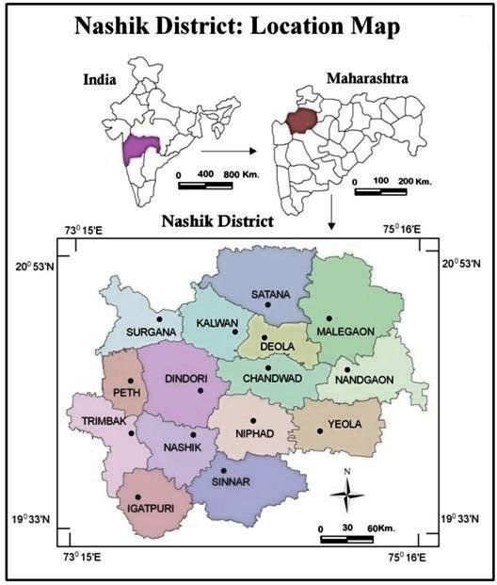
Aims and Objective:
The main Aim of this research is to conduct a geographical study of agro tourism in Nashik district. The objectives to achieve this are as follows.
- To study the geographical distribution of agro tourism in Nashik district.
- Studying the characteristics of agro-tourism in Nashik district
Methodology:
The following methods have been used to fulfill the aims and objectives of this research paper. The data required is mainly primary and secondary data methods. Observations have been made by visiting the Agro Tourism Center in Nashik district. Various research papers, reference books, and internet have been used for secondary data. Also, GPS has been used to get the location of Agro Tourism, and GIS method has been used for the map.
Result and Discussion:
Since ancient times, the world's population has been continuously increasing. Due to the increasing population, many social, economic, cultural, political and environmental problems are arising in the world. These problems vary depending on the place and time. The nature of the population of a country depends on the number of resources in the country. If the population is more than the availability of resources, that population is called excess population e.g. India, China, Pakistan and Bangladesh. Geographical study of population characteristics of a region is of important for understanding its dynamism as well as for planning at the local and regional level. In increase or decrease in the population may bring about a versatile change in the man-land ratio, distribution and composition of population. Population as resources become the Population distribution, density, sex ratio, literacy rate, literates, growth rate etc. depends on quantity and qualities of population. Due to various reasons, the population is increasing, so tourism has gained great importance in this hectic life. Due to this, the demand for various types of tourism is increasing, and among them, agro tourism, a type of tourism in rural areas, is moving towards development. By visiting various centers in Nashik district, the geographical features and general characteristics of that tourist center are explained through the following points.
- Requirements for Agro-Tourism Centers :
To establish an Agro-Tourism Center, key requirements include: a substantial agricultural land area, suitable accommodation facilities, a variety of agricultural activities to showcase, proper sanitation, readily available food options, clear safety measures, and a focus on local culture and experiences; often requiring a minimum land size of 2-5 acres with diverse crops and the ability to host activities like farm tours, harvest demonstrations, and traditional food tastings.
- Infrastructure Facilities:
Cooking equipment for cooking food, if tourists have interested Emergency medical cares with first aid box.
  - Bullock cart, cattle shade, telephone facilities etc
  - Goat farm, Emu (Ostrich bird) farm, sericulture farm, green house, etc.
- Accommodation facilities at same place or alliance with nearest hotels.
  - Farmhouse, which has the rural look and feel comfortable along with all minimum required facilities.
  - Rich resources in agriculture namely water and plants at the place.
  - Cooking equipment for cooking food, if tourists have interested. • Emergency medical cares with first aid box.
  - The well or lake or swimming tank for fishing, swimming
  - Bullock cart, cattle shade, telephone facilities etc
  - Goat farm, Emu (Ostrich bird) farm, sericulture farm, green house, etc.
- Facilities Be Provided:
1. Offer authentic rural Indian / Maharashtra food for breakfast, lunch and dinner.
2. Farmers should offer to see and participate in the agricultural activities.
3. Offer an opportunity to participate in the rural games to the tourist
4. Provide information them about the culture, dress, arts, crafts, festivals, rural traditions and also give possible demonstration of some arts.
5. Offer bullock cart for riding and horse riding, buffalo ride in the water, fishing facility in your pounds or nearest lake.
6. Offer fruits, corns, groundnuts, sugarcane and other agro-products as per availability.
7. Show local birds, animals and waterfalls etc and give authentic information about them.
8. Must provide safety to tourists with the support of alliance hospitals.
9. Arrange folk dance programme, Shekoti folk songs Bhajan, Kirtana, Lezim dance,
Dhangari gaja, etc.
10. Make available some agro-product to purchase to the tourist
- Benefits of Agro-Tourism Centres:
Agro-Tourism has the potential to change the economic face of traditional agriculture. The benefits of agro-tourism development are manifold. It would bring many direct and indirect benefits to the farmers and rural people. Some of the benefits are following:
• Employment opportunities to the farmers including farm family members and youth
• Additional income source for the farmers to protest against income fluctuation.
• Cultural transformation between urban and rural people including social moral values
• Farmers can improve their standard of living due to the contacts with urban people.
• Benefits to the urban people, they can understand about the rural life and know about the agricultural activities.
• It supports for rural and agricultural development process.
• Help to the reduce burden on the other traditional tourist centers.

Map no 02: Agro- Tourism Center in Nashik District
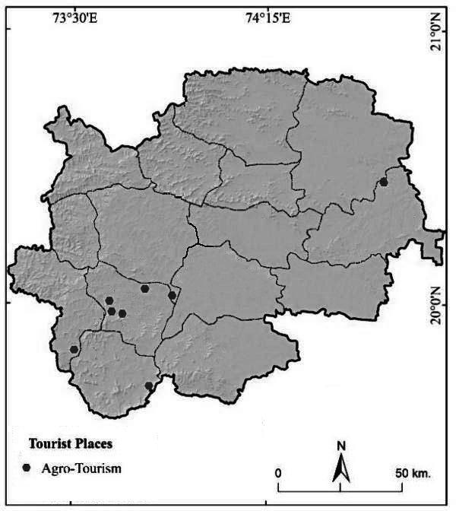

There are a total of eight agro-tourism centers in Nashik district, one in Nandgaon tehsil, one in Dindori tehsil, four in Nashik tehsil, one in Trimbak tehsil and one in Igatpuri tehsil. The geographical distribution of all these 8 agro-tourism is shown in Map No. 02. Nashik Tehsil has the highest agro tourism. The important reason for this is that Nashik Tehsil has the highest urban population and this city population is exposed to all the economic activities, events related to agriculture, and a large number of people visit agro tourism here to live the life of rural people. Also, a large number of tourists visit various agro tourism sites in Nashik Tehsil to enjoy and enjoy the pleasant, pollution-free environment from the hectic life of the city. Various swimming pools and water parks have been provided for swimming on this agro-tourism site. Along with these facilities, various activities like Hurda party, bullock cart, horse cart, goat farming, thatched house and tasting of food from rural areas are available here. Various agro tourism facilities in Nashik district include various breakfasts, lunch, and dinner facilities in rural areas. Also, one can participate in activities related to agriculture, games, culture, dress, arts, festivals, rural traditional, arts, horse riding, buffalo raid, fishing facilities, all these things are available here. Along with this, various agricultural products like sugarcane, groundnut, offer foods, can also be tasted here. Also, local birds and animals from rural areas are available. Along with this, various water parks related elements can also be tasted here. Arrange folk dance programme, Shekoti folk songs bhajan, kirtana, lezim dance, dhangari gaja, etc.
Conclusion:
Agro-tourism centers are mainly concentrated around urban areas that is in areas where there is a rural area surrounding an urban area. Nashik Tehsil has the highest agro tourism. The important reason for this is that Nashik Tehsil has the highest urban population and this city population is exposed to all the economic activities, events related to agriculture, and a large number of people visit agro tourism here to live the life of rural people. Also, a large number of tourists visit various agro tourism sites in Nashik Tehsil to enjoy and enjoy the pleasant, pollution-free environment from the hectic life of the city. Various swimming pools and water parks have been provided for swimming on this agro-tourism site. Along with these facilities, various activities like Hurda party, bullock cart, horse cart, goat farming, thatched house and tasting of food from rural areas are available here. Various agro tourism facilities in Nashik district include various breakfasts, lunch, and dinner facilities in rural areas.
DISCLAIMER (ARTIFICIAL INTELLIGENCE)
Author(s) hereby declare that NO generative AI technologies such as Large Language Models (ChatGPT, COPILOT, etc.) And text-to-image generators have been used during the writing or editing of this manuscript.
COMPETING INTERESTS:
Authors have declared that no competing interests exist.

Author’s contribution:
The author visited the Agro Tourism centers in Nashik district and the location of Agro Tourism was taken with the help of GPS machine. He has presented his own opinion after observing the Agro Tourism centers visited. Also, the author designed the study himself and wrote the first draft of his manuscript. And he himself prepared the map related to Agro Tourism with the help of GIS and all the authors have read and approved the entire literature.

Reference:
- Balasaheb Raghunath Chakor et.al, (2024) Prognostication of Urbanisation Growth and Level in Pune District of Maharashtra State an Using GIS Technique, Journal of Computational Analysis and Applications 33(8) 473-482
- Deepak Janardhan Gadekar (2024) A Study of Tourist Satisfaction Index (TSI) of Heritage Tourist Place of Ajanta Cave in Chatrapati Sambhaji Nagar District of Maharashtra State in India, Heritage: Journal of Multidisciplinary Studies in Archaeology 11.2 Pp 1195-1199.
- Gadekar, D. J and Shejul Meena Eknath (2025) Impact of Tourism: A Success story of Shirdi Tourism Centre , Crown Publishing, Aryan Tower, East Jail Road, Ranchi, Pp 1- 162, ISBN 978-93-6426-547-8
- Gadekar, D. J. (2011) Pilgrimage assessment in Shirdi religious tourist center of Ahmednagar District, Maharashtra. International Referred Research Journal, 1(17), 15–56.
- Jawahar L. Chaudhari (2016) A Geographical Study on Agro Tourism Activities Effect in Rural Development With Special Reference to Rural Maharashtra, Golden Research Thoughts, 5 (10) Pp 1-5.
- Medhe Ravindra Sampat et.al, (2024) Estimate the Rate of Change in Forest Cover and Its Impact on Soil by Using GIS And Remote Sensing, A Case Study of Gadchiroli District, Maharashtra, The Bioscan19(3): 08-18
- Medhe Ravindra Sampat et.al, (2024) Land Use and Land Cover Mapping Using Digital Classification Technique in Dindori Tehsil of Nashik District, Maharashtra State, India Using Remote Sensing, Journal of Computational Analysis and Applications, 33 (6) 604-617
- Mhaske P H (2009), Analysis of Roads Network Connectivity in Ahmednagar District, Research Analysis and Evaluation International, 2(18), 26-27.
- Mhaske P.H. etal. (2001). Land Use & Economic Activity in Shirdi. Rahata Taluka, District Ahemadnagar M.H, International Refereed Research Journal, Research Analysis and Evaluation, 2(18), pp. 75-76.
- Sanjay Dagu Pagar (2020) Awareness of Soil Testing in Nashik District, Maharashtra, Studies in Indian Place Names , 40(3) 2816- 2829
- Shejul Meena Eknath (2020) Level of Human Resources Development - A Conceptual and Review Exposition, International Journal for Research in Applied Science & Engineering Technology, 8 (03) , Pp687-691. https://doi.org/10.22214/ijraset.2020.3130
- Shejul M. E et al., (2020) “A Geographical Study of Human Resources Development in Ahmednagar District, Maharashtra, India”. EPRA International Journal of Multidisciplinary Research, 6 (3) Pp 86-93. https:/ /doi.org/ 10. 3671 3/ epra4116
- Shejul M.E. (2020). Temporal Analysis of Human Resources Development (HRD) in Pathardi Tehsil of Ahmednagar District, Maharashtra State, India, International Journal of Scientific Research in Multidisciplinary Studies, 6(8) 36-45.
- Shraddha Mayuresh Bhome and Remya Anilkumar , Unleashing The Potential of Sustainability: Agro-Tourism in Maharashtra W.R.T. Konkan Region , Sustainable Development, ISBN: 978-81-978152-3-2 Pp 52-58.
- Sonawane V. R. et.,al.(2020), Analysis of Chemical Properties of Soil under Sugarcane Crop: A Case Study of Khandala, Shrirampur, Ahmednagar District, Maharashtra State, India. Our Heritage 68(30) 6522-6547.
- Sonawane V.R. et al., (2020), A Geographical Study of Crop Combination in Tribal Area of Nashik District, Maharashtra, India. Studies in Indian Place Names, 40 (3) , pp. 3915-3940.
- Soniya Sonkar (2021) The Study of Physico-Chemical Characteristics Of Pravara River, International Journal of Science, Engineering and Technology,9(2) Pp 1-6
- Tupe B.K., Gadekar D.J (2010), Agricultural land use and Crop Pattern in Rahata Tahsil of Ahmadnagar District in Maharashtra State, Maharashtra Bhugolshastra Sanshodhan Patrika Vol., 27 Issue 01, pp.30-37.

