**ASSESSING THE IMPACT OF QUARRYING ACTIVITIES ON SOIL AND SURFACE WATER QUALITY IN MPAPE, ABUJA: AN AI-DRIVEN APPROACH**

**ABSTRACT**

Quarrying, a critical industry in Nigeria driven by construction demands, poses significant environmental challenges, particularly in areas like Mpape, Abuja, where quarry sites are densely concentrated. This research utilizes advanced AI techniques to assess the impacts of quarrying activities on soil and surface water quality. A total of 50 samples were systematically collected from five quarry and rock crushing sites and analyzed for various physicochemical parameters and heavy metals through standard analytical methods. The results revealed that soil pH levels ranged from 5.89 ± 0.15 to 6.82 ± 1.07, indicating a trend towards acidity, while water samples maintained pH levels between 6.24 ± 0.11 and 7.95 ± 2.00, with most falling within WHO acceptable limits, except at site QW3. However, physicochemical parameters such as total organic carbon (TOC) %, electrical conductivity (EC) µs/cm, and nitrate (NO₃-) mg/kg were found to be below WHO guidelines for soil quality. Analysis of water samples indicated elevated mean hardness and calcium (Ca²+) levels at 162.43 mg/l and 95.10 mg/l, respectively, exceeding WHO thresholds, while other parameters like chloride (Cl⁻), magnesium (Mg²+), sulphate (SO₄²-), and nitrate(NO₃-) remained within acceptable limits. The contamination of soil near quarry sites was evident, with significantly high concentrations of metals, including Cu, Mn, Fe, Pb, Cd, and Ni, detected. Notably, the mean concentration of heavy metals in soil samples ranged from 6.68 ± 0.15 mg/kg (Ni) at site QS4 to an alarming 1875.03 ± 1.12 mg/kg (Fe) at site QS2, while surface water samples exhibited metal concentrations ranging from 0.012 ± 0.00 mg/l (Cd) at site QW2 to 0.520 ± 0.01 mg/l (Mn) at site QW5. Pearson correlation analysis, enhanced through AI methodologies, revealed strong positive relationships among heavy metals and other parameters (Fe/Mn, Fe/Ni, TOC/Pb, hardness/Ca, and pH/Pb), indicating a common source of pollution and strong negative relationships (Mn/Cu, SO₄²-/NO₃-, Cd/TOC) for both samples. This study underscores the potential of AI-driven analysis in environmental science, offering vital insights into the detrimental effects of quarrying in Nigeria and advocating for informed decision-making to mitigate environmental degradation in the African context.

**Keywords:** Quarrying, soil quality, surface water, metals, Mpape.

**1. INTRODUCTION**

Quarrying is an essential part of the Nigerian economy, playing a significant role in the construction and mining industries. The extraction of granite, limestone, and other aggregates is crucial for building infrastructure and urban development (Akanwa *et al.,* 2017). However, the environmental repercussions of quarrying, particularly on soil and water resources, have become a growing concern (Nartey *et al.,* 2012; Olufemi *et al.,* 2014; Abam & Anthony, 2018). In regions like Mpape, a quarry-dense area near the capital city Abuja, the proliferation of quarry sites has raised alarms about the degradation of local ecosystems (Abdul-Wahab & Marikar, 2012; Ekoh *et al.,* 2019). The issues of concern include visual intrusion, damage to landscapes, traffic, smoke, noise effects, dust, creation of caves, loss of land, and deterioration in water quality (Vincent *et al.,* 2009; Omosanya & Ajibade, 2010; **Abu *et al.,* 2020**). Of major concern is blasting which is necessary to break down the rocks from the ground for subsequent processing into aggregates.

The environmental impact of quarrying often includes the release of hazardous pollutants such as heavy metals and waste materials into nearby soil and water bodies (Zuhairi *et al.,* 2009; Ekpo *et al.,* 2011; Abur *et al.,* 2014). Heavy metals are regarded as the most serious environmental pollutants because of their persistence and tendency to accumulate in the environment (Adamu *et al.,* 2013; Nazir, 2015; Fashola *et al.,* 2016). These pollutants, in turn, contribute to the degradation of natural resources whereby they pose significant risk to public health and environmental sustainability (Adamu *et al.,* 2015; Adedeji *et al.,* 2020). In response to this, there is need for rigorous scientific assessment to quantify the environmental impacts because understanding the magnitude of this pollution is crucial for implementing mitigation strategies.

This study uses a novel approach by integrating artificial intelligence (AI) techniques with traditional analytical methods to provide a comprehensive assessment of quarrying impacts on soil and surface water quality. AI methodologies allow for more efficient data interpretation and pattern recognition, offering insights that may otherwise remain undetected (Taddeo & Floridi, 2018; Cervantes *et al.,* 2020). It can be expected that the future use of AI is anticipated to greatly expand the field of chemical sciences (Barredo *et al.,* 2020; Vo *et al.,* 2020). Although more of these improvisations are likely to occur in the future, it is still important to make sure that the scientific community is aware of the technological developments being made in artificial intelligence (Coeckelbergh, 2020; Zachary *et al.,* 2021). This combination will aid researchers in the coming decades not just in gathering vast amounts of data and creating algorithms for better usage, but also in enabling discoveries in a variety of areas that will have remarkable effects on humanity (Taddeo & Floridi, 2018; Cervantes *et al.,* 2020). It is important to notice that there is an increase in the number of publications about AI and chemistry, and the most significant has been in the fields of analytical chemistry and biochemistry, because both fields integrate AI to the maximum extent and with the highest growth rates (Ruiz-Mercado *et al.,* 2012; Zachary *et al.,* 2021). Thus, the purpose of this research is to evaluate the physicochemical characteristics of soil and water in Mpape, and to quantify the levels of heavy metal contamination due to quarrying activities. By doing so, this study aims to highlight the urgent need for regulatory measures and sustainable quarrying practices in Nigeria.

**2. MATERIALS AND METHODS**

**2.1 Study Area**

Mpape, a satellite settlement located in Abuja the Federal Capital Territory, is a prominent quarrying area with several active and abandoned quarry sites. Mpape lies within Latitude 9o9′30″N, 9o 7′0″N and Longitude 7o 28′30″E, 7o 30′30″E with central time zone of Africa/ Lagos. Mpape falls under the administration of the Bwari Area council, one of the six Area Councils in FCT (Balogun, 2001). It experiences sunrise at 06:33am and sunset at 18:40pm. It is a hill in the region of the north west of the capital city, with an average elevation of 4,124 feet above sea level. The area's geology is primarily composed of granite, gneiss, and schist, which are extensively mined for construction purposes (FCDA, 1979; FCDA, 1998; Abur *et al.,* 2014). The region’s tropical climate and seasonal variations contribute to the dynamics of soil and surface water qualities, particularly during the rainy season when runoff from quarry sites may exacerbate contamination. The stream is used as source of water for irrigation purposes majorly during dry seasons in the area. Inhabitants of the area, however, depend on the stream for fishery activities and use it also for domestic purposes. Mpape can have low impact or less average earthquakes (on average of one for every 50 years), with occurrences at (< 5 Richter) (Ekoh *et al.,* 2019).

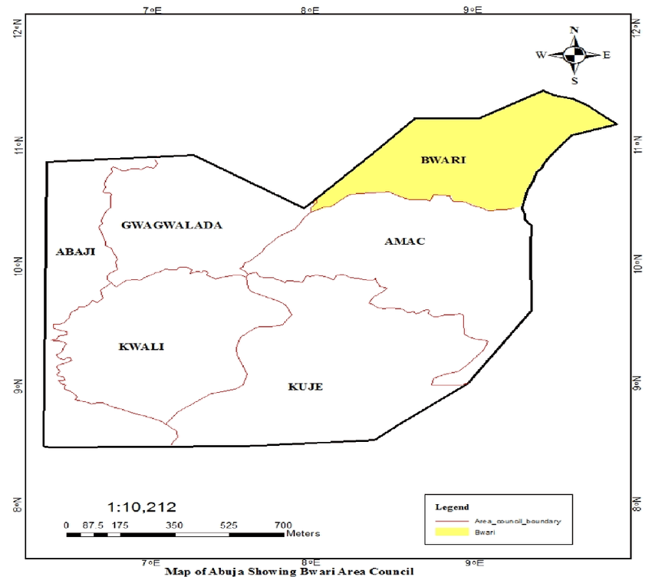

**Figure 1. Map of FCT, Abuja showing the study area**

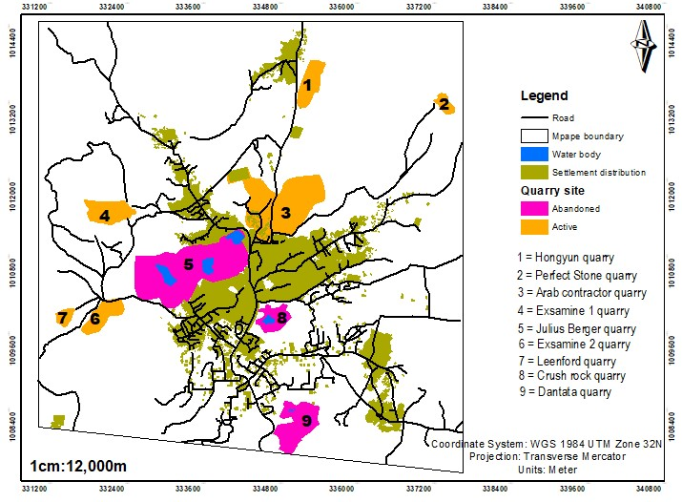

**Figure 2. Map showing abandoned and active quarry sites in the study area**

*Source: (Modified from Musa et al., 2019)*

**2.2** **Sample Collection, Handling and Preservation**

A total of 50 samples (30 soil samples and 20 water samples) were collected from five active quarry sites in Mpape, designated as QS1–QS5 for soil samples and QW1–QW5 for water samples. The sampling strategy involved systematic grid sampling from areas within 500 meters of the quarry operations. Soil samples were taken at depths of 0–15 cm using a stainless-steel auger to minimize contamination. Water samples were collected from nearby streams and surface water bodies that were potentially impacted by quarry runoff. Sampling of water was done using 1 L well-labelled high-density polyethylene bottles (HDPE) which were prewashed and soaked in 1 M HNO3 for 24 hours and later rinsed with deionised water. The samples were transported to the laboratory in a cooler of ice to ensure rapid cooling and were protected from direct sunlight during transportation to avoid depletion of the contamination due to oxidation. The soil samples were air –dried, and sieved properly (2mm pore size), homogenized and stored in labelled polythene bags at 4oC prior to laboratory analysis (Adeoye & Okafor, 2018; Useh *et al.,* 2022).

**2.3** **Laboratory Analysis**

Physicochemical parameters of the soil and water samples were measured using standard methods. For soil analysis, pH and electrical conductivity were measured in a soil suspension (1:10 w/v dilution) by digital pH meter (Jenway model 3015) and conductivity meter (Systronics-304), respectively. Nitrate (NO₃-) was quantified using ion chromatography while total organic carbon (TOC) was measured by combustion analysis (Adewumi & Adebayo, 2021). Cation exchange capacity (CEC) was determined according to the procedure outlined by Useh *et al.,* (2015). For the quantification of total heavy metals in the soil samples, acid digestion method was employed. A test portion of 1.00 g of each soil sample was digested using the conventional aqua regia (3:1, v/v, HCl to HNO3) digestion procedure (Useh and Dauda, 2018). Heavy metal concentrations (Cu, Mn, Fe, Pb, Cd, Ni, Zn) in both soil and water were determined by atomic absorption spectrophotometer (AAS) iCE 3000 Series. Water samples were further analyzed for hardness, and key ions like calcium (Ca²+), chloride (Cl⁻), and magnesium (Mg²+), following WHO guidelines for water quality. All analyses were carried out in triplicates (APHA, 2008).

**2.4** **AI-Driven Data/Statistical Analysis**

AI-enhanced data analysis involved the application of machine learning algorithms to identify patterns and correlations within the dataset. Pearson correlation coefficients were computed for heavy metal concentrations and other parameters, revealing potential sources of pollution using IBM Statistical Package (IBM SPSS, version 26, 2018). AI-based clustering algorithms were used to group sites with similar contamination profiles, providing insights into pollution dynamics across different quarry locations.

**3. RESULTS AND DISCUSSION**

**3.1 Physicochemical Properties**

Table 1 below shows the results of soil physicochemical properties and heavy metal concentrations for the five quarry sites. The results of soil analysis showed that pH levels at the quarry sites ranged from 5.89 ± 0.15 to 6.82 ± 1.07, suggesting a general trend toward acidity, which can have implications for soil health and crop productivity. QS1 even fell significantly below the WHO recommended range of 6.5–8.5. Quarry dust and acidic leachates from mining operations may contribute to lower pH values, especially in areas with heavy rock crushing or waste deposition (Effiong & Gilbert, 2012; Aigbedion & Iyayi, 2017). Acidic soils reduce the availability of essential nutrients and may increase the solubility of toxic metals, exacerbating their uptake by plants and potential contamination of nearby water bodies (Gibson & Klink, 2005; Akinluyi ***et al.,* 2019; Abu *et al.,* 2020**). Sites with higher pH (e.g., QS4 and QS5) may reflect areas with reduced quarry activity or natural buffering capacity due to surrounding vegetation. Other studies like Adeoye & Okafor,(2018); Ekpo *et al.,* (2013) and Ako *et al.,* (2014) reported similar acidic conditions in soils near quarry sites in Nigeria, linking them to acid-generating minerals like sulphides found in rock debris. Acidic conditions require remediation strategies like liming to neutralize soil pH and enhance nutrient availability (Akpan *et al.,* 2021; Bhagat *et al.,* 2024).

The concentration of TOC and other physicochemical parameters, such as EC and nitrate, were within WHO acceptable limits for soil quality, indicating that quarrying activities have not yet caused widespread nutrient depletion in the soil. The low TOC values (1.25–1.45%) reflect reduced organic matter content, which is essential for soil structure, nutrient retention, and microbial activity. Quarrying activities often remove surface vegetation, leading to organic matter depletion (Bamgbose *et al.,* 2014). Similar observations were made by Akabzaa & Darimani, (2001) and Nazir, (2015), where low TOC levels were linked to mining-induced erosion and minimal vegetation cover. Regular addition of organic materials such as compost or manure can help restore TOC levels, improving soil fertility and microbial diversity (Egeh *et al.,* 2004). The EC values (105.9–115.8 µS/cm) are far below the WHO threshold of 1000 µS/cm, indicating low salinity and minimal ionic concentration.

**Table 1. Soil physicochemical properties and heavy metal concentrations**

|  |  |  |  |  |  |  |
| --- | --- | --- | --- | --- | --- | --- |
| **Parameters** | **QS1** | **QS2** | **QS3** | **QS4** | **QS5** | **WHO limits** |
| pH | 5.89±0.15 | 6.12±0.19 | 6.53±0.20 | 6.82±1.07 | 6.47±0.34 | 6.5 - 8.5 |
| TOC (%) | 1.45 | 1.39 | 1.3 | 1.25 | 1.41 | - |
| EC (µs/cm) | 110.1 | 112.5 | 105.9 | 108.6 | 115.8 | 1000 |
| NO3- (mg/kg) | 0.09 | 0.64 | 0.08 | 0.35 | 0.72 | 20 |
| CEC (meq/100g) | 10.37 | 8.67 | 11.08 | 9.63 | 10.22 | < 50 |
| Fe (mg/kg) | 1325.12 | 1875.03 | 1575.3 | 1423.56 | 1255.47 | 20 |
| Mn (mg/kg) | 16.35 | 25.7 | 13.23 | 18.43 | 14.79 | 0.2 |
| Cu (mg/kg) | 22.47 | 18.56 | 24.17 | 19.85 | 23.19 | 1 |
| Pb (mg/kg) | 25.75 | 20.22 | 15.78 | 18.1 | 22.4 | 1 |
| Cd (mg/kg) | 0.95 | 0.98 | 1.1 | 1.12 | 1.05 | 1 |
| Ni (mg/kg) | 6.89 | 7.35 | 6.91 | 6.68 | 7.02 | <1.0 |

While low EC is generally favorable for agricultural use, the nutrient depletion implied by such low values could limit plant growth (Isaac *et al.,* 2013). Darwish,*et al.,* (2008) and Akpan,*et al.,* (2021) observed similar low EC levels in disturbed soils and linked them to nutrient loss due to quarrying activities. Nutrient supplementation using balanced fertilizers can help address deficiencies. The nitrate (NO₃⁻) concentrations (0.08–0.72 mg/kg) are significantly below the WHO limit of 20 mg/kg, indicating nitrogen deficiency. This deficiency may result from the lack of organic matter, reduced microbial nitrogen fixation, or nutrient leaching. Bhagat*et al.,* (2024) highlighted that mining activities often disturb the nitrogen cycle, leading to low nitrate levels in soil. Application of nitrogen-rich fertilizers or leguminous cover crops can restore soil nitrogen levels. CEC values (8.67–11.08 meq/100g) are below the optimal level of **<**50 meq/100g, reflecting limited capacity for nutrient retention. This is common in sandy or degraded soils. Lower CEC values in QS2 might point to degradation of organic matter or depletion of clay minerals, which can be attributed to quarry operations. Akinluyi *et al.,* (2019) and Akpan*et al.,* (2021) found similar low CEC in quarry-affected soils. Use of biochar or organic amendments can enhance soil CEC.

Table 2 above shows the results of water physicochemical properties and heavy metal concentrations for the five quarry sites. Water samples collected from the vicinity of the quarry sites showed pH values ranging between 6.24 ± 0.11 and 7.95 ± 2.00. Similar findings were reported by Ekpo et al., (2013), where quarry-impacted water sources had pH levels between 6.2 and 8.0. While most of the sites were within WHO guidelines, site QW3 exhibited lower pH levels, pointing to potential acidification due to quarry runoff.

**Table 2. Water physicochemical properties and heavy metal concentrations**

|  |  |  |  |  |  |  |
| --- | --- | --- | --- | --- | --- | --- |
| **Parameters** | **QW1** | **QW2** | **QW3** | **QW4** | **QW5** | **WHO Limits** |
| pH | 7.10±0.12 | 6.95±0.17 | 6.24±0.11 | 7.24±0.15 | 7.95±2.00 | 6.5-8.5 |
| Hardness (mg/l) | 152.3 | 140.25 | 162.43 | 148.9 | 160.11 | 200 |
| SO42- (mg/l) | 87.36 | 113.25 | 94.18 | 96.57 | 105.62 | 250 |
| Ca²⁺ (mg/l) | 85.76 | 76.13 | 95.1 | 80.33 | 90.15 | 0 |
| Cl⁻ (mg/l) | 27.12 | 25.56 | 30.19 | 22.65 | 28.55 | 250 |
| Mg²⁺ (mg/l) | 10.57 | 11.33 | 12.76 | 10.95 | 14.32 | 0.3 |
| NO3- (mg/l) | 5.03 | 2.98 | 4.71 | 5.16 | 3.78 | 10 |
| Fe (mg/l) | 0.045 | 0.038 | 0.05 | 0.042 | 0.048 | 0.3 |
| Mn (mg/l) | 0.231 | 0.245 | 0.287 | 0.251 | 0.52 | 0.4 |
| Pb (mg/l) | 0.013 | 0.017 | 0.014 | 0.019 | 0.022 | 0.015 |
| Cd (mg/l) | 0.016 | 0.012 | 0.018 | 0.015 | 0.014 | 0.003 |

The hardness values were below the WHO limit of 200 mg/L, ranging from 140.25 mg/L (QW2) to 162.43 mg/L (QW3). This suggests that the water is moderately hard, consistent with studies by Bodo & Okechukwu,(2019), which observed hardness levels of 120–180 mg/L in quarry sites in Nigeria. Moderate hardness suggests a balanced mineral content, which may be suitable for domestic use but could cause scaling in industrial applications. Sulphate (SO₄²⁻) concentrations ranged from 87.36 mg/L (QW1) to 113.25 mg/L (QW2), significantly below the WHO limit of 250 mg/L. These levels are typical of quarry sites, as documented by Abam & Anthony,(2018). However, sulphate concentrations could increase over time if quarrying activities intensify, as sulphates are commonly associated with mineral dissolution. Calcium (Ca²⁺)concentrations ranged from 76.13 mg/L (QW2) to 95.10 mg/L (QW3), while magnesium (Mg²⁺) levels ranged from 10.57 mg/L (QW1) to 14.32 mg/L (QW5). Both parameters indicated the presence of dissolved minerals, characteristic of quarry water, as also noted by Ochelebeet al., (2017) in southern Nigeria**.** Chloride (Cl⁻) levels, between 22.65 mg/L (QW4) and 30.19 mg/L (QW3), were well below the WHO limit of 250 mg/L. This suggests minimal anthropogenic pollution, aligning with findings by Hassanet al., (2012). Nitrate (NO₃⁻) concentrations ranged from 2.98 mg/L (QW2) to 5.16 mg/L (QW4), far below the WHO limit of 10 mg/L. These low levels are consistent with studies by Onwuemesi*et al.,* (2011) on water from quarry site.

**3.2 Heavy Metals Distribution in the Study Area**

The presence of heavy metals in soil was of great concern. The mean concentrations of Fe (1255.47–1875.03 mg/kg) were significantly elevated, compared to the WHO limit (20 mg/kg). High Fe levels can lead to phytotoxicity and contaminate surrounding ecosystems. Olufemi *et al.,* (2014) attributed such high Fe levels to mineral-rich rock debris from quarries. Remediation strategies like phytoremediation (using plants like vetiver grass) and soil washing may help reduce Fe content. Mn levels (13.23–25.7 mg/kg) greatly exceeded the WHO standard of 0.2 mg/kg, posing risks of toxicity to plants and microbes. Similar high Mn levels were reported by Yang *et al.,* (2013) and Ruqia *et al.,* (2015), linked to manganese-rich bedrock in quarry zones. Use of Mn-absorbing plant species like sunflower may reduce excess Mn. Cu concentrations (18.56–24.17 mg/kg) far exceed the WHO limit of 1 mg/kg, disrupting soil microbial balance and enzyme activity. Elevated Cu levels in quarry soils were reported by Omosanya & Ajibade, (2010), highlighting its toxicity. Application of organic amendments can bind Cu and reduce its bioavailability. Pb levels (15.78–25.75 mg/kg) recorded were highly toxic, exceeding the WHO standard of 1 mg/kg. This poses severe risks to plants, animals, and human health through bioaccumulation. Pb is a neurotoxin with severe developmental impacts, and is likely introduced by quarry dust deposition, mining runoff, and leaching from rocks. Phytoremediation with plants like Indian mustard, combined with chemical stabilizers, can mitigate Pb toxicity (Vincent *et al.,* 2009; Tiimub, *et al.,* 2020). Cd and Ni concentrations were also above WHO limits, with Cd ranging from 0.95–1.12 mg/kg and Ni from 6.68–7.35 mg/kg. Both are toxic and carcinogenic, disrupting enzyme activity and contaminating food chains (Ruqia *et al.,* 2015). Chemical stabilization using lime or gypsum and planting Cd/Ni hyperaccumulator plants can reduce risks (Yang *et al.,* 2013).

Metal analysis of the water samples revealed that concentrations of Fe were between 0.38 mg/L (QW2) and 0.50 mg/L (QW3), exceeding the WHO limit of 0.3 mg/L across all sites. This is a concern, as high iron levels in quarry water are well-documented by Ruqia *et al.,* (2015) and Akinluyi *et al.,* (2019), attributing it to mineral-rich rock leaching. Onwuemesi *et al.,* (2011) highlighted similar water quality concerns in Ebonyi State, Nigeria with iron and cadmium exceeding permissible limits. High Fe levels can stain laundry and plumbing fixtures and may cause health issues like iron overload in susceptible individuals (Hassan *et al.,* 2012). Manganese levels ranged from 0.151 mg/L (QW4) to 0.287 mg/L (QW3). Except for QW5, the sites fall within the WHO limit of 0.4 mg/L. While Mn is an essential nutrient, excessive levels can impact both water quality and health, by leading to neurological effects, especially in children (Ruqia *et al.,* 2015), Lead concentrations were within permissible limits at most sites, except for QW5 (0.022 mg/L). This aligns with findings by Nartey *et al.,* (2012), which highlighted occasional lead contamination near quarry operations. Cadmium levels ranged from 0.012 mg/L (QW2) to 0.018 mg/L (QW3), exceeding the WHO limit of 0.003 mg/L at all sites. Such contamination is often linked to quarry dust and leachates, as also discussed by Abam & Anthony, (2018) aligning with the observations in QW5. These metals are known for their toxicity, particularly cadmium, which poses serious health risks at even low concentrations. Abdul-Wahab & Marikar, (2012) reported heavy metal contamination in quarry sites, emphasizing the need for mitigation. These findings indicate that quarrying operations are contributing to the accumulation of toxic heavy metals in the surrounding environment. Communities relying on this water for drinking or agricultural irrigation are at risk of toxic exposure, warranting urgent attention.

**3.3 Relationships of the Analyzed Parameters**

**3.3.1 Pearson Correlation Analysis**

The Pearson correlation matrix (Table 3) showed the relationships between soil physicochemical properties and heavy metal concentrations across the five sites. pH displayed a strong positive correlation with Cd (r = 0.97), indicating that Cd levels rise with increasing pH. A moderate negative correlation occurred between pH versus TOC (r = -0.87) and pH versus Pb (r = -0.73), suggesting that as pH increases, the organic content and Pb concentrations tend to decrease. TOC (%) had a strong positive correlation with Pb (r = 0.87) and it is negatively correlated with Cd (r = -0.90), implying that soils with higher organic content may also have higher levels of Pb but associated with lower Cd levels.

**Table 3. Pearson correlation matrix for soil quality parameters**

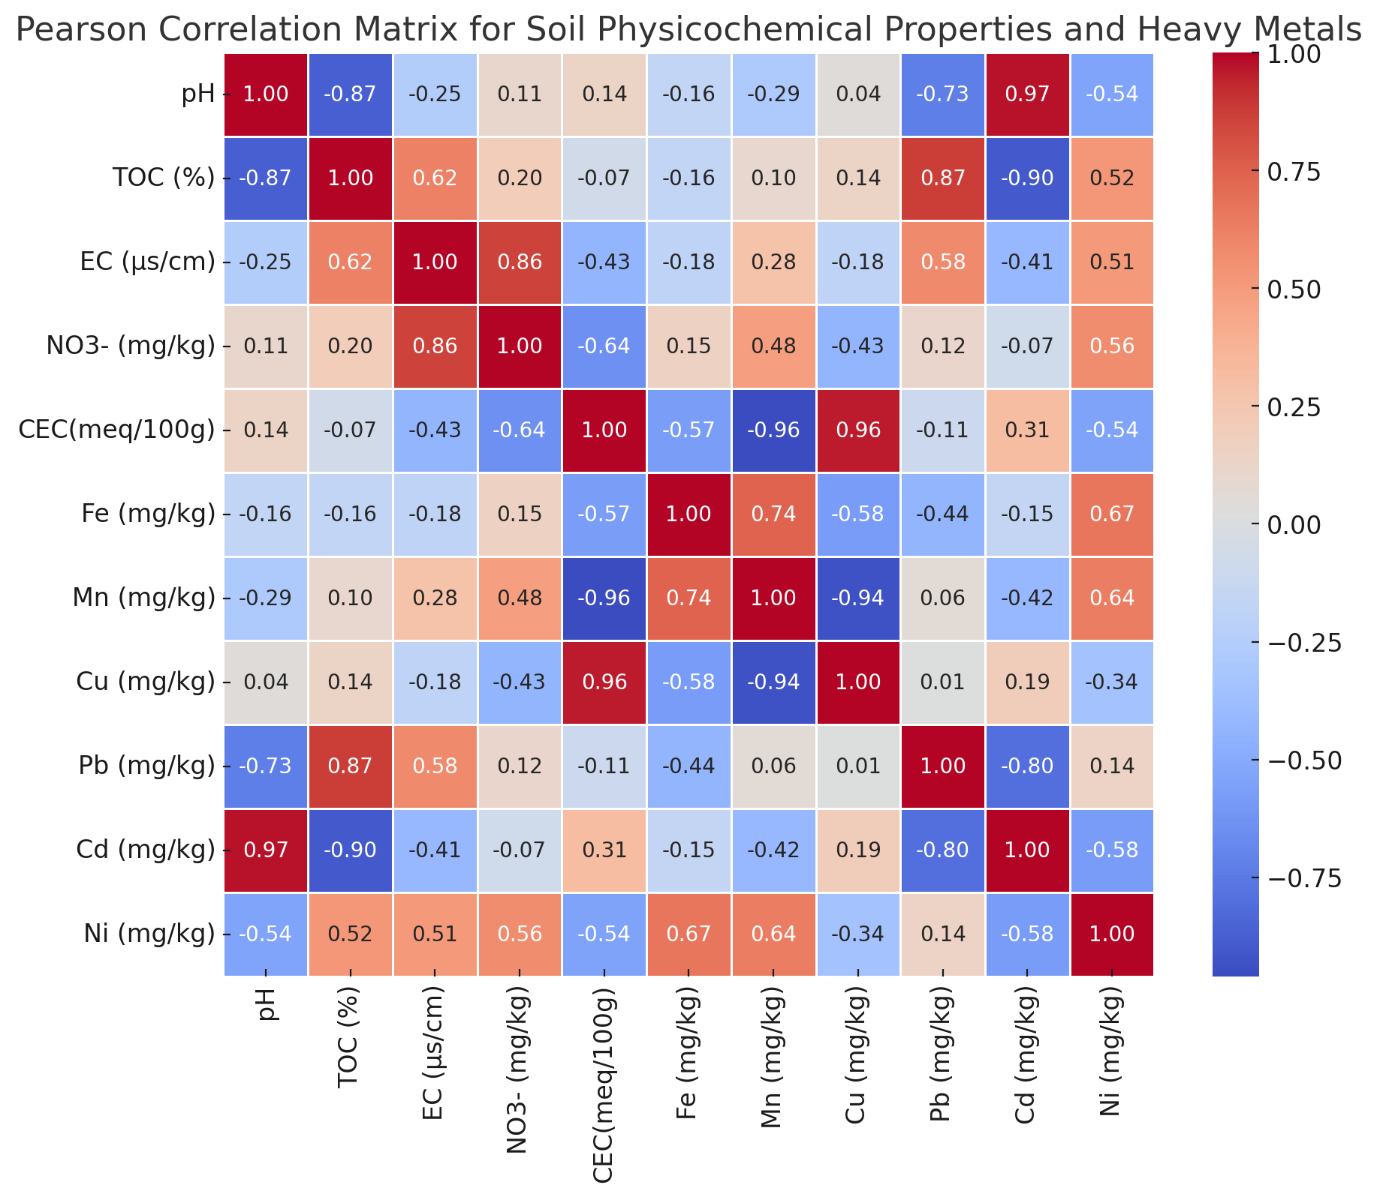

CEC (meq/100g) is strongly positively correlated with Cu (r = 0.96) and showed a strong negative correlation with Mn (r = -0.96), which may indicate different binding capacities or competitive interactions among these metals in the soil matrix. Fe showed moderate positive correlations with both Mn (r = 0.74) and Ni (r = 0.67), suggesting that soils high in Fe might also tend to have elevated Mn and Ni levels. Mn and Cu exhibited a strong negative correlation (r = -0.94), indicating that these metals might compete in the soil matrix, with higher levels of one corresponding to lower levels of the other. This correlation analysis provides valuable information about how soil properties and heavy metal concentrations are interrelated, which may inform soil quality assessments, pollution studies, and environmental monitoring efforts. EC positively correlated with NO3- (r = 0.86), indicating that soils with higher conductivity also tend to have elevated nitrate concentrations, likely due to higher ionic content from dissolved minerals.

Table 4 indicates relationships between the physicochemical properties and heavy metal concentrations in water samples from the five sites (QW1–QW5). Notably, hardness and Ca²⁺ exhibited a very strong positive correlation (r = 0.978), indicating that calcium is a significant contributor to water hardness, which is expected in natural water systems. Quarrying activities often expose calcium-rich minerals, such as limestone, which dissolve into groundwater and contribute to increased hardness. Also, hardness vs Mg²⁺ (r = 0.675) indicated that Mg is another contributor to water hardness, likely sourced from magnesium-bearing rocks disturbed during quarrying.

**Table 4. Pearson correlation matrix for water quality parameters**

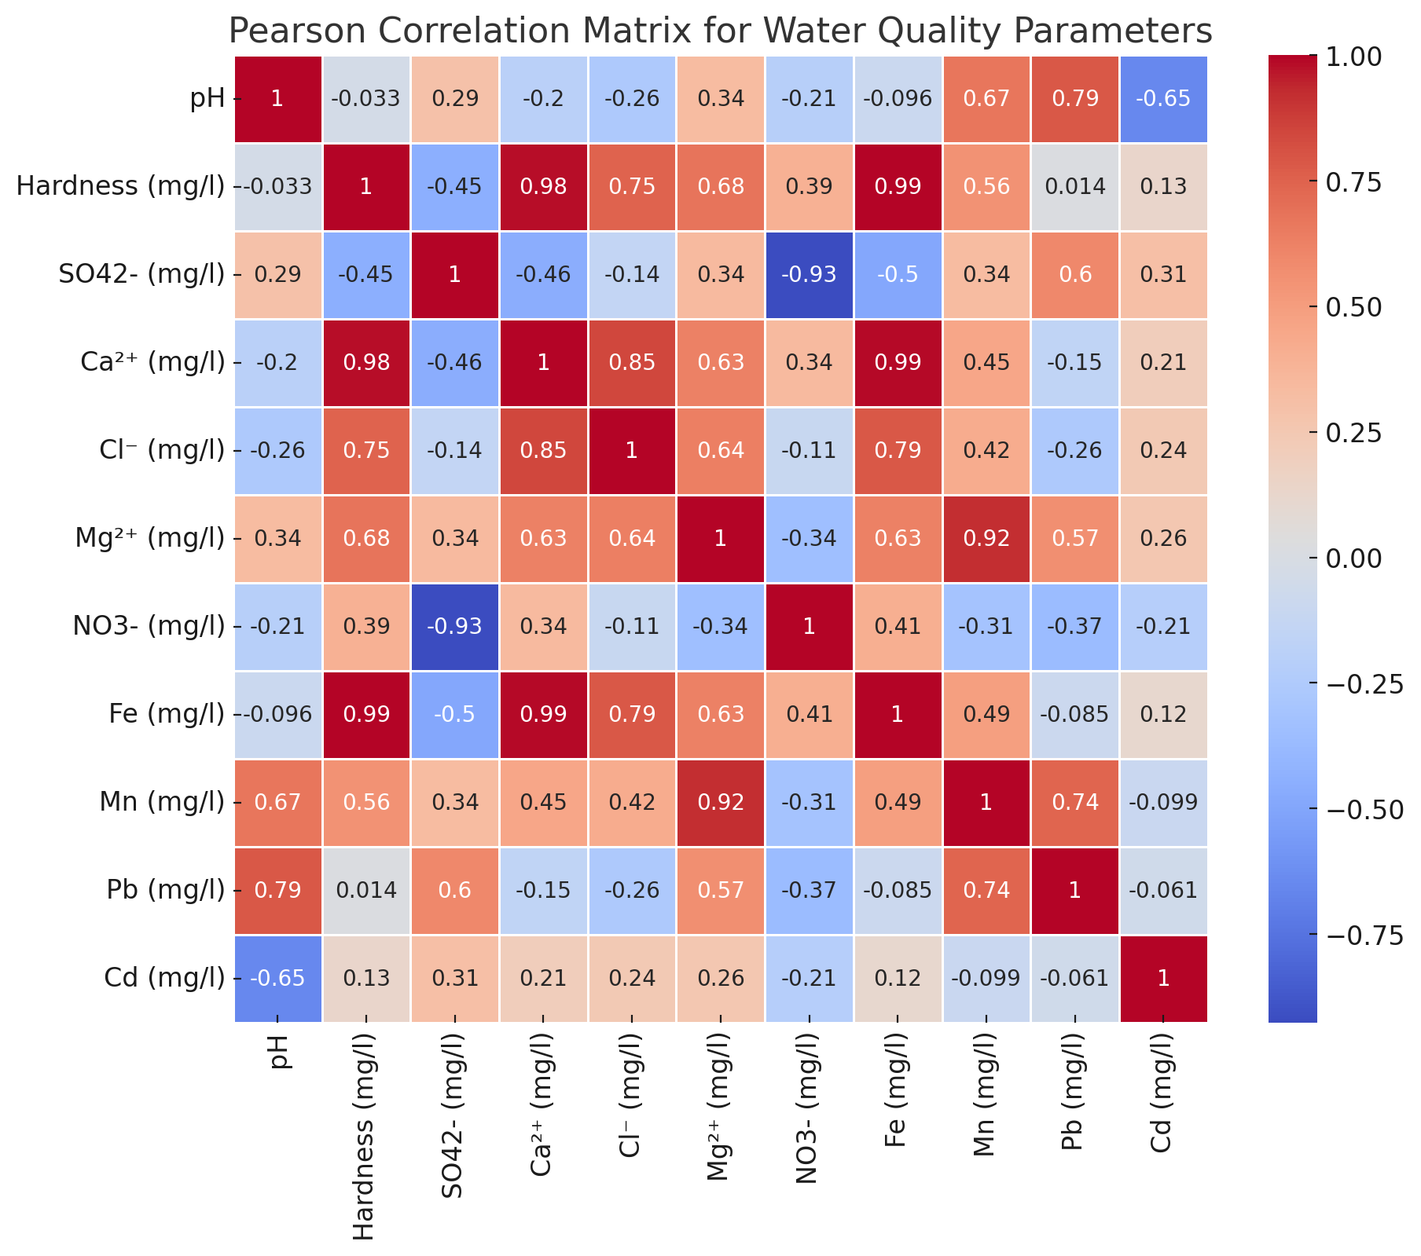

This relationship reinforces the influence of mineral leaching from quarry sites. For hardness vs (Cl⁻) (r = 0.749) a strong correlation showing that chloride may be associated with the dissolution of salts or exposure of chloride-bearing rocks during quarrying. This relationship suggests that quarry activities may contribute to elevated chloride levels. A very high positive correlation (r = 0.994) occurred between hardness and Fe suggesting that high hardness is primarily driven by Fe content in the water. There was a strong positive correlation (r = 0.673) between pH and Mn, meaning higher pH levels are associated with increased manganese concentration. A moderately strong negative correlation (r = -0.646) between pH and Cd showed that lower pH values (more acidic conditions) can increase the solubility of heavy metals like cadmium, making them more bioavailable in water. This relationship indicates that cadmium contamination could worsen in acidic conditions, possibly due to acid rock drainage from quarrying. SO₄²⁻ and NO₃⁻ showed a very strong negative correlation (r = -0.927), suggesting that where sulphate concentrations are high, nitrate levels tend to be lower. Mn exhibited a very strong positive correlation (r = 0.920) with Mg²⁺ indicating that these elements tend to increase together in the water samples. A moderately strong positive correlation (r = 0.789) also occurred between pH and Pb implying that higher pH (alkaline conditions) may enhance lead precipitation, reducing its solubility. These relationships reflect the interplay between different ions and metals present in the water, with significant environmental implications for quarrying activities affecting water quality. This analysis can help inform targeted environmental mitigation strategies for controlling water pollution near quarry sites.

**​​3.3.2 Cluster Analysis**

A cluster analysis was performed on the soil and water physicochemical properties and heavy metal concentrations across the sampling sites, by applying hierarchical clustering to identify patterns and groupings among the sites based on their measured attributes. Hierarchical clustering is often visualized using a dendrogram, which provides insight into the similarity between sites (Figure 3 and 4). Cluster analysis groups samples based on shared properties across various variables which can be beneficial for environmental monitoring and targeted interventions.

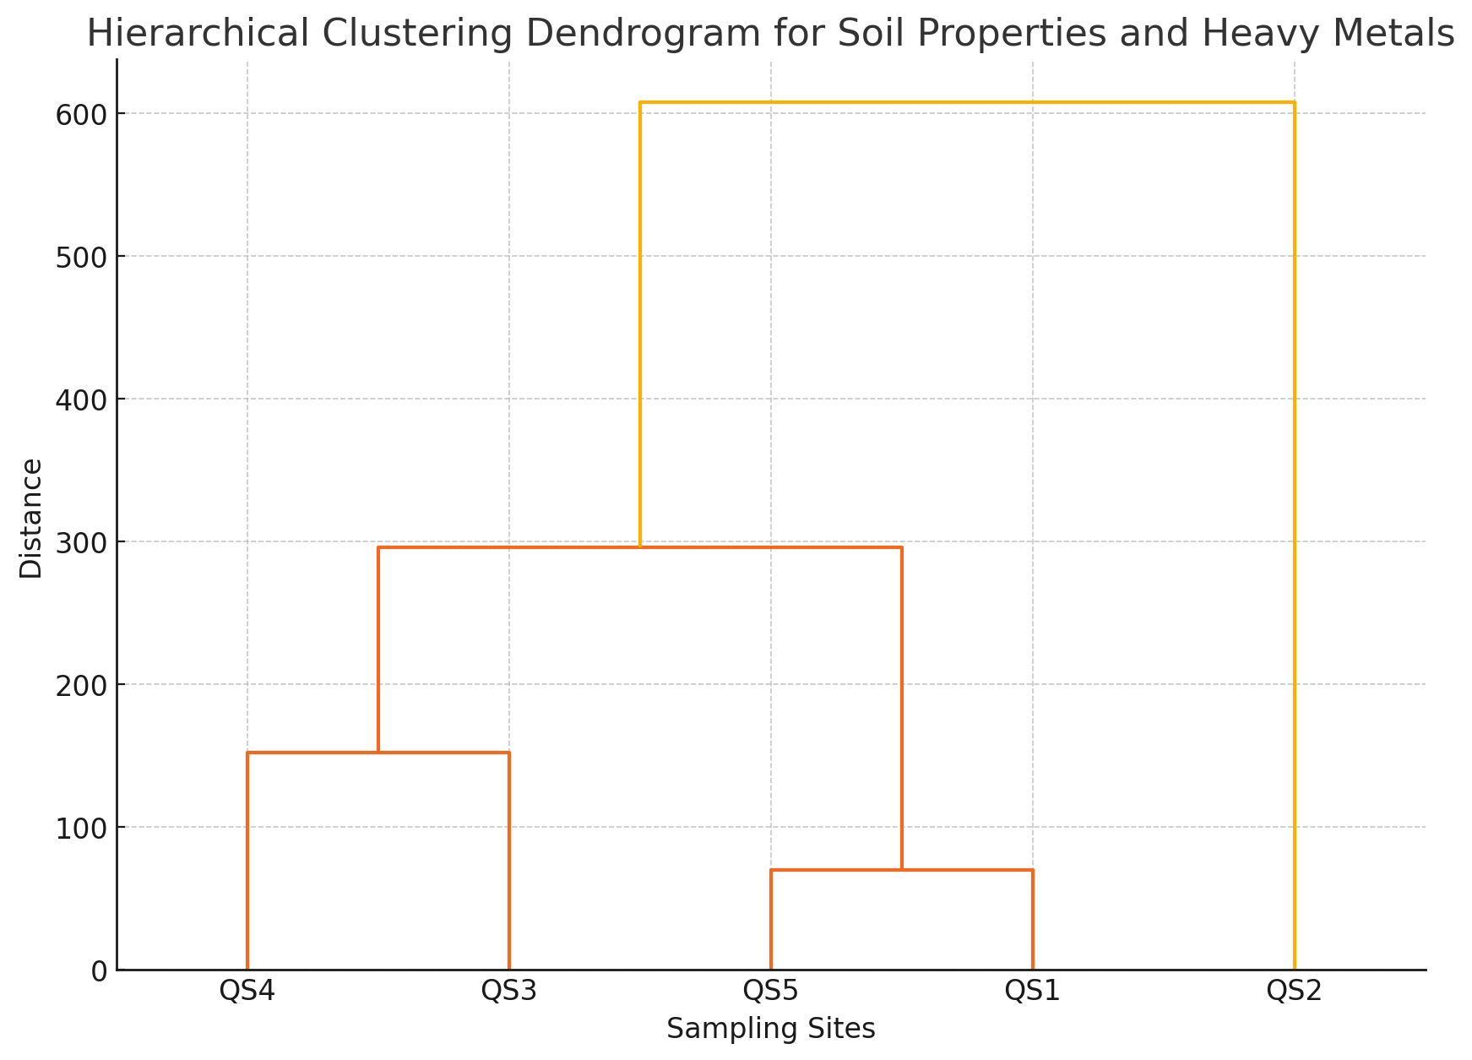

**Figure 3. Hierarchical Clustering Dendrogram for Soil Parameters**

For the soil samples, according to Figure 3, the following key observations were made:

**Main Clusters:** The samples are divided into two primary clusters. This indicates that there are substantial differences in soil properties and heavy metal concentrations among the samples, leading to two main groupings.

**Distinct Outlier (QS2):** QS2 stands apart from the other samples, meaning it has unique characteristics compared to the others. Examining the table, we can see that QS2 has relatively high levels of Fe (1875.03 mg/kg) and Mn (25.7 mg/kg) as well as slightly higher Cd and Ni concentrations than the rest. These values might be contributing to its separation in the dendrogram. QS2 also has a lower Cation Exchange Capacity (CEC) of 8.67 meq/100g compared to others. Lower CEC indicates that this soil might have a reduced ability to retain essential nutrients, potentially impacting soil fertility and plant growth. This unique grouping suggests that QS2 may be impacted by specific local factors, such as soil composition, intense quarrying activities, particularly from waste leachates and runoff, or agricultural practices.

**Sub-cluster 1 within the Main Group (QS3 and QS4):** QS3 and QS4 are closely related, forming a smaller subgroup. These samples have similar pH levels, consistent CEC values and exhibit comparable concentrations of elements like Pb, Cd, and Ni. However, QS3 has slightly higher Fe concentration (1575.3 mg/kg) compared to QS4 (1423.56 mg/kg), which may be contributing to a minor difference in the dendrogram. The heavy metal concentrations are moderately elevated, which could be linked to intermediate exposure to quarry activities.

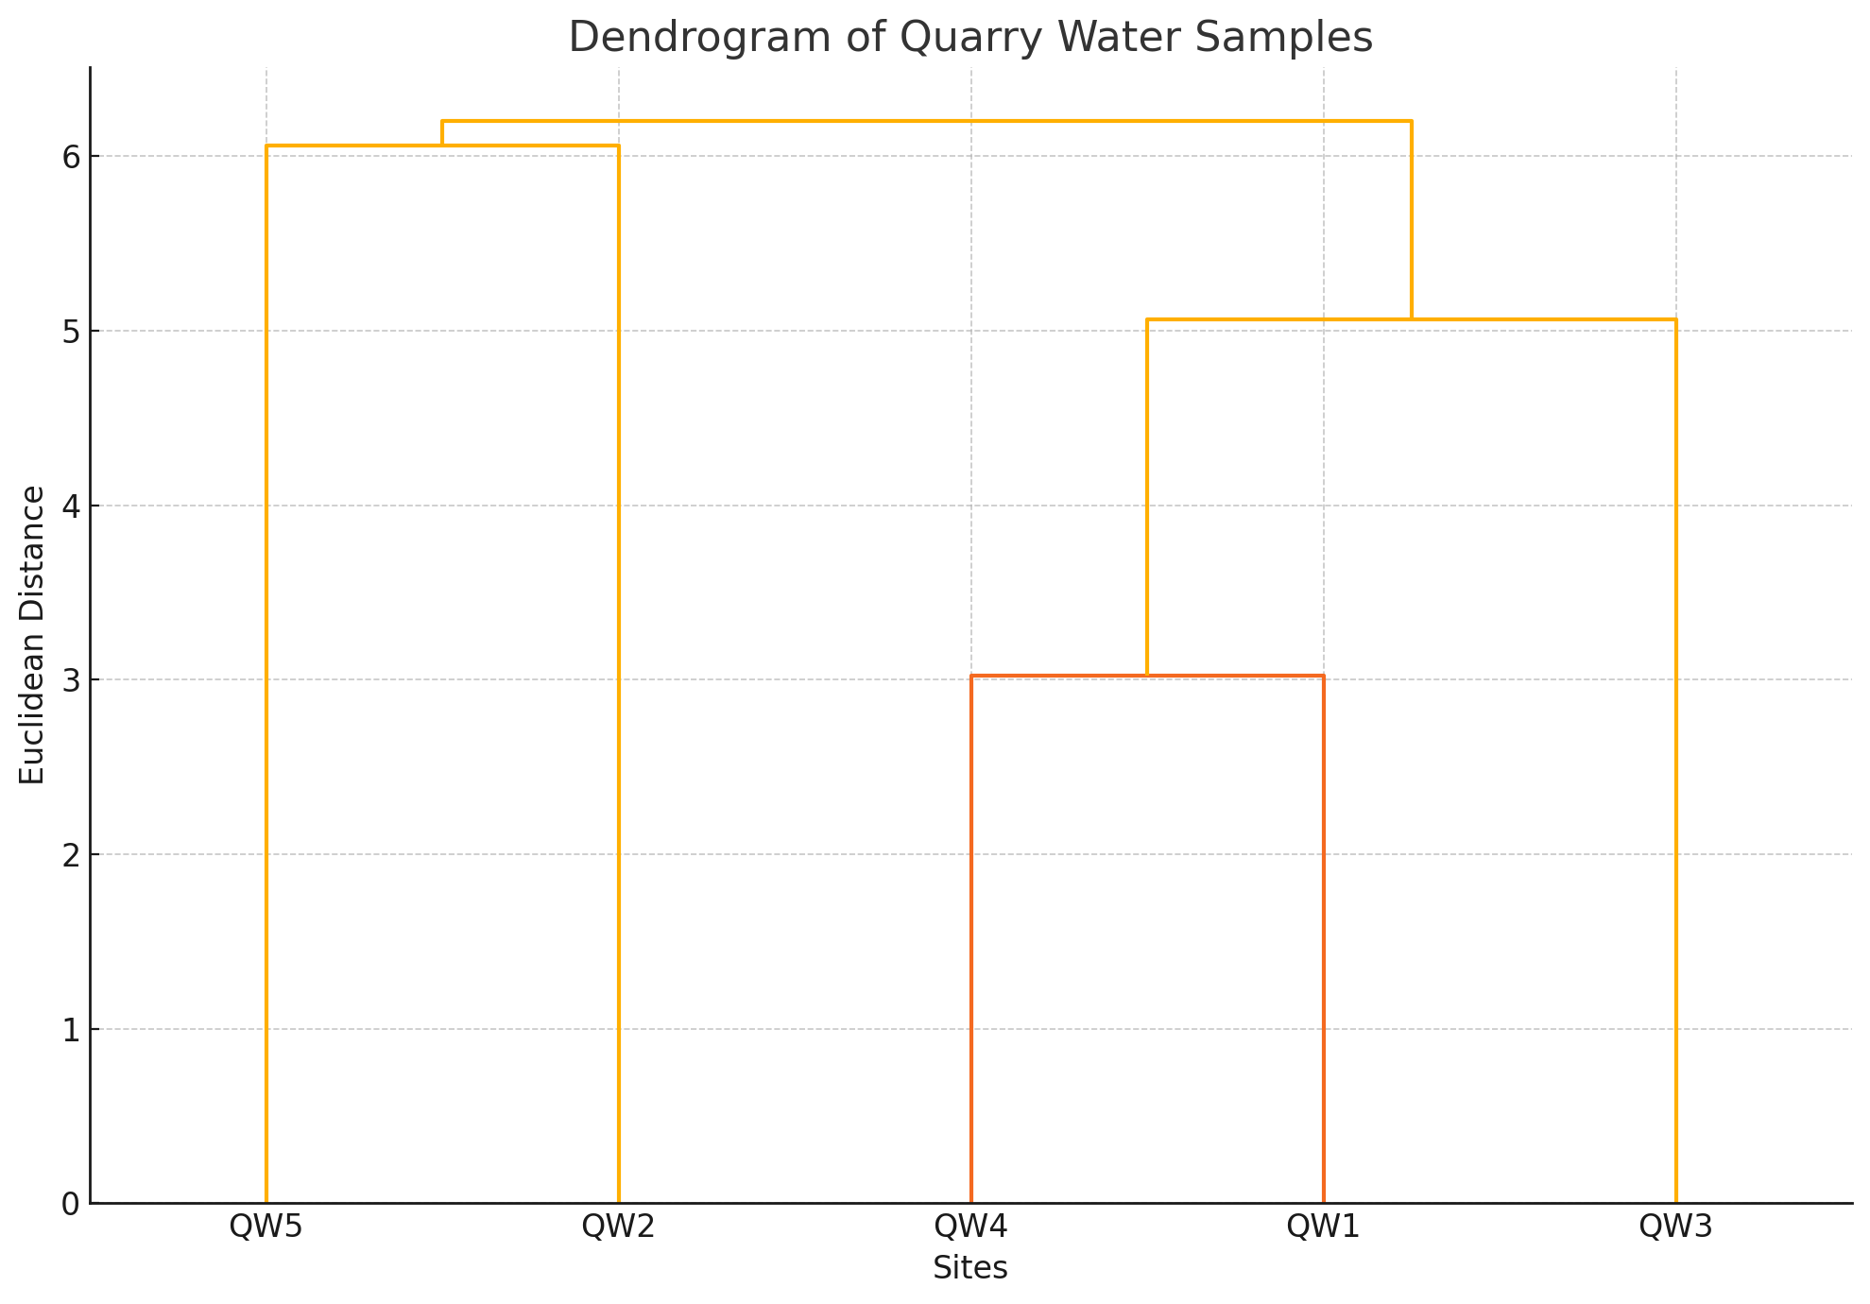

**Figure 4. Hierarchical clustering Dendrogram for Water Parameters**

**Sub-cluster 2 within the Main Group (QS1 and QS5)**: QS1 and QS5 are also closely related, though with slightly more variability than QS3 and QS4. This group has similar TOC (elevated) values and NO₃⁻ levels. They also show comparable Mn, and Cu with significantly high Fe concentrations, signifying heavy exposure to quarrying activities. Both samples have intermediate pH values (more acidic), suggesting they may have similar soil acidity and nutrient availability. High Pb and Cd levels further highlight the contamination potentially caused by blasting and deposition of quarry residues.

The dendrogram and K-Means clustering analysis (Figure 4) displays the clustering of water quality parameters from the quarry sites (QW1 to QW5). The analysis highlights three distinct clusters and offers insights into the relationships among these quarry sites.

Cluster 1 (QW4 and QW1): QW4 and QW1 are closely linked, indicating high similarity in their water quality parameters. Both sites exhibit comparable pH levels (7.24 and 7.10, respectively), indicating slightly alkaline water. There are moderate concentrations of major ions such as sulphate (SO₄²⁻) and calcium (Ca²⁺), suggesting minimal external contamination as well as low levels of heavy metals (e.g., Fe, Pb, and Cd), which fall within permissible limits for drinking water. These similarities suggest that QW1 and QW4 may share geological or environmental conditions, such as similar rock formations or exposure to similar anthropogenic activities.

Cluster 2 (QW2 and QW5): These sites form another close cluster. Despite being geographically separated (likely), their water properties exhibit significant overlap: Higher nitrate (NO₃⁻) levels in QW5 (14.32 mg/l) and QW2 (11.33 mg/l), potentially indicating agricultural runoff or biological activity near these sites. Slightly elevated heavy metal levels (e.g., Mn), particularly in QW5 (Mn = 0.520 mg/l), which might reflect localized contamination from quarrying or industrial activities. This cluster may highlight sites influenced by external contamination sources, such as fertilizers or mining.

**Distinct Outlier (QS3)**: QW3 is isolated, indicating distinct water quality characteristics including elevated concentrations of calcium (95.1 mg/l) and chloride (30.19 mg/l), likely due to mineral dissolution from rocks. Moderate levels of sulphate (94.18 mg/l) and magnesium (12.76 mg/l), reflecting potential chemical weathering of quarry materials. Slightly acidic pH (6.24), which may indicate localized geochemical processes, such as acid mine drainage. QW3’s distinctiveness points to site-specific environmental or geological conditions, possibly a different type of rock or mining activity compared to the other sites. The clustering suggests this site may have greater contamination due to more intense quarrying activities. Clustering analysis helps identify areas with more significant contamination, guiding targeted environmental management efforts.

​**3.3.3 Principal Component Analysis (PCA)**

The soil and water sample data were subjected to PCA to interpret the data in its simplest form by introducing new uncorrelated variables. Firstly, the data were standardized (mean = 0, variance = 1) to eliminate the influence of scale differences among variables. Then, the principal components were extracted to capture the variance in the data. This was done by visualizing the PCA results with a scree plot and a biplot.

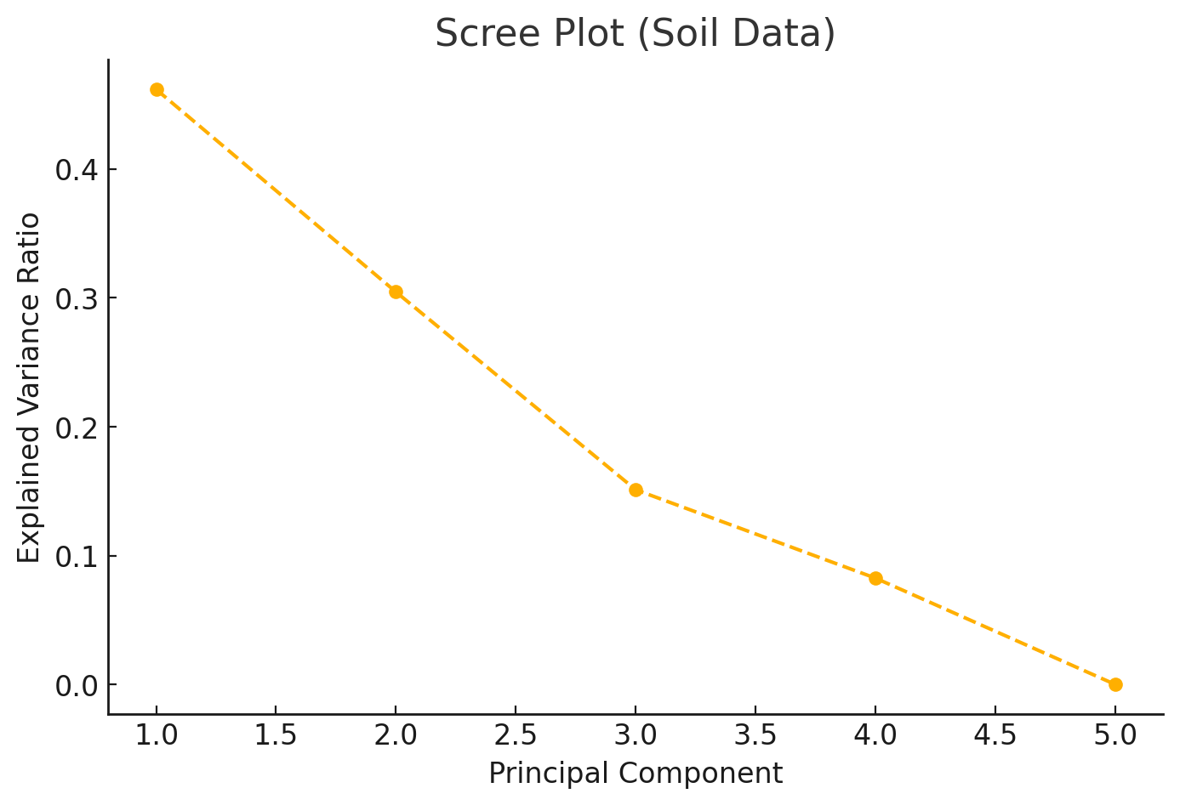

**Fig. 5. Scree Plot for Soil Samples**

The scree plot shows the proportion of total variance captured by each principal component. Generally, components with the highest variance are prioritized, and this graph helps in deciding how many components to retain for analysis. Obviously**, PC1 and PC2 account for most of the variance,** suggesting that they encapsulate the majority of the patterns and trends in the dataset. Beyond PC2, the explained variance drops significantly, making subsequent components less informative. Since the first two components (PC1 and PC2) capture the majority of the variance, signifying that these two components effectively represent the data, this means the results can be reasonably interpreted using only PC1 and PC2, simplifying the analysis.

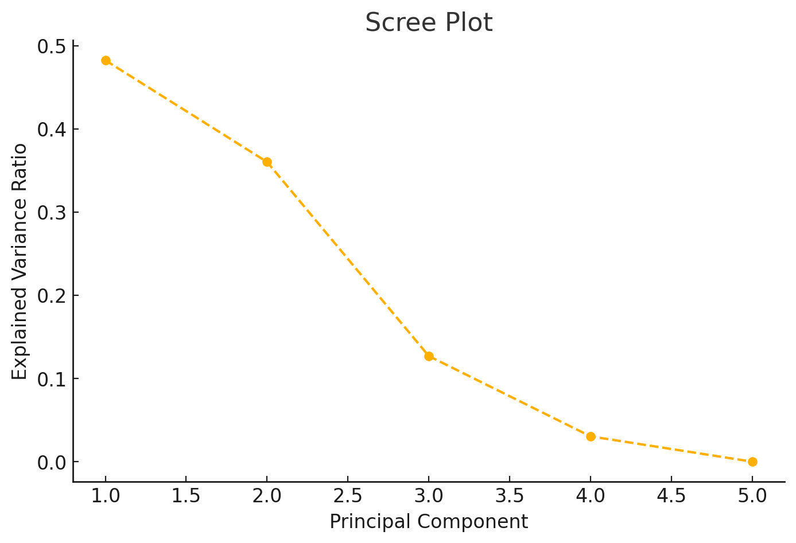

**Fig. 6. Scree Plot for Water Samples**

The biplot (or scatter plot) is a 2D plot with the first two principal components (PC1 and PC2) on the axes showing both Samples (each site plotted as a point based on its score for PC1 and PC2) and Variable Loadings (arrows representing each original variable's contribution to PC1 and PC2). Longer arrows indicate a higher contribution, and the direction shows the correlation between variables. A biplot shows how samples relate in terms of the first two principal components and to see the influence of each variable. Samples close to each other have similar characteristics. For soil samples, pH and Cd are strongly associated with each other and negatively correlated with PC1, which means they have an opposite influence compared to variables like Fe and NO3-. CEC and Cu in addition to pH, have a strong positive association with PC2, showing that PC2 is reflecting soil physicochemical characteristics. These properties could be influenced by organic matter and chemical alterations due to quarry activities. Pb and TOC also align together, indicating they contribute similarly across the samples. Parameters like Fe, Mn, and NO3- (mainly environmental variables) are positively correlated with PC1. These variables are likely associated with quarry-related disturbances which indicates that PC1 could represent a factor linked to metal presence or concentration variability across the soil sites. The Site Distribution shows that sites QS1 and QS5 cluster closely, indicating similar levels of quarry influence or shared environmental conditions. QS2 and QS3 show distinct differences, they are outliers, with elevated concentrations of specific metals like Fe and Mn, possibly due to their proximity to high-impact quarry zones or differences in the type of rock being quarried.

Therefore, PC1 represents the heavy metal soil attributes, while PC2 captures organic or nutrient availability factors. Each variable’s contribution helps identify relationships and potential environmental influences among soil properties. The PCA indicates that quarrying significantly impacts soil physicochemical properties and heavy metal distribution. Sites closer to active quarry areas or receiving higher particulate deposition show elevated heavy metal concentrations (e.g., Fe, Mn, Pb), which could affect soil health and ecosystem dynamics.

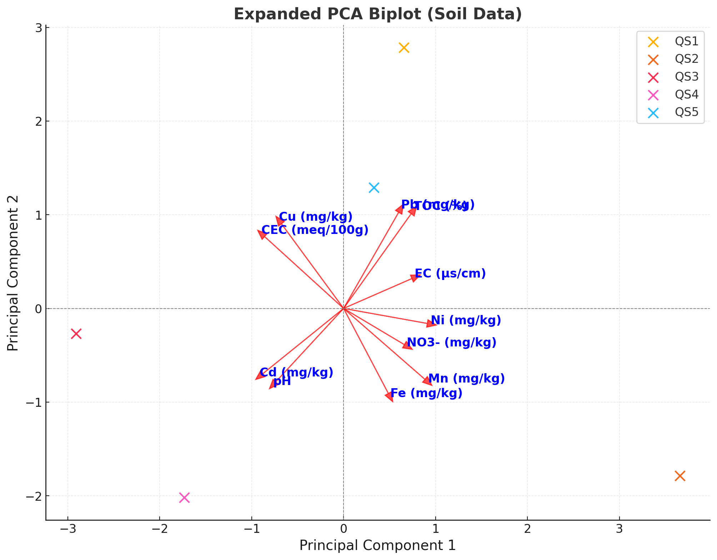

**Figure 7. PCA Biplot for Soil Samples**

For water samples, the first principal component (PC1) represents the largest variation in the data and it explains 48.24% of the variance in the dataset. The second (PC2) captures additional variation not explained by PC1 and it explains 36.02% of the variance. Combined, these two components capture 84.26% of the total variance, making them sufficient for understanding the main patterns in the data. Variables like Hardness, SO4²⁻, Ca²⁺, Cl- and Mg²⁺ have strong positive correlations with PC1. This suggests that PC1 is influenced primarily by parameters related to water hardness and salinity. Further explaining that these parameters are swayed by similar processes, potentially related to the dissolution of quarry materials and runoff. PC2 captures additional variation, orthogonal to PC1. Fe, Mn, Pb, and Cd contribute more to PC2, indicating their distribution might be influenced by localized quarry activities such as heavy metal leaching or sediment deposition. The site grouping shows that QW5 is distinctly separated along both PC1 and PC2, indicating unique physicochemical and metal properties compared to other sites. This could reflect higher Mn and Cd levels. QW1 and QW3 are grouped closer to each other, suggesting similar characteristics, especially in parameters like Fe, Pb, and hardness. QW2 and QW4 also form another grouping along PC1, reflecting similar contributions from parameters such as Ca2+ and Cl−. The clustering of QW1, QW3, and the proximity of QW2 and QW4 suggest consistent influences from shared water sources or similar environmental conditions.

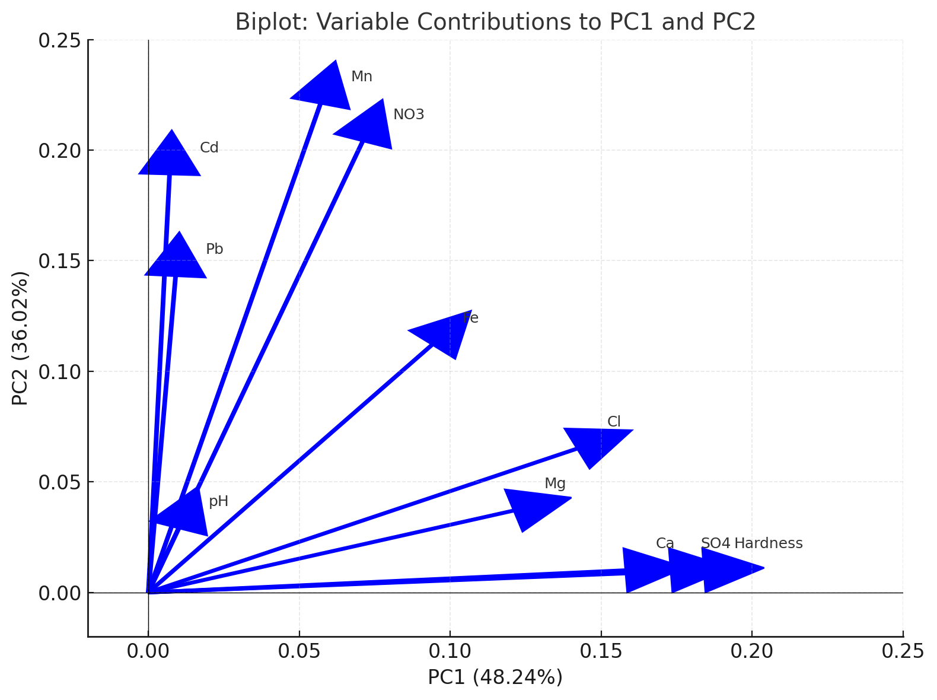 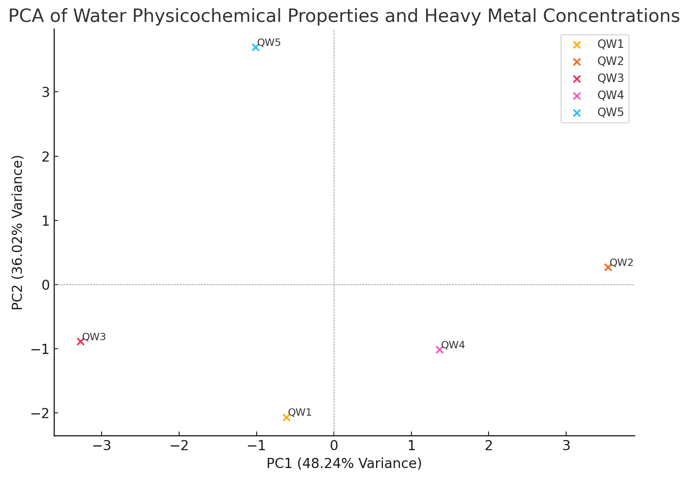

**Figure 8a. PCA Biplot for Water Samples Figure 8b. PCA Biplot for Water Samples**

In summary, PC1 captures variations associated with general water hardness and salinity. PC2 emphasizes variations in heavy metals and pollutants, making it critical for identifying sites with contamination risks. Sites that are high on PC1 likely have elevated physicochemical content and are influenced by geochemical processes. Sites that are high on PC2 exhibit higher levels of metal contamination, potentially from anthropogenic sources such as quarry activities, industrial discharge or agricultural runoff. The low contributions of pH to both PC1 and PC2 suggest it has minimal variability across the sites. PCA successfully reduces the dimensionality of the dataset while retaining the most critical variations, making it easier to identify patterns and outliers.

**4. CONCLUSION**

The findings of this study demonstrate the environmental consequences of quarrying activities in Mpape, Abuja, with significant contamination of soil and water resources by heavy metals. The integration of AI-driven methodologies allowed for a more comprehensive understanding of the relationships between different pollutants and their potential sources. The strong correlations among heavy metals indicate that quarrying is a major contributor to environmental degradation in the area. Urgent regulatory intervention is needed to enforce stricter environmental standards in quarrying operations. Measures such as improved waste management, regular monitoring of soil and water quality, and the adoption of greener technologies can help mitigate the negative impacts of quarrying. This study also highlights the potential of AI-enhanced environmental assessments, which can provide critical insights for decision-makers and support efforts toward sustainable development in Nigeria and beyond.

**5. RECOMMENDATIONS**

* + Dust suppression techniques should be implemented to reduce particulate deposition.
  + Proper disposal of quarry waste should be ensured to minimize runoff and leaching.
  + Use of organic amendments like compost or biochar to restore pH and improve CEC is recommended.
  + Regular monitoring of soil and water quality should be ensured to track heavy metal accumulation and other physicochemical changes.
  + Buffer zones with vegetation should be established to reduce the spread of contaminants.
  + Investigating the sources of high Pb and Cd levels is necessary to develop effective control measures.

Disclaimer (Artificial intelligence)

Option 2:

Author(s) hereby declare that generative AI technologies such as Large Language Models, etc. have been used during the writing or editing of manuscripts. This explanation will include the name, version, model, and source of the generative AI technology and as well as all input prompts provided to the generative AI technology

Details of the AI usage are given below:

1. Generative AI technologies: ChatGPT

2. Model: GPT-4o

3. Input prompts provided: Data from the laboratory analysis

**REFERENCES**

Abam, T. K. S., & Anthony, E. E. (2018). Environmental Impacts of Quarrying in Nigeria: A Review. *Journal of Environmental Management*, 12(3), 187-196.

Abdul-Wahab, S. & Marikar, F. (2012). The environmental impact of gold mines: pollution by heavy metals. *Central European Journal of Engineering*, 2(2), 304-313.

**Abu, O., Fatokun, E. Y. & Godwin, T. A. (2020).** Assessment of Soil Quality in Quarry Sites: A Case Study of South-Western Nigeria. ***Journal of Soil and Environmental Science,*** 15(2), 112–126.

Abur, B. T.; Oguche, E. E. & Duvuna, G. A. (2014). Characterization of Municipal Solid Waste in the Federal Capital Abuja, Nigeria. *Global Journal of Science Frontier Research,* 4(2), 351- 367*.*

Adamu, C. I., Nganje, T. & Edet, A., (2013). Hydrochemical Assessment of pond and stream Water near abandoned barite mine sites in parts of Oban Massif and Mamfe Embayment, Southeastern Nigeria. Environ Earth Sci. 1(4), 266-278.

Adamu, C. I., Nganje, T. N. & Edet, A., (2015). Major and Trace Element pollution of Sediments associated with abandoned barite mines in parts of Oban Massif and Mamfe Embayment, Southeastern Nigeria. *Journal of Geochemical Exploration*, 151:1-33.

Adedeji, O.H., Olayinka, O.O., Tope-Ajayi, O.O. & Azeez, O.I. (2020). Land use/Land cover changes due to Quarrying in Odeda Local Government Area of Ogun State, Nigeria: An Assessment and Implication for Rural Livelihood. *Journal of Meteorology and Climate Science*, 18(1), 28-40.

Adeoye, U. E. & Okafor, T. H. (2018). Assessment of Heavy Metals Concentration and Enrichment Levels in Soils around Quarries and Barite Mine Sites in Part of Akamkpa and Biase Area, Southeastern Nigeria. *Journal of Geoscience and Environment Protection*, 8, 107-128.

Adewumi, J. R., & Adebayo, S. B. (2021). Soil Contamination by Heavy Metals in Quarrying Areas of Nigeria. *Environmental Science and Pollution Research*, 28(9), 6754-6765.

Aigbedion, I & Iyayi, S. E. (2017). Environmental effect of mineral exploitation in Nigeria. *International Journal of Physical Sciences*, 2 (2): 033-038.

Akabzaa, T. & Darimani, A. (2001). A Study of Impacts of Mining Sector Investment in Ghana on Mining Communities, Accra: Structural Adjustment Participatory Review Initiative (SAPRI) on Ghana.

Akanwa, A. O., Okeke, F. I., Nnodu, V. C., and Iortyom, E. T. (2017). Quarrying and its effect on vegetation cover for sustainable development using high-resolution satellite image and GIS. Journal of Environmental Health Sciences, *Springer*, 76(4), 1-12.

Akinluyi, F. O., Awoniran, D. R., Oladejo, S. O. & Ogunniyi, O. S. (2019). Environmental Evaluation of Quarry Operation in Akure Metropolis, Ondo State, Nigeria. *Ethiopian Journal of Environmental Studies & Management*, 12(2), 229 – 237.

Ako, T. A, Onoduku U. S., Oke, S. A., Adamu I. A., Ali S. E., Mamodu A. & Ibrahim A. T, (2014). Environmental Impact of Artisanal Gold Mining in Luku, Minna, Niger State, North Central Nigeria. *Journal of Geosciences and Geomatics*, 2(1), 28-37.

Akpan, E. B., Etim, R. E., & Udo, J. O. (2021). Effects of quarrying activities on soil conductivity and fertility in Akwa Ibom State, Nigeria*.* ***African Journal of Environmental Science and Technology****,* 15(3), 89–97.

American Public Health Association (APHA), (2008). “Standard methods of examination of water and waste water, 20th Edition. Washington DC, USA.

Balogun, O. (2001). The Federal Capital Territory of Nigeria: Geography of its Development. University of Ibadan; Ibadan University Press.

Bamgbose, T. O, Omisore, O. A, Ademola, A. O. & Oyesola, O. B. (2014). Challenges of quarry activities among rural dwellers in Odeda local government area of Ogun state. *Research Journal of Agriculture and Environmental Management*, 3(1), 49-55.

Barredo Arrieta, A., Díaz-Rodríguez, N., Del Ser, J., Benneto, A., Tabik, S., Barbado, A., Garcia, S., Gil Lopez, S., Molina, D., Benjamins, R., Chatila, R., & Herrera, F. (2020). Explainable Artificial Intel ligence (XAI): Concepts, taxonomies, opportunities and challenges toward responsible AI. *Information Fusion*, 58, 82–115.

Bhagat, N. K., Singh, R. K. & Hembram, P. (2024). A Scientific Exploration of Blast-Induced Ground Vibration Mitigation Strategies for Sustainable Coal Mining in India. *Mining, Metallurgy & Exploration*, 4(1), 123–138.

Bodo, R. A., & Okechukwu, O. (2019). Assessing Water Quality in Nigeria's Quarrying Regions. *Journal of Environmental Monitoring*, 17(5), 892-899.

Cervantes, J. A., López, S., Rodríguez, L. F., Cervantes, S., Cervantes, F., & Ramos, F. (2020). Artificial moral agents: A survey of the current status. *Science and Engineering Ethics*, 26(2), 501–532.

Coeckelbergh, M. (2020). Artificial intelligence, responsibility attribution, and a relational justification of explainability. *Science and Engineering Ethics*, 26(4), 2051–2068.

Darwish, T. M., Stehouwer, R. Miller, D. Sloan, J. Jomma, I. and Shaban, A. (2008). Assessment of abandoned quarries for revegetation and water harvesting in Lebanon, East Mediterranean. Presented at 2008 National Meeting of the American Society of Mining and Reclamation. Richmond VA, New Opportunities to Apply Our Science. 22.

Effiong U. E. & Gilbert U. A. (2012). Assessment of toxic heavy metal loading in topsoil samples within the vicinity of a limestone quarry in South Western Nigeria. *African Journal of Environmental Science and Technology*, Vol. 6(8), 322-330.

Egeh, E. U., Ekwueme, B. N. & Akpeke, B., (2004). The appraisal of a proposed barite quarry in Akpet area, Cross River State, from resistivity investigation. *Global Journal of Geological Science*. 2 (2):171–175.

Ekoh, H. C., Ekoh, N. M. and Iloso, E. S. (2019). Health Impact Assessment of Commercial Rock Blasting: A Study of the Julius Berger Quarry in Mpape (An Area Highly Concentrated with Quarry Sites) In Abuja. *International Journal of Engineering Applied Sciences and Technology*, 4(8), 334-349.

Ekpo, F. E., Agu, U. & Udoakpan, U. I. (2013). Influence of heavy metal concentration in three common fish, Sediment and water collected within quarry environment Akampa L.G. area, Cross River, Nigeria. *European Journal of Toxicology and Science*, 5(3): 34 – 38.

Ekpo, F. E., Nzegblue E. C., & Asuquo, M. E., (2011). A Comparative Study of The Influence of Heavy Metals on Soil and Crops Growing Within Quarry Environment at Akamkpa, Cross River State, Nigeria. *Global Journal of Agricultural Sciences*, 11(1): 1-4.

Fashola, M. O., Ngole-Jeme, V. M. & Babalola, O. O. (2016). Heavy Metal Pollution from Gold Mines: Environmental Effects and Bacterial Strategies for Resistance. *Int. J. Environ. Res. Public Health*, 13(11): 1047.

Federal Capital Development Authority (FCDA). (1979). The master plan for Abuja the new federal capital of Nigeria. FCDA, Abuja, Nigeria.

Federal Capital Development Authority (FCDA). (1998). Abuja Handbook. FCDA, Abuja, Nigeria.

Gibson, G. & Klink, J. (2005). Canada’s resilient north: the impact of mining on aboriginal communities. *Pimatisiwin,* 1(3), 116 – 139.

Hassan, Z., Anwar, Z., Khattak, U.K., Islam, M., Khan, R. U., Khattak, K., (2012). Civic Pollution and Its Effect on Water Quality of River Toi at District Kohat. *Research Journal of Environmental and Earth Sciences,* 4 (5), 27-39.

Isaac, A. o., Bello, O. M., & Patricia E. O. (2013). Heavy metals evaluation of Madna Stream Sediment in Kubokun village of Abuja metropolis. *Journal of Advance in Applied Science Research.* 4 (6): 237 – 241.

Musa, S., Ezeamaka, C. K., Adewuyi, T. O. & Daful, M. G. (2019). Spatio-Temporal Assessment of Quarry Sites in Mpape, Abuja, Nigeria. *Journal of Remote Sensing & GIS,* 8(1), 255-268.

Nartey, V. K, Nano, J. N. & Klake R. K. (2012). Effects of quarry activities on some selected communities in the lower manya krobo District of the Eastern Region of Ghana. *Atmospheric and Climate Sciences*, 2(3),362–372.

Nazir R. (2015). Accumulation of Heavy Metals (Ni, Cu, Cd, Cr, Pb, Zn, Fe) in the soil, water and plants and analysis of physico-chemical parameters of soil and water Collected from Tanda Dam kohat. *Journal of Pharmaceutical Sciences and Research*, 7(3), 89-97.

Ochelebe, I., Ekwere, A. S. & Ekwere, S. J., (2017). Environmental Implication of the Distribution of Heavy Metals in Soils and Water in Okpoma Area, Southeastern Nigeria. *International Journal of Science and Engineering Investigations*. 6(69):105-113.

Ogbonna, C. E., Otuu, F. C., Ugbogu, O. C., Nwaugo, V. O. & Ugbogu, A. E. (2015). Public health implication of heavy metal contamination of plants growing in the lead zinc mining area of Ishiagu, Nigeria. *International Journal of Biodiversity and Environmental Science,* 7(3),76-86.

Olufemi, J. A., Olubunmi S. S., &Temitope, B. (2014). Heavy metal pollution assessment of granite quarrying operations at Ikole Ekiti, Nigeria. *International Journal of Environmental Monitoring and Analysis,* 2(6), 333-339.

Omosanya, K. O. & Ajibade, O. M. (2010). Environmental impact of quarrying on Otere Village, Odede, South Western Nigeria. Ozean; *Journal of Applied Sciences*, 4(1):75-82.

Onwuemesi, F. E., Ajiwe, V. E., Okoye, A. C., Nnodu, V. C. & Onuba, L. (2011). Effect of lead and zinc mining activities on ground water quality in Ishiagu, EbonyiState, Nigeria. *Journal of International Environmental Applications and Science,* 6(1),600- 605.

Ruiz-Mercado, G. J., Smith, R. L., & Gonzalez, M. A. (2012). Sustainability indicators for chemical pro cesses: I. Taxonomy. *Industrial & Engineering Chemistry Research*, 51(5), 2309–2328.

Ruqia, N., Muslim, K., Muhammadu, M., Hameed, R., Naveed, R., Surrya, S., Nosheen, A., & Muhammadu, S. (2015). Accumulation of heavy metals in the soil, water and plants and analysis of physico-chemical parameters of soil and water collected from Tanda Dam Kohat. *Journal of Pharmaceutical Science and Research*.7 (3): 89 – 97.

Sayara, T. (2016). Environmental impact assessment of quarries and stone cutting industries in Palestine: Case Study of Jammain. *Journal of Environmental Protection and Sustainable Development,* 2(4): 32-38.

Taddeo, M., & Floridi, L. (2018). How AI can be a force for good. *Science,* 361(6404), 751–752.

Tiimub, B. M., Sarkodie, P. A., Monney, I., & Maxwell, O. (2015). Heavy metal contamination of soil by quarry dust at Asonomaso in the Ashanti Region of Ghana. *Chemistry & Materials Research,* 5(7), 42-50.

Urich, P. B. (2002). Land use in karst terrain: Review of impacts of primary activities on temperate karst ecosystems science for conservation. Department of Conservation. Wellington, New Zealand. 198pp.

Useh, M. U., Uzama, D. & Etuk-Udo, G. (2022). Effect of Dumpsite Leachate on Groundwater Quality in Mpape Community, Bwari Area Council, Abuja, Nigeria. *Nigerian Research Journal of Chemical Sciences*. Volume 10, Issue 1, 2022.

Vincent, K. N., Joseph, N. N. & Raphael, K. K. (2009). Effect of quarry activities on some selected communities in the Lower Mangakrobo District of Eastern Region of Ghana. *Atmospheric and Climatic Science*, 2(4), 365-372.

Vo, A. H., Van Vleet, T. R., Gupta, R. R., Liguori, M. J., & Rao, M. S. (2020). An overview of machine learning and big data for drug toxicity evaluation. *Chemical Research in Toxicology*, 33(1), 20–37.

World Health Organisation. (2017). Guidelines for drinking-water quality, fourth Edition. Incorporating the Third Addendum Volume 2; Recommendations. 225 – 1235.

Xianfei, H., Jiwei, H., Cun -xiong, L., Jianjun, D., & Jian, L. (2009). Heavy Metal Pollution and Potential Ecological Risk Assessment of sediments from Baihua Lake, China. *International Journal of Environmental Health Research*.19: 405- 419.

Yang, C. L., Guo, R. P., Yue, Q. L., Zhou, K., & Wu, Z. F., (2013). Environmental quality assessment and spatial pattern of potentially toxic elements in soils of Guangdong Province, China. *Environ. Earth Sci.* 70: 1903–1910.

Zachary J. Baum, Xiang Yu, Philippe Y. Ayala, Yanan Zhao, Steven P. Watkins, Qiongqiong Zhou. Artificial Intelligence in Chemistry: Current Trends and Future Directions, J. of Chem. Info. and Mod. 2021; 7: 3197 3212.

Zhang, Q., Feng, M. & Hoa, X., (2018). Application of Nemerow Index Method and Integrated Water Quality Index Method in Water Quality Assessment of Zhangze Reservoir. IOP Conf series. *Earth and Environmental Science*. 128 012160.

Zuhairi, W., Yaacob, W., Syuhadah, N., Pauzi, M. & Mutalib, H. A. (2009). Acid mine rainy age and heavy metals contamination at abandoned and active mine sites in Pahang. *Geological Society Bulletin*, 55: 15 - 20.