**Original Research Article**

**Evaluation of old dams for risk management and dam safety criteria using GIS and remote sensing**

ABSTRACT

|  |
| --- |
| This study presents an integrated approach combining Geographic Information Systems (GIS), Remote Sensing (RS), and the Analytic Hierarchy Process (AHP) to assess dam conditions through multi-criteria risk analysis. Geographic Information Systems (GIS) and Remote Sensing technologies have emerged as powerful tools in the evaluation and monitoring of dam conditions. Dam management and safety compliance are critical for safeguarding infrastructure and communities in disaster-prone regions. Key criteria including topography, land use, hydrology, climatic conditions, population density, and soil stability were weighted using AHP to reflect their relative impacts on dam safety. A weighted overlay analysis in ArcMap 10.7 classified risks into three zones: high, moderate, and low. The results revealed significant spatial disparities: high-risk zones (48.27 km², 33.64%) dominate the dam’s western flank due to extreme anthropogenic pressures from uncontrolled settlements and unsustainable farming, moderate-risk zones (31.40 km², 21.88%) cluster near bushland and Mindu Mountain, where environmental factors like slope instability pose intermediate threats, and low-risk zones (63.83 km², 44.48%) prevail on the eastern side along Uluguru Mountain, where stable terrain and minimal human activity enhance resilience. The analysis emphasizes human encroachment as the primary driver of dam vulnerability, particularly on the western side, necessitating urgent land-use regulations and soil conservation measures. Conversely, the eastern low-risk zone highlights the protective role of undisturbed ecosystems. Satellite-derived RS data enabled dynamic monitoring of environmental changes, while GIS-based predictive models identified future hazards, such as sedimentation and flooding. By translating complex spatial data into actionable insights, this framework empowers policymakers, engineers, and regulators to prioritize mitigation efforts, enforce zoning laws, and implement adaptive strategies. The study demonstrates the efficacy of GIS-RS-AHP integration in achieving cost-effective, proactive dam management, balancing ecological preservation with infrastructure safety amid evolving environmental and anthropogenic challenges. |

**Keywords:** *Geographical information system (GIS), remote sensing (RS), analytic hierarchy process (AHP), risk potential assessment.*

1. INTRODUCTION

Internationally, the World Register of Dams reports that there are approximately 57,000 large dams across the globe (Adamo et al., 2020). These structures are pivotal for water supply, flood control, irrigation, and renewable energy generation. However, they also pose a significant risk, as over the past century, thousands of dam failures have resulted in the loss of countless lives and immense economic damage (Adamo et al., 2017; *Model State Dam Safety Program Manual*, 2022). The consequences of dam failures can include loss of life, property damage, environmental degradation, and economic disruption (Barbara, 2001; Akinlabi & Olanrewaju, 2024). Hence, regulatory agencies and dam owners prioritize the establishment of risk management programs that encompass inspection, assessment, and mitigation measures (Mancusi et al., 2019; Science & Seker, 2015).

Furthermore, evolving regulatory standards, technological advancements, and lessons learned from past dam incidents necessitate periodic assessments of dam safety conditions to ensure they meet contemporary safety requirements (Khahro & Memon, 2017; Obialor et al., 2019). To address this concern, it is crucial to evaluate dam conditions rigorously and implement effective risk management programs. Dam safety is primarily concerned with preventing catastrophic failures and minimizing the potential risks associated with dams. Such risks encompass factors like structural integrity, seepage, flood control, and emergency preparedness (Jongman et al., 2012; Al-Balawna et al., 2024).

In recent years, Geographic Information Systems (GIS) and Remote Sensing technologies have emerged as powerful tools in the evaluation and monitoring of dam conditions (Gebresilasie et al., 2022). It enables engineers, dam operators, and regulatory agencies to monitor a wide range of parameters, such as structural deformation, water levels, land subsidence, and environmental changes, all of which can influence dam safety (CWC, s2019). These advanced technologies offer a holistic approach to assessing dam safety and compliance with risk management programs in a continent where resources for extensive on-ground inspections can be limited (Ćosić-Flajsig et al., 2020). GIS enables the spatial representation and analysis of various geospatial data, including topography, land use, hydrology, and infrastructure, providing a holistic view of the dam's surroundings (Fréchette et al., 2022; Toombes & Ayre, 2011). This information can be used to assess the potential impact of natural disasters, population growth, and land use changes on dam safety (Wieland, 2021). Remote Sensing complements GIS by providing valuable data through satellite imagery, aerial photography, and LiDAR, offering insight into dam conditions, vegetation, water levels, and land subsidence (Ćosić-Flajsig et al., 2020; Shim et al., 2018).

Tanzania is home to numerous dams, both small and large, and ensuring their structural integrity and overall safety is imperative to prevent catastrophic failures that could result in loss of life and property (Fluixá-Sanmartín et al., 2019). Over the years, there has been a growing recognition of the need for comprehensive risk management programs tailored to the unique conditions and challenges in Tanzania, such as heavy rainfall and seismic activity in certain regions (Khalid et al., 2012). These programs encompass a range of activities, including periodic inspections, maintenance, and the establishment of emergency response plans (Essex and Suffolk Water, 2014). In light of this, it is essential to delve into the background and context of these dams, considering factors such as age, construction materials, design standards, and local environmental conditions to assess their compliance with established risk management protocols and ensure the safety and well-being of Tanzanian communities (Dorm-Adzobu & Ampomah, 2014). Tanzania has established a regulatory framework to govern dam safety, with the National Environment Management Council (NEMC) and the Ministry of Water playing key roles in oversight. The Water Resources Management Act (2009) and the National Water Policy provide the legal basis for dam safety in the country (MacLeish et al., 2015; Maro, 2008). However, evaluating the conditions of a dam for compliance with risk management programs for dam safety in Tanzania is a vital and multifaceted task that demands a comprehensive approach (Maro, 2008). The safety and integrity of these structures are of paramount importance, not only for the protection of human lives and property but also for ensuring the sustainability of essential water resources (Gericke, 2011; Hahn & Kuhn, 2012). A diligent assessment of a dam's structural, hydraulic, and environmental factors is essential to identify potential risks and develop strategies to mitigate them(Hoyt & Liebenberg, 2011). As Tanzania strives to meet the highest standards in dam safety, it must remain committed to maintaining, upgrading, and adapting its risk management programs to ensure the enduring protection of its dams and the communities they serve (Essex and Suffolk Water, 2014; Thaxton, 2007). This paper aims to explore the use of GIS and Remote Sensing in evaluating dam conditions for compliance with risk management programs Specifically this study aims on (1) The use of geospatial technique in identify factor determining the dam condition and (2) The use of Hierarchy Process (AHP) as a decision-making framework to evaluate and determine the risk dam condition.

1. materialS and method
   1. **Description of the study area**

This study was conducted at the Mindu Dam, located in the Morogoro region's Morogoro municipal council. Situated in the Ngerengere River Valley, Mindu Dam is roughly 3.8 kilometers southwest of Morogoro Urban (Kimambo et al., 2019). It is located within the latitudes and longitudes: 6.82°S, and 37.66°E in the Morogoro region (Figure 1). The dam received a bimodal rainfall pattern, with long rains in March, April, and May and short rains in September, October, and November, is what defines the catchment(Gobry et al., 2023). With an annual rainfall of between 800 and 1500 mm, the Uluguru Mountains receive the most precipitation in the basin. The dam primarily supplies Morogoro town with water(Kimambo et al., 2019). Its construction started in 1983 and was finished in 1985 with a dam design storage capacity of 20 Million m3(Josephine et al., 1974).

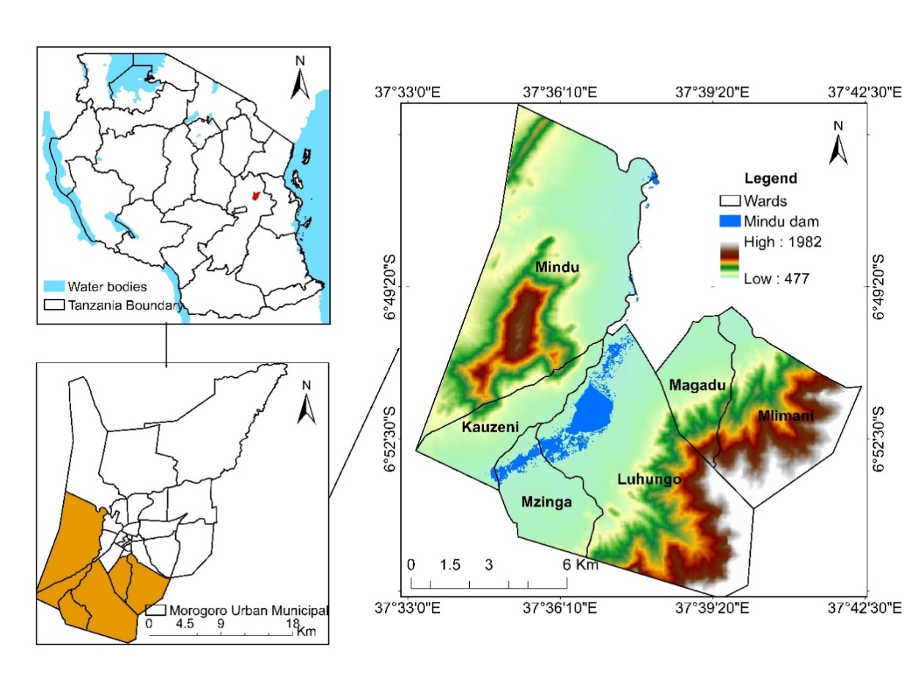

Figure 1. Study area showing the location of Mindu Dam ~~(Author,2023)~~

* 1. **Research design and data collection**

This study employs a mixed-methods research design, integrating both qualitative and quantitative approaches to evaluate the conditions of old dams for compliance with risk management programs for dam safety. The qualitative aspect focuses on analyzing secondary data sources, including scientific literature, government reports, and hydrological studies, to incorporate contextual and historical knowledge of the study area. Case studies from similar regions and expert insights on dam safety management enhance the understanding of spatial models. The quantitative approach utilizes geospatial analysis through GIS and remote sensing technologies. Satellite imagery from Landsat missions and Digital Elevation Models (DEMs) are used to derive key topographical factors such as slope, aspect, and elevation, which influence dam safety. These data are processed in ArcGIS 10.7 software to detect structural changes and assess the surrounding terrain.

The data collection and analysis involve integrating remote sensing and secondary data to comprehensively assess dam safety conditions. Landsat satellite imagery is obtained from the USGS Earth Explorer for multi-temporal analysis of dam structures and environmental changes, while Digital Elevation Models (DEMs) are utilized to derive slope, aspect, and elevation for topographical assessments. Secondary data, including dam inspection reports, safety guidelines, and scientific literature, provide regulatory and historical context. Data processing involves GIS tools like QGIS, and ArcGIS, to analyze terrain stability and detect structural alterations. Qualitative analysis of secondary sources complements geospatial findings, enhancing interpretations with expert insights and historical management practices. This integrated approach ensures thorough evaluations for dam safety compliance and risk management.

**2.3 Geospatial and collateral data**

The study used the remote sensing dataset which were acquired from the USGS site (http://www.usgs.gov/, retrieved on August 03, 2023), Climate engine and The National Bureau of Statistics (NBS) acting as the main foundation of the criteria for determination of old dam risk assessment. Land use/cover, Digital Elevation (DEM), Weather Data, river and road network distances respectively are the criteria generated for this study, covering a couple of years. All these criteria were converted into the same spatial resolution of 30m by 30m (Table 1).

Table 1. Data Sources and Acquisition

|  |  |  |  |  |
| --- | --- | --- | --- | --- |
| Data type | Source | Sensor type | Spatial resolution | Acquisition year |
| Satellite Data | USGS Earth Explorer | Landsat-TM | 30m | 2023 |
| Digital Elevation Model | Google Earth Pro ground points |  | 30m | 2023 |
| Climate Data | Climate Engine |  | 1km and resampled for 30m | 2020-2023 |
| Administrative boundaries | The National Bureau of Statistics (NBS) |  |  | 2020 |
| Rivers and Road networks | Open Street Map (OSM) |  | Resample to 30m | 2022 |
| The Digital Soil Map of the World (DSMW) | FAO/UNESCO |  | Resample to 30m | 2022 |
| Population Density | Worldpop.org and Tanzania bureau of statistics |  | Resample to 30m | 2022 |

* + - 1. **Land use/cover classification**

The corrected images were processed via Arc GIS to generate regions of interest for various land use/cover identified in the study area to facilitate classification by supervised random forest classer algorithm in Google Earth Engine (GEE) platform, the method has been widely used and reported in other studies (Liaw and Wiener, 2002; Adam et al., 2014; Feng et al., 2015; Camargo et al., 2019; Nurfadila et al., 2019). Five land cover classes (Built-up, Agriculture, Water, Bare land and Forest) were identified in our study area from the Landsat imagery.

* + - 1. **Analytical hierarchical process (AHP)**

Analytic Hierarchy Process (AHP), one of the multi-criteria decision-making techniques is, in essence, a technique for generating ratio scales from paired comparisons. The input can come from objective judgment, such as satisfied emotions and preferences, or objective measurements, such as price, weight, etc. Since people are not always consistent, AHP permits some little judgmental inconsistency. The consistency index is obtained from the principal Eigenvalue, whereas the ratio scales are derived from the principal Eigenvectors(He et al., 2020).

or consistent reciprocal matrices, the greatest Eigenvalue is equal to the size of the comparison matrix, or $λ_{max}=n$. Then he provided a consistency index, which is a deviation or degree of consistency, using the formula below;

ConsistencyIndex = $\frac{λ_{max}-n}{n-1}$................... Equation (1)

Once more, suggested the use of this index by contrasting it with the proper one. The proper consistency metric is known as the Random Consistency Index (RI), which are constant as define in the table below,

Table 3. Random Consistency Index (RI)

|  |  |  |  |  |  |  |  |  |  |  |
| --- | --- | --- | --- | --- | --- | --- | --- | --- | --- | --- |
| n | 1 | 2 | 3 | 4 | 5 | 6 | 7 | 8 | 9 | 10 |
| Rn | 0 | 0 | 0.58 | 0.9 | 1.12 | 1.24 | 1.32 | 1.41 | 1.45 | 1.49 |

Consistency Ratio = $\frac{Consistency Index (CI)}{Random Consistency Index (RI)}$**...............**Equation (2)

The inconsistency is acceptable if the consistency ratio value is less than or equal to 10%. We must update the subjective assessment if the consistency ratio is larger than 10%.

Data processing and extraction such as band composition, mosaicking of the images, image re-projection, Reclassification and re-sampling were performed using ArcGIS 10.7image-processing software

This study employed methodological flow chart that combines GIS, remote sensing, and multi-criteria decision analysis (MCDA) to assess the compliance of aging dams with risk management frameworks. The workflow includes data collection, criteria selection, spatial analysis, and risk modeling using AHP model, as shown in the figure 2 below.

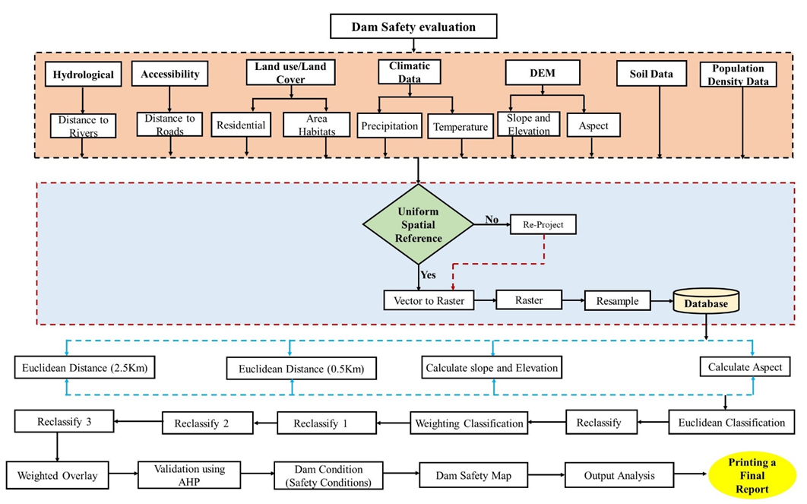

**Figure 2. Methodological flowchart**

3. results and discussion

**3.1 Factor determining the dam condition**

To evaluate the conditions of old dams for compliance with risk management programs for dam safety using GIS and Remote Sensing. The output of the approach used various criteria (Land use/Land cover, Slope, Elevation, Aspect, Climatic conditions, Soil, Population Density, Distance to road and Distance to river) to form a map demonstrating risk areas around the dam.

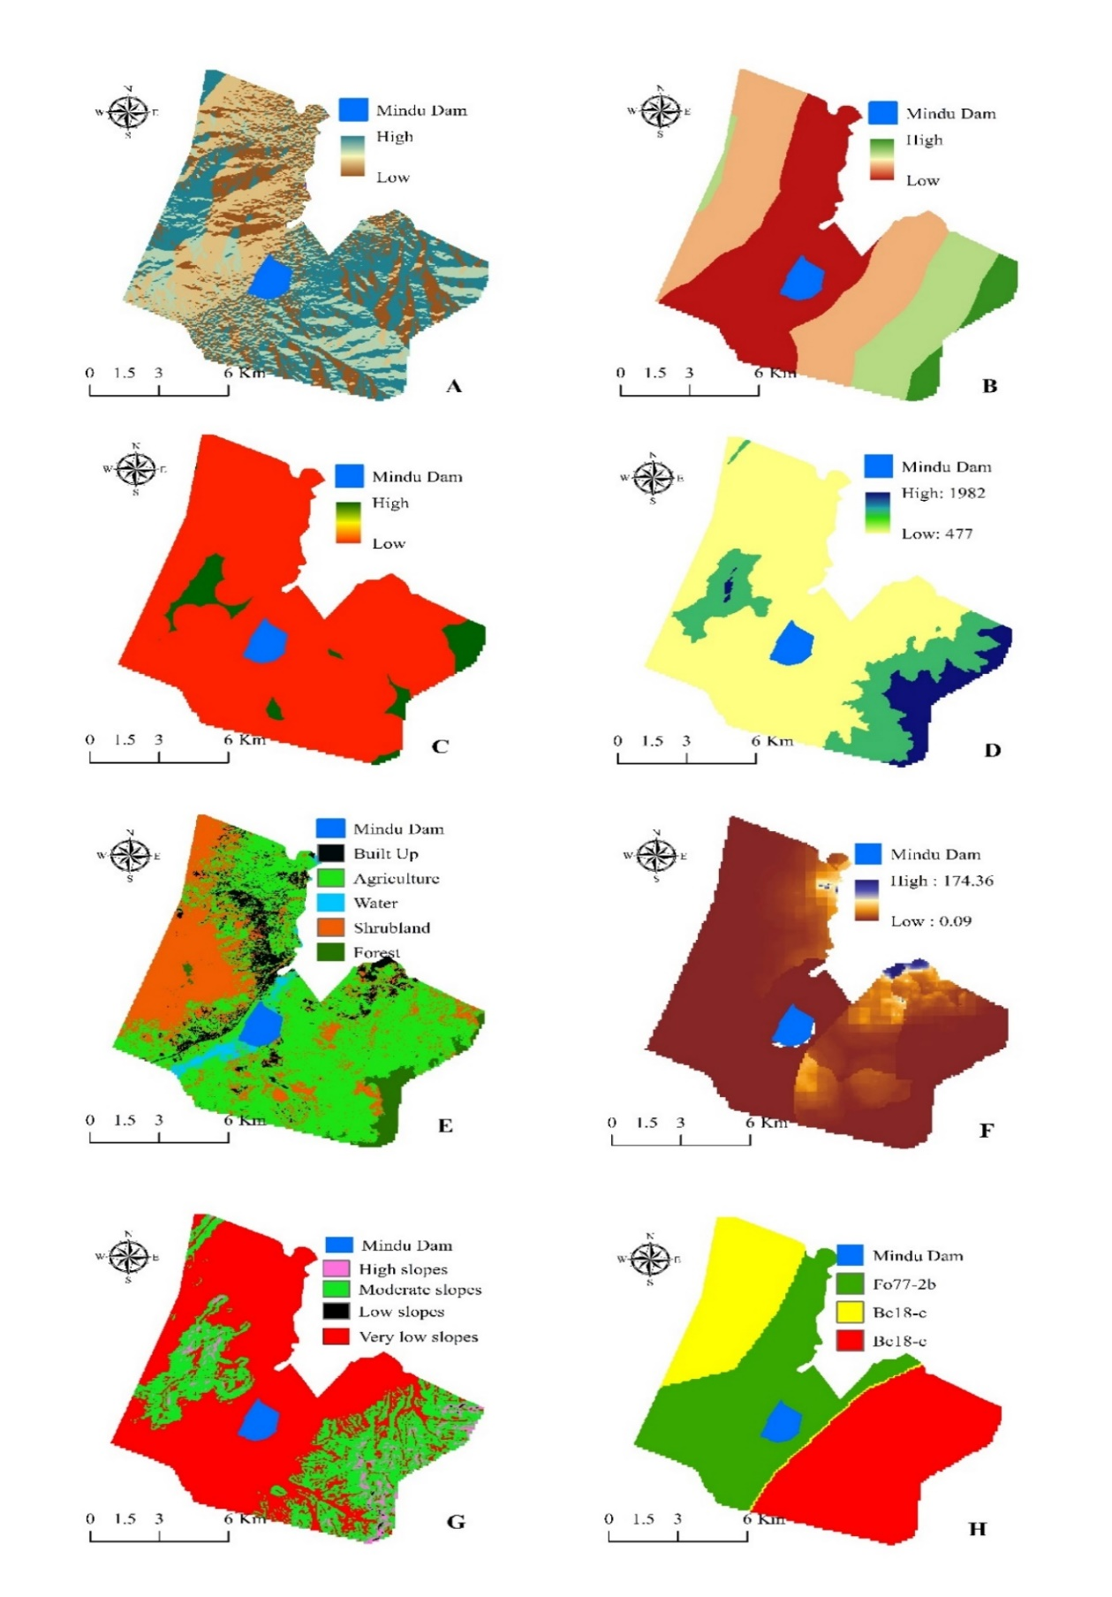

Figure 3. Shows the key factors A. Aspect, B. Distance to River, C. Distance to Road, D. Elevation, E. Land Use Land Cover, F. Population Density, G. Slopeand H. Soil.

**3.1.1 Description of factors influencing the existing conditions of the dam**

**3.1.1.1 Slope**

The slope of an area is the most important criteria in finding risk conditions for the dam sites. The slope of an area was calculated using ArcMap 10.7 software through Spatial Analyst Tools/Arc Toolbox/Surface/Slope. The steeper slopes become more detrimental as increase the construction costs, restrict the floor space areas and give rise to erosion during construction and use. The slope significantly affects the runoff, recharge, and movement of surface water as well as the number of sediments. The slope was generalized into four classes and measured into percentage rises. Figure. 3(G) shows the classification of the classes whereby high slopes cover 5.51Km2 (3.60%) of the study area, moderate slopes cover 44.2467Km2 (28.93%), low slopes cover 0.324Km2 (0.21%) of the study area and very low slopes covering an area of 102.84Km2 (67.25%). These findings align with existing literature that highlights the influence of topographical gradients on dam site stability and surface water behavior. According to Sharma and Singh (2020), steeper slopes contribute to rapid water flow and heightened erosion, which can compromise structural integrity. Additionally, steeper terrains increase sediment transport, as prominent by Gupta et al. (2019), affecting reservoir capacity and potentially requiring more frequent maintenance. Conversely, areas with gentler slopes offer more stable construction grounds and reduced risk of sedimentation, providing favorable conditions for long-term dam performance. By understanding the spatial distribution of slope classes in the study area, the risk assessment for dam safety can be refined, guiding targeted maintenance and mitigation strategies to enhance structural resilience and operational sustainability.

**3.1.1.2 Land Use Land Cover**

The land use land cover analysis was performed through Remote sensing data, for our study the Landsat images with resolutions of 30 meters were used to analyze the land use/ land covering the area. According to Jha et al. (2014), land use is a crucial component in the generation of surface runoff. A region's land use or cover has a significant impact on runoff velocity, the infiltration process, and evapotranspiration, and these processes were crucial in defining an appropriate zone for the dam site. The changing of land use and land cover is a complicated phenomenon that is both directly and indirectly influenced by several socioeconomic and biophysical driving forces that act on a variety of scales. Specifically, information about the factors influencing LU/LC changes in the area was gathered from key informants. Some of the factors include the expansion of cropland, overgrazing, climate change, land degradation, drought, and a lack of precipitation as drivers of LU/LC changes, which lead to a great change in the structure and conditions of the dam. The Mindu land use and cover map Figure. 3 (E) illustrates that there are five major types of Land use/cover namely; Built-Up (8.08%), Agriculture (55.23%), Water (3.4%), shrub land (29.20%) and Forest (4.09%) with their coverage areas. From the derived results in the study area, agriculture had the largest coverage area, shadowed by bare land as compared to the other classes. Expansion of agricultural activities can accelerate soil erosion and increase sediment deposition in reservoirs, reducing storage capacity and affecting dam stability. Built-up areas, comprising 8.08% of the study area, contribute to impervious surfaces that enhance surface runoff and flood risk (Muthoni et al., 2018). Conversely, forested and shrub land areas help stabilize soil and mitigate sediment transport, playing a protective role in dam catchments. Understanding these land use dynamics allows for better planning of conservation measures, promoting sustainable land management to safeguard dam infrastructure and enhance water resource management. This analysis provides a comprehensive framework for integrating LU/LC factors into dam safety assessments and proactive mitigation strategies.

**3.1.1.3 Distance to the Road and River**

One of the important socioeconomic criteria for site evaluation and assessment is the distance to the road and river networks, which is crucial when choosing a suitable location for a dam. Since it is expensive to build access roads and infrastructure, it is assumed that sites far from road networks were unsuitable for dam construction such that roads must be accessed. On the other hand, rivers' natural flow is altered by dams. They can hold sediment, cremating aquatic life's spawning grounds in river rock beds. Apart from becoming trapped behind dams are important food and habitat components like gravel and logs. Creating and maintaining more complex habitats (like riffles and pools) downstream is negatively impacted by this. The distances were computed in ArcMap 10.7 software by calculating the Euclidean distance in which the road access network was computed to 2.5Km as the minimum distance while the distance to the river was 0.5Km and both were reclassified into four classes Figure. 3 (B).Proximity to roads ensures easier access for maintenance and reduces infrastructure costs, while proximity to rivers influences hydrological alterations caused by dams.

Dams impact river ecosystems by altering natural flow regimes and trapping sediments, which affects aquatic habitats and reduces gravel and log deposition downstream, disrupting habitat complexity. According to Poff and Hart (2002), sediment retention behind dams can lead to reduced spawning grounds for fish and other aquatic life. Understanding these spatial relationships informs better ~~siting~~ decisions, balancing access needs with ecological impacts. Hence, incorporating road and river distance into dam safety assessments helps optimize location choices while mitigating construction costs and environmental consequences.

**3.1.1.4 Soil**

The soils of the study area were obtained from the Food and Agricultural Organization (FAO/ UNESCO, 1995) commonly known as The Digital Soil Map of the World (DSMW) and processed in GIS software. The results consisted of the two phases of the soils with several lithology namely; Precambrian comprising of schist, gneiss, charnockite, quartzite and Stony Comprising Precambrian: shale, sandstone, conglomerate, phyllite, schist, gneiss, charnockite, quartzite, cipolin with the two codes namely; Fo77-2b and Bc18-c respectively as indicated in the figure. 3. The region consisted of Sandy Clay Loam (61.56%) and Loam (91.92%) as the soil texture of the study area Figure 3 (H). According to FAO/ UNESCO (1995), the soil textures are supported under various climatic conditions such as dry semi-tropical with a humidity index of 0.44 to 1.00, humid tierra templada with Hu Mo, Dry tierra templada with Mo mo and Medium tierra fria with Hu MO Momo. However, loam soils have great features like being able to hold water, making it resistant to drought and quicker to warm up in the spring than clay, and may store nutrients, allowing for productive soil, and adequate air and water infiltration.According to FAO/UNESCO (1995), loam soils are particularly suitable for dam construction due to their ability to retain water, resist drought, and facilitate nutrient storage. Loam also allows for better air and water infiltration, supporting dam embankment stability. Sandy clay loam, while less water-retentive, provides sufficient structural support under semi-tropical dry and humid climates. These soil properties significantly influence the dam’s structural integrity, affecting seepage rates, infiltration, and the risk of erosion. The classification of soils in this study helps identify areas where soil conditions are optimal for dam safety, while also highlighting regions susceptible to erosion or sedimentation risks. Incorporating soil texture into dam safety assessments improves predictive modelling and informs targeted engineering solutions to enhance dam resilience.

**3.1.1.5 Climatic Condition analysis**

The climate analysis is an important factor in the evaluation of the dam risks and conditions. Several issues affecting the dams, such as the definition of downstream consequences and incoming floods, are predicted to be impacted by climate change. As a result, to analyze how climate change may affect a dam's overall safety, it is important to separate it into the various components that make up dam risk. The study used both climatic data including the rainfall and temperature data obtained in the climate engine. The rainfall data was used for runoff analysis, which was received in monthly and annual rainfall for each year. The overall risk impact of each dam safety component can also be calculated; emphasizing which area of the dam is more vulnerable to climate change or has a greater impact on the level of danger that is ultimately present.Furthermore, the proposed risk analysis approach can be used to reflect how climate change may affect both regular components of risk (like the population exposure downstream of the dam) and extreme components of risk (like flood events).In the context of Mindu Dam, recent studies have highlighted significant climatic trends over the past few decades. Research conducted by (Mbuligwe, .2021) indicates that the maximum air temperature in the Morogoro Municipality, where Mindu Dam is located, has increased at a rate of 0.045% over a span of 30 years. Concurrently, rainfall patterns have shown a decreasing trend, contributing to a reduction in water levels within the dam. The study also observed an increasing trend in wind speed, with a coefficient of determination (R²) of 63.4% for the period from 2014 to 2019. These climatic changes have led to prolonged droughts, further decreasing water levels in the dam and affecting water supply services. Notably, in 2017, Mindu Dam was closed due to insufficient water levels, underscoring the tangible impacts of climate change on water resources in the region.

**3.1.1.6. Population Density**

The possible effects of dam failures are strongly influenced by population density, which has a substantial impact on dam safety.

Population density plays a pivotal role in determining the potential consequences of dam failures, influencing both human safety and financial risk. According to the National Bureau of Statistics of Tanzania, the Mindu Dam ward has experienced a consistent increase in population density over the last few decades. Census data reveals an increase from approximately 300 people per square kilometer in 2002 to 400 people per square kilometer in 2012, reaching an estimated 450 people per square kilometer in 2022. This rising trend reflects growing urbanization and infrastructure development around the dam's downstream areas, heightening the urgency for comprehensive dam safety measures.

Higher population density increases the risk of catastrophic outcomes in the event of dam failure, necessitating enhanced monitoring, maintenance, and emergency preparedness. Each additional resident downstream contributes to a higher likelihood of fatalities and significant property damage, as noted by Smith et al. (2020). Urban expansion alters natural hydrological patterns, leading to increased surface runoff and flood potential, further complicating dam operations and increasing sediment loads.

The integration of population data into dam risk assessments allows for more precise identification of vulnerable zones. Effective policy-making, regular inspections, and disaster response planning become critical components in safeguarding communities. Future efforts should incorporate dynamic urban growth models and population forecasting to strengthen adaptive dam safety strategies in area experiencing rapid population increases.

**3.2. The application of the AHP model to evaluate the conditions of the dams for compliance with risk management programs for dam safety.**

The Analytic Hierarchy Process (AHP) approach has been used in the evaluation of the conditions of the dams for compliance with risk management for dam safety that used the principal criteria namely slope, land use/land cover, soil, Distance to river and road, aspects, climatic factors (Rainfall and Temperature), elevation and population density (Saaty, 2008). These criteria were used in the preparation of the suitable map that demonstrated the suitable areas (dam safety). Any suitability analysis must be assigned the scores. The pair-wise matrix has been used to rate the scores on a scale. The development of a pairwise matrix requires the creation of the ratio matrix taken as inputs and relative weights and produced as output

|  |  |  |  |  |  |  |  |  |  |  |  |
| --- | --- | --- | --- | --- | --- | --- | --- | --- | --- | --- | --- |
| **Criteria** | **Aspect** | **Distance to River** | **Distance to Road** | **Elevation** | **LULC** | **Population Density** | **Rainfall** | **Slope** | **Soil** | **Temperature** | **Criteria Weights** |
| **Aspect** | 0.186 | 0.163 | 0.173 | 0.213 | 0.250 | 0.197 | 0.112 | 0.147 | 0.160 | 0.407 | 0.201 |
| **Distance to River** | 0.093 | 0.082 | 0.130 | 0.160 | 0.104 | 0.123 | 0.160 | 0.074 | 0.064 | 0.017 | 0.101 |
| **Distance to Road** | 0.047 | 0.027 | 0.043 | 0.015 | 0.039 | 0.049 | 0.056 | 0.074 | 0.053 | 0.025 | 0.043 |
| **Elevation** | 0.047 | 0.027 | 0.152 | 0.053 | 0.038 | 0.049 | 0.056 | 0.061 | 0.053 | 0.085 | 0.062 |
| **LULC** | 0.047 | 0.049 | 0.069 | 0.089 | 0.063 | 0.039 | 0.056 | 0.074 | 0.080 | 0.085 | 0.065 |
| **Population Density** | 0.093 | 0.065 | 0.087 | 0.107 | 0.156 | 0.099 | 0.056 | 0.092 | 0.134 | 0.102 | 0.099 |
| **Rainfall** | 0.186 | 0.057 | 0.087 | 0.107 | 0.125 | 0.197 | 0.112 | 0.147 | 0.160 | 0.025 | 0.120 |
| **Slope** | 0.093 | 0.082 | 0.043 | 0.064 | 0.063 | 0.079 | 0.056 | 0.074 | 0.053 | 0.102 | 0.071 |
| **Soil** | 0.186 | 0.204 | 0.130 | 0.160 | 0.125 | 0.118 | 0.112 | 0.221 | 0.160 | 0.102 | 0.152 |
| **Temperature** | 0.125 | 0.245 | 0.087 | 0.032 | 0.038 | 0.049 | 0.224 | 0.037 | 0.080 | 0.051 | 0.097 |

Table 5. shows the Nomalize pairwise matrices of factors for assessment of dam risk management with weighted values

The normalized comparison matrix was then used to figure out the consistency of that pairwise matrix, which was used to find the Consistency Index (C.I) that is obtained by finding out the Weighted Sum Values with the weighted criteria that give out the threshold, which is used to find the λmax, which is 0.04.

Table 6. Illustrates the Normalized pair-wise comparison matrix

Moreover, the CR should be less than 10% (CR<10%) for it to be consistent. As the CR was 0.06%, which is less than 10% seemed to be consistent as it was less than 10%.

The generation of the final map was performed in Arc Map by overlaying all the influencing risk conditions regarding the dam safety with various criteria, reasonable level as the indication of the pairwise comparison matrix, in which each factor was given a percentage according to the degree of the importance. The final map was classed into three classes high risks, moderate risks and low risks.

4. Conclusion

Ensuring the safety and reliability of dams is of paramount importance, given their critical role in water resource management and infrastructure support. A comprehensive evaluation of dam conditions in compliance with risk management practices is essential for safeguarding public safety and protecting downstream environments. Statistical data underscores the urgency and significance of this evaluation process (Bowles et al., 1997). The statistics revealed that more than 2,300 dams in the United States were deficient and posed an elevated risk of failure (Donnelly & Consulting, 2020). This underscores the need for a rigorous and systematic evaluation of dam conditions to prioritize maintenance and upgrades where necessary (American Society of Civil Engineers, 2021).

AHP models facilitate a comprehensive evaluation of dam conditions by systematically breaking down complex risk factors into a hierarchy of criteria and sub-criteria. For instance, structural integrity, hydrological conditions, environmental impact, socio-economic factors, and regulatory compliance can all be dissected into further sub-categories. This hierarchical approach enables stakeholders to discern not only which factors contribute to risk but also the degree of their influence, thus allowing for more targeted risk management strategies.

Recent studies analyzed the risk factors affecting dam safety across various regions, and AHP was employed to prioritize criteria such as structural stability, environmental sensitivity, and socio-economic impact. The results revealed that structural stability was given the highest weight (53.4%), followed by environmental sensitivity (26.8%) and socio-economic impact (19.8%). This prioritization helps allocate resources more efficiently, with a focus on the factors contributing most significantly to risk. Such data-driven decision-making can lead to cost-effective risk management efforts. Furthermore, the inclusion of socio-economic considerations in the AHP model acknowledges the downstream communities' vulnerability in the event of a dam failure (Jozi et al., 2015). Figures from the International Commission on Large Dams (ICOLD) show that the number of people living in areas potentially affected by dam failures has increased significantly in recent years. With the AHP approach, such demographic trends can be incorporated into the risk assessment process, allowing for better-informed decisions and resource allocation that prioritize public safety.

**4.1 Tanzania's Dam Infrastructure Landscape:**

Tanzania boasts a significant number of dams, primarily used for water storage, irrigation, and hydropower generation. As of my last knowledge update in September 2021, the National Irrigation Commission reported over 127 dams for irrigation and water resource management. Furthermore, the country is actively pursuing hydroelectric power projects such as the Julius Nyerere Hydropower Station (Hoag & Ohman, 2023). With an increasing reliance on dams, it becomes imperative to rigorously evaluate and manage dam safety to mitigate risks and ensure the safety of downstream communities (Nobert, 2022).

Tanzania, like many countries, faces unique challenges concerning dam safety. Variability in hydrological conditions due to changing rainfall patterns and climate change, coupled with population growth in downstream areas, has increased the complexity of dam safety management. This makes a structured approach, such as AHP, invaluable for assessing the multifaceted factors impacting dam safety (Deshpande & Narayanamoorthy, 2001).

**4.2 Comprehensive Assessment for Enhanced Safety:**

A vital component of this evaluation is compliance with regulatory standards. Regulatory agencies establish guidelines for dam safety, and the evaluation process must ensure that these standards are met. Failure to comply with regulations can have severe consequences, including legal and financial liabilities (Clarkson et al., 2021). Additionally, continuous monitoring and maintenance are essential to address issues as they arise and prevent potential risks from developing into serious threats. By employing advanced technologies and methods like remote sensing and real-time monitoring systems, dam operators can proactively manage dam safety (Goff et al., 2021; Matthew, 2017). The integration of all these factors into a multi-criteria decision-making framework, such as the Analytic Hierarchy Process (AHP), aids in the prioritization and allocation of resources for risk mitigation and maintenance (Russo & Camanho, 2015). The ultimate goal of this comprehensive evaluation is to safeguard the public, protect the environment, and ensure the continued functionality of dams, which are indispensable for water management and energy generation (Fairman & Yapp, 2005; Overlay & Analyst, 2023).

Hence, employing robust multi-criteria approaches like AHP is a proactive step toward mitigating these risks, safeguarding communities, and preserving essential water resources (Russo & Camanho, 2015).

**Disclaimer (Artificial intelligence)**

Author(s) hereby declare that NO generative AI technologies such as Large Language Models (ChatGPT, COPILOT, etc.) and text-to-image generators have been used during the writing or editing of this manuscript.

References

Adamo, N., Al-ansari, N., Laue, J., Knutsson, S., & Sissakian, V. (2017). *Risk Management Concepts in Dam Safety Evaluation: Mosul Dam as a Case Study*. *11*, 635–652. https://doi.org/10.17265/1934-7359/2017.07.002

Adamo, N., Al-ansari, N., Sissakian, V., & Laue, J. (2020). *Dam Safety : Monitoring of Tailings Dams and Safety Reviews*. *11*(1), 249–289.

Barbara, S. (2001). *Evaluation and Use of Risk Estimates in Dam Safety Decisionmaking David S. Bowles, Fellow, ASCE 1*. *August*, 1–17.

Bowles, D. S., Anderson, L. R., & Glover, T. F. (1997). *A Role for Risk Assessment in Dam Safety Management*. *June*.

Bozdağ, A., Yavuz, F., & Günay, A. S. (2016). AHP and GIS based land suitability analysis for Cihanbeyli (Turkey) County. *Environmental Earth Sciences*, *75*(9). https://doi.org/10.1007/s12665-016-5558-9

Clarkson, L., Williams, D., & Seppälä, J. (2021). Real-time monitoring of tailings dams. *Georisk*, *15*(2), 113–127. https://doi.org/10.1080/17499518.2020.1740280

Ćosić-Flajsig, G., Vučković, I., & Karleuša, B. (2020). An innovative holistic approach to an e-flow assessment model. *Civil Engineering Journal (Iran)*, *6*(11), 2188–2202. https://doi.org/10.28991/cej-2020-03091611

Deshpande, R. S., & Narayanamoorthy, A. (2001). *Economic and Political Weekly Issues before Second Irrigation Commission of Maharashtra*. *36*(12), 1034–1043.

Donnelly, C. R., & Consulting, C. R. D. (2020). *A Discussion on the Evolution and Application of Quantitative Risk Informed Dam Safety Decision Making A Discussion on the Evolution and Application of Quantitative Risk Informed Dam Safety Decision Making*. *April*. https://doi.org/10.1007/978-981-15-1971-0

Dorm-Adzobu, C., & Ampomah, B. Y. (2014). Legislative and institutional reforms for water resources management in Ghana. *International Journal of Water Resources Development*, *30*(3), 559–571. https://doi.org/10.1080/07900627.2013.837359

Essex and Suffolk Water. (2014). Final Water Resources Management Plan. *Water Resources Management*, *August*.

Fairman, R., & Yapp, C. (2005). Enforced self-regulation, prescription, and conceptions of compliance within small businesses: The impact of enforcement. *Law and Policy*, *27*(4), 491–519. https://doi.org/10.1111/j.1467-9930.2005.00209.x

Fluixá-Sanmartín, J., Morales-Torres, A., Altarejos-García, L., & Escuder-Bueno, I. (2019). Incorporation of a time-dependent risk analysis approach to dam safety management. *Sustainable and Safe Dams Around the World*, *September*, 2384–2392. https://doi.org/10.1201/9780429319778-213

Fréchette, V., Suzanne Lacasse, C., & Eng, P. (2022). *Risk-Informed Approach for the Safety Assessment of Dams a Toolkit for the Dam Owner*. *October*.

Gebresilasie, Y., Tesfa, H., Andualem, G., Abathun, M., Workineh, M., & Ayele, T. (2022). Suitable dam site identification using GIS ‑ based MCDA : a case study of Chemoga watershed , Ethiopia. *Applied Water Science*, *12*(4), 1–26. https://doi.org/10.1007/s13201-022-01592-9

Gobry, J. J., Twisa, S. S., Ngassapa, F., & Kilulya, K. F. (2023). Impact of land-use/cover change on water quality in the Mindu Dam drainage, Tanzania. *Water Practice and Technology*, *18*(5), 1086–1098. https://doi.org/10.2166/wpt.2023.067

Goff, C., Ainscoe, E., Liu, Y., & Roca, M. (2021). Satellite data for dam safety monitoring. *Dams and Reservoirs*, *31*(3), 90–100. https://doi.org/10.1680/jdare.21.00021

Hahn, G. J., & Kuhn, H. (2012). Value-based performance and risk management in supply chains: A robust optimization approach. *International Journal of Production Economics*, *139*(1), 135–144. https://doi.org/10.1016/j.ijpe.2011.04.002

He, G., Chai, J., Qin, Y., Xu, Z., & Li, S. (2020). *Evaluation of Dam Break Social Impact Assessments Based on an Improved Variable Fuzzy Set Model*.

Hoag, H. J., & Ohman, M. (2023). *Turning Water into Power : Debates over the Development of Tanzania ’ s Rufiji River Basin , Author ( s ): Heather J . Hoag and May-Britt Öhman Source : Technology and Culture , Vol . 49 , No . 3 , Water ( Jul ., 2008 ), pp . 624-651 Published by : The Jo*. *49*(3), 624–651.

Hoyt, R. E., & Liebenberg, A. P. (2011). The Value of Enterprise Risk Management Author ( s ): Robert E . Hoyt and Andre P . Liebenberg Published by : American Risk and Insurance Association Stable URL : https://www.jstor.org/stable/41350401 The Value of Enterprise Risk Management. *Journal of Risk and Insuranc*, *78*(4), 795–822. https://doi.org/10.1111/j.l539-6975.2011.01413.x

Jongman, B., Kreibich, H., Apel, H., Barredo, J. I., Bates, P. D., Feyen, L., Gericke, A., Neal, J., Aerts, J. C. J. H., & Ward, P. J. (2012). Comparative flood damage model assessment: Towards a European approach. *Natural Hazards and Earth System Science*, *12*(12), 3733–3752. https://doi.org/10.5194/nhess-12-3733-2012

Jozi, S. A., Shoshtary, M. T., & Zadeh, A. R. K. (2015). Environmental Risk Assessment of Dams in Construction Phase Using a Multi-Criteria Decision-Making (MCDM) Method. *Human and Ecological Risk Assessment*, *21*(1), 1–16. https://doi.org/10.1080/10807039.2013.821905

Khahro, S. H., & Memon, Z. A. (2017). Gis based land suitability analysis for petrol stations. *International Journal of Civil Engineering and Technology*, *8*(10), 1–6.

Khalid, R., Rahman, S., Mangsor, M., Ali, S., Sulaiman, S., Bakar, N., & Ismail, I. (2012). Constitutional Issues in Integrating Water Resources Management in Malaysia: A Case Study of the Selangor Water Management Authority. *OIDA International Journal of Sustainable Development*, *3*(8), 11–18.

Kimambo, O. N., Chikoore, H., Gumbo, J. R., & Msagati, T. A. M. (2019). Retrospective analysis of Chlorophyll-a and its correlation with climate and hydrological variations in Mindu Dam, Morogoro, Tanzania. *Heliyon*, *5*(11), e02834. https://doi.org/10.1016/j.heliyon.2019.e02834

MacLeish, M. M., Akinyede, J. O., White, R. J., Goswami, N., & Thomson, W. A. (2015). Global space workforce development: A model for partnership building and knowledge transfer to developing space-faring societies. *Acta Astronautica*, *116*(December), 106–116. https://doi.org/10.1016/j.actaastro.2015.07.003

Mancusi, L., Adamowski, J., & Cantisani, A. (2019). *A GIS Tool for Mapping Dam-Break Flood Hazards in Italy*.

Maro, P. S. (2008). A review of current Tanzanian national environmental policy. *Geographical Journal*, *174*(2), 150–154. https://doi.org/10.1111/j.1475-4959.2008.00285.x

Mindu, T., River, N., & River, N. (1974). *Some development and economic aspects of the Mindu Dam project , Morogoro : a background analysis for decision making Josephine Diana Kaduma Master of Arts University of Dar es Salaam , College of Social Sciences , 1972*.

*Model State Dam Safety Program Manual*. (2022). *September*.

Nobert, J. (2022). Assessment of the Impact of Climate Change on Stream Flow: The Case of Little Ruaha Catchment, Rufiji Basin, Tanzania. *Tanzania Journal of Science*, *48*(1), 170–184. https://doi.org/10.4314/tjs.v48i1.16

Obialor, C. A., Okeke, O. C., Onunkwo, A. A., Fagorite, V. I., & Ehujuo. (2019). Reservoir sedimentation : Causes, effects and mitigation. *International Journal of Advanced Academic Research*, *5*(10), 92–109.

Overlay, F., & Analyst, S. (2023). *Fuzzy Overlay ( Spatial Analyst ) Title Fuzzy Overlay ( Spatial Analyst )*. 10–12.

Russo, R. D. F. S. M., & Camanho, R. (2015). Criteria in AHP: A systematic review of literature. *Procedia Computer Science*, *55*(Itqm), 1123–1132. https://doi.org/10.1016/j.procs.2015.07.081

Saaty, R. W. (1987). The analytic hierarchy process-what it is and how it is used. *Mathematical Modelling*, *9*(3–5), 161–176. https://doi.org/10.1016/0270-0255(87)90473-8

Science, W., & Seker, D. Z. (2015). *Risk Assessment of A Dam-Break Using GIS Technology*. *February 2003*. https://doi.org/10.2166/wst.2003.0546

Shim, H., Shin, N., Stern, A., Aharon, S., Binyamin, T., Karmi, A., Rotem, D., Etgar, L., Porath, D., Pradhan, B., Kumar, G. S., Sain, S., Dalui, A., Ghorai, U. K., Pradhan, S. K., Acharya, S., Quan, L. N., Rand, B. P., Friend, R. H., … Gmbh, Z. (2018). No Title. *Advanced Optical Materials*, *10*(1), 1–9.

Thaxton, M. (2007). Integrating population, health, and environment in tanzania. *Environment*, 12.

Toombes, L., & Ayre, R. (2011). *Holistic Dam Operations Assessment for Southeast Queensland*.

CWC (2019) Guidelines for Assessing and Managing Risks Associated with Dams, Document No. CDSO_GUD_DS_10_v1.0, February 2019, Central Water Commission (CWC), Ministry of Water River Development & Ganga Rejuvenation, Government of India

Akinlabi I. A., and Olanrewaju S. A. 2024. “Assessment of Seepage in an Embankment Dam Using Very Low Frequency Electromagnetic and Geoelectrical Methods”. Asian Journal of Environment & Ecology 23 (7):114-24. https://doi.org/10.9734/ajee/2024/v23i7568.

Al-Balawna, Zohuir A., Ideisan I. Abu-Abdoun, Othman Y. Saleh, Ala Alden M. Khamis, and Taleb M. Al-Talb. 2024. “Chemical Analysis and Agricultural Utilizations of Dams Reservoir Sediments”. Journal of Experimental Agriculture International 46 (7):40-46. https://doi.org/10.9734/jeai/2024/v46i72555.