Chemical Composition and Storage Stability of Dolphinfish (Coryphaena spp.) Siomai from Kiamba, Sarangani Province under Chilled and Frozen Conditions

ABSTRACT

The increasing demand for value-added fish products has led to the exploration of alternative preservation methods to extend shelf life and maintain quality. Temperature is one of the primary factors in controlling the spoilage in fish because it has a direct effect on the growth of microorganisms. Thus, this study evaluates the acceptability and nutritional value of dolphinfish (Coryphaena hippurus) siomai stored under chilled (0–5°C) and frozen (-18°C) conditions over 45 days. The proximate composition analysis determined the moisture, fat, protein, and ash content of the product. Lipid oxidation was assessed using peroxide value (PV) analysis at intervals of 0, 20, and 40 days. Sensory evaluation was conducted by a panel of 10 participants using a hedonic scale to assess appearance, odor, texture, flavor, and general acceptability. Results indicated that frozen storage significantly reduced lipid oxidation, with lower PV levels compared to chilled samples. Peroxide values in chilled samples exceeded the acceptable limit (5.0 meq/kg) by Day 40, whereas frozen samples remained within safe thresholds. Sensory evaluation showed no significant differences (p > 0.05) in appearance, texture, and flavor between storage treatments, with both conditions maintaining acceptable quality until Day 45. However, chilled samples showed higher susceptibility to oxidation and spoilage. This study confirms that frozen storage effectively slows lipid oxidation, prolonging the shelf life and maintaining the sensory attributes of dolphinfish siomai. Further research is recommended to optimize packaging and freezing techniques for improved preservation.

Keywords: siomai, organoleptic properties, oxidation, sensory evaluation, flying fish

1. INTRODUCTION

Fish is a vital source of protein and essential nutrients for many communities in the Philippines, particularly in coastal regions where it serves as a primary food source. According to the Food and Agriculture Organization (FAO) FishStat database, the Philippines remained as the 11th largest fish-producing country in the world, with a total production of 4.12 million MT of fish, crustaceans, molluscs, and aquatic plants (including seaweeds) in 2022. It contributes significantly to food security and livelihoods, providing animal protein intake for many Filipinos (FAO, 2020). Additionally, the Philippine Statistics Authority (PSA) reports that the fisheries sector plays a crucial role in the country’s economy and nutrition, with fish consumption averaging 34.27 kg/year of fish and fishery/aquatic products (BFAR, 2023).

The demand for value-added fish products, including fillets, comminuted and surimi-based products, as well as ready-to-heat fish dishes, has been increasing globally. In the local market, minced fish products such as fish balls, fish sausages, squid balls, and fish nuggets have become common in supermarkets, utilizing by-catch, market surpluses, and farmed species to maximize resource efficiency (Espejo-Hermes, 1998). To meet consumer demand and regulatory standards, the seafood industry must continually enhance its ecological and quality control measures.

Siomai is a popular street food and snack in the Philippines, influenced by Chinese cuisine. It is a type of dumpling typically made with ground pork, shrimp, or a combination of both, mixed with extenders like mushrooms, garlic, and onions. However, seafood-based variations have emerged as an alternative, providing consumers with diverse and nutritious options. Siomai continues to be a staple in the Filipino diet, with its market characterized by dynamic trends, established brands, and evolving consumer preferences. The industry's growth presents opportunities for both consumers and entrepreneurs to explore and enjoy this delectable dumpling (mybest,2024).

The quality and shelf life of seafood-based products, such as siomai, are significantly influenced by storage temperature. Temperature is a critical factor influencing fish spoilage, as it directly affects microbial growth and biochemical degradation (Connell, 1990). While freezing (-18°C) slows microbial and enzymatic activities, lipid oxidation and protein denaturation still occur, leading to quality deterioration over time (Kolbe & Kramer, 2007). Lipid oxidation remains a key concern in frozen fish storage, affecting sensory quality and consumer acceptance. Although freezing cannot entirely prevent lipid oxidation, it substantially delays the enzymatic, bacterial, chemical, and physical reactions responsible for food spoilage. Maintaining an optimal storage temperature is essential for preserving fish quality. On the other hand, chilled storage (0–5°C) extends shelf life but does not entirely prevent bacterial growth and biochemical degradation, which can lead to spoilage and reduced consumer acceptability (FDA, 2001a). However, lipid oxidation and sensory changes still occur over time, necessitating further research into optimizing preservation techniques for seafood-based products.

Understanding the impact of storage temperature on the product. This study aimed to evaluate the acceptability and nutritional value of Dolphinfish (Coryphaena hippurus) siomai produced in Kiamba, Sarangani Province during long-term storage. Specifically, this research assessed the peroxide value and sensory attributes of dolphinfish siomai stored under chilled (0–5°C) and frozen (-18°C) conditions to determine the effects of storage temperature on product quality and shelf-life.

2. material and methods

Raw Materials
The raw materials Dolphinfish siomai was obtained from the locals of Kiamba, Sarangani Province Food Processors. Tt has been rapidly subjected into frozen and chilled conditions for two months. Dolphinfish siomai was thawed before each analysis.
Proximate Composition
The chemical analysis for moisture, fat proteins and ash were conducted at the Analytical Solutions Testing and Services. Methods were in accordance to AOAC Official Method. Kjeldahl Method for determination of protein, Fat-Soxhlet Extraction Method for the determination of Fat, Gravimetric Method for determination of moisture content and crude ash.
Oxidation Parameters
Lipid Oxidation
Two treatments (Chilled and Frozen) of dolphinfish siomai were subjected to lipid rancidity test to determine the levels of peroxide value (PV) following the methods described by the American oil Chemists’ Society at the Science Laboratory Services in the Natural Science and Mathematics, MSU-GSC. The samples were analyzed for the determination of peroxide value with the interval of day 0, day 20 and day 40.
An amount of 5 mL oil extract from each treatment were analyzed with 3 replicates during days 0, 20 and 40 at the College of Natural Science and Mathematics laboratory at Mindanao State University, General Santos City. Peroxide value was determined using the Titration Method.
Peroxide Value (meq/1000) = (A-B) X M x 1000
Weight of the Sample
Sensory Analysis
Samples were coded randomly. Consisting of ten (10) panel from student of College of Fisheries evaluated the different samples for appearance, odor, texture, flavor and general acceptability profile. Using hedonic scale were 9 is the highest acceptability, 1 as the limit and 5 is the limit of acceptability.
Statistics
Differences were considered significant at (p = 0.05). All data were analyzed using independent sample T-Test. All statistical analysis were done using SPSS for Windows version 20. Data are presented as means ± standard deviation for replicate treatments and trends were graphed using Microsoft Excel 365 to analyze the regression.
3. RESULTS AND DISCUSSION

Proximate Composition

The results of proximate composition of the Dolphin fish siomai are shown below.
Table 1. Proximate Analysis of Dolphinfish Siomai.

Sample Description
Crude Fat
(%)

Crude Protein MC
(%) (%)

Crude Ash
(%)

Dolphinfish Siomai 14.12 13.84 67.10 4.14
The Moisture Content (MC), crude protein, crude fat content and ash content of dolphinfish siomai are described on Table 1. According to the findings; the moisture and fat value were 67.10% and 14.12% respectively for the crude protein and crude ash value were 13.84% and 4.14%. Protein content of the dolphinfish flesh is within 8-20% thus, result in table 1 shows that protein result had fall in between the criterion for the protein content of the dolphinfish. However, cooking had a great effect on the nutritional composition of fish steaming increases fat, protein, and ash it causes oil absorption moisture loss and the kind of ingredients used in making the dolphinfish siomai (Koo et.al., 1996). The nutritional composition of dolphinfish is also influenced by the season, sexual maturity, size and other genetic and environmental factors. Table 1 shows that the sample met the criterion of top graded and industrial surimi product. According to Icott (1986) the moisture content of the industrial surimi should be less than 85%. Fat content of dolfinfish is 1.0% thus, the results of crude fat in Table 1was gradually high due to the oil added during cooking of the siomai as one of the ingredients used during cooking to prevent the sticking of the siomai with the steamer.
Lipid Oxidation
Based on Figure 1 below the degree of lipid oxidation in Day 0 were generally low than those in Day 20 until Day 40. Results implied that in Day 0 oxidative rancidity is not yet detected.

Peroxide Value
20
15 14.67
10.91
5.02
2.82
2.82
3.82

10
meq/kg

5
0
Day 40
Day0 Day20
TREATMENT II (Chilled)
TREATMENT I (Frozen)
Figure 1. Peroxide values of dolphinfish siomai stored in chilled and frozen condition.
As the storage period progress, the results are gradually increasing. These can be due to some different factors such as the degree of fatty acids present fish oil, level of concentration of natural antioxidant added, storage, exposure to light, and the content of metals or other compounds that may catalyze the oxidation process (Choe & Min, 2009). In the study it shows that the dolphinfish siomai that are subjected in frozen condition are less prone to oxidation process.
The results demonstrate that Day 0 had a peroxide value of 2.82 1.00 meq/kg as a whole. In Day 20 Treatment I which is the frozen samples had a peroxide value of 3.82/1.00 meq/kg and Treatment II which is the samples from chilled condition had a 10.91/1.00 meq/kg. The result shows relatively increasing as the storage condition progress. In Day 40 Treatment I from frozen condition got higher peroxide value which is 5.02 1.00 meq/kg and Treatment II from chilled had a result of 14.67 1.00 meq/kg. The results show irregular trend, due to unstable condition of the storage used and the unsteady temperature while conducting the study. There are several factors that can affect the oxidation, which include oxygen presence, temperature and light exposure. The storage used for the dolphinfish siomai had affect the increasing results on the rancidity of the product in the study for temperature is the primary factor controlling the spoilage in fish because it has direct effect on the growth of microorganisms (Connell, 1990).
Statistical analysis revealed that there is a significant difference found among treatment as the day progress. Increase in peroxide value in Day 20 until the last day of storage. Another factor is due to difference in storage condition and climate area where the process analysis takes place.
The results demonstrate that the chilled samples are more prone to oxidative rancidity than the samples subjected to frozen condition. According to Gandotra et al. (2012) chilling the products allows the comparatively rapid proliferation of bacteria, protein denaturation, lipid hydrolysis and oxidation; thereby it reduces the shelf-life of the product. As shown in the graph above the pathway of the peroxide value for both storage increases as the day progresses. Treatment I which is under the frozen condition had lower results than Treatment II which is the chilled for chilling of product is just limited and does not ensure that products will last longer for temperature is not maintained between 0-5◦C and both chilling and freezing prolong shelf-life by slowing the reactions rates of enzymatic, bacterial, chemical and physical changes that adversely affect the quality of the product it does not imply that both storage can stop the growth of spoilage instead slows the growth of microorganism (FDA 2001a).
Further statistical analysis revealed that there is highly significant difference (p 0.01) found among treatments on Day 40 treatment I had peroxide value of 5.02 1.00 meq/kg; treatment II with 14.67 1.00 meq/kg respectively. According to Aminah (2010), high peroxide value indicates that oil has been oxidized but low value does not necessarily indicate the condition of premature oxidation. The peroxide value may occur as a result of new peroxide formation rate which is smaller than the rate of degradation into another compound.
In the present study, the samples were subjected into different storage condition to reduce lipid oxidation. This statistical analysis findings agreed with the study conducted by Gandotra et al., (2012) where the frozen storage sample had a lower peroxide value than the chilled storage sample. UNDP-FAO in 2008 reported that shelf-life of product can be extended significantly as storage temperature become colder. For most products, a temperature of 0℉(-18℃) or below is required if storage is expected to exceed 6 months for the growth of microorganism is slower for it is controlled by the temperature of both storage.
Hence, all examined fish oil samples stored at chilled condition exceeds the acceptable limit for peroxide value. While the samples that are stored under frozen conditions results is still acceptable. Accordingly, the acceptable limit for peroxide value of crude fish oil is between 7-8 meq/kg, not exceeding 20 meq/kg and 5.0 meq/kg as maximum level for fish products (US-FDA, 2016). This finding shows the effect of different storage condition. Frozen condition just slower down the formation of lipid peroxidation and free fatty acid (Gandotra et al., 2012).
According to Suja K. P. et al., (2004) the products of lipid oxidation are known to be health hazards since they are associated with aging, membrane damage, heart disease, and cancer. The consumption of such oxidized fats has been reported to cause diarrhea and liver enlargement.
Sensory Evaluation
The organoleptic evaluation of food products to any processing technology is very important in determining the acceptability (Mohamed et al., 2011). Sensory evaluation is a scientific discipline that analyses and measures human responses to the composition of food, such as appearance, odour, texture, flavor and taste.
Appearance
During day 0 until day 45 most of the panelist observed that the color of the sample is Creamy as shown in the Table 2.
Table 2. Appearance Profile of steamed Dolphinfish siomai during chilled and frozen storage.
Treatments | Day 0 | Day 15 | Day 30 | Day 45
I(Frozen) | Creamy | Creamy | Creamy | Creamy
II(Chilled) | Creamy | Creamy | Creamy | Creamy
This may be due to the wrapper used in making the siomai for the wrappers. The color quality of the illumination, in terms of intensity, color temperature and fidelity and the nature of the structure of the product all affect the appearance. The distribution of surface reflectance, the nature of internally scattered light, and the pigmentation of the product are all necessary for a complete specification of appearance. As the storage time progress, the color is still acceptable. There are no significant changes in all treatments from day 0 to day 45. Both treatment shows a consistent color attribute. This implicates that the storage does not have an effect in the color characteristic of the products. When the organoleptic parameters were evaluated on the samples the results showed that the most acceptable color as scored by the panelist was Creamy. Figure 2 shows that the panelist consistently evaluated the appearance of both treatments for all samples stored at Chilled and Frozen temperature, all samples were still acceptable and passed the limit of acceptability of the panelist. There is no significant difference during storage period analyzed using independent sample T-Test.
Appearance
8
5
1
7.90 8.00
7.90 8.10
7.90 8.10
7.90 8.10
Day0 Day15 Day30 Day45 Days of Storage
Treatment 1 (Frozen)
Treatment 2 (Chilled)

Figure 2. Mean score for appearance of steam dolphinfish siomai during chilled and frozen storage

Flavor
Flavors mean score of all sample samples during 0 to 45 days of storage are shown in Figure 3. Figure then shows score until day 45 for all samples stored at chilled and frozen temperature. There is no significant difference (p > 0.05). All samples had acceptable flavor.
Sensory evaluation of both chilled and frozen dolphinfish siomai sample showed that the product from both storage conditions were quite acceptable at the end of Day 45. However, frozen dolphinfish siomai were rated just the same with chilled dolphinfish siomai, where freezing fish products for storage purposes where it slower down the bacterial growth microbes and it help to slow down the lipid hydrolysis and oxidation which may lead food spoilage and cause loss of flavor, thereby increasing the shelf life of the product (Gandotra et al., 2012). While chilling it allows the comparatively rapid proliferation of bacteria, protein denaturation, lipid hydrolysis and oxidation; thereby reducing the shelf life of the product (Gandotra et al., 2012).

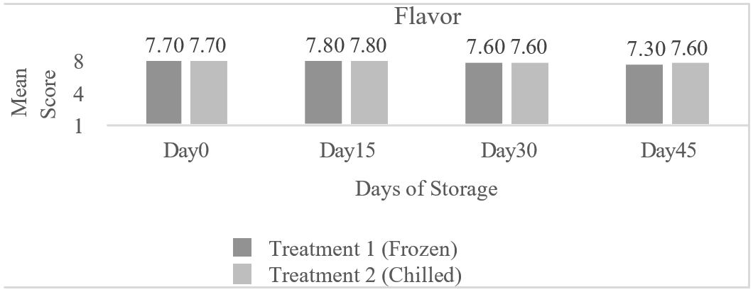
Figure 3. Mean score for flavor of steamed dolphinfish siomai during chilled and frozen storage.
Flavor is combined sensory response by the receptors int the mouth and nose. It is a sensation complicated by individual variations. Table 3 shows that in Day 0 until Day 45 the sensory panelist consistently evaluated Treatment I and the Treatment II have the same descriptive taste in Day 0 until Day 45 at this point the treatments does not greatly affect the quality of the product.
Most of the panelist member scored the flavor of the product as “Savory” as shown in Table 3. This may be due to the ingredients used in making the product and the addition of food flavors, food flavors are used to alter the flavors of the natural food products or creating a flavor for products that do not have the desired flavor and from the sensory perspective, the presence of fat helps make food taste good – smoother, creamier, richer, and more tender. This is so whether the fat is a structural ingredient as in meat and not by the way of storing it under chilled and frozen condition.
Table 3. Flavor Profile Steamed Dolphinfish siomai during chilled and frozen storage.

Treatments | Day 0 | Day 15 | Day 30 | Day 45
I(Frozen) | Savory | Savory | Savory | Savory
II(Chilled) | Savory | Savory | Savory | Savory

Odor
Food odors have been shown to influence food choices, portion selection and can promote a specific desire to consume certain food. This evaluation begins before consumption of food and is based on how the food smells. The sensory panel rating showed that the odor from day 0 to day 45 in both treatments as of what the panelist have observed was Neutral odor. This may be due to the ingredients like bread, carrots, eggs, and other spices such as pepper, garlic powder, MSG and other seasonings used that neutralizes the fishy odor of the products, the methods used for cooking and to the panel’s interest towards the product. This implicates that the products subjected under two storing conditions, it successfully preserved without degrading or affecting the odor quality of the product. The organoleptic evaluation of food products to any processing technology is very important in determining the acceptability (Mohamed et.al. 2011). Dolphinfish siomai were steamed and evaluated. Figure 4 shows that there are no changes in the odor evaluated by the panelist.
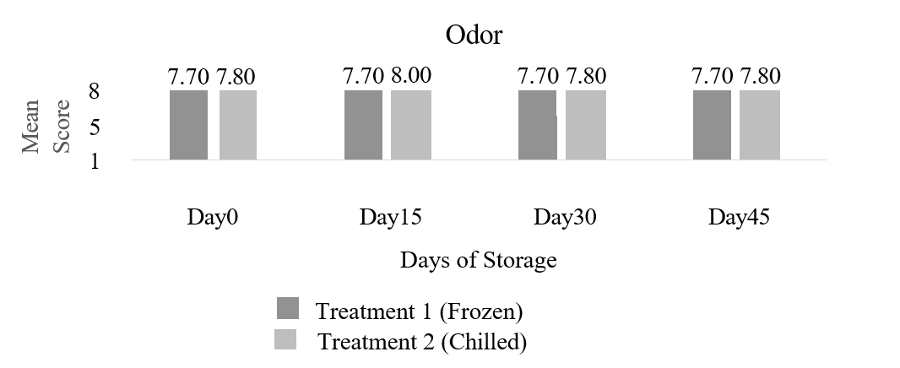

Figure 4. Mean score for Odor of steamed dolphinfish siomai during chilled and frozen

storage.

Table 4. Odor Profile of steamed dolphinfish siomai during chilled and frozen storage.

Treatments | Day 0 | Day 15 | Day 30 | Day 45
I(Frozen) | Neutral | Neutral | Neutral | Neutral
II(Chilled) | Neutral | Neutral | Neutral | Neutral

Texture
Food texture is a collective term of sensory experiences originated from visual, audio, and tactile stimuli. The sensation of food texture plays a crucial role in influencing consumers’ liking and preference of a food product. Consumer concern and interest of food texture vary from one type of food to another. Table 5. Shows that the textures of the samples did not change in textural attributes as day progresses. In day 0, panelist describes the samples as Soft in terms of its texture. This may be due to the crude fat of the sample which is 14.12%, the wanton wrappers that is made of flour which absorbs moisture, moisture content of the sample was 67.10% of the entire proximate composition of the samples that made the soimai soft in texture. In treatment I and II the panelist describes the sample from day 20 until day 45 as Soft as described in the Table 5.

Table 5. Texture Profile of steamed dolphinfish siomai during chilled and frozen storage.
Treatments | Day 0 | Day 15 | Day 30 | Day 45
I(Chilled) | Soft | Soft | Soft | Soft
II(Frozen) | Soft | Soft | Soft | Soft

All treatments obtained a constant trend as the day progress. In terms of texture, Treatment I had the highest panelist score. These treatments have a soft texture, in which according to the limit of acceptability, are acceptable quality. The sensory evaluation revealed that there were no significant differences (p > 0.05) as shown in the Figure 5.

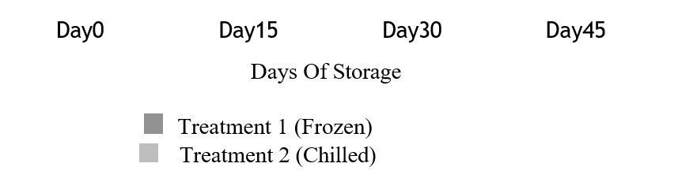
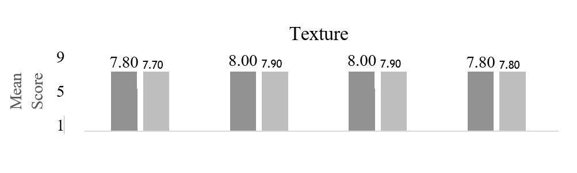

Figure 5. Mean score for Texture of steamed dolphinfish siomai during chilled and frozen storage.

General Acceptability

The overall acceptability of steamed dolphinfish siomai stored at different storage condition was done to evaluate the consumer acceptance in the product. Higher scores indicated better acceptability of the products.
Table 6 and Figure 6 shows that there is no significant difference (p > 0.05) because panelists describe treatment I samples as Like Moderately from the beginning of the study until the end, and Treatment II as Like Very Much from day 0 to day 45. The panelist tallied score arrived that Treatment I only got Like Moderately than Treatment II this could be due to what is the panelist interest towards the product and the form of analysis which is a comparative analysis where the testers answered it on which sample is accepted more and another factor is the mental images that people create regarding the product. Using significant level of 0.05%, results showed that there is no significant difference (p > 0.05) in general acceptability of sample in day 0 until day 30 as the day progresses when the sample reaches Day 45.

Table 6. General Acceptability Profile of steamed dolphinfish siomai during chilled and frozen storage.
Treatments Day 0 Day 15 Day 30 Day 45
Treatment 1 LM LM LM LM
Treatment 2 LVM LVM LVM LVM
*LM means Like Moderately
*LVM means Like Very Much

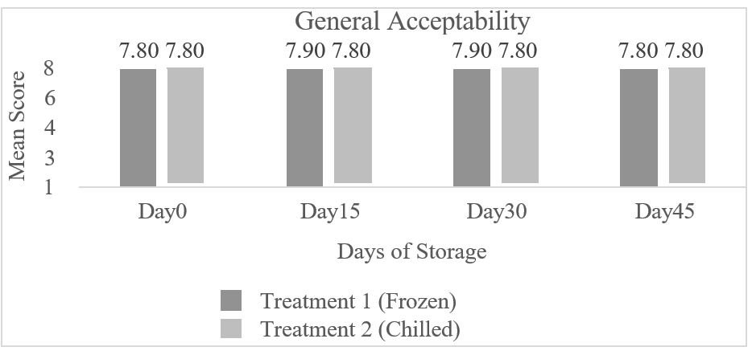

Figure 6. Mean score for General Acceptability of fried steamed dolphinfish siomai during chilled and frozen storage.

4. Conclusion

The spoilage of fish and fish products depends on a number of factors. These factors as well as the spoilage mechanism must be thoroughly understood before developing proper handling and pretreatment methods and preservation techniques for food products. To slow down the rapid spoilage of fish, it is essential to store the fish at 0°C after catching during harvesting. However, the energy intensive freezing operations is only a temporary method for preservation of the fish as freeze storage can decrease microbial and enzymatic spoilage but cannot prevent oxidative spoilage.
Frozen condition had been proven that it helps to slower down lipid oxidation and have longer shelf-life. This study revealed that dolphinfish siomai under frozen condition had lower peroxide value result that chilled. In this study the suggested storage was the frozen condition for it shows that the results were lower than the chilled that exceeds the acceptable limit of peroxide value. The maximum acceptable limit for fish products in peroxide value must not be 5.0 meq/kg and the values for frozen condition meets the acceptable limit, the researcher recommends that in storing fish products frozen condition will preserve its quality.
This study also shows that external factors like temperature storage and light exposure of the product can affect autoxidation. Dolphinfish siomai under chilled condition only texture was found to be significantly affected (p=0.05). The overall acceptability of the two treatments were not significantly affected by storage condition.
The researcher recommends to further monitor oxidative rancidity of dolphinfish siomai. It is likewise recommended that longer storage studies at lower temperatures (i.e. frozen storage) be conducted to observe other quality changes in surimi-based products and to determine their shelf-life.
Disclaimer:
This manuscript was prepared with the assistance of ChatGPT for language refinement. All content has been reviewed and edited to ensure accuracy and originality.
- chatgpt

AUTHOR CONTRIBUTION:
This work was carried out in collaboration among all authors. Author GMN conducted of the experiment including writing of the manuscript. Author LFB assisted in the conduct and the writing of the paper and improving the manuscript, submitting it to the journal, and handling the publication process in the study. Author GSH worked primarily in the editing of the proposal and final manuscript including data analysis and interpretation. Author ETM work primarily in the editing of the proposal and final manuscript including conceiving and designing the experiment. All authors read and approved the final manuscript.

References

Aminah (2010). Investigating Changes and Effects of Peroxide Values in Cooking Oils Subjected to Light and Heat. College for Women University, Pakistan.
AOAC (1984). Official Methods for Analysis Chemists, 14th Edition. Arlington, VA. pp. 11- .
BFAR (2023). Philippine Fisheries Profile. Fisheries Policy and Economics Division, Bureau of Fisheries and Aquatic Resources.
Choe, E., Min, D. (2009). Mechanisms of Antioxidants in the Oxidation of Foods. Comprehensive Review in Food Science and Technology. https://doi.org/10.1111/j.1541-4337.2009.00085.x
Connell (1990). Food Safety and Shelf Life of Cooked Meat Stored Under Different Temperatures. Tamil Nadu, India.
Espejo-Hermes (1998). Fish Processing Technology in the Tropics. National Science and Technology Authority and University of the Philippines, Quezon City.
FDA (2001a). GMPs Appendix A: Annotated Bibliography on Food Safety Problems and Recommended Controls.
Food And Agriculture Organization (FAO). (2020). The State Of World Fisheries And Aquaculture 2020: Sustainability In Action. Rome: Fao.
Gandotra et al. (2012). Change in Proximate Composition and Microbial Count by Low-Temperature Preservation in Fish Muscle of Labeo Rohita (Ham-Buch).
Huntsman (1931). Advances in Food Research.
Icott, C. M., and Lee (1986). Surimi: The "High-Value" Raw Material from Minced Fish Flesh. Food Reviews Int'l, 2: 213-246.
Kolbe & Kramer (2007). Planning for Seafood Freezing. University of Alaska, Fairbanks.
Koo, J. E., and J. L. Silva (1996). Optimization of a Process for the Processing of Dolphin Fish. October 9, Greenwood, MS.
Mohamed et al. (2011). Food Chemistry, 411-421.
Mybest (2024). 10 Best Siomai in the Philippines 2024 | Buying Guide Reviewed by Nutritionist-Dietitian - https://ph.my-best.com/16066
Philippine Fisheries Profile (2023). Fisheries Policy and Economics Division, Bureau of Fisheries and Aquatic Resources.
Suja, K. P., et al. (2004). Antioxidant Efficacy of Sesame Cake Extract in Vegetable Oil Protection. Food Chemistry, 84, 393-400.
UNDP/FAO Caribbean Fisheries Development Project, Barbados. DPWFLO Revised (2008). Frozen Food Handling and Storage.
US-FDA (2016). Code of Federal Regulation (CFR) Title 21

