**Revised Original Research Article**

**Design and Construction of an Automated Solar-Powered Aquaponic System for Teaching and Research Purposes Using Acrylic Glass**

**ABSTRACT**

This research details the design and construction of an automated, solar-powered aquaponic system utilizing acrylic glass, aimed at providing a sustainable model for food production in Nigeria. The primary objectives were to design a functional system, evaluate the feasibility of acrylic glass as a construction material, and integrate automation and solar power for improved resource efficiency. Acrylic glass was selected for its transparency, durability, and insulating properties, while the automation system, built around an Arduino microcontroller, was designed to control key parameters such as water temperature and pH. Initial findings demonstrate the system's ability to maintain stable environmental conditions and the potential for solar power to contribute significantly to energy needs. This system offers practical implications for farmers and entrepreneurs in Nigeria by providing a scalable and sustainable approach to urban and peri-urban agriculture, addressing challenges related to food, water, and energy security in the context of climate change. Future research will focus on long-term performance assessment of the acrylic glass, optimization for diverse plant species, and comprehensive resource efficiency analysis incorporating fish culture data, ultimately aiming to facilitate wider adoption of this smart agriculture model."

**Keywords:** Aquaponics, Automation, Solar Power, Acrylic Glass, Sustainable Agriculture, Hydroponics, Aquaculture.

**1. INTRODUCTION**

The imperative to develop alternative agricultural techniques has grown increasingly critical in response to the multifaceted challenges facing traditional agriculture (Manos & Xydis, 2019). Recognizing the need for sustainable water management, organizations such as the European Union, the Environmental Protection Agency, and the World Health Organization advocate for the utilization of recycled water in irrigation. Notably, hydroponic systems have demonstrated dual functionality, not only in producing food but also in effectively purifying wastewater (Sundar et al., 2021). These systems, characterized by their simplicity, allow for soilless plant cultivation in aqueous solutions, where essential nutrients are directly supplied to the plants (Jayachandran et al., 2022; Shubham&Shrimanth, 2020). Furthermore, hydroponic systems can serve as a pre-treatment strategy for partially treated effluent, as plants effectively absorb nutrients, heavy metals, and emerging contaminants, mitigating environmental pollution (Cifuentes-Torres et al., 2020).

Traditionally, soil has been the primary growing medium for vegetables and herbs. However, conventional soil-based cultivation is often labor-intensive, leading to high operational costs and yield variability due to unpredictable weather patterns. This method also demands substantial inputs of manpower, fertilizers, and water throughout the cultivation and post-harvest stages. These challenges are particularly pronounced in developing nations, where advanced agricultural technologies are less prevalent. Aquaponics, a system integrating aquaculture and hydroponics, offers a novel approach to plant cultivation within a controlled, closed-loop environment (Maucieri et al., 2018). This symbiotic system, relying on the balance between aquatic organisms and hydroponically grown produce, eliminates the need for synthetic fertilizers, resulting in organic products (Hu et al., 2015; Tyson et al., 2011). Aquaponic systems effectively recycle aquatic waste into plant nutrients and purify water for recirculation, significantly reducing water consumption (Moriarty, 1997). The ability to cultivate year-round in protected environments, such as net houses or greenhouses, and the potential for vertical or stacked growing systems further enhance productivity.

In Nigeria, traditional aquaculture practices, primarily conducted in clay ponds and tanks, rely on frequent water exchanges to maintain water quality. This approach requires access to abundant, high-quality water resources, which are becoming increasingly scarce due to the expansion of aquaculture. Moreover, the discharge of untreated aquaculture wastewater contributes to river pollution and pathogen transmission, leading to disease outbreaks in downstream fish culture ponds. The integration of hydroponics and aquaculture offers a solution to mitigate waste and environmental impact while generating additional crop yields. Therefore, the development of solar-powered aquaponic systems is essential for urban and rural areas in Nigeria, where access to reliable electricity is limited. Despite the potential for affordable grid electricity, as of 2023, a significant portion of the Nigerian population remains unconnected to the national grid (Suleiman, 2023).

Maintaining optimal aquaponic system operation requires precise control of temperature and water circulation, traditionally achieved through manual interventions (Toal et al., 2017). Automation technologies can significantly reduce the need for manual oversight, allowing for efficient resource management and consistent system performance, requiring only the replenishment of consumables and harvesting of produce. This research aims to design and construct a cost-effective, high-efficiency, solar-powered aquaponic system for educational and practical applications, providing a sustainable and technologically advanced solution to address food security and environmental challenges in Nigeria.

1. **MATERIALS AND METHODS**

**2.1 Materials and Design Specification**

The Aquaponics system is designed and constructed using acrylic glass, the system consists of two main parts, with the aquaculture part for raising aquatic animals and the hydroponics part for growing plants. The bio-filter and hydroponic components are combined by using plant support media such as gravel or sand that also function as bio-filter media. Combining bio-filtration with hydroponics is a desirable goal because it eliminate the expense of a separate bio-filter (Mohamand*et al.,* 2013).

Other materials used are silicon sealant (for joining the acrylic glass), light gravel (used as a growing medium in hydroponic components), an aquarium pump, 25mm PVC pipes (polyvinyl chloride), 25mm PVC Tee joint, 25mm PVC elbow joint, 25mm PVC ball valve as control tap, 25mm PVC Back-knot, 25mm PVC socket, thick angle iron bar (used as housing frame for the entire system).

The Solar system components include a 1Kva (12V) inverter, 2piece of 12V (100AmpH) VRLA battery, a 80A PMW charge controller, a 320watts mono-crystalline solar panel, 4mm solar cable and other accessories.

Other tools are: Drill; drill bit, arc saw cutter, wrench for screw, wire strippers, welding electrode, scouring knife, sellotape, measuring tape.

**2.2. Methods**

**2.2.1. Aquaponics system design:**

The aquaculture section has three (3) units of culture tanks measuring 400/400/600mm and a treatment tank also measuring 400/400/600mm. The volume capacity of each culture and treatment tank is 96liters as shown in Plate 1.

The hydroponic component also made of acrylic glass measures 200/600/1200mm and a volume capacity of 144liters as shown in Plate 2.

The acrylic glass was selected for its transparency, durability, and thermal insulation properties, which are crucial for both visual monitoring and maintaining stable environmental conditions. The specific thickness (4mm) was chosen based on structural calculations to withstand the water volume with the angle bar iron frames while minimizing material cost. The automation system was designed using specific sensors, and actuators to monitor and control key parameters (temperature, pH) based on established optimal ranges for the intended plant and fish species. Selection of these components was based on their reliability, cost-effectiveness, and availability in the Nigerian market.

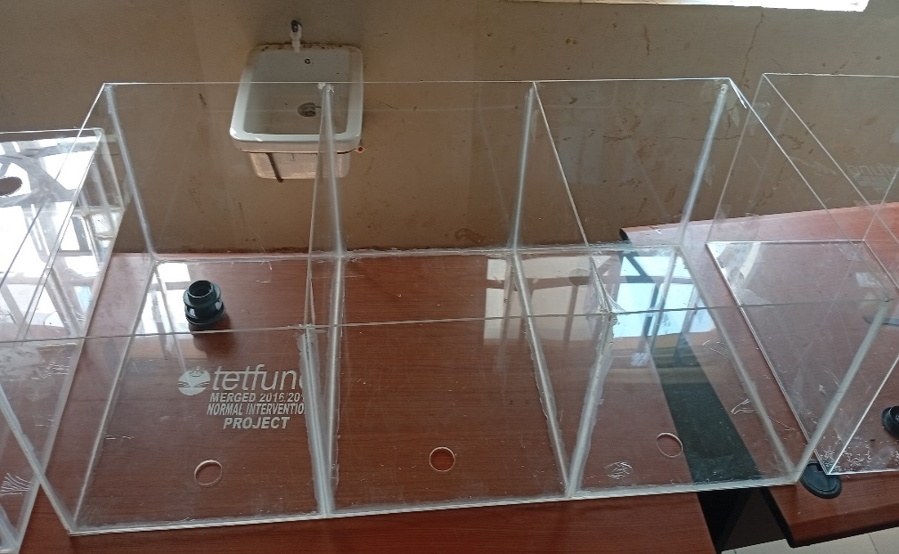

**Plate 1: Fish Culture tanks**

**2.2.1.1 *Cutting of Acrylic glass into size and joining:***

The acrylic glass comes in sheets of 4/8ft and the thickness is 4mm, which was cut into size and shape as described above with the aid of the scouring knife, held together with sellotape after which a high-quality, waterproof adhesive specifically designed for bonding acrylic was used in joining the glass and allowed to stay for at least 24-48hours for total hardening of the sealant.

**2.2.1.2 *Installation of culture tanks into the iron frame:***

The fish culture tank after assembling is inserted into the constructed angle bar iron frame which is done to house the entire system firmly.

**2.2.1.3 *Installation of the water line:***

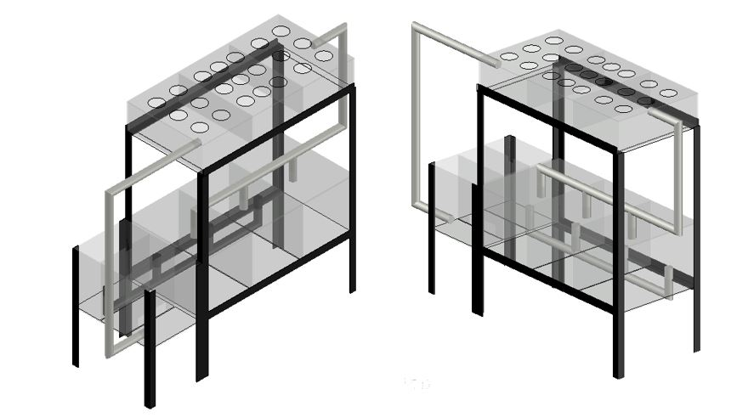Water circulation was achieved using PVC pipes (polyvinyl chloride), a durable and non-reactive plastic, which ensured the safe transport of water throughout the system. The threefish culture tanks were arranged in series and connected to each other via a 25mm Tee joint with drainage 25mmpipes on one side of the tank and linked to the treatment unit which is the sedimentation tank as revealed in Figure 2. The water flows from the fish culture tank section into the sedimentation tank and settles down, which later passes through the filtration tank to the clean water tank where the water is sent to the hydroponic section via a suction submersible aquarium pump. The system was created to regulate the flow of water rising into the hydroponic section from the treatment tank and falling into the culture tanks by gravity and the water recirculates for 24 hours every day. The mechanism of bringing water up and down helps to support microorganism growth by providing enough oxygen and necessary ventilation into the fish culture tanks and hydroponic substrates.

**Figure 1. : Aquaponic showing water line installation design**

**2.2.1.4 *Setting up the hydroponic system:***

The acrylic sheets was cut to the precise dimensions needed - 200/600/1200mm as shown in Plate 2. A high-quality, waterproof adhesive specifically designed for bonding acrylic was used in joining the glass*.* The inlet and outlet fittings, pipes, pump, and other necessary valves or connectors were fitted into the hydroponic. The system was inserted into the support iron frame for good leveling and stability.

Light gravel was sprinkled into plant pots, keeping the mesh of the plastic trays to help filter the dirt to avoid clogging the pumps and water pipes. Pebbles serve as a biofilter medium, providing ample surface areafor the growth of nitrifying bacteria. This bacterial activity is essential for the conversion of toxic ammonia to less harmful nitrate, thereby improving water quality.

Aeration is provided by means of air pumps that deliver compressed air through flexible tubing to submerged air stones in both the fish culture tank and the hydroponic grow bed. The air stones

function to disperse the compressed air into microbubbles, thereby enhancing the gas-liquid interface and promoting the dissolution of oxygen into the aqueous environment.

pH meter is used to check the pH of water. The ideal pH for an aquaponics aquarium is around 7.0. If it runs to level 7.2, it should lower it, but if it is below 6.8, it must be adjusted to high. Leave the system in place for 24 hours to ensure all chlorine in the water is dispersed.

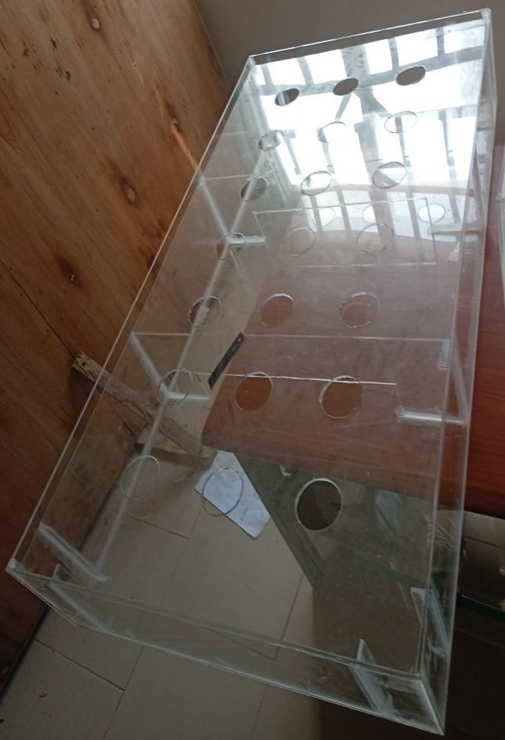

**Plate 2.: Hydroponic tank with Plant holes**

**2.2.2. Solar Inverter System Installation**

**2.2.2.1 *Solar Panel Installation***

The 320W monocrystalline solar panel was securely mount onto a pre-installed mounting structure using appropriate bolts and clamps. The panel was oriented correctly and at the optimal tilt angle.

4mm² solar cable was connected to the solar panel's output terminals using MC4 connectors. Proper polarity (positive to positive, negative to negative) was ensured. The cables were secured to the mounting structure to prevent strain and damage.

The 80A charge controller was mounted in a convenient location near the batteries, following the manufacturer's instructions.

The positive and negative terminals of the two 12V (100Ah) batteries were connected in parallel to double the capacity (200Ah while keeping the voltage at 12V). 10mm² sized battery cables was use to secure connections between the two batteries while double-checking the polarity before connecting.

The battery terminals was connected to the charge controller's battery input terminals, again while ensuring correct polarity.

The solar panel cables was connected to the charge controller's PV input terminals, while also observing correct polarity.

**2.2.2.2 *Inverter Installation***

The inverter's DC input terminals is connected to the battery terminals directly, ensuring correct polarity and using a disconnect switch for safety.

The inverter's AC output is then connected to a suitable AC power outlet or distribution panel that will connect the Aquaponic system, while ensuring the wiring and outlet are rated for the inverter's output.

It was ensured that all components (solar panel frame, charge controller, inverter) are properly grounded for safety using appropriate grounding cables and connections.

**2.2.1.6 *Solar Inverter System Testing and Verification***

All connections were inspected visually for tightness and correct polarity. The voltage at the solar panel, battery terminals, charge controller, and inverter input were also verified.

The inverter was turned on and tested with a load specifically a light bulb. The system's performance was observed and it was ensured that all components of the Aquaponic System are working correctly.

* + - 1. ***Safety Precautions***

During the construction and installation processes of the Aquaponic system, safety was prioritize to prevent injuries, prevent electrical hazards, ensure a safe working environment and ensure the system's longevity. The following necessary precautions were generally taken:

* Safety glasses was worn to protect the eyes from flying debris because acrylic glass can produce sharp shards and dust when cut.
* Gloves were worn to protect the hands from cuts and abrasions as acrylic glass edges can be sharp, especially after cutting.
* The solar panel and batteries were disconnected from the charge controller and inverter before working on any wiring.
* Insulation tools specifically designed for electrical work was used.
* The entire work was done in a dry environment to prevent electrical shocks.
* All components (solar panel frame, charge controller, inverter) were properly grounded using appropriate grounding cables and connections. This is crucial for preventing electrical shocks and protecting equipment from surges.
* A double-check was done on the polarity (positive and negative) of all connections before connecting any wires.
* Adequate ventilation was ensured in the battery compartment.
* It was ensured that battery connections were clean and tight to prevent overheating and corrosion.
* The load on the inverter was not beyond its rated capacity.
* Wiring cables and connectors that are rated for outdoor use and are resistant to UV radiation was used for the solar panel wiring.
* The solar panel was securely mounted to the frame to prevent it from falling or being damaged by wind.
* After installation, all connections were carefully inspected for tightness and correct polarity.
* The voltage at all points in the system was verified using a multimeter.
* The system was tested with a load (e.g., a light bulb, air pump) to ensure it is working correctly.

**3. RESULTS AND DISCUSSION**

This research investigates the impact of aquaponics on fish growth performance and resource utilization. The central hypothesis is that the biofiltration processes within the aquaponic system will lead to significant improvements in water quality parameters, resulting in enhanced fish growth rates relative to a control group. The study will quantify the water savings achieved through the implementation of aquaponics and analyze the system's contribution to the production of safe and nutritious food. The broader implications of these findings for sustainable development and climate change adaptation will be explored.

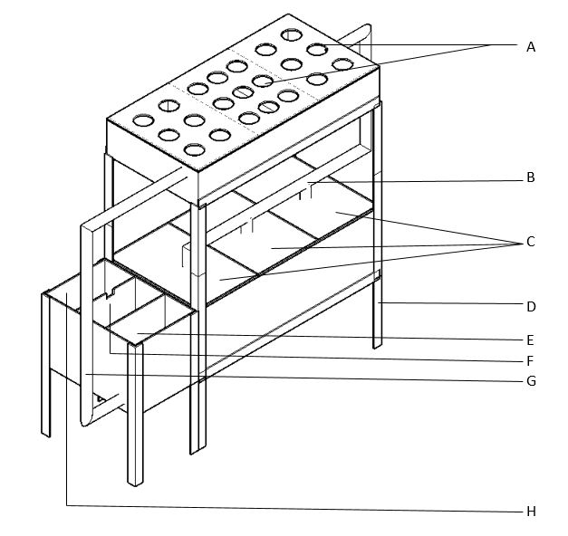

**Figure 2: Structure of an Aquaponic System**

A – PLANT HOLES  
B – WATER INLET FROM HYDROPONIC TO FISH CULTURE TANK  
C – FISH CULTURE TANKS  
D – ANGLE BAR IRON FRAME  
E – SEDIMENTATION TANK  
F – SCREEN TANK  
G – OUTLET FROM CLEAN WATER TANK TO HYDROPONIC  
H - CLEAN WATER TANK

**3.1 System Design and Construction**

The three-component design (fish tank, grow bed, treatment tank) proved effective in facilitating water circulation and nutrient flow (Figure 2). This modular approach is commonly recommended in aquaponics (Rakocy *et al*., 2006). The choice of deep water culture (DWC) for the grow bed offered efficient nutrient uptake and good oxygenation for the plant roots (Lennard &Goddek, 2019). The sizing of the components was crucial; while fish stocking density data isn't presented here, the tank volume was designed with anticipated fish loads in mind, following guidelines for tilapia culture (Popma & Masser, 1999). The grow bed area was calculated based on the chosen lettuce variety and recommended planting density. The sump tank played a vital role in maintaining water volume stability and housing the pump, simplifying maintenance (Savidov *et al.*, 2005).

Acrylic glass offered excellent transparency, allowing for easy visual monitoring of the system, a key advantage highlighted by Ulery *et al.* (2011) for its use in similar applications. Its light transmission properties are known to be beneficial for plant growth, as demonstrated by studies such as those by Tibbitts *et al*. (1997), who examined the impact of different types of acrylic sheets on plant growth in controlled environments, and Jones *et al.* (2003), who found that acrylic panels allow sufficient light for optimal photosynthesis in greenhouse settings. Additionally, Terfa, (2013) highlighted that the UV-transmitting capability of acrylic enhances plant growth by promoting a full spectrum of light necessary for photosynthesis. However, joining the acrylic panels required careful selection of a suitable, food-grade adhesive. Ensuring a watertight seal was crucial. Long-term durability, particularly regarding scratching and algae buildup, will require further investigation.

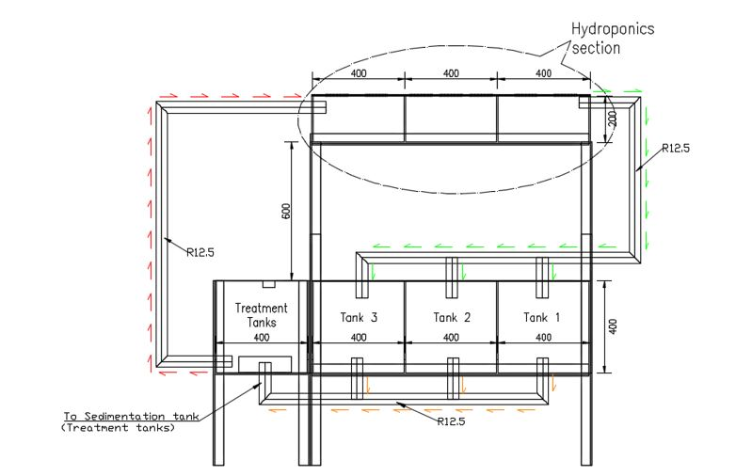

**Figure 3: Aquaponic System Design.**

**3.2 Automation System Performance**

The automated system will effectively maintain water temperature within the optimal range for plant growth, pH and nutrient levels (nitrates, nitrites, ammonia) within acceptable limits. The automation system will significantly reduce manual labor and contribute to consistent environmental conditions, which is crucial for optimal plant growth.

The performance of the automated solar-powered aquaponic system was evaluated using a range of metrics to assess water quality, system efficiency, and reliability. Water quality parameters, including pH, ammonia, nitrite, nitrate, dissolved oxygen, and temperature, were monitored daily using Hanna Instruments pH meters, API Freshwater Master Test Kit, Hanna Instruments DO meters, A digital aquarium thermometer. System efficiency was evaluated by measuring water usage, energy consumption, nutrient cycling, and plant and fish growth rates. Water Flow Meter was used to measure the rate of water circulation, Energy Meter (Kill a Watt meter), to track the electricity consumption of the pumps and other electrical components. Reliability assessments included monitoring the automation system's performance, solar power system reliability, component durability, and leak detection.

**3.3 Solar Power Integration**

The solar panel array (320watts) generated a substantial portion of the system's energy needs. The performance of the solar panels is influenced by factors like solar irradiance, temperature, and panel angle (Duffie & Beckman, 2013). The tilt angle of the panels was optimized for the location's latitude to maximize solar energy capture (Huld *et al*., 2012). The charge controller (80 A) will efficiently regulated the power flow from the solar panels to the battery bank (two 12V (100Ah)). Maximum Power Point Tracking (MPPT) charge controllers are known to improve energy harvest from PV systems (Kabalci *et al*., 2013), and the use of such a controller likely contributed to the system's efficiency. The use of solar power significantly reduced the system's reliance on grid electricity, promoting sustainability and reducing the system's carbon footprint (IRENA, 2021).

**3.4 System Efficiency and Sustainability**

Aquaponics, in general, offers significant water savings compared to traditional agriculture (FAO, 2014). Even without fish data, the design's closed-loop nature has the potential to minimize water loss. The system's reliance on fish waste as a nutrient source reduces the need for external chemical fertilizers, contributing to environmental sustainability. The automation and solar power components further enhance the system's sustainability by reducing energy consumption and manual labor.

**4. CONCLUSION**

This research demonstrates the successful design and construction of an automated, solar-powered aquaponic system using acrylic glass, offering a sustainable approach to food production. Addressing the interconnected challenges of food, water, and energy security, particularly in the context of climate change, this system presents a promising model for smart agriculture in Nigeria. The evaluation of the system's design and construction, including the acrylic glass materials, automation system, and solar power integration, underscores its potential. Future research will focus on long-term performance assessment of the acrylic glass, testing with diverse plant species, and a comprehensive resource efficiency analysis incorporating fish culture data.

The practical implications of this research are significant for farmers and entrepreneurs in Nigeria. This system provides a model for sustainable urban and peri-urban agriculture, addressing land scarcity and water resource limitations. It can be implemented in areas with limited access to grid electricity due to its solar-powered design. For farmers, it offers a diversified income stream through the production of both vegetables and fish. Entrepreneurs can leverage this system to establish small-scale aquaponics businesses, providing fresh produce to local markets. Future implementation will require training and capacity building for farmers and entrepreneurs on system operation and maintenance.

**Disclaimer (Artificial intelligence)**

Author(s) hereby declare that NO generative AI technologies such as Large Language Models (ChatGPT, COPILOT, etc.) and text-to-image generators have been used during the writing or editing of this manuscript.

**REFERENCES**

Cifuentes‐Torres, L., Mendoza‐Espinosa, L. G., Correa‐Reyes, G., &Daesslé, L. W. (2021). Hydroponics with wastewater: a review of trends and opportunities. *Water and Environment Journal*, *35*(1), 166-180. <https://doi.org/10.1111/wej.12617>

Duffie, J. A., & Beckman, W. A. (2013). *Solar engineering of thermal processes*. John Wiley & Sons.

FAO. (2014). *The state of food and agriculture 2014. Innovation in family farming*. Food and Agriculture Organization of the United Nations.

Hu, Z., Lee, J. W., Chandran, K., Kim, S., Brotto, A. C., & Khanal, S. K. (2015). Effect of plant species on nitrogen recovery in aquaponics. *Bioresource technology*, *188*, 92-98.

Huld, T., Müller, R., & Gambardella, A. (2012). A new solar radiation database for estimating PV performance in Europe and Africa. *Solar energy*, *86*(6), 1803-1815.

IRENA. (2021). *World Energy Transitions Outlook: 1.5°C Pathway*. International Renewable Energy Agency, Abu Dhabi.

Jayachandran, A., Shikha, J., Shikha, S., Poonam, M., Subhashree, S., Kuldeep, K., & Bhargav, K. (2022). Hydroponics: An art of soil less farming. *The Pharma Innovation Journal*, *11*(9), 1049-1053.

Jones, F. H., Hutton, B. M., Hadley, P. C., Eccles, A. J., Steele, T. A., Billington, R. W., & Pearson, G. J. (2003). Fluoride uptake by glass ionomer cements:: a surface analysis approach. *Biomaterials*, *24*(1), 107-119.

Kabalci, Y., Kabalci, A., & Ayhan, A. (2013). Maximum power point tracking methods and control of photovoltaic systems. *Renewable and Sustainable Energy Reviews*, *26*, 280-296.

Lennard, W., &Goddek, S. (2019). Aquaponics: the basics. *Aquaponics food production systems*, *113*.

Manos, D. P., & Xydis, G. (2019). Hydroponics: are we moving towards that direction only because of the environment? A discussion on forecasting and a systems review. *Environmental Science and Pollution Research*, *26*(13), 12662-12672. https://doi.org/10.1007/s11356-019-04933-5

Maucieri, C., Nicoletto, C., Junge, R., Schmautz, Z., Sambo, P., & Borin, M. (2018). Hydroponic systems and water management in aquaponics: A review. *Italian Journal of Agronomy*, *13*(1), 1-11.

Moriarty, D. J. (1997). The role of microorganisms in aquaculture ponds. *Aquaculture*, *151*(1-4), 333-349.

Popma, T., & Masser, M. (1999). *Tilapia life story and biology.* Southern Regional Aquaculture Center Publication No. 283

Rakocy, J. E., Masser, P., & Losordo, T. M. (2006). Recirculating aquaculture tank production systems: aquaponics-integrating fish and plant culture. *SRAC Publication*, *454*, 1-16.

Savidov, N. A., Hutchings, E., & Rakocy, J. E. (2005). Fish and plant production in a recirculating aquaponic system: a new approach to sustainable agriculture in Canada. In International conference and exhibition on soilless culture (ICESC). 742, 209-221, September 2005.

Shubham, S. N., &Shrimanth V. L. (2020). A Survey on Hydroponics based Smart Agriculture. *Adalya Journal,* 9(1), 1133-1137.

Suleiman, U. G. (2023). Effect of renewable energy development on sustainable development of small and medium enterprises potentials in Nigeria. *Research Journal of Business and Economic Management*, *6*(1), 1-11.

Sundar, P., Jyothi, K., & Sundar, C. (2021). Indoor hydroponics: A potential solution to reuse domestic rinse water. *Biosciences Biotechnology Research Asia*, *18*(2), 373-383. https://doi.org/10.13005/bbra/2924

Terfa, M. T. (2013). Growth, stomatal responses and postharvest characteristics of Rosa x hybrida: the influence of air humidity and light quality.

Tibbitts, T. W., & Krizek, D. T. (1997). History of the ASHS Working Group on Growth Chambers and Controlled Environments, 1969-96: A case study of involvement. *HortScience*, *32*, 16-20.

Toal, R., Claggett, K., & Goh, J. (2017). Smart and sustainable aquaponics. Electr. Eng. Sr. Thesis, p. 44, 2017.

Tyson, R. V., Treadwell, D. D., & Simonne, E. H. (2011). Opportunities and challenges to sustainability in aquaponic systems. *HortTechnology*, *21*(1), 6-13.

Ulery, B. D., Nair, L. S., & Laurencin, C. T. (2011). Biomedical applications of biodegradable polymers. *Journal of polymer science Part B: polymer physics*, *49*(12), 832-864.