**The Development of a Test Paper for Spatial Concept Core Literacy Based on** **Compulsory Education Mathematics Curriculum Standards**

**ABSTRACT**

In the context of the construction of the Compulsory Education Mathematics Curriculum Standards (2022 Edition), China's junior middle school mathematics teaching emphasizes the core literacy orientation, and the implementation of spatial conceptual literacy, as one of the main manifestations of junior middle school mathematical core literacy, has attracted a lot of attention, but how can we assess whether students have mastered the spatial conceptual literacy? How to quantify the level of spatial conceptual literacy of middle school students? This problem still has no good way to solve. Based on this, this paper analyzes the meaning, dimensions and performance of spatial conceptual literacy based on the curriculum standards, and refers to the steps of test preparation in Yang Zezhong's book Measurement and Evaluation in Mathematics Education, to design a set of test papers for junior high school students' spatial conceptual literacy level around the theme of spatial conceptual literacy, with a view to evaluating the spatial conceptual literacy level of the students through quantitative methods. The test consists of 10 questions, which are strictly in accordance with the requirements for spatial conceptual literacy in the curriculum standards, and the difficulty and gradient are reasonably designed, with the aim of providing an effective reference for the quantitative assessment of junior high school students' spatial conceptual literacy.

**Keywords:** Spatial Concept; Core Literacy; Mathematics Curriculum Standards; Test Paper Development; Junior High School Mathematics

1. **INTRODUCTION**

With the continuous deepening of mathematics curriculum reform, the Ministry of Education of China issued the *Opinions on Comprehensively Deepening Curriculum Reform and Implementing the Fundamental Task of Cultivating Morality and Talent* in March 2014, which clearly pointed out the core position of the core literacy system in deepening curriculum reform and implementing the fundamental task of cultivating morality and talent. Spatial concept, as one of the core literacy elements in junior high school mathematics, was first explicitly proposed in the *Compulsory Education Mathematics Curriculum Standards (2022 Edition)*.[1] It mainly refers to the understanding of the shape, size, and positional relationships of spatial objects or figures. The Mathematics Curriculum Standards for Compulsory Education (2022 Edition) was revised to meet the needs of education reform in the new era and to implement the fundamental task of establishing moral character. It specifies that the core qualities to be cultivated in the mathematics curriculum at the stage of compulsory education are the “three knowledges”, i.e., the ability to observe the real world with mathematical vision, the ability to think about the real world with mathematical thinking, and the ability to express the real world in the language of mathematics. express the real world in the language of mathematics. Spatial conception is an important part of the core literacy in mathematics, which involves the ability to perceive, imagine, reason and express spatial objects. It is not only the foundation of students' mathematical learning, but also an important support for the spirit of innovation and practical ability. Internationally, research on spatial conception has gradually become a hot topic in education, especially in mathematics education and cognitive science, where spatial conception is regarded as a key ability for students to understand mathematical concepts, solve practical problems, and engage in creative thinking. In terms of cognitive development, researchers have focused on the process of formation and development of spatial concepts in children and adolescents. Studies have shown that the development of spatial concepts is closely related to the cognitive developmental stage of an individual, and is also influenced by the educational environment and teaching methods; in terms of educational practice, the curriculum standards and teaching reforms of many countries emphasize the cultivation of spatial concepts. For example, the mathematics curriculum standard of the United States takes spatial conception as one of the core contents, and develops students' spatial understanding and expression through the study of graphics and geometry. The development of spatial concept literacy not only helps students understand the forms and structures of spatial objects in real life but also promotes the formation of spatial imagination and enhances spatial reasoning ability, enabling students to analyze problems and find solutions in complex situations[3-4]. In recent years, the rapid development of technologies such as "Internet+" and artificial intelligence has brought unprecedented changes to human social life and has put forward higher requirements for the cultivation of talents in the new era. Future mathematics talents are not only required to possess professional mathematical knowledge but also need to have imagination and creativity.

Then how to measure the level of students' spatial conception? In his book Measurement and Evaluation in Mathematics Education, Prof. Yang Zezhong mentions the steps of preparing a measurement paper: analyzing the measurement objectives, measuring the performance dimensions of the objectives, measuring the performance of the objectives in each dimension, reverse checking, coming up with questions for each dimension, giving the scoring criteria, and preparing a complete set of test papers. However, he only gave generalized steps for the preparation of test papers and did not focus on a particular measurement issue such as spatial conceptual literacy. Therefore, the purpose of this study is to refer to the connotation and requirements of the new curriculum standard on spatial conceptual literacy, and refer to the steps of preparing a measurement paper in Yang Zezhong's book Measurement and Evaluation in Mathematics Education, to prepare a set of test papers for junior high school students' spatial conceptual literacy developmental level with reference to the issue of spatial conceptual literacy[7] in order to assess the developmental level of junior high school students' spatial conceptual literacy in quantitative terms[2][5][6][10].

The research is guided by the following questions:

(1)How to construct the test dimensions for the development level of spatial concept literacy among junior high school students?

(2) What questions can be developed to assess the development level of spatial concept literacy among junior high school students?

**2. ANALYSIS OF MEASUREMENT OBJECTIVES**

The measurement objective of this study is the spatial concept literacy of junior high school students. According to the definition in the *Compulsory Education Mathematics Curriculum Standards (2022 Edition)*, spatial concept mainly refers to the understanding of the shape, size, and positional relationships of spatial objects or figures. It includes the ability to abstract geometric figures from object characteristics and to imagine actual objects from geometric figures; to imagine and express the spatial orientation and positional relationships of objects; and to perceive and describe the motion and change patterns of figures.

It covers multiple aspects of spatial abilities, such as spatial perception, spatial imagination, spatial reasoning, spatial expression, spatial application, spatial abstraction, and spatial integration. It is expected that students will be able to perceive the shape, size, position, and relationships of objects through observation and manipulation; construct and manipulate geometric figures in their minds, such as rotation, translation, and symmetry; analyze the properties and relationships of geometric figures through logical reasoning to solve related problems; abstract geometric concepts and properties from concrete figures for theoretical analysis; and accurately express them using language, symbols, or diagrams.

**3. DIMENSIONS OF MEASUREMENT OBJECTIVES**

Based on the definition of spatial concept, the spatial concept literacy of junior high school students can be divided into the following four dimensions:

**3.1 Dimension 1: Ability to Abstract Geometric Figures from Object Characteristics**

Students can observe the size, shape, and structure of objects, ignoring non-geometric attributes such as material and color, and extract basic geometric figures such as squares, rectangles, triangles, and circles. This abstraction process helps to understand the essential attributes of objects. Students who can identify basic geometric features from complex objects and transform three-dimensional objects into two-dimensional figures demonstrate a keen perception of shape, spatial imagination, and abstraction abilities. For example, a basketball can be abstracted into a sphere by ignoring its texture and color; a desk can be abstracted into a combination of rectangular prisms and cylinders by ignoring its color and material.

**3.2 Dimension 2: Ability to Imagine Actual Objects from Geometric Figures**

Students can observe and analyze geometric figures (such as circles, triangles, and cylinders), understand their shape, structure, size, and characteristics, and associate them with concrete objects in real life to form specific object images in their minds. This ability to link abstract geometric shapes with real objects helps develop spatial imagination. For example, seeing a sphere can evoke images of basketballs or soccer balls; seeing a rectangular prism can evoke images of desks or books.

**3.3 Dimension 3: Imagine and Express the Spatial Orientation and Positional Relationships of Objects**

By observing and thinking, students can construct the position, direction, and relative relationships of objects in space in their minds and accurately express them using language, images, or other means. In simple terms, they can understand the spatial position of objects (such as up, down, left, right, front, back) and their relative relationships (such as adjacent, parallel, perpendicular) and describe or demonstrate these relationships accurately.

**3.4 Dimension 4: Perceive and Describe the Motion and Change Patterns of Figures**

By observing and analyzing, students can understand the characteristics, trends, and patterns of figures in motion or change and clearly express them using language, symbols, or diagrams. In simple terms, they can observe how figures move, rotate, scale, or deform and summarize the patterns of these motions and changes. The motions of figures include translation, rotation, and axial symmetry.

**4. SUB-DIMENSIONS OF MEASUREMENT OBJECTIVES**

This step further refines the dimensions described in Section 3.

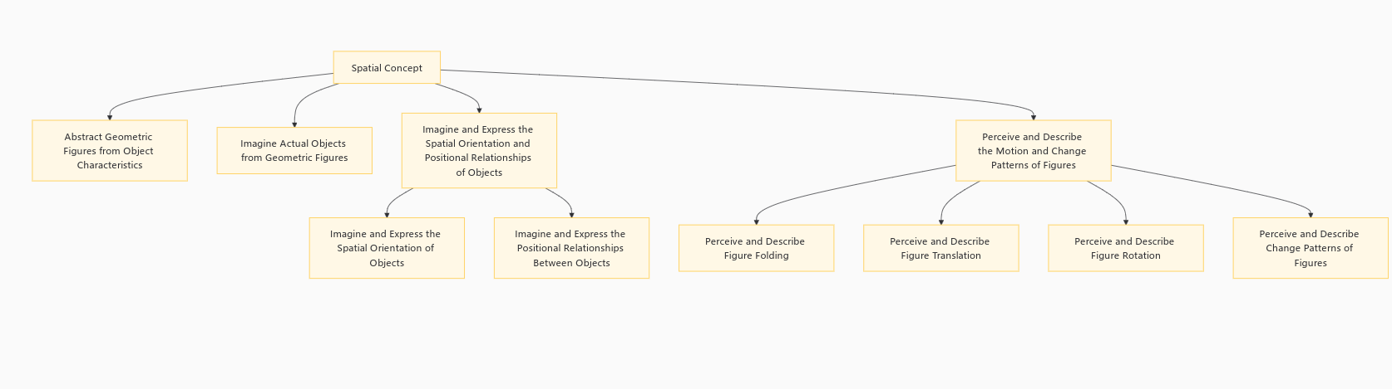

Figure 1: Further Subdivision Diagram of Spatial Concept Literacy

It can be seen that based on the dimensions described in Section 3, the dimension "Imagine and express the spatial orientation and positional relationships of objects" is further divided into "Imagine and express the spatial orientation of objects" and "Imagine and express the positional relationships between objects"; the dimension "Perceive and describe the motion and change patterns of figures" is divided into "Perceive and describe figure folding," "Perceive and describe figure translation," "Perceive and describe figure rotation," and "Perceive and describe the change patterns of figures." This refinement allows for more detailed and reasonable measurement.

Therefore, the development level of spatial concept literacy is divided into the following eight dimensions:

Dimension 1: Ability to abstract geometric figures from object characteristics.

Dimension 2: Ability to imagine actual objects from geometric figures.

Dimension 3: Imagine and express the spatial orientation of objects.

Dimension 4: Imagine and express the positional relationships between objects.

Dimension 5: Perceive and describe figure folding.

Dimension 6: Perceive and describe figure translation.

Dimension 7: Perceive and describe figure rotation.

Dimension 8: Perceive and describe the change patterns of figures.

**5. REVERSE CHECKING OF DIMENSIONS**

This step checks whether the dimensions identified can reflect the development level of students' spatial concept literacy in reverse.

After expert review and peer discussion, it was unanimously agreed that the eight dimensions—"Ability to abstract geometric figures from object characteristics," "Ability to imagine actual objects from geometric figures," "Imagine and express the spatial orientation of objects," "Imagine and express the positional relationships between objects," "Perceive and describe figure folding," "Perceive and describe figure translation," "Perceive and describe figure rotation," and "Perceive and describe the change patterns of figures"—can all reflect the development level of spatial concept literacy among junior high school students. Therefore, all dimensions are retained.

**6. QUESTION DEVELOPMENT FOR EACH DIMENSION**

**6.1 Questions for Dimension 1****[8-9]:**

**Question 1:** Please draw the geometric figure corresponding to the following actual object:



Figure 2: Diagram for Question 1

**Question 2:** Please draw the geometric figure corresponding to the following actual object:



Figure 3: Diagram for Question 2

**Design Intent:** Questions 1 and 2 aim to assess students' ability to abstract geometric figures from object characteristics. The design is relatively basic, divided into two levels. Question 1 examines a single geometric figure, while Question 2 increases the difficulty by examining composite figures. If a student cannot answer Question 1, it indicates an inability to abstract geometric figures from object characteristics. If a student can answer Question 1 but not Question 2, it suggests they can only abstract simple geometric figures. Only if both questions are answered correctly can it be concluded that the student can abstract geometric figures from object characteristics. This question design effectively links mathematics with real life, stimulating student interest and prompting reflection.

**6.2 Questions for Dimension 2:**

**Question 3:** Please list the actual objects corresponding to the following geometric figures (three or more examples for full marks):



Figure 4: Diagram for Question 3

**Question 4:** Please list the actual objects corresponding to the following geometric figures (three or more examples for full marks):

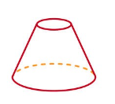

Figure 5: Diagram for Question 4

**Design Intent:** Questions 3 and 4 aim to assess students' ability to imagine actual objects from geometric figures. The design is relatively basic, divided into two levels. Question 3 examines whether students can imagine actual objects from plane geometric figures, while Question 4 examines whether they can imagine actual objects from solid geometric figures. If a student cannot answer Question 3, it indicates an inability to imagine actual objects from geometric figures. If a student can answer Question 3 but not Question 4, it suggests they can only imagine actual objects from simple plane geometric figures. Only if both questions are answered correctly can it be concluded that the student can imagine actual objects from geometric figures.

**6.3 Question for Dimension 3:**

**Question 5:** Imagine what your dream room looks like and describe the specific positions of the objects within it.

**Design Intent:** Question 5 aims to assess students' ability to imagine and express the spatial orientation of objects. This question is of medium difficulty and examines students' spatial imagination and expression abilities through a real-life problem. It is both novel and effective, with no fixed answers as long as the description is reasonable.

**6.4 Question for Dimension 4:**

**Question 6:** Describe the positions of other objects in your actual room, using the bed as a reference point.

**Design Intent:** Question 6 aims to assess students' ability to imagine and express the positional relationships between objects. This question is relatively easy and examines students' imagination and expression abilities through a real-life situation, as well as their understanding of reference points and the positional relationships between two objects. There are no fixed answers as long as the description is reasonable.

**6.5 Question for Dimension 5:**

**Question 7:** Describe how the blue figure is obtained from quadrilateral ABCD through a certain motion.

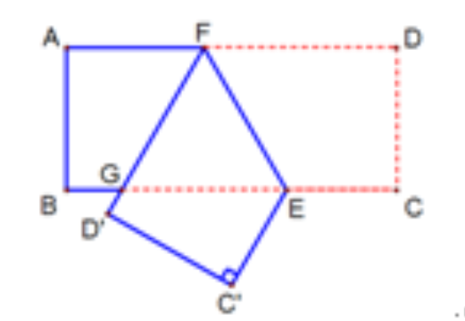

Figure 6: Diagram for Question 7

**Design Intent:** Question 7 aims to assess students' ability to perceive and describe figure folding. This question is relatively easy and examines a common folding figure in junior high school. Students who pay attention should be able to identify it.

**6.6 Question for Dimension 6:**

**Question 8:** Describe how the lower figure is obtained from the upper figure through a certain motion.

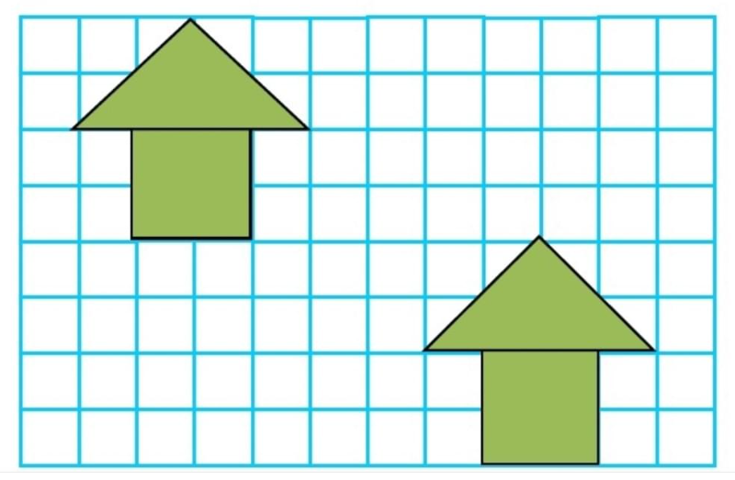

Figure 7: Diagram for Question 8

**Design Intent:** Question 8 aims to assess students' ability to perceive and describe figure translation. This question is of medium difficulty and examines whether students can observe that this is a translation motion of the figure and accurately describe it. There are no fixed answers.

**6.7 Question for Dimension 7:**

**Question 9:** Describe how the following figure is obtained through a certain motion.

Figure 8: Diagram for Question 9

**Design Intent:** Question 9 aims to assess students' ability to perceive and describe figure rotation. This question is of medium difficulty and examines whether students can observe that the figure is obtained through a rotation motion and accurately describe it. The figure used is the Bauhinia flower from the Hong Kong Special Administrative Region's emblem, which not only tests students' abilities but also instills a sense of patriotism.

**6.8 Question for Dimension 8:**

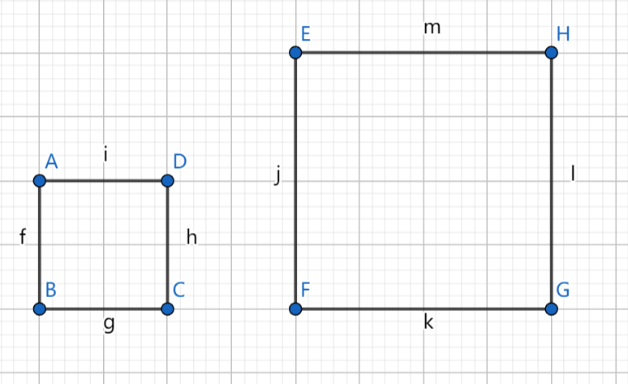**Question 10:** Describe how square EFGH is obtained from square ABCD through a certain change.

Figure 9: Diagram for Question 10

**Design Intent:** Question 10 aims to assess students' ability to perceive and describe the change patterns of figures. This question is relatively difficult and examines whether students can observe that square EFGH is obtained from square ABCD through a scaling transformation and accurately describe the magnification or reduction factor.

**7. SCORING CRITERIA**

After expert review and peer discussion, the total score for the test paper is set at 100 points. The first seven dimensions each account for 12 points, while the last dimension, which requires higher comprehensive literacy, accounts for 16 points. Dimensions 1 and 2 each have two questions, with the latter being more difficult than the former. Therefore, the first question in each dimension is worth 5 points, and the second question is worth 7 points. One point is deducted for each missing example. Students scoring above 90 points demonstrate excellent spatial concept literacy; those scoring between 80 and 90 points have good spatial concept literacy; those scoring between 70 and 80 points have average spatial concept literacy; those scoring between 60 and 70 points have poor spatial concept literacy; and those scoring below 60 points have very poor spatial concept literacy.

**8. CONCLUSION**

The *Compulsory Education Mathematics Curriculum Standards (2022 Edition)* emphasize that junior high school mathematics teaching should be oriented toward core literacy. However, assessing whether students have mastered a particular core literacy has become a challenge for teachers. Taking spatial concept literacy as an example, this study divides it into four major dimensions based on the definition provided in the curriculum standards. After peer discussion, expert consultation, and reverse checking, it is further refined into eight dimensions: 1) Ability to abstract geometric figures from object characteristics; 2) Ability to imagine actual objects from geometric figures; 3) Imagine and express the spatial orientation of objects; 4) Imagine and express the positional relationships between objects; 5) Perceive and describe figure folding; 6) Perceive and describe figure translation; 7) Perceive and describe figure rotation; 8) Perceive and describe the change patterns of figures. Questions were developed for each of these eight dimensions to form a test paper. The test paper consists of 10 questions with a total score of 100 points. The difficulty and gradient are designed reasonably to provide an effective reference for the quantitative assessment of spatial concept literacy among junior high school students.

Admittedly, the selection and matching of questions are inevitably influenced by subjective factors. Moreover, due to the differences in students' thinking levels, the test paper development process should be adjusted according to the actual conditions of different regions, schools, and classes. For example, the difficulty and types of questions should be appropriately modified. However, any adjustment should be based on the requirements of the curriculum standards and follow certain scientific theories to fairly and reasonably quantify the assessment of students' literacy levels.

**ACKNOWLEGEMENT**

This work is supported by Research Project on the Reform of Postgraduate Education and Teaching of Shandong Normal University (Grant No. SDNUYJG202320).

**Disclaimer (Artificial intelligence)**

Author(s) hereby declare that NO generative AI technologies such as Large Language Models (ChatGPT, COPILOT, etc.) and text-to-image generators have been used during the writing or editing of this manuscript.

**References**

[1] Ministry of Education of the People's Republic of China. *Compulsory Education Mathematics Curriculum Standards (2022 Edition)*. Beijing: Beijing Normal University Press, 2022.

<https://www.bnupg.com/>

[2] Song Haichao, Wu Jietao, Ye Qing. Development of a Test Paper for Intuitive Imagination Mathematics Core Literacy Based on Curriculum Standards. *Science Examination Research*, 2024, 31(21): 6-10.

<http://lkks.juqk.net/>

[3] Guo Yufeng, Wang Yiyang, He Quanrong. Cultivation Paths and Prospects for Spatial Concept Literacy. *Curriculum. Textbook. Pedagogy*, 2025, 45(01): 100-107. DOI: 10.19877/j.cnki.kcjcjf.2025.01.008.

<http://kcjcjf.llyj.net/>

[4] Guo Min. Strategies for Cultivating Spatial Concept among Junior High School Students under Core Literacy. *Guizhou Education*, 2024, (10): 45-47.

<http://gzjy.juqk.net/>

[5] Zhang Lu. Research on Situational Assessment of Spatial Concept among Junior High School Students. Dissertation, Jiangnan University, 2023. DOI: 10.27169/d.cnki.gwqgu.2023.001998.

[6] Zhong Yan. Construction of Indicators and Task Design for Performance Assessment of Spatial Concept in Primary School Mathematics. *New Teacher*, 2023, (09): 39-42.

<https://xinjiaoshi.xueshu.com/>

[7] Luo Yi. Research on the Development of Spatial Concept among Seventh-Grade Students Based on Geometry. Dissertation, Sichuan Normal University, 2024. DOI: 10.27347/d.cnki.gssdu.2024.000816.

[8] Ma Fang. Analysis and Research on Examination Questions for Developing Spatial Concept. *Journal of Shanxi Normal University (Natural Science Edition)*, 2009, 23(S1): 18-22.

[http://xbweb.sxnu.edu.cn](http://xbweb.sxnu.edu.cn/)

[9] Zhao Zhixiong. Analysis of Mathematics Examination Questions on Spatial Concept in Tianjin. *Forest Area Teaching*, 2019, (01): 89-91.

[http://lqxj.cbpt.cnki.net](http://lqxj.cbpt.cnki.net/)

[10] Lin Wei, Huang Fuquan. Development and Validation of a Mathematics Core Literacy Test Scale for Primary School Students. *Journal of Guangdong University of Education*, 2024, 44(05): 85-96.

<https://gjxy.cbpt.cnki.net/>

[11] Zhang Guifang. Basic Points and Conjectures for Testing Mathematics Core Literacy in Academic Quality Examinations. *Journal of Nanning Normal University (Natural Science Edition)*, 2021, 38(02): 177-180. DOI: 10.16601/j.cnki.issn2096-7330.2021.02.026.

[https://gxsz.cbpt.cnki.net](https://gxsz.cbpt.cnki.net/)

[12] Li XS, Yang ZZ. Research on the Implementation of Spatial Concept Literacy in Junior High School Mathematics Classroom Teaching in China. *Asian Journal of Education and Social Studies*. 2023;49(3):231-236.

<https://journals.indexcopernicus.com/issues/51602/350513>

[13]Biehler R. Allgemeinbildung, mathematical literacy, and competence orientation. Traditions in German-speaking mathematics education research. 2019:141-70.