**Riparian Forest Composition, Tree Diversity and its Association with Mand River, Chhattisgarh, India**

**Abstract:**

This study aims to evaluate the riparian tree diversity and species composition of the Mand river. It offers insights into species richness, dominance and community organization along the river by systematic vegetation surveys and statistical analysis.

The research utilizes a systematic methodology integrating remote sensing, GIS analysis and field sampling techniques to assess tree diversity in the riparian zones of the Mand River. Ecological indicators evaluated species diversity, including species richness, frequency, density, abundance and Importance Value Index (IVI). The Shannon-Wiener Index (H') assessed for species richness and evenness and Simpson's Diversity Index (D) measured for species dominance and rarity of the tree species in the riparian ecosystem.

The Importance Value Index of riparian tree species indicates that *Shorea robusta* (Sal) is the dominant species across all distance classes, consistent with the Sal-dominated forest type exists in the region.  The study indicates a progressive transition from moisture-dependent species along the riverbank (0m) to drought-resistant species in elevated regions (500m). The 250m zone demonstrates the highest species richness, indicating that transitional zones offer ideal circumstances for the coexistence of different species. The variety of plants in riparian forests improves ecological resilience, hydrological stability and biodiversity preservation.  The results of this study will help design efficient conservation and management strategies for the Mand River watershed and improve our knowledge of riparian ecology in central India.

***Key Words:*** *Riparian forest, Species composition, Biodiversity conservation, Riparian ecology*

1. **Introduction:**

Riparian environments along riverbanks are essential for preserving ecological balance by regulating hydrological processes, avoiding soil erosion and offering habitat for various flora and fauna (Sumarmi et al., 2022; Nagaraja et al., 2014). These ecosystems are especially important in tropical and subtropical climates, where they support high biodiversity and substantially enhance ecosystem services. The composition and diversity of riparian tree species effect water quality, sediment stability and nutrient cycling, rendering them vital for the sustainability of riverine ecosystems (Deshpande et al., 2021; Householder et al., 2024; Park et al., 2021).

Riparian ecosystems worldwide are facing increasing pressure from climate change, deforestation and alterations in land use. Riparian forests have been significantly modified in several regions globally, including North America, Europe and Asia, due to agricultural growth, urbanization and industrial activity (Johnson et al., 2020; Riis et al., 2020). Studies indicates that the deterioration of riparian vegetation results in less biodiversity, modified hydrological patterns and heightened susceptibility to extreme weather phenomena, including floods and droughts. Numerous nations have implemented conservation and restoration projects to mitigate these effects, prioritizing reforestation, regulated land use and policy-oriented management measures (Mubeen et al., 2021; Strassburg et al., 2020). Understanding these global patterns and their implications can aid in the formulation of regional conservation initiatives.

The Mand River, an important tributary of the Mahanadi River in Chhattisgarh, India, traverses a wide range of environments, encompassing forests, agricultural areas and populated regions. The river and its adjacent riparian zones function as a crucial ecological corridor, sustaining a multitude of plant and animal species. However, escalating human-induced pressures, including deforestation, agricultural expansion and infrastructure development, have resulted in habitat fragmentation and changes in riparian vegetation composition. Comprehending tree diversity, species composition and their biological relationships in riparian zones is crucial for developing conservation strategies and sustainable land-use planning.

Although the ecological importance of riparian vegetation, extensive research on tree diversity and composition along the Mand River is still limited. This study aims to address this deficiency by evaluating riparian tree diversity, examining species composition and investigating the correlation between tree species and environmental conditions. This study provide insights into species richness, dominance and community structure along the river through systematic vegetation surveys and statistical analysis. Furthermore, it will assess the influence of land use and environmental factors on the dynamics of riparian vegetation (Friedman et al., 2022). The results of this study will help design efficient conservation and management strategies for the Mand River watershed by advancing our knowledge of riparian ecology in central India.

1. **Material and Method:**
   1. **Study Area**

The Mand River is a significant left-bank tributary of the Mahanadi in northeastern Chhattisgarh, India, and the catchment area contributing around 7.35% to the Mahanadi basin. It lies between the latitudes of 21°42′6.27″N and 23°4′2.86″N and the longitudes of 82°50′32.31″E and 83°36′14.78″E (Fig. 1). The Mand River Watershed has an elevation between 125 m and 1088 m above mean sea level, with a geographical expanse of 5331.44 km². The river extends 241 kilometers through Surguja, Jashpur, Raigarh, Korba and Janjgir-Champa. It merges into the Mahanadi in the eastern area of Janjgir-Champa at Chandrapur (Choudhury et al., 2023).

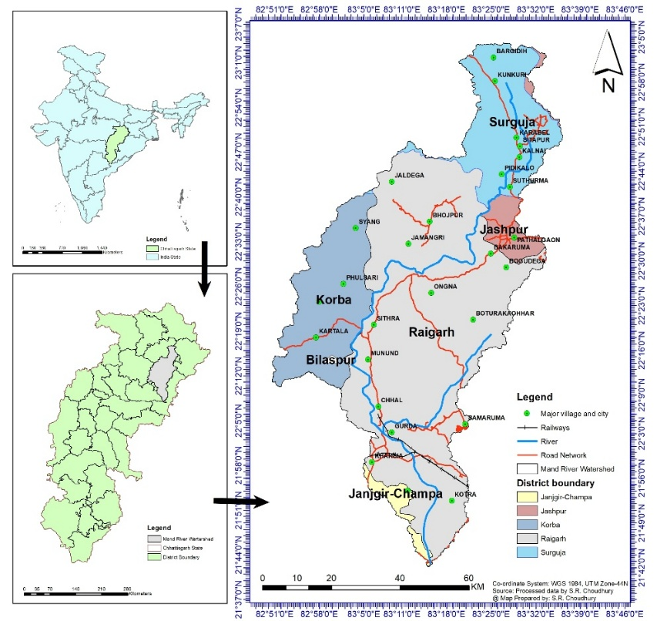

1. **Mand River Watershed showing District, Major villages and Town**

The region displays a subtropical monsoon climate characterized by three distinct seasons. The southwest monsoon is the primary source of groundwater recharge in the study area, accounting for 85% of the annual precipitation, which averages 1192.1 mm. The lowest temperature documented was 8.2 °C in January, but the average highest temperature was 42.5 °C in May . The watershed falls under five forest divisions: Dharamjaygarh, Jashpur, Korba, Raigarh and Surguja.

The Mand River watershed features a varied landscape of forests, agricultural lands, aquatic systems and settlements. The watershed includes parts of many districts, mostly located in Raigarh district. The primary land use and land cover in the river region include forest, agricultural land and barren ground.

* 1. **Site selection**

The study of tree diversity in the Mand River Watershed riparian zones employs a systematic methodology that combines remote sensing, GIS analysis and field sampling approaches. Initially, the Land Use and Land Cover (LULC) and forest map were used to determine forest cover in the Mand River Watershed region. Purwanto and Andrasmoro (2021) used elevation, forest range and forest division data to determine the sample site for the research region.

To evaluate tree diversity, the forested area along the Mand river was identified. The sampling were selected using random sampling method. The quadrat sampling method was used with a transect line of 500m and a 10m × 10m sample plot placed alternately every 250m along the walking path. All transact lines begin at the edge of the river within the forest. The transact-based quadrat sampling method effectively assesses distance-based tree diversity, taking into account distances from rivers and topography (Naidu et al., 2018).

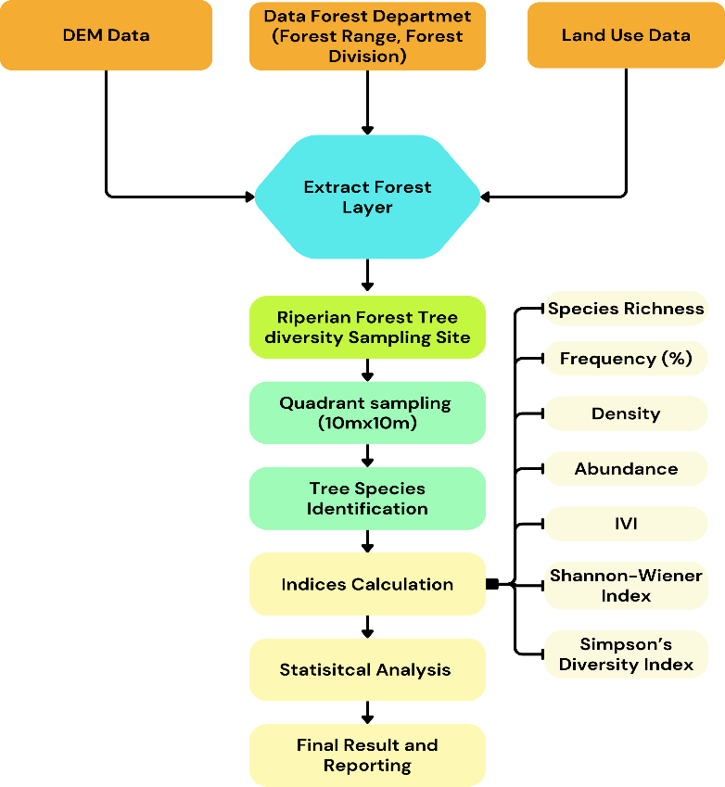

1. **Methodology for Tree Diversity study of Mand River Watershed**
   1. **Data Collection**

The quadrats were arranged to record tree species, individual counts and Diameter at Breast Height (DBH) measurements. Species with a Girth at Breast Height (GBH) greater than 30 cm were classified as trees and the results were documented. Tree species were identified by an examination of the local flora and consultation with experts. The gathered data was entered into Excel spreadsheets. The data analysis was done using Excel and GraphPad Prism. The maps and GIS analysis were done using ArcGIS 10.4 and QGIS 3.34.5. A number of ecological indicators were used to assess the structural and functional aspects of tree diversity. The metrics included species richness, which measured the total number of documented tree species, frequency (%), density, abundance and Importance Value Index. For a thorough investigation of species diversity, the Shannon-Wiener Index was used to evaluate species richness and evenness, while Simpson's Diversity Index evaluated species dominance and rarity (Estimating Biodiversity, 2024). The comprehensive data analysis procedure is described below.

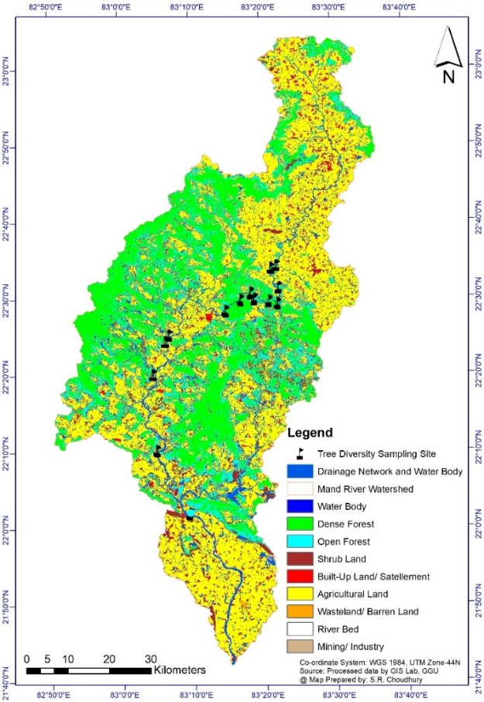

1. **LULC map and Site selected for Tree diversity study**
   1. **Data analysis**

**Species Richness (S)** is a simple count of the individual species found in a given area or sample plot. It represents species diversity in the environment without regard for abundance or dispersion (Frosini, 2023).

**Frequency (F)** is useful in ecological research, particularly when understanding species distribution within a given area. It represents the frequency of a species within a set of sample units (plots or quadrats) in a given study area (Frosini, 2023).

$$Frequency \left(\%\right)=\frac{Number of quadrats in which species occured }{Total number of quadrats studied}×100$$

**Density (D)** is an important indicator in ecological studies because it indicates the abundance of a specific species within a given region. It displays the density of individuals of a species per unit area, providing information about the species abundance or rarity within a habitat.

$$Density=\frac{Number of individuals of a species in all quadrats }{Total number of quadrats studied}$$

**Abundance** **(Ab)** in ecology denotes the quantity of individuals of a certain species within a designated sampling region. It aids in understanding the population density of a species compared to the entire sampled area (Rees, 2018).

$$Abundance=\frac{Total Number of individuals of a species in all quadrats }{Total number of quadrats in which the species occurred}$$

**Importance Value Index (IVI)** is a comprehensive measure used in ecology to assess the overall significance of a species within a community. It combines three key parameters: Relative Frequency, Relative Density and Relative Dominance. The IVI helps determine the dominance and ecological significance of a species, making it particularly useful in forest studies.

IVI=Relative Frequency + Relative Density + Relative Dominance

Interpretation of IVI: An elevated IVI signifies that a species assumes a more dominating or ecologically significant function within the community. IVI values enable ecologists to evaluate species within a community and identify dominant or keystone species that may substantially influence ecosystem function and structure (Gara & Stapanian, 2014; Zhao et al., 2019).

**Shannon-Wiener Index (H'):** It is widely used to assess species diversity. It takes into account species richness (the total number of species) and species evenness (the equitable distribution of individuals within each species). An elevated index value indicates higher species diversity.

$$H^{i}=-\sum_{i=1}^{S}{P_{i}\ln\left(P_{i}\right)}$$

Where:

S is the total number of species (species richness).

Pi​ is the proportion of individuals of species i relative to the total number of individuals in the sample.

$\ln\left(P_{i}\right)$ is the natural logarithm of *Pi*​

**Calculate Proportion of Each Species (Pi)**:

H' = 0: indicates that there is no diversity (i.e., only one species exists). Higher H' values indicate greater species diversity, implying a larger number of species and/or a more evenly distributed population across species. This indicator is useful for comparing the diversity of different ecosystems and analyzing changes in biodiversity over time.

**Simpson’s Diversity Index (D)**:

This measure of species diversity reflects the likelihood that two randomly chosen individuals within a population would be from distinct species (Morris et al., 2014; Palaghianu, 2016). In contrast to the Shannon-Wiener Index, which prioritises uncommon species, Simpson's Index assigns greater significance to the most prevalent species.

**Simpson's Diversity Index (1 - D)**: A version where higher values indicate greater diversity.

**1. Simpson’s Index (D) Formula:**

$$D=\sum_{i=1}^{S}{P_{i}^{2}}$$

Where:

S is the total number of species.

Pi is the proportion of individuals of species iii relative to the total number of individuals in the community.

$P_{i}^{2}$ ​ is the squared proportion for species iii and the sum is taken over all species in the community.

**2. Simpson’s Diversity Index (1 - D) Formula:**

To express diversity (where higher values indicate higher diversity), the formula is:

1−D

This version is more intuitive because higher values indicate greater diversity, ranging from 0 (no diversity) to 1 (infinite diversity).

Simpson's Diversity Index is useful for comparing species diversity between communities or over time. It is especially effective at detecting dominance of one or a few species.

The calculated diversity indices were analyzed using established criteria to assess the study area's tree diversity. The study looked at the floristic composition, structure and diversity of tree communities in the Mand River watershed. The findings improve understanding of tree diversity patterns and conservation status in this ecologically significant area. The data connects land use and land cover changes over time to explain the factors influencing tree diversity in this watershed (Ruziman et al., 2022).

1. **Result and Discussion**

The Mand River Watershed has diverse forest cover, predominantly having Sal-dominated forests and mixed and bamboo-dominated forests across many density classes. In the riparian study, 42 quadrats were laid in 14 locations to measure riparian tree diversity. Riparian forests have considerable diversity, with 63 species from 25 families, highlighting the importance of water availability on tree diversity.

* 1. **Species Distribution**

The Fabaceae family is the most abundant at the family level, with 13 species recorded in riparian forests (Table 1). The wide distribution of Fabaceae may be due to its ecological adaptability, ability to fix nitrogen and extensive habitat tolerance, allowing species within this family to thrive in a variety of environments (Amaludin et al., 2022; Dalavi et al., 2021). Additionally, the families Combretaceae and Moraceae each have five species. Other families, such as Ebenaceae, Myrtaceae and Euphorbiaceae, are present in moderate quantities. In contrast, many families, like Annonaceae, Dipterocarpaceae and Sapindaceae, are represented by only one or two species, indicating a restricted distribution for these families.

The distribution of families and species over various distance classes (0m, 250m and 500m) from the Mand River offers essential insights into the range and composition of riparian tree species (Fig. 4). In the Immediate Riparian Zone (0m), 20 families and 43 species were documented. This area fosters a significant species diversity due to its closeness to the river, ensuring enough water supply and conducive development circumstances (Deshpande et al., 2021). Moisture-dependent plants, including Syzygium and Diospyros, are abundant in this region. The 250m zone had the highest species richness, with 49 species from 22 families. This transitional zone accommodates riparian and upland species, fostering a complex biological gradient. Moisture-loving and drought-resistant species are a blend of various ecological niches (Sumarmi et al., 2022). At 500 meters, 19 families and 34 species were documented, (fig. 4) indicating the lowest species richness among the three zones. The prevalence of *Shorea robusta* and Terminalia species in this region underscores their resilience to reduced water supply and arid soils (Akash et al., 2021).

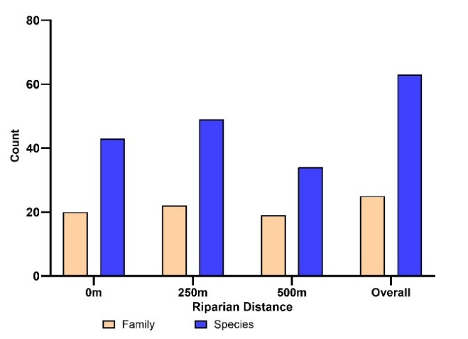

1. **Distribution of Family and Species in different riparian distances**

The study highlights a gradual shift from high moisture-dependent species near the river (0m) to more dry-tolerant species in upland areas (500m). The 250m zone exhibits the highest species richness, suggesting that transitional zones provide optimal conditions for diverse species coexistence. These findings are crucial for riparian forest conservation and management strategies, ensuring the preservation of biodiversity along the Mand River watershed.

* 1. **Diversity of Trees in Riparian Forests**

The dominant species, *Shorea robusta* (Sal), has an Importance Value Index (IVI) of 47.01, showing its ecological significance within the forest. The frequency (F) is 73.81% and the density (D) is 150 stem per hectare (Fig. 5). *Pterocarpus marsupium* demonstrates a significant IVI of 21.45, with a frequency of 35.71% and a density of 57.14 individuals per hectare. This shows its substantial existence and ecological function within the riparian forest.

Other notable species, such *Lagerstroemia parviflora* and *Terminalia elliptica*, exhibit IVI values of 16.56 and 15.93, respectively. The contributions of these species to forest structure and function are significant, marked by high density and dominance values. The presence of *Syzygium salicifolium* (IVI 7.60), *Diospyros malabarica* (IVI 7.62) and *Syzygium cumini* (IVI 6.36) highlights the significant role of moisture-dependent plants in riparian habitats. *Madhuca longifolia* and *Diospyros melanoxylon* demonstrate substantial prevalence, with IVI values of 15.47 and 11.18, respectively. *Garuga pinnata* (IVI 6.80) and *Buchanania lanzan* (IVI 5.42) are crucial for augmenting the morphological and functional diversity of the riparian zone. The notable Importance Value Index (IVI) of *Terminalia arjuna* (IVI 5.28) is particularly striking, as this plant flourishes near riverbanks. Species including *Aegle marmelos*, *Cordia myxa* and *Phyllanthus emblica* have low IVI values, indicating their rare occurrence in the forest habitat. Although not the most dominant, these species are essential for enhancing total biodiversity and may inhabit certain ecological niches. Some uncommon species, such as *Oroxylum indicum*, *Schrebera swietenioides* and *Ziziphus xylopyrus*, had low IVI values, indicating a scattered distribution within the riparian habitat. The diversity present enhances ecological resilience, hydrological stability and biodiversity conservation.

1. **List of trees documented in the Riparian area of the Mand river**

|  |  |  |  |
| --- | --- | --- | --- |
| **Family** | **Tree Species** | **Common Name** | **IUCN Status** |
| Anacardiaceae | *Buchanania lanzan* Spreng. | Chaar | VU |
| *Lannea coromandelica* (Houtt.) Merr. | Gunja, Moyan | LC |
| *Semecarpus anacardium* L.f. | Viliba, Bhelwa | LC |
| Annonaceae | *Miliusa tomentosa (Roxb.) Finet & Gagnep.* | Kari | LC |
| Apocynaceae | *Holarrhena pubescens* Wall. ex G.Don | Dhudhi, Korea | LC |
| Bignoniaceae | *Oroxylum indicum* (L.) Kurz | Indian Trumpet | LC |
| Boraginaceae | *Cordia myxa* L. | Lasoda | LC |
| Burseraceae | *Boswellia serrata* Roxb. | Salai, Sahalia | NT |
| *Garuga pinnata* Roxb. | Kekad | NE |
| Combretaceae | *Terminalia anogeissiana* Gere & Boatwr. | Dhawada | LC |
| *Terminalia arjuna* (Roxb. ex DC.) Wight & Arn. | Arjun, Kahua | NE |
| *Terminalia bellirica* (Gaertn.) Roxb. | Baheda | LC |
| *Terminalia chebula* Retz. | Harra | LC |
| *Terminalia elliptica* Willd. | Saja | LC |
| Cornaceae | *Alangium salvifolium*(Linn.f.) Wang. | Akol | LC |
| Depterocarpaceae | *Shorea robusta* C.F.Gaertn. | Sal | LC |
| Ebenaceae | *Diospyros malabarica* (Desr.) Kostel. | Makar tendu | NE |
| *Diospyros melanoxylon* Roxb. | Tendu, kendu | LC |
| *Diospyros montana* Roxb. | Basendu | NE |
| Euphorbiaceae | *Croton persimilis* Müll.Arg. | Chucka | LC |
| Fabaceae | *Albizia lebbeck* (L.) Benth. | Kala sirus | LC |
| *Albizia procera*(Roxb.) Benth. | White Siris | LC |
| *Bauhinia variegata* L. | Kachnar | LC |
| *Butea monosperma* (Lam.) Kuntze | Palas | LC |
| *Cassia fistula* L. | Amaltash | LC |
| *Dalbergia lanceolaria* subsp. *paniculata* (Roxb.) Thoth. | Dhobin | LC |
| *Dalbergia latifolia* Roxb. | Siris | VU |
| *Ougeinia oojeinensis* (Roxb.) Hochr. | Tinsa | NE |
| *Phanera roxburghiana* (Voigt) Bandyop., Anand Kumar & Chakrab. | Thhaur | NE |
| *Piliostigma malabaricum* (Roxb.) Benth. | Amta | LC |
| *Pongamia pinnata* (L.) Pierre | karanj | LC |
| *Pterocarpus marsupium* Roxb. | Bija | NT |
| *Tamarindus indica* L. | Imli | LC |
| Lamiaceae | *Gmelina arborea* Roxb. ex Sm. | Khamer | LC |
| *Tectona grandis*  L.f. | Saguan | EN |
| Lythraceae | *Lagerstroemia parviflora* Roxb. | Senha | LC |
| Malvaceae | *Bombax ceiba* L. | Semal | LC |
| *Sterculia urens* Roxb. | Kulu | LC |
| Moraceae | *Ficus amplissima* Sm. | Pimpri | LC |
| *Ficus benghalensis* L. | Bargad | LC |
| *Ficus hispida* L.f. | Katgoolar | LC |
| *Ficus racemosa* L. | Dumar | LC |
| *Ficus religiosa* L. | Pipal | LC |
| *Ficus semicordata* Buch.-Ham. ex Sm. | Bauhin Doomar | LC |
| Myrtaceae | *Careya arborea* Roxb. | Kumbhi | LC |
| *Syzygium cumini* (L.) Skeels | Jamun | LC |
| *syzygium salicifolium* J.Graham | Kath-jamun | LC |
| Oleaceae | *Schrebera swietenioides* Roxb. | Mokha | LC |
| Phyllanthaceae | *Bridelia retusa* (L.) A.Juss. | Kassi, Khaja | LC |
| *Phyllanthus emblica*L. | Aamla | LC |
| Rhamnaceae | *Ziziphus mauritiana* Lam. | Ber | LC |
| *Ziziphus xylopyrus* (Retz.) Willd. | Ghatbor | NE |
| Rubiaceae | *Adina cordifolia*(Roxb.) Brandis | Haldu | LC |
| *Gardenia latifolia* Aiton | Papda | LC |
| *Gardenia resinifera* Roth | Dekamali | LC |
| *Mitragyna parvifolia* var. *parvifolia* | Mundi | LC |
| Rutaceae | *Aegle marmelos* (L.) Corrêa | Bel | NT |
| *Chloroxylon swietenia* DC*.* | Bhirra, Bhirha | VU |
| Salicaceae | *Casearia graveolens* Dalzell | Chili | NE |
| *Flacourtia indica* (Burm.f.) Merr. | Kakai | LC |
| Sapindaceae | *Schleichera oleosa* (Lour.) Oken | Kusum | LC |
| Sapotaceae | *Madhuca longifolia* var. *latifolia* (Roxb.) A.Chev. | Mahua | NE |
| *Mimusops elengi* L. | Bakula | LC |

**Notes:** VU – Vulnerable; LC – Least Concern; NT – Near Threatened; NE – Not Evaluated; EN – Endangered

* 1. **Analysis of Species Composition Across Varying Distances**
     1. **Importance Value Index (IVI) of Riparian Tree Species**

At the bank of the river zone of 0m, *Syzygium salicifolium* was the dominant species (Fig. 5), with a highest IVI of 21.42. *Diospyros malabarica* followed with an IVI of 15.22, *Terminalia arjuna* at 9.42 and *Bombax ceiba* with an IVI of 7.68. These species are mostly trees that grow in wet habitats, demonstrating significant adaptations to moist soil conditions and flooding events. The presence of Ficus species such as *Ficus racemosa* and *Ficus hispida* highlights their ecological importance in maintaining riparian area. The abundance of moisture-dependent species at 0m signifies that this region is important for riverbanks, maintaining water and preserving biodiversity.

Tree composition changes at 250 m to combine dryland and riparian species. *Shorea robusta* is the dominant species, exhibiting an IVI of 30.04, indicating a transition from a riparian habitat to a more varied forest type. Other significant species are *Pterocarpus marsupium* (IVI 11.89), *Lagerstroemia parviflora* (IVI 13.16) and *Madhuca longifolia* (IVI 11.17). The noted decline in Syzygium species and *Terminalia arjuna* at this distance suggests water-dependent plants often declining because of the distances from the river.

At 500m, *Shorea robusta* shows considerable dominance with an IVI of 37.79, underscoring the transition to a Sal-dominated dryland forest. Notable species at this distance include *Pterocarpus marsupium* (IVI 17.91), *Terminalia elliptica* (IVI 20.22) and *Lagerstroemia parviflora* (IVI 17.23). The decline of moisture-dependent species such as *Syzygium cumini* and *Diospyros malabarica* signifies that the influence of riparian trees significantly decreases beyond 250 meters.

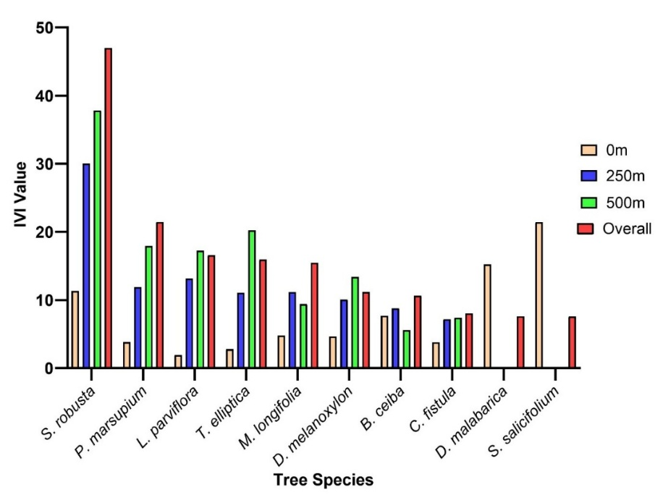

1. **IVI value of top 10 species of riparian area of Mand river**

*Shorea robusta* (Sal) is the dominant species across all distance classes, with a highest IVI of 47.01. This dominance aligns with the Sal-dominated forest type observed throughout the region. The gradual rise in IVI of *S. robusta* from 0m to 500m shows its dominance in slightly elevated areas, rather the adjacent riparian zone. The *S. salicifolium*, which documented at 0m, absent entirely beyond the adjacent riparian zone, reflecting its depend on higher moisture supply. Species such as *D. malabarica*, having a relatively high IVI at 0m, notice a decrease in abundance with increasing distance from the river.  This regional distribution shows the influence of water availability on the formation of tree communities. The species richness in these forests is likely affected by increased soil moisture, nutrient availability and disturbance patterns, such as seasonal flooding, which create dynamic ecological conditions that favor particular tree species (Hasnat & Hossain, 2019; Razak et al., 2019).

* + 1. **Frequency of Riparian Tree Species**

At the river bank (0m), *Syzygium salicifolium* (64.29%) has the highest frequency (Fig. 6), followed by *Diospyros malabarica* (50%), having strong association with riparian zones. *Shorea robusta* (35.71%), *Bombax ceiba* (28.57%) and *Cassia fistula* (14.29%) have moderate frequency, indicating adaptation to both humid and transitional environments. *Terminalia arjuna* (28.57%) and *Bauhinia vahlii* (28.57%) show notable frequency.

At 250m, *Shorea robusta* (92.86%) appears as the dominant species. Pterocarpus marsupium (42.86%), *Lagerstroemia parviflora* (42.86%) and *Terminalia elliptica* (42.86%) demonstrate high capacity to transitional environments. *Diospyros montana* (35.71%) and *Madhuca longifolia* (42.86%) persist under moderate moisture situations, yet *D. malabarica* is absent, underscoring its affinity for near riparian zones.

At 500m, *Shorea robusta* (92.86%) is the dominant species, in stable soil conditions. *T. elliptica* (57.14%), *P. marsupium* (50.00%) and *L. parviflora* (57.14%) consistently exhibit elevated frequencies (Fig. 6). Species like *Syzygium salicifolium* (7.14%) and *Butea monosperma* (7.14%) have lower frequency.

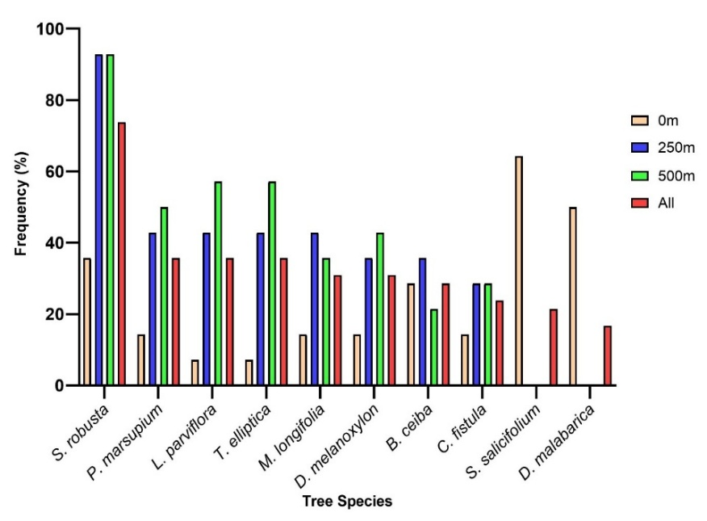

1. **Frequency of top 10 species of riparian area of Mand river**

*Shorea robusta* (73.81%) is the most frequent species over all distances, indicating its wide adaptability. Additional species exhibiting elevated overall frequencies are *T. elliptica* (35.71%), *P. marsupium* (35.71%) and *L. parviflora* (35.71%), shows their resilience to varying moisture conditions. *D. malabarica* (30.95%) and *M. longifolia* (30.95%) are prevalent in riparian and transitional zones but decrease with increasing distance from the river. *Syzygium salicifolium* (21.43%), prevalent at 0m, rapidly reduces at increasing distances.

The frequency analysis reveals a distinct shift from moisture-dependent species at 0m to drought-resistant species at 500m (Fig. 6). *Shorea robusta* is dominant at all distances, whereas species such as *Syzygium salicifolium* and *Diospyros malabarica* are restricted to riparian zones.

* + 1. **Abundance of Riparian Tree Species**

The abundance, measure as the number of individuals per hectare, offers insights on species dominance and distribution patterns within the study area. The variation in species abundance at several distances from the river (0m, 250m, 500m) demonstrate the tree adaptation to moisture availability and surroundings (Fig. 7).

At 0m, *Syzygium salicifolium* (64.29 individuals/ha) demonstrates the highest abundance (Fig. 7), indicating its affinity for moist environments and prevalence in the adjacent riparian zone. *Diospyros malabarica* (50.00 individuals/ha) has a notable abundance. Other species, like *Bombax ceiba* (28.57 individuals/ha), *Bauhinia vahlii* (28.57 individuals/ha) and *Cassia fistula* (14.29 individuals/ha), showed intermediate abundance. *Shorea robusta* (35.71 individuals/ha), although a prominent species overall, has comparatively lower abundance in the riparian zone than Syzygium and Diospyros species.

At 250m, *Shorea robusta* (92.86 individuals/ha) is the dominant species, indicating its growing dominance as moisture reliance diminishes. *Pterocarpus marsupium* (42.86 individuals/ha), *Lagerstroemia parviflora* (42.86 individuals/ha) and *Terminalia elliptica* (42.86 individuals/ha) show significant abundance.

1. **Abundance of top 10 species in the study area**

At 500m, *Shorea robusta* (92.86 individuals/ha) persists in its dominance, sustaining considerable abundance in arid circumstances. *Pterocarpus marsupium* (50.00 individuals/ha), *Terminalia elliptica* (57.14 individuals/ha) and *Lagerstroemia parviflora* (57.14 individuals/ha) are prevalent. Other species, like *Diospyros montana* (28.57 individuals/ha) and *Madhuca longifolia* (35.71 individuals/ha), exhibit intermediate abundance.

*Shorea robusta* (73.81 individuals/ha) is the abundant species at all distance class. *Syzygium salicifolium* (21.43 individuals/ha) is very prevalent adjacent to the river but is entirely absent beyond the local riparian zone. The abundance distribution indicates a progressive transition from moisture-dependent species (e.g., *Syzygium salicifolium* and *Diospyros malabarica*) to drier upland-adapted species (e.g., *Shorea robusta* and *Terminalia elliptica*) with increasing distance from the river.

* + 1. **Shannon-Wiener Index of Riparian Tree Species**

The Shannon-Wiener Index (H') at different distances from the river inside the riparian forest show a clear gradient in species diversity. In totality the riparian forest has highest diversity (H' = 3.5560), whereas lesser diversity an 0m (H' = 3.4950) and 250m (H' = 3.3665) was observed. there is a significant reduction in diversity at 500m from the river (H' = 2.9040), indicating a decrease in both species richness and evenness as the distance from the river increases.  The pattern that has been observed suggests that closer from the river increases tree diversity, may be due to moisture availability and microhabitat differences that support an more number of species (Mubi, 2012; Pereira et al., 2012).

* + 1. **Simpson's Index of Riparian Tree Species**

The Simpson's Index (D), a measure of species dominance, has an inverse relation with Shannon-Wiener values (Pertiwi et al., 2019). The highest dominance, shown by the lowest diversity, is observed at Riparian 500m (D = 0.0921). In contrast, Riparian 0m has the lowest Simpson’s Index (D = 0.0413), signifying a more equitable distribution of species near the river, with no single species dominance.

1. **Conclusion**

The observed pattern in diversity indices shows a significant relationship between water availability and tree species richness in riparian environments.  The diversity adjacent to the river (0m) is likely attributable to favorable growth circumstances, including enough moisture, sporadic nutrient influx and reduced competition from species suited to the forest (Pielech, 2021; Sumarmi et al., 2022).  The riparian zone provides an ecological niche that supports both water-loving and generalist tree species, resulting in higher Shannon-Wiener values and lower Simpson dominance (Mubi, 2012). The influence of riparian zones decreases with increasing distance, reducing species diversity and a higher dominance of a limited number of well-adapted species (Koskey et al., 2021; Pertiwi et al., 2019).

Protecting the 0m and 250m riparian zones is essential for biodiversity conservation, water quality management and climate resilience improvement. The riparian forest has a transparent ecological gradient marked by a shift in species composition from moisture-dependent to drought-tolerant communities as distance from the water source increases.   Protecting hydrological integrity and minimizing anthropogenic disruptions are crucial for maintaining the ecological balance of this dynamic environment.

**Disclaimer (Artificial intelligence)**

Author(s) hereby declare that NO generative AI technologies such as Large Language Models (ChatGPT, COPILOT, etc.) and text-to-image generators have been used during the writing or editing of this manuscript.

**References:**

Akash, A., Z̲ākir, M., Bithel, N., & Bhandari, B. S. (2021). Species Diversity, Soil Nutrients Dynamics and Regeneration Status of Sal (*Shorea robusta*) Forests in Western Himalayan Region of India. In Nature Environment and Pollution Technology (Vol. 20, Issue 3). https://doi.org/10.46488/nept.2021.v20i03.008

Amaludin, N. A., Zulkafli, N. N. M., Zu, S. A. A., Zamri, N. A. Z., Majid, N. A. A., Daliman, S., Nor, A. N. M., & Zakaria, R. (2022). Analysis of riparian vegetation of a recreation site in Jeli, Kelantan. In IOP Conference Series Earth and Environmental Science (Vol. 1053, Issue 1, p. 12007). IOP Publishing. https://doi.org/10.1088/1755-1315/1053/1/012007

Choudhury, S. R., Singh, A. K., Mahato, A., Anand, A., & Chandrakar, A. K. (2023). A comprehensive review of the Mahanadi River Basin in Chhattisgarh, India. Ecology, Environment & Conservation, 29(4), 147–157.

Dalavi, J. V., Pujar, R., Kambale, S. S., Jadhav-Rathod, V., & Yadav, S. R. (2021). Legumes (Angiosperms: Fabaceae) of Bagalkot District, Karnataka, India. In Journal of Threatened Taxa (Vol. 13, Issue 5, p. 18283). Wildlife Information Liaison Development Society. https://doi.org/10.11609/jott.6394.13.5.18283-18296

Deshpande, S., Amritkar, K., & Kulkarni, S. (2021). Documentation of Riparian Biodiversity of an Urban River Stretch - A Citizen’s Initiative. In Journal of Ecological Society (Issue 1). ScienceOpen. https://doi.org/10.54081/jes.027/05

Estimating Biodiversity. (2024). <https://www.webpages.uidaho.edu/veg_measure/modules/lessons/module%209(composition&diversity)/9_3_Estimating%20Biodiversity.htm>

Friedman, J. M., Eurich, A. M., Auble, G. T., Scott, M. L., Shafroth, P. B., & Gibson, P. P. (2022). Response of riparian vegetation to short‐ and long‐term hydrologic variation. In Ecological Applications (Vol. 32, Issue 8). Wiley. https://doi.org/10.1002/eap.2689

Frosini, B. V. (2023). DESCRIPTIVE MEASURES OF ECOLOGICAL DIVERSITY. https://www.semanticscholar.org/paper/DESCRIPTIVE-MEASURES-OF-ECOLOGICAL-DIVERSITY-Frosini/9189b5e0c74f313b87b8ff73a108fc6578a09baa

García, M., & Jáuregui, D. (2020). Morphoanatomical Characteristics in Riparian Vegetation and Its Adaptative Value. In IntechOpen eBooks. IntechOpen. https://doi.org/10.5772/intechopen.94933

Hasnat, G. N. T., & Hossain, M. K. (2019). Global Overview of Tropical Dry Forests. In Practice, progress and proficiency in sustainability (p. 1). IGI Global. https://doi.org/10.4018/978-1-7998-0014-9.ch001

Householder, J. E., Wittmann, F., Schöngart, J., Piedade, M. T. F., Junk, W. J., Latrubesse, E. M., Quaresma, A. C., Demarchi, L. O., Lobo, G., Aguiar, D. P. P. de, Assis, R. L., Lopes, A., Parolin, P., Amaral, I. L. do, Coêlho, L. de S., Matos, F. D. de A., Filho, D. de A. L., Salomão, R. P., Castilho, C. V., … Damasco, G. (2024). One sixth of Amazonian tree diversity is dependent on river floodplains. In Nature Ecology & Evolution (Vol. 8, Issue 5, p. 901). Nature Portfolio. https://doi.org/10.1038/s41559-024-02364-1

Johnson, L. R., Trammell, T. L. E., Bishop, T. J., Barth, J., Drzyzga, S. A., & Jantz, C. A. (2020). Squeezed from All Sides: Urbanization, Invasive Species and Climate Change Threaten Riparian Forest Buffers. In Sustainability (Vol. 12, Issue 4, p. 1448). Multidisciplinary Digital Publishing Institute. https://doi.org/10.3390/su12041448

Koskey, J. C., M’Erimba, C., & Ogendi, G. M. (2021). Effects of Land Use on the Riparian Vegetation along the Njoro and Kamweti Rivers, Kenya. In Open Journal of Ecology (Vol. 11, Issue 11, p. 807). Scientific Research Publishing. https://doi.org/10.4236/oje.2021.1111049

Mubeen, A., Ruangpan, L., Vojinović, Z., Sánchez, A., & Plavšić, J. (2021). Planning and Suitability Assessment of Large-scale Nature-based Solutions for Flood-risk Reduction. In Water Resources Management (Vol. 35, Issue 10, p. 3063). Springer Science+Business Media. https://doi.org/10.1007/s11269-021-02848-w

Mubi, A. (2012). Species Distrbution within Riparian Landcape along Mayo Kam of Gashaka Taraba State, Nigeria. In Ethiopian Journal of Environmental Studies and Management (Vol. 5, Issue 1). African Journals OnLine. https://doi.org/10.4314/ejesm.v5i1.6

Nagaraja, B. C., Sunil, C. N., & Somashekar, R. (2014). Protection of Riparian Habitats to Conserve Keystone Species with Reference to Terminalia arjuna – A Case Study from South India. In InTech eBooks. https://doi.org/10.5772/58355

Naidu, M. T., PREMAVANI, D., Suthari, S., & Venkaiah, M. (2018). Assessment of tree diversity in tropical deciduous forests of Northcentral Eastern Ghats, India. In Geology Ecology and Landscapes (Vol. 2, Issue 3, p. 216). Taylor & Francis. https://doi.org/10.1080/24749508.2018.1452479

Park, S.-R., Kim, S., & Lee, S. (2021). Evaluating the Relationships between Riparian Land Cover Characteristics and Biological Integrity of Streams Using Random Forest Algorithms. In International Journal of Environmental Research and Public Health (Vol. 18, Issue 6, p. 3182). Multidisciplinary Digital Publishing Institute. https://doi.org/10.3390/ijerph18063182

Pereira, I. M., Botelho, S. A., Machado, E. L. M., & Silveira, C. J. A. (2012). Tree species occurring on ariparian slope and correlations with soil variables in the upper Grande River, Minas Gerais, Brazil. In Ciência Rural (Vol. 42, Issue 12, p. 2192). Universidade Federal de Santa Maria. https://doi.org/10.1590/s0103-84782012005000092

Pertiwi, N., Taufieq, N. A. S., & Hiola, St. F. (2019). The Diversity of Riparian Trees Vegetation at Around The Lawo River, South Sulawesi, Indonesia. In Journal of Physics Conference Series (Vol. 1244, Issue 1, p. 12008). IOP Publishing. https://doi.org/10.1088/1742-6596/1244/1/012008

Pielech, R. (2021). Plant species richness in riparian forests: Comparison to other forest ecosystems, longitudinal patterns, role of rare species and topographic factors. In Forest Ecology and Management (Vol. 496, p. 119400). Elsevier BV. https://doi.org/10.1016/j.foreco.2021.119400

Purwanto, A., & Andrasmoro, D. (2021). The Utilization of Remote Sensing and Geographic Information Systems for Monitoring Damage of The Mandor Natural Reserves in West Kalimantan Province. In GeoEco (Vol. 7, Issue 2, p. 145). https://doi.org/10.20961/ge.v7i2.44837

Razak, M. A. A., Mergoum, M., Alona, C. L., Omar, H., & Misman, M. A. (2019). Tree Species Richness, Diversity and Distribution at Sungai Menyala Forest Reserve, Negeri Sembilan. In IOP Conference Series Earth and Environmental Science (Vol. 269, Issue 1, p. 12003). IOP Publishing. https://doi.org/10.1088/1755-1315/269/1/012003

Riis, T., Kelly‐Quinn, M., Aguiar, F. C., Manolaki, P., Bruno, D., Bejarano, M. D., Clerici, N., Fernandes, M. R., Franco, J. C., Pettit, N. E., Portela, A. P., Tammeorg, O., Tammeorg, P., Rodríguez‐González, P. M., & Dufour, S. (2020). Global Overview of Ecosystem Services Provided by Riparian Vegetation. In BioScience (Vol. 70, Issue 6, p. 501). Oxford University Press. https://doi.org/10.1093/biosci/biaa041

Ruziman, H. H., Ismail, A., Radzun, K. A., Ishak, N. S., Zohari, A. F., Kusin, M., & Pardi, F. (2022). Tree Species Diversity and Conservation Status of Keniam Forest, Taman Negara, Pahang. In IOP Conference Series Earth and Environmental Science (Vol. 1019, Issue 1, p. 12014). IOP Publishing. https://doi.org/10.1088/1755-1315/1019/1/012014

Strassburg, B. B. N., Iribarrem, Á., Beyer, H. L., Cordeiro, C. L., Crouzeilles, R., Jakovac, C. C., Junqueira, A. B., Lacerda, E., Latawiec, A. E., Balmford, A., Brooks, T. M., Butchart, S. H. M., Chazdon, R. L., Erb, K., Brancalion, P. H. S., Buchanan, G. M., Cooper, D., Dı́az, S., Donald, P. F., … Visconti, P. (2020). Global priority areas for ecosystem restoration. In Nature (Vol. 586, Issue 7831, p. 724). Nature Portfolio. https://doi.org/10.1038/s41586-020-2784-9

Sumarmi, S., Pakarti, T. I., Destari, L. F. P., Aini, N., & Tanjung, A. (2022). Preservation of Vegetation Diversity to Maintain the Riparian Ecosystem of the Sampean Watershed. In KnE Social Sciences. Knowledge E. https://doi.org/10.18502/kss.v7i16.12168