GIS and ML-Driven Insights into Forest Vulnerability and Climate Hotspots in Assam, India

Abstract:
This study assesses the impact of regional climate variability on forest vulnerability in Assam using a GIS and Machine Learning (ML)-based approach. A grid-based Forest Vulnerability Index (FVI) was developed using eight key indicators, and climate change hotspots were mapped using temperature and precipitation anomalies. The results revealed that 87 forested grids are highly vulnerable, with significant overlaps between climate hotspots and biodiversity risk zones. The study highlights the urgent need for adaptive forest management, AI-driven monitoring, and policy interventions to mitigate climate-induced risks.
Keywords: Forest Vulnerability, Biodiversity Mapping, Climate Hotspots, Forest Canopy Density, Fire Risk, Machine Learning, GIS

Introduction
Assam, a biodiversity-rich state in Northeast India, faces significant threats from climate variability and human-induced pressures. Increased deforestation, erratic rainfall, and rising temperatures have led to ecosystem degradation and reduced forest resilience (Gupta et al., 2020; Nandy et al., 2015; Chakraborty et al., 2018). Climate projections indicate that by 2080, Assam’s forests may fall into high vulnerability zones under mid-range emissions scenarios (RCP 4.5 and RCP 8.5) (ISFR, 2021; SAPCC, 2015). Given these trends, there is a need to develop spatially explicit vulnerability assessment models integrating climate, ecological, and anthropogenic stressors (Hinkel, 2011). Several studies have been carried out in different parts of the world to assess forest vulnerability using remote sensing and GIS-based techniques (Kumar et al., 2021; Hussain et al.,2020; Bamal et al., 2024). This study employs a GIS and Machine Learning (ML)-based vulnerability assessment to map climate change hotspots and their correlation with forest degradation, aiming to provide a scientific basis for adaptive conservation strategies. A key component of this study is the delineation of vulnerability hotspots of forests and biodiversity by integrating biophysical and climatic parameters. The Forest Vulnerability Index (FVI) is derived by assigning weights to selected indicators through the Analytical Hierarchy Process (AHP) (Saaty, 1980). Concurrently, climate change hotspots are identified based on temperature and precipitation anomalies. The correlation of these datasets enables spatial mapping of regions at highest risk, facilitating targeted conservation efforts and adaptive forest management (Kumar et al., 2021).

Study Area
The study focuses on Assam (24°08'10" N - 27°58'15" N, 89°42'05" E - 96°01'14" E), covering 78,438 sq. km, with 36.09% forest cover (ISFR, 2021). Assam’s forests are classified into five major types, ranging from tropical wet evergreen to subtropical pine forests. The region experiences annual rainfall exceeding 200 cm and temperatures from 7°C to 35°C, with climate variability contributing to frequent floods, droughts, and habitat fragmentation (SAPCC, 2015). For vulnerability assessment, the entire state of Assam has been divided into grids of size 0.25°, equivalent to the grid size of available IMD gridded climate data. Only the grids that have at least 5% area under forest cover, as per ISFR 2021 forest cover data, have been designated as forest grids, and the vulnerability assessment has been conducted exclusively for these grids.

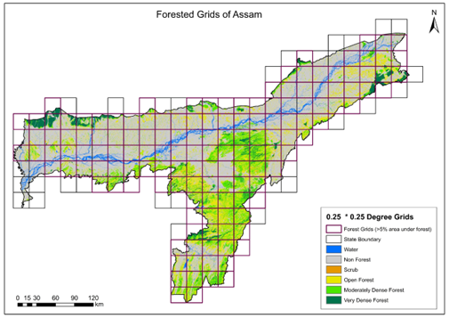
Figure 1. Forested grids (>5% area under forest cover) of Assam

OBJECTIVES
The study aims to assess the impact of climate variability on forest and biodiversity vulnerability by analyzing how changing temperature patterns, precipitation anomalies, and extreme weather events are affecting Assam’s forests. A key objective is to identify climate change hotspots by mapping high-risk areas where drought, flooding, and rising temperatures are intensifying forest and biodiversity vulnerability. To understand these patterns, the study analyses long-term trends in precipitation and temperature, examining historical climate data to detect shifts in rainfall reduction, increasing temperatures, and changing monsoon patterns, all of which significantly impact forest health and regeneration capacity. Also, an integrated vulnerability assessment framework is developed to classify forests based on climatic, ecological, and anthropogenic factors, ensuring a comprehensive evaluation of susceptibility to climate change impacts in Assam state of India.

Methodology
A grid-based vulnerability assessment was conducted using 140 forested grids (≥5% forest cover), integrating eight key indicators: Biological Richness Index (BRI) for species diversity and ecological uniqueness, Disturbance Index (DI) for human-induced forest degradation, Forest Canopy Density (FCD) for vegetation health and cover loss trends, Fire Point Intensity (FPI) for fire-prone zones mapped using MODIS fire data, Biomass Extraction Intensity (BEI) for human dependence on forest resources, Slope (S) for topographic susceptibility to erosion, Standardized Precipitation Index (SPI) for drought-prone areas based on rainfall trends, and Flood Vulnerability Index (FVI) for identifying flood-sensitive forest regions. Weights were assigned using the Analytical Hierarchy Process (AHP), and spatial vulnerability mapping was conducted to identify high-risk areas.

Results and Discussion
Out of 140 assessed forested grids, 19 were categorized as very highly vulnerable and 68 as highly vulnerable, indicating that nearly 62% of Assam’s forested areas face substantial ecological stress. Climate hotspot analysis identified 38 grids with very high exposure and 47 grids with high exposure, showing strong overlap with forest vulnerability zones. Over 22 years, a 4.06% decline in very dense forests and a 1.56% reduction in total forest cover were observed (ISFR, 2021). Fire-prone areas increased, with six districts categorized as highly vulnerable to wildfires, and seven districts identified as extreme drought-prone zones. LULC analysis revealed a 9.3% rise in cropland and 1% increase in settlements, leading to further habitat fragmentation. The Standardized Precipitation Index (SPI) analysis indicated increasing drought frequency, particularly in central and western Assam, where prolonged dry spells have intensified soil moisture deficits and affected forest regeneration. Results further highlight that the mean annual temperature in Assam has increased by 0.59°C over the last two decades. The rainfall anomaly distribution over the past 65 years indicates significant changes in precipitation patterns. Among 140 forested grids, 16 grids were identified as experiencing very high rainfall anomalies, while 52 grids showed high rainfall anomalies, with variations ranging from 400 mm to over 800 mm annually. The Flood Vulnerability Index (FVI) assessment highlighted that low-lying forested regions in eastern and southern Assam are at high risk, with extreme flood events increasing by 25% in the past two decades. The study also highlights that annual rainfall has reduced at a rate of -2.96 mm per year, while extreme rainfall events have increased by 5% to 38%. Despite the overall decline in total precipitation, the frequency of high-intensity, short-duration rainfall events has increased, leading to flooding, soil erosion, and alterations in groundwater recharge patterns, further intensifying forest vulnerability in Assam. Further, increasing forest degradation in the state impacts carbon sequestration potential as well as ecosystem services such as water retention, biodiversity conservation, and local livelihoods dependent on forest resources. The spatial overlay of fire-prone zones and high-temperature grids suggests that forest fire risks are escalating due to prolonged dry spells, increasing the need for remote sensing-based early detection systems. Additionally, fragmentation analysis indicates that small forest patches are becoming increasingly isolated, posing challenges for wildlife movement and habitat connectivity.
Figure 2. Forest and Biodiversity Vulnerability Assessment

Figure 3. Indicator-Based Vulnerability of Forested Grids

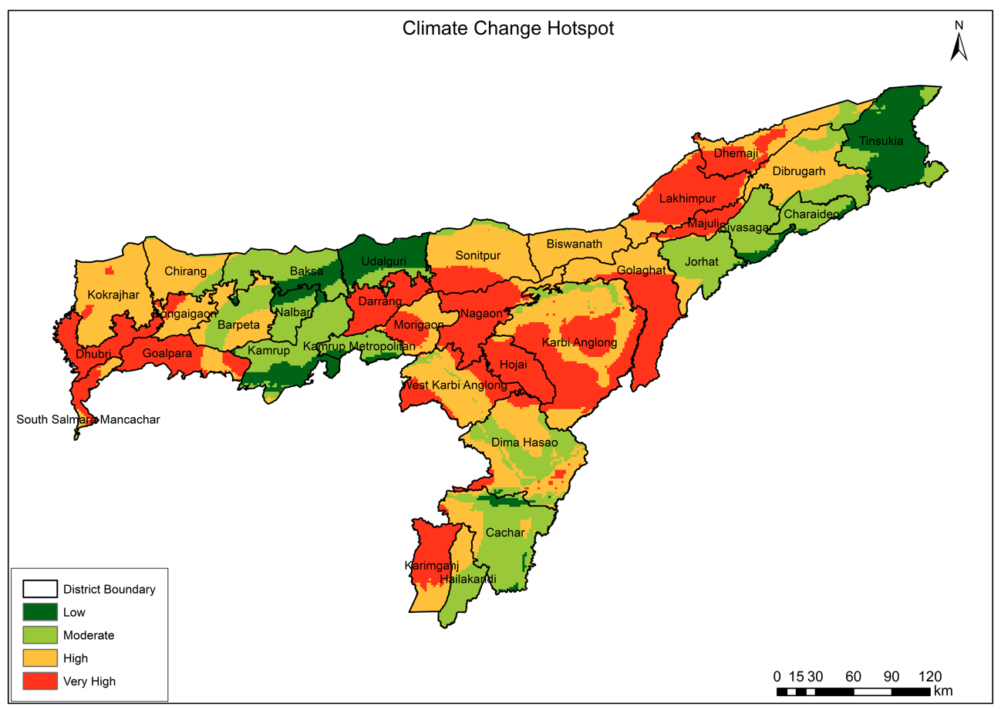
Figure 4. Spatial distribution of Climate Change Hotspot
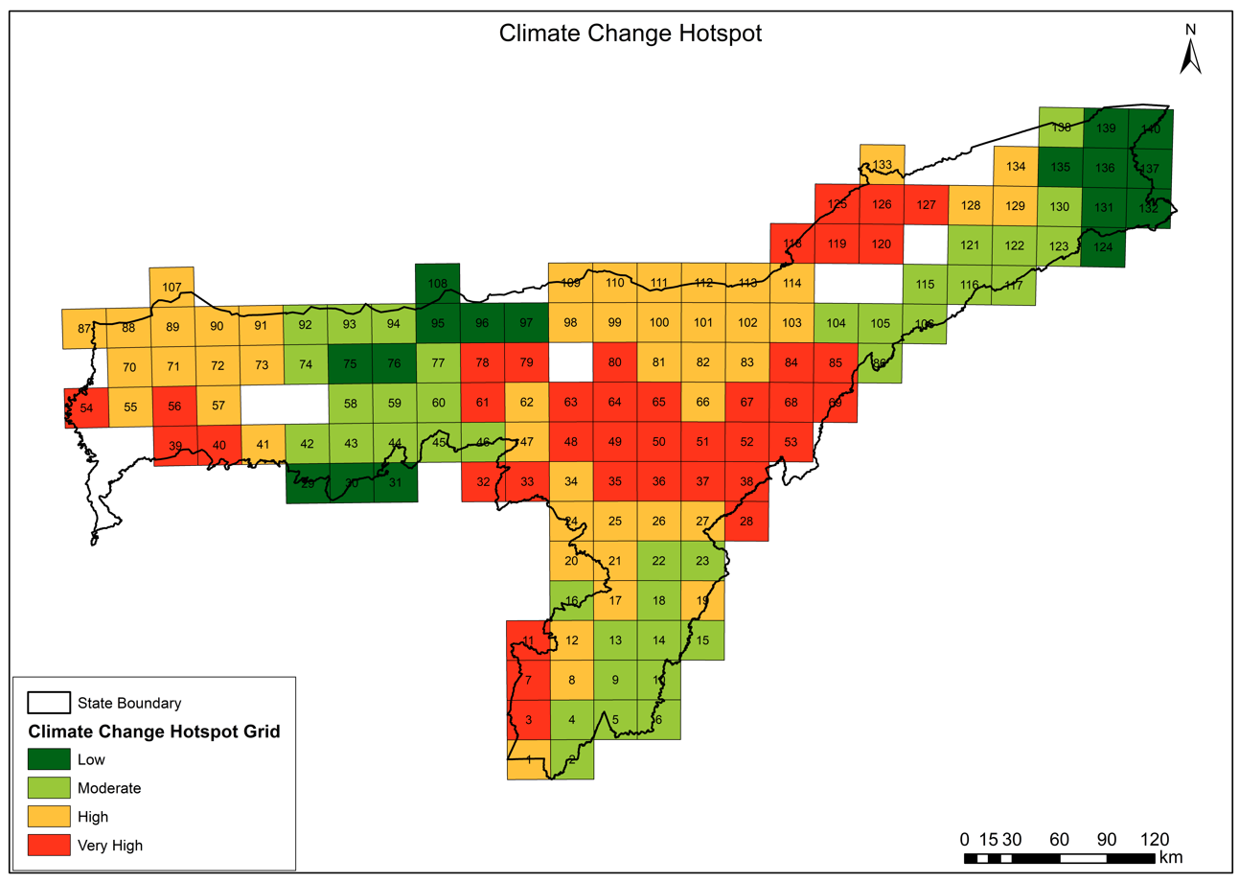
Figure 5. Grid-wise distribution of Climate Change Hotspot

Conclusion
This study highlights the significant impact of climate variability and anthropogenic pressures on Assam’s forests and biodiversity, revealing that out of 140 assessed forested grids, 19 were categorized as very highly vulnerable and 68 as highly vulnerable. The spatial correlation between climate change hotspots and forest vulnerability zones indicates that regions experiencing temperature anomalies, erratic rainfall patterns, and frequent flooding are also the most ecologically sensitive areas. Over the past 22 years, forest canopy density has declined by 4.06%, while cropland and settlement expansion (9.3% and 1%, respectively) has led to further habitat fragmentation. Increased fire risk in six highly fire-prone districts and the identification of 38 climate hotspots with very high exposure emphasize the need for urgent adaptive management strategies. Future research should focus on AI and deep learning models for real-time forest monitoring, long-term climate projection models under multiple RCP scenarios, and high-resolution carbon stock assessments. Additionally, socio-economic drivers of deforestation should be quantified, integrating community-based conservation approaches to enhance policy-driven adaptation strategies. Advanced LiDAR-based biomass estimation and spatially explicit ecosystem services valuation will further improve climate adaptation and carbon finance mechanisms (e.g., ARR in degraded Land or REDD+). Strengthening institutional capacities, promoting participatory forest management, and integrating climate risk into policy frameworks will be critical in ensuring the long-term resilience of Assam’s forests and biodiversity against climate change and human-induced pressures.

Acknowledgment
The authors sincerely thank the Director General, The Energy and Resources Institute (TERI), for their continuous support and guidance. We also extend our gratitude to the Forest Department, Assam, for their necessary support and collaboration, which significantly contributed to the successful completion of this study.

Disclaimer (Artificial intelligence)
Option 1:
Author(s) hereby declare that NO generative AI technologies such as Large Language Models (ChatGPT, COPILOT, etc.) and text-to-image generators have been used during the writing or editing of this manuscript.
Option 2:
Author(s) hereby declare that generative AI technologies such as Large Language Models, etc. have been used during the writing or editing of manuscripts. This explanation will include the name, version, model, and source of the generative AI technology and as well as all input prompts provided to the generative AI technology
Details of the AI usage are given below:
1.
2.
3.

References
- Chakraborty, S., et al. (2018). Vulnerability of forests in the Himalayan region to climate change impacts and anthropogenic disturbances. Ecological Indicators, 97, 112-125.
- Gupta, R., Kalra, N., & Kumar, M. (2020). Climate vulnerability assessment for forests and biodiversity in the Indian Himalayan region. Ecological Indicators, 113, 106223.
- Hinkel, J. (2011). Indicators of vulnerability and adaptive capacity: towards a clarification of the science-policy interface. Global Environmental Change, 21, 198-208.
- Hussain, N., & Islam, M. N. (2020). Hot spot (G i∗) model for forest vulnerability assessment: A remote sensing-based geo-statistical investigation of the Sundarbans mangrove forest, Bangladesh. Modeling Earth Systems and Environment, 6(4), 2141-2151. https://doi.org/10.1007/s40808-020-00820-6
- Indian State of Forest Report (ISFR), 2021. Forest Survey of India, Ministry of Environment, Forest and Climate Change.
- Kumar, M., Kalra, N., Singh, H., Sharma, S., Rawat, P. S., Singh, R. K., & Gupta, A. K. (2021). Indicator-based vulnerability assessment of forest ecosystem in the Indian Western Himalayas: An analytical hierarchy process integrated approach. Ecological Indicators, 125, 107568.
- Nandy, S., Kushwaha, S. P. S., & Mukhopadhyay, S. (2015). Monitoring forest degradation in the Western Himalayas using remote sensing and GIS. Environmental Monitoring and Assessment, 187, 405.
- Saaty, T. L. (1980). The Analytical Hierarchy Process: Planning, Priority Setting, Resource Allocation. McGraw-Hill.
- State Action Plan on Climate Change (SAPCC), 2015. Assam State Government.
- Bamal, A., Uddin, M. G., & Olbert, A. I. (2024). Harnessing machine learning for assessing climate change influences on groundwater resources: a comprehensive review. Heliyon, 10(17).

