Original Research Article

Influence of Climatic and Soil Factors on the Spatial Distribution of Chrysophyllum albidum (Sapotaceae) in Benin

ABSTRACT
Chrysophyllum albidum is one of the plant species widely used by the local populations of West Africa. With the aim of contributing to the conservation of this specy threatened with extinction in Benin, the present study aims to determine the impact of climatic and pedological disturbances on its phytogeographic distribution. For this purpose, 311 occurrences of C. albidum were collected from the Global Biodiversity Information Facility (GBIF), the iNaturalist platform and several field explorations carried out in particular in the phytodistricts Bassila, Coastal, Plateau, Pobè, Valley of Ouémé and Zou. These recorded presence data were combined with the environmental variables of the two climate scenarios RCP 4.5 (optimistic) and RCP 8.5 (perssimistic), following the Maximum Entropy (MaxEnt) approach. From the results obtained, it appears that the areas currently favorable to C. albidum cover 6.86% of the total area of ​​Benin. The optimistic scenario predicts on the horizon 2055 an increase of 31.20% in areas currently favorable to the specy. On the other hand, the pessimistic scenario predicts on the horizon 2055, a reduction of 44.80% of these currently favorable habitats. Under current and future climatic conditions (RCP 4.5 and RCP 8.5), the areas favorable to C. albidum correspond to the Guineo-Congolese climatic zone where the Nitisols are located, a type of soil on which the species is widely distributed; the phytodistricts Coastal, Plateau, Pobè and Valley of Ouémé are and will remain favorable to this high-value specy. These different results presented thus provide useful information that can promote the introduction of C. albidum into suitable habitats and necessary for its proper conservation in Benin, or even in West Africa.

Key words: Chrysophyllum albidum, Climate change, Ecological niche modeling, Phytodistrict, adaptation, conservation strategies.

- INTRODUCTION
Agriculture constitutes a major challenge of sustainable development. In developing countries, it is mainly practiced by rural communities. The increasing agricultural productivity by 1% reduces the poverty rate by 0.6% (Thirtle et al., 2003). However, in Africa, agricultural yields remain extremely low and local populations, to resist the challenge of food security, use the plant genetic resources of fruit trees on a large scale (Mbaye, 2011; Akouèhou et al., 2013). To reduce the risks of food insecurity caused, among other things, by the growing population increase, indigenous and multi-use fruit plants are identified and recommended (World Agroforestry Center, 2008). In Benin, Chrysophyllum albidum, one of the 2807 plant species inventoried in forest ecosystems (Akoègninou et al., 2006), is widely used and absolutely to be prioritized (Dah-Dovonon, 2002). Almost all the organs of the trees of this highly valuable species are exploited by local populations (Alowanou-Kélé et al., 2023). As proof, its very enriching fruits (Edem et al., 1984) contribute to human nutrition, its wood serves as both energy wood and lumber, its leaves, its bark and its root are organs frequently used in pharmacopoeia and animal feed (Houessou et al., 2012; Alowanou-Kélé et al., 2023). However, despite the importance of forest plant species in general, and of C. albidum in particular, in improving human living conditions in Benin, the long-term conservation of their natural habitats poses real problems (Schmidt-Soltau and Alimi, 2008). The extinction of these woody species in Benin is due to the types of organs used and the method of their removal (Alowanou-Kélé et al., 2023), climate change (Brou et al., 2005; Agbo et al., 2019) and demographic growth (Feely & Terborgh, 2008), a source of sometimes very extensive deforestation (Adjahossou et al., 2016).
The climates changes dangerously threaten the maintenance of forest resources (Sala et al., 2001; Boko et al., 2007). They are caused by changes in the atmospheric balance and characterized, among other things, by the increase in temperatures causing global warming, the increase in atmospheric CO₂ concentration, the rise in sea level and a change in the rainfall regime (Munasinghe, 2007). According to Busby et al. (2010), 20% to 30% of plant and animal species could disappear in Africa if warming exceeds 1.5°C to 2.5°C. The development of modern human activities, including industrialization, transport, agriculture and deforestation, is the main cause of the recents climates changes and therefore the source of massive emissions of Greenhouse Gases (GHGs) including CO₂ (IPCC, 2007). This imbalance modifies the temperatures on the earth's surface, causes numerous edaphic damages and contributes to the drop in agricultural yields (Katé et al., 2014) then to the drastic reduction in the trees populations of Non-Timber Forest Product (Agbo et al., 2018).
In his phytogeographic and phytosociological study of plant formations in Benin, Adomou (2005) differentiated ten large floristically homogeneous regions called phytodistricts. This is how we distinguish the phytodistricts Coastal, Plateau, Pobè and Valley of Ouémé in the Guineo-Congolese climatic zone; the phytodistricts Bassila, Borgou-Sud and Zou belonging to the Guinea-Sudanian transition climatic zone then the phytodistricts Borgou-North, Atacora Range and Mékrou-Pendjari in the Sudanian climatic zone. According to Gbesso et al. (2013), C. albidum is present in the phytodistricts Bassila, Coastal, Plateau, Pobè, Valley of Ouémé and Zou. This species is widely distributed in Benin and is therefore adapted to several types of soil (Kouyaté & Lamien, 2011). In several forest species, the distribution is strongly influenced by soil types (Badeau et al., 2005; Fachola et al., 2019). This is the case, for example, of Detarium microcarpum in which the pedological origin significantly influences the variability of morphological descriptors, in Benin (Agbo et al., 2018). Soil types discriminate C. albidum much more than the phytodistricts where the species is present in Benin (Alowanou-Kélé et al., 2025). Hence the importance of taking edaphic factors into account in this study devoted to the spatial distribution of C. albidum in Benin. The various works already carried out on the species have unfortunately not integrated this soil data, although it is important for predicting habitats favorable to plant species (Adjahossou et al., 2016; Ayihouenou et al., 2016; Guo et al., 2024).
For the conservation of plant species in order to guarantee the sustainable management of plant genetic resources, it is necessary to identify the capacity of adaptation of these species to the very changing environment (Bowe, 2007 ; Bourou, 2012) and to identify their preferred areas to meet the requirements of good domestication (Wembou et al., 2017). Numerous models for predicting variations in species distribution, including those using the Maximum Entropy (MaxEnt) approach, have been designed (Elith & Leathwick, 2009) to determine, based on climate change, current and future habitats favorable to the cultivation of a species, with a view to planning appropriate strategies for its conservation (Fandohan et al., 2015 ; Avaligbé et al., 2021). So, modeling the distribution of plant species plays a major role in anticipation and decision-making in order to conserve nature (Toffa, et al., 2022 ; Sinadouwirou et al., 2023). The MaxEnt algorithm constitutes one of the very reliable and efficient methods using the presence data and climatic and edaphic variables to carry out, whatever the scale, the modeling of the ecological niche (Elith et al., 2006).
All in all, on the one hand, C. albidum, a very vulnerable species, is threatened with extinction in Benin (Alowanou-Kélé et al., 2023) and on the other hand, the influence of environmental factors on its spatial distribution is not yet well explored. In order to address this lack of information preventing the development of adequate in situ conservation strategies for this priority species (Dah-Dovonon, 2002), the present study aims to determine the impact of climatic and pedological variables on its phytogeographic distribution in Benin. Specifically, it was a question of : (i) identify habitats favorable to the conservation and cultivation of C. albidum in Benin, (ii) evaluate on horizon 2055, the influence of climate on its spatial distribution, taking into account the various existing models.

- MATERIAL AND METHODS
  - Study Area
This study covers the various localities located in all the phytodistricts likely to harbor individuals of Chrysophyllum albidum in Benin (photo). These are the phytodistricts Bassila, Coastal, Plateau, Pobè, Valley of Ouémé and Zou (Gbesso et al., 2013). These phytogeographic districts (figure 1) are distinguished, among other things, by the nature of the soils, the climate and anthropogenic actions.

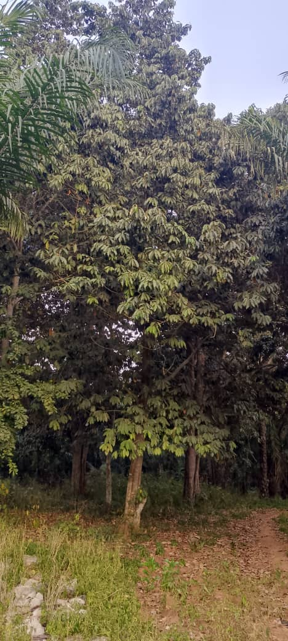

Photo 1 : Overview of a wooded savannah illustrating the natural regeneration of Chrysophyllum albidum plants in the Plateau, one phytodistrict of Benin
Source : Field photography (Alowanou-Kélé, 2024)

  - Data Collection
    - Occurrence Data
Following several field explorations, the collection of data on the presence of C. albidum trees was carried out in Benin, in the phytodistricts where the species lives (Gbesso et al., 2013). During the multiple outings carried out, all the C. albidum plants encountered were georeferenced using a Garmin 95 brand GPS (Global Positioning System). In total, three hundred and eleven (311) occurrences of C. albidum were collected to constitute the raw database across Benin. One hundred and sixteen (116) occurrences resulted from field work, one hundred and seventy-two (172) occurrences were downloaded from the Global Biodiversity Information Facility (GBIF.org (04 October 2023) GBIF Occurrence Download https://doi.org/10.15468/dl.zsduz4) and twenty-three (23) occurrences came from the iNaturalist citizen platform (www.inaturalist.org/). After cleaning (removal of duplicates), 159 occurrences of C. albidum were retained and used for mapping and modeling the ecological niche of the species. Figure 2 presents the variation in the occurrence data retained compared to the raw data of C. albidum.

    - Environmental Data
The environmental data used in this study concerns climatic environmental variables and edaphic environmental variables. The taking into account of edaphic factors as environmental variables is explained by the fact that the geographical distribution of Chrysophyllum albidum can depend on both climate and soil type.
The climatic variables considered (Table 1) were imported onto the Worldclim website (http://www.worldclim.org/) at a resolution of 2.5 minutes (≈ 0.0417° or about 5 km²). The climate variables of the future are those of the model global of circulation MIROC-AO for 2055. Furthermore, the non-climatic (edaphic) environmental variables used (Table 2) come from the Harmonized World Soil Database version 2.0 (Harmonized World Soil Database v2.0) at a resolution of 30 seconds corresponding to the finest spatial resolution. The Harmonized Global Soil Database version 2.0 (HWSD v2.0) is a comprehensive global soil inventory that offers detailed information on soil properties, including their morphology, chemistry and physical characteristics with emphasis on 1 kilometer resolution. It is a valuable tool for research in areas such as agriculture, food security and the impacts of climate change. Developed in 2008 by the International Institute for Applied Systems Analysis (IIASA) and the Food and Agriculture Organization of the United Nations (FAO), this database was a collaborative project involving other notable organizations such as the International Soil Reference and Information Center (ISRIC), the European Soil Bureau Network (ESBN) and the Institute of Soil Science of the Chinese Academy of Sciences (CAS). This collaboration ensured that the database was complete and accurate. Subsequent updates were made in 2013 (HWSD v1.2) and 2023 (HWSD v2.0).

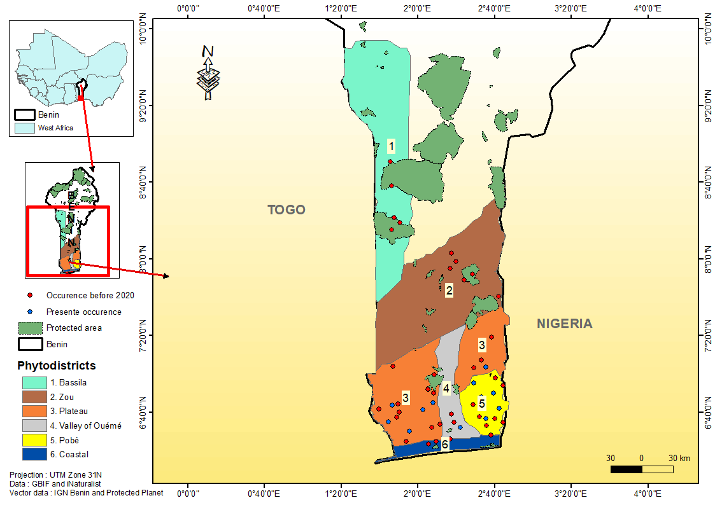

Figure 1 : Map illustrating the phytodistricts where Chrysophyllum albidum plants are present, in Benin
Source : (Alowanou-Kélé, 2023)
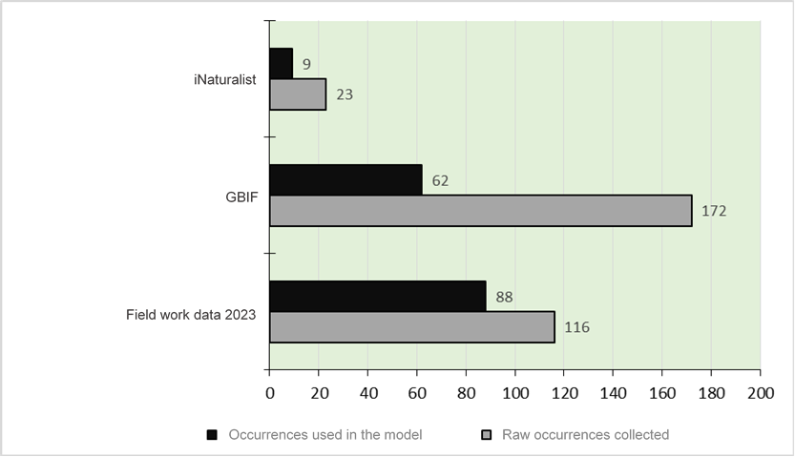
Figure 2 : Chrysophyllum albidum occurrence data

Table 1 : List of bioclimatic variables considered in the modeling of favorable habitats for Chrysophyllum albidum in Benin

Code | Signification en Anglais | Units
Bio1 | Annual mean temperature | °C
Bio2 | Mean diurnal range | °C
Bio3 | Isothermality | -
Bio4 | Temperature seasonality | °C
Bio5 | Maximum temperature of warmest month | °C
Bio6 | Minimum temperature of coldest month | °C
Bio7 | Temperature annual range | °C
Bio8 | Mean temperature of wettest quarter | °C
Bio9 | Mean temperature of driest quarter | °C
Bio10 | Mean temperature of warmest quarter | °C
Bio11 | Mean temperature of coldest quarter | °C
Bio12 | Annual precipitation | mm
Bio13 | Precipitation of wettest month | mm
Bio14 | Precipitation of driest month | mm
Bio15 | Precipitation seasonality | -
Bio16 | Precipitation of wettest quarter | mm
Bio17 | Precipitation of driest quarter | mm
MI | Annual moisture index | °C/mm
MIMQ | Quarter moisture index | °C/mm
MIAQ | Quarterly humidity and aridity index | °C/mm
DM | Number of driest month | Mois
LLDS | Length of longest dry season | Mois/jour

Table 2: List of edaphic variables considered in the modeling of favorable habitats for Chrysophyllum albidum in Benin

Codes | Meanings | Units
CoS₁, CoS₂, CoS₃ et CoS₄ | Soil organic carbon at the depth horizon n (1, 2,3 et 4) | g/kg
Ts (Ts_{a}, Ts_{b}, Ts_{c} Ts_{d}, Ts_{e,} Ts_{f} Ts_{g} Ts_{h} Ts_{i}) | Soil type with for the modality  a = arenosol, b = cambisol, c = gleysol, d = leptosol, e = luvisol, f = lixisol,  g = nitisol, h = Vertisol, i = Plinthosol | Categorical qualitative variable
Cec₁, Cec₂, Cec₃ et Cec₄ | Cation exchange capacity of the soil at of the depth horizon n (1, 2,3 et 4) | cmol/kg
Tes | Sand content at depth horizon n (1, 2,3 et 4) | %
Te | Silt content of the soil at of the depth horizon n (1, 2,3 et 4) | %
TeA | Clay content of the soil at of the depth horizon n (1, 2,3 et 4) | %

  - Data Analysis
    - Occurrence Data and Environmental Variables
The Chrysophyllum albidum presence data recorded underwent a thorough and careful cleaning (Data cleaning) thanks mainly to the interphase GeoCAT (Geospatial Conservation Assessment Tool ; http://geocat.kew.org/) (Bachman et al., 2011), the statistical software R, the database management software OpenRefine 1.6.1 and the mapping software ArcGIS 10.7. Using ArcGIS 10.7 mapping software, the Outliers were removed from the raw database. Thanks to the OpenRefine 1.6.1 database management software, presence data lacking the essential attributes (scientific name, XY coordinates, date and method of collection) were isolated in the same way as white spaces and synonymies. Furthermore, duplicate recordings were also eliminated and only presence points at least 5 km apart (Tphin = 5 km) were retained from the Tphin package thanks the R statistical software (Costello et al., 2013).
The climatic and edaphic environmental variables obtained were subjected to various treatments. Specifically, they were cut according to the mask (current occupancy zone of the species), aligned and converted in the ASCII format before being integrated into the modeling algorithm. The modeling algorithm used is the Maximum Entropy (MaxEnt) through Wallace, a flexible tool in terms of adaptability to the data to be integrated for reproducible ecological modeling that predicts the response of the species to environmental conditions.

    - Modeling and Validation of the MaxEnt Model then Mapping and Spatial Analysis
The bioclimatic variables were subjected to a Jackknife’s test in MaxEnt (Phillips et al., 2006) to assess the individual contribution of each of these environmental variables to the model on the one hand (Gbesso et al., 2013) and to identify, on the other hand, the behavior of the model when each of the variables retained is excluded. The variables converted into ASCII format were integrated in the algorithm and a cross-validation was carried out following AUC (Area Under the Curve) metric values ​​in order to select the variables which best respond to the spatial distribution of the species. Based on the variables obtained, the current phytogeographic distribution of C. albidum was observed and projected into the future on maps following the most recent RCP 4.5 and RCP 8.5 scenarios (optimistic and pessimistic respectively), on the horizon 2055.
The model was run five times using the logistic approach as the output format. The “10 percentile training presence logistic threshold” value was used as a probability threshold, to define the levels of habitat suitability for the species. The zone of probability of occurrence below the threshold is considered to be unfavorable habitat for the species while the zone of probability of occurrence above the threshold corresponds to a more favorable habitat for the species. The accuracy of the model was assessed using TSS (True Skill Statistics). 25% of the observation points of the species were used to test the model and 75% of the points were used to calibrate the model. The cross-validate method was used to calculate the AUC, the interpretation thresholds of which are defined in Table 3.

Table 3 : Validity of the MaxEnt test according to the AUC values ​​(Gnagbo et al., 2015)
AUC values | Corresponding interpretations
0.5 ˂ AUC ˂ 0.6 | Invalid
0.6 ˂ AUC ˂ 0.7 | Bad
0.7 ˂ AUC ˂ 0.8 | Acceptable
0.8 ˂ AUC ˂ 0.9 | Good
0.9 ˂ AUC ˂ 1 | Excellente

- RESULTS
  - Current Spatial Distribution of Chrysophyllum albidum
In Benin, C. albidum is distributed in the southern part with a concentration in the Guineo-Congolese climatic zone. The species is present more precisely in the phytodistricts Coastal, Plateau, Pobè and Valley of Ouémé (Figure 3).

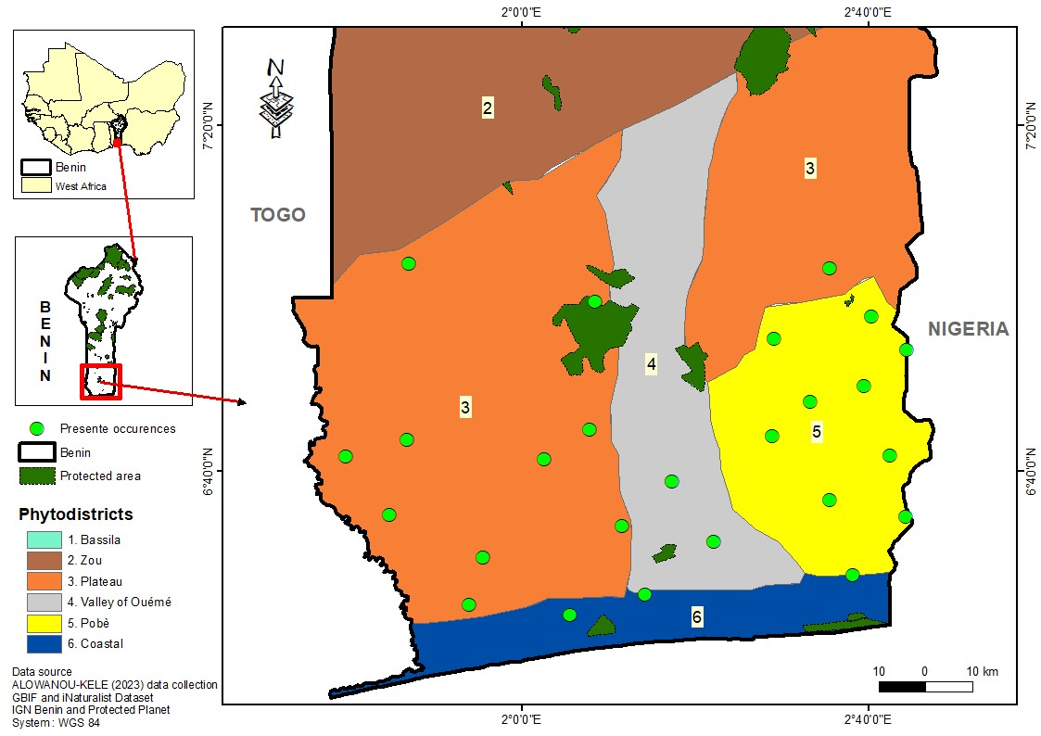

Figure 3 : Current spatial distribution map of Chrysophyllum albidum in Benin
Source : (Alowanou-Kélé,2023)

  - Modeling the Current Potential Ecological Niche and on Horizon 2055, of Chrysophyllum albidum in Benin

    - Selection of Environmental Variables and Model Validation

Five environmental variables were retained based on their percentages of contribution to the model. These are : Bio7 (annual temperature difference), Bio14 (rainfall in the driest month), Bio4 (temperature seasonality), Bio15 (rainfall seasonality) and Ts (Soil type). Table 4 presents the degree of contribution of each of these variables in the development of the model. From the analysis of this table, it appears that the variables which contributed the most to the development of the model are respectively the variables Bio7, Bio14, Bio4, Ts and Bio15. The Jackknife’s test was used to assess the individual contribution of each environmental variable to the model and to provide indications on the functioning of the model when each of the variables is excluded. It follows from the analysis of Figure 4 presenting the results of this test, that depending on their contributions to the development of the model, the environmental variables which increase the gain of information explaining the distribution of C. albidum when used in isolation in the model are respectively : Bio7, Bio4, Bio14, Ts and Bio15. Consequently, the annual temperature difference (Bio7) is the environmental variable that holds much more information not contained in the other variables and the seasonality of precipitation (Bio15) constitutes the environmental variable that holds less information explaining the spatial distribution of the species.

Table 4 : Contribution of the five selected environmental variables

Variable code | Meaning | Contribution to the development of the model (%)
Bio7 | Temperature annual range | 47
Bio14 | Precipitation of driest month | 40,8
Bio4 | Temperature seasonality | 6,5
Ts | Soil type | 3,2
Bio15 | Precipitation seasonality | 2,6

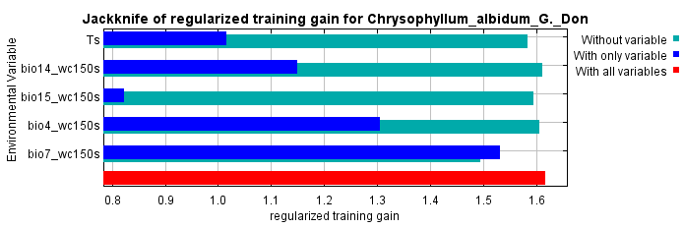

Legend : The figure presents the environmental variables (y-axis) according to their contributions to the calibration of the model (x-axis). The red band shows the performance of the model shot with all variables selected. The bands corresponding to each environmental variable reveal the performance of the model when the latter is run with said variable alone (blue color) or without it (green color).
Figure 4 : Result of the Jackknife’s test on the contribution of environmental variables to the spatial distribution model of Chrysophyllum albidum

The performance of the model was assessed by three statistical parameters. These are the area under the curve (AUC) value, the TSS value and the ROC partial statistical test. Figure 5 shows that the AUC value from running the MaxEnt model is 0.92. This reflects the excellent performance of the MaxEnt algorithm in capturing variations in environmental data to predict habitats favorable to the species. The TSS value obtained is 0.46, allowing us to conclude that the model would work better than a random model. The result of the Partial ROC statistical test (Figure 6) indicates that the model would perform significantly with a normal distribution of Partial AUC.

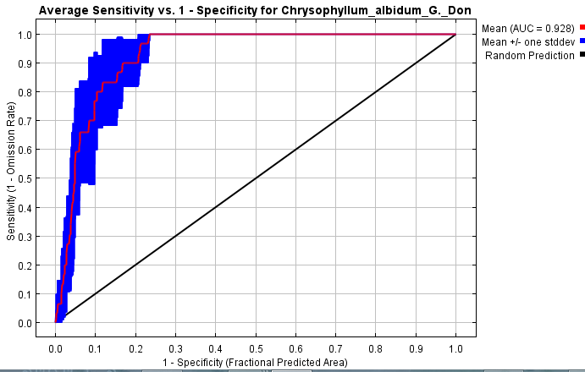
Figure 5 : Curve of the average AUC value of the spatial distribution model of Chrysophyllum albidum

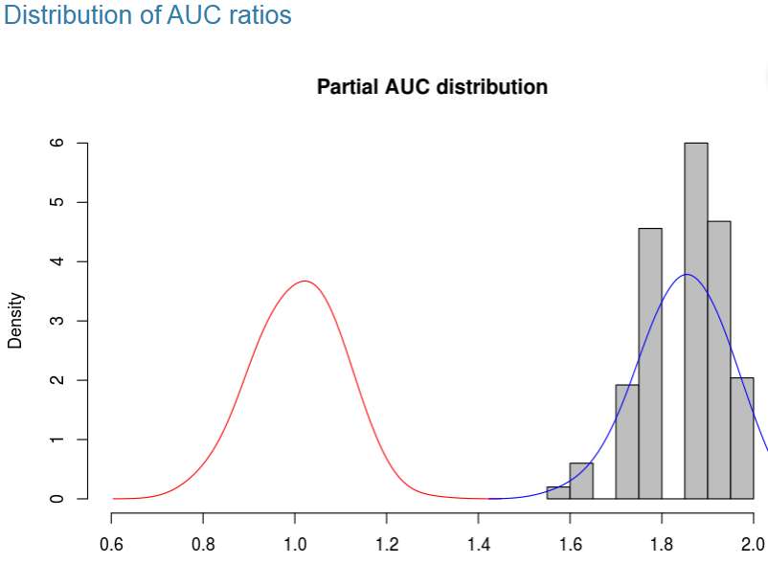
Figure 6 : Partial AUC distribution result obtained from the Partial ROC test

    - Present and Future Favorable Habitats of Chrysophyllum albidum in Benin

The modeling of favorable ecological niches of C. albidum was carried out in the Wallace interface via the MaxEnt algorithm. From the exploitation of Figure 7 presenting the distribution of current and future habitats of C. albidum in Benin, it emerges among other things that in the present environmental conditions, the areas favorable to this species cover the Coastal, Plateau, Pobè and Valley of Ouémé phytodistricts belonging to the Guinéo-Congolese climatic zone. So currently, the phytodistricts located in the Guinean-Sudanian transition climatic zone and those coming from the Sudanese climatic zone are unfavorable for the species.
Future projections of the spatial distribution of C. albidum were carried out for 2055 using the Greenhouse Gas (GHG) emission scenarios RCP 4.5 and RCP 8.5. Figure 8 predicts an increase in areas currently favorable to the species, with the optimistic scenario RCP 4.5. On the other hand, considerable fragmentation of areas currently favorable to the species is predicted with the pessimistic scenario RCP 8.5, which suggests an increase in GHG emissions on the horizon 2055 (figure 7). The areas that will be potentially favorable to this species whatever the climatic scenario are located in the phytogeographic districts Coastal, Plateau, Pobè and Valley of Ouémé. According to Table 5 showing the variation in areas favorable to the conservation of C. albidum in Benin, the areas currently favorable to the species cover 7874.85 km² or approximately 6.86% of the total area of ​​Benin estimated at 114763 km². The optimistic scenario RCP 4.5 predicts on the horizon 2055 an increase of 31.20% of this area currently favorable to the species while the pessimistic scenario RCP 8.5 instead predicts a reduction of 44.80% of currently favorable habitats. Table 6 presents the climatic zones, phytodistricts and protected areas favorable to C. albidum. It emerges from the analysis of this table that in current and future possible climatic conditions, the zones favorable to C. albidum correspond to the Guineo-Congolese climatic zone ; the phytodistricts Coastal, Plateau, Pobè and Valley of Ouémé are and will remain favorable to the species. Furthermore, the classified forests of Pahou, Lama, Pobè and Itchèdè constitute protected areas favorable to C. albidum. Figure 8 showing the superposition of C. albidum occurrences on the soil layer on the interphase of Harmonized World Soil Database Viewer (HWSD-Viewer), reveals that the species is distributed mainly on Nitisols, a type of soil located in the Guineo-Congolese zone of Benin.

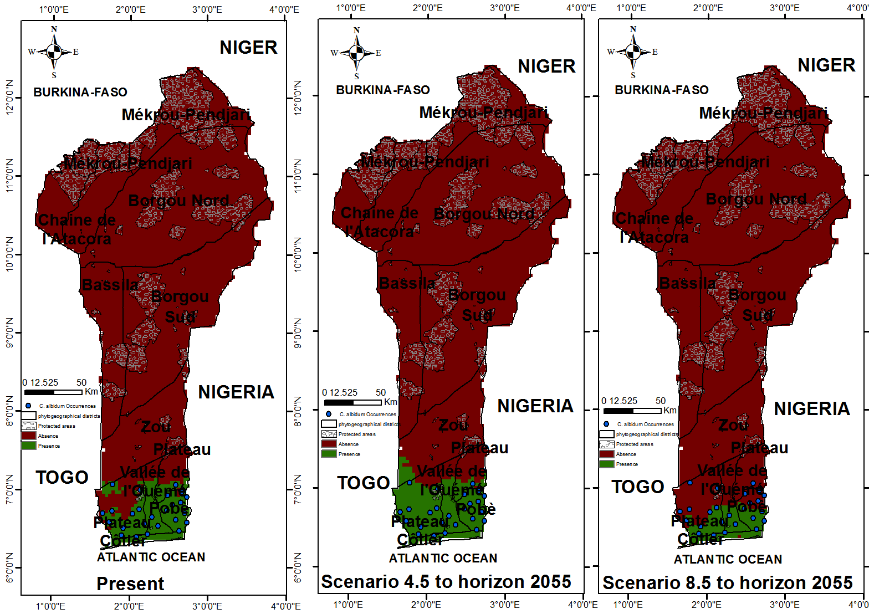

Figure 7 : Distribution of current and future habitats (RCP 4.5 and RCP 8.5) of Chrysophyllum albidum in Benin
Source : (Alowanou-Kélé, 2023)
Table 5 : Variation of areas favorable to the conservation of Chrysophyllum albidum in Benin
 | Favorable areas |  | Unfavorable areas |  | Total Area
 | Area (Km²) | Tendency (%) | Area (Km²) | Tendency  (%) | Area (Km²)
Present | 7874,85  (6,86%) | --- | 106888,14 (93,15%) | --- | 114763
RCP 4.5 | 10331,81 | + 31,20 | 104431,19 | - 2,30 | 114763
RCP 8.5 | 4346,92 | - 44,80 | 110416,08 | + 3,30 | 114763

Table 6 : Climatic zones, phytodistricts and protected areas favorable to Chrysophyllum albidum

Chrysophyllum albidum G. Don
 | Climatic zones  favorable | Favorable phytodistricts | Favorable protected areas
Present | Guineo-Congolese Zone | Coastal, Plateau, Pobè and Valley of Ouémé. | Classified forests of Pahou, Lama, Pobè and Itchèdè.
RCP 4.5 | Guineo-Congolese Zone | Coastal, Plateau, Pobè and Valley of Ouémé. | Classified forests of Pahou, Lama, Pobè and Itchèdè.
RCP 8.5 | Guineo-Congolese Zone | Coastal, Plateau, Pobè and Valley of Ouémé. | Classified forests of Pahou, Lama, Pobè and Itchèdè.

Figure 8 : Current and future distribution (RCP 4.5 and RCP 8.5) of Chrysophyllum albidum in Benin, depending on soil types

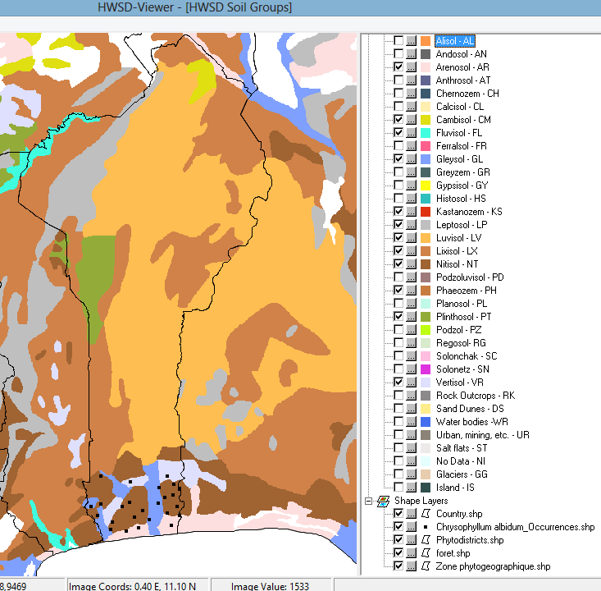

- DISCUSSION
  - Importance of Environmental Variables in the Distribution of Chrysophyllum albidum, and Model Performance
The analysis of the results obtained reveals that five environmental variables predict the distribution of C. albidum. These are the four climatic variables Bio4, Bio7, Bio14 and Bio15 then the pedological variable soil type (Ts). With its rate of 3.2%, the edaphic parameter soil type contributed more to the determination of the model than the climatic variable Bio15 (Seasonality of precipitation) whose contribution rate is 2.6%. Better, according to our results, C. albidum is distributed mainly on Nitisols, a type of soil located in the Guineo-Congolese climatic zone of Benin. We then remember that the soil, despite its small contribution to the creation of the model, should not be neglected (Adjahossou et al., 2016). Consequently, climatic and edaphic factors all influence to varying degrees the spatial distribution of C. albidum in Benin. Similar results have been obtained by many other authors, notably on Parkia biglobosa (Ayihouenou et al., 2016 ; Fachola et al., 2019) and on Detarium microcarpum (Agbo et al., 2019). In accordance with the results of the research work of Gbesso et al. (2013), the results of the present study reveal that the distribution of C. albidum habitats is essentially influenced by climatic variables. However, edaphic factors are also essential because they act physiologically on plant species (Badeau et al., 2005 ; Guo et al., 2024) and then participate in the improvement and precision of spatial distribution models (Ayihouenou et al., 2016).
In natural conditions, the ecological niche constitutes the environmental space occupied by a species (Pulliam, 2000) independently of possible biotic interactions with other species (Ricklefs, 2010). Ecological niche modeling corrects the problem linked to the inability to completely cover the living environment of a plant species during field collections and allows the design of appropriate conservation strategies (Sinadouwirou et al., 2023). For this purpose, there are generally two categories of models, namely : empirical models and mechanistic models (Toffa et al., 2022). MaxEnt, one of the empirical models, is the algorithm used in this study because only species presence data is held (Fachola et al., 2019). The MaxEnt method is based on these observed occurrences and environmental data from the environment where the species lives to provide information on its favorable and unfavorable habitats (Toffa et al., 2022). Obtaining the value 0.92 as the average AUC reflects the excellent performance of the MaxEnt model used in the present work.

  - Implication of the Study for the in Situ Conservation of Chrysophyllum albidum
The results of the present study show that under current and future climatic conditions, the favorable areas of C. albidum correspond to the Guineo-Congolese climatic zone ; the phytodistricts Coastal, Plateau, Pobè and Valley of Ouémé are and will remain favorable to this species in Benin. These results reinforce those of Gbesso et al., who already revealed in 2013 that habitats very favorable to C. albidum are located in the Plateau, Pobè and Vallée de l’Ouémé phytodistricts of the Guinéo-Congolese climatic zone. The Coastal supernumerary phytodistrict added by this work not only confirms that the species is little threatened by climate change in Benin (Gbesso et al., 2013), but also explains a certain dynamic of its propagation favored by some additional environmental factors (Ogougbé et al., 2021). However, unlike the work of Gbesso et al. (2013), the results of the present work had the merit of providing precise information on the degree of contribution of edaphic factors in the spatial distribution of C. albidum. Consequently, this present study addresses the lack of information essentiale for better conservation of this species widely used by the local populations of Benin.
According to the results of this study and those of Gbesso et al. (2013), the Guineo-Congolese climatic zone constitutes the natural biotope of C. albidum in Benin. Therefore, the Sudano-Guinean transition climatic zone presents areas unfavorable to the species. This scientific reality could be explained by the fact that the species is distributed mainly on Nitisols, a type of soil located in the Guineo-Congolese zone. We deduce that the Guineo-Congolese climatic zone has the environmental conditions likely to allow good conservation of C. albidum, facing the effects of climate change on the horizon 2055. The selection of elite morphotypes is necessary to successfully conserve a plant species (Koffi et al., 2023 ; Bolamba et al., 2024 ; Alowanou-Kélé et al., 2025) in its favorable habitats (Avaligbé et al., 2021).
Anthropogenic action strongly threatens the sustainable conservation of several species such as C. albidum. Better still, the socio-economic importance of C. albidum causes its overexploitation, or even its disappearance, in Nigeria (Formecu, 1999) and in Benin where a high vulnerability index (Iv ≥ 2.50) is recorded for this species at the national level (Alowanou-Kélé et al., 2023). By deduction therefore, human actions strongly contribute to the reduction of the current habitats of C. albidum in Benin. Hence the limitation of this study which did not take into account human actions in modeling the spatial distribution of C. albidum, a species with multiple uses (Houessou et al., 2012).

- CONCLUSION
Faced with the threat of extinction weighing on Chrysophyllum albidum in Benin, this research made it possible to determine, using the climatic and edaphic data collected, all the present and future habitats favorable to the development of the species, in order to develop strategies that could promote its sustainable conservation. It follows from the results obtained that in current and future climatic conditions (RCP 4.5 and RCP 8.5), the areas favorable to C. albidum correspond to the Guineo-Congolese climatic zone where the Nitisols are located, a type of soil on which the species is widely distributed ; the phytodistricts Coastal, Plateau, Pobè and then Valley of Ouémé are and will remain suitable for this species. All environmental variables (climatic and edaphic) considered in this study therefore influence to varying degrees, the spatial distribution of C. albidum. This various information rendered available will undoubtedly promote the introduction of C. albidum into the appropriate and necessary habitats for its sustainable conservation.
For the efficiency of the conservation of C. albidum, we suggest :
- Conduct a germination test of C. albidum seeds in order to know precisely the conditions for the lifting of dormancy of its seeds ;
- Evaluate the phenology of C. albidum to identify the environmental parameters that influence the foliage, flowering, and fruiting of the species ;
- Conduct studies on the silviculture of C. albidum in order to successfully domesticate it.

Disclaimer (Artificial intelligence)
Option 1:
Author(s) hereby declare that NO generative AI technologies such as Large Language Models (ChatGPT, COPILOT, etc.) and text-to-image generators have been used during the writing or editing of this manuscript.

- REFERENCES
Adjahossou, S.G.C., Gouwakinnou, G.N., Houehanou, D.T., Sodé, A.I., Yaoitcha, A.S., Houinato, M.R.B., Sinsin, B. (2016). Effectiveness of protected areas in the conservation of priority favorable habitats of valuable woody species in Benin. Wood and forests of the tropics, 328(67-76) (2).

Adomou, C.A. (2005). Vegetation Patterns and Environmental gradients in Benin. Implications for biogeography and conservation. PhD Thesis. Wageningen University, Wageningen. 133p. https://doi.org/10.18174/121707.
Agbo, I.R., Missihoun, A.A., Dagba, R.A., Assogbadjo, E.A., Agbangla, C. (2018). Morphological variability of Detarium microcarpum Guill. & Perr. (Caesalpiniaceae) in Benin, West Africa. Asian Journal of Research in Agriculture and Forestry, 1(2) : 1-12. https://doi.org/10.9734/AJRAF /2018/41234.
Agbo, I.R., Idohou, R., Vihotogbé, R., Missihoun, A.A., Dagba, A.R., Assogbadjo, E.A., Agbangla, C. (2019). Spatio-temporal dynamics of suitable habitats for Detarium microcarpum Guill. & Perr. (Caesalpiniaceae), a priority food tree species in Benin (West Africa). Modeling Earth Systems and Environment, 5 : 595–604. Springer Nature 2019. https://doi.org/10.1007/s40808-018-0550-x.
Akoègninou, A., Van der Burg, W.J., Van der Maesen, L.J.G. (eds). (2006). Analytical Flora of Benin. Backhuys Publishers, Leiden, University of Abomey-Calavi, Cotonou (Benin), 1034p.
Akouèhou, G.S., Houndonougbo, A., Tenté, B. (2013). The dynamics of production systems in agricultural lands bordering the intercommunal forest of Fita-Agbado in the communes of Dassa-Zoumè and Savalou, Collines Department in Central Benin. Int. J. Biol. Chem. Sciences, 7(5) : 1877-1891. http://dx.doi.org/10.4314/ijbcs.v7i5.8.
Alowanou-Kélé, B., Missihoun, A.A., Agbo, R.I., Ewédjè, E.-E.B.K., Yédomonhan, H. and Agbangla, C. (2023). Impacts of the Use of Chrysophyllum albidum G. Don on Its Vulnerability and Its Conservation in Benin. Annual Research & Review in Biology, 38, 11 (Dec. 2023), 1-13. DOI: https://doi.org/10.9734/arrb/2023/v38i1130613.
Alowanou-Kélé, Blaise, Missihoun, A.A., Agbo, R.I., Sedah P., Ewédjè E-E, Yédomonhan H. and Agbangla, C. (2025). Morphological Diversity and Phytogeographic Patterns of Chrysophyllum albidum (Sapotaceae) in Benin. International Journal of Plant & Soil Science, 37 (2) : 290-305. https://doi.org/10.9734/ijpss/2025/v37i25332.
Avaligbé, Y., Chabi, F., Gnanglè, C., Bello, O., Yabi, I., Ahoton, L. and Saïdou, A. (2021). Modeling the current and future spatial distribution area of ​​shea (Vittelaria paradoxa CF Gaertn) in the context of climate change in Benin. American Journal of Climate Change, 10 , 263-281. Doi : 10.4236/ajcc.2021.103012.
Ayihouenou, E.B., Fandohan, B., Sodé, A.I., Gouwakinnou, N.G., Djossa, A.B. (2016). Biogeography of the nere (Parkia biglobosa (Jack.) R. Br. ex. Don.) under current and future environmental conditions in Benin. Benin Agricultural Research Bulletin (BRAB). Special issue Agronomy, Society, Environment & Food Security - August 2016. ISSN on hard copy : 1025-2355 and ISSN online : 1840-7099.
Bachman, S., Moat, J., Hill, A.W., Torre, J., Scott, B. (2011). Supporting Red List threat assessments with GeoCAT (Geospatial Conservation Assessment Tool). In : Smith V, Penev L (Eds) e-Infrastructures for data publishing in biodiversity science. ZooKeys 150 : 117–126. https://doi.org/10.3897/zookeys.150.2109.
Badeau, V., Dupouey, J. L., Cluzeau, C., Drapier, J. (2005). Potential distribution areas of forest species by 2100. Forest Business, vol. 162, pp. 25-29.
https://hal.inrae.fr/hal-02665646v1.

Boko, M., Niang, I., Nyong, A., Vogel, C. (2007). Africa Climate change 2007 : Impacts, Adaptation and Vulnerability. Contribution of Working Group II to the 4th Assessment report of the Intergovernmental Panel on Climate Change. Cambridge University Press : Cambridge, UK ;433-467. https://www.ipcc.ch/site/assets/uploads/2018/03/ar4_wg2_full_report.pdf.
Bolamba, F., Mukandama, J-P., Looli, L. & Nzawele, D.B. (2024). Morpho-quantitative characterization of local cassava cultivar (Manihot esculenta Crantz) collected at the Tshopo Province (DR. Congo). African Agronomy, 36 (1), pp 99 - 111.
Bourou, S. (2012). Eco-physiological study of the tamarind tree (Tamarindus indica L.) in an arid tropical environment, Doctoral thesis, Faculty of Bioengineering Sciences, Ghent University, Belgium, 193 p. http://dx.doi.org/10.21825/af.v25i1.18056.
Bowe, C. (2007). Predicting suitable areas for the production of tamarind (Tamarindus indica L.) an underutilised fruit tree species, PhD Thesis, University of Southampton, Southampton, UK, 230 p.
Brou, Y.T., Akindès, F., Bigot S. (2005). Climate variability in Côte d’Ivoire : between social perceptions and agricultural responses. Notebooks Agriculture, Vol.14 (6) : 533-540.
http://dx.doi.org/10.13140/2.1.5174.3368.

Busby, J.W., Smith, T.G., White, K.L., Strange, S.M. (2010). Locating climate insecurity : where are the most vulnerable places in Africa ? Austin, TX, USA : University of Texas, The Robert Strauss Center for International Security and Law, Climate Change and African Political Stability (CCAPS) Austin, TX, USA.
http://dx.doi.org/10.1007/978-3-642-28626-1_23.

Costello, M.J., Michener, W.K.., Gahegan, M., Zhang, Z.Q., & Bourne, P.E. (2013). Biodiversity data should be published, cited, and peer reviewed. Trends in Ecology & Evolution, 28(8), 454-461. http://dx.doi.org/10.1016/j.tree.2013.05.002.
Dah-Dovonon, J.Z. (2002). Benin Report, In Network “Food Woody Species”. Proceedings of the first meeting of the Network : 11–13 December 2000. Edited by Eyog-Matig O., Gaoué O.G., Dossou B. IPGRI : Ouagadougou, Burkina Faso, 2–19.
Edem, D.O., Eka, O., Ifon, E.T. (1984). Chemical evaluation of the nutritive value of the fruits of African star apple (Chrysophyllum albidum). Food Chem, 14 : 303–311. https://doi.org/10.1016/0308-8146(84)90085-2.
Elith, J., Graham, H.C., Anderson, P., Dudik, M., Ferrier, S., Guisan, A., Hijmans, J., Huettmann, F., Leathwick, R., Lehmann, A., Li J., Lohmann, G., Loiselle, A., Manion, G., Moritz, C., Nakamura, M., Nakazawa, Y., Overton, M.C., Townsend, P., Phillips, J., Richardson, K., Scachetti-Pereira, R., Schapire, E., Soberon, J., Williams, S., Wisz, S.M., Zimmermann, E. (2006). Novel methods improve prediction of species' distributions from occurrence data. Ecography, 29 : 129-151.
http://dx.doi.org/10.1111/j.2006.0906-7590.04596.x.

Elith, J., Leathwick, J.R. (2009). Species Distribution Models : Ecological Explanation and Prediction Across Space and Time. Annual Review of Ecology Evolution and Systematics, 40 : 677-697. http://dx.doi.org/10.1146/annurev.ecolsys.110308.120159.
Fachola, O.B., Lougbégnon, O.T., Agossou, N. (2019). Modeling the ecological niche of Parkia biglobosa (Jacq.) in southern and central Benin (West Africa). Canadian Journal of Geography, 1, 19-25.
Fandohan, A.B., Moutouama, K.J., Biaou, S.S.H., Gouwakinnou, N.G., Adomou, C.A. (2015). Does the Benin-Togo protected area network ensure the conservation of Thunbergia atacorensis (Acanthaceae) ? Rev. Cames - vol.03 num.02. ISSN 2424-7235. Life, Earth and Agronomy Science, PP 25-31.
Feely, K.J., Terborgh, J.W. (2008). Direct verses indirect effects of habitat reduction on the loss of avian species from tropical forest fragments. Animal Conservation, 11, 353-360.
Formecu (1999). Forest Resources Study, Nigeria–Revised Forest Management Plan Edo State. A report prepared and submitted to FORMECO by two consortia – Black Consultants Ltd and Geomatric International / Geomatrics Nigeria Ltd. June 28 :1999. 126pp.
Gbesso, F.H.G., Tenté, B.H.A., Gouwakinnou, N.G., Sinsin, B.A. (2013). Influence of climate change on the geographical distribution of Chrysophyllum albidum G. Don (Sapotaceae) in Benin. Int. J. Biol. Chem. Sci, 7(5) : 2007-2018.
http://dx.doi.org/10.4314/ijbcs.v7i5.18.

Guo, J., Zhang, M., Bi, Y., Zhao Z., Wang R., & Li M. (2024). Spatiotemporal distribution
prediction of the relict and endangered plant Tetraena mongolica in inner Mongolia, China under climate change. Sci Rep 14, 28478.
https://doi.org/10.1038/s41598-024-79088-6.

Houessou, G.L., Lougbégnon, O.T., Gbesso, G.H.F, Anagonou, S.L, Sinsin, B. (2012). Ethnobotanical study of the African star apple (Chrysophyllum albidum G. Don) in the Southern Benin (West Africa). Journal of Ethnobiology and Ethnomedicine, 8 : 40. http://dx.doi.org/10.1186/1746-4269-8-40.
IPCC (2007). Climate change : synthesis report. Cambridge University Press, New York, USA. https://www.ipcc.ch/site/assets/uploads/2018/02/ar4_syr_full_report.pdf.
Katé, S., Dagbénonbakin, G. D., Agbangba, C. E., De Souza, J. F., Kpagbin, G., Azontondé, A., & Sinsin, B. (2014). Local perceptions of climate change manifestation and adaptation measures in soil fertility management in the Banikoara Commune in Northern Benin. Journal of Applied Biosciences, 82 (1), 7418-7435.
http://dx.doi.org/10.4314/jab.v82i1.11.

Koffi, J-M, Kouakou, C.K., Koffi, P.K., Sarron, J, Fondio, L., Djaha, J.B.A., Soro, D., Faye E. (2023). Morphological diversity of mango tree varieties from the collection of the National Agronomic Research Center station in Lataha, Ivory Coast. Agronomie Africaine, 35 (1) : 125-135. https://www.ajol.info/index.php/aga/article/view/252605.
Kouyaté, A.M., Lamien, N. (2011). Conservation and Sustainable Use of Genetic Resources of Priority Food Tree Species in Sub-Saharan Africa. Biodiversity International (Rome, Italy), 4-8.
Mbaye, A (2011). Jatropha cultivation in Senegal : Between promoters’ logic and farmers’ skepticism. In : Collection of summaries of the final workshop of the RIPIECSA program, Palais des congrès, Cotonou. Benin, 10p.
Munasinghe, M. (2007). Making Development More Sustainable : Sustainomics Framework and Practical Applications (Colombo, Sri Lanka : MIND Press, Munasinghe Institute for Development) ; www.mindlanka.org Intergovernmental Panel on Climate Change, Synthesis Report Fourth Assessment (Geneva) ; www.ipcc.ch.
Ogougbé, E.R., Agbo, I.R., Ahamidé, B., Djego-Djossou, S., Djego, G.J. (2021). Potential geographic distribution and modelling of the ecological niche of Harrisonia abyssinica, a priority medicinal tree species in Benin (West Africa). Modeling Earth Systems and Environment, 1-13. Springer Nature 2021.
https://doi.org/10.1007/s40808-021-01236-y.

Phillips, S.J., Anderson, R.P., Schapired, R.E. (2006). Maximum Entropy Modeling of species geographic distributions. Ecological Modelling, 190 : 231-259.
http://dx.doi.org/10.1016/j.ecolmodel.2005.03.026.

Pulliam, H.R. (2000). On the relationship between niche and distribution. Ecology Letters, 3 : 349-361.
Ricklefs, R. E. (2010). A Economia da Natureza. Guanabara Koogan, Rio de Janeiro, 570 p.
Sala, E., Ballesteros, E., Starr, R.M. (2001). Rapid decline of Nassau grouper spawning aggregations in Belize : Fishery Management and Conservation Needs, 26 : 23-30.
Schmidt-Soltau, K, Alimi, R.M. (2008). National Program for Sustainable Management of Natural Resources. Final Report. Republic of Benin. 55 p. + annexes.
Sinadouwirou, A.T., Gouwakinnou, G.N. and Dramani, R. Assede, P.E., Orou, H., Biaou H.S. (2023). Modeling the ecological niche of Detarium microcarpum Guill & Perr. : Evidence for local adaptation across the climatic gradient in Benin. TOUR. RAMRES Life, Earth and Agronomy Sciences 10 (2) :43–52.
Thirtle, C., Lin, L., Piesse, J. (2003). The impact of research-led agricultural productivity growth on poverty reduction in Africa. Asia and Latin America. World Development, 31 (12), 1959–1975. http://dx.doi.org/10.1016/j.worlddev.2003.07.001.
Toffa, Y., Idohou, R., Fandohan, A.B., (2022). Modeling species distribution in Africa : state of the art and perspectives. Physical Geography and Environment, 17 : 43-65. http://dx.doi.org/10.4000/physio-geo.13738.
Wembou, P.E., Atakpama, W., Fandohan, B., Tozo, K., Akpagana, K., (2017). Impacts of bioclimatic factors on the distribution and conservation of Dioscorea praehensilis Benth in the subhumid zone of Togo. Canadian journal of tropical geography, Vol. (4) 1. pp.59- 68.
World Agroforestry Centre (2008). Transforming Lives and Landscapes. Strategy 2008-2015. World Agroforestry Centre : Nairobi ; 39.

