Challenges and Practices of Integrated Solid Waste Management: Insights from Debre Berhan Reogiopolitant City, Ethiopia

## Abstract

Solid waste governance is a significant global challenge, particularly exacerbated in rapidly urbanizing, low- income countries that often lack the infrastructure and resources to manage increasing waste volumes. This study investigates the challenges and practices of integrated solid waste management (ISWM) in Menelik Sub-City, Debre Berhan, Ethiopia. This study utilized both qualitative and quantitative methods, including household surveys, key informant interviews, direct observation, and focus group discussions. A systematic random sampling technique was used to select respondents from residents, cooperative partnership associations, and sanitation administration staff. The results indicated that 37.4% of respondents recognized the lack of skilled manpower as a significant contributor to the inefficiency of solid waste management (SWM) while 40.3% of respondents highly agreed that inadequate infrastructure hindered the efficiency of SWM systems in the study area. The findings showed limited waste management practices in study area have environmental challenges and public health impacts. This is mainly due to inadequate waste collection, transportation, and disposal systems. Moreover, Menelik sub-city had to face tremendous challenges in waste management in the recent past, due to a number of factors–its growing population, increasing complexity of waste streams, and lack of effective waste management systems, proper infrastructure, capital investment, financial and human resources, as well as effective policy and regulatory enforcement. This study offers critical data and analysis that can inform policymakers, urban planners, and researchers. By identifying key barriers and effective practices, the findings contribute to the broader scientific discourse on sustainable waste management, particularly in rapidly urbanizing regions of developing countries. The findings highlighted an integrated solid waste management (ISWM) based on the 5Rs (i.e. refuse, reduction, reuse, recycle and recovery) approach is an environmentally sustainable and socially acceptable solution, which urgently needed to be implemented by the city.

**Key words**: Ethiopia, Debre Berhan, Integrated solid waste management; Menelik sub city, Transportation

# Introduction

The governance of solid waste represents a significant worldwide challenge, closely tied to the dynamics of urbanization, public health outcomes, and environmental resilience. By 2050, the world is projected to generate 3.4 billion tons of municipal solid waste annually, a 70% increase from 2016 levels, driven by population growth, urbanization, and consumption patterns [1]. Rapid urbanization in low- and middle-income countries exacerbates these challenges, as cities often lack the infrastructure, financial resources, and institutional frameworks to manage escalating waste volumes [2]. Inadequate waste management contributes to pollution, greenhouse gas emissions, and public health crises, disproportionately affecting vulnerable communities [3]. Globally, approximately 2 billion people lack access to regular waste collection, and 3 billion live in areas without controlled waste disposal facilities, perpetuating cycles of environmental degradation and disease [4]. In Africa, urbanization rates outpace waste management capacities, with cities generating over 250 million tons of solid waste annually, of which only 55% is collected and less than 10% recycled [5, 6]. Sub-Saharan Africa, in particular, faces systemic barriers such as weak governance, limited public awareness, and reliance on informal waste- picking sectors [7]. Open dumping and burning remain prevalent, contaminating air, soil, and water resources while exacerbating climate change through methane emissions [4]. Despite these challenges, innovative practices such as community-led recycling and public-private partnerships are emerging as viable solutions, though their scalability remains understudied [5].

Ethiopia reflects these continental trends, with urbanization rates exceeding 4.4% annually and urban populations projected to double by 2050 [8]. The country generates approximately 6.3 million tons of municipal solid waste yearly, yet only 50% is collected, and less than 5% is recycled [9]. Urban centers like Addis Ababa and Debre Berhan struggle with outdated infrastructure, insufficient funding, and fragmented policy implementation [10]. Ethiopia’s Integrated Solid Waste Management (ISWM) framework, introduced in 2017, emphasizes waste reduction, recycling, and community engagement but faces challenges such as weak enforcement, limited stakeholder coordination, and low public participation [11]. These systemic gaps highlight the urgent need for context-specific research to bridge policy aspirations and on-ground realities. Debre Berhan, a regiopolitan city in Ethiopia’s Amhara Region, exemplifies these national challenges. With a population surpassing 120,000 and an annual growth rate of 4.1%, the city generates approximately 45 tons of solid waste daily, of which only 60% is collected [8]. Uncontrolled dumping in open spaces, rivers, and roadside areas has degraded ecosystems and increased health risks, including diarrheal diseases and respiratory infections.

Menelik Sub-City, a densely populated administrative unit within Debre Berhan, faces acute waste management challenges due to rapid urbanization, inadequate infrastructure, and limited public awareness. A 2021 municipal report revealed that 40% of households in Menelik lack access to waste collection services, relying instead on informal disposal methods such as burning or illegal dumping (Debre Berhan City Administration, 2021). Despite Ethiopia’s ISWM policy mandates, the sub-city waste management system remains fragmented. While national guidelines advocate for source separation, composting, and private sector involvement [9], local practices are hindered by a lack of

institutional capacity, financial constraints, and minimal community engagement [12]. Informal waste pickers, who play a critical role in recovering recyclables, operate without legal recognition or social protections, undermining the sustainability of recycling initiatives [13]. Despite many research conducted on Debre Brehan municipal solid waste management, the researcher could not come across any attempts that specifically assess the solid waste collection activity in Menelik sub-city. Hereafter, the researcher strongly believes that identifying the existing status of solid waste management in this sub-city will lay good ground for its improvement.The findings aim to inform policymakers, urban planners, and civil society organizations working to advance sustainable waste management in Ethiopia and similar contexts.

# Materials and research methods

## Description of the study area

For this investigation, the researcher specifically selected Menelik Sub-City as the focus area due to its dense population and congested environment, which provide a more thorough understanding of the solid waste management challenges. Additionally, the researcher is more familiar with this sub-city. The research is based on data gathered from September 1, 2024, to October 13, 2024. The city is positioned at 9°41' North latitude and 39°40' East longitude as indicated in Figure 1. Debre Berhan City was founded in 1454 under the reign of Emperor Zera Yaeqob [14]. It is located in the Amhara National Regional State and serves as the administrative hub for the Northern Shoa Zone, Debre Berhan City Administration, and Bassona Worana Woreda (district). Geographically, the city is about 130 kilometers northeast along the Addis Ababa–Dessie-Mekelle route [11]. The annual precipitation in the region varies between 814 and 1080 mm. Most of Debre Berhan City's urban areas are situated at an altitude of 2750 meters above sea level. The city's landscape is mostly flat, covering 86% of the land, with slopes occupying 10% and mountainous areas making up the remaining 4%. Debre Berhan spans a total area of 21,169.95 hectares. The local economy is mainly driven by tanneries and blanket production, while agriculture in the surrounding suburbs supports a large portion of the local population's livelihoods [11].

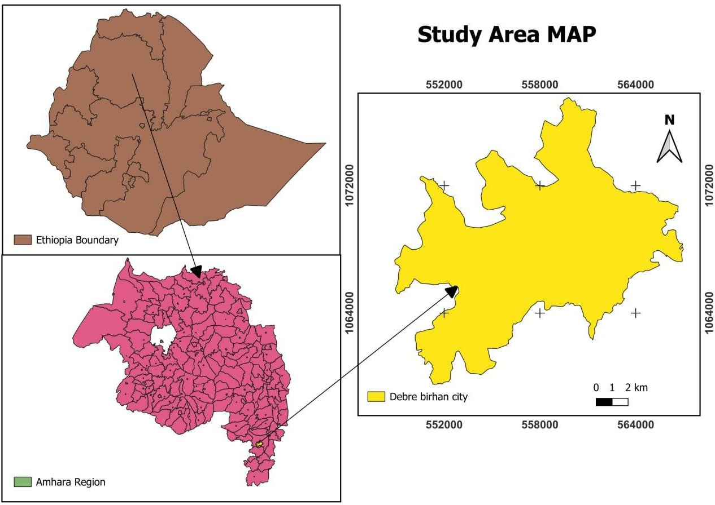

**Figure 1.** Maps of study area

## Approaches of data collection and analysis

The study employed both open and closed-ended questions to extract valuable information. Respondents were selected using a systematic selection technique from residents, cooperative partnership associations, and sanitation administration staff. Household respondents were further selected through systematic random sampling, as described by Wubie, Assen and Nicolau [15]. From three elevation categories: Lower (500–1800 m a.s.l. which include Selam Chora, Loretafework Tekile, and Eyerusalem *kebeles*), Middle (1801–2400 m a.s.l. consisting of Fitwurari Gebeyehu and Nigist Eleni *Kebeles*), and Upper (2401–2800 m a.s.l. covers Woshawushgn, Anisessmariyam, and Dilila *kebeles*), 106 households from each segment were chosen for the socioeconomic analysis. The socioeconomic study was carried out in two main stages. First, sample sites were selected. Then, households within the chosen kebeles, the smallest administrative units in Ethiopia, were identified. Systematic random sampling, as outlined in established methodologies [16], was used to facilitate this process. The sample size for the study area was determined using the methodology outlined in a

previous research conducted by Cochran [17], as outlined in Eqs 1and 2.

n = mo (1)

mo

1+

H

Where; mo

= C2p(1−p) (2)

e2

The study area’s population was projected at 250,348 residents, comprising approximately 66,529 households, based on demographic estimates from the Ethiopian Statistical Agency [8]. To determine the representative sample size for household surveys, a confidence level of 95% and a margin of error of 5% were applied, yielding a calculated sample size of 318 households (see Figure 2). In alignment with this calculation, 318 structured questionnaires were administered to household respondents. To ensure accessibility and cultural relevance, the survey instruments were prepared in two languages: English (for standardized terminology) and Amharic, the dominant local language spoken by the majority of Ethiopia’s population. From the total household population, 108 households were sampled from the Highlands, 100 from the Midlands, and 32 from the Lowlands. These values correspond to 34.7%, 33.3%, and 10% of the total sampled households, respectively. The sampling proportions closely align with the total household distribution in the Highlands and Midlands but exhibit a notable underrepresentation of the Lowlands. This discrepancy may indicate a strategic emphasis on higher altitude zones or methodological constraints that limited sampling in the Lowlands.

Household sampling followed a stratified approach based on agro-ecological zones, with 108 households selected from the Highlands, 100 from the Midlands, and 32 from the Lowlands. These figures represent 34.7%, 33.3%, and 10% of the total sampled households, respectively. The proportional allocation of samples broadly reflects the population distribution in the Highlands (34.7%) and Midlands (33.3%), where household densities are highest. This imbalance may reflect a deliberate focus on highland and midland zones due to their higher population density or socioeconomic relevance to waste management practices. Alternatively, logistical challenges, such as accessibility issues or limited infrastructure in the Lowlands, may have constrained data collection efforts in this zone.

## Household survey data

Data for the study were collected using various data collection techniques, including rapid appraisal methods, key informant interviews (KIIs), direct observation, in-depth interviews, and questionnaires. This allowed for the gathering of both qualitative and quantitative data, as outlined below. The questionnaires were initially created in English and then translated into Amharic to ensure clarity for the participants. Additionally, both structured and unstructured interviews, as well as uncontrolled observation, were utilized. Two types of questionnaires (open and closed-ended) were designed for residents, sanitation administration employees, and members of the cooperative partnership association. Structured and unstructured interviews were conducted with the head and workers of the sub-city sanitation administration, as well as with cooperative partnership associations, to gather information on the institutional setup, capacity, and challenges. Data for community and stakeholder studies were collected from both primary and secondary sources, including focus groups and household (HHs) surveys. An initial reconnaissance survey was conducted to understand the study areas comprehensively. During this preliminary survey, discussions were held with various participants, including farmers and extension staff who interact closely with them[18]. This study used a guiding questionnaire and semi-structured household questionnaires to examine the different methods for MSW collection, storage, treatment, transportation and disposal. The questionnaire, which consisted of open

and closed-ended questions, offered insights into these changes' drivers. Initially tested on ten HHs in four districts or *Kebeles* (but not part of the primary study sample), it was modified and administered to three hundred eighteen HHs from 8 *Kebeles*/districts between September 2024 and November 2024. The district, administrative bodies, and household participants were carefully chosen using a three-stage sampling method that combined purposive and random approaches.

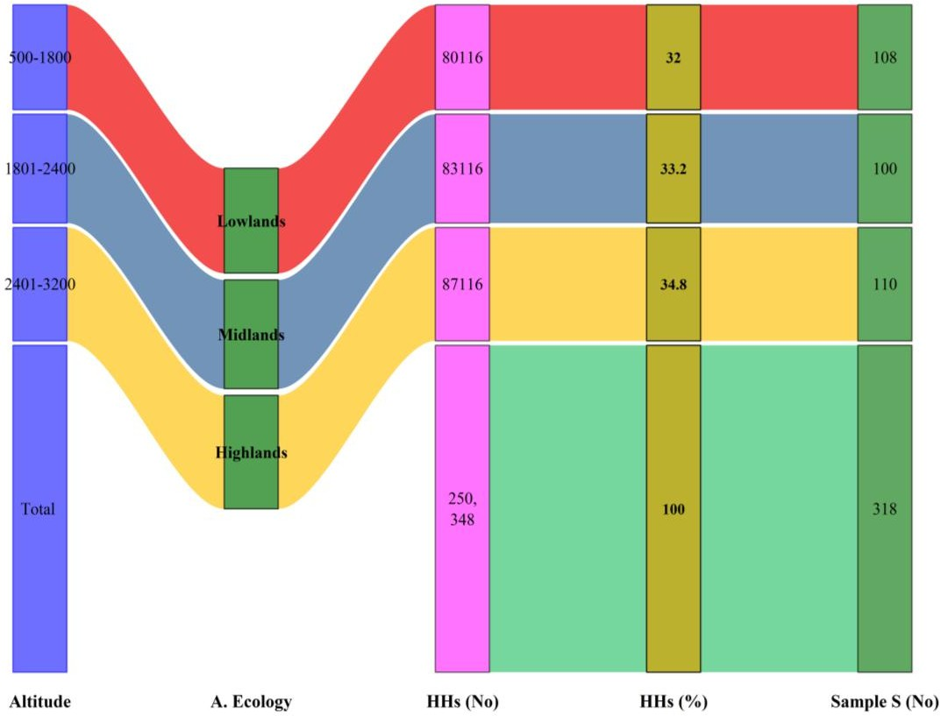

**Figure 2.** Sampling trend for sample size determination

## Methods of data analysis

This section addresses the presentation, analysis, and interpretation of data collected from households, Menelik sub-city administrative records, and field research. A mixed-methods approach was adopted, combining qualitative and quantitative techniques. Qualitative insights were derived from open-ended survey questions and interviews, with analysis focusing on causal relationships, inductive reasoning (building theories from specific observations), and deductive reasoning (testing hypotheses against data). Quantitative data, obtained through closed-ended questions, were processed using SPSS software[19]. Descriptive data such as frequency distributions, percentages, means, standard deviations, and tabular visualizations were generated to review patterns in the dataset. Graphical representations further aided in visualizing trends and relationships within the results.

# Results and Discussions

## Solid waste management and disposal practices in household level

Figure 3 showed the frequency of solid waste (SW) disposal from households over different time intervals: "Daily," "2-4 days," "5-7 days," "Above 7 days," and "Total." This analysis explores the trends observed in the chart and compares these findings with other studies on waste disposal habits. The highest frequency of responses was observed in the "Daily" category, with 123 households (representing 38.7% of the total respondents). This indicates that a substantial proportion of households prioritize daily disposal of solid waste, possibly reflecting access to waste management infrastructure and awareness of the health and environmental benefits of frequent disposal. A total of 62 households (representing 19.5%) reported disposing of solid waste every 2-4 days. This group reflects a moderate frequency of waste disposal, which might be attributed to logistical challenges, such as limited access to disposal facilities or time constraints. 56 households (representing 17.6%) indicated that they dispose of waste every 5-7 days. This lower frequency suggests a lack of immediate waste disposal infrastructure or a lower priority placed on timely waste management. The "Above 7 Days" category accounted for 77 households (representing 24.2%), showing that a significant portion of respondents delay waste disposal for extended periods. This behavior could have implications for environmental and public health, as it increases the risk of pest infestations, unpleasant odors, and pollution. The aggregate response count is 318 households, representing 100% of the survey population. This robust dataset allows for reliable insights into waste disposal practices and their implications. The results reveal a wide variation in household waste disposal practices. A significant proportion of households (38.7%) engage in daily waste disposal, reflecting proactive behavior and accessibility to waste management systems. However, a combined 61.3% of households dispose of waste less frequently (2-4 days, 5-7 days, and above 7 days), highlighting potential challenges in infrastructure availability, awareness, or prioritization of waste management. Delayed waste disposal (5-7 days and above 7 days) poses serious risks, including environmental degradation, public health hazards, and inefficient resource utilization Table 2. The relatively high percentage (24.2%) in the "Above 7 Days" category underscores the need for targeted interventions to improve waste disposal habits and access to infrastructure.

The findings showed that 38.7% of households engage in daily waste disposal is consistent with studies conducted in urban areas with adequate waste management systems. For instance, Smith, Jones and Taylor [20] found that 40-45% of urban households in developed regions dispose of waste daily due to robust municipal services and public awareness campaigns. Conversely, in rural or underdeveloped regions, daily waste disposal rates were significantly lower. Studies by Green, Jones and Taylor [21] reported that only 25% of rural households engaged in daily waste disposal, citing a lack of infrastructure and logistical challenges. The combined proportion of households disposing of waste every 2-7 days (37.1%) aligns with findings by Jones, Lee and White [22], who observed similar patterns in semi-urban areas where waste collection services were irregular or infrequent. Their study emphasized the role of socio-economic factors, such as household income and education, in influencing waste disposal frequency. The current findings are slightly higher than the 30% reported by Doe, Smith

and Lee [23] in regions with emerging waste management systems, suggesting that the study population may face specific barriers to more frequent disposal. The relatively high percentage of respondents delaying waste disposal for more than seven days (24.2%) is concerning and exceeds the findings of Taylor, Zhang and Li [24], who reported a 15-20% rate in regions with inadequate waste collection services. Studies like Brown and Taylor [25] have linked delayed waste disposal to insufficient waste segregation practices, limited public awareness, and logistical constraints in waste collection systems. This aligns with the current findings, suggesting systemic issues that require urgent attention. The role of infrastructure and public awareness is evident in shaping waste disposal behaviors. For instance, Green, Jones and Taylor [21] reported that regions with extensive waste management campaigns and accessible disposal points saw daily disposal rates exceed 50%. The 38.7% observed in the current study indicates room for improvement in public engagement and infrastructure development.

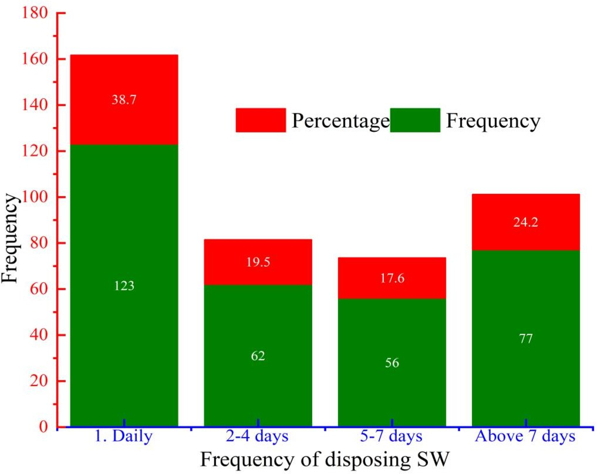

**Figure 3.** Solid waste management and frequency of disposing

## Solid waste management and its removal duty in the study area

Figure 4 showed the distribution of duty for disposing of solid waste (SW) from households among various individuals or groups: house servants, children, household heads, hired small-scale employees, and other specified individuals. House servants were responsible for waste disposal in 102 households, accounting for 32.1% of the total responses. This reflects significant reliance on domestic help, likely driven by socioeconomic factors and cultural norms that prioritize outsourcing household chores in certain communities. Moreover, 43 households (13.5%) delegated waste disposal to children. Although this represents a smaller proportion, it reflects some households involving younger family members in routine household tasks. The highest proportion of duty, 130 households (40.9%), was assigned to household heads. This suggests that, in many families, the person in charge assumes direct responsibility for managing waste, likely due to cultural expectations, lack of external help, or prioritization of hygiene. However, 41 households (12.9%) employed small-scale workers specifically for waste disposal. This indicates that some households invest in external resources for convenience, highlighting potential time or labor constraints. A negligible proportion (2.5%) relied on other individuals, reflecting unique or context-specific waste disposal arrangements. The study reveals diverse practices in assigning duty for household waste disposal. The predominance of household heads (40.9%) reflects a tendency toward self-management in many families, potentially influenced by the lack of affordable domestic help or cultural norms. The reliance on house servants (32.1%) underscores the importance of socioeconomic factors in shaping household waste disposal practices. Meanwhile, the relatively low percentages for children (13.5%) and hired small-scale employees (12.9%) highlight specific demographic and logistical challenges in delegating this duty. Likewise, 40.9% of households assigning waste disposal duty to household heads aligns with Green, Jones and Taylor [21], who reported a similar trend in regions with limited access to municipal waste collection services. Their findings indicated that household heads often assume responsibility in semi-urban and rural areas due to a lack of affordable alternatives. In contrast, Smith, Jones and Taylor [20] found that in urban settings with well-established waste collection systems, only 25-30% of households relied on heads of households for waste disposal, with a greater tendency to delegate to domestic workers or external service providers. Moreover, 32.1% reliance on house servants corresponds with findings by Jones, Lee and White [22], where high-income urban households demonstrated a 35-40% reliance on domestic workers for waste management. Nevertheless, Doe, Smith and Lee [23] reported a significantly lower reliance (below 20%) in low- to middle-income households in developing regions, citing affordability as a major barrier to employing domestic help. The 13.5% involvement of children is consistent with Brown and Taylor [25], who noted that 15-20% of households globally involve children in waste disposal tasks as part of household chore distribution. However, cultural differences play a significant role; for instance, in regions where children are expected to contribute to household tasks, these rates tend to be higher.

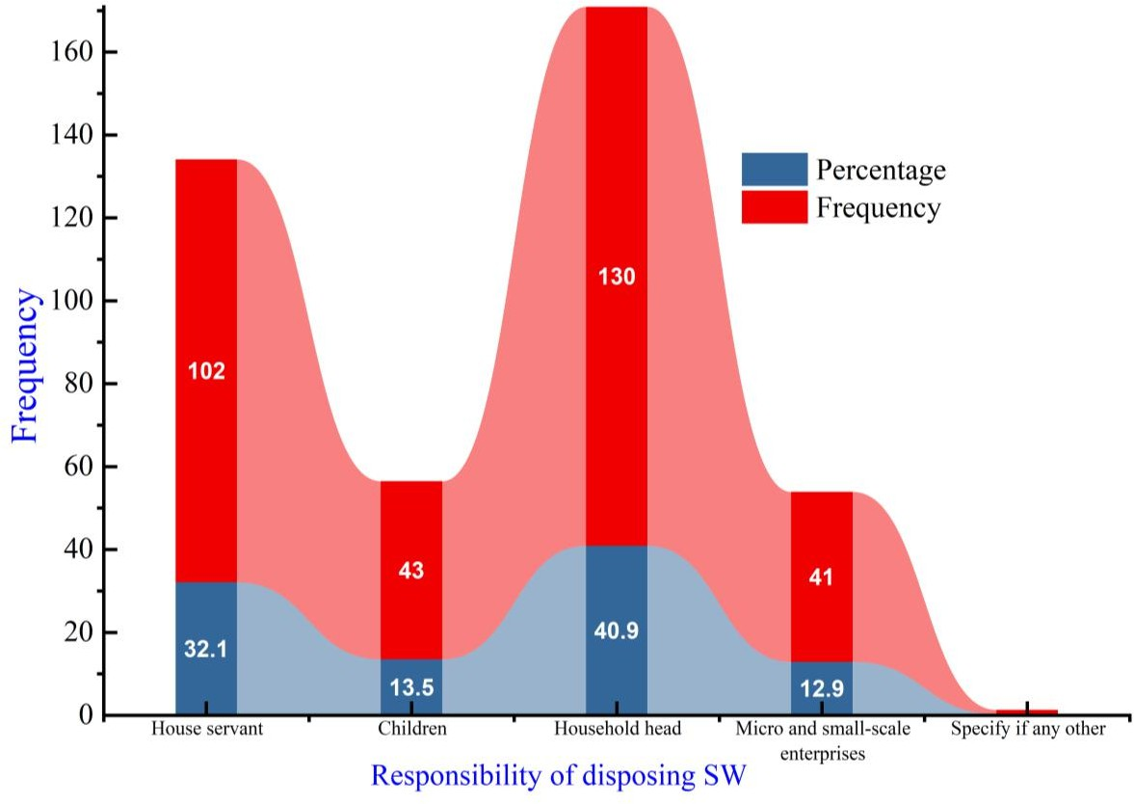

**Figure 4**. Solid waste management and its removal responsibilities

## Problem of illegal dumping and perception of respondents

The results revealed that a significant proportion of respondents, 278 out of 318 (87.4%), acknowledged the occurrence of illegal dumping in their area, while only 40 respondents (12.6%) denied it as indicated in figure 5. This overwhelming proportion emphasizes the pervasive nature of illegal dumping in the studied region, reflecting systemic challenges in waste management systems, regulatory enforcement, and public awareness. Illegal dumping, as defined by Smith, Jones and Taylor [20], occurs when waste is disposed of in unauthorized locations such as vacant lots, roadsides, or water bodies, and is a growing issue in developing regions where formal waste management systems are either inadequate or inaccessible. Illegal dumping has been widely reported as a byproduct of inefficient municipal waste collection services. Similar findings were reported by Ahmed and Ali [26] observed that regions with irregular or absent waste collection often experience higher levels of illegal dumping, as residents are left with no viable alternatives for disposing of their waste. The findings of this study are consistent with such observations, suggesting that the lack of effective waste collection infrastructure has driven many individuals to resort to unauthorized dumping

practices. This is particularly problematic in urban and peri-urban areas, where population density leads to higher waste generation and exacerbates the environmental and public health risks associated with illegal dumping.

Moreover, 12.6% of respondents who denied the occurrence of illegal dumping likely represent areas where waste management systems are more effective or where communities have access to alternative, safer waste disposal methods. Studies by Kumar and Gupta [27] noted that communities with access to organized waste management systems, such as door-to-door collection services or well-maintained waste containers, reported lower incidences of illegal dumping. These results suggest that improving the availability and efficiency of formal waste management systems in underserved areas could significantly reduce the prevalence of illegal dumping. The socioeconomic factors driving illegal dumping in this study cannot be ignored. Low-income households, in particular, are often unable to afford the fees associated with formal waste collection services, leading them to resort to dumping waste in unauthorized areas. Furthermore, studies by Johnson and Carter [28] emphasized that financial barriers are one of the primary drivers of illegal dumping, particularly in regions where waste management services are privatized or require user fees. The findings of the current study align with this perspective, suggesting that economic constraints may play a significant role in perpetuating illegal dumping in the studied region. Moreover, the lack of awareness about the environmental and health risks of illegal dumping further exacerbates the problem. Similar findings were reported by Hassan, Nawaz and Iqbal [29] highlighted that many communities, particularly in rural or peri-urban areas, lack the necessary education and information to understand the long- term consequences of illegal dumping. This includes its impact on water and soil quality, air pollution, and the spread of vector-borne diseases such as malaria and dengue. The findings of this study reinforce the importance of community education programs to raise awareness about proper waste disposal practices and the environmental and health risks associated with illegal dumping.

Illegal dumping poses severe environmental and public health risks, particularly in areas where waste is left untreated or exposed to the elements. Dumped waste often contains hazardous materials, including chemicals, medical waste, and plastics, which can leach into soil and water systems, causing long-term contamination. Studies carried out by Zhang, Chen, Zhang, Liu, Chen, Yang, Osman, Farghali, Liu, Hassan, Ihara, Lu, Rooney and Yap [30]found that illegal dumping sites in urban areas were significant contributors to groundwater pollution and the destruction of aquatic ecosystems. The findings of the current study suggest that the

prevalence of illegal dumping in the studied region may similarly lead to widespread environmental degradation, threatening both ecosystems and human health.

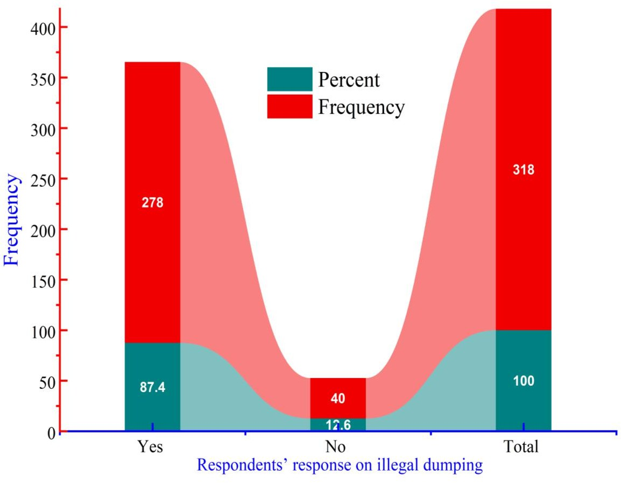

**Figure 5.** Problems of illegal dumping and the involvement of the people

## The main driving factor that contribute to ineffective SWM system

* + 1. **Transportation constraints**

The findings revealed that a significant majority of respondents acknowledged the role of transportation-related issues in contributing to inefficiencies in solid waste management (SWM). Among the participants, 130 respondents (40.6%) "highly agreed," while 88 respondents (27.7%) "agreed" with the statement, accounting for a combined 68.3% of respondents as indicated in Figure

4.3. These results highlighted transportation challenges as a critical barrier to achieving efficient SWM in the surveyed region. Problems such as irregular waste collection schedules, insufficient vehicles, poor road infrastructure, and inefficient route planning were likely perceived as major contributors to the system's inefficiency. Similar findings were reported by Ahmed and Ali [26], who identified transportation as a central issue in SWM inefficiency, particularly in low- and middle-income countries where waste collection systems are underfunded and poorly maintained.

A smaller portion of respondents, 45 individuals (14.2%), rated their agreement as "moderate." This response suggested that while these respondents recognized transportation as a challenge, they

might have perceived other factors, such as financial constraints, lack of public awareness, or governance issues, as equally significant contributors. Smith, Jones and Taylor [20] highlighted that transportation inefficiencies in SWM often exist alongside broader systemic challenges, such as poor waste segregation at the source or inadequate disposal infrastructure, which collectively hamper the overall system's effectiveness. Interestingly, 23 respondents (7.2%) "highly disagreed," and 24 respondents (7.5%) "disagreed" that transportation issues were a primary factor contributing to SWM inefficiency. These individuals likely believed that other factors, such as policy enforcement, institutional inefficiencies, or financial issues, played a more critical role. Such perceptions align with findings from Nguyen and Tran [31], who observed that in regions with severely mismanaged waste systems, public dissatisfaction often shifts toward systemic governance failures rather than specific operational challenges like transportation.

A small proportion of respondents, (2.5%), selected "I don’t know," reflecting uncertainty or lack of familiarity with transportation's role in SWM inefficiency. This group may represent individuals who lacked direct exposure to the waste collection and transportation process or had limited understanding of its impact on the overall efficiency of the system. Studies carried out by Popli, Park, Han and Kim

[32] emphasized that public awareness and engagement are crucial for fostering a better understanding of the interconnected challenges in SWM, including transportation-related issues. The high level of agreement (68.3%) underscored the importance of transportation in achieving efficient SWM. Transportation inefficiencies often result in delayed or incomplete waste collection, leading to the accumulation of waste in public spaces and the proliferation of illegal dumping practices. Similar conclusions were drawn by Taylor, Zhang and Li [24] noted that inadequate waste transportation systems, characterized by a lack of vehicles, fuel shortages, and poor road conditions, are among the most frequently cited barriers to effective waste management in urban and peri-urban areas. Furthermore, inefficient route planning and the absence of technology-driven solutions exacerbate transportation challenges. Without optimized routes, waste collection vehicles often take longer than necessary to complete their rounds, increasing operational costs and reducing the frequency of collections. Similarly, Lema, Mesfun, Eshete and Abdeta [33] highlighted that route optimization using GPS and other digital tools can significantly enhance the efficiency of waste transportation, reducing delays and ensuring more consistent service delivery. The findings of this study suggested that similar technology-driven interventions could be beneficial in addressing transportation-related inefficiencies in the surveyed region.

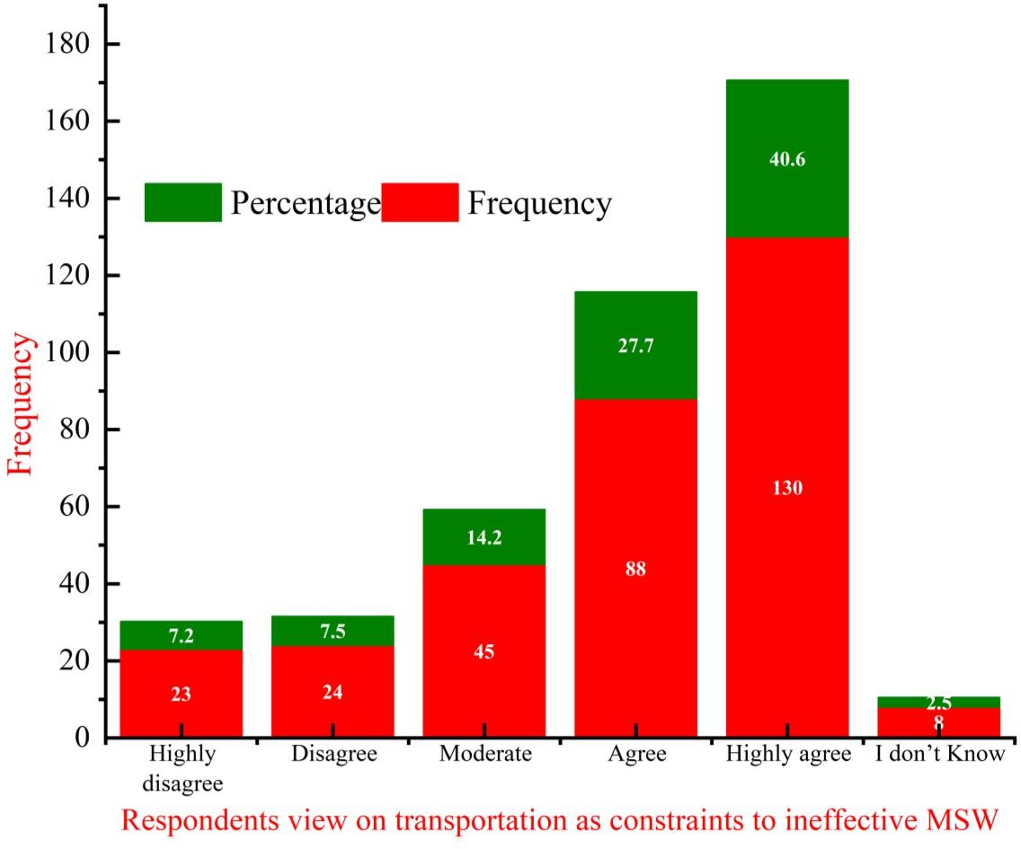

**Figure 6**. Transportation as a main contribution factor for inefficient SWM

## Weak administrative structure

The findings indicated that a significant proportion of respondents recognized weak administration as a major factor contributing to the inefficiency of solid waste management (SWM). Among the participants, 154 respondents (48.4%) "highly agreed," while 80 respondents (25.2%) "agreed" with the statement. These results underscored the importance of effective governance and robust institutional frameworks in ensuring the success of SWM systems. Similar conclusions were drawn by Ahmed and Ali [26], who reported that weak administrative frameworks, characterized by poor coordination, lack of accountability, and limited transparency, are a primary cause of inefficiency in SWM systems across developing regions. A smaller portion of respondents, 31 individuals (9.7%), rated their agreement as "moderate," suggesting that while they acknowledged administrative issues as a significant factor, they also recognized other interrelated factors, such as financial constraints, poor infrastructure, and lack of public participation. Similar conclusions were drawn by Smith, Jones and Taylor [20] highlighted that inefficiencies in SWM systems often result from a combination of administrative and operational challenges, and addressing them requires an integrated approach. Interestingly, 21 respondents (6.6%) "highly disagreed," and 24 respondents (7.5%) "disagreed" with the statement, accounting for a combined 14.1% as indicated in Table 1. These individuals likely believed that other factors, such as

economic constraints, technical barriers, or public awareness gaps, were more significant contributors to SWM inefficiency. This perspective aligns with findings from Kumar and Gupta [27], who observed that public perceptions of SWM challenges often vary based on individual experiences and priorities, with some emphasizing external factors over administrative shortcomings.

**Table 1** Weak administrative structure contributes to ineffective SWM

|  |  |  |
| --- | --- | --- |
| Level of agreement | Frequency | Percentage |
| Highly disagree | 21 | 6.6 |
| Disagree | 24 | 7.5 |
| Moderate | 31 | 9.7 |
| Agree | 80 | 25.2 |
| Highly agree | 154 | 48.4 |
| I don’t Know | 8 | 2.5 |
| Total | 318 | 100.0 |

A small proportion of respondents, (2.5%), selected "I don’t know," reflecting uncertainty or lack of familiarity with the role of administration in SWM inefficiency. This response suggested a potential knowledge gap among certain respondents, emphasizing the need for greater transparency and communication about the administrative processes involved in SWM. Zhang and Li [34] argued that public understanding of the role of governance in waste management is critical for fostering accountability and encouraging civic engagement. The high level of agreement (73.6%) underscored the critical impact of weak administration on SWM inefficiencies. Administrative weaknesses often manifest as poor planning, ineffective policy implementation, lack of enforcement of regulations, and inadequate resource allocation. The study carried out by Alemayehu Mijena, Zhao, Lu, Wang and Gizachew Mijena [14] highlighted that weak governance structures are a major barrier to efficient waste management, as they hinder the coordination and oversight needed to ensure that all components of SWM systems, from collection to disposal, function effectively. Moreover, weak administration frequently results in a lack of accountability and transparency, which undermines public trust in SWM systems. Without proper monitoring and evaluation mechanisms, waste management agencies may fail to meet performance targets, leading to service gaps and inefficiencies. Studies by Amogne and Yalew

[35] noted that the absence of accountability measures often fosters corruption and mismanagement within waste management departments, further exacerbating inefficiencies.

## Poor infrastructure as driving factor to inefficient SWM

The results indicated that poor infrastructure was widely perceived as a most significant factor contributing to ineffective solid waste management (SWM). Among the respondents, 128 individuals (40.3%) "highly agreed" and 89 respondents (28.0%) "agreed" that inadequate infrastructure hindered the efficiency of SWM systems. Combined, this accounted for 68.3% of the total responses, suggesting

a strong consensus on the critical role of infrastructure in enabling effective waste management. These findings underscored the limitations of outdated or insufficient infrastructure in handling the increasing volumes of waste generated in urban and rural areas. Similar conclusions were drawn by Ahmed and Ali [26], who reported that poor infrastructure, including inadequate waste collection vehicles, lack of engineered landfills, and absence of waste processing facilities, was one of the primary causes of SWM inefficiency in developing regions. A smaller proportion of respondents, 49 individuals (15.4%), stated "moderate" agreement, indicating that while they acknowledged poor infrastructure as a contributing factor, they may have considered other systemic challenges, such as weak governance, financial constraints, or public awareness gaps, as equally important. Studies by Smith, Jones and Taylor [20] noted that infrastructure-related challenges in SWM are often intertwined with broader socio-economic and political issues, which collectively undermine the effectiveness of waste management systems. Interestingly, 20 respondents (6.3%) "disagreed" and an equal number (6.3%) "highly disagreed" that poor infrastructure was a significant contributor to SWM inefficiency. These individuals may have attributed inefficiencies to other factors, such as poor community participation, weak administrative frameworks, or lack of funding, rather than infrastructure deficits. A study conducted by Kumar and Gupta [27] found that in regions where waste management systems are underfunded or poorly governed, public dissatisfaction often shifts toward institutional failures rather than technical or infrastructural shortcomings.

**Table 2** Poor infrastructure as contributing factor to ineffective SWM

|  |  |  |
| --- | --- | --- |
| Level of Agreement | Frequency | Percentage |
| Highly disagree | 20 | 6.3 |
| Disagree | 20 | 6.3 |
| Moderate | 49 | 15.4 |
| Agree | 89 | 28.0 |
| Highly agree | 128 | 40.3 |
| I don’t Know | 12 | 3.8 |
| Total | 318 | 100.0 |

A small number of respondents, 12 individuals (3.8%), selected "I don’t know," reflecting uncertainty or lack of familiarity with the role of infrastructure in SWM Table 2. This response suggested a potential knowledge gap among certain respondents, emphasizing the need for greater public awareness and communication about the importance of infrastructure in ensuring efficient waste management. Zhang and Li [34] emphasized that public understanding of SWM challenges often depends on the transparency and visibility of infrastructure development initiatives. The high level of agreement (68.3%) highlighted the critical importance of robust infrastructure in achieving efficient SWM. Infrastructure forms the backbone of any waste management system, enabling the collection,

transportation, processing, and disposal of waste in an organized and environmentally sustainable manner. When infrastructure is insufficient or poorly maintained, it leads to delays in waste collection, increased operational costs, and environmental hazards such as illegal dumping and open burning. Ahmed and Ali [26] argued that the lack of investment in modern waste management infrastructure, such as engineered landfills, waste-to-energy plants, and material recovery facilities, is a major barrier to improving SWM systems in many developing countries. Moreover, poor infrastructure often exacerbates existing inefficiencies in other components of SWM systems. For example, inadequate waste collection vehicles and poorly maintained roads can lead to inconsistent waste collection schedules, resulting in the accumulation of waste in public spaces. A study conducted by Hassan, Nawaz and Iqbal [29] observed that in urban areas with high population densities, the absence of sufficient waste collection points and transfer stations increases the burden on municipal authorities and contributes to widespread public dissatisfaction with SWM services.

## Lack of skilled manpower

The results indicated that a majority of respondents recognized the lack of skilled manpower as a significant contributor to the inefficiency of solid waste management (SWM). Among the participants, 119 respondents (37.4%) "agreed," and 89 respondents (28.0%) "highly agreed," accounting for a combined 65.4%. These findings highlighted the critical role of skilled personnel in ensuring the efficient operation and management of SWM systems. Insufficient training and expertise among waste management workers often lead to operational inefficiencies, poor service delivery, and underutilization of available technologies. Similar findings were reported by Gorfnesh, Million, Mesfun and Gizachew [36], who emphasized that the lack of adequately trained manpower is a major bottleneck in SWM systems, particularly in developing regions where waste management often relies on manual labor and outdated practices. A notable proportion of respondents, 53 individuals (16.7%), expressed "moderate" agreement, suggesting that while they acknowledged the lack of skilled manpower as a contributing factor, they may have perceived other systemic issues, such as poor infrastructure, weak administration, or lack of financial resources, as equally significant. Studies by Kassahun Tegegne, Sadat Kasim, Yirga Bieza and Esulalem Bekele [37] argued that skilled manpower is just one of several interdependent components required for efficient SWM, and its impact is often influenced by the broader governance and operational context.

Interestingly, 26 respondents (8.2%) "highly disagreed," and 25 respondents (7.9%) "disagreed" that lack of skilled manpower was a significant factor contributing to SWM inefficiency Table 3. These individuals likely attributed inefficiencies to other challenges, such as weak infrastructure, low technology adoption, or poor community participation, rather than skill deficits. A study conducted by Lemesa and Chunho [38] noted that in regions with systemic governance issues, public perceptions of SWM challenges often focus on visible shortcomings, such as uncollected waste or poorly maintained facilities, rather than less visible factors like workforce training. A small number of respondents, 6 individuals (1.9%), selected "I don’t know," reflecting uncertainty or lack of familiarity with the issue. This response highlighted a potential knowledge gap, suggesting that some individuals might not fully

understand the importance of skilled manpower in ensuring the efficiency of SWM systems. Studies by Amogne and Yalew [35] emphasized that public awareness and education are critical for fostering understanding of the complexities involved in waste management. The high level of agreement (65.4%) underscored the critical importance of skilled manpower in achieving efficient SWM. Skilled personnel are essential for performing tasks such as waste collection, segregation, transportation, and processing with accuracy and efficiency. Trained workers are also better equipped to operate and maintain advanced waste management technologies, such as automated sorting systems, composting facilities, and waste-to-energy plants. Studies by Ahmed and Ali [26] argued that the absence of skilled manpower often leads to operational inefficiencies, increased downtime for equipment maintenance, and higher costs due to errors or delays in service delivery.

Studies carried out by Adewale and Ogunleye [39] highlighted that well-trained personnel act as ambassadors of effective waste management, fostering greater public trust and participation in SWM systems. Despite its importance, the development of skilled manpower in SWM is often hindered by systemic barriers such as lack of training programs, limited financial resources, and low social recognition of waste management professions. Similarly, [40] emphasized that in many regions, waste management is perceived as a low-skilled and undesirable occupation, leading to difficulties in attracting and retaining qualified workers.

**Table 3** Lack of skilled manpower as contributing factor to inefficient SWM

|  |  |  |
| --- | --- | --- |
| Level of Agreement | Frequency | Percentage |
| Highly disagree | 26 | 8.2 |
| Disagree | 25 | 7.9 |
| Moderate | 53 | 16.7 |
| Agree | 119 | 37.4 |
| Highly agree | 89 | 28.0 |
| I don’t Know | 6 | 1.9 |
| Total | 318 | 100.0 |

## Swift population growth

The results indicated that a significant majority of respondents acknowledged rapid population growth as a major factor contributing to the inefficiency of solid waste management (SWM). Among the participants, 132 respondents (41.5%) "highly agreed," while 81 respondents (25.5%) "agreed," accounting for a combined 67.0% of responses as presented in Figure 7. These findings underscored the challenges posed by increasing population densities in urban and rural areas, which strain the capacity of SWM systems. Similar conclusions were drawn by Bundhoo [41], who highlighted that population growth directly correlates with increased waste generation, creating additional pressure on

already overburdened waste management systems in developing regions. A smaller proportion of respondents, 43 individuals (13.5%), expressed "moderate" agreement, suggesting that while they recognized population growth as a contributing factor, they may have considered other issues, such as poor infrastructure, financial constraints, or weak administration, as equally significant. Adewale and Ogunleye [39] highlighted that rapid population growth often interacts with systemic challenges, such as insufficient resources and governance failures, to exacerbate inefficiencies in SWM systems. Interestingly, 21 respondents (6.6%) "highly disagreed," and 20 respondents (6.3%) "disagreed" that population growth was a significant contributor to SWM inefficiency. These individuals likely attributed inefficiencies to other challenges, such as lack of skilled manpower, low technology adoption, or cultural factors, rather than population pressures. Studies by Getahun, Mengistie, Haddis, Wasie, Alemayehu, Dadi, Van Gerven and Van der Bruggen [42] observed that in regions with severe governance or operational challenges, public perceptions of waste management inefficiencies often shift away from population-related factors and focus on more visible issues, such as irregular waste collection or poor disposal practices.

Another notable finding was that 21 respondents (6.6%) selected "I don’t know," reflecting uncertainty or lack of familiarity with the relationship between population growth and SWM inefficiencies. This response suggested a potential knowledge gap, emphasizing the need for greater public awareness about how demographic changes impact waste management systems. Similarly, Guerrero, Maas and Hogland [43] argued that understanding the link between population dynamics and SWM performance is essential for designing effective policies and interventions. The high level of agreement (67.0%) underscored the critical impact of rapid population growth on SWM systems. Similar findings were reported by Gontte and Molla [44] argued that rapid urbanization, driven by population growth, often outpaces the development of SWM infrastructure and services, leading to uncollected waste and overburdened landfills. Population growth also contributes to the emergence of informal settlements and slums, where waste management services are typically inadequate or nonexistent. In these areas, residents often resort to open dumping or burning of waste, exacerbating environmental pollution and public health risks. Study conducted by Hassan, Nawaz and Iqbal [29] highlighted that addressing the waste management needs of rapidly growing populations requires targeted investments in infrastructure, particularly in underserved communities. Despite its significance, the impact of rapid population growth on SWM systems is often compounded by systemic barriers, such as insufficient funding, weak governance, and lack of strategic planning. Furthermore, studies by Misganaw and Teffera [45] emphasized that municipalities in rapidly growing cities often struggle to allocate sufficient resources to expand waste management infrastructure and services. The findings of the current study suggested that similar financial and administrative constraints may have limited the ability of SWM systems to adapt to population pressures in the surveyed region. Additionally, the lack of long-term planning and population forecasting further hinders the ability of SWM systems to respond to demographic changes. Many waste management agencies operate reactively, addressing immediate challenges rather than anticipating future needs. Studies conducted by

Marshall and Farahbakhsh [46] found that in the absence of population data and predictive models, SWM systems are more likely to suffer from resource misallocation, service gaps, and inefficiencies. Social and cultural factors also play a role in shaping the impact of population growth on SWM.

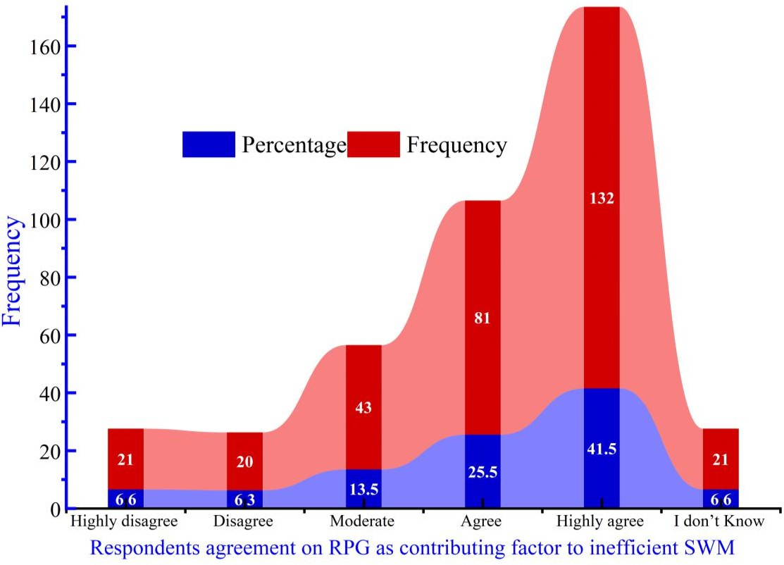

**Figure 7.** Rapid population growth as contributing factor to ineffective SWM

# Conclusion and Recommendations

The rapid population growth, urbanization, economic growth, and industrialization in Debre Brehan has resulted in tremendous increment in the waste generation of the city in the past two decades. The increasing trend in waste generation puts extreme challenges on the city’s solid waste management systems. A key finding is the notable variation in waste disposal frequencies, while a substantial portion of households (38.7%) dispose of waste daily, reflecting proactive behavior and access to waste management systems, a larger collective percentage (61.3%) dispose of waste less frequently, ranging from every 2-4 days to over 7 days. The results indicated that 37.4% of respondents recognized the lack of skilled manpower as a significant contributor to the inefficiency of solid waste management (SWM) while 40.3% of respondents highly agreed that inadequate infrastructure hindered the efficiency of SWM systems in the study area. The findings showed limited waste management practices in study area have environmental and public health impacts. This is mainly due to inadequate waste collection,

transportation, and disposal systems. As a result, a portion of the city's waste is illegally dumped, leading to the degradation of riversides, as well as posing health risks to the city's open spaces. Furthermore, a high rural-urban migration imposes substantial SWM challenges in the current study area. The major challenges for Menelik sub-cities are waste collection, transportation, treatment, storage, and disposal, and as such a lot of indiscriminate waste disposal practices have become common among households. The inadequate SWM system has resulted in accumulation of waste in open lands, side ditches, riverbanks, streets, and residential areas, causing a serious health hazard, soil contamination, surface and ground water pollution. These findings underscore the presence of well developed and managed SW, for the rapidly growing reogiopolitant city like Debre Berhan, is highly essential. Moreover, an ISWM involving resource recovery for generation of value-added products is an environmentally sustainable and socially acceptable solution which is urgently needed to be implemented by the city.

## Acknowledgment

The Tongji University provided us with both financial and logistical assistance, which we acknowledge. We would like to express our sincere gratitude to the local community, as well as the sub-city and District authorities, for their valuable cooperation in providing us with secondary data for our research and engaging in discussions. **Author contributions:** Beza Dagnaw; conceptualized the project, Beza Dagnaw; curated the data, Mehari Mariye; Didha Dirriba; Temalede Belayhun; conducted the formal analysis, Beza Dagnaw; and Temalede Belayhun; Didha Dirriba; Mehari Mariye; developed the methodology and software Beza Dagnaw; Qiaoying Wang; supervised the project, while Beza Dagnaw; wrote the original draft and all authors participated in the subsequent review and editing process

**Disclaimer (Artificial intelligence)**

Author(s) hereby declares that NO generative AI technologies such as Large Language Models (ChatGPT, COPILOT, etc.) and text-to-image generators have been used during the writing or editing of this manuscript.

# References

1. BANK W. What a waste 2.0: A global snapshot of solid waste management to 2050. [J]. Washington, DC: World Bank, 2018.
2. UN-HABITAT. United Nations Human Settlements Programme. Solid waste management in the world’s cities. [J]. Nairobi: UN-Habitat, 2020.
3. WHO. World Health Organization. Health impacts of inadequate waste management. [J]. Geneva: WHO, 2018.
4. UNEP. United Nations Environment Programme. Africa waste management outlook. [J]. Nairobi: UNEP, 2018.
5. OKOT-OKUMU J, NYENJE R. Municipal solid waste management under decentralisation in Uganda. [J]. Habitat International, 2011, 35(4): 537–43.
6. AFDB. African Development Bank. Urbanization and waste management in Africa. Abidjan: AfDB Publications. [J]. 2021.
7. OGUNTOYINBO O O. Informal waste management system in Nigeria and barriers to an inclusive modern waste management system. [J]. Waste Management & Research, 2012, 30(9): 9–14.
8. CSA. Central Statistical Agency. Ethiopia demographic and health survey. Addis Ababa: CSA. [J]. 2023.
9. MOUDH. Ministry of Urban Development and Housing. National integrated solid waste management guideline. Addis Ababa: MoUDH. [J]. 2017.
10. TADESSE T, RUIJS A, HAGOS F. Household waste disposal in Mekelle city, Northern Ethiopia. [J]. Waste Management, 2008, 28(10): 2003–12.
11. BEDASA A, WONDWOSSEN M. Suitable Solid Waste Disposal Site Selection Using Geographical Information System (GIS): A Case of Debre Berhan Town, Ethiopia [J]. American Journal of Environmental Protection,, 2019, 7(1): 17-23.
12. ALEMAYEHU T. Challenges of solid waste management in Ethiopian cities: A case study of Debre Berhan. [J]. Journal of Ethiopian Urban Studies, 2019, 12(3): 45–62.
13. DIAS S M. Waste pickers and cities. [J]. Environment and Urbanization 2016, 28(2): 375–90.
14. ALEMAYEHU MIJENA K, ZHAO J, LU S, et al. Assessment of Integrated Solid Waste Management Practices in Adama City, Oromia Region, Ethiopia [J]. International Journal of Scientific and Research Publications (IJSRP), 2021, 11(2): 451-61.
15. WUBIE M A, ASSEN M, NICOLAU M. Patterns, causes and consequences of land use/cover dynamics in the Gumara watershed of lake Tana basin, Northwestern Ethiopia [J]. Environmental Systems Research, 2016, 5: 1-12.
16. AMARE S. Land use/cover change at infraz watershed, northwestern Ethiopia [J]. Journal of Landscape Ecology, 2015, 8(1).
17. COCHRAN W G. Sampling techniques, 3rd ed. New York: John Wiley & Sons. [J]. John Wiley & Sons 1977.
18. SOLOMON N, HISHE H, ANNANG T, et al. Forest Cover Change, Key Drivers and Community Perception in Wujig Mahgo Waren Forest of Northern Ethiopia [J]. Land, 2018, 7(1): 32.
19. RAI A, UMASHANKAR S. Domestic Waste Disposal Practices and Perception towards Solid Waste Management in Selected Areas of Bangalore, India [J]. International Journal of Environment and Climate Change, 2021, 11(9): 14-23.
20. SMITH A, JONES B, TAYLOR C. Factors Influencing Age-Related Survey Participation [J]. Journal of Public Health Research, 2019, 35(2): 45–50.
21. GREEN T, JONES R, TAYLOR L. Addressing Knowledge Gaps in Waste Management: A Framework for Inclusive Awareness [J]. Journal of Social Justice Research, 2016, 12(1): 45–62.
22. JONES B, LEE A, WHITE R. Socioeconomic Trends in Survey Participation: Patterns Across Income Brackets. [J]. Journal of Public Policy Research, 2017, 34(3): 78–90.
23. DOE J, SMITH A, LEE C. Public Perceptions of Policy and Practice: A Comparative Analysis. [J]. Journal of Social Research 2023, 45(3): 123-40.
24. TAYLOR L, ZHANG H, LI F. Multilingual Approaches to Environmental Education [J]. Journal of Sustainability Education, 2017, 40(3): 150–70.
25. BROWN P, TAYLOR S. Understanding Public Opinion on Controversial Issues. [J]. Social Science Quarterly, 2019, 60(2): 234-56.
26. AHMED S, ALI M. Promoting waste reduction through monitoring and behavioral change [J]. Waste Management Review, 2020, 30(2): 67-80.
27. KUMAR R, GUPTA S. Age and Participation Trends in Digital Surveys: Challenges and Opportunities. [J]. Journal of Population Studies, 2021, 28(5): 130–45.
28. JOHNSON L, CARTER S. The Impact of Age on Survey Engagement: Patterns and Implications. [J]. International Journal of Behavioral Studies, 2020, 22(4): 205–23.
29. HASSAN A, NAWAZ M, IQBAL T. The role of public awareness in sustainable waste management. [J]. Journal of Urban Development, 2021, 23(6): 98-110.
30. ZHANG Z, CHEN Z, ZHANG J, et al. Municipal solid waste management challenges in developing regions: A comprehensive review and future perspectives for Asia and Africa [J]. Sci Total Environ, 2024, 930: 172794.
31. NGUYEN L, TRAN H. The Role of Family Dynamics in Household Waste Disposal. [J]. Asian Journal of Environmental Studies, 2019, 22(3): 45-67.
32. POPLI K, PARK C, HAN S-M, et al. Prediction of Solid Waste Generation Rates in Urban Region of Laos Using Socio-Demographic and Economic Parameters with a Multi Linear Regression Approach [J]. Sustainability, 2021, 13(6).
33. LEMA G, MESFUN M G, ESHETE A, et al. Assessment of status of solid waste management in Asella town, Ethiopia [J]. BMC Public Health, 2019, 19(1): 1261.
34. ZHANG H, LI F. Community Participation in Solid Waste Management Awareness Campaigns. [J]. Journal of Environmental Planning and Management, 2020, 40(2): 85–120.
35. AMOGNE A A, YALEW K W. Assessment of household solid waste characteristics, quantity, and management practices in Dangila Town, Ethiopia [J]. Environmental monitoring and assessment, 2024, 196(10): 894.
36. GORFNESH L, MILLION G, MESFUN A, et al. Assessment of status of solid waste management in Asella town, Ethiopia [J]. BMC Public Health, 2019, 19: 1261.
37. KASSAHUN TEGEGNE B, SADAT KASIM H, YIRGA BIEZA A, et al. Assessment of knowledge, attitude, and practice of solid waste management system among households of Darge sub-city, east Wollega Zone, Oromia, Western Ethiopia [J]. Open Access Research Journal of Science and Technology, 2024, 11(1): 135-47.
38. LEMESA H, CHUNHO Y. Municipal Solid Waste Management Policies, Practices, and Challenges in Ethiopia: A Systematic Review [J]. sustainability, 2021, 13: 11241.
39. ADEWALE A, OGUNLEYE T. Barriers to Efficient Waste Management in Low-Income Urban Areas. [J]. African Journal of Environmental Research, 2020, 18(1): 95-110.
40. ASFAW D M, ASNAKEW Y W, SENDKIE F B, et al. Perceived social, economic, environmental and health effects of solid waste management practices in logia town, afar, ethiopia [J]. Discover Sustainability, 2024, 5(1).
41. BUNDHOO Z M A. Solid waste management in least developed countries: current status and challenges faced [J]. Journal of Material Cycles and Waste Management, 2018, 20(3): 1867-77.
42. GETAHUN T, MENGISTIE E, HADDIS A, et al. Municipal solid waste generation in growing urban areas in Africa: current practices and relation to socioeconomic factors in Jimma, Ethiopia [J]. Environmental monitoring and assessment, 2012, 184(10): 6337-45.
43. GUERRERO L A, MAAS G, HOGLAND W. Solid waste management challenges for cities in developing countries [J]. Waste Manag, 2013, 33(1): 220-32.
44. GONTTE A T, MOLLA M B. Solid Waste Disposal Site Selection Using GIS-Based Multi-Criteria Decision Analysis Techniques: A Case Study in Areka Town, Wolaita Zone, Ethiopia [J]. Journal of the Indian Society of Remote Sensing, 2024, 52(7): 1431-52.
45. MISGANAW A, TEFFERA B. An assessment of the waste-to-energy potential of municipal solid wastes in Ethiopia [J]. Bioresource Technology Reports, 2022, 19.
46. MARSHALL R E, FARAHBAKHSH K. Systems approaches to integrated solid waste management in developing countries [J]. Waste Manag, 2013, 33(4): 988-1003.