**An Empirical Study on the Impact of FII and DII on Volatility, Leverage, and Long-Term Returns of the Indian Stock Index**

## Category: Original Research Article

## ABSTRACT

Estimating volatility is the key factor to be analyzed in taking the financial decisions.Financial strategies are framed after due investigation of financial market volatility.This study examines the impact of foreign institutional investment (FII) & Domestic Institutional investment (DII) in Indian stock market and analyses the volatility of National Stock Exchange (NSE) categorical indices for the period of 10 years from 20th February 2014 to 20th February 2024. The study is conducted using the logarithmic return of series of Nifty 50, Nifty Midcap 50 & Nifty Small Cap 50. GARCH (1,1) & T-GARCH (1,1) model has been used to check the volatility & leverage effect in the three major indices of Nifty.The study shows Nifty MidCap 50 is highly volatile compared to Nifty50 & Nifty Small Cap 50. By analyzing T-GARCH all the indices have leverage effect.Moreover, foreign institutional investment (FII) & Domestic Institutional Investment (DII) have statistically significant impact on volatility of Nifty 50 & Nifty Midcap 50. The study will be helpful for the retail as well as institutional investors for identifying & comparing the volatility of different indices.

**Keywords:** ARCH, GARCH, FII, Volatility, Nifty, DII

1. **Introduction**

The Indian stock market is been identified by its stochastic nature which involves the vulnerable ups and downs of equities. Unpredictable Capital market is an indispensable gauge of dynamic irrationality of thesecurities. Volatility is termed as the fluctuations in the returns caused by the changes in price of security. It is measured by the variance or Standard deviation. Increase and decrease in the prices of securities is common in stock market and not easy for investor to analyze and predict. It becomes more complicated when the fluctuations are steep and sharp. Investors face a challenging task to analyze and formulate strategies when there is an excessive fluctuation. From past many years, rigorous studies and research has been conducted for modelling and forecasting the volatility. It has become the most important factor for investment decision (Bagchi et al., 2022). Thus, a study on stock market volatility is very essential in a developing country like India.Several models have been proposed to capture the Volatility of stock market. First model named as Autoregressive conditional heteroskedasticity ARCH was introduced by Robert Engle in 1982. Later by Tim Bollerslev, Generalized model of it with incubating the lags of conditional variance was developed naming as GARCH (Generalized ARCH). These models have been frequently used by researchers to study the volatility of stock market.

There are two broad sources of investment in Indian stock market: Foreign Institutional Investors & Domestic Institutional Investors other than the retail investors (Mohapatra et al., 2024) Domestic Institutional Investors refers to those investors who invest as an institution like, Mutual Funds, Insurance companies Development Financial institutions etc. Whereas, Foreign institutional Investors refers to those institution investors who invest in country outside which they reside.

The study is aimed to determining the volatility of varied broad market indices of Nifty and to find out the impact of FII & DII in volatility of Nifty indices.

1. **Literature Review:**

Indian stock market started its growth journey from the period of economic reform. The foreign funds start appreciating from this period. But at the same time, these capital flows have also given a significant threat like economic and financial threats to the system of the economy. The threats being very prominent in terms of inflationary, overheating of the system and unmanageable volatility in the Indian capital market due to the uncertain nature of these FII/DII flows(Kashyap et al., 2017; Mohanty et al., 2023). As per the report over US$ 64 billion investment have been made by FII’s in 2020, Considering to be the 5th largest recipient in the world. Attractive opportunities to investors is being provided by Mid cap & Small Cap companies (IBEG).The Foreign Institutional Investors (FIIs) have arisen as imperative players in the Indian stock market and their developing commitment adds as a significant element of the improvement of stock market in India (Kannan and Arockiam, 2016; Mohanty et al., 2021).Subsequently, the Indian stock markets have arrived at new statures and turned out to be more unstable making the research work in this element of building up the connection among FIIs and stock market volatility. The Domestic Institutional Investors are additionally the significant financial backers in corresponding to Foreign Institutional Investors and comprehend the general methodologies of Domestic players accessible in the market. Hence, it's an intriguing space of research to analyze the influence of FIIs and DII in Stock Market Volatility (Dhananjaya, 2020).

India is one among the fastest growing economy. The whole world keeps an eye on India for the purpose of investment. The stock exchanges of India like BSE and NSE are getting more attractiveness. The exchanges are becoming pretty volatile. This volatility is a result of FIIs flow to the country. The measures of volatility are so many but GARCH is one among the most trusted techniques (Garg & Bodla, 2011; Mohanty et al., 2021). BSE being the oldest stock exchange of Asia, is one of the most attractive stock exchanges of the continent. The volatility of Sensex makes people more reluctant to invest in this. The volatility is contributed by so many factors including FII flow. There has been a good long run association between FII and stock return as well as volatility of stocks (Kedia, 2017).

Foreign Institutional Investors are one among the biggest players in the stock market. Investors tend be a very deciding factor for the growth of a stock market.It is important to know the correlation between the funds flow and volatility of the stock market(Loomba, 2012; Vikram et al, 2022). Not only domestic investors but also foreign investors keep investing in Indian markets. The prominent market indices are Nifty 50, Sensex, BSE 100 etc. Volatility of the stocks are very closely associated with the flow of funds from both domestic and foreign sources(Gahlot, 2019).

The relationship can be analyzed by using so many different tools. When the data are stationary in different levels ARDL model can be a best model (Srivastava & Varshney, 2020; Khandelwal & Mohanty, 2021). However ARCH and GARCH models can be used to check the volatility too.(Joo, 2014).The tools like VAR, VECM and Johansen co-integration can be used to check the log-run relationship among the variables(Ickizlerli, 2020).

1. **Research Methodology**

**3.1 Data Collection**

The current study is focused on return series of indices whose values are obtained from National Stock Exchange website. Nifty50, Nifty Mid Cap 50 & Nifty Small Cap 50 indices are considered to be the representative samples of share value in India as it is believed to reflect the performance of the entire stock market. Data span a 10 year period 20th February 2014 to 20th February 2024.

**3.2 Methodology**

Volatility refers back to the unfold of all probable results of anunsure variable. To measure the volatility, GARCH model will be applies in this study. Prior to applying the model, there are certain assumptions which must be checked. Stationary of the series, Presence of volatility clustering & heteroscedasticity are those assumptions. The statistical tool used to carry out all the tests and to estimate all the models of this study is Eviews 11.

**3.3 Stationarity Testing**

Stationary time series refers to those series whose properties does not depend on the time when observed and are constant. Statistical forecasting are generally based on the assumption that stationarized series is relatively easy to predict. In order to test the stationarity, Augmented Dickey Fuller Test (ADF test) has been used. The null hypothesis is:-

H0 : There is a unit root; the time series is non stationary.

**3.4 Heteroscedasticity Testing**

One of the most vital aspect before applying GARCH model is to primarily examine the residual of the series for evidence of heteroscedasticity (Bollerslev et al, 1992). To examine the presence of heteroscedasticity, ARCH-LM test proposed by Robert Engle is applied (engle).The null hypothesis is that there is no arch effect up to order q.

∆yt=∝0 + θyt-1 +Xni=1 ∝ ∆yt + et------------------------(1)

where ‘y’ explains the differenced time series, ‘t’ is the time, ‘n’ represents number of optimum lags, ‘α0’ is the constant and ‘e’ represents the error term.

**3.5 GARCH MODEL**

To investigate the volatility clustering and persistence level of Nifty 50, Nifty Mid Cap 50 & Nifty small Cap 50 , Generalized Autoregressive Conditional Heteroscedasticity model has been employed which is used for modeling volatility (Andersen et al., 2014). It is considered to be the standard model for estimating volatility. The equation is

Rt = µ+ t--------------------(2)

------------------------------(3)

Where Rt indicates the conditional mean, $h_{t}$ explains conditional variance, t is the error term for mean equation, q and p are the lag of the residual and conditionalvariance terms in the variance equation,ω and µ are the constant.

αi and βiareused to depict the Arch effect &Garch effect respectively. ‘α’ depicts the recent news about volatility from previous period, measured as the lag of the squared residuals, whereas ‘β’ explains the long-term volatility from the last period forecast. (α + β) indicates the level of persistence in series,so higher values of (α + β) imply higher persistence in volatility (Rastogi, 2014).

**3.6 GARCH MODEL WITH EXOGENEOUS VARIABLE**

It is evident from the literature review that the upward or downward movement of the stock market is impacted by the net flows of FII & DII. Hence, Net flows of FII & DII for the period 12 years from Feb 2009 to Feb 2021 are used as regressors to from the extended GARCH model. The equation formed is

Conditional Mean Equation

yt = µ + λ1FIIt + t -----------------------------(4)

Conditional Variance Equation

ht2 = ω + α1ε2t−1 + β1h2t−1 + δ1FIIt-------------(5)

1. **Analysis and Interpretation**

**4.1 Descriptive Statistics**

**Table 1: Descriptive Statistics**

|  |  |  |  |
| --- | --- | --- | --- |
| **Particulars** | **Nifty 50** | **Nifty Mid Cap 50** | **Nifty Small Cap 50** |
| **Mean** | 0.000540 | 0.000565 | 0.000451 |
| **Std. Deviation** | 0.012074 | 0.015087 | 0.015162 |
| **Skewness** | 0.131590 | -0.689645 | -0.853755 |
| **Kurtosis** | 24.17717 | 12.15027 | 10.50127 |
| **Jb Statistics** | 54666.01* | 10436.14* | 7213.1344* |

*\*Significance at 1% level*

Table 1 reports the descriptive statistics of 10 years of daily return series of Nifty 50, Nifty Mid Cap 50 & Nifty Small Cap 50. The above figures indicate that all the three indices have a positive return in the long run. Nifty Mid Cap 50(-0.896) & Nifty Small Cap 50 (-0.853) have a negative skewness value which leads to a long left tail. While Nifty 50 (0.130) has a positive skewness value leading to a long right tail. The kurtosis value of the indices is greater than 3 which represents that all the series are leptokurtic. As the figures of Jarque-Bera Statistics are less than 1% significance level, there is an absence of normality in the series.

The time series plot of daily returns for Nifty 50, Nifty Mid Cap 50 & Nifty small Cap 50 is present in Figure 1. From the below-given plot, it is clear that there are periods of high and low volatility for all the indices. The presence of Volatility clustering is identified through figures. There is a continuous variation without a definite pattern in the data. All the series are mean-reverting as they are fluctuating nearby Zero.

**Figure 1: Graphical representation of the time series plot showing daily returns for Nifty 50, Nifty Mid Cap 50 & Nifty small Cap 50**

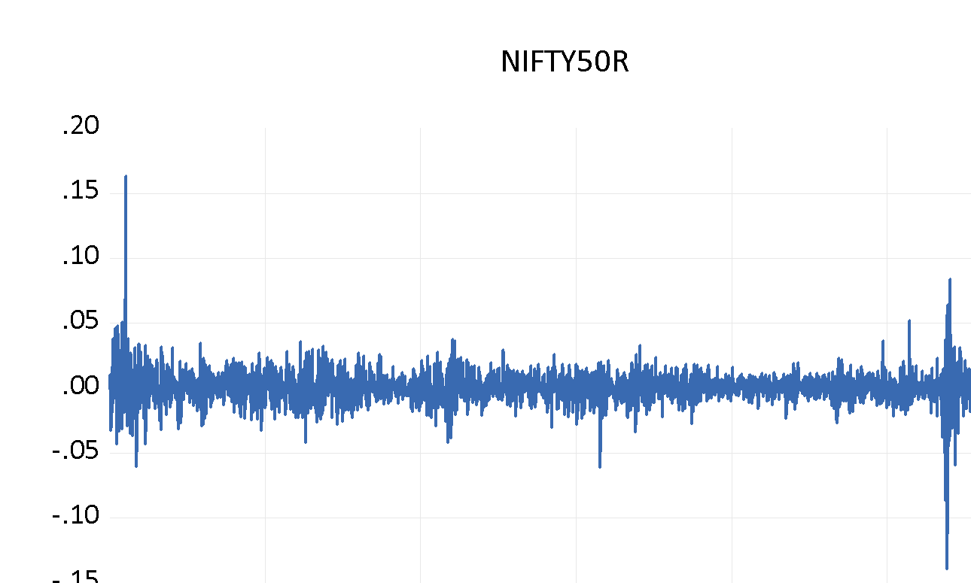

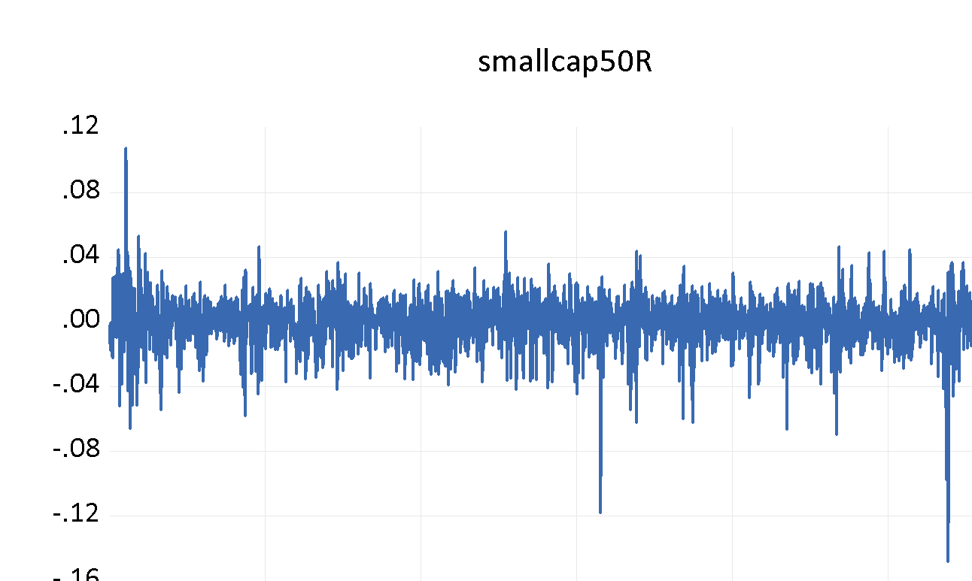

To predict the volatility of Nifty 50, Nifty Mid Cap 50 & Nifty Small Cap 50, GARCH family models are employed. Stationarity of series and presence of heteroscedasticity are the pre conditions to be met before applying GARCH models. To examine the above-mentioned conditions, the ADF test & ARCH-LM test wereapplied respectively.

* 1. **ARCH and GARCH result**

**Table 2: ADF test & ARCH-LM test**

|  |  |  |
| --- | --- | --- |
| **Particulars** | **ADF in Level T-Statistics** | **ARCH Effects Obs *R-squared** |
| Nifty 50 | -19.53473* | 26.02815* |
| Nifty Mid Cap 50 | -50.60728* | 42.64378* |
| Nifty Small Cap 50 | -45.94607* | 29.22677* |

Table 2 here projects the results of Unit root test & presence of heteroscedasticity of the dataset. The null hypothesis of ADF test is that there is presence of unit root among series. It is evident from the column 1 of the table that the null hypothesis has been not supported, resulting that there is stationarity among the series. The null hypothesis of Arch-LM test is that there is no existing ARCH up to order q in the residuals. Since the p-value of Arch-LM test was less than 0.05, it is concluded that there is autoregressive conditional heteroscedasticity in the dataset. As the required conditions to apply GARCH has been fulfilled, GARCH (1,1) model can be applied to the return series.

**Table3: GARCH (1, 1) model estimation**

|  |  |  |  |  |
| --- | --- | --- | --- | --- |
|  | **Parameters** | **Nifty 50** | **Nifty Midcap 50** | **Nifty Small Cap 50** |
| **Variance Equation** | C (constant) | 1.90E-06* | 8.45E-06* | 1.54E-05* |
| (ARCH - α) | 0.021856* | 0.053212* | 0.062911* |
| GARCH(-1)  (β) | 0.900989* | 0.865514* | 0.802045* |
| α +  β | 0.922845 | 0.918726 | 0.864956 |
| Log likelihood | 9303.512 | 8394.821 | 8412.560 |
| **Residual Diagnostics** | Arch LM Test statistic | 1.906326 | 0.464604 | 1.717679 |
| P-Value | 0.1675 | 0.4955 | 0.1901 |

To estimate the volatility of Nifty Indices, GARCH (1,1) model has been used. Table 3 here depicts the estimation of GARCH model applied on Nifty 50, Nifty Mid Cap 50 & Nifty Small Cap 50.The Arch term tells that the current data is influenced by the past squared residual term ( news about previous volatility). Whereas, The GARCH term here says that previous volatility has a significant influence in current volatility. The arch coefficient of Nifty 50 (0.021856 ), Nifty Mid Cap 50 (0.053212 ) & Nifty Small Cap 50 (0.062911) are positively significant at 1% level. The Garch coefficient of Nifty 50 (0.900989), Nifty Mid Cap 50 (0.865514) & Nifty Small Cap 50 (0.802045) are also positively significant at 1% level. This leads to interpretation that the previous news & previous volatility has a influence over current volatility among these indices. Sum of Arch &Garch coefficients depicts the persistence level of Volatility. If sum of these terms is one then they are persistent. In this study, sum of arch and garch term for Nifty 50 , Nifty Mid Cap 50 is & Nifty Small Cap 50 is closer to unity we can conclude that the volatility of Nifty 50, Nifty Mid Cap 50 & Nifty Small Cap 50 can be mean reverting and time decaying.

**Table 4: Garch (1, 1) model estimation with exogeneous regressor**

|  |  |  |  |  |
| --- | --- | --- | --- | --- |
|  | Parameters | Nifty 50 | Nifty Mid  Cap 50 | Nifty Small  Cap 50 |
| Variance Equation | **C (constant)** | 1.90E-06* | 8.82E-06* | 1.60E-05* |
| **(ARCH - α)** | 0.15000* | 0.099597* | 0.127997* |
| **GARCH(-1)  (β)** | 0.60000* | 0.865810* | 0.803005* |
| **FII (-1)** | -7.51E-09* | -3.77E-09* | -3.15E-09** |
| **DII(-1)** | -9014E-09* | -4.53E-09* | -1.85E-09 |
| **Log likelihood** | 8953.299 | 8383.909 | 8394.854 |
| Residual Diagnostics | **Arch LM Test statistic** | 1.906326 | 0.464604 | 1.717679 |
| **P-Value** | 0.1675 | 0.4955 | 0.1901 |

Foreign Institutional Investors & Domestic Institutional Investors have a great influence on the volatility on Indian stock market. Above table shows the impact of previous days Net flows of FII & DII on the volatility of Nifty 50, Nifty Midcap 50 & Nifty Smallcap 50. It is evident from 1% significant level that both the FII & DII impact the volatility of all the three indices. The negative coefficients indicate a correlation between previous day net flows of FII & DII and reduction in the volatility of Nifty 50, Nifty MidCap50 & Nifty Smallcap50.

1. **Conclusion**

The paper examined the impact of Net flows of FIIs & DIIs on the Nifty Broader Indices by using GARCH (1, 1) model and exogenous regressor. 10 years return series from 20th February 2014 to 20th February 2024 of Nifty 50, Nifty Mid Cap 50 & Nifty Small Cap 50 was used to carry out the study. The volatility of the indices are highly influenced by the flow from FII as well as DII at the same time the current data is influenced by the past squared residual term.Nifty 50, Nifty Mid Cap 50 & Nifty Small Cap 50 can be mean reverting and time decaying. While considering the stock market as a whole it can also be observed that there is a strong impact of FII as well as DII on Indian capital market (Kannan & Arockiam, 2016). So increase in capital flow whether FII or DII or retail funds influences the stock market grow and vice-versa and these flows appreciates the volatility of all the indices. While making an investment decision it is necessary not understand the impact of all the factors contributing to to volatility of the market and the stocks as well.

The study provides a useful insight to the policy makers, Government and regulatory bodies to have proper steps to strengthen the flow of funds. This study will be helpful to the portfolio managers and retail investors to understand the volatility and its linkage to FII and DII.

Disclaimer (Artificial intelligence)

Option 1:

Author(s) hereby declare that NO generative AI technologies such as Large Language Models (ChatGPT, COPILOT, etc.) and text-to-image generators have been used during the writing or editing of this manuscript.

Option 2:

Author(s) hereby declare that generative AI technologies such as Large Language Models, etc. have been used during the writing or editing of manuscripts. This explanation will include the name, version, model, and source of the generative AI technology and as well as all input prompts provided to the generative AI technology

Details of the AI usage are given below:

1. Authors didn’t use any AI technologies to prepare the paper.

**References**

Andersen, T., Bollerslev, T., & Hadi, A. (2014). ARCH and GARCH models. *John Wiley & Sons*.

Bagchi, S., Mukherjee, D., Mohanty, D., & Verma, A. (2022). Influence of behavioral biases while making decision on mutual fund investment. *Journal of Information and Optimization Sciences*, *43*(7), 1733-1747.

Bollerslev, T., Chou, R. Y., & Kroner, K. F. (1992). ARCH modeling in finance: A review of the theory and empirical evidence. *Journal of econometrics*, *52*(1-2), 5-59.

Dhananjaya, K. (2020). Do Domestic Institutional Investors (DIIs) Neutralize the Impact of Large Reversal by Foreign Institutional Investors (FIIs)? Recent Evidence from Indian Stock Market. *Recent Evidence from Indian Stock Market (July 17, 2020). Dhananjaya, K & Wright*, 65-72.

Gahlot, R. (2019). An analytical study on effect of FIIs & DIIs on Indian stock market. *Journal of Transnational Management*, *24*(2), 67–82. https://doi.org/10.1080/15475778.2019.1601485

Garg, A., & Bodla, B. (2011). Impact of the Foreign Institutional Investments on Stock Market: Evidence from India. *Indian Economic Review*, *46*(2), 303–322.

Ikizlerli, D. (2020). Institutional investors and stock market volatility. Evidence from Korea. *Applied Economics Letters*, *27*(6), 473–476. https://doi.org/10.1080/13504851.2019.1632413

Joo, B. A. (2014). Impact of Foreign Institutional Investment on the Volatility of Indian Stock Market. *Journal of Academic Research in Economics (JARE)*, *6*(1), 32–44.

Kannan, V., & Arockiam, J. J. (2016). Impact Created by Foreign Institutional Investors and Domestic Institutional Investors on Indian Capital Market. *International Journal of Engineering and Management Research*, *3*, 435–438. www.IndianJournals.com

Kashyap, S. K., Srivastava, A. K., & Sarva, M. K. (2017). *Study of Stochastic Causality between FII Flows , DII Flows and Indian Stock Market*. 527–536.

Khandelwal, S., & Mohanty, D. (2021).[Stock Price Prediction Using ARIMA Model](https://scholar.google.com/citations?view_op=view_citation&hl=en&user=XnPzi2EAAAAJ&pagesize=80&sortby=pubdate&citation_for_view=XnPzi2EAAAAJ:hMod-77fHWUC), *International Journal of Marketing & Human Resource Research*, 2 (2), 98-10

Kedia, N. (2017). *Impact of fII ’ s on IndIan Stock Market ( specific to SENSEX )*. *7*(5), 255–268.

Loomba, J. (2012). Do Fiis Impact Volatility of Indian Stock Market ? *International Journal of Marketing, Financial Services & Management Research*, *1*(7), 80–93.

Mohanty, D., Mohapatra, A. K., Tripathy, S., & Matta, R. (2023). Nexus between foreign exchange rate and stock market: evidence from India.*Investment Management & Financial Innovations*, 20(3), 79-90.doi:10.21511/imfi.20(3).2023.07

Mohapatra, A. K., Mohanty, D., Sardana, V., & Shrivastava, A. (2024). The ripple effect: Influence of exchange rate volatility on Indian sectoral indices. *Indian Journal of Finance,* 18(2), 8-24.DOI: [10.17010/ijf/2024/v18i2/173519](http://dx.doi.org/10.17010/ijf%2F2024%2Fv18i2%2F173519)

Mohanty, D., Khan, J. S., Das, S., & Mohapatra, S. R. (2021). Dynamic relationship between Indian stock index and commodity derivatives: with special reference to metals. *International Journal of Economics and Accounting*, 10(4), 394-409.<https://doi.org/10.1504/IJEA.2021.118280>

Mohanty, D., Khan, J. S., & Mohapatra, S. R. (2021). Impact of Macroeconomic Variables on Indian Stock Market. *Empirical Economics Letters*, *20*, 27-36.

Rastogi, S. (2014). The financial crisis of 2008 and stock market volatility - Analysis and impact on emerging economies pre and post crisis. *Afro-Asian Journal of Finance and Accounting*, *4*(4), 443–459. https://doi.org/10.1504/AAJFA.2014.067017

Srivastava, P., & Varshney, S. (2020). The relationship of domestic institutional investors and India stock market returns: An ARDL bound testing approach. *Journal of Transnational Management*, *0*(0), 1–20. https://doi.org/10.1080/15475778.2020.1789412

Vikram, I., Hotwan, A., & Mohanty, D. (2022). Comparison of International Stock Market Volatility: An Empirical Analysis During Economic Crisis 2008 and COVID-19. *ECS Transactions*, 107(1), 18593.DOI 10.1149/10701.18593ecst.

Vikram., Mohanty, D., & Agrawal, A. (2022). The outbreak of COVID-19 pandemic and its impact on volatility of Indian stock market: evidence from top ten stocks of Bombay Stock Exchange. *African Journal of Accounting, Auditing and Finance*, 8(1), 91-105.