Entrepreneurial Orientation, Innovation Capabilities and the Performance of Culinary Tourism Centers: The Moderating Role of Social Media in East Surabaya

.
ABSTRACT

Aims The aims of this research to determine the influence of entrepreneurial orientation on innovation ability and SWK performance through social media. The abstract provides a cursory overview of the research endeavor; however, it necessitates refinement in terms of clarity and structural organization. The research objectives should be explicitly articulated in a concise and succinct manner. Furthermore, the methodology section requires expansion to incorporate the primary statistical findings, thereby providing a more comprehensive understanding of the research design.
Study design: The total sample is 184 culinary tourism center traders who are still active. Analysis method using SEM.
Place and Duration of Study: This research is quantitative. Sampling was taken using cluster proportional sampling.
Methodology: Analysis method using SEM. The results of research on entrepreneurial orientation influence culinary tourism center's innovation ability, innovation capability influences SWK performance, innovation capability as a mediating variable for the influence of entrepreneurial orientation on SWK performance and social media as a moderating variable for the influence of entrepreneurial orientation on culinary tourism center performance in East Surabaya.
Results: The results of research on entrepreneurial orientation influence culinary tourism center's innovation ability, innovation capability influences SWK performance, innovation capability as a mediating variable for the influence of entrepreneurial orientation on SWK performance and social media as a moderating variable for the influence of entrepreneurial orientation on culinary tourism center performance in East Surabaya. A concise conclusion summarizing the research findings, significance, and potential implications should be appended to the manuscript.

Keywords: entrepreneurial orientation, innovation capabilities,performance of culinary tourism centers

1. INTRODUCTION

“In the current era, there are fewer job opportunities than prospective workers who need them, so one alternative is that every individual has the opportunity to create jobs for themselves and especially in the new normal era after the Covid 19 pandemic. Especially for someone who chooses to be an entrepreneur, entrepreneurial orientation will work when the person concerned has a basic entrepreneurial spirit. Entrepreneurial orientation is the tendency of individuals to actively carry out proactive innovation and be willing to face or take risks to start or manage the business activities they have chosen.Entrepreneurship plays significant role in encouraging economic growth in the country by creating job opportunities and eliminating poverty. Hence, it is considered, executing entrepreneurial activity is consequently a top priority in any society” (Fayolle & Gailly, 2015) in N, jasintha (2021) and the second alternative is joining other people as professional workers. Widiana (2017) The entrepreneurial orientation is illustrated by the process of practice and decision-making activities that encourage new entry, so entrepreneurship can be considered a product of entrepreneurial orientation.
“Innovation capability is the development of ideas for entrepreneurs to create new products that are in line with current or current developments. Nowadays, many millennials prefer contemporary food. Market demands will influence product development that must be carried out by companies so that consumers have many alternatives to choose products produced by an entrepreneur. Product innovation is a way to create new products based on the existence of old products in order to meet the dynamic needs and desires of consumers. Innovation is different from creativity” (Fayolle & Gailly, 2015). Avermaete et al., 2003 in Kafetzopoulos dan Psomas (2015) innovation includes new products or services and processes that are new to the organization, or changes in the way products are made or delivered Munongo,& Pooe (2025).
“Social media is a means for an entrepreneur to market his products online via Instagram, TikTok, Whatsapp, Facebook, etc. Social media is any form of interactive communication media that allows for two-way interaction and feedback. Social media are all forms of interactive communication media that allow two-way interaction and feedback. Social media is used very productively by the whole society, business, politics, media, advertising, emergency services” (Kent, 2013; Figiel, & Badar, 2025).
The Performance of the Culinary Tourism Center (SWK) is a place where entrepreneurs run their business to achieve success. An entrepreneur hopes that all activities carried out will produce maximum performance in order to obtain maximum performance in the process of activities carried out. Taufiq, et.al (2020) “MSME business performance is one of the important things that can determine whether the business can survive in a global era like this. The current phenomenon is that culinary tourism center have not been able to recover because they are still hampered by technology due to lack of understanding of digital marketing, lack of product innovation, lack of business capital, lack of knowledge and difficulties in adopting digitalization, especially in terms of digital marketing in developing their businesses, so there are still many culinary tourism center who have not been able to get back on their feet”.
LITERATURE REVIEW
Entrepreneurial Orientation
Entrepreneurial orientation is an attitude or direction to determine an action in order to gain opportunities in the market so that creativity and innovation are needed to suit current developments. Entrepreneurial orientation refers to “processes, practices, and decision-making activities that lead to new entry” (Lumpkin & Dess, 1996:136) in Kiyabo dan Isaga (2020). Entrepreneurial orientation has actually emerged as one of the most studied construct in entrepreneurship and management literature for more than three decades ago (Covin et. al., 2019; Gupta, 2015). Despite the presence of many articles studying entrepreneurial orientation in top entrepreneurship and related journals, literature is in deficit of high value added entrepreneurial orientation research domains (Covin et. al., 2019). Kreiser, et.al, (2002) the concept of entrepreneurship orientation using three dimensions: innovativeness, risk-taking, and proactiveness.

Social Media
Social media is a medium used by consumers/communities for text, image, sound and video-based information both with other people and companies (Philip, 2017:12). Social media is a medium that helps enhance social networks with the potential to increase the likelihood of success in a number of ways at different stages of business development (Adebayo, 2015:11). Kotler dan Keller (2016:642) mendefinisikan social media as a tool or method used by consumers to share information in the form of text, images, audio, and video to other people and companies or vice versa. Gupta et al, 2021) Social media is said to help for a two-way process where communication can occur between the two, both the company and its customers. Ekasari (2014) the indicators used in this research are relationship, communication, post-purchase interaction, information format.

Innovation Ability
Songkajorn, et. al (2020) Using innovation is also considered the crucial factor to achieve competitive advantages. The ability to innovate in developing a product is really needed at this time because it can support good and high business results Rajapathirana dan Hui (2017) innovation capability is considered as the valuable assets for the firms to provide and sustaining competitive advantage and in the implementation of the entire strategy. Wang in Songkajorn, et.al (2020) divides innovation capability into five aspects: product innovation capability, market innovation capability, process innovation capability, behavior innovation capability, and strategic innovativeness capability.

Performance of Culinary Tourism Centers
MSME performance is a business that can provide success for a business so that it can increase the expected targets. The performance of MSMEs also often experiences obstacles in being able to survive, grow and develop. Some of the causes are the ability of human resources, product ownership, financing, marketing so that in this case MSMEs are less able to compete. (Budiarto, et.al (2018). Zaenal (2012) dalam Setiawan & Feranita (2018) in Taufiq, et.al (2020) expressed the opinion that measuring the achievement of business performance development can be reviewed through several indicators contained in the company, namely profit growth, growth in the number of customers, development in the number of sales, and growth in the number of assets.
Conceptual Framework

Innovation Ability (Y₁)

H1 H3
H4
Culinary Tourism center performance(Y₂)
Entrepreneur Orientation (X)
H2

_{H5}

Social Media (Z)

Figure 1. Conceptual Framework
The hypothesis in this research are:
H1: Entrepreneurial orientation influences the innovation ability of culinary tourism center in East Surabaya
H2: Entrepreneurial orientation influences entrepreneurial performance at culinary tourism center in East Surabaya
H3: Innovation ability influences entrepreneurial performance at culinary tourism center in East Surabaya
H4: Innovation ability as a mediating variable influences entrepreneurial orientation on entrepreneurial performance at culinary tourism center in East Surabaya
H5: Social Media as a moderating variable influences entrepreneurial orientation on culinary tourism center entrepreneurial performance in East Surabaya

RESEARCH METHODOLOGY:
This research is quantitative with an analysis unit of culinary tourism center traders in the East Surabaya area. Sampling of 184 traders who are still active in culinary tourism centers in East Surabaya, using cluster proportional sampling. Risal and Abdullah (2023:126) take sampling by region. Hair, et.al in Ferdinand (2002:48) The large sample size plays an important role in estimating and interpreting SEM 100-200 results. The data collection by distributing questionnaires. It measured by Likert scale, there are strongly disagree with score 1, disagree with skore 2, netral with skore 3, agree with skore 4, very agree with skore 5. ( Risal and Abdullah, 2012 : 154)The data analysis using Smart PLS 3.0 (Partial Least Square).
RESULT AND DISCUSSION
Following about respondents in Culinary Tourism Centers. See an example at Table 1.
Table 1. Respondent gender, range of age, education and work experience

Respondent Demographics | Categories | Numbers | In %
Gender | Male  Female | 89  95 | 48.3  51.7
Range of age | 21 – 30 years old  31 – 40 years old  41-50 years old  More than 50 years | 49  64  46  25 | 26.6  34.8  25  13.6
Education | Junior high school  Senior high school  Diploma  Bachelor degree  Master of degree | 37  82  33  29  3 | 17.9  44.5  17.9  15.8  01.6
Work experience | Less than 1 year  1-5 year  6 -10 year  11-15 year  More than 10 year | 35  89  51  6  3 | 19.0  48.4  27.7  03.3  01.6
Marital Status | Not yet married  Married  Ever married | 35  129  20 | 19.0  70.1  10.9
Turnover a Month | Less than 10 million  11 – 20 million  21 – 30 million  More than 30 million | 93  50  41  - | 50.5  27.2  22.3  -
Source: respondents in Culinary Tourism Centers
Table 1, the results of the research were carried out by distributing questionnaires to traders in the Culinary Tourism center area of ​​East Surabaya. The age criteria for the dominant SWK traders is age between 31-40 years, there are 64 (34.8%), between 21-30 years, there are 49 (26,6%). Between 41-50 there are 46 (25%) and more than 50 years, there are 25 (13,6%). The most gender is female. There are 95 (51,7%) and male are 89 (48,3%). The most education is senior high school are 82 (44,5%), junior high school there are 37 (17,9), Diploma are 33 (17,9), bachelor degree (S1) are 29 (15,8%) and master of degree are 3 (01,6%). For marital status the most is already married about 129 (70,1%), not yet married about 35 (19,0%) and ever married about 20 (10,9%). Length of work in Business/work experience less than 1 year 35 (19.0%), the most is 1-5 years about 89 (48,4%), 6 until 10 years about 51 (27,7%),11 until 15 years 6 (03.3%), more than 10 years 3 (01.6%). Income per month less than 10 million about 93 (50,5%), 11 until 20 million about 50 (27,2%) and 21 until 30 million about 41 (22,3%).

Construct Validity
Construct validity shows a test to determine the extent to which indicators measure a construct. In SEM, construct validity testing is carried out through convergent validity with rule of thumb is a construct that is said to fulfill convergent validity if the indicators in the construct have value standardized regression weight (factor loading) di atas 0,50.

Tabel .2 Construct validity of this study
Variabel | Indikator | Factor Loading (FL) | Keterangan
Entrepreneur Orientation (X) | X1.1 | 0.783 | Valid
 | X1.2 | 0.763 | Valid
 | X1.3 | 0.770 | Valid
Innovation Ability (Y1) | X2.1 | 0.757 | Valid
 | X2.2 | 0.700 | Valid
 | X2.3 | 0.741 | Valid
 | X2.4 | 0.721 | Valid
 | X2.5 | 0.764 | Valid
Culinary Tourism Center Performance (Y2) | X3.1 | 0.796 | Valid
 | X3.2 | 0.759 | Valid
 | X3.3 | 0.767 | Valid
 | X3.4 | 0.732 | Valid
Social Media (Z) | Y1.1 | 0.774 | Valid
 | Y1.2 | 0.738 | Valid
 | Y1.3 | 0.768 | Valid
 | Y1.4 | 0.748 | Valid
Source: output SEM
Table 2 shows the measurement model, each indicator in each construct that consists of the construct entrepreneur orientation, innovation ability, culinary tourism center performance, and social media, all of them have factor loading more than 0.50, so all of indicators are valid in forming constructs and can be used to build models.

Construct reliability
The construct reliability test is checked by using construct reliability, a construct is said reliable if reliability more than 0,70 (Solimun, 2017:78). Hair et al. (2014:605) added, rule of thumb if construct reliability more than 0,70, and construct reliability more than 0,60 still be accepted. It can be seen in the Table 3:

Table 3 Construct reliability of this study
Variabel | Construct Reliability | AVE | Keterangan
Entrepreneur Orientation (X) | 0.816 | 0.676 | Reliabel
Innovation Ability (Y1) | 0.856 | 0.623 | Reliabel
Culinary Tourism Center Performance (Y2) | 0.848 | 0.663 | Reliabel
Social Media (Z) | 0.843 | 0.653 | Reliabel
Source: output SEM
Tabel 3, it shown that every construct more than 0,70, AVE more than 0,50 so all of indicators are reliable.

Structural model fit (goodness of fit)
After the measurement model analysis stage is fulfilled, the next stage is structural model analysis Structural model fit (goodness of fit), have functions to ensure that the model is developed by data. The result of the structural model estimation can be seen below in figure 2

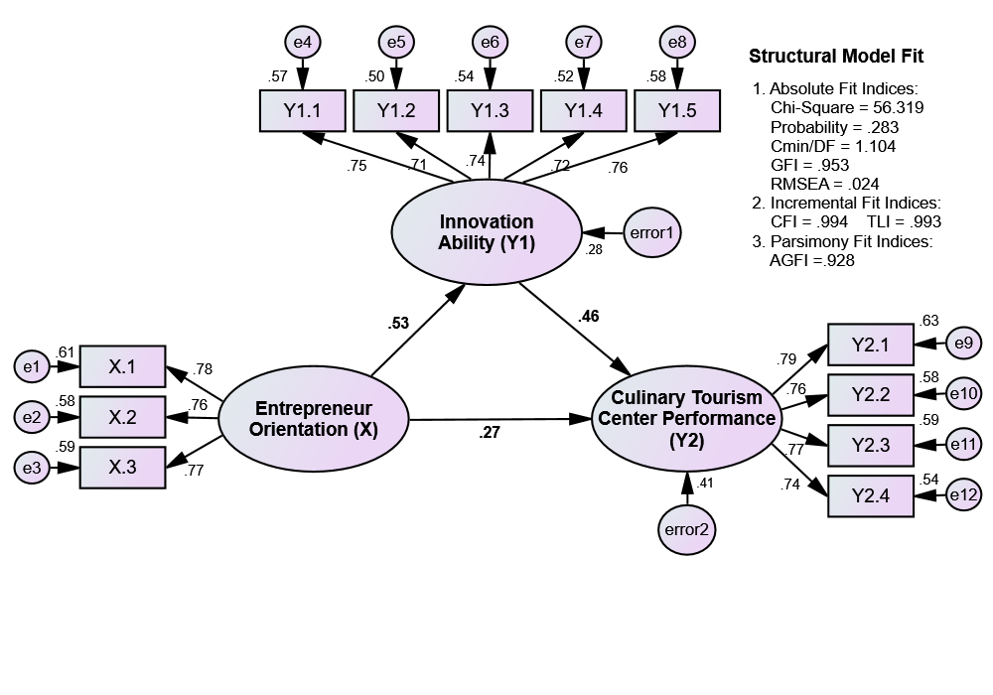
Figure 2. Assesing the structural model (model utama)
The results of calculating the goodness of fit index value produced by the structural model are as follows:
Tabel 4. Fit measure for the structural model
Fit Measure |  | Critical Value | Structural Model
 |  |  | Index value | Decision
Absolute Fit Indices | Probability | > 0.05 | 0.283 | Good fit
 | Cmin/DF | ≤ 2.00 | 1.104 | Good fit
 | GFI | ≥ 0.90 | 0.953 | Good fit
 | RMSEA | ≤ 0.08 | 0.024 | Good fit
Incremental Fit Indices | CFI | ≥ 0.95 | 0.994 | Good fit
 | TLI | ≥ 0.95 | 0.993 | Good fit
Parsimony Fit Indices | AGFI | ≥ 0.90 | 0.918 | Good fit
Source: output SEM
The result of structural model show that absolute fit indices, incremental fit indices, dan parsimony fit indices has fulfilled the requirements (good fit), so that the structural model can be accepted, and then testing the significance of the influence between variables, wither direct influence and indirect influence.

Analysis of the direct effect
namely examining the estimated parameters of the relationship between variables that represent each theoretical hypothesis. The hypothesis can be accepted if the path parameter is statistically significant with the direction of influence as predicted, meaning that the path parameter must be greater than zero for the positive direction and less than zero for the negative direction (Hair et al., 2014:589).
In testing structural relationships, hypothesis testing is carried out to test the significance of the influence between variables, using values, using value of critical ratio (CR) and probability (p-value). Significan or not used requirements if CR ≥ 1,96 or p-value ≤ 5%, it was decided that there was a significant influence between these variabels. Following are the results of testing each research hypotesis:
Table 5 Summary of the direct effect testing
Hip. | Structural relationship |  |  | Std. Estimate | C.R. | P  value
H₁ | Entrepreneur Orientation (X) |  | Innovation Ability (Y1) | 0.532 | 5.679 | 0.000*
H₂ | Entrepreneur Orientation (X) |  | Culinary Tourism Center Performance (Y2) | 0.267 | 2.765 | 0.006*
H₃ | Innovation Ability (Y1) |  | Culinary Tourism Center Performance (Y2) | 0.459 | 4.611 | 0.000*
*. Significant at the 0.05 level n.s. Not significant
Source: output SEM
Based on Table 5 can be explain as follows:
- The parameter estimation results for the influence of entrepreneurial orientation on innovation ability show a significant CR sebesar 5.679 more than 1.96) and significancy (p-value) 0.000 (smaller than 5%). The resulting influence coefficient is 0.532 (positive), meaning that the higher the trader's entrepreneurial orientation, the higher their innovation ability. Thus, the first hypothesis which states that entrepreneurial orientation influences the innovation ability of culinary tourism center traders in East Surabaya, can be accepted (H1 is accepted).
- The parameter estimation results for the influence of entrepreneurial orientation on SWK performance also show a significant influence with a CR value of 2.765 (greater than 1.96) and a significance value (p-value) of 0.006 (smaller than the 5% significance level). The resulting influence coefficient is 0.267 (positive), meaning that the higher the entrepreneurial orientation, the higher the Culinary Tourism center performance. Thus, the second hypothesis which states that entrepreneurial orientation influences the SWK performance of culinary tourism center traders in East Surabaya, can also be accepted (H2 is accepted).
- The parameter estimation results for the influence of innovation capability on Culinary Tourism center performance also show a significant influence with a CR value of 4.611 (greater than 1.96) and a significance value (p-value) of 0.000 (smaller than 5% significance level). The resulting influence coefficient is 0.459 (positive), meaning that the higher the innovation ability, the higher the Culinary Tourism center performance. Thus, the third hypothesis which states that innovation ability influences the Culinary Tourism center performance of traders in East Surabaya, can also be accepted (H3 is accepted).
Analysis of the indirect effect
Hypothesis testing to test the significance of indirect effects is carried out in the same way, namely using the critical ratio (CR) value and probability value (p-value). If the CR value is ≥ 1.96 or the p-value is ≤ 5% significance level, then it is decided that there is a significant mediation effect. After testing the significance of the mediation effect, the next stage is to find out the nature of the mediation. Ghozali (2011:248) explains that detecting the nature of mediation can be seen from the mediation effect. If the direct effect of the exogenous variable on the endogenous variable is significant, and the indirect effect through the intervening variable also goes through a significant path, then it is said to be partial mediation. On the other hand, if the direct influence of exogenous variables on endogenous variables is not significant, while the indirect influence through intervening variables goes through a significant path, then it is said to be full mediation or perfect mediation. The following are the results of testing structural relationships in the context of testing indirect effects based on SEM output:

Table 6 Summary of the indirect effect testing
Hip. | Indirect effect | Std. Estimate | P-value | Type of mediation
H₄ | Entrepreneur Orientation (X) Innovation Ability (Y1) Culinary Tourism Center Performance (Y2) | 0.244 | 0.004* | Partially mediation
*. Significant at the 0.05 level n.s. Not significant

Table 6 above, it can be explained that the results of the significance test are indirect XY₁Y₂ shows a significant effect with a significance value (p-value) of 0.004 (smaller than the 5% significance level). Thus, innovation capability significantly mediates the influence of entrepreneurial orientation on culinary tourism center performance (H4 is accepted). The nature of the mediator is known to be partial mediation, meaning that improving the performance of culinary tourism center traders in East Surabaya can only be done by increasing their entrepreneurial orientation, but if it is also supported by increasing innovation capabilities, then Culinary Tourism center 's performance can improve even more.

Analysis of the total effect
Analysis of the total effect of each variable on culinary tourism center performance is the sum of the direct and indirect effects. The total effect value does not need to be calculated manually, but has been calculated automatically by the Amos software (see Appendix 1), the results of which can be shown in Figure 3 below

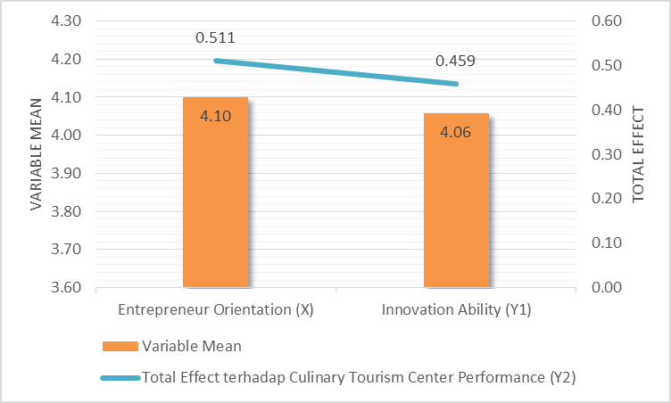
Figure 3. Comparison between variabel mean and total effect
The total effect shows the total influence of the predictor variables in increasing the response (in this case SWK performance), while the mean shows the average value of the central tendency for each variable. The results of the comparative analysis of variable mean and total effect conclude that in order to improve the performance of culinary tourism center traders in East Surabaya, entrepreneurial orientation is the priority, followed by innovation ability.

Analysis of the moderation effect
The next stage of analysis is testing the moderating effect. According to Fauzi, M.A (2022: 259-269), testing the moderating effect in SEM can be carried out using three approaches, namely the product indicator approach, orthogonalizing approach, and two-step approach. Moderation effect analysis can also be strengthened with multigroup analysis (MGA) which is useful for comparing models and studying differences between sub-samples of moderator variables. In this research, testing the moderating effect will use a two-stage approach, because the purpose of the analysis is to test the significance of the moderating effect. Furthermore, it was confirmed by multigroup analysis to determine the differences in the strength of the influence of entrepreneurial orientation on SWK performance, at different levels of social media. The results of the two-stage approach moderating effect test are presented in the following table:

Table 7. Summary of the moderating effect hypotheses
Hip. | Moderating relationship | Std. Estimate | C.R. | P value | Result
H₅ | Social Media (Z) memoderasi pengaruh Entrepreneur Orientation (X) terhadap Culinary Tourism Center Performance (Y2) | 0.360  (strengthen) | 5.240 | 0.000* | H₅ accepted
*. Significant at the 0.05 level n.s. Not significant
Sumber: Lampiran 10
Table 7 above, it can be explained that the results of the social media moderation analysis on the influence of entrepreneurial orientation on culinary tourism center performance show a significant influence with a CR value of 5,240 (greater than 1.96) and a significance value (p-value) of 0.000 (smaller than the 5% significance level). The resulting influence coefficient is 0.360 (positive), meaning that social media significantly strengthens the influence of entrepreneurial orientation on SWK performance. Thus, the fifth hypothesis which states that social media moderates the influence of entrepreneurial orientation on the performance of culinary tourism center traders in East Surabaya, can be accepted (H5 is accepted).
To clarify the moderating influence of social media on the influence of entrepreneurial orientation on SWK performance, a multigroup analysis was also carried out (figure 5), the results of which are presented in the following figure.

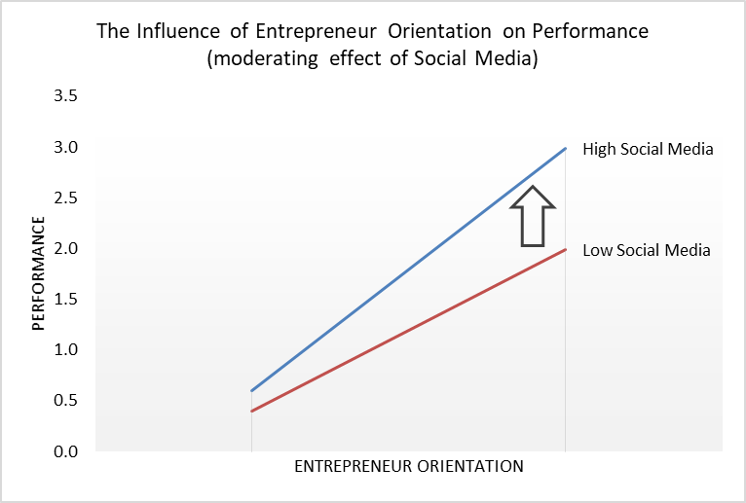
Fig 4: The influence of entrepreneur orientation on performance (moderating effect of social media)
Innovation Ability (Y1)
Culinary Tourism Center Performance (Y2)
Entrepreneur Orientation (X)
Social
Media (Z)
0,267*
0,532*
0,459*
0,360*
0,244*

Figure 5. SEM Multigroup Analysis

Figure 5 above provides information that the higher the level of social media among traders, the stronger the influence of entrepreneurial orientation on culinary tourism center performance. It can be seen that the path line in the group of traders with high social media (blue line) has a higher slope or level of slope than the group of traders with low social media (red line). These results mean that for traders with high social media, efforts to strengthen entrepreneurial orientation will have a stronger impact on improving their performance. After estimating the main model and the model with moderation effect testing, the estimation results can be combined in the following figure:

Entrepreneurial orientation influences the innovation capabilities of culinary tourism center in East Surabaya
In this current era, the development of a product is very necessary so that it can be accepted by society through innovation capabilities that are based on turning old products into contemporary products that are adapted to current developments. SWK traders have developed their products and also marketed them using applications and there are a few who haven't so they choose to withdraw because they are unable to continue their business, in addition because they don't have capital. Traders at SWK who have used their application are starting to make new innovations with various new products or menus adapted to current developments, namely by selling contemporary food, but there are also those who sell the latest menus with various additional variations. Rakthai, et.al (2019) entrepreneurial orientation has positive relationships with network capacity and innovative capacity.

Entrepreneurial orientation influences entrepreneurial performance at culinary tourism center in East Surabaya
Entrepreneurial orientation is an effort for SWK so that their products can be accepted by society. The higher the entrepreneurial orientation of the culinary tourism center, the more their entrepreneurial performance will increase. Culinary tourism center traders provide various kinds of menus and are followed by offering various discounts, food and drink packages and offering separate menus according to consumer tastes. This is what makes the traders at SWK start to be visited by young people and the elderly to choose a menu that suits their wishes. Ludiya and Kurniawan (2020) Entrepreneurial orientation has a partially significant effect on business performance.

Innovation ability influences entrepreneurial performance at culinary tourism center in East Surabaya
SWK traders in East Surabaya innovate what they sell, such as food, drinks, snacks and so on, so they hope they can build good relationships with customers. The innovation carried out is by providing a variety of dishes so that customers are free to choose the dishes they like according to their needs. The results of this research support research conducted by Widhiantara and Kusumadewi (2020) that innovation ability has a positive and significant effect on product performance.

Innovation ability as a mediating variable influences entrepreneurial orientation on entrepreneurial performance at culinary tourism center in East Surabaya
The research results show that entrepreneurial orientation has an indirect positive effect on entrepreneurial performance as mediated by innovation ability. The right entrepreneurial orientation will make innovation capabilities strong and will later influence entrepreneurial performance Suasana, et al (2025). Traders at culinary tourism center have started to focus on their sales so that the higher the entrepreneurial performance, the more ability they need to innovate so that they are expected to be able to adapt to market trends. Innovation capabilities can increase customer interest in coming and buying the products offered. Widhiantara and Kusumadewi (2020),Kumar., et al (2025),Niguse.,et al (2025) innovation ability is able to partially mediate the influence of entrepreneurial orientation on product performance

Social media as a moderating variable influences entrepreneurial orientation on culinary tourism center entrepreneurial performance in East Surabaya
Conclusion
Social media has an important role in moderating entrepreneurial orientation on entrepreneurial performance. Social media has become a necessity that can make it easier for everyone, especially in selling, rather than selling traditionally. Social media is a medium for socialization and interaction so that it can attract other people to view, buy and visit links that contain information about the products being sold and can be used as marketing media. Traders at culinary tourism center started serving sales via online and offline to be more competitive with other traders in selling. The results of this research support the research of Rozikin, et.al (2019),Ismiyanti, et al (2025) employee performance variables are not considered as intervening variables due to its smaller contribution on direct business development compared to influence of social media.

Further study
For further research, it is hoped that more other variables will be explored regarding their influence on culinary tourism center performance, especially in East Surabaya, so that it is more comprehensive to find out its performance through several other variables. Entrepreneurs at culinary tourism center East Surabaya need to pay attention to several things as follows: Increasing their innovation capabilities for food and beverage products sold so that consumers have many choices to try more variants that can satisfy them. Need to strengthen knowledge about social media so that product promotion can have a wider reach to attract new consumers and retain loyal consumers. In addition, transactions with consumers can be faster if someone needs it online and consumers don't need to come directly to the culinary tourism center in question. Always study changes in consumer behavior regarding the taste of the product. because there are new entrants with the same variants and offering different flavors to influence consumer behaviour Rocha.,et al (2025),Akinwale.,et al (2025),Martinez.,et al (2025).
Implications
The results of research on entrepreneurial orientation influence culinary tourism center's innovation ability, innovation capability influences SWK performance, innovation capability as a mediating variable for the influence of entrepreneurial orientation on SWK performance and social media as a moderating variable for the influence of entrepreneurial orientation on culinary tourism center performance in East Surabaya.
Disclaimer (Artificial intelligence)
Option 1:
Author(s) hereby declare that NO generative AI technologies such as Large Language Models (ChatGPT, COPILOT, etc.) and text-to-image generators have been used during the writing or editing of this manuscript.
Option 2:
Author(s) hereby declare that generative AI technologies such as Large Language Models, etc. have been used during the writing or editing of manuscripts. This explanation will include the name, version, model, and source of the generative AI technology and as well as all input prompts provided to the generative AI technology
Details of the AI usage are given below:
1.
2.
3.
REFERENCES
Akinwale, Y. O., Adelowo, C. M., & Surujlal, J. (2025). Entrepreneurial orientation and financial performance among MSMEs in Nigeria. International Journal of Business Innovation and Research, 36(1), 131-147.
Adebayo, P. O. (2015). Impact of social media on students entrepreneurial orientation: A study of selected institutions in Nigeria. Journal of the International Association of Advanced Technology and Science, 1(12), 1-13.
Budiarto, R., Putero, S. H., Suyatna, H., Astuti, P., Saptoadi, H., Ridwan, M. M., & Susilo, B. (2018). Pengembangan UMKM antara konseptual dan pengalaman praktis. Ugm Press.
Covin, J. G., & Wales, W. J. (2019). Crafting high-impact entrepreneurial orientation research: Some suggested guidelines. Entrepreneurship theory and practice, 43(1), 3-18.
Ekasari, N. (2014). Pengaruh promosi berbasis sosial media terhadap keputusan pembelian produk jasa pembiayaan kendaraan pada PT. BFI Finance Jambi.
Figiel, A., & Badar, A. (2025). Effect of Green Entrepreneurial Orientation and Absorptive Capacity on Green Innovation and Environmental Orientation Among Educated Gen Z’s in Europe. Sustainability, 17(2), 593.
Fauzi, M. A. (2022). Partial Least Square Structural Equation Modelling (PLS-SEM) in Knowledge Management Studies: Knowledge Sharing in Virtual Communities. Knowledge Management & E-Learning, 14(1), 103-124.
Gupta, S., Saha, R., Kaur, J., Kathuria, S., & Paul, J. (2021). Factors impacting innovation performance for entrepreneurs in India. International Journal of Entrepreneurial Behavior & Research, 27(2), 356-377.
Gupta, V. K. (2015). Construction of entrepreneurial orientation: Dispute, demand, and dare. New England Journal of Entrepreneurship, 18(1), 7.
Ismiyanti, F., Mahadwartha, P. A., Zunairoh, Z., & Ardiansyahmiraja, B. (2025). The resilience of micro, small and medium enterprises in Indonesia: COVID-19 perspective. International Journal of Entrepreneurship and Small Business, 54(2), 274-288.
Sarstedt, M., Ringle, C. M., & Hair, J. F. (2021). Partial least squares structural equation modeling. In Handbook of market research (pp. 587-632). Cham: Springer International Publishing.
Suasana, G. A. K. G., Riana, G., & Suparna, G. (2025). The Role of Business Learning as Moderating the Influence of Entrepreneurship Orientation on Business Innovation and Performance. Calitatea, 26(204), 203-216.
Kafetzopoulos, D., & Psomas, E. (2015). The impact of innovation capability on the performance of manufacturing companies: The Greek case. Journal of Manufacturing Technology Management, 26(1), 104-130.
Chinsuvapala, P. (2017). Kotler, Philip and Keller Kelvin Lane.(2016). Marketing Management.(15th global edition) Edinburgh: Pearson Education.(679 pp). Kasem Bundit Journal, 18(2), 180-183.
Kreiser, P. M., Marino, L. D., & Weaver, K. M. (2002). Assessing the psychometric properties of the entrepreneurial orientation scale: A multi-country analysis. Entrepreneurship theory and practice, 26(4), 71-93.
Kiyabo, K and N. Isaga. 2020. Entrepreneurial orientation, competitive advantage, and SMEs’ performance: application of firm growth and personal wealth measures. Journal of Innovation and Entrepreneurship. https://doi.org/10.1186/s13731-020-00123-7
Kiyabo, K., & Isaga, N. (2020). Entrepreneurial orientation, competitive advantage, and SMEs’ performance: application of firm growth and personal wealth measures. Journal of innovation and entrepreneurship, 9(1), 12.
Kent, M. L., & Saffer, A. J. (2014). A Delphi study of the future of new technology research in public relations. Public relations review, 40(3), 568-576.
Kumar, V., Kumar, S., Chaudhuri, R., Chatterjee, S., Vrontis, D., & Rezaee Vessal, S. (2025). Innovation capability and R&D performance of organizations: moderating role of industry–academic knowledge transfer. Journal of Knowledge Management, 29(3), 891-914.
Ludiya, E. (2020). Pengaruh Kompetensi Kewirausahaan dan Orientasi Kewirausahaan Terhadap Kinerja Usaha Pada UMKM Bidang Fashion di Kota Cimahi. Jurnal Ilmu Manajemen dan Bisnis, 11(2), 141-154.
Jasintha, N. (2021). The intervening effect of entrepreneurial orientation on the nexus between entrepreneurial motivation and self-employment intention: an evidence from Sri Lankan engineering graduates. International Journal of Accounting and Business Finance, 7(2).
Lane, M. P. R., & Milesi-Ferretti, M. G. M. (2017). International financial integration in the aftermath of the global financial crisis. International Monetary Fund.
Martínez-Falcó, J., Sánchez-García, E., Marco-Lajara, B., & Zaragoza-Sáez, P. (2025). Green intellectual capital and sustainable competitive advantage: unraveling role of environmental management accounting and green entrepreneurship orientation. Journal of Intellectual Capital, 26(1), 104-129.
Munongo, S., & Pooe, D. (2025). The Influence of Entrepreneurial Orientation on Supply Chain Resilience: Evidence from the Small and Medium Sized Enterprises. International Journal of Economics and Financial Issues, 15(1), 208-217.
Niguse, T., Kant, S., & Adula, M. (2025). Mediation Effect of Customer Loyalty in Relationship Between Market Orientation, Entrepreneurial Orientation, and Firm Performance in Ethiopia. In Leveraging AI for Effective Digital Relationship Marketing (pp. 419-458). IGI Global.
Rakthai, T., Aujirapongpan, S., & Suanpong, K. (2019). Innovative capacity and the performance of businesses incubated in university incubator units: Empirical study from universities in Thailand. Journal of open innovation: technology, market, and complexity, 5(2), 33.
Rajapathirana, R. J., & Hui, Y. (2018). Relationship between innovation capability, innovation type, and firm performance. Journal of Innovation & Knowledge, 3(1), 44-55.
Rocha, R. G., Ed-Dafali, S., & Sharma, N. (2025). Entrepreneurial orientation, agility and responsibility: a triad for sustainable competitive advantage. Journal of Small Business and Enterprise Development.
Rozikin, A. Z., Indartono, S., & Sugiharsono, S. (2019). The use social media and employee performance in msmes development: glass noodle home industry manjung indonesia. Jurnal Economia, 15(2), 221-231.
Taufiq, M., Prihatni, R., & Gurendrawati, E. (2020). Pengaruh inovasi produk, kualitas produk dan penggunaan sistem akuntansi terhadap kinerja umkm. Jurnal Akuntansi, Perpajakan Dan Auditing, 1(2), 204-220.
Risal, Z., Hakim, R., & Abdullah, A. R. (2023). Metode Penelitian dan Pengembangan Research and Development (R&D)–Konsep, Teori-Teori, dan Desain Penelitian.
Songkajorn, Y., Aujirapongpan, S., Deelers, S., Rakthai, T., & Jutidharabongse, J. (2020). Innovation capability indicators for entrepreneurs developed the business from Thai university incubator. Journal of Southwest Jiaotong University, 55(6), 1-12.
Widiana, M. E. (2017). The role of innovat case study in sidoarjo East Java. International Journal of Current Key words.
Widhiantara, I. P. O., & Kusumadewi, N. M. W. Kemampuan Inovasi Memediasi Pengaruh Orientasi Kewirausahaan Terhadap Kinerja Produk, E-Jurnal Manajemen, Vol. 11, No. 6, 2022 : 1069-1089

