**Mapping the Impact of Skill Development on Sustainable Livelihoods of Tribal Youth: A Bibliometric Approach**

**ABSTRACT**

*In order to increase employability, productivity, and economic resilience and support sustainable livelihoods particularly for tribal youth’s skill development is essential. By analysing academic literatures from Scopus databases, this study does a bibliometric analysis from 1999 to 2025 to identify scholarly studies that map the effect of skill development on sustainable livelihoods. This study aims to conduct a bibliometric analysis of research on sustainable livelihood through skill development, using VOS viewer to map scholarly contributions, co-authorship networks, citation patterns, and thematic clusters. The goal is to identify research gaps and provide insights into the evolving discourse on this topic. The findings of the study reveal that skill development is a fundamental driver of sustainable livelihoods, but its success depends on a multi-faceted approach that considers economic, social, and environmental dimensions. Strategic interventions that align with local needs, technological advancements, and inclusive development models have the potential to create lasting positive impacts on livelihoods worldwide. Policymakers, educators, and academics who want to improve the efficacy of skill development programs for sustainable livelihoods would find this bibliometric study to be quite insightful. As this study is based on bibliometric analysis it considers the literatures developed across the globe during the study period in general, but it focuses on the Indian subcontinent in particular.*

**Keywords:** *Sustainable Livelihood, Skill Development, Bibliometric Analysis, Vocational Training, Digital Skill, Tribal Youth*

1. **INTRODUCTION**

Poverty and economic insecurity remain significant challenges in many parts of India, particularly affecting tribal youth who face multiple forms of deprivation, including low income, insecure livelihoods, and inadequate access to resources. While India’s economy is largely based on agriculture, its growth is hampered by factors such as small landholdings, low productivity, droughts, and frequent flooding. This has led to an increasing need for livelihood diversification to reduce dependency on agriculture and create alternative employment opportunities for marginalized communities. The lack of sustainable livelihood options, especially in rural areas, forces many low-income individuals, including tribal youth, to migrate in search of employment, often engaging in unskilled, informal sector jobs with poor wages and job security.

In a developing country like India, unemployment and underemployment are the major challenges, as a large number of the workforce is engaged in low-paying, temporary, or seasonal jobs (Gupta, 2006). To address these challenges, skill development and vocational training have emerged as critical solutions to enhance employability and promote sustainable livelihoods. According to Majumdar (2008), knowledge and skills are key drivers of economic and social development, providing low-income youth with better job prospects and improved earning potential. Ahmed (2007) also emphasizes that a skilled workforce enhances labour market efficiency, increases job mobility, and reduces skill shortages, ultimately leading to economic growth and social progress.

With India's rapid economic growth and technological advancements, there has been a shift in employment patterns from agriculture (primary sector) to industry and services (secondary and tertiary sectors), which require a more skilled and educated workforce. Recognizing this, the Government of India has increased its efforts to strengthen skill training programs, and align them with market demands to enhance employability. However, these challenges persist in the Industrial Training Institutes (ITIs), which largely offer traditional courses without assessing labour market needs, which leads to an imbalance between skill supply and demand (Gupta, 2006). Additionally, the lack of employer participation in vocational training programs and the insufficient integration of vocational education within the formal education system further hinder the effectiveness of skill development initiatives.

* **Problem Statement**

Sustainable livelihood is a crucial aspect of socio-economic development, particularly in addressing poverty and unemployment. Skill development plays a vital role in empowering individuals and communities, yet there is a lack of comprehensive bibliometric analysis on this subject. Understanding the research landscape, key contributions, and trends in this domain can help policymakers, researchers, and educators design effective strategies for skill-based livelihood enhancement.

* **Aim of the Paper**

The aim of the study is to conduct a bibliometric analysis of research on sustainable livelihood through skill development, using VOS viewer to map scholarly contributions, co-authorship networks, citation patterns, and thematic clusters. The goal is to identify research gaps and provide insights into the evolving discourse on this topic.

**II.**   **RESEARCH METHODOLOGY**

A bibliometric study is used to examine the collected data on the chosen topic. This evaluation on literature is an important contribution to sustainable livelihood research because it gives a systematic method for selection of study (Briones-Bitar et al. 2020; Herrera-Franco et al. 2021; Montalván-Burbano et al. 2021). As a result, the advice presented can help to reduce potential biases and inaccuracies when selecting research studies for a literature review. Furthermore, the results of the current literature can be utilised to emphasise the limitations of knowledge in the chosen study field and identify the research gap more effectively.

The bibliometric analysis used the similarity visualisation technique. This type of visualisation is known as bibliometric mapping, and it allows us to see connections in the scientific field structure in terms of authors, keywords, documents, countries, and other scientific production factors (Briones-Bitar et al. 2020; et al. 2021). This bibliometric analysis was divided into three stages: data collection; software and data cleaning; and analysis, interpretation, and visualisation.

* **Data Compilation**

This study conducts a review on scholarly literature in the Scopus database from 1999 to 2025 to explore the connection between skill development and sustainable livelihoods. The search query used for the study was TITLE-ABS-KEY (("sustainable livelihood" OR "livelihood sustainability") AND ("skill development" OR "vocational training" OR "capacity building") AND ("tribal youth" OR "indigenous youth" OR "rural youth")), which provided 192 documents. The results indicate that this research area remains underexplored, presenting an opportunity to contribute to academic discourse and expand the scope of sustainable livelihood studies through skill development initiatives.

* **Software and Data Cleaning**

In the second stage, the articles collected from Scopus data base were examined with the VOS viewer. The information gathered during the first stage was saved to an Excel spreadsheet for analysis and organisation. The constructed database included a variety of parameters such as author names, cited publications, journal titles, and keywords. Furthermore, the identified papers were grouped into clusters, and the clustering solutions were presented. Clustering is an analytical method that organizes items based on their similarities or differences (Chen et al., 2016; Nobanee, 2021). In this study, keywords extracted from publications that exhibited a strong association with each other were grouped into relevant clusters, providing a structured understanding of the research landscape.

Publications were clustered based on their relatedness. This study employed the word relations approach among the two widely used bibliometric analysis methodologies i.e. citation analysis and word relations. This method identifies clusters by analysing related words within the full texts, abstracts, and titles of publications (Van Eck & Waltman, 2017; Nobanee, 2020). The word relations-based bibliometric approach was chosen due to its numerous advantages in aligning with the study's research objectives. Co-word analysis identified linkages between concepts used to examine the sustainable livelihood topic in order to understand the existing status of research concepts and predict where future research should be performed.  However, the co-word method to bibliometric analysis has certain challenges. Certain words may have varied meanings depending on the context, resulting in an inaccurate representation of publications from distinct domains. Furthermore, certain phrases are broad and can be applied to research in a variety of fields, providing no useful information in determining the relatedness of articles (Van Eck and Waltman 2017). As a result, when interpreting the study findings, it is important to consider that clusters may include keywords with weak semantic relationships, which could impact the precision of the clustering outcomes.

The VOS viewer programme was used to examine clustering solutions at a broader level using a term-map. A word map visualises the subjects associated with each cluster (Van Eck and Waltman 2017). This visualisation allows you to emphasise the key terms that appear in publications inside a cluster, as well as the co-occurrence of relationships between these terms. A key assumption of clustering is that items within the same cluster represent comparable subjects. Beyond co-word analysis, which was the primary focus of the literature review, cluster analysis was also applied to examine additional elements of the publications, such as authors and cited papers. Cluster analysis of word relations revealed four groups of subjects addressed within chosen publications. Items in distinct clusters are shown in different colours, with each point on the term map assigned a colour based on the keyword density at that location. As a result, denser areas​ signified a greater weight for neighbouring words, and vice versa.

* **Analysis, Interpretation, and Visualization**

The final stage involved a careful inspection of the identified clusters. All qualitative data from each article was exported into an excel file and then integrated into ad hoc pivot tables. The total connection strength for each publication's attributes was determined, demonstrating multiple publications where two elements appear together (Guo et al. 2019). The literature review was conducted using the resulting tables and visualisation maps.

**III.** **Analysis and Interpretation**

* **Publication Trends: Year-wise growth in research articles**

Figure 1 illustrates the time distribution of articles published between 1999 and 2025, providing a visual representation of publication trends over the observed period. There has been limited development in the number of publications on sustainable livelihood and skill development, and for several years a very few articles on the subject until it acquired popularity in 2018. Since then, research interest in sustainable livelihoods has expanded considerably, reflecting its growing importance in academic and policy discussions. This figure illustrates that the biggest number of papers, so far, on sustainable livelihood was in 2024, which was 24 articles. The number is expected to rise by 2025 as the topic undergoes a widespread upheaval

**FIGURE 1**

**TIME DISTRIBUTION OF ARTICLES ACROSS THE OBSERVED PERIOD**

***Source: Compiled from collected data.***

* **Document source and type**

We examine the collected documents from the literatures available in the Scopus database using the document type, source title, and source type. A document can refer to various types of scholarly outputs, including published papers, conference papers, reviews, books, book chapters, editorials, and other academic or professional publications. Figure 2 illustrates the document type analysis. Over 75% works are published in articles on sustainable livelihood, with conference papers 16% and books and book chapters 8%, respectively.

**FIGURE 2**

**DOCUMENT TYPE ANALYSIS**

***Source: Compiled from collected data.***

* **Most Cited paper**

This section relies on citations obtained by authors from 1999 to 2025, identifying the most productive and influential researchers in the field over time. Table 1 presents valuable insights into the leading contributors to research on rural sustainable livelihoods over the 27-year period, highlighting their impact and scholarly influence. The most cited papers were identified based on citation count and connectivity within the network. These papers often introduce ground-breaking theories, novel methodologies, and influential frameworks that shape future research.

**TABLE 1**

**LIST OF MOST CITED PAPER**

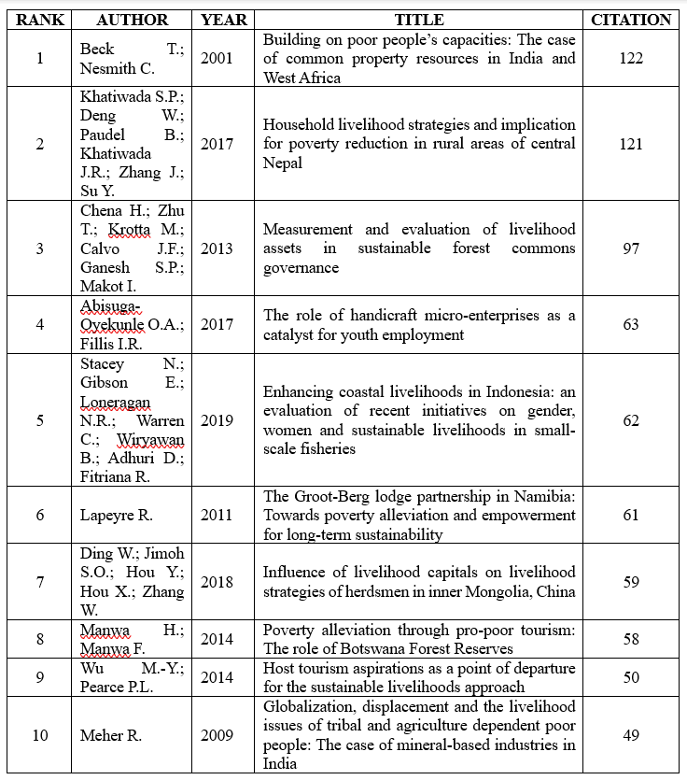

***Source: Compiled from collected data.***

* **Keyword Analysis**

Keyword cluster analysis was used to represent and compare the content of the most popular articles, which included the author's keywords. Furthermore, the frequency with which terms appeared was used to identify the current streams and topics employed in the chosen research field. Table 2 shows the top 10 keywords having the highest frequency of occurrence. Thus, the following terms appeared most frequently in the article titles: livelihood (37 occurrences), Sustainability (24 occurrences), capacity building (27 occurrences), and sustainable development (29 occurrences). The VOS viewer programme also generated a theme map in which the density of the words appeared. The high-density keyword in the cluster analysis indicates a strong link with other keywords stated in the articles' titles.

**TABLE 2**

**KEYWORD ANALYSIS**

|  |  |  |  |  |
| --- | --- | --- | --- | --- |
| **Rank** | **Keyword** | **Occurrence** | **Link** | **Total Link Strength** |
| 1 | Livelihood | 37 | 38 | 133 |
| 2 | Sustainability | 24 | 32 | 93 |
| 3 | Capacity Building | 27 | 31 | 89 |
| 4 | Sustainable development | 29 | 35 | 76 |
| 5 | Youth | 19 | 25 | 54 |
| 6 | Sustainable livelihoods | 23 | 23 | 43 |
| 7 | Agriculture | 13 | 24 | 41 |
| 8 | Rural area | 9 | 20 | 33 |
| 9 | Adaptive Management | 6 | 20 | 32 |
| 10 | Empowerment | 9 | 18 | 29 |

***Source: Compiled from collected data.***

​ Figure 3 depicts the similarity results, demonstrating how the clusters are all interconnected. As a result, the search string was effective since the interconnected boundaries are blurred and bordering articles represent the themes from multiple clusters. Figure 3 shows that four groups of keywords were highlighted. Figure 3 highlights four distinct keyword groups, illustrating the key thematic clusters that emerged from the analysis.

The first cluster contains 13 elements which are highlighted in red, and the most commonly used keywords in the cluster are indigenous knowledge, livelihood, rural development and sustainability.  The second cluster contains 12 elements which are highlighted in green, and the most commonly used keywords in the cluster are adaptive management, capacity building, and sustainable development. The third cluster contains 9 elements which are highlighted in blue, and the most commonly used keywords in the cluster are employment, innovation and youth. Finally, the fourth cluster is highlighted in yellow and contains six elements which include phrases like education and empowerment.

**FIGURE 3**

**SIMILARITY RESULTS, DEMONSTRATING HOW THE CLUSTERS ARE ALL INTERCONNECTED**

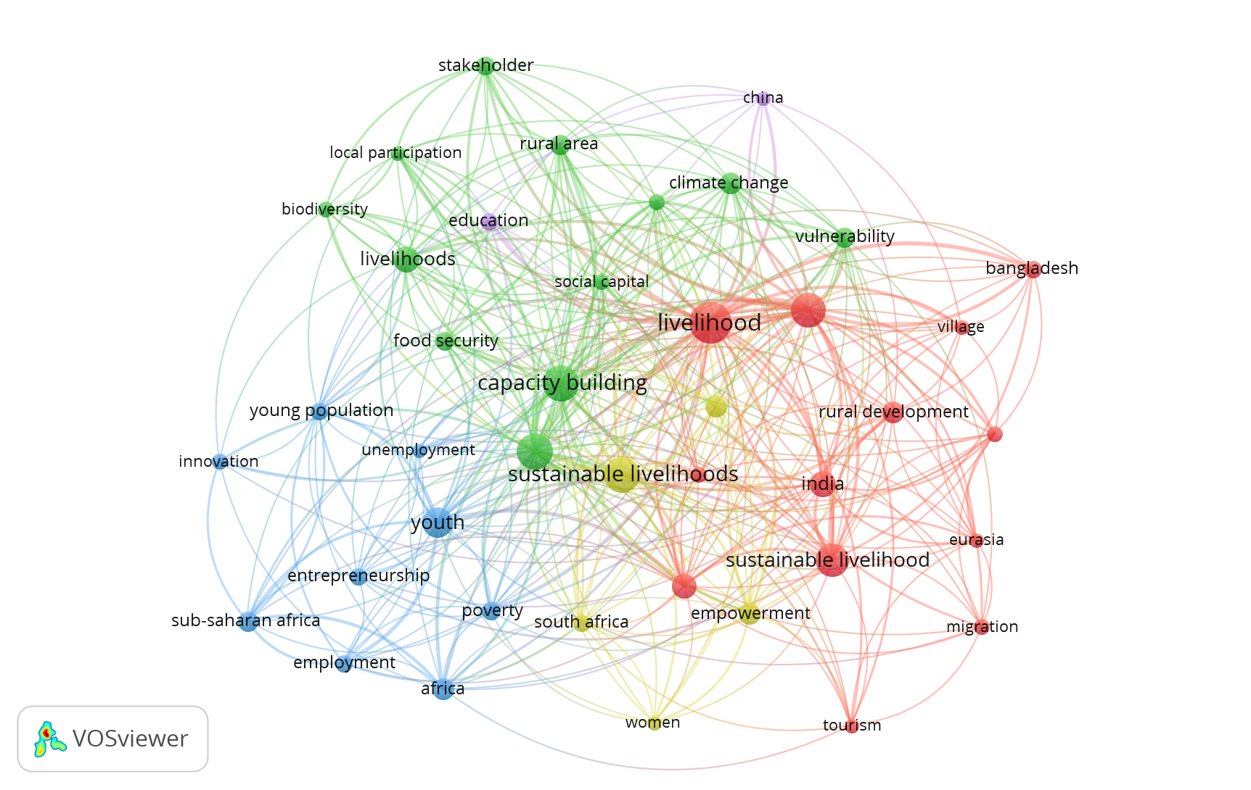

***Source: Compiled from collected data.***

* **Co-Authors Network**

Figure 4 depicts the cluster distribution of authors based on their number of publications and their citation. The literature review comprised a total of 535 writers. This figure shows the authors who have at least two articles in the dataset. Thus, the most publications were contributed by Islam, Md. Monirul (3 papers), followed by Goswami, Gour Gobinda (2 papers). The remaining writers in the list were the authors of two papers.

**FIGURE 4**

**CLUSTER DISTRIBUTION OF AUTHORS BASED ON THEIR NUMBER OF PUBLICATIONS AND THEIR CITATION**

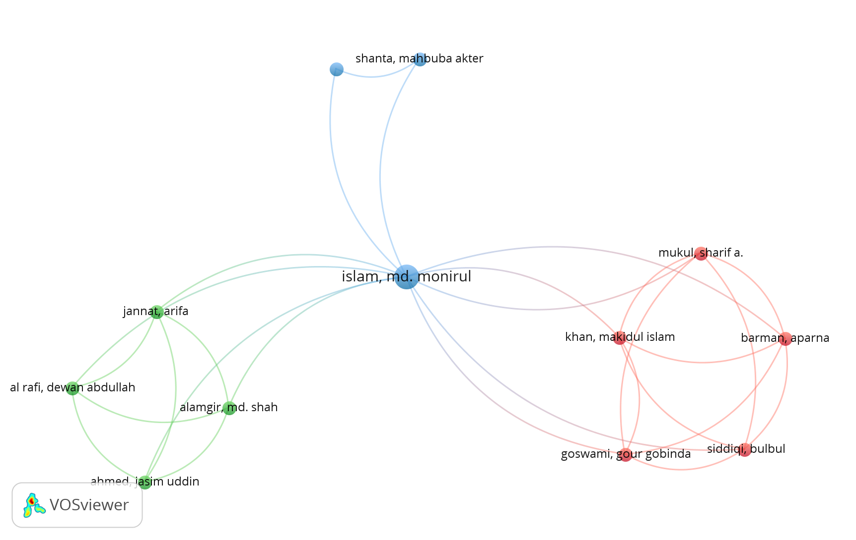

***SOURCE: Compiled from collected data.***

* **Co-Authorship among organisations**

Figure 4 depicts the results co-authorship among organisations, demonstrating how the organisations are all interconnected. The visualization reveals a dense collaboration network, with several major institutions forming the central nodes. These key organizations exhibit co-authorship frequency, indicating their role as research hubs.

**FIGURE 5**

**CO-AUTHORSHIP AMONG ORGANISATIONS, DEMONSTRATING HOW THE ORGANISATIONS ARE ALL INTERCONNECTED**

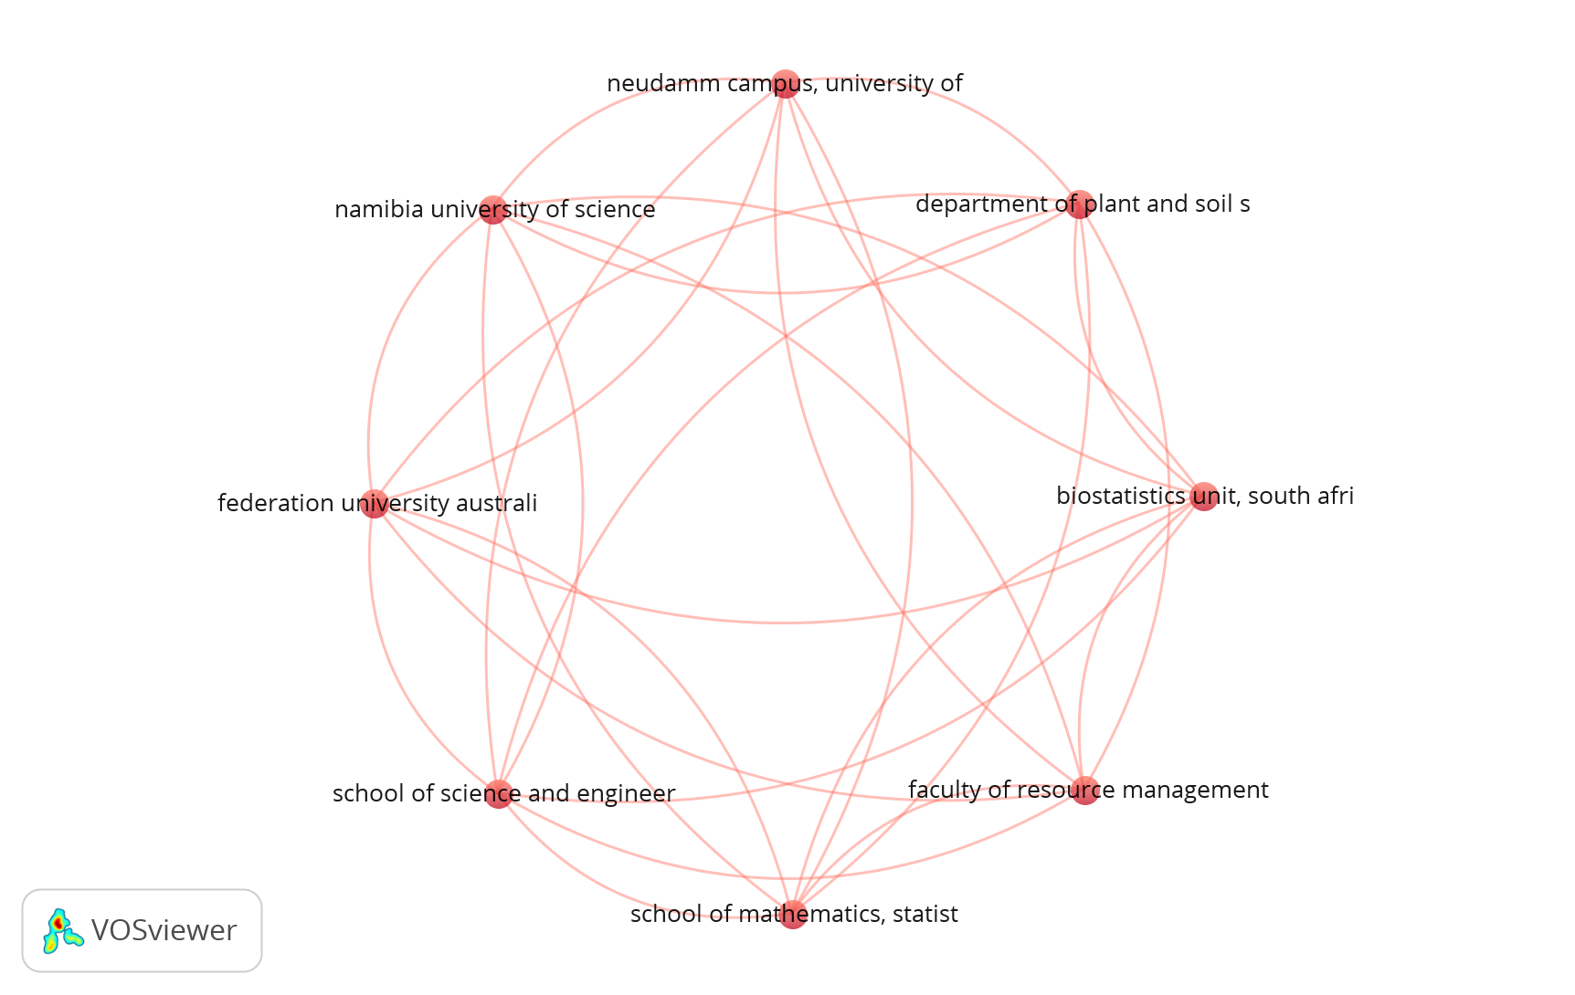

***Source: Compiled from collected data.***

* **Co-operation network among countries**

The visualization in figure 6 reveals a highly interconnected network, with several major countries forming central nodes. These key nations exhibit co-authorship frequency, indicating their role as research leaders on this topic in global academia. The most influential countries were identified based on the number of co-authored publications and link strength. India, South Africa, United Kingdom, exhibit strong research ties, while other countries have relatively fewer connections.

**FIGURE 6**

**HIGHLY INTERCONNECTED NETWORK, WITH SEVERAL MAJOR COUNTRIES FORMING CENTRAL NODES.**

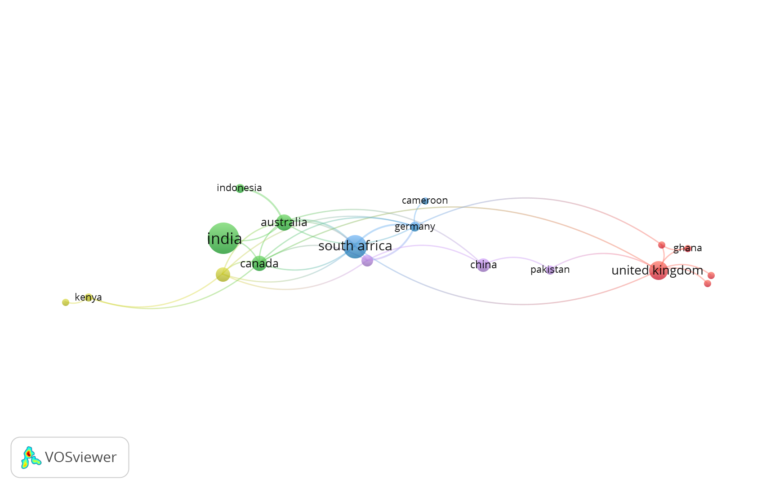

***Source: Compiled from collected data.***

**Result and Discussion:**

The bibliometric analysis of sustainable livelihood through skill development highlights diverse strategies across different geographical regions, focusing on the role of skill enhancement in fostering economic stability, poverty alleviation, and environmental sustainability. A common theme emerging from the study is the interplay between formal and informal skill development initiatives in empowering marginalized communities, including women, youth, and indigenous populations. Many studies emphasize the significance of vocational training, digital literacy, and entrepreneurial skills in enabling sustainable livelihoods.

Several papers examine the impact of industry-specific skill development, such as aquaculture, agroforestry, and non-timber forest product harvesting, in creating employment opportunities for vulnerable communities. Particularly in South Asia and Africa, community-based livelihood interventions have proven to be effective when integrated with local knowledge systems and conservation strategies. Case studies from Bangladesh, India, and Africa demonstrate how livelihood diversification, especially in rural and coastal regions, contributes to economic resilience against climate change and environmental degradation. The importance of ecosystem-based approaches, such as sustainable tourism and agro-ecology, also emerges as a key factor in ensuring long-term livelihood sustainability.

Technology and digital skills play a growing role in sustainable livelihood strategies, with studies highlighting how Industry 4.0 and ICT tools enhance employability and market access. For instance, MSMEs and rural entrepreneurs in developing economies benefit significantly from targeted training programs in financial literacy, digital marketing, and mechanized farming. Additionally, the research highlights the role of corporate social responsibility (CSR) initiatives in bridging skill gaps and promoting sustainable business models.

Gender and social inclusion remain critical aspects of skill development programs, with several studies revealing persistent challenges in integrating women and marginalized groups into the mainstream economy. Traditional vocational education and training (TVET) programs are increasingly being reformed to address gender disparities and equip women with entrepreneurial skills, particularly in agriculture and small-scale industries. Findings from sub-Saharan Africa suggest that TVET can serve as a transformative tool not only for economic empowerment but also for social change by challenging patriarchal structures.

Climate change and environmental sustainability are recurring themes across multiple studies, with an emphasis on adaptive skill-building for climate-resilient livelihoods. Several research papers highlight the role of non-formal education and indigenous knowledge systems in preparing rural communities for environmental shocks. Sustainable agriculture, agroforestry, and renewable energy projects are identified as crucial livelihood strategies, particularly in regions prone to extreme weather conditions.

Despite the positive impact of skill development programs, challenges such as policy fragmentation, limited financial resources, and inadequate infrastructure continue to hinder large-scale implementation. Many studies call for stronger public-private partnerships, increased government support, and better integration of community-led initiatives into national development frameworks.

Overall, the bibliometric analysis reveals that skill development is a fundamental driver of sustainable livelihoods, but its success depends on a multi-faceted approach that considers economic, social, and environmental dimensions. Strategic interventions that align with local needs, technological advancements, and inclusive development models have the potential to create lasting positive impacts on livelihoods worldwide.

1. **CONCLUSION**

This bibliometric analysis highlights the critical role of skill development in fostering sustainable livelihoods, particularly among marginalized communities, by enhancing economic resilience, promoting gender empowerment, and enabling climate adaptation. Various studies emphasize the impact of vocational training, digital literacy, and entrepreneurship in diversifying income sources and strengthening long-term sustainability. However, challenges such as limited access to education, financial constraints, and inadequate policy frameworks persist, underscoring the need for stronger collaboration between governments, private sectors, and local communities. Bridging these gaps through innovative, inclusive, and scalable solutions will be essential in ensuring equitable and resilient livelihoods. Future research should focus on addressing systemic barriers and leveraging emerging technologies to create sustainable livelihood opportunities for diverse populations.

**Disclaimer (Artificial intelligence)**

Author hereby declares that NO generative AI technologies such as Large Language Models (ChatGPT, COPILOT, etc.) and text-to-image generators have been used during the writing or editing of this manuscript.

**REFERENCES**

1. *Ahmed,S (2007). Job Creation and poverty reduction in India, towards rapid and Sustained Growth. New Delhi: SAGE Publications. 283-315.*
2. *Briones-Bitar, J., Carrión-Mero, P., Montalván-Burbano, N., & Morante-Carballo, F. (2020). Rockfall research: A bibliometric analysis and future trends. Geosciences, 10(10), 403.*
3. *Briones-Bitar, J., Carrión-Mero, P., Montalván-Burbano, N., & Morante-Carballo, F. (2020). Rockfall research: A bibliometric analysis and future trends. Geosciences, 10(10), 403.*
4. *Chen, Xiuwen, Jianming Chen, Dengsheng Wu, Yongjia Xie, and Jing Li. 2016. Mapping the research trends by co-word analysis based on keywords from funded project. Procedia Computer Science 91: 547–55.*
5. *Gupta, S.P (2006). Globalisation, Economic reforms and Employment strategy in India. New Delhi: Academic Foundation. 45-97.*
6. *Herrera-Franco, G., Montalván-Burbano, N., Mora-Frank, C., & Bravo-Montero, L. (2021). Scientific research in Ecuador: A bibliometric analysis. Publications, 9(4), 55.*
7. *Hendratmi A, Salleh MC, Sukmaningrum PS, Ratnasari RT. Toward SDG's 8: How sustainability livelihood affecting survival strategy of woman entrepreneurs in Indonesia. World Development Sustainability. 2024 Dec 1;5:100175.*
8. *Montalván-Burbano, N., Velastegui-Montoya, A., Gurumendi-Noriega, M., Morante-Carballo, F., & Adami, M. (2021). Worldwide research on land use and land cover in the amazon region. Sustainability, 13(11), 6039.*
9. *Majumdar, S. (2008). Modelling growth strategy in small entrepreneurial business organisations. The Journal of Entrepreneurship, 17(2), 157-168.*
10. *Nobanee, Haitham. 2020. Big Data in Business: A Bibliometric Analysis of Relevant Literature. Big Data 8: 459–63.*
11. *Nobanee, Haitham. 2021. A Bibliometric Review of Big Data in Finance. Big Data 9: 1–6.*
12. *Nobanee, Haitham, Maryam Alhajjar, Ghada Abushairah, and Safaa Al Harbi. 2021. Reputational Risk and Sustainability: A Bibliometric Analysis of Relevant Literature. Risks 9: 134.*
13. *Van Eck, Nees Jan, and Ludo Waltman. 2017. Citation-based clustering of publications using CitNetExplorer and VOSviewer. Scientometrics 1112: 1–19.*