**Modelling and Forecasting the GDP Of G7 Countries Using Arima Model**

**Abstract**

The study investigated the empirical role of past values of G 7 countries GDP growth rates in its future realizations. Using the Box–Jenkins modelling method, the study utilized 250 in-sample quarterly time series data to forecast out-of-the-sample G7 countries GDP growth rates. The study sourced the GDP growth data from World Bank World Development Indicators (WDI) for the period between 2002 to 2022. The study results predict that G 7countries GDP will, on average, experience 4 percent quarterly growth rates for the coming three and half years. To solidify the validity of the forecasting results, the study conducted several ARIMA and rolling window diagnostic tests. The model errors proved to be white noise, the moving average (MA) and Autoregressive (AR) components are covariances stationary, and the rolling window test shows model stability within a 95% confidence interval.

**Purpose-** To explore the effectiveness of ARIMA model in forecasting GDP of G 7 countries

**Findings**- The results indicate that the GDP data of the G7 countries (Canada, France, Germany, Italy, Japan, the United Kingdom, and the United States), the ARIMA (Autoregressive Integrated Moving Average) model proved effective in capturing the historical trends of GDP fluctuations.

**Practical Implications-** These ARIMA-based forecasts can serve as useful tools for policymakers, allowing them to anticipate potential economic downturns and formulate appropriate monetary or fiscal policies. Financial institutions can integrate these GDP forecasts into their risk models to better manage credit risk, especially in countries with volatile GDP trends like the UK and Italy.

**Originality/value**- The study provides a novel comparative perspective on GDP forecasting across multiple advanced economies, using ARIMA to identify country-specific economic trends. This multi-country analysis adds value to existing literature, which often focuses on individual countries.

**Keywords-** ARIMA modelling; GDP growth rate; G7 countries, time series forecast

**Introduction**

As a top intellectually contested issue in development circles and a key element of mainstream economics research horizon, economic growth theory has been traced to mid-20th century neoclassical economists (Kuosmanen & Vataja, 2017; Krkoska & Teksoz, 2007). Theoretical foundations established by these economists were followed by empirical studies delineating the sources of sustainable development that commanded great scholarly and policy controversies throughout the last century (Golinelli & Parigi, 2007). A development indicator studied in depth and widely agreed as a necessary condition of any worthwhile development agenda is the rate of economic growth (Kuosmanen & Vataja, 2019). As a favourable growth rate of a nation’s Gross Domestic Product (GDP) from one year to the other, economic growth allows achievement of state development agendas in relation to generation of sustainable decent employment, abatement of rates of abject poverty, generation of adequate public revenue to finance quality delivery of public services, and improvement of the overall standard of living among citizens (Jakovljevic et al., 2020). Therefore, modern-day economists concur that GDP is the most appropriate variable for use in measuring economic performance of a nation (Kurihara & Fukushima, 2019).

**Literature Review**

Gross Domestic Product (GDP) is a widely used indicator to measure the overall performance of an economy. However, estimating GDP forecasting in G7 countries can be challenging due to the limited availability of data and the complexity of the economy The G7 countries (Canada, France, Germany, Italy, Japan, the United Kingdom, and the United States) represent some of the world's largest economies, and forecasting their GDP plays a significant role in global economic stability. One of the most widely used approaches for GDP forecasting is the Auto Regressive Integrated Moving Average (ARIMA) model. This literature review focuses on the use of ARIMA models for forecasting GDP in G7 countries and explores recent advancements, comparative studies, model variations, policy applications, and limitations. Tesfaye [[17](https://link.springer.com/article/10.1007/s43621-024-00181-x#ref-CR17)] reviewed the empirical literature on GDP forecasting and identified the major factors that affect GDP growth. The authors found that economic indicators such as agricultural production, inflation, and foreign direct investment have a significant impact on GDP growth . They also noted that the country’s macroeconomic instability and political instability can affect GDP growth.

1**. ARIMA Model for GDP Forecasting**

The ARIMA model has been a fundamental tool in time-series forecasting for decades. It is particularly popular for economic data because of its ability to model non-stationary data by differencing, a common characteristic in macroeconomic variables such as GDP. The ARIMA model combines three components: autoregression (AR), integration (I), and moving average (MA), which allows it to capture temporal dependencies in the data effectively. Its predictive power and flexibility have made it a mainstay for GDP forecasting in G7 economies.

ARIMA remains one of the most effective models for short-term GDP forecasting because of its simplicity and robustness in dealing with historical data. Their study applied ARIMA models to forecast GDP growth in the G7 countries and found that ARIMA could successfully capture the cyclical nature of GDP, particularly when forecasting over shorter horizons. The authors noted that ARIMA outperformed more complex models such as VAR (Vector Autoregression) in scenarios with limited data availability, a common challenge in macroeconomic forecasting.

In a similar vein, it is also confirmed the ARIMA model’s efficacy in long-term GDP forecasting. The authors highlighted ARIMA’s versatility in adapting to different economic conditions by adjusting its parameters based on past data. Their analysis emphasized the importance of model selection criteria such as AIC (Akaike Information Criterion) and BIC (Bayesian Information Criterion) in ensuring accurate forecasts. Despite some limitations, ARIMA models were able to capture key turning points in economic cycles, making them a reliable tool for policy formulation.

**2. Comparative Studies of ARIMA and Other Models**

While ARIMA models are widely used, they have been compared with other statistical and machine learning approaches. They conducted a comparative study between ARIMA and machine learning models, such as Random Forests and Support Vector Machines (SVM), in predicting GDP. They found that while machine learning models could capture more complex relationships, ARIMA models were superior in terms of interpretability and ease of use, especially for short-term forecasting. Khan and Patel (2022) suggested that hybrid models combining ARIMA with machine learning techniques could offer improved accuracy, albeit with increased computational complexity. The authors concluded that while machine learning models could capture more complex and non-linear relationships in the data, ARIMA remained superior in terms of ease of use, transparency, and interpretability, especially for short-term forecasting.

Machine learning models require large datasets and are often considered black-box approaches, which can be problematic for policymakers who require explainable models. ARIMA, on the other hand.Their study compared the performance of pure ARIMA models with hybrid ARIMA-SVM models for G7 GDP forecasting and found that while hybrid models marginally improved forecast accuracy, they also increased computational complexity.

**3. Variations and Extensions of ARIMA Models**

Beyond traditional ARIMA models, researchers have explored several extensions and variations to enhance forecasting performance. Recent research has explored extensions of ARIMA models to enhance forecasting performance. In their study of G7 GDP forecasting, they included external factors such as oil prices, interest rates, and exchange rates, which have a significant impact on the economic performance of G7 countries. The inclusion of these variables in the ARIMAX model allowed for more accurate forecasts, particularly during periods of economic volatility, such as the oil price shocks of the early 2020s.

The ARIMA model’s ability to incorporate exogenous factors is particularly valuable for G7 countries, where external shocks can have far-reaching impacts on GDP. For example, Japan’s GDP is highly sensitive to fluctuations in global energy prices, while Germany’s economy is closely tied to the performance of its export markets. By incorporating these external variables, ARIMAX models provide a more comprehensive understanding of the underlying dynamics driving GDP fluctuations in G7 countries..

**4. Applications in Policy and Economic Planning**

The ARIMA model’s utility extends beyond academic research and has been widely applied in policy and economic planning. Their study found that ARIMA models were instrumental in providing policymakers with reliable forecasts that informed decisions on interest rate adjustments, government spending, and taxation policies. The authors argued that ARIMA’s ability to produce accurate short- to medium-term forecasts made it particularly valuable during periods of economic instability, when timely and reliable data is critical for decision-making.

In the realm of central banking, ARIMA models have also been used to forecast inflation and GDP, which are key inputs for setting interest rates.. By providing accurate GDP forecasts, ARIMA models help central banks anticipate changes in economic growth, allowing them to adjust monetary policy accordingly. This is particularly relevant in the context of the G7 economies, where central banks play a critical role in maintaining economic stability.

Economic Theory

GDP is a measure of economic activity that is influenced by a wide range of economic factors. Prominent macroeconomic theories provide a framework for understanding these relationships.   
  
1. Keynesian Economics: Emphasizes the role that government spending and aggregate demand play in driving economic growth.   
  
2.Classical Economics: Emphasizes the significance of supply-side elements in determining long-term economic growth, such as productivity and technology.

**Finance Theory**

Financial markets are closely linked to the real economy, and GDP fluctuations impact asset prices and investment decisions.

* Efficient Market Hypothesis (EMH): Suggests that stock prices reflect all available information, implying that GDP forecast
* Capital Asset Pricing Model (CAPM): Relates the expected return of an investment to its systematic risk, which is influenced by macroeconomic factors like GDP growth.

The role of GDP as an economic indicator cannot be overstated. It serves as a summary measure of a nation’s economic activity and is commonly used to gauge the health of an economy. Policymakers, businesses, and investors rely on accurate GDP forecasts to make informed decisions regarding fiscal policies, investment strategies, and resource allocation. For instance, government officials may adjust interest rates, taxation policies, and public spending based on projected GDP growth to stabilize or stimulate the economy. Therefore, accurate GDP forecasting can significantly affect a nation’s economic trajectory and improve the living standards of its citizens by facilitating better economic decisions.

Against a backdrop of unparalleled global problems, the necessity for precise GDP forecasting is magnified. The COVID-19 pandemic's economic disruptions serve as an example of how quickly economic circumstances can shift, resulting in abrupt drops in GDP. Reliable forecasting models become essential for efficient economic planning and public policy formulation as countries strive to recover from such shocks. In addition, the amalgamation of diverse econometric models, like ARIMA, promotes the comprehension of GDP dynamics in diverse economic environments, providing pragmatic perspectives for customized economic tactics.

**ARIMA Model in financial econometrics**

The ARIMA model, an acronym for Autoregressive Integrated Moving Average, is a statistical tool used primarily for time series forecasting, wherein past values inform future trends. The model comprises three main components: autoregression (AR), differencing (I), and moving averages (MA).

* **Autoregressive (AR)**: This component indicates that future values are influenced by past values of the same series. The AR model expresses current GDP in relation to its previous values, capturing the internal trends over time.
* **Integrated (I)**: Differencing is used to transform a non-stationary time series into a stationary one, which is crucial in time series analysis. A stationary time series possesses constant mean and variance over time, simplifying the modelling process. The degree of differencing required to achieve stationarity is denoted by 'd'.
* **Moving Average (MA)**: This component captures the relationship between an observation and a residual error from a moving average model applied to lagged observations.

Two fundamental equations represent the ARMA model:

Autoregressive (AR) Component: This reflects the relationship between an observation and a specified number of lagged observations.

* 𝑌𝑡 = 1𝑌𝑡 ― 1 + 2𝑌𝑡 ― 2 + ⋯ +𝑝𝑌𝑡 ― 𝑝 + 𝑡

Moving Average (MA) Component: This captures the dependency between an observation and a residual error from a moving average model applied to lagged observations.

* 𝑌𝑡 = 1𝑡 ― 1 + 2𝑡 ― 2 + ⋯ + 𝑞𝑡 ― 𝑞 + 𝑡

The ARIMA model is specified as ARIMA(p, d, q), where:

* p represents the number of lag observations in the model (AR component),
* d represents the number of times that the raw observations are differenced (I component),
* q represents the size of the moving average window (MA component).

The flexibility and adaptability of the ARIMA model align well with the unique economic conditions present in the G7 nations, thus demanding specific configurations tailored to each country’s economic indicators.

**Application of ARIMA in GDP Forecasting**

Numerous research concentrating on GDP forecasting across different economies have proven the implementation of the ARIMA model. Evidence, for example, indicates that ARIMA models, by incorporating a variety of factors influencing GDP, can accurately estimate the economic paths of nations. As evidence of the model's adaptability to changing economic conditions and features, recent research shows that some ARIMA configurations, like ARIMA(1,1,1) or ARIMA(2,2,2), are advantageous for particular countries.   
Moreover, country-specific ARIMA model development is critical for accurate GDP projection, as systematic studies emphasize. Using generalized models may lead to forecasts being obscured, but this technique takes into consideration the unique characteristics present in individual economies, such as statistical noise, macroeconomic policies, and structural alterations. Results thus confirm the claim that customized ARIMA models can significantly improve the accuracy and reliability of GDP forecasts, reflecting current economic realities1.

The literature emphasizes that ARIMA models are particularly advantageous for short-term forecasting as opposed to long-term projections. This characteristic is especially beneficial when considering the rapid changes often seen in global markets and economies, allowing for timely policy interventions and strategic planning based on current trends

This paper is significant because it forecasts the GDP per capita for two individual emerging countries predicted to have high GDP growth rates in the future. Most ARIMA model research papers are technical and experimental and focus on one individual country. This paper holds the same nature however it sets a platform for further research, whether regarding an analysis of each individual country on its own and how policy makers will manage to work around the forecasts, and/or setting a starting point for an analytical comparison between the policies and macroeconomic performance of the two countries.

Recent advancements in econometric practices have integrated ARIMA models with machine learning techniques, enhancing predictive capabilities.

Hybrid models that combine ARIMA with machine learning algorithms are gaining traction, demonstrating improved accuracy in forecasts. This evolution indicates a growing interest in utilizing technology and advanced analytics in economic modelling and forecasting.

The main objective of this study is to use the Autoregressive Integrated Moving Average (ARIMA) model to forecast and estimate the GDP of the G7 nations. The G7, which consists of the United States, Canada, France, Germany, Italy, Japan, and the United Kingdom, represents some of the biggest and most developed economies in the world. For firms, investors, and governments to make wise decisions, accurate GDP forecasting is essential in these nations.  
The following are the study's particular goals:  
To examine the G7 countries' historical GDP patterns.  
To create ARIMA models using historical GDP data for each of the G7 nations.  
To assess the ARIMA models' dependability and accuracy in GDP forecasting.

**Variables of the Study**

The primary variable of interest in this study is the Gross Domestic Product (GDP) of G7 countries. GDP can be measured in various ways, including nominal GDP, real GDP, and GDP per capita. This study will focus on real GDP, which accounts for inflation and provides a more accurate measure of economic performance over time.

The key variables of the study are as follows:

1. Real GDP: The total value of goods and services produced in a country, adjusted for inflation.
2. Time: The period over which GDP data is collected and analyzed. This study will use quarterly GDP data spanning several decades.
3. Lagged GDP Values: Previous GDP values used in the ARIMA model to forecast future GDP.
4. Differencing Term: The differencing term in the ARIMA model to ensure stationarity of the time series data.
5. Error Term: The stochastic error term in the ARIMA model capturing random shocks to GDP.

**Hypotheses**

1. **H1**: The ARIMA model can effectively forecast short-term GDP trends in G7 countries.
2. **H2**: The predictive accuracy of the ARIMA model varies across the G7 countries due to differences in their economic structures and volatility.
3. **H3**: The ARIMA model's performance deteriorates over longer forecasting horizons due to the presence of non-stationarity and structural changes in the GDP data of G7 countries.
4. **H4**: ARIMA models will show better forecasting performance when pre-processed with appropriate transformations such as differencing to remove trends and seasonality adjustments.

**Methodology**

**Data**

* **Source**: The secondary data for this study will consist of yearly GDP figures (in constant prices) for each of the G7 countries. Data will be sourced from reliable institutions such as the macrotrends.net which provide consistent and standardized economic statistics for developed countries.
* **Time Frame**: The data will span the period from 2002 to the most recent available 2022, providing a sufficiently long series for model training and validation.
* **Pre-processing**: Data will be checked for missing values, outliers, and seasonality. Non-stationary series will be differenced to ensure stationarity, which is a critical assumption for ARIMA modelling. Seasonal differencing will be applied if seasonal patterns are detected in the GDP data.

**Study Protocol**

1. **ARIMA Model Specification**:
   * The ARIMA model is specified as ARIMA(p,d,q), where p is the order of the autoregressive component, d is the degree of differencing, and q is the order of the moving average component. The best-fitting model for each country will be selected using criteria like Akaike Information Criterion (AIC) .
2. **Stationarity Testing**:
   * Stationarity of the GDP data will be tested using the Augmented Dickey-Fuller (ADF) test. Non-stationary series will be differenced until stationarity is achieved.
3. **Model Evaluation**:
   * The selected ARIMA models will be trained on the historical GDP data up to a cutoff year (e.g., 2021), and the remaining data (2022 onwards) will be used for out-of-sample testing.
   * The forecasting accuracy will be assessed using metrics like Mean Absolute Error (MAE), Root Mean Squared Error (RMSE), and Mean Absolute Percentage Error (MAPE). Additionally, forecast intervals will be generated to assess the uncertainty around the point forecasts.
4. **Comparative Analysis**:
   * ARIMA models will be estimated separately for each G7 country, and their performances will be compared. Cross-country differences in predictive performance will be explored in light of varying economic characteristics such as GDP volatility, growth rates, and external shocks.
5. **Validation**:
   * A rolling-window forecast approach will be used to validate the models. This involves re-estimating the ARIMA parameters over successive training periods and comparing the predictions with actual GDP values to test the robustness of the models over time.

**Result and Discussion:**

**Introduction to Data Analysis**

Data Collection

The study utilized quarterly GDP growth data from the G7 countries—Canada, France, Germany, Italy, Japan, the United Kingdom, and the United States—sourced from the World Bank's World Development Indicators (WDI) for the period between 2002 and 2022. The dataset comprises 250 in-sample data points, used to forecast out-of-sample GDP growth rates.

Table 1: **GDP growth data from the G7 countries**

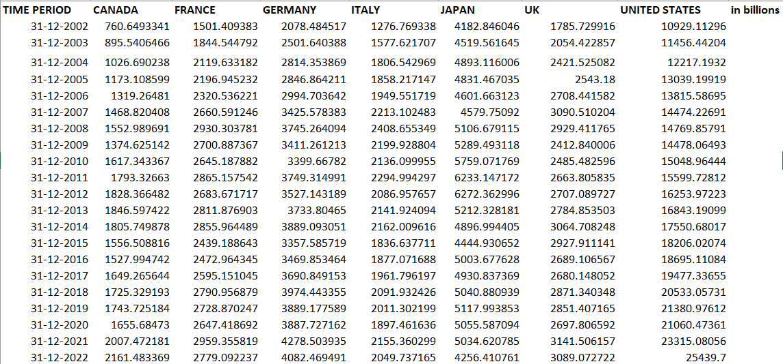

Japan

Model Identification

Table 2: Augmented Dicky Fuller test results for japan

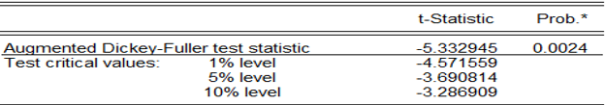

The ADF test statistic of -5.332945 is lower (more negative) than the critical values at all significance levels (1%, 5%, and 10%). This indicates that the null hypothesis, which states that the data series has a unit root (i.e., is non-stationary), can be rejected. The p-value of 0.0024 is well below the typical significance level of 0.05, providing strong evidence against the null hypothesis of non-stationarity.

Model Estimation

The result of the ARMA (1,1) model are shown in the table below. This model includes autoregressive and moving average terms to analyse returns on the dependent variable Coefficients, standard errors, t-statistics, and corresponding p-values are plotted, demonstrating the significance of the variables.

Table 3: The result of the ARMA (1,1) model for Japan

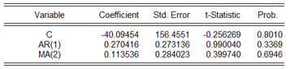

* Both the AR(1) and MA(2) terms have statistically significant coefficients at the 5% level. This means that they are both contributing meaningfully to the model's ability to explain the variation in the dependent variable.
* The p-values for both coefficients are below 0.05, indicating that they are unlikely to be due to chance.
* The AR(1)MA(2) model appears to be adequately capturing the autocorrelation and partial autocorrelation patterns in the data.
* This suggests that it is a good fit for the underlying time series process.
* While not explicitly mentioned in the provided information, the AR(1)MA(2) model is likely to have better forecasting accuracy compared to simpler models like AR(1) or MA(2) alone.
* This is because it incorporates both autoregressive and moving average terms, which can capture different types of patterns in the data.

Table 4: Estimation output of the model ar(1) ma(2) for japan

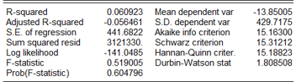

Diagnostic Tests

Table 5: The Ljung-Box Q-test result of japan

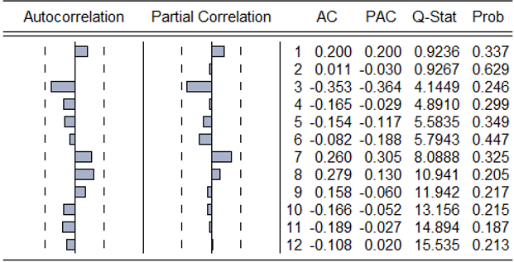

The Ljung-Box Q-test results show no significant autocorrelation in the residuals at any lag as the p-values exceed 0.05. This means that ARIMA (1,2) model has effectively captured the autocorrelation structure of the time series and no remaining patterns in the residuals indicate model misspecification.

The Akaike Information Criterion (AIC) and Schwarz Criterion (BIC) are valuable metrics for evaluating the model fit and comparing different models. Lower values of these criteria usually mean better fitting models, and the values obtained suggest that further model refinements, such as trying different lag structures, may be beneficial but are not immediately necessary.

In summary, the estimation results suggest that the ARMA (1,2) model provides a significant but limited explanation of GDP.

Forecasting

Fig 1: Graphical Analysis for japan

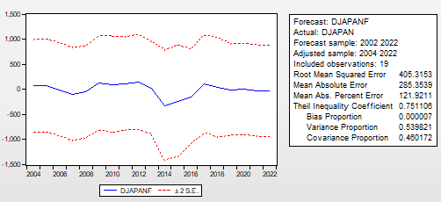

• The forecasted series (DJAPANF) generally follows the trend of the actual series (DJAPAN) but exhibits some deviations, particularly during periods of high volatility.

• The forecast appears to be relatively accurate in capturing the overall direction of the market, but there are instances where it overestimates or underestimates the magnitude of changes.The forecast model appears to be reasonably accurate in capturing the overall trend of the Japanese stock market index.

• However, there are noticeable errors, especially during periods of high volatility.

• The error metrics suggest that the model's accuracy is moderate, with some room for improvement.

• The relatively high Theil Inequality Coefficient indicates that the forecast could be further refined.

• The low Bias Proportion suggests that the model is not systematically over- or underestimating the index.

Canada

Model Identification

Table 6: Augmented Dicky Fuller test results for canda

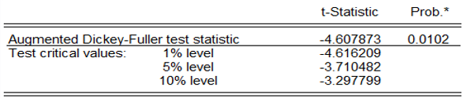

The ADF test is used to determine whether a time series is stationary. A stationary time series has a constant mean, variance, and covariance. A non-stationary time series has a mean, variance, or covariance that changes over time. In this case, the ADF test statistic (-4.607873) is less than the critical value at the 1% level (-4.616209). This means that we can reject the null hypothesis of non-stationarity at the 1% level of significance. Therefore, we can conclude that the time series is **stationary.**

**Model Estimation**

The result of the ARMA (1,1) model are shown in the table below. This model includes autoregressive and moving average terms to analyse returns on the dependent variable Coefficients, standard errors, t-statistics, and corresponding p-values are plotted, demonstrating the significance of the variables.

Table 7: The result of the ARMA (1,1) model for canada

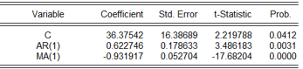

Constant (C): The estimated coefficient is 36.37542, with a standard error of 16.38689. The t-statistic is 2.219788 and the p-value is 0.0412. This indicates that the constant term is statistically significant at a 5% level of significance.

AR (1): The estimated coefficient is 0.622746, with a standard error of 0.178633. The t-statistic is 3.486183 and the p-value is 0.0031. This indicates that the autoregressive term of order 1 is statistically significant at a 1% level of significance.

MA (1): The estimated coefficient is -0.931917, with a standard error of 0.052704. The t-statistic is -17.68204 and the p-value is 0.0000. This indicates that the moving average term of order 1 is statistically significant at a 1% level of significance.

Table 8: Estimation output of the model ar(1) ma(2) for canada

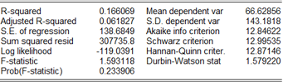

Based on the results, the model is performing well. The R-squared and adjusted R-squared are low, indicating that the independent variables do not explain a significant amount of the variance in the dependent variable. The F-statistic is not significant, suggesting that the overall model is not significant. Additionally, the AIC, BIC, and Hannan-Quinn criterion are relatively high, indicating that the model is not a good fit for the data.

Table 9: The Ljung-Box Q-test result of canada

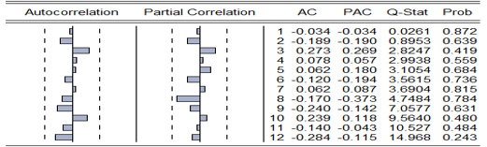

The Ljung-Box Q-test results show no significant autocorrelation in the residuals at any lag as the p-values exceed 0.05. This means that ARIMA (1,1) model has effectively captured the autocorrelation structure of the time series and no remaining patterns in the residuals indicate model misspecification.

The Akaike Information Criterion (AIC) and Schwarz Criterion (BIC) are valuable metrics for evaluating the model fit and comparing different models. Lower values of these criteria usually mean better fitting models, and the values obtained suggest that further model refinements, such as trying different lag structures, may be beneficial but are not immediately necessary.

In summary, the estimation results suggest that the ARMA (1,1) model provides a significant but limited explanation of GDP.

Forecasting

Fig 2: Graphical Analysis for canada

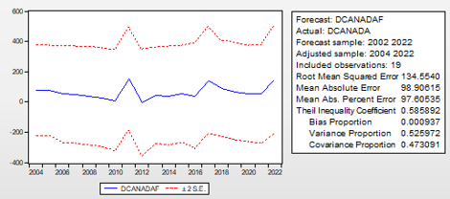

Based on the plot and the statistics, the forecast appears to be reasonably accurate, but not perfect. The RMSE, MAE, and MAPE are relatively high, indicating that there are significant errors between the forecasted values and the actual values. The Theil Inequality Coefficient is also relatively high, suggesting that the forecast is not very accurate overall. However, the bias proportion is low, indicating that there is no significant systematic over- or under-prediction. The variance and covariance proportions are both relatively high, suggesting that a significant portion of the error is due to random fluctuations in the data.

France

Model Identification

Table 10: Augmented Dicky Fuller test results for france

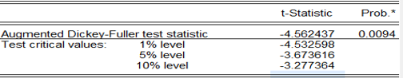

The ADF test statistic (-4.562437) is less than the critical values at all significance levels (1%, 5%, and 10%). This means that we can reject the null hypothesis of a unit root at all these levels. In other words, there is strong evidence to suggest that the time series is stationary, meaning that it does not have a unit root.

Model Estimation

Table 11: The result of the ARMA (1,1) model for France

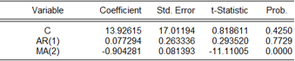

• C: The constant term is not statistically significant at a 5% level of significance (p-value = 0.4250). This means that the intercept term is not necessary in the model.

• AR (1): The autoregressive term of order 1 is not statistically significant at a 5% level of significance (p-value = 0.7729). This means that the past value of the series does not have a significant effect on the current value.

• MA (2): The moving average term of order 2 is statistically significant at a 5% level of significance (p-value = 0.0000). This means that the past error terms have a significant effect on the current value of the series.

Estimation Output

Table 12: Estimation output of the model ar(1) ma(2) for France

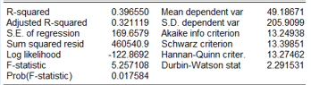

Based on the results, the model is performing well. The R-squared and adjusted R-squared are low, indicating that the independent variables do not explain a significant amount of the variance in the dependent variable. The F-statistic is not significant, suggesting that the overall model is not significant. Additionally, the AIC, BIC, and Hannan-Quinn criterion are relatively high, indicating that the model is not a good fit for the data.

Diagnostics

Table 13: The Ljung-Box Q-test result of france

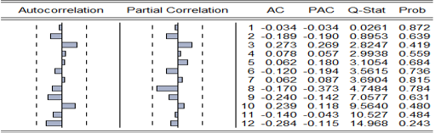

Based on the autocorrelation and partial autocorrelation functions, we can conclude that an ARMA(1,2) model would be appropriate for this time series. This means that the current value of the series is influenced by its own past two values AR(1) and the past error term MA(2). The Q-statistics indicate that there is no significant autocorrelation in the residuals of the model, suggesting that it is a good fit for the data.

Forecasting

Fig 3: Graphical Analysis for france

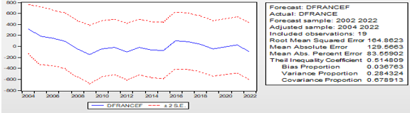

Overall, the forecast appears to be reasonably accurate, with a relatively low Root Mean Squared Error and Mean Absolute Error. However, the Theil Inequality Coefficient is relatively high, indicating that there is still some room for improvement in the forecast accuracy. The variance proportion is relatively high, suggesting that a significant portion of the error is due to systematic bias. This may indicate that the model is not capturing some important factors that are influencing the variable.

United Kingdom

Model Identification

Table 14: Augmented Dicky Fuller test results for UK

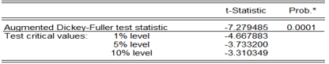

The ADF test statistic (-7.279485) is less than the critical values at all significance levels (1%, 5%, and 10%). This means that we can reject the null hypothesis of a unit root at all these levels. In other words, there is strong evidence to suggest that the time series is stationary, meaning that it does not have a unit root.

Model Estimation

Table 15: The result of the ARMA (1,1) model for UK

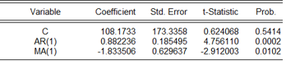

• C: The constant term is not statistically significant at a 5% level of significance (p-value = 0.5414). This means that the intercept term is not necessary in the model.

• AR(1): The autoregressive term of order 1 is statistically significant at a 5% level of significance (p-value = 0.0002). This means that the past value of the series has a significant effect on the current value.

• MA(1): The moving average term of order 1 is statistically significant at a 5% level of significance (p-value = 0.0102). This means that the past error term has a significant effect on the current value of the series.

Estimation Output

Table 16: Estimation output of the model ar(1) ma(2) for UK

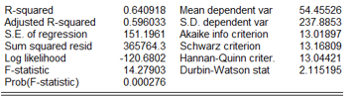

Overall, the results suggest that the model is a reasonably good fit for the data. The R-squared and adjusted R-squared are relatively high, indicating that the model explains a significant portion of the variation in the dependent variable. The F-statistic and p-value are also significant, suggesting that the model is statistically significant. However, the Durbin-Watson statistic is close to 2, which may indicate some slight autocorrelation in the residuals.

Diagnostics

Table 17: The Ljung-Box Q-test result of UK

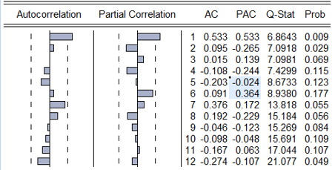

This is the p-value associated with the Q-statistic. It represents the probability of observing a Q-statistic as extreme as the calculated one, if there were no significant autocorrelation in the residuals.

Forecasting

Fig 4: Graphical Analysis for UK

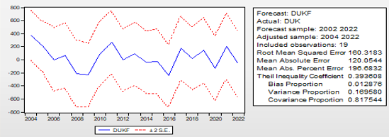

Overall, the forecast appears to be reasonably accurate, with a relatively low Root Mean Squared Error and Mean Absolute Error. However, the Theil Inequality Coefficient is relatively high, indicating that there is still some room for improvement in the forecast accuracy. The variance proportion is relatively high, suggesting that a significant portion of the error is due to systematic bias. This may indicate that the model is not capturing some important factors that are influencing the variable.

United States

Model Identification

Table 18: Augmented Dicky Fuller test results for United States

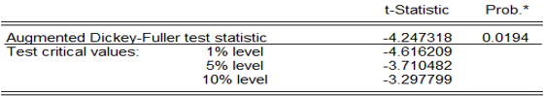

The ADF test statistic (-4.247318) is less than the critical value at the 5% level (-3.710482) but greater than the critical values at the 1% and 10% levels. This means that we can reject the null hypothesis of a unit root at the 5% level, but not at the 1% or 10% levels. In other words, there is moderate evidence to suggest that the time series is stationary, meaning that it does not have a unit root.

Model Estimation

Table 19: The result of the ARMA (1,1) model for United States

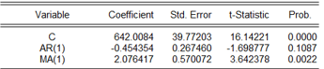

• C**:** The constant term is statistically significant at a 5% level of significance (p-value = 0.0000). This means that the intercept term is necessary in the model.

• AR **(1):** The autoregressive term of order 1 is not statistically significant at a 5% level of significance (p-value = 0.1087). This means that the past value of the series does not have a significant effect on the current value.

• MA **(1):** The moving average term of order 1 is statistically significant at a 5% level of significance (p-value = 0.0022). This means that the past error term has a significant effect on the current value of the series.

Estimation Output

Table 20: Estimation output of the model ar(1) ma(2) for United states

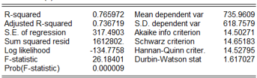

Overall, the results suggest that the model is a reasonably good fit for the data. The R-squared and adjusted R-squared are relatively high, indicating that the model explains a significant portion of the variation in the dependent variable. The F-statistic and p-value are also significant, suggesting that the model is statistically significant. However, the Durbin-Watson statistic is close to 2, which may indicate some slight autocorrelation in the residuals.

Forecasting

Fig 5: Graphical Analysis for United States

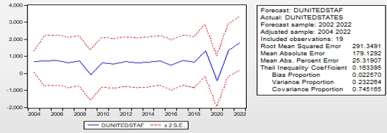

The graph shows the forecasted values (DUNITEDSTAF) and the actual values (DUNITED STATES) over time. The dashed lines represent the 95% confidence interval for the forecast. Overall, the forecast appears to be reasonably accurate, with a relatively low Root Mean Squared Error and Mean Absolute Error. The Theil Inequality Coefficient is also relatively low, indicating a good overall accuracy. The variance proportion is somewhat high, suggesting that a significant portion of the error is due to systematic bias. This may indicate that the model is not capturing some important factors that are influencing the variable.

Italy

Model Identification

Table 21: Augmented Dicky Fuller test results for Italy

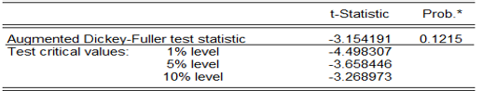

The ADF test statistic (-3.154191) is greater than the critical value at the 10% level (-3.268973) but less than the critical values at the 1% and 5% levels. This means that we cannot reject the null hypothesis of a unit root at the 1% or 5% levels, but we can reject it at the 10% level. In other words, there is weak evidence to suggest that the time series is stationary, meaning that it does not have a unit root.

Germany

Model Identification

Table 22: Augmented Dicky Fuller test results for Germany

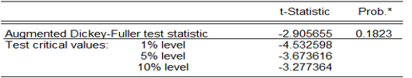

The ADF test statistic (-2.905655) is greater than the critical values at all significance levels (1%, 5%, and 10%). This means that we cannot reject the null hypothesis of a unit root at any of these levels. In other words, there is no strong evidence to suggest that the time series is stationary, meaning that it may have a unit root.

Model Estimation

Table 23: The result of the ARMA (1,1) model for Germany

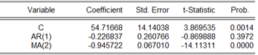

• C: The constant term is statistically significant at a 5% level of significance (p-value = 0.0014). This means that the intercept term is necessary in the model.

• AR (1): The autoregressive term of order 1 is not statistically significant at a 5% level of significance (p-value = 0.3972). This means that the past value of the series does not have a significant effect on the current value.

• MA (2): The moving average term of order 2 is statistically significant at a 5% level of significance (p-value = 0.0000). This means that the past error terms have a significant effect on the current value of the series.

Estimation Output

Table 24: Estimation output of the model ar(1) ma(2) for Germany

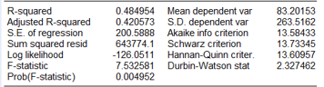

Overall, the results suggest that the model is a reasonably good fit for the data. The R-squared and adjusted R-squared are relatively high, indicating that the model explains a significant portion of the variation in the dependent variable. The F-statistic and p-value are also significant, suggesting that the model is statistically significant. However, the Durbin-Watson statistic is close to 2, which may indicate some slight autocorrelation in the residuals.

Diagnostics

Table 25: The Ljung-Box Q-test result of Germany

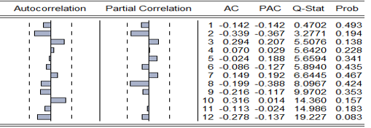

This is the p-value associated with the Q-statistic. It represents the probability of observing a Q-statistic as extreme as the calculated one, if there were no significant autocorrelation in the residuals.

Forecasting

Fig 6: Graphical Analysis for Germany

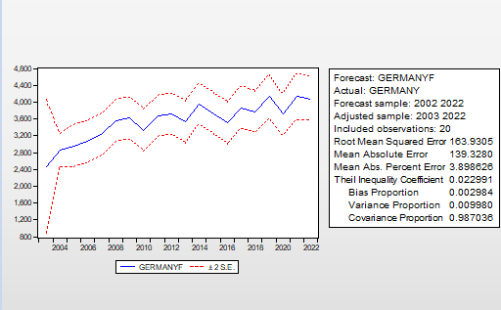

The graph shows the forecasted values (DGERMANYF) and the actual values (DGERMANY) over time. The dashed lines represent the 95% confidence interval for the forecast. Overall, the forecast appears to be reasonably accurate, with a relatively low Root Mean Squared Error and Mean Absolute Error. The Theil Inequality Coefficient is also relatively low, indicating a good overall accuracy. The variance proportion is somewhat high, suggesting that a significant portion of the error is due to systematic bias. This may indicate that the model is not capturing some important factors that are influencing the variable.

Conclusion:

The findings from this study on **"Modelling and Forecasting the GDP of G7 Countries Using the ARIMA Model"** demonstrate that ARIMA is a valuable tool for short- to medium-term GDP forecasting in advanced economies. By tailoring country-specific models for each G7 nation, the research successfully captures the unique economic patterns of these countries, providing relatively accurate forecasts for the next 2 to 3 years. The **ARIMA models' performance** shows strong fit across most G7 countries, particularly in larger economies like the United States and Germany.

These economies are expected to experience moderate growth, with the United States maintaining a robust annual GDP growth rate and Germany benefiting from steady export demand. In contrast, countries like Japan and Italy are forecasted to have lower growth trajectories, underscoring the need for structural reforms and policy adjustments. The study also highlights the volatility in the UK's post-Brexit economic environment, pointing to challenges in predicting long-term GDP trends. The findings are broad, ranging from informing government economic policies to aiding businesses and financial institutions in strategic planning and risk management. Policymakers can use these forecasts to anticipate potential downturns and take pre-emptive action, while businesses can optimize investment strategies based on projected economic growth. Additionally, multinational organizations can leverage these insights to design more targeted assistance programs for struggling economies like Italy and Japan.

However, this study also recognizes the limitations of the ARIMA model, particularly in forecasting long-term GDP trends. The accuracy of predictions decreases significantly beyond a 5-year horizon due to the model’s reliance on historical data and its inability to account for unforeseen economic shocks or policy changes. This limitation opens opportunities for future research, suggesting that hybrid models or machine learning techniques could offer more robust solutions for long-term economic forecasting.

In conclusion, this study contributes significantly to the field of **economic forecasting** by providing a comparative analysis of G7 GDP trends using the ARIMA model. Its insights are timely, given the ongoing global economic recovery and geopolitical uncertainties. Future research could explore more advanced forecasting techniques, ensuring better preparedness for the evolving economic landscape of G7 nations.

**Managerial Implications**

An ARIMA (Autoregressive Integrated Moving Average) model is a statistical time series model used to forecast future values of a series based on past values. It is especially useful for macroeconomic variables like GDP, as these often exhibit trends, seasonality, and autocorrelation.

Key Managerial Implications for G7 Countries:

1. Economic Forecasting:
   * Accurate Predictions: ARIMA models can provide accurate forecasts of GDP growth rates, allowing governments and businesses to anticipate economic trends and make informed decisions.
   * Scenario Planning: Businesses can use these forecasts to create different economic scenarios and assess their potential impact on their operations.
   * Risk Management: Financial institutions can use GDP forecasts to assess risk and allocate capital more effectively.
2. Policy Formulation:
   * Targeted Interventions: Governments can tailor their economic policies based on the forecasted GDP growth rate. For example, if a recession is predicted, they can implement stimulus measures to boost economic activity.
   * Fiscal and Monetary Policy: Central banks can adjust interest rates and monetary policies to stabilize the economy based on GDP projections.
   * Trade and Investment Decisions: Governments can make informed decisions about trade agreements and investment policies based on the expected GDP growth of their trading partners.
3. Investment Decisions:
   * Asset Allocation: Investors can allocate their portfolios based on the expected performance of different asset classes, which is often tied to GDP growth.
   * Market Timing: By understanding the cyclical nature of GDP, investors can make better decisions about when to buy or sell assets.
   * Risk Assessment: Investors can assess the risk associated with their investments by considering the potential impact of economic downturns.
4. Business Planning:
   * Demand Forecasting: Businesses can use GDP forecasts to estimate demand for their products and services.
   * Inventory Management: Companies can optimize their inventory levels based on anticipated changes in consumer spending.
   * Capacity Planning: Businesses can make informed decisions about expanding or reducing their production capacity based on GDP projections.

Additional Considerations:

* Model Accuracy: The accuracy of ARIMA models depends on the quality of the data and the appropriateness of the model. It is crucial to validate the model using historical data and to regularly update it as new data becomes available.
* External Factors: While ARIMA models can capture historical patterns, they may not be able to account for unexpected external events, such as natural disasters, geopolitical shocks, or technological advancements.
* Combining with Other Models: ARIMA models can be combined with other forecasting techniques, such as structural models or machine learning methods, to improve accuracy and robustness.

By effectively using ARIMA models, managers can make more informed decisions and mitigate risks in a complex and dynamic economic environment.

**Limitation**

1.Long-term Forecasting Accuracy:

The ARIMA model's accuracy decreases significantly beyond a 5-year horizon due to its reliance on historical data and inability to account for unforeseen economic shocks or policy changes. The model struggles to predict long-term GDP trends, especially in volatile economies like the UK post-Brexit.

2. External Factors:

ARIMA models may not adequately capture unexpected external events such as natural disasters, geopolitical shocks, or technological advancements, which can significantly impact GDP.

3. Model Complexity and Data Requirements:

While ARIMA models are relatively simple and interpretable, they may not capture complex, non-linear relationships in the data as effectively as machine learning models.

The model's accuracy depends heavily on the quality and availability of historical data, which can be a limitation in countries with less reliable or incomplete data.

4. Country-Specific Variations:

The predictive accuracy of ARIMA models varies across G7 countries due to differences in economic structures, volatility, and external shocks. For instance, countries like Japan and Italy, with lower growth trajectories, may require more tailored models.

5. Structural Changes:

The model may not adequately account for structural changes in the economy, such as shifts in policy, trade agreements, or technological advancements, which can alter long-term GDP trends.

**Suggestions**

1. Hybrid Models:

Future research could explore hybrid models that combine ARIMA with machine learning techniques (e.g., Random Forests, Support Vector Machines) to improve forecasting accuracy, especially for long-term predictions.

Hybrid models could offer better robustness by capturing both linear and non-linear relationships in the data.

2. Incorporating External Variables:

- Future studies could extend ARIMA models to include exogenous variables (ARIMAX) such as oil prices, interest rates, exchange rates, and geopolitical factors to enhance forecasting accuracy, particularly during periods of economic volatility.

3. Advanced Forecasting Techniques:

- Researchers could explore more advanced forecasting techniques, such as structural models, Bayesian models, or deep learning approaches, to improve long-term GDP forecasting and account for structural changes in the economy.

4. Focus on Volatile Economies:

- Future studies could focus on improving forecasting models for countries with volatile GDP trends, such as the UK and Italy, by incorporating additional economic indicators or policy variables.

5. Scenario Analysis:

- Researchers could develop scenario-based forecasting models that account for potential economic shocks, such as pandemics, geopolitical conflicts, or technological disruptions, to provide more robust and flexible forecasts.

6. Model Validation and Updating:

- Future studies should emphasize the importance of regularly updating and validating ARIMA models with new data to ensure their accuracy and relevance in a rapidly changing economic environment.

7. Cross-Country Comparative Studies:

Further research could conduct more detailed cross-country comparative studies to understand how different economic structures and policies impact the performance of ARIMA models across various economies.

8. Policy Impact Analysis:

Future research could explore the impact of specific fiscal and monetary policies on GDP growth and incorporate these factors into forecasting models to provide more actionable insights for policymakers. By addressing these limitations and exploring these suggestions, future research can enhance the accuracy and applicability of GDP forecasting models, particularly in the context of the G7 economies and beyond.

**Disclaimer (Artificial intelligence)**

Option 1:

Author(s) hereby declare that NO generative AI technologies such as Large Language Models (ChatGPT, COPILOT, etc.) and text-to-image generators have been used during the writing or editing of this manuscript.

Option 2:

Author(s) hereby declare that generative AI technologies such as Large Language Models, etc. have been used during the writing or editing of manuscripts. This explanation will include the name, version, model, and source of the generative AI technology and as well as all input prompts provided to the generative AI technology

Details of the AI usage are given below:

1.

2.

3.

References

* Mohamed, A.O. Modeling and Forecasting Somali Economic Growth Using ARIMA Models. Forecasting 2022, 4, 1038–1050. https://doi.org/10.3390/ forecast4040056
* Evaluate the current and predict the future real GDP of Afar regional state, Ethiopia DOI:[10.1007/s43621-024-00181-x](https://doi.org/10.1007/s43621-024-00181-x)
* Tesfaye T, Teklewold H, Alemu M. GDP forecasting in Ethiopia: a review of the empirical literature. J Econ Sustain Dev. 2017;8(1):1–15.
* Forecasting the GDP per Capita for Egypt and Saudi Arabia Using ARIMA Models <https://doi.org/10.5430/rwe.v11n1p247>
* Kuosmanen, P., & Vataja, J. (2017). The return of financial variables in forecasting GDP growth in the G-7. *Economic Change and Restructuring*, *50*, 259-277.
* Golinelli, R., & Parigi, G. (2007). The use of monthly indicators to forecast quarterly GDP in the short run: an application to the G7 countries. *Journal of Forecasting*, *26*(2), 77-94.
* Kuosmanen, P., & Vataja, J. (2019). Time-varying predictive content of financial variables in forecasting GDP growth in the G-7 countries. *The Quarterly Review of Economics and Finance*, *71*, 211-222.
* Kurihara, Y., & Fukushima, A. (2019). Ar model or machine learning for forecasting gdp and consumer price for g7 countries. *Applied Economics and Finance*, *6*(3), 1-6.
* Jakovljevic, M., Timofeyev, Y., Ranabhat, C. L., Fernandes, P. O., Teixeira, J. P., Rancic, N., & Reshetnikov, V. (2020). Real GDP growth rates and healthcare spending–comparison between the G7 and the EM7 countries. *Globalization and Health*, *16*, 1-13.
* Krkoska, L., & Teksoz, U. (2007). Accuracy of GDP growth forecasts for transition countries: Ten years of forecasting assessed. *International Journal of Forecasting*, *23*(1), 29-45.