**DIAMETER STANDARDISATION OF COMMERCIALLY AVAILABLE GUTTA PERCHA CONES**

**Abstract**

**Aim:** This research aims to standardize the diameter of commercially available gutta-percha (GP) cones used in endodontic procedures. By establishing consistent and accurate measurements, the study seeks to address variations in cone sizes across manufacturers, ensuring improved compatibility with root canal instruments and enhancing the precision of root canal treatments. The ultimate goal is to promote uniformity in GP cone production, contributing to better clinical outcomes and increased efficiency in root canal therapy.

**Material and method:** A totalof 150 gutta percha cones from different brands namely HTM X2 GP Cones for Protaper:NEXT (n=60), Densply Sirona Conform Fit for Protaper: NEXT (n=60), Densply Sirona Gutta percha Cones for Protaper: NEXT (n=30). Individual gutta percha cone was measured at D1 and D6 twice by different operators. To measure the GP point, a digital calliper is used. Diameter measurements at D1 and D6 are done with the aid of a digital calliper. The accuracy of the digital calliper is pre-validated with a pre-cut GP and confirmed with two(2) GP gauges. Observations are assisted by magnification of dental loupes. Two(2) separate examiners record the readings and then those readings are put to statistical analysis using SPSS.

**Results:** Analysis of the reliability of the measurements to measure study error was done. Paired T value for D1 across two (2) measurements from different operators is 0.3938. Paired T value for D1 across two (2) measurements from different operators is 0.2091.

The D1 mean value for Group 1 – HTM X2 GP Cones for Protaper:NEXT (n=60) is 0.3115 with standard deviation (SD) value of 0.0293. D1 mean value for Group 2 – Densply Sirona Conform Fit for Protaper: NEXT (n=60) is 0.3044 with standard deviation (SD) of 0.0116. D1 mean value for Group 3 – Densply Sirona Gutta percha Cones for Protaper: NEXT (n=30) is 0.2873 with standard deviation (SD) of 0.0122.

The ideal value of D1 on X2 GP cone in Protaper: NEXT system across manufacturers is: 0.31/0.06.

The D6 mean value for Group 1 – HTM X2 GP Cones for Protaper:NEXT is 0.6216 with standard deviation (SD) value of 0.0293. D6 mean value for Group 2 – Densply Sirona Conform Fit for Protaper: NEXT is 0.5568 with standard deviation (SD) of 0.0098. D6 mean value for Group 3 – Densply Sirona Gutta percha Cones for Protaper: NEXT is 0.5837 with standard deviation (SD) of 0.0160.

The ideal value of D6 on X2 GP cone in Protaper: NEXT system across manufacturers is: 0.63/0.07.

**Conclusion:** It can be concluded that at D1, Group 1 – HTM X2 GP Cones for Protaper:NEXT (n=60) has the closest mean value (0.3115) to ideal value of 0.31 followed by Group 2 – Densply Sirona Conform Fit for Protaper: NEXT (n=60) with mean value of 0.3044 and Group 3 – Densply Sirona Gutta percha Cones for Protaper: NEXT (n=30) with mean value of 0.2873.

At D6, It can be concluded that, Group 1 – HTM X2 GP Cones for Protaper:NEXT (n=60) has the closest mean value (0.6216) to ideal value of 0.63 followed by Group 3 – Densply Sirona Gutta percha Cones for Protaper: NEXT (n=30) with mean value of 0.5837 and Group 2 – Densply Sirona Conform Fit for Protaper: NEXT (n=60) with mean value of 0.5568.

We can also deduced that Group 2 – Densply Sirona Conform Fit for Protaper:NEXT has the most consistent measurement readings across individual GPs with smallest standard deviation on D1 and D6 of 0.0116 and 0.0098 respectively. At D1, Group 3 is more consistent than Group 1 with smaller standard deviation of 0.0122 compared to 0.0293. At D6, Group 3 is more consistent than Group 1 with smaller standard deviation of 0.0160 compared to 0.1327.

KEYWORDS: gutta-percha (GP) cones, Densply Sirona, Densply Sirona, canal treatments, Protaper

1.1 **Introduction**

Gutta-percha (GPs) is a material used in dentistry to obturate root canals. In 1847, Edwin Truman introduced gutta percha to the field of dentistry. It was first used as a filling and denture base material. In 1867, gutta percha was popularised as root filling material by G. A Bowman. Some commercially available GP points brands from earlier periods (1970s) were manufactured by companies such as Dent-O-Lux, Indian Head, Mynol, Premier, and Tempryte. Gutta percha is a plastic substance from a Malaysian tree called a percha tree. It is a thermoplastic and viscoelastic material which is temperature sensitive. It becomes brittle on prolonged exposure to light and air due to oxidation. It becomes soft at 60°C and melts around 95°C-100°C with partial degradation. Generally, there are a few types of manufacturing processes that have been used. It includes special technology which blends and passes the ingredient through the specification mould under high vacuum suction or by injection moulding and hand rolling.

Furthermore, gutta percha has three different types which are alpha, beta and gamma. The alpha type of gutta-percha is gluey, brittle at room temperature and highly flowable when heated. In contrast, beta form is more stable, flexible at room temperature and it is less flowable. Gamma type of gutta percha has similar characteristics as alpha type. Gutta percha is still commonly used to fill root canals because it is considered as one of the best obturators for root canal. It has the ability to adequately seal the canal and prevent the entry of bacteria that can cause reinfection when it is used together with root canal sealer. There are some advantages and disadvantages of gutta percha in root canal treatment. The benefits of gutta percha is it has a low toxicity level and allergic risk compared to other materials. In addition, gutta percha is radiopaque therefore it is visible on x-ray.

On the other hand, disadvantages include it does not bond to the root canal properly. To overcome this drawback, bonded resin materials were developed. Gutta percha also has a lack of rigidity and length control. During the root canal treatment, the devitalised pulp is removed and the root canals are cleaned out and disinfected before being sealed. Three-dimensional obturations is one of the main objectives of root canal treatment. Hence, to achieve this objective, adequate adaptation of gutta-percha (GP) filling and sealer to the canal walls is mandatory. When GP is applied as a solid core material for root canal obturation, small gaps are frequently formed between the GP and root canal walls. To fill these gaps and create a fluid-tight seal, a sealer is utilised. However, this sealer may contribute to microleakage and should be used sparingly.

To decrease the amount of sealant, the master GP cone's dimensions (diameter and taper) should nearly match those of the previous instrument used at working length. This dimension compatibility will result in the adaption of the GP cone to the canal wall, leaving a minimal space for sealer. This is especially essential when obturation is performed with a single GP cone. By that, all the gutta percha points should be in accurate size and shape. However, many of the manufacturers fail to standardise the size and dimension of GP cones. The lack of uniformity and standardisation of gutta percha cones will lead to endodontic treatment failure.

Therefore, this study is conducted to evaluate the standardisation in diameter of gutta percha cones from different variety of brands such as HTM X2 GP Cones for Protaper:NEXT (n=60), Densply Sirona Conform Fit for Protaper: NEXT (n=60), Densply Sirona Gutta percha Cones for Protaper: NEXT (n=30). The diameter of the gutta percha is measured at D1 point with the aid of dental loupes and digital calliper.D1 point represents 1mm short of the tip while D6 is 6mm short of the tip.

Gutta-percha cones are widely used in endodontic procedures for the obturation of root canals. The material, derived from the latex of the Palaquium gutta tree, has been the preferred choice in endodontics due to its biocompatibility, flexibility, and adaptability to the complex anatomy of root canal systems. However, its effectiveness largely depends on its ability to precisely fit within the prepared canal space, ensuring a hermetic seal that prevents bacterial re-entry and post-operative complications.

The International Organization for Standardization (ISO) has established standards (ISO 6877) for the dimensions of gutta-percha cones, specifying the diameter and taper for various sizes. These standards are designed to ensure that gutta-percha cones are compatible with the corresponding endodontic instruments used for canal preparation, such as files and reamers. The compatibility is critical to achieving an adequate apical and coronal seal during root canal treatment.

Despite these established guidelines, numerous studies have reported significant variations in the actual diameters of gutta-percha cones from different manufacturers. These deviations, sometimes referred to as "cone size discrepancies," pose a challenge for clinicians who rely on the accuracy of these products to achieve optimal treatment outcomes. If the gutta-percha cone is too small, it may not adequately fill the canal, leaving voids and increasing the risk of reinfection. Conversely, if it is too large, it may fail to reach the working length, compromising the seal at the apical end of the canal.

Previous studies, such as those conducted by ElAyouti et al. (2005) and Ingle et al. (2019), have demonstrated variability in the tip diameters and tapers of gutta-percha cones from various commercial brands, despite being labeled with the same ISO sizes. This inconsistency is believed to stem from differences in manufacturing techniques and quality control processes among different manufacturers. The resulting lack of uniformity can make it difficult for clinicians to select the appropriate cone size, which is essential for maintaining the integrity of the obturation process.

The lack of consistency has led to growing concerns within the endodontic community regarding the reliability of these products. As a result, clinicians often need to resort to empirical methods, such as trimming or customizing gutta-percha cones, to achieve a better fit, which can increase the complexity of the procedure and the risk of errors.

The problem of diameter variation underscores the need for a more rigorous approach to standardization and quality control in the manufacturing of gutta-percha cones. By conducting a comprehensive analysis of commercially available gutta-percha cones, this research aims to evaluate the extent of diameter discrepancies and provide insights into the potential need for revised manufacturing protocols or enhanced enforcement of existing standards. Standardizing the dimensions of gutta-percha cones will ultimately contribute to improved clinical outcomes and patient safety in endodontic treatments.

1.3 **Problem statement**

The standardization of gutta-percha cones used in endodontics is critical for ensuring the accuracy, safety, and success of root canal treatments. However, despite the establishment of international standards (e.g., ISO standards), discrepancies in the diameter of commercially available gutta-percha cones are frequently reported. These inconsistencies may result in improper fit during procedures, leading to potential issues such as poor sealing, increased risk of infection, or compromised long-term outcomes for the patient.

Existing research has highlighted significant variations in the manufacturing processes of different brands, resulting in deviations from the prescribed sizes. This variability can hinder clinical precision, particularly when it comes to matching the gutta-percha cone to the corresponding endodontic file system. Despite these known challenges, comprehensive studies evaluating the extent of the diameter inconsistencies across multiple brands of gutta-percha cones are limited.

The problem lies in the lack of a universally enforced standard for the manufacturing of gutta-percha cones, leading to potential quality control issues. It becomes essential to investigate and standardize the diameters of these cones to ensure uniformity, optimize clinical outcomes, and enhance patient safety. This study aims to address this gap by assessing the diameter variation in commercially available gutta-percha cones and recommending measures for better standardization.

1.4 **Research Questions**

1. What are the variations in diameter among commercially available gutta percha cones within the same size category?
2. How do the diameters of gutta percha cones from different manufacturers compare with standardized ISO sizes?
3. What is the level of consistency in diameter among gutta percha cones within a single package and between different packages from the same manufacturer?
4. To what extent do deviations in gutta percha cone diameter affect their adaptability and sealing quality in endodontic procedures?
5. What are the primary factors influencing diameter inconsistencies in commercially available gutta percha cones?
6. How does the diameter variability of gutta percha cones impact clinicians' selection of cones for endodontic use?
7. What are the potential clinical implications of non-standardized gutta percha cone diameters on the success rate of root canal treatments?
8. How feasible is the implementation of more rigorous manufacturing standards to ensure diameter consistency in gutta percha cones across brands?

1.5 **Research objectives**

1. To assess the diameter variations in commercially available gutta percha cones at D1 and D6.
2. To compare the diameters of gutta percha cones from various manufacturers with International Organization for Standardization (ISO) standards.
3. To evaluate the consistency in diameter within individual packages and across different packages from the same manufacturer.
4. To investigate the impact of diameter deviations on the adaptability and sealing quality of gutta percha cones in endodontic procedures.
5. To identify key factors that contribute to diameter inconsistencies in commercially available gutta percha cones.
6. To examine how the variability in gutta percha cone diameter affects clinicians' selection and usage during endodontic procedures.
7. To analyze the potential clinical implications of non-standardized gutta percha cone diameters on root canal treatment outcomes.
8. To explore the feasibility of implementing stricter manufacturing standards to ensure uniform diameter consistency across brands and batches.

1.6 **Research hypothesis**

H1: There are significant diameter variations in gutta percha cones of the same nominal size from different manufacturers.

H2: Gutta percha cones from the same manufacturer display consistent diameters within individual packages but show variation between packages.

H3: The diameters of commercially available gutta percha cones do not consistently match the ISO standard for their nominal size.

H4: Diameter variations in gutta percha cones significantly affect their sealing effectiveness in endodontic procedures.

H5: Gutta percha cones from manufacturers with established quality control measures exhibit less diameter variability than those without such measures.

H6: Clinicians experience challenges in achieving optimal root canal filling when using gutta percha cones with inconsistent diameters.

H7: Standardization of gutta percha cone diameters across brands would improve the overall success rate of endodontic treatments.

1.7 **Significance of study**

The findings of this research on the diameter standardization of gutta-percha (GP) cones are crucial for both the clinical and manufacturing aspects of endodontics. Inconsistent GP cone dimensions can lead to suboptimal root canal fillings, increasing the likelihood of microleakage, reinfection, and treatment failure. By highlighting these discrepancies across brands, this study provides valuable insights that could drive the need for uniform manufacturing standards in GP cone production, ultimately benefiting dental practitioners and patients.

For clinicians, the standardization of GP cones simplifies the selection process and ensures better compatibility with root canal preparation instruments. This alignment significantly reduces the need for modifications, minimizes chair time, and lowers the risks associated with mismatched GP cones and root canal preparations. Furthermore, ensuring accurate GP cone sizes across brands enhances the quality of obturation, improving the overall prognosis and success rate of endodontic treatments.

From a manufacturing perspective, this study underscores the importance of adopting and adhering to rigorous quality control measures to meet ISO standards. Uniformity in GP cone production can position manufacturers as reliable suppliers of quality materials, which could drive consumer trust and preference. Ultimately, by advocating for industry-wide standardization, this research aims to contribute to higher clinical success rates, safer patient outcomes, and more efficient endodontic practices.

2.0 **Review of literature**

Gutta percha (GP) is formed into either standard or nonstandard cones of different tip sizes and tapers. Standardised cones conform to the requirements of the International Organization of Standardization (ISO) and nonstandardized (conventional) GPs do not comply with the standard set by ISO or American National Standards Institute (ANSI). According to Bajaj et al. (2017), the diameters of most Protaper NEXT and WaveOne GP cones are greater than their corresponding obturation which result in chances of under obturation with both systems. A tooth whose root canal system has been inadequately obturated in any dimension, leaving large reservoirs for contamination and infection. The ideal root canal filling should be three- dimensionally filling the entire root canal system as close to the cemento-dentinal junction as possible. Its shape should be reflecting a continuously tapered funnel, approximately the same as the external root morphology. The larger diameter of GP cones that are not corresponding to file system may only obturate coronally and cause underobturation apically due to inadequate working length. The ISO system of limits and fits is a coordinated system of hole and shaft tolerances for engineering and manufacturing used for cutting tools, material stock, gauges and others.

Bajaj et al. (2017) states that studied manufacturers follow the current guidelines, which state that the acceptable GP cone diameter can range from 0.005 to 0.007 mm. Cones of one indicated size may be one size larger or less than stated, for instance, an ISO # 25 cone may have an ISO # 30 or ISO # 20 (Bajaj et al.,2017). Kunert et al. in 2008 used several GP gauges to measure the adaptation GP points at D0 for five different brands namely Diadent, Lexicon, Maillifer, K3 and Maxima. The data from Kunert et al. with T-value considering a level of 5% significance, all brands did not present a standardisation in its apical diameter (D0). Moule (2002) supports the clinical finding that individual gutta-percha cone tips for sizes 25, 30, and 35 from Dentsply, Hygenic, Kerr, Meta, P.D. Gunz, Progress, Regional, and Roeko exhibit significant variation. The Michanowicz-Low temperature injectable GP-ultrafils was introduced in 1984 as the manufacturing process, replaced the injectable thermoplasticized GP by Yee et al. in 1977 and Carrier based GP-thermafil by Ben Johnson in 1978.

According to Bajaj et al. (2017), an experienced endodontist can manage diameter and tip size variability when selecting a master cone, but for a less-experienced clinician, this type of disparity can be a time-wasting headache. The fit of the GP along the full length of the root canal, from the apical to the coronal third, is also a concern since any disparity can result in leakage.

According to Nathan Y. LI et al (2015) from Dentsply Sirona Endodontics who patented the manufacturer production methods claim that moulded root canal filling points or cones are one target of the current invention. A thermo-pressure moulding procedure for creating root canal filling appliances is another feature of the current invention (e.g., Gutta percha points). The construction of the mould used for thermo-injection moulding is another characteristic. The improved root canal filling point/cone offered by the current invention can be precisely constructed to produce greater obturation with reduced micro-leakage. Using scanning electron microscopy, Goldberg et al. (1991) found that even though the majority of commercial gutta-percha cones had very uniform and smooth surfaces, some of them revealed morphologic variances like large protuberances or deeply cratered regions with a lot of crystal-like particles either free or trapped inside of them.

Vishwanat et al. (2019) states that polyisoprene's trans- isomer is GP. It has a 1, 4, trans-polyisoprene chemical structure. GP, a cis-isomer of polyisoprene, has a molecular structure that is similar to that of natural rubber from the Hevea brasiliensis plant. Both are high- molecular-weight polymers with the same isoprenemer as their fundamental structural component.

3.1 **Inclusion criteria**

3.1.1 Gutta percha (GP) cones that are genuine and manufactured by designated manufacturers.

3.1.2 Gutta percha (GP) cones with no deformities.

3.2 **Exclusion criteria**

3.2.1 Gutta percha (GP) cones with kinked tip.

3.2.2 Gutta percha (GP) cones with defective surface such as folding, cuts and uneven surface along the body.

3.2.3 Gutta percha (GP) cones that has exceeded the expiry date.

3.3 **Data collection tool**

To measure the GP point, a digital calliper is used. Diameter measurements at D1 and D6 are done with the aid of a digital calliper. The accuracy of the digital calliper is pre-validated with a pre-cut GP and confirmed with two(2) GP gauges. Observations are assisted by magnification of dental loupes. Data Entry & Statistical Analysis: Two(2) separate examiners record the readings and then those readings are put to statistical analysis using SPSS

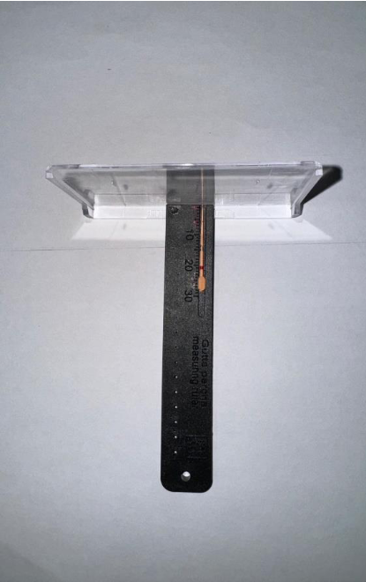

Figure 1: GP cone is measured with modified endo ruler

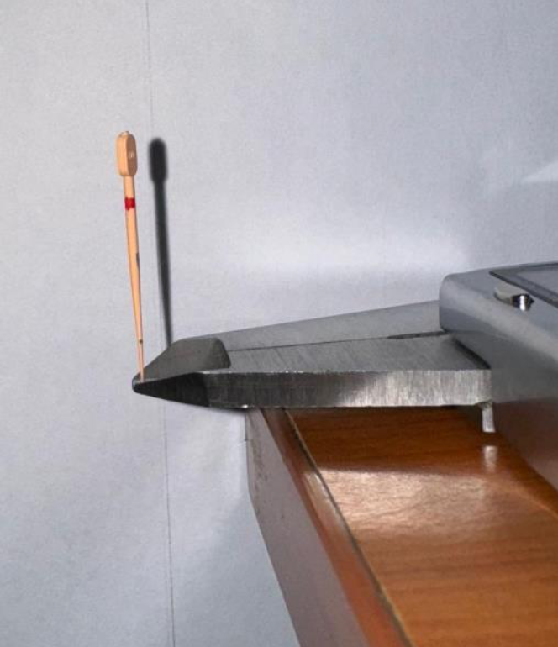

Figure 2: (Side view) D1 is measured at the tip of external jaws of digital calliper.

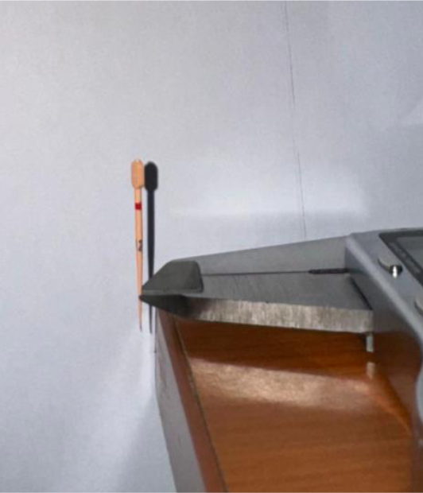

Figure 3: (Side view) D6 is measured at the tip of external jaws of digital calliper

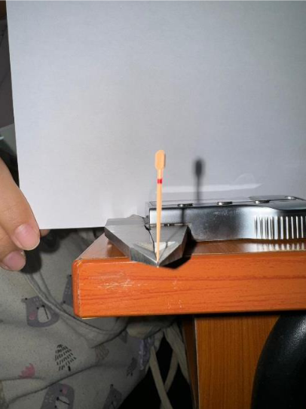

Figure 4: (Front Parallax view) D1 is measured at the tip of external jaws of digital calliper

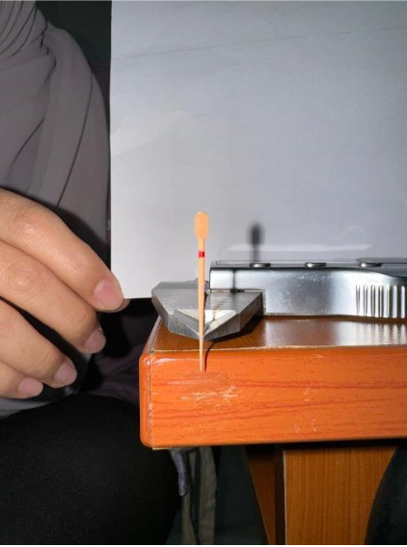

Figure 5: (Parallax) D6 is measured at the tip of external jaws of digital calliper.

3.4 **Results**:

Table 1: Analysis of the reliability of the measurements: Study error

|  |  |  |  |  |  |
| --- | --- | --- | --- | --- | --- |
| Comparison | n | Mean | SD | Comparison  (Paired T) | Comparison  (P-value) |
|  |  |  |  |  |  |
| D1 |  |  |  |  |  |
| First measurement | 10 | 0.276 | 0.0306 | 0.3938 | 0.2427 |
| Second measurement | 10 | 0.271 | 0.0265 |  |  |
| D6 |  |  |  |  |  |
| First measurement | 10 | 0.592 | 0.0338 | 0.2091 | 0.0763 |
| Second measurement | 10 | 0.600 | 0.0381 |  |  |
|  |  |  |  |  |  |

SD: Standard Deviation

Table 2a: Descriptive statistical analysis: Gutta-percha cone diameter (Group 1 – HTM X2 GP Cones for Protaper:NEXT)

|  |  |  |  |  |  |  |  |  |  |  |  |
| --- | --- | --- | --- | --- | --- | --- | --- | --- | --- | --- | --- |
| Measurement | Size | | n | | Minimum | | Maximum | | Mean | | SD |
|  |  |  | |  | |  | |  | |
| D1 | 25/0.06 | | 60 | | 0.28 | | 0.35 | | 0.3115 | | 0.0293 |
| D6 | 25/0.06 | | 60 | | 0.57 | | 0.67 | | 0.6216 | | 0.1327 |

Table 2b: Descriptive statistical analysis: Gutta-percha cone diameter (Group 2 – Densply Sirona Conform Fit for Protaper: NEXT)

|  |  |  |  |  |  |  |  |  |  |  |  |
| --- | --- | --- | --- | --- | --- | --- | --- | --- | --- | --- | --- |
| Measurement | Size | | n | | Minimum | | Maximum | | Mean | | SD |
|  |  |  | |  | |  | |  | |
| D1 | 25/0.06 | | 60 | | 0.27 | | 0.31 | | 0.3044 | | 0.0116 |
| D6 | 25/0.06 | | 60 | | 0.54 | | 0.58 | | 0.5568 | | 0.0098 |

Table 2c: Descriptive statistical analysis: Gutta-percha con e diameter (Group 3 – Densply Sirona Gutta percha Cones for Protaper: NEXT)

|  |  |  |  |  |  |  |  |  |  |  |  |
| --- | --- | --- | --- | --- | --- | --- | --- | --- | --- | --- | --- |
| Measurement | Size | | n | | Minimum | | Maximum | | Mean | | SD |
|  |  |  | |  | |  | |  | |
| D1 | 25/0.06 | | 30 | | 0.27 | | 0.30 | | 0.2873 | | 0.0122 |
| D6 | 25/0.06 | | 30 | | 0.56 | | 0.61 | | 0.5837 | | 0.0160 |

**3.5 Result summary:**

Analysis of the reliability of the measurements to measure study error was done. Paired T value for D1 across two (2) measurements from different operators is 0.3938. Paired T value for D6 across two (2) measurements from different operators is 0.2091.

The D1 mean value for Group 1 – HTM X2 GP Cones for Protaper:NEXT (n=60) is 0.3115 with standard deviation (SD) value of 0.0293. D1 mean value for Group 2 – Densply Sirona Conform Fit for Protaper: NEXT (n=60) is 0.3044 with standard deviation (SD) of 0.0116. D1 mean value for Group 3 – Densply Sirona Gutta percha Cones for Protaper: NEXT (n=30) is 0.2873 with standard deviation (SD) of 0.0122.

The ideal value of D1 on X2 GP cone in Protaper: NEXT system across manufacturers is: 0.31/0.06.

The D6 mean value for Group 1 – HTM X2 GP Cones for Protaper:NEXT is 0.6216 with standard deviation (SD) value of 0.0293. D6 mean value for Group 2 – Densply Sirona Conform Fit for Protaper: NEXT is 0.5568 with standard deviation (SD) of 0.0098. D6 mean value for Group 3 – Densply Sirona Gutta percha Cones for Protaper: NEXT is 0.5837 with standard deviation (SD) of 0.0160.

The ideal value of D6 on X2 GP cone in Protaper: NEXT system across manufacturers is: 0.63/0.07.

4.0 **Discussion**

Standardisation and uniformity of size and shape of the gutta percha are fundamentals factor for successful 3D obturation of root canal system. The gutta percha at D1 and D6 region were analysed because these points are responsible to seal the apical third of the prepared root canal, 1mm and 6mm short respectively from the working length. The lack of uniformity and standardisation of gutta percha especially at D1 region will ultimately lead to endodontic treatment failure. This is because improper apical seal of root canal and incomplete filling of the canal will contribute to voids and re-infection. Other than that, lack of standardisation of gutta percha will increase the use of sealer and time needed to fill the root canal space. Thus, assessment of standardisation of GP points from 3 different GP products were carried out. During the analysis of the results, we found that significant number of gutta percha cones at D1 and D6 point from Group 1, Group 2 and Group 3 did not correspond to the ISO standard (D1=0.31/0.06, D6=0.63/0.07). There are variations from the specified diameter, some were smaller and larger than the ISO standard. It can be concluded that at D1, group 1-HTM X2 GP cones for Protaper: Next has the closest mean value (0.3115) to ideal value of 0.31 followed by group 2-Dentsply Sirona Conform Fit for Protaper: Next with mean value of 0.3044 and group 3- Dentsply Sirona GP cones for Protaper: Next with mean value of 0.2873. At D6, group 1 has the closest mean value (0.6216) to ideal value of 0.63 followed by group 3 with mean value of 0.5837 and group 2 with mean value of 0.5568. This result is correlated with previous study conducted by EIAyouti et al. (2005) and Ingle et al. (2019) which have demonstrated variability in the tip diameters and tapers of gutta-percha cones from various commercial brands, despite being labels with the same ISO sizes. Furthermore, gutta percha from group 3 were found to have the smallest diameter at D1 region if compared to ISO standard. Thus, obturation of root canal using Dentsply Sirona GP cones for Protaper: Next GP cones would require generous amount of sealer to seal the gaps between the GP cones and prepared canal. The use of this sealer may contribute to microleakage over the time.

The statistical analysis showed that GP cones from Group 1 at D1 region and D6 region have less of uniformity and standardisation in size and dimension in comparison to Group 2 and Group 3. This signifies that individual GP cone may not be that accurate and shall be measured in diameter before material selection for obturation.

Noted that Group 3 has less sample size (n=30) than Group 1 and Group 2 (n=60) due to unavailability of the products in the market due to very least supply.

5.0 **Conclusion**

This study aimed to assess the standardization of commercially available gutta-percha (GP) cones across different brands, focusing on the diameter measurements at D1 and D6 points. Our findings reveal considerable variation in GP cone dimensions across brands, even when cones were labeled with similar nominal sizes. Specifically, HTM X2 GP Cones for Protaper: NEXT showed the closest alignment to ideal ISO standards at both D1 and D6 points, suggesting a higher degree of size consistency. In contrast, Dentsply Sirona Conform Fit and Gutta Percha Cones for Protaper: NEXT displayed greater variability, especially at the D1 point.

These discrepancies highlight the need for stricter standardization protocols among manufacturers to ensure uniform sizing and compatibility with root canal systems, potentially reducing the reliance on sealers and enhancing the sealing efficacy. The observed variability underscores the importance of more rigorous quality control measures in GP cone production, which could enhance clinical outcomes by providing a more reliable apical seal and reducing risks of post-treatment reinfection.

Ultimately, improving manufacturing standards and enforcing consistent ISO compliance in GP cone dimensions could play a vital role in advancing the success rates of endodontic procedures and enhancing patient safety.

**5.1 Future Research directions**

1. Exploration of Material Composition and Its Impact on Consistency: Future studies could investigate whether the material composition of gutta percha cones influences their diameter stability and how different compositions contribute to diameter variability.
2. Impact of Standardization on Clinical Outcomes: Further research could assess the clinical outcomes of standardized vs. non-standardized gutta percha cones in root canal treatments, focusing on patient outcomes, treatment success rates, and long-term sealing effectiveness.
3. Development of Enhanced Manufacturing Techniques: Research could focus on developing and evaluating advanced manufacturing techniques to reduce diameter variability, exploring innovations such as precision molding and automation.
4. Comparison of Cone Diameter Consistency Across International Markets: A comparative study could analyze gutta percha cones from various international markets to determine if standardization and consistency vary by region, examining how regional regulations impact product quality.
5. Evaluation of Alternative Endodontic Filling Materials: Exploring alternative filling materials that offer superior diameter consistency and sealing properties could broaden the scope of materials available for root canal treatments, potentially improving treatment reliability.
6. Longitudinal Analysis of Diameter Stability Post-Manufacture: Future studies might analyze how factors like storage conditions, temperature, and humidity impact the diameter stability of gutta percha cones over time, providing insights into optimal storage practices.
7. Development of Guidelines for Clinicians on Handling Diameter Variability: Research could develop practical guidelines or a classification system to help clinicians effectively manage diameter variability when choosing gutta percha cones for specific clinical cases.

Disclaimer (Artificial intelligence)

Option 1:

Author(s) hereby declare that NO generative AI technologies such as Large Language Models (ChatGPT, COPILOT, etc.) and text-to-image generators have been used during the writing or editing of this manuscript.

Option 2:

Author(s) hereby declare that generative AI technologies such as Large Language Models, etc. have been used during the writing or editing of manuscripts. This explanation will include the name, version, model, and source of the generative AI technology and as well as all input prompts provided to the generative AI technology

Details of the AI usage are given below:

1.

2.

3.

6.0 **References**

Gutta percha: What is it and when is it used: Colgate®. Gutta percha: What Is It And When Is It Used | Colgate®. (n.d.). Retrieved November 29, 2022, from https://www.colgate.com/en-us/oral-health/root-canals/gutta-percha-what-is-it-and-when-is-it-used

Bajaj, N., Monga, P., & Mahajan, P. (2019, September 23). Assessment of consistency in the dimension of gutta-percha cones of protaper next and WaveOne with their corresponding number files. European Journal of Dentistry. Retrieved November 29, 2022, from

<https://www.thieme-connect.com/products/ejournals/html/10.4103/ejd.ejd_167_16>

Kevin P. Cunningham, Mary P. Walker, James C. Kulild, John T. w, Variability of the Diameter and Taper of Size #30, 0.04 Gutta-Percha Cones, Journal of Endodontics, Volume 32, Issue 11, 2006, ISSN 0099-2399, https://doi.org/10.1016/j.joen.2006.06.007.

Moule AJ, Kellaway R, Clarkson R, Rowell J, Macfarlane R, Lewis D, Cameron T, Atkins D. Variability of master gutta-percha cones. Aust Endod J. 2002 Apr;28(1):38-43.

doi: 10.1111/j.1747-4477.2002.tb00365.x. PMID:12360680.

Vishwanath V, Rao HM. Gutta-percha in endodontics – A comprehensive review of material science. J Conserv Dent. 2019 May-Jun;22(3):216-222. doi: 10.4103/JCD.JCD_420_18. PMID: 31367101; PMCID:PMC6632621.

Goldberg F, Massone EJ, Pruskin E, Zmener O. SEM study of surface architecture of gutta-percha cones. Endod Dent Traumatol. 1991 Feb;7(1):15-8. doi: 10.1111/j.1600 9657.1991.tb00177.x. PMID: 1915121.

Low JF, Dom TNM, Baharin SA. Magnification in endodontics: A review of its application and acceptance among dental practitioners. Eur J Dent. 2018 Oct-Dec;12(4):610-616. doi: 10.4103/ejd.ejd_248_18. PMID: 30369811; PMCID: PMC6178675.

LI, Nathan Y. (Malibu, CA, US), WU, Daqing (Beijing,CN) 2015 Dental Root Canal Filling Material Cartridge Having Built-In Heating Mechanism For Softening The Material , United States LI NATHAN Y.,WU DAQING

Kunert GK, Melo TAF, Oliveira EPM, Barletta FB. Evaluation of the fit of standardized ProTaper gutta- percha cones using two caliper rulers. Rev Assoc Paul Cir Dent. 2008;62(4):309-13.

APPENDIX

ATTACHMENT A

