Original Research Article

PREVALANCE OF CARDIORENAL SYNDROME ASSOCIATED WITH DMVD IN DOGS

.
ABSTRACT

Aim: This study aims to determine the prevalence of cardiorenal syndrome (CRS) associated with degenerative mitral valve disease (DMVD) in dogs and to analyze its demographic distribution, including age, breed, and gender predisposition.
Study Design: A cross-sectional observational study.
Place and Duration of Study: Department of Veterinary Clinical Medicine, College of Veterinary Science (CVSc), Rajendranagar, PVNRTVU, Hyderabad, from March to August 2024.
Methodology: A total of 8,924 adult dogs were examined through clinical evaluations, diagnostic imaging, and hematobiochemical analyses. Dogs exhibiting clinical signs such as cough, exercise intolerance, dyspnea, polyuria, polydipsia, and vomiting were selected for further cardiac and renal evaluation. Diagnosis of cardiac disease was based on electrocardiography (ECG), radiography, and echocardiography. Dogs diagnosed with DMVD were further assessed for renal involvement using serum creatinine levels (SCr >1.4 mg/dL) to confirm CRS. Data on breed, age, and sex distribution were recorded and analyzed.
Results: Of the total examined dogs, 91 were diagnosed with cardiac disorders, with an incidence rate of 1.01%. DMVD was the most prevalent cardiac disorder (n=61, 67%), followed by dilated cardiomyopathy (n=23, 25.3%). Among DMVD cases, 27 dogs exhibited renal dysfunction, resulting in a CRS incidence rate of 44.3%. The majority of CRS-affected dogs were between 8-10 years (40.74%), followed by dogs aged 10 to 12 years accounted for 18.52% of cases and those over 12 years made up 11.11%. In comparison, younger dogs were diagnosed less frequently, with 7.41% being under six years old and 22.22% falling within the six to eight-year age range. There is a higher prevalence in males (70.3%). Breed predisposition analysis showed Pomeranians had the highest prevalence (40.74%), followed by Shih Tzus (22.22%) Pugs (11.11%), Lhasa Apsos and Labradors (10% each), Mongrels (7.41%), and Chihuahuas (3.7%).
Conclusion: The study highlights a significant prevalence of CRS in dogs with DMVD, particularly in geriatric and small-breed dogs. Early identification and targeted management strategies are essential to improving clinical outcomes. Further studies are required to explore the pathophysiology and optimize therapeutic interventions for CRS in dogs.

Keywords: Cardiorenal Syndrome, Degenerative Mitral Valve Disease, Chronic Kidney Disease, Echocardiography, Azotemia, Prevalence Study

1. INTRODUCTION

Cardiorenal syndrome (CRS) is a complex disorder characterized by the intricate interrelationship between cardiac and renal dysfunction. The bidirectional nature of this syndrome means that primary dysfunction in either the heart or the kidneys can induce and perpetuate injury in the other organ, leading to progressive systemic deterioration (Ronco et al., 2008).
Recent studies suggest that organ failure in CRS is driven by multiple interrelated mechanisms, including hemodynamic changes, neurohormonal activation, and inflammatory pathways. Feedback loops between the cardiovascular and renal systems exacerbate disease progression through biochemical, immunological, and hemodynamic alterations (Bock & Gottlieb, 2010b). According to Pouchelon et al. (2015), cardiorenal vascular disorders (CvRD) can be defined as structural or functional damage to the kidneys and/or cardiovascular system due to disease, toxins, or pharmacological agents, which disrupts normal physiological interactions between these systems, ultimately worsening the function of one or both organs. Among the various etiologies of CRS, one of the most frequently observed manifestations is renal impairment secondary to heart failure (Lopes, 2016).
The primary pathophysiological mechanisms underlying CRS involve hemodynamic alterations such as decreased renal perfusion pressure, elevated central venous pressure, and the activation of various neurohormonal systems (Liang et al., 2006). Notably, the renin-angiotensin-aldosterone system (RAAS) plays a pivotal role in the progression of CRS. Chronic heart failure (CHF) and chronic kidney disease (CKD) both contribute to RAAS activation, leading to endothelial dysfunction, suppression of fibrinolysis, and acceleration of atherosclerosis. Furthermore, angiotensin II induces vasoconstriction and promotes aldosterone secretion, resulting in increased sodium and water retention, which exacerbates damage to both the heart and kidneys (Brewster & Perazella, 2004).
To provide a structured approach in clinical practice, CRS has been categorized into five subtypes, based on whether the primary disease originates in the heart or kidneys, the acute or chronic nature of the condition, and the presence of systemic diseases that concurrently affect both organs (Ronco et al., 2008).
In veterinary medicine, managing CRS in dogs presents a significant clinical challenge, requiring a careful balance between treating cardiac conditions, such as CHF, and preserving renal function, particularly in cases of CKD (Lopes, 2016). A comprehensive approach that considers hemodynamic stability, neurohormonal modulation, and individualized therapeutic strategies is essential to improving outcomes in affected patients.
The aim of this study is to find out the prevalence of cardio renal syndrome in dogs.

2. methodology
This study was conducted in the Department of Veterinary Clinical Medicine, College of Veterinary Science (CVSc), Rajendranagar, PVNRTVU, Hyderabad, during the period from March to August 2024. Dogs included in the study were diagnosed with cardiac disease through physical and clinical examination along with echocardiographic, electrocardiographic, radiographic as well as hematologic evaluation. Historical data were recorded for all dogs including dog breed, age, sex, body weight as well as associated clinical signs. Dogs with clinical signs like cough, exercise intolerance, dyspnea and polyuria, polydypsia and vomiting were selected for further cardiac and renal evaluation. ECG was recorded using the standard bipolar and augmented unipolar limb leads at 25 mm/s speed and interpreted as described by Tilley (1992) using BPL Cardiart 9108-D, a single channel, 12 lead ECG machine. Based on the results of physical examination and ECG findings (the dogs with cardiac disorders were subjected to right lateral and ventrodorsal thoracic exposure using 500mA X-ray machine (Seimens ergophos, India) and the radiographs were analyzed for abnormality. Transthoracic echocardiograms were obtained in right lateral recumbency by using 1-5 MHz sector probe on Esaote Mylab X7 Ultrasound machine to diagnose DMVD. Dogs with elevated Serum creatinine (SCr > 1.4mg/dl) were diagnosed with renal failure. Dogs without clinical signs of cardiac disease or renal disease, those with acute illnesses or unrelated chronic conditions, and those with incomplete medical records were excluded.

3. results and discussion

During the study conducted from March to August 2024 at the Medicine OP of the Veterinary Clinical Complex (VCC), College of Veterinary Science (CVSc), Rajendranagar, PVNRTVU, Hyderabad, a total of 8,924 adult dogs were examined. Clinical evaluations, including physical assessments, diagnostic imaging, and hematobiochemical analyses, led to the identification of cardiac disorders in 91 dogs, resulting in an overall incidence rate of 1.01%. Among the diagnosed cases, Degenerative Mitral Valve Disease (DMVD) was the most prevalent, affecting 61 dogs, followed by Dilated Cardiomyopathy (DCM) in 23 cases. Additionally, four dogs were diagnosed with pericardial effusion, while isolated cases of an atrial septal defect, a pericardial tumor, and a right ventricular clot were identified (Table 1). Notably, 27 of the 61 DMVD-affected dogs also diagnosed for a renal disease, resulting in a Cardiorenal Syndrome (CRS) incidence rate of 44.3% within DMVD cases (Table 2). The presence of azotemia in dogs with mitral valve disease has been documented in previous studies, with reported incidence rates ranging from 50-70% (Nicolle et al., 2007). Similarly, Ohad et al. (2010) found that 24.1% of 223 dogs diagnosed with heart disease exhibited azotemia, suggesting compromised kidney function.
The study highlighted a higher prevalence of DMVD among geriatric dogs. Specifically, the majority of affected dogs were between 8 and 11 years old (40.74%), followed by those aged 10 to 12 years (18.52%) and those over 12 years (11.11%). In contrast, younger dogs were less frequently diagnosed, with 7.41% under six years old and 22.22% between six and eight years old (Table 3). These findings align with previous studies, such as those conducted by Yun et al. (2023) and Jung et al. (2018), which also identified an average age of 11.5 years in affected dogs. The increased susceptibility of older dogs to DMVD can be attributed to age-related physiological changes, including diminished renal perfusion, nephron loss, and impaired renal resorption processes, as suggested by Grauer (2005) and Kralova et al., (2010).
Breed predisposition analysis revealed that Pomeranians exhibited the highest prevalence (40.74%), followed by Shih Tzus (22.22%), Pugs (11.11%), Lhasa Apsos and Labradors (10% each), Mongrels (7.41%), and Chihuahuas (3.7%) (Table 4). Studies by Borgarelli et al. (2004), Haggstrom et al. (2004) and Keene et al., (2019) have noted a predisposition for mitral valve disease in small breed dogs. Furthermore, gender-based analysis of CRS in DMVD-affected dogs indicated a higher occurrence in males (70.3%) compared to females (29.6%). Similar findings were reported in a study conducted on humans with CRS by Shah et al. (2016) who reported 66.6 % incidence in males.
The findings of this study reinforce the increasing presence of cardiorenal syndrome in dogs, emphasizing the need for early detection and targeted management strategies in geriatric canine patients.

Table 1: Incidence of various Cardiac disorders in dogs
S.No | Disease | No. of Cases (n=91) | Percentage (%)
1 | Degenerative Mitral Valve Disease | 61 | 67
2 | Dilated Cardiomyopathy | 23 | 25.3
3 | Pericardial effusion | 4 | 4.4
4 | Atrial septal defect | 1 | 1.1
5 | Pericardial tumour | 1 | 1.1
6 | Clot in Right ventricle | 1 | 1.1
7 | Total | 91 | 100

Table 2: Incidence of CRS associated with DMVD in dogs (n=61)
Total no.of  dogs  evaluated | Cardiac disorders  (n=2200) |  | DMVD among cardiac disorders (n=91) |  | CRS with DMVD  (n=61)
 | Number | Percentage | Number | Percentage | Number | Percentage
8924 | 91 | 1.01 | 61 | 67 | 27 | 44.3

Table 3: Age wise incidence of CRS associated with DMVD in dogs (n=27)
Sl no | Age | Number (n=27) | Percentage
1 | < 6 years | 2 | 7.41
2 | 6-8 years | 6 | 22.22
3 | 8-10 years | 11 | 40.74
4 | 10-12 years | 5 | 18.52
5 | >12 years | 3 | 11.11

Table 4: Breed wise incidence in CRS dogs with DMVD(n=27)
Sl no | Breed | Number (n=27) | Percentage (%)
1 | Pomeranian | 11 | 40.74
2 | Shih tzu | 6 | 22.22
3 | Pug | 3 | 11.11
4 | Labrador | 2 | 7.41
5 | Lhasa Apso | 2 | 7.41
6 | Mongrel | 2 | 7.41
7 | Chihuahua | 1 | 3.7
8 | Total | 27 | 100

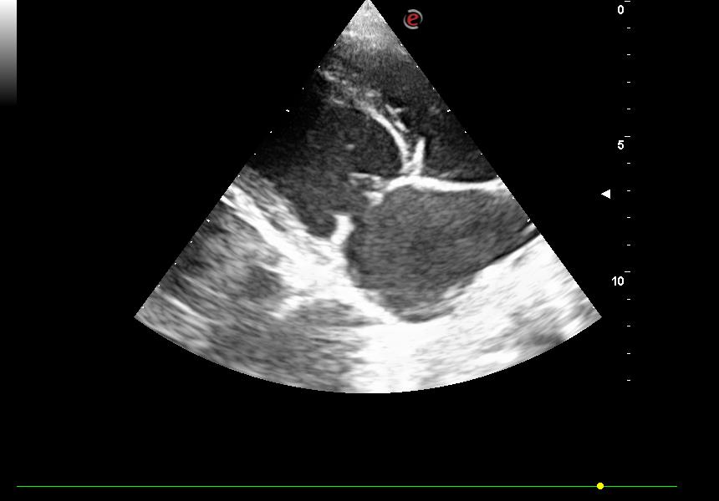 | 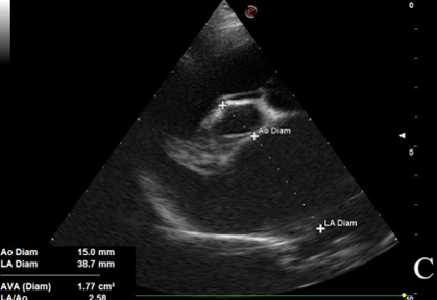
Fig 1: Right parasternal long axis view showing gross dilatation of left heart with degeneration of mitral valves | Fig 2: 2D echocardiograph in right parasternal short axis view showing increased LA/Ao ratio (2.58)
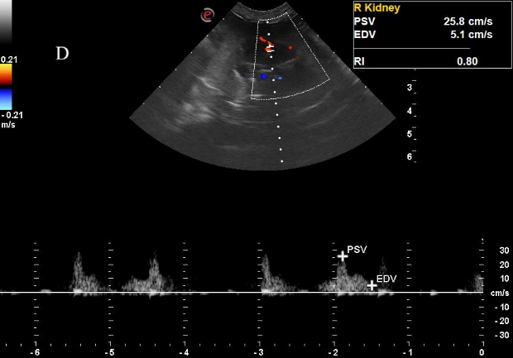 | 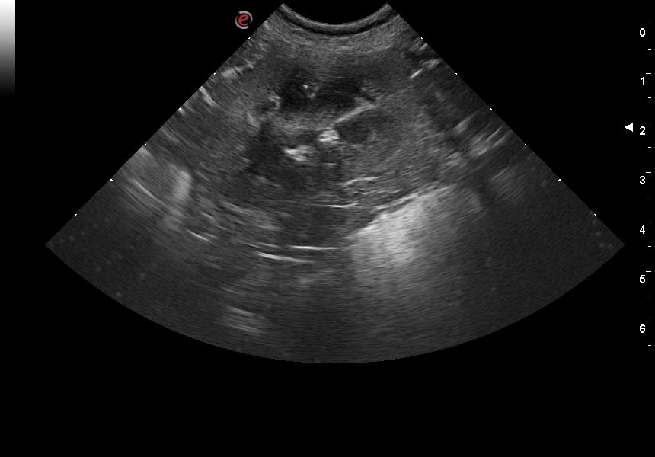
Fig 3: Ultrasonograph of kidney in CRS dogs; showing increased renal resistive index (0.80) | Fig 4: Ultrasonograph showing shrunken kidney with mineral deposits with anechoeic shadow in renal pelvis

4. Conclusion

This study highlights the significant prevalence of Cardiorenal Syndrome (CRS) in dogs affected by Degenerative Mitral Valve Disease (DMVD), with 44.3% of DMVD cases showing concurrent renal dysfunction. The findings emphasize that geriatric dogs, particularly small breeds like Pomeranians and Shih Tzus, are at a higher risk, with males being more commonly affected. Given the progressive nature of CRS, early diagnosis and a balanced therapeutic approach focusing on both cardiac and renal health are crucial. Regular monitoring, timely intervention, and individualized treatment strategies can help improve the quality of life and clinical outcomes in affected dogs.

Consent and Ethical approval
It is not applicable.

COMPETING INTERESTS DISCLAIMER:
Authors have declared that they have no known competing financial interests or non-financial interests or personal relationships that could have appeared to influence the work reported in this paper.

References

- Ronco, C., Haapio, M., House, A. A., Anavekar, N., & Bellomo, R. (2008). Cardiorenal syndrome. Journal of the American College of Cardiology, 52(19), 1527–1539.
- Bock, J. S., & Gottlieb, S. S. (2010). Cardiorenal syndrome: New perspectives. Circulation, 121(21), 2592–2600.
- Pouchelon, J. L., Atkins, C. E., Bussadori, C., Oyama, M. A., Vaden, S. L., Bonagura, J. D., & Van Israël, N. (2015). Cardiovascular–renal axis disorders in the domestic dog and cat: A veterinary consensus statement. Journal of Small Animal Practice, 56(9), 537–552.
- Lopes, S. C. C. (2016). Cardiorenal syndrome: Therapeutical challenge [Doctoral dissertation].
- Liang, K. V., Williams, A. W., Greene, E. L., & Redfield, M. M. (2006). Cardiorenal syndrome in acute decompensated heart failure. Clinical Journal of the American Society of Nephrology, 1(Suppl 2), 2013–2026.
- Brewster, U. C., & Perazella, M. A. (2004). The renin-angiotensin-aldosterone system and the kidney: Effects on kidney disease. American Journal of Medicine, 116(4), 263–272.
- Tilley, L. P. (1992). Essentials of Canine and Feline Electrocardiography (3rd ed.). Lea and Febiger, Philadelphia.
- Nicolle, A. P., Chetboul, V., Allerheiligen, T., Pouchelon, J. L., Gouni, V., & Tessier‐Vetzel, D. (2007). Azotemia and glomerular filtration rate in dogs with chronic valvular disease. Journal of Veterinary Internal Medicine, 21(5), 943–949.
- Ohad, D. G., Berkowitz, J., & Bdolah-Abram, R. (2010). The prevalence and effects of canine cardio-renal-anemia syndrome. Proceedings of the 2010 ACVIM Forum, Anaheim, CA.
- Yun, H., Koo, Y., Yun, T., Chae, Y., Lee, D., & Cha, S. (2023). Evaluation of progression of chronic kidney disease in dogs with myxomatous mitral valve disease. Frontiers in Veterinary Science, 10, 1200653.
- Jung, H. B., Kang, M. H., & Park, H. M. (2018). Evaluation of serum neutrophil gelatinase-associated lipocalin as a novel biomarker of cardiorenal syndrome in dogs. Journal of Veterinary Diagnostic Investigation, 30(3), 386–391.
- Grauer, G. F. (2005). Early detection of renal damage and disease in dogs and cats. Veterinary Clinics: Small Animal Practice, 35(3), 581–596.
- Kralova, S., Leva, L., & Toman, M. (2010). Polymorphonuclear function in naturally occurring renal failure in dogs. Veterinární Medicína, 54(5), 236–243.
- Borgarelli, M., Zini, E., D’Agnolo, G., Tarducci, A., Santilli, R. A., Chiavegato, D., Tursi, M., Prunotto, M., & Haggstrom, J. (2004). Comparison of primary mitral valve disease in German Shepherd dogs and in small breeds. Journal of Veterinary Cardiology, 6, 27–34.
- Haggstrom, J., Pedersen, H. D., & Kvart, C. (2004). New insights into degenerative mitral valve disease in dogs. Veterinary Clinics of North America: Small Animal Practice, 34, 1209–1226
- Keene BW, Atkins CE, Bonagura JD, Fox PR, Häggström J, Fuentes VL, Oyama MA, Rush JE, Stepien R, Uechi M. ACVIM consensus guidelines for the diagnosis and treatment of myxomatous mitral valve disease in dogs. Journal of veterinary internal medicine. 2019 May;33(3):1127-40.

- Shah H R, Singh N P, Aggarwal N P, Singhania D and Kumar A. 2016. Cardiorenal syndrome: Clinical outcome study. Journal of the Association of Physicians of India 64(12): 41–6.

