***Case report***

**A Case Report on Multimodal Imaging in Diagnosing True or False Ventricular Aneurysm**

# Abstract

**Background:** True and false left ventricular (LV) aneurysms are two rare and severe complications of acute myocardial infarction (AMI). While differentiating between these entities is challenging, early treatment is crucial to guide surgery and prevent life-threatening complications.

**Case presentation**: Here, two cases illustrating these two entities have been presented.

-**First case**: A 64-year-old patient, with high cardiovascular risk, was admitted for worsening dyspnea (NYHA class II). Physical examination revealed signs of left heart failure with pulmonary edema and mild mitral regurgitation. The electrocardiogram (ECG) showed lateral necrosis, and transthoracic echocardiography (TTE) revealed a true aneurysm of the LV lateral wall, mild mitral regurgitation, and severe LV dysfunction (left ventricular ejection fraction [LVEF] 25%). Cardiac magnetic resonance imaging (MRI) confirmed the diagnosis with transmural enhancement and severe LV dysfunction. Coronary angiography revealed triple-vessel disease. After stabilization with anti-ischemic and heart failure medications, the patient underwent triple coronary artery bypass grafting (CABG) with favorable outcomes.

_**Second case**: A 58-year-old male patient, with a medical history of diabetes and dyslipidemia, presented with brief chest pain at rest for the past two weeks. Physical examination was unremarkable, and an ECG showed an incomplete bundle branch block with negative Sgarbossa criteria. TTE revealed a false aneurysm in the LV lateral wall, confirmed by cardiac MRI, along with non-viability in the right coronary artery territory. Coronary angiography indicated triple-vessel disease that required surgical intervention; however, the patient remained asymptomatic after refusing surgery and was discharged on optimal medical therapy.

**Conclusion**: These two cases highlight the diagnostic challenge between true and false LV aneurysms. Multimodal imaging plays a critical role in ensuring accurate diagnosis and hence, guiding optimal management. Cardiac MRI with its advanced sequences can characterize these outpouchings very well, thus helping clinicians to better understand their natural history and to guide proper management decisions with accurate diagnosis.

Keywords: left ventricle, cardiac magnetic resonance, true and false aneurysms, left ventricle pseudoaneurysm, acute myocardial infarction

# Introduction

Myocardial infarction can lead to both true and false heart aneurysms. True aneurysms are caused by the ventricular wall following transmural infarction gradually thinning. On the other hand, false aneurysms develop after hemorrhagic dissection into a transmural infarction, leading to a free intrapericardial rupture of the heart, cardiac tamponade, and death. However, on occasion the rupture is halted by locally adhering pericardium, leading to a false aneurysm and a cavity connecting with the LV cavity through the point of rupture.

From a therapeutic point of view, it is important to differentiate between true and [false aneurysms](https://www.sciencedirect.com/topics/medicine-and-dentistry/pseudoaneurysm) (or pseudoaneurysms). In the former, due to chronic outpouching of the LV wall, the aneurysmal wall consists of discernable myocardial layers. This dyskinetic and fibrotic area is generally resistant to rupture, with a 5-year survival of 71% when conservatively treated. In the latter, a contained rupture of the [myocardium](https://www.sciencedirect.com/topics/medicine-and-dentistry/myocardium) underlies pseudoaneurysm formation, with only a thin pericardial layer covering the leak, which is vulnerable to sudden expansion and rupture with high mortality [15].

As seen in this instance, Cardiac Magnetic resonance (CMR) has evolved into becoming a valuable technique in the 3D characterization of LV aneurysms and could eventually be able to tell the difference between true and false aneurysms. Two separate LV aneurysm cases, one true and one false, are shown, illustrating the value of CMR as a diagnostic and prognostic tool.

# Case Presentation

First Case report:

A sixty-four-year-old active smoker who is not diabetic, has well-controlled hypertension, dyslipidemia and no family history of coronary artery disease and complains of dyspnea for two months was admitted to the intensive care unit with symptoms of acute heart failure.

He had stable vital signs upon examination (BP 130/80 millimeters of mercury, HR 86, SaO2 92%, accompanied with bibasilar crackles, stethacoustic semiology in favor of mitral regurgitation. Troponin I (cTnI) levels in the blood were normal 17pg/ml, but N-terminal-prob-type natriuretic peptide (NT pro-BNP) levels were increased 16000 pg/ml.

The electrocardiogram results are shown in *(figure1)* which includes sinus rhythm, right axis deviation, right bundle branch block with a Q wave in lateral leads.

The Transthoracic echocardiography found a dilated left ventricle with a massive lateral aneurysm that entered the left ventricle through a neck that measured 20 mm in width, along with mild mitral regurgitation and a contraction abnormality in the following segments, and the pulmonary systolic pressure assessed from the tricuspid regurgitation jet was 60 mmHg.

A second evaluation was performed using cardiac magnetic resonance (CMR) which confirmed a massive lateral left wall LV aneurysm *(figure 2,3)* and Late enhancement sequences showing transmural late enhancement in the lateral area, indicating the absence of viability *(figure 4)*.

After being hospitalized in the coronary care unit, the patient received statins, antiplatelet medication, and intravenous diuretics as part of their initial treatment. A triple vessel lesion was identified via coronary angiography.

The patient successfully underwent left ventriculoplasty along with coronary artery bypass grafting (CABG).

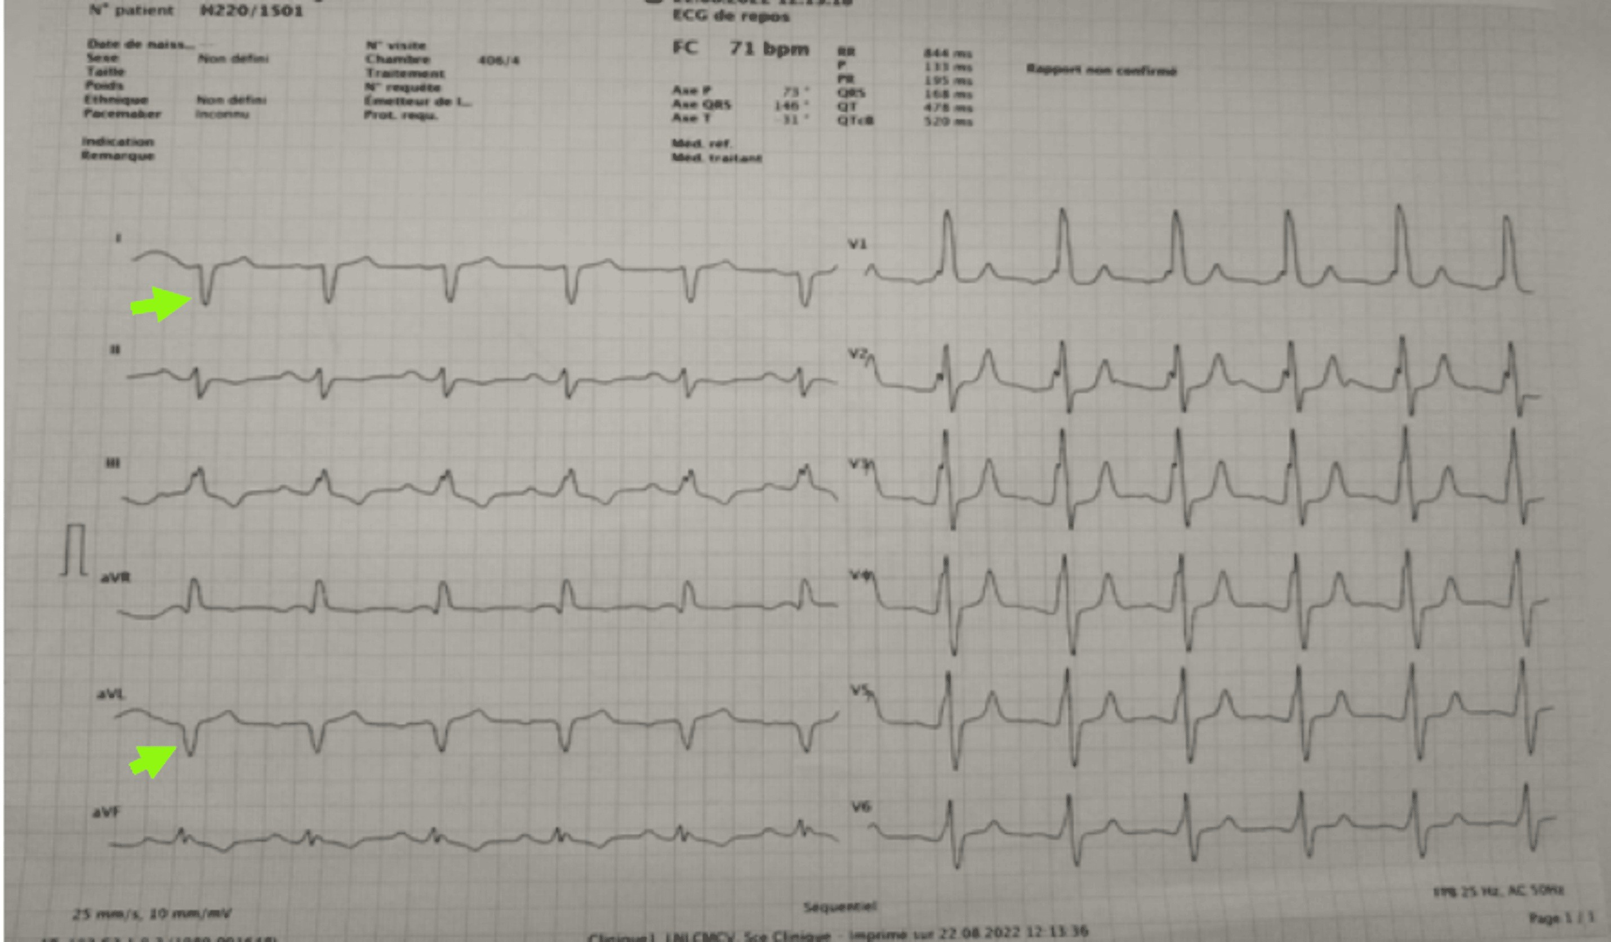

**FIGURE 1: electrocardiogram shown right bundle branch block with circumferentially fragmented QRS, and Q wave in lateral leads.**

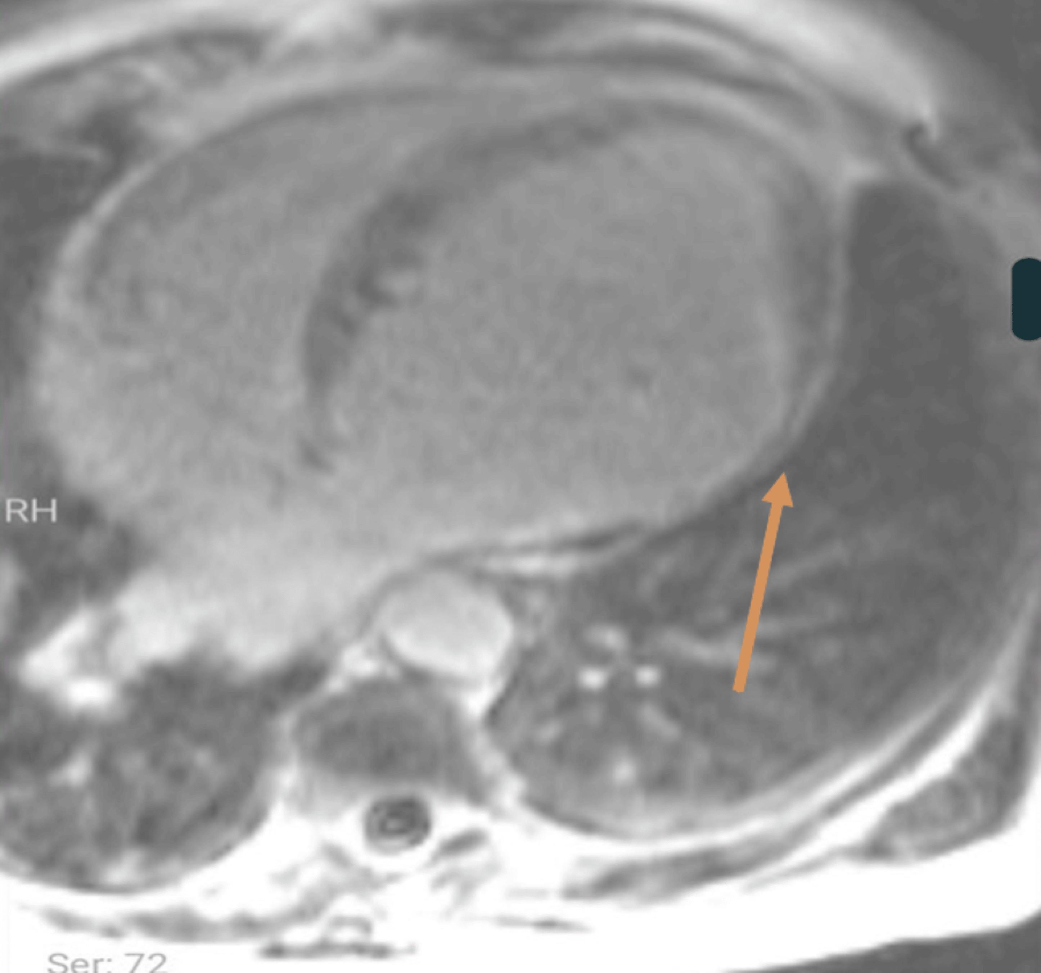

**FIGURE 2: Cardiac magnetic resonance Late enhancement sequences showing transmural late enhancement in the lateral area, indicating the absence of viability**

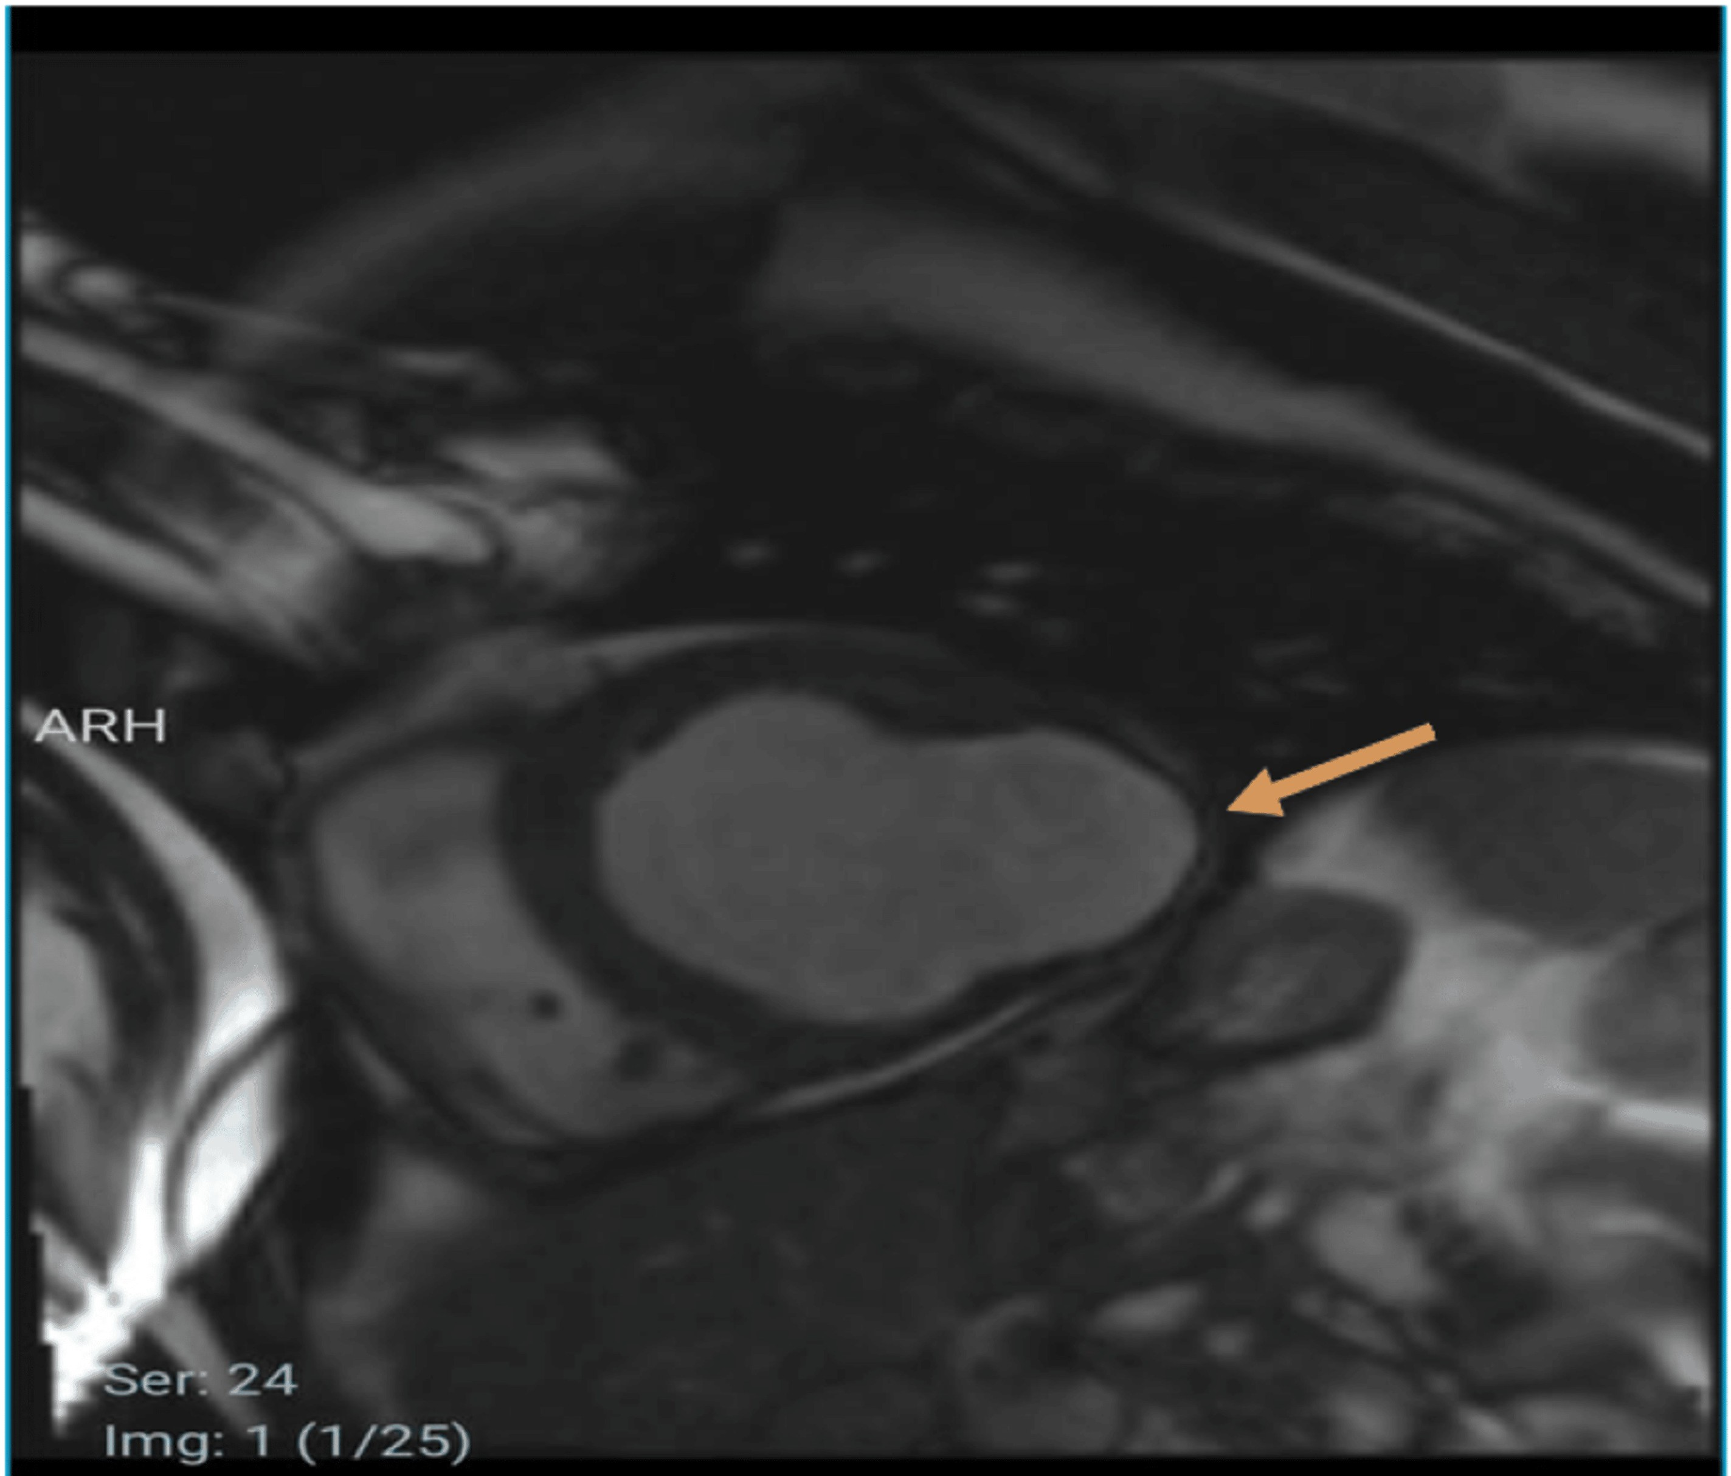

**FIGURE 3: Cardiac magnetic resonance showing the cine SSFP sequence in the short axis revealing the lateral aneurysm.**

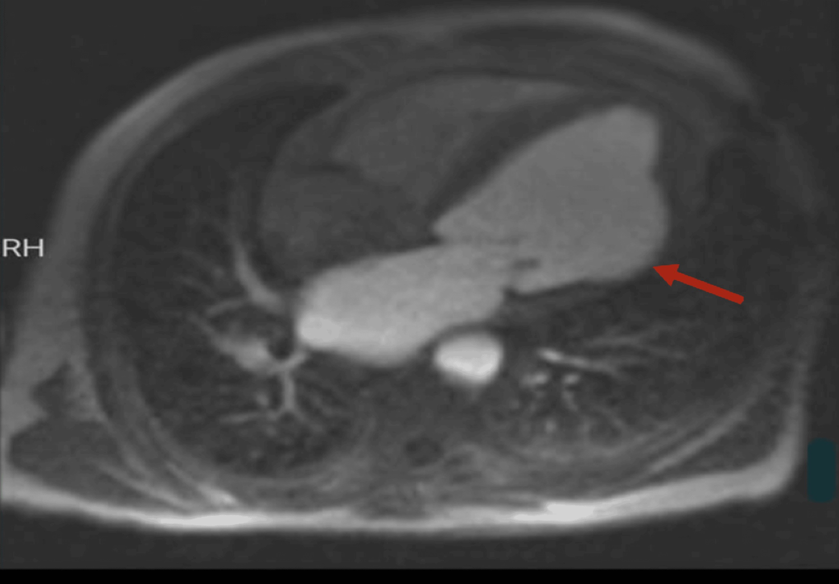

**FIGURE 4: Cardiac magnetic resonance Perfusion sequence showing a perfusion defect in the basal and mid-lateral segments indicative of a recent lateral myocardial infarction.**

Second case report:

A fifty-eight-year-old male patient with risk factors including diabetes under oral medication and dyslipidemia under statin, with no notable medical history, consults for chest pain occurring at rest of brief duration dating from two weeks without recurrences, but physical examination is unremarkable and electrocardiogram records incomplete left branch block with negative scarbosa criteria.

An incidental finding on echocardiography revealed a false aneurysm of the lateral wall of the left ventricle, confirmed by cardiac magnetic resonance, with absence of viability in the territory of the right coronary artery*(figure5.6).* Coronary angiography demonstrated a triple vessel lesion requiring surgical treatment; however, the patient remained asymptomatic up to this day after refusing surgery and was discharged on optimal medical treatment

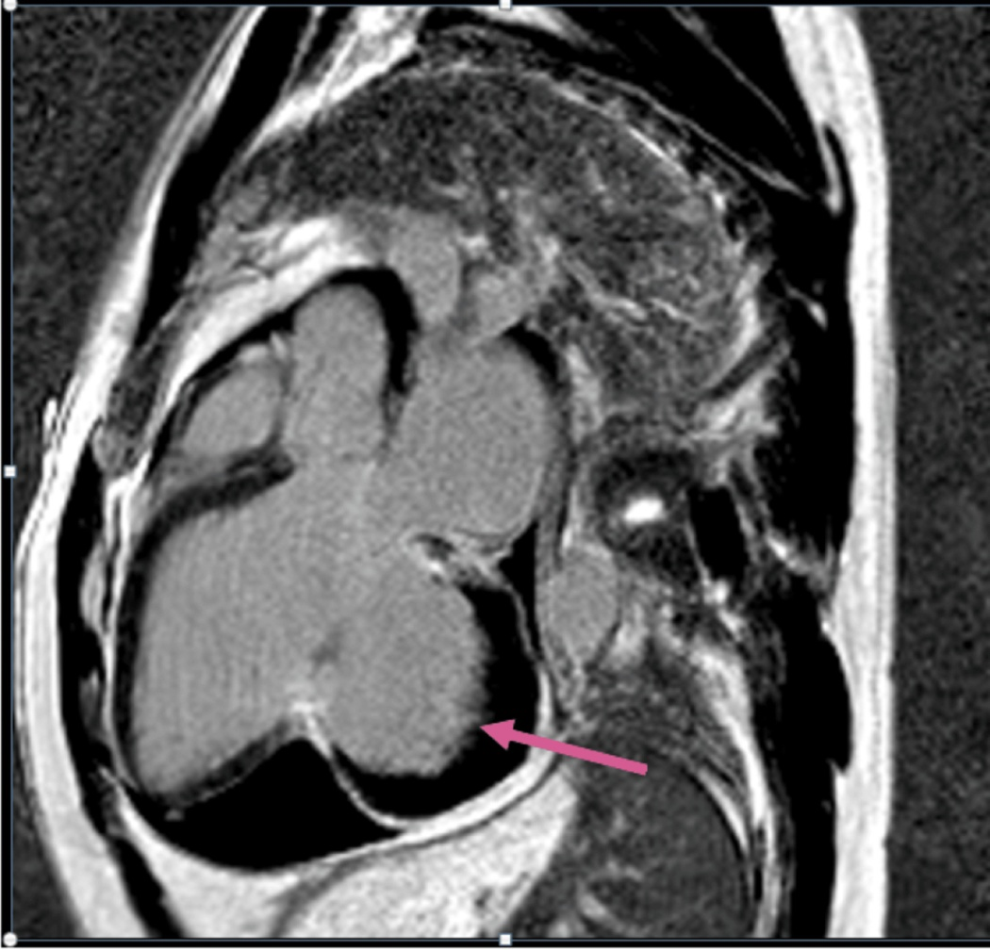

**FIGURE 5: Cardiac magnetic resonance Late enhancement sequence PSIR three cavities long axis targeting the fissuring of the free wall of the LV in a partitioned pericardium with transmural enhancement indicating the absence of viability in the territory of the right coronary artery.**

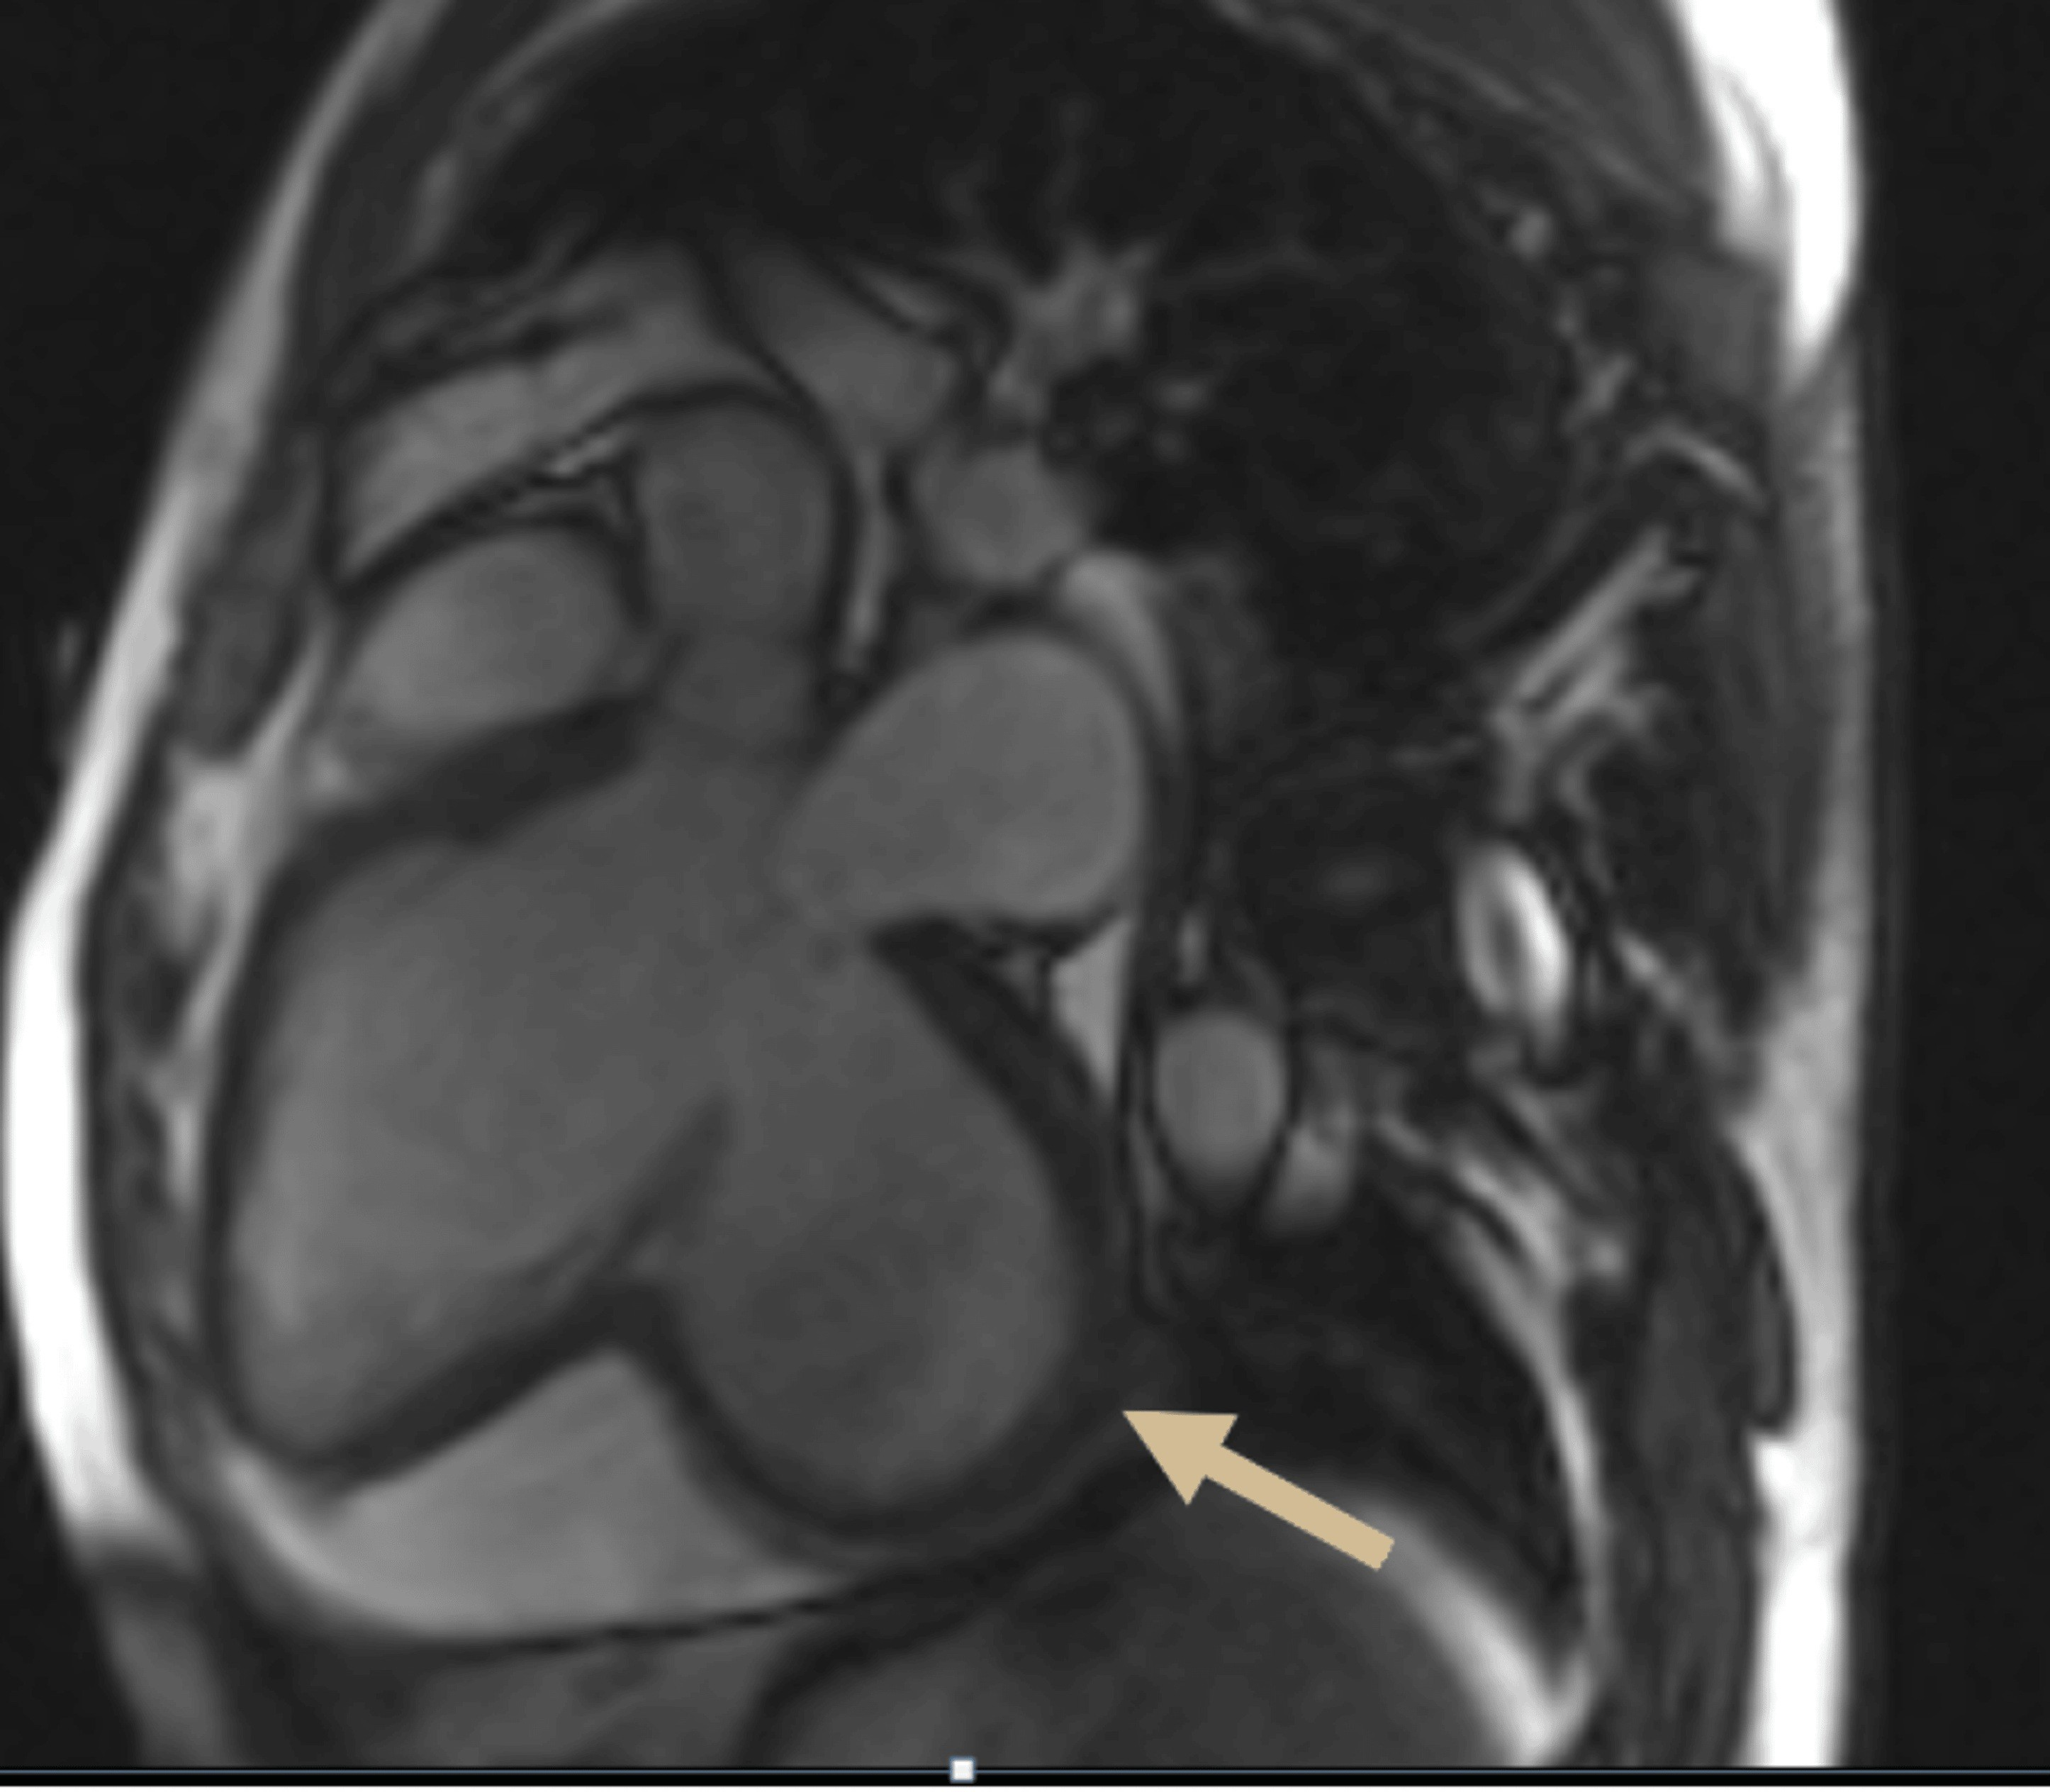

**FIGURE6: Cardiac magnetic resonance with cine SSFP sequence Three cavities long axis showing an aneurysmal sac connected to the inferior wall of the left ventricle by a relatively narrow neck."**

# Discussion

True and false left ventricular aneurysm are both potential complications following a myocardial infarction (MI).

A pseudo aneurysm is defined as a rupture of the ventricular free-wall that is contained by adherent pericardium or scar tissue [1].

It is typically a rare complication of myocardial infarction, occurring in less than 0.1% of all myocardial infarction, and usually develops within 2 months. However, it can also rise following cardiac surgery, chest trauma, or endocarditis [2]. Mandatory ECG must be ensured in patients who come in with minimal chest discomfort in the emergency department to avoid cardiac hazards [16].

A true aneurysm corresponds to a scarred area in the form of a pocket with thin walls communicating with the rest of the LV via a wide neck that has lost its contractile function as a result of transmural necrosis; This is not an extension of myocardial infarction (MI), but rather a change in the form of the necrotic wall. Its incidence significantly decreased following the emergence of coronary reperfusion. It rose from 38% to 15% in, or 8.5% of MI [3].

From a clinical and imaging perspective, it is still difficult to distinguish between these two entities. Due to the commonality of nonspecific symptoms including dyspnea (15%), chest pain (13%), arrhythmias/syncope (10%), and systemic embolism (6%), it is hard to differentiate between them on the basis of clinical findings alone. Furthermore, 10% of cases may be asymptomatic and unintentionally identified by different imaging techniques with chronic evolution, as our case, which was discovered by TTE [3], However, it can also present as cardiac tamponade or rupture leading to sudden cardiac arrest (30%-45%) [4,5].

TTE and CMR are two approaches that are essential for imaging-based diagnosis. TTE plays a major role before, during, and following surgery. The detection or absence of continuity in the myocardium is the most important and difficult finding in echocardiography prior to surgery, aside from standard controls (aortic valve, mitral valve regurgitation, ventricle volumes, atrial volumes, thrombus.

In our patient, the three key echocardiographic features most indicative of a pseudoaneurysm were the saccular shape of the aneurysm, a narrow opening relative to the aneurysm's fundus diameter, and a sharp discontinuity of the endocardial border at the base of the pseudoaneurysm. These same characteristics were also observed in another study using Transthoracic Echocardiography to diagnose pseudoaneurysms. When comparing true aneurysms to pseudoaneurysms, the ratio of the aneurysm's maximum internal neck width (Omax) to its largest parallel internal diameter (Dmax) was 0.5 in pseudoaneurysms, whereas in true aneurysms, the ratio ranged from 0.9 to 1.0 [6]. However, a later study showed that this criterion had suboptimal specificity.

Color flow Doppler has been used to detect turbulent flow through the neck of the pseudoaneurysm. However, the absence of such flow does not confirm the presence of the aneurysm, making this technique specific but not sensitive [7].

Cardiac Magnetic Resonance (CMR) has emerged as a promising non-invasive method for distinguishing between left ventricular pseudoaneurysms and true aneurysms, identifying the location of the aneurysm, and differentiating the pericardium, thrombus, and myocardium within the aneurysm wall.

The presence of epicardial fat next to ananeurysm cavity on magnetic resonance imaging almost completely rules out the possibility of a pseudoaneurysm [1].

On cardiac magnetic resonance, a true aneurysm can be recognized by its broad neck and a smooth transition from normal to thinner myocardium. The ratio of the largest orifice diameter to the maximum internal cavity diameter in true aneurysms is between 0.9 and 1.0.

Delayed enhancement imaging may reveal myocardial tissue in the aneurysm wall, which suggests a true aneurysm, along with a possible infarct. In contrast, the sac of a pseudoaneurysm lacks Myocardium, preventing it from enhancing [8].

This makes the delayed enhancement of the adjacent pericardium a useful indicator for distinguishing between true and false aneurysms [9].

In a study of 22 cases, only 14% of patients with true aneurysms showed delayed pericardial enhancement, while none of the patients with pseudoaneurysms exhibited this finding. It is believed that this enhancement occurs due to chemical irritation of the pericardium by blood released during the acute phase of myocardial rupture, triggering an inflammatory response and the formation of new blood vessels in the pericardium.

Although 85% of true left ventricular aneurysms are found in the apical and anteroseptal walls, the occurrence of aneurysms in the inferior-posterior or lateral walls is rare, around 5% to 10%, similar to our first case. In contrast, false aneurysms are more likely to affect the posterior or diaphragmatic surface rather than the apical or lateral walls, as seen in our case [10].

Although some studies report acceptable survival rates in patients with left ventricular aneurysms [11,12].

The management of LV aneurysms includes medical and surgical. Small or medium, or large LV aneurysms with no symptoms can be safely monitored with an expected five-year survival of up to 90%. The medical management can include optimization of coronary artery disease risk factors for ischemia prevention, afterload reduction with angiotensin-converting enzyme inhibitors or angiotensin receptor blockers, and anticoagulation to prevent thromboembolism. In case of surgical treatment, all patients considered for surgery must undergo right and left cardiac catheterization with coronary arteriography and left ventriculography. An echocardiographic assessment of the mitral valve should be done with +2 mitral regurgitation with cardiac catheterization and should be evaluated for intrinsic valve disease not amenable to annuloplasty. The left ventricular aneurysmal repair constitutes aneurysmectomy, aneurysmorrhaphy, and ventricular restoration that requires cardiopulmonary bypass and a balanced anesthetic technique. The ultimate size of the left ventricular cavity at the end of the procedure is critical to patient outcomes [17].

Surgery is highly recommended when feasible, as these aneurysms carry a substantial risk of rupture (30- 45%) and immediate mortality from tamponade [12,13].

This was true for our patient, who did not undergo surgery and survived for two years after the diagnosis. In contrast, true left ventricular aneurysms rarely rupture and are often managed with medication. Surgical aneurysmectomy (or"endoaneurysmorrhaphy") for true aneurysms is recommended only in cases of refractory congestive heart failure or ventricular arrhythmias [14].

# Conclusions

Differentiating between true and pseudo left ventricular aneurysms can be diagnostically challenging. Both types can cause symptoms such as chest pain, shortness of breath, and syncope, but they are often discovered incidentally during cardiac imaging conducted for other reasons. When a left ventricle aneurysm is detected, it is crucial to accurately distinguish between a pseudoaneurysm and a true aneurysm due to their different natural histories and treatment approaches. Echocardiography and contrast-enhanced cardiac MRI all provide useful and complementary information to distinguish between these entities, however, Cardiac MRI with its advanced sequences can characterize these outpouchings very well, thus helping clinicians to better understand their natural history and to guide proper management decisions with accurate diagnosis.

**Consent to Participate:** Written informed consent was obtained from both patients for the publication of this case report and any accompanying images.

**Ethical Approval:** Ethical approval was not required for this case report.

Disclaimer (Artificial intelligence)

Option 1:

Author(s) hereby declare that NO generative AI technologies such as Large Language Models (ChatGPT, COPILOT, etc.) and text-to-image generators have been used during the writing or editing of this manuscript.

Option 2:

Author(s) hereby declare that generative AI technologies such as Large Language Models, etc. have been used during the writing or editing of manuscripts. This explanation will include the name, version, model, and source of the generative AI technology and as well as all input prompts provided to the generative AI technology

Details of the AI usage are given below:

1.

2.

3.

# References

1. [Duvernoy O, Wikstrom G, Mannting F, et al.:Pre- and postoperative CT and MR in pseudoaneurysms of th](https://dx.doi.org/10.1097/00004728-199205000-00011?utm_medium=email&utm_source=transaction)e[heart. J Comput Assist Tomogr. 1992, 16:401- 409.10.1097/00004728-199205000-00011](https://dx.doi.org/10.1097/00004728-199205000-00011?utm_medium=email&utm_source=transaction)
2. YeoTC,MaloufJF,OhJK,etal.:[Clinicalprofileandoutcomein52patientswithcardiacpseudoaneurysm](https://dx.doi.org/10.7326/0003-4819-128-4-199802150-00010?utm_medium=email&utm_source=transaction) .Ann Intern Med. 1998, 128:299-305. [10.7326/0003-4819-128-4-199802150-0001](https://dx.doi.org/10.7326/0003-4819-128-4-199802150-00010?utm_medium=email&utm_source=transaction)0
3. FrancesC,RomeroA,GradyD:[Leftventricularpseudoaneurysm](https://dx.doi.org/10.1016/s0735-1097(98)00290-3?utm_medium=email&utm_source=transaction).JAmCollCardiol.32:557-61.[10.1016/s0735-1097(98)00290-3](https://dx.doi.org/10.1016/s0735-1097(98)00290-3?utm_medium=email&utm_source=transaction)
4. BisoyiS,DashAK,NayakD,etal.:[Leftventricularpseudoaneurysmversusaneurysmadiagnosisdilemma](https://dx.doi.org/10.4103/0971-9784.173042?utm_medium=email&utm_source=transaction).Ann Card Anaesth. 2016, 19:169-72.[10.4103/0971-9784.173042](https://dx.doi.org/10.4103/0971-9784.173042?utm_medium=email&utm_source=transaction)
5. [BrownSL,GroplerRJ,HarrisKM:Distinguishingleftventricularaneurysmfrompseudoaneurysm.Areviewof the literature. Chest. 1997, 111:1403-9.10.1378/chest.111.5.1403](https://dx.doi.org/10.1378/chest.111.5.1403?utm_medium=email&utm_source=transaction)
6. [Gatewood RP, Nanda NC:Differentiation of left ventricular pseudoaneurysm from true aneurysm with tw](https://dx.doi.org/10.1016/0002-9149(80)90442-7?utm_medium=email&utm_source=transaction)o[dimensional echocardiography. Am J Cardiol. 198046, 10:1016/0002.10.1016/0002-9149(80)90442-7](https://dx.doi.org/10.1016/0002-9149(80)90442-7?utm_medium=email&utm_source=transaction)
7. [Van Tassel RA, Edwards JE:Rupture of heart complicating myocardial infarction. Analysis of 40 case](https://dx.doi.org/10.1378/chest.61.2.104?utm_medium=email&utm_source=transaction)s[including nine examples of left ventricular false aneurysm. Chest. 1972, 61:104-116.10.1378/chest.61.2.10](https://dx.doi.org/10.1378/chest.61.2.104?utm_medium=email&utm_source=transaction)4
8. [KumbaserB,WuKC,KamelIR,etal.:Leftventriculartrueaneurysm:DiagnosisofmyocardialviabilityonMRimaging.AJRAmJRoentgenol.2002179,472-474.10.2214/ajr.179.2.1790472](https://dx.doi.org/10.2214/ajr.179.2.1790472?utm_medium=email&utm_source=transaction)
9. [Konen E, Merchant N, Gutierrez C, et al.:True versus false left ventricular aneurysm: differentiation wit](https://dx.doi.org/10.1148/radiol.2361031699?utm_medium=email&utm_source=transaction)h[MR imaging—initial experience. Radiology. 2005, 236:65-70.10.1148/radiol.2361031699](https://dx.doi.org/10.1148/radiol.2361031699?utm_medium=email&utm_source=transaction)
10. SattarY,AlraiesMC.VentricularAneurysm.2022Nov14.In:StatPearls[Internet].TreasureIsland(FL):StatPearls Publishing; 2023 Jan-. PMID: 32310415: [10.1093/ehjci/ehaa946.0761](https://dx.doi.org/10.1093/ehjci/ehaa946.0761?utm_medium=email&utm_source=transaction)
11. [MorenoR,GordilloE:ZamoranoJ,AlmeriaC,Garcia-RubiraJC,Fernandez-OrtizA,etal.Longtermoutcome of patients with postinfarction left ventricle pseudoaneurysm. Heart. 2003, 89:1144-6.10.1136/heart.89.10.1144](https://dx.doi.org/10.1136/heart.89.10.1144?utm_medium=email&utm_source=transaction)
12. Grisel,P.,Müller,H:[[b]Complications[/b]mécaniquesdel’infarctusdumyocarde](https://dx.doi.org/10.53738/revmed.2011.7.297.1189?utm_medium=email&utm_source=transaction).RevueMédicaleSuisse.7:1189-1192.[10.53738/revmed.2011.7.297.1189](https://dx.doi.org/10.53738/revmed.2011.7.297.1189?utm_medium=email&utm_source=transaction)
13. [SutherlandFW,GuellFJ,PathiVL,NaikSK:Postinfarctionventricularfreewallrupture:strategiesfo](https://dx.doi.org/10.1016/0003-4975(95)01160-9?utm_medium=email&utm_source=transaction)r[diagnosis and treatment. Ann Thorac Surg. 1996, 61:1281-5.10.1016/0003-4975(95)01160-9](https://dx.doi.org/10.1016/0003-4975(95)01160-9?utm_medium=email&utm_source=transaction)
14. Antman,ElliottM.:[ST-SegmentElevationMyocardialInfarction](https://dx.doi.org/10.1016/b978-1-4377-0398-6.00054-8?utm_medium=email&utm_source=transaction).BraunwaldsHeartDisease:ATextbookof[Cardiovascular Medicine, 7th ed. Philadelphia: Elsevier Saunders. 2005, 1016:978-1. 10.1016/b978-1-4377](https://dx.doi.org/10.1016/b978-1-4377-0398-6.00054-8?utm_medium=email&utm_source=transaction)-[0398-6.00054-8](https://dx.doi.org/10.1016/b978-1-4377-0398-6.00054-8?utm_medium=email&utm_source=transaction)
15. Holtackers RJ, Ter Bekke RM, Bijvoet GP, Gommers S, Chiribiri A, Lorusso R. A Boolean dilemma: true or false aneurysm?. Case Reports. 2021 Jan 1;3(1):112-6.
16. Kabir CMN. Significance of ECG in Acute Myocardial Infarction Diagnosis in Absence of Chest Pain at Emergency Department. J. Adv. Med. Med. Res. 2024 Jun. 26;36(7):152-61.
17. Song Y, Xu F, Feng W. Surgical treatment of left ventricular aneurysm in patients with prior myocardial infarction in the absence of obstructive coronary artery disease (MINOCA): a cohort study. Journal of Cardiothoracic Surgery. 2023 Oct 31;18(1):304.