**Case report**

**CORPORA AMYLACEA IN WARTHIN’S TUMOR: A RARE HISTOPATHOLOGICAL FINDING**

**ABSTRACT-** This case report presents a rare instance of Warthin’s tumor with presence of corpora amylacea. While Warthin’s tumor is a common benign neoplasm of the parotid gland, the occurrence of corpora amylacea is exceedingly rare. Histopathologically it is characterized by presence of double layered oncocytic epithelium within a papillary and cystic pattern, surrounded by lymphocytic germinal centres. This report aims to shed light on the histopathological characteristics, potential etiologies, and clinical significance of corpora amylacea in Warthin’s tumor.

**KEYWORDS**- Warthin’s tumor, Papillary cystadenoma lymphomatosum, Corpora amylacea

## INTRODUCTION

Warthin’s tumor was first reported by Hildebrand in 1895 as a variant of lateral cervical cyst. Albrechet and Artz, in 1910, termed this tumor as papillary cystadenoma. In 1929, Aldred Scott Warthin published two additional cases and called it Papillary cystadenoma lymphomatosum (PCL). The term ‘Warthin’s tumor’ was first used in 1944 by Martin and Ehrlich, and since then it has been extensively used. However, its alternative name, “Adenolymphoma” should not be used as it’s a misnomer because it overemphasizes the lymphoid component and could mistakenly suggest that lesion is a kind of lymphoma [1,2]

It presents usually as a slow growing, painless, superficial firm mass, lying just beneath the parotid capsule. Macroscopically, it is large, encapsulated and well demarcated from the surrounding tissue [3].Histopathologically, it is characterized by presence of double layered oncocytic epithelium with a papillary and cystic pattern [4]. The presence of round, acellular, lamellated eosinophilic structures within cystic spaces, called “Corpora Amylacea”, is an exceptionally rare finding [5]. These eosinophilic bodies have several amyloid-like characteristics histochemically and have been reported only in a handful of cases in literature [5].

Allegra suggested that oxyphilic metaplasia of striated ducts followed by papillary projections with secretions leads to delayed hypersensitivity reaction & infiltration of lymphocytic stroma [6]. Another reason for delayed hypersensitivity reaction could be Epstein Barr Virus (EBV), which may infect ductal epithelium cells and release of EBV gene products may cause polyclonal B cell response [6].

There has been an increased incidence of Warthin’s tumor by four to eight times in smokers as compared to non-smokers. The pathophysiology could be related to the fact that a variety of chemical irritants of tobacco, like benzopyrene, arsenic, N-nitrosoguanidine, etc., impact the aberrant salivary gland tissue of a lymph node [6].

**CASE PRESENTATION**

A 52-year-old male patient reported to OPD with the chief complaint of swelling over the right parotid region for the past 7 months (Chart 1). The swelling was insidious in onset and progressively increased in size. There was no history of pain, pus discharge, paraesthesia or halitosis during enlargement. The patient had been a chronic smoker for 32 years with a frequency of 6-8 bidis per day.

On extraoral examination, a single swelling of dimension 4.9×3.3 cm was palpated in the right preauricular area involving the submandibular lymph nodes. The swelling was painless, non-pulsatile and non-reducible. The right ear lobe was raised, lymph nodes were palpable and facial asymmetry was evident. Intraoral examination revealed no abnormalities, and mouth opening was adequate.

Hematological and biochemical findings were within normal limits. MRI of the neck revealed a large lobulated cystic lesion appearing hypotense on T1 and hypertense on T2 in the superficial lobe of the right parotid gland. Ultrasound of the neck revealed a mass of size 4×3×5.3 cm over the right parotid region.

**MACROSCOPIC FINDINGS**

The gross examination of the excised mass revealed a creamish, brown colored, ovoid shaped lesion measuring about 7×4×3.5 cm. The cut section showed a large circumscribed, encapsulated colloid mass, yellowish tan in color with a soft consistency measuring about 4×3.5×3 cm (Fig. 2A). Another small encapsulated lesion was present 3 cm away from the first lesion, measuring about 2×1.5×1.5 cm.

Multiple sections from the specimen showed a well encapsulated tumor with varying proportion of papillary cystic architecture lined by bilayer oncocytic epithelium (Fig. 2C). The epithelial cells comprised of inner columnar and outer cuboidal cells with granular eosinophilic cytoplasm and round to oval nucleus (Fig. 3D). The intervening stroma within the papillary structures showed dense lymphocytic infiltrate with germinal centre formation (Fig. 3E). The cystic spaces contained homogeneous eosinophilic material with few concentric lamellar condensed deposits resembling corpora amylacea (Fig. 3F). The surrounding glandular tissue appeared normal in morphology.

**DISCUSSION**

Warthin’s tumor accounts for approximately 5-10% of all salivary gland neoplasm and typically presents as a painless swelling [7]. Histopathologically, it consists of papillary cystic structures lined by inner columnar and outer cuboidal cells, with occasional foci of mucus-secreting, ciliated, and epithelial cells [4]. Corpora amylacea are round, eosinophilic, laminated structures typically composed of glycoproteins and polysaccharides. They are commonly observed in aging tissues or degenerative diseases but are rare in Warthin's tumor [5]. Theories regarding their formation include degenerative processes, ductal obstruction, and secretory stasis [8]. Their presence in Warthin’s tumor could be attributed to the cystic and oncocytic nature of the lesion, promoting secretory stasis. The clinical significance of corpora amylacea remains uncertain, but their identification is crucial to avoid misdiagnosis with amyloid or other calcified bodies.

Several studies have discussed corpora amylacea in various organs, but its occurrence in salivary gland neoplasms, particularly Warthin’s tumor, remains rare [5,9,10]. This rarity contributes to diagnostic challenges. Additionally, its histochemical similarity to amyloid poses potential diagnostic pitfalls, necessitating awareness among pathologists. The review of literature also suggests a possible link between chronic inflammation and corpora amylacea formation, which could be relevant given the patient’s history of chronic smoking [8].

**CONCLUSION**

In summary, previous studies have reported the presence of round, laminated eosinophilic structures, known as corpora amylacea, in the cytology and biopsy specimens of Warthin’s tumor—structures more commonly associated with the prostate [11]. In the present case, these eosinophilic structures appear as concentric lamellar deposits, further emphasizing the tumor’s diagnostic specificity.

**Data Availability** No datasets were generated or analysed during the current study.

**Compliance with Ethical Standards**

**Ethical Approval:** As per international standards or university standards written ethical approval has been collected and preserved by the author(s).

**Conflicts of Interest:** No conflict of interest

**Informed Consent**: As per international standards or university standards, patient(s) written consent has been collected and preserved by the author(s).

**Disclaimer (Artificial intelligence):** Author(s) hereby declare that no generative AI technologies such as Large Language Models (ChatGPT, COPILOT, etc.) and text-to-taxt image generators were used during the writing or editing of this manuscript.

Disclaimer (Artificial intelligence)

Option 1:

Author(s) hereby declare that NO generative AI technologies such as Large Language Models (ChatGPT, COPILOT, etc.) and text-to-image generators have been used during the writing or editing of this manuscript.

Option 2:

Author(s) hereby declare that generative AI technologies such as Large Language Models, etc. have been used during the writing or editing of manuscripts. This explanation will include the name, version, model, and source of the generative AI technology and as well as all input prompts provided to the generative AI technology

Details of the AI usage are given below:

1.

2.

3.

**REFERENCES**

1. Ellis GL, Auclair PL. Surgical Pathology of salivary glands, Philadelphia: W.B. Saunders Company Ltd; 1991. pp. 187-201.

2. Neville BW, Damm DD, Allen CM, Bouquot JE. Oral and Maxillofacial Pathology. 2nd ed. New Delhi: Elsevier; 2002. pp. 344-46.

3. Kobayashi Y, Nozomu K, Guo X, Shioya A, Kitamura M, Tsuji H, Yamada S. The potential role of follicular helper T cells and helper T cells type 1 in Warthin tumour. Pathology- Research and Practice. 220(2021) 153386.

4. Limaiem F, Jain P. Warthin Tumor, StatPearls- NCBI Bookshelf. 2023.

5. David R, Buchner A. Corpora amylacea in adenolymphoma (Warthin’s tumor). American Journal of Clinical Pathology. 1978 Feb 1;69(2):173-5.

6. Raghu AR, Rehani S, Bishen KA, Sagari S. Warthin's Tumour: A Case Report and Review on Pathogenesis and its Histological Subtypes. Journal of Clinical and Diagnostic Research. 2014 Sep, Vol-8(9): ZD37- ZD40.

7. Salaria N, Garg U, Kumar S, Verma D, Sharma N, Singh K. Giant Warthin’s tumor of the Parotid gland: A rare case report. Indian journal of otolaryngology head neck surgery. October 2019, 71 (suppl 1):S839-843.

8. Kolary-Siekierska K, Jalocha-Kaczka A, Niewiadomski P, Milonski J. Warthin tumors – risk factors, diagnostics, treatment. Nowotwory J Oncol. 2024;74:99-104.

9. Singh AP, Tandon A, Chowdhary A, Mujoo S. Adenolymphoma: A probing entity: Case report and review. Journal of Natural Science, Biology, and Medicine. 2013 Jul;4(2):492.

10. Eveson JW, Cawson RA. Warthin's tumor (cystadenolymphoma) of salivary glands: a clinicopathologic investigation of 278 cases. Oral surgery, oral medicine, oral pathology. 1986 Mar 1;61(3):256-62.

11. Fležar M, Pogačnik A. Warthin's tumour: unusual vs. common morphological findings in fine needle aspiration biopsies. Cytopathology. 2002 Aug;13(4):232-41.

Figure 1- Clinical image demonstrating swelling of right parotid region

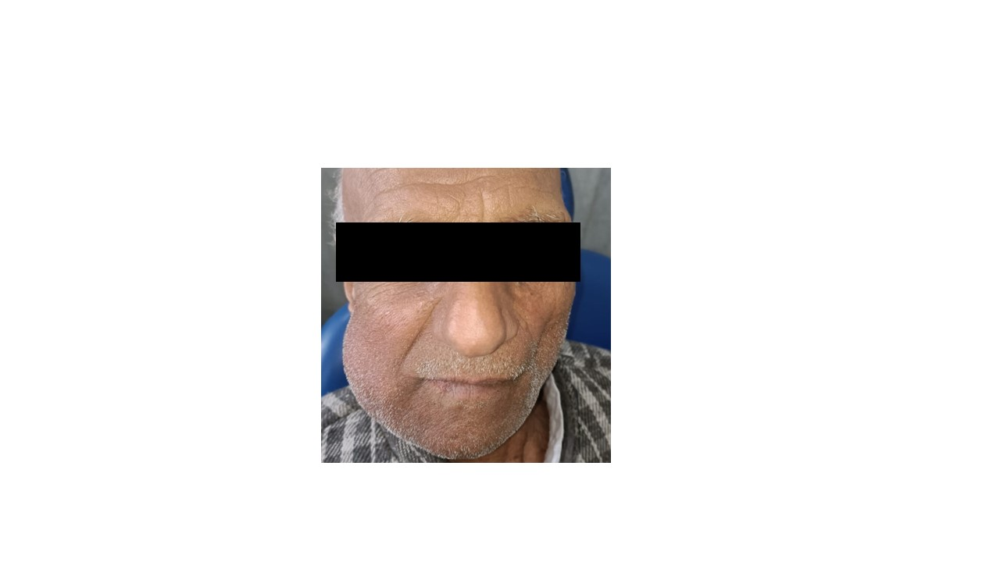

Figure 2: A) Inked cut section of the gross specimen shows a large circumscribed encapsulated colloid mass, yellowish tan in colour and glistening with soft consistency measuring approximately 4×3.5×3 cm, B) Hand draw illustration of Warthin’s tumor, C) Photo micrograph a panoramic view showing well encapsulated tumor with papillary architecture of tumor lined by bilayered oncocytic epithelial cells. The cystic spaces contain homogeneous eosinophilic material with stroma showing lymphocytic infiltrate. (H&E 40X)

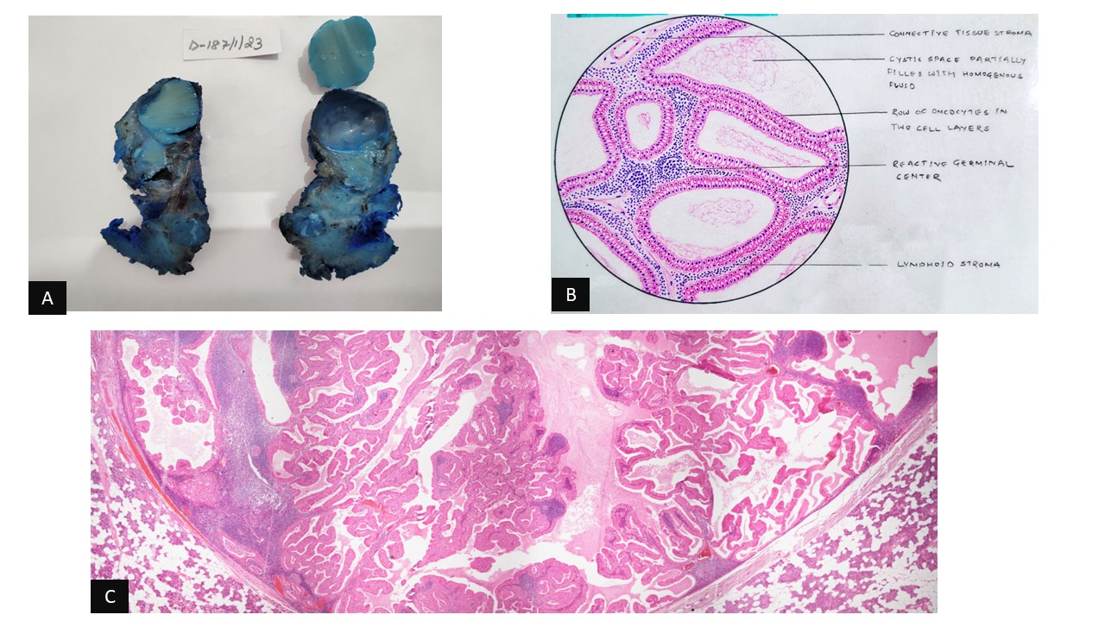

Figure 3: D) Photo micrograph showing bilayered oncocytic epithelial cells lining the papillary structures. Stroma show lymphocytic infiltrates. (H&E 200X), E) Photo micrograph showing well encapsulated tumor with papillary architecture of tumor lined by bilayered oncocytic epithelial cells. The cystic spaces contain homogeneous eosinophilic material with stroma showing lymphocytic infiltrate. (H&E 40X), F) Photo micrograph showing homogeneous eosinophilic material with presence of concentric lamellar structures suggestive of corpora amylacea. (H&E 400X), G) Photo micrograph showing bilayered oncocytic epithelial cells lining the papillary structures. (PTAH 200X)

