***Case report***

**Management of pediatric fracture mandible by closed reduction technique: A Case report**

**Abstract**

The prevalence of facial fractures in children is lower than that of adults, however, this may lead to serious complications. The etiology and epidemiology vary depending on various ethnics and demographic aspects. A fall from heigh had resulted in a right parasymphysial mandibular fracture in an 11-year-old girl. The diagnosis was confirmed by multidetector CT scan. Closed reduction with intermaxillary fixation (IMF) was performed under general anesthesia. The occlusal plane of the mandible was found to be normal by postoperative imaging. There were no complications and the patient was able to achieve both functional and aesthetic results. For pediatric mandibular fractures, closed reduction with IMF is a minimally invasive and cost-effective procedure promoting appropriate alignment, healing, and functional recovery. This strategy is suitable in environments where resources are scarce or sophisticated fixation techniques are unavailable.

In the last check up after 3 months in the outpatient clinic the patient showed normal mastication and painless chewing of food with no food or fluid drippling, normal oral occlusion with distortion of all anatomical, functional and cosmetic aspects. Facial symmetry had been restored without any deformities

**Keywords.** Mandibular fracture, pediatric trauma, intermaxillary fixation.

**Introduction**

Pediatric maxillofacial trauma is a distinct and extremely specialized area of traumatology because of the protective anatomical features of a child's face, growth considerations, larger ratio of cranial to facial skeleton size. 80% of mandibular fractures occurs at the angle, condyle, and sub-condylar areas. Body fractures are uncommon, symphysis and parasymphysis fractures making up 15–25% of cases [1], while fractures of the mandibular angle account for 41% of mandibular fractures [2]. Children are more subjected to sustain cranio-facial trauma than adults due to a higher cranial-facial volume (8:1 in newborns Vs. 2.5:1 in adults) [3]. Maxillofacial injuries are uncommon in children under five (0.6%–1.4%), with increasing incidence by school age, with another peak incidence during adolescence and puberty. Nasal fractures are the most frequent, followed by mandibular fractures, mid-facial fractures are of rare incidence [4].

Children’s’ fractures are of green stick nature, more common in children with immature bone having a higher percentage of cancellous tissue [5]. Following fractures, the process of bone regeneration adopts a fundamental and secondary forms. When bony ends are precisely reduced, aligned, stabilized and fixed under compression, primary healing takes place, where Haversian canals and lamellar bone can directly remodel promoting bone healing [6]. Although open reduction internal fixation accomplishes primary bone healing, yet, secondary healing is more prevalent [7] with intramembranous and endochondral ossification, which occurs in four stages; hematoma formation, formation of the fibrocartilaginous network, bony callus formation and bone remodeling where the bony callus is remodeled via osteoclasts and osteoblasts to form compact bone centrally, and lamellar bone peripherally [8]. Due to the larger subperiosteal hematoma and the stronger periosteum, callous forms more quickly, which speeds up fracture healing in comparison to adults [9]. Child's fracture healing mechanisms were already in progress when the fracture occurs. Any sins of fracture alignment or angulation can be corrected by the still-growing bone without any traces [10].

**Case report**

To our emergency clinic, a fall from heigh brought an 11-year-old female patient. As the parents were questioned, they explained that he had fallen from the second-floor balcony (about 3 meters) less than 20 minutes ago.

General status: The patient was fully-conscious, alert and in-pain. No signs of sensory-motor affection. The patient's Glasgow Coma Scale (GCS) was 15/15. Normal breathing with freely mobile chest walls with no respiratory distress signs. Completely lax anterolateral abdominal. No limb fractures. The patient was normothermic and normotensive.

Status localis: Mild facial edema which was more prominent at the right side. Patent airways. No signs of facial nerve affection or cervical spine fractures. No soft tissue injuries expect for bilateral periorbital contusions with bilateral red eyes, with painless, stable zygomatic bone underneath. No bleeding. No signs for facial bone fractures expect for a closed, displaced, type A right parasymphysial mandibular fracture [Figure 1]. An increased mandibular right-angle volume was found during the examination [Figure 2]. Ophthalmological consultation, revealed normal visual acuity with no signs of optic nerve affection orbital fractures.

The MDCT slides revealed fracture in Parasymphysis of the mandible. The fractures were displaced, with the presence of teeth at both sides of the fracture [Figure 3,4].

The patient was given 100 mg IV metronidazole and 600 mg IV amoxicillin-clavulanate as preoperative prophylactic antibiotics. The patient was placed supine with their head extended under general anesthesia by nasotracheal intubation, and a jaw retractor was used to reveal the fractures [Figure 5].

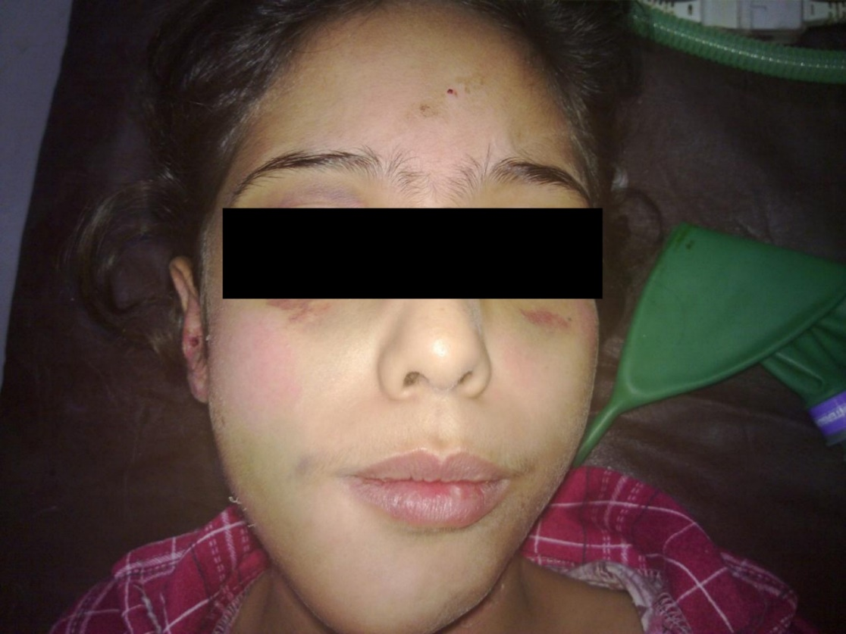

**Figure 1.** Facial edema, bilateral periorbital contusions and red eyes.

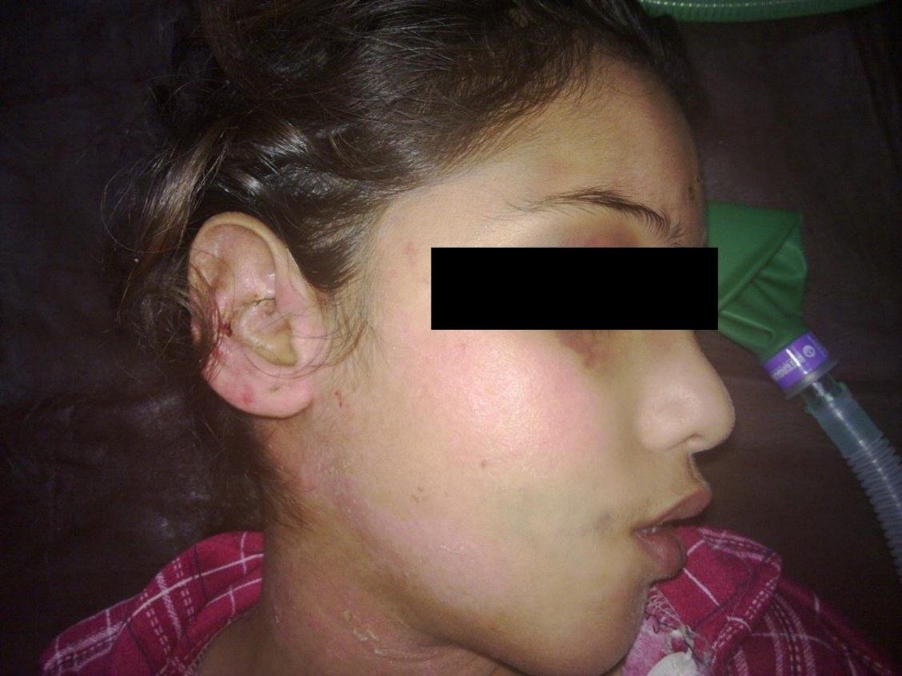

**Figure 2.** Increased mandibular right-angle volume.

The MDCT slides revealed fracture in Parasymphysis of the mandible. The fractures were displaced, with the presence of teeth at both sides of the fracture [Figure 3,4].

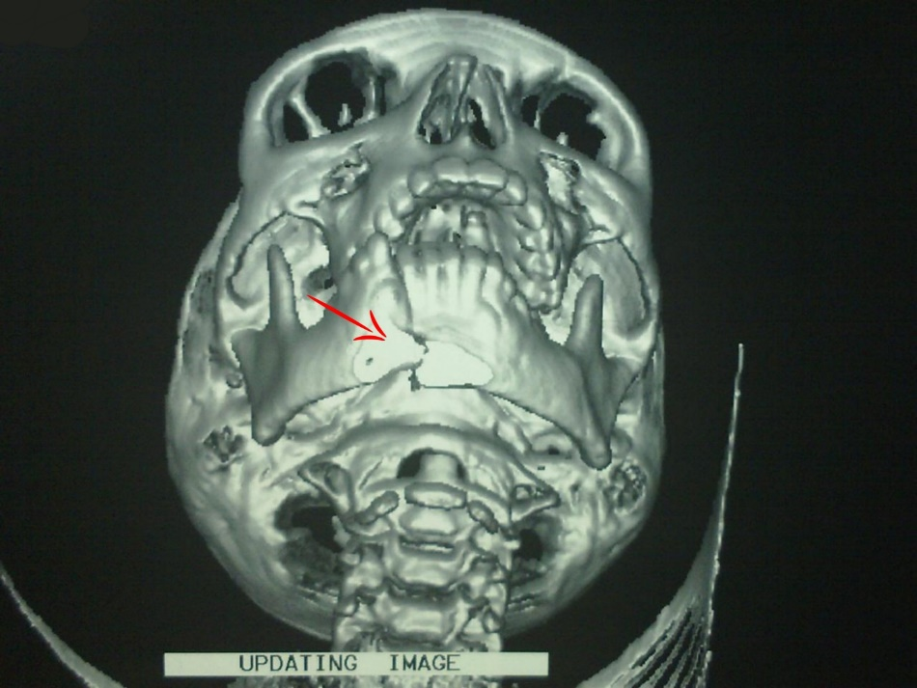

**Figure 3**. Multidetector computerized tomography of mandibular fracture, parasymphysial mandibular fracture (anterior view) (Red arrow).

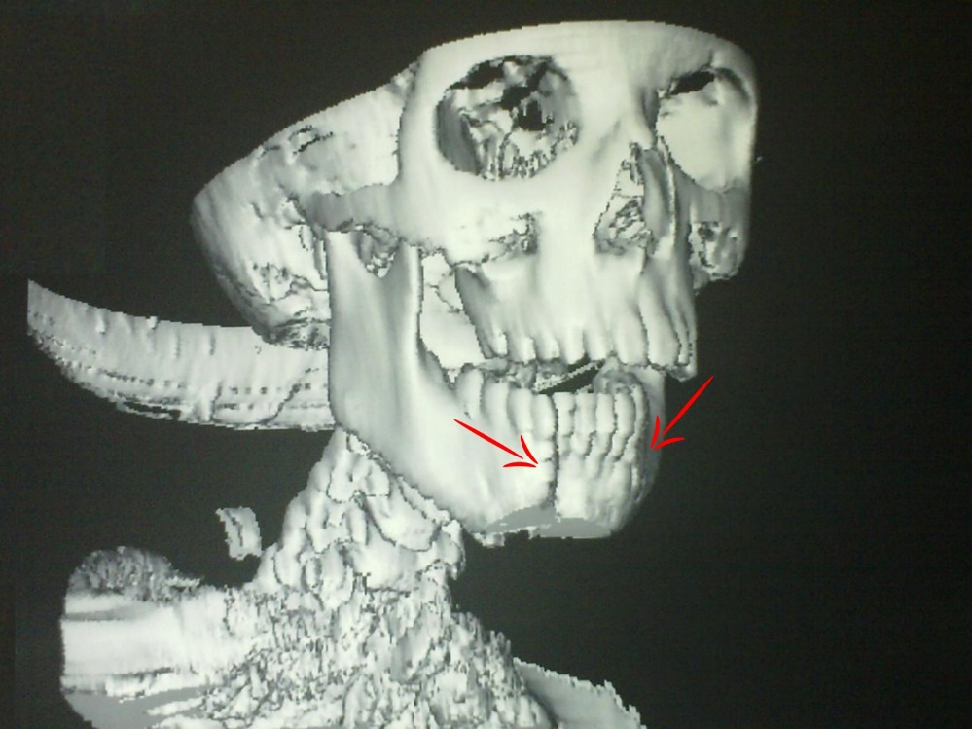

**Figure 4.** Multidetector computerized tomography of mandibular fracture,

parasymphysial mandibular fracture (lateral view) (Red arrows)

The patient was given 100 mg IV metronidazole and 600 mg IV amoxicillin-clavulanate as preoperative prophylactic antibiotics. The patient was placed supine with their head extended under general anesthesia by nasotracheal intubation, and a jaw retractor was used to reveal the fractures [Figure 5].

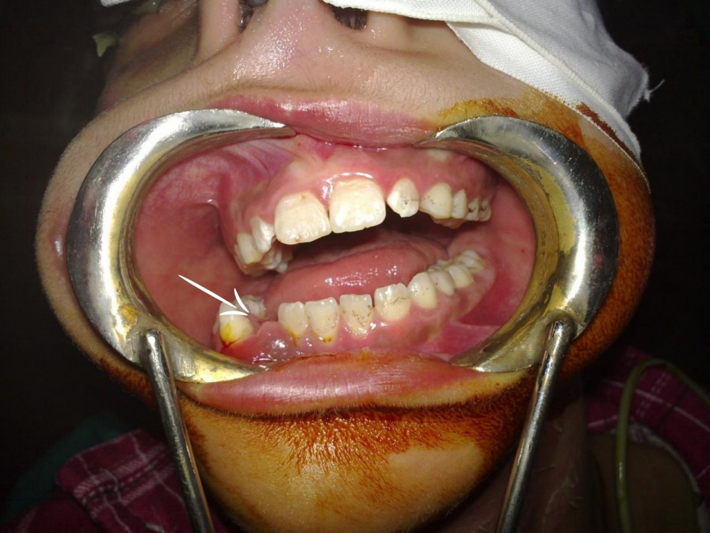

**Figure 5**. Mandibular fracture exposure using jaw retractor (White arrow).

**Surgical technique and Management**

The displaced fracture was manually anatomically reduced, restoring the mandibular normal occlusion and symmetry. Trans-dental wires of a 5 mm thickness, were used to secure stainless steel arch bars to the maxillary and mandibular dental arches; Intermaxillary Fixations (IMF). After the oropharyngeal pack was removed, elastic materials were stretched in-between the hooks of both arches sealing the oral cavity [Figure 6].

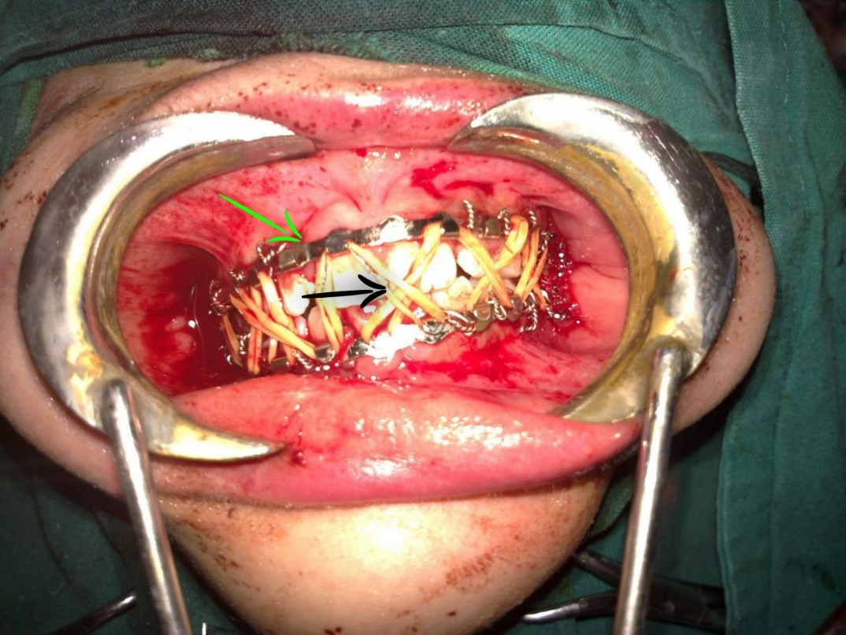

**Figure 6.** IMF (Green arrow) and closing the oral cavity using elastic materials (Black arrow).

After a seamless extubation in the operating room, the patient was moved to the recovery area for observation. Post-operative skull x rays were done (Anteroposterior view [Figure 7] and lateral views Figure 8]) which revealed proper anatomical reduction with restoration of the normal mandibular occlusion without any deformities and Oral fluids were initiated through the retromolar space four hours after surgery. IV perfalgan solution was used to successfully treat the postoperative discomfort. For 48 hours after surgery, intravenous antibiotics (metronidazole and amoxicillin-clavulanate) were administered. The post-operative panorama showed no problems and normal occlusions. On the fifth postoperative day, the patient was discharged and received a patient’s follow up card describing the medications to be administrated during the follow up period (Reparil gel), instructions for regular oral care and feeding by fluids and semisolids through the retromolar space and to attend weekly follow up visits in the outpatient clinic.

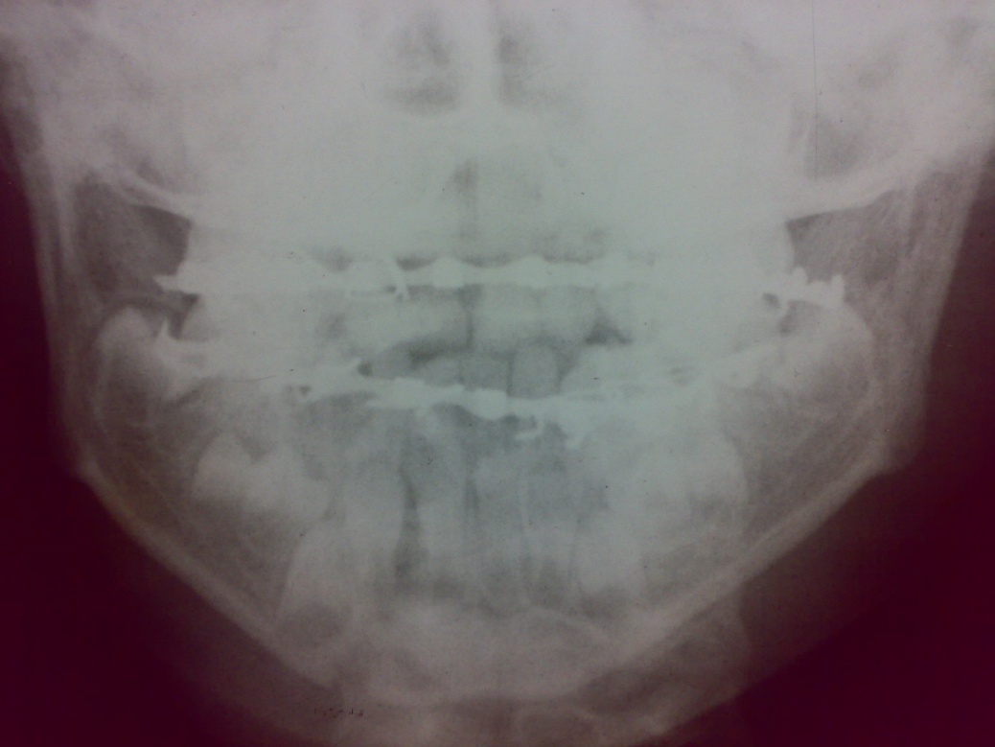

**Figure 7.** Postoperative skull x ray Anteroposterior view.

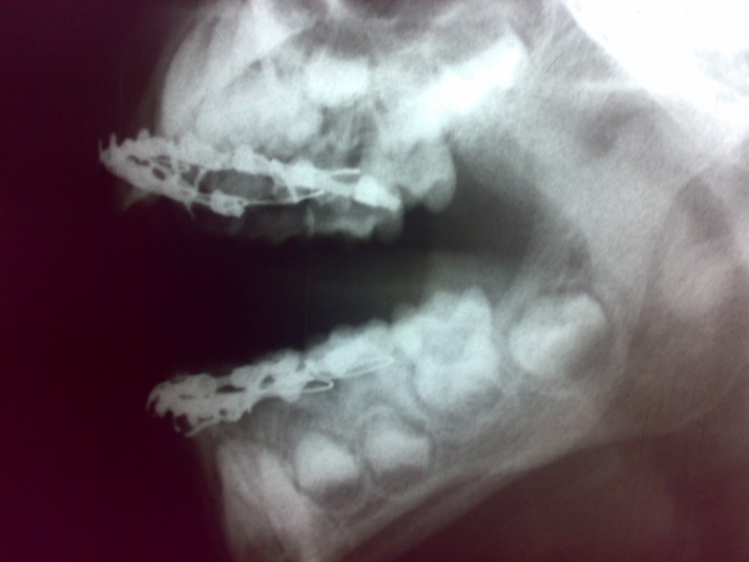

**Figure 8.** Postoperative skull x ray anterior view.

**Results**

After two weeks, the elastic materials were removed at the outpatient clinic. The patient began consuming semisolid foods. Two weeks later, the arch bars and wires were extracted, restoring the mandibular occlusion to normal [Figure 9]. Following full restoration of both functional and cosmetic features, the patient resumed his pre-injury lifestyle [Figure 10].

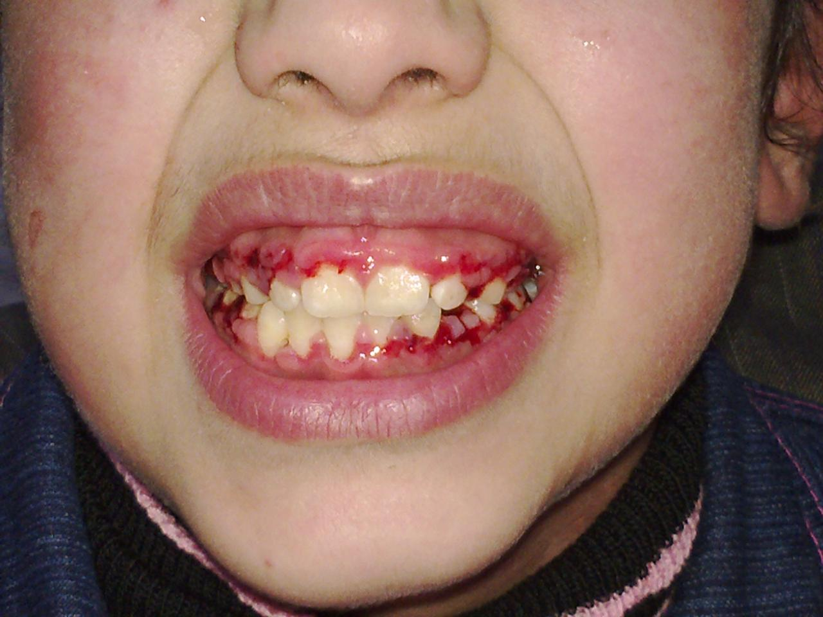

**Figure 9.** Normal mandibular occlusion after removal of the dental arches.

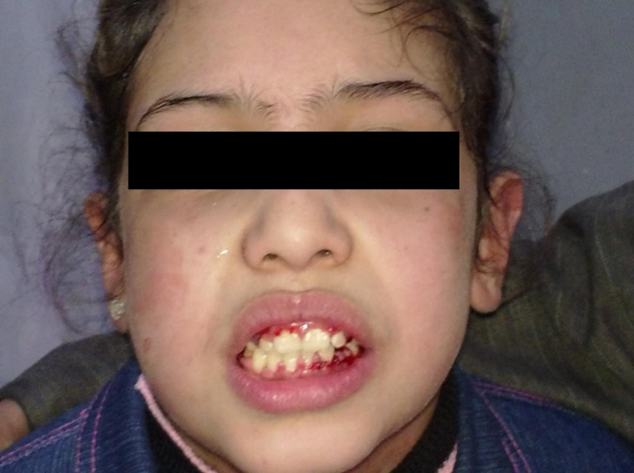

**Figure 10.** Complete healing of the bone and soft tissue injuries after 1 month of management.

#### Discussion

Over the past thirty years, significant progress has been made in the prevention, diagnosis, and treatment of craniomaxillofacial injuries in children. Pediatric facial fractures have become less common and less severe, especially in children under ten years old. Due to anatomical difference, healing speed, degree of cooperation, and the possibility of interfering with mandibular growth, managing mandibular fractures in children is different from managing them in adults. The same management guidelines apply to soft tissue injuries, with the exception that recovery happens more quickly, therapy should begin as soon as feasible. The child's soft tissues contain immature collagen, which produces esthetic effects but can also result in hypertrophic scars and keloids. In young patients, closed reduction with intermaxillary fixation is the ideal method to minimize invasiveness while guaranteeing appropriate alignment and healing. It is also economical when other costly fixation solutions, such as biodegradable plates, are unavailable.

**Conclusion**

For pediatric mandibular fractures, closed reduction with IMF is a minimally invasive and cost-effective procedure promoting appropriate alignment, healing, and functional recovery. This strategy is suitable in environments where resources are scarce or sophisticated fixation techniques are unavailable.

**Consent**

Patient’s informed written consent was taken to publish her case for academic purpose.

**Ethical approval**

As per international standards or university standards written ethical approval has been collected and preserved by the authors.

Disclaimer (Artificial intelligence)

Option 1:

Author(s) hereby declare that NO generative AI technologies such as Large Language Models (ChatGPT, COPILOT, etc.) and text-to-image generators have been used during the writing or editing of this manuscript.

Option 2:

Author(s) hereby declare that generative AI technologies such as Large Language Models, etc. have been used during the writing or editing of manuscripts. This explanation will include the name, version, model, and source of the generative AI technology and as well as all input prompts provided to the generative AI technology

Details of the AI usage are given below:

1.

2.

3.

References.

1. Salem S, Mekhaeel MSF, Protasov A, Nada T, Mohamed A, Noureldin S. Outcomes of a pediatric facial fracture reconstruction: Case report. Archiv Euromedica. 2024;14(6):1-8. doi:10.35630/2024/14/6.604
2. Almeida RS de, Rodrigues WC, Guimarães MTB Ávila, Falci SGM, Kaba SCP, Vieira EH, Shinohara Élio H. “Three-Dimension Grid Plate Effecting in Mandibular Fracture Fixation”. Archives of Current Research International. 2024;24(10):205-12. doi: 10.9734/acri/2024/v24i10923.
3. Horswell BB, Meara DJ. Pediatric Facial Trauma. In: Miloro, M., Ghali, G.E., Larsen, P.E., Waite, P. (eds) Peterson’s Principles of Oral and Maxillofacial Surgery. Springer, Cham.2020. doi:10.1007/978-3-030-91920-7_28
4. Sneha A, Pendem S, Krishnan M, Dhasarathan P, Aravindan V. Impacted Mandibular Fracture: A Report of a Rare Case. Cureus. 2023;14;15(5):e38999. doi: 10.7759/cureus.38999
5. Țenț PA, Juncar RI, Moca AE, Moca RT, Juncar M. The Etiology and Epidemiology of Pediatric Facial Fractures in North-Western Romania: A 10-Year Retrospective Study. Children (Basel). 2022;21;9(7):932. doi: 10.3390/children9070932
6. Mabrouk A, Helal H, Mohamed AR, Mahmoud N. Incidence, etiology, and patterns of maxillofacial fractures in ain-shams university, Cairo, Egypt: a 4-year retrospective study. Craniomaxillofac Trauma Reconstr. 2014;7(3):224-32. doi: 10.1055/s-0034-1374061
7. Lindaman LM. Bone healing in children. Clin Podiatr Med Surg. 2001;18(1):97-108. DOI: [10.1016/S0891-8422(23)01169-2](http://dx.doi.org/10.1016/S0891-8422(23)01169-2)
8. Kalia, V.a; Singh, A. P.b. Greenstick fracture of the mandible: A case report. Journal of Indian Society of Pedodontics and Preventive Dentistry 2008;26(1):32-35. doi: 10.4103/0970-4388.40320
9. Hiram Daniel López-Santacruz, Joselin Flores-Velázquez, Miguel Ángel Rosales-Berber. Mandibular greenstick fracture healing: A conservative approach, Pediatric Dental Journal. 2019;(29)3. doi: [10.1016/j.pdj.2019.07.001](http://dx.doi.org/10.1016/j.pdj.2019.07.001)
10. ElHawary H, Baradaran A, Abi-Rafeh J, Vorstenbosch J, Xu L, Efanov JI. Bone Healing and Inflammation: Principles of Fracture and Repair. Semin Plast Surg. 2021;35(3):198-203. doi: 10.1055/s-0041-1732334