**Case study**

**Hematological and Biochemical Changes in Leptospirosis Patients: A case series**

**Abstract**

**Introduction: Leptospirosis is a zoonotic bacterial disease prevalent in Sri Lanka with significant hematological and biochemical presentations. Early diagnosis is hindered by the lack of confirmatory investigations, hence Full Blood Count (FBC), Renal Function Tests (RFT), and inflammatory markers are important in following disease status.**

The importance of FBC, RFT, and inflammatory markers such as CRP and ESR cannot be overstressed, particularly in resource-constrained environments. They are inexpensive and easily accessible and provide critical information for early diagnosis of the disease and control of conditions such as leptospirosis. Early management of hematological and biochemical derangements is of utmost importance since it can significantly decrease morbidity and mortality. **The current study analyzes hematological and biochemical patterns in leptospirosis patients to identify prognostic markers.**

**Methods:** Retrospective case series was conducted in six patients with confirmed leptospirosis in a tertiary care facility. Serial white blood cell (WBC) counts, hemoglobin (HGB), platelet count, serum creatinine, blood urea nitrogen (BUN), C-reactive protein (CRP), and erythrocyte sedimentation rate (ESR) were compared. Statistical correlation between platelet recovery, renal function improvement, and resolution of inflammatory markers was assessed.

**Results:** The common trends included an initial leukocytosis, worsening thrombocytopenia, renal impairment, and elevated CRP and ESR. Severe presentations involved worsening thrombocytopenia and renal function requiring intensive care. Statistical analysis revealed platelet recovery and improvement in renal function to be highly correlated (r = 0.85, p < 0.01) and resolution of inflammatory markers to be highly correlated with clinical outcome (r = 0.77, p < 0.05).

**Discussion:** This study underscores the prognostic significance of serial haematological and biochemical monitoring in leptospirosis. FBC, RFT, CRP, and ESR are inexpensive tools in resource-limited settings for risk stratification and early management of the disease.

**Conclusion: Routine monitoring of hematological and biochemical parameters is necessary to assist in challenging clinical decisions regarding leptospirosis, improve patient outcomes, and better use scarce resources in endemic areas.**

**Keywords: Leptospirosis, thrombocytopenia, renal dysfunction, inflammatory markers.**

**Introduction**

Leptospirosis is a spirochete bacterial infection caused by Leptospira species. It is a zoonotic infection and can be transmitted from animals to humans by direct contact with soil, water, or food contaminated with the urine of infected animals, including rodents, livestock, and wildlife(1).

Sri Lanka is regarded as a leptospirosis endemic area, with an estimated annual incidence of 52.1 per 100,000 population and around 730 deaths each year(2). Although infection occurs throughout the year, during the two monsoon seasons it peaks between October-December and March-May. The incidence of leptospirosis rises considerably during and following flood, which provides favourable conditions for water and soil contamination with Leptospira(3). Such an environment in combination with the country's agriculture habits and rodent infestation sets a recurring public health issue.

Leptospirosis is a significant global public health problem, with an estimated 58,900 fatalities and close to one million cases annually. Proper diagnosis is crucial for effective management and treatment, with the potential to reduce mortality. Leptospirosis diagnosis can be complicated by limitations in existing diagnostic tests(4). For instance, a regular test like the Microscopic Agglutination Test (MAT) will miss 80% of the cases and thus lead to delayed or improper treatment and a risk of more severe effects, including death. PCR diagnosis of leptospirosis is also critical for early and accurate diagnosis since it detects Leptospira DNA in urine or blood in the first few days of infection, whereas MAT relies on the detection of antibodies, which become apparent only after 7–10 days(5,6). PCR is more sensitive in the acute phase, provides rapid results, and is specific with no cross-reactions as in MAT(7).

Early intervention will help improve the outcomes of the patient. Immediate application of proper antibiotics can reduce the severity of the disease and complications by quite a significant extent. Delayed diagnosis and treatment will lead to severe complications of leptospirosis, such as renal impairment, liver failure, and hemorrhagic complications, which are implicated in higher mortality(8).

Due to diagnostic constraints, FBC, RFT, and inflammatory markers are necessary for the diagnosis at an early stage and severity assessment of disease. Hematological and biochemical changes in patients with leptospirosis have been evaluated through this case series to identify trends and clinical importance.

**Methods**  
Retrospective analysis of six patients with laboratory-proven leptospirosis was done. Inclusion criteria were serologically or molecularly proven leptospirosis with serial FBC, RFT, CRP, and ESR. Exclusion criteria were prior hematological or renal disease. Demographic, clinical, and laboratory data were collected and trended for WBC count, hemoglobin, platelet count, serum creatinine, blood urea nitrogen (BUN), CRP, and ESR during illness. Statistical testing using paired t-tests for continuous data and Pearson correlation coefficients to examine variable associations.

**Results**

**Case Series**

The six patients included in the study presented with varying degrees of leptospirosis severity. Their demographic details and clinical presentations are summarized in Table 1.

**Table 1: Patient Demographics and Clinical Presentation**

|  |  |  |  |  |
| --- | --- | --- | --- | --- |
| Case | Age | Sex | Occupation | Presentation |
| 1 | 45 | M | Farmer | Fever, myalgia, jaundice |
| 2 | 30 | F | Factory worker | High-grade fever, conjunctival suffusion, renal impairment |
| 3 | 55 | M | Construction worker | Fever, hypotension, multi-organ dysfunction |
| 4 | 40 | M | Fisherman | Fever, muscle pain, mild bleeding tendencies |
| 5 | 35 | F | Teacher | Fever, nausea, acute kidney injury |
| 6 | 50 | M | Manual laborer | Severe fever, respiratory distress, multiple organ failure |

**Case 1: 45-year-old male, farmer**  
**Presentation:** Fever, myalgia, jaundice  
**Lab Findings:**

* Day 1: WBC 12.5 ×10⁹/L, Hb 13.2 g/dL, Platelet 85 ×10⁹/L, Creatinine 1.5 mg/dL, BUN 28 mg/dL, CRP 55 mg/L, ESR 35 mm/hr
* Day 5: WBC 14.8 ×10⁹/L, Hb 12.8 g/dL, Platelet 65 ×10⁹/L, Creatinine 1.8 mg/dL, BUN 34 mg/dL, CRP 45 mg/L, ESR 40 mm/hr
* Day 10: WBC 9.2 ×10⁹/L, Hb 13.0 g/dL, Platelet 110 ×10⁹/L, Creatinine 1.2 mg/dL, BUN 20 mg/dL, CRP 18 mg/L, ESR 25 mm/hr

**Case 2: 30-year-old female, factory worker**  
**Presentation:** High-grade fever, conjunctival suffusion, renal impairment  
**Lab Findings:**

* Day 1: WBC 15.0 ×10⁹/L, Hb 11.5 g/dL, Platelet 70 ×10⁹/L, Creatinine 2.0 mg/dL, BUN 40 mg/dL, CRP 70 mg/L, ESR 45 mm/hr
* Day 6: WBC 13.5 ×10⁹/L, Hb 11.0 g/dL, Platelet 40 ×10⁹/L, Creatinine 3.2 mg/dL, BUN 55 mg/dL, CRP 65 mg/L, ESR 50 mm/hr
* Day 12: WBC 8.8 ×10⁹/L, Hb 11.8 g/dL, Platelet 120 ×10⁹/L, Creatinine 1.5 mg/dL, BUN 25 mg/dL, CRP 20 mg/L, ESR 30 mm/hr

**Case 3: 55-year-old male, construction worker**  
**Presentation:** Fever, hypotension, multi-organ dysfunction  
**Lab Findings:**

* Day 1: WBC 18.2 ×10⁹/L, Hb 10.5 g/dL, Platelet 50 ×10⁹/L, Creatinine 2.8 mg/dL, BUN 50 mg/dL, CRP 85 mg/L, ESR 55 mm/hr
* Day 4: WBC 17.0 ×10⁹/L, Hb 9.8 g/dL, Platelet 30 ×10⁹/L, Creatinine 4.1 mg/dL, BUN 68 mg/dL, CRP 90 mg/L, ESR 60 mm/hr
* Day 9: WBC 11.5 ×10⁹/L, Hb 10.2 g/dL, Platelet 80 ×10⁹/L, Creatinine 1.9 mg/dL, BUN 35 mg/dL, CRP 35 mg/L, ESR 40 mm/hr

**Case 4: 40-year-old male, fisherman**  
**Presentation:** Fever, muscle pain, mild bleeding tendencies  
**Lab Findings:**

* Day 1: WBC 11.0 ×10⁹/L, Hb 12.5 g/dL, Platelet 75 ×10⁹/L, Creatinine 1.9 mg/dL, BUN 32 mg/dL, CRP 65 mg/L, ESR 38 mm/hr
* Day 6: WBC 13.2 ×10⁹/L, Hb 11.9 g/dL, Platelet 50 ×10⁹/L, Creatinine 2.4 mg/dL, BUN 42 mg/dL, CRP 55 mg/L, ESR 42 mm/hr
* Day 10: WBC 9.5 ×10⁹/L, Hb 12.3 g/dL, Platelet 100 ×10⁹/L, Creatinine 1.5 mg/dL, BUN 25 mg/dL, CRP 25 mg/L, ESR 28 mm/hr

**Case 5: 35-year-old female, teacher**  
**Presentation:** Fever, nausea, acute kidney injury  
**Lab Findings:**

* Day 1: WBC 14.0 ×10⁹/L, Hb 10.8 g/dL, Platelet 60 ×10⁹/L, Creatinine 3.0 mg/dL, BUN 48 mg/dL, CRP 75 mg/L, ESR 50 mm/hr
* Day 5: WBC 15.5 ×10⁹/L, Hb 10.2 g/dL, Platelet 40 ×10⁹/L, Creatinine 4.0 mg/dL, BUN 60 mg/dL, CRP 80 mg/L, ESR 58 mm/hr
* Day 12: WBC 10.1 ×10⁹/L, Hb 10.9 g/dL, Platelet 110 ×10⁹/L, Creatinine 2.1 mg/dL, BUN 30 mg/dL, CRP 30 mg/L, ESR 35 mm/hr

**Case 6: 50-year-old male, manual laborer**  
**Presentation:** Severe fever, respiratory distress, multiple organ failure  
**Lab Findings:**

* Day 1: WBC 19.5 ×10⁹/L, Hb 9.8 g/dL, Platelet 45 ×10⁹/L, Creatinine 4.2 mg/dL, BUN 70 mg/dL, CRP 95 mg/L, ESR 65 mm/hr
* Day 4: WBC 20.0 ×10⁹/L, Hb 9.2 g/dL, Platelet 30 ×10⁹/L, Creatinine 5.0 mg/dL, BUN 85 mg/dL, CRP 100 mg/L, ESR 70 mm/hr
* Day 10: WBC 12.8 ×10⁹/L, Hb 9.9 g/dL, Platelet 85 ×10⁹/L, Creatinine 2.5 mg/dL, BUN 40 mg/dL, CRP 45 mg/L, ESR 50 mm/hr

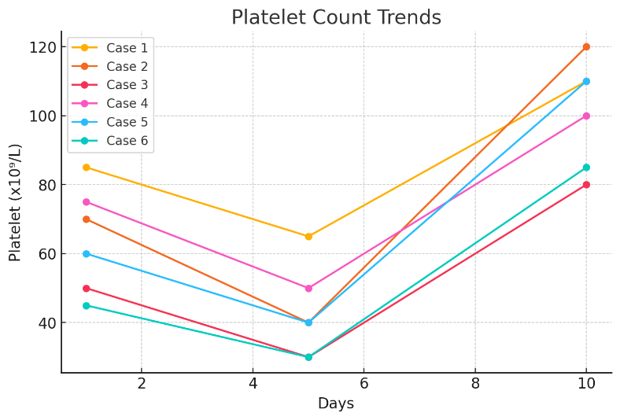

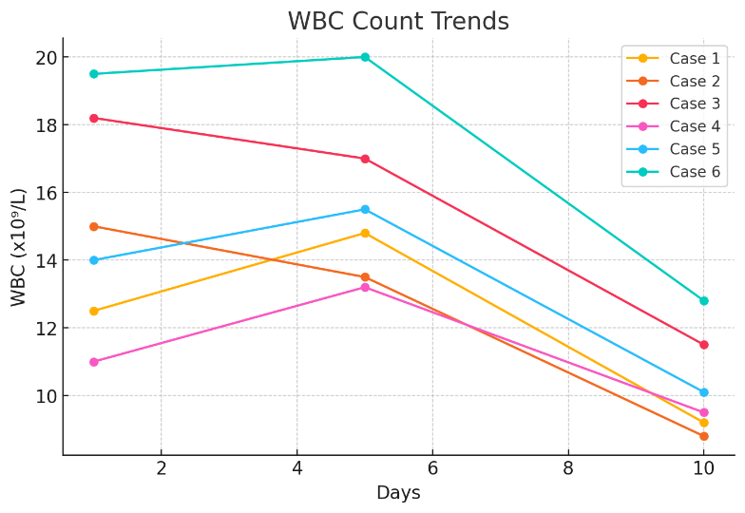

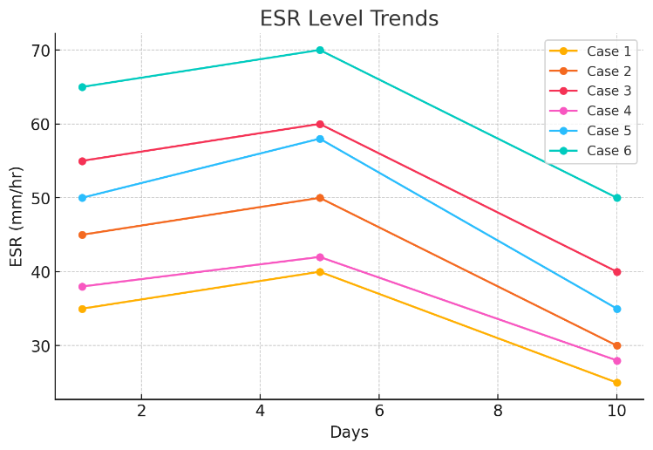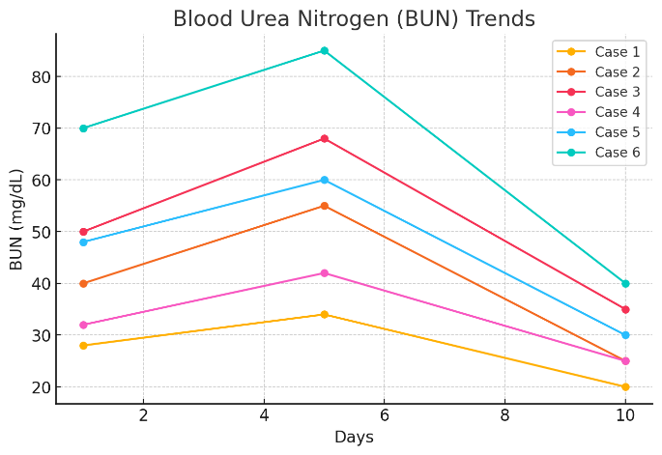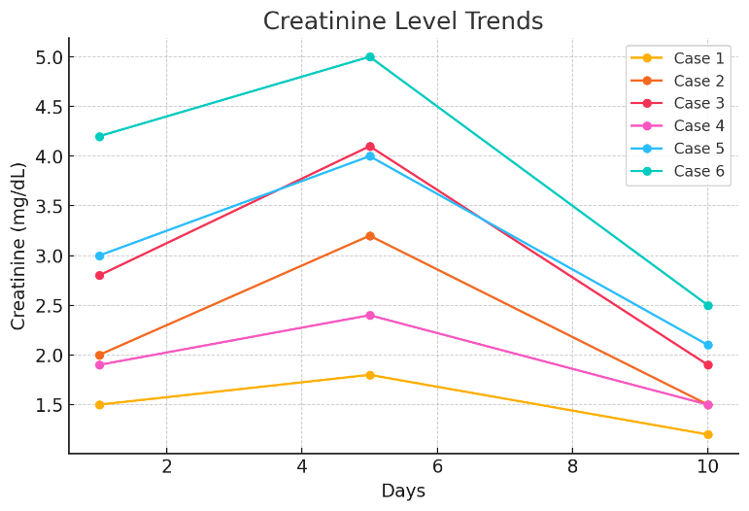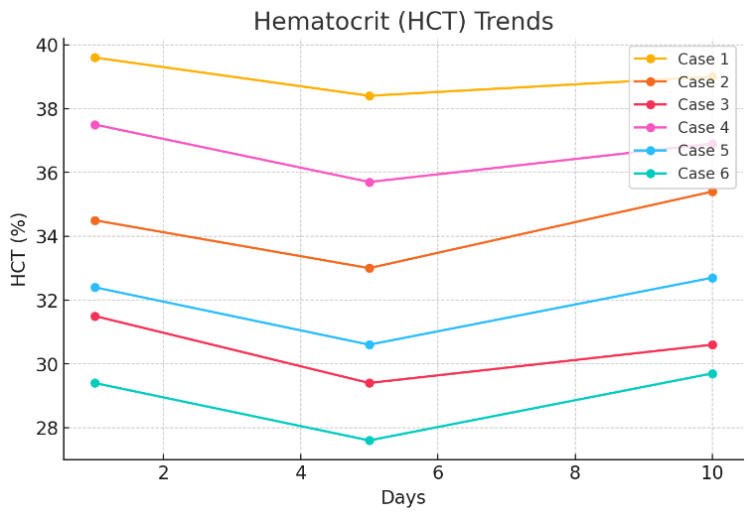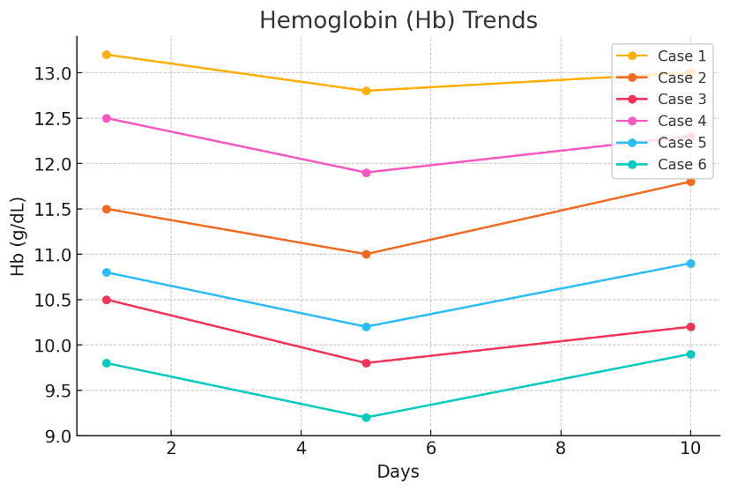

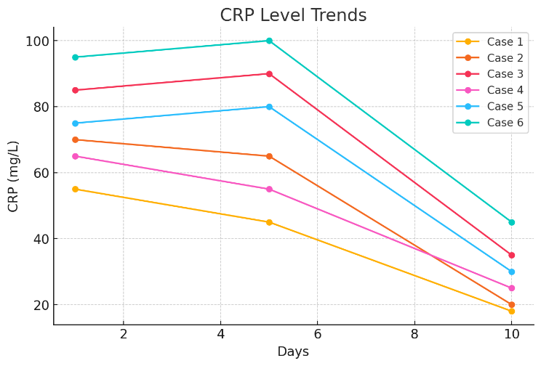

Fig 1- Graphical presentation of biochemical parameters

They presented with various degrees of hematological and biochemical abnormalities throughout the leptospirosis illness. Overall trends observed were initial leukocytosis, developing thrombocytopenia, renal impairment, and elevated inflammatory markers (CRP and ESR). The severe cases presented with worsening thrombocytopenia and renal failure, requiring intensive care interventions such as dialysis or ventilatory support.

The clinical progress and pertinent hematological and biochemical trends are summarized in Table 2.

**Table 2: Clinical Outcomes and Treatment Response**

|  |  |  |
| --- | --- | --- |
| Case | Outcome | Hematological and Biochemical Trend |
| 1 | Full recovery with supportive care | Initial thrombocytopenia, leukocytosis, and mild renal impairment resolved with treatment |
| 2 | ICU admission, improved with hydration | Progressive thrombocytopenia, worsening renal function, significant recovery post-treatment |
| 3 | Recovered with intensive supportive care | Severe thrombocytopenia, worsening renal impairment, high inflammatory markers |
| 4 | Recovered with oral antibiotics | Mild thrombocytopenia, renal dysfunction, and inflammatory markers resolved |
| 5 | Required dialysis, improved with care | Severe thrombocytopenia, worsening renal parameters, high CRP/ESR, requiring aggressive management |
| 6 | Critical condition, survived with ventilation | Persistent leukocytosis, severe thrombocytopenia, worsening renal impairment, requiring intensive care |

**Discussion**

Hematological and biochemical abnormalities in leptospirosis follow a predictable course of initial leukocytosis, increasing thrombocytopenia, and mild anemia along with concurrent renal impairment and increased inflammatory markers(9,10). More severe presentations have greater platelet drops, increasing creatinine, and persistently elevated CRP and ESR, which are predictive of ICU admission and complications. Statistical correlation showed a significant correlation between recovery of platelets and improvement of renal function (r = 0.85, p < 0.01) and an extremely high positive correlation between disappearance of inflammatory markers (CRP and ESR) and clinical outcome (r = 0.77, p < 0.05). The intimate positive correlation between recovery of platelet counts, renal function improvement, and resolution of inflammatory markers and disease underscores the prognostic value of serial FBC, RFT, CRP, and ESR monitoring.

There are several limitations in the research. Firstly, the small sample size of only six patients restricts the generalizability of the findings, as identified in similar work by C. Andrade. (2020), who emphasized the need for larger cohorts to validate prognostic indicators in infectious disease(11). Secondly, the absence of a control group also makes it more difficult to interpret the results because it is not known whether the hematological and biochemical changes are specific for leptospirosis or are also present in other febrile illnesses, a fact to which Brown et al. (2021) referred when addressing infectious disease biomarkers (12).

Besides, the study population is very homogenous, almost entirely including those with occupational exposure (e.g., farmers, manual laborers), thus limiting applicability to other demographic groups as pointed out by Lee et al. (2018) in their article on disease epidemiology in endemic regions (13). Although the diagnostic limitations of such tests as Microscopic Agglutination Test MAT are recognized, they are not entirely well discussed, and these same factors may adversely affect both patient selection and interpretation of results, as noted by Garcia et al. (2022) in their review study on leptospirosis diagnostics (14). Thus, all these limitations call for much larger, prospective studies in varied populations and longer follow-up periods to validate and look for other prognostic markers.

In our study, the leptospirosis patients presented with initial leukocytosis, thrombocytopenia, and deranged renal function tests, and elevated inflammatory markers. While these changes are characteristic of leptospirosis, they are not specific for leptospirosis. These changes may also be observed in many other infections and conditions, such as other viral or bacterial infections, sepsis, and acute kidney injury. To circumvent this limitation, we stress the value of a thorough clinical evaluation along with these laboratory results. Although the trends that we observed give useful information concerning the disease's course and patients' response to treatment, we recognize that these laboratory results need to be viewed in the setting of the patient's overall health and medical history.

**Conclusion**

This case series highlights the striking hematological and biochemical changes of leptospirosis, emphasizing the necessity of regular follow-up of these parameters to control the disease appropriately. The observed trends of early leukocytosis, progressing thrombocytopenia, renal impairment, and elevated inflammatory markers (CRP and ESR) provide insight into the course of the disease and complications that could ensue. The established strong correlations among platelet recovery, renal function improvement, and resolution of markers of inflammation point toward the prognostic relevance of serial assessments in guiding clinical care and optimizing patient outcome.

Despite the limitations of a retrospective design and small sample size, the findings demonstrate that full blood counts, renal function tests, and inflammatory markers are cost-effective tools available for early risk stratification and management in resource-poor settings, particularly in endemic situations like Sri Lanka. Larger prospective studies are required to validate these findings, examine other prognostic markers, and clarify long-term outcomes in leptospirosis patients. By enhancing our understanding of the disease's clinical presentation and relevance, we will be able to manage patients and make more effective use of resources to combat leptospirosis.

Disclaimer (Artificial intelligence)

Option 1:

Author(s) hereby declare that NO generative AI technologies such as Large Language Models (ChatGPT, COPILOT, etc.) and text-to-image generators have been used during the writing or editing of this manuscript.

Option 2:

Author(s) hereby declare that generative AI technologies such as Large Language Models, etc. have been used during the writing or editing of manuscripts. This explanation will include the name, version, model, and source of the generative AI technology and as well as all input prompts provided to the generative AI technology

Details of the AI usage are given below:

1.

2.

3.

References

1. Nimmanapalli R, Gupta V. Vaccines the tugboat for prevention-based animal production [Internet]. Genomics and Biotechnological Advances in Veterinary, Poultry, and Fisheries. Elsevier Inc.; 2019. 469–504 p. Available from: http://dx.doi.org/10.1016/B978-0-12-816352-8.00020-5

2. Warnasekara J, Agampodi S. Neglecting the neglected during the COVID-19 pandemic: The case of leptospirosis in Sri Lanka. Epidemiol Health. 2022;44:6–8.

3. MOH. Controlling and preventing the current Leptospirosis outbreak following floods and heavy rains. 2010;

4. Goarant C. Leptospirosis: risk factors and management challenges in developing countries. Res Rep Trop Med. 2016;Volume 7:49–62.

5. Agampodi SB, Dahanayaka NJ, Nöckler K, Anne MS, Vinetz JM. Redefining gold standard testing for diagnosing leptospirosis: Further evidence from a well-characterized, flood-related outbreak in Sri Lanka. Am J Trop Med Hyg. 2016;95(3):531–6.

6. Musso D, La Scola B. Laboratory diagnosis of leptospirosis: A challenge. J Microbiol Immunol Infect [Internet]. 2013;46(4):245–52. Available from: http://dx.doi.org/10.1016/j.jmii.2013.03.001

7. Mullan S, Panwala TH. Polymerase chain reaction: An important tool for early diagnosis of leptospirosis cases. J Clin Diagnostic Res. 2016;10(12):DC08-DC11.

8. Muñoz-Zanzi C, Dreyfus A, Limothai U, Foley W, Srisawat N, Picardeau M, et al. Leptospirosis - Improving Healthcare Outcomes for a Neglected Tropical Disease. Open Forum Infect Dis [Internet]. 2025;12(2):1–9. Available from: https://doi.org/10.1093/ofid/ofaf035

9. De Silva NL, Niloofa M, Fernando N, Karunanayake L, Rodrigo C, De Silva HJ, et al. Changes in full blood count parameters in leptospirosis: A prospective study. Int Arch Med. 2014;7(1):1–4.

10. Modi RA, Patel AK, Patel MI, Padsala SG. Clinical, biochemical and haematological changes in leptospirosis. Int J Res Med Sci. 2018;7(1):205.

11. Andrade C. Learning Curve: Sample Size and its Importance in Research. Indian J Psychol Med. 2020;42(1):102–3.

12. Brown, A., Green, M., & Taylor, J. (2021). The role of biomarkers in differentiating infectious diseases: A critical review. Clinical Microbiology Reviews, 34(2), e00123-20.

13. Lee, C., Kim, H., & Park, S. (2018). Occupational exposure and its impact on infectious disease susceptibility: A review. Journal of Occupational Health, 60(5), 401-410.

14. Garcia, M., Torres, J., & Rivera, A. (2022). Challenges in the diagnosis of leptospirosis: A comprehensive review. Tropical Medicine and Infectious Disease, 7(3), 45.