**IMPACT OF TIGER NUTSAND DATE PALM FLOUR MIXTURE ON MALE REPRODUCTIVE FUNCTIONS IN SSWISTAR ALBINO RATS**

**Abstract**

The use of synthetic drugs in the treatment of infertility is quite expensive and has shown to produce some adverse effects. Natural remedy such as the use of plants is recommended because they pose little or no side effects. This present work is on Impact of Tiger nuts and Date palm flour Mixture on Male reproductive functions in Wistar rats. Thirty (30) male Wistar rats weighing 70-120g were grouped into six (6) of five (5) rats per group. Group one (1) the control was administered rat feed only, Group two (2) was given rat feed and Tiger nut flour only, Group Three (3) was given rat feed and Date palm flour only, Group four (4) was given rat feed, Tiger nut and Date flour mixture in ratio 1:1, Group five (5) was given rat feed and mixture of Tiger nut and Date flour in ratio 1:2 and Group Six (6) was given rat feed with mixture of tiger nut and Date flour in ratio 2:1 for twenty-eight (28) days. The result revealed a boost in sperm count, viability and motility across all groups with a notable increase in Group four (4) in sperm count (494.00 ±177.44), viability (68.00 ±5.83), and motility (64.00 ±7.14) when compared with their respective controls (62.00±18.27), (58.00±2.54) and (52.00 ±3.39). Group Six (6) administered rat feed with a mixture of tiger nut and Date flour in a ratio of 2:1 showed a marked increase in testosterone (2.30nmol/L) level, also with a significant (p≤0.05) increase in Follicle Stimulating Hormone (FSH) (2.31mIU/ML) when compared with the control Testosterone (1.30±0.19) and FSH (0.25±0.04). Normal spermatocytes, seminiferous tubules, and spermatogonia were found in the testes of all groups given the formulated diet which shows histologically no pathology in the Testes compared to the control. This shows that Tiger nuts flour when in combination with Dates flour enhanced the reproductive function in Male Wistar rats and their use does not create or pose any risk to the testes. Therefore, its use in the treatment of male infertility should be encouraged.

**Keywords:** Histopathology, Sperm, Testosterone, Follicle Stimulating Hormone (FSH).

**INTRODUCTION**

Research by World Health Organization, observed that male fertility is dropping to nearly 50% among married couples. This might be as a result of a stressful lifestyle which has greatly affected subjects that suffers from sexual dysfunction (WHO, 2000). There are Synthetic drugs for these problems, but the disadvantage of these drugs is its adverse side effect. Natural treatment on the other hand is advised because it is believed to be devoid of side effect, this might not be true due to the fact that there is scarcity of information on the adverse effect of these medicinal plants used against fertility problem (Carpentier *et al.,* 2004).

*Cyperus esculentus* (Tiger nuts) is a perennial plant species that belongs to the Cyperaceae family and grows abundantly in the Mediterranean region. The cultivation of this plant started far back as 5000 BC in Egypt (Defelis,2002). These tubers are commonly known by several names such as chufa, earth almond, and tiger nuts (Pascual *et al.,* 2000). The rich carbohydrate, protein and fat content of this plant makes it serves as food to man and animal (Tunde and Oke, 2012). In the Middle East this plant is called “the seeds of men” when translated literarily. This is because they believe that it aids male sexually.

The Date palm (*Phoenix dactylifera L.*) has been cultivated since the 6000 years. Date palm is a genus of palm, the most important species of which is the common Date palm, a native of the North half of Africa, the South West of Asia and some parts of India. From studies, Dates has a high amount of carbohydrates, fats with 14 different types of fatty acids, salts, minerals, proteins with 23 different amino acids, 6 vitamins and dietary fibre. These nutritional benefits of dates are for those who take it as food rather than those that just have it as snacks (Sahari *et al.,* 2007).

**STATEMENT OF THE PROBLEM**

Infertility is a condition where there is a regular and unprotected sex without conception for a period of one year. There are associated male factors that could lead to this problem. About 50% of infertility is caused by male related factor. Using synthetic drugs to remedy this situation has not helped due to its side effects, which has made many to resort to natural plant products. Even with the success recorded in the use of plant to improve fertility there is still need for more discoveries of the use of plants to cure infertility problems.

**AIMS AND OBJECTIVES**

The aim of this study is to know the Impact of Tiger nutsand Date palm flour Mixture on Male reproductive functions in Wistar Albino rats.

The objectives were to:

1. Investigate the effect of the feed mixture on sperm analysis (volume, viability, viscosity, morphology, and sperm count) and on the male hormones (Testosterone and Follicle Stimulating Hormone).

1. Determine its effect on the histology of the testes.

**MATERIALS AND METHOD**

**Collection of Plant and identification**

Tiger nuts *(C. esculentus)* and Date fruits *(P. dactylifera)* were bought from slaughter market in Trans Amadi, Port Harcourt, Nigeria. They were identified at the Department of Plant Science and Biotechnology, University of Port Harcourt, Choba.

**Sample preparation:** Upon purchase,the dried Tiger nuts tubers were properly selected and washed to remove dirt and then it was sliced with a kitchen knife and put in an oven at 500C to dry. After drying it was ground to obtain a flour and kept in a transparent container until used for the study.

Dried Date fruits were stored in an open space for 3days to absorb moisture because of its hardness, thereafter it was cleaned and the seeds were removed. This was also kept to dry in an oven at 500C, and then ground to flour and kept in a transparent container until used for the study.

**Specimen (animal) used for the experiment:**

The Animal house of the University of Port Harcourt, Choba, Rivers State Nigeria, was where Thirty (30) male Wistar rats that weighed between 70-120g was purchased. The rats were kept in standard cages under good atmospheric conditions with water and rat chow provided *ad libitum* under room temperature. They were allowed to acclimatize for one week and then their weight was taken before commencement of the experiment.

**Animal grouping/treatment:** After one week of acclimatization, the animals were randomly assigned to 6 groups, containing 5 Wistar rats each. Different ratios of Tiger nuts and Date flour were administered to the animals for 28days as follows:

1. Control group were administered rat feed only.
2. Group two were administered rat feed, and Tiger nuts flour only.
3. Group three were administered rat feed and Date fruit flour only.
4. Group four were administered rat feed and a mixture of Tiger nut flour and Date fruit flour (ratio of 1:1). The total amount of each feed mixture was 700g with 350g of Tiger nuts flour and 350g of Date fruit flour.
5. Group five were administered rats chow and a mixture of Tiger nuts flour and Date fruit flour in the ratio of 1:2 (i.e. 230g of Tiger nuts flour mixed with 470g of Date flour, making it a total amount of 700g mixture).
6. Group six were administered rats chow and a mixture of Tiger nuts flour and Date

Fruits flour in the ratio of 2:1(i.e. 470g of Tiger nuts mixed with 230g of Dates flour, making it a total amount of 700g mixture).

After 28 days, the animals were sacrificed under anaesthesia (chloroform suffocation) and blood sample collected through cardiac puncture into Ethylenediaminetetraacetic acid (EDTA) bottles. The Testes were collected through abdomino-thoracic dissection into plain bottles containing Bouin’s fixatives containing 75ml Picric acid, 25ml raw formaldehyde and 5ml acetic acid for histological study. Part of the testes were collected in plain bottles for sperm analysis.

## Determination of sperm parameters: (Haemocytometer method)

In a beaker containing 10ml diluting solution, the cauda part was excised and placed in the beaker after separation from each separated epididymis (sodium bicarbonate 5 g and formalin neutral 1 mL in 100 mL of distilled water). Spermatozoa were liberated for a few minutes into the solution after each section was quickly macerated with the aid of a sharp scissors. Neubauer Haemocytometre was used to carry out the sperm count under a microscope and the sperm count was calculated per epididymis. 2 drops of warm 2.9 percent sodium citrate were added after semen drop had been placed on the slide. A cover slip was used to cover the slide while examination was carried out under the microscope using x 40 objectives for these parameters: sperm motility, morphology, abnormality, sluggishness and dead cells.

**Hormonal assay**

**Determination of testosterone (Accu-Bind Kits)**

**Principle**

The principle uses a competitive immunofluorescence assay. A fluorescence conjugated anti-testosterone in a buffer (detection) binds to testosterone in a specimen and unbound anti-body binds to covalently coupled testosterone-BSA which has been made immovable on a test strip, as specimen migrates via the nitrocellular matrix. This way, the more testosterone in blood, smaller quantities of unbound fluorescence labelled antibodies accumulates on the test strip. The anti-testosterone antibody fluorescence intensity reflects the quantity of antigen captured and the ichroma reader processes it to establish the level of testosterone in the sample.

**Procedure**

Seventy-five microlitres of sample was added with the aid of transfer pipette into a sample mixing tube containing thirty microlitres of displacing reagent, the sample was thoroughly mixed and left to stand for ten minutes after closing the lid of sample mixing tube. The sample mixture was used instantly and incubated for three minutes. Seventy-five microlitres of sample was added with aid of transfer pipette into a tube containing the detection buffer, the sample was thoroughly mixed and left to stand for ten minutes after closing the lid of the detection buffer. The sample mixture was used immediately. Seventy-five microlitres of sample mixture was transferred using a pipette and dispensed into the sample well on the test cartridge. The Cartridge was left for twelve minutes before the Cartridge was inserted into the holder. The sample-loaded test cartridge was inserted into the Test Cartridge holder in the ichroma Reader for scanning.

## Determination of Follicle Stimulating Hormone (Accu-Bind Kits)

**Principle**

This analysis relies on immunoassay system via antigen-antibody interaction and fluorescence technology. The complete mixing of sample and a detection buffer, loaded into a sample well cartridge, forms complex of antibody (anti-FSH)-antigen (FSH)-antibody (anti-FSH) –fluorescence on the cartridge. Consequently, the more FSH is in plasma/plasma, the more complexes are accumulated on the membrane. The strength of the fluorescence on the membrane is scrutinized by the ichroma Reader which displays the FSH concentration on the LCD screen of the reader.

**Procedure**

Seventy-five microliters of sample was added with the aid of transfer pipette into a tube containing the detection buffer, the sample was thoroughly mixed and left to stand for ten minutes after closing the lid of the detection buffer. 75 µl of the sample was dispensed into the sample well on the test cartridge and left for fifteen minutes. The ichroma Reader was switched on and the ID chip was slotted into the ID chip port of the reader and proper orientation of the test cartridge was done. The select button on the ichroma Reader was pushed and the scanning process commenced, and the results were displaced on the screen.

**Histological examination**

Fixative principle: Bouin solution was used for fixing. It is a mixture of picric acid, acetic acid and formaldehyde which works together to produce a fixed tissue. Acetic acid helps to lyses the blood. Formalin makes the cytoplasm basophilic and helps harden the tissue although this is regulated by picric acid which also regulates the tissue swelling effect of acetic acid.

**Procedure**

Microscopic examination of the testis was undertaken. Pieces of tissues in the fixative were selected and histological procedures were then carried out. Tissues were fixed in Bouin’s solution for 12 hours. Section of the tissue were then selected from the fixative, cut, well labelled and then processed for histological studies. The tissues were first dehydrated by passing through graded percentage of alcohol solution in automated tissue processor as follows, 50 percent, 70 percent, 95 percent overnight, then absolute alcohol for two hours after which cleaning was done using xylene and then impregnation using molten paraffin wax, melting point 540C- 640C for one and half hours.

The tissue was subsequently embedded using fresh molten paraffin wax in L-shape iron moulds (embedding moulds 2cm x 3cm) and allowed to solidify. The paraffin blocks were then removed from the mould and trimmed. Attached to this is a wooden blocks (3cm- 4cm) and these were labelled accordingly. These blocks were placed in the microtome for sectioning or microtome. The micrometre was adjusted and set appropriately for sectioning serial thin uniform sections of about 8 micrometre thickness were produced. The best of the cut section were picked with stainless steel forceps and placed on glass slides. Twenty percent alcohol was applied to the paraffin ribbon to spread the serial sections on the slides. The sections were then floated in an electro-thermal water bath at 500C for the paraffin ribbon containing the section to spread out well.

The sections were then deparaffinised using pure xylene. The slides were then placed in absolute alcohol for 30 seconds to get rid xylene and this was done using nose forceps. The slides were then placed to a second dish of absolute alcohol to ensure all xylene had been removed. They were then immersed in 95 percent alcohol followed by 70 percent alcohol then 50 percent alcohol for 30 seconds each. The slides were then washed in distilled water and placed on stant’s hot plate at 600C for an hour to dewax. After dewaxing, the slides were stained for morphological changes and viewed using light microscope and histopathological changes were observed and recorded at X400 magnification.

**Data Analysis:**

All data were subjected to statistical analysis. The values reported as mean ±standard deviation (SD) while one-way anova was used to test for differences between test groups and control groups using statistical package for social sciences (SPSS) version 21 (IBM Corp., Armonk, N.Y., USA). The results were considered significant at p-values of less than 0.05 that is at 95% confidence level (p < 0.05).

**RESULTS**

**Sperm quality and quantity of wistar rats fed rat chow with tiger nut and Date for 28 days.**

Table 1a sperm analysis results of Wistar rats fed with different compositions of Tiger nuts and Dates fruit, shows there was marked increase in volume in Group II (0.24±0.11%), Group III (0.84±0.03%) and Group VI (0.16±0.04%) when compared with the control (0.02±0.01%). Sperm viability increased slightly across all groups with the highest increase in Group IV (68.00±5.83%) when compared to the control (58.00±2.54%). However normal morphology increased insignificantly in Group III (68.00±4.63%) and in Group IV (67.00±4.06%) when compared with the control (58.00±3.39%), while the abnormal morphology of the sperm increased in Group VI (57.00±4.89%) though not significant when compared with the control. There was notable increase in actively motile sperm cells in all the groups though not significant where the highest increase was found in Group IV (64.00±7.14%) when compared with the control value (52.00±3.39%). A marked decrease in sluggishly motile sperm cells was observed only in Group VI (10.00±0.01%) when compared with the control (12.00±1.22%). The death of sperm cells was increased in all the Groups with a significant (p≤0.05) increase in Group V (34.00±6.00%) when compared with the control (12:00±1.22%). There was also increase in sperm count though not significant in all the groups with Group IV (494.00±177.44x106) having the highest increase.

**Hormonal concentration of albino Wistar rats fed normal feed, tiger nut and Date for 28 days.**

Table 1b showed the result of the hormones analysed (testosterone and Follicle Stimulating Hormone). Result from the study showed that there was a notable increase in testosterone level in Group IV (1.40±0.15nmol/L) and a significant (p≤0.05) increase in group VI (2.30±0.63nmol/L) when compared with the control (1.30±0.19nmol/L). However, there was also an insignificant increase in follicle Stimulating hormone (FSH) in Group II (0.33±0.08mlU/ml), Group III (0.29±0.06mlU/ml), Group V (0.45±0.04mlU/ml) and a significant increase (P≤0.05) in Group VI (2.31±0.58mlU/ml) when compared with the control (0.25±0.04mlU/ml).

**Table 1a Sperm quality and quantity of albino wistar rats given normal feed, tiger nut and Date flour for 28 days.**

|  |  |  |  |  |  |  |  |  |
| --- | --- | --- | --- | --- | --- | --- | --- | --- |
| TEST GROUPS | Volume(%) | Viability (%) | NORM MORP(%) | ABN  MORP(%) | ACTIVELY  MOTILE(%) | SLUG(%) | DEATH(%) | SPERM COUNT (x106) |
| CONTROL | 0.02 ±0.01a | 58.00 ±2.54a | 58.00 ±3.39a | 42.00 ±3.39a | 52.00 ±3.39a | 12.00 ±1.22a | 12.00 ±1.22a | 62.00 ±18.27a |
| Group II | 0.24 ±0.11a | 61.00 ±3.31a | 58.00 ±3.74a | 41.00 ±3.31a | 55.00 ±5.24a | 12.00 ±1.22a | 33.00± 4.89a | 216.00 ±111.22a |
| Group III | 0.84 ±0.03a | 65.00 ±4.74a | 68.00 ±4.63a | 32.00 ±4.63a | 59.00 ±5.09a | 12.00 ±1.22a | 12.00 ±1.22a | 156 ±44.56a |
| Group IV | 0.08 ±0.03a | 68.00 ±5.83a | 67.00 ±4.06a | 33.00 ±4.06a | 64.00 ±7.14a | 12.00 ±1.22a | 24.00 ±7.31a | 494.00 ±177.44a |
| Group V | 0.09±0.03a | 61.00±6.00a | 61.00 ±4.84a | 38.00 ±5.38a | 54.00 ±5.78a | 12.00 ±1.22a | 34.00 ±6.00b | 334.00 ±160.33a |
| Group VI | 0.16 ±0.04a | 60.00 ±5.47a | 62.00 ±2.54a | 57.00 ±4.89a | 57.00 ±4.89a | 10.00 ±0.01a | 33.00 ±4.89a | 270.00 ±97.92a |

Data are mean values ± standard deviation of three determinations, n=6 rats. Values that are in chats bearing the same superscript letters are not significant (p<0.05) compared to the control whereas values in chats bearing different superscript letters are significant (p<0.05) compared to the control. NORM MORP-=Normal morphology, ABN MORP = Abnormal Morphology, SLUG=Sluggishly motile.

**Table 1b Hormonal concentration of albino wistar rats fed normal feed, tiger nut and Date for 28 days**.

|  |  |  |
| --- | --- | --- |
| TEST GROUPS | TESTOSTERONE  ( nmol/L) | FSH  ( mlU/ml) |
| CONTROL | 1.30 ±0.19a | 0.25 ±0.04a |
| Group II | 1.25±0.12a | 0.33 ±0.08a |
| Group III | 1.21 ±0.02a | 0.29 ±0.06a |
| Group IV | 0.92 ±0.0a | 0.25 ±0.04a |
| Group V | 1.40 ±0.15a | 0.45 ±0.04a |
| Group VI | 2.30 ±0.63b | 2.31±0.58b |

Data are mean values ± standard deviation of three determinations. Values that are in the same column and bearing similar superscript letters are not significant (p>0.05) compared to the control whereas values that are in the same column with different superscript letters are significant (p<0.05) compared to the control.

**HISTOLOGY OF THE TESTES**

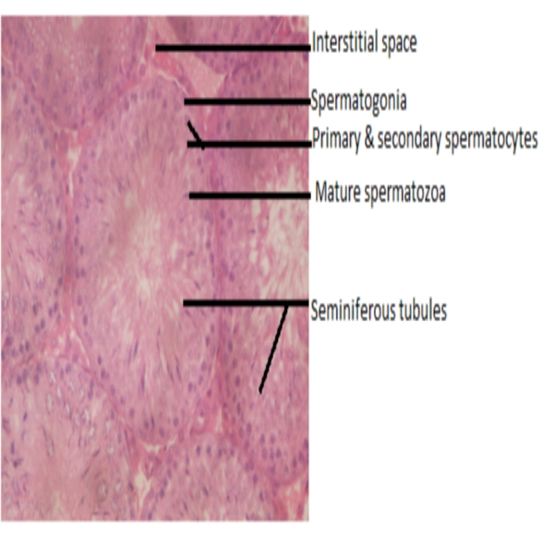

Plate 1: photomicrograph of the testes of control rat. (H and E staining, 400x) stain. (H and E staining, 400x) stain. Normal seminiferous tubule, spermatocytes, and intact spermatogonia.

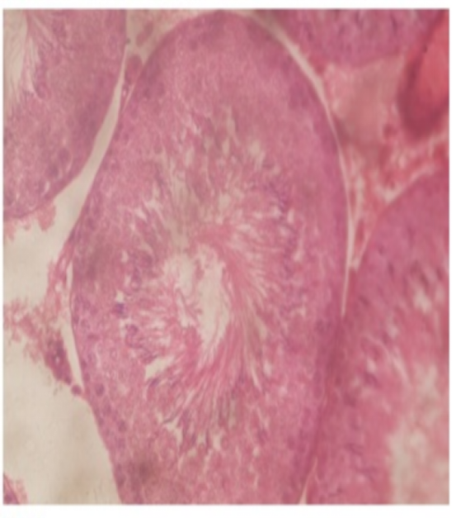

Plate 2: photomicrograph of group 2 rat. (H and E staining, 400x). Normal seminiferous tubule, spermatocytes, interstitial cells and space and intact spermatogonia.

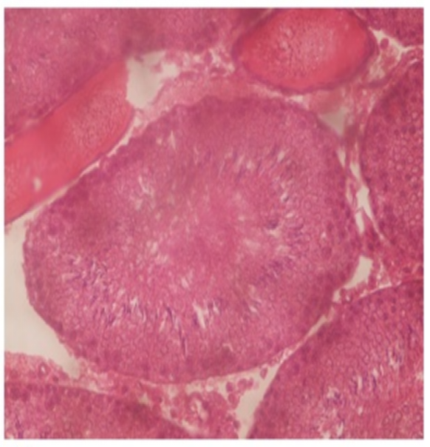

Plate 3: the photomicrograph of group 3 rat. (H and E staining, 400x). Normal seminiferous tubule, spermatocytes, and distended spermatogonia.

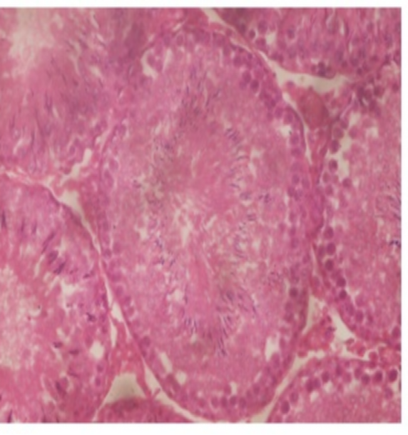

Plate 4: photomicrograph of group 4 rat (H and E staining, 400x). Showing normal seminiferous tubule, formation of new secondary spermatocytes, and proliferated spermatocytes.

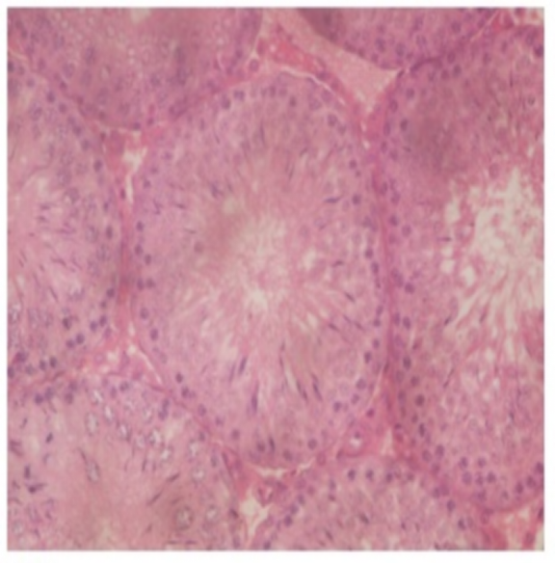

Plate 5: photomicrograph of group 5 rat (H and E staining, 400x) stain. Improved seminiferous tubule, primary and secondary spermatocytes and intact interstitial cells.

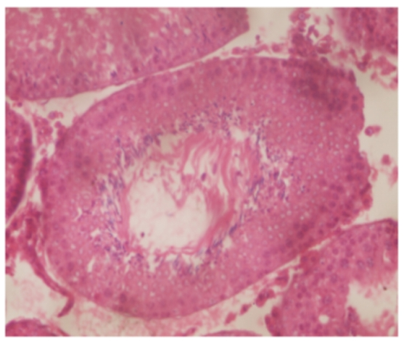

Plate 6: photomicrograph of group 6 rat (H and E staining, 400x). Mild inflammation seminiferous tubule, spermatogonia, interstitial cells, primary and secondary spermatocytes and intact interstitial cells.

**DISCUSSION**

This study clearly demonstrated that the mixture of tiger nuts and Date flour enhanced the sperm quality and quantity. This is obvious in the sperm Volume, viability, normal morphology, motility and sperm count, which increased across all groups. This might be due to the presence of flavonoids a good antioxidant, which was present in both samples. Antioxidants have been shown to improve key steps in spermatogenesis, steroidogenesis (Sheweita *et al.*, 2005). Similar report was obtained by Biglari (2009), who confirmed that Dates are made up of phenolic compounds and flavonoids which provide antioxidant activities, also a report by Bennet *et al.,*(1966) and Mahran *et al.,*(1976) indicated that Date palm contains estradiol and flavonoid components which has helpful effects on sperm quality. Ekaluo *et al.,*(2015) used an aqueous extract of tiger nuts and confirmed that tiger nut extracts have the capability of enhancing sperm count and quality and hence can improve fertility and ease toxicity on sperm. When combined with Dates flour, tiger nuts flour increased the sperm count and quality more than when the two samples were used separately.

Testosterone is the major male hormone it works with FSH to initiate and maintain spermatogenesis. In this study, the significant increase in testosterone and Follicle Stimulating hormone (FSH) observed in Group VI and the notable increase though not significant seen in Group V might be linked to the ability of the mixture therapy of Dates and tiger nut flour having androspermatogenic potentials. Also in agreement with (Allouh et al., 2015), Tiger nuts increased testosterone levels in male Wistar rats because it has quercetin which is a phytoestrogen that induces a stimulatory effect on Steroidogenesis.

Normal spermatocytes, seminiferous tubules, and spermatogonia of the group given the formulated diet were histologically shown in Plates 2-6 to have no pathology when compared to the control Plate 1. This proves that the feed mixture is histopathologically safe for the testes.

**CONCLUSION**

The use of Tiger nuts and Dates to improve sperm quality and quantity in male Wistar rats resulted in the regeneration of the sperm cells of the rats as can be evidenced in their volume, viability, morphology, motility, and sperm counts.

The combined use of Dates fruit and tiger nuts in Wistar rats is a better option in enhancing male reproductive functions as their use does not create or pose great risk to the testes.

In improving fertility, Tiger nuts alone and in combination with Dates enhanced the sex hormones (Testosterone and Follicle Stimulating Hormone) responsible for male fertility.

**RECOMMENDATION**

* Further studies should be carried out on male rats involving the female rats too to ascertain their mounting frequency, intromission frequency and Ejaculatory frequency. Also studies to ascertain their mounting latency, intromission latency and ejaculatory latency should be carried out.
* The combination therapy of tiger nuts and Dates should be tried on patients with erectile dysfunction to ascertain its effects.

**CONTRIBUTION TO KNOWLEDGE**

The administration of the mixture of Tiger nuts and Dates fruit helped in improving the sperm quality and quantity, and also the levels of the reproductive hormones (FSH and Testosterone) of male Wistar albino rats

**DISCLAIMER (ARTIFICIAL INTELLIGENCE)**

Authors hereby declare that NO generative AI technologies such as Large Language Models (ChatGPT, COPILOT, etc.) and text-to-image generators have been used during the writing or editing of this manuscript.

**ETHICAL APPROVAL**

Approval and permission for animal studies was obtained Animal Ethics Committee of the University of Port Harcourt, Nigeria.

**HUMAN AND ANIMAL RIGHTS**

The care and use of animals was in compliance with the National Institute of Health Guide for the care and use of laboratory Animals (NIH, 1996).

**COMPETING INTERESTS**

Authors has declared that there are no competing interests.

**REFERENCES**

1. Ajiboye, T.O, Nurudeen, O.O, Yakubu, M.T (2014). Aphrodisiac effect of aqueous root extract of *Lecaniodiscus cupaniodes* in sexually impaired rats. *Journal of basic and clinical physiology and pharmacology.* **25**(2): 241-248.
2. Agim, Agaba, Eric, Ujah, Williams Oche, Sadeyeng Ernest Anani, Nsikak Michael Umoh, Eteng Katherine Kenyoh, Enang Kingsley Bassey, Christie Elum Fischer, Victor Adolf Fischer, and Emmanuel I. Odom, (2025). “Protective Effects of Flavonoid-Rich and Saponin-Rich Fractions from *Cyperus Esculentus* and *Phoenix Dactylifera* on Aluminum Chloride-Induced Testicular Damage in Male Wistar Rats”. Journal of Complementary and Alternative Medical Research 26 (3):18-34.
3. Allouh, M. Z., Daradka, H. M.,& Abu-Ghaida, J. H. (2015). “Influence of Cyperus esculentus tubers (tiger nut) on male rat copulatory behavior”. BMC Complementary and Alternative Medicine,15, 331.
4. Biglari, F. (2009). Assessment of Antioxidant potential of Date (Phoenix Dactylifera) fruits from Iran, Effect of cold storage and addition to minced chicken Meat; *Universiti Sains Malaysia.* P 17.
5. Carpentier, M. Sahpaz, S. and Bailleul, F. (2004). “Plants and Erectile dysfunction”, Phototherapy, Volume **3**, page 66-71.
6. Defelis M.S. (2002). Yellow nutsedge *Cyperus esculentus L*. Snack food of the gods. *Weed / Technology,* **16**:901-907.
7. Ekaluo, U.B, Ikpeme, E.V, Etta, S.E, and Ekpo P.B. (2015). Effect of Aqueous extract of Tiger nut (*Cyperus esculentus*) on sperm parameters and Testosterone level of male albino rats. *Asian Journal of Biotechnology* **7**(1): 39-45.
8. Izunwanne, D.I, Egwurugwu JN, Emegano CL., (2020). “Effect of Tiger Nut Meal on Some Sex Hormones and Sperm Cells in Androgen-induced Benign Prostate Hyperplasia in Adult Male Wistar Rats”. J. Adv. Medical Research;32(14):74-82.
9. Pascual B. Marto JV, Lopez-Galarza S, Sanbautista A, Alagarda J. (2000) Chufa *(Cyperus esculentus L. Varsativus Boeck)*: an unconventional corporation. Studies related to applications and cultivation. *Economic Botany*, **54**:439-448.
10. Sahari, M.A., Barzegar M. and Radfar R, (2007). Effect of Varieties on the composition of Dates *(Phoenix dactylifera L.)*. *Food Science and Technology International,* **13**:269-275
11. Sheweita, A.S, Tilmisany M.A, Al-Sawaf, H (2005). Mechanisms of male infertility: role of antioxidants. *Current Drug Metabolism* **6**:1-7.
12. Tuned-Akintunde Ty, Oke M.O (2012). Thin-layer drying characteristics of tiger nut *(Cyperus esculentus)* seeds. *Journal of food processing and preservation,* **36**: 457-464.
13. WHO (2000). Manual for standardized Investigation, Diagnosis and management of the Infertile Male, Cambridge. University Press, Cambridge, UK. Volume 2, Issue 4.