**Molecular Detection of Herpes Simplex 1, 2 and Human Cytomegalovirus in Chronic Periodontitis Patients in Khartoum State, Sudan**

**ABSTRACT**

**Background**

Herpes virus infected periodontal sites tend to show tissue breakdown more frequently than herpes virus free sites, and this active infection is associated with increased risk of progressive periodontal disease, Herpes viruses can reduce the host defense system via infecting and altering the functions of monocytes, macrophages, and lymphocytes as antigen presenting cells in periodontitis lesions and this effect may hamper tissue turnover and repair.

**Objective**

Study was aimed to detect the frequency of HSV 1, 2 and CMV in Sudanese patients with chronic Periodontitis infection.

**Materials and Methods**

The study was conducted in Khartoum state, during period from March 2022 to January 2023. 50 Saliva samples were collected from chronic Periodontitis infected patients, was extracted, and subjected to PCR test to detect the frequency of HSV 1, 2 and CMV in each sample.

**Results**

Three out of 50 patients with chronic Periodontitis the frequency of HSV 1, 2 was 06% (03/50), 2 cases were from 25-45 age group, one case was from 46-65 age group (P. value = 0.57), one case was male, while 2 cases were females (P. value = 0.33). While no CMV was found in their saliva samples.

**Conclusion**

The results of present study, reveal that the frequency of HSV 1, 2 among Sudanese patients with chronic Periodontal infection was low (06%), while CMV was not found.

**KEYWORDS: Herpes virus,** **chronic Periodontitis infection,** **lymphocytes,** **saliva**

**INTRODUCTION** :

“Periodontitis is a complex disease that is among the most prevalent microbial diseases and chronic inflammatory diseases worldwide, although the process of periodontitis is considered to involve a multi factorial interaction between microbial, host, and environmental modulating factors” **(1).** “Microbial agents are of key importance in the development of periodontitis. It is well accepted that periodontitis is associated with colonization of specific bacterial species upon the teeth surfaces. The bacteria involved are largely gram negative species that express pathogenic factors that elicit host defense responses resulting in inflammation and tissue destruction” **(2). “**Periodontal diseases are multi factorial, and many etiological agents are suggested to play a role in their etiopathogenesis. There are several risk factors which are associated with progression of periodontal disease. Even though, specific bacteria were considered as major pathogens for the disease, but, the occurrence of periodontal disease in some patient groups is still poorly understood, and the role of other initiating agents is being investigated. The virulence of infecting agents was also suggested as a major determinant in the onset and severity of periodontitis, as in any other human disease” (**3). “**Various studies have shown that human viruses, especially human cytomegalovirus (CMV), Epstein-Barr virus (EBV) and herpes simplex virus (HSV-1) seem to play a part in the pathogenesis of periodontal disease .The hypothesis of a correlation between CMV and EBV infection and the pathogenesis and progression of aggressive periodontitis has been proposed by various studies. Periodontal destruction may be associated with the coexistence of periodontal herpes viruses, especially CMV, EBV and periodontopathic bacteria. The herpes viral infection can stimulate the release of cytokines and chemokines from inflammatory and non inflammatory cells and impair the periodontal immune defense, resulting in more virulent resident bacteria” **(4)**. “But several studies have reported the absence of these specific bacterial species in patients with periodontal disease, and no significant difference has been found in the prevalence of bacteria between healthy and diseased periodontal tissues. It is becoming increasingly clear that some major clinical characteristics of periodontitis, such as, site specificity, self-limited progression and recurrence, are difficult to be explained simply by the theory of bacterial infection.

Periodontal disease is a microbial infection involving a variety of microbes that trigger inflammation, loss of connective tissue attachment and alveolar bone around the teeth” **(5).**

“Symptomatic apical peri­odontitis occurs within a previously healthy periodical region in response to either microbiological or physical irritation. Teeth with symptomatic apical periodontitis will have very marked tenderness to percussion and pain when pressure is applied to the tooth. It may or may not be associated with an apical radiolucent area. Acute periodical infection eventually turns into a chronic state predominated by macrophages, lymphocytes and plasma cells encapsulated in collagenous connective tissue. Asymptomatic apical periodontitis is a long-standing periapical inflammatory lesion with radio graphically visible periodical bone re sorption but with minimal or no clinical symptoms. Histopathologically, it consists of granulomatous tissue with infiltrate cells, fibroblasts, and a well-developed fibrous capsule .Viral infections may facilitate the destruction of periodontal tissue by lyticactivity against periodontal cells, immune mediated tissue destruction and immune suppression, which increase the susceptibility of the host to bacterial attacks. Cytomegalovirus (CMV) and Epstein-Barr virus type 1 (EBV-1) assume a particularly close relationship with human periodontitis while herpes simplex virus (HSV), human herpes virus 6 (HHV-6) and EBV-2 seem to exhibit little or no association with most types of periodontitis disease” **(6)**. “Individuals with periodontal lesions may harbor millions of genomic copies of herpes viruses, papilloma viruses, human immunodeficiency virus (HIV), human T-lymph tropic virus type 1, torqueteno virus, and hepatitis B and C viruses, as they were detected in periodontal infections. Thus, reactivation of these viruses may initiate or accelerate periodontal tissue destruction by lyticactivity against periodontal cells, immune mediated tissue destruction and immune suppression, which elevates the susceptibility of the host to bacterial attacks and increases virulence of local pathogenic bacteria. Therefore, the evolution of periodontal disease depends upon: periodontopathic properties such as virulence factors and an anaerobiosis; local host immune responses that activate innate immune system cells which include macrophages, dendritic cells, natural killer cells, neutrophils, osteoclasts and furthermore humeral response via B-cells: oral cavity environmental changes such as smoking, diabetes and nutrition”**(7).**

**Herpes viruses**

“Viruses of the family Herpes viridae are widespread in the human population. The prototypical structure of herpes viruses consists of a double-stranded DNA genome encased within an icosahedral capsid, a proteinaceous tegument and a lipid-containing envelope with embed­ded viral glycoproteins. Herpes simplex virus-1, herpes simplex virus-2, varicella–zoster virus, EBV, CMV, human herpesvirus-6, human herpesvirus-7 and human herpesvirus-8. The initial herpes virus infection is followed by a latent phase in host cells, which ensures the survival of the viral genome throughout the lifetime of infected individuals. Herpes virus reactivation may oc­cur spontaneously or as a result of concurrent infection, fever, drugs, tissue trauma, emotional stress, and other factors impairing the host immune defense. Herpes viruses express proteins during the normal lytic and latent viral life cycle that can interfere with activi­ties of the innate and adaptive immune systems and alter the cellular environment” **(8).** They are transmitted from person to person during the period of primary infection or re activation .Salivary glands are reservoir for salivary herpes viruses.

“All human herpes viruses measure approximately 200 nm in diameter and contain a linear, double stranded DNA core of approximately 150 kilo base pair (Kbp) enclosed within a protein capsid , covered by a tegument and a glycoprotein-containing envelope. The expressed pattern of alpha, beta, and gamma genes respectively control translation of viral genome, transcription of proteins essential for viral DNA synthesis, and collection/exit of viral particles from the infected cell.HSV 1 and 2 are considered less aggressive than other human herpes viruses on the basis of their virulence potential in tissue culture demonstrated as viral cytopathy. Although HSV-1 and HSV-2 serotypes share similarities in their DNA sequence, they are anti genetically distinct because of their different envelope proteins .Biological features unique to herpes viruses include latency and reactivation. Initial exposure to herpes viruses often leads to viral invasion of epithelial cells and intracellular replication at the site of primary exposure. Irrespective of clinical symptomatology, after primary infection, herpes viruses ascend in a retrograde manner through the periaxonal sheath of sensory nerves to the trigeminal, cervical, lumbosacral, or autonomic ganglia of the host nervous system. There, virus replicates, is sequestered from the host immune surveillance, and persists in a dormant state for life. The trigeminal and sacral ganglia are the most common location for HSV1 and HSV2 latency, respectively” **(9). “**Herpes viruses have been linked with malignant diseases in humans and lower animals: EBV with Burkittlymphoma of African children, with nasopharyngeal carcinoma, and with other lymphomas; KSHV with Kaposi sarcoma; Mare disease virus with a lymphoma of chickens; and a number of primate herpes viruses with reticulum cell sarcomas and lymphomas in monkeys” **(10).**

**Herpes simplex virus**

“HSV belongs to the alpha herpes viridae and is a member of the double-stranded DNA virus family. It consists of an envelope with different glycol proteins (gG) and spikes (gD, gB) and has a diameter of 100 nm. HSV type 1 (HSV1) is an orofacial virus whereas HSV type 2 (HSV2) primarily infects the genital region. However, infections of the genital region by HSV1 and orofacial region by HSV2 do occur. The genomes of HSV1 andHSV2 have nearly 50% nucletotide identity. Seroprevalence of HSV is high and is estimated to be about 80–90% for HSV1 and 12–15% for HSV2 in some studies”**(11).**

**Human cytomegalovirus**

“Human cytomegalovirus (HCMV), also called Human Herpes virus 5 (HHV5), belongs to the β-*herpesviridae* family and, as all herpes viruses (HV), is able to establish life-long latency in infected individuals. CMV is the largest HHV with a double stranded DNA genome of about 240kb. It is usually transmitted through body fluids such as saliva, urine or breast milk but also through sexual contacts. Primary infection is generally benign or silent in healthy individuals but may be much more serious and even life threatening in immuno-compromised patients, especially those having received hematopoietic cells or solid organ transplants, or AIDS patients. The virus is also able to cross the placental barrier and primary CMV infection during pregnancy, mainly during the first quarter, is the leading cause of birth defects, with an estimation of one million CMV congenital infections worldwide per year” **(12).**

“Cytomegalovirus is a common herpes virus. Many people do not know they have it, because they may have no symptoms. But the virus, which remains dormant in the body, can cause complications during pregnancy and for people with a weakened immune system. The virus spreads through bodily fluids, and it can be passed on from a pregnant mother to her unborn baby” **(13).**

**MATERIALS AND METHODS:**

The study is descriptive, cross-sectional study design, conducted in Dental Teaching Hospital in Khartoum State, during the period from March 2022 to January2023.

The study recruited 50 chronic Periodontitis patients who were attended dental care center. All patients that diagnosed with chronic periodontitis during the period from March 2022 to January 2023, given oral informed consent were included in this study, otherwise were excluded**.**

The study was approved by Department of Medical Microbiology Faculty of Medical Laboratory Sciences, Al-Neelain University, and verbal consent was taken before sample collection.

A total of 50 saliva sample were collect from periodontitis patients in this study and stored at -200c.

Clinical examination depended on plaque index, gingival index, bleeding on probing, probing pocket depth and clinical attachment level at 4 sites for all teeth except 3rdmolar. All patients had periodontal pocket equal or greater than 4mm with clinical attachment loss.

All participants were instructed not eat or drink at least 1 hr prior to donation of saliva, after mouth rinse several times with sterilized water, 5 ml saliva were collected into container with viral transport media and used for DNA extraction and conventional PCR.

Data were collected through a structured questionnaire, information on age; gender.

**DNA Extraction Kit (Patho Gene-SpinTM DNA/RNA Extraction Kit)**

DNA was extracted using **Patho Gene-SpinTM DNA/RNA Extraction Kit**). 300 µl of sample were added to 1.5 micro centrifuge tube, and 600 µl of lysis buffer and the mixture was vortexes for 15 sec. The mixture was then incubated at RT (150-250 C) for 10 min, then 600ul of Binding Buffer were added and mixed well by vortexing. Carefully the mixture was added to the spin column (in a 2 ml collection tube), cap was closed, and then centrifuged at 13000/1 min. The filtrate was discarded and spin column were placed in clean 2 ml collection tube. Carefully 500 µl of washing buffer was added to the spin column and the columns were centrifuged at 13000/1 min. After discarding the filtrate, 500 µl of washing buffer B was added to the spin column and the columns were centrifuged at 13000/1 min. Then spin columns were placed in a clean 2 ml collection tube, centrifuged at 13000/1 min. Finally, the spin column were placed in 1.5 ml micro centrifuge tube and 30-60 µl of Elution Buffer was added to the columns, incubated at room temperature (15-25 c) for 1 min and centrifuged at 13000/1 min to obtain DNA. The extracted DNA was stored at -20 ºC until used.

**Conventional Polymerase Chain Reaction (PCR) Assays**

The PCR was performed by processing the extracted DNA from saliva with primers that are specific for the HCMV and HSV I. The primers used consisted of forward primer 5'- GGA TCC GCA TGG CAT TCA CGT ATG T-3', and reverse primer, 5-GAA TTC AGT GGA TAA CCT GCG GCGA-3.The reaction was performed in 25μl volume using Solis Bio dyne master mix. The volume included: 4 μl master mix, 1 μl forward primer, 1 μl reverse primer, 3 μl extracted DNA and 13μl distilled water. The DNA was amplified in thermo- cycling conditions using PCR machine Techno (Japan) as follow: initial denaturation at 95°C for 10 min, followed by 35 cycles of denaturation at 94°C for 45 sec, annealing at 58°C for 50 sec and extension at 72°C for 45 sec, with a final extension 72°C for 5 min.

**Visualization of products**

10 μl of the amplified product was subjected to direct analysis by gel electrophoresis in 2% Agarose, the gel was prepared by adding 0.7 g of Agarose to 35 ml 5X Tris Borate EDTA buffer. The product was visualized by staining with 0.15% Ethidium bromide using UV gel documentation system UV SOLO TS. The expected size of surface antigen gene amplicon was 406bp for CMV and 200 bp for HSV 1, 2.

Collected data were analyzed by the statistical package of social science (SPSS, version 20), cross tabulation was used to determine the association between the presence of these viruses with age, gender and duration of the disease, Chi-square statistical analyses was used to determine *P* value to detect the statistical significance.

**RESULTS**

In this study, 50 patients with chronic Periodontitis infection from different Khartoum State Dental Hospitals were enrolled to detect the frequency of CMV and HSV 1, 2 in their saliva, 30 (60%) of them were males, and 20 (40%) were females, with age range from 25 to 80 years, mean age 52.9 years old.

Out of 50 patients with chronic Periodontitis the frequency of HSV 1, 2was 06% (03/50), 2 cases were from 25-45 age group, one case was from 46-65 age group, one case was male, while 2 cases were females. while no CMV was found in their saliva samples. (Table 1),

Out of these three positive patients to HSV 1, 2 02/21 (09.5%) were within age group 25-45 years, and one 01/19 (05.3%) patient was within age group 46-65 years, but there is no positive sample within age group 66-85. the study showed insignificant difference between age groups and the presence of HSV 1, 2 (P*.* value= 0.57). (Table 1)

The study found that one case 01/30 (3.4%) was contain HSV 1, 2 from male group, while in female group there were two cases 02/20 (10.0%) their saliva contain HSV 1, 2, also statistically there was insignificant difference between each gender and the presence of HSV 1, 2 (P. value = 0.33) (Table 1).Gel electrophoresis is presented in (Figure 1,2)

Table 1: The frequency of HSV 1, 2 and CMV in saliva

|  |  |  |  |  |  |  |
| --- | --- | --- | --- | --- | --- | --- |
| **Variable** | | **HSV 1,2** | | **CMV** | | **Total** |
| **Detected** | **Not detected** | **Detected** | **Not detected** |
| Age | 25-45 | 02 (9.5%) | 19 (91.5%) | 00 | 21 (100%) | 21 |
| 46-65 | 01 (5.3%) | 18 (94.7%) | 00 | 19 (100%) | 19 |
| 66-85 | 00 (00%) | 10 (100%) | 00 | 10 (100%) | 10 |
|  | | 03 | 47 | 00 | 50 | 50 (100%) |
| Gender | Male | 01(3.4%) | 29(96.6%) | 00 | 30(100%) | 30 |
| Female | 02(10.0%) | 18(90.0%) | 00 | 20 (100%) | 20 |
|  | | 03 | 47 | 00 | 50 | 50 (100%) |

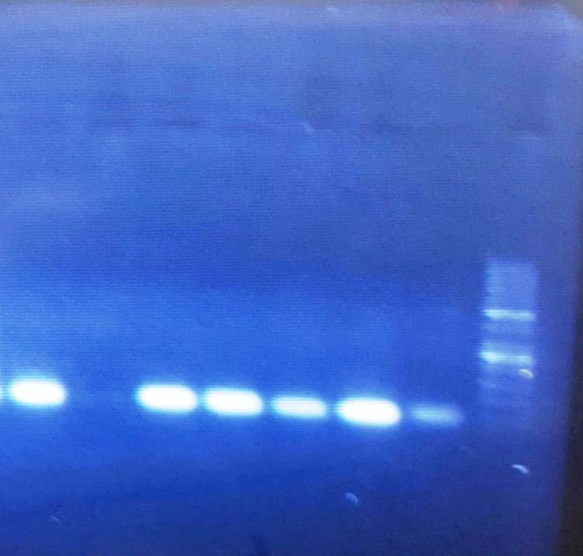

Figure:1 Gel electrophoresis of CMV PCR product. Lane no. 1 contains 100-bp DNA ladder. Lane no. 2 contains control negative, other lanes negative samples for CMV. (Band appears at 406bp).

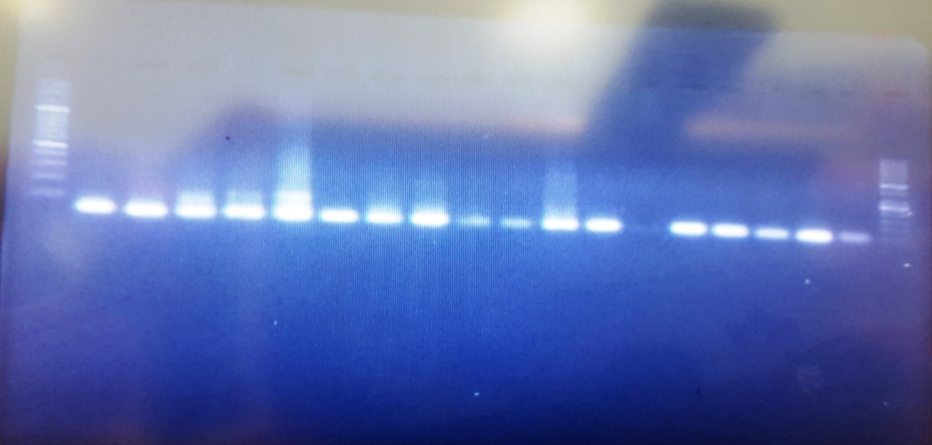

Figure: 2 Gel electrophoresis of HSV 1,2 PCR product. Lane no. 1 contains 100-bp DNA ladder. Lane no. 2 contains control negative, other lanes contains positive and negative samples for HSV 1,2. (Band appears at 200bp).

**DISCUSSION**

“Various studies have shown that human viruses, especially human cytomegalovirus (CMV), Epstein-Barr virus (EBV) and herpes simplex virus (HSV-1) seem to play a part in the pathogenesis of periodontal disease. The hypothesis of a correlation between Herpes Viruses infection and the pathogenesis and progression of aggressive periodontitis has been proposed by various studies” **(4)**.

The current study was conducted in Khartoum State during period from 50 Sudanese patients with chronic periodontitis were enrolled, 30(60%) of them were males and 20(40%) were females, age range from 25 years to 80 years with mean age 52.9 years old.

In a study done by (**14),** in which they found that wide variation in the occurrence of HSV (13%), EBV (3%), and CMV (0.3%) which is closely similar to the present findings in which HSV (06%), CMV was (00%).

In a study done by (**15**) from different countries, in which he reported that CMV and HSV-1 yield median frequency of 40% and 45% respectively in patients with chronic periodontitis, which is higher than the frequencies obtained from the present study, CMV (00%) while HSV 1, 2 (06%), since the study of Jorgen, done in a wide range with different populations groups.

The present study found that the frequency of CMV in chronic periodontitis was (00%) which is totally differ from study done by **(2**) in which she observed that the percentage of study group who were positive for CMV was (22.6%).

Finally; these findings should highlight the need for the establishment in Sudan of rapid, sensitive, and specific diagnostic techniques (such as ones used here) in suffer for better management of chronic periodontitis infections especially in the high risk groups (infants, elderly and immunocompromised patients). To our knowledge this is the first attempt to identify the causative viral agents of chronic periodontitis in Sudan by using molecular techniques. The results obtained should call for wider surveillance at the national level in order to fully elucidate the true status and epidemiology of CMV, HSV1, 2 and other herpes viruses in Sudan.

**CONCLUSION**

In conclusion, the present study found that the frequency of HSV1, 2 in patients with chronic periodontitis was low, while no positive results was detected with CMV. Incidence and existence of HSV1, 2 in Sudan was documented through detection of HSV1 indicating high prevalence among chronic periodontitis patients in Sudan. Moreover, the CMV and HSV1, 2 detection using PCR was Generally, these findings are useful for future studies since there is little available information about CMV and HSV1, 2 infection in chronic periodontitis patients in Sudan.

Ethical Approval And Consent:

The study was approved by Department of Medical Microbiology Faculty of Medical Laboratory Sciences, Al-Neelain University, and verbal consent was taken before sample collection.

**Conflict of interest statement**

We declare that we have no conflict of interest and NO generative AI technologies such as Large Language Models (ChatGPT, COPILOT, etc.) have been used during the writing or editing of this manuscript.

**Disclaimer (Artificial intelligence)**

**Option 1:**

**Author(s) hereby declare that NO generative AI technologies such as Large Language Models (ChatGPT, COPILOT, etc.) and text-to-image generators have been used during the writing or editing of this manuscript.**

**Option 2:**

**Author(s) hereby declare that generative AI technologies such as Large Language Models, etc. have been used during the writing or editing of manuscripts. This explanation will include the name, version, model, and source of the generative AI technology and as well as all input prompts provided to the generative AI technology**

**Details of the AI usage are given below:**

**1.**

**2.**

**3.**

**References :**

1- **Ce Zhu, Li F, Wong M.C.M, Feng X-P, Lu HX, Xu W**. (2015), Association between Herpes viruses and Chronic Periodontitis: A Meta-Analysis Based on Case-Control Studies. *PLoS ONE*, **10**(12): e0144319.

2- **Wasan A and Dawood S.**(2014), Detection of CMV DNA in Chronic Perodontitis Patients by Real time PCR and its relation with the severity of disease, *AJPS*, **14**:26-11.

3- **Zaveri H, Rathva V, Sant A and Dave D**. (2016), VIRUSES: Aconundrum In Periodontal Diseases' –A Review, *International Journal of Oral and Maxillofacial Diseases;***1**(1):14-21.

4- **Kolliyavar B, Setty S and Thakur S.**(2014), Detection of Human Cytomegalovirus (Hcmv) Epstein Barr Virus (Ebv) and Herpes Simplex Virus (Hsv) in Periodontal Disease and Effect of Scaling and Root Planing (Srp) on the Presence of These Viruses. *Indian Journal of Applied Research*, **4**(12): 49-55.

5- **Ana V, Sabrina R, Nivea M, Osmar O, Roberto F and Fabio D.**(2008), Detection of Epistein Barr Virus and Human Cytomegalovirus in Blood and Oral Samples: Comparison of Three Sampling Method. *Journal of Oral Science*:**50**(1), 25-31.

6- **Tantivanich S, Laohapand P, Thaweeboon S, Desakorn V, Wuthinuntiwong P, *et al,***(2004), Prevalence of HCMV, HHV-6 and EBV in Periodontitis Patients and healthy Subject in the Thai population, *South east Asian Journal,,***35**(3), 635-40

7- **Mahmoud Y and Zeyad T.**(2014), Chronic Periodontitis and Herpes Viruses, *Journal of Human Virology &Retro virology*, **1**(2): 00-7.

8- **Ozbek SM, Ozbek A, Yavuz MS.**(2013), Detection of human cytomegalovirus and Epstein-Barr Virus in symptomatic and asymptomatic apical perio­dontitis lesions by real-time *PCR. Med Oral Patol Oral Cir Bucal*; **18**(5):811-6.

9- **Fatahzadeh M and Robert A.** (2007), Human herpes simplex virus infections :Epidemiology, pathogenesis, symptomatology, diagnosis, and management, *American Academy of Dermatology*, **57**:737-63**254**

10- **Brooks F, Stephen A, Karen C, Timothy A and Janet S.**(2013), Herpes Viruses in *Medical Microbiology,* Mc Grow Hill, New York, 26th edition.467.

11- **Bussmann C,Peng W, Bieber T and Novak N.** (2008),Molecular pathogenesis and clinical implications of eczema herpeticum, *expert reviews in molecular medicine*,**10**(21): 800-756.

12- **Mariamé B, Sandrine K, Martin K, Stéphanie B, Franck G and Kerstin B**. (2018), Real time visualization and quantification of human Cytomegalovirus replication in living cells using the ANCHOR DNA labeling technology ,*Journal of Virology*, **11**(28):571-18.

13- **Luo X,** (2017), Symptoms, causes and treatment for herpes, *Medical News Today*, 13.

14- **Imbronito A, Okuda O, Maria N, Moreira F and NunesD**. (2008), Detection of herpes viruses and periodontal pathogens in sub gingival plaque of patients with chronic periodontitis, generalized aggressive periodontitis or gingivitis. *J Periodontol*; **79**: 2313–2321.

15- **Jorgen S.**(2015), Periodontal herpes viruses: Prevalence, pathogenicity, systemic risk, *Periodontology*, **69**(1):12085.