Regeneration of Embryogenic Cells and Haustorium-Like Structures of Dua Xiem Xanh (Dwarf Green Xiem Coconut) Sourced From Go Cong Province of Vietnam

ABSTRACT
Aim: Coconut is one of the most valuable crops, producing remarkable products. The Vietnamese Xiem Green Dwarf variety sourced from Go Cong province is particularly renowned for its use in fresh coconut water production. With the growing demand of seedling for coconut production and decline in crop yields, it is essential to focus on coconut cultivation.
Methods: Somatic embryogenesis offers a promising solution for this issue. This study evaluates factors: including plumule maturity, sucrose supplementation in culture media, and the effects of TDZ. Coconut embryos were pre-cultured for germination at four durations: 0, 7, 14, and 21 days, before the plumules were excised and used as explants for callus induction. To assess the impact of sucrose on callus formation, three different sucrose concentrations were tested: 30, 45 and 60 g. The embryogenic callus that developed was then cultured in a plant growth regulator-free medium before the regeneration stage. To promote somatic embryo development and germination, TDZ was tested at various concentrations.
Results: The results indicate that 14-day plumule maturity and 45 g of sucrose were optimal for callus induction. Additionally, TDZ showed a significant effect on generating coconut somatic embryos, with the best results observed at concentrations ranging from 25 µM to 50 µM.
Conclusion: This research established a somatic embryogenesis protocol for the Vietnamese Xiem Green Dwarf variety, considering new factors for coconut improvement.

Key words: Coconut, embryogenic cells, plumule, germination, sucrose concentration, thidiazuron (TDZ)

1. Introduction
Coconut palm (Cocos nucifera L.) is the solely known species within the monotypic genus Cocos of the Arecaceae or Palmae family (Chan and Elevitch 2006) [1]. Coconut exhibits a wide geographic distribution, this palm can be found in numerous tropical and subtropical countries, inhabiting various biomes, ranging from coastal regions to mountainous terrains (Thomas et al. 2019 [2]; Foale et al. 2020 [3]). The extensive advantages of this crop, including its utility in food, beverages, medical treatments, and high-value byproducts, have led to its industrial cultivation in more than 90 countries (Samosir and Adkins 2014) [4], benefiting over 10 million families economically (Rethinam 2018 [5]). In recent years, demand for coconut products has profoundingly escalated, especially coconut oil and coconut water, for their recognized health promoting capabilities and diversity application food & beverage and personal care industries (Lockyer and Stanner 2016 [6]; Samarajeewa 2024 [7]). In 2024, global coconut products market was valued at more than 21 billion USD and was predicted to reach 53 billion USD in 2033 (IMARC group 2024 [8]). The escalating annual demand for coconut products necessitated strategic expansion of coconut cultivation to ensure a stable supply of high quality planting materials to sustain future production.
Unfortunately, cultivated coconut population is decreasing at an alarming pace, driven by multiple factors, including an aging population of coconut trees, pest attacks, disease outbreaks, and the adverse effects of global warming (Gurr et al. 2016 [9]; Vadamalai et al. 2017 [10]; Silva et al. 2017 [11]; Tzec-Simá et al. 2022 [12])., Until today, traditional plantation methods and breeding program using seed is still the most common coconut propagation technique used and have been deeply studied (Batugal et al. 2009 [13]; Perera 2016 [14]). However, traditional breeding methods necessitated prolonged cultivation periods, substantial land allocation for trials (Adkins et al. 2020 [15]; Arhin et al. 2023 [16]). Futhermore, the method is low seed-to-plantlet ratio, with each seed yielding only one plantlet yet while not all seed would germinate add another layer of complexity to the process (Ledo et al. 2001 [17]; Beveridge et al. 2022 [18]). Therefore, advanced techniques using tissue culture including have been studied contributed significantly to coconut propagation. The first attempt in in vitro coconut cultivation through zygotic embryo culture occurred in 1954 (Cutter, and Wilson 1954 [19]). Since then, many studies on coconut embryo culture have been conducted to provide the most optimal growing conditions and procedures (Sisunandar et al. 2018 [20]; Lédo et al. 2019 [21]). Eventhough embryo culture improved greatly coconut germination rate while requiring small working area, it is still 1:1 seed-to-plantlet ratio (Nguyen et al. 2015 [22]).
Somatic embryogenesis was introduced to coconut propogation since 1977 and have been proved to be a promosing technique for coconut micropopagation (Eeuwens and Blake 1977 [23]; Sáenz et al. 1999 [24]). SE is defined as a process by which somatic cells differentiate into somatic embryo (von Arnold et al. 2002 [25]). For almost five decades, somatic embryogenesis has been applied to numerous coconut varieties and retrieved prevalent remarkable accomplishment (Kalaipandian et al. 2021 [26]). In Vietnam, somatic embryogenesis has been studied and applied to high value Makapuno coconut and somatic plantlets have been developed (Phạm 2022 [27]; Nam 2024 [28]).
The focus of this study was the Vietnamese Xiem Green Dwarf (XGD) coconut variety, a well-established and widely cultivated cultivar in Ben Tre Province (Lệ 2010 [29]). XGD water , famous for its mild-sweetness and distinctive flavor, is water enjoys widespread popularity domestically and serves as a major source of export revenue (VITIC 2018 [30]; An Hoà 2023 [31]). Until now, XGD was still being cultivating using conventional method. In this experiment, somatic embryogenesis was applied to this variety in order to establish a protocol. Plumule maturity and sucrose concentration was tested to identify their effect on callus induction and TDZ was used to test plant regeneration
2. Material and Methods
2.1 Plant materials
Xiem Xanh Dwarf coconut fruits that aged 10 to 12 months were selected in Go Cong Province. The husked coconuts were transported to Plant Biotechnology laboratory, Internation University. The drupes were broken in halves and an cork borer was used to harvest embryo-containing endosperm. The plugs were washed with 70 % ethanol for one minute and rinsed with sterilized distilled water three times. Under aseptic condition, embryos were carefully removed from the endosperm plugs and were sterilized with 0.6 % Ca(ClO)₂ solution for 10 minutes and were rinsed with sterilized distilled water three times (Tran 2023 [32]).
2.2 Effect of plumule maturity on formation of initial callus and primary embryogenic callus
In this experiment, sterilized embryos were cultured in germination medium containing: Y3 basal salt (Eeuwens 1976 [33]) supplemented with 5 µM 6-benzylaminopurine (BAP), 30 g L¹ sucrose, 1 g L⁻¹ activated charcoal (AC,Sigma, Product number C9157, Series number 102004011) and 2 g L⁻¹ Phytagel (Sigma, Product number P8169, Series number 101938611) (Tran 2019 [34]). Embryos were incubated in complete darkness environments, temperature at 27 ± 2 °C.
Embryo cultivation periods were 0 - 7 - 14 - and 21 days. At each period, plumules were excised and transferred to callus induction medium containing: Y3 basal salt, 600 µM 2,4D supplemented with 30 g L¹ sucrose, 2.5 g L⁻¹ AC, 2.5 g L⁻¹ phytagel (Pérez-Núñez et al. 2006 [35]; Sáenz et al. 2018 [36]). Excised plumules were continued incubated in no light condition with temperature maintained at 27 ± 2 °C for 12 weeks. Each treatment had 3 replications. Percentages of initial callus and embryogenic callus induction were collected after week 12.

2.3 Effect of supplemented sucrose concentrations on formation of callus induction
After sterilization process, embryos were cultured in germination media with similar components with previous experiment, and were supplemented with 3 sucrose concentrations: 30 - 45 and 60 g L⁻¹. Embryo culture were occurred in absence of light area, with temperatures remained at 27 ± 2 °C for 14 days.
Following this, after 2 weeks, developed plumules were excised and aseptically transferred to callus induction media. The excised callus was incubated in darkness for 12 weeks, under temperature of 27 ± 2 °C. Primary embryogenic callus was subcultured with identical mediua composition and cultivated for 8 -10 weeks (Pérez-Núñez et al. 2006 [35]). Each treatment had 3 replications. Percentages of initial callus and primary embryogenic callus were collected at week 12; and data of secondary embryogenic callus were collected right before next subculture.
For next subculture, embryogenic callus were cultured in callus induction medium with 45 g L⁻¹ of sucrose to maintain callus line.
2.4 Effect of thidiazuron on somatic embryo regeneration
From each subculture cycle, several embryogenic callus structures were selected as explants for subsequent regeneration experiment and others were remain in callus multiplication culture to maintain callus lines.
Selected embryogenic callus masses were cultured in maturation medium formulated with Y3 basal salt supplemented witn 45 g L⁻¹ sucrose, 2.5 g L⁻¹ AC and 7.5 g L⁻¹ agar agar (Hai Long agar powder). The callus masses were placed in this medium for 4 weeks in dark incubator with temperature remained at 27 °C .
After 4 weeks, they were transferred to regeneration media containing Y3 basal salt, 45 g L⁻¹ sucrose, 2.5 g L⁻¹ AC and 7.5 g L⁻¹ agar supplemented with 300 µM BAP or TDZ with different concentrations: 0 – 25 – 50 – 100 - and 150 μM. The cultures were placed in dark incubator for first 4 weeks, then in 16/8 light conditions for another 4 weeks. Data were collected before the samples were subcultured.
Subcultures were performed every 2 months for 3 times. Coconut somatic embryogenic plantlet were cultured medium containing 5 μM BAP for 6 months.

Data analysis
The raw collected data were processed in excel. SPSS v.22 program was used to perform ANOVA. However, the shortage of samples and time limitation, the data from maturation experiment did not analyze by ANOVA, the result showed the average of replicates.
3. Results
3.1 Embryogenic callus induction of Vietnamese Xiem Green Dwarf Coconut
Excised plumules from precultured embryos were cultured in high 2,4D concentration medium for 12 weeks for callus induction. After first 4 weeks, initial callus were observed at rised from plumular explants, appeared as small, white structure with smooth surface. The formation of initial indicated the positive responses to auxin and possibility for growth of embryogenic callus. At week 8, formation embryogenic callus was visually apparent in some samples.
Embryogenic callus can be distinguished by its translucent appearance, smooth surface and characteristic ear-shape or globular (Sáenz et al. 2006 [37]). However, several initial callus had become non-embryogenic callus. Non-embryogenic callus encompassed all callus tissues that did not exhibit these specific morphological characteristics. Figure 1D and 1E demostrated two types of non-embryogenic callus, browning color, rough surface or sponge like. After 12 weeks of culture, Figure 1C shown embryogenic callus developed fully, globular embryogenic callus were also detected. Callus was then subculture to new medium, in order to maintain and enhance the embryogenic capacity. Similar growth rate also observed on several dwarf coconut varieties such as Malayan Yellow Dwarf or Chowghat Orange Dwarf (Pérez-Núñez et al. 2006 [35]; Greeshma et al. 2018 [38]).
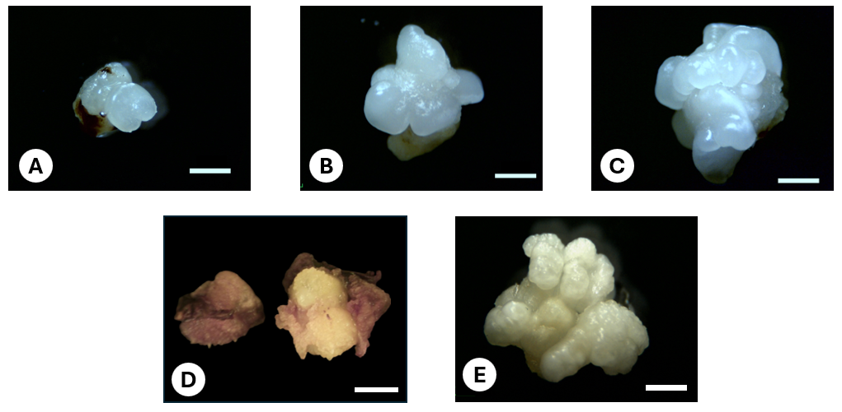
Figure 1: Primary embryogenic callus initiation and development after 4 weeks (A), 8 weeks (B) and 12 weeks (C) in culture medium containing 600 μM 2,4D. Browning non-embryogenic callus (D) and spongy texture non-embryogenic callus (E). Scale bar = 3 mm
3.2 Effect of plumule maturity on embryogenic callus induction of Vietnamese Xiem Green Dwarf coconut.
In this experiment, plumules with 4 maturity periods (0 - 7 - 14 - and 21 days) were cultured in callus induction medium for 12 weeks. After 12 weeks, iembryogenic callus were visibled in all 4 treatments but effect of plumule maturity on embryogenic callus induction formation rate was distinguished.
Table 1: Percentage of initial callus and embryogenic callus formation induced from pre-culture embryo excised plumules.
Plumule maturity  (day) | Initial callus formation  (%) | Embryogenic callus formation (%)
0 | 71.43c ± 2.75 | 25.40b ± 1.59
7 | 75.93bc ± 1.85 | 29.63ab ± 1.85
14 | 91.92a ± 1.01 | 35.35a ± 1.01
21 | 83.33ab ± 3.33 | 6.67c ± 3.33

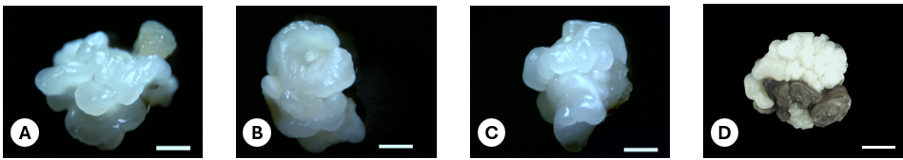
Figure 2: Primary embryogenic callus induction after 12 weeks from 4 plumule maturity treatments: 0 day (A), 7 days (B), 14 days (C) and 21 days (D)
The rate of callus formation demonstrated a positive correlation with the duration of embryo preculture, attaining a maximum at 14 days, followed by a subsequent decline. Initial callus and embryogenic callus formation rate from treatment 14 days had highest percentages: 91.92 ± 1.01 % and 35.35 ± 1.01 % prespectively. Embryogenic callus from 14-day treatment were covered in translucent embryogenic callus with both ear shape and globular shape structure (Figure 2C). 21-day plumule maturity treatment had the lowest embryogenic callus formation rate with 6.67 ± 3.33 %. Treatment 21-day plumule maturity was out-numbered with non-embryogenic callus Figure 2D). Embryogenic callus formation was at the lowest when using plumules excised from 21-day pre-culture embryo with 6.67 ± 3.33 %. Ear-shaped embryogenic callus were all well- developed and observed in 0-day and 7-day treatments (Figure 2A and 2B) with formation rate of 25.40± 1.59 % and 29.63ab ± 1.85 % respectively. The analytically significant differences between callus formation rate of four treatments indicated the influence of plumule maturity on embryogenic callus induction of coconut

3.3 Effect of supplemented sucrose concentrations on formation of embryogenic callus
In this experiment, 3 different sucrose concentration 30 g L⁻¹, 45 g L⁻¹, and 60 g L⁻¹ were used in culture media. Results based on Table 2 shown that supplemented sucrose had greatly impact on embryogenic callus induction in XGD coconut. Figure 3 shown embryogenic callus were induced in all 3 treatments.
In 3 sucrose concentration, while primary initial callus formation rate were not significantly different, embryogenic callus rate from primary callus induction stage and callus multiplication stage were influenced significantly. During both primary callus induction stage and callus multiplication stage, 45 g L⁻¹ sucrose treatment gave the highest embryogenic callus induction with 40 ± 2.89 % and 30.48 ± 0.95 % respectively eventhough structure still contained small part of nont embryogenic callus.
Table 2: Effect of sucrose concentrations in culture media on primary callus induction and callus multiplication
Sucrose concentration (g L⁻¹) | Primary callus induction |  | Callus multiplication
 | Initial callus  (%) | Embryogenic callus (%) | Embryogenic callus (%)
30 | 91.92a ± 1.01 | 35.35ab ± 1.01 | 15.32c ± 0.90
45 | 86.67a ± 1.67 | 40.00a ± 2.89 | 30.48a ± 0.95
60 | 84.21a ± 3.04 | 29.82b ± 1.75 | 23.68b ± 1.52

On embryogenic callus from 30g treatment globular shape callus was found (Figure 3A) but primary embryogenic callus formation rate was only at rate second and then drop to last place in callus multiplication stage. Furthermore, eventhough, 60 g L⁻¹ treatment induced the lowest embryogenic callus in at first stage, after first subcutlure, formation rate of this treatment surpassed 30 g L⁻¹ treatment
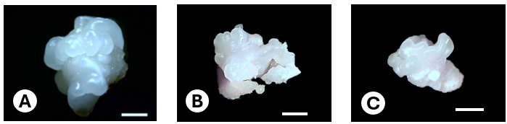
Figure 3: Primary embryogenic callus induction after 12 weeks cultured in 3 supplemented sucrose concentrations: 30 gL⁻¹ (A), 45 gL⁻¹ (B) and 60 gL⁻¹ (C), scale bar = 3mm
3.4 Effect of TDZ on regeneration
Embryogenic callus mass was cultured in plant growth regulator free medium for maturation and then was cultured in regeneration media supplemented with 300 µM BAP or TDZ with different concentrations.
Both BAP and TDZ were shown to promote formation and germination of somatic embryos. After 2 months, formation of globular somatic embryos was recorded the highest when cultured in 50 µM TDZ (86,42a ± 1,23 %) while non-PGR had the lowest rate (46,46c ± 3,84 %) . Non-PGR treatment also did not efficiently help in germinating somatic embryo. Germination rate of somatic embryo were achieved most in 50 µM and 100 µM TDZ treatment, with two results did not different significantly. Treatment 50 µM TDZ produced more somatic embryo than treatment with BAP – which is commonly applied for coconut regeneration stage. There was a positive correlation between rise of TDZ concentration with the incresed in development of somatic embryo and reach peach 50 µM. After 4 months in regeneration media, treatment with 50 µM TDZ still produced the most both globular and germinating somatic embryo. After 4 months of without supplementing PGR, no new somatic embryo were developed in this treatment.
Table 3: Effect of BAP and TDZ on development and germination of coconut somatic embryo
Treatmen  (µM) | 2 months |  | 4 months
 | Globular SE  (%) | Germinating SE  (%) | Globular SE  (%) | Germinating SE (%)
BA 300 | 81,48ab ± 2,14 | 50,62ab ± 1,23 | 72.73a ± 5.25 | 51.52bc ± 3.03
TDZ 0 | 46,46c ±3,84 | 22,22c ± 2,22 | 6.67b ± 6.67 | 0.00d ± 0.00
TDZ 25 | 67,71ab ±1,04 | 48,96ab ± 1,04 | 70.18a ± 0.88 | 47.37c ± 1.52
TDZ 50 | 86,42a ±1,23 | 54,32a ± 1,23 | 86.11a ± 2.78 | 63.89ab ± 2.78
TDZ 100 | 79,17ab ±2,08 | 64,58a ± 2,08 | 85.71a ± 8.25 | 71.43a ± 8.25
TDZ 150 | 66,67b ± 8,33 | 33,33bc ± 8,33 | N/A | N/A

After 4 weeks in maturation medium, coconut proembryos was developed on callus mass, with translucent globular shape that still obtain smooth, glossy surface (Figure 4A) . After 2 months in regeneration medium, proembryos had developed into somatic embryos with globular shape and then to germinating embryos with coleoptilar shape (Figure 4B). After 4 months, germinated somatic embryos were elongated, several torpedo-shape somatic embryos still remained their smooth structures with transition from translucent to white-off color while other have rough surface and were turning green (Figure 4C)
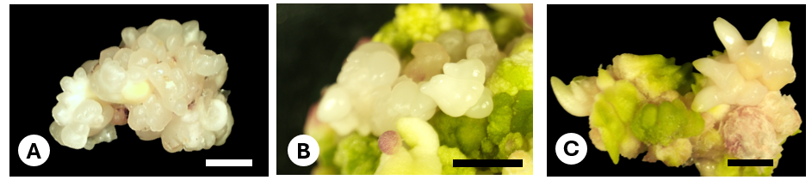
Figure 4: Pro-embryos development after 4 weeks in maturation medium (A). Somatic embryo growth in regeneration medium after 2 months (B) and after 4 months (C). Scale bar = 3mm
3.5 Haustorium-like structure and adventitous root development during regeneration stage.
During regeneration stage, upon globular and torpedeo SE (describe above) were seem, structures with rough surfaces that had white off or green color were observed. These structures could be found on the same mass as shown in Figure 5A or whole mass were developed into this. Figure 5B,C,D shown other type of haustorium-like structure with torpedo shapes but that had rough surface and stiff looking with white off or green color. Based on Table 4, after 2 months and 4 months mark, haustorium-like structures can be found in all treatments and with high formation percentage. At 2 months, the highest haustorium-like structures was found in treatment 25 µM TDZ with 89.59 % while PGR free was the lowest. After 4 months, haustorium formation rates were lower than the previous check-up in all 4 treatment. At this stage, the highest was found in PGR treatment will the lowest was in 100 µM TDZ treatment.
Table 4: Development of adventitious roots and haustorium structure in each treatment during regeneration stage
Treatment  (µM) | 2 months |  | 4 months
 | Globular SE  (%) | Germinating SE  (%) | Globular SE  (%) | Germinating SE  (%)
BAP 300 | 86,42ab ± 1,23 | 72,84b ± 1,23 | 63.64ab ± 5.24 | 81.82ab ± 5.24
TDZ 0 | 60,00c ± 3,85 | 31,11a ± 2,22 | 73.33a ± 6.67 | 66.67b ± 6.67
TDZ 25 | 89,58a ± 1,04 | 68,75b ± 1,08 | 59.65ab ± 0.87 | 85.96ab ± 0.87
TDZ 50 | 82,71ab ± 1,23 | 59,26b ± 2,14 | 44.44bc ± 2.78 | 80.56ab ± 2.78
TDZ 100 | 68,75bc ± 3,61 | 70,83b ± 1,08 | 33.33c ± 4.76 | 95.24a ± 4.76
TDZ 150 | 83,33ab ± 8,33 | 66,67b ± 8,33 | N/A | N/A

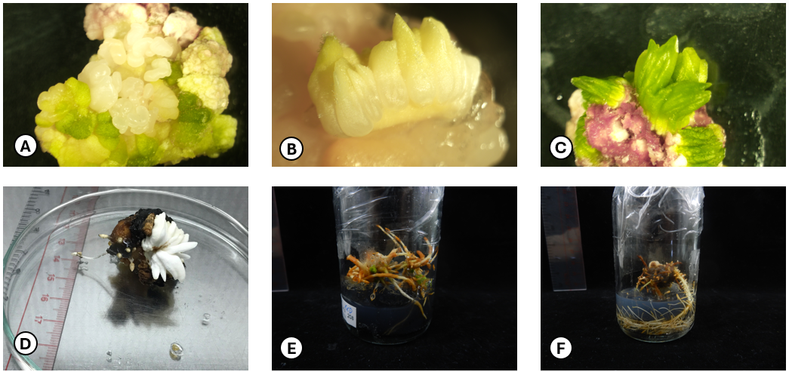
Figure 5. Development of haustorium-like structures (A, B, C, D) and adventitious roots (E, F) during the regeneration of somatic embryo in XGD coconut variety
Adventitous roots were also found developing strongly in regeneration stages. There were twon common seen adventitous roots developed: one callus mass produce numerous main roots with white or brown color (Figure 5E) and callus mass produce one big main roots that later emerged abundant of smaller hairy roots (Figure 5F). The formation rate of adventitous roots were also very high. At 2-month, the lowest root formation ratee was found in PGR free treatment while other treatment were unsignificantly high, all above 50 % (Table 4). After 4 months, unlike decline pace of haustorium, adventitous roots of all treatments tend to increase noticeably. The highest formation rate were in 100 µM TDZ treatment while PGR remain the lowest.
3.6 Flush out process of coconut somatic embryogenesis
Embryogenic callus was developed from plumular explants after 8 weeks and fully developed after 12 weeks. Embryogenic callus was subculture 4 times in order to have more embryogenic structure on callus mass (Figure 6A). Proembryos were formed after 4 weeks in maturation medium with no PGR (Figure 6B). After 8 weeks in TDZ supplemented medium, globular somatic embryo were formed (Figure 6C) and started to elongated (Figure 6D). Figure 6E demonstrated a fully developed somatic embryo after 6 months in regeneration medium. Shoot was induced and elongated. After 8 months leaves was formed and plantlets were cultured in 5 µM BAP for root growth.
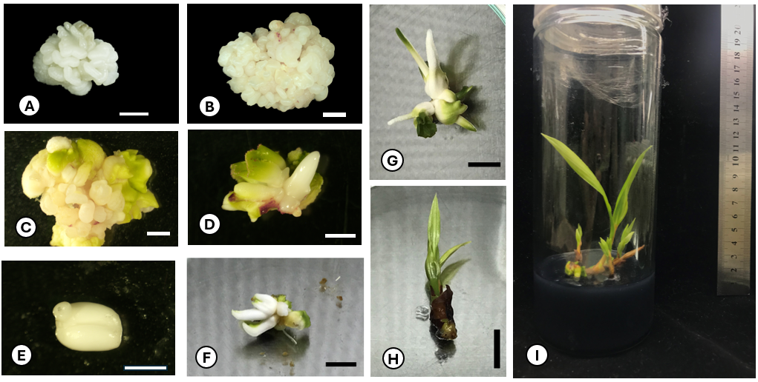
Figure 6: Coconut somatic embryogenesis from callus to plantlet: Ear-shaped and globular embryogenic callus formation in callus induction medium (A), globular embryogenic callus and somatic embryo initiation after 4 weeks in PGR-free maturation medium (B), germination of globular somatic embryo to scutellar stage with in TDZ supplemented medium (C), germinated somatic embryo elongated and started greening (D), full developed coconut somatic embryo (E), shoot growth and development after 6 months (F), and and elongation after 8 months (G), leaves were developed after 10 months (H), young coconut plantlet (I)
4. Discussions
4.1 Plumule maturity
The result indicated that plumules from 14-day preculture embryo help to promote the highest embryogenic callus formation rate. In a previous research on plumule maturity studying Malayan Yellow Dwarf variety, initial callus and embryogenic callus formation rate using plumules excised from 14-day preculture embryos were 83 % and 40 %, much higher than other treatments tested (Nguyen 2018 [39]). Another study suggested that 7-day plumule maturity treatments was more suitable for Aromatic coconut varieties with 73.3 % embryogenic callus formation (Pham 2019 [40]). Typical practice in coconut somatic embryogenesis had been to extract plumule immediately after sterilization (Chan et al. 1998 [41]; Pérez-Núñez et al. 2006 [35]; Sáenz et al. 2018 [36]).
A limited number of research incorporating embryo pre-culture step in coconut somatic embryogenesis. First research, involved culturing embryo for 15 to 17 days prior plumule excise, leading to high embryogenic callus formation rate of over 50 % (Fernando et al. 2003 [42], 2004 [43]). Recently, a study conducted on somatic embryogenesis of Hainan Tall coconut indicated that embryogenic callus rate from 15-day plumule maturity (75 %) was significantly higher than outcome of no preculture embryo (52.4 %) (Mu et al. 2024 [44]).
Choice of explant represent a key determinant of success in plant somatic embryogenesis (Ree and Guerra 2015 [45]), including coconut (Sáenz-Carbonell et al. 2016 [46]; Kalaipandian et al. 2021 [26]). Plumules have been one of the most responsive explants in callus induction in coconut and been used for numerous of varieties . However, studies on plumule maturity was scarced. Coconut plumule was consisted of shoot meristem, covered by two leaves primodia where initial callus was growth from (Sáenz et al. 2006 [37]; Jayaraj et al. 2015 [47]). Supplement of cytokinin BAP in preculture medium signaled germination in coconut embryo, which promoted changed and development of primodial leaves. This might indicated coconut callus induction success might have correlation with the development of primodial leaves. This might need more studies to understand deeper.
4.2 Sucrose supplement
The result indicated that enhancing sucrose from 30 to 45 g L⁻¹ had promoted better callus induction, yet the decline at 60 g L⁻¹ treatment implied too much sucrose might hinder the formation of embryogenic callus. The findings of this study underscored the significant impact of sucrose concentration on embryogenic callus production, emphasizing the importance of identifying the optimal level for maximizing yield.
Sugar is a key component of tissue culture media, acting as a primary carbon source to supply energy for cellular metabolism, facilitate the synthesis of cellular structures, and function as an osmotic agent (Yaseen et al. 2012 [48]; Kong et al. 2020 [49]). Sucrose has been proved to be the most suitable source of sugar for plant tissue culture including coconut (Fuentes et al. 2005 [50]; George et al. 2007 [51]). In coconut somatic embryogenesis procedures, 3% sucrose was the most common used (Nguyen et al. 2015 [22]). Results from a research studying MATAG coconut – a hybrid – also indicated that 3 % sucrose was most suitable for callu induction for this cultivar (Zuraida et al. 2022 [52]). Several research on coconut somatic embryogenesis in Mexico have demonstrated a growing trend towards supplementing culture media with higher concentrations of sucrose, with a notable shift from 3% to 5% in plumule (Pérez-Núñez et al. 2006 [35]; Sáenz et al. 2018 [36]) and immature inflorescence explants (Sandoval-Cancino et al. 2016 [53]; Oropeza et al. 2018 [54]).
4.3 Regeneration
Formation of somatic embryo and embryo germination were signaled by the cytokinin (Sáenz-Carbonell et al. 2020 [55]). The result indicated that TDZ did help to regenerate coconut embryogenic callus to somatic embryo. Usually, BAP would be supplemented for this stage (Oropeza et al. 2018 [54]; Sáenz et al. 2018 [36]) has been a universal cytokinin that was applied to plant tissue culture of numerous species including coconut somatic embryogenesis. . Since, success of using BAP for coconut somatic embryo regeneration was low, other cytokinin had been tested. Thidiazuron (TDZ) has been considered recently for shoot organogenesis in many plant including palmae species (Graner et al. 2013 [56]; Ahmed 2014 [57]). TDZ has been favored over the years because TDZ is more active than BAP, kinetin or zeatin and requires lower concentration (10 to 1000 times lower) for regeneration compared to PGR (Capelle et al. 1983 [58]; Guo et al. 2011 [59]).
There was an maturation stage where embryogenic callus were culture in PGR-free medium for 4 weeks. This was an essential stage in order to reduce endogenous auxin ratio after long period culturing in high 2,4D medium.
Along with formation of somatic embryos, other structures were also observed – adventitious roots and haustorium. through observation, there were the emergence of haustorium like structure and adventitious roots hinder the regeneration stage. As shown on figure, several structures had torpedo shape but had rough surfaces and greenish color indicated that this structure had successfully regenerated to somatic embryo but turn into stiff haustorium structures. Further cultivation and subculture only lead to growth of haustorium structures not expected SE Adventitious roots were formed might results from 2 reasons – high concentration of endogenous auxin from long periods culturing in high 2,4D medium and TDZ. Eventhough, in this study, TDZ was used as cytokinin, TDZ also had auxin properties that had been applied for callus induction in many species including coconut (Gairi and Rashid 2004 [60]; Zayed and Abdelbar 2017 [61]). While presents of haustorium was familiar and can be found all stages of somatic embryogenesis. In regeneration stage, the presence of these structures had negative correlation with formation rate of somatic embryos that might hindered the further development into plantlets.
5. Conclusions
In this study, somatic embryogenesis was conducted in Vietnamese Xiem Green Dwarf variety using plumule as explant. Results shown that highest embryogenic callus formation was occurred plumule were excised after 14-day preculture and cultured in medium supplemented with 45 g L-1 of sucrose. TDZ was a good cytokinin for somatic embryo formation and germination. This study helped to understand more about coconut somatic embryogenesis

Disclaimer (Artificial intelligence)
Option 1:
Author(s) hereby declare that NO generative AI technologies such as Large Language Models (ChatGPT, COPILOT, etc.) and text-to-image generators have been used during the writing or editing of this manuscript.

References
1. Chan E, Elevitch CR (2006) Cocos nucifera L. (coconut). Species Profiles Pac Isl Agrofor 27
2. Thomas GV, Krishnakumar V, Dhanapal R, Srinivasa Reddy DV (2019) Agro-management Practices for Sustainable Coconut Production. In: The Coconut Palm (Cocos nucifera L.) - Research and Development Perspectives, 1st edn. Springer Singapore, pp 227–322
3. Foale M, Biddle J, Bazrafshan A, Adkins S (2020) Biology, Ecology, and Evolution of Coconut. In: Adkins S, Foale M, Bourdeix R, et al. (eds) Coconut Biotechnology: Towards the Sustainability of the ‘Tree of Life.’ Springer International Publishing, Cham, pp 17–27
4. Samosir YMS, Adkins S (2014) Improving acclimatization through the photoautotrophic culture of coconut (Cocos nucifera) seedlings: an in vitro system for the efficient exchange of germplasm. Vitro Cell Dev Biol - Plant 50:493–501. https://doi.org/10.1007/s11627-014-9599-z
5. Rethinam P (2018) International Scenario of Coconut Sector. In: Krishnakumar V, Thampan PK, Nair MA (eds) The Coconut Palm (Cocos nucifera L.) - Research and Development Perspectives. Springer Singapore, Singapore, pp 21–56
6. Lockyer S, Stanner S (2016) Coconut oil – a nutty idea? Nutr Bull 41:42–54. https://doi.org/10.1111/nbu.12188
7. Samarajeewa U (2024) Coconut: Nutritional and Industrial Significance. In: Nut Consumption and Usefulness in the Modern World
8. IMARC group (2024) Coconut Products Market Report by Product Type (Coconut Oil, Coconut Water, Coconut Milk, Desiccated Coconut, and Others), Form (Solid, Liquid, Powder), Distribution Channel (Business to Business, Business to Consumer), Application (Cosmetics, Food and Beverage, and Others), and Region 2025-2033
9. Gurr GM, Johnson AC, Ash GJ, et al (2016) Coconut Lethal Yellowing Diseases: A Phytoplasma Threat to Palms of Global Economic and Social Significance. Front Plant Sci 7:. https://doi.org/10.3389/fpls.2016.01521
10. Vadamalai G, Thanarajoo SS, Joseph H, et al (2017) Coconut Cadang-Cadang Viroid and Coconut Tinangaja Viroid. In: Viroids and Satellites, 1st edn. Academic Press, Malaysia, pp 263–273
11. Silva ARAD, Bezerra FML, Lacerda CFD, et al (2017) PHYSIOLOGICAL RESPONSES OF DWARF COCONUT PLANTS UNDER WATER DEFICIT IN SALT-AFFECTED SOILS. Rev Caatinga 30:447–457. https://doi.org/10.1590/1983-21252017v30n220rc
12. Tzec-Simá M, Félix JW, Granados-Alegría M, et al (2022) Potential of Omics to Control Diseases and Pests in the Coconut Tree. Agronomy 12:17. https://doi.org/10.3390/agronomy12123164
13. Batugal P, Bourdeix R, Baudouin L (2009) Coconut Breeding. In: Jain SM, Priyadarshan PM (eds) Breeding Plantation Tree Crops: Tropical Species. Springer New York, New York, NY, pp 327–375
14. Perera SACN (2016) Coconut. In: Breeding Oilseed Crops for Sustainable Production: Opportunities and Constraints, 1st edn. Academic Press, Santiago, CA, USA, pp 201–216
15. Adkins SW, Biddle J, Nguyen QT, Foale M (2020) 4.1 Cocos nucifera Coconut. 13
16. Arhin L, Abdullah S nor A, Jaafar JN, Ramlee SI (2023) Conventional and modern breeding technologies for improving dwarf coconut cultivars: A review. J Hortic Sci Biotechnol 98:551–562. https://doi.org/10.1080/14620316.2023.2195863
17. Ledo ADS, Lameira OA, Benbadis AK, et al (2001) CULTURA IN VITRO DE EMBRIÕES ZIGÓTICOS DE AÇAIZEIRO. Rev Bras Frutic 23:468–472. https://doi.org/10.1590/S0100-29452001000300003
18. Beveridge FC, Kalaipandian S, Yang C, Adkins SW (2022) Fruit Biology of Coconut (Cocos nucifera L.)
19. Cutter, VM, Wilson KS (1954) Effect of Coconut Endosperm and Other Growth Stimulants upon the Development In vitro of Embryos of Cocos nucifera L. Bot Gaz 115:234–240. https://doi.org/10.1086/335819
20. Sisunandar, Alkhikmah, Husin A, et al (2018) Ex vitro rooting using a mini growth chamber increases root induction and accelerates acclimatization of Kopyor coconut (Cocos nucifera L.) embryo culture-derived seedlings. Vitro Cell Dev Biol - Plant 54:508–517. https://doi.org/10.1007/s11627-018-9897-y
21. Lédo A da S, Passos EEM, Fontes HR, et al (2019) Advances in Coconut palm propagation. Rev Bras Frutic 41:. https://doi.org/10.1590/0100-29452019159
22. Nguyen QT, Bandupriya HDD, López-Villalobos A, et al (2015) Tissue culture and associated biotechnological interventions for the improvement of coconut (Cocos nucifera L.): a review. Planta 242:1059–1076. https://doi.org/10.1007/s00425-015-2362-9
23. Eeuwens CJ, Blake J (1977) Culture of coconut and date palm tissue with a view to vegetative propagation. Acta Hortic 277–286. https://doi.org/10.17660/ActaHortic.1977.78.35
24. Sáenz L, Chan JL, Souza R, et al (1999) Somatic embryogenesis and regeneration in coconut from plumular explants. In: Oropeza C, Verdeil JL, Ashburner GR, et al. (eds) Current Advances in Coconut Biotechnology. Springer Netherlands, Dordrecht, pp 309–319
25. von Arnold S, Sabala I, Bozhkov P, et al (2002) Developmental pathways of somatic embryogenesis. Plant Cell Tissue Organ Cult 69:233–249. https://doi.org/10.1023/A:1015673200621
26. Kalaipandian S, Mu Z, Kong EYY, et al (2021) Cloning Coconut via Somatic Embryogenesis: A Review of the Current Status and Future Prospects. Plants 10:2050. https://doi.org/10.3390/plants10102050
27. Phạm TPT (2022) Nghiên cứu nhân giống dừa bằng công nghệ nuôi cấy mô tế bào và kỹ thuật thâm canh dừa trồng giống nuôi cấy mô. Trường Đại học Trà Vinh, Trà Vinh
28. Nam BNNV (2024) Dừa sáp cấy mô đầu tiên cho trái. https://nongnghiep.vn/dua-sap-cay-mo-dau-tien-cho-trai-d400766.html. Accessed 23 Dec 2024
29. Lệ T (2010) Đa dạng các giống dừa
30. VITIC (2018) Dừa xiêm xanh Bến Tre có hiệu quả kinh tế cao. In: Bộ Công Thương - Trang Thông Tin Thương Mại Biên Giới Miền Núi Hải Đảo. https://thuongmaibiengioimiennui.gov.vn/san-pham-vung-mien/mien-nam/2018/10/dua-xiem-xanh-ben-tre-co-hieu-qua-kinh-te-cao. Accessed 23 Dec 2024
31. An Hoà (2023) Dừa xiêm xanh - đặc sản nổi tiếng của tỉnh Bến Tre. In: Bộ Công Thương Việt Nam - Minist. Ind. Trade Social. Repub. Vietnam
32. Tran QP (2023) Investigating factors for vigorous ex vitro growth and development of Vietnamese coconut varieties. MSc, International University - Vietnam National University HCM
33. Eeuwens CJ (1976) Mineral Requirements for Growth and Callus Initiation of Tissue Explants Excised from Mature Coconut Palms (Cocos nucifera L.) and Cultured in vitro. Physiol Plant 36:23–28. https://doi.org/10.1111/j.1399-3054.1976.tb05022.x
34. Tran QP (2019) Effects of Activated Charcoal and Coconut Water on in vitro growth of Coconut (Cocos nucifera L.) Zygotic Embryos. International University - Vietnam National University HCM
35. Pérez-Núñez MT, Chan JL, Sáenz L, et al (2006) Improved somatic embryogenesis from Cocos nucifera (L.) plumule explants. Vitro Cell Dev Biol - Plant 42:37–43. https://doi.org/10.1079/IVP2005722
36. Sáenz L, Chan JL, Narvaez M, Oropeza C (2018) Protocol for the Micropropagation of Coconut from Plumule Explants. In: Loyola-Vargas VM, Ochoa-Alejo N (eds) Plant Cell Culture Protocols. Springer New York, New York, NY, pp 161–170
37. Sáenz L, Azpeitia A, Chuc-Armendariz B, et al (2006) Morphological and histological changes during somatic embryo formation from coconut plumule explants. Vitro Cell Dev Biol - Plant 42:19–25. https://doi.org/10.1079/IVP2005728
38. Greeshma JA, Renuka R, Meera R, Nirmala N (2018) Effect of Plant Growth Hormones on Development of Embryogenic Structures in Somatic Embryogenesis of Coconut
39. Nguyen TQ (2018) Clonal propagation of coconut (Cocos nucifera L.) for elite seedling production and germplasm exchange. PhD thesis, University of Queensland
40. Pham NHB (2019) EFFECT OF PLUMULE MATURITY ON EMBRYOGENIC CALLUS INDUCTION IN VIETNAMESE AROMATIC COCONUT (COCOS NUCIFERA L.) VARIETY. Bachelor Thesis, International University - Vietnam National University HCM
41. Chan JL, Saénz L, Talavera C, et al (1998) Regeneration of coconut (Cocos nucifera L.) from plumule explants through somatic embryogenesis. Plant Cell Rep 17:515–521. https://doi.org/10.1007/s002990050434
42. Fernando SC, Verdeil JL, Hocher V, et al (2003) Histological analysis of plant regeneration from plumule explants of Cocos nucifera L. Plant Cell Tissue Organ Cult 72:4
43. Fernando SC, Weerakoon LK, Gunathilake TR (2004) Micropropagation of Coconut through Plumule Culture. COCOS 16:01. https://doi.org/10.4038/cocos.v16i0.1003
44. Mu Z, Yang S, Xu H, et al (2024) The Influence of Maturity, Storage, and Embryo Size on Coconut Callus Induction Success
45. Ree JF, Guerra MP (2015) Palm (Arecaceae) somatic embryogenesis. Vitro Cell Dev Biol - Plant 51:589–602. https://doi.org/10.1007/s11627-015-9722-9
46. Sáenz-Carbonell L, Montero-Cortés M, Pérez-Nuñez T, et al (2016) Somatic Embryogenesis in Cocos nucifera L. In: Loyola-Vargas VM, Ochoa-Alejo N (eds) Somatic Embryogenesis: Fundamental Aspects and Applications. Springer International Publishing, Cham, pp 297–318
47. Jayaraj KL, Bhavyashree U, Fayas TP, et al (2015) Histological studies of cellular differentiation during somatic embryogenesis of coconut plumule-derived calli. J Plant Crops 43:. https://doi.org/10.19071/jpc.2015.v43.i3.2853
48. Yaseen M, Ahmad T, Sablok G, et al (2012) Review: Role of carbon sources for in vitro plant growth and development. Mol Biol Rep 39:13. https://doi.org/DOI 10.1007/s11033-012-2299-z
49. Kong EYY, Biddle J, Foale M, Adkins SW (2020) Cell suspension culture: A potential in vitro culture method for clonal propagation of coconut plantlets via somatic embryogenesis. Ind Crops Prod 147:112125. https://doi.org/10.1016/j.indcrop.2020.112125
50. Fuentes G, Talavera C, Oropeza C, et al (2005) Exogenous sucrose can decrease in vitro photosynthesis but improve field survival and growth of coconut (Cocos nucifera L.) in vitro plantlets. Vitro Cell Dev Biol - Plant 41:69–76. https://doi.org/10.1079/IVP2004597
51. George EF, Hall MA, Klerk G-JD (2007) The Components of Plant Tissue Culture Media II: Organic Additions, Osmotic and pH Effects and Support Systems. In: Plant Propagation by Tissue Culture, 3rd edn. Springer, Dordrecht, p 60
52. Zuraida AR, Sentoor KG, Ahmad N, et al (2022) Effect of sucrose and 2, 4-Dichlorophenoxyacetic acid (2, 4-D) on callus induction and proliferation of Coconut cv MATAG from Plumule Explants. Int J Appl Sci Res 5:. https://doi.org/10.56293/IJASR.2022.5409
53. Sandoval-Cancino G, Sáenz L, Chan JL, Oropeza C (2016) Improved formation of embryogenic callus from coconut immature inflorescence explants. Vitro Cell Dev Biol - Plant 52:367–378. https://doi.org/10.1007/s11627-016-9780-7
54. Oropeza C, Sandoval-Cancino G, Sáenz L, et al (2018) Coconut (Cocos nucifera L.) Somatic Embryogenesis Using Immature Inflorescence Explants. In: Jain SM, Gupta P (eds) Step Wise Protocols for Somatic Embryogenesis of Important Woody Plants. Springer International Publishing, Cham, pp 103–111
55. Sáenz-Carbonell L, Nguyen Q, Oropeza Salin CM (2020) Coconut Micropropagation for Worldwide Replanting Needs. In: Coconut Biotechnology: Towards the Sustainability of the ‘Tree of Life,’ 1st edn. Springer, Cham, pp 227–240
56. Graner ÉM, Oberschelp GPJ, Brondani GE, et al (2013) TDZ pulsing evaluation on the in vitro morphogenesis of peach palm. Physiol Mol Biol Plants 19:283–288. https://doi.org/10.1007/s12298-012-0160-4
57. Ahmed MWA-M (2014) Thidiazuron-induced in vitro bud organogenesis of the date palm (Phoenix dactylifera L.) cv. Hillawi. Afr J Biotechnol 13:3581–3590. https://doi.org/10.5897/AJB2014.13762
58. Capelle SC, Mok DWS, Kirchner SC, Mok MC (1983) Effects of Thidiazuron on Cytokinin Autonomy and the Metabolism of N ⁶ -(Δ ² -Isopentenyl)[8- ¹⁴ C]Adenosine in Callus Tissues of Phaseolus lunatus L. Plant Physiol 73:796–802. https://doi.org/10.1104/pp.73.3.796
59. Guo B, Abbasi BH, Zeb A, et al (2011) Thidiazuron: A multi-dimensional plant growth regulator. Afr J Biotechnol 10:8984–9000. https://doi.org/10.5897/AJB11.636
60. Gairi A, Rashid A (2004) TDZ-induced somatic embryogenesis in non-responsive caryopses of rice using a short treatment with 2,4-D. Plant Cell Tissue Organ Cult 76:29–33. https://doi.org/10.1023/A:1025864605846
61. Zayed EMM, Abdelbar OH (2017) Histological Evidence of Indirect Somatic Embryogenesis from Immature Female Date Palm Inflorescences. In: Al-Khayri JM, Jain SM, Johnson DV (eds) Date Palm Biotechnology Protocols Volume I. Springer New York, New York, NY, pp 129–144

