Caspase 3 Gene Expression Profile in Carbon Tetrachloride (CCL₄) Induced Hepatotoxicity in Wistar Rats Against Hepatoprotective Effect of Azadiracthta Indica

Abstract
Liver is the vital organ of metabolism and excretion. It is also an important target of the toxicity of xenobiotics and oxidative stress. The study was carried out to determine the expression profile of caspase-3 gene in carbon tetrachloride (CCl₄) induced hepatotoxicity in wistar rats. Thiry-five (35) wistar rats were divided into seven groups of five rats each group were given varying treatments along with intraperitonial administration of CCl₄. The effects of aqueous and methanolic leaf extracts of Azadirachta indica were determined by evaluating the liver function enzymes namely Alanine aminotransferase (ALT), Aspartate aminotransferase (AST), Alkaline phosphatase (ALP), and Total bilirubin (T. bil). Histopathological changes induced on the liver was examined and Caspase-3 expression in the liver was determined by real time PCR. Results showed increased in levels of AST (24.6±3.79), ALT, ALP (438.6±46.19), and T.BIL in CCl₄-intoxicated rats were restored towards normalization in rats treated with the aqueous and methanolic extracts in a dose-dependent manner the highest from ALP and the least in AST. Histopathological studies revealed that rats treated with high dose (150mg/kg) of aqueous and methanolic extracts showed maximum hepatoprotective effects by alleviating the serum enzymes level at 150mg/kg body weight. Results furthermore, showed that A. indica significantly (p < 0.05) decreased the level (0.07, 0.06, 0.08, 0.04, 0.05) of caspase-3 gene expression towards normal in rats administered with the aqueous, methanolic leaf extracts and silymarin respectively. This reveals that the Caspase-3 gene, as the enzyme executing apoptosis were expressed in less amount while wistar rats were induced with CCl_{4.} Thus, conferring the protective effects of the leaf extracts and silymarin.

Keywords: Caspase-3 gene, Carbon tetrachloride (CCl₄), Azadirachta indica and Hepatotoxicity

- INTRODUCTION
The natural technique for programmable cell death in cells is called apoptosis. Due to its crucial function in development and homeostasis [1], it is especially important in long-lived mammals [2]. Apoptosis is carried out by the essential enzyme caspase-3 throughout multicellular organisms' ontogenesis and homeostasis. According to Jorgensen et al. [3], a number of diseases, including sepsis, stroke, Alzheimer's, Parkinson's, myocardial infarction, and neurodegenerative diseases, are accompanied with increased apoptosis and caspase-3 activity. Caspase-3 is thought to play a typical function in apoptosis since it is activated in apoptotic cells by intrinsic (mitochondrial) and extrinsic (death ligand) pathways [4].
Caspases continue to be one of the key players in the initiation and completion of apoptosis. Therefore, it is sensible to believe that low Caspase levels or a malfunctioning Caspase could reduce apoptosis and carcinogenesis [5]. According to Zaman et al. [6], there are three executioner caspases (caspase-3, -6, -7) and four initiator caspases (caspase-2, -8, -9, and 10). “The executioner caspases cleave the targeted proteins, eventually resulting in cell death. The intrinsic and extrinsic processes, which are correlated with the signal type, are two distinct pathways that result in apoptosis. They are also known as the death receptor pathway and the mitochondrial pathway, respectively. The most prevalent extracellular signals are death-inducing signals produced by cytotoxic T cells from the immune system in response to damaged or infected cells, whereas the intracellular signals include DNA damage, growth factor deprivation, and cytokine deprivation” [6].
Some studies have revealed that CCL₄ hepatotoxicity is induced by cytochrome P450 in liver cells which consequently catalyzes the reductive dehalogenation of CCL₄ metabolism, also activates cascade of secondary mechanisms. Plasma membrane disruption and other effects that lead to cell death are mostly induced by these mechanisms. Once metabolized by cytochrome P450, CCL₄ can generate free radicals and reactive oxygen species (ROS) that damage the liver [7]. The generation of these metabolites cause lipid peroxidation, which can lead to liver damage [8]. Antioxidants have been previously reported by several works for its potency to reduce the risk of liver disease by preventing oxidative damage [9,10]. CCL₄ -induced liver damage can be prevented and treated by directly reducing ROS levels and inhibiting the oxidative chain reaction induced by CCL₄. The formation of ROS leads to cellular damage, DNA fragmentation, degeneration of nuclear protein, dysfunction and, finally, programmed cell death [10,11]. “In the expression of gene which information from a gene is used in the synthesis of a functional gene product, which are often proteins. But in nonprotein coding genes such as rRNA genes or tRNA genes, the product is a structural or housekeeping RNA. In addition, small non-coding RNAs (miRNAs, piRNA) and various classes of long non-coding RNAs are involved in a variety of regulatory functions” [12].
Therefore, it is paramount to study the expression of this Caspase-3 gene by quantitating the changes in the expression levels and as well looking at overall patterns of its expression using real-time PCR. Hence, this research evaluated the expression level of Caspase-3 gene in the liver of wistar rats using carbon tetrachloride CCl₄ to induce hepatoxicity.
2.0 MATERIALS AND METHODS
2.1 Preparation of Plant Extracts
The collected Azadirachta indica leaves was cleaned, washed twice with tap water and air-dried under shade for a week. The dried leaves were pulverized into powder form using mortar and pestle, followed by an electrical blender (Fadar plus FD-998). Aqueous extract was prepared by measuring two hundred and fifty grams (250) of the powdered leaves using an electronic scale (G & G T1000).
This was placed in a clean container and soaked in two (2) liters of distilled water and similarly methanolic extract was also prepared by measuring two hundred and fifty grams (250) of the powdered leaves which was soaked in two (2) liters of methanol. Both containers with the contents were mixed using laboratory spatula for 20 minutes, sealed and kept at room temperature for 72 hours. The mixtures were filtered through Whatman filter paper (No.1 Bibby RE 200, Sterilin Ltd, UK) and then the filtrates were concentrated using rotary evaporator (RE-52A PEC Medical USA) at 45ºC in water bath (HH-S6 PEC Medical USA) at 40ºC [13].
The yield of the extract was calculated as follows:
Percentage (%) yield = (W₂ – W₁) X 100
W₀
Where W₂ is the weight of extract and container, W₁ is the weight of the empty container and W₀ is the weight of the initial dried leaves [14].
2.2 Experimental Animals
Thirty-five (35) wistar rats (Wistar strains) weighing 120 - 250g were purchased from College of Agriculture and Animal Science, Mando, Kaduna State. The rats were kept in a wire mesh cages in a well-ventilated room with free access to food and water for two weeks to acclimatize. The rats were maintained on standard animal feeds (Chikun feeds) manufactured in Kaduna State by crown flour mill and clean tap water ad libitum. Experiment was performed according to ethical guidelines for the investigation of experimental pain in conscious animals [15,16]. The standard rats feeding cannula was used for oral administration of the extracts.
2.3 Animal Grouping and Induction of Carbon Tetrachloride (CCl₄) in Liquid Paraffin.
A total of 35 wistar rats were randomly divided into seven (7) groups of five (5) rats each. Carbon tetrachloride induction of hepatotoxicity was carried out according to reported procedures of Guntupalli et al. [17], with some modification. Dose used in the study were calculated according to Erhirhie et al. [18] as follows:
Dosage in mg = Body weight of animal (g) x dose (mg)
1000g

Group I Control: Administered daily dose of liquid paraffin (1 ml/kg body weight, orally) from first day to the fifth day.
Group II Induced: Administered 40% carbon tetrachloride in liquid paraffin (1 ml/kg body weight, intra peritoneal) from second day to the fifth day.
Group III Test group: Administered CCl₄ (1 ml/kg body weight, intra peritoneal injection) and a daily dose of (50 mg/kg body weight, orally) of Aqueous leaf extract in the form of aqueous suspension, from second day to fifth day.
Group IV Test group: Administered CCl₄ (1 ml/kg body weight, intra peritoneal injection) and a daily dose of (150 mg/kg body weight, orally) of Aqueous leaf extract in the form of aqueous suspension, from second day to fifth day.
Group V Test group: Administered CCl₄ (1 ml/kg body weight, intra peritoneal injection) and a daily dose of (50 mg/kg body weight, orally) of methanol leaf extract in the form of aqueous suspension, from second day to fifth day.
Group VI Test group: Administered CCl₄ (1 ml/kg body weight, intra peritoneal injection) and a daily dose of (150 mg/kg body weight, orally) of Methanolic leaf extract in the form of aqueous suspension, from second day to fifth day.
Group VII: Administered CCl₄ (1 ml/kg body weight, intra peritoneal) and Silymarin, (a known antihepatotoxic drug) at a dose of 100mg/kg orally, from the second to the fifth day.

2.4 Collection of Blood and Liver Samples
After 14 days of treatment, all the animals were weighed and sacrificed 48 hours after the last injection via chloroform anesthesia. Blood samples was collected by cardiac puncture into plain sample tubes, allowed to clot for 30 minutes, and then centrifuged at 3000 revolutions per minute for 5 minutes at 37°C using bench centrifuge. Serum was separated for various biochemical measurements of liver enzymes like alanine aminotransferases (ALT), aspartate aminotransferases (AST), alkaline phosphatases (ALP), total bilirubin and stored at -20 °C prior to use [19]. The liver was dissected out. Part of the liver tissue was fixed immediately in 10% formaldehyde for histological studies and another part of the liver section were kept immediately on ice for gene expression analysis and stored at −20°C prior to performing the experiment.
2.5 Histopathology Studies
The liver tissues were harvested and fixed in 10% formaldehyde and were histologically processed according to the method of Bancroft and Stevens, [20]. Tissues were dehydrated through ascending grades of alcohol (70%, 90%, and 100%) for 2 hours each and were cleared in xylene for 2 minutes, and then impregnated and embedded in paraffin wax. Tissues were sectioned at 5micron thickness using a rotary microtome machine (Leica RT 25, England). After sectioning, tissues were mounted on slides, dried and stained using Hematoxylin and Eosin (H and E) stain for general tissue structures and with Alcian Blue Stain for goblet cells. Stained slides of the tissues were photomicrographed using the Amscope Digital Camera for Microscope Version 3.0, Japan, at x250 magnification [21].
2.6 Molecular Analysis: Primers were designed using Primer-Blast program from National Centre of Biotechnology Information (NCBI). The PCR primer sequences was BLAST, searched to ensure for specificity to the particular gene. The primers were obtained from Inqaba Biotech South Africa as follow;

2.7 Total RNA Extraction
Total RNA was extracted using Biospin Total RNA Extraction Kit II, (BSC80MI, China). The frozen liver tissues were homogenized into fine powder in liquid nitrogen using a clean laboratory mortar and pestle. Then 500µL of lysis buffer was added into the 1.5mL microcentrifuge tubes, followed by addition of 30mg of the homogenized samples respectively. These was shaken, vortexed, and incubated at room temperature for 5 minutes. The samples were centrifuged at 12,000 rpm for 5 minutes at 4°C to remove protein, fat, polysaccharide, and insoluble matter, and the supernatant was transferred to a new centrifuge tube. Two hundred microlitre (200µL) of chloroform was added into each tube, vortexed for 15 seconds, incubated at room temperature for 2 minutes, and then centrifuged at 12000 rpm for 10 minutes at 4°C. At this stage, the samples formed three layers. The aqueous layer, which contains mainly the RNA, was transferred into a new RNase-free centrifuge tube. Absolute ethanol was added into the aqueous phase. (The volume of the absolute ethanol added was 0.5 times the volume of the aqueous phase) and mixed by inversion. The mixed solution was transferred to a spin column and then centrifuged at 12000 rpm for 30 seconds at 4°C, and the liquid in the tubes was discarded.
Then, 500µL of DNase stop buffer was added to the spin column, centrifuged at 12000 rpm for 30 seconds at 4°C, and the liquid in the tubes was discarded. The 500µL of wash buffer was added to the spin column, centrifuged at 12000 rpm for 30 seconds at 4°C, and the liquid in the tubes was discarded. The procedure above was also repeated, and the spin column was transferred into a new tube and centrifuged at 12000 rpm for 2 minutes at 4°C. The spin column was transferred into a new 1.5mL RNase-free tube and 100µL of RElution buffer was added into the spin column, incubated at room temperature for 1 minute, centrifuged at 12000 rpm for 1 minute at 4°C, and the spin column was discarded. The liquid in the 1.5mL centrifuge tubes contained the RNA. The extracted RNA was stored at -80°C prior to use.
Table 1. Sequence Specific Primer for Caspase-3 Gene
Primer Sequence Reference
Rat caspase-3 Forward: 5´-GCATGATCCGCGACGTGGAA-3´ (Dkhil et al., 2013)
Reverse: 5´-AGATCCATGCCGTTGGCCAG-3´
Rat Beta-Actin (ACTB). Forward: 5´-CCCGCGAGTACAACCTTCTT-3´
Reverse: 5´-AACACAGCCTGGATGGCTAC- 3´

2.8 Reverse Transcription of RNA to cDNA
The cDNA was synthesized from 2µl of the extracted total RNA, using 18µl of sequence specific primer and reverse transcriptase enzyme PreMix (AccuPower® RT PreMix kit, Bioneer Corporation, USA). Reverse transcriptase (RTase) reactions were incubated at 42°C for 60 minutes and then followed by RTase inactivation at 95°C for 5 minutes. The fragments of the caspase-3 gene were PCR amplified from 10pg to 50ng of cDNA equivalent using degenerated primers (Table 1).
2.9 Real-Time Polymerase Chain Reaction
Real-time PCR was performed using the Bio-Rad iQ5 multicolor real-time detection system and SYBR Green, Low ROX (Applied Biosystem, USA). A total volume of 20µl reaction was used for the RT-PCR reaction, containing 50ng of cDNA, 10pmole of each pair of primers, and 10µl of 2x master mix (SYBR Green, Low ROX, Mg²⁺, dNTPs mixture, and PCR buffer) for the amplification of the gene of interest. Optimization of primers was carried out at melting temperature (Tm at 55.9°C: 55.9°C and 53.8°C: 53.8°C respectively) followed by actual RT-PCR at melting temperature (Tm 50°C). Polymerase chain reaction was carried out using (Bio-Rad iQ5 real-time detection System, USA) with the following reaction conditions; pre-denaturation at 95°C for 1 minute, followed by 35 cycles of denaturation at 95°C for 15 seconds, annealing at 51°C for 30 seconds, and extension at 72°C for 30 seconds. The comparative CT method was used to calculate the relative quantity of the transcripts in all groups, and genes were normalized to the endogenous controls. The final cycle threshold (Ct) values of caspase were normalized to the beta-actin genes and qualified relative to the reference gene. The relative expression ratio was calculated using the formula as follows;
Relative expression ratio (R) = 2^{-[ΔCt sample – ΔCt control]}
R= 2^{-ΔCt}
Where ΔCt is the difference in Ct between the targeted gene and housekeeping controls. The expression ratio calculated as: 2^{ΔCt} [22].
2.10 Data Analysis
Results obtained from this study were analysed using statistical package for social sciences (version 23.0 SPSS Inc. Chicago, USA). Results were expressed as LSD with a probability of P<0.05 level of confidence using one way Analysis of Variance (ANOVA) to determine whether there are significant differences between the means.
3.0 RESULTS
The mRNA expression level of apoptotic caspase-3 was determined in all groups by the real-time PCR method, which further supports the hepatoprotective effect of aqueous and methanolic extracts of A. indica against CCl₄-induced liver damage. Liver excised from wistar rats induced with CCl₄ (Group 2) showed high Caspase-3 expression (R = 0.12) when compared to normal control (R = 0.0). Caspase-3 expression was decreased in CCl₄-intoxicated wistar rats treated with 50mg/kg ALE and MLE to (R = 0.07 and 0.08), respectively. Further treatment with a high dose of 150mg/kg ALE and MLE as well as 100mg/kg of silymarin showed a more decreased level of caspase-3 expression (R = 0.06, 0.04, and 0.05) respectively as shown in (Table 3).
The histopathological observation of the liver tissues shown in plate (1-7) basically supported the results obtained from the serum enzyme assays. The photomicrograph of normal control wistar rats (Group I) showed that the central vein (CV), hepatocytes, and sinusoids present normal histological features.
The liver section of wistar rats intoxicated with CCL₄ (Group II) showed focal area necrosis (circle), dilated central vein and sinusoid (green arrow), and scanty infiltrated macrophage (blue arrow). Wistar rats treated with 50mg/kg aqueous and 50mg/kg methanolic A. indica (Group III and V) demonstrated anisonucleosis with mild kupffer cell hyperplasia and slight dilated sinusoids (arrows). The liver section of wistar rats treated with 150mg/kg aqueous and 150mg/kg methanol A. indica (Group IV and VI) showed that the sinusoids and central vein are congested and surrounded by mononuclear cells, and most of the hepatocytes apparently appear normal with slightly focal hepatic changes when compared to normal control. The liver section treated with 100mg/kg silymarin (Group VII) apparently appears normal with a slightly dilated sinusoid and a central vein surrounded by anti-inflammatory cells. Therefore, wistar rats treated with high doses of aqueous 150mg/kg, methanolic 150mg/kg A. indica and silymarin 100mg/kg showed maximum hepatoprotective effects when compared to normal control.
Table 2. Effects of Aqueous and Methanolic Leaf Extracts of Azadirachta indica (neem) on CCL4 Induced Alternation in Liver Function of Wistar rats.
Group Treatment ALT(U/L) AST(U/L) ALP(U/L) T.BIL(mg/dL)
I Control (1mg/Kg) Paraffin 16.0±4.78 63.8±11.52 258.0±86.02 13.3±3.82
II 40% CCL₄ (Induced) 24.6±3.79* 99.2±5.91* 438.6±46.19* 38.0±2.70*
III ALE (50 mg/kg)+CCl₄ 18.4±0.68** 85.2±3.97 391.8±45.47 13.2±1.24*
IV ALE(150 mg/kg)+CCl₄ 19.0±1.87 70.2±3.58** 308.8±50.92 7.20±0.86**
V MLE (50 mg/kg)+CCl₄ 17.8±3.398** 78.4±3.92* 229.6±59.56** 13.0±2.07*
VI MLE(150 mg/kg)+CCl₄ 17.2±1.83** 60.4±7.3** 221.4±33.67** 7.20±1.46**
VII Silymarin (100 mg/kg)+CCl₄ 18.2±1.16** 73.6±6.23** 262.0±23.99** 8.60±0.68**
Data are expressed as mean±sandard error mean (n = 5). Means with different superscripts down the column are
significantly different P<0.05 at 95% confidence level using least significance difference (L.S.D) BDL-below detectable limit.
* Significantly different (P<0.05) from Control group I.
** Significantly different (P<0.05) from CCl₄ group II
AST: Aspartate transaminase, ALT: Alanine transaminase, ALP: Alkaline phosphatase, T.BIL: Total bilirubin, ALE: Aqueous leave extract, MLE: Methanolic leave extract.

Table 3. Real-time PCR Expression of Caspase-3 Gene
Group Treatment Casp-3(Ct) Actin(Ct) deltaCt Expression ratio (R)
I Control (1ml/Kg) Parafffin 21.73 33.04 -11.31 0.00
II 40% CCL4 21.96 25.03 -3.07 0.12
III ALE (50 mg/kg)+CCl₄ 20.51 24.31 -3.8 0.07
IV ALE (150 mg/kg)+CCl₄ 20.89 24.84 -3.95 0.06
V MLE (50 mg/kg)+CCl₄ 19.61 23.30 -3.69 0.08
VI MLE (150 mg/kg)+CCl₄ 20.11 25.82 -4.71 0.04
VII Silymarin (100mg/kg)+CCl₄ 21.36 25.68 -4.32 0.05

AST: Aspartate transaminase, ALT: Alanine transaminase, ALP: Alkaline phosphatase, T.BIL: Total bilirubin,
MLE: Methanolic leave extract, ALE: Aqueous leave extract.

Figure 1. Relative Quantification using RT-qPCR of mRNA Expression of Caspase-3 Genes Liver of wistar Rats

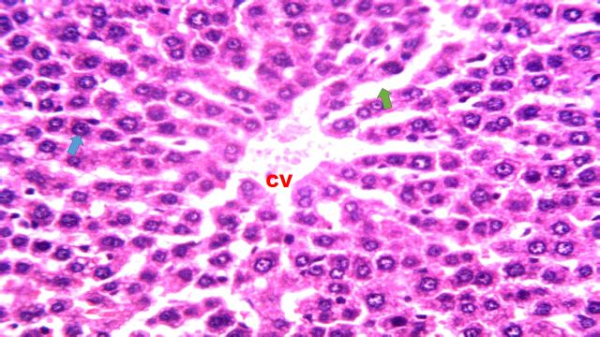  Plate 1: Liver sections of normal control rats (Group I) administered with liquid paraffin (1ml/kg), showing the central vein (CV), hepatocytes (blue arrow) and sinusoids (green arrow) apparently appear normal. Hematotoxylin and Eosin (H&E) ˟250. | 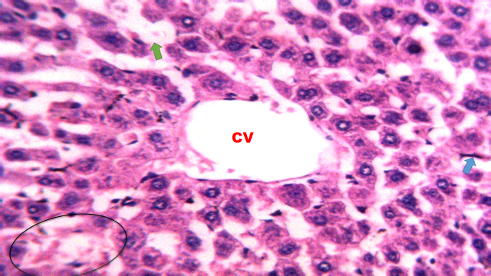  Plate 2: Liver sections of wistar rats (Group II) administered with CCl₄ (1ml/kg i.p), showing focal area of necrosis (circle), central vein (CV) and sinusoid (green arrow) appeared severely dilated. There are scanty infiltrated macrophages (blue arrow). Hematotoxylin and Eosin (H&E) ˟250
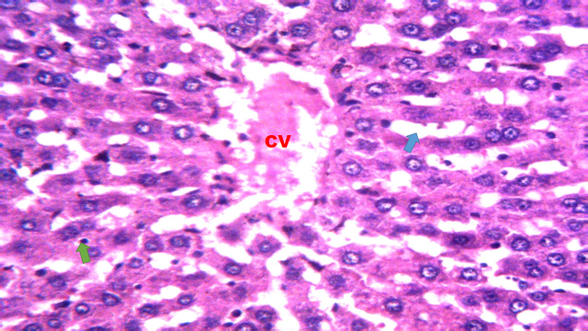  Plate 3: Liver section of wistar rats (Group III) treated with Aqueous extract of A. indica extract (50mg/kg. P.O) and CCl4 (1ml/kg, i.p.) X 6 days, showing anisonucleosis (green arrows) with slightly dilated sinusoids (blue arrow). Hematoxylin and Eosin (H&E) ˟250. | 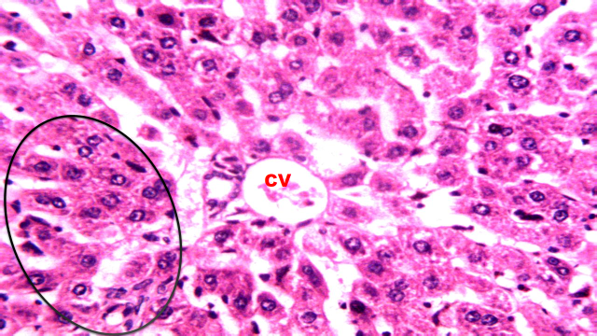  Plate 4: Liver section of wistar rats (Group IV) treated with Aqueous extract of A. indica extract (150mg/kg. P.O) and CCl4 (1ml/kg, i.p.) X 6 days, showing the section appearing normal with slightly focal hepatic changes (circle). Hematoxylin and Eosin (H&E) ˟250.
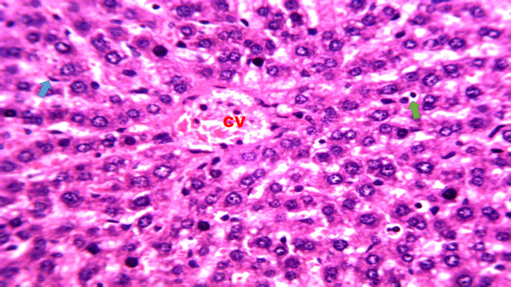  Plate 5: Liver section of wistar rats (Group V) treated with Methanolic extract of A. indica (50mg/kg. P.O) and CCl₄ (1ml/kg, i.p.) X 6 days, showing anisonucleosis with mild kupffer cell hyperplasia (arrows). Hematoxylin and Eosin (H&E) ˟250. | 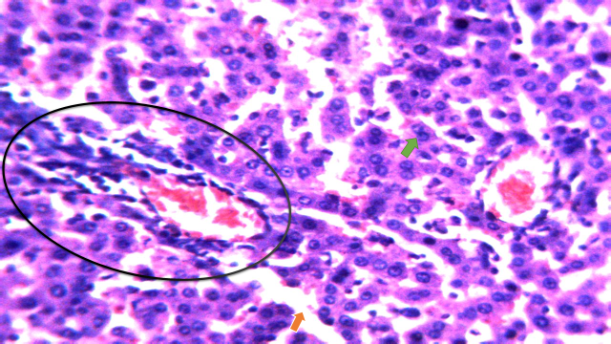  Plate 6: Liver section of wistar rats (Group VI) treated with Methanolic extract of A indica extract (150mg/kg. P.O) and CCl₄ (1ml/kg, i.p) X 6 days, showing normal hepatocytes (green arrow), congested sinusoids (orange arrow) and central vein and surrounded with mononuclear cells (circle). Hematoxylin and Eosin (H&E) ˟250.
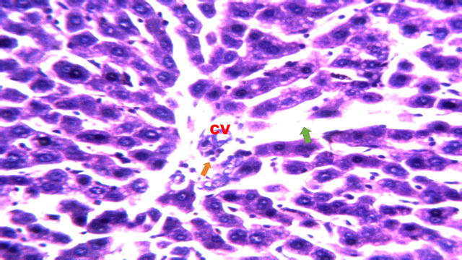
Plate 7: Liver section of wistar rats Group (VII) treated with Silymarin (100mg/kg. P.O) and CCl₄ (1ml/kg, i.p.) X 6 days, showing the section is apparently appearing normal with slightly dilated sinusoids (green arrow) and congested central vein (CV) surrounded by inflammatory cells (orange arrow). Hematoxylin and Eosin (H&E) ˟250.

4. Discussion
The effects of aqueous and methanolic extracts at dose levels of (150mg/kg) as well as silymarin (100mg/kg) on hepatic parameters; AST, ALT, ALP, and T.Bil in wistar rats were found to be alleviated when compared to CCl₄ induced group. The hepatotoxicity induce by CCl₄ is due to its metabolite CCl₃, a free radical that alkalytes cellular protein and other macromolecules with a simultaneous attack on polyunsaturated fatty acid, in the presence of oxygen, to produce lipid peroxide, leading to liver damage [23]. Hepatocellular necrosis leads to the elevation of the serum marker enzymes, which are released from the liver into the blood [24]. Increased level of AST, ALT, ALP, and T.Bil are conventional indicators of liver damage [25]. This agrees with work of Kalaivani et al. [27], already documented studies on the hepatoprotective properties of A. indica leaf. The observed increase in the hepatic markers enzymes AST, ALT, ALP, and T.Bil in CCl₄ induced but not treated rats (Group 2), is consistent with the findings of Guntupali et al. [17] and Dineshkumar et al. [26] on heptotoxic effects. Administration of aqueous and methanolic extracts at a high dose of 150mg/kg, orally showed effective hepatoprotection which was almost similar to that produced by silymarin treatment (100mg/kg). This agrees with Kalaivani et al. [17] and Mohammed et al. [28], that observed maximum hepatoprotective effects at a higher dose of 500mg/kg and 300mg/kg body weight respectively.
Caspase-3 is a protein that plays a vital role in apoptosis [29], by cytochrome c release and caspase-3 activation [30]. In this study, the mRNA expression of caspase-3 level was unchanged in the control group, indicating that hepatic satellite cells (HSCs) were still in their quiescent state. However, caspase-3 was found to be extensively expressed in the liver of rats intoxicated with CCl₄. Treatment with methanolic and aqueous A. indica extracts at (50mg/kg body weight) reduces caspase-3 expression, whereas at 150mg/kg of A. indica and silymarin (100mg/kg), caspase-3 expression was almost identical to that of the normal control. This is in agreement with the work of Dkhil et al. [31], which showed that treatment with methanolic neem leaf extract decrease the expression of caspase-3, caspase-9, and Bax. Also, findings of Wang et al. [32] showed that caspase-3 was significantly upregulated at 24 hours after CCl₄ injection compared to the control group. Pre-treatment with melatonin significantly lowers the caspase-3 mRNA expression. Apoptotic cells are morphologically characterized by membrane shrinkage, plasma and nuclear membrane blebbing, relocalization of organelles and compaction, as well as vesicles containing intracellular material [33]. Furthermore, apoptosis and necrosis have been widely observed in many studies upon CCl₄ administration [34].
Histopathological analysis showed that CCl₄ caused necrosis, dilated central vein and sinusoid, as well as degeneration of hepatocytes. Treatment with A. indica leave and silymarin exhibited hepatoprotection against CCl₄ hepatotoxicity, which was confirmed by the results of the liver function enzymes. The presence of bioactive compounds such as alkaloid, flavonoid, steroid, and saponin in A. indica leaves may have scavenged free radicals, resulting in hepatoprotection. Flavonoids, phenolic acid, and some terpenoids have been shown to have antioxidant activity via various mechanisms [35]. This is also in line with the study of Nwafor et al. [36], where Ethyl acetate fraction of magnifera haden seeds were used for hepatoprotection.
The neem plant has been reported to be endowed with bioactive compounds with a wide range of biological activities and medicinal properties [37]. Result from the findings of Bature et al. [38], revealed the presence of alkaloid, steroid, tannins, flavonoid, saponin, and phenolic compound in A. indica This also agrees with the findings of Al-Hashemi and Hossain, [39], whose results showed that methanolic and aqueous leaves extract analyzed contained alkaloids, steroid, tannins, amino acid, flavonoid, and saponin. These phytochemicals presence in the extracts could be responsible for hepatoprotective effect, hence scavenging the free radicals induced by CCl₄.
5. Conclusion
The relative expression ratio of the caspase-3 gene was found to be extensively expressed (R=0.12) in the liver of wistar rats induced with CCl₄ without treatment when compared to aqueous and methanolic leaf extracts of Azadirachta indica and silymarin, which showed a decrease in caspase-3 gene expression after treatment. Histopathological examination further revealed the level of liver damage induced by carbon tetrachloride (CCl₄) on wistar rats, and the treatments revealed the level of hepatoprotective effect of aqueous and methanolic leaf extracts of Azadirachta indica in the livers of wistar rats. The liver function enzymes evaluated, such as ALT, AST, ALP, and T.biI, were found to be elevated on wistar rats induced with CCl₄. Treatments of wistar rats with a high dose (150mg/kg body weight) of aqueous leaf extracts, (150mg/kg body weight) of methanolic leaf extracts and (100mg/kg body weight) silymarin showed hepatoprotection.
6.0 Recommendations
Intensive study should be carried out on hepatoprotective effect of Azadirachta indica using other solvents such as Ethanol, n-hexane, butanol and ethylacetate to compare the effectiveness of the solvents to that of aqueous and methanolic leaf extracts. Also, study should be carried out on hepatoprotective effect of the seed oil, stem and root of Azadirachta indica on induced liver damage. The protective effect and antioxidant activities of Azadirachta indica should be carryout on other organs such as kidneys, lungs and heart. Further study is required to determine other genes responsible for regulations of apoptosis (programmed cell death).
DISCLAIMER (ARTIFICIAL INTELLIGENCE)
Author(s) hereby declare that NO generative AI technologies such as Large Language Models (ChatGPT, COPILOT, etc) and text-to-image generators have been used during writing or editing of this manuscript.
REFERENCES
- Hassan M, Watari H, AbuAlmaaty A, Ohba Y, Sakuragi N, Apoptosis and Molecular Targeting Therapy in Cancer, Biomedical Research International. 2014;23. Article ID 150845.
- Danial NN, Korsmeyer SJ, Cell Death: Critical Control Points. Cell. 2004;116: 205–219.

- Jorgensen I, Rayamajhi M, Miao EA, Programmed Cell Death as a Defence Against Infection, Nature Reviews Immunology. 2017;17(3),151-164.

- Asadi M, Taghizadeh S, Kaviani E, Vakili O, Taheri‐Anganeh M, Tahamtan M, Savardashtaki A, Caspase‐3: Structure, Function, and Biotechnological Aspects. Biotechnology and Applied Biochemistry. 2022;69(4), 1633-1645.

- Wong RS, Apoptosis in Cancer: From Pathogenesis to Treatment. Journal of Experimental and Clinical Cancer Research. 2011; 30:87.

- Zaman S, Wang R, Gandhi V, Targeting the Apoptosis Pathway in Hematologic Malignancies, Leukemia and Lymphoma. 2014; 55 (9), 1980-1992.

- Al-Yahya M, Mothana R, Al-Said M, Al-Dosari M, Al-Musayeib N, Al-Sohaibani M, Attenuation of CCl₄-induced oxidative stress and hepatonephrotoxicity by Saudi Sidr honey in rats. Evid Based Complement Alternat Med. 2013; 569037.

- Fu Y, Zheng S, Lin J, Ryerse J, Chen A, Curcumin protects the rat liver from CCl₄-caused injury and fibrogenesis by attenuating oxidative stress and suppressing inflammation. Molecular Pharmacology. 2008; 73:399-409.

- AbuZahra HM, Rajendran P, Ismail MB, Zerumbone exhibit protective effect against zearalenone induced toxicity via ameliorating inflammation and oxidative stress induced apoptosis. Antioxidants (Basel) 2021; 10:1593.

- Rajendran P, Ammar RB, Al-Saeedi FJ, Mohamed ME, ElNaggar MA, Al-Ramadan SY, Kaempferol inhibits zearalenone-induced oxidative stress and apoptosis via the PI3K/Akt-mediated Nrf2 signaling pathway: In vitro and in vivo studies. International Journal of Molecular Sciences. 2020;22:217.

- Alzahrani SA, Bekhet GM, Ammar RB, Abdallah BM, Ali EM, Al-Ramadan SY, The inhibitory effect of geraniol on CCL4-induced hepatorenal toxicity in pregnant mice through the PI3K/ AKT signaling pathway. Saudi Journal of Medical Science. 2024; 12:17-26

- Taft R, Pang KC, Mercer TR, Dinger M, Mattick JS, Non-coding RNAs: Regulators of Disease. Journal of Pathology. 2010;220:126-139.

- Olaniyan JM, Muhammad HL, Makun HA, Busari MB, Abdullah AS, Acute and Sub-acute Toxicity Studies of Aqueous and Methanol Extracts of Nelsonia campestris in Rats. Journal of Acute Disease. 2016; 5(1), 62-70.

- Anokwuru CP, Anyasor GN, Ajibaye O, Fakoya O, Okebugwu P, Effect of Extraction Solvents on Phenolic, Flavoinoid, and Antioxidant Activities of Three Nigerian Medicinal Plants. Nature and Science. 2011; 9(7), 53-61.

- Zimmerman M, Ethical Guidelines for Investigation of Experimental Pain in Conscious Animal, International Journal of Biological Chemistry, 1983; 16(2),109-110.

- Sunday GA, Dikwa KB, Alhaji AI, Vantsawa PA, Nwankwo CT, Muhammed M, Hepatoprotective Effects of Aqueous and Methanolic Leaves Extracts of Azadiracta Indica Against Carbon Tetrachloride (CCl₄) Induced Hepatotoxicity in Wistar Rats, Academy Journal of Science and Engineering, 2024;18(1), 100-107, ISSN: 0795 0 2384.wwwacademyjsekad.edu.ng

- Guntupalli MMR, Chandana VR, Palpu P, Annie S, Hepatoprotective Effect of Rubiadin, a Major Constitute of Rubia cordifolia Linn: Journal Ethanopharmacology. 2006;103: 484-490.

- Erhirhie EO, Ekene NE, Ajaghaku DL, Guideline on Dose Calculation and Stock Solution Preparation in Experimental Animals Studies, Journal of Natural Science Research. 2014; 4(8) 100-106.

- Ali M, Qadir MI, Saleem M, Janbaz KH, Gul H, Hussain L, Ahmad B, Hepatoprotective Potential of Convolvulus arvensis Against Paracetamol-Induced Hepatotoxicity. Bangladesh Journal of Pharmacology. 2013;8: 4-300.

- Bancroft JD, Stevens A, Theory and Practice of Histopathological Techniques 3rd edition. Churchhill Livingstone, Edinburgh, 1990. The Journal of Pathology. 2010;164(3)281-281.

- Al-Rasheed NM, El-Masry TA, Tousson E, Hassan HM, Al-Ghadeer A, Hepatic Protective Effect of Grape Seed Proanthocyanidin Extract Against Gleevec-induced Apoptosis, Liver Injury and Ki67 Alterations in Rats. Brazilian Journal of Pharmaceutical Sciences. 2018; 54 (2) 1-6.

- Livak KJ, Schmittgen TD, Analysis of Relative Gene Expression Data Using Real-Time Quantitative PCR and the 2(-Delta Delta C(T) Method. Methods, 2001;25:402-408.

- Sanmugapriya E, Venkataraman S, Studies on Hepatoprotective and Antioxidant Actions of Strychnos potatorum Linn. Seeds on CCl₄-induced Acute Hepatic Injury in Experimental Rats, Journal of Ethnopharmacology. 2006;105(1-2):154-160.

- Ashok SK, Somayaji SN, Bairy KL, Evaluation of Hepatoprotective Activity of Gingo biloba in Rats, Indian Journal of Pharmacology. 2002;46(2), 167-174.

- Achiliya GS, Wadodkar SO, Dorle AK, Evaluation of Hepatoprotective Effect of Amakadi ghrita Against Carbon Tetrachloride Induced Hepatic Damage in Rats, Journal of Ethnopharmacology. 2004;90: 229-232.

- Dineshkumar G, Rajakumar IR, Mani P, Johnbastin TMM, Hepatoprotective Activity of Leaves Extract of Eichhornia crassipes Against CCl₄ Induced Hepatotoxicity Albino Rats. International Journal of Pure and Applied Zoology. 2013;1(3): 209-212.

- Kalaivani T, Meignanam IE, Premkumar N, Siva R, Vijayakumar V, Rajasekaran S, Ramya C Jayakumararaj R, Studies on Hepatoprotective Properties of Leaf Extracts of Azadirachta indica A. Juss (Meliaceae). Ethnobotanical Leaflets. 2009;13: 70-165.

- Mohammed TIA, Ashraf UCM, Erfan UM, Mominur RM, Razibul HM, Golam MUM, Atiar RM, Protective Effect of Methanolic Extract of Hylocereus polyrhizus Fruits on Carbon Tetra Chloride-Induced Hepatotoxicity in Rat. Euro. J. Med. Plants. [Internet]. 2013 Aug. 2 [cited 2025 Feb. 4];3(4):500-7. Available from: https://journalejmp.com/index.php/EJMP/article/view/618

- Liang B, Guo XL, Jin J, Ma YC, Feng ZQ, Glycyrrhizic Acid Inhibits Apoptosis and Fibrosis in Carbon-Tetrachloride-Induced Rat Liver Injury. World Journal Gastroenterology. 2015; 21(17): 80-5271.

- Martins NM, Santos NAG, Curti C, Bianchi MLP, DosSantos AC, Cisplatin Induces Mitochondrial Oxidative Stress with Resultant Energetic Metabolism Impairment, Membrane Rigidification and Apoptosis in Rat Liver, Journal of Applied Toxicology. 2008;28(3): 337–344.

- Dkhil MA, Al-Quraishy S, Aref AM, Othman MS, El-Deib KM, Abdel Moneim AE, The Potential role of Azadirachta indica Treatment on Cisplatin-Induced Hepatotoxicity and Oxidative Stress in Female Rats. Oxidative Medicine and Cellular Longevity, 2013;(1); 741-817.

- Wang TY, Yan L, Xiao W, Xiao LY, Yaguang W, Dan W, Protective Effects of Melatonin on CCl₄-induced Acute Liver Damage and Testicular Toxicity in Rats. Indian Journal of Pharmaceutical Science. 2018;80 (6): 1100-1107.

- Bold RJ, Termuhlen PM, McConkey DJ, Apoptosis, Cancer and Cancer Therapy. Surgical Oncology. 1997;6: 42-133.

- Yasuda M, Okabe T, Itoh J, Takekoshi S, Hasegawa H, Nagata H, Osamura YR, Watanabe K, Differentiation of Necrotic Cell Death with or without Lysosomal Activation: Application of Acute Liver Injury Models Induced by Carbon Tetrachloride (CCl₄) and Dimethylnitrosamine (DMN). Journal of Histochemistry and Cytochemistry. 2000;48 (10), 1331-1339.

- Mahmoud AH, Motawa HM, Wahba HE, Ebrahim AY, Study of Some Antioxidant Parameters in Mice Livers Affected with Urtica pilulifera Extracts. Asian Journal of Biochemistry. 2006;1(1): 67-74.

- Nwafor MN, Onyekwere OC, Ikimi CG, Ogunwa CS, Babandi A, Whyte AJ. Effects of Ethyl Acetate Fraction of Mangifera harden Seeds on Carbon Tetrachloride Induced Hepatotoxicity in Albino Rats. Int. J. Biochem. Res. Rev. [Internet]. 2024 Mar. 22 [cited 2025 Feb. 4];33(4):11-32. Available from: https://journalijbcrr.com/index.php/IJBCRR/article/view/866

- Biswas K, Chattopadhyay I, Banerjee RK, Bandyopadhyay U, Biological Activities and Medicinal Properties of Neem (Azadirachta indica),” Current Science. 2002;82(11), 1336– 1345.

- Bature AM, Dikwa KB, Alhaji AI, Dibal DM, Phytochemical Analysis and In Vivo Evaluation of Individual Activity of Ethanolic Leaf Extracts of A. indica, S. occidentalis and M. balsamina Against Plasmodium berghei Infected Mice. Journal of Advances in Microbiology. 2021;21(9): 39-49.

- Al-Hashemi ZSS, Hossain MA, Biological Activities of Different Neem Leaf Crude Extracts Used Locally in Ayurvedic Medicine, Pacific Science Review A: Natural Science and Engineering. 2016:1-4.

