Original Research Article

Investigation on the Shear Performance of Concrete Beams Reinforced with Glass Fiber Reinforced Polymer (GFRP) Bars

ABSTRACT
This paper presents the results of an experimental investigation on the shear behavior of reinforced concrete (RC) beams reinforced with Glass Fiber Reinforced Polymer (GFRP) bars. A total of six (6) RC beam specimens of dimensions 120 mm x 200 mm x 2000 mm were cast, consisting of five (5) full GFRP RC beams and one (1) full steel RC beam. The beams comprised normal concrete of strength of 23.4 N/mm² and 30.4 N/mm², reinforcement of 0.7% and 1.13% GFRP main tensile bars and a constant 0.7% GFRP compression reinforcement. A constant 0.65% shear reinforcement ratio (200 mm GFRP stirrup spacing) and a fixed shear span-to-depth ratio of 3.78 were maintained. The mechanical properties of GFRP and steel bars were evaluated, with nominal diameters of 10 mm for stirrups and 12 mm for longitudinal reinforcement. The investigation sought to evaluate the effects of these test variables on the shear performance of the RC beams subjected to a four-point monotonic loading. Experimental results showed that all GFRP RC beams with a 200 mm stirrup spacing failed in diagonal shear, while the control steel RC beam failed in concrete crushing after yielding of the longitudinal tension steel bars, as predicted by the theoretical analysis. The estimated average experimental-to-predicted shear capacity ratio (V_{Exp}/V_{Pred}) was 1.44, with a standard deviation (SD) of 0.17 and a coefficient of variation (COV) of 11.79%. With equivalent test variables, GFRP RC beams exhibited lower shear capacities in comparison to the control steel RC beam due to the reduced dowel action of the GFRP bars and their lower modulus of elasticity, which compromised post-cracking transverse stiffness and shear resistance. The study also examined the impact of strain energy absorption in GFRP RC beams on ductility and energy dissipation in relation to the observed failure modes.

Keywords:
Reinforced Concrete Beams, GFRP bars, Shear capacity, Stirrup spacing, Reinforcement ratio

- INTRODUCTION
Profound among concerns in the construction industry is the sudden and brittle shear failure in reinforced concrete structures, regardless of whether they are reinforced with fiber-reinforced polymer (FRP) or steel. This occurs when the primary tensile stresses exceed the concrete's ultimate tensile strength at critical shear regions [1]. Shear cracks spread more quickly than flexural cracks, highlighting the significance of proactively preventing catastrophic failures [2]. Glass Fiber Reinforced Polymer (GFRP) bars have gained significant attention as a reinforcement material for concrete structures due to their high tensile strength, light weight, corrosion resistance, non-magnetic and non-conductive properties [3, 4]. However, the FRP reinforcement presents some unique differences when compared to steel reinforcing bars, such as a lower modulus of elasticity and a linear elastic stress–strain diagram up to rupture, which implies a lack of plastic behavior [7-10]. FRP bars can be used as either longitudinal reinforcement or stirrups in concrete elements, replacing traditional steel reinforcement [11]. Notably, stirrups, being closer to the exterior of concrete structures, are more exposed to external environmental factors, making them susceptible to corrosion. This corrosion can compromise the transverse restraint provided by the stirrups, ultimately reducing the shear performance of the concrete member [12–14]. Therefore, using GFRP bars instead of steel reinforcement as stirrups will more effectively improve the durability of the whole concrete structure.
1.1 Mechanisms of shear transfer in GFRP reinforced concrete beams
Walraven [15] reported that shear failure is usually caused by a large amount of shear force that is transferred along the cracked surface via aggregate interlock, which provides resistance against slip. While the flexural behavior of reinforced concrete (RC) elements is well understood and accurately predictable, estimating their shear behavior remains challenging due to the complex shear transfer mechanisms that occur after cracking. Despite advanced models and analyses, no single theory reliably estimates the shear strength of RC elements [16, 17]. Most shear prediction models and design standards assume that GFRP RC beams resist shear similarly to steel-reinforced concrete, commonly using the V_{c}+V_{s} method based on the truss analogy [18, 19] [18, 19], where V_{c} and V_{s} are the concrete and stirrups contribution to shear strength, respectively.
The shear contribution of concrete (V_{c}) results from five key mechanisms activated after the formation of diagonal cracks: (1) shear resistance of uncracked concrete, (2) aggregate interlock, (3) dowel action of longitudinal reinforcement, (4) arch action, and (5) residual tensile stresses across the cracks [20, 21]. Concrete shear resistance increases with shallower cracked sections despite reduced strength. Aggregate interlock, functioning similarly to friction, resists the relative slip between rough crack surfaces and is mainly affected by aggregate size, concrete strength, and crack width [22]. Dowel action refers to the longitudinal reinforcement resisting shear by bridging cracks and limiting transverse displacement. However, due to GFRP's low transverse stiffness, its dowel action is minimal. In contrast, arch action occurs in deep members or those with a shear span-to-depth ratio (a/d) below 2.5. Residual tensile stresses in cracked concrete arise because initial cracking does not cause a complete separation. These stresses remain in cracks that are narrower than 0.15 mm [21, 23]. Considering beams with shear reinforcement, truss model analogies effectively predict the shear strength but are often overly conservative due to neglecting the compressive force in the concrete’s compression zone. The Ritter-Mörsch (R-M) truss model, with the limitation of θ = 45°, calculates the stirrup's shear contribution based on the assumption that shear failure occurs when the stirrups yield. [24].
1.2 Factors Affecting Shear Capacity
Key factors influencing the shear capacity of RC beams include the shear span-to-effective depth ratio, beam depth, concrete compressive strength, longitudinal reinforcement, and shear reinforcement [4, 9, 20]. Research by Abdullah et al. [25] revealed that by reducing the (a/d) ratio from 1.67 to 0.67, the shear strength of the GFRP-RC beams was increased by 45%. This was attributed to the arch-action mechanism. Similarly, Ahmad et al. [26] tested three pairs of beams with a/d ratios of 0.94, 0.76, and 0.64 under four-point loading, revealing that decreasing the a/d ratio increased the ultimate failure loads to 140.5 kN, 144.4 kN, and 149.1 kN, respectively. This occurs because, with a decrease in the a/d ratio, the load is transmitted directly to the supports through concrete struts formed by diagonal cracks. Furthermore, research indicates that an increase in beam depth generally leads to a decrease in the section's shear strength, and this phenomenon is prominently described as the size effect [27]. Jumaa and Yousif et al. [28] investigated the shear failure of twelve large-scale HSC beams without web reinforcement, and showed a significant size effect, with normalized shear strength decreasing by 32.8% and 43.6% as beam depth increased from 252 mm to 452 mm and 635 mm, respectively.
A recent study by Kpo et al. [29] concluded that increasing the concrete compressive strength of GFRP-RC beams from 23.4 N/mm² to 30.4 N/mm² resulted in a 28.6% increase in ultimate load resistance. Similarly, studies on normal and high-strength concrete have shown that shear capacity increases with an increase in compressive strength. An increase in compressive strength from 25 MPa to 70 MPa resulted in a 104% increase in shear strength [17]. A parametric study using a three-dimensional finite element model was conducted to investigate the shear behavior of GFRP-RC beams. The findings revealed that increasing the GFRP longitudinal reinforcement ratio from 0.26% to 1.64% resulted in a 33% increase in shear strength [1]. El-Sayed et al. [19] pointed out in their research that the shear strength of concrete beams increases with the increase in reinforcement ratio. Hegger et al. [30] found that beams with a low GFRP stirrup ratio typically failed due to stirrup fracture, whereas beams with a higher stirrup ratio failed due to concrete crushing. Additionally, the presence of GFRP stirrups significantly enhanced the shear capacity of the beams compared to similar beams without stirrups. More recently, Maranan et al. [31] found that beams reinforced with continuous rectangular GFRP spirals exhibited significantly higher shear strength than conventional concrete beams with steel spirals, due to the superior tensile strength of GFRP reinforcements.
- EXPERIMENTAL PROGRAM
2.1 Materials
Ordinary Portland cement of 42.5R grade was used. The fine aggregate consisted of pit sand, while the coarse aggregate was crushed granite with a 12.5 mm maximum size. Clean water, free from impurities, was used for both mixing the materials and curing the concrete samples. The GFRP bars used in the experiment were ribbed and sand-coated, with nominal diameters of 10 mm and 12 mm with reference to ACI 440.1R-06 [32]. All materials utilized in this study, including the GFRP bars, were locally manufactured in Ghana.
2.2 Preparation of Concrete Test Specimens
2.2.1 Mix design
Two concrete mix ratios were used: 1:2:3 with a water-cement ratio of 0.45, and 1:1:2 with a water-cement ratio of 0.4, in accordance with IS:10262 (1982) [33].
2.2.2 Mixing, casting, and curing
Concrete mixing was carried out mechanically using a concrete mixer. Fine aggregates and cement were first added, followed by coarse aggregates. The dry mix was blended for about two minutes before gradually adding water. Mixing was standardized to achieve a consistent plastic mix, with each cycle lasting 1.5 to 2 minutes and producing 15–20 batches per hour. The concrete was poured into the molds to dry, after which the specimens were de-molded following a period of 24 hours and cured under wet sacks at 28°C and 100% humidity to prevent micro-cracking.
2.3 Preparation of Control Specimens
Eighteen concrete cubes (150x150x150mm) were cast in accordance with BS EN 12390-3 [34], as well as six concrete prisms (100mmx100mmx500mm) specified by BS EN 12390-5 [35] were cast as a control for compressive strength and modulus of rupture respectively. The internal surfaces of the molds were thoroughly cleaned and coated with oil. They were then positioned on a smooth, horizontal, non-porous base plate. Concrete was poured into the molds in three layers, with each layer properly tamped to eliminate air pockets. After 24 hours, the specimens were removed from the molds and cured outdoors under wet sacks. Three cubes were cured for 7 days, while the rest were cured for 28 days.
2.4 Preparation of Reinforced Concrete Beams
A total of six (6) beams of dimensions 120 mm x 200 mm x 2000 mm were cast. Further details of the beams, including the cross-sectional dimensions, along with cube strength and modulus of rupture for all the beams, are summarized in Table 1. Two longitudinal tensile reinforcement ratios of 0.7% (2ø12 mm GFRP bar) and 1.13% (3ø12 mm GFRP bar) were used. A constant compression reinforcement ratio of 0.7% comprising two 12mm GFPR bars was also used across all beams. Additionally, a transverse shear reinforcement ratio of 0.65% (ø10mm GFRP bar, stirrups at 200 mm spacing) was adopted. A control beam comprised concrete beam reinforced steel with tensile bars of reinforcement ratios of 0.7% (2ø12 mm steel bar), and a compression reinforcement ratio of 0.7% comprising two 12 mm steel bars. The reinforcement details are illustrated in Fig. 1.
Table 1. Beams properties

Beam ID | Reinforcement type | Cross-section b x d (mm²) | Shear span-effective depth ratio (a/d) | Cube strength (N/mm²) | Modulus of rupture (N/mm²) | Tensile reinforcement, ρ (%) | Shear reinforcement, ρ (%)
BGF1 | GFRP | 120x200 | 3.78 | 23.4 | 2.4 | 0.7 | 0.65
BGF2 | GFRP | 120x200 | 3.78 | 30.4 | 3.1 | 0.7 | 0.65
BGF3 | GFRP | 120x200 | 3.78 | 23.4 | 2.4 | 1.13 | 0.65
BGF4 | GFRP | 120x200 | 3.78 | 23.4 | 2.4 | 1.13 | 0.65
BGF5 | GFRP | 120x200 | 3.78 | 23.4 | 2.4 | 1.13 | 0.65
BS1 | Steel | 120x200 | 3.78 | 23.4 | 2.4 | 0.7 | 0.65

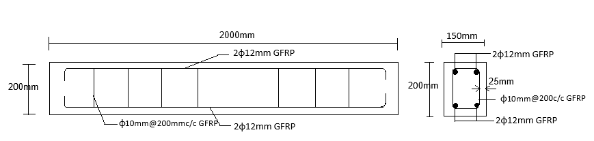
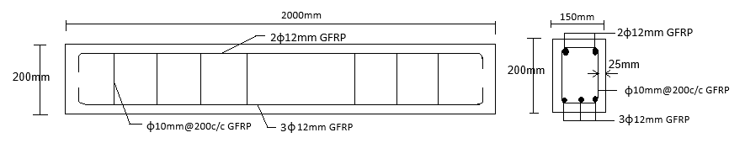
Fig. 1. Reinforcement details of beams

2.5 Test Procedures
2.5.1 Concrete compressive strength test
The concrete cubes (150×150×150 mm) were removed from the wet sacks and carefully cleaned, after which their exact dimensions and weight were recorded. Each cube was then placed in the Universal Testing Machine (UTM) with the load applied gradually and centrally to opposite faces until the specimen failed. The peak load at failure was recorded, and the compressive strength was determined by dividing this maximum load by the cube's cross-sectional area. The average compressive strength of the cured cubes was evaluated at 7, 14, and 28 days using a UTM. The test was carried out in accordance with guidelines of British Standards BS EN 12390-3 [34].
2.5.2 Concrete modulus of rupture test
The concrete prism (100mm × 100 mm × 500 mm) was placed as a simply supported beam over a 400 mm span within a rigid steel frame and subjected to a central point load until failure. The estimated modulus of rupture for the two mixes were 2.4 N/mm² and 3.1 N/mm² (Table 1). The test was conducted in accordance with the requirements of British Standards BS EN 12390-5 [35].
2.5.3 Tensile test of GFRP bars
The tensile strength of GFRP reinforcing bars was evaluated using a Universal Testing Machine (UTM) following ASTM D7205 [36]. Test samples with diameters of 10 mm and 12 mm were prepared by anchoring each end in a 25 mm steel pipe with an inner diameter of 22 mm. The GFRP bars were embedded 150 mm into the steel pipes on both ends, leaving a 300 mm free length. To secure the bars, a high-strength, non-shrink epoxy mixture (Bisphenol A) with expanding additives was used to fill the gap between the steel pipe and the GFRP bar. The specimens were sealed, cured for 24 hours, and allowed additional three days for full hardening. Tensile testing was performed using a 1000 kN ELE Universal Testing Machine equipped with a 50 mm gauge length extensometer. A constant loading rate of 3 mm/min was applied until failure. Observed failure modes included fiberglass fracture and epoxy bond failure. Throughout the test, tensile strength, Young's modulus, failure strain, and stress-strain behavior were automatically recorded. Tensile tests were also conducted on the reinforcing steel bars. The results for both steel bars and GFRP are summarized in Tables 2 and 3 respectively.
2.5.4 Testing of reinforced concrete beams
At 28 days of curing, the reinforced concrete beams were cleaned to aid crack detection, coated with white emulsion paint for enhanced visibility, and left to dry. The beams were positioned in a rigid steel loading frame with two supports 100 mm from the ends, creating a clear span of 1,800 mm. A hydraulic jack actuator with a 200 kN capacity and 2 kN intervals, equipped with a load cell, was used to apply incremental loads through a rigid steel spreader beam. The load was distributed to the specimen via two symmetrical loading points, 400 mm apart, each located 700 mm from the nearest support, as shown in Fig. 2. A dial gauge was centrally positioned underneath the beam setup to measure mid-point deflections of the beam. During the test, deflection and crack patterns were closely monitored, measured, and recorded. Upon reaching the failure load, crack propagation parameters—such as crack width, spacing, and types—were documented for analysis. The collected data were used to establish the load-deflection relationship, offering valuable insights into the beam's behavior under varying loads.

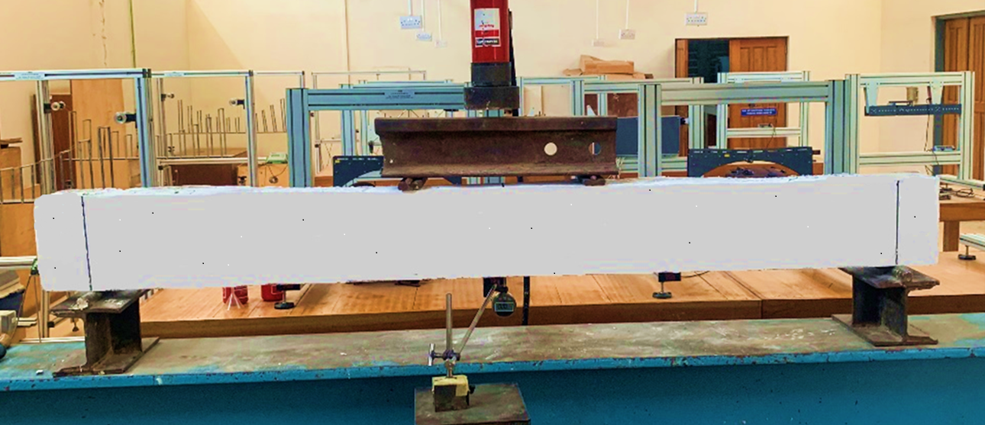
Fig. 2. Test set-up

- RESULTS AND DISCUSSIONS
3.1 Mechanical properties of reinforcement bars
The mechanical properties of GFRP bars and traditional mild steel bars are summarized in Tables 2 and 3 respectively. The 10 mm and 12 mm diameter GFRP bars exhibited ultimate tensile strengths of 1193 N/mm² and 1030 N/mm², respectively. The Young's modulus of elasticity for the GFRP bars was measured as 54.43 kN/mm² for the 10mm bars and 41.71 kN/mm² for the 12 mm bars. The ultimate elongation values for the 10 mm and 12 mm GFRP bars were recorded as 2.20% and 2.48%, respectively. As shown in Fig. 3, the stress-strain relationship for the GFRP bars is linear, with strain increasing proportionally as stress was applied until the ultimate strength was reached and failure occurred. Unlike steel bars, which display a distinct yield point and a combination of linear and non-linear behaviors typical of ductile failure modes, GFRP bars do not have a well-defined yielding stage. Despite the absence of a yield point, GFRP bars' high strain capacity and low modulus of elasticity throughout the elastic range make them effective for handling large stresses, even though they lack significant warning signs of impending failure [10, 37].

Table 2. Mechanical properties of GFRP bars
Bar Diameter | Average Diameter (mm) | Ultimate Tensile Strength (N/mm²) | Young’s Modulus of Elasticity (kN/mm²) | Average Ultimate Elongation (%)
10mm | 9.54 | 1193 | 54.43 | 2.20
12mm | 11.35 | 1030 | 41.71 | 2.48

Table 3. Mechanical properties of traditional steel reinforcing bars
Bar Diameter | Average Diameter (mm) | Yield Strength (N/mm²) | Yield Strain (E_{v}) | Tensile Strength (N/mm²) | Young’s Modulus of Elasticity (kN/mm²) | Average Ulti-mate Elongation (%)
10mm | 9.24 | 464.20 | 0.0026 | 545.19 | 200 | 18.03
12mm | 11.17 | 457.57 | 0.0031 | 538.30 | 198 | 18.7

Fig. 3. Stress-strain curve for 10mm and 12mm GFRP bars

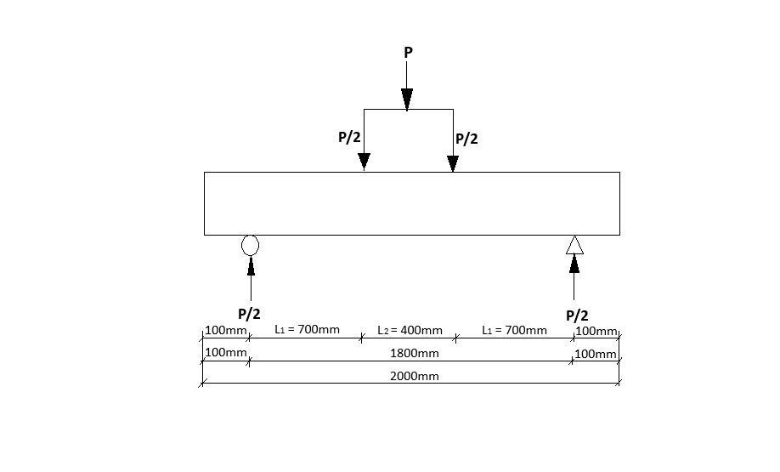
Fig. 4. Schematic diagram of the loaded beam

3.2 Experimental and Predicted Shear Capacities
The shear design of GFRP-reinforced beams is based on the guidelines outlined in ACI 440.1R-06 [32], which consider the material's lower stiffness and brittle failure behavior. The nominal shear strength of the reinforced concrete section (V_{n}) is determined by considering contributions from the concrete section, the tension reinforcement and the GFRP stirrups, using the following expression;
$$V_{n}=V_{c}+V_{f}………………\left(1\right)$$
where:
V_{c} is the shear resistance provided by the concrete (kN).
V_{f} is the shear resistance provided by the GFRP bar (kN).

The shear capacity of concrete, (V_{c}), in members reinforced with GFRP as the primary reinforcement can be assessed using the following approach:
$$V_{c}=5\sqrt{f_{c}}b_{w}(kd)………………\left(2\right)$$
where:
fc is the concrete compressive strength (N/mm²).
bw is the web width (mm).
kd is neutral axis depth (mm).
The shear resistance of the GFRP stirrups to the beam's resistance is based on the tensile strength of the GFRP bars and spacing of stirrups is expressed as:
$$V_{f}= \frac{A_{fv}f_{fv}d}{s}………………………………(3)$$
where:
V_{f} is the shear resistance provided by the GFRP bar (kN).
A_{fv} is the area of shear reinforcement (mm²).
d is the distance between the extreme compression fiber and the centroid of the tensile reinforcement (mm).
s is the shear reinforcement spacing (mm).
​The design tensile strength of GFRP shear reinforcement (f_{fv}) is given by:

$$f_{fv}=0.004E_{f}≤f_{fb}……………………(4)$$
where:
f_{fb} is the strength of the bent portion of the GFRP stirrups (N/mm²).
E_{f} is the Young’s modulus of elasticity of the GFRP bar (kN/mm²).

$$f_{fb}= \left(0.05\frac{r_{b}}{d_{b}}+0.3\right)f_{fd}≤f_{fd}……………..(5)$$
where:
r_{b} is bend radius of stirrup (mm).
d_{b} is the bar diameter (mm).
f_{fd} is the design tensile strength of the bent portion of GFRP bars (N/mm²).
Eqn. 4 was used since the stirrups were not bent to warrant the use of Eqn. 5. Table 6 presents the computed results for shear failure occurring first in the beams.
Table 4. Cracking and failure modes
Beam ID | Maximum crack width (mm) | Average crack spacing (mm) | Types and No. of cracks |  |  | Failure mode
 |  |  | No. of pure flexural cracks | No. of flexural shear cracks | No. of diagonal shear cracks | Predicted | Experimental
BGF1 | 1.0 | 97.50 | 4 | 5 | 4 | Diagonal Shear | Diagonal Shear
BGF2 | 1.0 | 55.54 | 6 | 6 | 3 | Diagonal Shear | Diagonal Shear
BGF3 | 0.5 | 71.88 | 5 | 6 | 3 | Diagonal Shear | Diagonal Shear
BGF4 | 1.0 | 68.90 | 4 | 4 | 7 | Diagonal Shear | Diagonal Shear
BGF5 | 0.5 | 91.57 | 3 | 6 | 5 | Diagonal Shear | Diagonal Shear
BS1 | 2.0 | 54.83 | 6 | 7 | 9 | Steel yielding | Steel yielding

Table 5. Deflections and post-cracking strain energy
Beam ID | Deflection at first crack, $δ_{cr}$ (mm) | Final deflection, $δ_{max}$ (mm) | $$\frac{δ_{cr}}{δ_{max}}$$ | Post-cracking strain energy, (Nm)
BGF1 | 0.98 | 28.86 | 0.03 | 554.7
BGF2 | 9.04 | 19.53 | 0.46 | 423.7
BGF3 | 5.19 | 19.88 | 0.26 | 472.3
BGF4 | 7.99 | 18.54 | 0.43 | 437.4
BGF5 | 4.66 | 20.38 | 0.23 | 420.9
Avg. | 5.57 | 21.44 | 0.28 | 461.8
BS1 | 4.43 | 11.39 | 0.39 | 278.8

Table 6. Cracking and failure loads of beams
Beam ID | Theoretical cracking load,  P_{cr} (kN) | Experimental cracking load,  P'_{cr} (kN) | Theoretical failure load Pult (kN) based on |  |  | Experimental failure load  P'_{ult} (kN) | P'_{cr}/P_{cr} | P'_{ult}/P_{ult} | P’_{cr}/P’_{ult}
 |  |  | Reinforcement failing | Concrete crushing | Shear failure
BGF1 | 5.4 | 4 | 52.3 | 37.0 | 27.4* | 38 | 0.74 | 1.39 | 0.11
BGF2 | 7.0 | 8 | 52.3 | 48.1 | 31.4* | 38 | 1.14 | 1.22 | 0.21
BGF3 | 5.4 | 8 | 78.6 | 37.0 | 27.4* | 44 | 1.48 | 1.61 | 0.18
BGF4 | 5.4 | 12 | 78.6 | 37.0 | 27.4* | 44 | 2.22 | 1.61 | 0.27
BGF5 | 5.4 | 8 | 78.6 | 37.0 | 27.4* | 38 | 1.48 | 1.39 | 0.21
 |  |  |  |  |  | Average | 1.41 | 1.44 | 0.20
BS1 | 5.4 | 12 | 30.6* | 70.5 | 55.8 | 44 | 2.22 | 1.44 | 0.27
Note: *Governing failure load of beam

- THEORETICAL AND EXPERIMENTAL RESULTS
4.1 Load-Deflection Response
The Load versus deflection curves for the six reinforced concrete beams are shown in Fig. 4. As depicted on the curves, the beams initially exhibited elastic behavior by their steep and linear curves before the first crack. These initial steep, linear curves indicate the beams' elastic behavior and load resistance without permanent deformation, reflecting the concrete's stiffness regardless of beam type or shear reinforcement. However, as the load increased, flexural cracks formed, causing a gradual change in the curve's slope. Despite this, the curve maintained a relatively linear response for some time, indicating sustained shear resistance. Eventually, significant deflection and reduced flexural stiffness led to failure, primarily due to diagonal shear and crack propagation into the compression zone, compromising the beam's shear capacity.

Fig. 5. Load - deflection curves

4.2 Post-cracking deflection and energy absorption
From the load deflection curve (Fig. 4), beam BGF1 with 0.7% tensile reinforcement ratio exhibited higher final deflection (28.86 mm) than their counterpart beams (BGF3, BGF4 and BGF5) with 1.13% tensile reinforcement ratio that recorded an average final deflection of 19.6 mm. This shows that an increase in tensile reinforcement ratio from 0.7% to 1.13% led to a 32.1% reduction in final deflection. This is attributed to the dowel action between the aggregates and the longitudinal reinforcement that increase the beams’ stiffness and enhanced its shear resistance as confirmed by previous research [1, 8].
From Fig. 4, beam BGF2 with 30.4 N/mm² concrete compressive strength achieved average final deflection of 19.53 mm in comparison to beam BGF1 with 23.4 N/mm² compressive strength which achieved a final deflection of 28.86 mm. Consequently, this depicts that an increase in concrete compressive strength from 23.4N/mm² to 30.4 N/mm² caused a 31% reduction in final deflection. Furthermore, it is evident from Table 5 that the mid-span deflections of all the GFRP RC beams, ranging from 18.54 mm to 28.86 mm, were higher than that of the control steel RC beam (11.39 mm) irrespective of their reinforcement ratios, stirrup spacing or concrete strengths. This is due to the lower Young’s modulus of elasticity of the GFRP than steel (see Tables 2 and 3), as confirmed by existing literature [31].
The ratio of deflection at first crack to the maximum deflection near collapse (δ_{cr}/δ_{max}) ranges from 0.03 to 0.46 (Table 5). These low ratios indicate limited ductility and plasticity of the GFRP RC beams. Post-cracking strain energy refers to the energy absorbed per unit cross-sectional area of a reinforced concrete beam after initial cracking, reflecting its ability to sustain loads and undergo deformation before ultimate failure. In this study, it is determined by the area under the load-mid-span deflection curve up to the failure of the beam [38]. The post-cracking strain energy of the beams ranged from 420.9 Nm - 554.7 Nm for GFRP RC beams with an average value of 461.8 Nm whilst that of steel RC beams achieved 278.8 Nm.
Moreover, Table 5 shows that Beam BGF1 of 0.65% GFRP shear reinforcement ratio achieved a post-cracking strain energy of 554.7 Nm in contrast to control steel RC Beam BS1 of the same reinforcement ratio and beam properties, which achieved a lower than expected post-cracking strain energy of 278.8 Nm. This could be attributed to the fact that GFRP-RC beams stored more energy elastically and released it suddenly upon failure, leading to inefficient energy dissipation and brittle failure mode due to its lower elastic modulus (see Table 2). On the other hand, the steel RC which exhibited improved ductility with efficient energy dissipation as a result of its higher modulus of elastic (see Table 3).

Fig. 5. Post-cracking strain energy

4.3 Cracking loads
The theoretical and experimental cracking loads for the beams subjected to monotonic loading are presented in Table 6. The experimental cracking loads (P’_{cr}) for the GFRP-reinforced beams averaged 1.41 of the theoretical cracking loads (P_{cr}) as compared to 2.22 for the steel RC beam. In addition, the first crack loads varied from 11% to 27% of the failure load for GFRP RC beams compared to 27% of the failure load for steel RC beams. The experimental cracking loads ranged from 4 kN for beam BGF1 to 12 kN for beam BS1. As shown in the table, beam BGF2 with 30.4 N/mm² compressive strength was predicted to develop a higher theoretical cracking load than beams with 23.4 N/mm² compressive strength due to its higher modulus of rupture of the beams (Table 1). This could be due to the improved frictional resistance to the rough and uneven sliding plane surface through aggregate interlock after the onset of diagonal cracking by virtue of the corresponding higher compressive strength of the beams as confirmed by other researchers [16, 19].

4.4 Failure Loads
Table 6 presents the theoretical and experimental failure loads of beams subjected to monotonic loading. The beam theoretical failure load was based on the critical (governing) load from three main possibilities: 1. Failure of beam due to failure of tensile reinforcing bars. 2. Failure of beam based on concrete crushing in compression, and 3. Failure of beam due to shear failure first. In applying concrete crushing first to cause beam failure, the contribution of GFRP bars in compression was ignored, but in the case of the compression steel bar, its contribution to beam compression resistance was not ignored. The GFRP RC beams exhibited experimental failure loads (P’ult) that were on average 1.44 of the theoretical failure loads (Pult), with values varying between 1.22 and 1.61. In comparison, the steel RC beam showed an experimental failure load that surpassed the theoretical value by a factor of 1.44. As presented in Table 6, beam BGF1, having a GFRP tensile reinforcement ratio of 0.7% and 0.65% shear reinforcement (200 mm GFRP stirrup spacing), experienced a sudden brittle diagonal shear failure at 38 kN. In the case of beams BGF3, BGF4, and BGF5, having a GFRP tensile reinforcement ratio of 1.13% and a constant 0.65% shear reinforcement (200 mm GFRP stirrup spacing), they also failed by diagonal shear but at relatively higher loads of 44 kN, 44 kN, and 38 kN respectively. As expected in beams BGF1 to BGF5, those with a 0.7% longitudinal reinforcement ratio of GFRP bars exhibited lower shear strengths compared to their counterparts with a 1.13% reinforcement ratio of GFRP bars. This is because, for beams with identical geometric dimensions and concrete compressive strength, dowel action is primarily influenced by the amount of longitudinal tension reinforcement provided [9]. On the other hand from Table 6, the control steel RC beam having a tensile reinforcement ratio of 0.7% and 0.65% shear reinforcement (200 mm steel stirrup spacing) experienced a failure by yielding of the steel bars at 44 kN. A noticeable trend noticed was that, GFRP-reinforced concrete beams exhibited a lower shear capacity than conventional steel-reinforced concrete beams, despite having the same compressive strength, tensile reinforcement ratio, shear span-to-depth ratio, and equivalent shear reinforcement ratio (identical stirrup spacing). This aligns with the findings of Razaqpur et al. [20] and Ahmad et al. [23], confirming that the reduction in shear strength was primarily due to the weaker dowel action of GFRP bars and their lower post-cracking transverse stiffness, which negatively affected the overall shear resistance.

4.5 Failure Mode
The failure mode of the beams was influenced by the bond between the GFRP bars and the concrete, concrete strength, longitudinal and shear reinforcement ratios, and the shear span-to-effective depth ratio (a/d). Initially, vertical flexural cracks developed in the constant moment zone. With increasing load, additional cracks developed in the shear region, eventually leading to the formation of diagonal cracks that extended toward the loading points. These diagonal shear failures followed a pattern similar to the one observed by Johnson and Sheik (2016) [39]. Other new diagonal cracks began to form separately from locations closer to the supports. The observed crack patterns indicate that the initial cracks developed near the tension zone, forming an inclination of approximately 45º. From Tables 4 and 6, the theoretical analysis predicted the failure mode for Beams BGF1 to BGF5 to be diagonal shear. Similarly, the experimental results confirmed diagonal shear mode as seen in figures 7 to 12. Practically, it implied that the shear reinforcement provided in the form of stirrups at 200 mm spacings was not adequate to resist the applied load. As such, the GFRP RC beams with 200 mm GFRP stirrup spacings experienced diagonal shear failure. On the other hand, the steel-reinforced beam failed in concrete crushing after yielding of the longitudinal tension steel bars, which was accurately predicted by the theoretical analysis

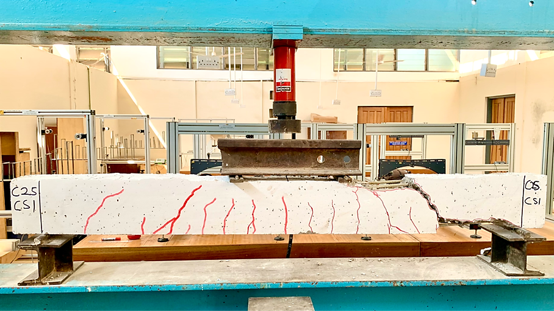
Fig. 6. Beam BGF1 (2BGFRP/200GFRP) at failure

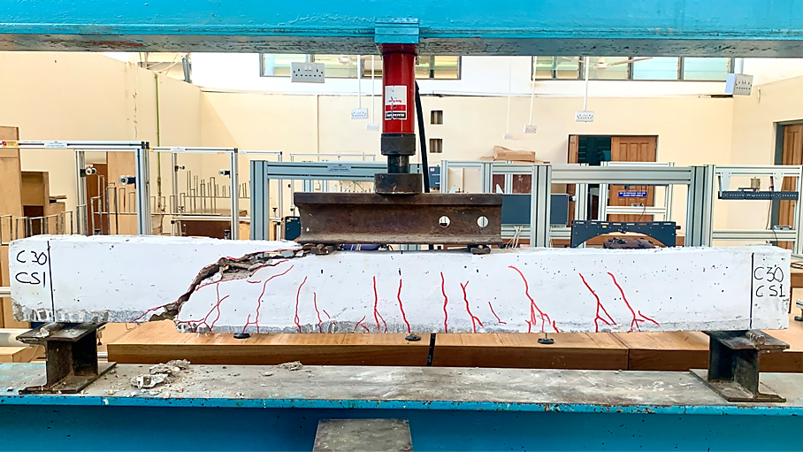
Fig. 7. Beam BGF2 (2BGFRP/200GFRP) failure mode

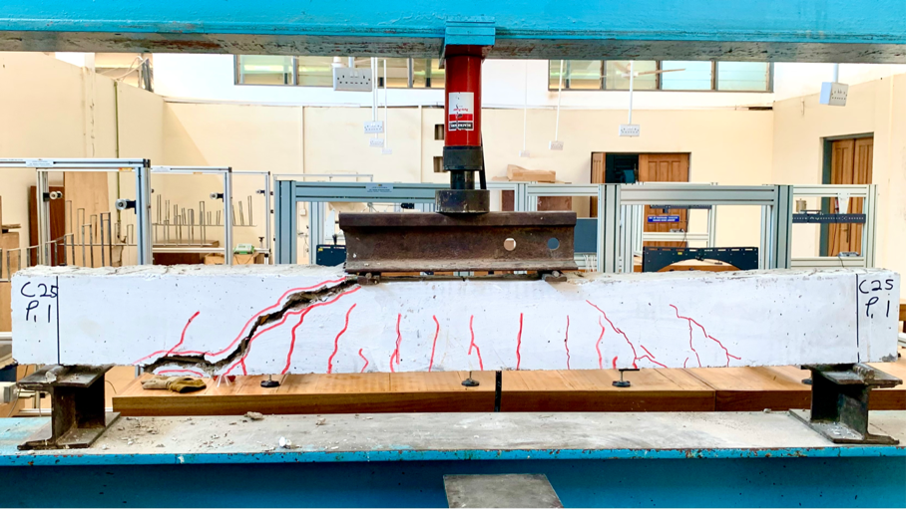
Fig. 8. Beam BGF3 (3BGFRP/200GFRP) at failure

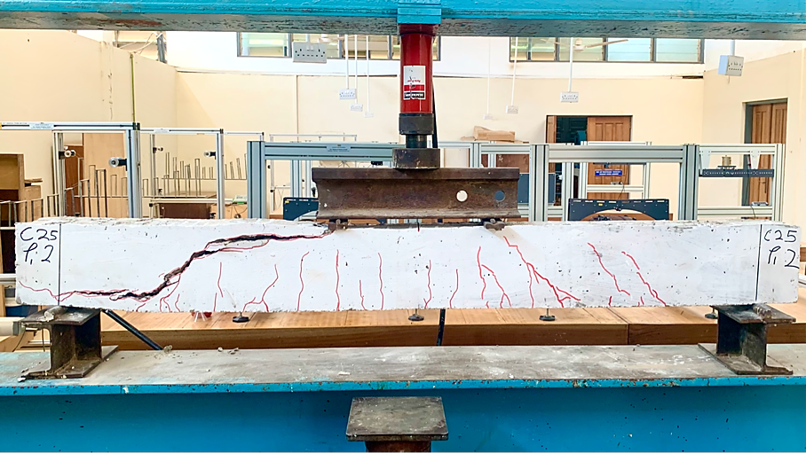
Fig. 9. Beam BGF4 (3BGFRP/200GFRP) at failure

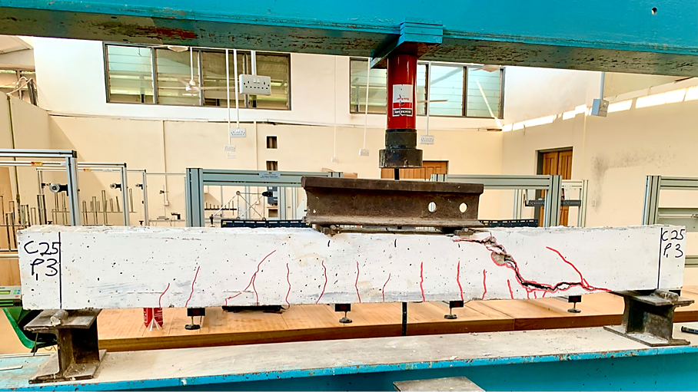
Fig. 10. Beam BGF5 (3BGFRP/200GFRP) at failure

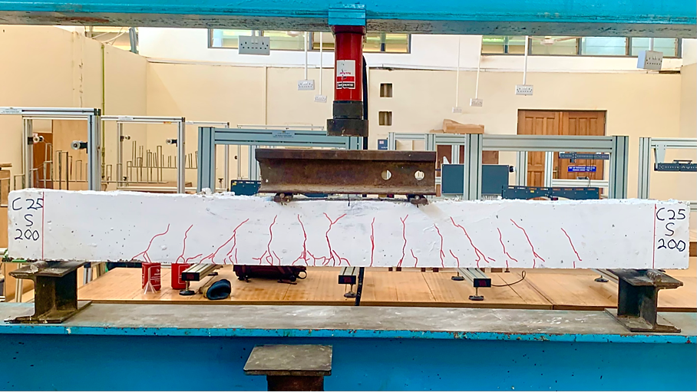
Fig. 11. Beam BS1 (2BST/200ST) at failure

Table 7: Comparison of Experimental shear and Theoretical Shear predictions
Beam | Angle of major crack, Ө (Degree) | Ultimate Shear, V_{Exp} (kN) | Theoretical Shear, V_{Pred} (kN) | V_{Exp}/V_{Pred}
BGF1 | 49 | 38 | 27.4 | 1.39
BGF2 | 45 | 38 | 31.4 | 1.21
BGF3 | 47 | 44 | 27.4 | 1.61
BGF4 | 39 | 44 | 27.4 | 1.61
BGF5 | 43 | 38 | 27.4 | 1.39
 |  |  | Average | 1.44
 |  |  | SD | 0.17
 |  |  | COV | 11.79

4.7 Comparison of experimental and predicted shear capacity
Table 7 presents a comparison between the experimentally measured shear capacity and the theoretical predictions. This is referred to the common concept in calculating the concrete contribution and GFRP stirrup contribution separately to derive shear capacity of the beam. It can be observed from Table 7 that the average ratio of experimental shear capacity to the predicted (V_{Exp}/V_{Pred}) was 1.44, indicating that the theoretical analysis using ACI 440 was conservative in the shear predictions. Additionally, a standard deviation (SD) of 0.17 and a coefficient of variation (COV) of 11.79% suggests that the theoretical shear predictions showed low spread around the mean, with low to moderate level of variability.

- CONCLUSIONS
This study explored the shear performance of concrete beams reinforced with GFRP bars. The study focused on the impact of varying concrete compressive strengths and tensile reinforcement ratios, with a constant transverse shear reinforcement spacing of 200 mm and shear span-to-effective depth ratio on the shear capacity of beams, which were subjected to a four-point monotonic loading system. Through a comprehensive analysis of both theoretical predictions and experimental findings, the following conclusions were drawn:
- Theoretical predictions of failure mode based on concrete crushing (i.e., failure in the compression zone) ignored contributions by GFRP compression bars in the beams but accounted for the contribution by compression steel bars in the control specimens.
- The experimental-to-predicted shear capacity ratio (V_{Exp}/V_{Pred}) averaged 1.44, with a standard deviation (SD) of 0.17 and a coefficient of variation (COV) of 11.79%, demonstrating that ACI 440 provided conservative shear predictions with reasonable consistency and a low to moderate variation in values.
- All beams reinforced with GFRP main bars and 200 mm GFRP stirrup spacing failed in diagonal shear, with cracks extending from the support through the compression zone to the nearest loading point. The provided GFRP shear reinforcement ratio was insufficient to ensure adequate confinement per unit volume of the beam section. In contrast, the control steel RC beam, reinforced with steel longitudinal bars and 200 mm steel stirrup spacing, failed by concrete crushing following the yielding of the longitudinal tension steel bars, as predicted by theoretical analysis.
- Crack angle of the failed specimens varied from 39° to 49° with an average of 44.6°, which shows good agreement with traditional truss model.
- With a constant 200 mm GFRP stirrup spacing, higher concrete compressive strength and longitudinal tension reinforcement ratios in GFRP RC beams led to increased shear capacity and reduced final deflections after diagonal cracking. This was due to improved shear resistance from aggregate interlock and dowel action between the aggregates and GFRP longitudinal reinforcement.
- Under similar conditions of compressive strength, tensile reinforcement ratios, shear span-to-depth ratios (a/d), and shear reinforcement ratios (stirrup spacings), GFRP RC beams exhibited lower shear capacity than steel RC beams. This reduction was mainly due to the limited dowel action of GFRP bars, coupled with their lower modulus of elasticity and reduced post-cracking transverse stiffness, which weakened shear resistance.
- The GFRP RC beams absorbed an average of 461.8 Nm strain energy, significantly higher than the control steel RC beam, which absorbed 278.8 Nm. The higher strain energy of the GFRP-RC beams was due to their ability to store energy elastically but then released it suddenly upon failure, resulting in brittle diagonal shear failure modes, whereas the steel RC beam dissipated energy more efficiently due to its high ductility obtained from its higher modulus of elasticity.

COMPETING INTERESTS
Authors have declared that they have no known competing financial interests or non-financial interests or personal relationships that could have appeared to influence the work reported in this paper.
Disclaimer (Artificial intelligence)
Author(s) hereby declare that NO generative AI technologies such as Large Language Models (ChatGPT, COPILOT, etc.) and text-to-image generators have been used during the writing or editing of this manuscript.

REFERENCES:
[1] Liang, X.; Peng, J.; Ren, R. A state-of-the-art review: Shear performance of the concrete beams reinforced with FRP bars. Constr. Build. Mater. (2023), 364, 129996.
[2] Mukhtar F, Deifalla A (2023) Shear strength of FRP reinforced deep concrete beams without stirrups: test database and a critical shear crack-based model. Compos Struct. https://doi.org/10.1016/j.compstruct.2022.116636.
[3] Ebid AM, Deifalla A (2021) Prediction of shear strength of FRP reinforced beams with and without stirrups using (GP) technique. Ain Shams Eng J 12:2493–2510. https://doi.org/10.1016/j.asej.2021.02.006.
[4] Oller E, Marı´ A, Baira´n JM, Cladera A (2015) Shear design of reinforced concrete beams with FRP longitudinal and transverse reinforcement. Compos B Eng 74:104–122. https://doi.org/10.1016/J.COMPOSITESB.2014.12.031.
[5] Ohene-Coffie, F., Kankam, C. K., Kpo, S. A. K., Boateng, G. O., & Nanor, E. S. (2024). “Anchorage Bond Strength of Glass Fibre Polymer Reinforced Concrete with Palm Kernel Shells as Partial Coarse Aggregate.” Journal of Engineering Research and Reports, 26(7): 1–16. https://doi.org/10.9734/jerr/2024/v26i71189.
[6] Wang B, Lui Gejia, Miao H. Experimental study on bond performance between Glass-Fiber-Reinforced Polymer (GFRP) bars and Concrete. Buildings. (2023);13 (9):2126.
[7] Xian, G.; Guo, R.; Li, C. Combined effects of sustained bending loading, water immersion and fiber hybrid mode on the mechanical properties of carbon/glass fiber reinforced polymer composite. Compos. Struct. (2022), 281, 115060.
[8] Mohammed SA, Said AI. A comparative study of the structural behavior of concrete beams Reinforced with Different Configurations of GFRP and Steel Bars, Jcoeng. Apr. (2024);30(04):200–218. https://doi.org/10.31026/j.eng.2024.04.12.
[9] MA E, Adam Abeer M, Habib Fatma A, El-Sayed, Taha A. Structural Behavior of High-Strength Concrete Slabs Reinforced with GFRP Bars. Polymers. 2021;13(17): 2997-NA. https://doi.org/10.3390/polym13172997.
[10] Boateng, G. O., Kankam, C. K., Mansar, E. C., Afrifa, R. O., Kwarteng, F., Ohene-Coffie, F., & Kpo, S. A. K. (2024). “Evaluating the Mechanical Properties of Fiber-glass-Reinforced Polymer Bar.” Journal of Engineering Research and Reports, 26(7): 150–160. https://doi.org/10.9734/jerr/2024/v26i71200.
[11] Nasrollahzadeh K, Basiri MM (2014) Prediction of shear strength of FRP reinforced concrete beams using fuzzy inference system. Expert Systems with Applications 41: 1006-1020.
[12] Kang, M.R.; Xue, W.C. Research Progress on shear behavior of concrete beams with FRP stirrups. J. North China Univ. Water Resour. Electr. Power (Nat. Sci. Ed.) 2015, 36, 15–20. (In Chinese)
[13] Maranan, G.B.; Manalo, A.C.; Benmokrane, B.; Karunasena,W.; Mendis, P.; Nguyen, T.Q. Shear behaviour of geopolymer-concrete beams transversely reinforced with continuous rectangular GFRP composite spirals. Compos. Struct. 2018, 187, 454–465.
[14]. Maranan, G.B.; Manalo, A.C.; Benmokrane, B.; Karunasena, W.; Mendis, P.; Nguyen, T.Q. Flexural behavior of geopolymer concrete beams longitudinally reinforced with GFRP and steel hybrid reinforcements. Eng. Struct. 2019, 182, 141–152.
[15] Walraven JC. Fundamental analysis of aggregate interlock. J Struct Div ASCE 1981;108:2245–70.
[16] Choi Y. W. Lee H. K. Chu S. B. Cheong S. H. and Jung W. Y. (2012). Shear Behavior and Performance of Deep Beams Made with Self-Compacting Concrete. International Journal of Concrete Structures and Materials, Vol.6, No.2, pp.65–78, June 2012.
[17] Hamrani, A.; Alnahhal, W. Shear behavior of basalt FRC beams reinforced with basalt FRP bars and glass FRP stirrups: Experimental and analytical investigations. Eng. Struct. 2021, 242, 112612.
[18] Machial R, Alam MS, Rteil A (2012) Revisiting the shear design equations for concrete beams reinforced with FRP rebar and stirrups. Mater Struct 45.
[19] El-Sayed A, El-Salakawy E, Benmokrane B (2005) Shear strength of concrete beams reinforced with FRP bars: Design method. Proceedings of the 7th International Symposium on Fiber Reinforced Polymer Reinforcement for Concrete Structures - FRPRCS-7: 955-974.
[20] Razaqpur AG, Isgor BO, Greenaway S, Selley A (2004) Concrete Contribution to the Shear Resistance of Fiber Reinforced Polymer Reinforced Concrete Members. J Compos Construct 8: 452-460.
[21] Machiel R, Alam MS, Rteil A (2010) Shear strength contribution of transverse FRP reinforcement in bridge girders. IABSE-JSCE 978-984.
[22] Said, M.; Adam, M.A.; Mahmoud, A.A.; Shanour, A.S. Experimental and analytical shear evaluation of concrete beams reinforced with glass fiber reinforced polymers bars. Constr. Build. Mater. 2016, 102, 574–591.
[23] S. Ahmad, A. Umar, A. Masood. 2017. Properties of Normal Concrete, Self-compacting Concrete and Glass Fibre-reinforced Self-compacting Concrete: An Experimental Study, Procedia Eng. 173: 807-813. doi:10.1016/j.proeng.2016.12.106.
[24] Concrete Structures 1999 by R. Warner (Author), B. Rangan (Author), A. Hall (Author), Ken Faulkes (Author). South Melbourne : Longman, 1998 xviii, 974 p. : ill. ; 25 cm. 0582802474.
[25] Abdullah M. Sagheer, Farid Abed. (2017) Finite Element Parametric Study of the Shear Behavior of GFRP-RC Short Beams. Conference: Seventh International Conference on Modeling, Simulation, and Applied Optimization (ICMSAO’17) http://dx.doi.org/10.1109/ICMSAO.2017.7934912
[26] Ahmad, S. H. S. Rafeeqi F.A. and Fareed F. (2011). Shear Strength of Normal and Light Weight Reinforced Concrete Deep Beams without Web Reinforcement. Journal of Emerging Trends in Engineering and Applied Sciences (JETEAS) 2 (6): 967-971.
[27] Alam, M. S., and Hussein, A. (2012). “Effect of member depth on shear strength of high-strength fiber-reinforced polymer-reinforced concrete beams.” J. Compos. Constr., 10.1061/(ASCE)CC.1943-5614.0000248, 119–126.
[28] Jumaa G. B. and Yousif A. R., Size effect in shear failure of high strength concrete beams without stirrup reinforced withbasalt FRP bars, KSCE J. Civ. Eng., 23 (2019) 1636–1650.
[29] Kpo, S. A. K., Kankam CK, Ohene-Coffie F, Boateng G. O, Nanor ES, Junior J. K. Q., Mansal E. C. 2024. “Strength and Deformation Characteristics of Concrete Beams Reinforced With Glass Fibre Reinforced Polymer Bars”. Asian Journal of Advanced Research and Reports 18 (9):151-69. https://doi.org/10.9734/ajarr/2024/v18i9741.
[30] Hegger, J.; Kurth, M. Shear capacity of concrete beams with FRP reinforcement. Proc. Fib Int. Phd Symp. Civ. 2011, 275, 1–14.
[31] Maranan, G.B.; Manalo, A.C.; Benmokrane, B.; Karunasena,W.; Mendis, P.; Nguyen, T.Q. Shear behaviour of geopolymer-concrete beams transversely reinforced with continuous rectangular GFRP composite spirals. Compos. Struct. 2018, 187, 454–465.
[32] American Concrete Institute (ACI). Guide for the design and construction of concrete reinforced with FRP bars. Farmington Hills, MI: ACI 440.1R-06; 2006.
[33] Indian standard, Recommended Guidelines for Concrete Mix Design, IS 10262:1982, Bureau of India Standard, New Delhi.
[34] BS EN 12390-3 (2009). Testing hardened concrete-Part 3: Compressive Strength of Test Specimens. British Standard Institution, London; 2009.
[35] BS EN 12390-5: Testing of hardened concrete Part 5: Flexural Strength of Test Specimens, British Standard Institution, London, UK; 2000.
[36] ASTM D7205 (2006). Standard test method for tensile properties of fiber reinforced polymer matrix composite bars. ASTM Committee D30; 2006.
[37] Taerwe L. Non-Metallic (FRP) Reinforcement for Concrete Structures: Proceedings of the Second International RILEM Symposium. CRC Press. 2004;18–24. [Online]. Available:https://books.google.com.gh/books?id=dUVZDwAAQBAJ.
[38] Kankam C.K., Adom-Asamoah M. (2002). Strength and ductility characteristics of reinforcing steel bars milled from scrap metals. Materials Design, 23(6), 537-545, https://doi.org/10.1016/S0261-3069(02)00028-6.
[39] Johnson, D., & Sheikh, S. (2016). Experimental investigation of glass fiber-reinforced polymer-reinforced normal-strength concrete beams. ACI Structural Journal, 113(6), 1165-1174.

