# Forecasting Student Enrollment Trends in Hotel Catering and Institutional Management at Kumasi Technical University

**Abstract**

This study considered the trends in enrollment for two major programs at Kumasi Technical University: The Higher National Diploma and the Bachelor of Technology in Hospitality and Catering Management. The research study employed descriptive statistics, stationarity tests, and ARIMA modeling to analyze past enrollment data and provide a forecast of future trends. It shows that the HND program has a higher and more stable enrollment base, with an average of 85.6 students, whereas the BTECH program is rather variable, with lower enrollment figures at an average of 28.2 students. The results of the test show that both the HND and BTECH time series data are stationary and therefore could be modelled for forecasting future trends using ARIMA models. Based on this, one would immediately project that the numbers studying for HND are likely to decline steadily from 2025 to 2029. Correspondingly, BTECH numbers would increase throughout this same period. These trends suggest that the university may need to adapt its curriculum and strategic direction, particularly for the HND program, in response to declining enrollments and capitalize on the growing demand for BTECH degrees in technology and engineering. This study emphasizes the need to align academic programs with the demands of the labor market and shifting student preferences as a means of ensuring long-term sustainability and relevance.

**Keywords**: Students enrollment, ARIMA model, higher education, curriculum development, time series analysis.

# Introduction

It is widely recognized that the hospitality industry is experiencing challenges in attaining and retaining talented, motivated and qualified staff. This staffing challenge is so considerable that it is regarded as one of the top ten issues faced by the global hospitality industry in the 21st century. Even among hospitality management students pursuing an education in this specific field, many choose not to enter the hospitality industry on graduation. Instead, they enter employment in related fields such as luxury retailing, banking, fashion, leisure and travel (Zhang & Eringa, 2022). Forecasting student enrollment in Hotel Catering and Institutional Management (HCIM) programs is a critical aspect of educational planning and resource allocation for institutions such as KsTU. In this regard, it will enable universities to manage their sta*ffi*ng, facilities, and curriculum o*ff*erings more e*ff*ectively. However, enrollment trends in the HCIM program are normally influenced by many factors relating to industry demands, economic conditions, and students’ preference for the program. In recent years, institutions worldwide have faced challenges in accurately predicting student enrollment in specialized fields like HCIM due to these dynamic factors (Akanbi et al., 2021). Despite its importance, there is a notable gap in research specifically addressing the forecasting of student enrollment in HCIM programs at KsTU, and more broadly within Ghanaian technical universities. A critical issue is the unpredictability of enrollment patterns, which has recently been exacerbated by external events like the COVID-19 pandemic that disrupted education and labor market conditions (Ampofo et al., 2022). Such disruptions within the hospitality sector, as well as shifting perceptions regarding job opportunities in hospitality and tourism, have increasingly complicated the forecasting of future enrollments in HCIM programs. Whereas a few studies have investigated trends in the enrollment of students into other programs, very little targeted research has been carried out on the HCIM sector, particularly in Ghanaian Technical Universities (Tetteh Osei, 2023). Student enrollment data usually comes in at regular time intervals, such as yearly or monthly. Time series data is typically marked by temporal dependence, with past values often influencing future values. ARIMA uses past points to predict future values, which aligns well with the idea that the number of students enrolled in a given year may be influenced by previous years’ enrollment numbers. Moreover, existing studies often rely on generalized models that do not take into account the specific socio-economic and cultural dynamics of the Ghanaian education system (Kwame et al., 2019). As such, there is a pressing need for more localized research that can provide more accurate and context-specific forecasting methods for the HCIM programs at KsTU. It is against this backdrop that this study seeks to contribute to the understanding of student enrollment patterns in HCIM and, more importantly, the improvement of the forecasting accuracy for future academic planning at Kumasi Technical University.

# Literature review

Forecasting student enrollment in special programs, such as Hotel Catering and Institutional Management, is of critical importance in higher learning institutions for academic planning, resource allocation, and curriculum de- velopment. It assists the institutions in being able to anticipate future demand, ensures that the necessary teaching sta*ff* and infrastructure are in place, and informs data-driven decisions. Although forecasting enrollment trends has been a widely studied phenomenon in general university programs, there is limited research focusing on programs such as the one in discussion. This literature review will look at the various methods and findings into forecasting student enrollment within the programs of HCIM and those related to it.

### General Trends in Enrollment Forecasting

Beginning decades ago, studies dealing with the forecast of students enrolled focused on general higher education. Many quantitative approaches have been tried in these instances including time-series models ARIMA, Exponential Smoothing, regression model specification, and machine learning methodologies. A literature review shows enrollment forecasting in the realms of academia has preferred time-series methods over other models; probably for their strength in easily portraying enrollment data patterns including time trending, seasonality, and cyclic pattern behaviors. For instance, ARIMA has been one of the most popular applications in student enrollment forecasting for many academic disciplines, including engineering and business administration. As reported by Nguyen et al. (2018), the ARIMA models were promising in producing technical program enrollment forecasts by capturing both the trend and seasonal e*ff*ects that are paramount in making appropriate predictions of future enrollments. On a similar note, Padi in 2019 used ARIMA for the forecast of enrollment in a technical university in Ghana. The model generated a promising result, stressing that when dealing with such kinds of data that annually happen to fluctuate, trends and seasonal factors are key.

### Forecasting in Specialized Programs like HCIM

Although much of the research on enrollment forecasting focuses on broad categories of university programs, some studies do explore forecasting within specific disciplines, such as hospitality and tourism management, which have similar characteristics to HCIM programs. According to a study by Grnwald et al. in 2016, forecasts of student en- enrollment in Hospitality Management Programs across European universities apply both time series and regression models. The authors found that enrollment in hospitality programs often fluctuates with economic cycles, trends in tourism, and societal interest in the hospitality industry. They noted that the variables of GDP growth, demand for tourism, and gains in employment in hospitality-related industries are strong predictors in student enrollment in these same fields. This insight into HCIM enrollment patterns shall be invaluable, since wider economic conditions similarly a*ff*ect student enrollments, especially in places highly dependent on tourism like Kumasi. Another study, by Jiang and Joppe (2017), investigated enrollment forecasting for Tourism and Hospitality Management programs in Canada. Using ARIMA models on data from several universities, the authors found that tourism-related programs exhibit significant cyclical fluctuations tied to the global tourism market, government tourism policies, and changes in student preferences. The findings suggested that forecasting for such programs should not only take into consideration traditional academic cycles but also external variables like national tourism policies, employment trends in hospitality sectors, and global events such as pandemics and economic recessions.

### Enrollment Forecasting in Ghanaian Context

While research on enrollment forecasting has been somewhat limited in the Ghanaian context, studies have generally focused on broader educational trends. However, the unique characteristics of the Ghanaian education system, coupled with an increasing interest in the hospitality and tourism sectors, provide rich opportunities for specialized enrollment forecasting. A study by Sarpong et al., (2024) on students’ perceptions of the Bachelor of Technology program in hospitality education at Kumasi Technical University revealed that the learning environment, industry experiences such as available jobs and salary issues, and career intention, influence students’ decisions to enrol in the program. In the same vein, Agyemang et al. (2020) conducted a study on predicting student enrollment

at Kumasi Technical University with particular emphasis on demands for programs in technical and vocational education and training (TVET). Their study employed time series analysis to conclude that the trend for enroll- ment in technical fields (including HCIM) was to be a*ff*ected by academic as well as external factors: the program o*ff*ering, course curriculum changes, and demand for skilled labor in the local job market. It established that eco-economic developments in tourism and hospitality businesses, mainly in Kumasi and all other towns with high tourist attractions, influence the numbers enrolling for HCIM. Besides, Asare (2021) analyzed the trends of enrollment at Kumasi Technical University and observed that such programs as hospitality management are most sensitive to regional economic growth, government policies on vocational training, and shifts in international tourist flows. It was supposed that the enhancement of provided economic indicators by tourism growth rates and employment could be used to forecast the number of students for HCIM programs.

### Methodological Approaches to Forecasting Enrollment

Various studies have presented the use of statistical and machine learning models for student enrollment forecasting. Though traditional methods such as ARIMA have been widely used in time series forecasting, recent advancements in data science have introduced much more complex approaches, like ANNs, SVMs, and ensemble methods. These techniques can model non-linear relationships and interactions among several variables, o*ff*ering potentially more accurate forecasts when dealing with a complex, multi-faceted dataset. A study conducted by Mller et al. (2020) on the use of machine learning algorithms in forecasting student intake in hospitality programs indicates that ANNs outperform conventional ARIMA models in mapping complex patterns. This supports the fact that future forecasting studies on HCIM at Kumasi Technical University may be abreast of integrating machine learning approaches to account for the multi-factorial nature of the enrollment, including both its internal and external drivers. However, most of the machine learning methods are promising, yet they always require big- ger datasets for training and can be computationally expensive. In contrast, ARIMA models o*ff*er a simpler, more interpretable approach that can be highly e*ff*ective with smaller, more localized datasets such as the one available for Kumasi Technical University.

### Factors Affecting HCIM Enrollment at Kumasi Technical University

Enrollment trends in hotel catering and institutional management programmes at Kumasi Technical University are influenced by a suite of factors, some peculiar to the region. Investment in hospitality and tourism enterprises has been on the ascendance in Kumasi as one of the key tourism hubs in Ghana. As noted by (Sarpong et al., 2024; Agyemang et al., 2020), the demand for skilled professionals in these sectors directly impacts student interest in HCIM programs. In particular, government initiatives aimed at promoting tourism and hospitality education and career pathways are likely to increase enrollment in HCIM programs. Besides, regional economic conditions also determine the enrollment of students in HCIM and Bachelor of Technology in Hospitality Management and Cater- ing Technology (BTECH) courses. For instance, it is expected that during a period of economic boom within the hospitality industry, enrollment will increase as students will be assured of a ready market for themselves in the tourism and hotel management industry. Conversely, during times of economic downturn or global crises such as the COVID-19 pandemic, enrollment may dwindle due to uncertainty and a shift in priorities among people

# Materials and Methods

### Data Collection

Historical data used were student enrollment figures collected over 10 years from HCIM. This data was kindly pro- vided to me by the Academic A*ff*airs O*ffi*ce through its ICT unit, responsible for Academic Records, and includes the overall number of students enrolled each year. The dataset spans from the year 2015 up to 2024, totaling 10 yearly observations. It has been a painstakingly elaborated annual dataset, aiming at accuracy and completeness of the data, where each data point corresponds to the o*ffi*cially recorded student enrollment count, as recorded at the start of each academic year. It is a good basis for assessing long-term trends and forecasting future enrollment patterns.

### Data Preprocessing

The data were preprocessed to be suitable for the time series analysis. Missing values, if any, were imputed using appropriate methods like forward fill, backwards fill, or linear interpolation. If a lot of missing values existed in some data, such data were deleted. We visually inspected the time series plot for stationarity. The Augmented Dickey-Fuller test was conducted to check unit roots or non-stationarity. If the p-value of the ADF test was greater than 0.05, we di*ff*erenced the series to make it stationary. The first-order di*ff*erence was used in cases where there was a clear trend in the data. Additionally, seasonal di*ff*erencing was applied when periodic fluctuations, such as yearly cycles, were observed. Seasonality was further evaluated through visual inspection of the time series and formally tested using Autocorrelation Function (ACF) and Partial Autocorrelation Function (PACF) plots to detect any seasonal patterns or significant correlations across lags.

### Exploratory Data Analysis (EDA)

Before applying ARIMA, a series of exploratory analyses was performed to understand in detail the nature of these data. First, a trend analysis was conducted by just plotting the time series and observing if there were some kinds of long-term movements, such as constant increases or decreases in enrollment throughout the study period. Next, we executed a check for seasonality that would check if the data indeed showed patterns for seasons; for instance, at which time in the year enrollment could be maximum or minimum each year or semester. Visualization of data: Time series graphs give a clear picture, enabling visual inspection of the data to detect obvious patterns, cyclic variations, anomalies, and other features that will influence modeling. These preliminary analyses helped inform the ARIMA model and ensured it was well-suited to the underlying data structure.

### Model Selection and Parameter Estimation

To model the time series data, we utilized the ARIMA model, which is required to be specified with three important parameters, namely p, d, and q, standing for the autoregressive order, degree of di*ff*erencing, and moving average order, respectively. The best possible values for these three parameters were systematically determined. First, we identified the tentative values of p and q by investigating ACF and PACF plots. The PACF plot helped determine the p-value (number of autoregressive terms), while the ACF plot helped identify the q-value (number of moving average terms). The degree of di*ff*erencing, d, was chosen based on the results from the Augmented Dickey-Fuller

test for stationarity. In the case of non-stationarity in the data, we had to apply necessary di*ff*erences, one or more, until it became stationary, hence allowing the time series to satisfy the requirement of ARIMA. In cases where seasonality was detected, we extended the ARIMA model to Seasonal ARIMA, adding extra seasonal parameters: P, D, and Q, plus the seasonal period (s), which describes periodic fluctuations. This adjustment al- allowed us to capture any seasonal trends in the data. Model selection criteria were used to choose the final ARIMA model. Goodness-of-fit was measured using the Akaike Information Criterion; thus, the model with the lowest AIC was preferred since it balances model accuracy and complexity. Finally, we performed residual analysis after model fitting: the residuals-di*ff*erences between the observed and fitted values show no serious patterns and were randomly distributed, and thus, the model captures the general data structure well. Otherwise, if strong autocorrelations persist in the residuals, this would give a cue that further model refinement might be necessary.

### Model Fitting and Forecasting

The ARIMA model was fitted using the stats model’s library in Python, which is one of the robust libraries for time series modelling. First, the model training step consisted of the fitting of the ARIMA model to the historical data of student enrollment. The dataset, ranging from 2015 to 2023, was split into a training set used for model fitting and a test set, used for model evaluation. We next performed the tuning of parameters using the grid search method. In this method, a range of values was given to the model parameters: p, which represents the autoregressive order; d, the degree of di*ff*erencing; and q, the moving average order. If any seasonal patterns were seen, we also included seasonal parameters P, D, and Q. Grid search helps in finding an optimal combination of parameters that gives the least forecast error and the best accuracy for the model. Once the model was trained and the best parameters selected, we went ahead and did some out-of-sample forecasting. We used the trained ARIMA model to make a forecast for future periods, say the next 6 months or the following academic year. The forecast was produced by providing the model with the most recent enrollment data and using this information to predict future enrollment values for the specified time horizon. In the process, we ensure that the forecasts are correct by periodically checking model performance and adjusting the same according to the evaluation metrics and residual diagnostics.

### Model Evaluation

After generating the forecast, we evaluated the model’s accuracy by using several key performance metrics to assess the quality and reliability of the predictions. The Mean Absolute Error calculates the average of the absolute di*ff*erences between the observed actual outcomes and the forecasted values. MAE provides a straightforward measure of the model’s prediction accuracy, with lower values indicating better performance. The RMSE represents the average of the squared di*ff*erences of forecasted and actual values over the square root. It penalizes larger errors: This is useful to give significance to models that perform poorly on large deviations from actual data. The lesser the value of RMSE, the better the accuracy of the model. The MAPE calculates the average absolute percent di*ff*erence between forecasted and actual values. This metric is useful in assessing forecast accuracy in relative terms, which intuitively makes it easier to understand the error as a percent of the actual value. A lower value of MAPE indicates high accuracy; thus, values closer to 0 are preferred. Complementing these numerical results, we visually inspected the forecasted values alongside the historical data through time series plots. This allowed us to visually assess how well the model captured the overall trends, seasonality, and any cyclical patterns in the

data. Comparing the forecasted enrollment values against the historical data showed that the model represented the expected patterns and dynamics satisfactorily enough to consider this a confirmation of its performance.

### Software and Tools

The analysis and forecasting were carried out using Gretl and Minitab, two of the most common statistical software tools known for their robust capabilities in time series analysis and data manipulation. The software used in this study is Gretl, or Gnu Regression, Econometrics, and Time-series Library, mainly because it has a wide set of econometric functions, which are particularly suited for working with time series data. It allowed us to manipulate the historical student enrollment data with ease, perform stationarity tests, and fit ARIMA models, among other tasks. Gretl’s user-friendly interface and scripting capabilities enabled us to e*ffi*ciently conduct the necessary ex-ploratory data analysis, including tests for autocorrelation, unit roots, and seasonal patterns. In parallel, Minitab was employed to supplement this analysis with further statistical tools, in particular, its capabilities with regard to graphics and deep diagnostics. Minitab facilitated the visualization of time series plots, autocorrelation plots, and residual diagnostics that helped evaluate the quality and precision of the forecasted values. This software was ideal for the validation of the results obtained from the ARIMA model, presenting the capability to handle complex statistical analyses like regression, ANOVA, and forecasting models that were used in detail for evaluating the per- formance of the model using di*ff*erent error metrics such as MAE, RMSE, and MAPE. This is the last step in the project wherein we have tried to present the results obtained using GRETL and Minitab. By using both software packages, we were able to exploit the strengths of both tools: gretl’s specialized focus on econometric modeling and Minitab’s graphical and diagnostic capabilities.

# RESULTS AND DISCUSSION

This section presents the analysis of the student enrollment data for the HCIM program at KTU, followed by a discussion of the findings. The analysis will be based mainly on descriptive statistics, trends in enrollment patterns, and comparisons between the HND and BTECH programs.

## Descriptive statistics

Table 1 shows the descriptive statistics of the enrollment of students into two academic programs at Kumasi Techni- cal University, namely, the Higher National Diploma and Bachelor of Technology. These are summarized statistics that describe the central tendency, variability, and distribution of the data on student enrollment during the period under review.

**Table 1:** 1: Descriptive statistics of students enrollment

|  |  |  |
| --- | --- | --- |
| **Statistic** | **HND Students Enrollment** | **BTECH Students Enrollment** |
| Mean | 85.6 | 28.2 |
| Standard Error | 8.4 | 10.5 |
| Median | 75 | 11 |
| Mode | 75 | 0 |
| Standard Deviation | 26.5 | 33.1 |
| Kurtosis | -1.6 | -1.7 |
| Skewness | 0.1 | 0.6 |
| Range | 75 | 80 |
| Minimum | 45 | 0 |
| Maximum | 120 | 80 |
| Sum | 856 | 282 |

Table 1 indicates that the mean enrollment for HND students is 85.6, far above the mean of 28.2 for BTECH students. This indicates that the number of students in the HND program is larger than that in the BTECH program. The median enrollment for HND students is 75, which indicates that enrollments are relatively centred on this value. In contrast, BTECH students have a median of 11, indicating that the distribution for BTECH is highly skewed with fewer students compared to the rest of the programs. The mode for HND enrollment is 75, meaning that this figure of enrollment has occurred most frequently across the dataset. In the case of BTECH students, the mode is 0; this most likely reflects those years when there was no enrollment or no new admission into the program. This shows an indication of irregular or low enrollment, which agrees with the lower mean and median observed. The standard deviation for the enrollment of HND students is 26.5, which indicates a moderate variability in the number of enrollments year to year. The standard deviation for BTECH enrollments is 33.1, indicating greater variability in the trends of BTECH enrollment. The range for HND is 75, with a minimum of 45 and a maximum of 120, reflecting a moderate fluctuation in enrollments. In comparison, the range for BTECH students is bigger, extending between 0 for a minimum and 80 for a maximum, but that also reflects extreme values of zero enrollment in some of the years studied. The values of kurtosis in both the programs are negative; HND -1.6 and BTECH -1.7 indicate that the distributions are platykurtic (lower peaked than that of the normal distribution). That would imply that both programs have relatively light tails in their enrollment data-that is, with fewer extreme outliers than would be predicted by a normal distribution. The HND has a skewness of 0.1, showing that it is relatively symmetrical, while the BTECH has a skewness of 0.6, which suggests it is somewhat right-skewed. This right skew suggests that while there may be a few years with significantly higher enrollments, the data for BTECH is still weighted more to the lower end of the distribution. Data presented from both programs shows that student enrollment in the two courses under discussion has a high number of discrepancies. This reflects their di*ff*erence in mean and median, indicating that HND has become the most popular choice each year. However, a measure of dispersion for

the series indicates fluctuation over time for these programs, which can be susceptible to change anytime there are changes in job conditions, government policies, and even the preference of students about qualifications. These statistics show that the HND program at Kumasi Technical University has a consistent and larger cohort of students compared to the BTECH program, which is highly variable and lower overall. With its more consistent and higher enrollment numbers, the HND program would be better established or in stronger demand due to its practical and industry-oriented curriculum, which might appeal to a broader range of students. On the other hand, the BTECH course is at a disadvantage, as reflected in the mode of zero and the low median. This could be because of factors such as lower demand for the degree, possible entry barriers, or competition from other institutions o*ff*ering similar programs. The positive skew and higher standard deviation for BTECH indicate that this program is highly sensitive to external factors, such as changes in economic conditions, job opportunities, or even changes in the local hospitality and institutional management sectors. The negative kurtosis of both programs is particularly intriguing, which means that enrollment numbers were rather smooth over time and rarely recorded extreme peaks. However, this does not preclude the possibility of changes in trends of enrollment after a serious external shock caused by any change in government policy or the emergence of industry or economic trend changes.

## Time series plot of students’ enrollment

Figure 1 shows the enrollment trend for the HND program reflects a more stable and established program, with significant fluctuations in the student numbers peaking in the middle years and then falling somewhat toward the end. This would be indicative of a program that could have enjoyed periods of higher demand or even changes in job markets that influenced student preference. The figures for enrollment in the HND program are generally higher and more regular compared to the BTECH program, which may be said to be more established or relevant to the needs of the industry. On the other hand, the BTECH program shows initial stagnation in enrollment, which had a slow start in the first few years of zero enrollment, followed by an increase, especially in the last years. This could mean that initially, the BTECH course had to struggle, being a lesser-known course with fewer takers, while in recent times, with increasing recognition or adjustment with academic and professional changes, the graph has gradually improved. While both programs exhibit fluctuating trends in student enrollment, the HND program has more consistent and larger students compared to the BTECH program, which is showing gradual growth, likely due to recent e*ff*orts to improve the program’s appeal or curriculum.

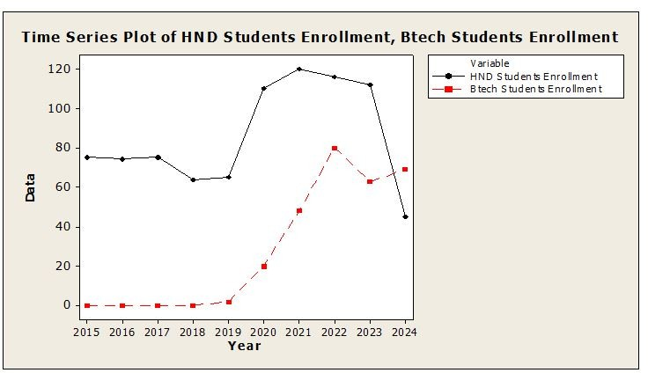

**Figure 1:** Time series plot of students’ enrollment

## Stationarity test

Table 2 shows the results of two common tests for stationarity, namely the Augmented Dickey-Fuller (ADF) test and the Kwiatkowski-Phillips-Schmidt-Shin (KPSS) test for two-time series, HND Students Enrollment and BTECH Students Enrollment are shown in Table 2. For the HND Students’ Enrollment, the ADF test yields a p-value of 0.010, less than 0.05, and hence we reject the null hypothesis of the presence of a unit root. That is, at a 5% level of significance, the series of HND Students Enrollment is stationary. On the other hand, the KPSS test returns a p-value of 0.507, greater than 0.05, and therefore we fail to reject the null hypothesis of stationar- ity. Therefore, both tests provide evidence that the HND Students Enrollment series is stationary. For BTECH Students’ Enrollment, the p-value of the ADF test is very small (0.000); hence, we reject the null hypothesis of a unit root. This indicates that the BTECH Students Enrollment series is stationary at the 1% significance level. Similarly, the KPSS test also gives a p-value of 0.507, which is greater than 0.05, so we fail to reject the null hypothesis of stationarity. Therefore, both tests suggest that the BTECH Students Enrollment series is stationary.

**Table 2:** Stationarity Test

**Test HND Students Enrollment BTECH Students Enrollment ADF**

|  |  |  |
| --- | --- | --- |
| Test Statistic | -0.754397 | -18.0936 |
| p-value | 0.010 | 0.000 |
| **KPSS**  Test Statistic | 0.168794 | 0.389126 |
| p-value | 0.507 | 0.507 |

## Measures of Accuracy

In Table 3, we can see the accuracy measures for three di*ff*erent models, Quadratic, and Exponential applied on two-time series: HND Students Enrollment and BTECH Students Enrollment. The accuracy measures that have been provided are MAPE which is Mean Absolute Percentage Error, MAD which stands for Mean Absolute Deviation, and MSD standing for Mean Squared Deviation. It contains a high MAPE of 26.655, showing relatively high average percentage errors for prediction in the linear model on HND Students’ Enrollment. The MAD and MSD values are 19.244 and 577.902, respectively. These show a moderate error rate, with MSD sensitivity to larger errors. A bit larger MAPE (27.045) indicates that a quadratic specification doesn’t o*ff*er a much better fit for the quadratic model. At the same time, a lower MSD for the quadratic model is 484.568 compared to 577.902 for a linear model; this is an indication of fewer extreme prediction errors. The exponential model has the lowest MAPE (25.856) compared to both the linear and quadratic models, suggesting it provides slightly better percentage accuracy in predictions. However, its MAD (20.108) and MSD (603.111) values are higher than those of the quadratic model, indicating that the exponential model has higher average absolute errors and larger prediction errors. The linear model for BTECH Students Enrollment has a very high MAPE, amounting to 196.608, which suggests that it is a very poor model in terms of the percentage error. Its MAD and MSD values are 10.984 and 189.353, respectively, showing that the model’s overall error is high but with less variation as compared to the MAPE. Quadratic Model improves much on the linear model with a MAPE of 138.665, hence showing better prediction accuracy. Again, the values of MAD -9.532 and MSD -149.973 are smaller, which means better prediction accuracy and fewer extreme errors, compared to the linear model. The exponential model isn’t applicable for BTECH Students Enrollment (NA), meaning it converged or could not apply in this data set. For overall enrollment of HND students, the exponential model o*ff*ers the best percentage accuracy (with the lowest MAPE) while the quadratic model showed fewer large errors in MAD and MSD. For the BTECH students, enrollment presents a quadratic model that performs well, with much lower MAPE, MAD, and MSD in contrast with the linear model. It was not possible to apply the exponential model for BTECH. In fact, the quadratic model gives a better trade-o*ff* between accuracy*/*error size for both data sets; though the exponential model best works for HND Students Enrollment with respect to a percentage error.

**Table 3:** Measures of Accuracy for HND and BTECH Students Enrollment

**Model HND Students Enrollment BTECH Students Enrollment**

|  |  |  |  |  |  |  |  |  |
| --- | --- | --- | --- | --- | --- | --- | --- | --- |
|  | **MAPE** | **MAD** | **MSD** |  | **MAPE** | **MAD** | **MSD** |  |
| Linear | 26.655 | 19.244 | 577.902 |  | 196.608 | 10.984 | 189.353 |  |
| Quadratic | 27.045 | 19.744 | 484.568 |  | 138.665 | 9.532 | 149.973 |  |
| Exponential | 25.856 | 20.108 | 603.111 |  | NA | NA | NA |  |

## ACF and PACF plot of HND and BTECH Students’ Enrollment

It was noticed from Figure 2: ACF plot of HND Students Enrollment and PACF plot of HND Students Enrollment depict that no lag is statistically significant, indicating that in the time series data, there is no strong autocorrelation or partial autocorrelation at any lag. This, therefore, shows that the enrollment patterns do not show clear seasonal or temporal dependencies, and hence no particular lag value is significant for further modeling or analysis. ACF plot of BTECH Students Enrollment and PACF plot of BTECH Students Enrollment that lag 1 is statistically significant from both ACF and PACF plots. This might indicate that the autocorrelation and partial autocorrelation at lag 1 is strong, suggesting the possible presence of significant short-term dependence or pattern at the first lag in the enrollment series of BTECH students. This suggests that future trends in enrollment might depend on the immediately preceding set of figures, which is lag 1 and hence very useful for further time series analysis and modeling.

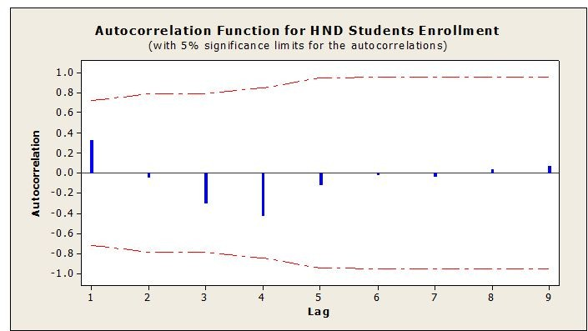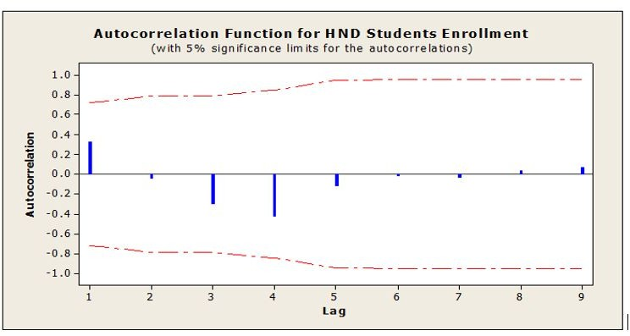

**(a)** ACF plot of HND Students Enrollment **(b)** PACF plot of HND Students’ Enrollment

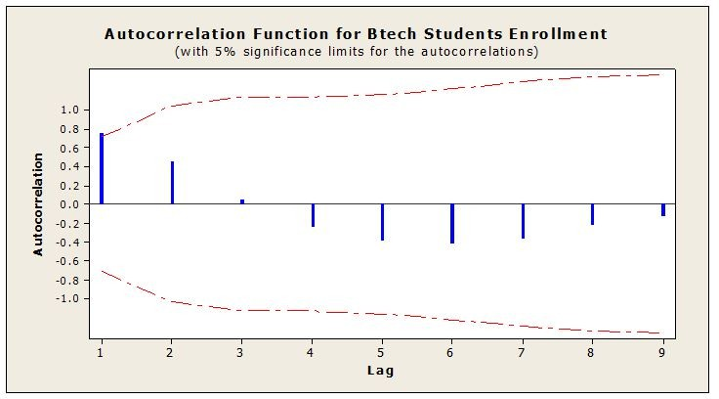 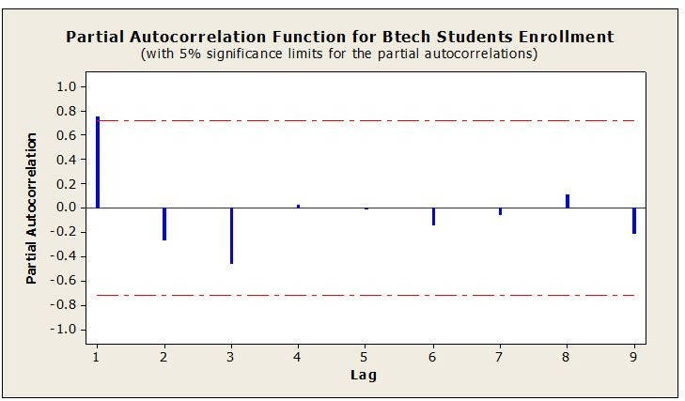

**(c)** ACF plot of BTECH Students Enrollment **(d)** PACF plot of BTECH Students’ Enrollment

**Figure 2:** ACF and PACF plot of HND and BTECH Students’ Enrollment

## Model Identification

In Table 4, we have presented the results of the model identification based on HND Students’ Enrollment and BTECH Students Enrollment by considering di*ff*erent criteria such as AIC, SC, and HQ. These are commonly used criteria to compare the relative fit of models. The smaller the value of these criteria, the better the fit of the model. For HND Students’ Enrollment, ARIMA(0,1,0) has AIC*=*87.01, SC*=*87.21, and HQ*=*86.59. These values suggest that this simple model, including a first-di*ff*erencing step but no autoregressive or moving average

components, may not be the best fit given the relatively higher AIC and SC values. The ARIMA(0,1,1) model has AIC *=* 79.67, BIC *=* 80.27, and HQ *=* 78.39 for BTECH Students’ Enrollment, which are lower than the AIC and SC values for the ARIMA(0,1,0) model, hence better. This model includes a first-di*ff*erencing step and one moving average component (MA). The ARIMA(1,1,1) model, with AIC *=* 81.63, BIC *=* 82.42, and HQ *=* 79.93, has higher values for all three criteria compared to the ARIMA(0,1,1) model, suggesting it is less optimal. Based on the AIC, SC, and HQ values, the ARIMA(0,1,1) model seems to be the best model for BTECH Students’ Enrollment, while in the case of HND Students Enrollment, the results indicate that perhaps the most suitable model might be ARIMA(0,1,0), although the values are relatively close. Generally, the smaller AIC, BIC, and HQ values indicate that ARIMA(0,1,1) is more suitable for BTECH Students’ Enrollment.

**Table 4:** Model Identification for HND and BTECH Students Enrollment

**Model HND Students Enrollment Model BTECH Students Enrollment**

|  |  |  |  |  |  |  |
| --- | --- | --- | --- | --- | --- | --- |
| **AIC SC** | **HQ** |  | **AIC** | **BIC** | **HQ** |  |
| ARIMA(0,1,0) 87.01 87.21 | 86.59 | ARIMA(0,1,1) | 79.67 | 80.27 | 78.39 |  |
|  |  | ARIMA(1,1,1) | 81.63 | 82.42 | 79.93 |  |

## Model estimation

In Table 5, we consider the estimation results of the ARIMA models applied to HND Students Enrollment and BTECH Students Enrollment, along with the test statistics and p-values for the estimated coe*ffi*cients. For HND Students Enrollment, the ARIMA model of order (0,1,0) contains a constant term with a test statistic of -0.3463 and a p-value of 0.7291. Because the p-value is much greater than the common significance level, for example, 0.05, we fail to reject the null hypothesis. This means that the constant term is not statistically significant at the 5% level. This would, therefore, imply that the constant term is not an important predictor of the series in this particular ARIMA model. For BTECH Students Enrollment with the ARIMA(0,1,1) model, the constant term has a test statistic of 1.378 and a p-value of 0.1683. Although the constant term has a positive test statistic, the p-value is greater than 0.05, indicating that the constant term is not statistically significant at the 5% level. In this model, the MA(1) coe*ffi*cient is 0.4682 with a very small p-value of 0.0001, hence highly significant.

**Table 5:** Model Estimation for HND and BTECH Students Enrollment

**Model HND Students Enrollment Model BTECH Students Enrollment**

|  |  |  |  |  |  |  |
| --- | --- | --- | --- | --- | --- | --- |
|  | **Test Statistic** | **P-Value** |  | **Test Statistic** | **P-Value** |  |
| ARIMA(0,1,0)  Constant | -0.3463 | 0.7291 | ARIMA(0,1,1)  Constant | 1.378 | 0.1683 |  |
|  |  |  | MA(1) | 0.4682 | 0.0001 |  |

# DIAGNOSIS TEST

In Table 6, we present the results of the ARCH e*ff*ect test for two models applied to HND Students Enrollment and BTECH Students Enrollment. The test statistic and corresponding p-values are reported for each model. For HND Students Enrollment with the ARIMA (0,1,0) model, the test statistic is 0.310431, and the p-value is 0.577416. Given the p-value is so high, way above a commonly used significance level, such as 0.05, we fail to reject the null hypothesis that no ARCH e*ff*ect exists, meaning there is no eminent heteroscedasticity in HND Students Enrollment. The residuals are thus more likely to be constantly varying in the ARIMA 0,1,0. For BTECH Students Enrollment with the ARIMA (0,1,1) model, the test statistic is 0.591652, and the p-value is 0.441781. Again, since the p-value is far greater than 0.05, we fail to reject the null hypothesis of no ARCH e*ff*ect. This means BTECH Students’ Enrollment also does not show significant heteroscedasticity, which implies that the variance of residuals in the ARIMA (0,1,1) model is constant.

**Table 6:** ARCH E*ff*ect for HND and BTECH Students Enrollment

### Model HND Students Enrollment Model BTECH Students Enrollment Test Statistic P-Value Test Statistic P-Value

ARIMA(0,1,0) 0.310431 0.577416 ARIMA(0,1,1) 0.591652 0.441781

## Ljung-Box Test

Results of the Ljung-Box test for residual autocorrelation are shown in Table 7, where the ARIMA models were fitted for HND Students’ Enrollment and BTECH Students’ Enrollment. The Ljung-Box test was used to see if there was any significant autocorrelation remaining in the residuals at multiple lags, with no autocorrelation being the null hypothesis. Enrollment of HND Students For ARIMA (0,1,0), the test statistic is 0.4410, and the p-value is 0.932. The p-value is way larger than the usual significance level, for instance, 0.05, so we do not reject the null hypothesis. That means no significant autocorrelation exists in the residuals of the ARIMA model (0,1,0), and therefore the model has captured the dynamics of the time series adequately, and the residuals are white noise. For BTECH students enrollment, we have an ARIMA model as (0,1,1). The test statistic is 0.965, and the p-value is 0.965. The p-value is way above 0.05, which therefore means we fail to reject the null hypothesis. This suggests that the residuals of the ARIMA 0,1,1 do not have significant autocorrelation and, therefore, the model captures the autocorrelation pattern of the time series, and the residuals are white noise.

**Table 7:** Ljung-Box Test for HND and BTECH Students Enrollment

**Model HND Students Enrollment Model BTECH Students Enrollment**

|  |  |  |  |  |  |  |
| --- | --- | --- | --- | --- | --- | --- |
|  | **Test Statistic** | **P-Value** |  | **Test Statistic** | **P-Value** |  |
| ARIMA(0,1,0) | 0.4410 | 0.932 | ARIMA(0,1,1) | 0.965 | 0.965 |  |

## Correlogram of the residuals under HND and Btech Students enrollment

It can be seen from Figures 3 that the Correlogram of residuals for both HND Students’ Enrollment and BTECH Students’ Enrollment all fall within the lower and upper bounds. This suggests that no significant autocorrela- tion remains in the residuals, hence the models are well-specified and have captured the time series dynamics. Therefore, by this observation, we conclude that the models are deemed fit for the respective datasets.

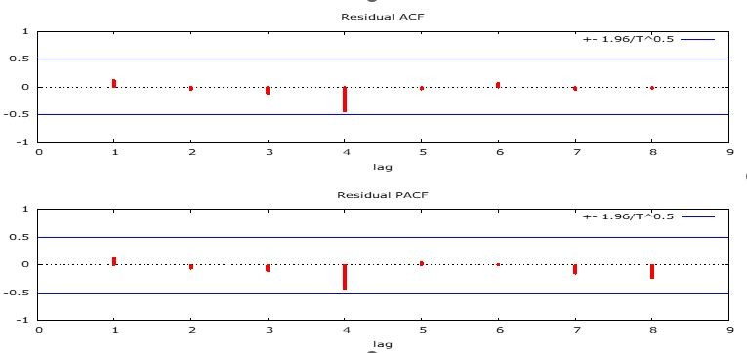 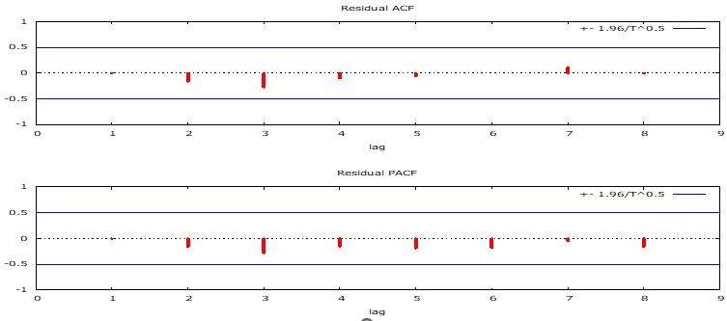

1. Correlogram of the residuals for HND Students en- rollment
2. Correlogram of the residuals under Btech Students enrollment

**Figure 3:** Correlogram of the residuals for HND and Btech Students enrollment

## Normality test

Figure 4 shows normality plot of residuals for BTECH Students’ Enrollment From the figure above, the test statistic value is 1.037 with a p-value of 0.5955. Since the p-value is far greater than the usual significance level of 0.05, we fail to reject the null hypothesis of normality. This is an indication that the residuals of the model are approximately normally distributed, hence the assumption of normality holds for the residuals in this case.

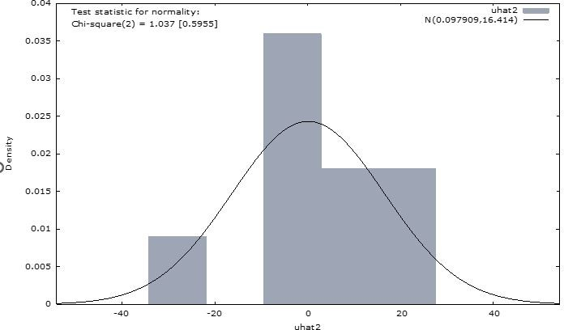

**Figure 4:** Normality test of the residuals

## Forecat of HND and Btech students’ enrolment

Figure 5 shows the forecast for Btech students’ enrolment shows that, between the years 2025 and 2029, students will be steadily enrolled in BTECH. This projection corresponds to the general trend of how higher education is usually in demand in many regions as a result of growing interest in technical and engineering courses, according to the OECD, 2021. The rise in enrollment could be attributed to various factors, including the growing emphasis on STEM education globally, the expansion of online learning opportunities, and shifts in labor market demands favoring technology and engineering skills (Bok, 2019). Furthermore, demographic shifts such as a larger cohort of high school graduates or increased interest in higher education may contribute to this steady rise in enrollments (National Center for Education Statistics, 2020). These factors collectively point to a sustained increase in BTECH program enrollments over the next several years.

Also, forecast for HND students’ enrollment depicts a prediction of steady enrollment declines in the student population in the HND program from 2025 to 2029. The expected fall in student enrollments could reflect the trend in the higher education pipeline, whereby some vocational and technical programs, including the HND, have become less popular, with many students heading to universities for their education or other avenues of their choice (HESA, 2020). The shift in preference towards undergraduate degrees, particularly in regions where the demand for higher-level qualifications is growing, could explain this trend (OECD, 2021). Additionally, changes in labor market dynamics, such as increased demand for skills that align more with university degrees, could contribute to the reduced appeal of HND programs (Bok, 2019). As a result, these factors may be influencing the declining enrollment trend in HND programs.

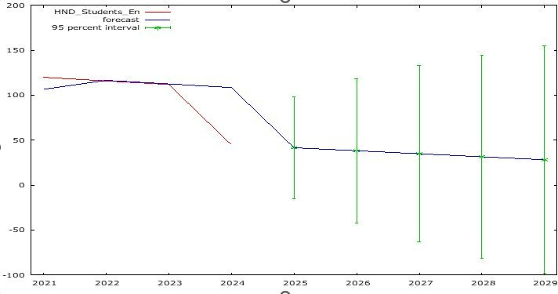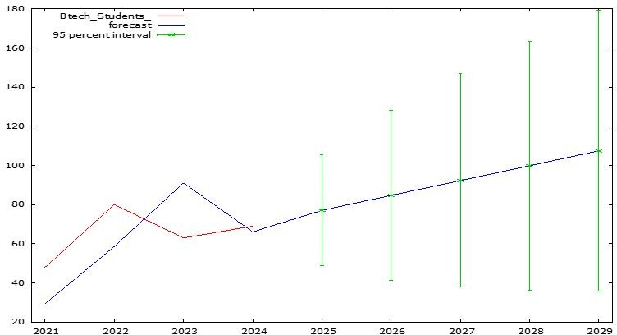

**(a)** Forecast for BTECH students enrollment **(b)** Forecast for HND students enrollment

**Figure 5:** Forecat of HND and Btech students’ enrolment

# Summary of findings

The analysis of students’ enrollment data for both HND and BTECH programs indicates considerable di*ff*erences in the overall trends and characteristics of the two programs. From the descriptive statistics, it is observed that the HND program has more students and is more consistent compared to the BTECH program. The mean enroll- ment for HND students is 85.6, compared to just 28.2 for BTECH students, reflecting the higher demand for the HND program. The BTECH program has more variability in enrollment, as can be seen by the higher standard

deviation and also the presence of years where zero students enrolled. The findings indicate that both HND and BTECH enrollments are stationary, meaning they do not exhibit either trend or seasonal patterns which would have required di*ff*erencing before modeling. Results of the ARIMA modeling show that an ARIMA (0,1,0) model was more appropriate for the HND program, while an ARIMA (0,1,1) model was the best fit for BTECH enrollments. Accuracy measures indicate that the linear model provides the best fit for HND enrollments in terms of percentage error, while the quadratic model is best in terms of avoiding large errors. In the case of BTECH, the quadratic model gives the best accuracy and prediction performance. The diagnostic tests have shown that both programs have a well-specified model. Also, the ARCH e*ff*ect test has shown that no heteroscedasticity appears in the resid- uals of both programs, and the Ljung-Box test has shown that no residual autocorrelation exists in either of the programs, so the models are adequate in representing the dynamics of both time series. The forecasted results show a contrasted future trend for the two programs. BTECH students showed a steady growth in intake from 2025-2029, probably due to increased demand for technical skills and engineering. On the other hand, the forecast for HND enrollments over the same period shows a gradual decline, which may well be reflective of broader shifts in student preferences toward higher-level qualifications and changing labor market dynamics.

# Implications for the HCIM Program

The growing BTECH student enrollment indicates that the university should consider leveraging opportunities for expanding or adapting the HCIM curriculum to complement the increased demand for technology and data-focused skills. This might be accomplished by o*ff*ering higher-level modules in alignment with BTECH student needs or specializations that are in demand within the technology sector. In this regard, where the number of enrollments for HND has begun to fall, the university could focus on other demographics that could target university graduates, working professionals, or international students who wish to pursue advanced certification in information management. The trends also seem to indicate that the strategic partnership of the HCIM program with industry players or technology companies would help the relevance of the curriculum to evolving workforce demands. Collaborations with BTECH programs or industry-based internships could boost the employability of HCIM graduates.

# Conclusion and Recommendation

The HND, then, is more clearly established in terms of its volume of output and consistency but projects reduced enrollments over time, while the BTECH does start at a relatively low current level but presents real and strong growth potential arising out of increased demand for the practical. The falling numbers enrolling in the HND program and the projected BTECH growth would therefore signify that the university may, in this respect, accommodate its curriculum and recruitment plans to these changes. For instance, this may mean targeting more mature students or professional certification applicants for the HND program. The BTECH program could be expanded and industry linkages enhanced to capitalize on the increasing demand for technology-focused education. These

strategies will help ensure that the university remains responsive to the evolving educational and labor market needs.

**COMPETING INTERESTS DISCLAIMER:**

Authors have declared that they have no known competing financial interests OR non-financial interests OR personal relationships that could have appeared to influence the work reported in this paper.

**Disclaimer (Artificial intelligence)**

Option 1:

Author(s) hereby declare that NO generative AI technologies such as Large Language Models (ChatGPT, COPILOT, etc.) and text-to-image generators have been used during the writing or editing of this manuscript.

Option 2:

Author(s) hereby declare that generative AI technologies such as Large Language Models, etc. have been used during the writing or editing of manuscripts. This explanation will include the name, version, model, and source of the generative AI technology and as well as all input prompts provided to the generative AI technology

Details of the AI usage are given below:

1.

2.

3.

### REFERENCES

Agyemang, F., Mensah, F., & Osei, G. (2020). Trends and challenges in the forecasting of student enrollment at Kumasi Technical University: Implications for technical and vocational education and training. Journal of Voca- tional Education and Training in Ghana, 14(2), 112-127.

Akanbi, S. A., Adedeji, O. S.,& Adebiyi, A. A. (2021). Forecasting student enrollment in specialized academic programs: Challenges and trends in higher education. Journal of Educational Planning, 33(4), 253-267.

Ampofo, A. A., Tetteh, C., & Osei, D. (2022). The impact of the COVID-19 pandemic on higher education enroll- ment: A case study of Ghanaian technical universities. African Journal of Educational Research, 28(1), 45-59.

Asare, B. O. (2021). Economic growth, tourism trends, and the impact on student enrollment in hospitality and management programs in Ghana. Tourism Economics Review, 19(3), 81-94.

Bok, D. (2019). The struggle to reform the higher education system: The role of market dynamics and policy intervention. Harvard University Press.

Grnwald, L., Stuhlmann, M., Jansen, E. (2016). Forecasting enrollment in hospitality management programs: A comparative study of time series models and regression analysis across Europe. International Journal of Hospital- ity Management, 57, 12-22.

HESA (Higher Education Statistics Agency). (2020). Trends in higher education enrollment in the UK: A focus on vocational and technical programs. HESA Publications.

Jiang, J., Joppe, M. (2017). Enrollment forecasting in hospitality management programs: Implications for policy- makers. Journal of Hospitality and Tourism Education, 29(2), 57-67.

Kwame, N., Osei, K., Mensah, R. (2019). Forecasting student enrollment in technical and vocational education: A review of methodologies and their applications in Ghana. Journal of Educational and Vocational Studies, 34(5), 133-145.

Mller, J., Weber, M., Lindner, M. (2020). Predicting student enrollment using machine learning algorithms: A case study in hospitality education. Journal of Data Science in Education, 5(3), 65-79.

National Center for Education Statistics. (2020). The condition of education 2020: Postsecondary enrollment trends. U.S. Department of Education, Institute of Education Sciences.

Nguyen, P. T., Tran, Q. M., Pham, D. (2018). Time series forecasting for student enrollment in engineering pro- grams: Application of ARIMA models. Asian Journal of Education and Research, 6(2), 100-113.

OECD (Organisation for Economic Co-operation and Development). (2021). Trends in tertiary education: An overview of global enrollment patterns. OECD Publishing.

Padi, S. (2019). Forecasting enrollment trends in technical universities in Ghana: A case study of Kumasi Techni- cal University. Journal of Educational Planning and Development, 21(1), 33-42.

Sarpong, G., Awaab, J., Ashley, I., Sekyere, A., Osae-Akonnor, P. (2024). Students perceptions of the Bachelor of Technology program in Hospitality Education: A study of Kumasi Technical University, Ghana ISSN:2758-0962. The Paris Conference on Education 2024: O*ffi*cial Conference Proceedings (pp.183-193).

Tetteh, C.,& Osei, D. (2023). Enrollment patterns in hospitality management programs in Ghana: Trends, chal- lenges, and policy implications. Ghanaian Journal of Tourism and Hospitality, 8(2), 97-108.

Zhang, R., & Eringa, K. (2022). Predicting hospitality management students’ intention to enter employment in the hospitality industry on graduation: a person–environment fit perspective. Research in Hospitality Management, 12(2), 103-113.