**Original Research Article**

**Rising Damp in Buildings: Causes, Impacts, and Mitigation Strategies in Krofrom and Ampabame New Sites**

**ABSTRACT**

Rising damp is one of the common problems in buildings which affects the durability of the buildings and the health of the people living in it. This study investigates the causes, effects and mitigation measures of rising damp in buildings within Krofrom and Ampabame new sites. Rising damp is particularly a problem in domestic structures where damp-proof courses (DPCs) or membranes are often absent due to poor construction management, and lack of information. An explorative research approach was adopted to collect data from 150 buildings through direct observation, questionnaires, interviews, and laboratory analysis of the soil samples. The results showed that 66.7% of the buildings were affected by rising dampness, which caused some typical defects including mold growth (58%), peeling paint (62%), efflorescence (45%), and wet patches (76%). Laboratory analysis indicated that the soil had relatively high levels of moisture with an average of 18.5% at shallow depths. The effect of rising damp included higher maintenance costs, deterioration of the structure, and health problems, with 65% of the tenants experiencing symptoms of respiratory diseases.

The study revealed that conventional treatments such as paint, waterproofing, and drainage were effective for only the short term. The most effective solution was the installation of new damp-proof courses, which decreased the level of dampness by 85%, however, the main drawbacks were the high costs and technological complexities. Thus, there should be stricter rules regarding building, more available information and subsidies for materials that are resistant to moisture. Also, further studies should be made on the development of environmentally friendly and economic measures for moisture management. Treating rising damp needs the involvement of policy makers, builders, and the public to increase the durability of buildings and improve the quality of life of occupants.

Keywords: Rising Damp, Moisture Intrusion, Building Defects, Construction Practices, Structural Integrity.

1. **INTRODUCTION**

A common structural problem that greatly limits the durability and functionality of a building is rising damp. It is the ability of water to ascend in the form of vapor through porous materials like concrete or brick due to capillary action (Hall & Hoff 2021). Regions with high water tables, strong rainfall, or poor drainage are most prone to this problem. The effects include; wet patches, peeling paint, efflorescence, and structural weakness due dissolved salts precipitating when they evaporate. These conditions foster mold and fungi growth, further compromising structural integrity and health (Hall & Hoff 2021; Al-Qahtani et al., 2023).

Rising damp is a major challenge in Ghana particularly in the peri-urban and urban areas of the Ashanti Region, Krofrom, and Ampabame. The climate in these regions is warm and humid with plenty of rainfall which only worsens the conditions that lead to rising damp. The situation has also deteriorated because of poor construction-related preventive measures such as the use of DPCs or membranes and disregard of the building codes. From the field observations, it can be seen that the great majority of buildings in Krofrom and Ampabame have symptoms of rising damping, which are the discoloration of the walls, peeling paint, and growth of mold especially on the lower parts of the walls. These defects are of frequent occurrence and show a poor maintenance culture as well as poor construction practices (Boateng, 2020).

This phenomenon again, has been recognized as a major issue in the construction industry worldwide, and researchers have highlighted the adverse effects of this on building performance (Kong et al., 2021; Malaquias et al., 2022). Similar problems have been observed in other studies from North America and Europe where several buildings show clear signs of dampness which affects the health of building occupants (Coulburn and Miller, 2022; WHO, 2024). The problem is just as bad in Ghana. In a study by Agyekum et al. (2019), the climate in Ghana and poor construction methods that do not prevent dampness are the cause of the rising dampness, which is evident in most buildings.

Rising damp in buildings pose major structural and health risks caused by the coercive movement of groundwater through porous building materials. The process of capillary rise of water through porous materials is responsible for the rising damp. When groundwater comes into contact with the adhesive forces between water molecules and the porous surfaces of building walls, the groundwater is pulled up (Li et al., 2024). Salts, porosity of the material, and height of evaporation are some of the factors that determine the level of capillary rise. The high-water tables and poor drainage systems are often the cause of the problem, especially in areas like Krofrom and Ampabame where homes and businesses are built without a thorough site analysis of the soil or groundwater levels (Hazelton and Murphy, 2021).

From a structural point of view, prolonged contact with water weakens building materials thus reducing the overall life of the structure (Lacasse et al., 2020). Rising damp affects the building fabric in a drastic manner through plastering, masonry crazing and paint flaking (Desarnaud et al., 2021). Other cosmetic problems include flaking paint and discoloration of the walls which negatively affect the appearance and value of the property. In addition, Kong et al. (2021) asserts that it leads to higher energy usage due to the increased thermal conductivity of walls, which in turn reduces the effectiveness of heating and cooling systems.

The health consequences of rising damp are also severe as the presence of moisture encourages the development of mould which can cause respiratory diseases and other health issues (Mydin et al., 2024). Tuuminen (2020) highlight that dampness poses health threats by encouraging the growth of mold and fungi, which can cause allergic reactions and respiratory problems in residents. The situation is further worsened by the absence of an efficient DPC, inappropriate grading, and climate conditions which include high humidity and rainfall (Nyarko-Boateng et al., 2023). A major concern is the additional long-term costs of regular repair and maintenance duties such as painting and plastering due to damage caused by rising damp. Scholars have proposed several measures such as chemical injection barriers, electro-osmosis treatment, and new DPC materials and their performance to mitigate rising damp (Bernardo et al., 2024). Preventing rising damp needs a systematic approach that includes the right construction methods, regular care, and new damp-proofing systems for green buildings.

However, despite advancement in building materials and technology, the issue persists due to knowledge gaps and poor construction practices. Different levels of success have been achieved through drainage systems, waterproof coatings, and DPCs in various regions of the world (Kog, 2024). However, the problem persists in Ghana due to ignorance, bad construction practices, and scarcity of the right materials. For instance, in communities such as Krofrom and Ampabame, the prevalence of rising damp is compounded by the use of low-quality blocks and poor site preparation.

This study proposes a four-level strategy to tackle rising damp: enhanced preventive measures, enforcement of building codes, raising awareness among construction industry professionals and research into sustainable solutions. This study aims to identify the causes of rising damp in Krofrom and Ampabame, examine the impact of rising damp on structures and inhabitants, and provide recommendations for possible solutions. This is in a bid to contribute to the body of knowledge in construction management and to offer practical recommendations to stakeholders in Ghana and other countries.

**Objectives**

The purpose of this study is to investigate the rising damp in buildings which can affect the looks of the building, its durability, and the health of the occupants. Specifically, the study has the following objectives:

1. To investigate the causes of rising damp in buildings in Krofrom and Ampabame new site.

2. To investigate the effects of rising damp in buildings in Krofrom and Ampabame new site.

3. To suggest effective measures for mitigating rising damp in buildings in Krofrom and Ampabame new site.

**2. METHODOLOGY**

**Study Area**

The survey area is in the Atwima Kwawoma District of the Ashanti Region of Ghana and covers 251.9 square kilometers or 1.08% of the area of the region which is 24,389 square kilometers. The district capital is about 18km from Kumasi and it borders Kwadaso Municipal, Bosomtwe District, Atwima Nwabiagya Municipal, and Amansie West District. As per the 2021 Population and Housing Census, the district has a population of 234,846 people, among them 114,128 are males and 120,723 are females (Ghana Statistical Service, 2021). It is in the transitional forest zone, about 270km north of Accra, and has a Wet Semi-Equatorial climate with the vegetation of the moist semi-deciduous South-East Ecological Zone (Ghana Statistical Service, 2021; Koranteng et al., 2021; Verma & Asafo-Adjei, 2021). The underlying geology is granitoids, of the Cape Coast and Winneba rock types, emplaced during the later stages of the Eburnean Orogeny and the Birimian deposits (Ayamga et al., 2021; Osei et al., 2022). The major soil type is residual, covered with weathered argillaceous phyllite from the country rock. These are the geological and climatic factors that help understand rising damp in buildings within the study area.

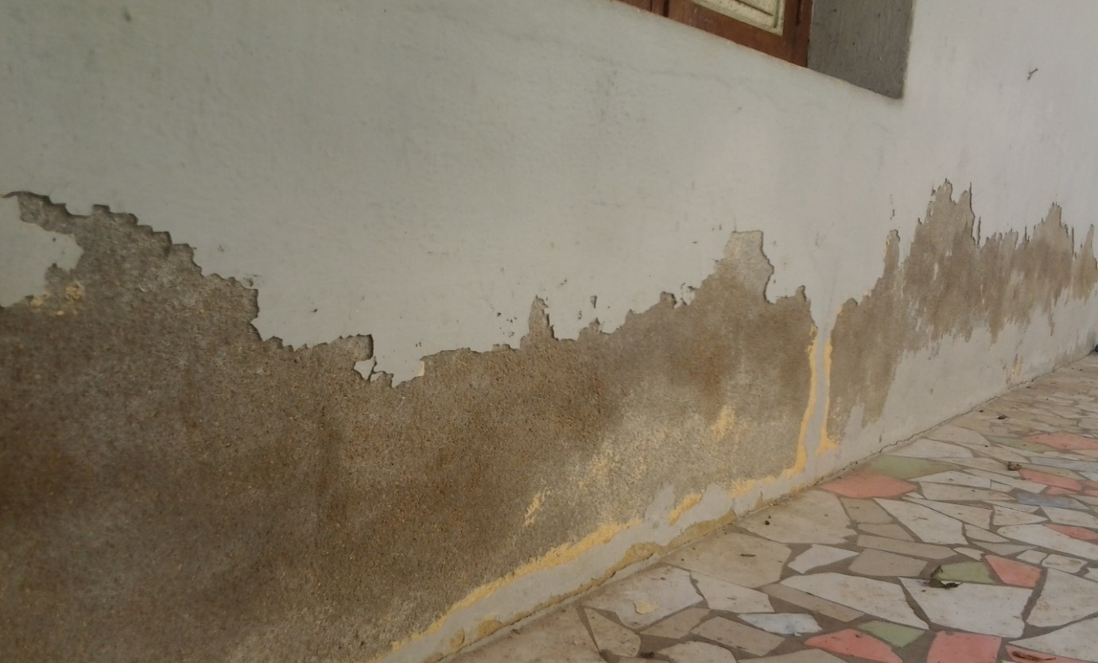

Figure 1: Peeling Off of Paints at Visiting Sites

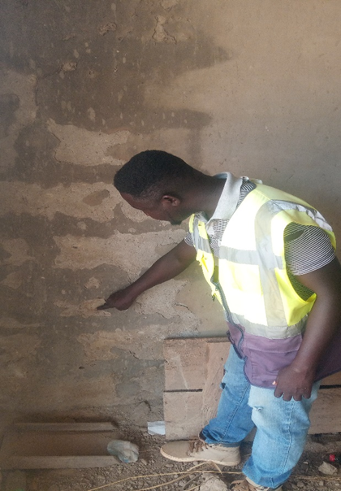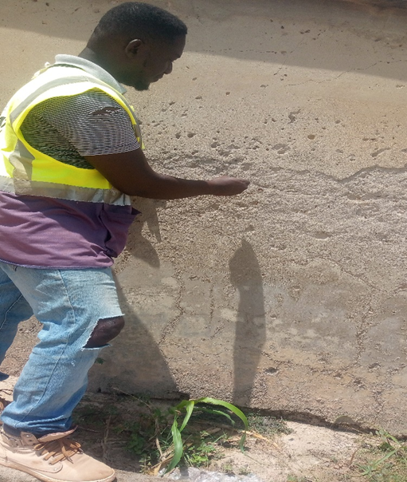

Figure 2: Chalking of Plastered Wall

This research used a descriptive research design to determine the prevalence, causes, and impacts of rising damp in buildings in Krofrom and Ampabame new sites. The design helped in data collection through direct observation and questionnaires to identify the causes of dampness and the effects that come with it. The population of the study comprised buildings in the chosen areas, construction personnel (engineers, architects, masons, quantity surveyors), landlords, and tenants. Purposive sampling was used to select participants who were knowledgeable and/or experienced in the area of study. The study was conducted on 100 buildings that had symptoms of dampness out of the available 150 buildings in the study area using Yamane's (1967) formula for determining sample size. The quota sampling technique was first used to ensure that the sample was evenly divided between the locations and then the purposive sampling was used to pick certain residential buildings. For expert opinion, one hundred respondents were picked from private consulting firms, construction companies, municipal engineers, civil engineers, masons, and professional bodies. Surveys were also conducted on landlords and tenants to understand their experiences with rising damp.

Multiple methods of data collection were employed; visual surveys, interviews, laboratory tests, and questionnaire surveys. The visual survey entailed physical observations of 150 buildings and among these, 100 were suspected to have rising damp. One hundred landlords, tenants, and professionals were interviewed to determine their level of awareness of rising damp, its causes, and possible control measures. Soil samples were collected at 0-300mm, 400-700mm, and 700-1000mm from locations near affected buildings, and laboratory analyses of moisture content were done at Kwame Nkrumah University of Science and Technology (KNUST). A questionnaire was developed to ensure that both open and closed-ended questions were asked and these were administered through Google Forms to building occupants and construction professionals. Surveys and laboratory test results were analyzed to determine the prevalence and severity of rising damp. Percentages and frequency distributions were used to present the findings of the study based on descriptive statistics.

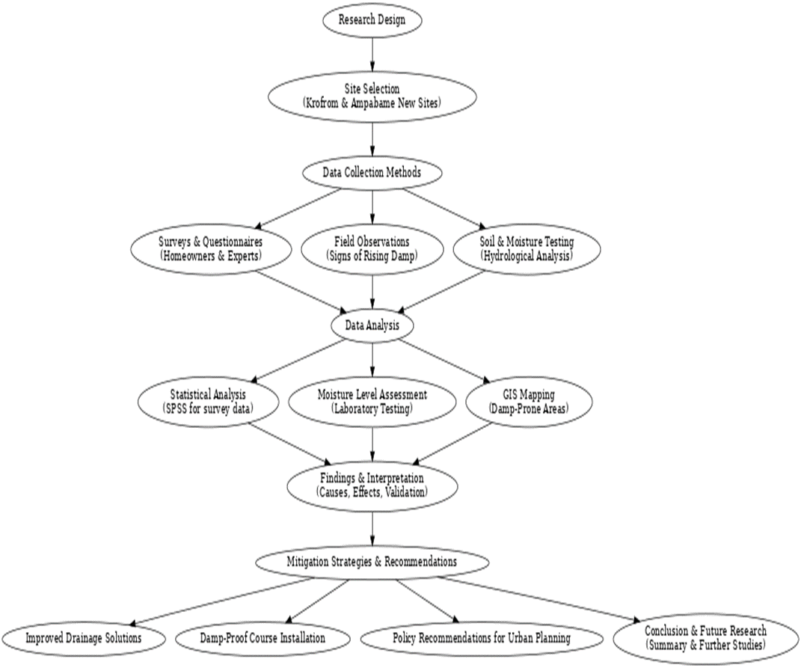

Figure 3: Methodological Flowchart

1. **RESULTS AND DISCUSSIONS**

***3.1 Visual Survey***

Table 1: Descriptive Statistics of Observed Building

|  |  |  |
| --- | --- | --- |
| **Observed Defect** | **No. of Buildings** | **% Of Defective Building** |
| Damp patches | 60 | 60 |
| Peeling off of paints | 75 | 75 |
| Efflorescence | 5 | 5 |
| Chalking of render | 25 | 25 |
| Stains and Patches of molds | 40 | 40 |
| Disintegration of building component | 15 | 15 |

As can be seen from Table 1, the survey revealed several defects in buildings, mainly on rendered (plastered) and unrendered walls made of sandcrete blocks, and more than one defect was observed in the same building. Stains were most obvious on the walls of saturated or wet areas, which were darker than the rest of the walls and did not improve the appearance of the buildings. Damp patches were noticed in 60 buildings, this is 60% of the sample size. Peeling paint was another major defect found to have affected 75% of the 100 buildings sampled. This was attributed to poor adhesion between the paint and the substrate due to moisture penetration that led to the chipping off of the paint. Efflorescence was the least observed defect and was seen to occur in only 5% of the buildings. Chalking is a phenomenon that occurs due to moisture or wrong mortar ratio and it was noticed in 25 buildings (25% of the sample) which led to the flaking off of the plaster and sand. Mold is dependent on moisture, temperature, and material conditions and was observed in 40 buildings, which is 40% of the sample, and may be harmful to building occupants. Finally, moisture led to the delamination or breaking of building components like between block walls and concrete floors or wooden rot in wooden parts and severely damaged 15 buildings (15% of the sample).

**3.2 Causes of Rising Damp in Buildings**

Table 2: Responses of Owners and Tenants

|  |  |  |
| --- | --- | --- |
| Questions | **No. of Respondents** | **(%) Percentage** |
| 1. Was any professional involved in your project  (Yes/ No) | NO = 90  YES = 10 | YES = 90  NO = 10 |
| 2. Respondent familiarity with the concept of dampness | YES = 15  NO = 85 | YES = 15  NO = 85 |
| 3. Are you comfortable living in the building? | NO = 100 | NO= 100 |
| 4. Have you experienced any health issues which can be associated with the issue? | YES = 25  N0 = 75 | YES = 25  N0 = 75 |
| 5. How often do you perform maintenance on the building | Once in a while = 75  Very often = 25 | Once in a while = 75  Very often = 25 |

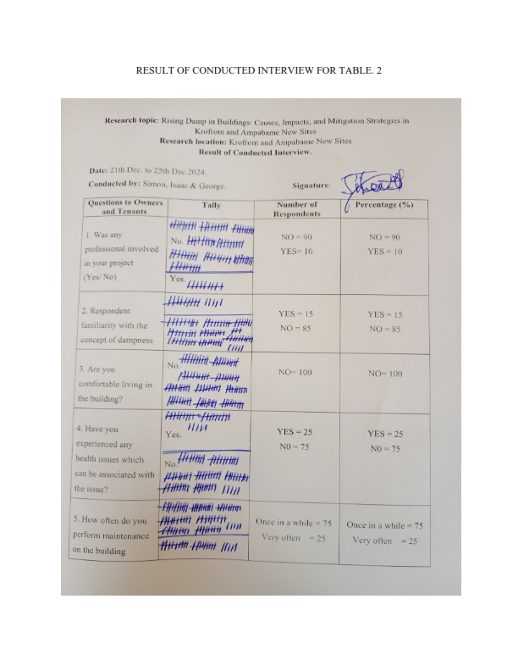*Figure 4.a: Results of Response from Interview*

As presented in Table 2, 90% of respondents indicated that no professional was involved in the construction of their buildings, this may lead to a concern of absence of professional input in ensuring that the structures are built to the right quality and duration. Moreover, only 15% of the respondents were familiar with the concept of dampness which shows a low level of knowledge of this frequent building problem, which if not identified early could be poorly managed. All respondents (100%) reported dissatisfaction with their living conditions, suggesting the presence of major structural or environmental defects, including dampness. All the respondents (100%) stated that they are not happy with the situation in their buildings, which implies that there is a single major problem that is probably related to different defects, including dampness. Moreover, 25% of respondents had health problems that might have been related to the conditions in the building, and 75% of them denied having any, claiming that the problems were environmental, such as mold or dampness. As for maintenance, only 25% of the respondents undertook maintenance work regularly, 25% did so frequently, and 60% did so occasionally, which shows that there are irregularities in the maintenance of the buildings. Hence, these findings reveal major problems with the quality of construction, awareness of residents, and care of the building, with adverse effects on habitability and health.

Table 3: Moisture Content Result for Soil Samples



The data in Table 3 showed that there were different moisture contents which were measured at different depths. At the Krofrom Church of Pentecost building site, groundwater was encountered at a depth of 1000mm. Soil samples were taken when there was no recent rain and are therefore a representation of the natural moisture content of the ground. The moisture content increased with depth which means that there was a lot of moisture that would rise a lot during rainfall and would be absorbed by the building's blockwork through capillarity. There was one location that had a moisture content of 24.19%, this was because there was a wall without weep holes which held moisture and caused dampness in the building. Laboratory analyses of the soil samples revealed that the moisture contents of the soil at various levels in the Ampabame area were 25.39%, 17.33%, and 24.19% respectively. The soil strata were reddish brown topsoil, then starchy brown clay which held more moisture because it is more absorptive. It was also noticed that deeper pits had higher moisture content and this was most evident at the Ampabame new site junction which had the highest moisture content in the 700mm–1000mm range. On the other hand, Krofrom Sarboam had the lowest moisture content. The guest house area at the Krofrom site had the highest moisture content of 21.85% in the 700mm–1000mm layer.

Table 4: Percentages of the Type of Building

|  |  |
| --- | --- |
| Type of building | Percentage (%) |
| Residential | 92 |
| Commercial | 4 |
| Industrial | 4 |

Figure 4: Percentage of the Type of Building

Table 4 depicts that the majority of rising damp problems which was seen and identified were mostly in residential buildings located within the research area which accounted for Ninety-two percent (92%) of the sample size. Industrial buildings and Commercial buildings had four percent each (4%). In their study, Nyarko-Boateng et al. (2023) pointed out that rising damp affects residential buildings more frequently due to poor construction and the absence of an adequate damp-proof course. Likewise, Mydin et al. (2024) investigated the effects of dampness on buildings in Malaysia and revealed that residential structures are most likely to be affected.

Table 5: Percentages of the Age of Building

|  |  |
| --- | --- |
| Age of building (years) | Percentage (%) |
| 0-5 | 28 |
| 6-10 | 49 |
| 11-15 | 8 |
| 16-20 | 5 |
| More than 20 | 12 |

Figure 5: Percentage of the Age of Building

The results in Table 5 showed that the most common phenomenon was rising damp in buildings 6-10 years old, which was observed in 49% of the cases. The next highest frequency was in buildings less than 6 years old, with 28% of the instances. The occurrence was lowest in buildings more than 20 years old at 12%, and buildings 16-20 years old had the lowest frequency of rising damp, constituting only 5% of the sample. In terms of awareness of rising damp, 97% of the respondents were aware of the problem and only 3% were not aware of it. In their study, Philip et al. (2024) found that buildings between 6–10 years of age are most likely to suffer from rising damp as a result of age-related failures of materials and construction errors. In addition, Li et al. (2021) pointed out that wear and tear in construction materials lead to an increased moisture retention in buildings over time.

Table 6: Causes and Mechanism of Rising Damp

|  |  |
| --- | --- |
| Causes and mechanism | Percentage (%) |
| High groundwater levels | 87 |
| Defective or absent of damp-proof coarse | 92 |
| Poor drainage system | 79 |
| Construction in a moisture-prone area | 64 |

Figure 6: Causes and Mechanism of Rising Damp

As shown in Table 6, the primary cause of rising damp in buildings according to 92% of the respondents was attributed to poor construction practices. High groundwater levels were also quite frequent, mentioned by 87% of the respondents, and construction in moisture-prone areas was also a significant factor of 64%. A poor drainage system was the least influential but still a contributor to rising damp, as 79% of respondents said it was a cause. In their study, Nyarko-Boateng et al. (2023) pointed out that the main causes of rising damp include inadequate damp-proof courses, high levels of groundwater and poor drainage. Similarly, Taptiklis (2023) argued that rising damp is mainly ascribed to inadequate building envelope management.

Table 7: Effects of Rising Damp

|  |  |
| --- | --- |
| Effects and impacts of rising damp | Percentage (%) |
| Damp patches | 92 |
| Peeling of paints | 94 |
| Musty odor | 61 |
| Molds and mildew growth | 78 |
| Structural damage | 81 |
| Health issue | 72 |
| Others (specify) | 3 |

Figure 7: Effects of Rising Damp

As can be seen from Table 7, the respondents identified several major effects of rising damp on buildings, peeling paint being the most frequent, 94% of the respondents. Almost equally many, 92%, noted damp patches on walls as happening rather often. Another important impact was structural damage, 81% of respondents reported this. Molds and mildew growth were almost as much of an issue, according to 78% of respondents; health problems connected with rising damp affected 72% of respondents. The presence of a musty odor in the rooms was the least common, but still mentioned by 61% of the respondents. Only 3% of the respondents mentioned other effects which were not otherwise specified. Philip et al. (2024) established that rising damp is the main cause of structural damage, mold growth, and health issues. Also, Mydin et al. (2024) documented health risks such as respiratory 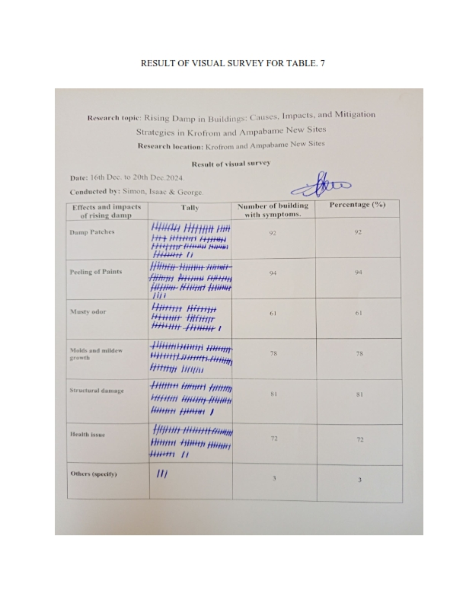diseases from damp environments.

*Figure 7*.1: *Effects of Rising Damp*

***3.3 Mitigation Strategies for Addressing Rising Damp in Buildings***

Table 8: Effectiveness of Mitigative Measures

|  |  |
| --- | --- |
| Effectiveness of mitigative measures | Percentage (%) |
| Very effective | 18 |
| Effective | 69 |
| Somewhat effective | 13 |

Figure 8: Effectiveness of Mitigation Measures

In Table 8, 69% of respondents evaluated the measures as being fairly successful in combating the problem of rising damp in buildings. Customer satisfaction is also quite high; 18% of respondents rated the methods as very effective, and 13% rated them as somewhat effective in handling the rising damp problem. Desarnaud et al. (2021) evaluated electromagnetic and electro-osmosis methods for treating rising damp.

*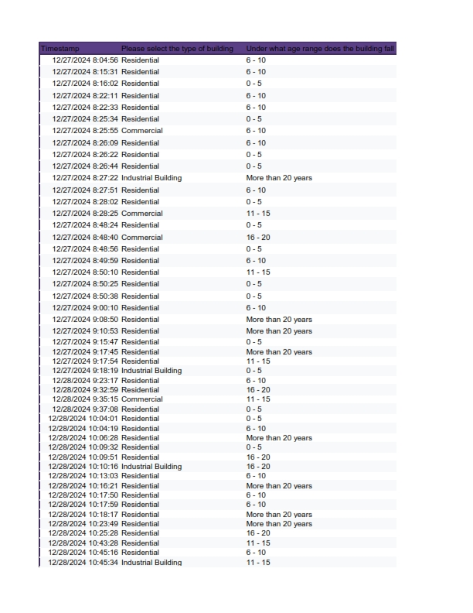**Figure. 8.1. Response from Google Form*

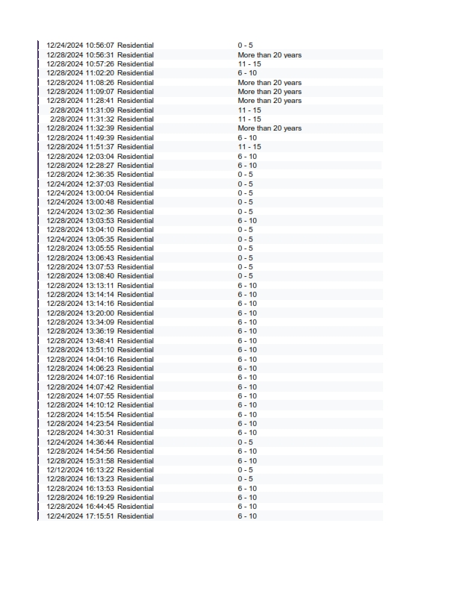*Figure. 8.1a. Response from Google Form*

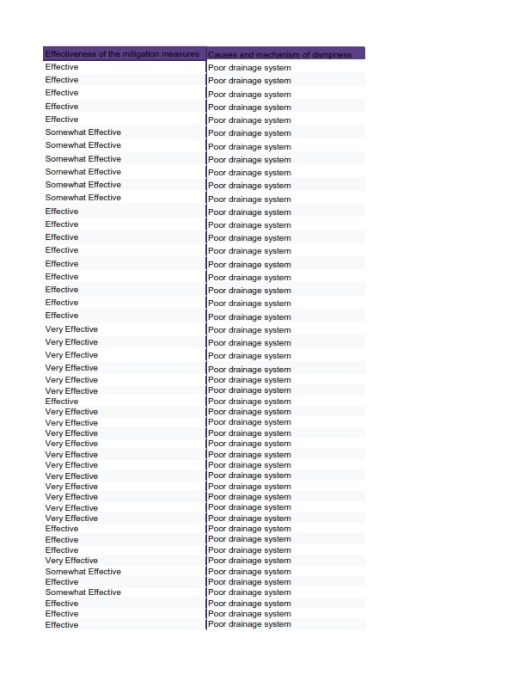

*Figure. 8.2. Response from Google Form*

*Figure. 8.2a. Response from Google Form*

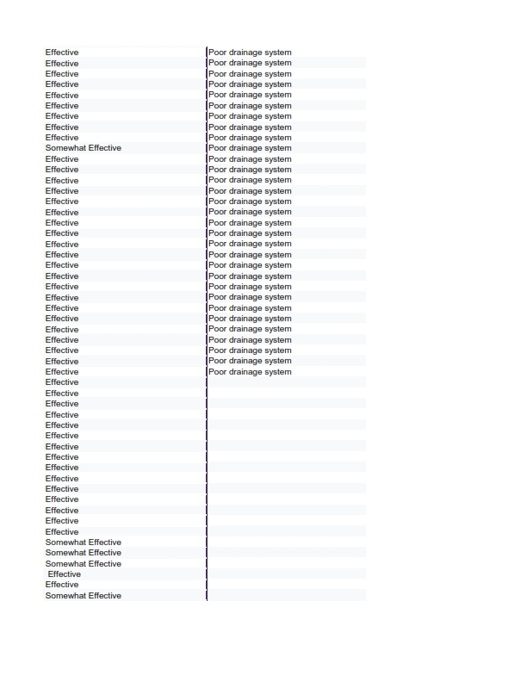

*Figure. 8.3. Response from Google Form*

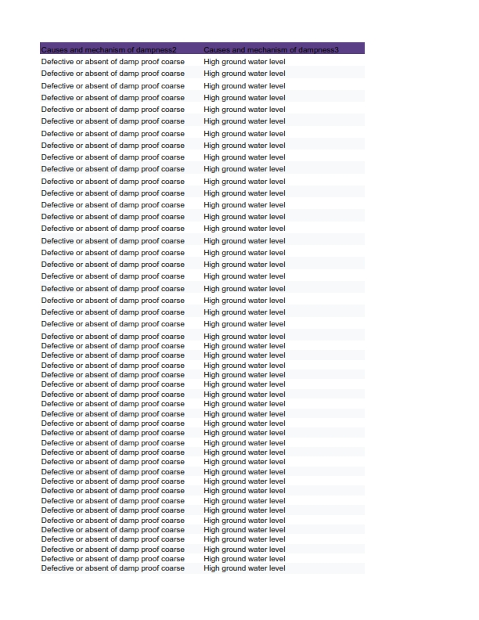

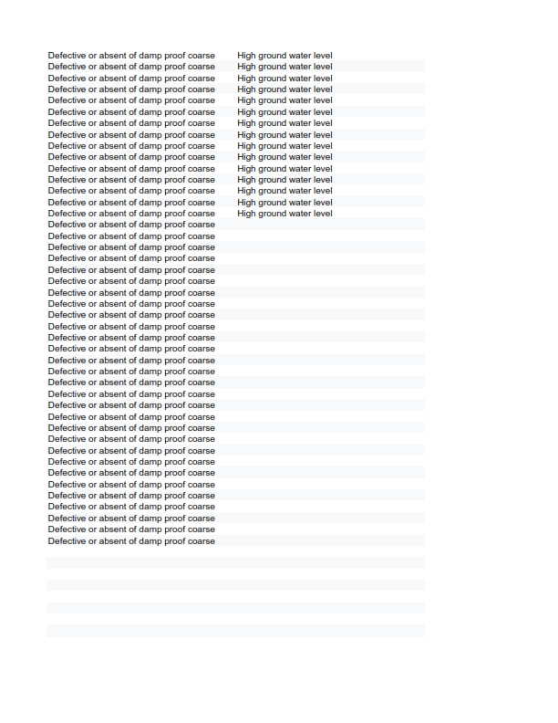*Figure. 8.3. Response from Google Form*

**3.4 Discussion of Findings**

The study results show that there are numerous defects in the buildings studied, and the major defects were observed in rendered and unrendered sandcrete block walls. Major defects observed included stains, damp patches, peeling paint, efflorescence, chalking, mold growth, and delamination of building components. These problems are attributed to poor construction practices, wrong choice of materials, and absence of professional supervision. A review of the relevant literature presents both similar and unique viewpoints on these issues.

The fact that stains and damp patches were observed in 60% of the buildings and peeling paint in 75% of the buildings shows that moisture problems are severe in the surveyed buildings. Abykaeva (2019) pointed out that moisture is one of the most damaging elements that affect the physical appearance of building structures. Efflorescence was also observed in 5% of the buildings even though it is a problem. Mydin et al. (2024) reported that dampness is still a major problem in Malaysian buildings and that it has adverse effects on the building structure and the health of the occupants.

The poor professional supervision in construction as indicated by 90% of the respondents is an issue of concern. Borku (2020) pointed out that the major causes of building defects include poor workmanship, no supervision, and the use of inferior materials. Likewise, Vos et al. (2020) established that moisture-related problems were the most common type of defect in Belgian buildings and were mainly a result of bad construction.

The most common type of dampness reported was rising damp which was most evident in residential buildings (92%) than in industrial and commercial buildings (4% each). Guolo et al. (2022) observed that the rate of rising damp in Venetian masonry is higher than that of other types of masonry because of the climate and the materials used. In a similar study, Nyarko-Boateng et al. (2023) argued that failure to adhere to the building codes and weak technical supervision lead to moisture problems in residential buildings.

The study also showed that the moisture content was not the same at different levels of the soil and was higher in the clayey soil which caused capillary rise of moisture into the structures. Agyekum et al. (2019) confirmed capillary action as one of the main causes of rising damp, especially in areas with high water tables. Monczyński et al. (2019) also pointed out that drainage and weep holes are critical in preventing moisture from entering the building. The major causes of rising damp as perceived by the respondents include; poor construction techniques (92%), high groundwater levels (87%), and construction in wet areas (64%). Li et al. (2021) proved that construction errors have a great impact on the permeability of the material. Furthermore, Taptiklis (2023) noted that a lack of care for the building envelope results in long-standing dampness and mold growth in the interior of the building.

Another important finding was health effects, where 25% of the respondents reported symptoms that may have been caused by moisture-related defects. Mydin et al. (2024) explained that dampness in buildings has many associated health risks, including respiratory diseases and mold growth. Both Franzoni & Bassi (2022) and Abykaeva (2019) explained that proper moisture management is crucial to prevent the deterioration of materials and poor indoor air quality. When it comes to prevention, 69% of the respondents stated that the moisture control measures are quite effective, while only 18% of them considered them to be very effective. Seidu et al. (2019) investigated sustainable approaches to dampness and reported that even though some chemical methods are effective, green options are not fully developed and used yet.

1. **CONCLUSION**

The study establishes that moisture-related defects in buildings do have a significant negative impact on structural integrity and occupant health (Kong et al., 2021; Mydin et al., 2024; Philip et al., 2024). The results of the study show that there is a need for better construction practices, more awareness, and better maintenance strategies. To address these issues comprehensive policies are needed, enforcement of building codes and education of construction professionals on a continuous basis. Future work should include research on sustainable moisture mitigation techniques to improve the durability and indoor air quality of buildings.

*Figure 9: Impact of Rising Damp on Building*

1. **RECOMMENDATIONS**

Policy

1. There should be measures to ensure that new building codes are enforced to include the use of damp-proof courses (DPCs) and other measures to prevent moisture penetration.
2. Subsidy programs for moisture-resistant construction materials should also be introduced to encourage their use.
3. The government should also step up surveillance to guarantee that construction quality standards are met.

Practical

1. There should be an advocate for frequent building repairs and the engagement of qualified construction personnel.
2. There should be enhancement of the design and installation of water drainage systems to prevent water from seeping into the ground.
3. Homeowners and builders should be made aware of the need for moisture control during construction.

Future

1. To determine affordable and environmentally friendly ways of preventing rising damp.
2. There should be an assessment of the long-term effectiveness of various measures taken to prevent moisture ingress into the building.
3. There should be the creation of new materials and construction methods that can help in the fight against moisture.

**COMPETING INTERESTS**

Authors have declared that they have no known competing financial interests OR non-financial interests OR personal relationships that could have appeared to influence the work reported in this paper.

Disclaimer (Artificial intelligence)

Option 1:

Author(s) hereby declares that NO generative AI technologies such as Large Language Models (ChatGPT, COPILOT, etc.) and text-to-image generators have been used during the writing or editing of this manuscript.

**REFERENCES**

Abykaeva, A., K. (2019). The effects of moisture on building constructions of real estate, 646-650. https://doi.org/10.35803/1694-5298.2019.4.646-650.

Agyekum, K., Blay, K., & Opoku, A. (2019). Mechanisms for preventing rising damp in new building infrastructure. *International Journal of Building Pathology and Adaptation*. <https://doi.org/10.1108/IJBPA-06-2018-0048>.

Al-Qahtani, S., Koç, M., & Isaifan, R. J. (2023). Mycelium-based thermal insulation for domestic cooling footprint reduction: A review. Sustainability, 15(17), 13217.

Awoonor, J. K., & Dogbey, B. F. (2021). An assessment of soil variability along a toposequence in the tropical moist semi-deciduous forest of Ghana. Open Journal of Soil Science, 11(9), 448-477.

Ayamga, J., Pabi, O., Amisigo, B., Fosu-Mensah, B., & Codjoe, S. (2021). Annual and intra-annual climate variability and change of the Volta Delta, Ghana. *Environmental Monitoring and Assessment*, 193, 1-19. <https://doi.org/10.1007/s10661-021-08986-3>.

Bernardo, G., Rinaldi, C., & Guida, A. (2024). Critical Analysis of Restoration Practices Against Rising Damp. *Rivista Tema*. <https://doi.org/10.30682/tema100020>.

Boateng, F. G. (2020). Building collapse in cities in Ghana: A case for a historical-institutional grounding for building risks in developing countries. International Journal of Disaster Risk Reduction, 50, 101912.

Borku, W. (2020). Causes of defects in building construction projects and its recommended remedial measures: A case study in Tepi Town, Southern Ethiopia. *International Journal of Advance Research, Ideas and Innovations in Technology*, 6, 129-131.

Brambilla, A., & Sangiorgio, A. (2020). Mould growth in energy efficient buildings: Causes, health implications and strategies to mitigate the risk. Renewable and Sustainable Energy Reviews, 132, 110093.

Coulburn, L., & Miller, W. (2022). Prevalence, risk factors and impacts related to mould-affected housing: an Australian integrative review. International Journal of Environmental Research and Public Health, 19(3), 1854.

Dai, C., Li, Z., Zheng, K., Zhang, J. H., Dai, R., Luo, D., & Xu, X. (2024). Strategic design of porous interfacial evaporators: A comprehensive review unveiling the significant role of pore engineering. Nano Energy, 110244.

Desarnaud, J., Vanhellemont, Y., Lubelli, B., & Bouw, M. (2021). Effectiveness of electromagnetic and electro-osmosis methods for the treatment of rising damp. *Effectiveness of electromagnetic and electro-osmosis methods for the treatment of rising damp*. <https://doi.org/10.14293/ICMB210086>.

Drdácký, M., Ševčík, R., Frankeová, D., Koudelková, V., Buzek, J., Eisler, M., & Valach, J. (2024). Degradation Mechanisms of Mortar and Plaster Layers. Materials, 17(14), 3419.

Franzoni, E., & Bassi, M. (2022). A new sensorized ceramic plug for the remote monitoring of moisture in historic masonry walls: First results from laboratory and onsite testing. *Structural Control and Health Monitoring*, 29. <https://doi.org/10.1002/stc.3126>.

Ghana Statistical Service. (2021). *2021 Population and Housing Census: General Report.* Ghana Statistical Service. Retrieved from <https://www.statsghana.gov.gh>

Guolo, E., Romagnoni, P., Mora, D., & Peron, F. (2022). The Rising Damp in Venetian Masonry: Preliminary Results Comparing Laboratory Tests and Dynamic Simulations. *Sustainability*. <https://doi.org/10.3390/su15010076>.

Hall, C., & Hoff, W. D. (2021). Water transport in brick, stone and concrete. CRC Press.

Hazelton, P., & Murphy, B. (2021). Understanding soils in urban environments. Csiro publishing.

Kog, Y. C. (2024). Waterproofing integrity and water tightness of buildings in the tropic. Proceedings of the Institution of Civil Engineers-Forensic Engineering, 177(4), 120-133.

Kong, Z., Xie, H., Cai, Y., Tan, X., Hokoi, S., & Li, Y. (2021). The effect of rising damp on heat transfer performance and energy consumption of two kinds of Chinese blue-brick masonry walls. *Journal of Physics: Conference Series*, 2069. <https://doi.org/10.1088/1742-6596/2069/1/012038>.

Koranteng, C., Simons, B., & Gyimah, K. (2021). Potential measures towards the reduction of cooling loads of office buildings in Ghana. *Frontiers in Engineering and Built Environment*. <https://doi.org/10.1108/febe-03-2021-0016>.

Kreienkamp, F., Philip, S. Y., Tradowsky, J. S., Kew, S. F., Lorenz, P., Arrighi, J., & Wanders, N. (2021). Rapid attribution of heavy rainfall events leading to the severe flooding in Western Europe during July 2021. World Weather Attribution.

Lacasse, M. A., Gaur, A., & Moore, T. V. (2020). Durability and climate change—Implications for service life prediction and the maintainability of buildings. Buildings, 10(3), 53.

Li, Y., Kong, Z., Xie, H., , Y., Mu, B., & Hokoi, S. (2021). Construction type influences features of rising damp of blue-brick masonry walls. *Construction and Building Materials*, 284, 122791. <https://doi.org/10.1016/J.CONBUILDMAT.2021.122791>.

Li, Y., Zhao, Y., Bi, J., Wang, C., Ning, L., Zhou, Z., & Zhou, C. (2024). Study on the pore structure and capillary water migration characteristics of microbially improved strongly weathered phyllite. Construction and Building Materials, 425, 136028.

Li, Z., Li, Y., & Bai, X. (2023). Repair of damp-proof layers of historic masonry buildings in Shanghai, China. *Proceedings of the Institution of Civil Engineers - Civil Engineering*. <https://doi.org/10.1680/jcien.22.00237>.

Malaquias, R., Bruschi, G., & De Senna Brisotto, D. (2022). Performance analysis of gravity chemical blockers in the treatment of rising damp in masonry walls. *CONGRESO LATINO-AMERICANO DE PATOLOGÍA DE CONSTRUCCIÓN*. <https://doi.org/10.4322/conpat2021.597>.

Monczyński, B., Ksit, B., & Szymczak-Graczyk, A. (2019). Assessment of The Effectiveness of Secondary Horizontal Insulation Against Rising Damp Performed by Chemical Injection. *IOP Conference Series: Materials Science and Engineering*, 471. <https://doi.org/10.1088/1757-899X/471/5/052063>.

Mydin, M., Omar, R., Azian, F., Nawi, M., & Kadir, H. (2024). Establishing the Taxonomy of Building Defects Triggered by Moisture Intrusion and Dampness. *Journal of Advanced Research in Fluid Mechanics and Thermal Sciences*. <https://doi.org/10.37934/arfmts.119.2.211228>.

Mydin, M., Sarpin, N., Zainol, R., Odeh, R., & Nawi, M. (2024). The Impact of Climatological Factors on the Multifaceted and Multisystemic Deficiencies of Building Anatomy. *Journal of Advanced Research in Applied Sciences and Engineering*

Niedostatkiewicz, M., & Majewski, T. (2024). Causes of defects and damage to brick masonry elements in historic buildings. Civil and Environmental Engineering Reports, 34, 423-448.

Nyarko-Boateng, O., Mensah, A., Nyadubea, F., & Yeboah, F. (2023). Detection of the root cause and implications of building dampness. *Open Access Research Journal of Engineering and Technology*. <https://doi.org/10.53022/oarjet.2023.5.2.0080>.

Nyarko-Boateng, O., Nyadubea, F., Darko, O., & Mensah, A. (2023). Analyzing the origins and consequences of dampness in building structures: A case study at mile 50 in the New Juaben Metropolitan Assembly. *Open Access Research Journal of Engineering and Technology*. <https://doi.org/10.53022/oarjet.2023.5.2.0078>.

Odidi, M. D., Fagan-Endres, M. A., & Harrison, S. T. (2023). Moisture absorption rates via capillary suction within packed beds–the effect of material and fluid properties with implications for heap leaching operations. Hydrometallurgy, 215, 105975.

Osei, B., Osei, M., & Agyemang, F. (2022). The impact of climate variability on agricultural food crop production and output: the case of some selected communities in Offinso South District of Ghana. *Archives of Food and Nutritional Science*. <https://doi.org/10.29328/journal.afns.1001042>.

Pacheco, S. E., Guidos-Fogelbach, G., Annesi-Maesano, I., Pawankar, R., d'Amato, G., Latour-Staffeld, P., & Respiratory Health Committee. (2021). Climate change and global issues in allergy and immunology. Journal of Allergy and Clinical Immunology, 148(6), 1366-1377.

Philip, G., Philip, G., Bajau, M., Adamu, M., & Hussaini, A. (2024). Impacts of Dampness on Structural Stability of Public Secondary School Buildings in Adamawa State, Nigeria. *International Journal of Innovative Science and Research Technology (IJISRT)*. <https://doi.org/10.38124/ijisrt/ijisrt24jul398>.

Seidu, R., Young, B., Nemcic, D., Robinson, H., & Ebohon, J. (2019). Sustainable Solutions to Dampness in Building: A Case Study of Selected Period Properties in England.

Taptiklis, P. (2023). Condition of the building envelope is associated with indoor dampness, mould and musty odour, as well as moisture measured in floor joists. *Condition of the building envelope is associated with indoor dampness, mould and musty odour, as well as moisture measured in floor joists*. <https://doi.org/10.14293/icmb230055>.

Thomas, D. L., Martin, D., Campbell, J., Zhang, H., Taghvaeian, S., Abit, S., & Alian, S. (2020). Addressing drainage issues in the urban landscape. Oklahoma Cooperative Extension Service.

Tuuminen, T. (2020). The roles of autoimmunity and biotoxicosis in sick building syndrome as a “starting point” for irreversible dampness and mold hypersensitivity syndrome. Antibodies, 9(2), 26.

Verma, M., & Asafo-Adjei, D. (2021). Green approach to reducing electricity consumption in Ghana-current status and future prospect: a review.

Vos, J., Blommaert, A., & Bossche, N. (2020). Statistical Analysis on Belgian Building Defects. . <https://doi.org/10.23967/dbmc.2020.130>.

Wasko, C., Nathan, R., Stein, L., & O'Shea, D. (2021). Evidence of shorter more extreme rainfalls and increased flood variability under climate change. Journal of Hydrology, 603, 126994.

World Health Organisation (2024). Chronic Respiratory Diseases. Retrieved from <https://www.who.int/health-topics/chronic-respiratory-diseases#tab=tab_2>