**Case Report**

**Synchronous Granulosa Cell Tumor of the Ovary and Urothelial Carcinoma of the Urinary Bladder: A Rare Case Report**

**ABSTRACT-** The incidence of secondary primary malignancies (SPM) has been reported to range from 1.33% to 5.8% according to the location of the primary cancer and follow up duration. The term 'Synchronous Malignancy' is used when two or more malignancies appear within 6 months whether presenting in same or different organ with a different histology or morphology. Synchronous malignancies like these always carry a diagnostic challenge for the physician. Radiographic imaging collaborated with Histopathology and Immunohistochemistry are mandatory to form final diagnosis. Here we present a case of 56 year old female , known case of urinary bladder presenting with synchronous granulosa cell tumor. To the best of our knowledge, this is the first case of Urothelial carcinoma of the Urinary bladder presenting with synchronous malignancy of Granulosa cell tumor of the Ovary.Treatment in this case was done according to standard guidelines with acknowledgement of possible drug drug interactions.

**Key words:** Synchronous Granulosa Cell Tumor, Synchronous Malignancy, Carcinoma, Urinary Bladder

**INTRODUCTION**- The term 'Synchronous Malignancy' is used when two or more malignancies appear within 6 months whether presenting in same or different organ with a different histology or morphology[1].The frequency of synchronous malignancies or multiple primary tumors is around 2-17%[2-6].The presentation of such tumors include various risk factors ,exposure to chemicals, immunosuppression

UNDER PEER REVIEW

,familial hereditary syndromes,etc.[7,8].

They presented yolk sac differentiation in urothelial carcinoma of

the urinary bladder and AFP(Alphafetoprotein ) determination in such cases[10]. Urinary bladder carcinomas in females have various epidemiological risk factors such as menopausal status,chronic urinary tract infections,obesity, smoking, family history

,etc.[11]

The risk factors of GRANULOSA cell ovary include obesity, family history,genetic alterations such as FOXL2,Oral contraceptives, BRCA1 AND 2 mutation[12].Their presentation as a Synchronous malignancy is a rare scenario.There remains a therapeutic deliemma in management of these SPM( second primary malignancies) due to possible drug- drug interactions,CYP enzymes in metabolism and morbidity related to treatment via combined modalities. Any such interactions were ruled out before giving treatment to the patient.

**CASE PRESENTATION**

**CARCINOMA URINARY BLADDER WITH SYNCHRONOUS GRANULOSA CELL TUMOR OVARY**

56 year old female presented with complaints of pain abdomen and occasional blood in urine .Per abdomen was soft with mild tenderness in left iliac fossa.Ultrasound whole abdomen showed polypoidal lesion in the urinary bladder and a left adenexal mass.

PET CT scan showed 3*3 cm polypoidal lesion in the urinary bladder with FDG avid 7*9 cm adenexal mass.

TURBT showed low grade papillary urothelial carcinoma and adenexal deposit Biopsy and IHC(Immunohistochemistry) showed Granulosa cell tumor**[FIGURE 1,2]**

.

IHC confirmation of both specimens was done and at last a diagnosis of synchronous malignancy was made.TURBT sample was positive for CK20, P53 and E-Cadherin indicating low grade papillary urothelial neoplasm. Ovarian Sample stained positive for FOLX2, CD56,GATA 4 and SMAD 3 indicating Granulosa cell tumor ovary .

She was treated with 6 weekly cycles of intravesical BCG followed by 6 monthly cycles of intravesical BCG (Each cycle constituting a total dose of 80 mg BCG diluted in 100ml Normal saline, given intravesically for local action).

Now she is on maintenance Inj. Leuprolide 22.5 mg q3 monthly and Tab Tamoxifen 20 BID for GCT ovary.

Follow up PET CT scan showed complete resolution of UB lesion with decrease in size (now 3*2 cm) and activity of adenexal mass **[FIGURE 3]**.

Biochemical response was also seen with decreasing trend of AFP(200 baseline to 15current) ,BetaHCG( now unrecordable) ,LDH (800 baseline to 126).

The patient is on regular follow-up with subjective as well as objective response.

**DISCUSSION -**The incidence of synchronous malignancies is increasing, reasons may be the aggressive diagnostic techniques, extensive drug abuse,Oncoviruses ,host and genetic factors, environmental factors etc. [7,8].

Espejo et al.[9] presented a case of 76 year old male presenting with yolk sac tumor differentiation in a case of carcinoma Urinary baldder. Most relevant histological characteristic of the solid-neoplasms with YST differentiation is the identification of various patterns, which can be grouped in two classes: the classical ones, which comprise reticular-microcystic, polyvesicular patterns, and the special ones, which comprise glandular, hepatoid and sarcomatoid patterns. Their case showed the described immunohistochemistry profile, in agreement with the diagnosis of YST differentiation. This was one of the rare cases presenting carcinoma of urinary bladder with gonadal involvement as seen in our case.

UNDER PEER REVIEW

Chromosome 12 abnormalities, either as an i12p or as 12p overrepresentation, are the hallmark cytogenetic alteration of Granulosa cell tumors, most common of them being Trisomy of chromosome 12.

AFP serum levels should be determined in patients with urothelial neoplasms exhibiting infrequent histological patterns (e.g. glandular or hepatoid), because the elevation of these levels support the diagnosis of YST differentiation. Moreover, these determinations may be used to control the postsurgical evolution, and to detect tumor relapse among these patients [10].

According to a recent studies, instillation of a chemotherapy agent significantly reduces the recurrence rate in patients included in a low-risk group (level 1 evidence

)[13] as in the present study , the patient was treated with intravesical BCG post TURBT.

In a large cohort study of patients with granulosa cell tumors, the 6-month clinical benefit rate was seen with Leuprolide acetate treatment and progression-free survival was comparable to patients treated with chemotherapy[14]. In the present study , the patient was treated with leuprolide acetate monthly injections. She is doing well with subjective as well as objective response.

Only case reports are available for these entities in giving a guiding path for treatment

. Thorough immuno Histological and radiological workup is a must for developing

diagnosis and biochemistry plays no less role in supporting ongoing systemic chemotherapy.

**CONCLUSION-** Synchronous malignancies pave great diagnostic and therapeutic challenge for the physician. It is of utmost importance that each malignancy is diagnosed with radiological as well histopathological confirmation before starting any treatment. Treatment must be given under careful observation . Biochemical and radiological examination are excellent tools for assessment of ongoing treatment.

**Ethical Approval:**

As per international standards or university standards written ethical approval has been collected and preserved by the author(s).

**Consent**

As per international standards or university standards, patient(s) written consent has been collected and preserved by the author(s).

**Disclaimer (Artificial intelligence)**

Author(s) hereby declare that NO generative AI technologies such as Large Language Models (ChatGPT, COPILOT, etc.) and text-to-image generators have been used during the writing or editing of this manuscript.

**REFERENCES-**

1. De Luca A, Frusone F, Vergine M, Cocchiara R, La Torre G, Ballesio L, Monti M, Amabile MI. Breast Cancer and Multiple Primary Malignant Tumors: Case Report and Review of the Literature. (2019) *In vivo (Athens, Greece).* 33 (4): 1313-1324.
2. Coyte A, Morrison DS, McLoone P. Second primary cancer risk - the impact of applying different definitions of multiple primaries: results from a retrospective population-based cancer registry study. *BMC Cancer* 2014;14:272.

UNDER PEER REVIEW

1. Buiatti E, Crocetti E, Acciai S, et al.. Incidence of second primary cancers in three Italian population-based cancer registries. *Eur J Cancer* 1997;33:1829–34.
2. Weir HK, Johnson CJ, Thompson TD. The effect of multiple primary rules on population-based cancer survival. Cancer Causes Control 2013;24:1231–42.
3. Rosso S, De Angelis R, Ciccolallo L, et al.. Multiple tumours in survival estimates. *Eur J Cancer* 2009;45:1080–94.
4. Vogt, Alexia, et al. "Multiple Primary Tumours: Challenges and Approaches, a Review." *ESMO Open*, vol. 2, no. 2, 2017, p. e000172.
5. Amer MH. Multiple neoplasms, single primaries, and patient survival. *Cancer*

*Manag Res*. 2014;6:119–34.

1. Nogales FF, Preda O, Nicolae A. Yolk sac tumours revisited. A review of their many faces and names. *Histopathology.* 2012;60(7):1023–1033.
2. Espejo-Herrera N, Condom-Mundó E. Yolk sac tumor differentiation in urothelial carcinoma of the urinary bladder: a case report and differential diagnosis. *Diagn Pathol.* 2020 Jun 3;15(1):68.
3. Melms JC, Thummalapalli R, Shaw K, Ye H, Tsai L, Bhatt RS, Izar B. Alpha- fetoprotein (AFP) as tumor marker in a patient with urothelial cancer with exceptional response to anti-PD-1 therapy and an escape lesion mimic. *J Immunother Cancer.* 2018;6(1):89.
4. Zhang, Jianbin, et al. "Emerging Drivers of Female Bladder Cancer: A Pathway to Precision Prevention and Treatment." *Frontiers in Oncology*, vol. 15, 2025, p. 1497637.
5. Golmohammadi Tavallaee M, Hasanzadeh Mofrad M, Yousefi Z, Mottaghi M, Homaei Shandiz F, Davachi B, Hamidi B, Farazestanian M, Afzaljavan F. Risk

Factors and Clinical Outcomes of Recurrence in Adult Ovarian Granulosa Cell Tumors. *Cancer Rep (Hoboken).* 2024 Oct;7(10):e70036.

1. Oosterlinck, W., Solsona, E., Akaza, H., Busch, C., Goebell, P. J., Malmström, P., Özen, H., & Sved, P. (2005). Low-grade Ta (noninvasive) urothelial carcinoma of the bladder. *Urology*, *66*(6), 75-89.

**Figure 1- TURBT Biopsy specimen showing low grade papillary urothelial carcinoma.papillary core is seen with mildly dysplastic epithelium and mild loss of polarity of the nucleus.**

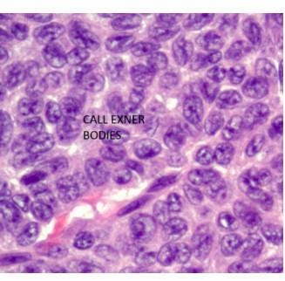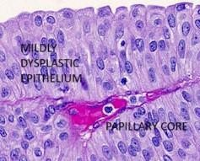N**Figur**D**e 2- G**E**RANU**R**LOSA CELL TUMOR SHOWING**R**CALL**E**EXN**V**ER BO**I**D**E**IES -**W **COFFEE BEAN NUCLEI SHOWING GROOVING WITH CENTRAL PAS POSITIVE HYALINE MATERIAL**

PEER

U

**Figure 3- CARCINOMA URINARY BLADDER WITH SYNCHRONOUS GRANULOSA CELL TUMOR OVARY - FOLLOW UP PET CT SCAN POST TREATMENT SHOWS NO METABOLICALLY ACTIVE LESION IN URINARY BLADDER AND ONLY 3*2 CM RESIDUAL IN LEFT ADENEXA SHOWN WITH RED ARROW**

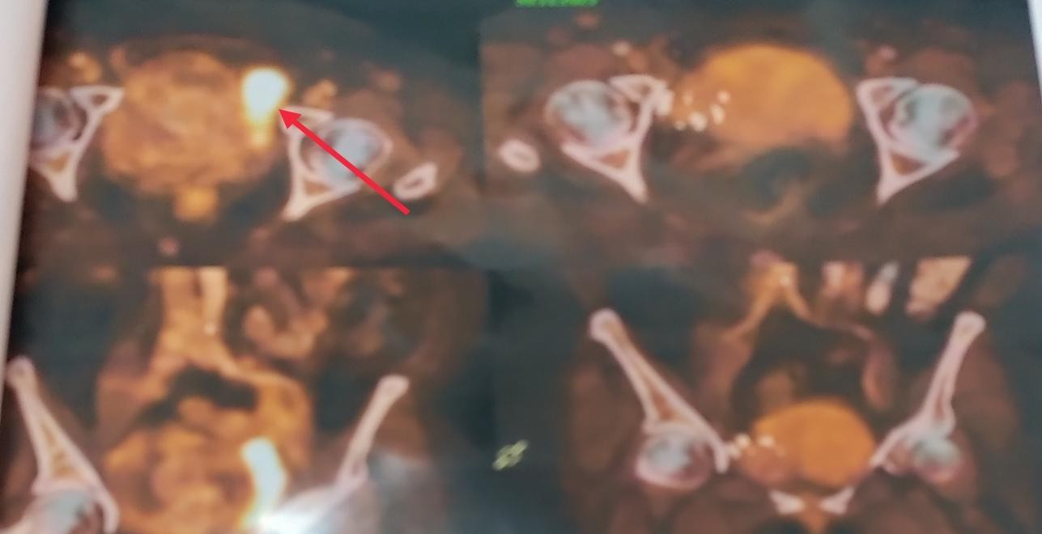

UNDER PEER REVIEW