Estimation of Crop Evapotranspiration of Wheat using Remote Sensing & GIS Based Crop Coefficient
ABSTRACT
The practice of planning and controlling irrigation water applications to satisfy crop water needs without wasting water, soil, or plant nutrients is known as irrigation water management. Usage of the FAO-56 bulletin's instructions, which use tabular crop coefficients (Kc), is popular when evaluating agricultural water requirements. Crop evapotranspiration (ETc), which is directly dependent on crop coefficient curves, is based on point-based crop coefficients. The trend of multispectral vegetation indices (VIs) produced from remote sensing is comparable to that of crop coefficients (Kc). As such, VIs can serve as a Kc alternative and be used to estimate crop coefficients. The use of VI may provide Kc a spatial dimension, allowing for the accurate recording of the spatial variability in water requirements. Therefore, the main objective of the current study, was to determine which VI is most appropriate for the rabi wheat crop for the 2022–2023 crop year and has a tight correlation with crop coefficients.
The study was carried out in the North Maharashtra district of Nashik. The Sentinel 2A, MIS sensor's multi-date and multi-spectral images were utilized to create the multi-temporal vegetation indices (NDVI, NDWI, SAVI, and MSAVI2) for the 2022–2023 year. The agricultural acreages were determined by applying hybrid classification utilizing K means clustering and visual analysis of remote sensing. These estimates for wheat showed 3.83 percent variations from the Department of Agriculture's predictions for the year 2022–2023. The multidate vegetation index data for NDVI, NDWI, SAVI, and MSAVI 2 were ordered for the years 2022–2023 based on age given in weeks. To establish a relationship with VIs, week wise crop coefficients (Kc), as recommended by MPKV Rahuri, were used. Through the use of linear regression analysis, the correlations were created into prediction models. In the situations of wheat year 2022–2023 among all the VIs, the NDWI model performed best it shown that NDWI showed the greatest collaboration with the crop coefficient. Its R² and D values were highly significant, at 0.9365 and 0.986, respectively. It also had the lowest PD, SE, and RMSE values-0.095, 0.0891, and 3.34, respectively. Thus, it is possible to calculate the geographical crop coefficients for wheat using the NDWI-Kc model (Kc = 4.2302NDWI + 0.3716).
The NDWI-Kc model was utilized to derive the week-wise crop coefficients (Kc) for wheat, and the FAO Penman-Monteith method was used to estimate the reference evapotranspiration (ETo). After that, the crop evapotranspiration (ETc) was estimated by multiplying the corresponding Kc values by ETo. 397.13 mm of water was anticipated to be needed overall for the wheat crop in the Nashik district. Thus, it was determined that the study area's total water need for wheat was 22907238.307 ha.cm, or 229.07 Mm3. Because there is less rainfall during the rabi season, the amount of water required for irrigation nearly equals the amount needed for crops in the area.
"This study investigates the use of multispectral remote sensing data from Sentinel-2A to estimate wheat evapotranspiration (ETc) using GIS-based crop coefficients. Vegetation indices such as NDVI, NDWI, SAVI, and MSAVI2 were evaluated to identify the most accurate model for predicting crop water demand. The results show that the NDWI-Kc model demonstrated the strongest correlation and accuracy in estimating spatial crop coefficients."
Keywords: Remote Sensing, Geographical Information System, crop coefficient, Vegetation indices, irrigation and drainage engineering
- INTRODUCTION
Worldwide, water is a dominant resource required for the daily sustenance and survival of human beings. Water is significant to facilitate livelihoods and economic growth, e.g. vital for the industrial and agricultural sector. Currently, irrigated agriculture is the main fresh water user, accounting for about 70% of the water from lakes, rivers and ground aquifers (Cai et al., 2002). Hence, it is crucial to develop methods or tools to quantify water use and availability (e.g. evapotranspiration) over large spatial scales in order to inform decision makers on sustainable utilization and management of this resource.
Evapotranspiration (ET) is a largest consumer of irrigated water, and measuring the amount of ET in a particular region gives water managers a useful tool for calculating water consumption. Because of the complicated interaction between the land surface, vegetation, and atmosphere, computing ET is one of the most difficult aspects of the hydrological cycle (Xu and Singh, 2005; Fang et al., 2012). To determine how much of the available energy is used in ET, water managers have traditionally employed reference ET and reference ET based crop coefficients (KC). The standard ET-based crop coefficient technique was created for ideal growing conditions, however it may neglect actual stressed crop conditions. Because the crop coefficient method is limited in its capacity to capture spatial variability, it can only provide very accurate results.
Irrigated water is limited and scarce in many areas of the world. Agriculture is the major consumer of fresh water (Heermann and Solomon, 2007; Gontia and Tiwari, 2010), but it is not necessarily used efficiently due to farmers’ supplying more water than is consumed by the crop. Thus, better estimation of irrigation water requirements is essential to use water efficiently so water is available for use in the future. A useful method for estimating crop water requirements is to multiply reference evapotranspiration (ET0) by a crop coefficient (KC). ET0 is estimated based on meteorological information (e.g. solar radiation, air temperature, wind, and air vapour pressure deficit) from a local weather station data. The FAO-56 Penman-Monteith equation has been advanced as the standard method for estimating ET0 (Allen et al., 1998)

2. MATERIALS AND METHODS
2.1 Study Area
A study has been chosen to investigate the issue and accessibility of meteorological data in the Nashik area of Maharashtra, India. Nashik, popularly referred to as the "Wine Capital," is a popular pilgrimage destination in Maharashtra. With a land area of 15,582 km², the district is located between latitudes 19035'N and 20050'N and longitudes 73016'E and 74056'E. In Nashik district the major part of the total geographical area is under agricultural use, the net sown area of the district is 7, 42,400 ha, the gross cropped area is 798.5 ha and the average cropping intensity is 107.5 percent, the forest area is 3, 20,668 ha, gross irrigated area is 4, 07,400 ha, irrigated through the tank, open wells, bore wells, canals, lift and micro-irrigation and other sources (Anonymous, 2016).
The soils in the district are classified as lateritic black soil, reddish-brown soil, coarse shallow reddish black soil, and medium light brownish black soil. In general, the soils are very fertile and suitable for growing cereal and pulses. The red soil is less common and is suitable for cultivation under heavy and consistent rainfall. The major Kharif crops of Nashik district are 18 Bajra, Paddy, Jowar, Cotton, Soyabean, Sugarcane, and Groundnut, while in rabi Wheat, Sorghum, and Gram. Horticultural crops like Mango, Pomegranate, and Grapes and vegetables like Brinjal, Cabbage, Onion, Cauliflower, Tomato, and Potato are cultivated in various parts of the district. Among spices Chillies, Coriander, Turmeric, Mustard Seeds, Ginger, Clove, Pepper, Garlic, and Cinnamon are cultivated (Anonymous, 2018)
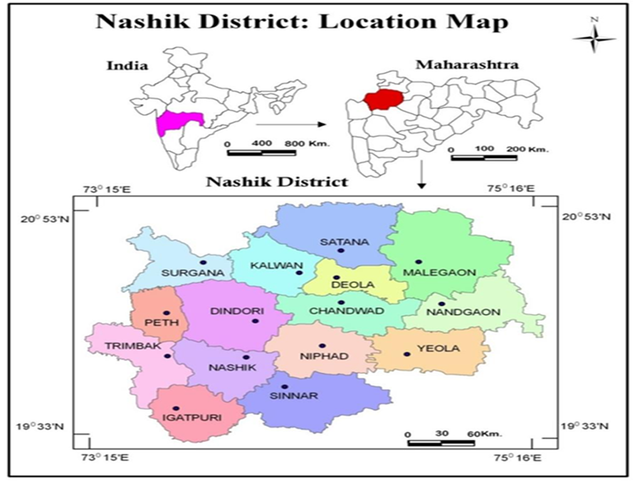
Fig. 1 Location Map of Study Area

2.2 Satellite Image Data
Multi-date, multispectral satellite images from the Sentinel 2A satellite were downloaded from the Copernicus open-access hub website for a period of five months, ranging from November 2022 to March 2023. Two satellite images were downloaded for each month, except for March to capture the growth period of the wheat crop.

Table 1 Multi-date, Multispectral Sentinel 2A satellite data used for the study
Sr. no. | Satellite | Sensor | Date of Pass
1 | Sentinel 2A | MSI | 02-11-2022
2 | Sentinel 2A | MSI | 17-11-2022
3 | Sentinel 2A | MSI | 02-12-2022
4 | Sentinel 2A | MSI | 17-12-2022
5 | Sentinel 2A | MSI | 01-01-2023
6 | Sentinel 2A | MSI | 16-01-2023
7 | Sentinel 2A | MSI | 05-02-2023
8 | Sentinel 2A | MSI | 20-02-2023
9 | Sentinel 2A | MSI | 02-03-2023
10 | Sentinel 2A | MSI | 12-03-2023
11 | Sentinel 2A | MSI | 27-03-2023
2.3 Ancillary Data
The present study utilized 1:50000 scale topographical maps (toposheets) obtained from the Survey of India (SOI) as a reference for the study area. These toposheets were used to digitize the administrative boundaries of the district under investigation. To prepare the non-crop mask (NCM) for the study area, various data sources were utilized, including information on water bodies, urban areas, forests, wastelands, and other non-crop features. This data was used to identify and delineate areas within the study area that are not under crop cultivation.
2.4 Meteorological Data
The required weekly meteorological data (maximum air temperature, minimum air temperature, mean air temperature, maximum relative humidity, minimum relative humidity, bright sunshine hours, wind speed, and rainfall) of the station Nashik for the period under study were collected from the Department of Agricultural Meteorology, Mahatma Phule Krishi Vidyapeeth, Rahuri & solar radiation was gathered from the website of NASA. (https://power.larc.nasa.gov)

2.5 The Digital Analysis
Digital analysis was carried out using Image processing and GIS software - ERDAS Imagine and ArcGIS. The methodology adopted for digital analysis is depicted in the flow chart (Fig.2)
Multidate Sentinel 2A
Collection of Satellite Data

Creating composite image

Vector map of the study area

Subset of the image

Unsupervised classification

Resultant classified image

Polygon vector layer
Extraction of Vis i.e. NDVI, NDWI, SAVI & MSAVI of wheat crop polygons

Creating layer stacks of VIS

Extraction temporal VI values of wheat
Temporal K_{c} value
Analyzing relationship between K_{c} & VIs

ET₀ by PM method
ET_{c}= ET₀ x K_{c} (Using best VI – Kc model)
Crop Acreage
Estimation of crop water demand

Fig. 2 Flow chart of the digital analysis

2.6 Collection of Ground Truth (GT) Data-
The ground truth (GT) work for crop locations was carried out from 6th to 11th January 2023 and 5th to 9th March 2023 in the study area.
2.7 Processing of Satellite Data for Vegetation Indices
Spectral vegetation indices (VIs) including the Normalized Difference Vegetation Index (NDVI), Normalized Difference Water Index (NDWI), Soil Adjusted Vegetation Index (SAVI) and Modified Soil Adjusted Vegetation Index (MSAVI2) were computed for each of the 11 pass dates listed in Table 2 to generate separate images for each vegetation index, the Model Builder Tool in ERDAS Imagine software was utilized. Furthermore, stacks of these index images were created using ERDAS Imagine software, combining the respective images for all vegetation indices.

Identification and Acreage Estimation of Wheat Crop
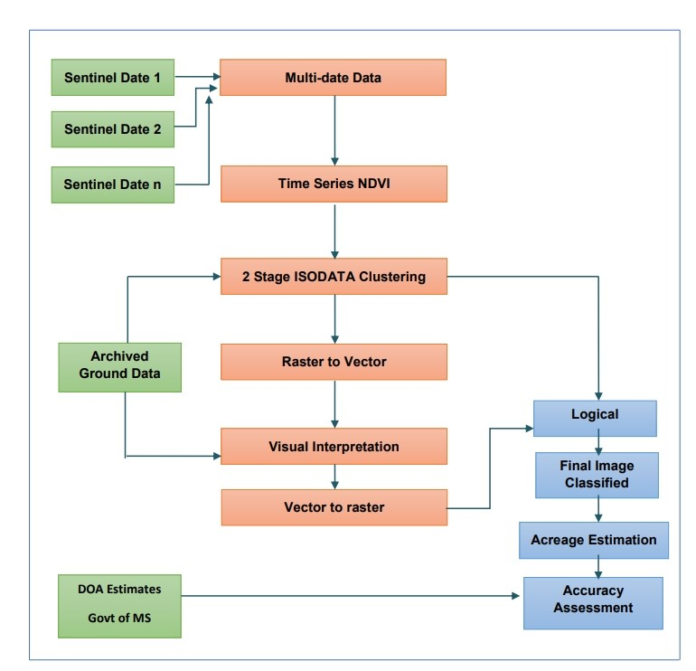
Fig.3 Flow diagram for acreage estimation
2.8 Establishing Relation between Vegetation Indices (VIs) and Crop Coefficients (Kc)
Using linear regression analysis, the empirical correlations between weekly wheat crop coefficients (Kc) proposed by Mahatma Phule Krishi Vidyapeeth Rahuri (MPKV) and VIs were discovered.VI-Kc model was assessed using statistical criteria such as Coefficient of determination (R2 ), Root Mean Square Error (RMSE), Willmott Index of agreement (D) and percent deviation (PD).
2.9 Estimation of water requirement
Using weekly meteorological data, FAO Penman Monteith technique was used to determine reference evapotranspiration (ETo). The week-wise crop coefficients were calculated using the best performing VI-Kc model. The week-wise water requirements (ETc) of the wheat crops were obtained by product of reference evapotranspiration and vegetation index-based crop coefficient

3. RESULTS AND DISCUSSION

3.1 Generation of Vegetation Indices Images
The study area Sentinel-2A satellite data were acquired for 11 specific dates during the growth period of the wheat crop. Essential bands were extracted and composite images were created by combining these bands. ERDAS Imagine software was utilized to process these images by executing vegetation index models, resulting in the generation of four distinct vegetation indices: Normalized Difference Vegetation Index (NDVI), Normalized Difference Water Index (NDWI), and Soil Adjusted Vegetation Index (SAVI) and Modified Soil Adjusted Vegetation Index (MSAVI 2) for all eleven satellite overpass dates.
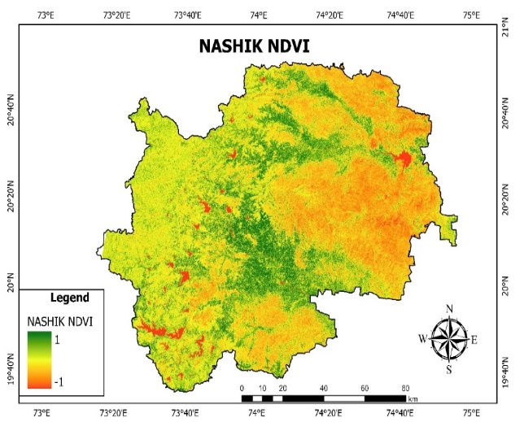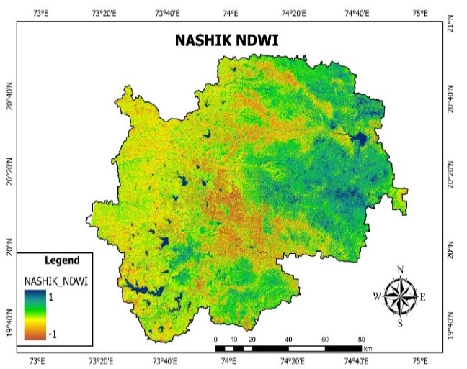
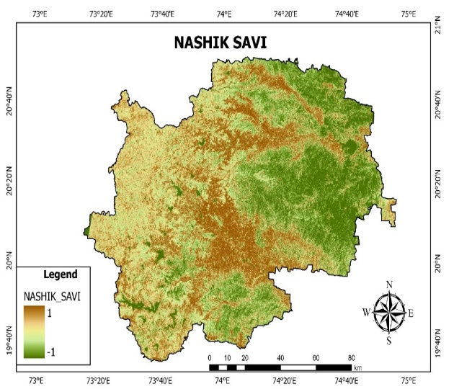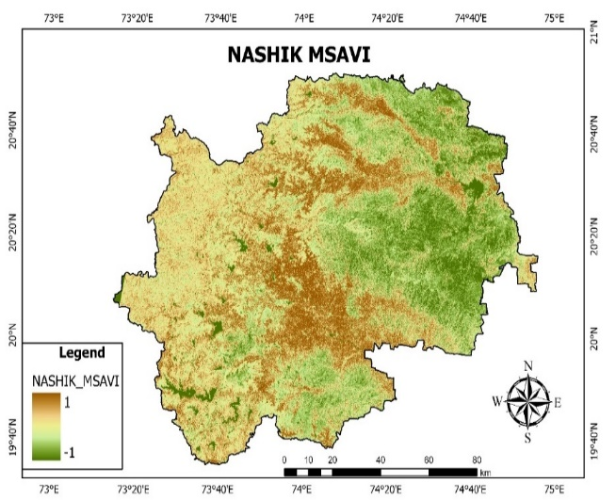
Fig. 4. Vegetation Indices Map of Study Area
The average VI values for each week were derived by calculating the mean of the entered mean values falling within that particular week.

Table 2 Average weekly values of vegetation indices of wheat
Weeks past Sowing | Vegetation Indices
Weeks past Sowing | NDVI | NDWI | SAVI | MSAVI 2
1 | 0.184 | 0.074 | 0.276 | 0.271
2 | 0.215 | 0.098 | 0.282 | 0.287
3 | 0.256 | 0.155 | 0.347 | 0.351
4 | 0.275 | 0.160 | 0.369 | 0.366
5 | 0.297 | 0.178 | 0.448 | 0.410
6 | 0.411 | 0.229 | 0.639 | 0.579
7 | 0.445 | 0.241 | 0.680 | 0.600
8 | 0.459 | 0.247 | 0.702 | 0.627
9 | 0.444 | 0.231 | 0.598 | 0.527
10 | 0.369 | 0.224 | 0.553 | 0.520
11 | 0.365 | 0.219 | 0.538 | 0.508
12 | 0.301 | 0.195 | 0.443 | 0.448
13 | 0.203 | 0.094 | 0.298 | 0.321
14 | 0.167 | 0.069 | 0.257 | 0.291
15 | 0.161 | 0.072 | 0.251 | 0.284
16 | 0.152 | 0.040 | 0.220 | 0.256
17 | 0.110 | -0.017 | 0.163 | 0.183

3.2 Identification and Acreage Estimation of Wheat Crop
The identification and estimation of wheat crop acreage were conducted utilizing multi-date time series data from the Sentinel-2A satellite. This was achieved by implementing a two-stage ISODATA clustering approach. Through this approach, the satellite data was processed to classify and determine the extent of the wheat crop within the study area enabling accurate estimation of its acreage.
To determine the area under the wheat crop, the number of wheat pixels (1955308) was multiplied by the spatial resolution of the satellite data (10 x 10 m) and converted into hectares, providing an estimation of the total acreage of wheat crop in the study area. The wheat acreage estimated from the final classified image for the study area was found 67476.42 hectares. Most of the pixels classified as wheat were correctly classified. It is observed that many linear features like canals and roads were correctly classified as a non-crop class in the present analysis. The area under wheat crop in the study area was estimated by remote sensing as 67476.42 ha against an actual area of 75975.55 ha reported by the Department of Agriculture showing 2.86 percent less estimation. Wheat being irrigated crop soil moisture affects the reflectance of the crop.
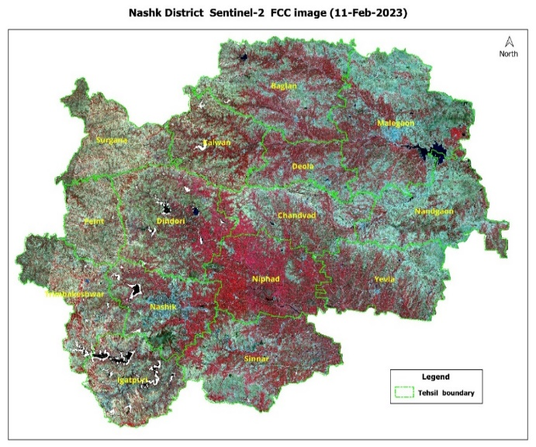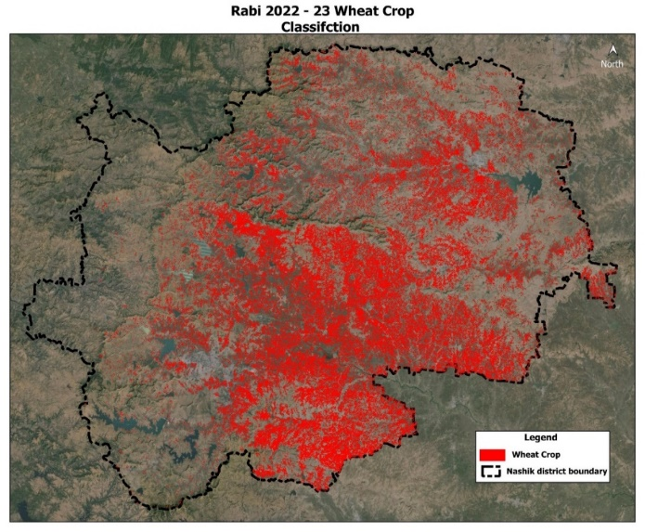
Fig 5 FCC Image of Study Area- Nashik District Fig 6 Classified image obtained by unsupervised classification
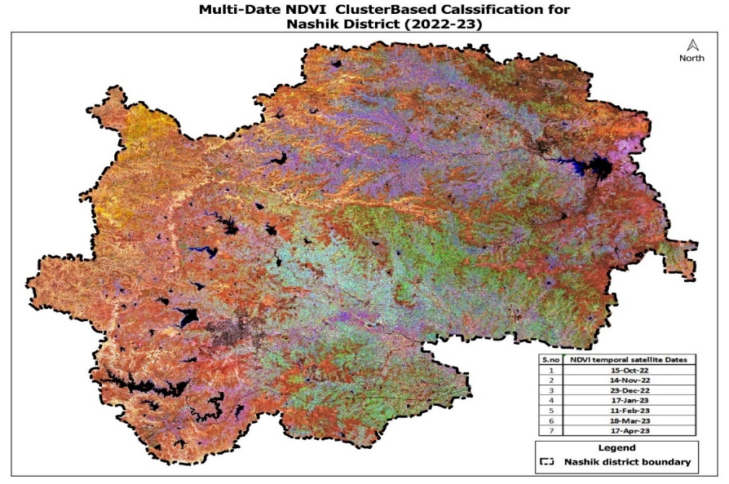
Fig 7 Final Classified image for 2022-23
3.3 Relationship between Crop Coefficients and VIs for Wheat.
The correlation analysis revealed that all the vegetation indices exhibited reasonably good correlations with wheat crop coefficients, as indicated by relatively high R² values. Among the indices under study, the NDWI-K_{c} model demonstrated the highest R² value of 0.934 along with a D value of 0.986, which indicates a strong relationship between NDWI and crop coefficients. Furthermore, the NDWI-K_{c} model showcased the lowest values for SE, RMSE and PD, which were 0.095, 0.0891 and 3.34 respectively. These findings confirm the excellent performance of the NDWI-Kc model in predicting crop coefficients of wheat crop accurately.The NDVI-K_{c} and NDWI-K_{c} models showed reasonably similar results after the SAVI-K_{c} model. The NDVI-K_{c} model exhibited an R² value of 0.8483 along with SE, RMSE, PD and D values of 0.116, 0.1090, 6.09 and 0.978 respectively. Similarly, the NDWI-K_{c} model demonstrated an R² value of 0.9365 along with SE, RMSE, PD and D values of 0.095, 0.0891, 3.34 and 0.986 respectively.

Fig. 8 (a, b, c and d) Relationship of crop coefficients with Vegetation Indices for wheat crop
3.4 Reference evapotranspiration (ET_{o} mm) & Crop Evapotranspiration (ET_{c} mm) of wheat in Nashik District 2022-23
The reference crop evapotranspiration (ET_{o}) for the Nashik district was estimated using the FAO Penman Monteith method and the week-wise values are presented in Table 3. As discussed in section 4.5, the NDWI vegetation index exhibited a high correlation with the wheat crop coefficients (K_{c}). By utilizing the linear regression equation derived from this correlation, the week-wise crop coefficients for wheat were determined. The crop evapotranspiration (ET_{c}) for wheat was then calculated by multiplying the reference evapotranspiration (ET_{o}) with the corresponding crop coefficients (K_{c}), as shown in Table 3. The total estimated crop evapotranspiration (ET_{c}) for wheat was found to be 397.13 mm.
To determine the water demand for wheat, the crop acreage obtained as per section 4.4 was multiplied by the corresponding total evapotranspiration (ET_{c}) for each week. The calculations for these water demands can be found in Annexure-III. The resulting week-wise water demands for wheat are presented in Table 4, with a total water demand of 22907238.30 ha.cm or 229.07 Mm³. Notably, the week-wise water demand exhibited higher values during the mid-season stages, highlighting the need for increased attention to irrigation during those periods.
Table 3. The Total Estimated Crop Evapotranspiration (Et_{c}) For Wheat
MET Weeks | Weeks Past Sowing | ET_{o}  (mm) | ET_{c}  (mm)
45 | 1 | 3.11 | 15.54
46 | 2 | 2.96 | 16.32
47 | 3 | 2.75 | 19.83
48 | 4 | 2.71 | 19.94
49 | 5 | 2.49 | 19.71
50 | 6 | 2.61 | 24.46
51 | 7 | 2.97 | 28.91
52 | 8 | 3.06 | 30.40
1 | 9 | 2.90 | 27.38
2 | 10 | 2.81 | 25.92
3 | 11 | 3.61 | 32.89
4 | 12 | 3.77 | 31.68
5 | 13 | 4.44 | 23.94
6 | 14 | 4.81 | 22.57
7 | 15 | 4.94 | 23.15
8 | 16 | 5.75 | 21.72
9 | 17 | 6.08 | 12.77
Total |  |  | 397.13

Table 4 Crop water demand of wheat (m³) in Nashik district for wheat crop
Weeks Past Sowing | ET_{c} (mm) | Crop Acreage (ha) | Water Demand  (ha-cm) | Water Demand  (m³) | Water Demand  (mm³)
1 | 15.54 | 67476 | 1048442.088 | 1048442 | 1048442
2 | 16.32 | 67476 | 1101302.786 | 1101303 | 1101303
3 | 19.83 | 67476 | 1337880.390 | 1337880 | 1337880
4 | 19.94 | 67476 | 1345437.702 | 1345438 | 1345438
5 | 19.71 | 67476 | 1329763.027 | 1329763 | 1329763
6 | 24.46 | 67476 | 1650125.580 | 1650126 | 1650126
7 | 28.91 | 67476 | 1950866.112 | 1950866 | 1950866
8 | 30.40 | 67476 | 2051418.847 | 2051419 | 2051419
9 | 27.38 | 67476 | 1847357.928 | 1847358 | 1847358
10 | 25.92 | 67476 | 1749301.805 | 1749302 | 1749302
11 | 32.89 | 67476 | 2219285.640 | 2219286 | 2219286
12 | 31.68 | 67476 | 2137639.680 | 2137640 | 2137640
13 | 23.94 | 67476 | 1615328.207 | 1615328 | 1615328
14 | 22.57 | 67476 | 1523088.515 | 1523089 | 1523089
Total | 339.49 |  | 22907238.307 | 22907238 | 22907238
Total (Mm3) |  |  |  |  | 229.07

4. SUMMARY AND CONCLUSIONS
The research study was carried out in Nashik, a wheat-growing district in Maharashtra. To determine if four widely used vegetative indices-NDVI, NDWI, SAVI, and MSAVI 2 were needed for developing a relationship to crop coefficients. These indices were created by using digital processing techniques to sentinel 2A satellite images. The study's conclusions show that there is a constant pattern in the spectral profiles of wheat as shown by NDVI, NDWI, SAVI, and MSAVI 2. A two-stage hybrid classification approach was used to identify and estimate the acreage of the wheat crop. The results closely matched the actual statistics provided by the Department of Agriculture, Government of Maharashtra, with the wheat crop showing a variance of only 3.83%. Also, the estimations obtained from remote sensing were acquired significantly earlier than the Department of Agriculture's published statistics, providing an advantage in terms of early knowledge.
The study of four vegetation indices for wheat crop, namely NDVI, NDWI, SAVI, and MSAVI, shown that NDWI showed the greatest collaboration with the crop coefficient. Its R2 and D values were highly significant, at 0.9365 and 0.986, respectively. It also had the lowest PD, SE, and RMSE values-0.095, 0.0891, and 3.34, respectively. Thus, it is possible to calculate the geographical crop coefficients for wheat using the NDWI-Kc model (Kc = 4.2302NDWI + 0.3716).The NDWI-Kc model was utilized to derive the week-wise crop coefficients (Kc) for wheat, and the FAO Penman-Monteith method was used to estimate the reference evapotranspiration (ETo). After that, the crop evapotranspiration (ETc) was estimated by multiplying the corresponding Kc values by ETo. 397.13 mm of water was anticipated to be needed overall for the wheat crop in the Nashik district. Thus, it was determined that the study area's total water need for wheat was 22907238.307 ha.cm, or 229.07 Mm3. Because there is less rainfall during the rabi season, the amount of water required for irrigation nearly equals the amount needed for crops in the area.

Conclusions
The following conclusions are derived from the findings of the present study:

- All the vegetation Indices (VIs) followed the pattern similar to crop coefficients. Conversely, phenologogical information can be tracked from temporal variations of VIs. Probable date of planting can be detected from the defined VI patterns. Similarity in pattern of VIs and Kc indicated that Kc can be estimated in terms of vegetation indices for wheat crop. The investigation's hypothesis is supported by this conclusion.

- Acreage estimation of wheat crop showed that the estimated acreages were observed very close to actual measurements with per cent deviation of 3.83 in case of wheat crop. Hence, timely and precise estimates of crop acreages can be obtained by using Remote Sensing and GIS techniques.

- The vegetation index, NDWI of wheat crop was found to be highly superior for their linear correlation with crop coefficient. Therefore, these developed VI-Kc relationships can be incorporated in the FAO-56 procedures in place of conventional tabulated Kc.

- Remote Sensing and GIS integrated approach can be applied to supply appropriate amount of irrigation water at different locations as per actual crop water demand leading to proper irrigation water management. This approach can also be used in water scarcity scenario to supply optimum irrigation water as a lifesaving irrigation to prevent crop failure.

- Real time high resolution remotely sensed data combined with automatic weather stations can constitute an expert system for accurate irrigation scheduling.

Disclaimer (Artificial intelligence)
Option 1:
Author(s) hereby declare that NO generative AI technologies such as Large Language Models (ChatGPT, COPILOT, etc.) and text-to-image generators have been used during the writing or editing of this manuscript.
Option 2:
Author(s) hereby declare that generative AI technologies such as Large Language Models, etc. have been used during the writing or editing of manuscripts. This explanation will include the name, version, model, and source of the generative AI technology and as well as all input prompts provided to the generative AI technology
Details of the AI usage are given below:
1.
2.
3.

5. REFERENCES

Ahmad, F. 2012b. A review of remote sensing data change detection: Comparison of Faisalabad and Multan Districts, Punjab Province. Pakistan J. Geog. and Reg. Planning. 5(9): 236-251
Allen, R. G., M. Smith, L. S. Pereira, D. Raes and J. L. Wright. 2000. Revised FAO Procedures for Calculating Evapotranspiration: Irrigation and Drainage Paper No. 56 for testing in Idaho. In Proc. Watershed Management and Operations Management. June 20-24, Fort Coll ins, CO.
Anonymous 2022. Agricultural land and Water statistics of India. India Water Portal, https://www.indiawaterportal.org
Anonymous. 2021. Crop statistics. Department of Agriculture, Maharashtra. Website- www.krishi.maharshtra.gov.in
Anonymous. 2022. Crop statistics. Department of Agriculture, Maharashtra. Website- www.krishi.maharshtra.gov.in
Anonymous. 2022. Meteorological data. NASA Power Data. Websitewww.power.larc.nasa.gov.in
Dingre, S. K. and S. D. Gorantiwar. 2020. Determination of the water requirement and crop coefficient values of sugarcane by field water balance method in semiarid region. Agric. Water Manage, 1-8
Gontia, N. K. and K. N. Tiwari. 2010. Estimation of crop coefficient and evapotranspiration of wheat (Triticuum aerstivum) in an irrigation command using remote sensing and GIS. Water Res. Manag. 24:1399- 1414
Goswami, S. B., G.D. Bairagi, C. K. Sarat and S.K. Sharma. 2016. Evaluation of LISS-III And AWiFS Sensor data for Wheat Acreage estimation., Proc. of SPIE Vol. 9880: 1-10
Jha, A., A. S. Nain and R. Ranjan. 2013. Wheat Acreage Estimation Using Remote Sensing in Tarai Region of Uttarakhand. Soc. for Plant Res., Vol. 26 (2): 105-111
Kadam, S. A., S. D. Gorantiwar, S. D. Dahiwalkar and M. G. Shinde. 2019. Crop Evapotranspiration and Normalized Difference Vegetation Index relationship for Wheat crop. Agric. Res. J., 56 (2):336-339
Kamble, B., A. lrmak and K. Hubbard. 2013. Estimating Crop Coefficients Using Remote Sensing-Based Vegetation Index. Remote Sens., 5: 1588-1602
Kosle A. 2021. Vegetation indices-based crop coefficients to estimate evapotranspiration of wheat. M. Tech thesis (unpub.), Department of Irrigation and Drainage Engineering, Dr. PDKV, Akola.
Monteith, J. L. 1965. Evaporation and environment. p. 205-234. In G.E. Fogg (ed.) the state and movement of water in living organisms. In Proc. Symp. Soc. Exp. Bioi. Vol. 19. Academic Press, New York
MPKV. 2021. Krishi Darshani-2021. Directorate of Extension Education, Rahuri, Maharashtra.
Pimpale, A. R., P. B. Rajankar, S. B. Wadatkar, S. S. Wanjari and I. K. Ramteke 2015. Estimation of water requirement of wheat using multispectral vegetation indices. J. of Agromet, 17 (2): 208-212
Ray, S. S. and V. K. Dadhwal. 2001. Estimation of crop evapotranspiration of irrigation command area using remote sensing and GIS. Agric. Water Manage, 49: 239-249
Sharma, R., L. Pradhan, M. Kumari and P. Bhattacharya. 2021. Comparative Analysis of Different Vegetation Indices of Noida City using Landsat Data. Advances in Energy and Environment, Lecture Notes in Civil Engineering. pp: 209-221.
Singh, S. K., Dutta S. and Dharaiya N. 2016. Remote Sensing Indices for Crop Water Management. Inter. J. of Engg. Sci. & Res. Tech., ISSN: 2277-9655: 326-334
Wang, P., X. Li, J. Gong and C. Song. 2001. “Vegetation temperature condition index and its application for drought monitoring.” Inter. Geoscience and Remote Sens. Symposium, Sydney, Australia, 9·14 July, pp: 141-143
Zhang, H., Y. Lan, R. Lacey, W. C. Hoffmann and Y. Huang. 2009. Analysis of vegetation indices derived from aerial multispectral and ground hyperspectral data. Int. J. Agric. and Biol. Engg., 2(3):33-40

